

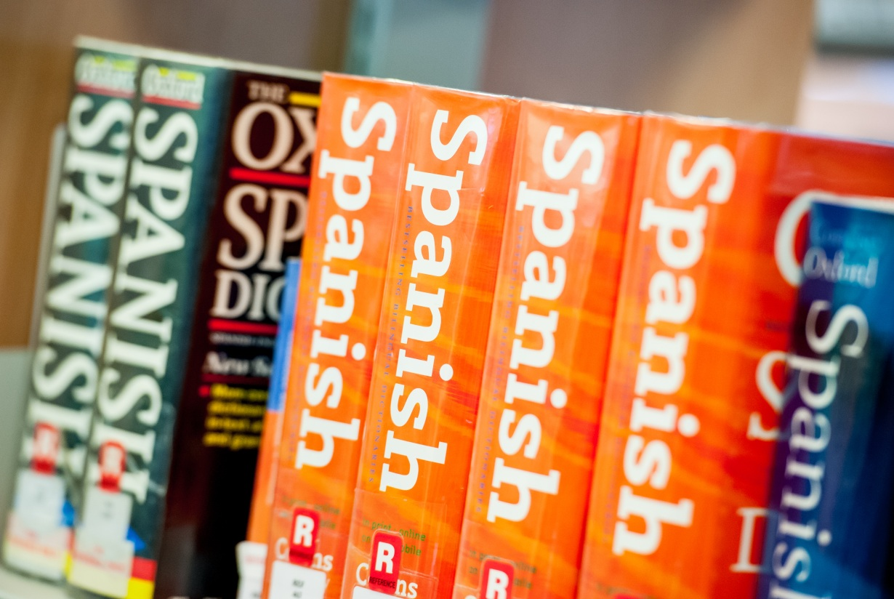

**SPANISH**

GCSE

AQA

Tuesley Lane, Godalming

GU7 1RS

T: 01483 423526

E: [college@godalming.ac.uk](mailto:college@godalming.ac.uk)

W: www.godalming.ac.uk

Tuesley Lane

Godalming

Surrey

GU7 1RS

T: 01483

E: [college@godalming.ac.uk](mailto:college@godalming.ac.uk)

W: [www.godalming.ac.uk](http://www.godalming.ac.uk)

Quiz - Can you name the two places of interest in the pictures?

Our aim is to ensure that you gain a sound, working knowledge of Spanish across a variety of topic areas that will be of practical use when visiting a Spanish-speaking country. In addition to this, you will learn about Spain and its culture. Ultimately, of course, you will gain a GCSE qualification.

What previous knowledge do you need?

You will either have studied some Spanish before or have a good qualification in another language (French, Portuguese or Italian) in order to cope with the fast pace required to cover the content in one year.

Which course will you follow?

Students follow and complete the AQA Spanish Full GCSE course in just one year. Three and three quarter hours per week will be allocated to this course.

What will you study?

In this course you will learn to listen to, speak, read and write Spanish up to GCSE standard. The topics covered will include talking about relationships with family and friends, social media and mobile technology, free-time activities, local, national, international and global areas of interest, current and future study and employment. You will learn to write letters in Spanish and discuss issues such as health and the difference between life in Spain and England.

What is the department like?

We are housed in the brand new, custom built 400s block with specialist classrooms which are equipped with a class set of PCs, access to tablets & a data projector which is connected to the College network. Such resources not only allow for improved teaching & learning during timetabled lessons but also give each individual student the opportunity to develop their skills at their own pace & in their own time.

Within the Department, there are three teachers of Spanish, one of whom is also a Foreign Language Assistant (FLA). All are native speakers of Spanish which is extremely advantageous both from a linguistic and cultural perspective.

How will you be assessed?

You will be examined in the four skill areas of Listening, Speaking, Reading & Writing at either Foundation or Higher level, depending upon your level of ability. All four skills are tested through four fairly short external examinations which take place in May.

What is the course about?