

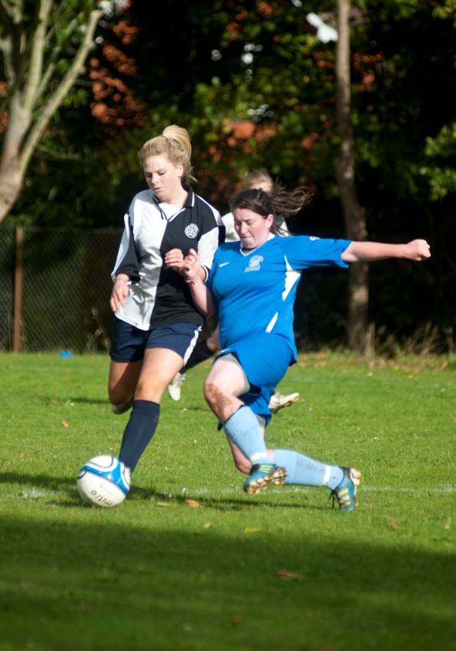

**SPORT**  BTEC Level 2 First Award

EDEXCEL

Tuesley Lane, Godalming

GU7 1RS

T: 01483 423526

E: [college@godalming.ac.uk](mailto:college@godalming.ac.uk)

W: www.godalming.ac.uk

Tuesley Lane

Godalming

Surrey

GU7 1RS

T: 01483

E: [college@godalming.ac.uk](mailto:college@godalming.ac.uk)

W: [www.godalming.ac.uk](http://www.godalming.ac.uk)

**Assessment**

Four units (75% coursework, 25 % test).

**Skills developed**

ICT

Research

Presentation

Functional English

Communication

First Aid

Leading Sports Sessions

**What’s next?**

BTEC Level 3 Extended Diploma in Sport, AS/A2 Physical Education

The course consists of four units which are graded as Pass, Merit and Distinction. The units are:

* Fitness for Sport & Exercise (Test)
* Practical Sport (performance and knowledge in 2 chosen sports).
* Leading Sports Activities (planning, organising and running sports sessions).
* Training for Personal Fitness

What is the course about?

What is the department like?

The PE & Sport Department is housed in a modern sports complex with large hall, gym and teaching rooms with computer access. As well as your studies, you will have chance to participate in a range of recreational activities such as basketball, badminton, 5 aside football, training in the gym, and volleyball. You might also want to play in one of the College’s teams that play in various leagues and cup competitions on a Wednesday afternoon. We currently have three men’s football, men’s rugby, two women’s netball, women’s football and a basketball team. We also enter regional competitions for swimming, athletics, badminton and cross country.

All the staff members are friendly and supportive and want you to achieve your best, both in the classroom and on the pitch or court.

What sort of work will I be doing?

You will be asked to prepare written reports, leaflets and case studies, complete practical assessments, use analysis systems to assess others, give presentations and lead activity sessions. You will be working in small groups and individually to complete weekly tasks which are compiled to produce an overall portfolio of your work. Tests are completed onscreen using PC’s.

What are the entry requirements?

Students will need at least two GCSEs at grade 4 to qualify for this programme and/or an average of grade 3 at GCSE overall.