How will I be assessed?

Most units are assessed by staff at the college using a range of assessment opportunities. These may be written work, oral presentations, witness statements from coaches, video analysis and so on. For courses starting September 2018, externally set and marked work will form part of the assessment. This will include one unit assessed by a written examination and three units assessed by written task set and marked by Pearson.

What skills will I develop during this course?

As well as an excellent knowledge base, you will develop your abilities to analyse situations and apply theoretical concepts to practical situations. This is a very necessary skill for any future career. You will develop both your communication skills to help you become an effective team member and your leadership qualities. Opportunities will be available for you to achieve the Award in Level 2&3 Sports Leadership and also other governing body officiating / coaching awards.

What extra work can I do?

It is important that you are as active as possible in your chosen practical assessments. Only a limited amount of time can be given in class time so you will need to develop your skills either outside of college or in one of our sports teams. A good general knowledge of the sports world will provide you with good up-to-date examples of our theory work so watch, listen and read all the sports articles you can find.

**The most important thing is to participate fully in all areas of sport and fitness.**

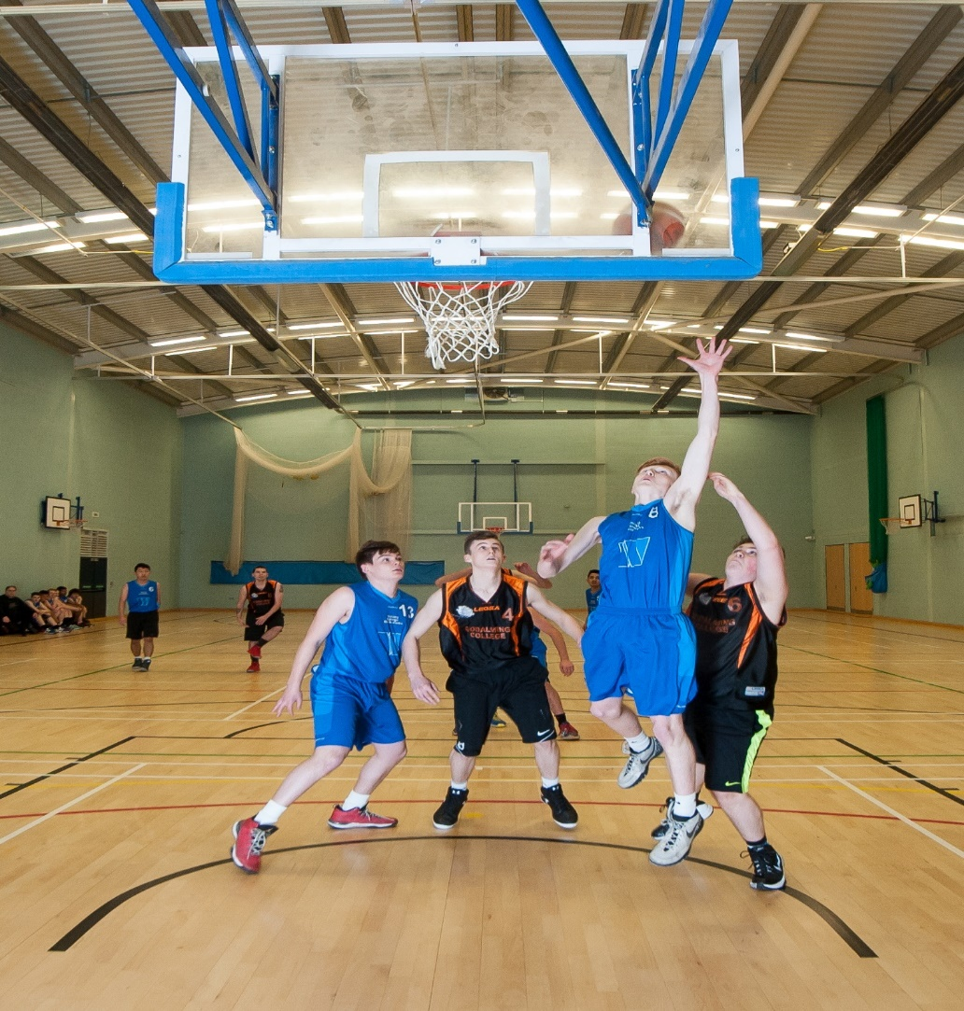

**SPORT DEVELOPMENT, COACHING & FITNESS**

BTEC level 3

Extended Diploma

EDEXCEL

Tuesley Lane, Godalming

GU7 1RS

T: 01483 423526

E: [college@godalming.ac.uk](mailto:college@godalming.ac.uk)

W: www.godalming.ac.uk

Tuesley Lane

Godalming

Surrey

GU7 1RS

T: 01483

E: [college@godalming.ac.uk](mailto:college@godalming.ac.uk)

W: [www.godalming.ac.uk](http://www.godalming.ac.uk)

What are the entry requirements?

A minimum of five GCSE subjects at Grade 4 or above including English, Mathematics and a Science. Not all students will have done GCSE Physical Education and it is **not necessary** to have done so in order to take the BTEC National Diploma in Sport.

A genuine interest in sport and fitness is required as your performance in both is a major part of your assessment.

.

What sort of work will I be doing?

The theory work will generally be delivered in a variety of environments focusing on a hands on approach and use a wide range of techniques will be used. Discussion, experiments, practical demonstrations, video, student presentations and good old-fashioned board work will be used to provide a varied approach to learning. There will also be opportunity to gain experience in leadership, coaching and officiating.

The BTEC National Diploma combines all the major elements of sports development and fitness. You will study fourteen units of work from the following topics:

|  |  |  |  |
| --- | --- | --- | --- |
| **Mandatory Units** | | Learners complete and achieve all units | |
| 1. Anatomy and Physiology | | | 3. Professional Development in the Sports Industry |
| 2. Fitness Training and Programming for Health, Sport & Well-being | | | 7. Practical Sports Performance |
| 4. Sports Leadership | | | 8. Coaching for Performance |
| 19. Development and Provision of Sport and Physical Activity | | | 9. Research Methods in Sport |
| 22. Investigating Business in Sport and Active Leisure | | | 23. Acquiring Skill in Sport |
| **Optional Units** | Learners complete four units chosen by Department | | |
| 5. Application of Fitness Testing | | |  |
| 6. Sports Psychology | | |  |
| 10. Sports Event Organisation | | |  |
| 25. Rules, Regulations and Officiating in Sport | | |  |

What is the department like?

The Physical Education Department is one of the liveliest and most successful departments in the college. Students who have completed courses in our department enjoy both the positive staff-student relationships and the varied approaches to study. Our value-added teaching scores are some of the highest around demonstrating that we cater for all abilities.

The department has superb new facilities on site, including a sports hall ready for top level badminton, basketball, netball, volleyball, 5 – aside, indoor hockey, trampolining and cricket. A state of the art fitness club with highly qualified instructors, two football pitches, one rugby pitch, two netball courts and three tennis courts. We also make full use of other specialist facilities such as Charterhouse astroturf, athletics track and pool. Our classrooms are right in the heart of the sports centre and we have access to all the latest audio-visual equipment.

As well as excellent teaching, the department offers a range of activities to enhance your time at Godalming. We run very successful teams in football, netball, rugby, basketball and swimming and we also have recreational classes for badminton, cricket and trampolining. We have used residential visits to well-known sports resorts such as Club La Santa, Lanzarote.

Godalming College PE & Sport Department welcomes people with a genuine interest in sport and many top international level performers study here alongside those who just enjoy playing.

What is the course about?

What are the progression routes for this qualification?

The aim of this course is to give the student an opportunity to investigate the breadth of the industry, from health and fitness and sports therapy to sports coaching, so that they are able to make informed choices regarding future employment opportunities such as: provision of individual / group sports activities, health promotion, coaching/instructing of specialist groups and community development. The course is also very suitable for progression to Higher Education courses in sports development, management and coaching.