

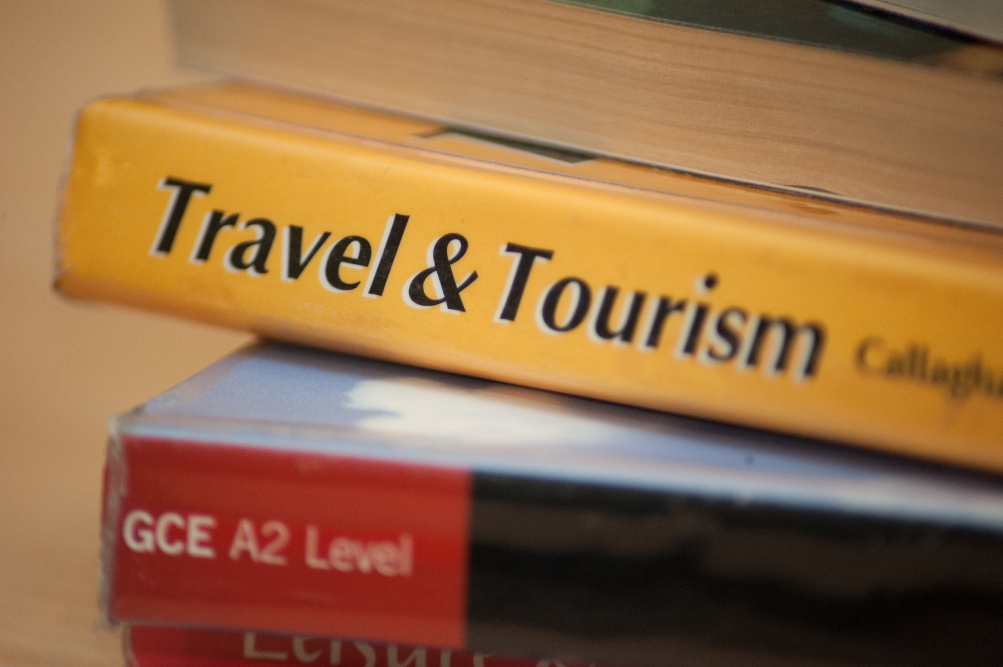

**Travel & Tourism** BTEC Level 2 First Award

(Pearson/Edexcel).

Tuesley Lane, Godalming

GU7 1RS

T: 01483 423526

E: [college@godalming.ac.uk](mailto:college@godalming.ac.uk)

W: www.godalming.ac.uk

Tuesley Lane

Godalming

Surrey

GU7 1RS

T: 01483

E: [college@godalming.ac.uk](mailto:college@godalming.ac.uk)

W: [www.godalming.ac.uk](http://www.godalming.ac.uk)

What are the progression routes for this qualification?

This course is offered as part of the College’s Access programme, for students wishing to improve their GCSE/Level 2 grade profile. Alongside other level 2 qualifications the Travel and Tourism course will allow you to progress onto level 3 courses including the BTEC level 3 Travel and Tourism course at Godalming College, other college courses or apprenticeships.

What are the entry requirements?

At least 2 GCSEs at grade 4 or above and an overall average GCSE grade of 3 based on the best 8 entries..

.

Skills developed?

Research, communication, customer service, presentation skills, selling skills.

Progression

The course can lead to further study at a higher level (e.g. BTEC National Tourism, Hospitality, Business) or to a related apprenticeshipin the Travel industry.

What sort of work will I be doing?

Lessons are very practical and will involve studying real organisations and destinations. You will use a range of industry resources and case studies from brochures, magazines, websites, newspapers and television to help enhance your knowledge and understanding of the subject. During the course, you will be invited to attend a variety of educational visits. Some will be for just a few hours, some for a day.

Units you will study:

Unit 1 – UK T&T Sector (Exam)

Unit 2 – UK Tourist Destinations

Unit 3 – International Destinations

Unit 4 – Customer Service in T&T

Assessment:

The four units (75% coursework, 25% exam), are graded at Pass, Merit, Distinction then combined to give a final grade equal to one GCSE.

What is the department like?

We are situated in a purpose built complex with dedicated teaching rooms, complete with multi-media equipment and computer suites consisting of fully networked machines.

The teaching team are all experienced teachers who have relevant industry experience within the Tourism Industry. They are very enthusiastic about their subjects and are fully committed to providing a high quality education in a caring and supportive environment. Their knowledge of these industries is used to promote a detailed and extensive learning environment as well as supporting you with your studies.

Educational visits, industrial experience and guest speakers form an integral part of the course in making the learning experience interesting, thought provoking and real.

This course is a practical, one year course that is ideal for students who have an interest in the travel & tourism industries. Through visits to actual facilities and destinations, you will build up an understanding of the importance of these industries to society and national/local economies as well as discovering why people visit specific areas in their spare time and what they do there. If you would like to study a subject that will broaden your experiences and gives you the opportunity to apply the theory to practical work outside the classroom, this could be the course for you.

What is the course about?