

**A guide to writing your milestones**

**Unit 3**



unit 3 2018

Godalming College

CLASSACTION

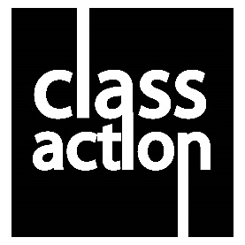

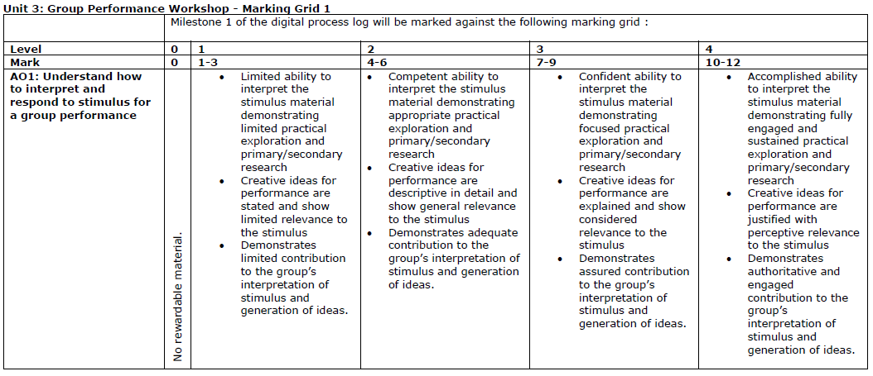

**MILESTONE 1**

**A GUIDE**

**Paragraph 1 – Description of Stimulus**

**Paragraph 2 – Primary Research**

**Paragraph 3 – Initial Ideas**

**Paragraph 4 – Secondary Research**

**Paragraph 5 – Performance Aims & Intentions**

|  |  |
| --- | --- |
| **As you write tick off this checklist and ensure somewhere you have included…** | Green Check Mark Clip Art |
| ***What form and style the performance will take*** |  |
| ***Who the target audience is and why*** |  |
| ***What are your artistic aims and intentions*** |  |
| ***What performance skills you may include*** |  |
| ***What research has informed the work*** |  |
| ***What is your stimuli*** |  |

**FROM THE EXAM BOARD:**

|  |
| --- |
| They must justify their initial creative ideas for the group performance making it clear how these creative ideas relate to the stimulus. Whilst doing this they must also demonstrate their contribution and engagement with the group’s interpretation of the stimulus and the generation of ideas |
| *There needs to be evidence of a rigorous investigation and practical exploration, which was consistently linked back to a sophisticated interpretation of the stimulus.* |
| In the responses gaining high marks, the individual learners ‘voice’ was clear, they provided focused and perceptive ideas for the group performance work. There was evidence of a rigorous investigation and practical exploration, which was consistently linked back to a sophisticated interpretation of the stimulus. |
| *Other learners provided a political standpoint, they sometimes referred to their artistic aims but again they did not outline their practical exploration nor their creative ideas for the performance piece. This meant that they were again not able to access the full range of marks.* |

**You must justify your initial creative ideas for the group performance making it clear how these creative ideas relate to the stimulus. Whilst doing this you must also demonstrate YOUR contribution and engagement with the group’s interpretation of the stimulus and the generation of ideas**

|  |
| --- |
| PARAGRAPH 1 – 150 WORDS **Description of Stimulus** |
| ‘The Persistence of Memory’ by Salvador Dali is our stimulus and starting point from which to devise our performance piece. Dali was and still remains one of the most prominent artists within the surrealist artistic movement which was started as a literary and political movement but had a profound impact on artist’s who were influenced by the idea of uncovering your subconscious using dreamlike imagery that challenges perceptions of reality. Immediately we brainstormed various images that we might project at the start of our piece which aim to capture the burning of the tower supporting the distorted dream mise-en-scene. Many surrealist artists used automatic drawing or writing to unlock ideas and images from their unconscious minds, and others sought to depict dream worlds or hidden psychological tensions; we undertook our own automatic writing as we watched news footage of the burning tower at Grenfell and use this text to open our work which will incorporate physical theatre and verbatim material. In Persistence of Memory, Salvador Dali illustrates how useless, irrelevant, and arbitrary our normal concept of time is inside the dream state. |

**Remember to talk about YOUR contribution as well as ideas generated BY THE GROUP (I and WE)**

**You must make reference to research and practical exploration and link the two. Research MUST BE SEEN TO HAVE strengthened and widened your response to the stimuli.**

|  |
| --- |
| PARAGRAPH 2 – 150 WORDS **Primary Research** |
| The idea of how our concept of time is arbitrary and useless is the first aspect linked to the painting that stood out to us. In order to gain a broader understanding of the painting, I conducted primary research and interviewed a Principal Examiner for A Level History of Art. We wanted to know whether the piece represents the disfiguration of memory and the mind as this was something that we had extrapolated from our initial analysis of the painting. We were told that melting clocks, and the way in which they are distorted, create something unfamiliar and reflect that time has melted away. We resemble this idea through our movement surrounding our Alzheimer’s patient, using contractions we melt our body as the memory placards move silently away upstage. The disfiguration of the memory was represented by the overlapping voices during our verbatim section ensuring the audience experienced what it was like to not be able to focus, to follow conversation and to hear conversation in a distorted manner. Surrealism (on top of realism) usually means ‘hyper realism’ and therefore we will incorporate the realism/naturalism genre in our performance giving all the characters a central truth and we will employ Stanislavskian techniques in our character creation. |

**Keep working to say HOW/WHY you reached decisions – keep linking to the stimuli or your research**

**It is also useful if you outline your artistic aims and intentions in this milestone. The target audience, the form and style of the performance and the practical performance skills you and the group can apply to the process and the final performance**

|  |
| --- |
| PARAGRAPH 3 – 150 WORDS **Initial Ideas** |
| Our initial idea to explore Alzheimer's was generated after conducting our primary research; I felt that this directly linked to the painting as memory is something that is clearly distorted with the aforementioned condition. Due to the nature of Alzheimer’s being a progressive neurological disease which affects multiple brain functions (including memory) we felt that this perfectly related to the painting and clearly showed a linear connection between the idea and source material. The first sign of Alzheimer's disease is usually minor memory problems. As a way of generating initial material we improvised scenes with our characters forgetting about recent conversations or events, and forgetting the names of places and objects adding in Frantic Assembly’s Building Block of Hymn Hands to try and show the patient attempting to grasp at and hold onto reality. Alzheimer's disease is a progressive condition, which means the symptoms develop gradually and become more severe over the course of several years. We developed a timeline of what a carer may go through using this to develop narrative scenes for our work. |

|  |
| --- |
| PARAGRAPH 4 – 150 WORDS **Secondary Research** |
| Our secondary research was inspired by this timeline as we wanted to gain a developed understanding of how many people are actually dealing with these issues so I looked at statistics <https://www.alzheimers.net/resources/alzheimers-statistics/> as a way of underpinning our work in facts. By having a better understanding of the volume of people that suffer with the condition, I could start to understand and I suggested starting our piece dropping photos of individual faces to represent all these researched cases. We hoped our audience would be able to empathise with the subject matter and engage with these individual stories. The distorting of memories and the mind is something which directly links to the painting as my secondary research <https://www.coursera.org/learn/ideas/lecture/GNtyc/2-9-salvador-dali-the-persistence-of-memory-1931> clearly talks about the painting attempting to reflect that time is something that is not fixed and relative to individuals; we are using the concept that memories can shift and alter depending on how our subconscious and unconscious minds interpret this to explore how the media manipulate our memories when constructing and sharing stories and this has become the guiding narrative of our piece with our developing key question being: does your memory of a person change after they’re no longer with you? Are our perceptions of victims altered and manipulated by the media? |

**You must demonstrate that you have applied research as you practically explored some of your initial ideas in order to fully interpret the stimulus and practically explore creative ideas for the final piece.**

**Beware of plagiarism – acknowledge all sources that you take information from (you get credit for doing this!**

**In the responses gaining high marks, the individual learners ‘voice’ MUST BE clear, you must provide focused and perceptive ideas for the group performance work.**

|  |
| --- |
| PARAGRAPH 5 – 150 WORDS **Performance Aims & Intentions** |
| The aim of our performance is to highlight the amount of people who are impacted by those who suffer with Alzheimer’s and to try and educate the audience as to how better support those who suffer with it; either directly or indirectly. The subject matter from our initial primary research interview has proven to be emotionally challenging and, and we are therefore creating our work for those over the age of 14 years as a didactic work. We intend to conduct several interviews from people in families who have had a loved one suffering with this affliction to develop our integration of primary research as Verbatim dialogue inspired by our interview with Melissa Booth of Portmanteau Theatre who says; “Interview people directly but the only issue with that is that it may not be fully representational of the whole spectrum – using articles and statistics can help with that”. We will combine this with physical theatre techniques such as Sign Describe and Audio Describe to attempt to physicalize the suffering and pain felt. We are currently setting up a meeting to be able to sit down and talk to a couple of carers who work with sufferers of Alzheimer’s to try and look more closely and the clinical support that they offer to allow our performance to incorporate more Verbatim that shows a clear representation of the impact and implications of the condition. We want our performance to be able to offer information and support to those who are perhaps unsure of what these conditions are and we hope that this will encourage our audience to want to learn more about how they can help people who suffer with Alzheimer’s. |

**There MUST BE evidence of a rigorous investigation and practical exploration, which consistently** **links back to a sophisticated interpretation of the stimulus.**

|  |
| --- |
| REFERENCES |
| Include her all your research sources including details of any primary research you have undertaken. |

YOU WILL WRITE IN THE TEMPLATE SUPPLIED BY PEARSON:

|  |  |
| --- | --- |
| **Learner Registration Number:** | YOUR CANDIDATE NUMBER |
| **Learner Name:** | YOUR FULL NAME |

|  |  |
| --- | --- |
| **Milestone 1: Planning and interpretation of stimulus** | |
| **Milestone Entry Date** | **THE DATE YOU WRITE THIS** |
| **Log Entry** | |
| **Your 800 words go here**  References  **All your sources go here** | |