***Res Gestae Divi Augusti***

**TASK: As you read the source make notes under the headings below. For each summarise what the *Res Gestae* has to say about it and provide one brief supporting quote**

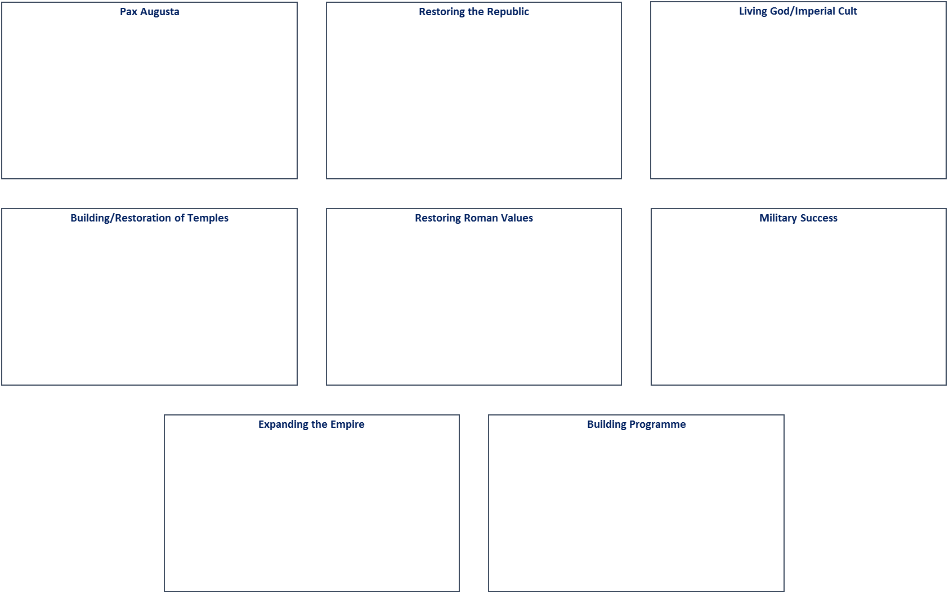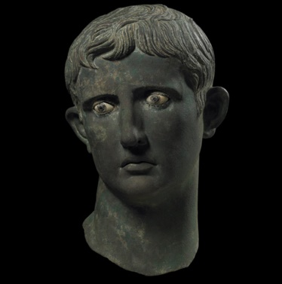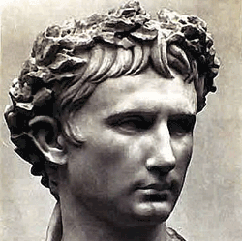

**Questions**

1. **How would you describe the nature of the *Res Gestae Divi Augusti?* (What type of source is it?)**
2. **What do you think Augustus was hoping to achieve by producing it?**
3. **What sense of the *Res Gestae* do you get from its introduction (the first three lines of the extract)**
4. **Can you think of any events or elements of Augustus’ rule that you have studied which are not mentioned in the *Res Gestae*? Try to think of at least two points and for each explain why you think Augustus did not include it in his official account.**
5. **Of the other ancient sources you have read, which author gives the most *similar* account or perspective of Augustus’ rule as the *Res Gestae* (explain your answer with examples)?**
6. **Of the other ancient sources you have read, which author gives the most *dissimilar* account or perspective of Augustus’ rule as the *Res Gestae* (explain your answer with examples)?**
7. **How useful is the *Res Gestae* to a historian trying to understand the rule of Augustus, 31 BC – AD 14?**