**June 2017 – Paper 2 Mark Scheme – Data Response**

**Q. 05 – 2 Marker**

* 2.88/6 = 0.48% to 2d.p

**Q. 06 – 4 Marker**

* Define economic growth (trend growth – stable around 2.25%) and how it is measured (Real GDP – adjusted for inflation)
* UK between 1 and 3% but Japan between 4.5 and -0.5. So range of GDP percentages is smaller than Japan.
* Japan also in negative growth in 2 periods when they were in a recession whereas UK not so as GDP is negative.
* Therefore since GDP measures economic growth, it can be seen that the UK had less volatile GDP than Japan in the same period.

**Q. 07- 9 Marker**

* Define deflation and concept of productivity
* Diagram of LRAS shifting to the right with AD. Emphasis the Price Level falling suggesting deflationary pressures.
* Productivity – new technology = lowers costs of production for firms = more competitive = ability to lower prices
* Productivity – better education of workers = more produced = greater supply of goods and services

**Q. 08- 25 Marker**

INTRO

* Define monetary policy (interest rates, QE and exchange rates)
* Context of Japan (‘lost decade’) and UK (recent scare because of financial crash although now at 2.8% because of BREXIT and falling pound
* Route through essay: monetary policy is one measure but fiscal policy also affects demand side. Supply side has an effect too.

MAIN

**Point 1: Monetary policy is the most effective through IR’s**

As: Interest rates and transmission mechanism (explain it).

Ae: ‘Liquidity trap’ (like UK) with very low interest rates, credibility of central bank (UK and MPC)?

**Point 2: Monetary policy is the most effective through QE and exchange rates**

As: QE as well. Strengthen pound by buying up sterling from FOREX?

Ae: Failures of QE (inflate assets not day to day spending)? Foreign reserves only have so much to buy sterling? Current BREXIT position would also me

**Point 3: Fiscal Policy is a better alternative**

As: Impact on AD by increasing budget deficit (increase G and cut taxes like VAT) to stimulate C. (AD curve to right). Multiplier etc.

Ae: Government deficit and debt (become like Greece?). Japan and UK already has problems. In long run, may increase LRAS which could worsen problems if excess capacity?

CONC

Position – best policy to combat deflation or not?

Support – explain why the strongest arguments is strong

Defend – explain why the weakest arguments are weak

EXAMINERS REPORT

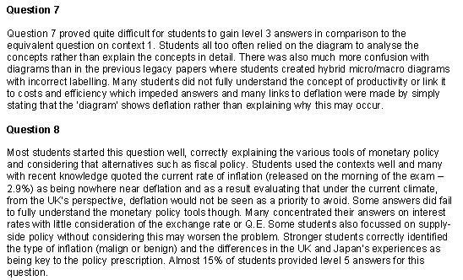

**June 2017 – Paper 2 Mark Scheme – Extended Essay**

**Q. 09- 15 Marks**

* Define – natural rate of unemployment (frictional and structural) and Government Policies (supply side policies)
* Point 1: Supply side policies – interventionist: education and training (what? Be specific!) (LRPC shifts to the left to improve occupational immobility reduce structural unemployment. Areas of South West, North East etc. that have been deindustrialised
* Point 2: Supply side policies – free market: reducing benefits (JSA) to prevent frictional unemployment being too high and shifting LRPC to the left.
* Point 3: Supply side policies – minimum wage: reduce frictional unemployment. Explain where we are at the moment and how this would help (supply and demand diagram)

Other points you could have made instead of those above – lower taxation, improve geographical mobility, better childcare assistance etc.

**Q. 10- 25 Marks**

INTRO

* Define – macroeconomic objectives and unemployment (voluntary and involuntary)
* Context – unemployment has been falling in the UK to lowest levels recently. Inflation is also at upper levels? Persistent current account deficit too.
* Route through the essay – inevitable in terms of inflation and balnce of payments but economic growth should increase in long run and Government policy in place to sort out trade offs so perhaps not inevitable?

MAIN BODY

Point 1: Falling Unemployment and increased Inflation and therefore is inevitable

As: Involuntary unemployment falls and SRPC means inflation increased. Wage spiral could occur (LRPC).

Ae: Depends on the unemployment? LRPC and reducing natural rate of unemployment means no trade off. Also depends on output gaps?

Point 2: Falling unemployment increase in current account deficit (reduction in the surplus)

As: Unemployment means more jobs and disposable income rises so imports are sucked in which leads to a rising current account deficit.

Ae: Elasticities of imports plus other aspects like exchange rates. Also could lead to econ growth (accelerator effect on investment shifts LRAS)

Point 3: Government policy prevents these trade-offs and therefore it isn’t inevitable

As: Monetary policy and credibility of Bank of England

Ae: Credibility poor plus ‘liquidity trap’

CONC

Position

Support it

Defend it

**EXAMINERS REPORT**

