**PAPER 1, 2 and 3: 25 Markers**

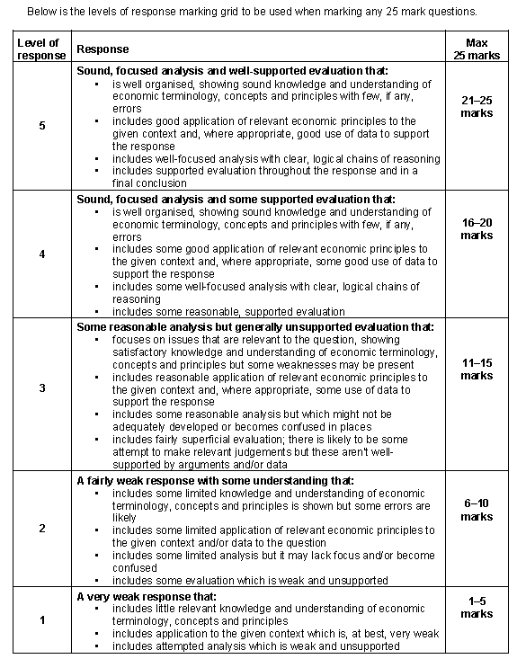

|  |  |
| --- | --- |
| **MICRO QUESTION EXAMINERS REPORT** | **MACRO QUESTION EXAMINERS REPORT** |

|  |  |
| --- | --- |
| **INTRO**   1. **Define** taxation and market failures 2. **Context** – obesity crisis in UK, sugar tax 3. **Route through essay** – tax could work, but role of market and also other options (subsidies, banning advertising for children etc.)   **MAIN BODY**  **Point 1: Remove intervention to allow the market to operate more freely is the most effective Government Policy**   * As – Market Success Arguments: Consumers have good info (especially with the growth of internet etc) and are will change their habits away from unhealthy food and drink as they understand more the long term costs of consumption (so demand curve shifts to the left). Substitute of healthier eating then takes place (demand curve to the right) and price mechanism shifts resources from being used for unhealthy to healthy foods. See Jamie Oliver and others for impact private sector can have. Also any Government policy is ‘nannying’; who are the Government to affect lifestyles? * Ae – Market Failure Arguments: This will arguably take too long and is guaranteed as unhealthy food is a demerit good (MPB is greater than MSB) and the substitute of healthy foods is a merit good (MPB less than MSB)   **Point 2: Imposing a tax is the most effective government policy**   * As – Government Intervention: Sugar tax? Indirect tax shifts the MPC to the left, thus reaching optimal consumption of unhealthy food. Also raises revenue to help fund education and healthcare for those suffering from negative externalities. * Ae – Government Failure: Problems with a tax - How much should it be without causing unemployment in this industry; not guaranteed that Government has perfect information. Tax could lead to inequality as lower socio-economic groups more likely to spend higher proportion of income on unhealthy foods (quick, easy, substitutes too expensive). Obesity not just caused by sugar? Elasticity of demand might affect the decrease?   **Point 3: Alternative policy of subsidising healthy alternatives?**   * As – Government Intervention: MPC curve shifts to the right and increases production of healthier foods which lowers prices and ensures greater consumption; makes it affordable for lower income groups. * Ae – Government Failure: Opportunity cost to Government (deficit and national debt). How do they decide what is healthy? Moral hazard to firms leads to overreliance and inefficiency? Elasticity of demand might affect the increase?   **CONCLUSION**   1. State a position – is a tax the most effective government policy? 2. Support that position by picking the arguments above which carry more weight and explain why 3. Defend that position – what are the weak arguments here? Why do they not carry that much weight?   **EXAM BOARD ADVICE** | **INTRO**   1. Define balance of payments and current account 2. Context – UK current account prolonged deficit and why important to macroeconomy? 3. Route through essay – demand (expenditure reducing and switching) and supply side solutions (productivity)   **MAIN BODY**  **Point 1: Expenditure Reducing (Deflation) – Short Term (demand side)**   * As: Raising interest rates and running a budget surplus (austerity) means less import buying * Ae: Immediate unemployment and poverty issues potentially? UK growth at lowest this last quarter and inflation dropping.   **Point 2: Expenditure Switching (Devaluation and Direct Controls) – Short Term (demand side)**   * As: Devaluation (through lowering interest rates or selling pound) and Protectionism (Tariffs and Subsidies etc.) * Ae: Devaluation (J-curve effect because elasticities are lower in the SR than the LR. Also liquidity trap and BofE independent) and Protectionism (Tariff diagram and subsidies issues – crowding out etc).   **Point 3: Supply Side Policies to improve competitiveness (supply side)**   * As: LRAS shifts to the right and creates lower prices = UK exports become cheaper and this causes BofP to reduce * Ae: Long time to come to fruition, no guarantee that this will lead to great exports (Inelastic demand?). Opportunity cost to Government of supply side policies?   **CONCLUSION**   1. State a position – position could be ‘the best policy’ or a ‘combination’…it’s pretty open as long as you link it to the UK’s balance of payments 2. Support that position by picking the arguments above which carry more weight and explain why 3. Defend that position – what are the weak arguments here? Why do they not carry that much weight?   **EXAM BOARD ADVICE** |