PAST PAPER MARK SCHEMES

PAST PAPER 1

(01) 80 to 170 (or around those figures) means: 170-80 / 80 = 112.5% [a range of 5% either side would get you the 2 marks)

(03) Negative externality diagram in production needed here. Mention the ‘tragedy of the commons’ and see if you can apply it to the extracts (so the fact no one owns the rights to the atmosphere mean oil burning producers do not care for it and therefore do not consider it part of their private costs. Therefore there is overproduction.). Equally, you could refer to fishing stocks with the rapid depletion of a natural resource.
Level | Mark | Notes
3 | 7-9 marks | Correct diagram and explanation with correct application will get you into the top band (7-9).  Mention the effect on the failures of both pollution AND rapid depletion of natural resource
2 | 4-6 marks | No diagram (or poorly explained)  Mentions only the effect on one of the failures (either pollution or depletion, not both)
1 | 0-3 marks | Understands the problem with property rights but no diagram and only deals with either pollution or depletion

(04) Three points here:
DISCLAIMER: There is not perfect way to answer an essay question; it could be that you have another way of answering it. This is just a template of a what I would consider a good answer to be but there are several ways to answer this question.

Point 1: Markets do succeed and therefore there is no need for Government intervention
As: Market success – rise in price of oil means there is a search for alternatives = means even poor can have energy. Also burning of bio fuels less of an issue for climate change than oil. Bio fuel also allows developing nations to trade more and grow out of poverty
Ae: Market failure – global inequality and poverty (30 million into poverty) , also the increase in price is due to large demand from emerging economies and not due to a fall in supply. This is creating negative externalities of pollution and climate change.

Point 2: Government’s shouldn’t intervene because rich countries have been altering the price mechanism
AS: Government failure - This is the reason for the poverty, not market failure above. Draw subsidy diagram to show how firms have an incentive to switch to bio fuel. Talk about wheat being a ‘composite good’ and Government accelerating the natural flow of the market for the worse. Also Oxfam claim that bio fuels do not help with bio fuels
Ae: Government success – climate change is a large issue as well; subsidies to switch to bio fuel production are more of a sustainable way for the future and preventing the warming of the planet.

Point 3: Government’s should intervene but through BENEFITS TO THE GLOBAL POOR
As: Government intervention – richer countries through international aid to provide food support; help those most in need?
Ae: Government failure – opportunity cost? Unintended effects (dependency on aid etc.)

PAST PAPER 2

(01) Total revenue = £1.3 million. Divide by 920,000 to get the AR (average revenue) = £1.41. To earn normal profit, the companies AC (average cost) must equal AR. Therefore the answer is £1.41. Any less than this and the company would need to shut down in the long run.

(03) Demand and supply diagram showing an initial equilibrium with title of Newspapers. Demand fall (sales have dropped = ExE L7) and Supply falls (cost of production increasing = Ex E L7). So Demand shifts to the left and supply shifts to the left. Make a note of the reduction in quantity on the X-axis….it should have fallen from both the demand and supply curve shifts.
Level | Mark | Notes
3 | 7-9 marks | Correct diagram and explanation with correct application will get you into the top band (7-9).  Mention the effect of both a DEMAND and SUPPLY affect on quantity
2 | 4-6 marks | Diagram (but labels missing and quantity x-axis not explicitly referred to). Might be that answer refers to the price axis instead (bottom of the band)  Mentions only the effect of either DEMAND or SUPPLY (or the explanations for both are superficial)
1 | 0-3 marks | No diagram (or badly drawn)  Refers only demand or supply  Moves the curves in the wrong direction

(04) Three points again (although you can still get good marks by just going for the first two)
DISCLAIMER: There is not perfect way to answer an essay question; it could be that you have another way of answering it. This is just a template of a what I would consider a good answer to be but there are several ways to answer this question.

Point 1: Government should not subsidise as markets work better and more efficiently than interference from the Government
As: Market Success – newspapers have coped with the falling sales by accessing other revenue streams. Still a lot of competition in the market currently. Agreed that newspapers are an important source but still plenty of choice plus information can be gained from TV and other news outlets.
Ae: Market failure – Merit Good argument (draw diagram to show how consumers are unwilling to value newspaper consumption as high as society wants it to. There are positive externalities of education and information which are currently not accurately priced by the market.

Point 2: Government should subsidise newspapers and online news
As: Government intervention - Draw merit good diagram and then the effect of a subsidy which would lead to a lowering of the price (MSC shifts to the right) and thus more newspapers are bought (along the MPB line). Cheaper news leads to more consumption.
Ae: Government Failure - Opportunity cost for Government of spending this money? How much should it subsidise by – Governments have imperfect information just like consumers and firms in the market; hard to get the level right? Could lead to distortions in the market by making substitute news sources (TV etc) go out of business = less choice for the consumer?

Point 3: Government should not subsidise newspapers but should pursue an alternative policy of banning the charging of newspapers. Almost like providing a maximum price of zero
As: Government intervention – quick and easy to implement; newspapers still able to earn money from considerable advertising revenues. Price of the newspaper is not their only revenue stream! Enables people on lower incomes to access news and very helpful for poorer kids in education who might not have had the access.
Ae: Government failure – bit of a draconian measure! Precedent with other markets set? Also could it lead to less competition in our news sources as some newspapers would have to quit. Culture of paying for news would develop, leading to ‘free rider’ issues and causing supply to approach zero as firms (because of Government intervention) are unable to exclude consumers. Arguably we already live in a ‘managed democracy’ where 80% of our Media is owned by 3 very rich and powerful men (Rupert Murdoch – Sun, Times; Paul Desmond – Express, Star; and Viscount Rothmere – Mail group). Would this policy give them more power? (unintended effect?)

PAST PAPER 3

(01) 473 to 1328 so 1328-473/473 *100 = 180%

(02) Draw a merit good diagram and explain how education could be a merit good.
Level | Mark | Notes
3 | 7-9 marks | Correct diagram and explanation with correct application will get you into the top band (7-9).  Explanation is clear and refers to the case study AND diagram
2 | 4-6 marks | Diagram (but labels missing and quantity x-axis not explicitly referred to).  Explanation is basic at the bottom of the range
1 | 0-3 marks | No diagram (or incorrect diagram)  Explanation is incorrect or poorly explained

(03)

AQA MARK SCHEME  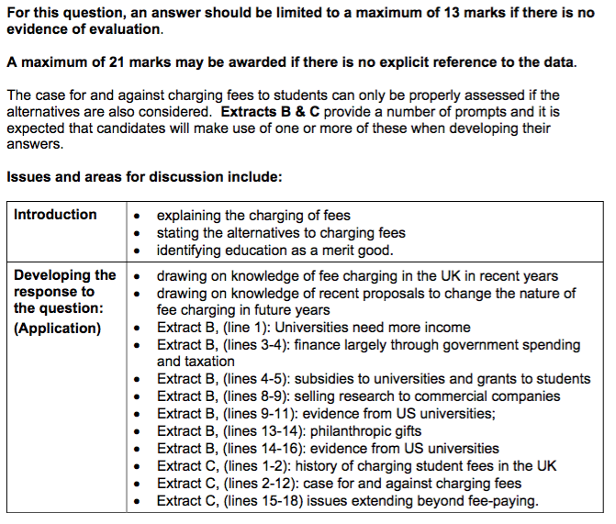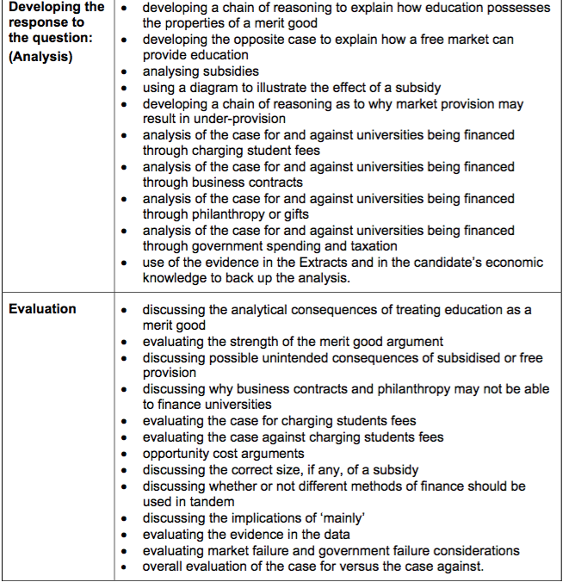 | OLLY’s ESSAY  P1: The Government should MAINLY finance universities through allowing universities to charge fees to students  As: Market success – allowing a price to be set is important to achieve allocative (universities need greater income to provide quality education) and productive efficiency (greater chance of competition for Universities leading to efficiency gains). Private sector will provide best education as education is valued by consumers and therefore profit can be made. Despite tuition fees, student numbers are still very high.  Ae: Inequality and poverty market failure? Also argument of education being a merit good (draw diagram of consumption externality); positive externality of wider benefits to economy which individual does not take into account. Education is undervalued therefore underproduction.  P2: Universities should not mainly finance themselves by charging but continue with subsidies and even remove tuition fees completely  As: Government intervention – making education free at point of use solves merit good issue (draw diagram showing MSC shifting to the right and making education cheaper). Encourage opportunity from lower economic groups and reduce income and wealth inequality.  Ae: Government failure – opportunity cost of subsidies? Especially given UK National Debt at record highs and day to day budget is still in deficit. Disincentive effect for students as ‘free good’ created potentially. Also Universities can get more money from other sources of funding such as charity etc.

PAST PAPER 4

(01) Quantity: 1,000,000-990,000 = 10,000 drop. -10000 / 1,000,000 *100 = -1%
PED = %change in Qd / % change P.
= -1 / 10 = -0.1 (inelastic)

(02) Smartphones have increased in sales because of a change in demand (demand curve shifts to the right) and cheaper prices (due to supply curve to the right down to lower costs of production – economies of scale, lower production costs, increased competition etc.)
Level | Mark | Notes
3 | 7-9 marks | Correct diagram and explanation with correct application will get you into the top band (7-9).  Explanation is clear and refers to two factors (both supply and demand)
2 | 4-6 marks | Diagram (but labels missing and quantity x-axis not explicitly referred to – sales of smartphones).  Explanation is basic at the bottom of the range – perhaps only one supply or demand factor is mentioned
1 | 0-3 marks | No diagram (or incorrect diagram)  Explanation is incorrect or poorly explained – theory is badly used or not at all.

(03)
AQA MARK SCHEME  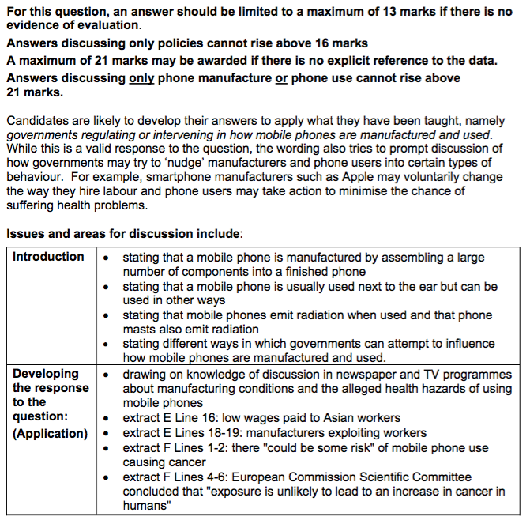  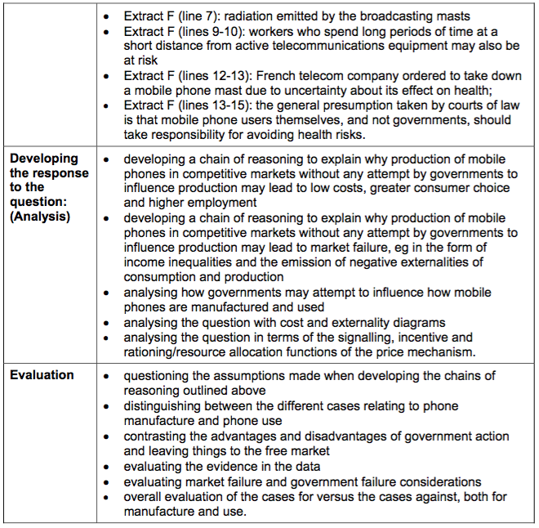 | ODS ESSAY  P1: Governments should leave the production and use of mobile phones purely to the free market.  As – Market Success: clear evidence that the market is responding well to changes in demand and supply and more of our scarce resources are moving into the market thanks to changes in the price mechanism (allocative efficiency). Lower costs lead to greater demand amongst all consumers. Greater demand for the product is leading to more competition within the market as firms scrabble to produce more mobile phones for consumers (allocative efficiency) creating greater consumer choice. Increased competition leading to productive efficiency and so even those on lower incomes able to afford phones; this will increase productivity overall in the UK economy = strong growth for UK in the future. Also creating job opportunities in less economically developed countries.  Ae – Market Failure: negative externalities diagram showing over production due to health issues not being taken into account (see extract). Also global inequality and poverty; causing sweatshops and general exploitation of a vulnerable group of people in third world countries.  P2: Therefore Governments should intervene in the production of mobile phones by adopting international regulations to prevent exploitation of foreign workers  As – Government intervention: to combat market failures above through countries agreeing on international labour regulations. Move the MPC curve to the left towards the MSC. Diagram?  Ae – Government Failure: Higher costs for mobile phones hurt lower incomes in this UK. Will global regulations really work? Do foreign workers benefit from manufacturing mobile phones?  P3: Governments should also intervene in people’s use of mobile phones by taxing those with mobile phones.  As – Government intervention: refer to consumption externalities (negative) and MPC curve shifting to the right. Prevent the over use of mobile phones and masts which consumers do not take into account when demanding mobile phones – consumers putting too much value on it. Taxation easy to implement. Also tax revenue will be high = spend on health complications in the future caused by mobile phones.  Ae – Government failure: how much should the tax be to ‘internalise the externality’? Governments have imperfect information. Refer to not grasping the opportunity of mobile phones and productivity arguments.
PAST PAPER 5

(01)
Average cost = 0.45
Average revenue = 3,000,000/2,000,000 = £1.5
Supernormal profit is difference between AR and AC so £1.05

(03) Draw a supply and demand diagram with the supply curve shifting to the right, causing a lower price and increase in demand along the line.
Level | Mark | Notes
3 | 7-9 marks | Correct diagram and explanation with correct application will get you into the top band (7-9).  Explanation is clear and uses disequilibrium analysis to explain how the equilibrium changes as a result of the price change.
2 | 4-6 marks | Diagram (but labels missing and only an implicit link as to how it will affect the market)  Explanation is basic at the bottom of the range – very little reference to the diagram for example?
1 | 0-3 marks | No diagram (or incorrect diagram)  Explanation is incorrect or poorly explained – theory is badly used or not at all.

(04)

OLLY’s ATTEMPT AT ESSAY

P1: No intervention is needed in the markets for food and drink because markets are able to sort out the issue of obesity
As: Firms respond to price signals which are reflected in changes in the tastes of products. Over the years, there has been a movement away from sugary drinks to sugar free. Firms in markets therefore have moved production from sugar to non sugar and therefore reduced the intake of sugar without the need for Government intervention. Equally, as it has become more fashionable to attend the gym, more consumers are opting to purchase gym memberships to keep themselves healthy.
Ae: Market failure – fast foods and sugary drinks are a demerit good (draw diagram). Therefore they are overproduced by the market, CAUSING the obesity problems. Equally, positive healthcare is underprovided by the market (merit good diagram).

P2: Therefore perhaps intervention is needed in the food and drink market to alter the price mechanism. A sugar tax would be a useful attempt to prevent the overconsumption and production of certain food and drinks. Equally a subsidy for gym memberships or fruit & vegetables might be a useful way to give more access to those on lower incomes.
As: Government success - Arguments for the sugar tax (refer to demerit diagram) plus support for subsidies (diagram as well)
Ae: Government failures - Arguments against the sugar tax and subsidies

P3: An alternative intervention from the Government might be more direct controls, perhaps through greater regulation
As: Ban advertising of sugary drinks and fast good – advantages of this?
Ae: Government failures?

