PAST PAPER 1

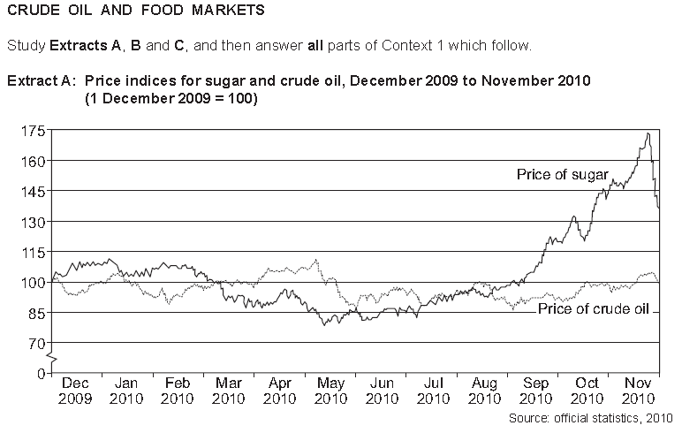

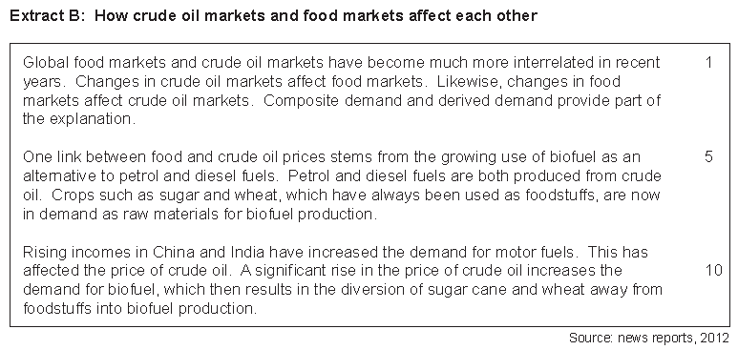

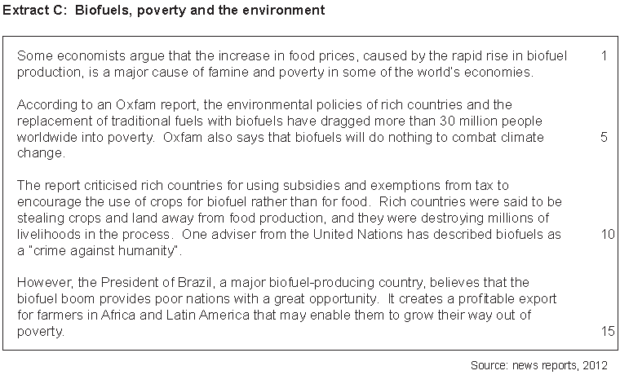

**01** Calculate the percentage increase in the price of sugar from May 2010 to November 2010 **[2 marks]**

**02** Using **Extract A**, identify **two** significant points of comparison between the price indices for sugar and crude oil over the period shown. **[4 marks]**

**03** With the help of a diagram, explain how the absence of property rights can worsen the environmental market failures of both pollution and the rapid depletion of natural resources. ***[9 marks].***

**04** ‘Some economists argue that the increase in food prices, caused by the rapid rise in biofuel production, is a major cause of famine and poverty in some of the world’s economies’ (**Extract C**, lines 1–2). Using the data and your economic knowledge, evaluate the case **for** and **against** governments intervening to prevent agricultural products from being used to produce biofuel. **[25 marks]**

PAST PAPER 2

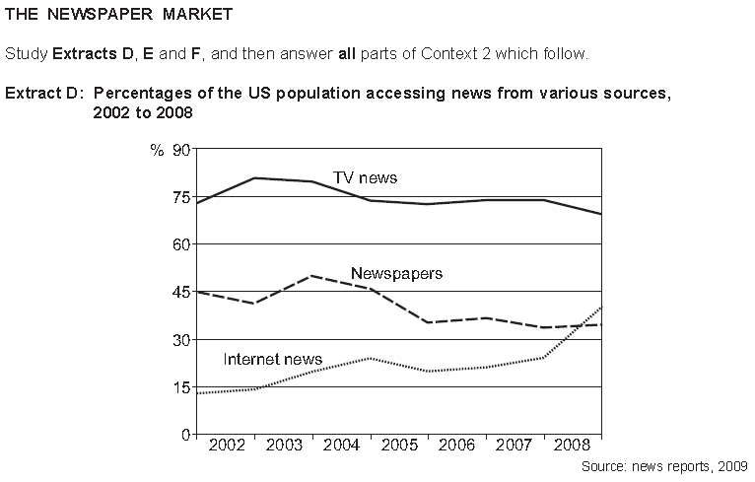

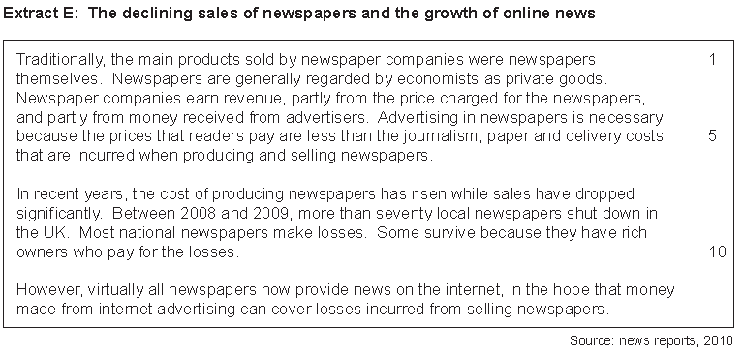

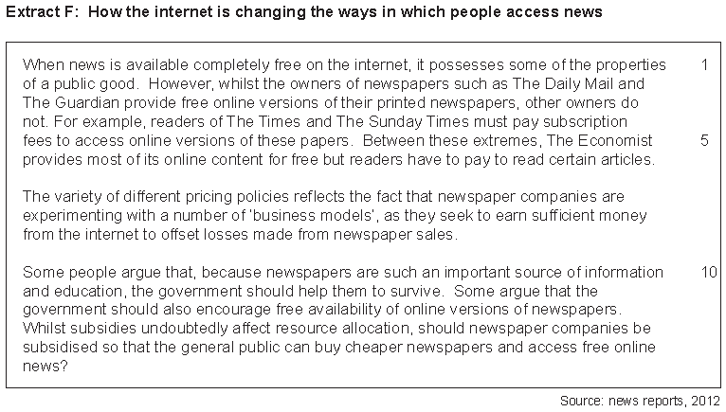

**01** In Extract E (line 8-9), it states that “Between 2008 and 2009, more than seventy local newspapers shut down in the UK.” If a newspaper has a revenue of £1.3 million in a year and sells 920,000 copies, what would the minimum average cost need to be for this firm to be earning normal profit and therefore not need to shut down? **[2 marks]**

**03** Using Extract D, identify two significant points of comparison between the various sources of news accessed over the period shown. **[4 marks]**

**05** Using a diagram, explain why the quantity of newspapers sold by most newspaper companies has fallen. **[9 marks]**

**06** ‘Some people argue that, because newspapers are such an important source of information and education, the government should help them to survive’ (Extract F, lines 10 –11). Using the data and your economic knowledge, evaluate the case for and against the government subsidising newspapers and online news. **[25 marks]**

PAST PAPER 3

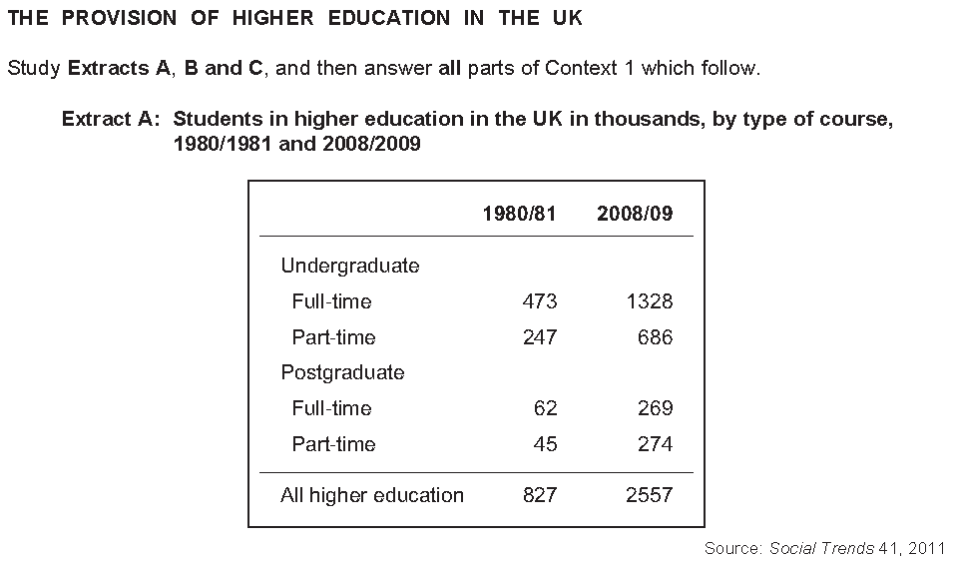

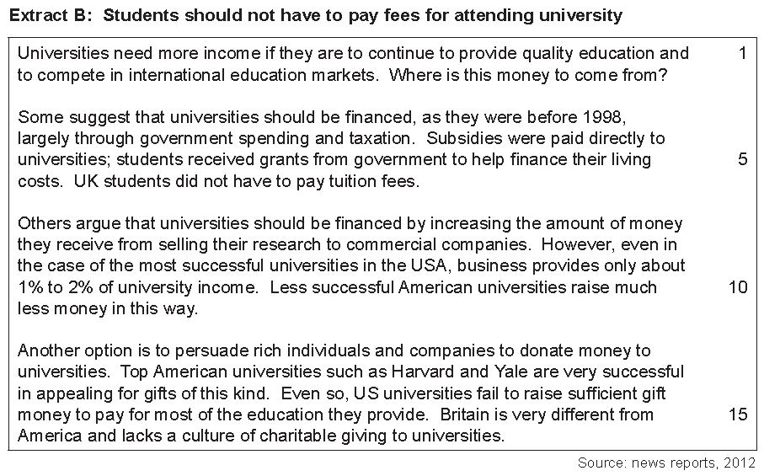

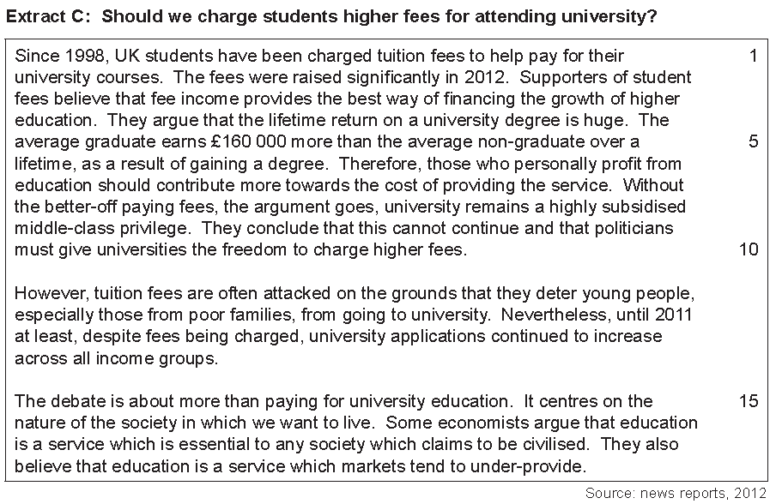

**02** Using Extract A, calculate the percentage increase in Full-time Undergraduates from 1980/81 to 2008/09

**(2 marks)**

**03** Define the term subsidies and using Extract A, identify two significant points of comparison between the number of students on full-time courses and those on part-time courses over the period shown. **(4 marks)**

**05** Using a diagram, explain the view of education as a ‘…service which markets tend to under-provided’ (Extract C, line 18)

**(9 marks)**

**06** Using the data and your own economic knowledge, assess the case for financing universities mainly through charging fees to their students. **(25 marks)**

PAST PAPER 4

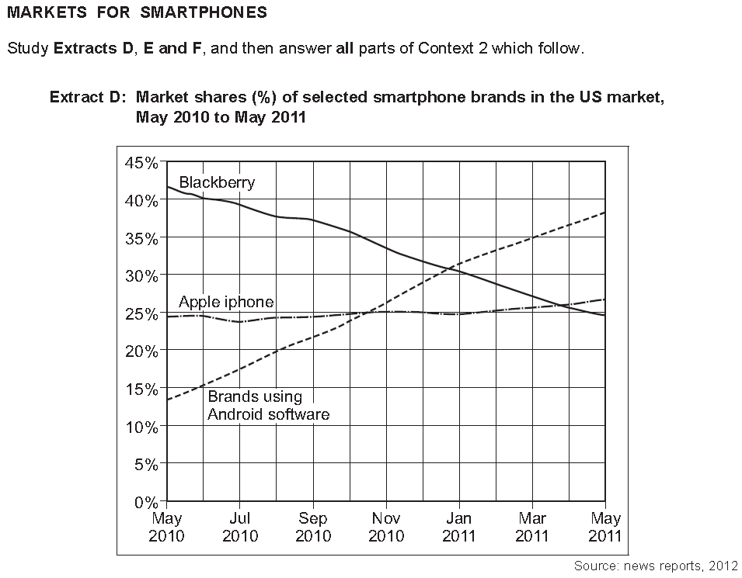

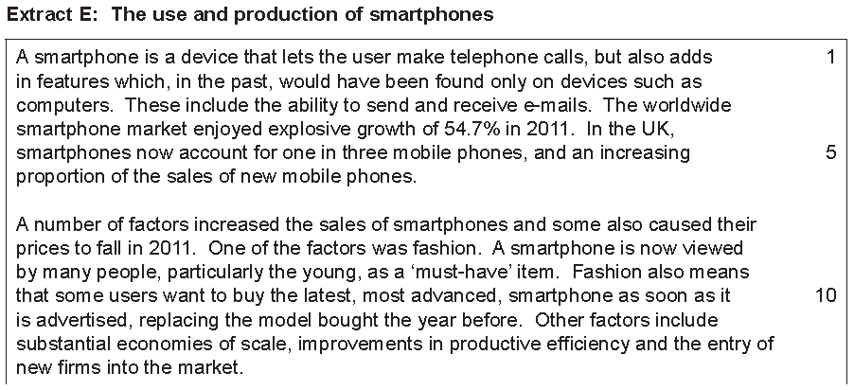

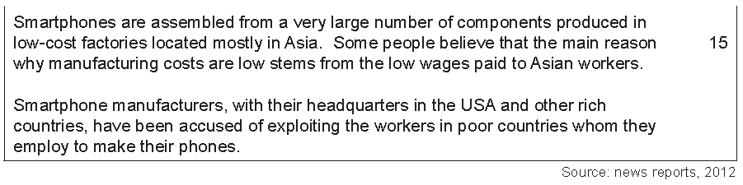

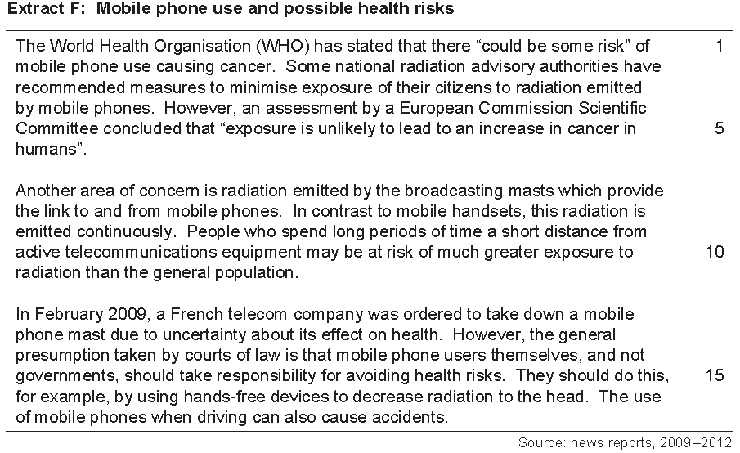

**01** Extract E (line 8-9) suggests that “A smartphone is now viewed by many people, particularly the young, as a ‘must-have’ item.” Calculate the price elasticity of demand for smartphones if a collective price rise of 10% leads to a reduction in demand of 1,000,000 sales to 990,000 to 2 decimal places. **(2 marks)**

**02** Extract E (lines 17-19) suggest that “Smartphone manufacturers, with their headquarters in the USA and other rich countries, have been accused of exploiting the workers in poor countries whom they employ to make their phones”. With the help of a supply and demand diagram, explain what the effect might be on the supply and demand of labour if one of these countries decided to implement a minimum wage.  **(4 marks)**

**03** With the help of the information in Extract E, explain two possible reasons for the change in the sales of smartphones in 2011. **(9 marks)**

**04** Using the information in the data and your own economic knowledge, evaluate the economic case for and against governments attempting to influence how mobile phones are manufactured and used. **(25 marks)**

PAST PAPER 5

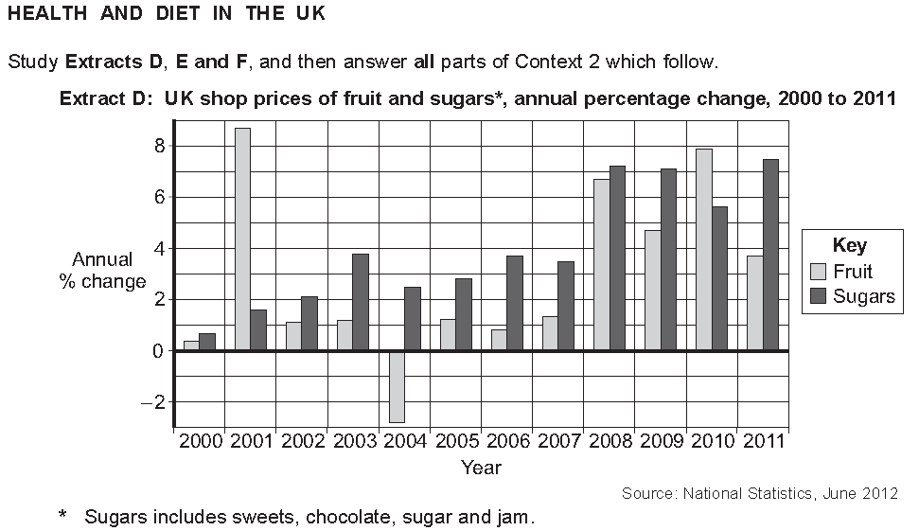

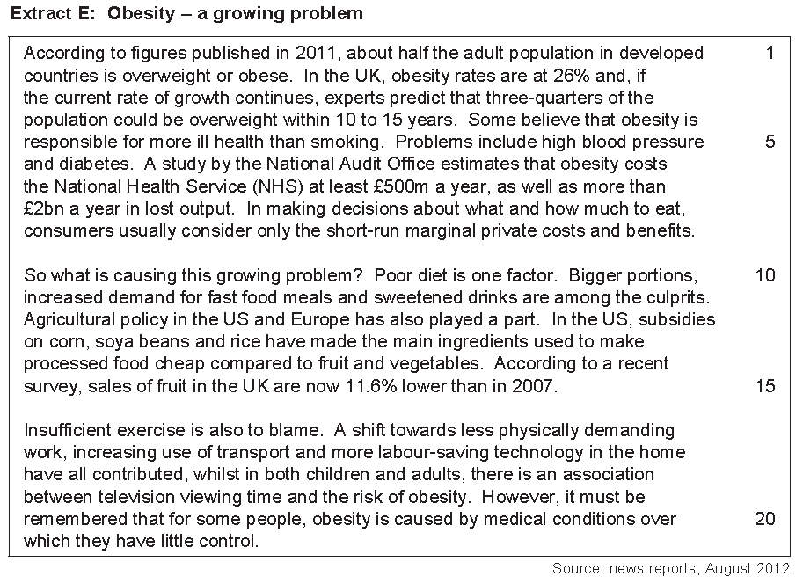

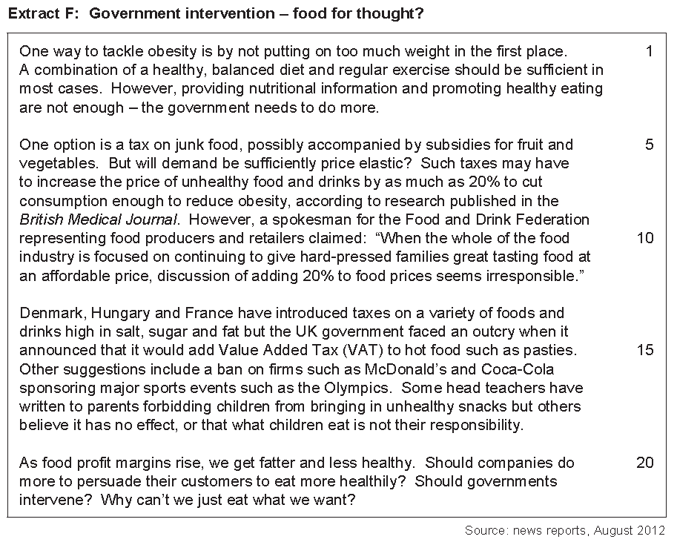

**01** Extract F (line 20) states “As food profit margins rise, we get fatter and less healthy.” If a large soft drinks manufacturer produces and sells 2 million soft drinks in one year. Calculate the super normal profit for this drinks company if average costs are £0.45 at this production level and total revenue is £3,000,000 for one year.

**(2 marks)**

**02** Using Extract D, identify two significant points of comparison, over the period shown, between the annual percentage changes in the shop prices of fruit and sugars in the UK.  **(4 marks)**

**03** Extract E (lines 12 to 14) states that in ‘the US, subsidies on corn, soya beans and rice have made the main ingredients used to make processed food cheap compared to fruit and vegetables’. Explain how subsidies on ingredients such as corn, soya beans and rice will affect the market for processed food. **(9 marks)**

**04** Extract F (lines 3 and 4) states that ‘providing nutritional information and promoting healthy eating are not enough – the government needs to do more’. Using the data and your economic knowledge, assess the case for and against government intervention in the markets for food and drink to encourage a healthy diet. **(25 marks)**

PAST PAPER 6

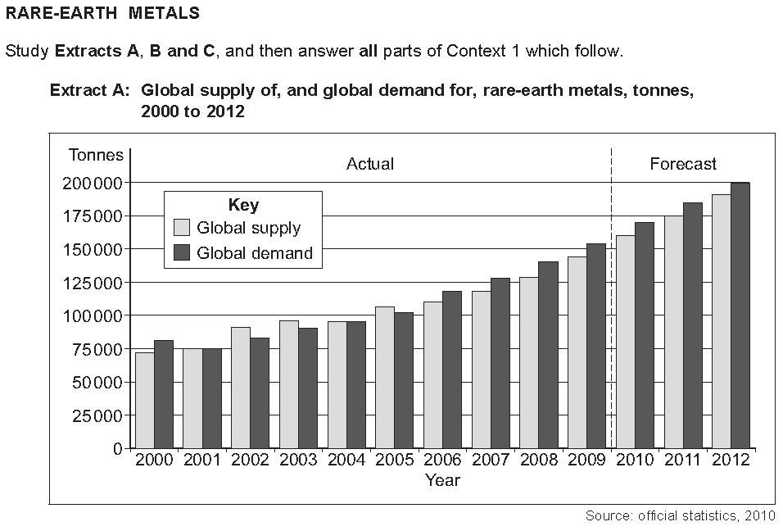

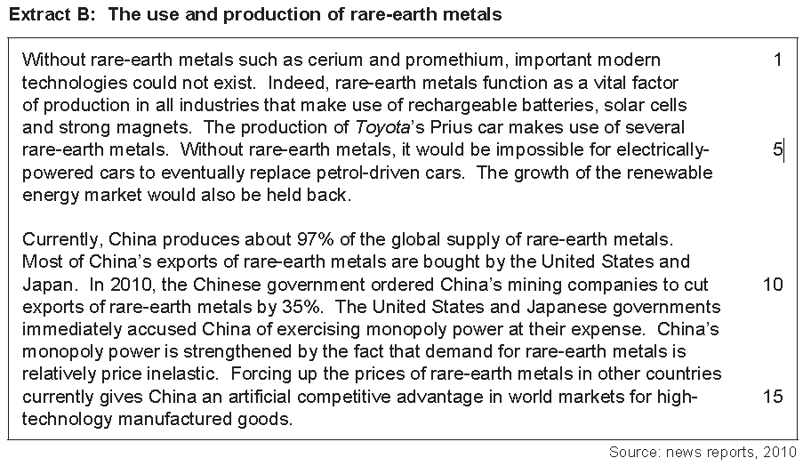

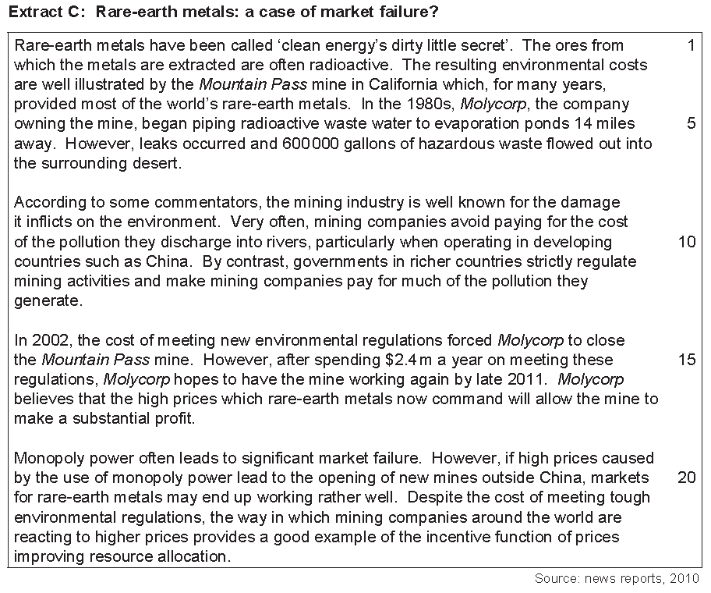

**01** Calculate the price elasticity of supply for the production of rare metals if the price rose by 30% and the subsequent production went from 200,000 tonnes to 230,000 tonnes. **(2 marks)**

**02** Extract B states that “China produces about 97% of the global supply of rare-earth metals.” Draw an average cost curve to demonstrate how increased production might mean China benefits from further economies of scale. **(4 marks)**

**03** With the help of an appropriate diagram and the information in Extract B, explain how China can increase the prices of rare-earth metals by using monopoly power. **(9 marks)**

**04** ‘According to some commentators, the mining industry is well known for the damage it inflicts on the environment’ (Extract C, lines 8–9). Using the data and your economic knowledge, evaluate the view that mining activities should be left to market forces with minimum intervention by governments. **(25 marks)**

PAST PAPER 7

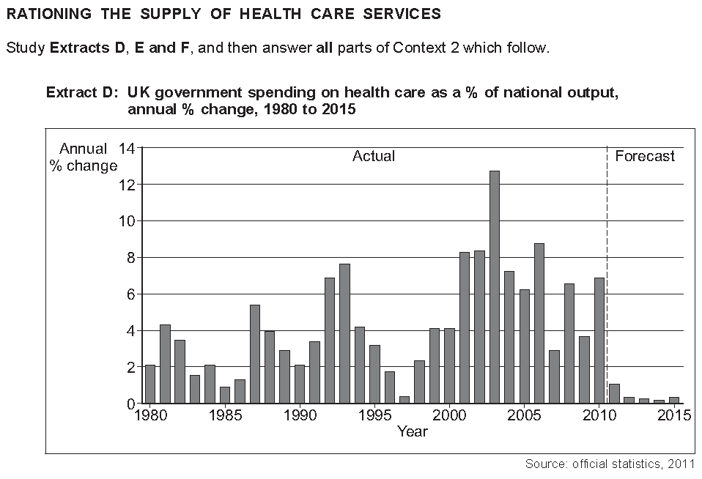

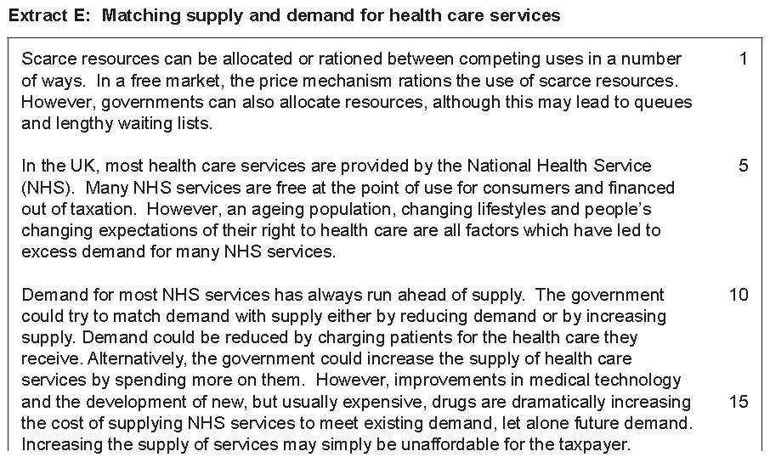

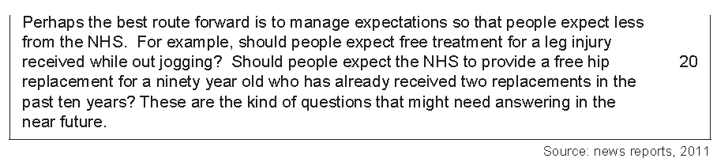

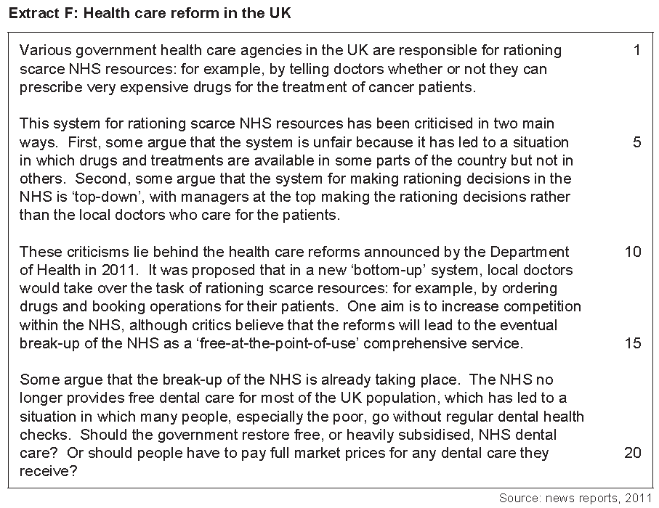

**01** Calculate the possible price elasticity of supply for healthcare services in the United Kingdom if prices increased by 40% and supply increased by 20%. **(2 marks)**

**02** Using Extract D, identify two significant features of changes in UK government spending on health care over the period shown. **(4 marks)**

**03** Using a diagram to show how the NHS is free at the point of use with Government subsidies and why this could cause excess demand **(9 marks)**

**04** ‘Scarce resources can be allocated or rationed between competing uses in a number of ways’ (Extract E, lines 1–2). Using the data and your economic knowledge, evaluate the case for and the case against the NHS charging for its services. **(25 marks)**

PAST PAPER 8

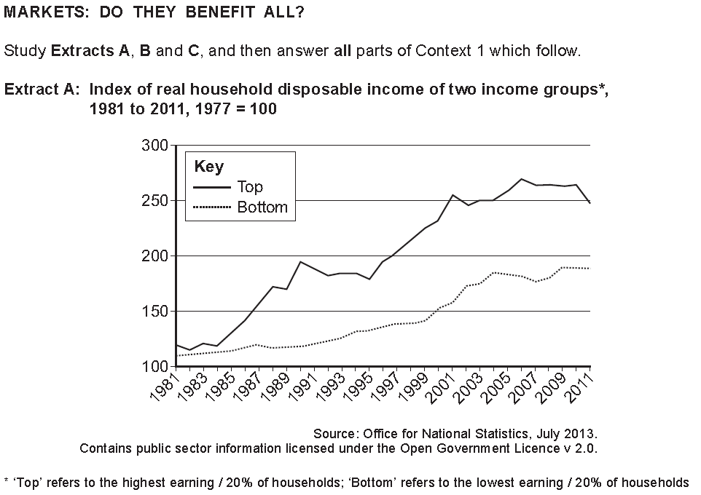

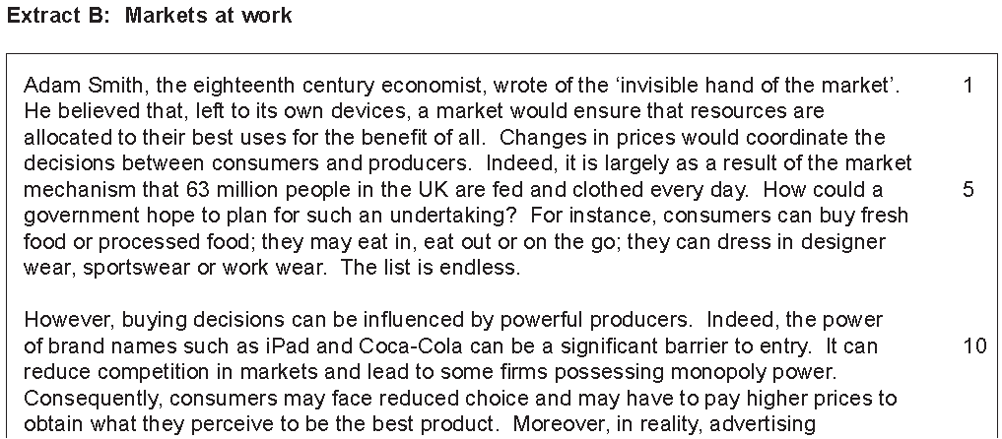

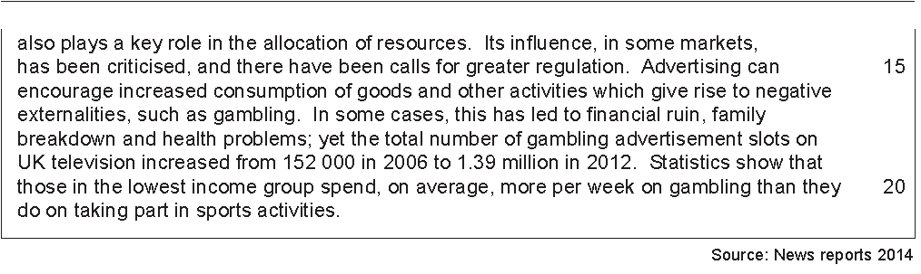

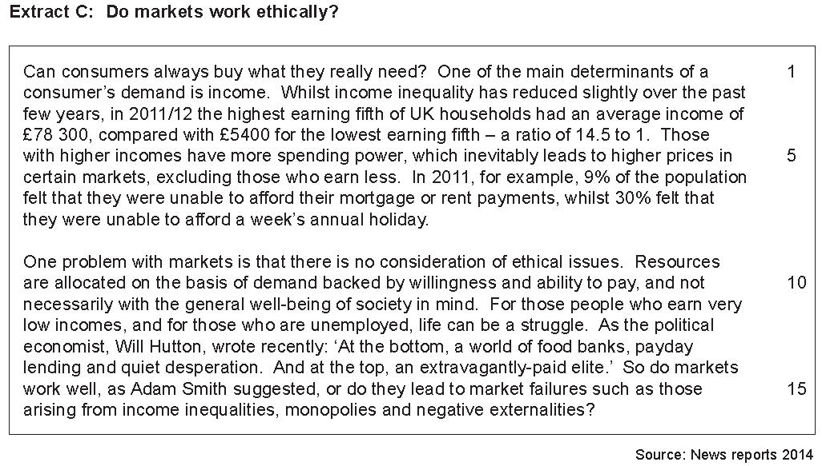

**01**  Using Extract A, calculate the percentage increase in the difference between the top and bottom income groups from the beginning of 1981 to the end of 2011 **[2 marks]**

**02**  Define income inequality and then using Extract A, identify two significant points of comparison between the changes in real household disposable income for the two income groups over the period shown **[4 marks]**

**03**  Extract B (lines 3 and 4) states that: ‘Changes in prices would coordinate the decisions between consumers and producers.’ Explain how changes in prices allocate scarce resources in a market economy. **[9 marks]**

**04**  Extract C (line 9) states that: ‘One problem with markets is that there is no consideration of ethical issues.’ Using the data and your knowledge of economics, evaluate the view that governments should intervene to correct market failures such as those arising from income inequality, monopolies and negative externalities. **[25 marks]**

PAST PAPER 9

**The Housing Market**

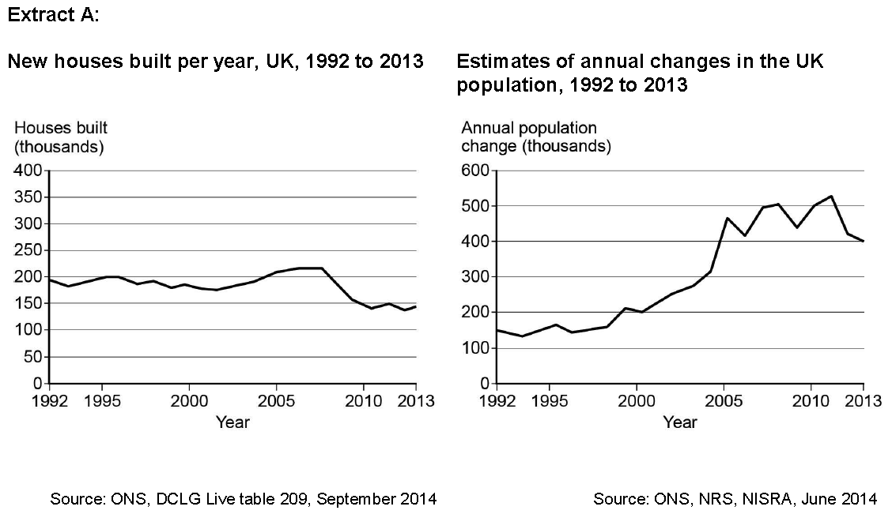

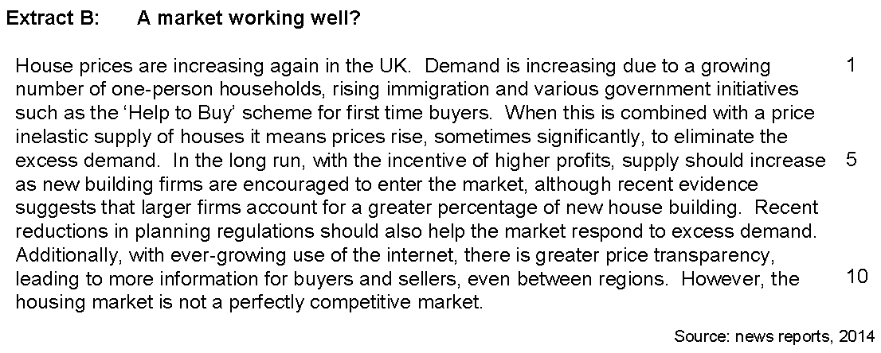

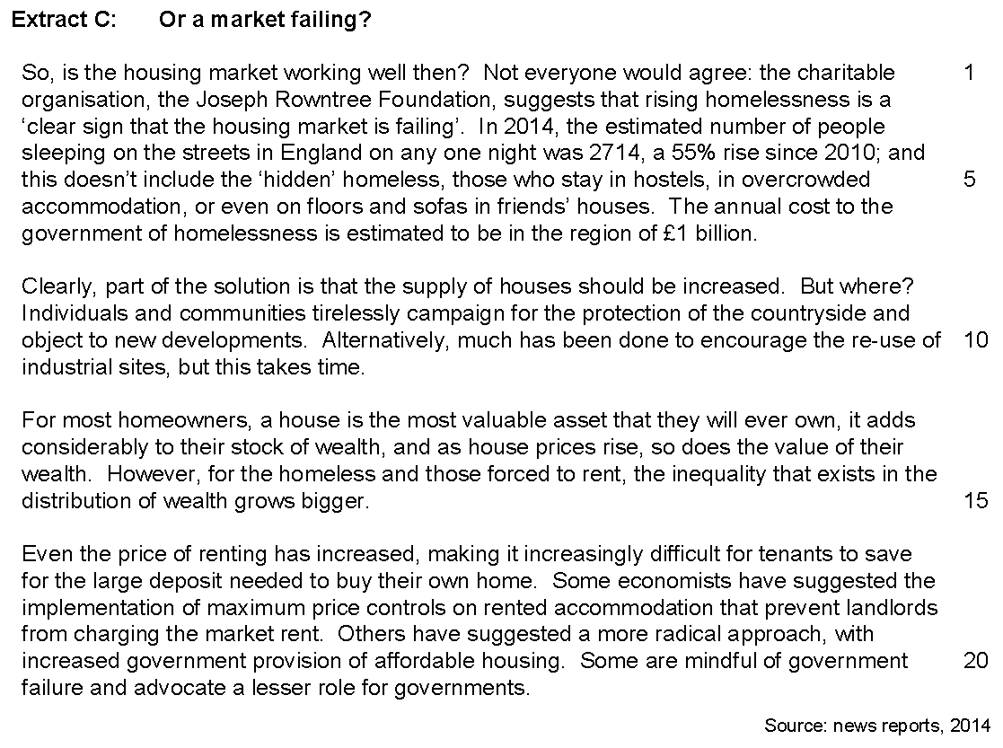

**(01)** Use Extract C to calculate, to the nearest whole number, the estimated number of people sleeping on the streets in England on any one night in 2010. **[2 marks]**

**(02)** Use Extract A to identify two significant points of comparison between the number of new houses built per year in the UK and the changes in UK population over the period shown. **[4 marks]**

**(03)** Extract B (lines 10 and 11) states ‘However, the housing market is not a perfectly competitive market.’

Explain why the housing market is not a perfectly competitive market. **[9 marks]**

**(04)** Extract C (lines 20 and 21) states that: ‘Some are mindful of government failure and advocate a lesser role for governments.’

Use the extracts and your knowledge of economics to assess the view that housing markets should be left to market forces with only the minimum of intervention from governments **[25 marks]**

PAST PAPER 10

**The Costs of Smoking**

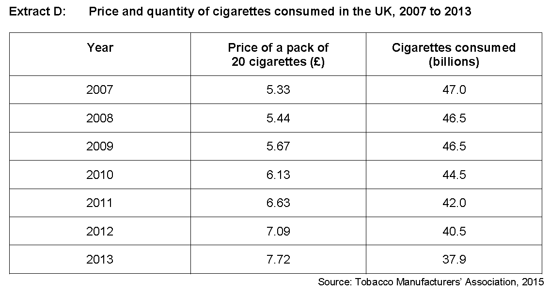

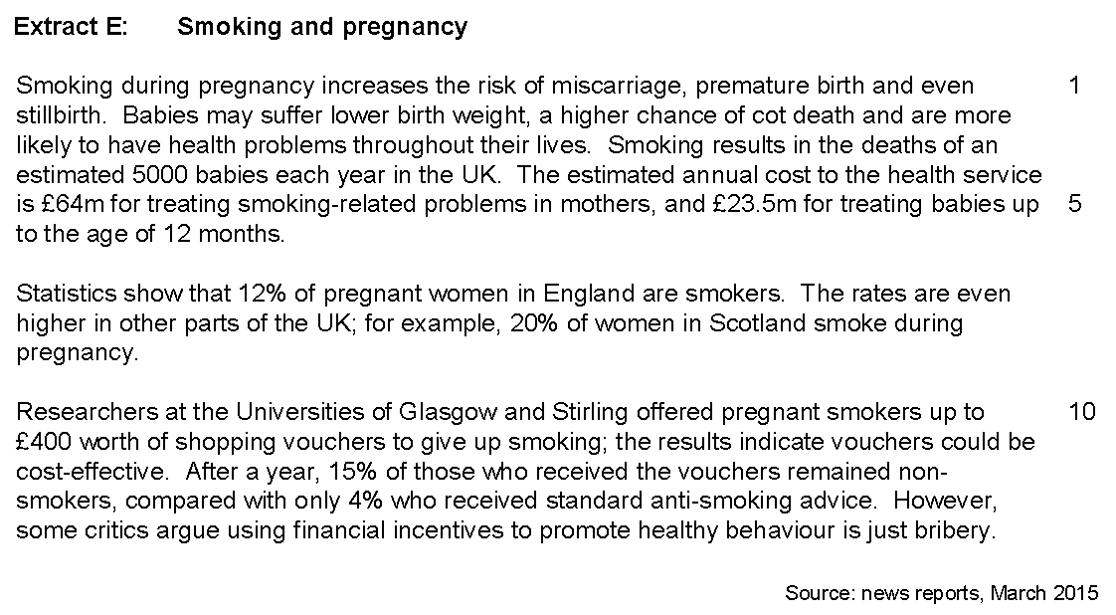

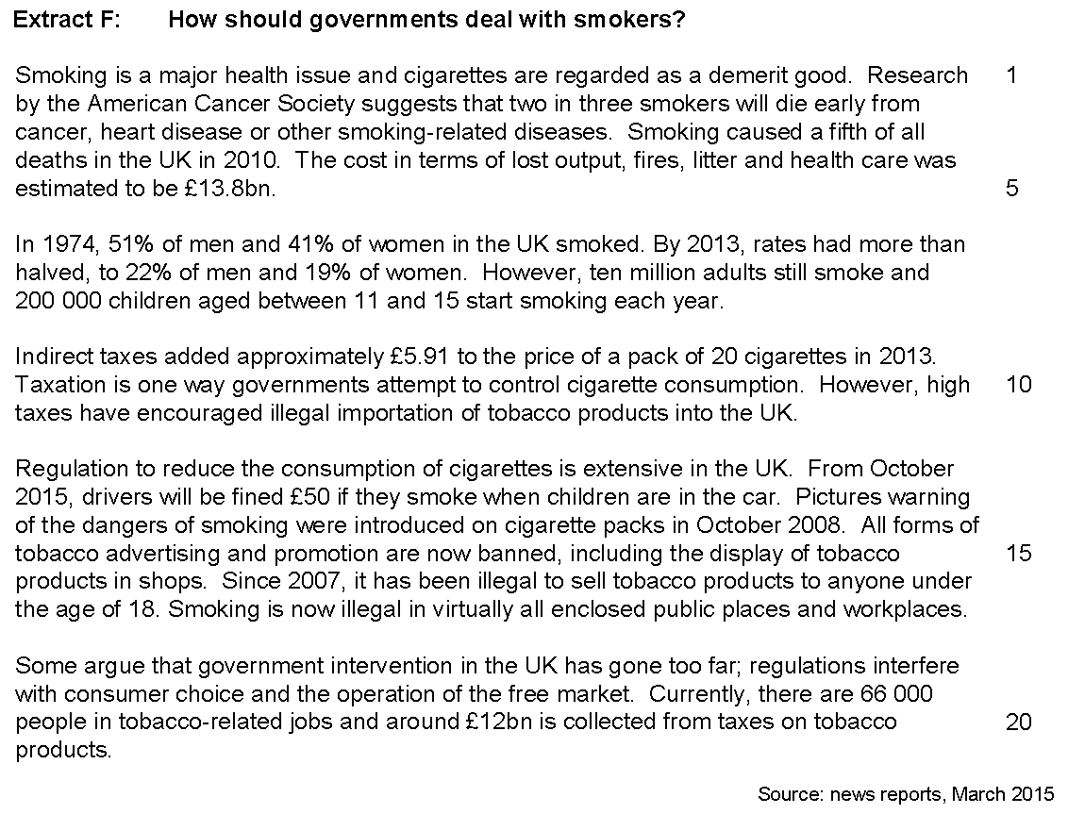

**(01)** Use Extract D to calculate, to the nearest penny, the mean average price of a pack of 20 cigarettes between 2007 and 2013. **[2 marks]**

**(02)** Define the term ‘demerit good’ and use Extract D to identify one significant point of comparison between the price and the quantity of cigarettes consumed in the UK from 2007 to 2013 **[4 marks]**

**(03)** Extract F (line 10) states ‘Taxation is one way governments attempt to control cigarette consumption.’

Explain the effect of indirect taxation on the consumption of cigarettes using a diagram and taking into account the concept of ‘elasticity’. **[9 marks]**

**(04)** Extract F (line 12) states ‘Regulation to reduce the consumption of cigarettes is extensive in the UK.’

Use the extracts and your economic knowledge to assess the view that regulation is the best way of dealing with the market failure that results from the consumption of cigarettes. **[25 marks]**