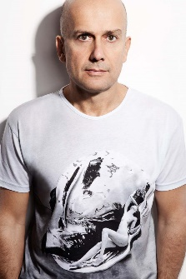Marc Quinn

***Specified sculptor***

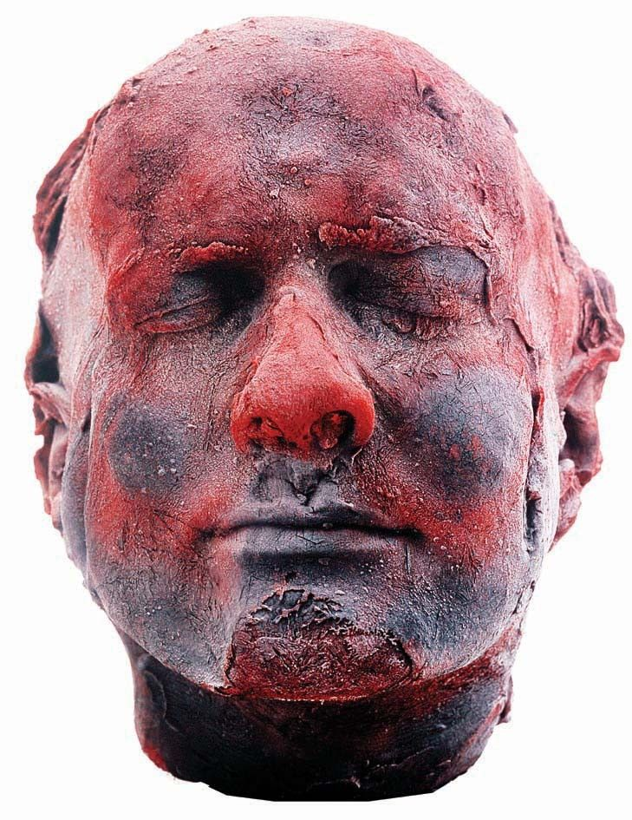

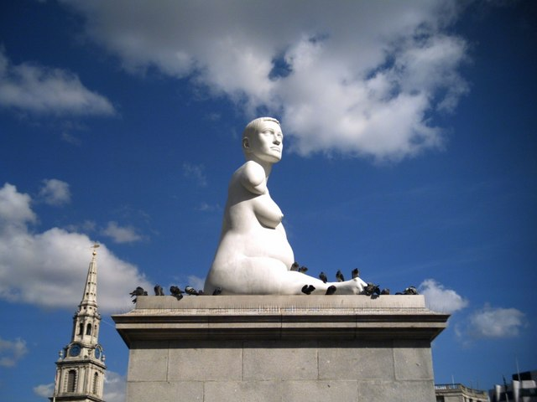

**Brief overview of biography:**

|  |  |
| --- | --- |
| 1964 | Born in London |
| 1983 | First learned to cast in bronze, while working as an assistant to Barry Flanagan |
| 1986 | Graduated from Cambridge University (History & History of Art) |
| 1988 | First solo show at Jay Jopling/Otis Gallery, London |
| 1991 | **SELF** |
| 1992 | Selected for the Sydney Biennale |
| 1993 | Participated in *Young British Artists II* at Saatchi Gallery |
| 1994 | Participated in *Time Machine* at British Museum |
| 1996 | Participated in *Thinking Print* at MoMA, New York |
| 1997 | Participated in *Sensation* at Royal Academy, London |
| 1998 | Solo show at South London Gallery, Camberwell, London |
| 2002 | Solo exhibition Tate Liverpool and participated in Liverpool Biennale |
| 2005-7 | **ALISON LAPPER PREGNANT**, first commission for Fourth Plinth, Trafalgar Square, London |
| 2008 | SIREN |
| 2012 | BREATH, London Paralympic Games |
| 2013 | Solo exhibition Venice Biennale |
| 2017 | Solo exhibition John Soane Museum, London |

**Self** is a self portrait and forms one of a series of similar works made by Quinn at five year intervals.

1. Research this and other self-portraits by Rembrandt, Van Gogh and Frida Kahlo. Each has similarly worked on their own image over a number of years and in multiple versions. Explain how you think their approaches and ideas are both similar and different to those of Marc Quinn? *Attach your image page to this booklet.*

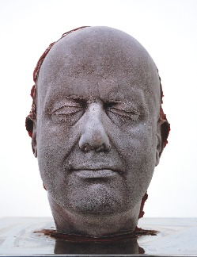

What do you think Quinn is saying about his own identity here? Why is it important that this work is a sculpture rather than a 2D work/a painting?

1. The materials and process by which Quinn made this work, using his own blood and face as a mould are obviously extraordinary and innovative. They are also shocking. Research and make notes on this process and consider how important you think the ‘shock’ element was to Quinn?

What materials are used to make this work?

How was the work made?

Watch this: <https://uk.video.search.yahoo.com/search/video?fr=mcafee&p=marc+quinn+making+self#id=2&vid=8ea4351858ac1a8bd552ae2b90941a9f&action=view>

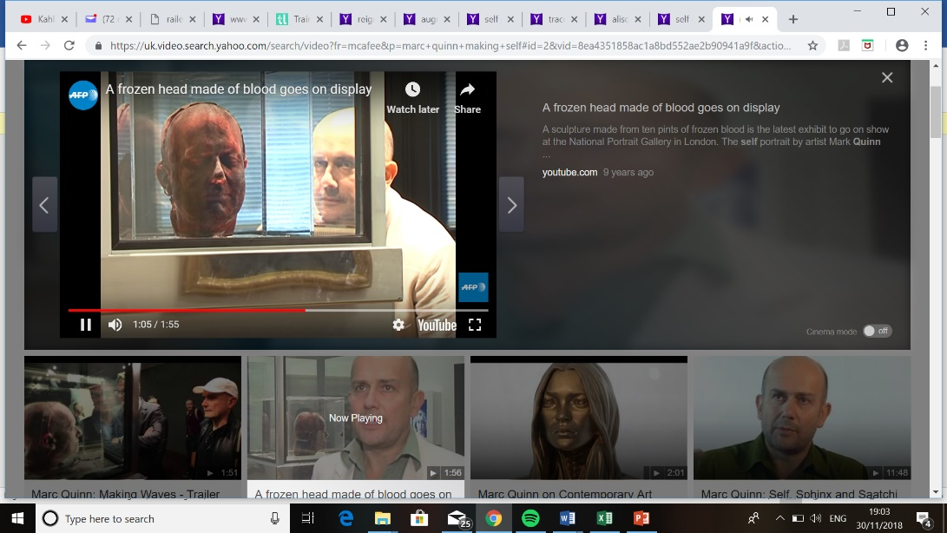

How and why does the location and display of the work at The National Portrait Gallery change people’s reception of/to it?

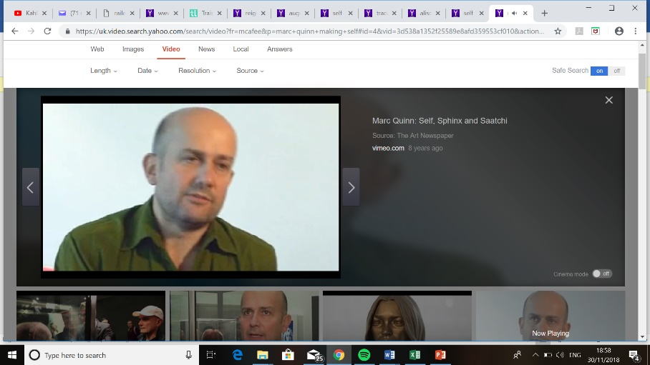

Watch this 12 minute video interview with Marc Quinn:

<https://uk.video.search.yahoo.com/search/video?fr=mcafee&p=marc+quinn+making+self#id=4&vid=3d538a1352f25589e8afd359553cf010&action=click>

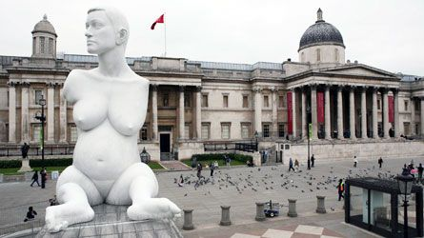**Alison Lapper Pregnant** is a 12m high, white marble sculpture of Alison Lapper, an artist from Brighton who was 8 months pregnant at the time Quinn worked with her.

1. Who was Alison Lapper?

Read this article and make some brief notes on who Alison Lapper was and why Quinn decided to make this work of her: <https://www.theguardian.com/lifeandstyle/2014/aug/02/alison-lapper-disabled-people-drain-on-society>

1. What is The Fourth Plinth Project?
2. Why was this chosen as the first work for this important public space? And why does it have additional meaning and impact in this place?
3. Marc Quinn subsequently made much larger versions of Alison Lapper Pregnant as temporary, inflatable installations for the London Paralympics in 2012 and the Venice Biennale in 2013. He renamed the work **Breath**. Why do you think he changed the name and how/why is this new name appropriate?
4. Research what the critics said about **Breath** in both locations. Note down their comments here, making sure you note which work/place they were talking about and that you understand why/what they did (or did not) like.

Materials and techniques

How was this work made? Make sure you note down where the marble came from and who worked on it? Many people are surprised by Quinn’s use of a team of assistants here rather than him doing all the work himself. However, this is a very traditional way to work – look (briefly) into the career and working practices of (perhaps) the most famous sculptor of the 19th century – Auguste Rodin for comparison.

Now, you need to explore how (and in what ways) Quinn was influenced by earlier and/or contemporary artists.

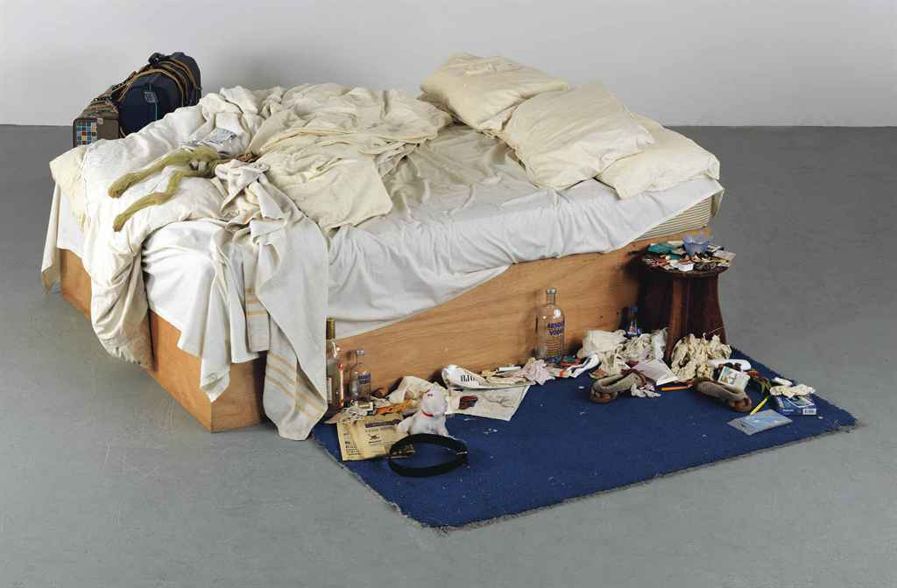Tracey Emin’s **My Bed** (1998) is also a kind of portrait and similarly caused huge outrage when it was first shortlisted for The Turner Prize. *Research this work.*

When was it made?

And where it was first exhibited?

What do you think Tracey Emin is saying about her own identity (values, self-respect, priorities, sense of belonging etc) here?

How did she know Marc Quinn? Is it valid to say that one influenced the other? How could you justify this?

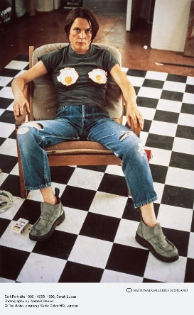

Now look at Sarah Lucas’ **Self portrait with Fried Eggs** (1996). Like Quinn’s Self, this work is now owned by the National Portrait Gallery. In what ways, could all three be said to be challenging ideas of personal identity at this time?

All three were part of the group known as the **Young British Artists**. Research the group and answer the questions below:

1. Where did the name come from?
2. What were the common aims of the group?
3. Can you find any common characteristics or elements to their work?
4. How did they come to be so famous?

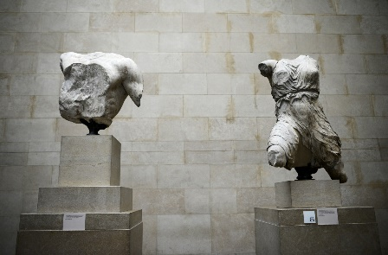Next, we need to look further back in time.

1. How (and in which work) was Quinn influenced by Classical Greek art?

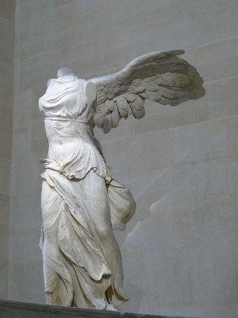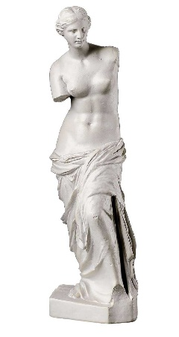

1. Name each of the Greek works shown to the right and explain why they are important to understanding Quinn’s work?
2. 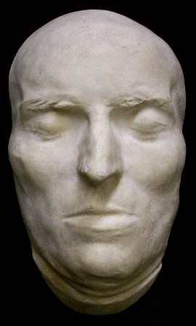In what ways could it be argued that Roman death masks are also influential to **Self**?
3. Finally, in order to make sure that you can contextualise the influences and achievements of Marc Quinn: make an image sheet of female figure sculptures and portrait busts by each of the following more traditional sculptors: Gianlorenzo Bernini, Antonio Canova and Auguste Rodin. *Briefly summarise your understanding about Quinn’s influences and innovations.*

***Exam style Questions***

1. *Explore the presentation of gender in one work of art after 1850.*
2. *Explore the presentation of identity in one 3D portrait, made after 1850.*
3. *Explore how the materials and techniques have contributed to the meaning and impact of one work of art.*
4. *Explore how the location and/or display of one work of art has contributed to its meaning.*
5. *Explore and evaluate how your chosen specified sculptor has responded to works by earlier or contemporary artists. You should refer to two works of art by your specified sculptor.*
6. *Explore how two works by your chosen specified sculptor express their ideas of identity.*
7. *Explore how two works present identity. One of your works should have been made before 1850 and one after 1850.*
8. *Explore how two portraits present character, likeness and status. At least one of your works should hae been made beyond the Western tradition.*