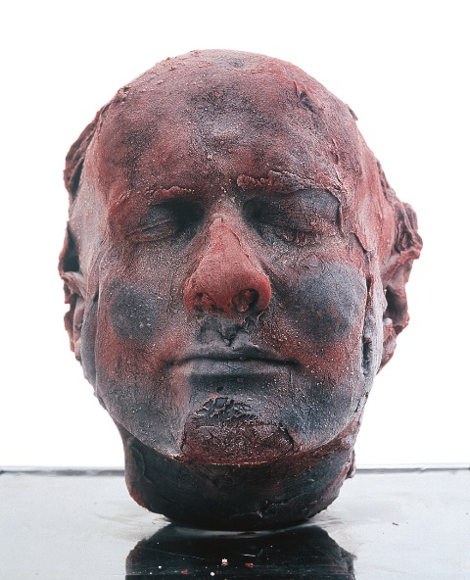SELF

Marc Quinn, created this self-portrait in 1991 although this is an ongoing series and he creates a new sculpture every 5 years, which makes it like a timeline of his life as viewers can see him aging and changing with each sculpture.

Terminology:

* Thick
* Dramatic
* Rough
* Uneven
* organic

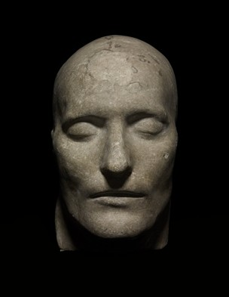The interesting thing about this series is that it is made out of 10 pints of Quinn’s own blood. He may have been inspired by Roman death masks which is where people created a mask of the face after death, specifically the death mask on display in the British museum which he had seen previously to creating this series of sculptures, however his sculptures differ from the death masks in the way as it is more of a life mask as it is made from human blood and is kept alive by being frozen.

By crafting these heads out of his own blood, Quinn reconnects us to the fact that in the fullness of time, no artist’s attempt at immortality through self-portraiture will prevail. And of course the series will presumably end in the course of the artist’s life, so the artwork’s time-dimension has a death of sorts as well.

The series was made during a time when Quinn was an alcoholic and is a way to document and preserve the natural aging process as well as a symbol of his dependency.

In order to retain its frozen shape, the works need to be plugged in to an electricity source which mirrors the idea of how no one in today’s society ‘can survive’ without electricity and internet access, and it also relates to his own alcohol dependency.

Before being able to create these kind of sculptures, Quinn had to visit a doctor to have his own blood drawn and saved over a period of 5 months until he had a sufficient amount of blood to fill the mould. Therefore this causes a lot of controversy amongst people over how 10 pints of blood could be put to a more practical use if it were to be donated to save lives rather than to be put into a mould and saved for years with the use of electricity which again needs to be saved to prevent global warming.

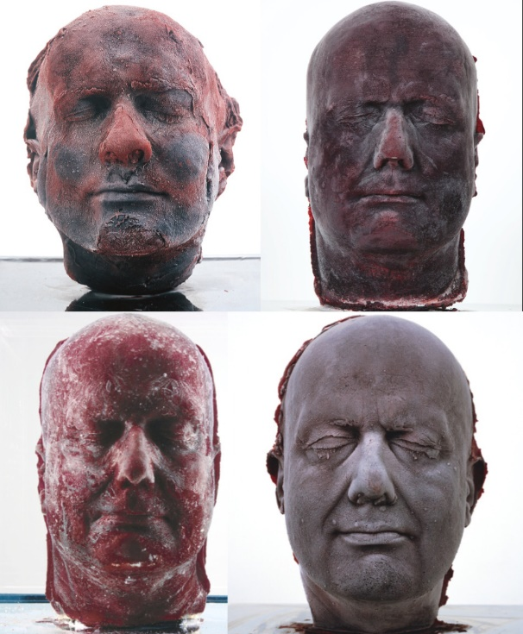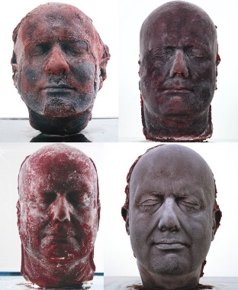Marc Quinn, who likes to employ biology and genetics in his works, to expresses how art and science work together, has worked with a variety of other more conventional materials, such as glass, gold and ice.