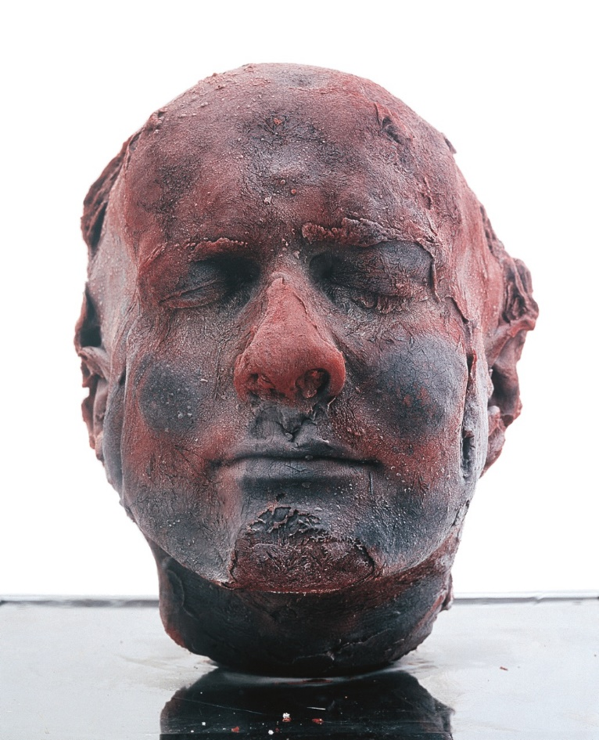**SELF - MARC QUINN**

**1991 (repeated every 5 years)**

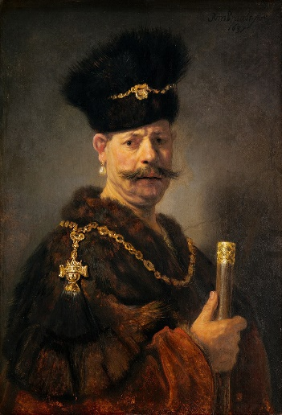The Self series was influenced by the Dutch painter Rembrandt. At Cambridge University he studied Rembrandt's self-portraits during his art history course and "thought it would be quite interesting to make a contemporary version of that". These self-portraits are extremely detailed and revealing of the person’s flaws or visual characteristics.

The work, in terms of how it was shaped by social aspects and opinions, has been viewed to be gruesome and an odd. But other critics have said it is a brilliant way to explore hyper-real bio art that defies the boundaries of painting. It is his own flesh and blood so could arguably be truer than any painting he could have done of himself.

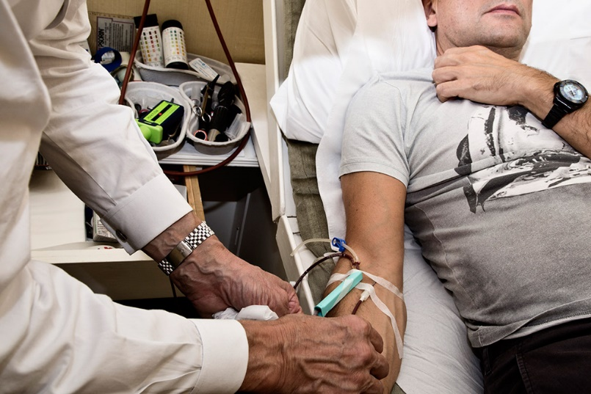"The sculpture sits in a limbo – simultaneously alive and dead, real and simulated. It is one of the uncanny works of recent contemporary practice." Jaklyn Babington, NGA senior curator of contemporary art.

The use of materials to express identity in the western world is an unusual one. It is an extremely modern and scientific approach to a self-portrait and could therefor express the scientific change that has happened in the 21st century, but also could be an exploration of how we as a society perceive each other today. Quinn is saying that it is not our looks which make ourselves but what is inside. He is exploring a deeper meaning of ‘identity’. These things could also be said about the techniques and processes used.

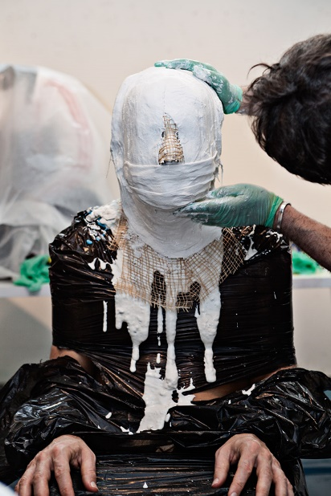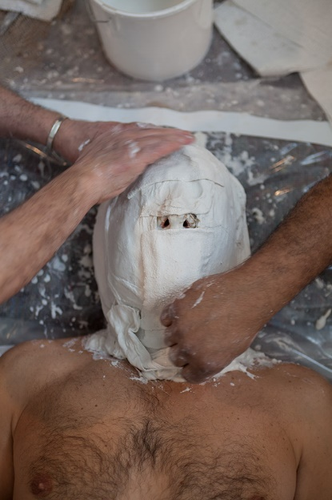Link to video of how the head was made: <http://www.smh.com.au/entertainment/art-and-design/hyperreal-how-the-head-of-blood-is-made-20171123-gzraec.html>

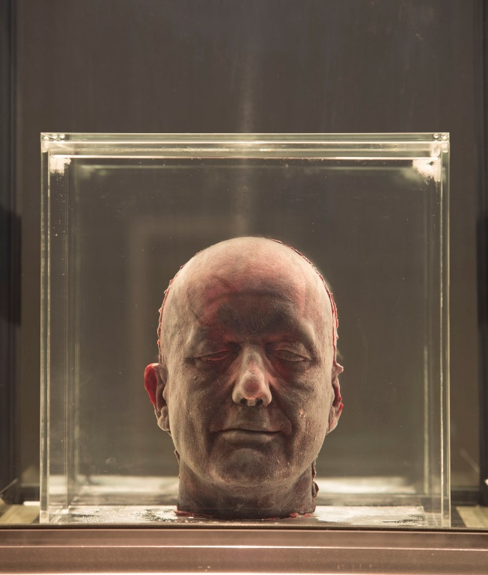The work was made at a time when Quinn was an alcoholic and a notion of dependency – of things needing to be plugged in or connected to something to survive – is apparent since the work needs electricity to retain its frozen appearance.

Marc has used ten pints of his own blood, liquid silicone, stainless steel, glass, and Perspex to create each sculpture in his ‘Self’ series. He uses refrigeration equipment to keep the blood frozen, which ensures that it keeps its form. If this equipment was turned off, the sculpture would melt and turn into a puddle of blood.

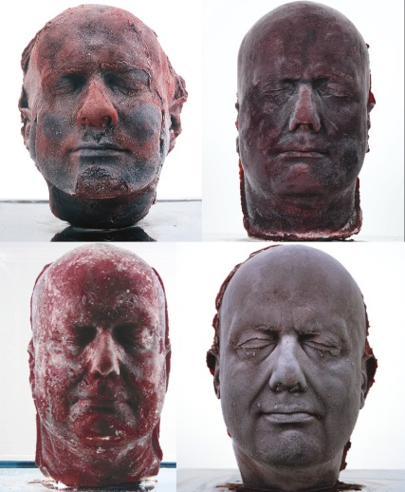The first work in his ‘Self’ series was created in 1991, a time when Quinn was an alcoholic. The need to be connected to something to survive – is reflected in the work as it needs electricity to retain its frozen appearance.

Quinn created this sculpture as a twist on the traditional self-portrait. By creating a mould of his face and using his own blood, suggests that this is the most realistic representation of him that he can create as it shows both his physical and biological identity. Every five years Quinn creates a ne w blood sculpture, which shows the changes in his body as he ages.