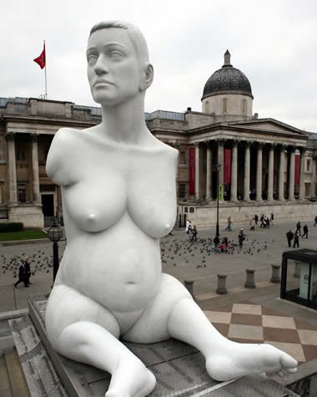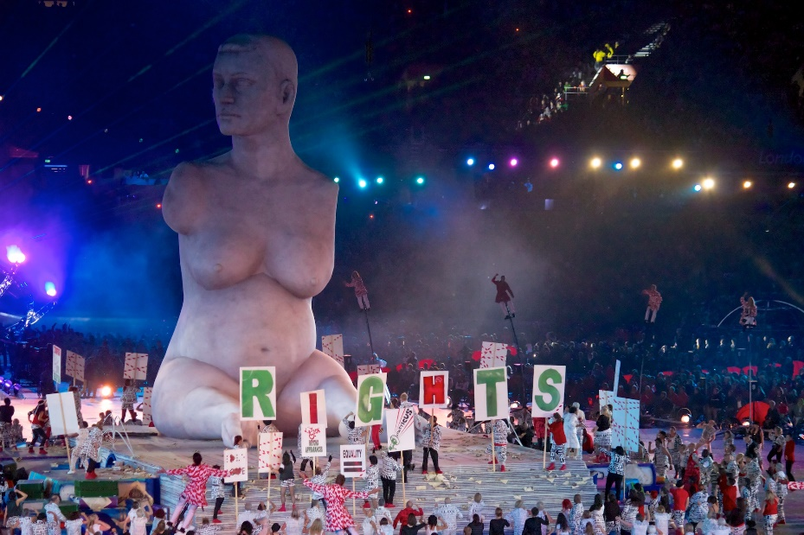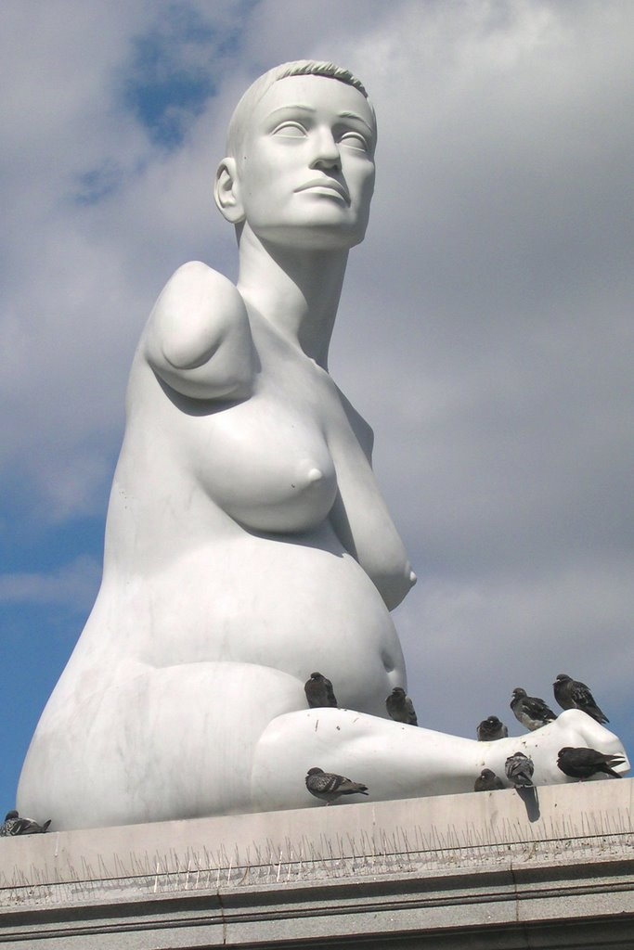

Alison Lapper Pregnant

A 3.5 metre 3D sculpture by Marc Quinn created in 2005 for the fifth plinth outside the national gallery and is 3.5 metres tall. Quinn was inspired and influenced by the Elgin marbles in the national gallery. How they are incomplete, with missing limbs but beautiful yet some disabled people are incomplete, but not considered classically beautiful. In 2005, the 1995 disability discrimination act was amended. This meant that disabled people got better pensions than before. The sculpture’s presence in Trafalgar Square has been hugely empowering in the progress of disabled rights in the UK.

Quinn says that people “Don’t want to see thought provoking art in a public space”. This sculpture is quite controversial as it is in the public eye and makes us question the narrow binds of acceptability into which social norms tend to push us. The fifth plinth is a place originally reserved for soldiers, this may be Marc Quinn showing how she is a soldier in her own right saying she has “a different kind of heroism”.

The sculpture was originally made in marble possibly as a direct reference to the Elgin Marbles, however for the opening of the Paralympics they wanted a bigger version of the sculpture to appear within 20 seconds he decided the most appropriate material would be making and inflatable version of the piece, which with modern materials and technique was able to be made very accurate copy of it. The grandness of the material used could be Quinn comparing them to other powerful figure who are shown in marble, saying that her disability does not take away from her strength.

He made it too show that even if you are disabled and pregnant- things that are not traditionally seen as beautiful-you can still be beautiful and wanted to show this to the world in a very public way.