BTEC yr2
Unit 36 – Lighting Techniques Learning Aim A (A2)
In preparation for writing and recording your audio script, jot down notes in the boxes below. You may find it beneficial to make note of specific timecodes of the lighting example you are planning to refer to.
Film Noir  Double Indemnity  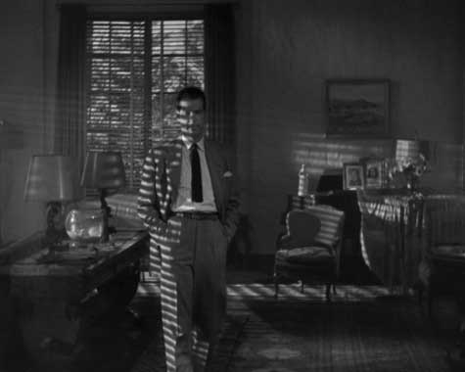 | low-key lighting, use of shadows to frame subjects, shadows from blinds to obscure faces and chiaroscuro.
Music Video  Grizzly Bear – ‘Yet Again’  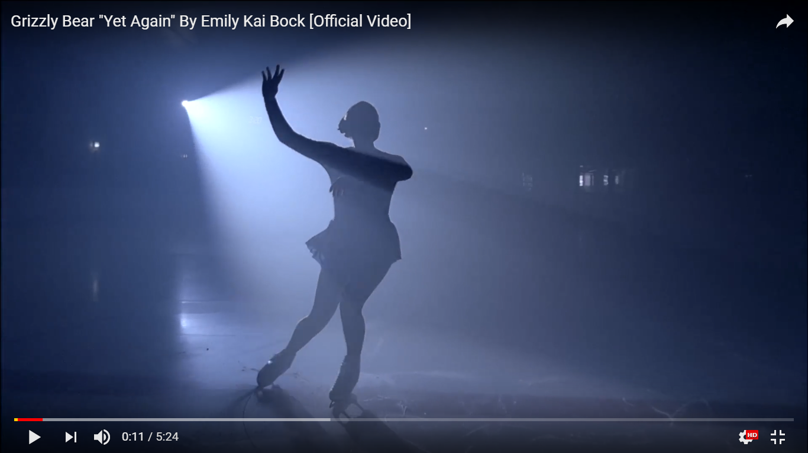 | Performance-based spotlighting, strobing, lighting to convey mood and lighting to create contrast.
Horror  A Nightmare on Elm Street  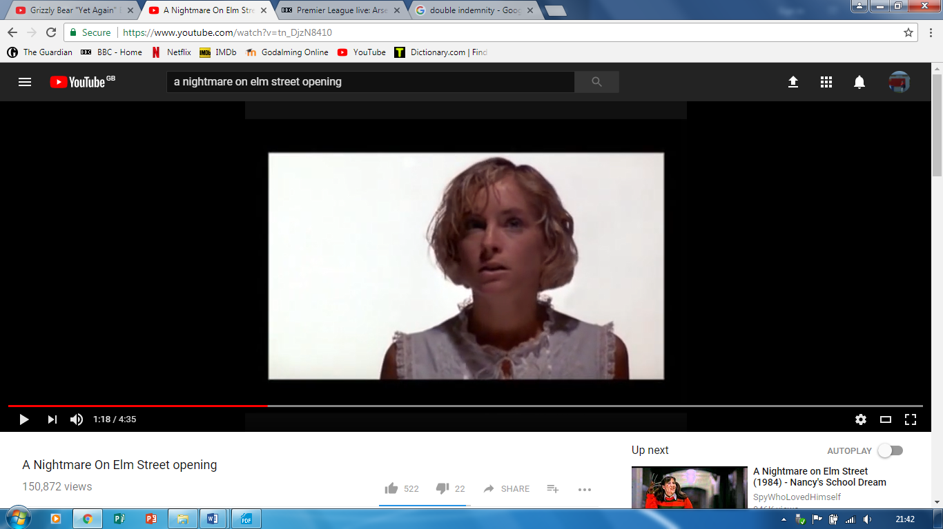 | Use of shadow, atmospheric effects and obscuring of detail to provoke imagination.

