**Themes in Art & Architecture: War**

Artist: Jeremy Deller (born 1966)

Title: ‘*We’re here because we’re here’*Scope of work: Participants in 2D or 3D

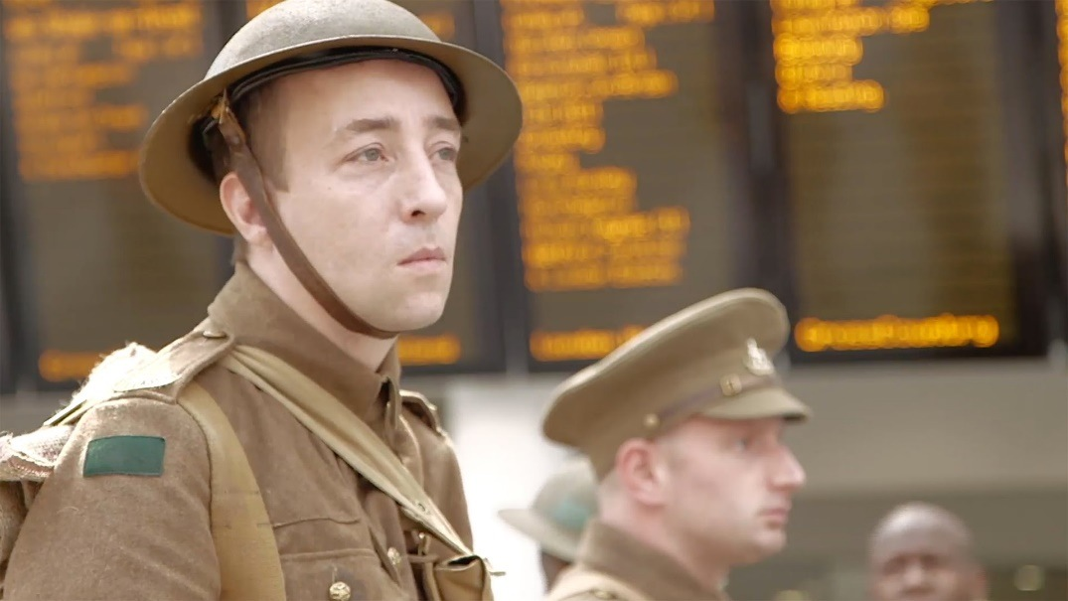

**Art Historical Terms and Concepts**  
**Subject matter**: It is the morning of July 1st 2016 and Private Harry Dobson of the 13th Battalion / York and Lancaster Regiment waits with fellow soldiers at a train station. They are soon to depart for the Somme. More than three million soldiers would participate in this battle and an estimated one million would be killed or wounded on both sides. Among the fatalities would be Harry, aged 18. He is played here by an actor to mark the centenary of what is considered one of the bloodiest battles in human history.

About the work:

On 1 July 2016, thousands of volunteers took part in a modern memorial to mark the centenary of the Battle of the Somme. 19,240 men were killed on the first day of the battle in 1916 – the bloodiest day in British military history. ‘we’re here because we’re here’ saw around 1400 voluntary participants dressed in First World War uniform appear unexpectedly in locations across the UK. Each participant represented an individual soldier who was killed on that day one hundred years before.

The participants wore historically accurate uniforms, representing 15 of the regiments that suffered losses in the first day of the Battle. The soldiers did not speak, but at points throughout the day would sing the song ‘we’re here because we’re here’, which was sung in the trenches during the First World War. They handed out cards to members of the public with the name and regiment of the soldier they represented, and, where known, the age of the soldier when he died on 1 July 1916.

The work is partly inspired by tales of sightings during and after the First World War by people who believed they had seen a dead loved one.

Jeremy Deller, the artist responsible for the work explained: “I wanted to make a contemporary memorial to mark the centenary of the Battle of the Somme, one that moved around the UK with an unpredictability in which the participants, by their actions, took the memorial to the public.”

‘we’re here because we’re here’ was a UK-wide event commissioned by 14-18 NOW, conceived and created by Turner Prize-winning artist Jeremy Deller in collaboration with Rufus Norris, Director of the National Theatre. Produced by Birmingham Repertory Theatre and the National Theatre, in collaboration with 26 organisations.

<https://becausewearehere.co.uk/>

Q: Give a brief explanation of the term ‘performance art’.

Q: What is a war memorial? And can ‘We’re here because we’re here’ be classified as such?

Find an image of a traditional memorial related to WW1 and include below. Include the location of your example.

Q: Where was the Somme located? Why was this location important/significant for both sides in the war?

Find images of ‘we’re here because we’re here’ and include them below.

Q: How did the performers interact with the public? What outcome may the artist have been hoping for?

Jeremy Deller.

Provide details for Jeremy Deller including his date of birth, where he studied and other examples of his work including titles and dates.