

NAME:

**Ancient History**

**Period Study: The Julio-Claudian Emperors, 31 BC – AD 68**

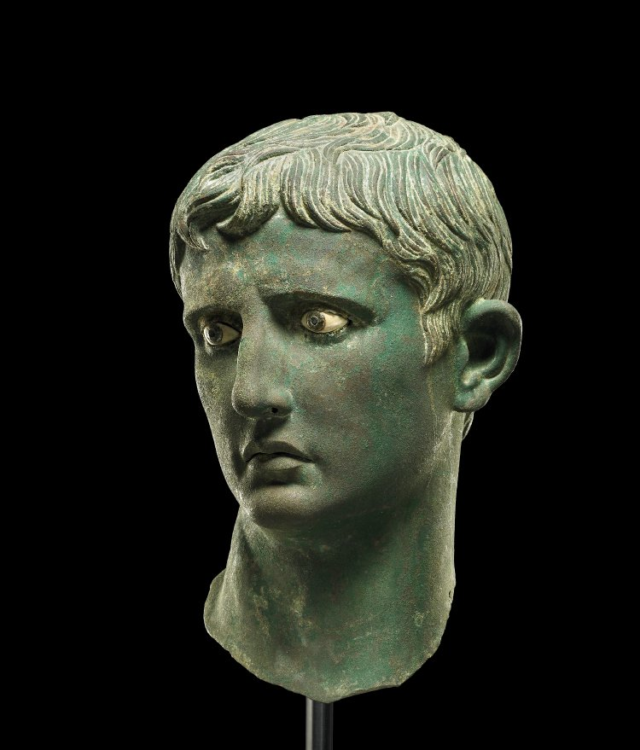**TOPIC 1: Augustus, 27 BC – AD 14**

**PART TWO**

***This booklet covers the following topics:***

* Relations with the Senate, Equestrians and Plebs
* Challenges to Augustus’ Rule
* Augustus’ establishment of a dynasty
* The *Res Gestae*

**Suggested Reading**

**History Today Articles (go to** [www.historytoday.com](http://www.historytoday.com) **username= Godalming; password= history)**

# Augustus Down the Centuries

By [John M. Carter](http://www.historytoday.com/author/john-m-carter)

Published in [History Today](http://www.historytoday.com/archive/history-today/latest) [Volume 33 Issue 3 March 1983](http://www.historytoday.com/archive/history-today/volume-33-issue-3-march-1983)

# The Problem of Augustus

By [Michael Grant](http://www.historytoday.com/author/michael-grant)

Published in [History Today](http://www.historytoday.com/archive/history-today/latest) [Volume 3 Issue 11 November 1953](http://www.historytoday.com/archive/history-today/volume-3-issue-11-november-1953)

# The Many and the Few: Augustus, Tiberius and Roman Ideals

By [T.P. Wiseman](http://www.historytoday.com/author/tp-wiseman)

Published in [History Today](http://www.historytoday.com/archive/history-today/latest) [Volume 64 Issue 8 August 2014](http://www.historytoday.com/archive/history-today/volume-64-issue-8-august-2014)

# Augustus and Cleopatra

By [Christopher Smith](http://www.historytoday.com/author/christopher-smith)

Published in [History Today](http://www.historytoday.com/archive/history-today/latest) [Volume 64 Issue 2 February 2014](http://www.historytoday.com/archive/history-today/volume-64-issue-2-february-2014)

# The Praetorian Guard

By [Geoffrey Powell](http://www.historytoday.com/author/geoffrey-powell)

Published in [History Today](http://www.historytoday.com/archive/history-today/latest) [Volume 18 Issue 12 December 1968](http://www.historytoday.com/archive/history-today/volume-18-issue-12-december-1968)

# Women in Imperial Rome

By [J.P.V.D. Balsdon](http://www.historytoday.com/author/jpvd-balsdon)

Published in [History Today](http://www.historytoday.com/archive/history-today/latest) [Volume 9 Issue 8 August 1959](http://www.historytoday.com/archive/history-today/volume-9-issue-8-august-1959)

# The Roman Legions and their Officers

By [Geoffrey Powell](http://www.historytoday.com/author/geoffrey-powell)

Published in [History Today](http://www.historytoday.com/archive/history-today/latest) [Volume 17 Issue 11 November 1967](http://www.historytoday.com/archive/history-today/volume-17-issue-11-november-1967)

**Textbooks**

* R. Cromarty, J. Harrison & S. Matthews, *OCR Ancient History, Component 2: Rome*, Bloomsbury, 2018 (Due to be published February 2018)

**Books in the ILC**

* R. L. Fox, The Classical World: an Epic History of Greece and Rome, Penguin, 2006
* M. Beard, *S.P.Q.R.: A History of Rome*, Profile Books, 2015
* T. Holland, *Dynasty,* Abacus, 2016
* P. Mantin & R. Pulley, *The Roman World, From Republic to Empire,* Cambridge, 1993
* T. Martin, *Ancient Rome: From Romulus to Justinian,* Yale, 2013

**Useful Websites**

* <https://www.bloomsbury.com/cw/ocr-as-and-a-level-ancient-history/?pid=330294> (A companion website for the OCR Ancient History textbook – good selection of wider reading and revision quizzes)
* <http://www.ancient.eu/>
* <http://www.livius.org/>
* [www.ocr.org.uk](http://www.ocr.org.uk)

**Podcasts**

Julius Caesar - [www.bbc.co.uk/programmes/b04jlygw](http://www.bbc.co.uk/programmes/b04jlygw)

The Augustan Age - <http://www.bbc.co.uk/programmes/b00ktfmw>

Rome and European Civilization **-** [www.bbc.co.uk/programmes/p00547ms](http://www.bbc.co.uk/programmes/p00547ms)

Tacitus and the Decadence of Rome - <http://www.bbc.co.uk/programmes/b00cdtxp>

Roman Satire - [www.bbc.co.uk/programmes/b00s0gwd](http://www.bbc.co.uk/programmes/b00s0gwd)

*For help in accessing the ebook catalogue on dawsonera, go to the ILC’s page on Godalming Online and read their guide to accessing ebooks.*

*Ebooks can be read using your college log on details whilst in college or at home.*

**ANCIENT HISTORY LUNCHTIME SUPPORT**

**If you need any help in Ancient History going over content, completing homework, attempting assessed questions or preparing for exams, there will be a lunchtime support session each Wednesday between 1 and 2 pm in room 211.**

**Relations with the Senate, Equestrians and Plebs**

***TASK:*** *From what you have studied so far, add any notes as to why each group below would be satisfied or dissatisfied with the rule of Augustus*

***If you were Augustus which of these groups would you want the support of the most and why?***

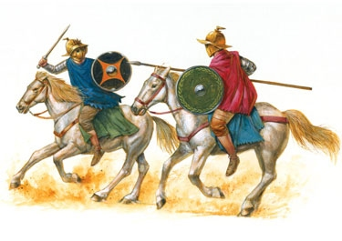

***EQUITES/*knights**

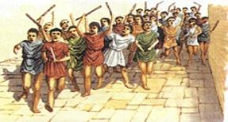

**plebs**

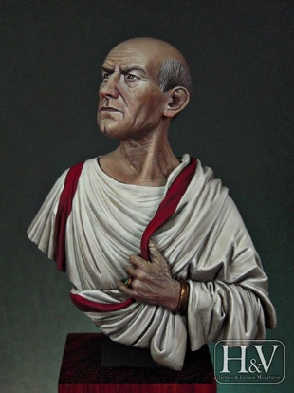

**Senators**

**Senators**

**Prescribed Source – Public vows for Augustus’ safety, *denarius*, 16 BC**

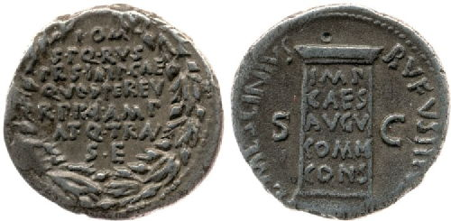

**Obv.:** Inscription within oak-wreath “To Jupiter Greatest and Best the Senate and People of Rome took vows for the safety of Imperator Caesar because through him the state is in a more expansive and peaceful condition”

**Rev.:** Pillar inscribed “to Imperator Caesar Augustus by common consensus” (By decree of the Senate)

The coin above has a copy of a public inscription, put up in Rome, to Augustus:

1. **What does the inscription tell you about the level of public support Augustus received?**

**PLEBS**

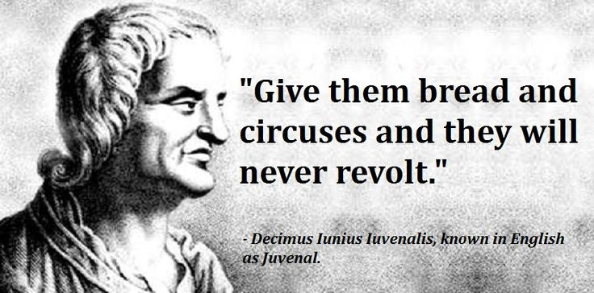Augustus realised the importance of the **plebs** in Rome if was to remain in power. If the plebs supported his rule then he would be firmly established, even if the senatorial class opposed him. If, however, the mob turned against him then unlike the senators, they had the physical power to potentially overthrow him.

To deal with the plebs, therefore, Augustus would develop a tactic of generosity and entertainment that would later be referred to as ‘**bread and circuses’** and would become the blueprint for future emperors.

The phrase was first used by the Roman satirist **Juvenal** but it is clear that our prescribed authors were also aware of Augustus’ strategy:

**Prescribed Source Tacitus, *Annals,* 1: 2.1**

2.1 After the death of Brutus and Cassius, the republic no longer had an army. Pompey had been defeated in Sicily, Lepidus disposed of, and Anthony killed. As a result even the Julian faction had only Caesar left to lead them. He laid aside the title of triumvir and presented himself as a consul, content to defend the people by virtue of the tribunician power. Thereafter, once he had seduced the soldiery with gifts, the people with corn, and everyone with the delights of peace, he gradually increased his power, arrogating to himself the functions of the senate, the magistrates and the law. He faced no opposition, since the bravest souls had died in battle or fallen victim to prosecution, while the surviving nobles enjoyed a wealth and status which increased in proportion to their servility; and having profited by revolution, the preferred present safety to the insecurity of the past.

1. **Highlight a phrase or sentence in this source from Tacitus that confirms the idea of ‘bread and circuses’**
2. **Explain in your own words what you understand by the phrase ‘bread and circuses’.**

Plebs in Rome received a regular corn ration which was the staple of the poorest (the ‘corn dole’). One of the reasons why Augustus had added Egypt to the empire and then kept such tight control of the province was that it was the ‘bread-basket of the empire’. The significance of the corn supply was made clear in 22 BC when a riot erupted following a shortage. Rather than blame Augustus, however, the plebs demanded that he accept the powers of dictator. Augustus refused and went on to quickly resolve the crisis. He would in AD 6-7 go on to set up more formal management of the corn supply. The plebs’ response to shortages however demonstrate clear support and loyalty towards Augustus. This was supported further by acts of public generosity, such as giving the plebs 400 sesterces each in 24 BC.

The other side of Augustus’ policy towards the plebs was putting on lavish public games. These included chariot races, re-enactments of battles, animal fights and gladiatorial contests.

1. **What do you think was the purpose and aim behind the Roman games? Think about this from the point of view of the plebs and the emperor.**

**EQUESTRIANS**

**Prescribed Source – Suetonius, *Augustus* 39-40**

39. With the assistance of ten senators, Augustus cross-examined every *eques* on his personal affairs. Some, whose lives proved to have been scandalous, were punished, others were degraded, but in most cases he was content to reprimand culprits with greater or less severity. The luckiest were those whom he obliged merely to take the tablets handed to them and read his censure in silence where they stood. *Equites* who had borrowed money at a low rate of interest, in order to invest it at a higher, earned his particular displeasure.

40. If insufficient candidates of senatorial rank presented themselves for election as tribunes of the people, Augustus nominated *equites* to fill the vacancies, but allowed them, when their term of office had expired, either to remain members of the equestrian order or to become senators, whichever they preferred. Since many *equites* had lost so much money during the civil wars that they no longer possessed the property qualifications of their rank, and therefore refrained from taking their seats in the fourteen rows reserved for the order, he announced that anyone who had once been a *eques* or was the son of a *eques* was not liable to punishment under the law governing theatres.

1. **From this source how would you summarise Augustus’ treatment of the equestrian class?**
2. **Why do you think he treated them in this way?**

Augustus would use the equestrian class more than had been the case under the Republic. The *equites* offered a potentially loyal group whom the emperor could reward and support in return for their service. Many had fallen into poverty during the civil war and could now be used to by-pass the power of senators. Augustus would raise the *equites* to the position of a distinct political group with some roles specific to them. For example under Augustus only an *equites* would be allowed to govern **Egypt**.

**SENATORS**

The senators were the group Augustus had to develop the most careful approach towards. On the one hand his rise to power as *princeps* took all real power away from the Senate, but to preserve his image as a restorer and protector of the Republic and traditional Roman values, Augustus needed to keep the Senate and the position of the senators.

**Prescribed Source - Tacitus, *Annals***

3.7 At home all was quiet and the magistrates enjoyed their traditional titles. The younger generation had been born after the victory at Actium, and most of their elders during the civil wars. How many remained who had seen the republic?

1. **Why according to this extract from Tacitus might the task of controlling the Senate be easy?**

Augustus wanted to use the Senate as a **‘rubber stamp’** i.e. a body that would approve and support his laws without seriously scrutinising or challenging them. One way to ensure this was by having the personal support of senators and this could be achieved relatively easily by bribing them:

**Prescribed Source - Macrobius, *Saturnalia* 2.4.23**

**Augustus’ large gifts to senators**

Augustus had actually paid of the debts of a senator friend of his unasked, to the tune of about four million sesterces. In return by way of thanks for his generosity he got the following note: “Nothing for me, then?”

**Prescribed Source - Tacitus, *Annals,* 2:37**

**Augustus’ large gifts to senators**

Marcus Hortalus was the grandson of the orator Quintus Hortensius and was persuaded by Augustus with a generous gift of a million sesterces to marry and raise children to ensure that his distinguished family should not die out.

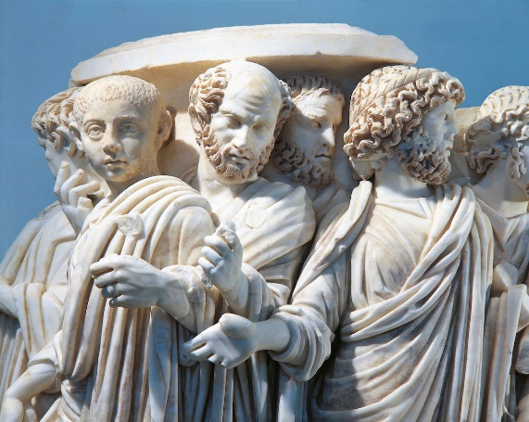

As has already been seen, Augustus also created a number of new offices and positions in the government of Rome which gave senators opportunities for jobs and promotions. For example, Augustus created:

* Two new praetor offices
* The position of *Praefectus Urbi*
* Offices for the upkeep of public buildings, road and aqueducts, and for the distribution of grain
* He also expanded the *cursus honorum* (the ‘course of offices’) which meant more routes for ambitious senators through the different magistrate positions in Rome

Augustus, therefore, used **generosity** and **incentives** to ensure the senate were a loyal and docile body. At the same time, however, he also purged the senate of members and reduced its powers.

**Recap:**

1. How many senators did Octavian inherit from Julius Caesar and what number had he reduced this to by 18 BC?
2. How had he reduced this number?

**Prescribed Source – Suetonius, *Augustus,* 35**

35. The number of senators had been swollen by a coarse and ungainly crowd: there were more than a thousand – some of them wholly unworthy and enrolled through backroom deals after the death of Caesar, who were popularly known as ‘Orcus Men’. Augustus restored the order to its former size and repute by two new acts of enrolment. First, each member was allowed to nominate one other, then Augustus and Agrippa together reviewed the list and announced their own choice. When Augustus presided on this second occasion he is said to have worn a sword and a steel corselet beneath his tunic, with ten burly senatorial friends crowding around him. According to Cremutius Cordus, the senators were not even then permitted to approach Augustus’ chair except singly and after the folds of their robes had been carefully searched. Though shaming some of them into resignation, he did not deny them the right to wear senatorial dress, or to watch public shows from the orchestra seats, or to attend the order’s public banquets. He then encouraged those selected for service to a more pious and less inconvenient discharge of their duties by ruling that, before taking his seat, each member should offer incense and wine at the altar of whatever temple had been selected for a meeting, that regular meetings should not be held more than twice a month – on the Kalends and the Ides – and that during September and October no member need attend apart from the few who names were drawn by lot to provide a quorum for the passing of decrees. He also arranged that personal counsellors should be chosen by lot every six months to assist him in reviewing business which would later be laid before the Senate as a whole. During debates of critical importance, Augustus shelved the custom of calling on members in order of seniority, and instead singled out speakers arbitrarily; this was intended to make all present take an alert interest in proceedings and feel responsible for constructive thought, instead of merely rising to remark, ‘I agree with the last speaker.’

1. **What does Suetonius seem to suggest was the result of Augustus’ reform of the Senate?**
2. **What do you learn from this source about Augustus’ personal relationship with senators?**

In addition to purging the membership of the senate, Augustus also took steps to reduce their power:

* Senators were banned from the province of Egypt (see Tacitus source below)
* He created the ***consilium principis*** which was a council made up of Augustus, the two consuls and 15 senators who put forward the laws and proposals to be discussed by the senate.
* In AD 6 a 5% inheritance tax was placed on senators to fund the military

**Prescribed Source - Tacitus, *Annals,* 2:59**

**Government of Egypt – senators barred from Egypt**

Augustus had forbidden senators and the more high ranking Roman equestrians to enter Egypt without his express permission. This was one of the secrets of his successful despotism. He made of it a special administrative area, so as to ensure that no one should get control of that province and starve Italy into surrender (however small their forces), since it had the capacity to resist the most formidable armies because it held the keys to control of both land and sea.

**Summary Questions**

1. **Why were the plebs a potentially dangerous group to Augustus?**
2. **In what ways did Augustus use the corn ration to control the plebs?**
3. **How was Augustus’s treatment of the equestrian class a break with tradition?**
4. **Overall, how successful do you think Augustus’s handling of the Senate and the senators was?**

**Challenges and Conspiracies**

**Recap:** How much opposition would you expect there to be to Emperor Augustus? Think carefully and explain your answer fully.

**Prescribed Source - Pliny, *Natural History* 7.147–150**

**Augustus’ misfortunes**

147. The whole world would account the deified Augustus one of the happiest of men. Yet of one studies it carefully, his life will be found to contain considerable variations in the cycle of human fortune…

149. There were so many mutinies in his armies, so many bouts of life-threatening illness, Marcellus’ suspect ambitions, the disgrace of Agrippa’s banishment, the fact that he was so often a target for assassination, and the accusation that he murdered his own children. He knew mush sorrow, not only the sorrow of bereavement, but also at his daughter Julia’s adultery, and the revelation that she had plotted parricide; there was the insulting withdrawal from public life of his step-son Nero; another adulterous affair, this time involving his granddaughter Julia. Add to these a long list of setbacks – shortage of funds for the armies, the rebellion in Illyricum, the need to enlist slaves, shortage of manpower, plague in Rome, famine in Italy, and his decision to commit suicide which, after four days of starvation, brought him near to death. 150. Then came the disaster to Varus’ legions with the disgrace it brought to his own reputation, the enforced rejection of Agrippa Postumus after his adoption as heir, and the loneliness he felt after Agrippa was exiled, the suspicion aroused against Fabius of betraying state secrets; and then, towards the end of his life, the machinations of his wife and Tiberius. In short, whether this god has acquired or earned his place in heaven I know not – but he died with his enemy’s own son nominated as his heir.

**Prescribed Source – Suetonius, *Augustus,* 19**

19. Next he suppressed a series of sporadic riots and revolts, besides certain conspiracies, all of them detected before they became dangerous. The leaders of the conspiracies were, in historical sequence, young Lepidus, Varro Murena and Fannius Caepio, Marcus Egnatius, and Plautius Rufus and Lucius Paulus, the husband of Augustus’ granddaughter. In addition to these, there were Lucius Audasius, a feeble old man who had been indicted for forgery, and Asinius Epicadus, a half-breed from the tribe of the Parthini, and lastly Telephus, a slave whose task it was to remind his noble mistress of her engagements: attempts against Augustus’ life were made by men from even the lowest walks of life. Audasius and Picadus planned to rescue Augustus’ daughter Julia and his grandson Agrippa from the island where they were confined and forcibly take them to the legions; Telephus nursed a delusion that he was fated to become emperor and planned an armed attack on the Senate as well as Augustus. Then an Illyrian camp orderly, who had managed to sneak by the porters, was caught one night near his bedroom, armed with a hunting knife; but since no statement could be extracted from him it is doubtful whether he was rally insane or merely pretending to be.

**Prescribed Source – Suetonius, *Augustus,* 66**

66. Though slow in making friends, once Augustus took to a man, he showed great constancy and not only rewarded him as his qualities deserved, but even condoned his minor shortcomings. Indeed, it would be hard to recall an instance when one of Augustus’ friends fell from favour, apart from Salvidienus Rufus and Cornelius Gallus, two nobodies whom he promoted, respectively, to a consulship and part of the governorship of Egypt. Rufus, who had taken part in a plot, was handed over to the Senate and sentenced to death; Gallus, who had shown ingratitude and an envious nature, was at first merely denied access to Augustus’ home and the imperial provinces, but prosecutions and senatorial decrees eventually drove him to suicide. Augustus commended the loyal Senate for feeling as strongly as they did on his behalf, but complained with tears of the unfortunate position in which he was placed: the only man in Rome who could not punish his friends merely by an expression of disgust for them – the matter must always be taken further. However, as I say, the cases of Rufus and Gallus were exceptional. Augustus’ other friends all continued rich and powerful so long as they lived, despite occasional coolness, each ranking among the leaders of his order. It will be enough to mention in this context his annoyance at Marcus Agrippa’s show of impatience and at Maecenas’ inability to hold his tongue. Agrippa had felt that Augustus was not behaving as warmly towards him as usual, and when Marcellus, not himself, became the second man at Rome he resigned all his offices and went off to Mytilene; Maecenas was guilty of confiding a secret to his wife Terentia – namely that Murena’s conspiracy had been disclosed.

**Prescribed Source - Suetonius, *Tiberius* 8.1**

**Tiberius prosecutes Caepio**

He (Tiberius) brought a prosecution for high treason against Fannius Caepio, who had conspired against Augustus with Varro Murena, and secured his condemnation.

**Prescribed Source - Macrobius, *Saturnalia* 1.11.21**

**Slave of Caepio, would-be assassin of Augustus**

Caepio had also planned to assassinate Augustus but his plot was discovered and he was condemned. A slave concealed him in a chest and transported him by night first to the Tiber, thence to Ostia, and finally to his father’s country house in the Laurentum district. When they were later shipwrecked off Cumae, he kept him hidden in Naples, and when captured by a centurion could not be persuaded by bribes or threats to betray the fugitive.

**Prescribed Source - Younger Seneca, *On Clemency*, 1.9.2–1.9.12**

**Cinna’s plot to assassinate Augustus (16 BC)**

9.2. But when he was in his forties and staying in Gaul, evidence was laid before him that Lucius Cinna, not one of our most sparkling intellects, was plotting against him. He was told when, where, and how he planned to make the attempt. One of the conspirators passed on the information. 9.3. Augustus decided that he must punish him and called a meeting of his council of friends. It cost him a night’s sleep as he pondered the implications of condemning a young nobleman of impeccable reputation (apart from this one act), who was also the grandson of Gnaeus Pompey. By this stage of his career he was incapable of killing even one man. Yet this was the same Caesar to whom Mark Anthony in earlier days had dictated the terms of the proscriptions over dinner.

9.4. As he agonised over the decision, he gave vent to many different and self-contradictory comments… 9.6. In the end it was his wife, Livia, who interrupted him. “will you listen to a woman’s advice?” she said. “Do what the doctors do. When conventional remedies fail, they try their opposites. Severity has got you nowhere. Lepidus followed Salvidienus; Murena followed Lepidus, Caepio followed Murena; Egnatius followed Caepio – quite apart from all the others whose reckless audacity scarcely merits mention. Now is the time for an experiment: see if clemency gets you any further. Pardon Lucius Cinna. He has been arrested. He cannot harm you further; but he could do wonders for your reputation.”

9.7. Enchanted to have found himself such an excellent source of advice, he thanked his wife and gave immediate orders countermanding the invitation to his friends to attend the council. Instead he summoned Cinna into his presence alone, ordered everyone else out of the room, and gave instructions for a second chair to be brought for him. “First of all,” he said, “I want no interruptions while I am speaking; no protests at my words. You will be given ample time to speak in due course. 9.8. When I found you in my enemies’ camp, an opponent not so much by choice as by birth, I spared your life and let you keep all your family estates. Today you are so successful and so rich that your conquerors are envious of the man they conquered. You were a candidate for the priesthood. I passed over many whose fathers had fought by my side to give it to you. Though I have done you such favours, you have decided to murder me.”

9.9. At this Cinna exclaimed that such madness was utterly alien to his thoughts. “You are breaking our bargain, Cinna,” replied Augustus. “We agreed: no interruptions, I say again, you are preparing my assassination.” He then listed the place, the accomplices, the date, and the plan for the assassination, and the name of the one who would wield the dagger…

9.11. I do not want to fill up the bulk of this book repeating the whole of the speech which, by common consent, is said to have gone on for more than two hours. This was the only punishment which Augustus intended to impose, and he wanted to make the most of it. “It is your life, Cinna, “he said, “which I am giving back to you for the second time. Last time you were my military opponent; now you are a conspirator and a parricide. But let this day mark the beginning of our friendship. Let us do battle once more; but this time to see which of us will show greater good faith – I in my gift of life to you; you in your debt for your life to me”. 9.12. After that he even gave Cinna a consulship, complaining only that he had not had the courage to stand as a candidate. He found him a truly loyal and close friend, and became his only heir. He was never again the target of a plot from any source.

**Prescribed Source - Velleius Paterculus, 2: 88.1–91.4**

**Velleius Paterculus, *History of Rome***

88.1. While Caesar was finishing off his campaigns at Actium and around Alexandria, Marcus Lepidus launched a plot to assassinate him as soon as he returned to Rome. The young man, distinguished more for his good looks than any unnatural intelligence was the son of Lepidus, the former Triumvir for setting the republic in order, and Brutus’ sister, Junia. 88.2. At the time Gaius Maecenas, of an equestrian but distinguished family, was commander of the city guards. With his inexhaustible reserves of energy he could tolerate sleepless nights when a crisis required it and combined shrewdness of calculation with practicality in action. Yet if he ever could snatch time from the affairs of state, he showed a more than feminine inclination for a life of luxurious ease. He was as close to Caesar as Agrippa was, but received from him rather less public recognition. Yet he gave all the signs of being satisfied with the narrow stripe, though he could have had honours as great as Agrippa, if he had so desired. 88.3 Working under cover and with the utmost discretion, Maecenas uncovered the plans of this impetuous youth and, without raising any general alarm, arrested him and thus speedily put an end to a plot which had threatened to resurrect the horrors of a renewed civil war. Lepidus paid the penalty for his abominable conspiracy, while his wife, Servilia, whose suicide gained her an immortality which compensated for her premature death, deserves respect similar to that accorded Antistius’ wife, mentioned above.

**Challenges and Conspiracies**

|  |  |  |  |
| --- | --- | --- | --- |
| **Conspiracy** | **Evidence it posed a serious threat** | **Evidence it did not pose a serious threat** | **How significant overall?** |
| **Aemilius Lepidus**  **31/30 BC** |  |  |  |
| **Gallus (governor of Egypt)**  **29 BC** |  |  |  |
| **Egnatius Rufus**  **26 BC** |  |  |  |
| **Caepio and Murena**  **23 BC** |  |  |  |
| **Cinna**  **16/15 BC** |  |  |  |

1. **On the basis of the evidence you have collected in your table, how far do you agree with the view that Augustus never faced a serious challenge to his power during his reign? (Developed and balanced answer needed)**
2. **In what way does the extract from Tacitus below potentially explain why there was relatively little opposition to Augustus?**

**Prescribed Source - Tacitus, *Annals,* 1: 2.1–2**

2.1 After the death of Brutus and Cassius, the republic no longer had an army. Pompey had been defeated in Sicily, Lepidus disposed of, and Anthony killed. As a result even the Julian faction had only Caesar left to lead them. He laid aside the title of triumvir and presented himself as a consul, content to defend the people by virtue of the tribunician power. Thereafter, once he had seduced the soldiery with gifts, the people with corn, and everyone with the delights of peace, he gradually increased his power, arrogating to himself the functions of the senate, the magistrates and the law. He faced no opposition, since the bravest souls had died in battle or fallen victim to prosecution, while the surviving nobles enjoyed a wealth and status which increased in proportion to their servility; and having profited by revolution, the preferred present safety to the insecurity of the past. 2.2 The provinces too had little objection to the prevailing state of affairs. They had lost faith in the rule of the senate and people, having suffered at the hands of rival governors and avaricious magistrates, and having been denied the protection of the laws which were constantly subverted by violence, intrigue, and finally corruption.

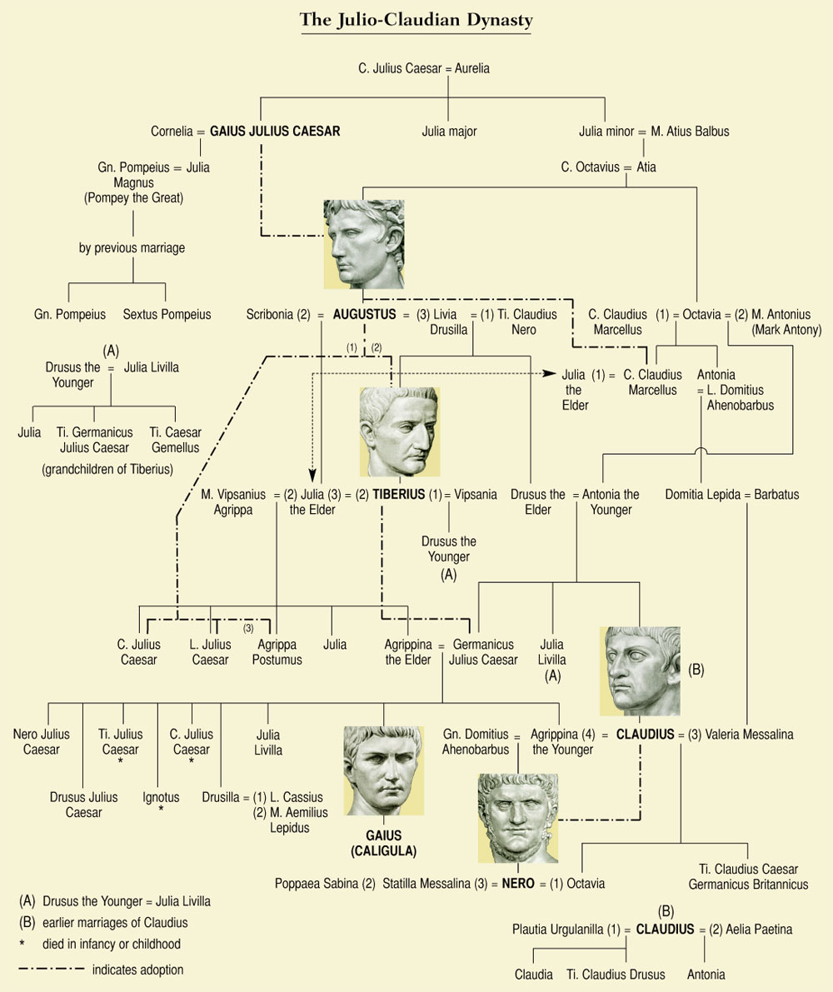**The Issue of Succession**

1. **How many wives did Augustus have during his life?**
2. **What was the name of Augustus daughter?**
3. **What relation was Claudius Marcellus to Augustus?**
4. **What relation were Gaius Julius Caesar, Lucius Julius Caesar and Agrippa Postumus to Augustus?**
5. **What according to the timeline did Augustus do to these three figures**
6. **What relation was Tiberius to Augustus before he was adopted?**
7. **Who did Tiberius adopt as his son?**

***Why was passing on his power to a successor difficult and potentially dangerous for Augustus?***

**What Happened to Augustus’s potential Successors?**

**Task –** As you read the following two sources from **Velleius Paterculus**, makes notes on the page after on who the different potential successors to Augustus were and what happened to them.

**Prescribed Source - Velleius Paterculus, 93.1–100.1**

93.1. Roughly three years before the plots of Egnatius exploded on the public scene and at about the time of the conspiracy of Murena and Caepio, exactly 52 years ago from now, Marcus Marcellus, son of Augustus’ sister, Octavia, died while still a young man, after celebrating his appointment as aedile with a most magnificent public spectacle. It had been generally assumed that if anything happened to Augustus, Marcellus would succeed him, though Marcus Agrippa would be unlikely to acquiesce too readily in such an appointment. Certainly if reports are to be believed, the lad was endowed with great natural abilities, high spirits, and a cheerful disposition, to talents to match the heavy responsibilities for which he was being groomed. 93.2. After his death, Agrippa returned from Asia and married Caesar’s daughter, Julia, Marcellus’ widow. He had withdrawn temporarily from the limelight and set out, ostensibly on a special mission for the *princeps*, but in reality (so it was rumoured) because of his private dislike of Marcellus. Julia’s record as a mother proved unfortunate, both for herself and for Rome.

94.1. At this period Tiberius Claudius Nero, now in his nineteenth year, entered public life as quaestor. He was only three years old when, as I have already recorded, his mother Livia, the daughter of Drusus Claudianus, had been given in marriage to Caesar by her own former husband, Tiberius Nero. 94.2. Thus the young man enjoyed an upbringing and training fit for a god. Since he was also distinguished lineage, good looks, and formidable physique, and had been educated to the highest level that study and his own outstanding ability could achieve, he gave early promise of the greatness to come. His very looks foreshadowed the future *princeps*. 94.3. The shortage of grain posed major problems to the new quaestor, but under his stepfather’s instruction he managed the task so skilfully both in Ostia and in Rome that his performance revealed the great potential which was later to be so fully realised.

94.4. Soon after, he was given another commission by his stepfather, to make a tour of inspection of the eastern provinces with an army and then to reorganise them. There, too, he gave ample evidence of his varied abilities, when he marched into Armenia with his legions and brought it back into the control of the Roman people, before appointing Tigranes, son of Artavasdes, as its ruler. His name and reputation so alarmed the Parthian king that he sent his own children to Caesar as hostages.

95.1. When Tiberius Nero returned home, Caesar decided to test him in a war of considerable importance, appointing, as his coadjutor, his brother Drusus Claudius, born to Livia when she was already a member of his own household. Together they launched a two-pronged attack upon the Raeti and Vindelici, 95.2. successfully storming a large number of cities and fortresses, and winning a number of pitched battles. The enemy tribes had very powerful defensive positions which were hard to approach; their numbers were considerable and their natural ferocity was a greater threat to the Roman army than their actual casualties, sustained in inflicting a total and bloody defeat upon the enemy, would suggest.

95.3 The censorship of Plancus and Paulus preceded these events and, being conducted with mutual acrimony, it brought neither honour to the incumbents themselves nor benefit to the republic. One lacked the force of personality for the office, the other the strength of character. Paulus was too slight a man for the censor’s role; Plancus should have feared it, since there was no charges he could lay or hear laid against younger men that he could fail to recognise in his own conduct, old though he was.

96.1. Then came the death of Agrippa, a *novus homo* whose innumerable achievements had won him nobility and elevated him to a position in which he was Tiberius Nero’s father-in-law. Indeed, Augustus had adopted Agrippa’s children, his own grandchildren, under the names of Gaius and Lucius. The death brought Nero and Caesar closer together, since his daughter Julia, previously married to Agrippa, now married Nero.

96.2. The war in Pannonia followed soon after. First undertaken by Agrippa and Marcus Vinicius, your grandfather, consul, and then carried on by Nero, it proved to be a major campaign, ferocious, and – because it was so close – a threat to Italy. 96.3. The tribes of Pannonia and the peoples of Dalmatia, the geography of the area and its rivers, the size and disposition of its forces, the superb and innumerable victories of our glorious general in this war – all this I shall unfold elsewhere. My present work must adhere to its overall design. With victory assured, Nero celebrated an ovation.

97.1. But while everything was going so very well in this part of the empire, in Germany s major disaster was sustained under the legate, Marcus Lollius, a man whose whole life had been devoted to the pursuit of profit rather than honourable conduct, and whose extreme depravity was matched only by his skill in concealing it. The Fifth Legion lost its standard and this brought Caesar out to the Gallic provinces from Rome. 97.2. The full weight of responsibility for the war in Germany was transferred to Drusus Claudius, Nero’s brother, a young man endowed with as many remarkable qualities as human nature can inherit or human effort develop to perfection. 97.3. Whether his talents were better suited to military action or the subtler skills of peacetime is hard to say; what can be said for certain is that his sweet nature, char, and easy-going lack of superiority towards his friends were, reportedly, inimitable, while his good looks almost matched his brother’s. Alas, though he had conquered much of Germany and shed much German blood on many a different battlefield, while he was still consul the cruel Fates snatched him away in his thirtieth year. 97.4. Thereafter the whole burden of the war devolved upon Nero, and he bore it with characteristic courage and success. He conducted a victorious campaign all over Germany without loss to the army in his care – as a general he was always particularly concerned to avoid casualties – and his conquest was so complete that he reduced the country almost to the status of a tributary province. He was then accorded a second triumph and a second consulship.

98.1. While the events described above were going on in Pannonia and Germany, a ferocious war broke out in Thrace, with all the tribes of that nation erupting into rebellion. Lucius Piso suppressed the revolt with great courage, though today (as city prefect) we see him rather as a conscientious and supremely gentle guardian of our civic order and security. 98.2. As Caesar’s legate he waged a three-year campaign and by a combination of pitched battles and sieges, in which he slaughtered vast numbers of the enemy, he returned these ferocious tribesmen to their previously peaceful state. By this achievement he restored security to Asia and peace to Macedonia. 98.3 Of this man it must be generally agreed and stated that his character is a remarkable blend of energy and gentleness, and that it would be almost impossible to fond anyone more dedicated to the cause of civil peace yet more capable of action, and when action was needed more capable of undertaking it with the utmost discretion.

99.1. Shortly afterwards Tiberius Nero, having held two consulships and enjoyed two triumphs, having been made an equal of Augustus by sharing with him the tribunician power, being now the foremost citizen of the state save only one (and that because he wished it so), our greatest general, blessed above all by fame and fortune, a second guiding light and leader of our nation. 99.2. sought from his father-in-law, who was also his stepfather, leave of absence for a period of rest after the relentless labours of recent years. It was an act of remarkable, incredible, indescribable loyalty to Caesar and though he concealed his real motives, they were soon apparent. Gaius Caesar had already assumed the toga of manhood; Lucius, too, was approaching maturity and Tiberius did not want his own distinction to rob the youngsters of the limelight at the beginning of their public careers. 99.3. An account of public reaction at the time to this proposal, the individual feelings, the tears of all who bade farewell to a great man, and how nearly the state imposed the claims of duty upon him – all this must be reserved for proper treatment elsewhere. 99.4. What I must record even in this brief summary about his seven-years sojourn to Rhodes is this: it was of such a character that all who set out for the overseas provinces, whether as proconsuls or imperial legates, interrupted their journeys to visit him; and though he was always only a private citizen (if such majesty can ever be called “private”), on meeting him they saluted him formally by lowering their *fasces*, thus declaring that his status in retirement was more distinguished than their official rank. 100.1. The whole world soon realised that Nero was no longer the city’s guardian – the Parthians broke off their alliance with us and seized Armenia; Germany rebelled, now that its conqueror’s eyes were turned elsewhere.

**Prescribed Source - Velleius Paterculus, 103.1–104.1**

But fortune, who had robbed us of our hopes of Caesar’s mighty line, had already restored to the republic her own favourite champion. Indeed Tiberius Nero’s return from Rhodes, in the year of your father Publius Vinicius’ consulship [AD 2] and before the deaths of either Gaius or Lucius, had led to an incredible outpouring of national rejoicing. 103.2 Caesar Augustus did not hesitate for long. There was no need to search for a successor; simply to choose the outstanding candidate. 103.3 And so, following the death of both young men, he now insisted on doing what he had wanted to do after the death of Lucius, but had been prevented by Nero’s own vigorous opposition because Gaius was still alive. He appointed him as partner in the tribunician power, despite his repeated objections both in private and in the senate. Then, on 27 June in the consulship of Aelius Cato and Gaius Sentius [AD 4], in the 755th year of Rome’s foundation, twenty-six years ago he adopted him.

103.4. The joy Rome knew that day, the crowds of citizens, the prayers poured out from hands raised almost into heaven, the general hope of permanent security and of an empire that would endure for ever, all these I shall hardly be able to describe even in my substantive work, let alone do justice to in this brief account. Sufficient here to have described what a blessed day it was for all. 103.5. On that day the light of hope assured shone like a beacon upon parents for their children, husbands for their marriages, on landowners for their inheritance, and all men for their future security, for peace at home and abroad, and for a tranquil civil order which exceeded men’s aspirations and was fulfilled beyond their wildest dreams. 104.1. On that same day Marcus Agrippa, the son born to Julia after Agrippa’s death, was also adopted. But in Nero’s adoption ceremony the following words, Caesar’s own were specifically added to the standard formula: “I make this adoption for the sake of Rome”.

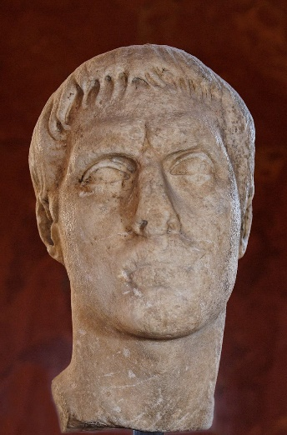

**Claudius Marcellus (42-23 BC)**

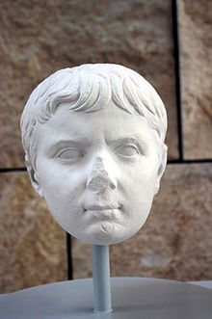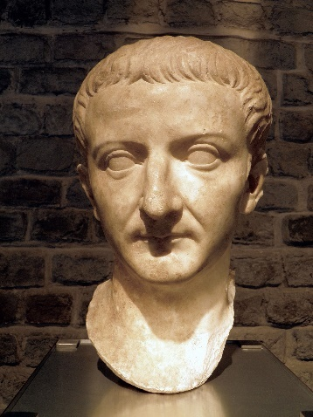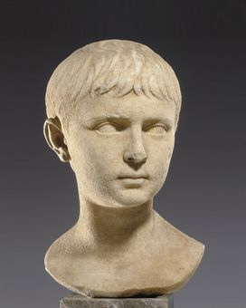

**Gaius Caesar (20 BC – AD 4)**

**Lucius Caesar (17 BC – AD 2)**

**Tiberius (42 BC – AD 37)**

**Prescribed Source - Velleius Paterculus, 2.123.1-123.2**

123.1. We come now to the moment which all Rome dreaded. Caesar Augustus had sent his grandson Germanicus to Germany to complete the final stages of the campaign, and was about to dispatch his son, Tiberius to Illyricum to reinforce the peace imposed by war. He set off for Campania with the intention of seeing Tiberius on his way and at the same time attending an athletics festival dedicated in his honour by the people of Naples. He was already aware of the advance of decrepitude and the early symptoms of declining health, but with his indomitable will he persisted in escorting his son; and having left him at Beneventum, he himself made for Nola. His health deteriorated daily and knowing very well whom he must send for if he wished to leave matters in safe hands after his death, he hurriedly recalled his son, Tiberius, who reached the side of the father of his country even sooner than expected. 123.2. Only then did Augustus declare that his anxieties were over; and reclining in the embrace of his beloved Tiberius, he commended to his care their joint endeavours and announced that he was ready for the end, if so the Fates demanded. Augustus’ breathing became less laboured when Tiberius first appeared and when he heard the voice of him that was most dear to him. But soon, since the Fates defeat all human solicitude, at the age of seventy-six, in the consulships of Pompeius and Apuleius, he returned to the elements from which he came, and gave his divine soul back to heaven.

1. **How does Paterculus present the succession of Tiberius and how reliable do you find this portrayal?**

Tiberius was far from Augustus’s first choice as a successor but by AD 14 he was left without any other option. Augustus had in fact had several successors lined up before this, all of whom, however, would die prematurely.

Firstly Augustus had marked out his nephew **Marcellus** as a successor by marrying him to his daughter Julia and then promoting him. After Marcellus’ death in 23 BC. Augustus then arranged the marriage of his daughter Julia to Agrippa. Three possible male heirs were born: **Gaius**, **Lucius** and **Agrippa Postumus**.

Augustus would regard Gaius and Lucius as his potential successors and both were given the title ***princeps iuventutis*** (leader of the youth) by the senate. Both were also made consul ‘designate’ at the ages of fifteen meaning that they would become full consuls when they turned nineteen. This was celebrated in the coin below:

**Prescribed Source – Aureus of Gaius and Lucius, 2 BC – AD 11**

**Obv.:** Augustus, “ Caesar Augustus, Son of the Deified, Father of the Fatherland

**Rev.:** Gaius and Lucius standing veiled, with shields, spears and priestly symbols between them; “Gaius and Lucius Caesar, Sons of Augustus, Consuls designate, Leaders of the Younger Generation

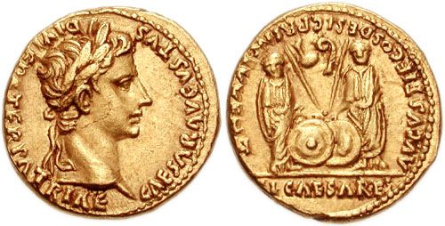

**Prescribed Source – Tacitus *Annals*, 1.3.2**

3.2 For he adopted Agrippa’s sons, Gaius and Lucius, into the family of the Caesars, and, before they had even laid aside their boy’s togas, he had been shamelessly eager, despite a parade of refusal, for them to be named *princeps* *iuventutis* and to be designated consuls.

**Prescribed Source - Suetonius, *Augustus* 64**

64. Julia bore Agrippa three sons, Gaius, Lucius and Agrippa, and two daughters, Julia and Agrippina. Augustus married this Julia to the son of Lucius Paulus the censor, and Agrippina to his sister’s grandson Germanicus. He adopted Gaius and Lucius and brought them up in his own home, after buying them from Agrippa in a symbolic sale. He trained his new sons in the business of government while they were still young, sending them as commander-in-chiefs to the provinces when only consuls-elect. The education of his daughter and granddaughters included even spinning and weaving; they were forbidden to say or do anything, either publicly or in private, that could not decently figure in the imperial daybook. He took severe measures to prevent them forming relationships without his consent, and once wrote to Lucius Vinicius, a young man of good family and conduct, ‘You were very ill mannered to visit my daughter at Baiae.’ Augustus gave his grandsons reading, writing and other simple lessons, for the most part acting as their tutor himself, and was at pains to make them model their handwriting on his own. Whenever they dined in his company he had them sit on the lowest couch, and while accompanying him on his travels they rode either ahead of his carriage or one on each side of it.

Augustus’ intended succession, however, was changed radically when both Gaius and Lucius **died** within the space of a few months of each other. Augustus then resorted to adopting his stepson **Tiberius**. Augustus would make Tiberius **co-tribune** indicating that he was the successor and would also show this in coins:

**Prescribed Source – Aureus of Tiberius, 13-14 AD**

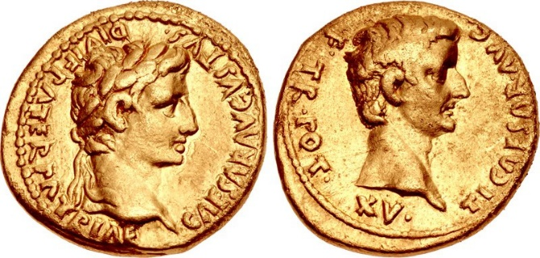

**Obv.:** Augustus, “Caesar Augustus, Son of the Deified, Father of the Fatherland

**Rev.:** Tiberius; “Tiberius Caesar, Son of Augustus, Tribunician power for the fifteenth time

The message from this coin was simple – Tiberius was Augustus’ successor. Augustus was apparently thinking even more long-term than this as, according to Tacitus, Tiberius also adopted his nephew **Germanicus** in AD 4 to create an ongoing line of succession:

**Prescribed Source - Tacitus, *Annals,* 4:57**

**Germanicus considered as Augustus’ heir**

Germanicus, Augustus’ great-nephew, was universally admired and Augustus had toyed with the idea of making him the ruler of the empire. But he was dissuaded by the entreaties of his wife Livia, and instead adopted Tiberius, while Tiberius adopted Germanicus.

**Prescribed Source - Ovid, *Fasti* 1.1–14**

Latium’s annual calendar, its times and seasons and their source,

The signs celestial that rise and sink below the earth – these are my song.

Caesar Germanicus, look kindly on my labour and receive

This dedication, playing the helmsman to my timid craft.

Though slight my compliment, turn not away; it is a gift

Of obligation vowed to yourself; approach and bless it with divinity.

Here you will read of holy rituals dredged from the annals of the past,

And how by its own peculiar circumstance each day is marked.

Here too you will find your family’s own domestic festivals;

Oft of your father will you read, oft of your grandsire too.

Their ornaments triumphal which adorn my painted calendar,

These will be yours one day – your brother Drusus’ too.

Let others sing of Caesar and his wars; Caesar’s altars rather

Are my theme, and all the days he added to the sacred calendar.

**Key Question –** From what you have studied so far, how successful do you think Augustus was in establishing a clear line of succession? Explain your answer fully and use **at least two different ancient sources.**

**How important were Agrippa, Tiberius and Livia in Augustus’ Regime?**

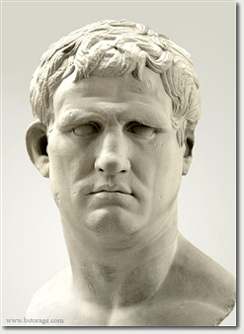**Case Study One - AGRIPPA**

**RECAP:** Can you remember what role Agrippa had played in helping Octavian secure power?

Until his death in 12 BC, Agrippa was Augustus’ right-hand-man. He was given tribunician power in 18 BC and again in 13 BC, singling him out as Augustus closest ally. As we have already seen, Agrippa was also given control of important building projects in Rome such as the construction and improvement of aqueducts. The clearest sign of Agrippa’s importance to Augustus was the Emperor’s decision to arrange the marriage between his daughter Julia and Agrippa. It was their children – Gaius, Lucius and Agrippa Postumus – that Augustus would look to succeed him.

**Prescribed Source – Augustus and Agrippa as Tribunes, *denarius*, 13 BC**

**Obv.:** Bare head of Augustus “Caesar Augustus”

**Rev.:** Augustus and Agrippa wearing togas seated on a tribune’s bench

1. **What do you think this coin was meant to celebrate?**
2. **What impression does it give you of Agrippa’s role?**

A further indication of the importance of Agrippa to Augustus is found in the funeral speech he delivered in 12 BC when Agrippa died:

**Prescribed Source – Augustus’ funeral oration in praise of Agrippa, 12 BC (*Laudatio Agrippae)***

…The tribunician power was granted to you for a period of five years in accordance with a senatorial decree, when the Lentuli were consuls, and granted again for another Olympiad when Tiberius Nero and Quinctilius Varus your sons-in-law were consuls. And it was ratified by law that to whatever provinces the public affairs of Rome might drag you, no-one’s power there should be greater than yours. You were raised to the highest position with our support and through your own virtues by the agreement of all men

[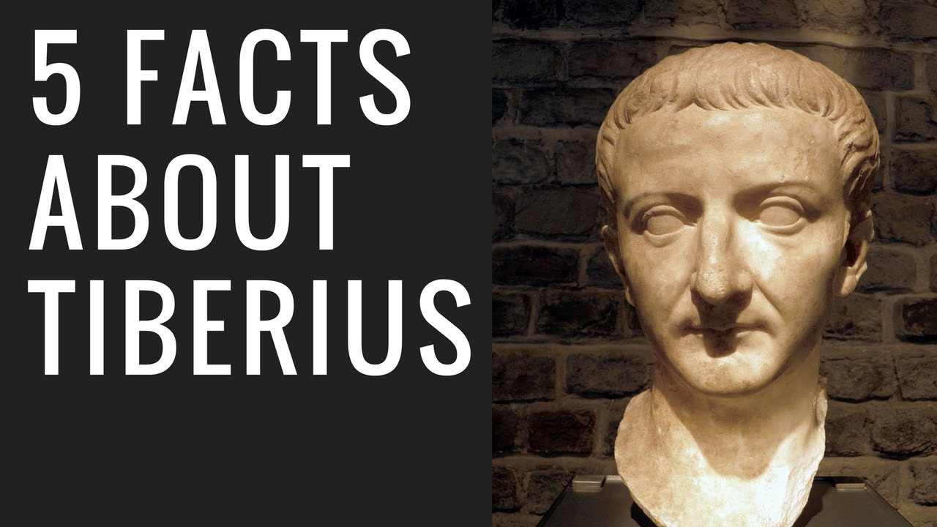](https://www.youtube.com/watch?v=setQeuKyc6Q)**Case Study Two – TIBERIUS**

**Prescribed Source - Tacitus, *Annals,* 3:29**

At about this time Tiberius commended Germanicus’ son Nero, to the favour of the senate when he had only just come of age and asked that he be exempt from service on the Board of Twenty and allowed to stand for the quaestorship five years earlier than the law allowed. The request was greeted with a degree of mockery, but Tiberius cited as a precedent the similar concession gained by Augustus for himself and his brother. Yet even in those days I have little doubt that such a request would have been met with ridicule, albeit concealed. But those at least were the early days of the Caesars’ imperial power, when tradition and precedent carried rather more weight; Augustus’ ties of kinship, furthermore, as stepfather to Tiberius, had been significantly less close than those of Tiberius, as grandfather to his grandson Nero.

1. **What clue do you get from this source about how Tiberius rose to power in Rome?**
2. **What appears to be Tacitus’ view on Augustus’ rule?**

**Prescribed Source - Velleius Paterculus, 93.1–100.1**

93.1. Roughly three years before the plots of Egnatius exploded on the public scene and at about the time of the conspiracy of Murena and Caepio, exactly 52 years ago from now, Marcus Marcellus, son of Augustus’ sister, Octavia, died while still a young man, after celebrating his appointment as aedile with a most magnificent pubic spectacle. It had been generally assumed that if anything happened to Augustus, Marcellus would succeed him, though Marcus Agrippa would be unlikely to acquiesce too readily in such an appointment. Certainly if reports are to be believed, the lad was endowed with great natural abilities, high spirits, and a cheerful disposition, to talents to match the heavy responsibilities for which he was being groomed. 93.2. After his death, Agrippa returned from Asia and married Caesar’s daughter, Julia, Marcellus’ widow. He had withdrawn temporarily from the limelight and set out, ostensibly on a special mission for the *princeps*, but in reality (so it was rumoured) because of his private dislike of Marcellus. Julia’s record as a mother proved unfortunate, both for herself and for Rome.

94.1. At this period Tiberius Claudius Nero, now in his nineteenth year, entered public life as quaestor. He was only three years old when, as I have already recorded, his mother Livia, the daughter of Drusus Claudianus, had been given in marriage to Caesar by her own former husband, Tiberius Nero. 94.2. Thus the young man enjoyed an upbringing and training fit for a god. Since he was also distinguished lineage, good looks, and formidable physique, and had been educated to the highest level that study and his own outstanding ability could achieve, he gave early promise of the greatness to come. His very looks foreshadowed the future *princeps*. 94.3. The shortage of grain posed major problems to the new quaestor, but under his stepfather’s instruction he managed the task so skilfully both in Ostia and in Rome that his performance revealed the great potential which was later to be so fully realised.

94.4. Soon after, he was given another commission by his stepfather, to make a tour of inspection of the eastern provinces with an army and then to reorganise them. There, too, he gave ample evidence of his varied abilities, when he marched into Armenia with his legions and brought it back into the control of the Roman people, before appointing Tigranes, son of Artavasdes, as its ruler. His name and reputation so alarmed the Parthian king that he sent his own children to Caesar as hostages.

95.1. When Tiberius Nero returned home, Caesar decided to test him in a war of considerable importance, appointing, as his coadjutor, his brother Drusus Claudius, born to Livia when she was already a member of his own household. Together they launched a two-pronged attack upon the Raeti and Vindelici, 95.2. Successfully storming a large number of cities and fortresses, and winning a number of pitched battles. The enemy tribes had very powerful defensive positions which were hard to approach; their numbers were considerable and their natural ferocity was a greater threat to the Roman army than their actual casualties, sustained in inflicting a total and bloody defeat upon the enemy, would suggest.

95.3 The censorship of Plancus and Paulus preceded these events and, being conducted with mutual acrimony, it brought neither honour to the incumbents themselves nor benefit to the republic. One lacked the force of personality for the office, the other the strength of character. Paulus was too slight a man for the censor’s role; Plancus should have feared it, since there was no charges he could lay or hear laid against younger men that he could fail to recognise in his own conduct, old though he was.

96.1. Then came the death of Agrippa, a *novus homo* whose innumerable achievements had won him nobility and elevated him to a position in which he was Tiberius Nero’s father-in-law. Indeed, Augustus had adopted Agrippa’s children, his own grandchildren, under the names of Gaius and Lucius. The death brought Nero and Caesar closer together, since his daughter Julia, previously married to Agrippa, now married Nero.

96.2. The war in Pannonia followed soon after. First undertaken by Agrippa and Marcus Vinicius, your grandfather, consul, and then carried on by Nero, it proved to be a major campaign, ferocious, and – because it was so close – a threat to Italy. 96.3. The tribes of Pannonia and the peoples of Dalmatia, the geography of the area and its rivers, the size and disposition of its forces, the superb and innumerable victories of our glorious general in this war – all this I shall unfold elsewhere. My present work must adhere to its overall design. With victory assured, Nero celebrated an ovation.

97.1. But while everything was going so very well in this part of the empire, in Germany s major disaster was sustained under the legate, Marcus Lollius, a man whose whole life had been devoted to the pursuit of profit rather than honourable conduct, and whose extreme depravity was matched only by his skill in concealing it. The Fifth Legion lost its standard and this brought Caesar out to the Gallic provinces from Rome. 97.2. The full weight of responsibility for the war in Germany was transferred to Drusus Claudius, Nero’s brother, a young man endowed with as many remarkable qualities as human nature can inherit or human effort develop to perfection. 97.3. Whether his talents were better suited to military action or the subtler skills of peacetime is hard to say; what can be said for certain is that his sweet nature, char, and easy-going lack of superiority towards his friends were, reportedly, inimitable, while his good looks almost matched his brother’s. Alas, though he had conquered much of Germany and shed much German blood on many a different battlefield, while he was still consul the cruel Fates snatched him away in his thirtieth year. 97.4. Thereafter the whole burden of the war devolved upon Nero, and he bore it with characteristic courage and success. He conducted a victorious campaign all over Germany without loss to the army in his care – as a general he was always particularly concerned to avoid casualties – and his conquest was so complete that he reduced the country almost to the status of a tributary province. He was then accorded a second triumph and a second consulship.

98.1. While the events described above were going on in Pannonia and Germany, a ferocious war broke out in Thrace, with all the tribes of that nation erupting into rebellion. Lucius Piso suppressed the revolt with great courage, though today (as city prefect) we see him rather as a conscientious and supremely gentle guardian of our civic order and security. 98.2. As Caesar’s legate he waged a three-year campaign and by a combination of pitched battles and sieges, in which he slaughtered vast numbers of the enemy, he returned these ferocious tribesmen to their previously peaceful state. By this achievement he restored security to Asia and peace to Macedonia. 98.3 Of this man it must be generally agreed and stated that his character is a remarkable blend of energy and gentleness, and that it would be almost impossible to find anyone more dedicated to the cause of civil peace yet more capable of action, and when action was needed more capable of undertaking it with the utmost discretion.

99.1. Shortly afterwards Tiberius Nero, having held two consulships and enjoyed two triumphs, having been made an equal of Augustus by sharing with him the tribunician power, being now the foremost citizen of the state save only one (and that because he wished it so), our greatest general, blessed above all by fame and fortune, a second guiding light and leader of our nation. 99.2. Sought from his father-in-law, who was also his stepfather, leave of absence for a period of rest after the relentless labours of recent years. It was an act of remarkable, incredible, indescribable loyalty to Caesar and though he concealed his real motives, they were soon apparent. Gaius Caesar had already assumed the toga of manhood; Lucius, too, was approaching maturity and Tiberius did not want his own distinction to rob the youngsters of the limelight at the beginning of their public careers. 99.3. An account of public reaction at the time to this proposal, the individual feelings, the tears of all who bade farewell to a great man, and how nearly the state imposed the claims of duty upon him – all this must be reserved for proper treatment elsewhere. 99.4. What I must record even in this brief summary about his seven-years sojourn to Rhodes is this: it was of such a character that all who set out for the overseas provinces, whether as proconsuls or imperial legates, interrupted their journeys to visit him; and though he was always only a private citizen (if such majesty can ever be called “private”), on meeting him they saluted him formally by lowering their *fasces*, thus declaring that his status in retirement was more distinguished than their official rank. 100.1. The whole world soon realised that Nero was no longer the city’s guardian – the Parthians broke off their alliance with us and seized Armenia; Germany rebelled, now that its conqueror’s eyes were turned elsewhere.

**Tiberius’ Rise to Power:**

**Task:** Produce a simple timeline, using the previous source from Paterculus, of the rise to power of Tiberius. You do not need the precise date of each event but try to sort these into the correct order below.

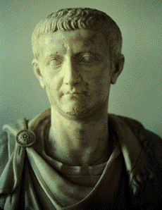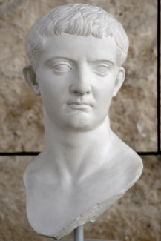

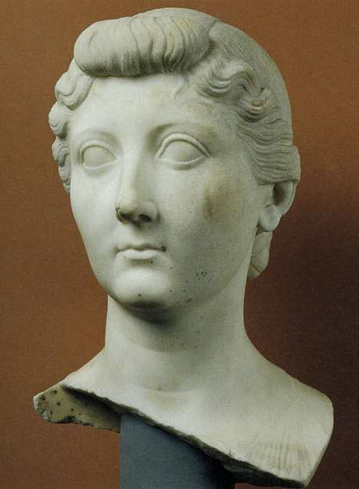**Case Study Three – LIVIA**

**RECAP**: Look back at the Julio-Claudian family tree on p.17 and answer:

* What was Livia’s full name?
* Which number wife of Augustus was she?
* What were the names of her two sons?

Augustus married Livia in 39 BC, he is reported to have divorced his then second wife Scribonia on the same day that she gave birth to his daughter Julia. Livia already had two children by the time she married the then Octavian, one of whom was Tiberius. She would go on to play a central role during the principate and has been presented as a force at work behind the scenes.

The level of Livia’s influence is made clear by the write Seneca when he gives an account of the Cinna conspiracy against Augustus in 16 BC:

**Prescribed Source - Younger Seneca, *On Clemency*, 1.9.2–1.9.12**

**Cinna’s plot to assassinate Augustus (16 BC)**

9.2. But when he was in his forties and staying in Gaul, evidence was laid before him that Lucius Cinna, not one of our most sparkling intellects, was plotting against him. He was told when, where, and how he planned to make the attempt. One of the conspirators passed on the information. 9.3. Augustus decided that he must punish him and called a meeting of his council of friends. It cost him a night’s sleep as he pondered the implications of condemning a young nobleman of impeccable reputation (apart from this one act), who was also the grandson of Gnaeus Pompey. By this stage of his career he was incapable of killing even one man. Yet this was the same Caesar to whom Mark Anthony in earlier days had dictated the terms of the proscriptions over dinner.

9.4. As he agonised over the decision, he gave vent to many different and self-contradictory comments… 9.6. In the end it was his wife, Livia, who interrupted him. “will you listen to a woman’s advice?” she said. “Do what the doctors do. When conventional remedies fail, they try their opposites. Severity has got you nowhere. Lepidus followed Salvidienus; Murena followed Lepidus, Caepio followed Murena; Egnatius followed Caepio – quite apart from all the others whose reckless audacity scarcely merits mention. Now is the time for an experiment: see if clemency gets you any further. Pardon Lucius Cinna. He has been arrested. He cannot harm you further; but he could do wonders for your reputation.”

9.7. Enchanted to have found himself such an excellent source of advice, he thanked his wife and gave immediate orders countermanding the invitation to his friends to attend the council. Instead he summoned Cinna into his presence alone, ordered everyone else out of the room, and gave instructions for a second chair to be brought for him. “First of all,” he said, “I want no interruptions while I am speaking; no protests at my words. You will be given ample time to speak in due course. 9.8. When I found you in my enemies’ camp, an opponent not so much by choice as by birth, I spared your life and let you keep all your family estates. Today you are so successful and so rich that your conquerors are envious of the man they conquered. You were a candidate for the priesthood. I passed over many whose fathers had fought by my side to give it to you. Though I have done you such favours, you have decided to murder me.”

9.9. At this Cinna exclaimed that such madness was utterly alien to his thoughts. “You are breaking our bargain, Cinna,” replied Augustus. “We agreed: no interruptions, I say again, you are preparing my assassination.” He then listed the place, the accomplices, the date, and the plan for the assassination, and the name of the one who would wield the dagger…

9.11. I do not want to fill up the bulk of this book repeating the whole of the speech which, by common consent, is said to have gone on for more than two hours. This was the only punishment which Augustus intended to impose, and he wanted to make the most of it. “It is your life, Cinna, “he said, “which I am giving back to you for the second time. Last time you were my military opponent; now you are a conspirator and a parricide. But let this day mark the beginning of our friendship. Let us do battle once more; but this time to see which of us will show greater good faith – I in my gift of life to you; you in your debt for your life to me”. 9.12. After that he even gave Cinna a consulship, complaining only that he had not had the courage to stand as a candidate. He found him a truly loyal and close friend, and became his only heir. He was never again the target of a plot from any source.

1. **Summarise in your own words what Livia’s role was in the Cinna conspiracy and how she is presented by Seneca in this source**

Other sources, however, portray Livia much more negatively, although it is difficult to tell how much this based on fact or on the writers’ own prejudices against powerful women. One example of this is Tacitus:

**Prescribed Source - Tacitus, *Annals,* 1.3.3**

3.3 Agrippa died, and both Lucius Caesar, on his way to join the army in Spain, and Gaius, on his way home from Armenia while still weakened by a wound, were carried off either by a death fated to be premature or by the treachery of their step-mother, Livia. With Drusus long since dead, Nero was Augustus’ only surviving step-son, and everything now converged upon him. He was adopted as Augustus’ son, his colleague in *imperium*, and partner in the tribunician power, and was paraded before all the armies, with his mother no longer scheming behind the scenes, but giving open encouragement.

**Prescribed Source - Tacitus, *Annals,* 1.10.5**

10.5 Nor was Augustus’ household spared. There was the abduction of Nero’s wife and that ludicrous consultation with the priests as to whether she could legally marry while pregnant but not yet delivered of her child; the extravagant lifestyle of … Vedius Pollio; and finally there was Livia, an oppressive mother to the state and an oppressive stepmother to the house of the Caesars.

1. **What image of Livia do these two sources from Tacitus create?**

**Who was the most important figure during the rule of Augustus – Agrippa, Tiberius or Livia?**

(When answering this question you must use at least three primary sources)

**The End of Augustus’ Rule**

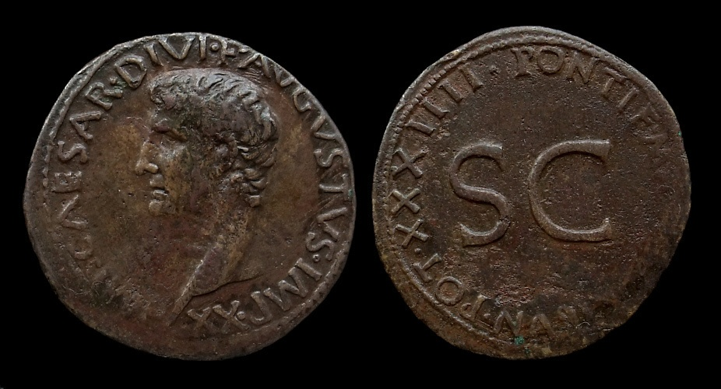

**Prescribed Source – Coin portrait of Augustus, aged 73 AD 11-12 (J24)**

**Obv.:** Augustus, “Imperator Caesar Augustus, Son of the Deifie, hailed victorious general twenty times”

**Rev.:** SC (by decree of the Senate), “Pontifex Maximus, Tribunician power for the thity-fourth time’

***How does Augustus appear at the end of his reign in this coin?***

**KEY DEBATE – To what extent did Augustus restore the Republic?**

|  |  |
| --- | --- |
| **Evidence that Augustus *did* restore the Republic** | **Evidence that Augustus *did not* restore the Republic** |
|  |  |
| **Which ancient author(s) supports this view?** | **Which ancient author(s) supports this view?** |

**KEY DEBATE – To what extent did Augustus restore the Republic?**

**TASK –** read the following two sources and add any extra detail to the previous table:

**Prescribed Source – Suetonius, *Augustus*, 28**

28. Twice Augustus seriously thought of restoring the republic: immediately after the fall of Antony, when he remembered that Antony had often accused him of being the one obstacle to such a change, and again when he could not shake off an exhausting illness. He then actually summoned the chief magistrates and the Senate to his house and gave them a faithful account of the military and financial state of the empire. On reconsideration, however, he decided that to divide the responsibilities of government among several hands would be to jeopardize not only his own life but also national security; so he did nothing. The results were almost as good as his intentions, which he expressed from time to time and even published in an edict: ‘May I be privileged to build firm and lasting foundations for the commonwealth. May I also achieve the reward to which I aspire: that of being the author of the best possible constitution, and of carrying with me, when I die, the hope that these foundations will abide secure.’ And, indeed, he achieved this success, having taken great trouble to prevent his political system from causing any individual distress.

Aware that the city was architecturally unworthy of its position as capital of the empire, besides being vulnerable to fire and river floods, Augustus so improved its appearance that he could justifiably boast, ‘I found Rome built of bricks, I leave it clothed in marble.’ He also used as much foresight as could have been expected in guarding against future disasters.

**Prescribed Source – Suetonius, *Augustus*, 28**

9.1 After this there was much discussion about Augustus. Most people wondered at such trifles as the coincidence that the day on which he had once assumed *imperium* was the same as that on which he had died; and that he had departed his life at Nola in the same house and bedroom as his father Octavius. 9.2 They remarked also on the number of consulships, which matched the combined totals of Valerius Corvus and Gaius Marius; on the thirty-seven consecutive years of his tribunician power; on the title of *imperator* gained on twenty-one occasions; and on the other honours, multiple or novel. 9.3 Among those of a more thoughtful turn of mind, however, his life was either extolled or criticised. One school of thought argued that duty to his father and the needs of the republic, in which there was then no place for law, had driven him to civil war, a course which none could prepare for or execute by honourable means. 9.4 While seeking vengeance on his father’s murderers, he had indeed made many concessions to Antony, many to Lepidus. Once the latter had lapsed into the inertia of senility and the former became corrupted by his own vices, there remained no other solution to the discords of the fatherland than that it should be ruled over by one man. 9.5 Yet he had ordered the republic not as a kingdom, nor as a dictatorship, but under the name of *princeps*; the boundaries of the empire were now defended by the Ocean and by mighty rivers; legions, provinces, fleets and the general administration were all now co-ordinated; towards citizens the law was observed, restraint towards allies. The city itself was now magnificently adorned; only on a few occasions had force been used to guarantee peace and quiet for the rest.

*Note –this account is of the events after Augustus’ death as people debated his rule and the power he had taken*

**Primary Sources**

|  |  |  |  |  |
| --- | --- | --- | --- | --- |
| **Source** | **Date** | **Nature** | **Reliable** | **Unreliable** |
| **Suetonius** |  |  |  |  |
| **Tacitus** |  |  |  |  |
| **Dio** |  |  |  |  |
| **Horace** |  |  |  |  |
| **Virgil** |  |  |  |  |
| **Strabo** |  |  |  |  |
| **Ovid** |  |  |  |  |
| **Pliny** |  |  |  |  |
| **Macrobius** |  |  |  |  |
| **Velleius Paterculus** |  |  |  |  |
| **Younger Seneca** |  |  |  |  |
| ***Res Gestae Divi Augusti*** |  |  |  |  |

**KEY TERMS**

|  |  |
| --- | --- |
| **Term** | **Description** |
| ***Cursus Honorum*** |  |
| ***Consilium Principis*** |  |
| ***Princeps Iuventutis*** |  |
|  |  |
|  |  |
|  |  |
|  |  |
|  |  |

**KEY FIGURES**

|  |  |
| --- | --- |
| **nAME** | **Description** |
| **Marcus Agrippa** |  |
| **Tiberius** |  |
| **Gaius Caesar** |  |
| **Lucius Caesar** |  |
| **Agrippa Postumus** |  |
| **Livia** |  |
| **Claudius Marcellus** |  |
|  |  |
|  |  |
|  |  |
|  |  |
|  |  |

**The Roman Empire**

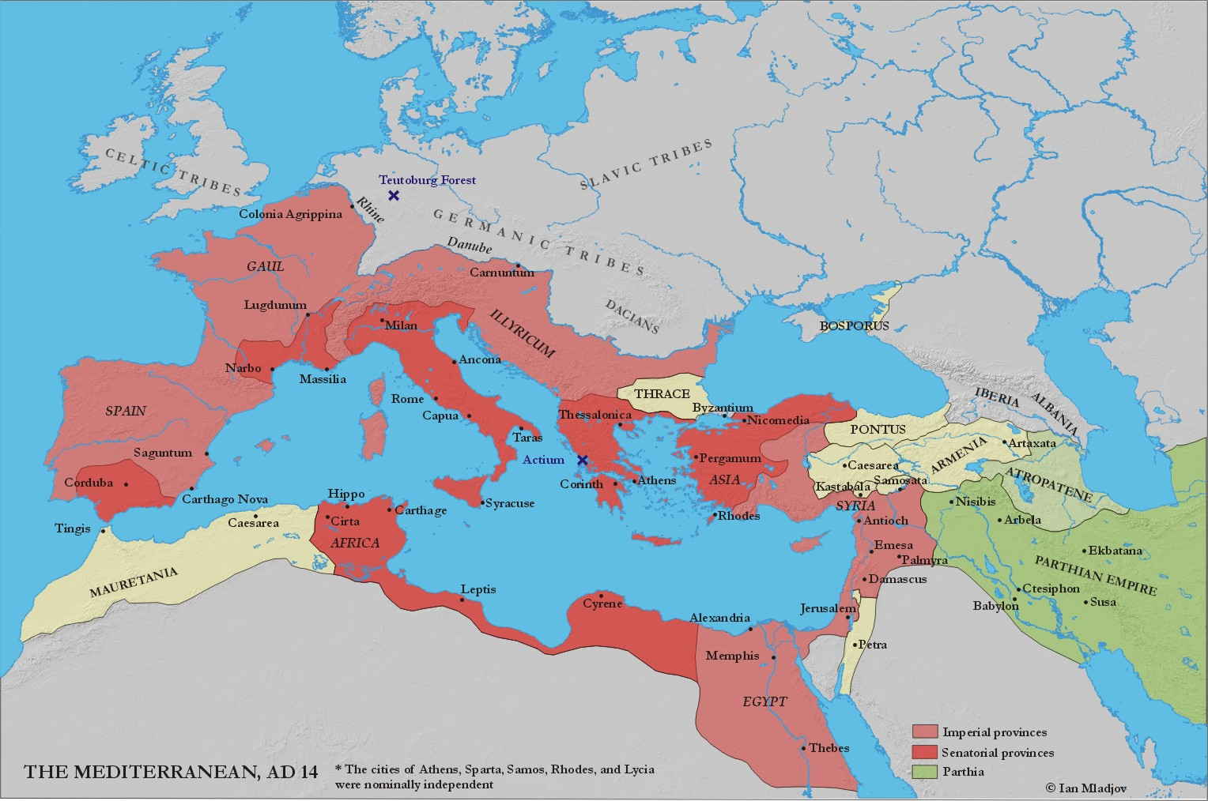



HOMEWORK RECORD

|  |  |  |  |
| --- | --- | --- | --- |
| ***Date set*** | ***Details*** | ***Date Due*** | ***Done?*** |
|  |  |  |  |
|  |  |  |  |
|  |  |  |  |
|  |  |  |  |
|  |  |  |  |
|  |  |  |  |
|  |  |  |  |
|  |  |  |  |
|  |  |  |  |
|  |  |  |  |