

NAME:

**Ancient History**

**Period Study: The Julio-Claudian Emperors, 31 BC – AD 68**

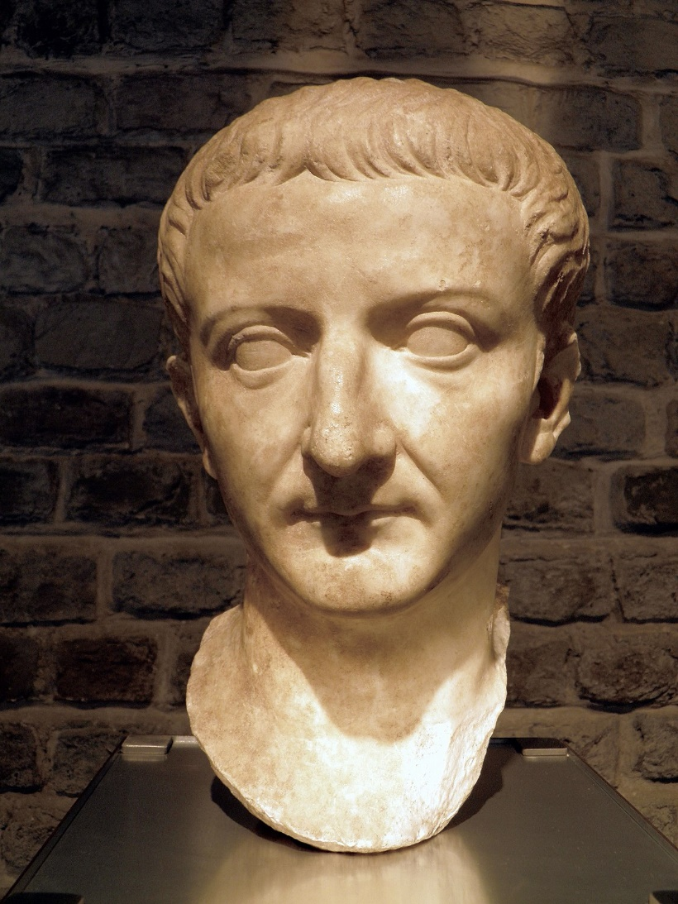**TOPIC 2: Tiberius, AD 14 - 37**

***This booklet covers the following topics:***

* The views of the ancient sources on Tiberius
* Germanicus and Sejanus
* Tiberius’ attitude towards religion
* Conspiracies against Tiberius
* The treason trials
* Tiberius’ relations with the Senate, equestrians and plebs

**Suggested Reading**

**History Today Articles (go to** [www.historytoday.com](http://www.historytoday.com) **username= Godalming; password= history)**

# Augustus Down the Centuries

By [John M. Carter](http://www.historytoday.com/author/john-m-carter)

Published in [History Today](http://www.historytoday.com/archive/history-today/latest) [Volume 33 Issue 3 March 1983](http://www.historytoday.com/archive/history-today/volume-33-issue-3-march-1983)

# The Problem of Augustus

By [Michael Grant](http://www.historytoday.com/author/michael-grant)

Published in [History Today](http://www.historytoday.com/archive/history-today/latest) [Volume 3 Issue 11 November 1953](http://www.historytoday.com/archive/history-today/volume-3-issue-11-november-1953)

# The Many and the Few: Augustus, Tiberius and Roman Ideals

By [T.P. Wiseman](http://www.historytoday.com/author/tp-wiseman)

Published in [History Today](http://www.historytoday.com/archive/history-today/latest) [Volume 64 Issue 8 August 2014](http://www.historytoday.com/archive/history-today/volume-64-issue-8-august-2014)

# Augustus and Cleopatra

By [Christopher Smith](http://www.historytoday.com/author/christopher-smith)

Published in [History Today](http://www.historytoday.com/archive/history-today/latest) [Volume 64 Issue 2 February 2014](http://www.historytoday.com/archive/history-today/volume-64-issue-2-february-2014)

# The Praetorian Guard

By [Geoffrey Powell](http://www.historytoday.com/author/geoffrey-powell)

Published in [History Today](http://www.historytoday.com/archive/history-today/latest) [Volume 18 Issue 12 December 1968](http://www.historytoday.com/archive/history-today/volume-18-issue-12-december-1968)

# Women in Imperial Rome

By [J.P.V.D. Balsdon](http://www.historytoday.com/author/jpvd-balsdon)

Published in [History Today](http://www.historytoday.com/archive/history-today/latest) [Volume 9 Issue 8 August 1959](http://www.historytoday.com/archive/history-today/volume-9-issue-8-august-1959)

# The Roman Legions and their Officers

By [Geoffrey Powell](http://www.historytoday.com/author/geoffrey-powell)

Published in [History Today](http://www.historytoday.com/archive/history-today/latest) [Volume 17 Issue 11 November 1967](http://www.historytoday.com/archive/history-today/volume-17-issue-11-november-1967)

**Textbooks**

* R. Cromarty, J. Harrison & S. Matthews, *OCR Ancient History, Component 2: Rome*, Bloomsbury, 2018 (Due to be published February 2018)

**Books in the ILC**

* R. L. Fox, The Classical World: an Epic History of Greece and Rome, Penguin, 2006
* M. Beard, *S.P.Q.R.: A History of Rome*, Profile Books, 2015
* T. Holland, *Dynasty,* Abacus, 2016
* P. Mantin & R. Pulley, *The Roman World, From Republic to Empire,* Cambridge, 1993
* T. Martin, *Ancient Rome: From Romulus to Justinian,* Yale, 2013

**Useful Websites**

* <https://www.bloomsbury.com/cw/ocr-as-and-a-level-ancient-history/?pid=330294> (A companion website for the OCR Ancient History textbook – good selection of wider reading and revision quizzes)
* <http://www.ancient.eu/>
* <http://www.livius.org/>
* [www.ocr.org.uk](http://www.ocr.org.uk)

**Podcasts**

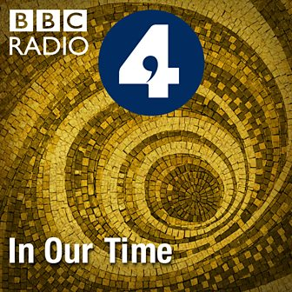Julius Caesar - [www.bbc.co.uk/programmes/b04jlygw](http://www.bbc.co.uk/programmes/b04jlygw)

The Augustan Age - <http://www.bbc.co.uk/programmes/b00ktfmw>

Rome and European Civilization **-** [www.bbc.co.uk/programmes/p00547ms](http://www.bbc.co.uk/programmes/p00547ms)

Tacitus and the Decadence of Rome - <http://www.bbc.co.uk/programmes/b00cdtxp>

Roman Satire - [www.bbc.co.uk/programmes/b00s0gwd](http://www.bbc.co.uk/programmes/b00s0gwd)

*For help in accessing the ebook catalogue on dawsonera, go to the ILC’s page on Godalming Online and read their guide to accessing ebooks.*

*Ebooks can be read using your college log on details whilst in college or at home.*

**ANCIENT HISTORY LUNCHTIME SUPPORT**

**If you need any help in Ancient History going over content, completing homework, attempting assessed questions or preparing for exams, there will be a lunchtime support session each Wednesday between 1 and 2 pm in room 211.**

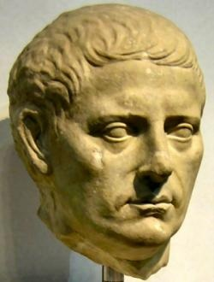 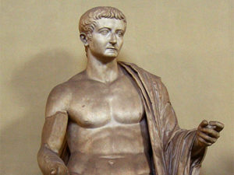**How is Tiberius Portrayed by the Ancient Sources?**

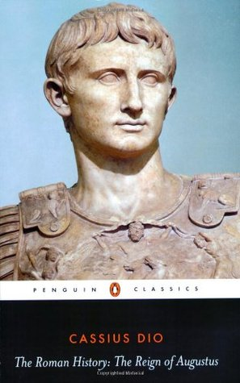

**Dio, *Roman History***



**Velleius Paterculus, *History of Rome***

**Suetonius*, Life of Tiberius***

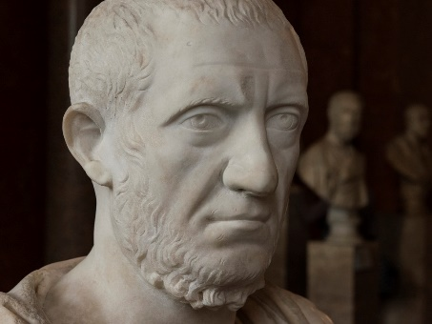

**Tacitus*, Annals***

**Prescribed Source - Tacitus, *Annals*, 1.10.7**

10.7 He [Augustus] had not even appointed Tiberius as his successor from affection or from concern for the republic but because, when he looked at his arrogance and cruelty, he hoped that the odious comparison would redound to his own greater glory. Only a few years before, when Augustus had been requesting from the senate a renewal of the tribunician power for Tiberius, in the midst of a complimentary speech he had included, as if to excuse them, certain criticisms of his deportment, style of dress, and way of life.

**Prescribed Source – Suetonius, *Tiberius* 29-33**

29. Tiberius showed an almost excessive courtesy when addressing both individual senators and the Senate as a whole. Once, on the floor of the Senate House, he found himself disagreeing with Quintus Haterius, and said, ‘You will, I hope, forgive me if I trespass on my rights as a senator by speaking rather more plainly than I should.’ Then he turned to the House, saying, ‘Let me repeat, gentlemen of the Senate, that a right-minded and true-hearted *princeps*, who has had as much power placed in his hands as you have placed in mine, should regard himself as the servant of the Senate, and often of the people as a whole, and sometimes even of private citizens. I do not regret this view, because I have always found you to be generous, just and indulgent masters.’

30. He even gave the appearance or restoring popular liberties by seeing that the Senate and magistrates enjoyed their former dignity and authority. He referred all public business, however important or unimportant, to the senators, asking for advice in every matter that concerned the national revenue, the allocation of monopolies and the construction or repair of public buildings; he even consulted them about the drafting or disbanding of troops, the stationing of legions and auxiliaries, the extension of military commands, the choice of generals to conduct particular campaigns, and how to answer letters from foreign rulers. When a cavalry officer was accused of robbery with violence, Tiberius ordered him to plead his case before the Senate. He always entered the Senate House unattended, except for one day when he was sick and carried in on a litter – and even then he dismissed his bearers immediately.

31. If decrees were passed in defiance of his wishes, he abstained from complaint – for example, when he had insisted that magistrates-elect should stay at home and attend to business, but the Senate allowed a praetor-elect to travel over-seas with free use of official transport and lodging. And on expressing the opinion that a road could rightfully be made at Trebiae with a legacy bequeathed to the city for building of a new theatre, he was overruled and the testator’s intentions were respected. Once it happened that the Senate put a motion to the vote; Tiberius sided with the minority, and not a soul followed him. He left  a great deal of public business to the magistrates and the ordinary processes of the law; the consuls grew so important again that an African embassy came before them, complaining that they could make no headway with Caesar, to whom they had been sent. Nor was this at all remarkable; everyone knew that he even stood up when the consuls appeared, and made way on meeting them in the streets.

32. Some generals of consular rank earned a rebuff by addressing their dispatches to Tiberius rather than the Senate and asking him to approve awards of military honours, as though they were not entitled to give these at their own discretion. He also congratulated a praetor who, when he assumed office, revived the ancient custom of publicly eulogizing his own ancestors, and he attended the funerals of important citizens to the extent of witnessing their cremation. Tiberius displayed a like moderation in dealing with men of lesser rank. He summoned to Rome the Rhodian magistrate wo had sent him a public report without adding the usual complimentary formula of prayers for his health, yet did not reprimand them when they appeared; he merely instructed them to repair the omission and sent them home again. During his stay at Rhodes a *Grammaticus* named Diogenes used to lecture every sabbath, and when Tiberius wanted to hear him some other day of the week he sent a slave out to say, ‘come back on the seventh day.’ Diogenes now turned up at Rome and waited at his door to pay Tiberius his respects; Tiberius’ only revenge was a mild message: ‘Come back in the seventh year.’ He answered some governors, who had written to recommend an increase in the burden of provincial taxation, with ‘A good shepherd shears his flock; he does not flay them.’

33. Very gradually Tiberius showed that he was indeed *princeps*, and though at first his policy was not always consistent, he nevertheless took considerable pains to further the national interest. At first, too, he intervened only when things were not done properly, revoking certain orders published by the Senate, and sometimes offering to sit on the tribunal beside the magistrate, or at one end of the curved dais, in an advisory capacity. And if it came to his ears that influence was being used to acquit a criminal in some court or other, he would suddenly appear and address the jury either from the floor or from the tribunal, asking them to remember the sanctity of the law and their oath to uphold it, and the serious nature of the crime on which their verdict was required. He also undertook to arrest any decline in public morality due to negligence or licence.

**Prescribed Source – Suetonius, *Tiberius* 47**

47. As *princeps*, he was responsible for no magnificent public works: his only to undertakings, the erection of Augustus’ Temple and the restoration of Pompey’s Theatre, still remained uncompleted at the end of all those years. He gave no public shows at all, and hardly every attended those given by others because he did not want to be asked for anything – especially when the crowd forced him, on one of his rare visits to the theatre, to buy the freedom of a slave comedian called Actius. Though relieving the financial distress of a few senators, he avoided having to repeat this generous act by announcing that in future imperial assistance would be restricted to such persons as could prove to the satisfaction of the Senate that they were not responsible for their financial embarrassment. Shame and pride then prevented many impoverished senators from making an application; among these was Hortalus, grandson of the orator Quintus Hortensius, whose income was very moderate indeed but whom Augustus’ pleas had encouraged to beget four children.

**Prescribed Source – Velleius Paterculus, 2.126.1-4**

**Panegyric on the last sixteen years of Tiberius’ rule (C3)**

126.1 Could anyone enumerate in detail all that has been achieved over the last sixteen years, since it is perfectly apparent to the hearts and minds of all of us? Caesar deified his father not so much by imperial decree as by his own display of religious devotion. He did not call him a god; he made him one. 126.2. Respect has been restored to public life, political conspiracy eliminated from it. Scheming for high office has been banished from elections, factional strife from the senate; justice, fairness, and commitment to hard work, qualities long buried and forgotten, have been brought back to the body politic. The magistrates have recovered their authority, the senate it former majesty and the law courts their solemnity, riots in the theatre are a thing of the past. Everyone now is driven by a desire to do what is right and fitting; if not, they are compelled to do so by force. 126.3. Good deeds are admired; evil deeds punished. The lower orders respect, but do not fear the higher; the higher orders claim precedence over, but do not despise the lower. When was the price of corn ever more stable? When were the blessings of peace more delightful to us all? The Augustan Peace has spread to the lands of the east and west, to the very limits of the north and south, and keeps every corner of the whole wide world safe and free from the fear of pirates and brigands. 126.4. Blind chance has brought losses to citizens and cities alike; the emperor’s generosity has made their losses his own. The cities of Asia have been restored; the provinces set free from the exploitation of their governors. For those who deserve it, honour is there for the taking; for criminals, punishment is slow but sure. Influence gives way to fairness; ambition to merit. Our best of emperors is teaching his citizens by example to do what is right; his power makes him supreme; his example greater still.

**Prescribed Source – Velleius Paterculus, 2.129.1-4**

**Highlights of Tiberius’ Reign (C5)**

129.1. I have set out, so to speak, the broad characteristics of Tiberius Caesar’s principate; let me know examine some of the details. What a shrew move it was to summon Rhascupolis to Rome, after he murdered his nephew, Cotys, the co-ruler of his Thracian kingdom. In a matter of such importance he had the outstanding services of Pomponius Flaccus, a man of consular rank, a skilful operator when it came to any form of delicate operation, but also a man of simple integrity, who always deserved but never demanded the highest accolades for his achievements. 129.2. Then there was the trial of Drusus Libo. How impressive was the serious attention which Tiberius gave to the case, not in his position as emperor, but in his role as a member of a senatorial jury; how impressive the speed with which he disposed of that ungrateful revolutionary! How well he trained his own Germanicus and imbued him with such understanding of military principles that, when his service was done, he welcomed him home as conqueror of Germany and loaded that young man with the highest honours, giving him a triumph whose scale matched his achievements in magnificence. 129.3. How often and how generously he gave largesse to the people, and willingly enhanced the census rating of individual senators, when he could do it with the senate’s blessing – his aim being to prevent honourable poverty depriving senators of their status without encouraging a general extravagance. What honours he heaped upon Germanicus before sending him to the provinces overseas! What guile he showed when, with the help of Drusus his son and lieutenant, he used salutary enticements (if I may describe them without disrespect to the emperor) to force Maroboduus to emerge like a serpent from his secret den, when he was stubbornly clinging to the very borders of the territories he had seized. He treated him honourably; but kept him on a very tight rein. When Sacrovir, the Gallic chieftain, and Florus Julius launched a ferocious revolt, how remarkable was the speed, the courage, with which he supressed it, with the result that the people of Rome learned of his victory before they knew that they were at war, and got news of his success before they were even aware of the danger. 129.4. As for the war in Africa, which caused a general panic and seemed to be growing more dangerous by the day – under his auspices and thanks to his strategic genius it was soon suppressed.

**Prescribed Source – Velleius Paterculus, 2.130.1-2**

**Tiberius’ Buildings in Rome (C6)**

130.1. What wonderful public buildings he erected in his own name or that of his relatives! And now he is building a temple to his father with lavish expenditure which, to an unbelievable degree, reflects his family devotion. His restoration of the fire-damaged buildings of Gnaeus Pompey is a splendid tribute to his generosity of spirit. For he believes that any buildings erected as a memorial to famous men should be preserved, as if it were a tribute to his own family. Note also his remarkable generosity on many other occasions, but especially after the recent fire on the Caelian hill, 130.2. when from his own resources he made good the losses of citizens of every order. Consider his recruitment for the army, something which has always been a source of special anxiety – it was carried through without fuss and without any of the usual panic associated with a military levy.

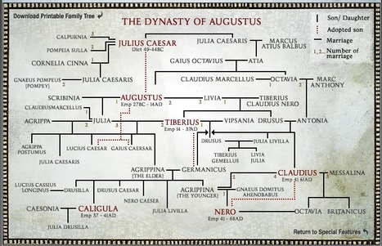**Tiberius’ Accession**

**TASK – using the family tree above as a guide, explain how Tiberius came to be emperor in 14 AD (bullet points are fine)**

Augustus had made Tiberius’ position as his chosen successor clear from the time of his **adoption in AD 4**. This had been confirmed by granting him **tribunician power** along with **proconsul imperium** equal to his own. The problem for Tiberius was that although he would have power it was known that that he was not Augustus’ first choice as successor and that he would lack Augustus’ ***auctoritas*** or ‘influence’.

The ancient sources also present differing views of Tiberius’ accession:

**Prescribed Source - Tacitus, *Annals*, 1.6-8**

6.1 The first act of the new principate was the murder of Agrippa Postumus. Although Agrippa had suspected nothing and was unarmed and he himself was resolute in his intention, the centurion who did the deed had the greatest difficulty in despatching him. Tiberius said nothing to the senate about the matter; he was pretending that his father had left orders which instructed the military tribune responsible for his custody to put Agrippa to death without delay when he himself had breathed his last. 6.2 Augustus had certainly uttered many harsh criticisms of the young man’s character and had thus ensured that his exile was sanctioned by decree of the senate; but he never steeled himself to have any of his relatives killed, nor was it credible that he would have had his grandson put to death to ensure his stepson’s piece of mind; more likely, Tiberius and Livia, he through fear and she with a stepmother’s malice, had moved swiftly to eliminate a young man whom they suspected and hated. 6.3 When the centurion reported, after military custom, that his order had been carried out, Tiberius replied that he had given no order and that a formal report must be laid before the senate. When this was discovered by Sallustius Crispus who was party to the secret dealings (it was he who had sent the note to the tribune) he was afraid that he would be personally held accountable for the deed and that he was equally at risk whether he told the lied or told the truth. So he warned Livia that the secrets of the household, the advice of friends, and the services of soldiers should not be made public and that Tiberius should not undermine the power of the principate by referring everything to the senate, since it was of the very essence of ruling that accounts would only balance if they were rendered to a single individual.

7.1 At Rome there was a headlong rush to servitude. Consuls, senators, equestrians – the higher their status the greater the haste, the greater the hypocrisy, as each composed his expression so as to appear neither delighted at the death of on *princeps* nor distressed at the accession of another, carefully blended tears with joy, flattery with lamentation. 7.2 Sextus Pompeius and Sextus Appuleius, the consuls, were the first to take the oath of allegiance to Tiberius Caesar, and in their presence Seius Strabo and Gaius Turranus did likewise, prefect both, the former of the praetorian cohorts, the latter of the corn supply. Soon senate, soldiery, and the people followed suit. 7.3 For Tiberius initiated all business through the consuls, as though the old republic still existed and he himself had doubts about ruling. Even the edict by which the senators were called to the senate-house was issued by virtue of the tribunician power, which he had received under Augustus. 7.4 The edict itself was brief and its tone very modest, to the effect that he would consult about the honours due to his father, that he was remaining with the corpse, and that this was the only public duty which he was discharging. 7.5 But in fact, on the death of Augustus, he had given the password of the day to the praetorian cohorts, as commander; the armed guards and other appurtenances of the court were his; soldiers escorted him to the forum and the senate house. He sent dispatches to the army as though the principate had already been conferred upon him, and acted decisively in every sphere, except when addressing the senate. 7.6 All this stemmed primarily from his fear that Germanicus, with so many legions and a swarm of allied auxiliaries at his disposal, and remarkable popular support, might prefer the reality of power to its expectation. 7.7 he had an eye to public opinion also, since he wished to appear to have been summoned and elected by the republic, rather than to have infiltrated his way to power through a wife’s scheming and a senile old man’s adoption. Later it became clear that he had affected this hesitant manner as a way of testing the inclinations of the leading men. For he distorted men’s words and expressions into proofs of treachery, and he never forgot them.

8.1 At the senate’s first meeting he allowed no business to be transacted except matters pertaining to the funeral of Augustus, whose will, brought in by the Vestal Virgins, named Tiberius and Livia as his heirs. Livia was adopted into the Julian family and the Augustan name. In default his grandsons and great-grandsons were nominated heirs, followed in third position by the leading citizens, most of whom he loathed; but he had named them out of ostentation and in order to win the admiration of posterity. 8.2 His bequests were appropriate to the means of a private citizen, except that he left 43,500,000 sesterces to the people and *plebs*, to the soldiers of the praetorian cohorts 1,000 sesterces, and to Roman citizens serving as legionaries or in cohorts 300 sesterces each. 8.3 Next, the senate was consulted about Augustus’ honours, of which the following were the most important: that the funeral procession should pass through the triumphal gate (proposed by Asinius Gallus); that the titles of the laws he had carried and the names of the peoples he had conquered should be paraded before him (proposed by Lucius Arruntius) 8.4 Valerius Messala proposed that the oath of allegiance to Tiberius should be renewed annually; and when Tiberius asked him if he had suggested this in response to any prompting from himself, he replied that it was entirely on his own initiative, and that in all matters pertaining to the safety of the state he would be influenced only by his personal judgement, even at the risk of giving offence. This represented the only form of flattery which remained available. 8.5 The senate declared with one voice that the corpse should be carried on the shoulders of senators to the funeral pyre. Caesar excused them with haughty moderation, and issued a warning to the people by edict that they should not seek to have Augustus cremated in the forum rather than, as planned, in the Campus Martius, as once before the funeral of the deified Julius had been turned into a riot by excessive zeal.

8.6 On the day of the funeral, the soldiery stood around the corpse like a bodyguard, eliciting much mockery from those who had witnessed in person or heard from their parents of that day when servitude was still fresh and liberty had been reclaimed with no happy outcome, when the assassination of the dictator Caesar seemed to some the vilest of deeds, but to others the most glorious. But now, they said, it seemed that the aged *princeps*, with long years of power behind him and abundant resources left to his heirs with which to coerce the state, actually needs a bodyguard to guarantee himself a quiet funeral.

**Prescribed Source - Tacitus, *Annals*, 1.11-15**

11.1 But it was Tiberius who was now the focus of men’s prayers. He dilated upon the massive burden of empire and his own modest capacities. Only the genius of an Augustus, now deified, was equal to such a mighty task. He himself having been summoned by Augustus to share his labours, had learned by experience how arduous a task it was to be ruler of the world, and how subject to the vagaries of fortune. For that reason, in a state which could depend on the talents of so many distinguished men, all the burdens should not fall on the shoulders of one. The task of government would be more readily discharged through the co-operative efforts of a greater number. 11.2 This speech lacked the conviction appropriate to such worthy sentiments. Tiberius’ words, whether by nature or habit, were always hesitantly and ambiguously express, even when he was not trying to mask his intentions. On this occasion, however, when he was doing his utmost to conceal his most secret ambitions, they became all the more convoluted, ambiguous, and capable of several interpretations. 11.3 For the senators, by contrast, there was only one anxiety – to avoid being seen to understand him all too well. They were in the midst of a flood of protestations, lamentations and supplications, stretching out their arms to the gods, the statue of Augustus, and the knees of Tiberius himself when he gave orders for a document to be produced and read out.

11.4 It contained a list of all public resources – the number of citizens and allied auxiliaries in the army, the fleets, the client kingdoms and the provinces, together with the tributes and taxes they paid, and the essential expenditure and optional grants they received. Augustus had recorded all this in his own hand, adding the recommendation (whether through motives of jealousy or genuine anxiety) that the empire should not be extended beyond its current boundaries.

12.1 With the senate now reduced to the most grovelling entreaties, Tiberius happened to remark that, though he did not feel equal to the task of ruling the whole republic, he would accept the guardianship of whichever part was entrusted to him. 12.2 At this point Asinius Gallus interjected, “What I want to know, Caesar, is this: which part of the republic would you like to have entrusted to you?” Disconcerted by the unexpected question, Tiberius was silent for a moment. But he recovered his poise and replied that, given his feelings of inadequacy, it would be entirely inappropriate to make or avoid any particular choice, since his preference was for total exemption. 12.3 Gallus guessed from Tiberius’ expression that he had given offence, so he now explained that his intention in putting the question had not been to recommend the dividing of what was indivisible, but to demonstrate from Tiberius’ own acknowledgement that the republic constituted a single body which must be governed by the will of a single ruler. He also praised Augustus and reminded Tiberius of his own victories and many outstanding achievements over his long years in public life. 12.4 This did nothing to mollify the emperor. He had long hated Gallus for marrying his own former wife, Vipsania, Marcus Agrippa’s daughter, and thereby revealing a degree of ambition inappropriate to any ordinary citizen, and for inheriting a censoriousness worthy of his father, Asinius Pollio.

13.1 Lucius Arruntius then spoke in very similar terms and gave no less offence, though Tiberius lacked any long-standing animosity towards him. But he was a rich man with a high public profile whose public reputation matched his remarkable talents, and he was therefore suspect. 13.2 Indeed during one of their last conversations Augustus, in discussing the principate, had distinguished between those who had the capacity to fill the office but would refuse it, those who desired it but lacked the capacity, and those who had the capacity and the desire. He had suggested that Marcus Lepidus had the ability but would reject the principate with contempt. Gallus Asinius coveted it but was inadequate to the task; while Lucius Arruntius had both the ability and the nerve to make a bid for it, if the chance was offered. 13.3 Of the three names mentioned, our sources are agreed upon the first two; but an alternative tradition reads Gnaeus Piso for Arruntius. Lepidus apart, all of them were soon disposed of at Tiberius; instigation under varying criminal charges. 13.4 Quintus Haterius and Mamercus Scaurus also inflamed his inherently suspicious temperament, Haterius by asking how long he proposed to allow the state to be without its head; Scaurus by saying that there were grounds for optimism that the senate’s prayers would soon be answered in the fact that he had not used his tribunician powers to veto the consuls’ proposals. Tiberius promptly launched a tirade against Haterius; but the remarks of Scaurus, against whom his anger was the more implacable, he passed over in silence.

13.5 In the end, exhausted by the general clamour and the individual protestations, he began to give way little by little, to the point of ceasing to provoke continuing demands by his persistent refusal, without actually acknowledging that he had now accepted the principate. 13.6 The sources record that Haterius later went into the palace to offer his apologies and, as Tiberius walked past, he clasped his knees in supplication – an act which brought Tiberius crashing to the ground, either by a mishap or because he had tripped him. This nearly led to his own death at the hands of the bodyguards. Despite his efforts, the threat to the distinguished senator’s life remained undiminished until he appealed to Augusta (Livia), and gained protection through her zealous intervention.

14.1 She too became the object of widespread flattery by the senate. Some proposed that she be give the title of “parent” or “mother” of her country; very many that the title “son of Julia” be added to Caesar’s formal designation. 14.2 Tiberius, however, repeatedly insisted that honours for women should be strictly curtailed and that he personally would display the same moderation over honours offered to himself. Nevertheless, jealously made him anxious; and because he regarded elevation in status for a woman as a diminution of his own, he refused to allow her to be voted even a single lictor, and also vetoed an altar of Adoption and other such honours. 14.3 But for Germanicus Caesar he requested proconsular *imperium*, and a special delegation was dispatched to confer it on him and at the same time to offer condolences on the death of Augustus. The reason he did not seek similar distinctions for Drusus was that he was consul-designate and already present in Rome. 14.4 For the praetorship he nominated twelve candidates, which was the traditional number established by Augustus. When the senate urged him to increase the number, he bound himself by a strict oath not to do so.

15.1 That was the first time, too, that elections were transferred from the citizens’ assemblies (held in the Campus Martius) to the senate. Hitherto, though the most important were settled by decision of the *princeps*, some were still left to the wishes of the assembly of the tribes. The people raised no objection to the loss of this prerogative, except perhaps in casual conversation, while the senate gladly acquiesced, since it was consequently spared the need for expense and undignified solicitation of votes, as Tiberius guaranteed that he would not recommend more than four candidates, who would have to be appointed without rejection or canvass. 15.2 At the same time the tribunes sought permission to celebrate at their own expense games which would be added to the official calendar and be known as the Augustales (derived from the name of Augustus). But it was decided that they should be financed by the state treasury, and that the tribunes should be allowed to wear triumphal dress in the Circus Maximus but not to ride in a triumphal chariot. 15.3 The conduct of this annual celebration was soon transferred to the praetor, to whom fell responsibility for civil suits between citizens and foreigners.

1. **According to Tacitus how did Tiberius act when he was named in Augustus’ will as his successor and the next *princeps*?**
2. **Why do you think he did this?**
3. **How does Tacitus portray senators in these two sources?**

**Prescribed Source – Suetonius, *Tiberius* 23-24**

23. Tiberius used his tribunician power to convene the Senate and break the news of Augustus’ death. After reading a few words of a prepared speech, he suddenly groaned aloud and, protesting that grief had robbed him of his voice and that he wished his life would also be taken, handed the scroll to his son Drusus, who finished the task. A freedman then read Augustus’ will aloud, all senators present who had witnessed the document being first called upon to acknowledge their seals – witnesses of lower rank would do the same outside the Senate House. The preamble to the will ran as follows: ‘Since fate has cruelly carried off my sons Gaius and Lucius, Tiberius Caesar is to inherit two-thirds of my property.’ This wording strengthened the suspicion that Augustus had nominated Tiberius as his successor only for want of any better choice.

24. Tiberius did not hesitate to exercise power immediately by calling on the praetorians to provide him with a bodyguard, which was to rule in fact and in appearance. Yet a long time elapsed before he assumed the position of *princeps*. When his friends urged him to accept it, he went through the farce of scolding them for the suggestion, saying that they did not realize what a monstrous beast power was, and he kept the Senate guessing by his carefully evasive answers and hesitations, even when they threw themselves at his feet imploring him to change his mind. This made some of them lose patience, and in the confusion a voice was heard shouting, ‘Oh, let him either take it or leave it.’ And another senator openly taunted him with ‘Some people are slow to do what they promise; you are slow to promise what you have already done.’ Finally, with a great show or reluctance, and complaints that they were forcing him to become a miserable and overworked slave, Tiberius accepted the principate; but even the he hinted that he might resign it. His actual words were ‘until I grow so old that you may be god enough to grant me a respite’.

1. **How similar is this account of Tiberius’ take-over of power to the one given by Tacitus?**

**Mutinies in the Army**

One of the first problems Tiberius had to deal with when he became emperor was an outbreak of mutiny from elements of the Roman army. The first happened in **Pannonia** (see map below) and the second in **Germany.**

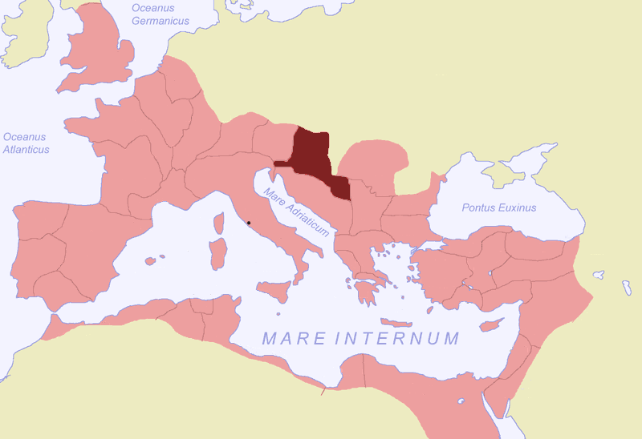**Prescribed Source - Tacitus, *Annals*, 1.6-8**

While these events were taking place at Rome, mutiny broke out in the regular army in Pannonia. There were no fresh motives for this, except that the change of emperors offered hopes of rioting with impunity and collecting the profits afforded by civil wars. Three brigades were stationed together in a summer camp with Quintus Junius Blaesus in command. When he heard of the death of Augustus and accession of Tiberius, he suspended normal duty for mourning (or rejoicing). This was when insubordination and altercation began.

Before long, easy living and idleness were all the troops wants; the idea of work and discipline became distasteful. There was a man called Percennius in the camp. Having become a private soldier after being a professional applause-leader in the theatre, he was insolent of tongue, and experienced in exciting crowds to cheer actors. The soldiers, simple men, were worried – now that Augustus was dead – about their future terms of service. Percennius gradually worked on them. After dark or in the evening twilight, when the better elements had dispersed to their tents and the riff-raff collected, they talked with him.

Finally Percennius had acquired a team of helpers ready for mutiny. Then he made something like a public speech. ‘Why’, he asked, ‘obey, like salves, a few commanders of companies, fewer still battalions? You will never be brave enough to demand better conditions if you are not prepared to petition – or threaten – an emperor who is new and still faltering. Inactivity has done quite enough harm in all these years. Old men, mutilated by wounds, are serving their thirtieth or fortieth year. And even after your official discharge your service is not finished; for you stay on with the colours as a reserve, still under canvas – the same drudgery under another name! And if you manage to survive all these hazards, even then you are dragged off to a remote country ad “settled” in some waterlogged swamp or untilled mountainside. Truly the army is a harsh, unrewarding professions! Body and soul are reckoned at two and a half sesterces a day – and with this you have to find clothes, weapons, tents, and bribes for brutal company commanders if you want to avoid chores.

‘Heaven knows, lashes and wounds are always with us! So are hard winters and hardworking summers, grim war and unprofitable peace. There will never be improvement until service is based on a contract – pay, four sesterces a day; duration of service, sixteen years with no subsequent recall; a gratuity to be paid in cash before leaving the camp. Guardsmen receive eight sesterces a day, and after sixteen years they go home. Yet obviously their service is no more dangerous than yours. I am not saying a word against sentry-duty in the capital. Still, here are we among tribes of savages, with the enemy actually visible from our quarters!’

Percennius had an enthusiastic reception. As one point or another struck home, his hearers indignantly showed their lash-marks, their white hair, their clothes so tattered that their bodies showed through. Finally, in frenzied excitement, they clamoured that the three brigades should be merged into one. But jealously wrecked this suggestion, because everyone wanted it to take his own brigade’s name. So the proposal was altered, and instead the three Eagles, and the standards of the battalions, were put side by side. Turf was piled up, and a platform erected so as to make the place as conspicuous as possible. As they were hurrying ahead with this, Blaesus came up and began to revile them. Seizing hold of one man after another, he cried: ‘Dye your hands in my blood instead! It would be less criminal to kill your general than to rebel against the emperor. As long as I live I shall keep my troops loyal – if I die, my death will help to bring them to their senses.’

1. **According to Tacitus, what were the causes of the mutiny in Pannonia?**
2. **Why do you think the mutiny occurred in AD 14?**
3. **In your opinion how threatening was the Pannonian mutiny to Tiberius?**

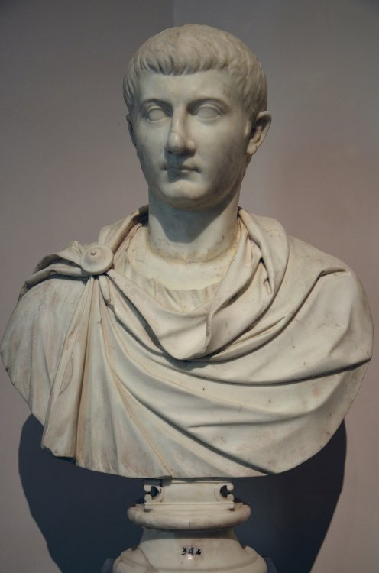

Tiberius’ response to the mutinies was to send his son **Drusus** to deal with the Pannonian mutiny and his adopted son **Germanicus** to deal with the German Mutiny.

Tacitus gives us an extremely detailed account of the two mutinies and he uses the events to make observations about the key figures involved.

**TASK –** As you read the following sources from Tacitus, covering the two mutinies, make nots on what they reveal to us about the characters of **Tiberius, Germanicus** and **Drusus**

**Prescribed Source - Tacitus, *Annals*, 1.21-5**

The arrival of men from Nauportus revived the mutiny. Now marauders began to roam about ransacking the whole district. A few who had looted more than the rest were ordered by Blaesus to be flogged and confined to dells, in order to frighten the others; for he was still obeyed by the company commanders and the steadier ordinary soldiers. As they were dragged away they offered resistance and grabbed at the legs of bystanders. Shouting out the names of their friends, and of their companies, battalions and brigades, they cried that the same fate was in store for everybody – all this was repeated insults against the general and invocations of the gods. In fact, they did everything possible to arouse sympathy, indignation, ill-feeling, and panic. Everyone surged to their rescue. The cells were forced open, and deserters and condemned murderers were released and joined them.

Now the mutiny gained momentum. More and more leaders came forward. A private soldier called Vibulenus was hoisted on the shoulders of the men standing round the general’s dais. The excited crowd, watching to see what he would do, heard him speak:

‘I know you have brought these poor innocent men back to life and daylight. But you can’t give my brother back to me, or me to him! The army in Germany sent him to talk to you about our common interests – and the general had him murdered last night by the gladiators whom he keeps armed to butcher us soldiers. Answer, Blaesus – where have you put his corpse? Even enemies don’t refuse a grave. Later, when I have embraced his corpse and mourned my fill, you can tell them to murder me as well. But they mustn’t grudge us burial. We are not dying because of any crime. We are dying because we worked for the army’s good!’

To add to the inflammatory effect, Vibulenus wept and struck his face and beat his chest. Then he pushed aside those who were holding him on their shoulders, and hurled himself flat in front of one man after another, appealing to them, They were frantic with impassioned hostility. One group arrested the gladiators who were slaves in the service of Blaesus while others captured the rest of Blaesus’ household, and a further band rushed off in search of the body. Indeed if it had not rapidly come to light that there was no body to be found, that the slaves denied the murder even under torture, and that Vibulenus had never had a brother, they were not far from killing the general himself.

As it was, they turned out the other senior officers, including the chief-of-staff – looting their luggage as they fled. The company-commander Lucilius, lost his life. In joking army talk his nickname was ‘Another-please’, because every time he broke a stick over a soldier’s back he used to shout loudly for another and then another. His fellow officers found safe hiding-places, except only Julius Clemens, who was kept because his intelligence was thought to qualify him for presenting the mutineers’ demands. The eighth and fifteenth brigades nearly came to blows when one shouted for the death of a company-commander, Sirpicus by name, and the other protected him. Finally, the men of the ninth brigade intervened with appeals – and with threats of violence against those who ignored them.

The natural inscrutability of Tiberius was always particularly impenetrable in a crisis. However, this news impelled him to send to the scene his son Drusus with a distinguished staff and two battalions of the Guard. Drusus was given no definite instructions – he was to act as the circumstance required. The Guard battalions were strengthened beyond their usual numbers by picked drafts, and were further augmented by a substantial part of the gorse Guard and also by the best of the Germans who at that time guarded the emperor’s person. With them went a man whose influence over Tiberius was very great, Lucius Aelius Sejanus, joint commander of the Guard with his father, Lucius Seius Strabo. He was to be the prince’s adviser, and not to let the rest of the party forget what they stood to gain – or lose.

As Drusus approached, the soldiers met him. Ostensibly this was a mark of respect. But there were none of the customary demonstrations of pleasure and glittering full-dress decorations. The men were disgustingly dirty, and their expressions, intended merely to display dejection, looked virtually treasonable. As soon as Drusus had passed inside the outworks, they picketed the gates, and set armed detachments at key points of the camp. Everyone else crowded round the dais in a gigantic mob. Drusus mounted it with a gesture calling for silence. The mutineers, looking round at the great crowd, set up a truculent roar. But the next instant, as they caught sight of Caesar, their nerve faltered. Violent yells alternated with confused mutterings, and then silence. They were terrifying and terrified in turn, as their feelings shifted. When Drusus finally got the better of the noise, he read out a letter from his father. It stated that the heroic Roman soldiers, his comrades in so many campaigns, were particularly near to his heart, and that as soon as the shock of his bereavement was over, he would refer their claims to the senate. Meanwhile he had sent his son to grant without delay any concessions that could be awarded immediately. The remaining points must be saved for the senate, which was as capable, they must understand, of generosity as of severity.

**Prescribed Source - Tacitus, *Annals*, 1.38-43**

Then Germanicus moved on to the army of Upper Germany. He Had no difficulty in inducing the second, thirteenth and sixteenth brigades to take the oath; the fourteenth only took it after hesitation. Thought there were demands for discharges and money payments, both were conceded. 1.38. In the territory of the Chauci, however, a fresh outbreak occurred, among a garrison consisting of detachments from the insubordinate brigades. The trouble was soon stamped out by two prompt executions. This illegal but salutary measure was carried out on the orders of the corps chief-of-staff Manius Ennius. Then, as the mutiny began to swell, he got away. But he was discovered. Relying on a bold course for the safety which his hiding-place had failed to provide, he cried out that their offence was not just against an officer, it was against Germanicus their commander – against Tiberius their emperor! At the same time, intimidating all opposition, he seized the standards and pointed it towards the Rhine. Then, shouting that everyone who fell out would be treated as a deserter, he conducted his men back to their winter camp – still rebellious, but frustrated.

Meanwhile the senate's mission to Germanicus found him back at the Ubian altar and capital. The first and the twentieth brigades were in winter quarters there, and also the soldiers who had recently been released but not yet demobilized. Mad with anxiety and bad conscience, these men were also terrified that the concessions which they had won by mutinous methods would be cancelled by the senatorial delegation. Crowds habitually find scapegoats, however unjustifiably, and now they attacked the chief envoy, the former consul Lucius Munatius Plancus, charging him with instigating sanctions against them in the senate. Early in the night they began to clamour for their standard, which was kept in Germanicus' residence. They rushed the door and forced him to get up and – under threat of death – to hand it over. Then, roaming the streets, they encountered the members of the delegation, who had heard the uproar and were on their way to Germanicus. The soldiers heaped abuse on them. Indeed they had it in mind to kill them, and especially Plancus. His high rank made it impossible for him to run away; and in his extreme danger the only available refuge was the camp of the first brigade. There he found sanctuary, grasping the Eagle and the standards. But if a colour-sergeant named Calpurnius had not protected him from his fate, then, without precedent even between enemies, the altars of the gods would have been stained with the blood of an emissary of the Roman people, in a Roman camp.

At last morning arrived; and commanders and private soldiers, and the night's doings, were seen for what they were. Germanicus came into the camp and ordered Plancus to be brought to him. Escorting him on to the dais, he assailed this disastrous, maniacal revival of violence. 'It shows how angry the gods are', he said, 'rather than the soldiers!' Then he explained why the delegation had come, and spoke with gloomy eloquence about the rights of envoys, and the deplorable and unfair treatment of Plancus himself – a disgrace to the brigade. The gathering was hardly pacified, but it was cowed; and Germanicus sent the delegates away under the protection of auxiliary cavalry.

In this alarming situation Germanicus was generally criticized for not proceeding to the upper army, which obeyed orders and would help against the rebels. Enough and more than enough mistakes had been made, it was felt, by releases and payments and mild measures. And even if he did not value his own life, people asked why, among these madmen who had broken every law, he kept with him his baby son and his pregnant wife. Surely he owed it to the nation and their imperial grandfather to send them back! Germanicus was long hesitant. His wife scorned the proposal, reminding him that she was of the blood of the divine Augustus and would live up to it, whatever the danger. Then he burst into tears – and clasping to him the expectant mother and their child, persuaded her to go. It was a pitiable feminine company that set out. The supreme commander's own wife, a refugee, clutched his infant son to her breast. Her escorts, his friends' wives – forced to leave with her – were in tears. Those who remained were equally mournful. The scene suggested a captured city rather than a highly successful Caesar in his own camp.

The women's sobbing and lamentation attracted the attention of the soldiers, who came out of their tents and asked why they were crying and what was wrong. Here were the distinguished ladies with no staff-officers or soldiers to look after them, none of the usual escort or other honours dues to the supreme commander's wife. And they were off to Treviri, to be looked after by foreigners! The men felt sorry for them, and ashamed, when they thought of their ancestry – her father was Agrippa, her grandfather Augustus, her father-in-law Nero Drusus – and of her impressive record as wife and mother. Besides, there was her baby son, Gaius, born in the camp and brought up with the regular troops as his comrades. In their army fashion they had nicknamed him 'little boots' (Caligula), because as a popular gesture he was often dressed in miniature army boots. But their jealously of the Treviri was what affected them most.

So now they wanted to prevent Agrippina's departure and appealed that she should stop and come back. Some ran to intercept her, the majority returned to Germanicus. He stood among them, still smarting with grief and anger. 'My wife and son', he told them 'are not more dear to me than my father and my country. Bu t my father has his august dignity to protect him, and the Roman empire has its other armies. I would willingly see my wife and children die for your greater glory. Now, however, I am taking them out of your demented reach. Whatever atrocities are impending, my life alone must atone for them. Do not make your guilt worse by murdering the great-grandson of Augustus, the daughter-in-law of Tiberius!

'In these last days you have committed every possible crime and horror. I do not know what to call this gathering! You men who have used your fortifications and weapons to blockade your emperor's son can hardly be called soldiers. And "citizens" is not the name for people who cast aside the authority of the senate. The international code too, rights due even to enemies, the sanctity of ambassadors – you have outraged them. The divine Julius Caesar suppressed a mutiny by one word: when his men would not take the oath he called them "civilians". The divine Augustus put fear into his troops at Actium by a look. I cannot yet compete with them. But I am their descendent; and if the soldiers even in Spain or Syria – where I am not known – were disrespectful to me, it would be surprising and scandalous enough. And here we have you, the first brigade, which received its colours from Tiberius, and you, the twentieth, his comrades in many battles. He rewarded you amply. How splendidly you are repaying your old commander! This, it seems, is the report I must take to my father – amid the good news that he has from every other province – that his own old soldiers, his own recruits, they and they alone, not content with releases and gratuities, are slaughtering their company-commanders, ejecting their colonels, arresting their generals, until the camp and the river are soaked in blood, and I myself, surrounded by hatred, live only on sufferance!

'When, at the first day's meeting, you pulled away the sword I was preparing to plunge into my body, your friendly solicitude was inconsiderate. A better, truer friend was the man who offered me his own sword. At any rate I should have died with my conscience spared all my army's crimes! The leader whom you would then have chosen need not have avenged my death. Instead he could have avenged Publius Quinctilius Varus and his three brigades. For heaven forbid that the distinction and glory of having helped Rome, and suppressed the peoples of Germany, should go to the Belgae – Gauls and foreigners – for all their offers. Divine Augustus, I call upon your spirit now in heaven! Nero Drusus my father, I invoke your image that is in our memories! Come to these soldiers of yours (into whose hearts shame and pride are making their way); wash clean this stain! Direct these revolutionary passions against enemy lives instead. And you men: I see your looks and hearts have changed. Will you give the senate back its delegates, be obedient to the emperor again – and return me my wife and son? Then shake off the contagion. Single out the culprits! That will show you are sorry, and prove you are loyal.'

**Prescribed Source - Tacitus, *Annals*, 1.46-47**

1.46. When Rome heard of the rebellion in Germany – before the final developments in Illyricum were known – the whole population rounded panic-stricken on Tiberius. Here was he with his insincere hesitation, making fools of the helpless, unarmed senate and Assembly; while the soldiers mutinied! Two half-grown boys, they felt, could not control these rebellions. Tiberius ought to have gone himself, and confronted them with imperial dignity: they would have given way when they saw their experienced emperor, with sovereign powers of retribution and reward. It was recalled that Augustus had made several visits to the Germanies in later life – yet here was Tiberius, in his prime, sitting in the senate quibbling at members' speeches! The enslavement of Rome, men said, was well in hand. Now something must be done to calm the troops and make peace.

1.47. Such talk made no impression on Tiberius. He was determined not to jeopardize the nation and himself by leaving the capital. His worries were various. Germany had the stronger army, Pannonia the nearer. The former had Gaul's resources behind it, the latter threatened Italy. So which should he visit first? And what if the one placed second should take serious offence? Whereas, through his sons, he could deal with both simultaneously and keep intact his imperial dignity – which was, indeed, more awe-inspiring at a adistance. Besides, it was excusable for the young Germanicus and Drusus to refer some points to their father, and resistance offered to them could be conciliated or broken by himself. If, on the other hand, the emperor were treated contemptuously, no expedient was left.

All the same, as though he were going to start at any moment, he chose his staff, collected equipment, and prepared ships. Then, however, he offered various excuses about the weather, and pressure of business. The deception worked – on intelligent people for a little while, on most people for some time, and on those in the province for longest of all.

**Prescribed Source - Tacitus, *Annals*, 1.49**

1.49. This was unlike any other civil war. It was not a battle between opposing forces. Men in the same quarters, who had eaten together by day and rested together by night, took sides and fought each other. The shrieks, wounds, and blood were unmistakable. But motives were mysterious, fates unpredictable. There were casualties among loyalists, too; for the culprits had also seized weapons when they realized who were being attacked. Generals, colonels, offered no restraining hand. Mass vengeance was indulged and glutted.

Soon afterwards Germanicus arrived in the camp. Bursting into tears, he cried: 'This is no cure; it is catastrophe!' Then he ordered the bodies to be cremated.

There was still a savage feeling among the troops – and a desire to make up for their lunacy by attacking the enemy. Honourable wounds, they felt, on their guilty breasts, were the only means of appeasing the ghosts of their fellow-soldiers. Germanicus encouraged these ambitions and built a bridge across the Rhine.

Across it he transported twelve thousand regular troops, twenty-six auxiliary battalions, and eight cavalry regiments, of the which the loyalty had not been affected during the rising.

**Prescribed Source - Tacitus, *Annals*, 1.52**

1.52. Tiberius' reaction to German developments included worry as well as relief. He was glad the mutiny had been put down. But he was not pleased that Germanicus had courted the army's goodwill by money payments and accelerated discharges – not to speak of his military success. Tiberius reported the achievements of Germanicus to the senate. But what he said, though complimentary, was so ostentatiously elaborate that it did not ring true. The few words with which he praised Drusus for ending the mutiny in Illyricum sounded more heartfelt and sincere; and he extended to the regular troops in Pannonia the concessions which Germanicus had granted to those on the Rhine.

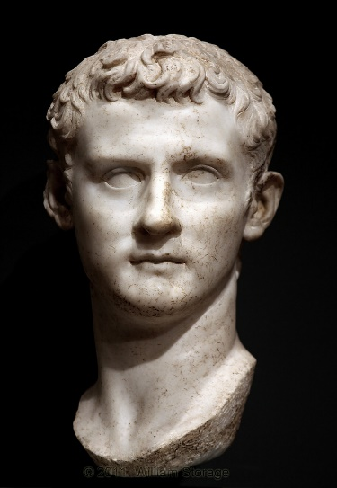**How Does Tacitus Portray Tiberius, Germanicus and Drusus in his coverage of the mutinies of AD 14?**

|  |  |  |
| --- | --- | --- |
| ***Tiberius*** | ***Germanicus*** | *[Drusus the Younger. Marble. Ca. 21 CE. Inv. No. CP 6460 / Ma 1240. Paris, Louvre Museum](http://ancientrome.ru/art/artwork/sculp/rom/imp/tiberius/drusus_minor/dru002.jpg)****Drusus*** |
| *http://0342aae.netsolhost.com/t/caesarTiberius.jpg* |  |  |

**Prescribed Source – Velleius Paterculus, 2.125.1-5**

**Mutinies in the Legions, AD 14 (C2)**

125.1. The nation’s prayers and wisdom were rapidly rewarded. For it very soon became clear to us what we might have suffered had we failed to persuade Tiberius to accept, and how greatly we profited from our success in persuading him. The army, which was campaigning in Germany under the direct and personal command of Germanicus, and the legions which were based in Illyricum, were simultaneously overtaken by a mad and overwhelming desire to cause chaos by demanding a new commander, a new constitution, and a new republic. Indeed they even had the nerve to threaten to impose their demands on the senate and the emperor himself. 125.2. They wanted to fix their own level of pay and the terms of their engagement, and it even looked as if they were prepared to make a fight of it. Swords were draw, and so convinced were the soldiers of their own inviolability that it almost became a full scale mutiny. There was no shortage of followers; all they lacked was someone to lead them into battle against their own country. 125.3. But Tiberius’ long experience as an army commander soon calmed their fury and put an end to this general breakdown of military discipline. Many were punished severely; some were bought off by promises, where it was possible to do so without undermining respect for their general’s standing. This combination of severe sanctions against the ringleaders and limited measures against the rest settled the matter.

125.4. Germanicus’ handling of the crisis had been generally fairly vigorous; but Drusus had recourse to a more traditional and old-fashioned severity. His father had dispatched him into the very heart of an army mutiny whose fires were already well and truly ablaze. He chose what was for himself the high risk option, rather than taking a more restrained approach which might have set a dangerous precedent for the future. He chose to supress the mutineers with the same brute force as they themselves used to threaten him. 125.5. In all this he was admirably supported by Junius Blaesus, a man whose military skills were more than matched by his political know-how. A few years later as proconsul in Africa he was awarded the richly deserved decorations of a military triumph and the title *imperator* (victorious general). But in the two Spanish provinces and their armies, by contrast, absolute peace and quiet reigned. Marcus Lepidus held the supreme command there, and I have already written about his remarkable personal qualities and his outstanding military service in Illyricum. He had a principled understanding of what was the right course of action and the natural authority to ensure that his views prevailed. Dolabella, a man of uncomplicated nobility of character, showed a similar commitment and devotion to duty in his command of the Illyricum coastline.

1. **How does Paterculus’ account of the mutinies of AD 14 compare to that of other ancient sources you have read? (This will require a developed paragraph that includes at least two quotes from thee source above and evaluation of the sources provenance).**

**Tiberius’ Relationship with Germanicus and Sejanus**

**Germanicus**

**[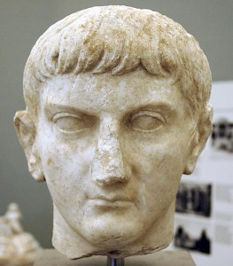](http://www.livius.org/pictures/a/roman-emperors/germanicus/)RECAP** – From the understanding you have gained so far, why do you think Tiberius and Germanicus’ relationship would be difficult?

Germanicus was a successful and charismatic military commander, who, as we have seen from Paterculus’ account, was encouraged to become emperor by his loyal troops during the mutinies of AD 14. This idea is also supported by Tacitus:

**Prescribed Source - Tacitus, *Annals*, 1.35.3**

Some asked Germanicus for the legacies which the divine Augustus had left them – adding expressions of personal support for Germanicus. If he wanted the throne, they showed they were for him. At this point he leapt off his dais as if their criminal intentions were polluting him, and moved away. But they blocked his path and menaced him until he went back. Then, however, shouting that death was better than disloyalty, he pulled the sword from his belt and lifted it as though to plunge it into his chest. The men round him clutched his arm and stopped him by force. But the close-packed masses at the back of the crowd, and even, remarkably enough, certain individuals who had pushed themselves into prominent positions, encouraged him to strike. A soldier called Calusidius even drew his own sword and offered it, remarking that it was sharper. But even in their demented frame of mind the men found this a brutal and repellent gesture. There was a pause; and Germanicus’ friends had time to hurry him into his tent.

Tacitus goes on to give a clear sense that as his success and popularity grew, Tiberius viewed Germanicus as a threat. Germanicus, following his suppression of the mutiny within the German Legions, went on the offensive and revisited the sight of the defeat to **Varus’ Legions** in AD 9 to find and bury the remains of the Roman soldiers who died. This was a particularly significant and sensitive sight for Rome and represented one of their greatest defeats. Tacitus was also clearly portraying Germanicus and Tiberius in simple terms of ‘good’ and ‘bad’ – Germanicus playing the part of the Roman hero.

**Prescribed Source - Tacitus, *Annals*, 1.62.2**

Now they were near the Teutoburgian Wood, in which the remains of Varus and his three divisions were said to be lying unburied. Germanicus conceived a desire to pay his last respects to these men and their general. Every soldier with him was overcome with pity when he thought of his relations and friends and reflected on the hazards of war and of human life. Caecina was sent ahead to reconnoitre the dark woods and build bridges and causeways on the treacherous surface of the sodden marshland. Then the army made its way over the tragic sites. The scene lived up to its horrible associations. Varus' extensive first camp, with its broad extent and headquarters marked out, testified to the whole army's labours. Then a half-ruined breastwork and shallow ditch showed where the last pathetic remnant had gathered. On the open ground were whitening bones, scattered where men had fled, heaped up where they had stood and fought back. Fragments of spears and of horses' limbs lay there – also human heads, fastened to tree-trunks. In groves nearby where the outlandish altars at which the Germans had massacred the Roman colonels and senior company-commanders.

Survivors of the catastrophe, who had escaped from the battle or from captivity, pointed out where the generals had fallen, and where the Eagles were captured. They showed where Varus received his first wound, and where he died by his own unhappy hand. And they told of the platform from which Arminius had spoken, and of his arrogant insults to the Eagles and standards – and of all the gibbets and pits for the prisoners.

[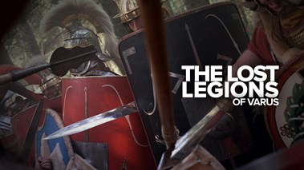](https://www.google.co.uk/url?sa=i&rct=j&q=&esrc=s&source=imgres&cd=&cad=rja&uact=8&ved=2ahUKEwj6l4HJntHZAhUJLcAKHUwPBIQQjRx6BAgAEAY&url=https://www.foxtel.com.au/got/whats-on/tv-guide/The-Lost-Legions-of-Varus/91796554&psig=AOvVaw1hWE9oFzmerFXlAymSBkUE&ust=1520203790508556)So, six years after the slaughter, a living Roman had come to bury the dead men's bones of three whole divisions. No one knew if the remains he was burying belonged to a stranger or a comrade. But in their bitter distress, and rising fury against the enemy, they looked on them all as friends and blood-brothers. Germanicus shared in the general grief, and laid the first turf of the funeral-mound as a heartfelt tribute to the dead. Thereby he earned Tiberius' disapproval. Perhaps this was because the emperor interpreted every action of Germanicus unfavourably. Or he may have felt that the sight of the unburied dead would make the army too respectful of its enemies, and reluctant to fight – nor should a commander belonging to the antique priesthood of the Augurs have handled objects belonging to the dead.

**EXTENSION TASK** – Do some simple research into the **Battle of Teutoburg Forest**. Find out who was involved, information of the events of the battle, and details on its impact

In AD 17 an opportunity arose for Tiberius to deal with Germanicus and reduce the threat he believed he posed. Unrest broke out in the eastern part of the empire (Judaea and Syria in particular) and Tiberius sent Germanicus to restore order. This had the advantage of sending one of Rome’s most capable commanders to maintain control but it also separated Germanicus from his main source of support – the Legions in Germany. In addition, Tiberius also replaced the governor of Syria at the same time he sent Germanicus. The new governor – **Gnaeus Calpurnius Piso** – was sent, according to Tacitus, to control and obstruct Germanicus. Germanicus would start his journey to the East in 18, at the same time as Piso.

**Prescribed Source - Tacitus, *Annals*, 2.53**

2.53. In the following year Tiberius was consul for the third time, Germanicus for the second. The latter assumed office at Nicopolis in the province of Achaia, which he had reached along the Adriatic coast after visiting his brother Drusus, then stationed in Dalmatia. Since both the Adriatic and the Ionian seas had been stormy, he spent a few days at Nicopolis overhauling his fleet. He employed this opportunity to visit the gulf famous for the victory of Actium, and its spoils dedicated by Augustus, and Antony’s camp. The place brought memories of his ancestors, for (as I have pointed out) he was the grand-nephew of Augustus, and the grandson of Antony. Here his imagination could re-enact mighty triumphs and might tragedies.

Then he visited Athens, contenting himself with one official attendant, out of regard for our treaty alliance with the ancient city. The Greeks received him with highly elaborate compliments, and flattery all the more impressive for their emphasis on the bygone deeds and words of their own compatriots.

**Prescribed Source - Tacitus, *Annals*, 2.55**

2.55. Cnaeus Calpurnius Piso was in a hurry to execute his designs. His impact on the Athenians was alarmingly violent. In a speech savagely attacking them, he criticized Germanicus (without naming him) for excessive compliments, incompatible with Roman dignity, to a people whom he called Athenians no longer (since successive catastrophes had exterminated them), but the dregs of the earth: allies of Mithridates VI of Pontus against Sulla, of Antony against the divine Augustus. And he even brought up ancient accusations – their failures against Macedonia and oppression of their own countrymen. He had personal reasons also for his hostility. For they had refused to release a certain Theophilus whom the Athenian High Court had condemned for forgery.

Then a quick sea-journey by a short cut through the Cyclades brought him to Germanicus at the island of Rhodes. Though aware of Piso’s attacks on him, Germanicus behaved so forgivingly that when a storm was driving Piso on to the rocks – so that his death could have been put down to accident – Germanicus sent warships to rescue his enemy. However, Piso was not mollified. Grudging even a single day’s delay, he left Germanicus and went on.

On reaching the army in Syria he was lavish with gifts, bribes, and favours, even to the humblest soldiers. He replaced company-commanders of long service, and the stricter among the colonels, by his own dependents and bad characters. He allowed the camp to become slack, the towns disorderly, and the me to wander in undisciplined fashion round the countryside. The demoralization was so bad that he was popularly called ‘father of the army’. And Plancina went beyond feminine respectability by attending cavalry exercises. Yet some even of the better soldiers were misguided enough to support her, because of secret rumours that the emperor’s approval was not lacking.

Germanicus knew what was happening. But his more urgent concern was to reach Armenia first.

1. **How was Germanicus treated as he moved east?**
2. **Who Reached Syria first?**
3. **What did he do when he recached Syria and why?**

In **AD 18**, Germanicus and Piso had their first meeting and open confrontation:

**Prescribed Source - Tacitus, *Annals*, 2.57**

2.57. Yet his satisfaction was ruined by Piso’s arrogance. Germanicus had ordered him to conduct part of the Roman army to Armenia, or send it with his son. Piso had done neither. Finally, at the winter quarters of the tenth brigade at Cyrrhus, they met. Their features were carefully composed, Piso’s to show no fear, Germanicus’ not to seem menacing. He was, as I have said, a kind-hearted man. But his friends knew how to work up ill-feeling, and piled up a variety of exaggerated facts and hostile fictions against Piso, Plancina, and their sons. A few friends were present at their meeting. Germanicus spoke first, with ill-concealed indignation. Piso apologized – insolently. They parted with undeclared enmity. Subsequently, Piso rarely sat on Germanicus’ dais, and, when he did, he looked sullen and critical. At a banquet given by the dependent king of the Nabataei, when heavy gold crowns were presented to Germanicus and Agrippina and lighter ones to Piso and the others, Piso was heard to say that the guest of honour was son of a Roman emperor, not of a Parthian king. He pushed his own crown aside, with a prolonged denunciation of extravagance. This was irritating to Germanicus. But he endured it.

In **AD 19** Germanicus visited Egypt but without the permission of Tiberius who saw this as a direct threat.

**Prescribed Source - Tacitus, *Annals*, 2.59**

2.59. In the following year (the consuls were Marcus Junius Silanus Torquatus and Lucius Norbanus Balbus) Germanicus went to Egypt to look at the antiquities. His ostensible object, however, was the country’s welfare; by opening the public granaries he lowered the price of corn. His behaviour was generally popular. He walked about without guards, in sandalled feet and Greek clothes, imitating Scipio Africanus, who is said to have done likewise in Sicily though the Second Punic War was still raging.

Tiberius criticized Germanicus mildly for his clothes and deportment, but reprimanded him severely for infringing a ruling of Augustus by entering Alexandria without the emperor’s permission. For one of the unspoken principles of Augustus’ domination had been the exclusion of senators and knights from Egypt without his leave. He had thereby isolated Egypt, to minimize the threat from any hostile power which, however weak itself and however powerful its opponents, might by holding that country – with its key-positions by land and sea – starve Italy.

While Germanicus was away, Piso continued to undermine his authority in Syria. When Germanicus returned, Piso decided to leave but at this point Germanicus fell ill and died, convinced that he had been poisoned by Piso, with the support or knowledge of Tiberius:

**Prescribed Source - Tacitus, *Annals*, 2.69-2.71**

2.69. On leaving Egypt Germanicus learnt that all his orders to divisional commanders and cities had been cancelled or reversed. Between him and Piso there were violent reciprocal denunciations. Then Piso decided to leave Syria. But Germanicus fell ill, and so Piso stayed on. When news came that the prince was better and vows offered for his recovery were being paid, Piso sent his attendants to disperse the rejoicing crowds in Antioch, with their sacrificial victims and apparatus. Then he left for Seleucia Pieria, to await the outcome of Germanicus’ illness. He had a relapse – aggravated by his belief that Piso had poisoned him. Examination of the floor and walls of his bedroom revealed the remains of human bodies, spells and curses, lead tablets inscribed with the patient’s name, charred and bloody ashes, and other malignant objects which are supposed to consign souls to the powers of the tomb. At the same time agents of Piso were accused of spying on the sickbed.

270. Germanicus, alarmed and angry, reflected that if his own house was besieged and his enemies were actually watching as he died, the prospects of his unhappy wife and babies were gloomy. Apparently poisoning was too slow; Piso was evidently impatient to monopolize the province and its garrison. But Germanicus felt he was not so feeble as all that – the murderer should not have his reward. He wrote to Piso renouncing his friendship, and it is usually believed that he ordered him out of the province. Piso now delayed no longer, and sailed. But he went slowly, so as to reduce the return journey in case Germanicus died and Syria became accessible again.

2.71. For a time Germanicus’ condition was encouraging, but then he lost his strength, and death became imminent. As his friends stood round him, he spoke to them. ‘Even if I were dying a natural death’, he said, ‘I should have a legitimate grudge against the gods for prematurely parting me, at this young age, from my parents, children, and country. But it is the wickedness of Piso and Plancina that have cut me off. I ask you to take my last request to your hearts. Tell by father and brother of the harrowing afflictions and ruinous conspiracies which have brought my wretched life to its miserable close. My relatives, those who shared my prospects, even those who envied me in my life, will lament that the once flourishing survivor of many campaigns has fallen to a woman’s treachery!

‘You will have the opportunity to protest to the senate and to invoke the law. The chief duty of a friend is not to walk behind the corpse pointlessly grieving, but to remember his desires and carry out his instructions. Even strangers will mourn Germanicus. But if it was I that you loved, and not my rank, you must avenge me! Show Rome my wife – the divine Augustus’ granddaughter. Call the roll of our six children. Sympathy will go to the accusers. Any tale of criminal instructions given to Piso will seem unbelievable or, if believed, unforgivable.

His friends touched the dying man’s right hand and swore to perish rather than leave him unavenged.

Piso returned to Rome to face trial but not explicitly for the murder of Germanicus but instead for creating civil war in Syria. He went on to commit suicide when he realised he did not have the support of Tiberius. The portrayal of these events by Tacitus gives the impression of Tiberius as a cruel and distant emperor (in stark contrast to the ‘ideal Roman’ Germanicus). When Germanicus’ wife **Agrippina** returned to Rome with his ashes Tiberius refused to meet her and demonstrated no obvious grief for Germanicus, instead urging Romans to stop grieving quickly.

1. **On the basis of the evidence, and from the account from Tacitus, how convincing do you find the idea that Germanicus was poisoned by Piso, encouraged by Tiberius? (think carefully and explain your answer fully)**
2. **How does the following source from Paterculus compare to Tacitus in the way it accounts for the death of Germanicus?**

**Prescribed Source – Velleius Paterculus, 2.130.3-5**

**Tiberius’ Misfortunes**

130.3. It may seem unnatural and impertinent for a humble mortal like myself to dare to utter this complaint to heaven – but I shall: what has Tiberius done to deserve the abominable conspiracy of Drusus Libo against him, and then to earn bitter enmity of Silius and Piso, men whose high status he either established or enhanced? For him these stroke of fortune indeed seemed cruel enough; but now I shall turn to others that were far worse. What did he do to merit the loss of his sons in their youth, and of Drusus his grandson? But those were personal tragedies. 130.4. Now we must turn to more shameful matters. Let me tell you, Marcus Vinicius, that these last three years have brought him heart-rending distress. It was a fore devouring his very heart, and all the more destructive for the fact that he kept it secret for so long. It was the sorrow, the furry, the shame he was compelled to endure because of his daughter-in-law Agrippina, and his grandson, Nero. The death of his mother, which occurred at the same time, could only aggravate his distress. 130.5. She was a peerless lady, in everything more like a goddess than a mortal being, who exercised her power only to help those in adversity or to enhance their rank and high position.

**Tiberius’ Relationship with Germanicus – the death of Germanicus in Five Steps**

In the sources covering Germanicus’ death, how does Tacitus portray Emperor Tiberius and how convincing fo you find this?

[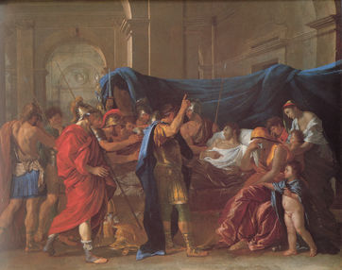](https://vignette.wikia.nocookie.net/bvgsuls/images/2/20/Poussin-The-Death-of-Germanicus.jpg/revision/latest?cb=20110909202153)

**The death of Germanicus in Five Steps**

**Sejanus**

**[](http://www.atlantaartsscene.com/wp-content/uploads/2016/11/Sejanua-001.jpg)TASK:** do some quick research into Sejanus to find – his birth and death dates, family background and class, role under Tiberius, downfall

**Prescribed Source - Tacitus, *Annals*, 4.1-3**

4.1. In the consulships of Gaius Asinius Pollio and Gaius Antistius Vetus, Tiberius now began his ninth year of national stability and domestic prosperity (the latter, he felt, augmented by Germanicus’ death). But then suddenly Fortune turned disruptive. The emperor himself became tyrannical – or gave tyrannical men power. The cause and beginning of the change lay with Lucius Aelius Sejanus, commander of the Guard. I have said something of his influence, and will now describe his origins and personality – and his criminal attempt on the throne.

Sejanus was born at Vulsinii. His father, Luucius Seius Strabo, was a Roman knight. After increasing his income – it was alleged – by a liaison with a rich debauchee named Marcus Gavius Apicius, the boy joined, while still young, the suite of Augustus’ grandson Gaius Caesar. Next by various devices he gained a complete ascendancy over Tiberius. To Sejanus alone the otherwise cryptic emperor spoke freely and unguardedly. This was hardly due to Sejanus’ cunning; in that he was outclassed by Tiberius. The cause was rather heaven’s anger against Rome – to which the triumph of Sejanus, and his downfall too were catastrophic. Of audacious character and untiring physique, secretive about himself and ever ready to incriminate others, a blend of arrogance and servility, he concealed behind a carefully modest exterior an unbound lust for power. Sometimes this compelled him to lavish excess, but more often to incessant work. And that is as damaging as excess when the throne is its aim.

4.2. The command of the Guard had hitherto been of slight importance. Sejanus enhanced it by concentrating the Guard battalions, scattered about Rome, in one camp. Orders could reach them simultaneously, and their visible numbers and strength would increase their self-confidence and intimidate the population. His pretexts were, that scattered quarters caused unruliness; that united action would be needed in an emergency; and that a camp away from the temptations of the city would improve discipline. When the camp was ready, he gradually insinuated himself into the men’s favour. He would talk with them addressing them by name. And he chose their company and battalion-commanders himself. Senators’ ambitions, too, he tempted with offices and governorships for his dependants.

Tiberius was readily amenable, praising him in conversation – and even in the senate and Assembly - as ‘the partner of my labours’, and allowing honours to his statues in theatres, public places, and brigade headquarters. 4.3. Yet Sejanus’ ambitions were impeded by the well-stocked imperial house, including a son and heir – in his prime – and grown-up grandchildren. Subtlety required that the crimes should be spaced out: it would be unsafe to strike at all of them simultaneously. So subtle methods prevailed. Sejanus decided to begin with Drusus, against whom he had a recent grudge. For Drusus, violent-tempered and resentful a rival, had raised his hand against him during a fortuitous quarrel and, when Sejanus resisted, had struck him in the face.

After considering every possibility, Sejanus felt most inclined to rely on Drusus’ wife Livilla, the sister of Germanicus. Unattractive in earlier years, she had become a great beauty. Sejanus professed devotion, and seduced her. Then, this first guilt move achieved – since a woman who has parted with her virtue will refuse nothing – he incited her to hope for marriage, partnership in the empire, and the death of her husband. So the grand-niece of Augustus, daughter-in-law of Tiberius, mother of Drusus’ children, degraded herself and her ancestors and descendants with a small-town adulterer; she sacrificed her honourable, assured position for infamy and hazard. The plot was communicated to Eudemus, Livilla’s friend and doctor, who had profession pretexts for frequent interviews. Sejanus encouraged his mistress by sending away his wife Apicata, the mother of his three children. Nevertheless the magnitude of the projected crime caused misgivings, delays, and (on occasion) conflicting plans.

1. **Choose three words that sum up the character of Sejanus (as it has been explained by Tacitus)**
2. **Give two ways in which Sejanus increased the power of the Praetorian Guard.**
3. **Why, according to Tacitus did Sejanus allegedly murder Drusus in 23 BC and how did he do this?**

As the commander of the **Praetorian Guard** Sejanus had almost uninterrupted access to Tiberius and used his position to increase his power and even build himself into the succession. Tiberius had been short of obvious successors at the beginning of the reign and, according to Tacitus, had begged the Senate to appoint a colleague to help him rule, so it is perhaps not as surprising as it seems that he would bring Sejanus into the succession. His power was seen by many to rival that of Tiberius and this is a view reinforced by Dio:

**Prescribed Source – Dio, *Roman History,* 58:4.1–4**

**Sejanus’ Power Increases**

4.1. Now Sejanus was growing more powerful and formidable all the time; as a result, the senators and all the other sections of Roman society treated him as if her were actually emperor, while they had only contempt for Tiberius. When Tiberius learned this, he neither treated the matter lightly nor avoided the issue; he was afraid they might declare Sejanus emperor outright. 4.2. As a result he did nothing openly, to be sure. For Sejanus had completely won over the entire Praetorian Guard and had gained the favour of the senators, partly by benefactions, partly by the hopes he inspired, and partly by intimidation. In addition, he had won over all Tiberius’ close associates so completely to his side that they immediately reported to him absolutely everything the emperor said or did, whereas no one told Tiberius what Sejanus was up to. 4.3. So Tiberius changed his line of attack: he appointed Sejanus consul, named him ‘Sharer of my Cares’, kept on calling him ‘My Sejanus’ and used it openly in letters addressed to the senate and to the people. 4.4. Men were taken in by this behaviour, thinking it to be genuine: they set up pairs of bronze statues of them both everywhere, wrote their names together in inscriptions, and brought gilded chairs into the theatre to honour both of them. Finally, it was voted that they should hold the consulship together every five years and that a delegations of citizens should go out to meet both alike whenever they entered Rome. Eventually, they sacrificed to the images of Sejanus just as they did to those of Tiberius.

As we have already seen from Tacitus, Sejanus rose to power by allegedly murdering Tiberius’ son Drusus in 23 BC and by seducing Drusus’ wife Livilla. Sejanus went even further than this though by trying to convince Tiberius to allow him to marry Livilla and thus guarantee his position as Tiberius’ successor.

**Prescribed Source - Tacitus, *Annals*, 4.1-3**

4.39. Sejanus' judgement now became affected by too great success; and feminine ambition hustled him, since Livilla was demanding her promised marriage. He wrote a memorandum to the emperor. (It was customary at that time to address him in writing even when he was at Rome.) This is what Sejanus said:

'The kindness of your father Augustus, and your own numerous marks of favour, have accustomed me to bringing my hopes and desires to the imperial ear as readily as to the gods. I have never asked for brilliant office. I would rather watch and work, like any soldier, for the emperor's safety. Yet I have gained the greatest privilege – to be thought worthy of a marriage-link with your house. That inspired me to hope: besides, I have heard that Augustus, when marrying his daughter, had not regarded even knights as beneath consideration. So please bear in mind, if you should seek a husband for Livilla, your friend who would gain nothing but prestige from the relationship. For I am content with the duties I have to perform; satisfied – for my children's sake – if my family is safeguarded against the unfounded malevolence of Agrippina. For myself, to live my appointed span under so great an emperor is all the lie I desire.'

4.40. In reply Tiberius praised Sejanus' loyalty, touched lightly on his own favours to him, and asked for time, ostensibly for unbiased reflection. Finally, he answered. 'Other men's decisions', he wrote, 'may be based on their own interests, but rulers are situated differently, since in important matters they need to consider public opinion. So I do not resort to the easy answer, that Livilla can decide for herself whether she should fill Drusus' place by remarrying, or stay in the same home. Nor shall I reply that she has a mother and grandmother who are her more intimate advisers than myself. I shall be more frank. In the first place Agrippina's ill-feelings will be intensified if Livilla marries: this would virtually split the imperial house in two. Even now, the women's rivalry is irrepressible, and my grandsons are torn between them. What if the proposed marriage accentuated the feud?

You are mistaken, Sejanus, if you think that Livilla, once married to Gaius Caesar and then to Drusus, would be content to grow old as the wife of a knight – or that you could retain your present status. Even if I allowed it, do you think it would tolerated by those who have seen her brother and father, and our ancestors, holding the great offices of state? You do not want to rise above your present rank. But the officials and distinguished men who force their way in upon you and consult you on all matters maintain openly that you have long ago eclipsed all other knights and risen above any friend of my father's. Moreover, envying you, they criticize me.

'Augustus, you say, considered marrying his daughter to a knight. But he foresaw that the man set apart by such as alliance would be enormously elevated; and it is surprising, therefore, that those he had in mind were men like Gaius Proculeius, noted for their retiring abstention from public affairs? Besides, if we are noting Augustus' delay in making up his mind, the decisive consideration is that the sons-in-law whom he actually chose were Marcus Agrippa and then, in due course, myself. I have spoken openly, as your friend. However, what you and Livilla decide, I shall not oppose. Of certain projects of my own, and additional ties by which I plan to link you with me, I shall not speak now. This only shall I say: for your merits and your devotion to me, no elevation would be too high. When the time comes to speak before the senate and public, I shall not be silent.'

4.41. Sejanus was alarmed, not just for his marriage but on graver grounds. He replied urging Tiberius to eschew suspicion and ignore rumour and malignant envy. Then, unwilling either to shut out his stream of visitors – which would mean loss of influence – or by receiving them to give his critics a handle, he turned his attention to persuading Tiberius to settle in some attractive place far from Rome, He foresaw many advantages in this. He himself would control access to the emperor – as well as most of his correspondence, since it would be transmitted by Guardsmen. Besides, the ageing monarch, slackening in retirement, would soon be readier to delegate governmental functions. Meanwhile Sejanus himself would become less unpopular when his large receptions ceased – by eliminating inessentials, he would strengthen his real power. So he increasingly denounced to Tiberius the drudgeries of Rome, its crowds and innumerable visitors, and spoke warmly of peace and solitude, far from vexation and friction: where first things come first.

1. **Give two reasons why Tiberius rejected Sejanus’ proposal to marry Livilla?**
2. **What did Sejanus try to do after this?**

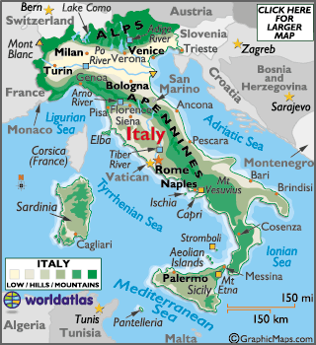Sejanus reacted to Tiberius’ refusal to allow him to marry Livilla by trying to persuade the emperor to leave Rome, first to **Campania in AD 25** and then to **Capri in 26** (find on the map). Tiberius had spent a long period of Augustus’ reign abroad so this was not unheard of but it did give Sejanus almost complete power back in Rome.

**Prescribed Source – Suetonius *Tiberius* 39-41**

39. After the loss of his son Drusus at Rome and his adopted son Germanicus in Syria, Tiberius retired to Campania - from which almost everyone swore he would not return, but would soon die there. This prediction was not far out, because Rome had in fact seen the last of him, and he narrowly escaped death a few days later. He was dining at a country house called The Cavern, near Tarracina, when some huge rocks fell from the roof and killed several guests and attendants close to him; he miraculously survived.

40. His pretext for the progress through Campania was that he must dedicate a temple to Jupiter Capitolinus at Capua and a temple to Augustus at Nola. But these tasks done, he crossed over to the isle of Capreae, which fascinated him by having only one small landing beach – the remainder of its coast consisted of sheer cliffs surrounded by deep water. However, a catastrophe at Fidenae recalled him to the mainland almost at once: the amphitheatre had collapsed during a gladiatorial show, and more than 20,000 people lay dead in the ruins. Tiberius now gave audiences to everyone who demanded them, and was the readier to be gracious because he had given orders on leaving the city some days previously that he must not be disturbed throughout his journey.

41. On his return to Capreae he let all affairs of state slide, neither filling vacancies that occurred in the equestrian order, nor appointing new military tribunes and cavalry officers, nor sending out new provincial governors; Spain and Syria were left without legates of consular rank for several years. He allowed the Parthians to overrun Armenia, the Dacians and Sarmatians to ravage Moesia, and the Germans to invade Gaul – a negligence as dangerous to the empire as it was dishonourable.

1. **How is the portrayal of Tiberius move to Capri slightly different to the image created by Tacitus?**

Tiberius’ departure meant that, according to Dio, “it was he who appeared to be emperor and Tiberius a kind of off-shore monarch.’ The senators swarmed around Sejanus recognising that he was now the centre of power.

This would not last, however, as in AD 31 Tiberius’ support for Sejanus began to decline. This was due in part to Sejanus’ attacks on Germanicus’ sons **Nero** and **Drusus** who were potential rivals to power when Tiberius died. Another possible reason for Sejanus’ change in fortunes was the role of his now abandoned wife **Apicata** who is meant to have told Tiberius of Sejanus’ part in the death of his son Drusus.

**Prescribed Source – Suetonius *Tiberius* 61**

61. Soon Tiberius broke out in every sort of cruelty, and never lacked for victim: these were the friends and even acquaintances first of his mother, then of Agrippina, Nero and Drusus, and finally of Sejanus. With Sejanus out of the way his savageries increased, which proved that Sejanus had not, as some thought, been inciting him to commit them, but had merely been providing the opportunities he demanded. Nevertheless, in Tiberius’ dry, brief autobiography we find him daring to assert that Sejanus had been killed for persecuting Nero and Drusus; the fact was that he had himself put Nero to death when Sejanus was already and object of suspicion, and Drusus after the had fallen from power.

**The Downfall of Sejanus**

**TASK – Read the sources on p. 34-38 that explain Sejanus’ fall from power. Once you have done so, write a newspaper-style summary of his fall and execution. Begin by choosing to do this in a pro-Tiberius or anti-Tiberius perspective and include specific references from the sources as supporting quote.**

**Prescribed Source – Dio, *Roman History,* 58: 5.1–7**

**Sejanus’ Position in AD 31**

5.1. Sejanus was now so great a person both in terms of the excessive extent of his pride and the scale of his power that, to put it in a nutshell, it was he who appeared to be the emperor and Tiberius a kind of off-shore monarch, since he spent his time on the island known as Capri. 5.2. There was plenty of anxious jostling around Sejanus’ door. People were afraid not only that they would not be seen by him, but also that they might be among the last to appear; for every word and nod was carefully observed, especially those of the leading citizens. 5.3. For those who hold power through their own inherited merit do not go out of their way to seek popularity from others; for them, since they know full well that they are not being scorned. But, on the other hand, those who reach an important position by some unexpected stroke of good fortune certainly seek after all these things, since they think them necessary for their merit to be fully recognized. And if they fail to receive these signs of acceptance, they are then annoyed as if they were being slandered, and grow angry as if they were being humiliated. 5.4. Therefore, one might say that people take more trouble over these sorts of person than over emperors, because it is a virtue for emperors to pardon people, even if they have committed an offence; but these other powerful individuals are convinced that it is a proof of weakness, whereas to go on the attack and take vengeance is thought to provide confirmation of their great power.

5.5. Now on the first day of the month many people were assembling at the house of Sejanus. The couch in the room in which he was greeting them completely collapsed under the weight of the crowd sitting on it; and as he was leaving the house, a weasel darted through the middle of the crowd. 5.6. And when he had finished sacrificing on the Capitol and was walking down to the Forum, the servants who were acting as his bodyguard turned off along the road leading to the prison, since they were unable to keep up with him because of the crowds. And as they were going down the steps down which condemned criminals were thrown, they slipped and fell. 5.7. and after this as he was taking the auspices, not one bird of good omen appeared, but instead many crows kept circling around him cawing, then flew off in a group towards the prison and perched on top of it.

**Prescribed Source – Dio, *Roman History,* 58: 6-7.3**

**Tiberius Plays Cat-and-Mouse with Sejanus**

6.1. Neither Sejanus nor anyone else took these omens to heart. For in view of the present circumstances not even if a god had clearly prophesied that such a great change was soon to take place, would anyone have believed it. 6.2. They constantly swore by his Fortune and addressed him as Tiberius’ colleague in power, not referring to the consulship, but to the supreme power. But know there was nothing that Tiberius did not know about Sejanus, and he was planning how he could put him to death. But since he could not find any way of doing this safely in the open, he treated Sejanus and the others in a remarkable fashion, so that he could discover exactly what was in their minds. 6.3. He kept sending various kinds of dispatches with news of himself to Sejanus and also to the senate. At one moment he would say that he was in a bad state of health and very close to death; and at another that he was feeling extremely well and would come straight to Rome. 6.4. At one moment he would lavish praise upon Sejanus, and then would utterly denounce him; and while he would honour some of Sejanus’ friends on his account, for others he would show no respect. So Sejanus, filled in turn with extreme elation and extreme fear, was in constant suspense; for he had no reason to panic and hence attempt a revolution, since he was still being honoured; nor did he have the confidence to undertake daring venture, since he was being discredited. 6.5. However, he was not alone, for everyone else was also in a state of uncertainty. They would hear the most contradictory stories one shortly after another, and so could no longer admire Sejanus, but nor could they despise him. As far as Tiberius was concerned, they could only guess whether he was dead or on his way to Rome.

7.1. Sejanus was upset by all this, and so much the more when, first, a large cloud of smoke burst out of one of the statues of him, and then, after they had removed its head to allow them to see what was going on inside, a large snake leapt up. Another head was immediately put back in its place. 7.2. And when Sejanus was about to offer sacrifice to himself because of this omen (for he used to include himself in such sacrifices), a rope was found coiled around the statue’s neck. There was also the case of a statue of Fortune, which had belonged, so people claim, to Tullius, who had once been one of the kings of Rome. At this time Sejanus had the statue in his home, and took great pleasure from this fact. As he was conducting a sacrifice, he saw it turn away from him.

**Prescribed Source – Dio, *Roman History,* 58: 8.4-11**

**The fall of Sejanus**

8.4. In a letter to the senate about the death of Nero Tiberius referred to Sejanus simply as Sejanus, without adding his usual titles. Furthermore, because people were carrying out sacrifices to Sejanus, he put a ban on offerings of this kind being made to any mere mortal. And because Sejanus was being voted many honours, he refused to allow any measure that proposed honours for himself. He had also made this prohibition earlier in his reign, but reiterated because of Sejanus; for anyone who did not allow himself to be honoured in any way would not be likely to allow anybody else to receive honours.

9.1. In this situation Sejanus was held more and more in contempt. People avoided meeting him or being left alone with him, in a way too obvious not to be noticed. So when Tiberius was informed of this, he was encouraged to think that he would have the people and the senate on his side, and so launched his attack upon Sejanus. 9.2. First, to put him as much off his guard as possible, he circulated a rumour that he was going to give Sejanus tribunician power. The he despatched Naevius Sertorius Macro to the senate-house with a letter denouncing Sejanus. He had already secretly appointed Macro to command the bodyguard and had explained to him in advance everything that needed to be done. 9.3. Macro entered Rome by night, pretending to be on some other business, and communicated his instructions to Memmius Regulus, who was consul at the time (his consular colleague took Sejanus’ side), and to Graecinius Laco, commander of the Night-Watch.

9.4. At dawn Macro went up to the Palatine – for the session of the senate was to take place in the temple of Apollo. He met Sejanus, who had not yet gone in, and seeing that he was agitated because Tiberius had not sent him any message, he took him aside and encouraged him, telling him in confidence that he was bringing him tribunician power. 9.5. Overjoyed at the news, Sejanus hurried into the senate-chamber. Macro then sent the praetorians who were guarding Sejanus and the senate back to their camp, after revealing his authority to them and stating that he had a letter from Tiberius granting them rewards. 9.6. Then after stationing Night-Watch around the temple to replace praetorians, he entered the temple, delivered the letter to the consuls and left before any of it was read. He ordered Laco to keep watch there, while he himself hurried to the camp, to prevent any revolutionary uprising.

10.1. Meanwhile the letter was read out. It was long and did not contain a wholesale denunciation of Sejanus, but first dealt with some other issue, then made some slight criticism of his conduct, then something else, and after that some further point against him; and it ended by saying that two senators who were among his closest friends had to be punished and that Sejanus himself must be kept under guard. 10.2. Tiberius did not give orders to put him to death on the spot: it was not that he did not wish to do so, but he was afraid that some disturbance might arise if this happened, At any rate, on the grounds that it was impossible for him even to make the journey to Rome in safety, he summoned one of the consuls to him. This was all that the letter disclosed; but it was possible to hear and see the many different effects that it had. 10.3. Before it was read out, the senators had been congratulating Sejanus on his imminent grant of the tribunician power. They had kept cheering him, anticipating the honours they hoped would be his and making it clear to him that they would support the grant. 10.4. But when nothing of the sort was found in the letter and they kept on hearing the complete opposite of what they had expected, they were at first confused, then completely dismayed. Some of those who were sitting near Sejanus actually stood up and left him. They no longer wanted to share the same seat with the man whose friendship they had previously cherished. 10.5. After this praetors and tribunes surrounded him, to prevent him from rushing out and causing a riot. And he certainly would have done this, if at the outset he had been startled by hearing a general denunciation. As it turned out, he paid no particular attention to the successive charges as they were read out, thinking each one a trivial matter in its own right, and hoping most of all that no further charge was contained in the letter, or at any rate none that he could not deal with, so he let the time slip by, and stayed in his seat.

10.6. At this moment Regulus called him forward, but he took no notice: not out of contempt (for by now he was humble enough), but because he was not used to taking orders. When the consul raised his voice and at the same time pointed to him, calling out for a second and third time, “Sejanus, come here”, he merely asked, “Do you mean me?” At last, however, he got to his feet and Laco came back in and stood right alongside him. 10.7. At last when the letter had been completely read out, everyone with one voice started to denounce and curse Sejanus, some because they had suffered wrongs at his hands, others through fear, some to conceal their friendship with him, others out of joy at his change in fortune. 10.8. Regulus did not call for a general vote or ask any individual senator to bring up the question of the death penalty: he was afraid of some opposition and consequent disorder, since Sejanus after all had numerous relatives and friends. He just asked a single seator whether Sejanus should be imprisoned and on getting an affirmative answer, he led him out of the senate and took him down to the prison, accompanied by Laco and the other magistrates.

11.1. On that occasion one could have seen for oneself a perfect proof of human powerless, enough to prevent anyone from ever becoming too proud. For the man whom at dawn everyone had escorted to the senate house, as they he was much more important then they, this same man they were now dragging off to prison as if her were no better than anyone else; the man whom they had previously honoured with many garlands, they were now encircling with bonds; 11.2. the man whom they had protected like a master, they now watched over like a runaway slave, uncovering his head as he tried to cover it up; the man whom they had honoured with a purple-boarded toga, this man they were now beating around the head; the man to whom they had bowed and sacrificed as if to a god, this man they were now leading away to his execution. 11.3. The people also started to attack him, vilifying him for all the people that he had destroyed and ridiculing him for all the hopes that he had inspired. As for all the images of him, they went round hurling them down, cutting them down an dragging them down, as if they were actually injuring his very body; he was becoming a spectator of the things that he was about to suffer. 11.4. For the time being, he was thrown into prison.

Not much later in fact on the same day, the senate met in the temple of Concord, not far from the prison, when they saw the people’s hostility towards him and that none of the Praetorian Guard were about; they passed a decree sentencing him to death. 11.5. After they had passed judgement in this way, his body was hurled down the Steps and the mob abused it for three whole days and then threw it into the Tiber. His children were put to death by senatorial decree: his daughter, who had been engaged to Claudius’ son, was first raped by the public executioner, since it was not considered proper for a girl who was still a virgin to be put to death in prison. 11.6. His wife Apicata was not condemned, but when she found out that her children had been executed and saw their bodies on the Steps, she went inside and wrote a note about the death of Drusus, in which she denounced Livilla, his wife. Livilla had been the cause of the quarrel between her and her husband Sejanus and their subsequent separation. 11.7. She sent this note to Tiberius and then committed suicide. This was how Tiberius received the note; and once he had read through its contents, he had Livilla and all the others mentioned in it put to death. I have now heard that he pardoned Livilla as a result of the actions of her mother Antonia, and that Antonia herself purposely starved her daughter to death. This happened later.

* **Summary question – how does the following view of Sejanus from Velleius Paterculus differ from that you have developed so far?**

**Prescribed Source – Velleius Paterculus, 2.127.1-128.4**

**Praise of Sejanus as Tiberius’ Assistant**

127.1. It is common enough for eminent men to employ distinguished assistant in the management of their affairs. The two Scipios recruited Laelii, and elevated them to positions of equality with themselves, Divine Augustus brought in Marcus Agrippa, and immediately after this Statilius Taurus. The fact that they lacked an aristocratic pedigree did not prevent them from winning promotion to repeated consulships and triumphs, as well as a number of priesthoods. Matters of high policy require administrators of outstanding ability, 127.2. and practical necessity requires that those who serve the national interest should be reinforced by high status, and their effectiveness assured by the authority of their position. 127.3. With such precedents to guide him, Tiberius Caesar brought in just such an outstanding administrator in Sejanus Aelius, to assist him in all the burdens of the principate – and he retains that position to this day. His father was a leading figure in the equestrian order; his mother claimed descent from some of the most ancient and distinguished families in Rome, holders of innumerable public offices. His brothers, cousins, and uncle were all of consular rank; his own loyalty to the emperor and capacity for hard work has been matched by a physical strength that more than equals his intellectual vigour. 127.4. He is a man of good natured seriousness of character and a somewhat old-fashioned sense of humour. His energy is masked by a deceptively relaxed manner; he has sought no personal advantage and for that reason has been granted every kind of distinction; his personal modesty is in sharp contrast to the high regard which others have for him; his life, like his general demeanour, shows no signs of stress; yet his is a sharp and always restless intelligence.

128.1. There is nothing to choose between the long standing regard felt for this man in the court of public opinion and the emperor’s own judgement of him. In this there is nothing new; it has always been the habit of the senate and the people of Rome to equate what is most noble with that which is best. Three hundred years ago, before the Punic War, they raised a new man, Tiberius Coruncanius to the highest pinnacle of public office, the consulship, as well as conferring on him all sorts of other honours, and even the office of *pontifex maximus*. 128.2. Then there was Spurius Carvilius, an equestrian by birth, and soon afterwards Marcus Cato, a new man and an immigrant to Rome from Tusculum, and Mummius, the conqueror of Achaia – they were all advanced to the offices of consul and censor, and awarded triumphs. 128.3. Nothing was known of Gaius Marius’ origins. But until his sixth consulship he was universally regarded as Rome’s first citizen (*princeps)*. Marcus Tullius Cicero was so highly regarded that his recommendation could win high office for almost anyone he wished. As for Asinius Pollio, they denied him nothing which could be earned by honest toil and sweat, even by the noblest in the land. They clearly realised that the highest rewards should be bestowed on those whose character revealed the noblest qualities. 128.4. It was that natural impulse to follow their example which led Caesar to put the qualities of Sejanus to the test, encouraged him to share the burdens of imperial office, and persuaded the senate and people of Rome to recruit to the defence of their own security the very man whom experience had showed them to be best suited to the task.

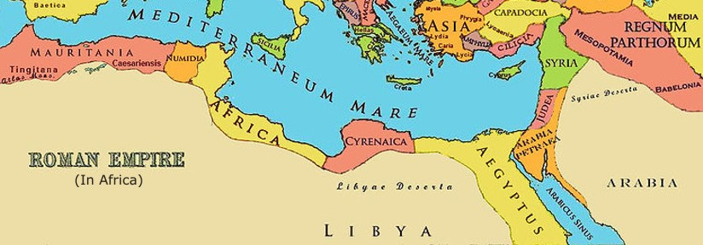**Challenges and Conspiracies**

**RECAP – what opposition to Tiberius are you already aware of?**

One of the major challenges to Tiberius during his reign was a revolt from a deserter from the Roman army **Tacfarinas**. This revolt centred in the Roman province of Africa. Tacfarinas launched attacks into neighbouring provinces and potentially threatened the grain supply from Egypt to Rome. The rebels were defeated in AD 17 by Furius Camillus but the rebellion continued achieving a victory over a cohort from the Third Legion. Tiberius eventually appointed Quintus Junius Blaesus who reduced the size number of Tacfarinas’ supporters by offering amnesty. Eventually Tacfarinas was killed in a surprise morning-attack on his camp.

**TASK – Use the following account of the Tacfarinas rebellion to produce a simple timeline of event son the age that follows.**

**Prescribed Source - Tacitus, *Annals*, 2.52**

2.52. In the same year war broke out in the province of Africa, under a Numidian leader called Tacfarinas. He had deserted from service as a Roman auxiliary. His first followers were vagabonds and marauders who came for loot. The he organized them into army units and formations, and was finally recognized as the chief, no longer of an undisciplined gang, but of the Musulamian people – a powerful nomad tribe on the edge of the African desert. Taking up arms, they brought in the neighbouring Mauretanians, under their leader Mazippa. Their army was in two parts. Tacfarinas retained in camp an elite force equipped in Roman fashion, which he instructed in discipline and obedience; while Mazippa’s light-armed troops burnt, killed, and intimidated. The substantial tribe of the Cinithii came over to the rebels.

At this stage Marcus Furius Camillus, governor of Africa, confronted Tacfarinas with his Roman brigade and its auxiliaries. Though this was a small army compared to the masses of Numidians and Mauretanians, his chief concern was to prevent the enemy from cautiously evading battle. Actually, the Africans were optimistic – and this lured them into an unsuccessful engagement. The Roman brigade was posted in the centre, the auxiliary infantry battalions and two cavalry regiments on the wings. Tacfarinas accepted the challenge, and the Numidians were routed. After centuries the Furian family had won military glory again. For ever since the great Marcus to whom Rome had owed its revival, and his son Lucius, success in the field had passed to other families; and the present commander was believed to be no general. So Tiberius was all the readier to praise his victory in the Senate. Camillus was voted an honorary triumph – and lived so unassumingly that he survived it.

**Prescribed Source - Tacitus, *Annals*, 3.20-21**

3.20. In the same year Tacfarinas, whose defeat in the previous summer by Marcus Furius Camillus I have recorded, resumed hostilities. After nomad raids – too swift for reprisals – he began destroying villages and looting extensively. Finally, he encircled a Roman regular battalion near the river Pagyda. The energetic and experienced commander of the fort, Decrius, considered the siege a disgrace, and ordered his men to fight in the open, forming line in front of the camp. The battalion succumbed to the first attack, but Decrius hurled himself into the rain of missiles to bar its flight, cursing the sergeant-majors for letting Roman soldiers run away from irregulars and deserters. He turned towards the enemy, wounded in body and face (one eye was pierced), and went on fighting until he fell. His men abandoned him.

3.21. When Lucius Apronius, the successor of Camillus, heard of this, he was less worried by the enemy’s success than by the Roman disgrace. Adopting an ancient procedure, now rare, he drew lots in the discredited battalion and had every tenth man flogged to death. The severity was effective. When the same force of Tacfarians attacked the fort of Mala, a detachment of only five hundred soldiers routed it. In the battle a private soldier, Helvius Rufus, won the honour of saving a citizen’s life. Apronius decorated him with the honorific chain and spear, and the Citizen’s Oak-wreath was added by Tiberius. The emperor pretended to deplore that Apronius, as governor and commander-in-chief had not made this award, like the others, on his own initiative.

Since the Numidians were demoralized and impatient of siege warfare. Tacfarinas conducted a guerrilla campaign, giving way under pressure and then attacking from the rear. The tired Romans, frustrated and ridiculed by these tactics, could not retaliate. But finally Tacfarinas turned aside to the coast and, immobilized by all the plunder he had collected, kept close to a stationary base; and then the Roman governor’s son, Lucius Apronius Caesianus, sent against him with cavalry, auxiliary infantry, and the most mobile Roman regulars, won a victory and drove the Numidians into the desert.

**Prescribed Source - Tacitus, *Annals*, 3.32**

A little later, Tiberius wrote to the senate reporting that an incursion by Tacfarinas had again broken the peace of Africa. He requested them to choose a governor who was an experienced military commander and physically fit for active service. Sextus Pomeius (II) seized the opportunity of ventilating his dislike if Manius Aemilius Lepidus, whom he described as a lazy degenerate pauper who ought to be excluded from the ballot both for Africa and Asia. The senate objected since it regarded Lepidus as mild and rather lazy, and his irreproachable bearing of an illustrious man – despite inherited poverty – as praiseworthy rather than discreditable. So Lepidus was appointed to Asia. With regard to Africa it was decided to let the emperor choose.

**Prescribed Source - Tacitus, *Annals*, 3.73-74**

3.73. Yet Blaesus’ achievements had earned the distinction. For Tacfarinas, despite frequent defeats, had raised reinforcements in the interior and was insolent enough to send representatives to Tiberius demanding land for himself and his army. As the alternative, he offered endless war. No personal or national slur, it is said, ever provoked the emperor more than the sight of this deserter and brigand behaving like a hostile sovereign. Even Spartacus (reflected Tiberius), burning Italy unavenged – at a time when he had destroyed consuls’ armies and the nation convulsed by terrible wars overseas against Quintus Sertorius and Mithridates VI of Pontus – had not been allowed conditions for his surrender. And now, with Roman power at hits height, was this bandit Tacfarinas to be bought off by a treaty granting lands?

Tiberius entrusted the matter to the governor Quintus Junius Blaesus. By promising pardon he was to induce the rebels to lay down arms – except the leader, who was to be captured by any means possible. The amnesty brought many over. Moreover, Tacfarinas was now confronted by methods like his own.

3.74. Since his army was inferior in fighting power but superior in raiding capacity, he operated with independent groups, avoiding engagements and setting traps. So the Romans, too, attacked with three separate formations. Each had a target of its own. One, under the divisional commander Publius Cornelius Lentulus Scipio, blocked the route by which the ebemy had raided Lepcis, with the Garamantes to fall back upon. On the other flank, a detachment commanded by Blaesus’ son protected the communities of Cirta against raids. In the centre was the governor and commander-in-chief himself with selected troops. By planting forts and defences at appropriate spots, he cramped and harassed the enemy. In whatever direction they moved, they found part of the Roman army on front, flanks and often rear. By these methods many rebels were killed and taken prisoner.

Then Blaesus split up his three formations into smaller bodies, each under a company-commander of distinguished record. It had been customary to withdraw the troops when summer was over, and quarter them in winter camps in Africa proper. Blaesus abolished this custom. Instead he established a chain of forts – the usual procedure at the beginning, not the end, of a campaigning season. Then, employing mobile columns with desert training, he kept Tacfarinas in a continual state of movement.

Finally, Blaesus captured the rebel leader’s brother. Then, however, he withdrew – too soon for the interests of the province, since enough of the enemy were left to revive hostilities. Nevertheless Tiberius treated the war as ended, and even allowed Blaesus the honour of being hailed victor by his army, a traditional distinction granted to successful generals by the spontaneous acclamation of their victorious troops. The distinction was not limited to one commander at a time, and did not confer precedence over others. It had been granted on certain occasions by Augustus. After this award by Tiberius to Blaesus it was never conferred again.

**Tacfarinas’ Rebellion:**

**Task:** How does Tacitus portray Tiberius’ handling of the Tacfarinas rebellion?

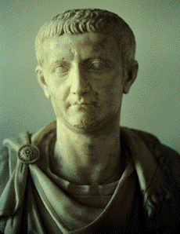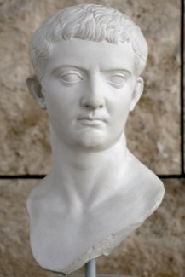

**The Treason Trials**

KEY TERM:

**MAIESTAS – The charge of treason against the Roman state, judged by the Senate, punished by death and confiscation of property**

[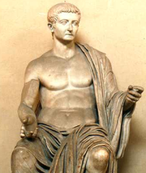](https://vignette.wikia.nocookie.net/real-life-villains/images/9/9c/Tiberius.png/revision/latest?cb=20120920015153)One of the most controversial aspects of Tiberius’ reign, and an aspect which Tacitus is particularly critical of, is his return of treason trials.

Tacitus gives detail on around eighty treason trials to demonstrate the tyrannical power of Tiberius. Many of these trials were against senators and were designed to reduce their freedom of speech and ability to criticise Tiberius’ regime.

Suetonius supports the view of Tiberius as a tyrannical ruler referring to the treason trials as ‘madness’. Seneca also reveals how open to abuse the treason trials were as people used the charge of *maiestas* to attack enemies and settle scores. This was made particularly bad by the use of professional informants called *delatores* who were paid a quarter of the value of the property confiscated from anyone they reported found guilty of treason.

**Tiberius’ Attitude towards Religion**

**RECAP – Explain what the following terms mean:**

*Imperial Cult:*

*Pontifex Maximus*

*Numen:*

*Genius:*

*Lares:*

Tiberius inherited the religious positions and power that Augustus had held. This meant the position of **Pontifex Maximus** along with the **imperial cult**, which he was now the centre of.

**Prescribed Source – Sestertius of Tiberius, AD 34/35**

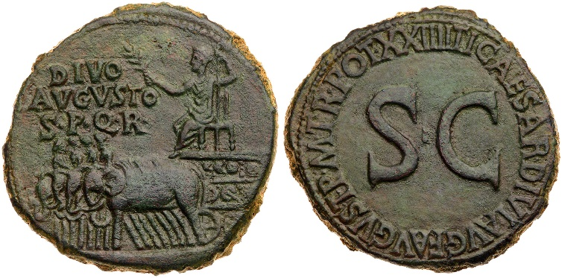

**Obv.:** Chariot drawn by four elephants with statue of Augustus; “To the divine Augustus from the Senate and People of Rome”

**Rev.:** “Augustus, son of Divus Augustus, pontifex maximus, in his 36th year of tribunician power (by the decree of the Senate)”

1. Give and explain two messages you think Tiberius was trying to send through this coin

Tiberius was the centre of religious life in Rome but he was clearly reluctant to take this role and he repeatedly vetoed proposals to give himself divine honours. This extended to preventing any new temples or priesthoods from being established in his name, as is recalled by Suetonius:

**Prescribed Source – Suetonius, *Tiberius* 26**

26. These immediate anxieties past, Tiberius at first behaved with great discretion and almost as modestly as if he had never held public office. Of the many high honours voted him, he accepted none but a few unimportant ones, and could hardly be persuaded to let his birthday, which fell on a day of the Plebeian Games, be honoured by the addition of a two-horse chariot race to those held in the Circus. He vetoed all bills for the dedication of temples and priests to his divinity, and reserved the right to sanction even the setting up of his statues and busts – which were not to be placed among the images of the gods, but only amid the temple décor. Proposals that all citizens should swear to approve his past and future actions, and that the months of September and October should be renamed respectively Tiberius and Livia (after his mother) met with his veto. He also declined to use Imperator as a praenomen or Father of His Country as a title, or to let the civil crown be fixed in his entry hall; and he even refrained from using the name Augustus, though his by right of inheritance, in any letters except those addressed to foreign monarchs. While *princeps*, he held no more than three consulships: one for a few days, the next for three months, and a third – during his absence – until 15 May.

However, despite Tiberius’ reluctance, it is clear that the imperial cult continued under his rule. This is made clear by two inscriptions:

1. **Inscription to the *genius* of Tiberius in Rome**
2. **Inscription from the citizens of Gytheion**

**Prescribed Source – Worship of Tiberius’ *genius* at Rome, AD 27**

To the *genius* of Tiberius Caesar Augustus, son of Divus Augustus. Gaius Fulvius Chryses, president of the lesser Amentine district, gave (this) as a gift on 28 May, in the consulship of Lucius Calpurnius and Marcus Crassus Frugi.

**Prescribed Source – Emperor-worship at Gytheion (Laconia), AD 15**

…Let him (i.e. the market clerk) set up …[on the first base a statue of god Augustus Caesar] the father, and on the second from the right of Julia Augusta, and on the third of *imperator* Tiberius Caesar Augustus, the city providing the statues for him. And let a table also be set out by him in the middle of the theatre and let an incense-burner be placed there, and let all the councillors and magistrates make sacrifices before the performances commence, on behalf of the safety of the leaders. And let him observe the first day in honour of god Caesar Augustus, son of a god, Saviour and Deliverer; the second day in honour of Imperator Tiberius Caesar Augustus and father of the fatherland; and the third day of Julia Augusta, the Fortune of our nation and city; and the fourth day of Germanicus Caesar, of Victory; and the fifth day as of Drusus Caesar, of Aphrodite; and the sixth day of Titus Quinctius Flaminius; and let him see to the good order of the competitors…

After the completion of the days of the gods and the leaders, let the market clerk introduce two further days for performances of the thymelic contests, one to the memory of Gaius Julius Eurykles, who has been benefactor of our nation and city in many ways, and a second for the honour of Gaius Julius Laco, who is protector of our nation and our city’s security and safety. Let him observe the contests of the goddess on whatever days he can; and whenever he leaves office, let the city hand over to the one who happens to be the next market clerk, by public document, all the sacrificial victims for the contests, and let the city obtain a hand-written receipt from the one who receives them. When the market clerk celebrates the thymelic games, he shall conduct a procession from the temple of Asklepios and Health including in it all ephebes and young men and other citizens wearing garlands of bay leaves, and in white clothing. They shall be accompanied in the procession by the sacred maidens and the women in their sacred clothing. And when the procession comes to the Caesareion (temple of Caesar), the ephors shall sacrifice a bull on behalf of the safety of our rulers ad gods and the eternal continuance of their rule, and after their sacrifice, they shall constrain the common messes and the collective magistracies to sacrifice in the agora, they shall pay to the gods 2,000 sacred drachmas. Permission shall be given to any citizen of Gytheion who wishes to accuse them.

While Chaion is strategos and priest of god Augustus Caesar, the ephos who are colleagues of Terentius Biades shall deliver three painted images of the god Augustus and Julia Augusta and Tiberius Caesar Augustus, and for the theatre (they shall deliver) the platform for the chorus and four doors for stage performance and footstalls for the musicians. And they shall erect a stele of stone with an inscription on it of this sacred law, and they shall deposit in the public archives a copy of the sacred law, in order that, reposing in a public place and in the open air for everyone to see, this law may continuously display the gratitude of the People of Gytheion toward their rulers for all man (to see). And if they do not inscribe this law or do not erect the stele in front of the temple or do not write up…

**Tiberius’ Reply**

[Tiberius Caesar] Augustus, son of [the god] Augustus, *pontifex maximus*, in his [16th] year of tribunician power, to the superintendents and city of Gytheion, greeting, Decimus Turranius Nicanor, the envoy sent by you to me and my mother, gave me your letter you which were appended the measures passed by you in veneration of my father and in our honour. I commend you for this and accept that it is fitting for all men in general and for your city in particular to reserve special honour befitting the gods in keeping with the greatness of the services of my father to the whole world; but I myself am satisfied with more moderate honours suitable for men. My mother, however, will reply to you when she hears your decision about

honours for her.

1. **Which prescribed source that you have read before is the inscription at Gytheion similar too?**
2. **What does Tiberius’ reaction to the offer of emperor-worship in Gytheion reveal about his attitude towards the imperial cult?**

**Tiberius’ Relationship with the Plebs, Equestrians and Senators**

Whereas Augustus was able to build an effective relationship with all of these groups, Tiberius struggled to build a strong relationship with any of them. According to Tacitus, Tiberius declared that **senators** were “primed for slavery”, the senate itself seems deeply **sycophantic:**

**Prescribed Source - Tacitus, *Annals*, 4.74**

The senate too, had more pressing concerns than a frontier setback. Metropolitan terrors were what preoccupied them. From these they sought relief in flattery. Though assembled to consider some unrelated business, they voted the erection of altars to Mercy and Friendship – the latter to be flanked by statues of Tiberius and Sejanus. The senate also repeatedly begged them to vouchsafe a view of themselves. But neither came into Rome, or near it. They thought it sufficient to leave their island and show themselves on the Campian coast opposite. There flocked senators and knights and large crowds of ordinary people – anxiously regarding Sejanus.

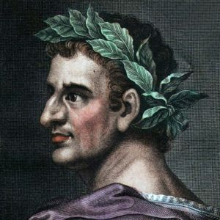Tiberius at the start of his reign appeared eager to work with the senate and include them in the government of the empire in a more serious way than had been the case under Augustus. The senate, however, were reluctant to do this and Tiberius became increasingly frustrated with them as his reign went on (good evidence of this is his attacks on senators with charges of treason).

In terms of the **plebs**, Augustus had understood the power of the ‘mob’ in Rome and had developed a clever policy of ‘bread and circuses’ to guarantee their support. Tiberius, however, was much less successful. He was cautious with money meaning that there were far fewer games and gifts to the plebs. By nature Tiberius was also extremely reclusive making him a distant and disconnected ruler for the plebs.

**Prescribed Source – Suetonius, *Tiberius* 47-48**

47. As *princeps*, he was responsible for no magnificent public works: his only to undertakings, the erection of Augustus’ Temple and the restoration of Pompey’s Theatre, still remained uncompleted at the end of all those years. He gave no public shows at all, and hardly every attended those given by others because he did not want to be asked for anything – especially when the crowd forced him, on one of his rare visits to the theatre, to buy the freedom of a slave comedian called Actius. Though relieving the financial distress of a few senators, he avoided having to repeat this generous act by announcing that in future imperial assistance would be restricted to such persons as could prove to the satisfaction of the Senate that they were not responsible for their financial embarrassment. Shame and pride then prevented many impoverished senators from making an application; among these was Hortalus, grandson of the orator Quintus Hortensius, whose income was very moderate indeed but whom Augustus’ pleas had encouraged to beget four children.

48. Tiberius showed large-scale generosity no more than twice. On the first occasion he offered a public loan of 100 million sesterces, free of interest, for three years, because a decree which he had persuaded the Senate to pass – ordering all moneylenders to invest two-thirds of their capital in agricultural land, provided that their debtors at one disbursed in cash two-thirds of what they owed – failed to relieve the acute economic crisis. On the second occasion, he paid for the rebuilding of certain blocks of houses on the Caelian Hill which had been destroyed in a fire. This too was an emergency measure during bad times, yet he made such a parade of his open-handedness as to rename the whole hill the ‘Augustan’. After doubling the legacies bequeathed by Augustus to the army, Tiberius never gave them anything beyond their pay, except for the 1,000 denarii a head which the praetorian guard won for not aligning themselves with Sejanus and some gifts awarded the legions in Syria for being the only ones not to have set consecrated statues of Sejanus among their regimental standards. He granted few veterans their discharge, reckoning that if they died while serving he would be spared the expense of the discharge bounty. The only free money grant any province got from him was when an earthquake destroyed some cities in Asia

**Prescribed Source - Tacitus 3.55**

3.55 When the emperor’s letter had been read, the aediles were excused from the task.

Since then, however, extravagant eating, which reached fantastic heights during the century between Actium and the disturbances which brought Galba to the throne, has gradually become unfashionable. The reasons for the change are worth examining. Old, rich families, noble and illustrious, were often ruined by their sumptuous tastes. For, in those days, to court (and be courted by) the public in Rome and the provinces, and by foreign monarchs, was allowed, Fortunes, palaces, and their contents dictated the size of dependent hordes and of reputations. But the reign of terror, when distinction meant death, induced prudence in survivors. At the same time too, the numerous self-made men admitted into the senate from Italian towns (and even from the provinces) brought frugal domestic habits, and, though by good fortune or hard work many of them were rich in later life, they did not change their ideas. No one promoted simplicity more than Vespasian, with his old-fashioned way of life. For deference to the emperor and the wish to imitate him were more than effective legal penalties and threats.

Or perhaps not only the seasons but everything else, social history included, moves in cycles. Not, however, that earlier times were better than ours in every way – our own epoch too has produced moral and intellectual achievements for our descendants to copy. And such honourable rivalry with the past is a fine thing.

**Prescribed Source – Suetonius, *Tiberius* 75**

75. The firm news of his death caused such joy at Rome that some people ran about yelling ‘To the Tiber with Tiberius!’ and others offered prayers to Mother Earth and the Di Manes to give him no home below except among the impious. There were also loud threats to drag his body off with a hook and fling it on the Gemonian Stairs, for popular resentment against his savage behaviour was now increased by a fresh outrage. It so happened that the Senate had decreed a ten days’ stay of execution in the case of all persons sentenced to death, and Tiberius died the very day on which the period of grace expired for some of them. The unfortunate creatures threw themselves on the mercy of the public, but since Gaius was not yet at hand there was no one to whom an appeal could be made, and the jailers, afraid of acting illegally, carried out the sentence of strangling them and throwing their bodies on the Gemonian Stairs. Thus the hatred of Tiberius grew hotter than ever – his cruelty was, it was said, continued even after his death – and when the funeral procession left Misenum, the cry went up, ‘Take him to Atella Give him a half-burning in an amphitheatre!’ However, the soldiers carried the corpse to Rome, where it was cremated with due ceremony.

1. **On the basis of the three sources above, how popular was Tiberius with the Plebs of Rome?**
2. **Can you think of any advantages to Tiberius attitude towards public games and generosity?**
3. **How does the following source from Paterculus contrast with those of Suetonius and Tacitus?**

**Prescribed Source – Velleius Paterculus, 2.129.3**

129.3. How often and how generously he gave largesse to the people, and willingly enhanced the census rating of individual senators, when he could do it with the senate’s blessing – his aim being to prevent honourable poverty depriving senators of their status without encouraging a general extravagance. What honours he heaped upon Germanicus before sending him to the provinces overseas! What guile he showed when, with the help of Drusus his son and lieutenant, he used salutary enticements (if I may describe them without disrespect to the emperor) to force Maroboduus to emerge like a serpent from his secret den, when he was stubbornly clinging to the very borders of the territories he had seized. He treated him honourably; but kept him on a very tight rein. When Sacrovir, the Gallic chieftain, and Florus Julius launched a ferocious revolt, how remarkable was the speed, the courage, with which he supressed it, with the result that the people of Rome learned of his victory before they knew that they were at war, and got news of his success before they were even aware of the danger.

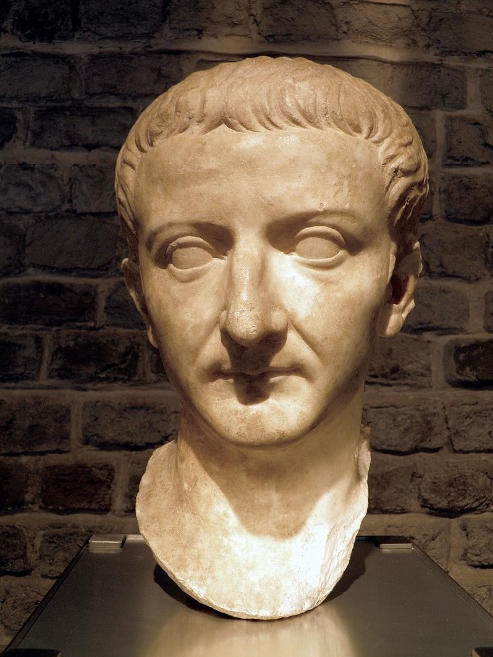**Summary Questions**

***How reliable are the ancient sources covering Tiberius’ reign?***

***What do we learn about Tiberius from his relationship with Germanicus and Sejanus?***

***How effective was Tiberius at dealing with problems during his reign?***

***Explain how Tiberius behaved when first taking the imperial throne and the different reasons for this***

**KEY TERMS**

|  |  |
| --- | --- |
| **Term** | **Description** |
| **Maiestas** |  |
| **Delatores** |  |
| **Pannonia** |  |
| **Decimation** |  |
| **Sententia** |  |
|  |  |
|  |  |
|  |  |
|  |  |
|  |  |

**KEY FIGURES**

|  |  |
| --- | --- |
| **nAME** | **Description** |
| **Germanicus** |  |
| **Drusus the Younger** |  |
| **Sejanus** |  |
| **Livia** |  |
| **Piso** |  |
| **Tacfarinas** |  |
| **Agrippina** |  |
|  |  |
|  |  |
|  |  |

**The Roman Empire**

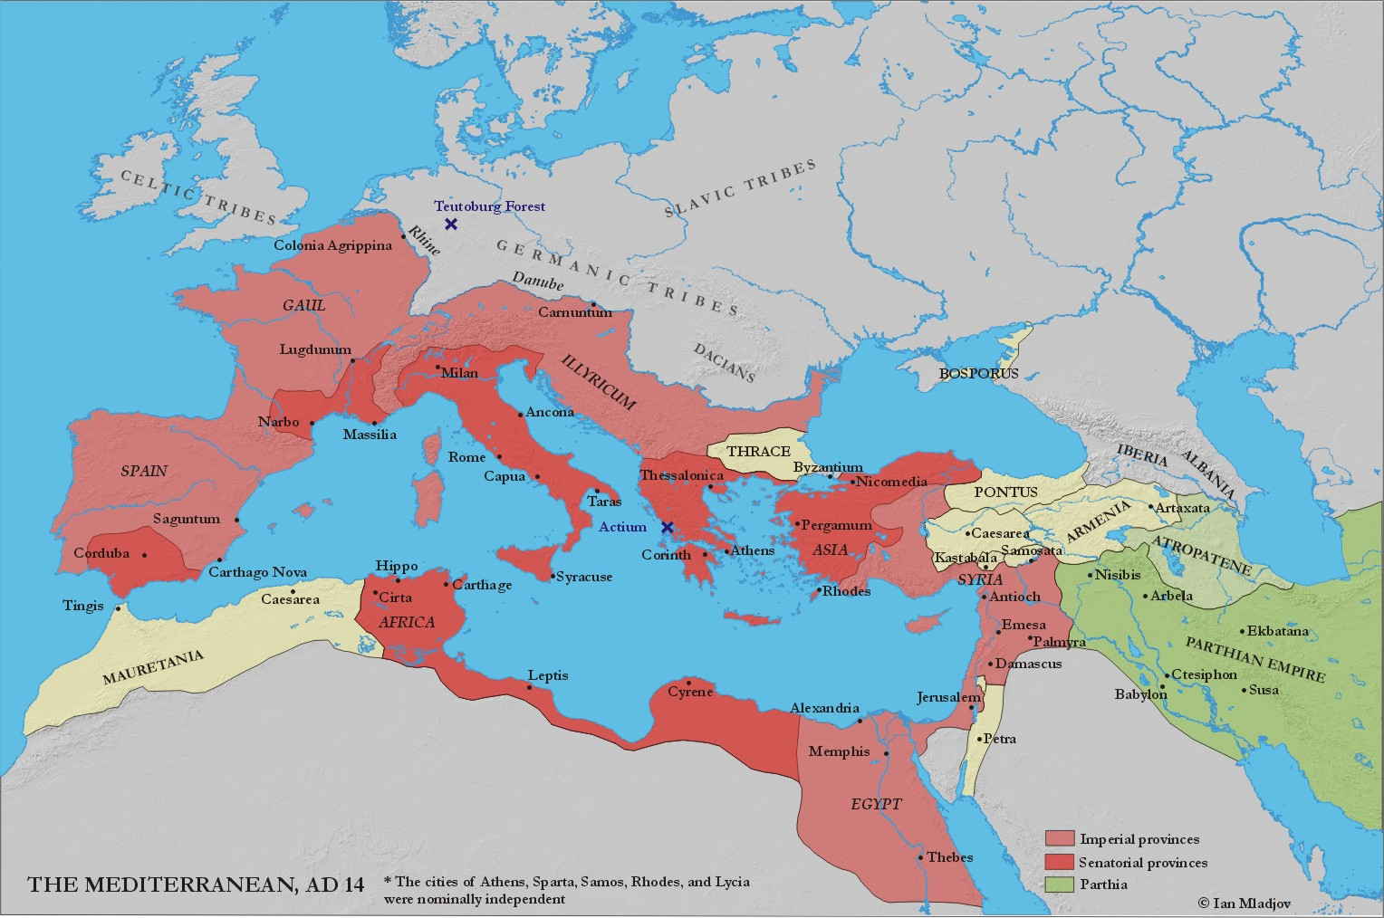



HOMEWORK RECORD

|  |  |  |  |
| --- | --- | --- | --- |
| ***Date set*** | ***Details*** | ***Date Due*** | ***Done?*** |
|  |  |  |  |
|  |  |  |  |
|  |  |  |  |
|  |  |  |  |
|  |  |  |  |
|  |  |  |  |
|  |  |  |  |
|  |  |  |  |
|  |  |  |  |
|  |  |  |  |