**Themes in Art & Architecture: War**

Artist: Jeremy Deller (born 1966)

Title: ‘*It Is What It Is’- Conversations about Iraq,* 2009.  
Scope of work: Places affected by war

**Art Historical Terms and Concepts**  
**Subject matter**: Primarily, *It is what it is* is a car that was blown up in a book market in Bagdad, Iraq, in 2007. Thirty-five people were killed and hundreds injured in the attack. The car cannot be interpreted as anything, it does not represent something. It is not an abstracted form or meaningful in relation to anything beyond itself – it is what it is – it represents itself. It is a Readymade, a Found Object, it is a real and destroyed car following a suicide bomber’s detonation of explosives nearby; ‘its primary meaning is itself’ (Deller, vimeo.com). The car was not where the bomb was hidden, it was a nearby casualty of the explosion. In relation to the places affected by war, Deller’s work forces us to consider that Iraqis suffered at the hands of Iraqis in a location perceived via the western media in terms of ‘us and them’.

**Deller said of this work:** This project started as the idea to create a mobile museum of the war in Iraq that would tour the US. Fin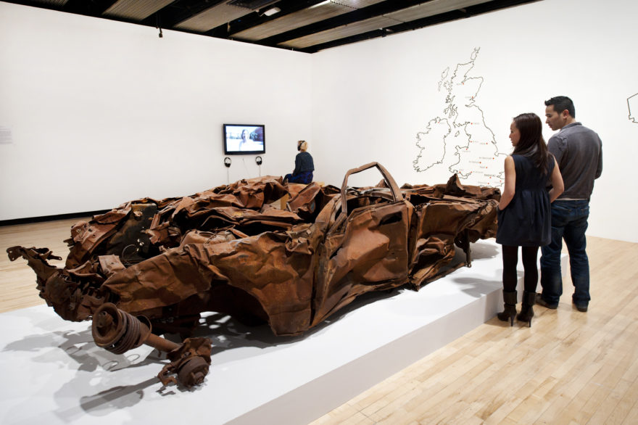ding material for the museum proved difficult, until we were offered a car that had been destroyed in Iraq, in the heart of the former British empire. From this car, used as a centrepiece, we constructed a room in the New Museum, New York, where the public could meet and talk to people involved in the conflict in some way. The idea was then taken on the road; we towed the car from New York to LA, stopping off in 14 towns and cities on the way – a classic American road trip route – accompanied by an Iraqi citizen and an enlisted American soldier. It was presented in as neutral a way as possible, which puzzled a lot of people. But it meant that the public were more likely to talk to us, because they weren’t scared of being dragged into some sort of political arena. Sometimes these conversations went on for hours. The car was subsequently donated to the Imperial War Museums.

**In the background: The Iraq War, 2003-2011.**

Why did the war begin? <https://www.youtube.com/watch?v=6daSrkgDX0k>

Some attitudes towards the war: <https://www.youtube.com/watch?v=tAjqGnQpVks>

Deller speaking about this work: <https://www.youtube.com/watch?v=2GPSVwWWr_0>

*‘It Is What It Is’*- Conversations About Iraq, 2009, Jeremy Deller

Q: What significance if any, can we take from the title?

Q: What associations do we make when thinking about a motor car?

Q: The car was used as a prop to stimulate conversation. What were these conversations about and why?

Q: What do you know about Iraq other than recent political issues?

Q: How has the destruction of this car come about? What involvement does the West have in its destruction?

Q: Why might Deller have decided to tour the car across the US in particular?

Q: An American veteran of the Iraqi war and an Iraqi citizen accompanied the car on its tour across the US. What was the purpose of their participation?

Q: As a sculptural object, the car fits the category of a *readymade*. What does this term mean?

Q: Deller has not changed or altered this work in any. Why might that be?

Q: Can any similarities be found between this work and Deller’s *We’re Here Because We’re Here*? What do both works require? What do you think Deller’s aims/objectives/goals are in his works relating to war?