Zambia: 1964-2018
Brief History of the Country
Currently a land locked country in sub-Saharan Africa with a population of 13 million, Zambia is still relatively a young country. Zambia was made independent in 1964 from Britain and was led by the “freedom fighter” Kenneth Kaunda until 1991. Zambia was heralded as one of the success stories of Africa in the mid-60’s and there were high hopes for this newly formed country. Kaunda, a socialist began with socialist and protectionist policies to protect infant industry, diversify the economy to reduce reliance on Copper but at the same time exploit the copper exports of his country. From 1964-1984, Zambia was very independent with Government’s conducting 5 year plans and being accountable to this. By the 1980’s as a result of both Government policy and external factors (oil crisis), Zambia was in large amounts of debt which led to the IMF intervening and Zambia for the next 25 years had to adopt policies of Economic liberalisation from these institutions. From 1991 to 2003, Zambia was led by Fredierick Chiluba who has more recently been charged with corruption within the state. So by 2005 after a growing debt burden for 32 years, liberalised economic policies imposed by foreign powers for 22 years, a growing population and corruption within the Government ranks over the previous 15 years, Zambia’s GDP per capita had fallen, life expectancy and poverty rates had increased (especially in rural areas) and the number of people who had contracted HIV/AIDS had increased substantially (14% of the population) compared to 1964. On top of this drastic cut backs in education and healthcare damaged an already scarred workforce and population. For the past 35 years, Zambia has experienced the worst economic decline in Sub-Saharan Africa (Appolinario, 2009). | 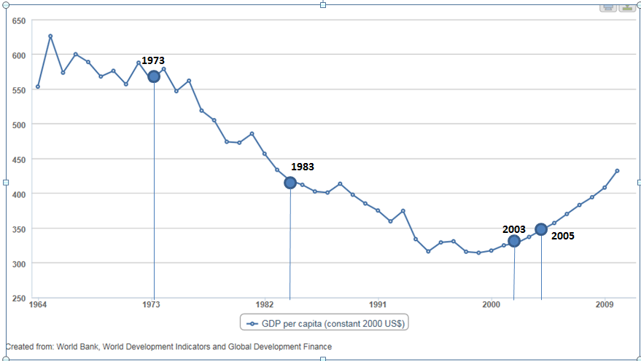
Since 2003, Zambia’s prospects had started to improve with the increase in worldwide copper prices attracting foreign investment, especially from the Chinese. Levy Mwanawasa was also elected to power in 2003 on an anti-corruption charge imprisoning and putting on trial previous ministers within the Government. As of 2005, Zambia met it’s HIPC commitments and finally qualified for full debt relief at the G8 Gleneagles summit, reducing debt from $7 billion to $500 million. Zambia’s recent growth rate in 2011 has been 7%, one of the highest in the world. Also in 2011, a new president Michael Sata was elected in a very peaceful election. Zambia has also always (on the whole) been a peaceful nation since 1964 and its model of democracy is heralded as a beacon for other countries in the region. All this points to an improving situation for Zambia demonstrated by it recently (2011) being granted lower middle income status. Further foreign investment has followed from the Chinese and other nations.
However challenges still remain. Zambia is still very reliant on the copper industry for income from abroad. The mining employment only employs 50000 people and only contributes 3% of GDP in taxation (DFID, 2011). HIV/AIDS is still a serious problem with 14% of the population affected and the burden on extended families still remains. The difference between rural and urban areas is still stark (OECD, 2011) therefore the rural population of Zambia are the poorest with three quarters living on less than $1 a day through subsistence farming and petty trade (DFID, 2011). Zambia, according to the Ministry of Finance has 28 donors providing ODA to Zambia – EU (14.3%), USA (10.7%), UK (9.0%), UN (8.9%), World Bank (8.7%) (OECD, 2011). It receives about $1 billion per year in foreign aid (McEwan, 2009). This is the equivalent to almost a third (29%) of Zambia’s Governmental budget (CIAFactfile, 2012) and so Zambia is still dependent on external assistance.

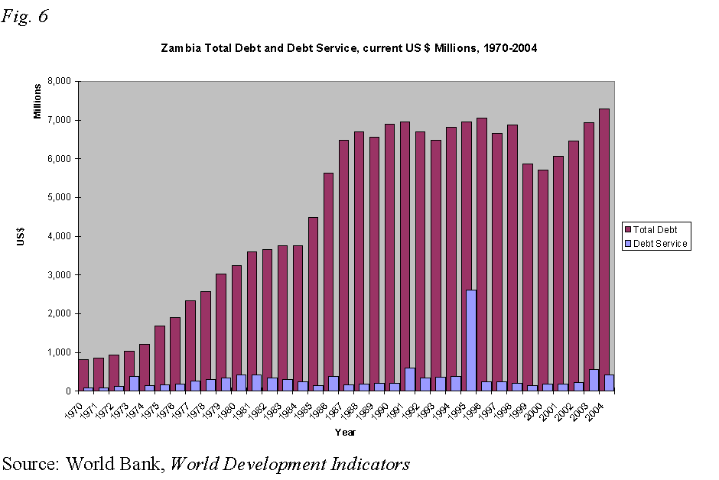 |  | 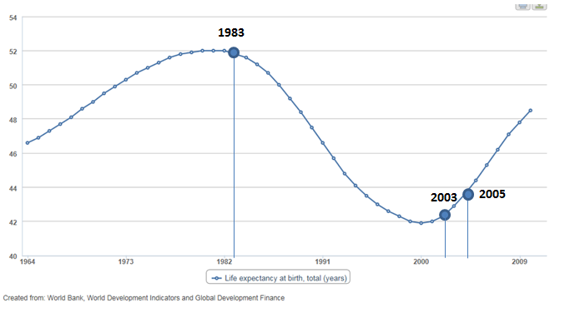

Key Facts, Dates and Figures for Zambia

 | Corruption problems 1991-2003: The prescribed neo-liberal capitalist polices were accompanied by corruption, which also contributed to poor economic performance. Rampant greed had permeated all the institutions of the government. Zambia is ranked the 11th most corrupt nation in the world as of 2002. There had been gross misuse of national resources including foreign assistance, mishandling of privatisation, and electoral fraud. Privatisation of public companies was deliberately mismanaged to allow leaders in the ruling party and the government, and their international allies to purchase them cheaply, and at times without depositing the money in the government treasury or distributing it to intended beneficiaries. In particular, the privatisation of the Zambian copper mines was seriously flawed. For example, the Chiluba government has not accounted for the sum of US $35 million from the sale of a particular mining company. Similarly, the foreign accounts of the government had been utilised for personal benefit by the leadership, as well as for political patronage purposes. | 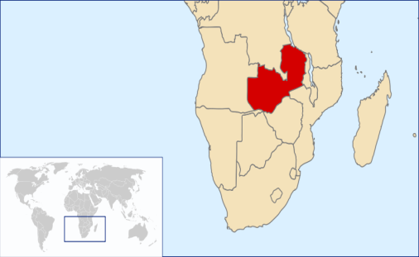

Economic | Social |  | Political
- GDP (PPP) 2009 estimate  - Total $18.454 billion  - Per capita $1,541 (now classed as a lower middle income country)  - HDI (2007) 0.481 (low) (164th)  - Dependency on copper and nickel for exports – a lack of a diversified economy  - Other exports include flowers and fruits/vegtables  - Scope for manufacturing sectors with a strong resource base and skilled workforce in places however challenges through global trade barriers, Zambia’s landlocked status and a lack of a skilled workforce across the country. | - About 68% of Zambians live below the recognised national poverty line,[22] with rural poverty rates standing at about 78%[23] and urban rates of 53%  - Zambia officially has extensive social protection targeted at low-capacity households, including social assistance (protection) and social insurance programmes (prevention), and programmes to improve economic productivity (promotion). However, these programmes face immense challenges and the actual coverage is very low and, in some cases, actually declining. Some analysts describe the programmes' coverage as patchy and transitory and not especially coherent or logical way.  - Zambia is one of the most unequal societies in Sub-Saharan Africa and the World. It’s GINI coefficient is estimated to be between 0.5 and 0.6 and on a similar scale to Brazil (UK is 0.36 and Scandanavian countries are 0.25!).Zambia has an unequal distribution of income with the bottom 10% of society receiving just 1.1% of the income, while the top 10% of society receives 41%. |  | Multi party democracy with the president being the head of state and head of Government (a combination of the Queen and Prime Minister in one!)  Kenneth Kaunda was the main figure in Zambian politics from 1964-1991 before being replaced by Fred Chiluba until 2001 and then Levy Mwanawasa until 2008 when he died. Replaced by vice-president Rupiah Banda. More recently Michael Sata (2011) has come to power and is challenging the Chinese
Key Era’s in Zambia’s History: A Summary  - 1964-1984: Total Zambian independence  - Adoption of 5 year national plans by the Government  - Socialist outlook: import substitution industrialisation and nationalisation of the Copper mines  - 1973: the international debt crisis  - 1984-2005: Conditionality of debt relief (SAP’s and PRSP’s) from the IMF  - Full scale adoption of SAP’s and economic liberalisation as a condition of debt relief until 1997 when the PRSP’s were adopted  - Accusations of corruption in the Chiluba presidency (91-03)  - Since 2003, Copper prices have risen considerably (maybe the result of a growing China) and once closed mines have reopened thanks to a large influx of foreign investment (especially from the Chinese)  - 2005-2017: Post debt relief  - From 2005, the Multilateral Debt Relief Initiative reduced debt from $7.2 billion to $500 million  - A rapid increase in foreign investment from the Chinese into non-mining sectors of the economy (chicken farming, agriculture etc.) – has this provided jobs and much needed income?  - Adoption of National Development Strategies (regaining sovereignty?)  - Zambia’s external debt has increased from $500 million in 2005 to $4.3 billion 2012 as a result of increased availability of “soft” loans from the Chinese (a form of Aid)  - Falling copper prices as a result of the financial crisis have led to job losses |  | Political History of Zambia  (1) 1964-1991 Kenneth Kaunda years (UNIP – United National Independence Party): An initial fruitful start for the economy, followed by import substitution industrialisation and a debt crisis in the 1970’s which severely damaged the Zambian economy as falling copper prices and rising oil prices combined to create a huge deficit in Zambia’s finances. By 1983, Kaunda had relented to the IMF and SAP’s to readjust the Zambian economy. This adjustment led to the first of two attempted coups and a degree of political instability in the late 80’s for Zambia with several food riots.  (2) 1991-2003 Fredick Chiluba years (MMD – movement for multiparty democracy): came to power on the basis of a multi party democracy for the first time but the optimism was short-lived with accusations of corruption and abuses of power, Chiluba was swept from power in 2003 by the corruption fighting Levy Mwanawasa.  (3) 2003-2008 Levy Mwanawasa years (MMD – the “New Deal”) was swept to power on the basis of a corrupt free Zambia and he immediately launched an investigation into the Chiluba years. Mwanawasa also attracted significant investment from abroad (especially the Chinese)  (4) 2008-2011 Rupiah Banda years: after the shock death of Levy Mwanawasa, Rupiah the vice-president took over the reins of presidency  (5) 2011-2014 Michael Sata years: based upon an anti-Chinese platform to capture the popular mood against the perceived imperialist advances of China  (6) 2014-2015 Guy Scott (Acting President)  (7) 2015-today Edgar Lungu - current president who controversially locked up in 2016 the opposition leader to his ruling party. Is Zambia’s democracy under threat?
Economic History of Zambia

After Independence: Adopting Import Substitution Industrialisation (or protectionism) – 1964-1974
ACROSS AFRICA: Between the 1950’s and late 1970’s, the new African leaders pursued industrialization in order to overcome the colonial inheritance. Rooted in the anticolonial struggle, some of their programs were socialist (as in Zambia), some more explicitly capitalist (as in Kenya). Others, such as that in Ethiopia, were more difficult to define. In practice, however, most African countries shared a commitment to modernization and industrialization. Many followed the model of Import-Substitution Industrialization (ISI), in which governments took control over national industry by protecting domestic industries from foreign competition through tariffs and domestic subsidies to producers. Rooted in modernization theory, the goal was for the state to protect their “infant” industries, mobilize enough investment in domestic industry to achieve the "big push" thought necessary for sustainable economic growth. State-led development became the norm in the 1960s.
ZAMBIA SPECIFICALLY: At independence in 1964, Zambia’s economy was mainly dependent on copper mining that accounted for 90 per cent of its export earnings. The leadership was committed to the promotion of economic development and restructuring the economy. The government, therefore, undertook rapid nationalisation of the economy shortly after independence, paving the way for state-led development. State intervention in the economy was set in motion with the 1968 Mulungushi Economic Reforms that allowed the government to acquire 51 per cent shares from private retail, transportation, and manufacturing firms. Nationalisation enabled the state to control 80 per cent of the economy through mining, energy, transport, tourism, finance, agriculture, trade, manufacturing and construction. Thus, the state became the engine of growth – a very socialist model.

Admittedly, there were reasonable growth rates in the 1960s and early 1970s in Zambia, primarily due to high copper production and prices and increases in maize and manufacturing output, as well as increases in numbers of social facilities and physical infrastructure. Employment rates soared as Zambians had jobs, income and the beginning of prosperity. However, the nationalization programmes in general, and import substitution in particular, proved very costly. Zambia failed to diversify the economy from copper mining and the import substitution strategy proved unsustainable because of the costs of subsidies to the Government and also the lack of choice for consumers, resulting in economic decline. Third, import substitution industries proved inefficient and uncompetitive due to high input costs as the companies had to buy the materials within Zambia, there were high monopoly prices for consumers, an over-reliance on government subsidies, and a lack of technological dynamism. Fourth, the bias against exports and import restrictions resulted in higher exchange rates of the Zambian currency (more expensive exports from Zambia) and reduced the gains from exports.

1974-1984. The Zambian debt crisis: was ISI to blame entirely or were there other reasons for Zambia’s declining economy:
- First, the decline in world copper prices since 1974 coupled with a large rise in oil prices (see AS notes on the debt crisis) contributed to economic decline causing reduced government expenditure on development, including import substitution industries, inability to import goods, especially, inputs into manufacturing and an inability to service external debt which was growing. Lack of savings by the government during periods of high copper prices to cushion the impact of any fall in copper prices worsened the economic situation – a classic example of resource curse.
- Second, extensive state intervention since 1964 gave rise to bureaucratisation and uncertainty, discouraging productive private investment and a failure to engage with foreign countries for trade initiatives.
- Thirdly, the bias against agriculture and rural areas meant the continued dependence on the copper mining industry – resource curse issues.

The World Bank and IMF to the rescue 1984-2005? Did the solution help?
Following the recommendations of the IMF and the WB, the government undertook economic policy reforms to rejuvenate the economy from 1983. However, these structural adjustment programmes (SAPs) worsened, rather than improved the economy. The IMF and WB prescribed an export-led growth strategy for Zambia (EOI) and encouraged/forced it to open its borders to trade liberalisation. This meant that foreign imports came into Zambia, putting many domestic firms out of business. For example in Zambia “Salaula” refers to the influx of second hand clothing from Western countries which then destroyed local textile manufacturing firms. Agricultural and manufacturing outputs and exports also failed to increase significantly as Zambian products were uncompetitive globally. It was also arguably due to the so-called “unfair global trading restrictions that Zambia faced as a poor developing country (remember tariff escalation etc.). On top of this the SAP’s led to wholesale economic liberalisation in line with ideological neo-liberal thinking of the time that was coming out of the US (The Washington Consensus). Previously nationalised industries were sold off leading to greater unemployment as these private firms then strove to cut costs to maximise profits. Government spending was also drastically cut back with education and healthcare being hit the hardest. The Zambian Government could provide no free healthcare or schooling – this was arguably to have effects on social development with the rise of HIV/Aids and the disillusionment of the young in Zambia.

The PRSP’s in the late 1990’s were an attempt by the IMF to change the nature of the SAP’s. Governments to qualify for the HIPC (Heavily Indebted Poor Countries) Initiative debt relief programme had to produce a national document laying out the changes they would make on an economic, social and political basis. This had the added advantage that the Government were responsible (accountable) for their programmes rather than top down heavy economic liberalisation as had occurred under the SAP’s. The downside was that the Zambian Government still had to pander to the IMF’s neo-liberal policies and thus Government spending was tightened further, privatisation increased as well as trade liberalisation; all of which arguably led to further declines in GDP per capita and in life expectancy and increases in poverty (especially rural poverty).

2005- today: The new hope or collapse
In 2003, copper prices on the world markets rose considerably which attracted Chinese investment and interest in both FDI and international aid, sparking increases in trade and improvements in infrastructure. Further investment also came because Levy Mwanawasa also came to power on an anti corruption charge which he tried to clean up the Government’s act. In 2005 Zambia was then finally granted full debt relief by the IMF after reaching its HIPC commitments. The Zambian Government now had more money to spend on development of its country rather than repaying the debt owed. It immediately made healthcare in rural areas free to try and combat the growing HIV/AIDS situation and decreasing life expectancy. As of 2012/13 Zambia has just had one of the fastest growth rates in the world of any country and has recently been classified again as a middle income (lower) country. However challenges still remain: Zambia is still dependent on international aid and its debt burden has increased (admittedly soft loans) as the Chinese have lent more and more money. Zambia is also still very reliant on worldwide copper prices and has not diversified its economy as much as it would like. On top of this there is growing resentment against the influx of the Chinese. Sata was elected on a platform of “making the Chinese pay” and so whether Zambia’s current life line of China will stay around for ever with this political pressure is anyone’s guess. Recent financial crisis has meant that copper prices have fallen and Zambia’s over-reliance on copper has been laid bare.
History of Aid to Zambia  Zambia has received foreign aid since the mid-1960s at the time of independence. There was a significant increase in the 1970s and again in the early 1990s in both per capita and on a percentage of GDP basis. This increase was due to the poor performance of the Zambian economy, due in part to the decline in copper prices. The importance of foreign aid during the early 1990s was enormous. In 1992 Overseas Development Assistance amounted to 67% of export earnings and 77% of total public expenditure. About 80% of all Zambia's capital expenditure was financed through foreign aid. Zambia was heavily dependent on International Aid since independence.  In the 1970s and 1980s most foreign aid was directed to agriculture, education, infrastructure and health. Much of this development assistance came from the World Bank. Up until 1978 Zambia was not entitled to borrow at concessionary rates from the World Bank and had to borrow from international banks at commercial rates. Since 1984 after a period of borrowing from both the International Banks and the World Bank, its multilateral development assistance came from the World Bank and IMF.  Zambia also received considerable amount of bilateral aid from Canada, Denmark, Finland, Japan, The Netherlands, Norway, Sweden, the UK and the USA. In the 1970s and the early part of the 1980s both Multilateral and Bilateral Assistance were largely free of any of the strict conditions of macroeconomic stabilisation and structural adjustment that were being imposed by the IMF on Zambia in return for loans to support its trade imbalances. Indeed some of these bilateral donors questioned the stringency of the SAP conditions and increased their assistance when the IMF and World Bank imposed conditionality.  However in the 1990s due to the reoccurring balance of payments deficits several donors shifted from project to programme aid where supporting the Government budget and trade imbalances was seen as being more important than individual projects within Zambia. The aid funds were now used to either ensure the supply of imports and to repay Zambia's external debt that had grown significantly since the 1970s. Increasingly bilateral donors were also tying their aid to the conditions of good governance, democratic government and human rights. Indeed the majority of Zambia's bilateral donors withheld programme aid support between 1996 and 1998 because of concern about abuses of democracy. Although programme aid aimed was being used as a tool for bringing about political and economic change project aid continued.  Overall, from 1964 to the late 1990’s, Zambia has received $514 million per year on average yet GDP per capita has reduced from $1251 in the 1960’s to $600 in the late 90’s. If all aid to Zambia had been effectively utilised, rapid economic growth would have resulted and raised per capita income above $20,000. Instead by the late 90’s it was only $600. However full debt relief was granted in 2005 by the IMF, World Bank and some bilateral donors (such as the UK) and this led to the Zambian Government not having to pay back the loans, and meant they had more money for development.  More recently, the Chinese have leant a significant amount of money to the Zambians (in the form of soft loans) as Aid. Today, Zamia receives about $1 billion per year in foreign aid. This is the equivalent to almost a third (29%) of Zambia’s Governmental budget and so Zambia is still dependent on external assistance. | Aid Effectiveness in Promoting Development?
 | 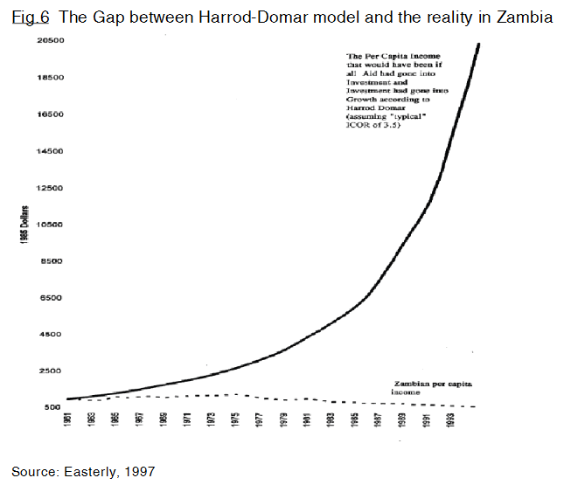  Paris Declaration (PD) on Aid Effectiveness in Zambia  Zambia joined more than 50 aid recipients in 2005 as part of the Paris Aid Effectiveness Agenda and has recently participated in Phase II of this process. This maybe demonstrates their commitment to making sure that Aid reaches the intended beneficiaries and also contributes to improving coherence between aid agencies.  Some argue that the PD was the result of the experiences of aid agencies in Zambia – Zambia was being held up as an example for the rest of the world!! However the supposed catalyst to tangible benefits from aid have yet to be realised compared to what was first thought.  Millenium Development Goal Progress Since 2000  Progress on the MDG’s especially child health, education and HIV/AIDS has been significant whereas extreme poverty and maternal mortality remain severely off-track. Key challenges for the coming years are maternal mortality and access to adequate sanitation. Whether the positives of the MDG’s are due to aid is hard to tell as although there has been increases in aid and debt relief in 2005, increased foreign investment from the Chinese since 2003 has also explained Zambia’s growing economy. |  | ANALYSIS: The graph to the left shows what might have happened to GDP per capita if all the aid monies had been spent effectively in Zambia. The solid line represents this and the dotted line represents what actually happened to GDP per capita.  It suggests that aid has not been at all effective in promoting economic development and if anything has led to a decline.  Aid Dependency?  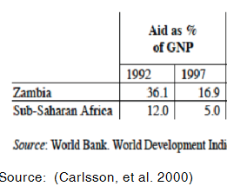  What does the above table demonstrate about aid dependency? On one hand, it demonstrates that in just 5 years aid dependency fell as a % of total GDP by 20% - significant! However compared to the rest of sub-Saharan Africa, the figures show that Zambia is still dependent.  In 2008, Mr. Felix Mutati said government has reduced its foreign aid dependency from 40 per cent of the Governmental budget (not GDP this time) to just 24 per cent over the last two years.  Recent Corruption Scandals with International Aid Agencies  In 2009 and 2010 the department for health came under scrutiny as minsters seemed to have a lot of cars and certain funds could not be accounted for. Several ministers were suspended on corruption charges. As a result in 2009 Denmark and the Netherlands suspended money meant for projects in Zambia to improve health facilities. In 2010, the Global Fund suspended $300 million that had been earmarked to help combat HIV/AIDS, malaria and other diseases. Both episodes are a big blow to Zambia’s perception to its donors and raises the question how much more money has been lost to corruption?
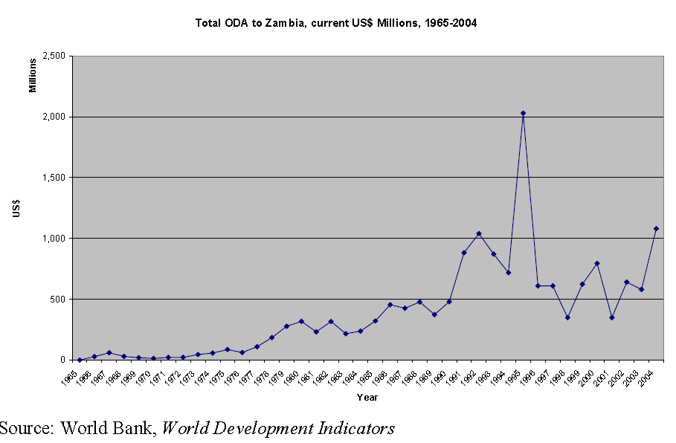  ANALYSIS: The graph above (“Total ODA to Zambia, current US$ Millions 1965-2004”) shows that international aid to Zambia has increased significantly since 1965 – but have there been any improvements in development? Hopefully the history of Zambia from before will help you come to a decision. |  | 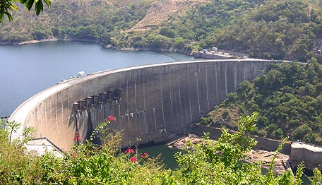  Kariba Dam – benefitting both Zambia and Zimbabwe – a World Bank Project

Examples of Large Aid Projects in Zambia in the past
The Kariba Dam (1950’s – prior to 1964 independence funded partly by the World Bank)  During the 1950s prior to Independence the colonial government saw that if the economy was to develop some major structural changes were necessary. At the time, the prevailing view of economic development was that it occurred in stages and if the economy was going to take off and achieve industrialisation then it needed the energy to modernise the economy.  The existing coal fired thermal power stations using high quality coal from Rhodesia (now Zimbabwe) provided much of the energy for the production of copper and other mineral extraction, and urban development in both Zimbabwe and Zambia. However it was recognised that coal fired power stations could not produce sufficient energy to satisfy the growing demand. Utilising hydroelectric power involving the damming of some of its natural river valleys had been considered for many years. High commodity prices, copper in Zambia and tobacco in Zimbabwe, stimulated the decision to go ahead and build a dam. Damming the Zambezi River was the inevitable choice.  After much debate about the relative merits of building a dam at Kariba and Kafue in 1955 the governments of Federation of Nyasaland and Rhodesia (now known as Zimbabwe) and Zambia eventually decided to go ahead with a joint hydro electric project at Kariba. The World Bank as one of the main funding agencies, made an appraisal of its finances. However, many development economists now argue that the investment appraisal failed to take into account the full social costs of the project.  The dam was completed in 1960 and hydro-electric production was introduced in two phases, the first on the south bank in 1960 and then a second on the north bank in 1976. Since building it has usually provided a source of cheap, plentiful and clean electricity except during droughts at full capacity. Electricity produced by coal fired generation was three times as costly. The impact on the people living in the Zambezi's valley was always going to be considerable and the environmental impact was large too.  However, benefits with energy provision, better irrigation for surrounding arable lands and the creation of a major tourist attraction have all had their benefits. | Zambia Railway Restructuring Project (2000-2005 funded by the World Bank)  Over the past 35 years Zambian Railways has experienced a substantial decrease in freight transport with a consequential fall in revenue for business and Government especially since Zambia is a landlocked country and rail freight can improve communications to neighbouring countries. However the state owned railway system by 2000 was inefficient, poorly maintained, prone to delays and derailment, under-invested, and unable to provide the quality service demanded in the face of increasing competition from road transport. In short it was worn-out! In addition other factors have contributed to the decline in the country's railways. The general economic decline of the country, the poor performance of Zambia's copper national company and the recessions and political instability in neighbouring Zimbabwe and Democratic Republic of Congo have all contributed to the dire situation that the railway is in.  The Zambian government approached the World Bank's International Development Association to provide US$31 million of credit to help restructure and privatise the railway. The government hopes that with this support it will be possible to find private sector firms that will participate in the management and operation of the railway.  Greater rail freight will reduce the burden on Zambia’s already crowded (and dangerous roads). More freight can be delivered at less cost compared to road travel. This will have improvements for Zambia’s trade relationships with other countries but also will help with moving resources around the country and improve business within Zambia. The hope is that this will lead to greater economic development in the long run and the maintenance of the railways will provide jobs and income for those who live along it’s tracks.  The outcome for the Railways Restructuring Project for Zambia was satisfactory, the sustainability was likely to happen, the institutional development impact was substantial, and the Bank and borrower performance were both satisfactory. Lessons learned from the project were that bids from companies for the work to be completed were often long winded and this led to delays with the project and a higher cost with more bureaucracy and “red tape”.

