**HW: GROWTH & DEVELOPMENT**

[**TASK:**](http://www.slideshare.net/tutor2u/constraints-on-growth-development) **Read the African case study and answer the questions in the space provided**

**Ext: Access the links for extension articles/videos**

**Overview: Africa the Fastest Growing Continent**

Economic growth and development in less economically developed countries is arguably one of the most important economic issues the world faces. The African continent is now growing faster than any other region in the global economy, taking the top place from Asia. Average growth rates in Africa were well under 4% between 1970 and 1995 compared to around 5% in Asia. However, they have now exceeded Asian growth rates since the beginning of the 2000s. More than one third of African countries grew faster than 6% in 2013. The IMF predicts that 14 of the 22 countries that will exceed 7% growth between now and 2019 will be in Africa. Growth rates like this will allow such countries to double in size in a decade. Overall, GDP per capita in the continent should soon top $1000 and more countries are being classified as middle income counties by the World Bank, with currently 26 out of 54 of Africa’s countries reaching this level.

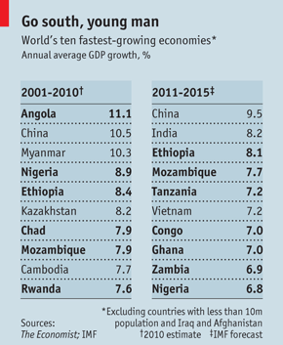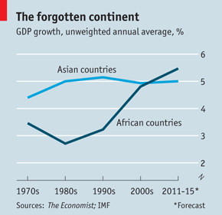

The challenge for Africa is to convert economic growth into economic development. Even though economic growth is seen as a necessary condition for economic development, it is not sufficient. For example, oil producing countries may see rocketing growth rates but rising inequality as oil producers reap the benefits of export success. Moreover, higher tax revenue from the expanding oil industry, corrupt or incompetent officials may not be invested this into productive areas of the economy to promote development in the long-term. The key to a successful Africa in future is that they take advantage of higher growth to put in place the infrastructure, education, healthcare needed for their expanding populations and to diversify their economies to reduce the risks of global shocks in future. This is not an easy task but a worthy aim

**Future Challenges for a Growing Africa**

**a) Infrastructure Deficiencies**

One of the major constraints on growth in Africa is inadequate infrastructure including roads, railways, sewage systems, access to clean water and power. For example, across the continent only 16% of roads are paved compared to 26% in Latin America and 65% in East Asia. There are exceptions, South Africa, but the continent’s largest economy, Nigeria, still has issues with its transport infrastructure and suffers power shortages. Even in countries where businesses are trying to improve networks they are often faced with large amounts of red tape and bureaucracy, constraining progress. Deficiencies in infrastructure can directly impact on living standards, as dirty water can lead to the spread of water borne diseases and reduce life expectancy and raise infant mortality rates. Moreover, power and transport infrastructure make doing business more costly deterring investment, trade and constraining economic growth. The World Bank estimates that poor infrastructure holds back African growth by as much as 2% a year and even with current increases in investment, more is clearly needed.

**Examples of infrastructure deficiencies:**

1.  **India:**India’s irrigation system is deficient and not properly managed and this has made it very difficult to sustain food grain production when rainfall is less than expected – as was the case in 2012. This has led to a surge in food prices which hits the poorest communities hardest. For a few days in the summer of 2012, much of northern India was plunged into darkness for two consecutive days. About 700 million people were left without power, a situation that affected transport, communication, healthcare, industries and farming. India needs an estimated $400bn investment in the power sector if it is to meet its development goals.

2.  **Sub-Saharan Africa:**The combined power generation capacity of the 48 countries of Sub-Saharan Africa is 68 gig watts – no more than Spain’s. Excluding South Africa, this figure falls to 28 GW, equivalent to the capacity of Argentina (except Argentina has a population of 40 million and Africa has 770 million.) A recent report from the Infrastructure Consortium of Africa (ICA), found that poor road, rail and harbour infrastructure adds 30-40% to the costs of goods traded among African countries. This chronic shortage of energy - with firms and people facing acute shortages of power – is a major barrier to growth and development.

**i) How could infrastructure deficiencies constrain African growth and development?**

* [**http://www.dw.com/en/poor-infrastructure-is-key-obstacle-to-development-in-africa/a-15264436**](http://www.dw.com/en/poor-infrastructure-is-key-obstacle-to-development-in-africa/a-15264436)

**b) Demographic and Human Capital Issues**

There are mixed views of demography across Africa but rising populations in many nations are provided challenges. In 2010, Africa had a population of 1 billion but this is likely to double by 2050 according to UN research. This is in part due to the fact that fertility rates have not fallen as dramatically as forecast, boosting future population figures. Commentators suggest a focus on family planning and education may be needed more in future.

Population changes can of course be a blessing and a curse. Some Asian economies, such as Bangladesh, are reaping a demographic dividend where high birth rates have tuned into large, abundant workforces. Whilst this may be partly true in Africa, with an extra 250 million workers under 25 able to join the workforce, only 10% are likely to find jobs in the formal sector by the time they are 30. Moreover, rising populations put pressure on resources, infrastructure and industrial cities with more young dependents in the short-term and elderly dependents longer term. An estimated 839 million young dependents will be in Africa by 2050 putting pressure on cities, 35 of which could have populations of over 5 million. In a continent already stretched in terms of infrastructure, there are significant worries about living standards even in the fastest growing economies.

Population has another final issue, finding enough school places for children. Uganda, like many sub-Saharan African countries, faces major challenges to build up its education system. At the most fundamental level it has to provide enough places for one of the world's fastest growing populations. There are more Ugandans under the age of 18 than there are adults. However, there are other issues such as lack of electricity, need to pay fees and lack of teachers.

**i) How could population changes constrain African growth and development?**

**ii) However, how could rising populations could be beneficial for an economy?**

* [**http://www.worldbank.org/en/region/afr/publication/africas-demographic-transition**](http://www.worldbank.org/en/region/afr/publication/africas-demographic-transition)
* [**http://www.bbc.co.uk/news/world-africa-34188248**](http://www.bbc.co.uk/news/world-africa-34188248)

**c) Corruption**

Corrupt leaders of the country may direct resources away from areas such as education, healthcare and infrastructure and instead use money for their own personal gain, to the detriment of living standards. In September 2014, anti-poverty organisation, ‘One’, released a report into the issue of corruption in less economically developed countries. They estimated that a trillion dollars were being taken out of poor countries, costing the lives of millions of citizens. If corruption was rooted out of Sub-Saharan Africa ‘One’ claimed that 10 million more children would be educated a year and 11 million people with HIV/Aids could be provided with appropriate medical drugs. Solutions to the corruption issue are not easy when problems are engrained in an economy. ‘One’ suggested mandatory reporting to improve accountability for oil, gas and mining sectors. These are areas where corruption can be especially endemic with officials skimming off revenues for themselves. Somalia at the top of the list of the world's most corrupt countries. Somalia has not had an effective central government since its long-serving ruler, Siad Barre, was overthrown in 1991.

**i) How could corruption constrain African growth and development?**

**ii) Why are resource rich countries often associated with high levels of corruption and what can be done about it?**

* [**http://www.bbc.co.uk/news/world-africa-35418979**](http://www.bbc.co.uk/news/world-africa-35418979)
* [**http://www.theguardian.com/global-development-professionals-network/ng-interactive/2015/feb/25/democracy-africa-maps-data-visualisation**](http://www.theguardian.com/global-development-professionals-network/ng-interactive/2015/feb/25/democracy-africa-maps-data-visualisation)
* [**http://www.worldbank.org/en/region/afr/publication/ebola-economic-analysis-ebola-long-term-economic-impact-could-be-devastating**](http://www.worldbank.org/en/region/afr/publication/ebola-economic-analysis-ebola-long-term-economic-impact-could-be-devastating)

**d) Debt**

Africa has the fastest-growing continental economy on the planet. And the thing that has been growing fastest of all is debt—personal, corporate and government. In 2015 Africa and its boosters will start to worry that the debt boom is getting out of hand. The continent has been deep in debt before, and is in danger of a rerun. Africa’s total debt-to-GDP ratio, which had fallen to less than 30% by 2008 (thanks to debt forgiveness as well as booming commodity prices), remains low, because GDP has been growing fast. But in some countries debt is now heading back up towards 70% of GDP or beyond. Budget surpluses have been replaced with budget deficits as governments have spent heavily on salaries, subsidies and infrastructure even as commodity prices and tax revenues have fallen. Ghana and Tanzania, are now running deficits of over 10% of GDP. In 1982 the government of Mexico defaulted on its debts and refused to make further payments. Banks were then very reluctant to lend to developing countries. Developing countries can end up paying more back in interest rates to developed countries than they receive in loans and aid.

**i) How could high levels of debt constrain growth and development in Africa?**

**e) The Impact of Disease and Conflict**

Africa suffers from other constraints on its growth and development including war, conflict and the spread of disease. The emergence of Ebola has been a disaster for the region. Diseases constrain African development by causing destruction to human life, living standards and the productive capacity of the region. Not only this but Ebola treatment diverts resources away from the treatment of other diseases, with some hospitals unable to deal with non-Ebola cases and patients themselves scared to attend. The first case of Ebola was reported as far back as December 2014 and as of the end of October 2014 there had been over 28,616 cases and 11,310 fatalities. The original countries affected were Guinea following by the bordering countries Sierra Leone and Liberia. The mortality rate was estimated as 70% at the start of the outbreak, much higher than typical diseases the world experiences. The IMF has cut its growth forecast for Africa this year from 5.5% to 5% due to Ebola outbreak in West Africa and violence in five African countries. For example, just as Nigeria was declared Ebola free, violence has erupted in the north of the country. These conflicts not only lead to the death of citizens but divert resources away from productive areas of the economy and reduce business confidence and investment.

**i) How could disease constrain African growth and development?**

**ii) How war and conflict could constrain African growth and development?**

* [**http://www.economist.com/news/21631955-worrying-build-up-borrowing-coming-african-debt-crisis**](http://www.economist.com/news/21631955-worrying-build-up-borrowing-coming-african-debt-crisis)

**f) Savings Gap and Foreign Exchange Gap**

Despite Africa's growth resurgence, concerns remain that growth has not been accompanied by commensurate reduction in poverty. Moreover, it has been characterized by high inequality, and generally it has not been broad-based. From a long-term perspective the question is whether this recent growth resurgence is sustainable. In particular, the issue is whether the current saving rates are sufficient to support high and sustained growth and development.

Domestic saving in African countries has remained low, leading to high investment-saving gaps and increased dependence on external capital. Evidence shows that the rise in saving rates during the growth acceleration is concentrated among oil rich countries. These countries have also grown faster than resource-poor countries. However, while oil-rich countries recorded rising saving rates, their investment rates did not rise proportionately.

One further problem for many countries is the foreign exchange gap, a separate issue to the savings gap. This is where countries have a shortage of hard currency that is required to import important capital (machinery) and consumer goods (medicine). This is because their domestic currency may not be convertible/ at a poor rate or they do not export many products.

**i) With reference to Harrod-Domar and examples, explain how the savings gap could constrain economic growth and development in Africa**

**ii) What is the difference between the savings gap and foreign exchange gap?**

**g) Capital Flight**

Capital flight is the movement of money from one investment to another in search of greater stability or increased returns. This can be to avoid political turmoil, instability or high taxation. In Africa, capital flight can partly be explained by trying to avoid tax and corruptly moving money out of the continent. Capital flight is often most severe however during financial and political crises, such as the Eurozone crisis or Latin American debt crises of the past.

The levels of capital flight have exploded over the past decade. Evidence suggests that capital flight may occur in economies with:

* **High external borrowing**: suggesting embezzlement of public debt.
* **High resource dependency**: suggesting embezzlement of the proceeds of resource exports and corrupt management of natural resource exploitation, as well as illicit behavior by MNCs in the sector
* **High levels of capital flight**: suggesting economies almost get trapped in a capital flight trap

This can have serious developmental consequences for Africa. Firstly, it reduces Government revenue through embezzlement of public resources and through a reduction in numbers paying domestic tax. Secondly, it also stops poverty reduction, as the money could be invested in projects to reduce absolute poverty or promote growth. Finally, capital flight has important distributional and equity implications. The holders of capital flight who are also guilty of tax evasion incur a relatively smaller tax burden than the poor.

* <https://www.youtube.com/watch?v=oxqmMaJ8vyA>

**i) Using examples, explain how capital flight could constrain economic growth and development in Africa**

* <http://www.ft.com/cms/s/3/69e98914-6829-11e5-a57f-21b88f7d973f.html#axzz3z3DBmKp3>

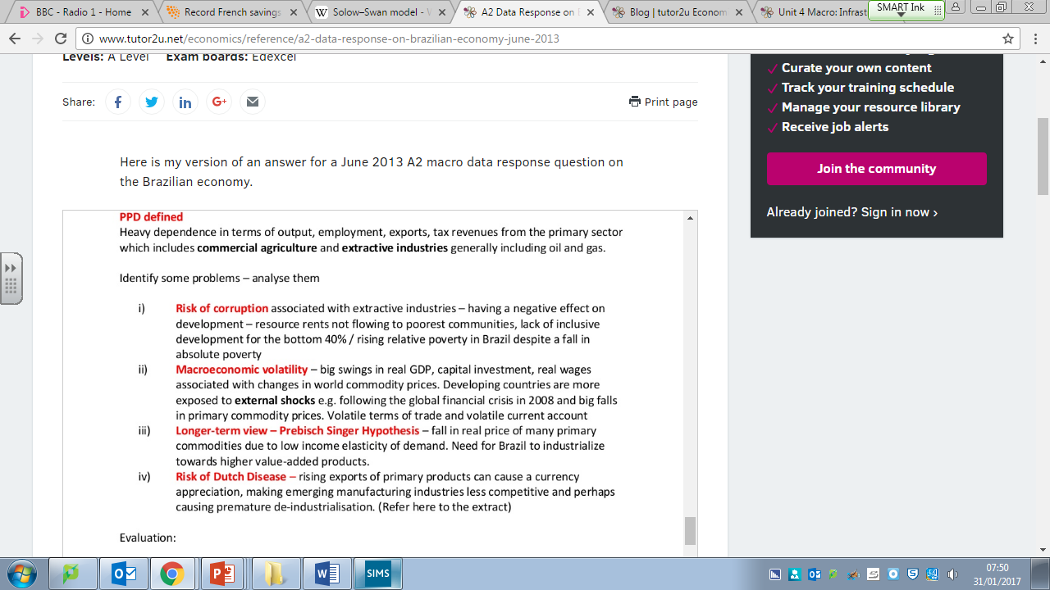**h) Primary Product Dependency**

**Example 1: Angola**

The Angolan economy is hugely dependent on the extraction and exporting of crude oil. With global prices remaining stubbornly low their economy is suffering from a steep decline in export revenues and tax receipts.

Falling oil prices having significant effect on Angolan economy:

1. Real GDP growth rate declining to 3%, per capita incomes declining
2. Fiscal deficit has increased to 7% of GDP, government cutting fuel subsidies
3. 40% of government debt is denominated in foreign currencies - Angolan kwanza has fallen by 18% in the last year
4. Collapse in the exchange rate has caused inflation to jump over 20%
5. Policy interest rates now 15%, central bank has devalued exchange rate 3 times since June 2015

Angola’s sovereign wealth fund is worth around $5bn (around 2.5% of GDP)

Government seeking financial help from China and also from the IMF. In the past, the default position of the IMF has been to apply conditionality to loan finance - for example requiring structural economic reforms and/or fiscal austerity. But there are signs that the IMF approach is changing.

Angola's export base is narrow and their economy is **highly vulnerable to global economic shocks.**According to economists at Rabobank, oil accounts for 98% of exports, around 80% of government revenue and 34% of GDP. Angola is therefore highly susceptible to volatility on the world oil market.

The country is ranked 148th/188 in the Human Development Index but scores even more poorly on ease of doing business - it is ranked 179th out of 183 countries according to the World Economic Forum.

**Example 2: Nigeria**

**Due to the oil price slump,** real GDP growth in Nigeria probably fell by half in 2015, from 6.3% to little more than 3%.  Oil accounts for 70% of the government’s revenues and 95% of Nigeria's export earnings. The government (fiscal) deficit will widen this year to about 3.5% of GDP. Little wonder therefore that their currency, the naira, is under downward pressure. The central bank insists on an official market exchange rate of 197-199 naira to the dollar. On the **black market**, dollars sell for 300 naira or more.

But instead of letting the naira **depreciate** to reflect the country’s loss of purchasing power, the president is determined to maintain it at a higher value. The central bank has restricted the supply of dollars and banned the import of a long list of goods, from shovels and rice to toothpicks. It hopes that this will **maintain currency reserves** and stimulate domestic production.

When a currency is devalued, all imports become more expensive. But the Nigerian government is trying to put up **import barriers**. Factory bosses complain they cannot import raw materials such as chemicals and fret that, if this continues, they may have to shut down. Many have turned to the black market to obtain US dollars, and are doubtless smuggling in some of the goods that have been banned.

**How does depending on primary products constrain economic growth and development?**