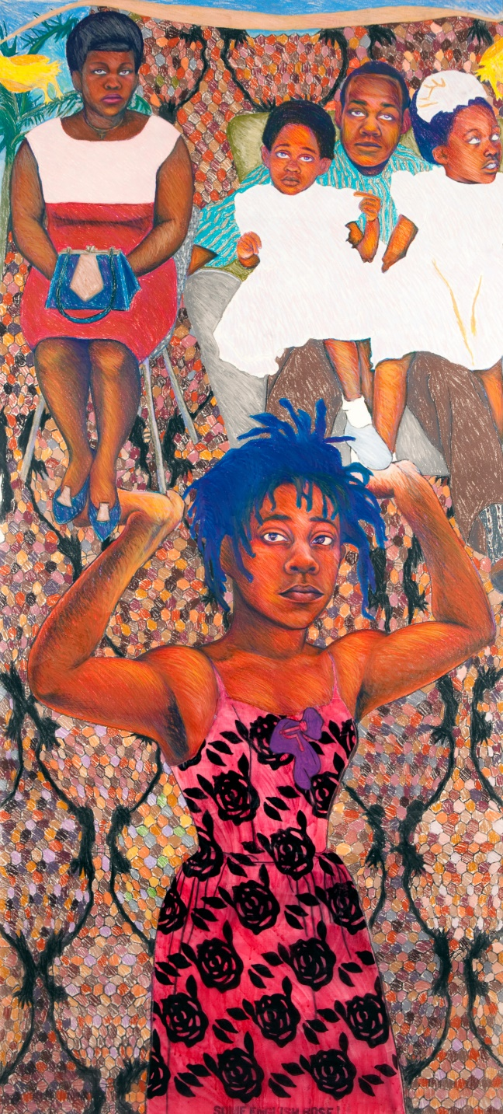Key work: ‘She ain’t holding them up, she’s holding on (some English rose)’

Artist: Sonia Boyce

Media: Crayon, chalk, pastel and ink on paper

Size: 218x99cm

Date: 1986

**Further reading/watching:**

Sonia Boyce Interview in the Royal Academy magazine: <https://www.royalacademy.org.uk/article/as-i-see-it-sonia-boyce>

No Colour Bar: Black British Art in Action: <https://newhumanist.org.uk/articles/4967/we-are-here-because-you-were-there-a-retrospective-of-black-british-art>

Podcast interview: Objects of Obsession: Sonia Boyce’s retrospective in Manchester – <http://manchesterartgallery.org/exhibitions-and-events/event/sonia-boyce/>

Hannah Johnson ‘Bodies of Difference’:

<https://hannahsbodiesofdifference.wordpress.com/2017/02/02/yinka-shonibare/>

**Questions to complete:**

1. When was she awarded an MBE?
2. When was she elected to the RA?
3. What is her current post?
4. List five other works she has done?
5. Which works are in the Tate collection? Add an image of From ‘Tarzan to Rambo’ and ‘Missionary Position II’ to your notes here and think about the multiple meanings of the titles?
6. Where is the ‘She ain’t holding them up’ work?
7. Sonia Boyce says that she was influenced by a Frida Kahlo work here – which one?
8. She also says that she was influenced by William Morris designs. Who was he and what kind of work she is talking about? Why does she say that she likes “flat pattern and surface”?
9. What does she say is the appeal of collage? (again, in the Objects of Obsession interview) Make sure you cover both political and aesthetic reasons.
10. The tall central, foreground figure is a representation of Boyce. Explore her life story and background and comment (with evidence) on who you think the other people might be?
11. In her interview with Tim Marlow (Objects of Obsession) why does she say that she uses herself as a model?
12. She goes on to say that she is ‘acting out’ this role rather than it being a portrait in the traditional sense. What does she mean? Explain this in your own words?
13. Look carefully at the background of this work. What decisions is Boyce making about setting? How can this be seen as a response to traditional ideas of setting in figurative works.
14. What do you make of her choice of materials here? What are the arguments for her choice of pastel rather than oil?
15. What figure from mythology is ‘typically’ portrayed as heroically holding up a huge weight? What is Boyce saying by ‘claiming’ this legend into her own life story/art?
16. Find images of works by other black British artists shown in the No Colour Bar exhibition: select at least three from Keith Piper, Uzo Egonu; Eddie Chambers; Tam Joseph; Claudette Johnson or George Kelly.
17. What ideas seem important to this group as a whole?
18. Look at Donald Rodney’s ‘In the house of my father’ and think about how it shows his identity. (Explore subject matter, use of materials and the symbolism of the work as well as finding out about how he died..)