**Specified Architect**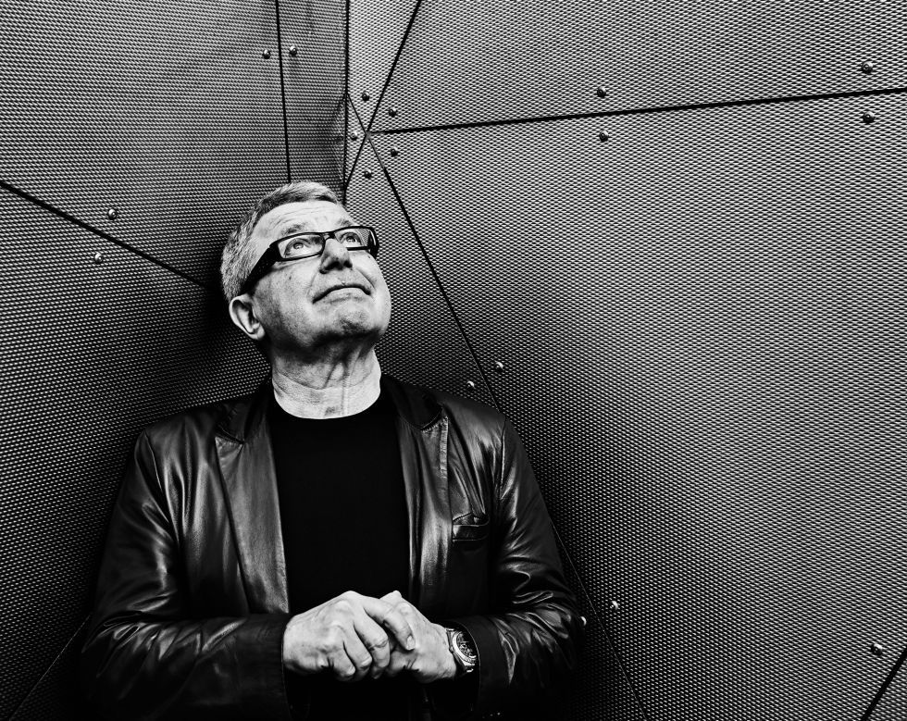

Daniel Libeskind  
Born 1946 in Poland.

Moved to New York in 1959.

Founded *Studio Daniel Libeskind* in 1989.

**Awards:**

RIBA International Award for the Imperial War Museum North (2004)

Appointed as the first Cultural Ambassador for Architecture by the U.S. Department of State (2004)

Honorary member of the Royal Academy of Arts in London, England (2004)

RIBA International Award for Wohl Centre at Bar-Ilan University (2006)

**Two Key Buildings:**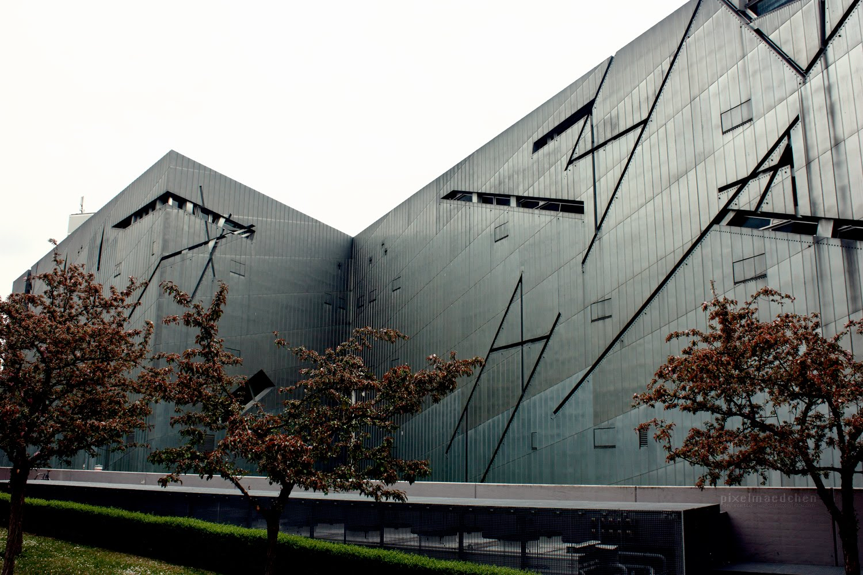

*Jewish Museum,* Berlin (2001)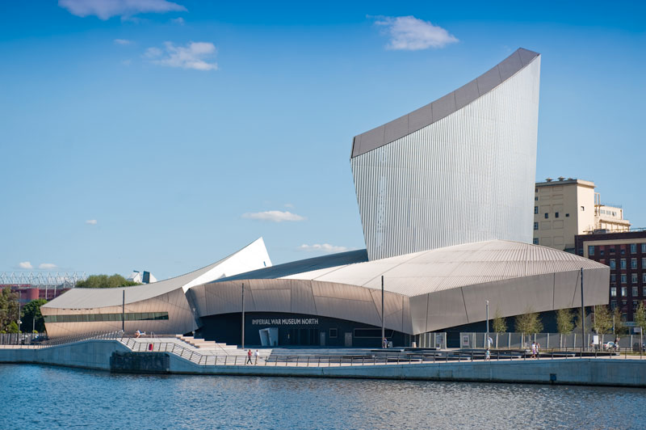

*Imperial War Museum North*(2001)

***Jewish Museum,* Berlin (2001)**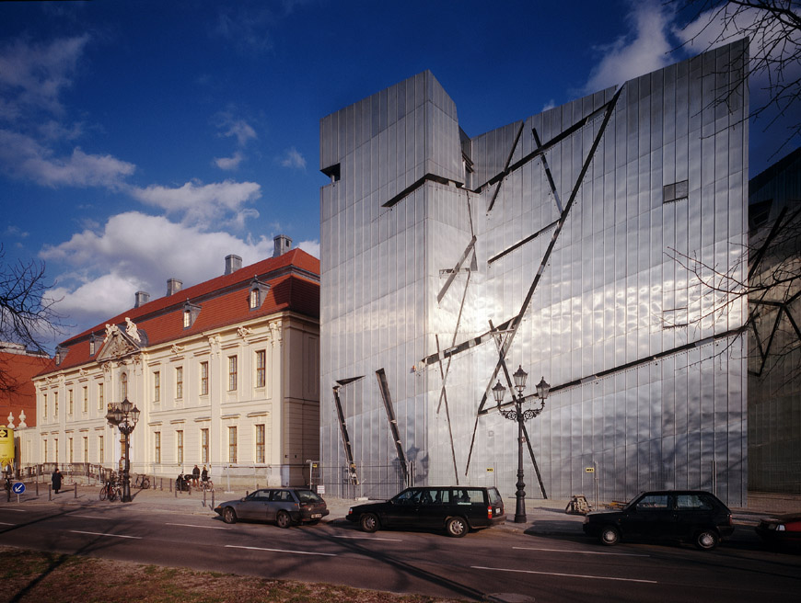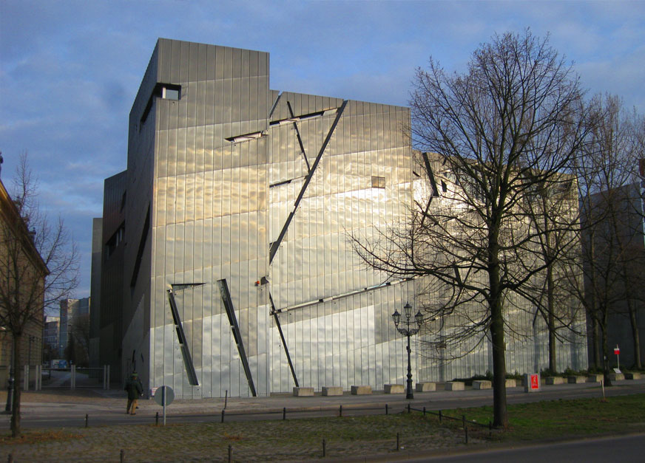

DATE: 1989-2001

**Description (from Libeskind’s website).**

<https://libeskind.com/work/jewish-museum-berlin/>

The Jewish Museum Berlin, which opened to the public in 2001, exhibits the social, political and cultural history of the Jews in Germany from the fourth century to the present, explicitly presenting and integrating, for the first time in postwar Germany, the repercussions of the Holocaust. The new building is housed next to the site of the original Prussian Court of Justice building which was completed in 1735 and now serves as the entrance to the new building.

Daniel Libeskind’s design, which was created a year before the Berlin Wall came down, was based on three insights:  it is impossible to understand the history of Berlin without understanding the enormous contributions made by its Jewish citizens; the meaning of the Holocaust must be integrated into the consciousness and memory of the city of Berlin; and, finally, for its future, the City of Berlin and the country of Germany must acknowledge the erasure of Jewish life in its history.

The visitor enters the Baroque Kollegienhaus and then descends by stairway through the dramatic Entry Void, into the underground. The existing building is tied to the new extension, through the underground, thus preserving the contradictory autonomy of both the old and new structures on the surface. The descent leads to three underground axial routes, each of which tells a different story. The first leads to a dead end – the Holocaust Tower.  The second leads out of the building and into the Garden of Exile and Emigration, remembering those who were forced to leave Berlin. The third and longest, traces a path leading to the Stair of Continuity, then up to the exhibition spaces of the museum, emphasizing the continuum of history.

A Void cuts through the zigzagging plan of the new building and creates a space that embodies absence. It is a straight line whose impenetrability becomes the central focus around which exhibitions are organized. In order to move from one side of the museum to the other, visitors must cross one of the 60 bridges that open onto this void.

<https://www.youtube.com/watch?v=dNJ5rgebyEE>  
  
<https://libeskind.com/work/jewish-museum-berlin/>

**Architect & concept**

Q: Explain in your own words the three ‘insights’ Libeskind hopes to achieve in this building.

Q: How does the visual appearance of the exterior of Libeskind’s design contrast with the older building directly beside it (the Kollegienhaus aka Court of Justice)?

Q: How is Libeskind’s personal life relevant to this work?

Q: Libeskind says he based the concept for his design on the opera ‘*Moses und Aron*’ (*Moses and Aaron*) by Arnold Schoenberg. What is distinctive about this opera and how does it relate to Libeskind’s finished building? And the Jewish community?

Q: The floorplan is designed as a broken line and has been nicknamed ‘the lightning’. What might be the significance of this design decision?

Q: Despite the building appearing ultra-modern and contemporary Libeskind attempts to make it blend with it’s surroundings. How does he do this and why?

Q: How does the entrance to Libeskind’s building contradict or contrast with traditional museum or gallery entrances?

Q: Libeskind covered the exterior of the building in zinc. This metal is designed to become less shiny over the years due to being subjected to weather conditions and Libeskind hopes that the building will blend more with its surroundings. What is Libeskind’s true intention here?

Q: Research the *Void of Memory* display in the museum. What is it, what does it contain and what is its purpose?

Q: Describe the appearance of the materials used in this building; concrete and sheet metal. Why might Libeskind have chosen these materials and what effect do they have on visitors/viewers?

**The Jewish Community in Berlin**

Q: How is the location of Libeskind’s structure significant?

Q: Explain in your own words what each of the axial routes represents in terms of the Jewish community.

Q: How did Libeskind develop the idea for the lines which cut across and scar the exterior of the building?

Q: The building can be described as ‘interactive’. Research some of the permanent contents of the museum, what is Libeskind hoping to achieve?

**The effect of the building on the visitor**

Q: Describe the Tower of the Holocaust and what effect it is designed to have on visitors.

Q: Describe the Garden of Exile and what effect it is designed to have on visitors.

Q: In 1999 the building opened to the public, no work was hung on the walls of the galleries. Hundreds of thousands of members of the public visited the empty museum for over two years. The architecture and design of the building became the display. Why?

Q: Libeskind faced questions and challenges from Berlin’s city officials who did not see the museum as being conventional or traditional. What conventions and traditions was Libeskind challenging?

Q: Why does this building fit into the ‘War’ theme?

Copy and past images here of the interior, exterior, aerial views to give you a clearer idea of the composition and appearance of the building.

***Imperial War Museum North*, 2002**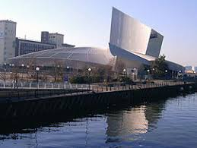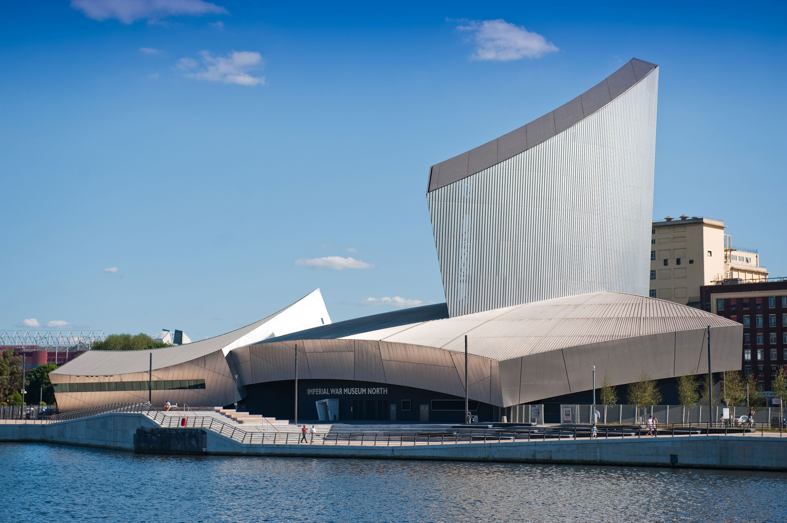

**Description (from the Imperial War Museum North website)**

<https://libeskind.com/work/imperial-war-museum-north/>

The Imperial War Museum North (IWMN) in Manchester, England, tells the story of how war has affected the lives of British and the Commonwealth citizens since 1914.

The design concept is a globe shattered into fragments and then reassembled. The interlocking of three of these fragments—representing earth, air, and water—comprise the building’s form. The Earth Shard forms the museum space, signifying the open, earthly realm of conflict and war; the Air Shard serves as a dramatic entry into the museum, with its projected images, observatories and education spaces; and the Water Shard forms the platform for viewing the canal, complete with a restaurant, cafe, deck and performance space.

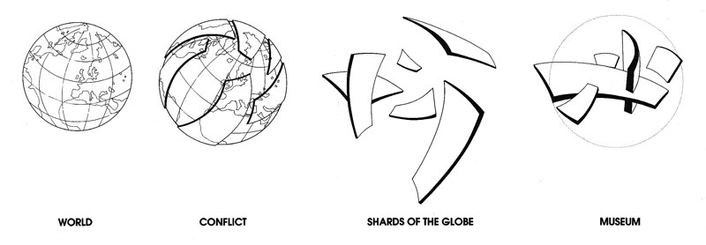

Q: What is the significance of the location/site of the Imperial War Museum North?

Q: The design of the building is composed of three distinct parts. What does these represent?

Q: In what ways does the internal layout and design of this building link to Libeskind’s Jewish Museum in Berlin?  
Q: The main display area is ‘immersive’. Sound, video and photographic projections surround visitors to the gallery. What was Libeskind hoping to achieve with this effect?

Q; The contents of the museum’s display aim to illustrate ‘conflict and it’s effect’. Name some of the conflicts referenced in this museum.

Q: What is the theory behind Libeskind’s design for this building (think of a globe)?

Q: Libeskind uses sloping floors, narrow passageways and leaning walls in the design of this building. Why?

Q: Explain the significance of each of these aspects of the building; the Watershard, the AirShard and the EarthShard. Find an image for each and include below your description.

Q: This building is described as Deconstructivist in style. What does this phrase mean in relation to architecture?

Q: Explain Libeskind’s choice of materials. Why does he use sheet metals such as aluminium and zinc? What are the advantages of using such materials?