

NAME:

**Ancient History**

**Period Study: The Julio-Claudian Emperors, 31 BC – AD 68**

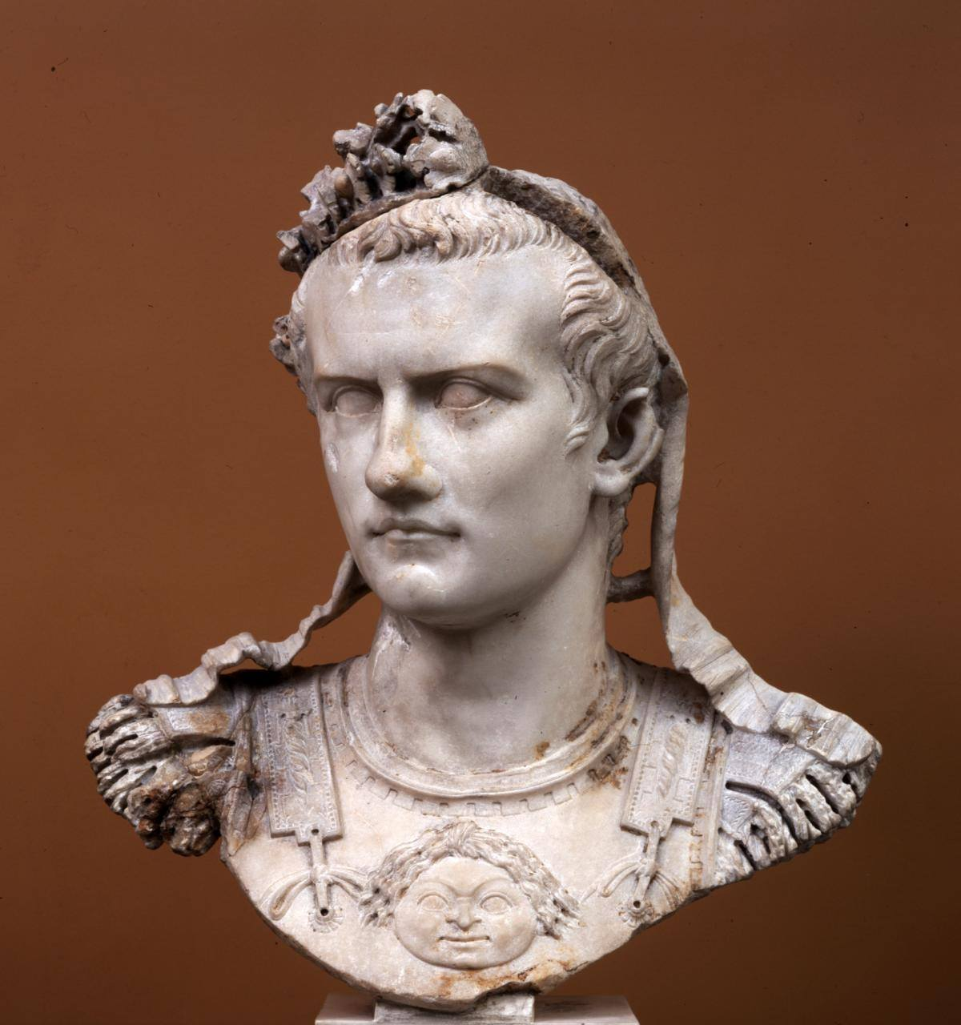**TOPIC 3: Gaius, AD 37-41**

***This booklet covers the following topics:***

* The views of the ancient sources on Gaius and his personality
* Changes to the administration of Rome
* Gaius’ relations with the Senate, equestrians and plebs
* Gaius’ attitude towards religion and the imperial cult
* His assassination in AD 41

**Suggested Reading**

**History Today Articles (go to** [www.historytoday.com](http://www.historytoday.com) **username= Godalming; password= history)**

# Augustus Down the Centuries

By [John M. Carter](http://www.historytoday.com/author/john-m-carter)

Published in [History Today](http://www.historytoday.com/archive/history-today/latest) [Volume 33 Issue 3 March 1983](http://www.historytoday.com/archive/history-today/volume-33-issue-3-march-1983)

# The Problem of Augustus

By [Michael Grant](http://www.historytoday.com/author/michael-grant)

Published in [History Today](http://www.historytoday.com/archive/history-today/latest) [Volume 3 Issue 11 November 1953](http://www.historytoday.com/archive/history-today/volume-3-issue-11-november-1953)

# The Many and the Few: Augustus, Tiberius and Roman Ideals

By [T.P. Wiseman](http://www.historytoday.com/author/tp-wiseman)

Published in [History Today](http://www.historytoday.com/archive/history-today/latest) [Volume 64 Issue 8 August 2014](http://www.historytoday.com/archive/history-today/volume-64-issue-8-august-2014)

# Augustus and Cleopatra

By [Christopher Smith](http://www.historytoday.com/author/christopher-smith)

Published in [History Today](http://www.historytoday.com/archive/history-today/latest) [Volume 64 Issue 2 February 2014](http://www.historytoday.com/archive/history-today/volume-64-issue-2-february-2014)

# The Praetorian Guard

By [Geoffrey Powell](http://www.historytoday.com/author/geoffrey-powell)

Published in [History Today](http://www.historytoday.com/archive/history-today/latest) [Volume 18 Issue 12 December 1968](http://www.historytoday.com/archive/history-today/volume-18-issue-12-december-1968)

# Women in Imperial Rome

By [J.P.V.D. Balsdon](http://www.historytoday.com/author/jpvd-balsdon)

Published in [History Today](http://www.historytoday.com/archive/history-today/latest) [Volume 9 Issue 8 August 1959](http://www.historytoday.com/archive/history-today/volume-9-issue-8-august-1959)

# The Roman Legions and their Officers

By [Geoffrey Powell](http://www.historytoday.com/author/geoffrey-powell)

Published in [History Today](http://www.historytoday.com/archive/history-today/latest) [Volume 17 Issue 11 November 1967](http://www.historytoday.com/archive/history-today/volume-17-issue-11-november-1967)

**Textbooks**

* R. Cromarty, J. Harrison & S. Matthews, *OCR Ancient History, Component 2: Rome*, Bloomsbury, 2018 (Due to be published February 2018)

**Books in the ILC**

* R. L. Fox, The Classical World: an Epic History of Greece and Rome, Penguin, 2006
* M. Beard, *S.P.Q.R.: A History of Rome*, Profile Books, 2015
* T. Holland, *Dynasty,* Abacus, 2016
* P. Mantin & R. Pulley, *The Roman World, From Republic to Empire,* Cambridge, 1993
* T. Martin, *Ancient Rome: From Romulus to Justinian,* Yale, 2013

**Useful Websites**

* <https://www.bloomsbury.com/cw/ocr-as-and-a-level-ancient-history/?pid=330294> (A companion website for the OCR Ancient History textbook – good selection of wider reading and revision quizzes)
* <http://www.ancient.eu/>
* <http://www.livius.org/>
* [www.ocr.org.uk](http://www.ocr.org.uk)

**Podcasts**

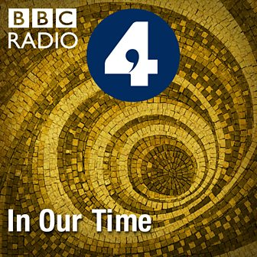Julius Caesar - [www.bbc.co.uk/programmes/b04jlygw](http://www.bbc.co.uk/programmes/b04jlygw)

The Augustan Age - <http://www.bbc.co.uk/programmes/b00ktfmw>

Rome and European Civilization **-** [www.bbc.co.uk/programmes/p00547ms](http://www.bbc.co.uk/programmes/p00547ms)

Tacitus and the Decadence of Rome - <http://www.bbc.co.uk/programmes/b00cdtxp>

Roman Satire - [www.bbc.co.uk/programmes/b00s0gwd](http://www.bbc.co.uk/programmes/b00s0gwd)

*For help in accessing the ebook catalogue on dawsonera, go to the ILC’s page on Godalming Online and read their guide to accessing ebooks.*

*Ebooks can be read using your college log on details whilst in college or at home.*

**ANCIENT HISTORY LUNCHTIME SUPPORT**

**If you need any help in Ancient History going over content, completing homework, attempting assessed questions or preparing for exams, there will be a lunchtime support session each Wednesday between 1 and 2 pm in room 211.**

**The Portrayal of Gaius by the ancient sources**

**RECAP:**

* Who were Gaius’ mother and father?
* Why was he known as ‘Caligula’?
* What was the public reaction in Rome to the death of Tiberius?
* Why might hopes for Gaius as an emperor be high?

Gaius had been forced to live with Tiberius on the island of Capri from AD 31. His rise to become Tiberius’ successor looked very unlikely. Tiberius was alleged to have orchestrated the murder of Gaius’ father Germanicus, and also imprisoned his mother Agrippina, along with his elder brother, both of whom would die in exile. Gaius, however, concealed his anger and by gaining a powerful ally in the then leader of the Praetorian Guard, Macro, came to be seen as Tiberius’ successor by AD 35. There is even a suggestion that Gaius and Macro may have murdered Tiberius by smothering him with a pillow, although there is no real evidence of this.

The ancient sources all reflect the idea that Gaius’ reign began positively as he undid several of Tiberius’ unpopular policies and showed generosity towards the people of Rome. However, the sources also show that after this start, Gaius’s reign descended into one of tyranny and cruelty until his assassination in AD 41.

Suetonius sums this idea up clearly:

Why might Suetonius’ have paid particular detail to Gaius in his work and how reliable do you think this will be?

**Prescribed Source – Suetonius *Gaius* 22**

So much for Gaius the Emperor; the rest of this history must deal with Gaius the Monster.

Some sources attribute this dramatic change in Gaius’ character and rule to a serious illness he suffered in October/November 37. Nonetheless, there is clear evidence of a positive start before this:

**Prescribed Source – Suetonius *Gaius* 13-14**

13. Gaius’s accession seemed to the Roman people – like the answer to their prayers. The memory of Germanicus and compassion for a family that had been practically wiped out by successive murderers made most provincial and soldiers, many of whom had known him as a child, and the entire population of Rome as well, show extravagant joy that he was now emperor. When he escorted Tiberius’ funeral procession from Misenum to Rome he was, of course, dressed in mourning, but a dense crown greeted him ecstatically with altars, sacrifices and torches, and such endearments as ‘star’, ‘chick’, ‘baby’ and ‘pet’.

14. On his arrival in the city the Senate (and a mob of people who had forced their way into the Senate House) immediately and unanimously conferred absolute power upon him. They set aside Tiberius’ will, which made his other grandson, then still a child, joint heir with Gaius, and so splendid were the celebrations that 160,000 victims were publicly sacrificed during the next three months or perhaps even a shorter period. A few days later he visited the prison islands off Campania, and vows were uttered for his safe return – at that time no opportunity of demonstrating a general concern for his welfare was ever disregarded. When he fell ill, anxious crowds besieged the Palatine all night. Some swore that they would fight as gladiators the gods allowed him to recover; others even carried placards volunteering to die instead of him. To the great love in which he was held by his own people, foreigners added their own tribute of devotion. Artabanus, the king of the Parthians, who had always loathed and despised Tiberius, made unsolicited overtures of friendship to Gaius, attended a conference with the governor of Syria, and, before returning across the river Euphrates, paid homage to the Roman Eagles and standards and the statues of the Caesars.

**Prescribed Source – Suetonius *Gaius* 18-20**

18. He held several gladiatorial contests some in Statilius Taurus’ amphitheatre and others in the Saepta, diversifying them with prize fights between the best boxers of Africa and Campania; he occasionally allowed magistrates or friends to preside at these instead of doing so himself. Again, he staged a great number of different theatrical shows in various buildings – sometimes at night, with the whole city illuminated – and would scatter vouchers among the audience entitling them to all sorts of gifts, over and above the basket of food which was everyone’s due. At one banquet, noticing with what extraordinary gusto an *eques* seated opposite dug into food, he sent him his own heaped plate as well, and rewarded a senator, who had been similarly enjoying himself, with a praetorship, though he was not yet qualified to hold this office. Many all-day games were held in the Circus, and between races he introduced panther-baiting and the Troy Game. For certain special games when all the charioteers were men of senatorial rank, he had the Circus decorated in red and green. Once, while he was inspecting the Circus equipment, from the Gelotian House which overlooks it, a group of people standing in the nearby balconies called out, ‘What about a day’s racing, Caesar?’ So on the spur of the moment he gave immediate orders for games to be held.

19. One of his spectacles was on such a fantastic scale that nothing like it had ever been seen before. He collected all the available merchant ships and anchored them in two lines, close together, the whole way from Baiae to the mole at Puteoli, a distance of some three miles and some 600 feet. Then he had the ships boarded over, with earth heaped on the planks and made a kind of Via Appia along which he trotted back and forth for two consecutive days. On the first day he wore a civic crown, a sword, a shield and a cloth-of-gold cloak, and rode a gaily caparisoned charger. On the second he appeared in charioteer’s costume driving a team of two famous horses, with a boy named Dareus, one of his Parthian hostages, triumphantly displayed in the car beside him; behind came a fore of praetorians and a group of his fiends mounted in Gallic chariots. Gaius is of course generally supposed to have built the bridge as an improvement on Xerxes’ famous feat of bridging the much narrower Hellespont. Others believe that he planned this huge engineering feat to terrify the Germans and Britons, on whom he had his eye. But my grandfather used to tell me as a boy that, according to some courtiers in Gaius’ confidence, the sole reason for the bridge was this: when Tiberius could not decide whom to appoint as his successor and inclined towards his grandson and namesake, Thrasyllus the astrologer had told him, ‘As for Gaius, he has no more chance of becoming emperor than of riding a horse dry-shod across the Gulf of Baiae’.

20. Gaius gave several shows abroad – theatrical performances at Syracuse and mixed games at Lugdunum, where he also held a competition in Greek and Latin oratory. The losers, they say, had to present the winners with prizes and make speeches praising them, while those who failed miserably were forced to erase their entries with sponges or their own tongues – at the threat of being thrashed and flung into the Rhone.

**Examples of Gaius’ positive start:**

* He held a series of Games (remember that according to Suetonius Tiberius had not done this)
* All exiles were recalled and any charges that were outstanding from the reign of Tiberius were cancelled

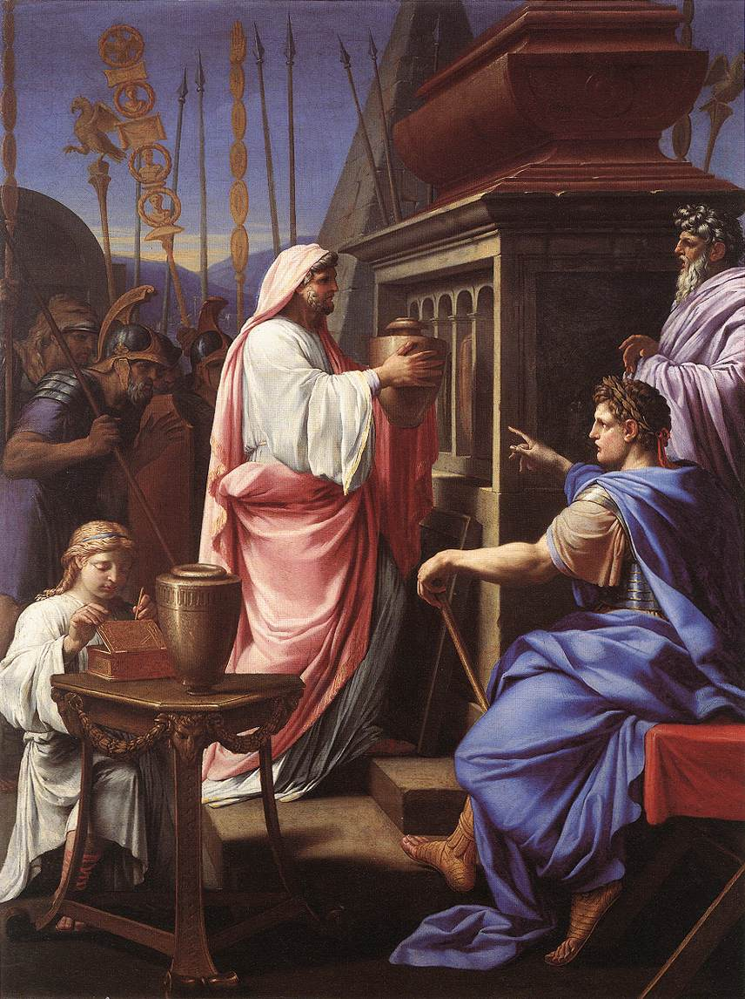

* It appeared as though he helped to reunite the Julio-Claudian household by adopting Tiberius’ grandson **Tiberius Gemellus**
* He honoured his grandmother with the title of ***Augusta* (Dio)**
* He brought back, in person, the remains of his mother and brother from the islands they had been exiled on to be placed in the Mausoleum of Augustus **(Dio)**

These actions were designed to gain popularity and support from the ‘mob’ in Rome, whilst at the same time appear respectful and tolerant to the higher orders.

Gaius was also keen at the start of his reign to reinforce his connection to his father Germanicus:

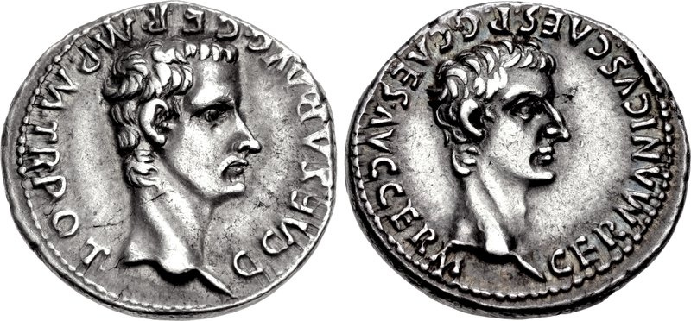**Prescribed Source – Denarius of Gaius, AD 37**

**Obv.:** Head of Gaius; “Gaius Caesar, Augustus, Germanicus, pontifex maximus, with tribunician power”

**Rev.:** Head of Germanicus; “Germanicus Caesar, father of Gaius Caesar Augustus Germanicus”

1. **Why do you think Gaius wanted to stress his links to his father Germanicus at the start of his reign?**

The ancient sources present the start of Gaius’ reign as a positive period but largely agree that this quickly changed as reign turned brutal and tyrannical.

**Prescribed Source - Josephus, *Jewish Antiquities* 19.1–3**

1. Gaius' madness was now an offence to god and man. He showed it not only in his sacrilegious conduct towards the Jews in Jerusalem and all the surrounding territory, but also exported it to infect every land and sea which was subject to the rule of Rome, inflicting on all of them innumerable misfortunes to a degree unprecedented in recorded history. 2. Rome herself above all became only too aware of the sheer horror of his actions, since he afforded her no special treatment compared with other cities. He plundered and laid waste her citizens, but in particular the senate and those of its members who were patricians or highly respected for their distinguished ancestry. 3. He also devised innumerable attacks upon the so-called *equites*, men whose status and financial power gave them a prestige equivalent to the senate in the eyes of ordinary citizens, since it was from them that senators were recruited. He would take away their privileges, order them into exile, put them to death and confiscate their property – indeed, the motive for such executions was usually in order to seize their possessions.

**Prescribed Source – Seneca, *On Consolation to Polybius* 17.3-5**

I have gone through the whole catalogue of Caesars from whom Fortune stole brothers and sisters. But I cannot leave out the one Caesar from all their number whose name deserves to be obliterated from that list. He was one whom Nature spawned to be the ruin and disgrace of all humanity; he brought fire and utter destruction to an empire, which is now being restored by the clemency of our most kindly emperor.

Gaius Caesar lost his sister, Drusilla. He was a man incapable of expressing grief or pleasure in a manner fit for an emperor. He shunned all sight of or converse with his fellow citizens, and did not even attend his own sister’s funeral rites or pay the respect and honour due to her remains. Instead, in his Alban villa he sought to lighten the distress of that most bitter loss by gambling with dice and indulging in other such occupations better suited to the vulgarities of the public squares. What a disgrace to our empire that its emperor, in mourning for his sister, should find solace in the dice board.

This was the selfsame Gaius who, with an inconsistency born of madness, would at one moment let his hair and beard grow long and the next proceed to shave them off. Meanwhile he wandered aimlessly along the shores of Italy and Sicily unable to make up his mind whether he wanted his sister to be mourned as a mortal or worshipped as a goddess. And all this time, while he was setting up temples and shrines to her memory, he inflicted the most savage punishments on those whose grief he deemed inadequate. In all this he bore the hammer blows of misfortune with that same lack of decency and restraint as he had shown when, in the elation of moments of good fortune, he had swollen with arrogance beyond all human propriety.

1. **Based on the information in the two sources above, select three words that sum up Gaius’ character**

**Prescribed Source – Dio, *Roman History* 59:3.1–5.5**

**Gaius’ Conduct as Emperor**

He showed just the same failing too in practically all other matters. At first he seemed very democratic: he neither sent any written instructions to the people or the senate, nor did he assume any of the imperial titles; but in time he became very monarchical. Thus in a single day he took all the honours Augustus had been slow to accept, and then only one by one as they had been voted to him during his long reign; and some of these Tiberius indeed had refused to accept at all. With the exception of the title ‘Father of the Fatherland’ he deferred none of them, and it was not long before he assumed that one too.

He turned out to be the most lustful of men; he even seized one woman as she was being handed over in marriage to her husband, others he snatched from their husbands when they were married. But then he came to hate them all except one, and he would certainly have come to detest her, if he had lived longer. His mother, his sisters and his grandmother Antonia he treated at first with great respect. He immediately gave Antonia the title ‘Augusta’ and appointed her priestess of Augustus, granting her on the spot the full privileges of the Vestal Virgins. To his sisters he also granted these privileges of the Vestal Virgins and in addition the right to watch the games in the circus with him from the same front seats, and the right to have their names included not only in the prayers offered annually by the magistrates and priests for his own welfare and the welfare of the state, but also in the oaths of allegiance that were sworn to his rule.

He sailed in person overseas and with his own hands collected and brought back the bones of his dead mother and brothers; and wearing a purple-boarded toga and attended by lictors, as if at a triumph, he had them laid to rest in the Mausoleum of Augustus. He annulled all the measures that had been passed against them, punished all who had conspired against them and recalled those who had been sent into exile because of some connexion with them. Yet, after doing all of this, he acted in a most impious fashion towards both his grandmother and sisters. He forced his grandmother to commit suicide because she had criticized him for something; and as for his sisters, after taking them all as sexual partners, he banished two of them to an island; the third had already died.

He even demanded that Tiberius, whom he called his ‘grandfather’, should be granted the same honours by the senate as Augustus had been. But the senate failed to vote Tiberius these honours immediately. (The senators could not bring themselves either to honour him or to dishonour him, because at this stage of his reign they had no clear idea of the young man’s mind, and so were postponing all decisions until his arrival in Rome.) As a result Gaius paid Tiberius no other mark of distinction besides a public funeral. It was night-time when he brought the body into the city, and at daybreak he had it laid out. And although he made an oration over his body, he did not so much praise the dead emperor as remind the people of Augustus and Germanicus and commend himself into their hands.

For indeed Gaius was by nature so contrary in all respects that he not only rivalled, but even surpassed Tiberius’ licentiousness and bloodthirstiness, for which he had the nerve to censure him. Conversely, he in no way initiated those aspects of Tiberius’ conduct that won his praise. He was the first to insult him and the first to castigate him. The result was that others, believing that they would gain his favour by so doing, went in for rather reckless freedom of speech. But later he started both to eulogize and to revere him, so much so that he punished some for what they had said. Those people he hated as enemies of Tiberius for their abusive comments; but he also hated those who had praised Tiberius in any way on the grounds that they were his supporters. He put a stop to accusations on the charge of treason, but then destroyed very may people using this very charge. His anger against those who had conspired against his father, mother and brothers had abated, so he claimed, and he had burned the papers about them. But he put many of them to death using that very evidence. For he did genuinely destroy some of these papers, but not, however, the originals which contained detailed proof, but just the copies he had made of them. In addition to this at the start of his reign he forbade the setting up of any images of him, but eventually proceeded to manufacture statues; and having once refused to sanction a vote that sacrifices be conducted to his Fortune, going even so far as to have thus recorded on an inscription, he eventually ordered that temples and sacrifices be granted him, as if to a god.

He rejoiced in turn in large crowds and then solitude. He grew angry if requests were made of him and then if requests were not made of him. He would display great enthusiasm for some projects and then become very uninterested when it came to carrying them out. He would both spend money unsparingly and seek out funds in a most sordid fashion. He was likewise annoyed and delighted both with those who flattered him and those who spoke their minds on some matters. He did not punish many who had committed great crimes, but slaughtered many who were not even under suspicion. Some of his entourage he flattered to an excessive degree, while other he utterly insulted. The result of this was that no one knew either what to say or how to act towards him; but those that managed to survive did so more by luck than judgement.

To such an emperor were the Romans at this time handed over. The result was that the people thought that the deeds of Tiberius, although they seemed very harsh at the time, were as far superior to those of Gaius as those of Augustus had been to those of Tiberius. For Tiberius always remained in control and used others as agents to carry out his own plans. Gaius on the other hand was controlled by the charioteers and by gladiators, and was the slave of actors and other people connected with the stage. Indeed he constantly kept Apelles, the most famous of the tragic actors, at his side – even in public. As a result of this, both the and they on their own initiative used their authority to do everything that men of this type dare whenever they are granted any power. For everything that had to do with their profession, on the slightest excuse he would arrange and organize in a very lavish fashion, and he forced both the praetors and the consuls to do the same. The result was that hardly a day passed when there was not some such performance. At first he was merely a spectator and part of the audience at these performances, and he would cheer and take sides as if he was one of the crowd; and on one occasion he was annoyed with those who supported the opposite side and so did not turn up to the spectacle. But as time went on, he started to imitate them and compete in many events. For he would drive chariots, fight in gladiatorial combats, indulge in dancing and act in tragedies. And he would do this all the time, but on one particular occasion he summoned the leading senators suddenly in the middle of the night as if on some urgent business and then danced in front of them.

1. **Focus on the source from Dio above. Use it to summarise evidence of a positive start by Gaius and then a move to tyranny**

|  |  |
| --- | --- |
| *Evidence that Gaius’s reign began well…* | *But then turned bad…* |
|  |  |

1. From the source you have just read, how would you summarise Dio’s view of Gaius’ character? Provide at least one quote from the source to support your answer.

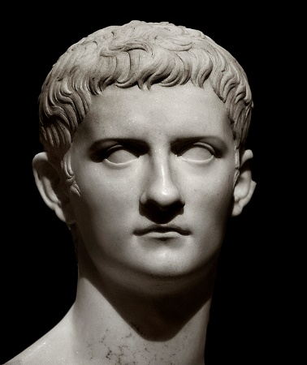**Administrative Changes to Rome**

Gaius’ government of Rome and its people appears as contradictory from the ancient sources as his character does. Some sources show us an emperor who introduced many positive reforms that promoted good government and helped the people. Others, however, depict Gaius as someone who exploited taxation and building projects for his own private pleasures.

***Evidence of positive changes to the government of Rome***

**Suetonius** lists a range of reforms brought in by Gaius all of which appear sensible and seem to challenge the image of a ‘mad’ emperor:

* The imperial budget was published
* Censorship on a number of Augustan writers and historians was lifted
* Magistrates were given full authority over court cases
* A fifth judicial division was created to spread the workload of the courts
* The list of *equites* was revised
* The leadership and government of several ‘buffer regions’ to the Roman empire were reorganised.

**Dio** also highlights several of these reforms:

**Prescribed Source – Dio, *Roman History* 9.4–7**

**Finances, Elections and the recruitment of the new Equestrians**

Gaius acted commendably and well in the following matters. As for the accounts of public funds, he published them in full, following the example of Augustus: they had not been published during Tiberius’ absence from the city. He helped the troops put out a fire and provided financial aid for the victims. Since the roll of the equestrian order was becoming depleted, he summoned men of distinguished family and great wealth from all over the Empire, even from outside Italy, and enrolled them in the order. He even gave some of them permission to wear senatorial dress before they had held any of the magistracies which entitle us to enter the senate in due course. Previously, it seems, only those who were from families of senatorial rank had been allowed to do this.

These measures caused general satisfaction; but when he put the elections once more in the hands of the people and the plebs, so reversing the arrangements of Tiberius, when he abolished the one per cent tax, and when at a gymnastic contest which he had arranged he threw tickets at random into the crowd and distributed a great number of gifts to those who successfully scrambled for them, he pleased the rabble, it is true; but he distressed sensible people, who reflected that if the magistracies should fall once more into the hands of the common people, and public funds be exhausted, and private resources dry up, many disasters would occur.

1. **What appears to be Dio’s general view on Gaius’ reforms? (First Paragraph)**
2. **What specific type of reform is critical of? (Second Paragraph)**
3. **How reliable do you think his views on this are? (Think carefully and try to remember who Dio is)**

Further evidence of positive reforms under Gaius comes from **Pliny the Elder**:

**Prescribed Source – Pliny the Elder, *Natural History*, 36.122-3**

The very recent spending on the works begun by Gaius Caesar and completed by Claudius has surpassed previous aqueducts. Starting at the 40th milestone, the Curtian and Caerulean springs and the *Anio novus* have been made to flow into the city at a height sufficient to all seven of her hills, at a total cost of 350 million sesterces. Careful consideration of the abundant supply of water to public buildings, baths, fish-ponds, water features, houses, private parks, and suburban villas; the distant source of the water; the arches built; the mountains tunnelled through; the valleys bridged, will make anyone admit that there has been no more remarkable achievement in the whole world.

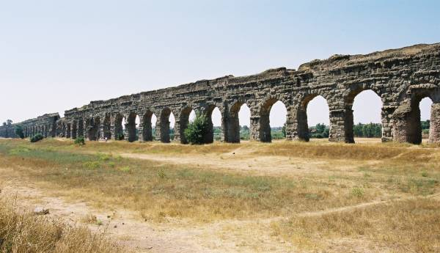This is particularly significant evidence as Pliny claimed to praise only ‘practical’ building programmes in his work and condemned private, vanity projects. The fact, therefore, that he credits these improvements to Gaius shows that he thought of them positively.

Anio Novus

Finally, **coinage** from Gaius’ reign also demonstrates positive reforms which were, in particular, designed to gain support of the masses. In AD 39 Gaius abolished the 0.5% auction tax and celebrated this in the design of a new coin:

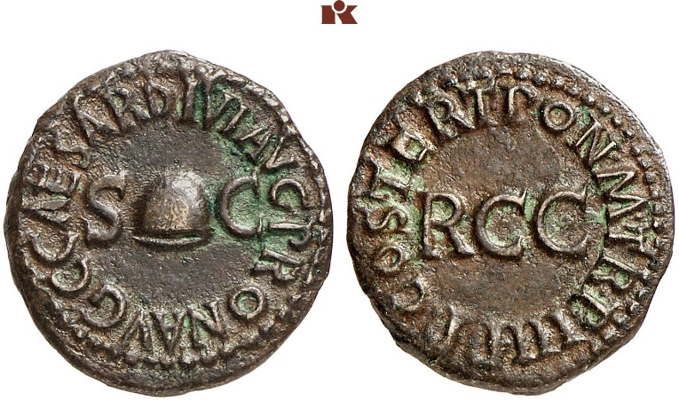

**Obv.:** Pileus between SC; “Gaius Caesar, Augustus, grandson of Augustus, by decree of the senate”

**Rev.:** RCC (Remission of the 1/200 tax); “pontifex maximus, in his 3rd year of tribunician power, father of the fatherland, designated consul for the 3rd time”

**Quadrans:** the lowest denomination Roman coin

A **pileus** was cap worn by freedmen and by using it on the coin Gaius was suggesting that abolishing the tax was like ending slavery for the people. This is a clear exaggeration, but the move would have been popular with ordinary Romans and by using the lowest value coin to send this message, Gaius was trying to communicate directly to them.

***Evidence of negative changes to the government of Rome***

A number of ancient sources also indicate much less successful changes under Gaius. Dio is quick to point out the recklessness of Gaius’ spending and the impact this had on taxation. He claims that Gaius squandered the wealth that he had been left by Tiberius and had spent 575,000,000 denarii in under a year forcing him to introduce harsh new taxes:

**Prescribed Source – Dio, *Roman History* 59.28.11**

Now this god, this Jupiter (for he was addressed by these titles so often at the end of the reign that they even appeared in documents) was doing all this at the same time as he was collecting money in a most disgraceful and terrible way. One might pass over the goods-for-sale and the taverns, the prostitutes and the lawcourts, the craftsmen and the wage-earning slaves, and all the other activities from which he did not cease collecting every sort of revenue. But how could anyone keep silent about the rooms which were marked out in the palace itself and about the wives of the leading citizens and the children of the most revered whom he dishonoured by setting up as prostitutes in these rooms and by harvesting revenue from all alike for their services? Some of them were happy to do this, but others were quite unwilling, but did it so as not to be thought to bear any grudge. The masses, however, were not even in the slightest disturbed by these events, but rather took pleasure together with him in his licentiousness, and also in the fact that each time he collected gold and silver from them, he would throw himself onto it and roll in it. However, when he introduced some severe measures about taxes and inscribed them on white boards in very small letters and then hung these from a very high position (he did this to ensure that the regulations should be read by as few people as possible, and as a result many would be liable to the penalties, since they would be unaware of what was lawful and unlawful), the masses suddenly rushed into the Circus in a great crowd and uttered a storm of protest.

In addition to this, Suetonius also presents Gaius’ building programmes in a more negative light than Pliny the Elder had.

**Prescribed Source – Suetonius, *Gaius*, 19**

19. One of his spectacles was on such a fantastic scale that nothing like it had ever been seen before. He collected all the available merchant ships and anchored them in two lines, close together, the whole way from Baiae to the mole at Puteoli, a distance of some three miles and some 600 feet. Then he had the ships boarded over, with earth heaped on the planks and made a kind of Via Appia along which he trotted back and forth for two consecutive days. On the first day he wore a civic crown, a sword, a shield and a cloth-of-gold cloak, and rode a gaily caparisoned charger. On the second he appeared in charioteer’s costume driving a team of two famous horses, with a boy named Dareus, one of his Parthian hostages, triumphantly displayed in the car beside him; behind came a fore of praetorians and a group of his fiends mounted in Gallic chariots. Gaius is of course generally supposed to have built the bridge as an improvement on Xerxes’ famous feat of bridging the much narrower Hellespont. Others believe that he planned this huge engineering feat to terrify the Germans and Britons, on whom he had his eye. But my grandfather used to tell me as a boy that, according to some courtiers in Gaius’ confidence, the sole reason for the bridge was this: when Tiberius could not decide whom to appoint as his successor and inclined towards his grandson and namesake, Thrasyllus the astrologer had told him, ‘As for Gaius, he has no more chance of becoming emperor than of riding a horse dry-shod across the Gulf of Baiae’.

1. **How could this account of Gaius’ building project at Baiae be viewed as negative?**
2. **On the basis of what you have gained so far, to what extent do Gaius’ reforms to the government of Rome support the image of a mad, tyrannical ruler?**

**Gaius’ relationship with the Plebs, Equestrians and Senate**

One of the difficulties in understanding Gaius’ relationship with the different groups in Rome is the unreliable nature of many of the sources. For example, several (Dio, Suetonius) are from an upper-class, senatorial perspective who are trying to portray Gaius as mad. The picture that we get from these sources is therefore **inconsistent**.

**Plebs**

We have already seen that Gaius wanted to appeal to the masses in Rome (e.g. he held a series of public games and abolished the 0.5% auction tax). However, his attitude towards the plebs could be brutal as well as generous as is shown by the source below from Josephus.

**Prescribed Source - Josephus, *Jewish Antiquities* 19.1–3**

This was the time when the chariot races were being held – a spectacle which is immensely popular with the Roman people. They flock enthusiastically to the Circus Maximus and large groups of them petition the emperors for whatever they want. Those emperors who decide that their demands are irresistible are naturally very popular. On this occasion they were making desperate requests to him to reduce taxes and grant some relief from the serious burden they entailed. But he would have none of it, and as the shouts grew louder and louder he sent his officials into different parts of the crowd with orders to arrest those who were shouting, drag them forward and execute them immediately. He issued the order; those so instructed carried it out. The victims of this barbarity were very numerous. As for the people, when they saw what happened they controlled themselves and stopped shouting, since they could see with their own eyes that any such petitions for financial help could only lead to their own deaths.

This vicious streak towards the people would be most famously summed up by Suetonius and Seneca who both included the famous quote that Gaius had wished that all the Romans ‘had only one neck’.

**Prescribed Source - Younger Seneca, *On Anger* 3.19.1–5**

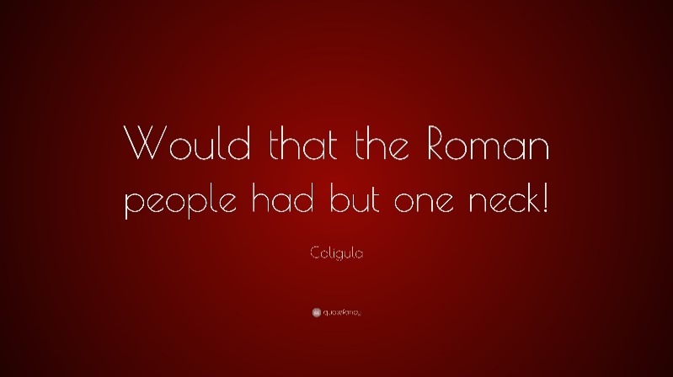In this context it is worth considering the arrogance which accompanied his cruelty. Some many regard this an irrelevance, a digression from the subject in hand. But this characteristic will be seen to be typical of an anger whose rage has got out of hand. He had flogged a number of senators; but he was the one who made it possible to describe this as an everyday occurrence. He tortured them in every conceivably painful way known to nature – by garrotte, ankle-pins, the rack, fire, and even having to look upon his face. But here’s the answer. Why all this fuss about three senators being cut to pieces by fire and flogging like insignificant salves by a man who had seriously considered butchering the whole senate. This was the same man who used to wish that the whole Roman people had one single neck, so that he could have concentrated all his crimes, spread over so many times and places, into one single stroke on one single day.

**Equestrians**

According to Suetonius, Gaius was hostile with the equestrians (this is also repeated in Josephus):

**Prescribed Source – Suetonius *Gaius* 18-20**

The *equites* earned his constant displeasure for spending their time, or so he complained, at the plays or games. On one occasion the people cheered the wrong team; he cried angrily, ‘I wish all you Romans had only one neck!’

However, this picture is not entirely convincing as Suetonius himself acknowledges that Gaius revised the list of *equites* and this is repeated by Dio:

**Prescribed Source – Dio, *Roman History* 9.4–7**

**Finances, Elections and the recruitment of the new Equestrians**

Gaius acted commendably and well in the following matters. As for the accounts of public funds, he published them in full, following the example of Augustus: they had not been published during Tiberius’ absence from the city. He helped the troops put out a fire and provided financial aid for the victims. Since the roll of the equestrian order was becoming depleted, he summoned men of distinguished family and great wealth from all over the Empire, even from outside Italy, and enrolled them in the order. He even gave some of them permission to wear senatorial dress before they had held any of the magistracies which entitle us to enter the senate in due course. Previously, it seems, only those who were from families of senatorial rank had been allowed to do this.

**Senate**

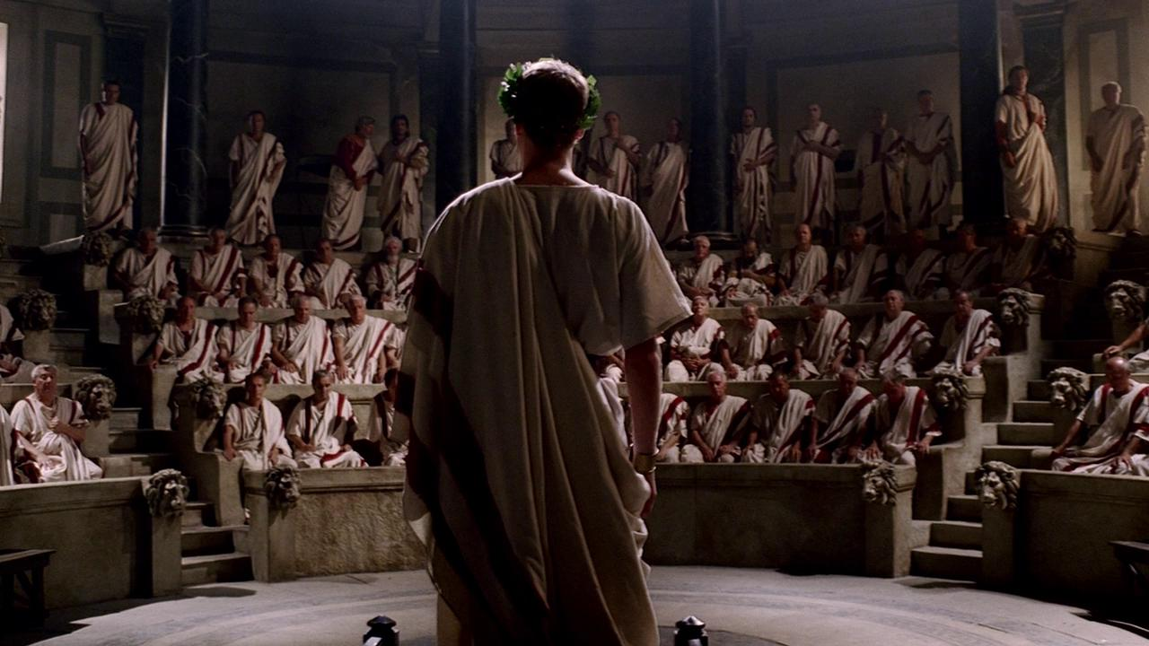**Prescribed Source – Suetonius *Gaius* 14**

On his arrival in the city the Senate (and a mob of people who had forced their way into the Senate House) immediately and unanimously conferred absolute power upon him. They set aside Tiberius’ will, which made his other grandson, then still a child, joint heir with Gaius, and so splendid were the celebrations that 160,000 victims were publicly sacrificed during the next three months or perhaps even a shorter period. A few days later he visited the prison islands off Campania, and vows were uttered for his safe return – at that time no opportunity of demonstrating a general concern for his welfare was ever disregarded. When he fell ill, anxious crowds besieged the Palatine all night. Some swore that they would fight as gladiators if the if the gods allowed him to recover; others even carried placards volunteering to die instead if him. To the great love in which he was held by his own people, foreigners added their own tribute of devotion. Artabanus, the king of the Parthians, who had always loathed and despised Tiberius, made unsolicited overtures of friendship to Gaius, attended a conference with the governor of Syria, and, before returning across the river Euphrates, paid homage to the Roman Eagles and standards and the statues of the Caesars.

**Prescribed Source – Dio, *Roman History* 59:3.1-2**

**Gaius’ Conduct as Emperor**

He showed just the same failing too in practically all other matters. At first he seemed very democratic: he neither sent any written instructions to the people or the senate, nor did he assume any of the imperial titles; but in time he became very monarchical. Thus in a single day he too all the honours Augustus had been slow to accept, and then only one by one as they had been voted to him during his long reign; and some of these Tiberius indeed had refused to accept at all. With the exception of the title ‘Father of the Fatherland’ he deferred none of them, and it was not long before he assumed that one too.

1. **According to both Suetonius and Dio, how did the Senate react to Gaius’ accession as emperor?**

**Prescribed Source - Dio, *Roman History* 59:16.1–11**

**Change in Gaius’ attitude towards Tiberius; reintroduction of the charge of treason; honours for Gaius**

Up to this point in his reign not only had Gaius continually denounced Tiberius in front of everybody, but rather than taking to people to task when they slandered him either in public or in private, he had actually taken pleasure in what they had said. But now he entered the senate-house and made a long speech praising him, in which he also censured at some length the senate and people on the grounds that they were quite wrong to criticize Tiberius. “It is within my power as emperor,” he said, “to do such things. But you are not only committing a crime, but also committing an act of treason by your attitude towards a man who was once your ruler.” As a result, he re-examined one by one the cases of those who had perished, and tried to prove, so it seemed to the people, that the senators had been guilty of causing the destruction of most of them: they had laid the charges against some, given evidence against others, but in short had voted to condemn them all. This evidence, supposedly drawn from those very documents that he had once claimed to have burned, was read out by the imperial freedmen. He then addressed them.

“If it is true that Tiberius treated you unjustly, you ought not to have honoured him during his lifetime, no by Jupiter, nor should you now be changing your minds on issues which you have many times made declarations and passed resolutions. You not only handled Tiberius in a devious manner, but also put Sejanus to death after pulling him up with pride and corrupting him. As a result, I ought not to expect any decent treatment from you.” After making such remarks, he introduced Tiberius himself, as it were, into his speech, who addressed him as follows. “All your remarks have been well-made and are quite truthful. Therefore, show neither affection nor mercy to any of them. For they all hate you, and they are all praying for your death. They will murder you, if they can. Therefore, don’t even consider what actions you can take to win their favour, and don’t worry if they gossip. Rather, take thought only for your own pleasure and safety; you’d be quite justified in doing this. For if you act in this way, you will suffer no harm and enjoy all the greatest pleasures. And yet you will still be honoured by them, whether they are willing or unwilling. But if you do show them any affection or mercy, you will derive no practical benefits, while in theory any good reputation you receive will be meaningless; for you will gain no further advantage, but rather become the victim of conspiracies an die an inglorious death. For no man is ruled by his own free will. As long as a person is afraid, he seeks the protection of the stronger, but whenever he gains in confidence, he takes it out on the weaker.”

After making this speech, Gaius reintroduced the charge of treason and gave orders that this should immediately be inscribed on a bronze plaque. He hurried out of the senate-house and set out on the same day for the suburbs. The senate and the people were greatly afraid, remembering the accusations they had often made against Tiberius and balancing what Gaius had just said against what they had heard in the past. As things stood, through shock and despondency they were unable to make any statement or conduct any business. But the next day they reassembled and made many speeches praising Gaius as a most sincere and pious ruler, since they were most grateful to him for not having put them to death. And for this reason they passed a resolution to offer a sacrifice of oxen to his clemency every year both on the anniversary of the day on which he had made his speech and also on the days belonging to the palace. In addition they voted that a golden image of Gaius should be carried up to the Capitol and hymns be sung in his honour by boys of the noblest families. They also gave him permission to celebrate a lesser triumph, as if he had defeated some external enemy. And this is what they decided on this occasion, and later they proposed many additional honours on almost any excuse.

1. **According to Dio’s account of Gaius’ speech, how did he view the senate?**
2. **What advice had Tiberius supposedly given him?**
3. **What did Gaius reintroduce after this speech?**

As can been seen from the speech above and the reaction of the senators to it, the senate was a largely **sycophantic** body under Gaius. It voted him all of the honours and powers that Tiberius had held instantly (this would become the model for all future emperors); the senate did nothing to oppose the reintroduction of the **treason trails** but instead thanked Gaius for not putting them to death; finally the senate also rewarded Gaius for his ‘clemency’ by offering him annual sacrifices, erecting a statue of him on the Capitoline Hill and awarding him a triumph as if he had defeated a foreign enemy.

***Is it fair to criticise the senate for their actions and attitude towards Gaius?***

**Gaius’ Attitude towards religion and the Imperial Cult**

Tiberius appears to us from the ancient sources as an emperor who was uncomfortable with his religious role and in particular with the imperial cult – remember that Tiberius had rejected a proposal from the Greek city of Gytheion asking to give him divine honours.

Gaius had no such difficulty and would very confidently **declare himself a god**. In doing this he would expand the imperial cult into something different to the one created by Augustus. Augustus had allowed the provinces to worship the emperor as a living god but had only allowed the ***genius***or ***lares*** of the emperor to be worshiped in **Rome**. This was a subtle difference but it meant that the imperial cult could be used as a tool of **Romanisation** in the provinces without looking sacrilegious or **overly-powerful** in Rome itself. Gaius would end this distinction and would demand to be worshipped as a living god in Rome and the emperor.

There are several possible reasons why Gaius did this:

* It was a way to assert his independence and difference from Tiberius who had been reluctant to support the imperial cult
* It was a natural consequence of the flattery Gaius received from the senate when he took power, this encouraged him to think of himself as more than mortal
* Gaius held no positions or powers before becoming emperor and therefore lack ***auctoritas***. Declaring himself a living god was a way to make up for this shortfall

According to Dio, Gaius at first stopped any images of him being set up in Rome and also did not approve of a vote that sacrifices should be held to his Fortune. Suetonius and Dio, however, then go on to explain how Gaius turned himself into a god:

**Prescribed Source - Dio, *Roman History* 26.5–27.1**

**Gaius’ Divine Pretensions**

Gaius was praised for this, partly out of fear, but partly for genuine reasons. But when people started calling him a demi-god and even a god, he went completely out of his mind. Even before this he had been demanding that he be considered something more than a mere human being, and he kept declaring that he was having sex with Luna, the moon-goddess, and being crowned by Victory. Furthermore, he kept pretending that he was Jupiter, and used this as a pretext for having sex with many different women, but most of all with his sisters. At other times he claimed to be Neptune, because he had bridged such a large stretch of water. He also played the part of Hercules, Bacchus, Apollo and the other gods, not just male, but the female deities as well. He often appeared as Juno Diana or Venus. In addition to this change in names, he would take on all the other appropriate attributes as well, so that he could appear most like them. At one moment he would be seen in female form, holding a wine bowl and a thyrsus; at another he would be wearing a male costume and carrying a club and lionskin or a helmet and shield. Now he would appear clean-shaven and then bearded; at one time he appeared shaking a trident, at another brandishing a thunderbolt. He would resemble a maiden dressed either for hunting or for war, and then shortly afterwards appear as a married woman. Thus, by changing his costume, his props and his wigs, he would play a whole variety of roles quite convincingly. And in every respect he wanted to appear more than just a human being and an emperor.

There was once a man from Gaul, who saw him conducting business from a high platform dressed up as Jupiter and burst out laughing. Gaius summoned him and asked, “What do you think of me?”

And he replied (and I quote his actual words), “You’re just a big joke!” Nevertheless, he did not even suffer any harm; for he was a cobbler. Thus it seems that such people find it easier to stomach the frank, honest remarks of people of low rank than those made of people of some distinction. It was these costumes that he used to assume, then, whenever he was pretending to be some god; and in addition supplications, prayers and sacrifices would be offered to him as was thought fit. At other times he usually appeared in public wearing silk or triumphal dress. He would kiss only a very small number of people. As far as most senators were concerned, he would just stretch out his hand or his foot for them to prostrate themselves before. As a result those who did receive kisses from him would express their gratitude to him even in the senate, even though he used to kiss dancers every day in full view of everyone.

Both Dio and Suetonius undoubtedly exaggerate the stories about Gaius’ claims to divinity. Their accounts are designed to shock and outrage their readers and all suggest that Gaius’ claim to be a god was a sign of his madness and tyranny.

An alternative theory about Gaius’ attitude towards the imperial cult is that he used it announce a move away from the principate of Augustus, which had kept the appearance of the old republic, towards more of an **absolute monarchy**. Potentially, therefore, Gaius was attempting to be seen like an Egyptian pharaoh and expand the imperial cult to achieve this.

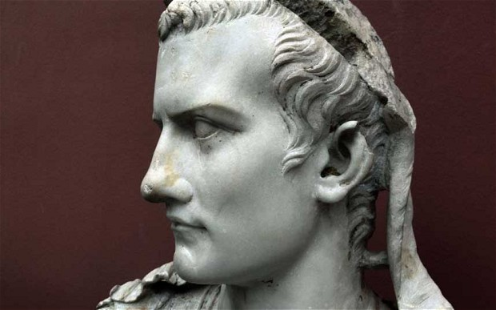

**Prescribed Source – Suetonius *Gaius* 22**

22. So much for Gaius the Emperor; the rest of this history must deal with Gaius the Monster.

He adopted a variety of titles, such as Pious, Son of the Camp, Father of the Army, Caesar Optimum Maximus. But when once, at the dinner table, some foreign kings who had come to pay homage were arguing which of them was the most nobly descended, he burst out, ‘Nay, let there be one master, and one king!’ And he nearly assumed a royal diadem then and there, transforming an ostensible principate into an actual kingdom. However, after his courtiers reminded him that he already outranked any king or local ruler, he insisted on being treated as a god – arranging for the most revered or artistically famous statues of the gods, including that of Jupiter at Olympia, to be brought from Greece and have their heads replaced by his own.

Next he extended his Palatine residence as far as the Forum, converted the shrine of Castor and Pollux into a vestibule, and would often stand between these divine brothers to be worshipped by all visitants, some of whom addressed him as ‘Jupiter Latiaris’. He established a shrine to his own godhead, with priests, the costliest possible victims, and a life-sized golden image, which was dressed every day in clothes identical with those that he happened to be wearing. All the richest citizens tried to gain priesthoods here, either by influence or by bribery. Flamingos, peacocks, black grouse, guinea hens and pheasants were offered as sacrifices, each on a particular day. When the moon shone full and bright he always invited the moon goddess into his bed, and during the day he would indulge in whispered conversations with Jupiter Capitolinus, pressing his ear to the god’s mouth, and sometimes raising his voice in anger. One he was overheard threatening the god, ‘Either you throw me or I will throw you!’ Finally he announced that Jupiter had persuaded him to share his home, and therefore connected the Palatine with the Capitol by throwing a bridge across the Temple of Divus Augustus; he next began building a new house inside the precincts of the Captiol itself, in order to live even nearer.

**Prescribed Source - Josephus, *Jewish Antiquities* 19.4–11**

His own deification was going to be his next step, since he was now claiming from his subjects honours no longer appropriate for mortal men. When he visited the temple of Jupiter, known as the Capitol and the most sacred of all Rome's temples, he brazenly addressed the god as his brother. His other actions were no less symptomatic of his madness. He decided that it was simply unacceptable to take a trireme to make the crossing from Puteoli, a coastal city in Campania, to Misenum. Since he was lord of the ocean, he felt entitled to demand the same sort of service from the sea as he did from the land. So he built a bridge nearly four miles long to link the two promontories and enclose the whole bay, and then he drove across it in his chariot. Since he was a god, he observed, that was the right and proper way for him to travel.

There was not a temple in Greece that he left un-plundered. All their paintings, sculptures, and other statuary and dedicatory offerings he ordered to be collected and brought to him, insisting that it was wrong for beautiful objects to be anywhere except in the most beautiful place in the world – and that just happened to be Rome. With all this material looted from Greece he adorned his palace and gardens and all his other properties throughout the land of Italy. He even dared to give orders for the statue of Zeus by Pheidias, the Athenian, which was worshipped by the Greeks at Olympia and therefore known as the 'Olympian Zeus', to be brought to Rome. In this he failed. The architects told Memmius Regulus, who had been tasked with moving the statue, that any attempt to do so would destroy it. Reports say that this was why Memmius postponed the removal, but that he was also influenced by a series of portents to powerful to be ignored. He explained all this in a letter of apology to Gaius for his failure to carry out his instructions. It would probably have cost him his life, but he was saved by the fact that Gaius died first.

His madness was so far advanced that when his daughter was born he carried her up to the temple of Capitoline Jupiter and placed her upon the knees of the statue, decalring that she was the child of both himself and Jupiter and that he had decided that she had two fathers, but he refused to say which of them was greater. That was the sort of activity that everyone had to put up with.

**Prescribed Source - Dio, *Roman History* 59:28.1–11**

**Gaius’ Megalomania: Imperial Cult**

Gaius gave orders that a sacred precinct should be consecrated to him in the province of Asia at Miletus. He said that he had chosen the city because Artemis had already taken over Ephesus, Augustus Pergamum and Tiberius Smyrna. But the real reason was that he wanted to take over all for himself and the large and exceedingly beautiful temple that the Milesians were at the time building in honour of Apollo.

He then went to still greater lengths, and actually set up in Rome itself a temple of his own, granted him by vote of the senate, but built at his own expense on the Palatine. He had already constructed a sort of lodge on the Capitoline, so as to share quarters, as he put it, with Jupiter. But he did not approve of being the junior partner in this union of the households and blamed the god for having occupied the Capitoline before him. So he pressed on with the erection of another temple on the Palatine, and actually wanted to transfer to it the statue of Olympian Zeus, after remodelling it to resemble himself. He found this impossible to achieve. For the ship built to carry the statue was wrecked by lightning, and loud laughter was heard every time anybody went near the statue to take hold of its base. Gaius uttered terrible threats against the statue and set up another instead.

The temple of Castor and Pollux which stood in the Roman forum he cut in two, and in so doing created an entrance to the palace right through the middle of the temple between the two statues, so that, as he used to put it, he could have the Dioscuri as his gate-keepers. He designated himself Jupiter Latiaris and appointed as his priests his wife Caesonia, Claudius and other very rich individuals. He received in return two and a half million denarii from each of them. He went even further and swore himself in as a priest of himself, an appointed his horse a fellow-priest. All kinds of expensive birds were sacrificed to him daily. He even had a machine for answering thunderclaps with thunderclaps, and whenever there was a flash of lightning, he sent a flash in return. Whenever a thunderbolt fell, he would hurl a javelin against a rock, quoting each time the line of Homer: “Either lift me up or I will lift you!”

When Caesonia gave birth to a baby daughter only after a month of marriage, he claimed this was due to divine intervention, exulting in the fact that he had become a husband and a father in such a short period of time. He named the girl Drusilla, took her up to the Capitol and placed her solemnly on the knee of Jupiter, as if she was his child. He also put her alongside Minerva to be suckled.

Now this god, this Jupiter (for he was addressed by these titles so often at the end of the reign that they even appeared in documents) was doing all this at the same time as he was collecting money in a most disgraceful and terrible way. One might pass over the goods-for-sale and the taverns, the prostitutes and the lawcourts, the craftsmen and the wage-earning slaves, and all the other activities from which he did not cease collecting every sort of revenue. But how could anyone keep silent about the rooms which were marked out in the palace itself and about the wives of the leading citizens and the children of the most revered whom he dishonoured by setting up as prostitutes in these rooms and by harvesting revenue from all alike for their services? Some of them were happy to do this, but others were quite unwilling, but did it so as not to be thought to bear any grudge. The masses, however, were not even in the slightest disturbed by these events, but rather took pleasure together with him in his licentiousness, and also in the fact that each time he collected gold and silver from them, he would throw himself onto it and roll in it. However, when he introduced some severe measures about taxes and inscribed them on white boards in very small letters and then hung these from a very high position (he did this to ensure that the regulations should be read by as few people as possible, and as a result many would be liable to the penalties, since they would be unaware of what was lawful and unlawful), the masses suddenly rushed into the Circus in a great crowd and uttered a storm of protest.

**Summary Questions**

Use the sources on p. 20-22 to answer the following questions

1. Give five examples of actions which Gaius took to expand the imperial cult and appear like a god



1. What, according to the sources was the reaction of the Roman people and senate to Gaius attempts to be seen as a god?
2. Select two quotes (each from a different source) that sum up the attitude of the ancient sources towards Gaius’ imperial cult?

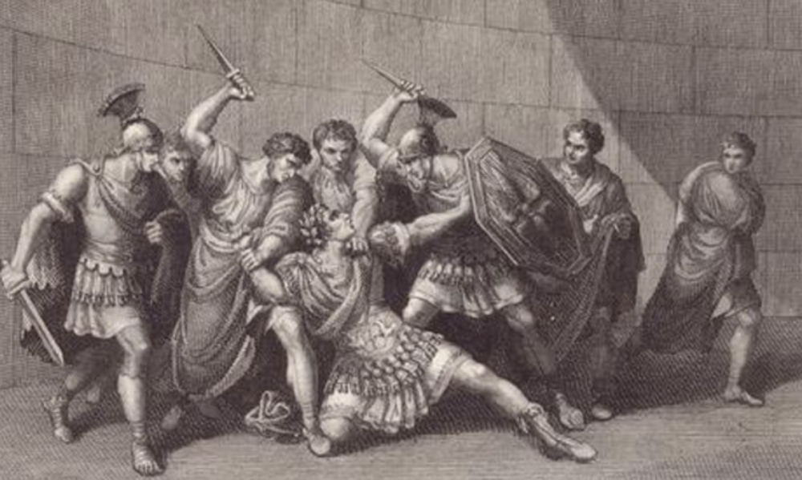**Gaius’ Assassination AD 41**

**KEY QUESTIONS**

1. Who assassinated Gaius?
2. Was the assassination of Gaius the work of a small group or a wider conspiracy?
3. Was there mass, popular support for the assassins?
4. What motivated the assassins?
5. How is the assassination presented in the ancient sources?

**TASK: Use the separate handout you have been given to produce a storyboard covering the events of Gaius’ assassination. Read all of the sources before doing this and produce the account which you believe to be the most accurate. This will mean combining the accounts of Dio, Josephus and Suetonius**

The writer Josephus claims that there were three different assassination plots against Gaius but is likely to be trying to create a picture of mass opposition to the emperor. The central figure in the assassination plot was **Cassius Chaerea** – a soldier in the Praetorian Guard.

**Prescribed Source - Younger Seneca, *On Firmness of Purpose* 18.3**

By contrast the military tribune, Chaerea had a limp manner of speech, which belied his outstanding military record; his voice was quiet and, if you did not know his record, you might have had your doubts about him. Ehen on duty he had to ask Gaius for the password, to which Gaius (himself dressed in see-through dress, sandals, and gold accessories) would give him “Venus” or “Priapus”, as if seeking to suggest in one way or another that this military hero was a lecherous effeminate. Rather than having to go on asking for the password in this way, Chaerea was driven by him to employ cold steel. He was the first of the conspirators to strike, with one blow cutting off the emperor’s head. After that, from every side sword thrusts rained upon him from men seeking vengeance for past insults, public and private. But the first to strike had been the man who seemed least likely of all to do it.

1. **What according to Seneca was Chaerea’s motive for assassinating Gaius?**

**Who was involved in the assassination plot?**

**Prescribed Source - Dio, *Roman History* 29.1**

**The Assassination of Gaius and its aftermath**

Since Gaius continued to play the complete madman in every way, a conspiracy was formed against him by Cassius Chaerea and Cornelius Sabinus, even though they were tribunes in the Praetorian Guard. There were a good many people involved in it, fully aware of what was going on, among whom were Callistus and the prefect of the Praetorian Guard.

Practically all of Gaius’ entourage were persuaded to take part in it, both to further their own interests and to benefit the state. Furthermore, those who chose not to join the conspiracy concealed their knowledge of it, since they were glad to see a plot forming against him.

1. **List the three names given of the people involved in the plot:**



Josephus adds to this list **Lucius Annius Vinicianus**, a senator who in Josephus’ account adds more influence and respect to the plot and demonstrates that it was not the result of just one group of disaffected soldiers.

Overall, the assassination of Gaius is presented by the ancient sources as the fitting end to such a tyrant and evidence in itself of his abusive, brutal reign. It was not, however, the work of a broad and well-supported group and the public reaction to it would be mixed. The assassins were also most probably not acting to restore the republic but instead in their own self-interest or to settle their own grudges.

**Prescribed Source - Josephus, *Jewish Antiquities* 201–211**

Gaius died in the fourth year of his reign as Emperor of the Romans, four months before its completion. As a man, even before he came to the throne, he was a flawed character, who had turned viciousness into fine art. Pleasure he found irresistible; slander a delight. Danger terrified him; for that reason he was savagely violent towards those whom he did not fear. Glutted with power, he used it for one purpose only: to do violence to others. He showed ludicrous generosity to those who least deserved it, and as the source of that generosity he used murder and judicial mayhem. He aspired to be, and to be seen to be, superior to the laws of god and man; yet he was a slave to the plaudits of the multitude. All that the law adjudges criminal and base, and seeks to punish, this he regarded as a source of virtue. Indifferent to friendship, however loyal and long standing, he would inflict punishment for the least offence on those who had incurred his anger. He hated everything to do with traditional values, and once he had set his heart on something, he found any opposition to his commands intolerable – hence his incest with his own sister. This was the source of the deep hatred for him among the ordinary citizens, a hatred that grew ever more intense as time went by. As a crime it was unheard of for centuries, and induced in everyone incredulity, and loathing for the perpetrator.

He constructed neither great public buildings, which could be said to be for the benefit of contemporaries or future generations, nor even a palace. The one exception was the harbour planned for the area of Rhegium and Sicily, intended to provide facilities for the grain ships from Egypt. This was certainly a major undertaking and an invaluable anchorage for sailors. But he never saw it through, and it was abandoned, half finished, thanks to his own half-hearted interest in it. The reason was clear; he was fascinated by the futile, and poured millions into pleasures which served no useful purpose beyond his own gratification. All this robbed him of any ambition for more demonstrably substantial achievements.

By contrast, he was an outstanding public speaker, with a profound understanding of Greek, as well as his native Latin. He could speak off the cuff, and would reply to speeches laboriously composed by others after much cogitation, in such a way as to appear immediately more convincing than anyone else, even on the most weighty subject. All this his owed to his natural talent, which he complimented with practice and hard work. He was great-nephew to Tiberius, whom he also succeeded as emperor, and this gave him great incentive to take his education seriously, since Tiberius himself had manifestly achieved the highest distinction in such matters. Gaius had a love of the fine arts, and in following the example of one who was both kinsman and guide, he achieved great distinction among his contemporaries.

Nevertheless, the benefits which he had gained from his education could not protect him from the ruinous effects of his acquisition of power. For the virtue of moderation is hard to acquire for those who have the power to act as they please and without restraint. At first, thanks to his education and desire for a high reputation in lofty pursuits, he was eager to cultivate the friendship of men who were in every way admirably suitable; but ultimately his sadistic extremes put them off from the friendship they had originally shown him, and once this had developed into absolute hatred, they plotted against him, and finally killed him.

1. **Select two quotes or phrases from this summary of Gaius’ reign that sum up the emperor. For each briefly explain why you chose it.**



**KEY TERMS**

|  |  |
| --- | --- |
| **Term** | **Description** |
| **Quadran** |  |
| **Pileus** |  |
| **Treason trials** |  |
|  |  |
|  |  |
|  |  |
|  |  |
|  |  |
|  |  |
|  |  |

**KEY FIGURES**

|  |  |
| --- | --- |
| **nAME** | **Description** |
| **Tiberius Gemellus** |  |
| **Agrippina** |  |
|  |  |
|  |  |
|  |  |
|  |  |
|  |  |
|  |  |
|  |  |
|  |  |

**The Roman Empire**

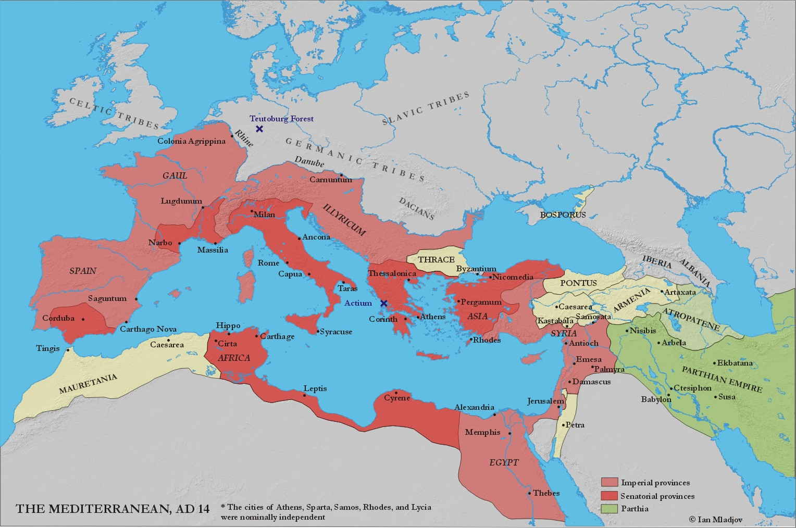



HOMEWORK RECORD

|  |  |  |  |
| --- | --- | --- | --- |
| ***Date set*** | ***Details*** | ***Date Due*** | ***Done?*** |
|  |  |  |  |
|  |  |  |  |
|  |  |  |  |
|  |  |  |  |
|  |  |  |  |
|  |  |  |  |
|  |  |  |  |
|  |  |  |  |
|  |  |  |  |
|  |  |  |  |