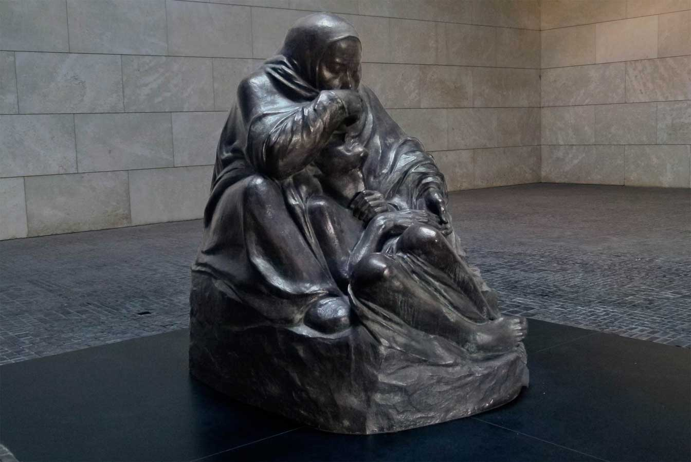

**Themes in Art & Architecture: War**

**Artist: Käthe Kollwitz**

**Title: *Pietà aka Mother with Her Dead Son***

**Key Facts**  
Size:

Material: **Bronze.**

Date: **1937-38/39.**

Location: **New Guardhouse, Berlin**

Category: **People affected by war in 2D or 3D**

(From the Käthe Kollwitz Museum Koln): On the anniversary of her son Peter's death in 1914 the artist noted in her diary in 1937: "I am working on a small sculpture which has developed out of my attempt to make a sculpture of an old person. It has become something like a Pietà. The mother is seated and has her dead son lying between her knees in her lap. There is no longer pain - only reflection." Käthe Kollwitz' Pietà which in spite of her remarks she did not regard as religious differs clearly from "traditional" Pietà representations where the dead Jesus is presented to the observer. In Käthe Kollwitz' Pietà the son is not resting on his mother's knees, he is huddled on the ground between her legs. As his legs are drawn up so far that he is totally enclosed by his mother's body he seems like a child seeking protection in his mother's lap.

Since the artist had not included her fallen son in his memorial sculpture in 1932 and had only shown the mourning parents, she created an intimate and private memorial for him and herself in this sculpture.

In 1993 the Federal Republic in Berlin, the new capital, erected a central memorial for the victims of war and dictatorship in Schinkel's "Royal Guard House" (Neue Wache) with an enlarged sculpture of Käthe Kollwitz' Pietà (made by Harald Haacke), which gave rise to an heated controversy.

<http://www.kollwitz.de/module/werkliste/Details.aspx?wid=350&lid=10&head=Tour+-+War&ln=e>

“I have no right to withdraw from the responsibility of being an advocate. It is my duty to voice the sufferings of people, the sufferings that never end and are as big as mountains.” So wrote Käthe Kollwitz – artist, socialist, pacifist, and grieving mother – five years after her son Peter died on the battlefield in World War I. In 1937, she began working on her Pietà in his memory as war loomed again. In that second great bloodletting she would lose her grandson, also named Peter, killed in action as a draftee for Hitler, whose regime was hounding Kollwitz for her dissident activities.

In 1993, an enlarged casting of the Pietà was installed as the centerpiece of Germany’s National Memorial to the Victims of War and Tyranny on Berlin’s Unter den Linden boulevard. The sculpture is situated in the Neue Wache guardhouse, once a national­istic shrine that pl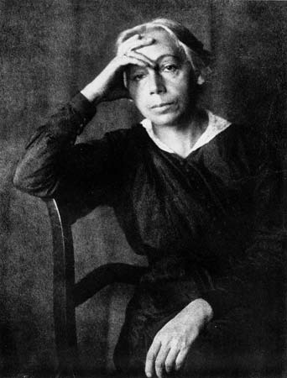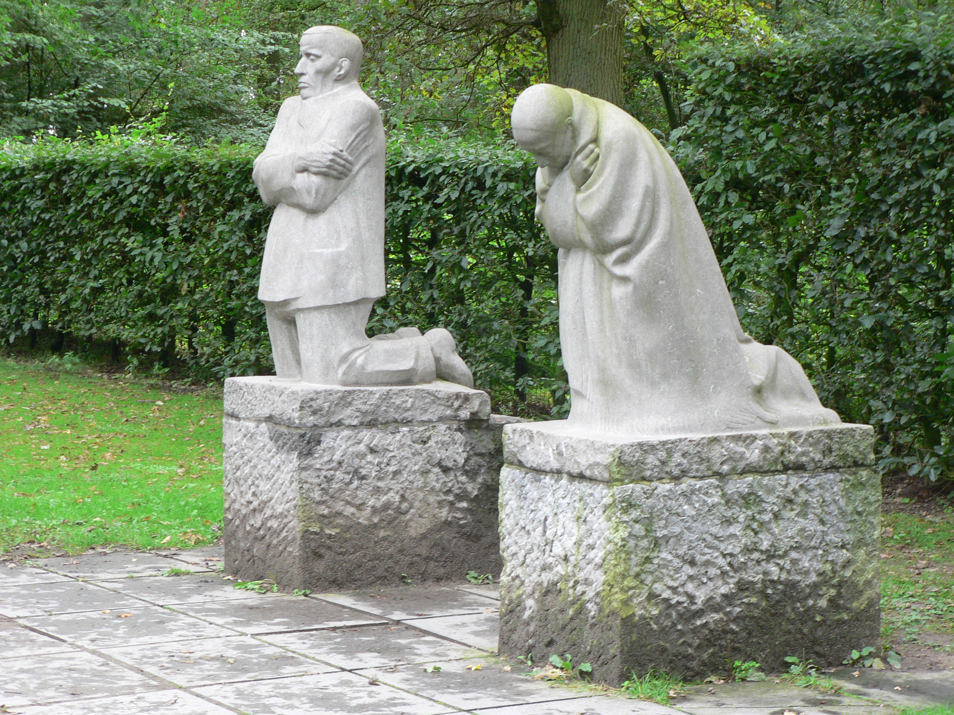ayed a central role in the Nazis’ annual parade for war heroes.

Today, the remains of an unknown soldier and an unknown concentration camp prisoner rest beneath Kollwitz’s statue. Directly overhead, the oculus allows sunlight, rain, and snow to fall onto the agonized mother. “Blessed are those who mourn” – this place draws us into the heart of this cryptic beatitude, evoking the suffering of mothers all over the world, from Syria to the Congo.

Berlin photographer Walter Mason writes: “Kollwitz’s statue, alone in the middle of the room, commands a respect that is immediately understood by anyone who enters. The tourists come in off the street and, without exception, fall silent. The mother with her son is so wrapped up in her sorrow that she seems ­unapproachable; the visitors stand at a distance and partake in her grief.”

<https://www.plough.com/en/topics/justice/nonviolence/kathe-kollwitzs-pieta>

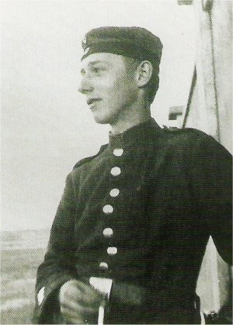

Käthe Kollwitz, 1867-1945

Peter Kollwitz, 1896-1914

*Grieving Parents*, 1932,  Vladslo German war cemetery

Q: How does *Pietà (Mother with Her Dead Son)* differ to *Grieving Parents* in terms of content and appearance? What message does each work distinctly convey?

Q: Research and summarise the history of the Neue Wache (New Guardhouse), where Kollwitz’s *Pietà* is displayed.

Q: Give a visual analysis of Kollwitz’s *Pietà.* Analyse its form, appearance, the depiction of the figures, and comment on Kollwitz’s use of materials. Also, find images of the sculpture from various angles and details of the faces of the figures. Include these images with your visual analysis.

Q: Research Kollwitz’s career. What awards does she receive? How does her career change with the rise of Hitler and why?

Q: Find other examples of Kollwitz’s work including prints, drawings and sculptures. Give the titles, dates and materials. Find works that share a theme across different media.

Q: Why might Kollwitz have chosen the theme of the *Pietà* for her memorial to her son? What links can be made between her son Peter and the subject matter of a traditional pietà?