**Themes in Art & Architecture: War**

**Artist: Unknown**

**Title: *Night Attack on the Sanjo Palace***

**Key Facts**  
Size:

Material: **ink and colour on paper.**

Date: **Second half of the 13th century.**

Location: **Museum of Fine Arts Boston**

Category: **Places affected by war in 2D or 3D**

At the time of this work’s creation Kyoto was the capital of Japan and the country was ruled by emperors. Sanjô Palace was the home of former Emperor Go‐Shirakawa. He had recently abdicated in favour of his son Emperor Nijô. Despite abdicating, the former emperor still wished to hold political influence and have a say in matters of state. Both men backed opposing members of the Fujiwara family. This was a powerful family or clan, heavily involved in the politics of the period including who should be emperor. One member of this clan, Fujiwara no Nobuyori, wished to seize power from the current emperor and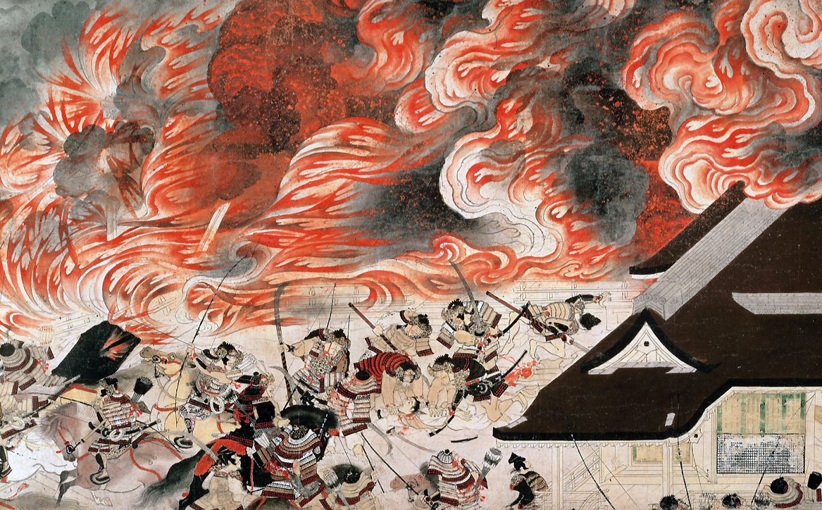 his retired father. In January 1160 Fujiwara no Nobuyori with the assistance of Minamoto no Yoshitomo, the head of another clan, attacked the Sanjô Palace during the night. They were aided by 500 men and during the assault on the palace abducted both the retired emperor and his son. This event would be just one part of the Heiji Insurrection.

The Heiji Insurrection was a short civil war fought between rival factions who each wished to increase their own power at court. The outcome of this fighting and upheaval would eventually lead to the dominance and power of the shogun in Japan’s political history. A shogun was a military figure/military dictator and these shoguns would replace emperors as leaders of Japan until the 19th century.

**Key words and phrases:**

|  |  |
| --- | --- |
| Emaki |  |
| Otoko-e |  |
| Shōgun |  |
| Heiji Insurrection of 1159‐60 aka Heiji rebellion |  |

Q: Which sides were involved in the attack on the Sanjô Palace?   
  
  
Q: Why might an emperor abdicate in favour of a son?

Q: What role did the daughters of emperors or high ranking families usually have at this time?

Q: What is a clan?

Q: What might the purpose of an emaki be?

Q: Describe the characters and individuals depicted in the emaki showing the *Night Attack on the Sanjoō Palace*. How are the soldiers depicted? Look at their faces. And the faces of the nobility?

Q: This work has a clear narrative. Explain how an emaki helps with the reading of the scene depicted in this work.

Q: Explain the artist’s use of materials in this work. How are they suitable for their purpose?

Q: What features/motifs do we see in this work which relate to the theme of war? Look at the scroll in detail on the interactive link here: <http://learn.bowdoin.edu/heijiscroll/viewer.html>

Q: Copy and paste detailed images of the scroll here.

Below are more links to give you an insight into this work:

<https://www.khanacademy.org/humanities/ap-art-history/south-east-se-asia/japan-art/a/night-attack>