**Practice Paper Set 1: AQA Economics 7136/03**

**A Level: Economic Principles and Issues**

**MARK SCHEME**

Key List

1. D
2. B
3. B
4. A
5. C
6. B
7. C
8. A
9. C
10. C
11. D
12. A
13. B
14. C
15. C
16. B
17. C
18. D
19. B
20. D
21. D
22. C
23. A
24. B
25. A
26. C
27. B
28. D
29. C
30. B

Section B

INVESTIGATION Total for this investigation: 50 marks

**31 Explain, with reference to the data, why it is that the Tata steel plant in Port Talbot, Wales, is losing up to £1m a day. [10]**

|  |  |  |
| --- | --- | --- |
| **Level of response** | **Response** | **Max**  **10 marks** |
| **3** | **A good response that:**  • uses the data to explain why the Tata steel plant is losing money  • is well organised and includes at least two relevant, well-developed explanations  • makes effective use of the data in Extracts A, B, C or D for both comparisons. | **8–10**  **marks** |
| **2** | **A reasonable response that:**  • is likely to explain why the Tata steel plant is losing money, but is unlikely to consider the data in any detailed way  • is fairly well organised and includes at least two relevant and fairly well-developed explanations  • includes some satisfactory use of the data in Extracts A, B, C or D. | **4–7**  **marks** |
| **1** | **A weak response that:**  • is very brief and/or lacks coherence  • might try to compare some of the explanations provided in the data  • contains very limited or poor use of the data in Extracts A, B, C or D | **1–3**  **marks** |

When seeking an explanation for the losses at the Tata steel plant candidates must make use of the data provided, but may also use their own knowledge of the British steel industry.

Relevant issues include:

* Global economic slowdown and fall in demand – especially in China
* Global oversupply of steel – especially from China
* Subsidies available to other suppliers allowing them to undercut Tata and therefore reducing demand for British steel
* High energy costs – Tata steel is therefore less price competitive
* High domestic wage costs – Tata steel is therefore less price competitive
* Appreciating Pound, therefore exports of Tata steel are less price competitive
* Dumping of Chinese steel
* High costs of operating the steel plant in the UK – high business rates
* Low productivity

MAXIMUM MARKS FOR QUESTION 31: 10 MARKS

**32 The Secretary of State and the British government have been criticised for not supporting the introduction of a tariff.**

**Explain, using a diagram, how a tariff may support the British steel industry in the face of Chinese competition. [15]**

Relevant issues include:

* Correct diagram, showing an increase in the price of imported steel
* Reference to decreased demand for imported steel and increased domestic supply.
* Increase in derived demand for British steel workers
* Increase in revenue/profit for British steel firms

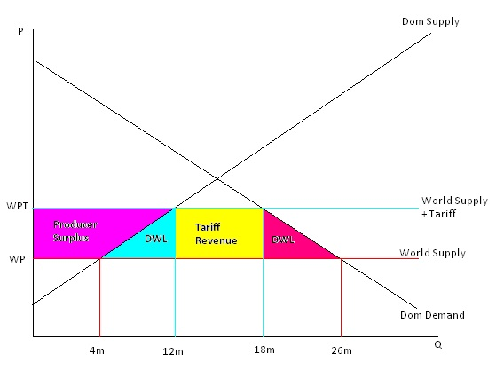

MAXIMUM FOR QUESTION 32: 15 MARKS

**33 Reference is made to the UK being better off out of the European Union (Extract C). Based on the information provided and your own economic knowledge, evaluate whether or not Britain would be better off in or out of the European Union. [25]**

Relevant issues

* Britain would be better off out of the EU
  + Would no longer EU contribution
  + Would be free to impose tariffs as it saw fit
  + Would be free to negotiate its own free trade agreements with other countries
  + Consumers would be better off as tariffs fall on goods from outside the EU and therefore prices fall.
  + Would have greater control over migration
  + Would be less exposed to economic difficulties in the rest of Europe
* Britain would be better off remaining in the EU
  + The EU contribution is not very large, after the rebate and receipts obtained from CAP and other funds
  + UK would lose free trade access to the EU market
  + Free trade agreements with other countries would take time to negotiate and may not be as favourable
  + Free trade with the EU may not result for a number of years
  + The UK would still need to have migrant labour to do a number of jobs, which the British have been reluctant to do in recent years
  + The UK would be limited in their ability to impose tariffs – WTO rules and possible retaliation from other countries. The UK is a much smaller economy than the whole of the EU.
  + FDI may leave the UK as it no longer can access the EU free trade area – resulting in a loss of employment

An answer that does not include any evaluation or a supported recommendation must not be awarded more than 13 marks.

MAXIMUM FOR QUESTION 33: 25 MARKS

Total for this Investigation: 50 marks