**Practice Paper Set 1: AQA Economics 7136/03**

**A Level: Economic Principles and Issues**

**2 hours; Maximum marks: 80**

**Section A**

**Answer all questions in this section**

**Only one answer per question is allowed**

1. The problem of scarcity exists in

1. in poorly managed economies
2. in free market economies only
3. in centrally planned economies only
4. in all economies

2. In a free market economy, the rationing function of the price mechanism means that

1. an increase in demand, leads to a rise in price, and encourages firms to enter the market
2. when there is a shortage of a product, price rises and deter some consumers from buying

the product

1. changes in price provide information to both producers and consumers about changes in

market conditions

1. if a product is scarce, a rise in price is likely to make the shortage worse

3. The US government plan to spend $500m on a project designed to widen the country’s major highways. The opportunity cost to the economy of the proposed project is

1. the extra congestion caused whilst the work is being completed
2. the purchase of ten new Apache helicopters, at a cost of $50m each
3. the potential increase in the number of traffic incidents following the completion of the work
4. the reduction of passenger numbers for long distance rail travel in the US

4. In an oligopoly, which feature of a particular industry would make collusion between firms **least** likely?

1. when the products of the individual firms are highly differentiated
2. when barriers to entry to the industry are high
3. when the market demand for the product is highly inelastic
4. when regulation is weak and poorly enforced

5. The diagram below shows the estimated demand curve for a toll road between two major cities.

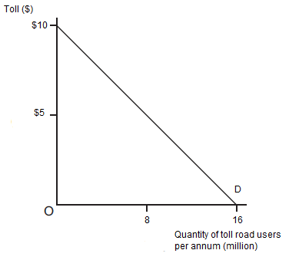

The estimated cost of operating the toll road (maintenance, toll booths etc.) is $30m per annum.

If the toll road is designed to maximise revenue for the firm operating it, how much profit/loss will be made per annum?

1. $40m
2. -$10m
3. $10m
4. unknown

6. The global platinum market is currently in equilibrium at point A on the diagram below. Platinum is a metal commonly used in manufacturing jewellery. What will be the new equilibrium point if there is an increase in the global price of silver and there are widespread miner strikes in South Africa, the world’s leading platinum producer? (Answer options on following page)

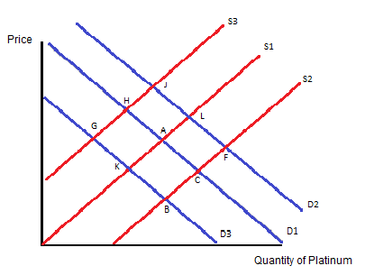

1. G
2. J
3. K
4. F

7. A firm finds that when it reduces the price of its product from £100 to £80 the quantity demanded for the good increases from 150,000 units a 165,000 units a month. The best estimate for the product’s price elasticity of demand is

1. 0.5
2. -2
3. -0.5
4. 2

8. Good Y has a high price elasticity of supply. Which of the following goods is most likely to be good Y?

1. games consoles, when large stocks are available
2. fresh oranges, as it takes a long time to grow them
3. breakfast cereal, as there are a large number of close substitutes
4. new build houses in the short run

9. The diagram below illustrates the demand and supply for a good T. Which area represents the total revenue for the firm if it can charge each individual consumer the maximum amount they are willing to pay for good T? (assume the firm is a profit maximiser)

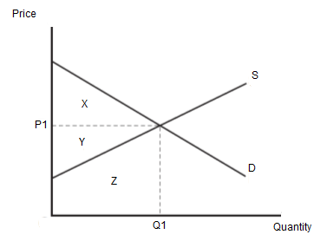

1. X
2. X + Y
3. X + Y + Z
4. Y + Z

10. Which of the following forms of government intervention would be best suited to correct market failure?

1. Privatisation of industries that provide public goods
2. Subsidies for goods which yield high external costs
3. Public sector provision of merit goods
4. Banning the consumption of inferior goods

11. A firm in a perfectly competitive market is profit maximising, but finds that its price is below its average cost. Such a firm should

1. raise prices immediately
2. continue to operate so long as the price is lower than the average variable cost
3. shut down immediately
4. continue to operate so long as the price is higher than the average variable cost

12. The diagram below is for a profit-maximising monopsonist who is obliged to pay the national minimum wage of W set by the government.

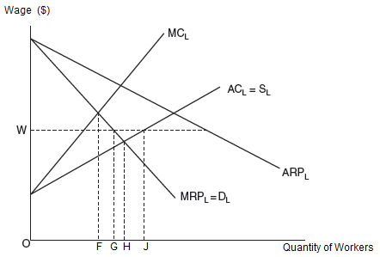

What will happen to the number of workers employed if the minimum wage applied on this labour market is removed?

1. fall by FG
2. rise by HJ
3. rise by GJ
4. fall by FH

13. Which of the following examples below is the best example of government failure?

1. the imposition of a carbon tax results in higher costs of production for firms
2. the high tax on cigarettes increases the incentive for consumers to purchase smuggled cigarettes
3. the subsidy provided by the government for a merit good is not large enough to   
   achieve the socially optimal level of output
4. the provision of public goods needs to be financed by higher taxes

14. The diagram below represents the Lorenz curve for an economy, but a number of the labels are missing.

Line B

Line A

If this economy were to experience an increase in inequality, what is the likely effect on the diagram above?

1. Line A would shift inwards
2. Line B would become straighter
3. The gap between Line A and Line B would increase
4. Line A would bow inwards

15. The graphic below illustrates the market share for the UK supermarket industry for 1998 and 2008.

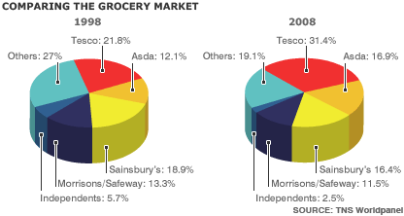

From the information above, which of the following statements is most valid?

1. The 3-firm concentration ratio has fallen over the period
2. A merger between Morrisons and Safeway in 1998 would have been referred   
   automatically to the competition authorities
3. the market has become more concentrated
4. The total sales revenue for the industry increased over the period

16. Which of the following is most likely to cause demand-pull inflation in the UK?

1. An increase in VAT
2. A sharp rise in the value of the Euro
3. A rise in interest rates
4. A decline in the global supply of oil

17. In March 2015 £1 traded at €1.40. By March 2016 the rate was €1.26 to the £. Which one of the following statements is true?

1. This fall in the Euro is probably due to Europe’s weak economic performance.
2. This 10% fall in the Euro’s value may help the Eurozone in achieving export-led growth.
3. This 10% fall in the £’s value should help combat deflation in the UK.
4. This fall in the £’s value is a result of falling confidence due to the Chinese slowdown.

18. An economy is operating at AD1. If it experiences a depreciation of its currency, how would that be reflected in the diagram?

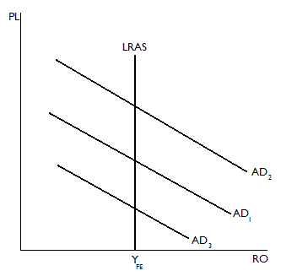

1. AD1 will shift left to AD3 because import prices will be forced downwards
2. AD will remain at AD1 but the long run AS curve will move rightwards
3. AD will shift left to AD3 because UK producers have become less   
   competitive internationally
4. AD will shift right to AD2 as the economy’s competitiveness improves.

19. Last year, in a small South American country, consumption was $65m, savings $6m, government spending $20m, imports $30m, exports $22m, and investment $8m. Calculate the value of the country’s aggregate demand.

1. $91m
2. $85m
3. $93m
4. $79m

20 With reference to the data below, between 2009 and 2012, which one of the following happened?

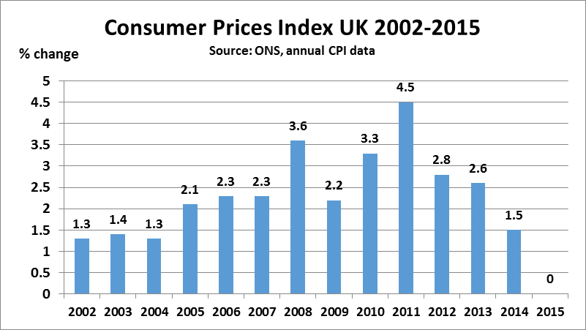

1. Inflation rose until deflation took over
2. Inflation increased and then levelled off
3. Prices went up and then came down
4. Price increases accelerated and then decelerated

21. The diagram shows an economy operating at point A. This economy must be experiencing:

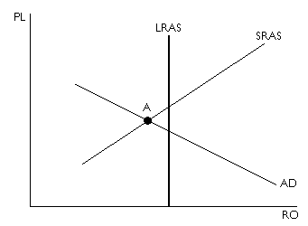

1. A positive output gap
2. Demand-pull inflation
3. A failure of supply-side policies
4. Demand-deficient unemployment

Questions 22 & 23 are based on the following data

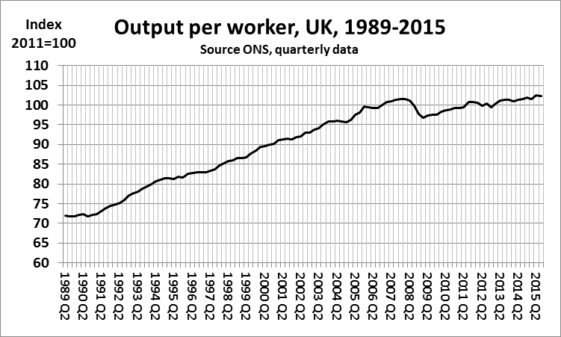

22. If the pre-2008 trend had continued, what difference would it have made to the UK economy by 2015?

1. Employment levels would have been higher.
2. The economy would have been closer to full allocative efficiency.
3. Long run aggregate supply would have been pushed to the right.
4. The government’s budgetary deficit would have been lower.

23. If this slow productivity growth continues, what is the most likely impact on the UK economy?

1. Falling international competitiveness leading to worsening balance of payments deficits
2. Falling employment levels leading to a rise in unemployment-related welfare payments
3. A fall in inward migration as UK demand for labour flattens out
4. A steady rise in demand-deficient unemployment

24. Which of the following is the best explanation of how quantitative easing (QE) works?

1. The Bank of England prints more physical money and gives better credit terms to   
   high street banks.
2. The Bank of England buys bonds from high street banks to boost those banks’ liquidity.
3. The Bank of England sells bonds to high street banks to boost those banks’ asset base.
4. The Bank of England cuts the reserve requirements for high street banks, allowing   
   them to lend more.

25. All other things being equal, which one of the following is most likely to cause the long-run aggregate supply curve to shift to the right?

1. the provision of funding by banks to finance investment in manufacturing industries
2. an increase in exports which causes a rise in the price level
3. an increase in interest rates to help reduce inflation in the economy
4. an increase in the provision of unemployment benefits

26. The diagram below represents an economy that has experienced inflation, with the price level rising from P1 to P2.



The most likely cause of the inflationary pressures shown in the diagram is;

1. a sustained increase in bank lending
2. expansionary fiscal policy
3. an increase in the national minimum wage
4. a rise in productivity levels

27. The table below shows the UK current account as a % of GDP, 2006 - 2015.

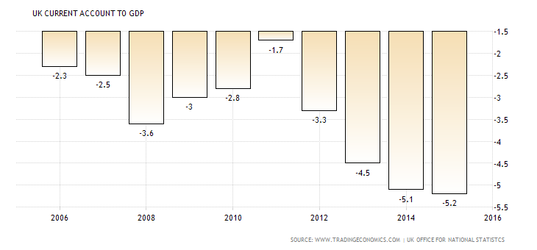

Which one of the following statements is a valid interpretation of the trend in the above data

1. It may be due to worsening exports and its effect is to worsen the national debt.
2. It may be caused by deteriorating returns on overseas investments by UK firms
3. It shows that the government’s austerity programme is failing because the deficit is worsening.
4. The reason may be that UK exports are performing better than the level of imports  
   to the UK.

28. A UK tractor manufacturer imports €8,400 engines from Germany. When the exchange rate is €1.40 to the £ the engines cost £6,000. Then the £ falls by 20% against the Euro. What is the probable new price tag for the tractor engines in the UK?

1. £4,800
2. £9,408
3. £5,000
4. £7,500

29. A surge in global oil prices results in an increase in inflation in an economy that is a net importer of oil.

In response to the higher rate of inflation, the central bank decide to raise interest rates. This is an example of;

1. expansionary fiscal policy
2. a supply-side policy
3. contractionary monetary policy
4. a devaluation in the currency

30. In a closed economy (with no international trade and no government) the current equilibrium level of income is £22bn. The full employment level of income is £25bn. To reach full employment would require an injection of £1bn. What can be deduced from this information?

1. the marginal propensity to consume is 1/3
2. the marginal propensity to consume is 2/3
3. the value of the multiplier is 1.5
4. the value of the multiplier is 1/3

**End of Section ASection B**

**Answer all the questions in this section**

Refer to the source booklet for Extracts A, B, C and D

The global steel glut

Paper 3: Economic Principles and issues

2 hours

INSERT

The Global Steel Glut

Extract A Port Talbot: Javid meeting workers at threatened steel plant

Extract B China’s growing share of world steel production

Extract C Tata Steel: ministers start hunt for buyers for British assets

Extract D Tariffs are not the answer to steel production woes

Extract A

**Port Talbot: Javid meeting workers at threatened steel plant**

**Sajid Javid is meeting steelworkers at the threatened plant in Port Talbot.**

The business secretary, under fire for being in Australia on official business when Tata announced plans to sell the site, said he wants to show he is on the side of workers, thousands of whose jobs are at risk. But one union leader complained Mr Javid "wasn't to be seen" at a time of crisis for the British steel industry. Whilst Chancellor George Osborne has insisted the UK was "leading the way" in Europe in trying to help the industry compete.

The government is facing claims that it has blocked an EU measure which would have tackled the "dumping" of cheap Chinese steel in Europe - one of main handicaps facing UK producers. Ministers opposed an European Commission proposal to lift the "lesser duty rule" cap, which would allow tougher tariffs to be imposed on cheap imported steel, arguing higher tariffs would hit other sectors such as the car industry.

Tata Steel's UK business - which directly employs 15,000 workers and supports thousands of others - includes plants in Port Talbot, Rotherham, Corby and Shotton. After a board meeting at its headquarters in Mumbai on Wednesday, Tata confirmed plans to sell its loss-making UK plants. Unless a buyer can be found, thousands of jobs are at risk. The Port Talbot plant - which employs 4,100 people - is said to be losing £1m a day.

**Dumping, duties and steel**

The EU is imposing financial penalties on 16 categories of Chinese steel imports which they believe are being "dumped" on overseas markets - effectively being sold at a loss. The rate of these duties varies but, controversially, they are more often than not lower than the actual amount by which the products are under-priced.

This is in, large part, down to the so-called "lesser duty" rule. This rule, which derives from [World Trade Organisation regulations](https://www.wto.org/english/tratop_e/adp_e/antidum2_e.htm), states that it is desirable, although not necessary, for tariffs to be applied at a level "adequate" to remove the financial harm caused to competitors but "at a level lower than the margin of dumping".

UK steel producers and unions argue the EU, by adhering to this rule, has effectively capped steel tariffs at 9% although the European Commission does not recognise this figure. Critics say tariffs are far higher in the US (at 266 per cent) and totally ineffective when heavily-subsidised Chinese steel is sold at 66% of cost price.

The UK has argued against higher tariffs, saying they would hit other sectors such as the car industry, which import a lot of foreign steel. But the European Commission is considering removing the rule from relevant legislation, a move reportedly backed by France and Germany. Ahead of the meeting, Mr Javid tweeted that he had also held "productive" talks with the local Labour MP Stephen Kinnock and Welsh Secretary Alun Cairns about the way forward.

Steel production makes up 1% of Britain's manufacturing output and 0.1% of the country's economic output. It is understood the government is looking at offering loan guarantees to potential buyers and tighter rules on procurement to make sure major British projects are obliged to buy British steel.

Source: Adapted from the BBC News online “*Port Talbot: Javid meeting workers at threatened steel plant*” 1st April 2016

Extract B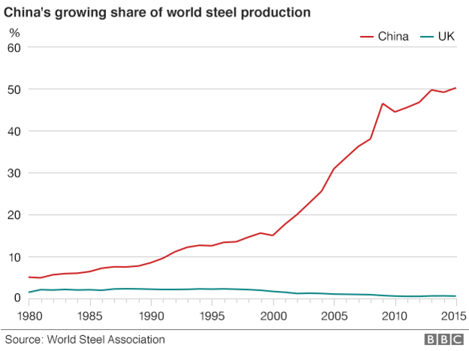

Source: BBC News online “*Port Talbot: Javid meeting workers at threatened steel plant*” 1st April 2016

Extract C

**Tata Steel: ministers start hunt for buyers for British assets**

Sajid Javid will travel to south Wales on Friday to promise steelworkers that the government will use all “ministerial, official and diplomatic levers” to help save their jobs, including actively seeking out buyers for Tata Steel’s British assets.

Arriving three days after the crisis broke, the business secretary will attempt to reassure 4,000 employees at the Port Talbot plant, despite a warning by David Cameron that the global collapse in the price of steel and massive overcapacity meant there was “no guarantee of success”.

It is understood that senior Whitehall officials have contacted Liberty House, a steels and metals group with an annual turnover of close to £5bn, which is in the process of buying sites in Scotland. Private equity companies, which would be likely to undertake radical cost-cutting steps, are also being approached.

Javid said he would meet workers, managers, unions, MPs and members of the Welsh government, and promised to do what he could to secure the long-term future of the company and steel industry. “Whilst we can’t change the status of the global steel market, we can and are playing a positive role in securing a sustainable future,” he added.

A source within Tata confirmed that the government was leading the efforts to find interested parties, but revealed that one option under consideration was a sale of “different portfolios”, which would mean breaking the company up. However, sources inside Tata Steel said the company, which is losing £1m a day on its UK operations, had failed to find a buyer over the past 18 months.

After hosting an emergency summit at No 10 following his return from holiday, Cameron said the situation was “of deep concern”, but added: “I don’t believe nationalisation is the right answer. What we want to do is secure a long-term future for Port Talbot and for other steel plants in the UK.”

The foreign secretary, Philip Hammond, warned of a “reality of a world which is drowning in an oversupply of steel”, arguing that producing steel for which there is no demand is not the answer. But with up to 40,000 jobs on the line nationally, ministers are under pressure to act.

The government said its intervention helped ensure that Tata announced a sales process for Port Talbot, rather than immediate closure.

But ministers have been widely attacked for failing to take more action. Anna Turley, Labour MP for Redcar, said similar promises were made in her constituency but the government failed to act, resulting in the loss of 3,000 jobs when the steel plant there was closed by its Thai owner SSI in October last year.

Stephen Doughty, another Labour MP, said he had publicly raised the challenges facing the steel industry with the government more than 60 times, and attended a series of meetings in which ministers were urged to take action.

“They cannot argue that they didn’t know or that the crisis point of the last few days has come as a surprise. They were warned again and again and again by the industry, by unions and by MPs,” he said.

Government sources stressed Javid’s visit on Friday is his second to the area, and that he recently chaired a steel summit in Whitehall. But critics say the government has failed to support the industry. Labour pointed out that Tory MEPs voted against EU proposals to take tougher action on Chinese dumping.

In a scathing attack the head of the European Steel Association, Axel Eggert, accused Britain of being a “ringleader” in attempts to block stronger defences for EU countries against cheap Chinese imports.

Britain blocked attempts to strengthen EU trade defences against imports of cheap Chinese steel that have devastated Tata’s operations in the UK, according to senior European officials. The Financial Times reported that French and Italian officials also said Britain had led the opposition to an overhaul of anti-dumping rules.

Chris Hagg, head of external affairs at another steel company, Celsa UK, said he wanted to see more action taken on energy costs. “Our industry needs to be put in a position where it can compete on a fair basis. The government needs to do more to help us on the energy front,” he said.

The issue has led to a fierce row between pro- and anti-EU campaigners. Stephen Kinnock accused Brexit campaigners of “cynically attempting to hijack and exploit” the steel crisis to their own advantage. He said it was absurd to suggest that leaving the EU would allow the government to protect the British steel industry. He accused ministers of cosying up to China, adding: “The reality is that the European commission has been trying to tackle the steel crisis for years now, but has consistently been hamstrung by a British government fighting tooth and nail to undermine those efforts.”

But Tom Pursglove MP, campaigning for Brexit, said: “If the UK were to leave the EU, we would have the flexibility to react to the current steel industry crisis with anti-dumping measures to counter the Chinese tactic of flooding the market with cheap steel.”

Source: Adapted from The Guardian “*Tata Steel: ministers start hunt for buyers for British assets*” 1st April 2016

Source D

**Tariffs are not the answer to steel production woes**

Sir, it is hard to disagree with Vince Cable that Tata’s withdrawal from the British steel industry is a serious political problem for the government, but one element of the former business secretary’s analysis cannot go unchallenged. He calls it a “mystery” that Britain has not adopted US-style protectionist tariffs on imported steel, but the reasons could not be more obvious. Tariffs would raise prices for steel-consuming manufacturers, while doing nothing to address the long-running decline in competitiveness of steel production in the UK, the reasons for which include high energy costs and business rates, as well as global oversupply. In both the US and the UK, steel consumers make up a far larger share of the economy than producers.

The history of steel tariffs is not encouraging. In March 2002, President George W Bush imposed monumental charges on imports in an attempt to protect jobs at US steel mills. The policy backfired almost immediately, with the House of Representatives’ Committee on Small Business reporting only four months later that small manufacturers were no longer able to compete with foreign companies because of the increased costs.

The current government is facing calls from all sides to intervene, whether through nationalisation, subsidies or tariffs. It has promised to do “everything it can” to keep steel production going at Port Talbot. I hope it is successful in helping Tata to find a buyer, but resorting to tariffs or long term financial intervention to protect steel production, an industry which accounts for 0.1 per cent of UK gross domestic product, would be a completely disproportionate response.

Source: Simon Walker, Director General, Institute of Directors, “*Letters to the Editor”* Financial Times 2nd April 2016

INVESTIGATION

You are a civil servant working for the Government Economic Service and have been asked to prepare a presentation to Sajid Javid, Secretary of State at the department for Business, Innovation and Skills on the crisis in the steel industry. You are to prepare answers to the following questions.

Referring to the source booklet, study Extracts A, B, C and D and then uses these and your own economic knowledge to help you answer questions 31, 32 and 33.

31 Explain, with reference to the data, why it is that the Tata steel plant in Port Talbot, Wales, is losing up to £1m a day. [10]

_______________________________________________________________________________

_______________________________________________________________________________

_______________________________________________________________________________

_______________________________________________________________________________

_______________________________________________________________________________

_______________________________________________________________________________

_______________________________________________________________________________

_______________________________________________________________________________

_______________________________________________________________________________

_______________________________________________________________________________

_______________________________________________________________________________

_______________________________________________________________________________

_______________________________________________________________________________

_______________________________________________________________________________

_______________________________________________________________________________

_______________________________________________________________________________

_______________________________________________________________________________

_______________________________________________________________________________

_______________________________________________________________________________

32 The Secretary of State and the British government have been criticised for not supporting the introduction of a tariff.

Explain, using a diagram, how a tariff may support the British steel industry in the face of Chinese competition. [15]

_______________________________________________________________________________

_______________________________________________________________________________

_______________________________________________________________________________

_______________________________________________________________________________

_______________________________________________________________________________

_______________________________________________________________________________

_______________________________________________________________________________

_______________________________________________________________________________

_______________________________________________________________________________

_______________________________________________________________________________

_______________________________________________________________________________

_______________________________________________________________________________

_______________________________________________________________________________

_______________________________________________________________________________

_______________________________________________________________________________

_______________________________________________________________________________

_______________________________________________________________________________

_______________________________________________________________________________

_______________________________________________________________________________

_______________________________________________________________________________

_______________________________________________________________________________

_______________________________________________________________________________

_______________________________________________________________________________

_______________________________________________________________________________

_______________________________________________________________________________

_______________________________________________________________________________

_______________________________________________________________________________

_______________________________________________________________________________

_______________________________________________________________________________

_______________________________________________________________________________

_______________________________________________________________________________

33 Reference is made to the UK being better off out of the European Union (Extract C). Based on the information provided and your own economic knowledge, evaluate whether or not Britain would be better off in or out of the European Union. [25]

_______________________________________________________________________________

_______________________________________________________________________________

_______________________________________________________________________________

_______________________________________________________________________________

_______________________________________________________________________________

_______________________________________________________________________________

_______________________________________________________________________________

_______________________________________________________________________________

_______________________________________________________________________________

_______________________________________________________________________________

_______________________________________________________________________________

_______________________________________________________________________________

_______________________________________________________________________________

_______________________________________________________________________________

_______________________________________________________________________________

_______________________________________________________________________________

_______________________________________________________________________________

_______________________________________________________________________________

_______________________________________________________________________________

_______________________________________________________________________________

_______________________________________________________________________________

_______________________________________________________________________________

_______________________________________________________________________________

_______________________________________________________________________________

_______________________________________________________________________________

_______________________________________________________________________________

_______________________________________________________________________________

_______________________________________________________________________________

_______________________________________________________________________________

_______________________________________________________________________________

_______________________________________________________________________________

_______________________________________________________________________________

_______________________________________________________________________________

_______________________________________________________________________________

_______________________________________________________________________________

_______________________________________________________________________________

_______________________________________________________________________________

_______________________________________________________________________________

_______________________________________________________________________________

_______________________________________________________________________________

_______________________________________________________________________________

_______________________________________________________________________________

_______________________________________________________________________________

_______________________________________________________________________________

_______________________________________________________________________________

_______________________________________________________________________________

_______________________________________________________________________________

_______________________________________________________________________________

_______________________________________________________________________________

_______________________________________________________________________________

**End of exam**