**Practice Paper Set 2: AQA Economics 7136/03**

**A Level: Economic Principles and Issues**

**MARK SCHEME**

Key List

1. C
2. D
3. B
4. B
5. A
6. D
7. D – see note below for explanation
8. B
9. D
10. B
11. C
12. D
13. D
14. B
15. A

Note for teachers: Q7 candidates may find this question quite demanding. A is correct because as the maximum price is lifted the quantity demanded will fall, in other words the excess demand disappears as the price rises (thus C is correct) to the market price for oil, at the same time though the effective demand for oil increases, and so the external costs associated with oil consumption increase (thus B is also correct).

1. C
2. D
3. D
4. C
5. C
6. B
7. A
8. C
9. C
10. C
11. B
12. C
13. B
14. C
15. A

Section B

INVESTIGATION Total for this investigation: 50 marks

**31 Explain why ASOS has been so successful in recent years. [10]**

|  |  |  |
| --- | --- | --- |
| **Level of response** | **Response** | **Max 10 marks** |
| **3** | **A good response that:**  • uses the data to explain why ASOS is being successful  • is well organised and includes at least two relevant, well-developed explanations  • makes effective use of the data in Extract D for both comparisons. | **8–10**  **marks** |
| **2** | **A reasonable response that:**  • is likely to explain why ASOS is being successful, but is unlikely to consider the data in any detailed way  • is fairly well organised and includes at least two relevant and fairly well-developed explanations  • includes some satisfactory use of the data in Extract D | **4–7**  **marks** |
| **1** | **A weak response that:**  • is very brief and/or lacks coherence  • might try to compare some of the explanations provided in the data  • contains very limited or poor use of the data in Extract D | **1–3**  **marks** |

When seeking an explanation for the success at ASOS, candidates must make use of the data provided, but may also use their own knowledge of the British clothing industry.

Relevant issues include:

* Speedy delivery – data refers to next day delivery cut off of midnight
* Currency hedging – data refers to efforts to reduce the impact of currency fluctuations
* Website and mobile app made easier to use
* Products attractive to young customer base
* Low cost manufacturing process – much of the output is outsourced
* Highly developed distribution network
* Operating in 200 countries – therefore less exposed to the UK market
* No bricks and mortar presence, therefore reduced costs of operation
* Introduction of a loyalty card
* Second most visited fashion website
* Social media presence to show off new ranges and special offers.

MAXIMUM MARKS FOR QUESTION 31: 10 MARKS

**32 Explain, using a diagram, why BHS has made losses in recent years. [15]**

|  |  |  |
| --- | --- | --- |
| **Level of response** | **Response** | **Max**  **15 marks** |
| **3** | **A good response provides an answer that:**  • is well organised and develops a selection of the key issues that are relevant to the question  • shows sound knowledge and understanding of economic terminology, concepts and principles with few, if any, errors  • includes good application of relevant economic principles and, where appropriate, good use of data to support the response  • includes well-focused analysis with clear, logical chains of reasoning. | **11–15**  **marks** |
| **2** | **A reasonable response provides an answer that:**  • focuses on issues that are relevant to the question  • shows satisfactory knowledge and understanding of economic terminology, concepts and principles but some weaknesses may be present  • includes reasonable application of relevant economic principles and, where appropriate, some use of data to support the response  • includes some reasonable analysis but which might not be adequately developed or becomes confused in places. | **6–10**  **marks** |
| **1** | **A weak response provides an answer that:**  • has one or more relevant issues identified  • has some limited knowledge and understanding of economic terminology, concepts and principles but some errors are likely  • has very limited application of relevant economic principles and/or data to the question  • might have some limited analysis but it may lack focus and/or become confused. | **1–5**  **marks** |

Relevant issues include:

* Correct diagram, showing a decrease in demand (or increased costs)
* Loss of demand due to
  + Increased competition on the High Street – reference to Primark and M&S
  + Increased competition online – reference to ASOS
  + Clothing range becoming less popular and fashionable
* Increased costs of rents

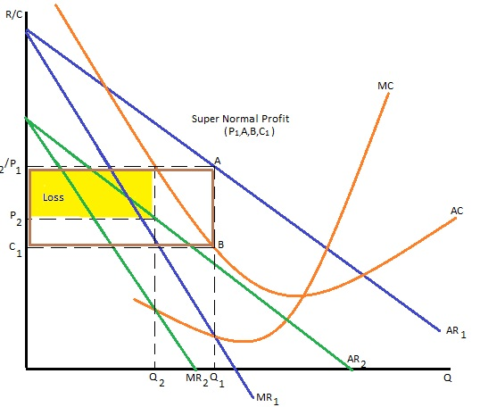

MAXIMUM FOR QUESTION 32: 15 MARKS

**33 Evaluate the strategies available to BHS which would enable them to make a profit. [25]**

Relevant issues

* Pricing strategies
  + Sales Maximisation (AC=AR)
  + Revenue Maximisation (MR=0)
  + Limit Pricing
  + Predatory Pricing
  + Price Discrimination (charge different prices in stores in different locations, different prices in store than online)
* Non-price strategies
  + Increased advertising
  + Improved quality of output
  + Increased range of desired products
  + Development into non-core products – e.g. food items
  + Cut costs –
    - Cut rents paid to stores
    - Cut supplier costs by using buyer power to negotiate better deals
    - Outsource production
    - Cut staff benefits
  + Develop an online presence
  + Collusion
* Possible evaluation
  + Pricing strategies are limited as they may cause a price war.
  + Pricing strategies which will cause the losses to increase will threaten the business and cannot be sustained long term.
  + Some pricing strategies may be illegal if they are geared to reducing competition in the market.
  + Does BHS have the funds to advertise their products?
  + Do they need to develop a new range of products before they can advertise them?
  + Do BHS have the funds to increase the range of products and quality of output?
  + How long will it take to develop a new range of clothing items? Can they sustain loses in the meantime?
  + Will non-core items cause BHS to get distracted from improving the core offering?
  + Cutting costs –
    - On employee benefits may mean that morale falls even further and the quality of service declines
    - Outsourcing production may mean that quality of production drops
    - Does BHS have the monopsony power to negotiate better deals?
  + Is it too late to develop an on-line presence? ASOS has already dominated the market?
  + The costs of developing an on-line presence and distribution network may be prohibitive.
  + Would any other firm wish to take on BHS and their liabilities?
  + Collusion – difficult in a competitive market and is illegal

An answer that does not include any evaluation or a supported recommendation must not be awarded more than 13 marks.

MAXIMUM FOR QUESTION 33: 25 MARKS; Total for this Investigation: 50 marks