**Practice Paper Set 2: AQA Economics 7136/03**

**A Level: Economic Principles and Issues**

**2 hours; Maximum marks: 80**

**Section A**

**Answer all questions in this section**

**Only one answer per question is allowed**

1. An economy produces two goods, guns and butter. The diagram shows the economy’s production possibility frontier:



Which of the following statements is true?

1. guns cost the same as butter
2. at a point inside the PPF, it is impossible to increase output of both goods

simultaneously

1. the production of both goods is subject to diminishing returns
2. the economy will want to operate at the middle point of the PPF

2. The diagram below shows the production possibility frontier for a country that produces two goods, good X and good Y. What can be concluded from the diagram?

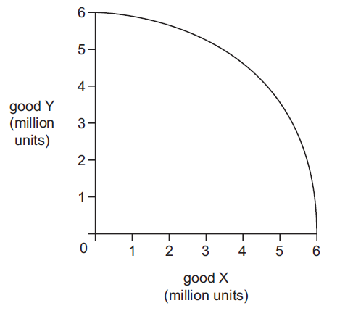

1. the amounts of good X and Y that the country will produce
2. the opportunity cost of producing good X is constant
3. the extent to which the county’s scarce resources are being allocated efficiently
4. none of the above

3. A sportswear manufacturer who specialise in basketball shoes employ a major NBA player to front a new advertising campaign. The effect of this on demand for their products, price and quantity sold will be as follows;

|  |  |  |  |
| --- | --- | --- | --- |
|  | Demand | Price of shoes | Quantity sold |
| A. | Increases | Increase | Increases |
| B. | Increases | Increase | Unknown |
| C. | Decreases | Increase | Increases |
| D. | Decreases | Decrease | Decrease |

4. In which of the following examples is price discrimination most likely to occur?

1. the sale of basic necessities in a supermarket
2. the sale of airline tickets for transatlantic flights
3. the sale of app downloads on smartphones
4. the sale of alcohol in an off-licence

5. Airlines that operate in the EU are required to purchase pollution permits under the Emission Trading Scheme. What combination of changes below would most likely result in a lower price for the permits?

|  |  |  |
| --- | --- | --- |
|  | Number of permits issued | Price of kerosene (jet fuel) |
| A. | Increases | Increases |
| B. | Increases | Decreases |
| C. | Decreases | Increases |
| D. | Decreases | Decreases |

6. The diagram below represents the labour market for a low-income job market. The market is currently in equilibrium at point A, where the PED for labour is also equal to -1.

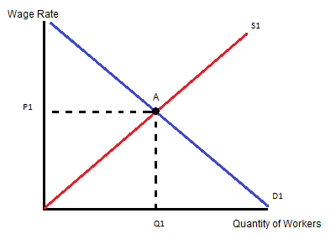

The government decide to introduce a minimum wage into this labour market, set above P1. The most likely effect of this legislation will be

1. an increase in total income generated in this labour market
2. a fall in the price of the product produced by this labour market
3. an increase in employment numbers in the labour market
4. a decrease in the total income generated in this labour market

7. A government in a South American economy currently employ a maximum price scheme for petrol. What would be the likely effect if this price control were to be removed?

1. quantity demanded would fall for petrol
2. external costs associated with motor vehicle use would increase
3. the price of petrol will rise
4. All of the above

8. A monopolist decides to switch from an objective of sales maximisation to profit maximisation. What will be the effect on price and quantity?

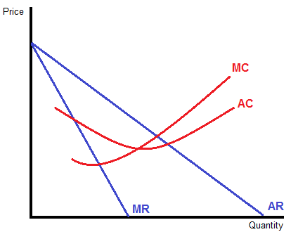

|  |  |  |
| --- | --- | --- |
|  | Price | Quantity |
| A. | Increases | Increases |
| B. | Increases | Decreases |
| C. | Decreases | Increases |
| D. | Unchanged | Unchanged |

9. The diagram below illustrates the market for good S, where the market is initially at equilibrium at E, and the income for the firm is area OPEQ.

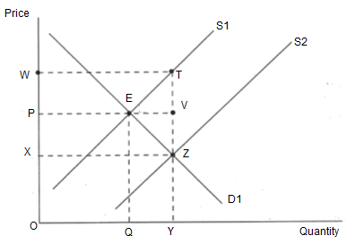

The government decide to provide a subsidy to firms that produce good S. This increases the firm’s total income for producing and selling good S to

1. WTZX
2. WTVP
3. XZYO
4. WTYO

10. The diagram below illustrates the market for flu vaccinations in an economy. The free market equilibrium output level is at X.

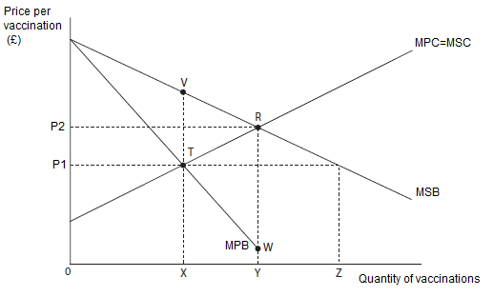

Which area represents the area of welfare gain from the market?

1. XVRY
2. VRT
3. RTW
4. OP2RY

11. Which of the following outcomes will be true for a monopolistically competitive firm in the long run?

|  |  |  |  |
| --- | --- | --- | --- |
|  | Allocative efficiency | Productive efficiency | Profit |
| **A** | No | Yes | Abnormal only |
| **B** | Yes | No | Abnormal only |
| **C** | No | No | Normal only |
| **D** | Yes | Yes | Normal only |

12. The production costs for firm Z are made up of both fixed and variable costs. The firm finds that it achieves productive efficiency at an output of Q units. If output rises beyond Q, what will necessarily be true of average costs, average variable costs and average fixed costs?

1. all of them will be falling
2. AFC and AVC will be falling, but AC will be rising
3. all of them will be rising
4. AFC will be falling, but AC and AVC will be rising

13. The table below gives estimates for own-price and cross-price elasticities of demand for bottled still water and bottled sparkling water.

|  |  |  |
| --- | --- | --- |
| Product | Elasticity with respect to the price of: | |
| Bottled still water | Bottled sparkling water |
| Bottled still water | -0.65 | +1.3 |
| Bottled sparkling water | +0.8 | -1.32 |

What would be the change in the quantity of bottled still water demanded if the price of bottled sparkling water increased by 10%?

1. -13.2%
2. +12.5%
3. -6.5%
4. + 13%

14. Listed below are a number of proposed solutions to the market failure associated with demerit goods. Which of the policy options would be most effective in correcting the market failure?

1. Lower taxes on the good
2. Greater information provision
3. Higher subsidies for complementary goods
4. Deregulation of the industry to allow for new firms to enter the market

15. In the 1980’s and early 1990’s the UK government embarked on a programme of privatisation, selling public sector assets to the private sector. One of the major benefits to households of this process would be

1. an increase in the dynamic efficiency of the private sector
2. a reduction in production costs as firms reduce the number of employees
3. an increase in prices as firms explore the objective of profit maximisation
4. The creation of natural monopolies in industries with high fixed costs

16. In the short-run, which one of the following policies is most likely to help stop spare capacity in the UK economy increasing?

1. a government focus on policies to raise output per worker in the economy
2. a reversal of the Quantitative Easing process
3. a reversal of the austerity measures implemented
4. tax breaks offered on research and development spending by firms

17. The table below shows both the unemployment rate and inflation rate for an economy between 2009 and 2012. Which one of the following can be deduced from the table?

|  |  |  |
| --- | --- | --- |
| **Year** | **Unemployment rate (%)** | **Inflation rate (%)** |
| 2009 | 5.1 | 3.7 |
| 2010 | 5.6 | 3.0 |
| 2011 | 4.7 | 3.4 |
| 2012 | 4.2 | 3.1 |

1. the employment rate in the economy rose over the period
2. there was an inverse relationship between the two objectives over the period
3. the value of money rose throughout the period
4. prices rose between 2009 and 2011

18. The graph below shows the annual percentage changes in consumer prices for Europe, Japan and the USA between 1984 and 1989.



Which of the following statements is correct?

1. in 1986 consumer prices were falling in Japan, the USA and Europe
2. in the period 1984-1987 consumer prices fell more quickly in Europe than in the USA
3. in the period 1987-1989 the USA had the highest consumer prices
4. in the period 1984-1989 Japan had the lowest consumer price inflation

19. In a closed economy (no international trade) the marginal propensity to save increases and tax rates remain unchanged. What effect will this have on the marginal propensity to consume and on the value of the multiplier?

1. marginal propensity to consume increases, multiplier decreases
2. marginal propensity to consume increases, multiplier increases
3. marginal propensity to consume decreases, multiplier decreases
4. marginal propensity to consume decreases, multiplier increases

20. Which of the following is most likely to result in a reduction in real GDP in an economy?

1. a depreciation in the exchange rate
2. a rise in average house prices
3. an increase in income tax rates
4. an increase in the amount the government spend on welfare payments

21. In one East European country, the population spends 40% of its income on potatoes, 50% on vodka and 10% on ice cream. The base period for its latest consumer prices index was January 2014.

|  |  |  |  |
| --- | --- | --- | --- |
|  | Potatoes (per kilo) | Vodka (per litre) | Ice cream (per litre) |
| January 2014 | £1.25 | £2.00 | £2.20 |
| January 2015 | £1.35 | £1.75 | £2.40 |
| January 2016 | £1.50 | £1.80 | £2.42 |

Calculate the country’s consumer prices index for January 2016.

1. 106.1
2. 104.0
3. 105.5
4. 106.7

22.Which factor is most likely to cause an equilibrium shift from P1/Y1 to P2/Y2?

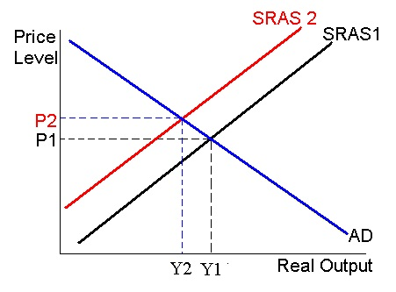

1. The national minimum ‘living wage’ rises from £7.20 to £9.00 an hour
2. A fal in employers’ national insurance contributions to help reduce the budget deficit
3. A rise in the value of the £ against both the U.S. dollar and the Euro
4. A rise in consumer demand fostered by a cut in the standard rate of income tax

23. In 2015/16 the budget deficit was falling but the national debt was rising. What could explain this?

1. Although the government’s annual deficit fell, it was still higher than the national debt
2. Government cutbacks in welfare spending were undermined by a worsening  
   balance of payments
3. As the debt is the accumulation of annual balances, every deficit, even if it is falling,   
   adds to the debt
4. The fall in the budget deficit would have cut the national debt if it hadn’t been   
   for one-offs such as the economic slowdown in the Eurozone

24. An injection of £10,000 into the economy eventually leads to £5,000 in extra saving, £35,000 of extra consumption and £40,000 of extra income. Therefore the multiplier can be calculated as:

1. 8
2. 0.5
3. 4
4. 3.5

25. The following diagram represents the Aggregate Demand and Short Run Aggregate Supply for the UK. Which of the following factors is most likely to have caused a shift in short run aggregate supply from SRAS1 to SRAS2?



1. A rise in corporation tax leading to a reduction in investment spending
2. Supply problems among French competitors due to industrial action
3. A fall in the exchange rate value of the £
4. A decision by government to cut the budget for spending on schools and colleges

26. The Gini coefficient can be used

1. To obtain a precise calculation of the effect of price on sales volume
2. To measure income inequality in an economy
3. To measure the level of productivity in an economy
4. To measure the size of the multiplier

27. The Human Development Index (HDI) comprises which four elements?

1. Real Income at PPP, infant mortality, mean years of schooling, adult literacy
2. Adult literacy, expected years of schooling (for children), income per capita at   
   current prices and life expectancy
3. Life expectancy, mean years of schooling (for adults), expected years of schooling (for children) and income per capita (at PPP)
4. Infant mortality, adult literacy, income per capita (at PPP) and mean years of schooling

28. What might be the effect of higher interest rates on the UK’s current account balance?

1. Hot money flows push the £ up and boost the UK’s exports
2. Lower consumer spending pushes imports down, but the higher £ makes imports cheaper
3. UK exports suffer due to lower consumer spending
4. It will boost the UK’s capital account and therefore boost the current account balance

On March 1st 2016 the U.S. government imposed the following tariffs on imported steel: China 266%, Japan 71% and Brazil 39%. Questions 29 and 30 are based on this information.

29. Which of the following represents the most likely reason for the US government’s action?

1. The US government wanting to protect the US car industry from using cheaper  
   foreign steel.
2. The US government wanting U.S. steel producers’ supply curves to be less elastic.
3. The US government wanting to protect senile industries from Chinese steel dumping.
4. The US government wanting to protect infant industries from Chinese steel dumping.

30. Which of the following represents the most likely effect of the US government’s action?

1. The demand curve for US manufactured steel in the US will shift to the right.
2. The demand curve for US manufactured steel in the US will shift leftwards.
3. The supply curve for US manufactured steel in the US will shift to the left.
4. The price of steel in the US will fall.

**End of Section ASection B**

**Answer all the questions in this section**

Refer to the source booklet for Extracts A, B, C and D

INSERT

The demise of a High Street giant

Extract A BHS battles to stay on the High Street

Extract B BHS close to offloading Oxford Street flagship

Extract C Where did BHS go wrong?

Extract D ASOS enjoys summer bloom

**Extract A BHS battles to stay on the high street**

Until it closed its doors in January, BHS had had a department store in Carlisle city centre for more than 30 years. The retailer, which was once British Home Stores and can trace its origins back nearly 90 years, was an anchor tenant of the Lanes shopping centre when it opened in 1984, and gave BHS a prime site right in the heart of the city.

The closure has caused controversy, not just because of the loss of 50 jobs but because it has emerged that BHS was paid more than £5m to leave the shop, with about a quarter of that coming from Carlisle city council. The council and the owner of the shopping centre were desperate to replace BHS with Primark, which will pay far more rent and potentially attract more visitors.

The events in Carlisle shine a rather different light on the problems facing BHS than its bosses have outlined. Not only does it have huge financial problems, it also has to reinvent a business regarded as old-fashioned or, as one analyst said, “irrelevant”, with no obvious place on the modern high street.

The retailer claims that it is struggling and desperately needs to restructure its finances because the rent it is paying on its shops is too high.

BHS is trying to push through a company voluntary arrangement (CVA) – an insolvency procedure – that will see rents cut at more than half of its 164 stores, with as many as 40 closing. Creditors will vote on the vital CVA on Wednesday. BHS needs 75% of creditors to vote in favour of the proposals and has warned that it will collapse into administration if it is rejected. Documents filed at the high court as part of the CVA show that BHS has debts of more than £1.3bn, including a pension deficit of £571m.

All BHS’s creditors, including suppliers, will have a vote in the CVA, despite landlords being the only ones asked to accept cuts. Darren Topp, chief executive of BHS, says he is confident of winning the vote, with a number of votes already posted to the company. “We are confident but are not complacent about that,” he said. “We will be grateful if they do. We believe we have a compelling story and a compelling turnaround. I think they [the creditors] do buy into it.”

That turnaround plan is designed to reinvent BHS, modernising stores, installing food departments, cutting the number of promotions in favour of lower everyday prices, and focusing on a smaller number of own-brand ranges.

However, the CVA document also underlines the true scale of the task facing Topp and his team even if creditors back the rent-reducing proposals. It shows that BHS still needs extra funds to be able to trade beyond 25 March and that it is trying to raise up to £100m.

The need for this extra funding shows that cutting costs is only part of the problem for BHS. The brand also needs to prove that it still has a place on the high street – and that will cost money.

“This has not happened quickly. It has happened over many years. BHS has been losing money for five years and more,” said Richard Hyman, a retail consultant. “I think it has become progressively irrelevant and it is a massive challenge to change that. I think the place to start is with understanding the customer better and editing the offers to become more relevant. It doesn’t have a place on the high street as it is. It has to change. It will need to invest money in these changes. It is not rocket science. I wouldn’t like to put a number on it, but it is going to be really tough, they have a mountain to climb.”

Sir Phillip Green owned BHS for 15 years after buying it for £200m in 2000. He initially sparked new life into the department store chain, but the online shopping revolution and the rise of new high street rivals such as Primark has taken its toll on BHS, which has lost money for several years in a row.

The retailer went on to become one of the best-known names on the high street. Today it has 164 stores and 67 franchise stores across 16 countries, employing more than 10,000 people. Despite its problems, the chain still generates one million transactions a week.

If BHS does collapse then its disappearance from the high street would have a similar impact to the recent failure of two other town centre stalwarts, Woolworths and Comet.

The billionaire eventually sold BHS last March, for just £1, to Retail Acquisitions Limited, a little-known collection of financiers, lawyers and accountants. Since then concerns about the future of the retailer, which now employs more than 10,000 staff, have only grown.

But a lot is at stake for BHS’s 10,000 staff and the 20,000 members of its pension scheme. The voluntary arrangement has triggered a process that is likely to lead to the scheme and its £571m pension deficit entering the Pension Protection Fund. For those yet to reach retirement, this means a cut of 10% to their benefits.

This week is pivotal for BHS. Even if the CVA is approved, as expected, the 88-year-old brand has a long battle ahead if it wants to enjoy a bright future on Britain’s high streets.

Source: Adapted from The Guardian “*BHS battles to stay on the High Street”* by Graham Ruddick, 20th March 2016

**Extract B BHS close to offloading Oxford Street flagship**

Struggling department store chain BHS is reportedly selling its Oxford Street flagship store to Abu Dhabi’s royal family.

After securing a CVA last week, it is understood that BHS is close to finalising a £55m deal with Lancer Property Asset Management who are working for the royal family, according to the Sunday Times.

The property group already owns the freehold of the site and wants to renovate the entire block including the London College of Fashion.

While the two parties have been in talks for several months, it is believed that the discussions have “accelerated” recently. An announcement regarding BHS’s flagship lease could be made this week.

In addition to its CVA approval, BHS is also in the process of securing a deal with American investment firm Gordon Brothers for a £60m loan.

Source: Adapted from Retail Gazette, *“BHS close to offloading Oxford Street flagship”* by Talya Misri 29th March 2016

**Extract C Where did BHS go wrong?**

Retail Acquisitions, the new owner of BHS, is hoping to secure £70m in funding to rescue the beleaguered chain just months after acquiring it.

Last year BHS posted a loss before tax of £85m, before Retail Acquisitions bought the struggling British department store for just £1 in March from Arcadia tycoon Sir Philip Green.

In a statement Retail Acquisitions said: “We have said all along that we would refinance to help accelerate the turnaround plan for the UK business. Every penny raised will support the regeneration of our portfolio of stores, returning this iconic British brand to its rightful place on the high street.”

BHS, which operates 171 stores in the UK and almost 80 overseas, was forced to re-mortgage its flagship store on London’s Oxford Street since buying the retail chain from Sir Philip.

For the retail veteran BHS had become a hindrance in Green’s fashionable empire, which encompassed BHS as well as Burtons, Dorothy Perkins, Evans, Miss Selfridge, Outfit and Wallis. Over time the department store lost any lacklustre it once had, struggling to differentiate itself in a tough, fast-paced market.

What was once a beacon of high street retail failed to keep up with the fast fashion at Primark, the sexy food at Marks and Spencer, the stylish home offerings at Next and the unbeatable price promise at John Lewis. Instead, as retail analyst Nick Bubb put it, BHS was the department store that was ‘Never Knowingly Not On Sale’.

Source: Adapted from Retail Gazette, *“Where did BHS go wrong”*, by Charlotte Brown 24th August 2015

**Extract D ASOS enjoys summer bloom**

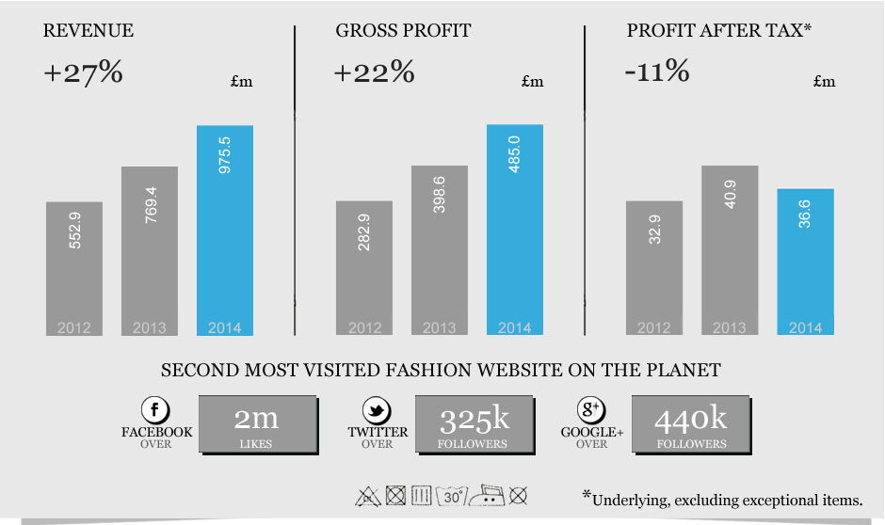

Source: The C suite [www.thecsuite.co.uk](http://www.thecsuite.co.uk) “ASOS share price: ASC A conviction sell for 2015 at Liberum capital” 19th December 2014

**Asos enjoys summer bloom as sales approach top of forecasts**

Demand for summer dresses and festival wear helped business boom for online fashion retailer [Asos](http://www.theguardian.com/business/asos), which said annual sales would be at the top of forecasts.

The company, whose customers include Michelle Obama and Samantha Cameron, said retail sales for the four months to 30 June 2015 increased 20%, or 24% allowing for currency movements.

Sales in Britain rose 27% and international sales, worth about 60% of the total, were up 16%, or 23% in constant currencies.

Nick Robertson, Asos’s chief executive, said top-selling items included sequinned miniskirts, structured sun dresses, dungarees and boots for festivals bought by customers in their 20s.

In the UK, new brands such as Misguided and Boohoo helped increase sales. The company also extended its cutoff time for next-day delivery to midnight from 10pm and simplified its smartphone app.

The company, which sells in about 200 countries, blamed weak international sales caused by the strong pound making goods expensive and it also suffered a fire at its main depot in Barnsley.

“A year ago our UK performance was OK but where we were struggling was international. That was with the currency working against us and we were unable back then to change our prices in international territories.”

Asos installed software so it could adjust prices quickly to compete in particular countries. It has cut prices but better stock control and strong full-price sales have helped keep gross profit margins steady when analysts had expected a sharp fall.

High-street fashion retailers suffered slow spring sales because of cold weather, prompting many to launch their sales early. Robertson said the unseasonal weather had little effect on Asos.

“We are very global and we are not reliant on the UK,” he said. The company is on track to reach its target of £2.5bn annual sales soon, Robertson said without being more specific.

Source: Adapted from The Guardian, “*ASOS enjoys summer bloom as sales approach top of forecasts”*, by Sean Farrell, 8th July 2015

INVESTIGATION

You are a management consultant brought in to advise the owners of BHS. You are to prepare answers to the following questions.

Referring to the source booklet, study Extracts A, B, C and D and then uses these and your own economic knowledge to help you answer questions 31, 32 and 33.

31 Explain why ASOS has been so successful in recent years. [10 marks]

_______________________________________________________________________________

_______________________________________________________________________________

_______________________________________________________________________________

_______________________________________________________________________________

_______________________________________________________________________________

_______________________________________________________________________________

_______________________________________________________________________________

_______________________________________________________________________________

_______________________________________________________________________________

_______________________________________________________________________________

_______________________________________________________________________________

_______________________________________________________________________________

_______________________________________________________________________________

_______________________________________________________________________________

_______________________________________________________________________________

_______________________________________________________________________________

_______________________________________________________________________________

_______________________________________________________________________________

_______________________________________________________________________________

32 Explain, using a diagram, why BHS has made losses in recent years. [15 marks]

_______________________________________________________________________________

_______________________________________________________________________________

_______________________________________________________________________________

_______________________________________________________________________________

_______________________________________________________________________________

_______________________________________________________________________________

_______________________________________________________________________________

_______________________________________________________________________________

_______________________________________________________________________________

_______________________________________________________________________________

_______________________________________________________________________________

_______________________________________________________________________________

_______________________________________________________________________________

_______________________________________________________________________________

_______________________________________________________________________________

_______________________________________________________________________________

_______________________________________________________________________________

_______________________________________________________________________________

_______________________________________________________________________________

_______________________________________________________________________________

_______________________________________________________________________________

_______________________________________________________________________________

_______________________________________________________________________________

_______________________________________________________________________________

_______________________________________________________________________________

_______________________________________________________________________________

_______________________________________________________________________________

_______________________________________________________________________________

_______________________________________________________________________________

_______________________________________________________________________________

_______________________________________________________________________________

_______________________________________________________________________________

_______________________________________________________________________________

33 Evaluate the strategies available to BHS which would enable them to make a profit. [25 marks]

_______________________________________________________________________________

_______________________________________________________________________________

_______________________________________________________________________________

_______________________________________________________________________________

_______________________________________________________________________________

_______________________________________________________________________________

_______________________________________________________________________________

_______________________________________________________________________________

_______________________________________________________________________________

_______________________________________________________________________________

_______________________________________________________________________________

_______________________________________________________________________________

_______________________________________________________________________________

_______________________________________________________________________________

_______________________________________________________________________________

_______________________________________________________________________________

_______________________________________________________________________________

_______________________________________________________________________________

_______________________________________________________________________________

_______________________________________________________________________________

_______________________________________________________________________________

_______________________________________________________________________________

_______________________________________________________________________________

_______________________________________________________________________________

_______________________________________________________________________________

_______________________________________________________________________________

_______________________________________________________________________________

_______________________________________________________________________________

_______________________________________________________________________________

_______________________________________________________________________________

_______________________________________________________________________________

_______________________________________________________________________________

_______________________________________________________________________________

_______________________________________________________________________________

_______________________________________________________________________________

_______________________________________________________________________________

_______________________________________________________________________________

_______________________________________________________________________________

_______________________________________________________________________________

_______________________________________________________________________________

_______________________________________________________________________________

_______________________________________________________________________________

_______________________________________________________________________________

_______________________________________________________________________________

_______________________________________________________________________________

**End of the exam**