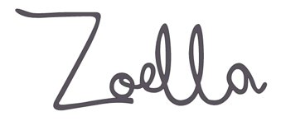**INDUSTRY: REGULATION**

The Advertising Standards Authority (ASA) is the UK’s independent advertising regulator across all media platforms (TV, radio, press, billboards…and is responsible for regulating bloggers/vloggers.

The ASA makes sure ads across UK media stick to the advertising rules (the Advertising Codes).

The Committee of Advertising Practice (CAP) is the sister organisation of the ASA and is responsible for writing the Advertising Codes.

Read the selected ASA articles, The NewStatesman and conduct your own research to answer the following questions:

**1. a)** Who are the ASA and CAP?

**b)** What do they do?

**c)** Why is it important, consider the audience in your response?

**2. a)** What constitutes an ad?

**b)** Can a blogger/vlogger get round these rules?

**c)** Should they?

**3.** What must bloggers/vloggers do to ensure they abide by the codes when advertising?

**4.** What is an advertorial blog?

**5.** What must a blogger/vlogger to if they are making a post advertising their own products?

**6.** What type of items aren’t controlled by the CAP code?

**7.** What is the difference between an advert and sponsorship

**Now research into Zoella’s ads and sponsorship deals, consider:**

1. **Who has sponsored her?**
2. **Who has she advertised for?**
3. **Find examples of her sponsored/advertising content**
4. **How much does she make from sponsorship?**
5. **Has she been at the centre of any controversy or rule breaking around #ads?**

**Anything else you find interesting**