NAME:

**AQA PHYSICAL EDUCATION**

**Paper 1: Factors affecting participation in Physical activity and Sport**

**Part 5 – The role of technology in physical activity and sport**

[](http://www.google.co.uk/url?sa=i&rct=j&q=&esrc=s&source=images&cd=&cad=rja&uact=8&ved=0ahUKEwi9_aPNhsLSAhVDShQKHYCbDrUQjRwIBw&url=http://www.innsport.com/software.aspx&bvm=bv.148747831,d.ZGg&psig=AFQjCNHTotmTAiowLMqXBdXQ_WyQPeHZ0w&ust=1488895622332404)

Understanding of technology for sports analytics.

Use of technology in data collection (quantitative and qualitative, objective and subjective, validity and reliability of data).

Video and analysis programmes,Testing and recording equipment (metabolic cart for indirect calorimetry), Use of GPS and motion tracking software and hardware.

Maintaining data integrity.

Functions of sports analytics: (Monitor fitness for performance.Skill and technique development. Injury prevention (vibration, electro stimulation).Game analysis.

Talent ID/scouting.

The development of equipment and facilities in physical activity and sport, and their impact on participation and performance.

Impact of material technology on equipment – adapted (disability, age).

Facilities – Olympic legacy, (surfaces, multiuse).

The role of technology in sport and its positive and negative impacts on the sport,

the performer, the coach and the audience.

**Sports analytics**

**1**

**Technology**

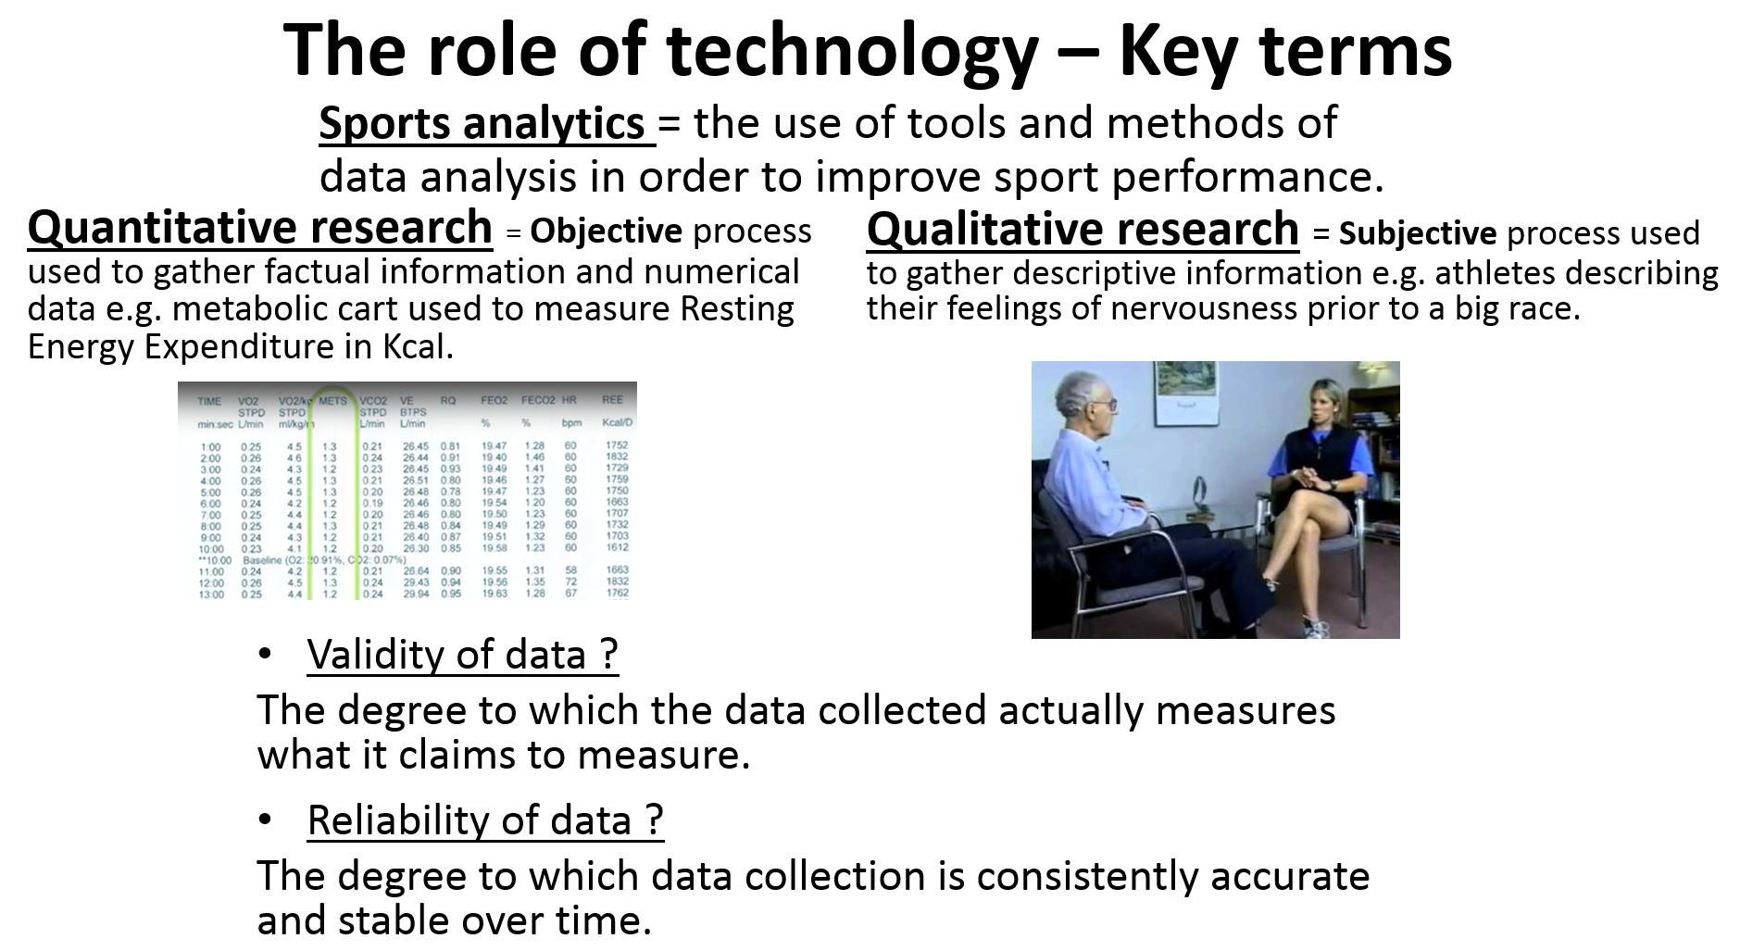

**Qualitative and Quantitative data collection: Using pass completion data to improve performance.**

Watch 5 minutes of game footage from your favourite team game (e.g. Netball). Complete the table below for both teams.

|  |  |  |  |
| --- | --- | --- | --- |
|  | **No. of passes completed (keep a tally and a total)** | **No. of failed passes (includes intercepted/ misplaced passes)** | **Percentage of pass completion** |
| **Home team** |  |  |  |
| **Away team** |  |  |  |

**17**

**Technology**

1. Is the data collected in the table above qualitative or quantitative? Explain your answer.

……………………………………………………………………………………………………………………………………………………………………………………………………………………………………………………………………………….

1. Are there any problems of validity? (Is pass completion a good measure of team performance?)

……………………………………………………………………………………………………………………………………………………………………………………………………………………………………………………………………………….…………………………………………………………………………………………………………………………………………………………………………………….

1. Are there any problems of reliability with the data collected above? (is the data consistently accurate over time?)

……………………………………………………………………………………………………………………………………………………………………………………………………………………………………………………………………………….…………………………………………………………………………………………………………………………………………………………………………………….

Practice question: Evaluate the use of qualitative and quantitative data collection for sports analytics. [8]

**Video & analysis programmes**

**17**

**Technology**

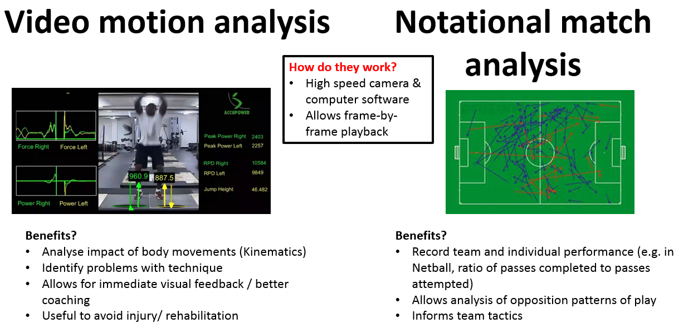

**Watch the clips on video motion analysis by Silicon Coach Software and Dartfish and complete the table below:**

|  |  |
| --- | --- |
| **Dartfish software** | **Silicon Coach software** |
| [**https://www.youtube.com/watch?v=FGqESzQRsHk**](https://www.youtube.com/watch?v=FGqESzQRsHk) | [**https://www.youtube.com/watch?v=hGzy9i309kA**](https://www.youtube.com/watch?v=hGzy9i309kA) |
| Possible benefits of Dartfish to athletes? ………………………………………………………..  ………………………………………………………..  ………………………………………………………..  ………………………………………………………..  ………………………………………………………..  ………………………………………………………  ………………………………………………………  ……………………………………………………….. | Possible benefits of Silicon to coaches?  ……………………………………………………..  …..…………………………………………………  ……..………………………………………………  ………..……………………………………………  …………..…………………………………………  ……………………………………………………  ……………………………………………………  …………………………………………………….. |

The box below contains Rugby match analysis statistics supplied by Opta**.**

**17**

**Technology**

[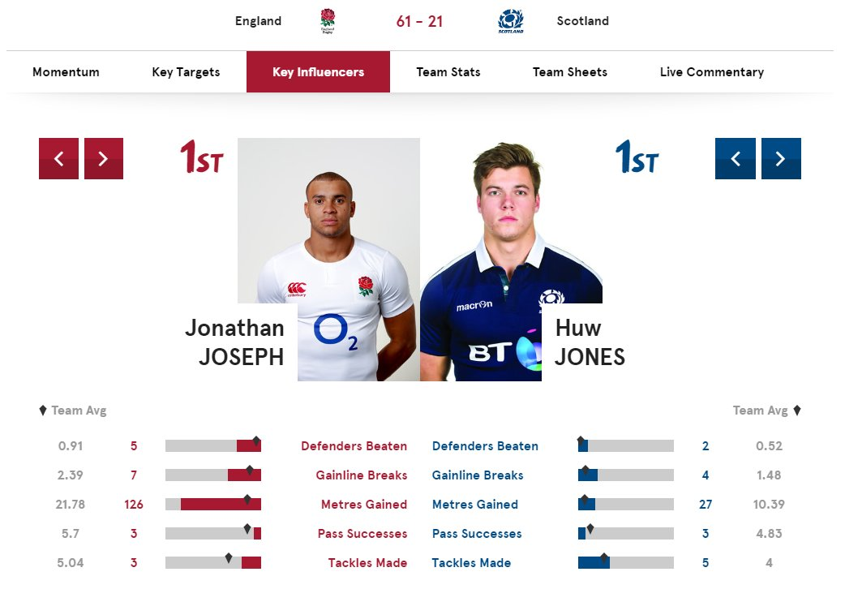](https://www.google.co.uk/url?sa=i&rct=j&q=&esrc=s&source=images&cd=&cad=rja&uact=8&ved=0ahUKEwidtZH5huXSAhVMOMAKHdbFB9EQjRwIBw&url=https://twitter.com/optasuit&bvm=bv.149760088,d.amc&psig=AFQjCNFN0QdsCjJ8twa5Xv5Mk1OhTkRm_A&ust=1490098298307312)

How can Opta match analysis statistics be used to improve performance in Rugby? [3]

…………………………………………………………………………………………………………………………………………………………………………………….

…………………………………………………………………………………………………………………………………………………………………………………….

What problems of validity affect video match analysis programmes? [3]

…………………………………………………………………………………………………………………………………………………………………………………….

…………………………………………………………………………………………………………………………………………………………………………………….

…………………………………………………………………………………………

………………………………………………………………………………………….

**Metabolic cart for indirect calorimetry**

**18**

**Technology**

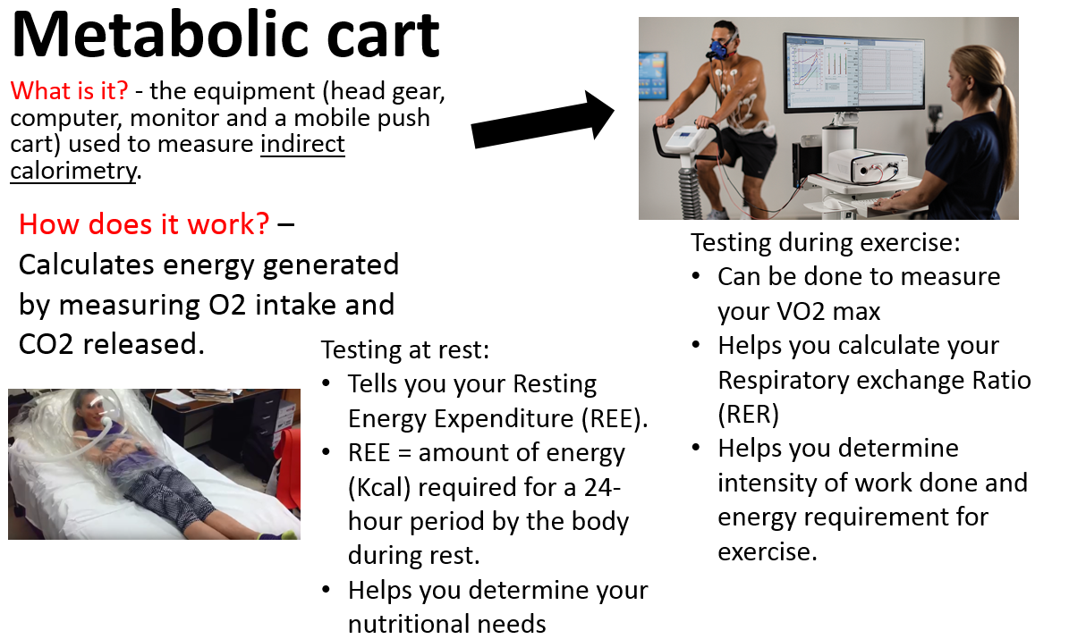

1. Watch the following clips on Metabolic cart testing and recording equipment.

<https://www.youtube.com/watch?v=oVS4hflzX9c>

<https://www.youtube.com/watch?v=cw9BWFMyO6s>

1. What reasons might a recreational gym user have for measuring indirect calorimetry via metabolic cart? [3]

…………………………………………………………………………………………………………………………………………………………………………………….

…………………………………………………………………………………………………………………………………………………………………………………….

…………………………………………………………………………………………

………………………………………………………………………………………….

1. Below is a set of quantitatve data gathered using metabolic cart.

**18**

**Technology**

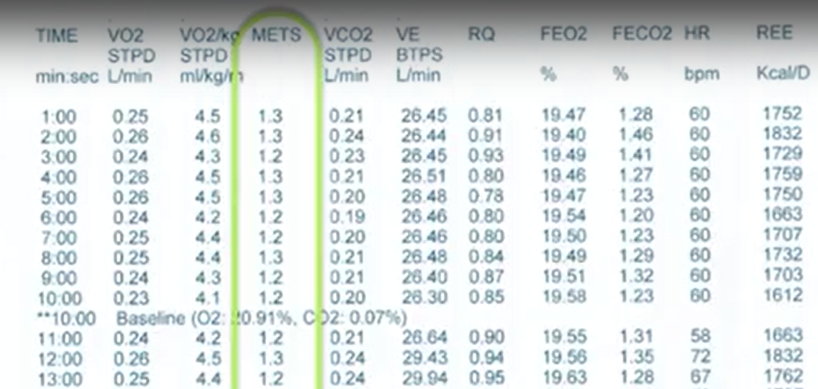

Interpret the data in the space below:

……………………………………………………………………………………… ………………………………………………………………………………………….

…………………………………………………………………………………………………………………………………………………………………………………….

…………………………………………………………………………………………

………………………………………………………………………………………….………………………………………………………………………………………….

…………………………………………………………………………………………………………………………………………………………………………………….

…………………………………………………………………………………………

………………………………………………………………………………………….

1. What problems affect the reliability of using indirect calorimetry via a metabolic cart? [3]

…………………………………………………………………………………………………………………………………………………………………………………….

…………………………………………………………………………………………

………………………………………………………………………………………….

**GPS & Motion tracking software & hardware**

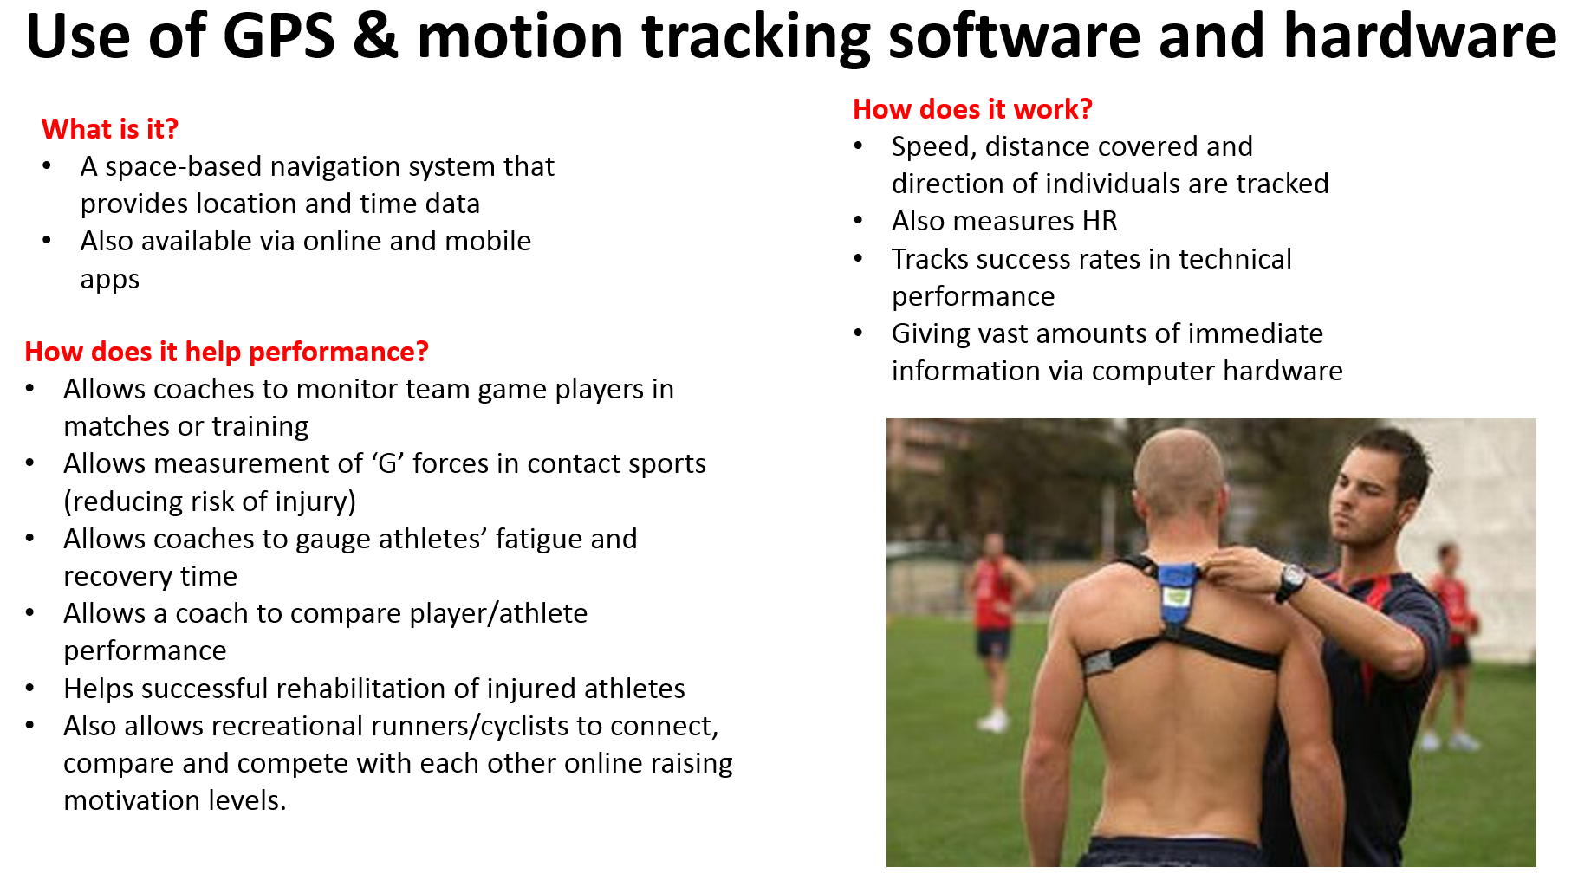

**18**

**Technology**

**Research the Strava website at the link below.**

**https://www.strava.com/**

Explain the usefulness of online and mobile GPS tracking apps (such as Strava) to a recreational cyclist. [3]

…………………………………………………………………………………………………………………………………………………………………………………….

…………………………………………………………………………………………

………………………………………………………………………………………….………………………………………………………………………………………….

…………………………………………………………………………………………………………………………………………………………………………………….

…………………………………………………………………………………………

**Monitoring data integrity**

**18**

**Technology**

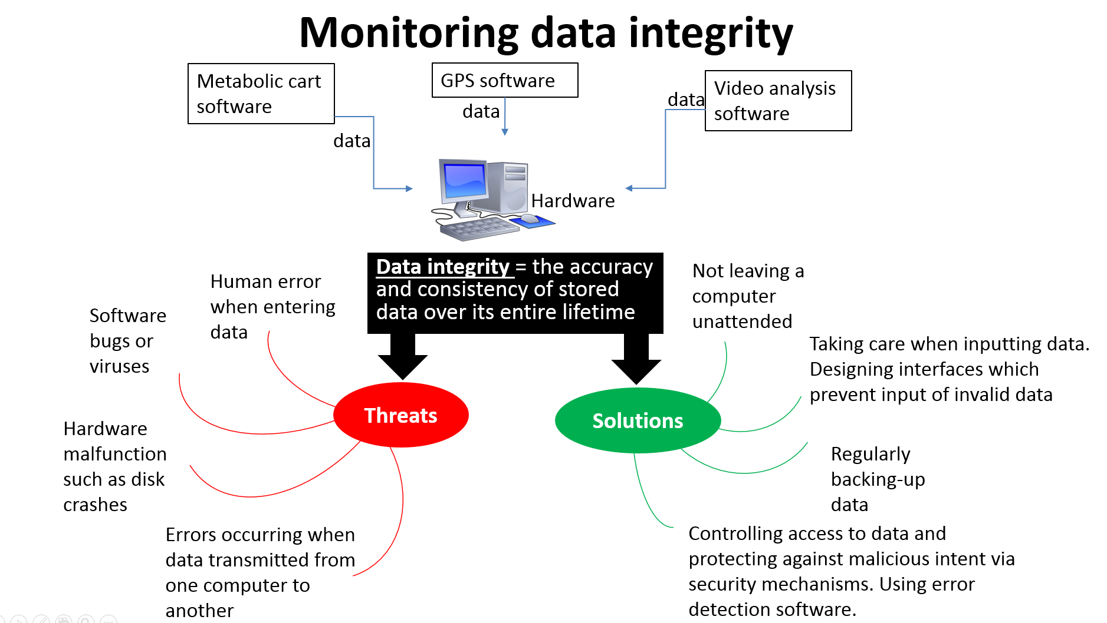

**Possible exam questions**

**Suggest ways to ensure data integrity when using motion tracking software and hardware. [3]**

**…………………………………………………………………………………………………………………………………………………………………………………….**

**…………………………………………………………………………………………**

**How do mobile video analysis programmes enhance the coaching process with competitive high jumpers. [6]**

**…………………………………………………………………………………………………………………………………………………………………………………….………………………………………………………………………………………….………………………………………………………………………………………….**

**19**

**Technology**

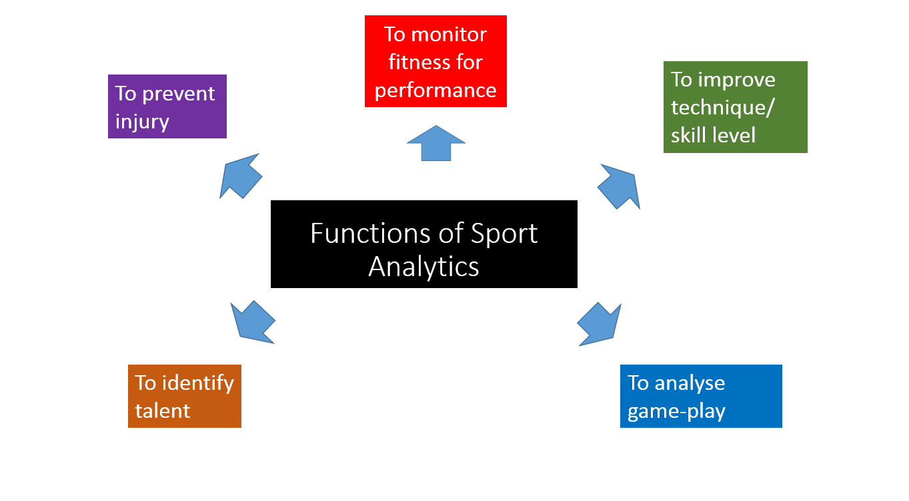

Sports performance can be analysed using Testing and recording equipment (such as metabolic cart), Video analysis software (such as Dartfish) and GPS tracking software (such as Strava).

Using examples from sport, **explain** the functions of sport analytics [8]

**Plan your answer in the space below and write up on lined paper.**

**Evaluating the role of technology in sport**

**19**

**Technology**

Below is a sample exam question and one student’s planned answer where she lists possible points for and against.

**Question:** Discuss the suggestion that the increased use of technology to help officials make the correct decision has improved the sporting event. *8 marks*

**Student plan:**

Advantages

* Ensure correct decisions are made/fair competition
* less controversy
* players more confident in decisions
* Helps officials communicate with each other
* Less pressure on official
* Timing/measurement accurate
* Creates excitement in crowd waiting for decision

Dis-advantages

* Officials using technology can still be wrong
* officials are an integral part of the sporting contest
* over reliance on technology
* lose respect of official’s decision being final
* Reliability?
* Changes the nature of the sport
* Cost limits use of technology at events

so not consistent for all players or spectators

* Breaks in play can be disruptive for spectators if too long

[](http://www.google.co.uk/url?sa=i&source=images&cd=&cad=rja&docid=U_3Gl3ZnVDy2MM&tbnid=s6Jd1KLP8te_bM:&ved=0CAgQjRwwAA&url=http://bcvle.bodmincollege.cornwall.sch.uk/moodle/mod/forum/discuss.php?d=71&ei=usHWUZC6L4viO4SlgNAE&psig=AFQjCNHMSSqQrq0Htmv1132_aV_zZfMM-Q&ust=1373115194811775)

**Task to tackle**

Use the student’s plan to help you complete the following table:

|  |  |  |
| --- | --- | --- |
|  | **Positives** | **Negatives** |
| **Video ref in Rugby** | Performer | Performer |
| Coach | Coach |
| Audience | Audience |
| Sport | Sport |

Repeat what you have just done for the following tables:

**19**

**Technology**

|  |  |  |
| --- | --- | --- |
|  | **Positives** | **Negatives** |
| **3G Astro turf in Football** | Performer | Performer |
| Coach | Coach |
| Audience | Audience |
| Sport | Sport |

|  |  |  |
| --- | --- | --- |
|  | **Positives** | **Negatives** |
| **Carbon-based rackets in tennis** | Performer | Performer |
| Coach | Coach |
| Audience | Audience |
| Sport | Sport |

**Task:** Using internet research, answer the 8 research questions below on both of

**20**

**Technology**

the technologies listed:

* **Vibration training technology**

(brands include Powerplate, Merax, Gadget:Fit, Confidence Fitness,Vibrofit )

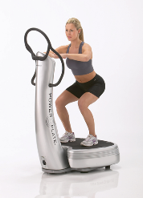

* **Electro-stimulation technology**

(brands include SixPad, Compex, The TENS company)

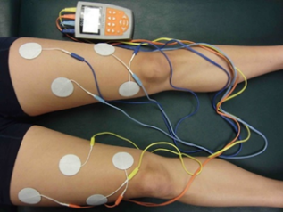

1. In basic terms, briefly describe what technology is involved and how it is used? [50 words]
2. Provide details of **one** of the brands/models listed below. Can you find an online review for this brand? What does it cost? Include a link to a video showing how it is used. [150 words]
3. What is the scientific reason for the technology? How does it work? [200 words]
4. How does it improve performance? [100 words]
5. How can it be used for rehabilitation from injury? [100 words]
6. How can it prevent injury? [100 words]
7. What application could this technology have in my sport? [150 words]
8. Is there unbiased scientific evidence to support the claims made about the benefits of using this technology? Summarise your findings. [150 words]

1000 words maximum.

Print each of your research assignments in a word document.

**Preparing for the essay:**

**20**

**Technology**

**Task:** Provide examples of each kind of technology listed.

Analysis tools

Equipment

Facilities

Stadia

Sports Science/ Physiotherapy

Advancements in Sports

technology

Drug Testing

Surfaces

Materials for disability/elderly

Media technology

Evaluate the impact of technology on the sport, performer and coach [15 marks].

**20**

**Technology**

**Marks for this question: AO1 = 4, AO2 = 5 and AO3 = 6**

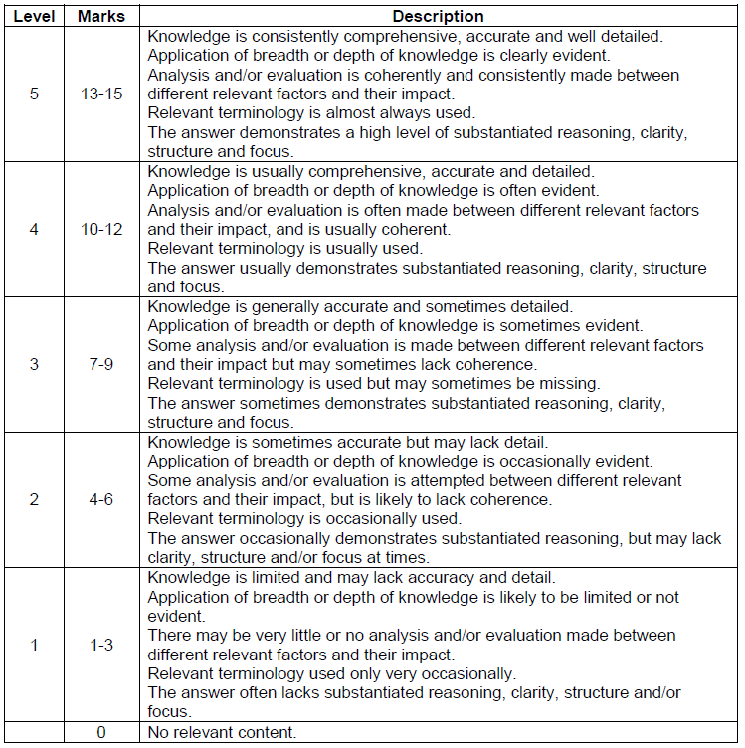

**Possible content may include:**

**AO1 – Knowledge of technology in sport.**

Use of technology in sport – Eg facilities, equipment, drugs/doping testing, video motion analysis, biological passport, video playback, CCTV, GPS tracking, Hawkeye/video ref, adapted equipment for disability/elderly, protective clothing, Metabolic cart software for indirect calorimetry, Vibration/electro-stimulation

**AO2 – Application of the use of technology in sport**

Eg Video playback used to review incidents in games that weren’t punished at the time of occurrence, eg Luis Suarez later banned and fined for biting opponent in a World Cup football match, despite not receiving a yellow/red card at the time.

Lightweight carbon rackets in Tennis allow for increased power and accuracy of shots meaning the standard and speed of serving has increased.

Prosthetic limbs for disability athletes have benefited from material technology. These can be designed to optimise gait and mobility.

**AO3 – Evaluation of the impact of technology to the sport, performers and coaches**

Eg Video playback helps to identify culprits of violent play so that they can be punished. This makes the sport safer/ protects performers from harm. This should act as a deterrent for others which should make sport fairer and less deviant. This should act as a deterrent due to punishment. Other players will see the behaviour has been punished and are less likely to copy thisbehaviour. This should lead to better role models for grass roots sport, ie children do not copy the deviant behaviour.

However, video playback captures bad behaviour and highlights it globally which could lead to a damaged reputation for the perfoemer and the sport.

Credit given for other relevant points evaluating the effectiveness of technology.

**20**

**Technology**

**AO1 – Knowledge**

**Knowledge of technology in sport.**

**AO2 – Application**

**Application of the use of technology to the sport, performers and coaches**

**AO3 – Analysis/Evaluation**

**Evaluation of the impact of technology use on performers, coaches and the sport.**

**Specimen answer:**

Part of a student answer to the essay might look like this:

Technology includes the improvements to sporting facilities. For example, the use of 4G astro turf for football training and matches has begun to replace grass pitches and means that pitches can be used more regularly and for longer without the need for grass/groundcare.This is great for performers and coaches because it means that training can be held more regularly and cancellations are avoided. The surface is less prone to damage meaning that the play is more controlled and consistent. The means that the standard of play can be progressed. The sport of football benefits as more people can play more regularly. However, 4G astro turf is very expensive so not all people if society will be able to afford access. The nature of the sport is affected because the bounce is different to a grass pitch and the surface can be too rigid leading to more player injuries.

**Task:** Use the above preparation and mark scheme to help you write an essay response to the question. This should be hand-written, finished for homework and handed in next lesson.

Possible exam questions:

1. How has the introduction of lightweight carbon-based rackets altered the sport of tennis? [3]
2. Explain the possible disadvantages of technology to the coach. [4]
3. Discuss the suggestion that the use of technology to help make officiating decisions has improved the sporting event. [6]
4. Discuss the suggestion that enhanced technology is beneficial to sports performers [8].
5. Evaluate the effectiveness of technology as a deterrent for deviant behaviour in sport. [15 marks]