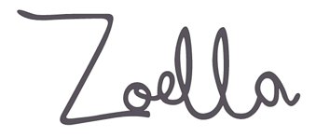

Listed below are our key blog and vlog entries from Zoella, although you are not limited studying just these they represent a good cross section of her content.

|  |  |
| --- | --- |
| **Homepage** | [www.zoella.co.uk](http://www.zoella.co.uk) |
| **Who Run the World? blog post** | <https://www.zoella.co.uk/2017/03/who-run-the-world.html> |
| **February Favourites 2018 vlog** | <https://www.youtube.com/watch?v=eljAjPH6zQI> |
| **My Winter Makeup vlog** | <https://www.youtube.com/watch?v=vn3EiuUVjBk> |
| **Dreaming of Mykonos blog post** | <https://www.zoella.co.uk/2016/09/dreaming-of-mykonos.html> |
| **Anxiety Update blog post** | <https://www.zoella.co.uk/2016/10/anxiety-the-update.html> |