Voting Behaviour and the Media Revision Session 2018

Key terms grid

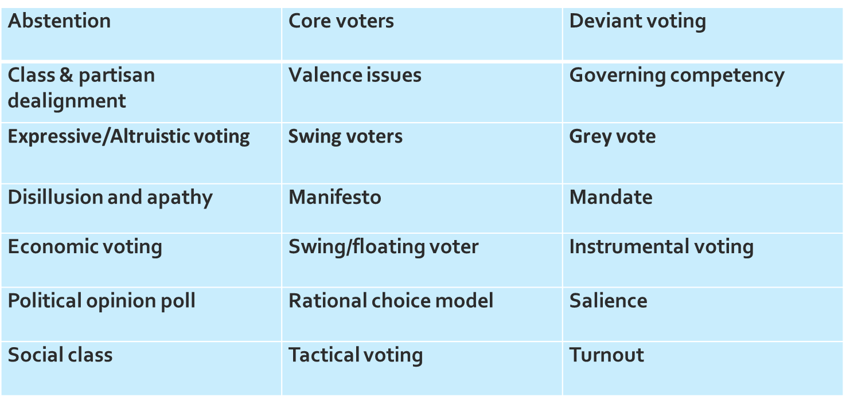

1. What factors can you think of that influence voter behaviour? You’ve got 1 minute to jot them all down in the box below:

2. The Four types of voter:

**Deviant voters:**

**Floating (or swing) voters:**

**Tactical Voters:**

**Core voters:**

3. Understanding Valence

Key point: **Valence includes the image of the leader – but it’s also about how voters judge the parties on the most salient issues to them, also on general competence, party unity etc.**

Define valence, and make notes on the significance of it here:

**Evaluate the view that the publication of opinion polls should be banned in the run up to elections (30)**

|  |  |  |
| --- | --- | --- |
| Ban | Not Ban | Judgement? |
|  |  |  |
|  |  |  |
|  |  |  |
|  |  |  |

**Evaluate the extent to which the dominance of the two main parties in the UK political system is in decline (30)**

|  |  |  |
| --- | --- | --- |
| In decline | Not in decline | Judgement? |
|  |  |  |
|  |  |  |
|  |  |  |
|  |  |  |