NAME: | ‘Charing Cross Bridge’ | 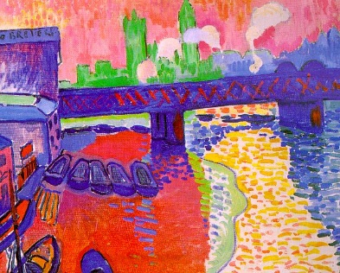
ARTIST: | Derain
DATE: | 1906
SIZE: | 80cm x 100cm
CHARACTERISTICS | SPECIFIC DETAIL/ZOOM | WHY?/CONTEXT/INFLUENCES | HOW ASSOCIATED WITH STYLE?
Subject matter: | London. View of industrial town with Lion Brewery on left. Train crossing the bridge with lime green Houses of Parliament silhouetted behind. | Following the scandal of the 1905 Salon d’Automne, Derain was sent to London by dealer, Ambroise Vollard, to paint a series of modern London in this new style of the new century. | Cityscape is not typical of the Fauvist choice of subject matters. Despite this, emphasis is still more on the experimentation with style than the importance of the specific subject.
Composition: | Simple and asymmetric with angled train bridge providing manmade ‘horizon line’. Tug boats in foreground cropped. | Simplicity and deliberate naivety pushing further than Post Impressionists but clearly influenced by Van Gogh and Gauguin. | Refusal to abide by ‘academic’ expectations of harmonious and symmetrical composition is typical. Wedge of bridge is disruptive.
Colour | Bright blocks of red left foreground, Parliament in vivid green, bridge, and water in blue with reflections shown in yellow. | Working with Matisse and Derain in previous summer and group experimentation with releasing colour from bounds of realism. | Vibrant and unrealistic. Colour used to show highlights rather than tone or shadowing. Derain’s colour palette is more primary than Matisse or Vlaminck’s.
Brushwork | Blocks on left, broad dabs on water with bare canvas showing through. Outline on tide mark and rough quick patterning on train bridge. | Dabs on water developed from Pointillist style of Signac: Derain wanted to achieve vibrancy but find a quicker method. | Varied mark making here illustrates evolving style. Some references to ‘Luxe’ in pointillism, but also pushing further in willingness to combine a range of techniques on a single canvas.
Space/depth | Flattened composition. Viewpoint from adjacent bridge and naïve perspective on buildings. | Influence of Post Impressionist and Japonisme to release modern art from traditional expectations. | Derain endlessly experimenting with earlier ideas in search for new.
CRITICAL RECEPTION? | Derain searching for “the fixed, the eternal, the complex” | Accused by Louvre guards of “assassinating beauty”. | Belief that the act of painting was at the heart of the matter.
QUOTE? | “deliberate disharmonies” (Derain) | Derain criticised Monet’s “fugitive short-lived colour” | Picture is the sum of marks made on canvas rather than mirror held up to nature, life or literature.

