Fauvism was the first of the avant-garde movements that flourished in France in the early years of the twentieth century. The Fauve painters were the first to break with [Impressionism](http://www.metmuseum.org/toah/hd/poim/hd_poim.htm) as well as with older, traditional methods of perception. Their spontaneous, often subjective response to nature was expressed in bold, undisguised brushstrokes and high-keyed, vibrant colours directly from the tube.   
  
[Henri Matisse](http://www.metmuseum.org/toah/hd/cube/hd_cube.htm) (French, 1869–1954) and André Derain (French, 1880–1954) introduced unnaturalistic color and vivid brushstrokes into their paintings in the summer of 1905, working together in the small fishing port of Collioure on the Mediterranean coast. When their pictures were exhibited later that year at the [Salon d'Automne in Paris](http://www.metmuseum.org/toah/bibliography/) (Matisse, *The Woman with a Hat*), they inspired the witty critic Louis Vauxcelles to call them *fauves* ("wild beasts") in his review for the magazine *Gil Blas*. This term was later applied to the artists themselves.

* 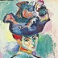Fauves were a loosely shaped group of artists sharing a similar approach to nature, but they had no definitive program. Their leader was Matisse, who had arrived at the Fauve style after earlier experimenting with the various [Post-Impressionist styles](http://www.metmuseum.org/toah/hd/mati/hd_mati.htm) of [Van Gogh](http://www.metmuseum.org/toah/hd/gaug/hd_gaug.htm), [Gauguin](http://www.metmuseum.org/toah/hd/sara/hd_sara.htm), and Cézanne, and the [Neo-Impressionism](http://www.metmuseum.org/toah/hd/imml/hd_imml.htm) of Seurat, Cross, and Signac. These influences inspired him to reject traditional three-dimensional space and seek instead a new picture space defined by the movement of colour planes.  
    
  Another major Fauve was Maurice de Vlaminck (French, 1876–1958), who might be called a "natural" Fauve because his use of highly intense colour corresponded to his own exuberant nature. Vlaminck took the final step toward embracing the Fauve style after seeing the second large retrospective exhibition of Van Gogh's work at the Salon des Indépendants in the spring of 1905, and the Fauve paintings produced by Matisse and Derain in Collioure.

As an artist, Derain occupied a place midway between the impetuous Vlaminck and the more controlled Matisse. He had worked with Vlaminck in Chatou, near Paris, intermittently from 1900 on ("School of Chatou"), and spent the summer of 1905 with Matisse in Collioure. In 1906–7, he also painted some twenty-nine scenes of London in a more restrained palette.  
  
Other important Fauvists were Kees van Dongen, Charles Camoin, Henri-Charles Manguin, Othon Friesz, Jean Puy, Louis Valtat, and Georges Rouault. These were joined in 1906 by Georges Braque and Raoul Dufy.   
  
For most of these artists, Fauvism was a transitional, learning stage. By 1908, a revived interest in Paul Cézanne's vision of the order and structure of nature had led many of them to reject the turbulent emotionalism of Fauvism in favor of the logic of Cubism. Braque became the cofounder with Picasso of [Cubism](http://www.metmuseum.org/toah/hd/gogh/hd_gogh.htm). Derain, after a brief flirtation with Cubism, became a widely popular painter in a somewhat neoclassical manner. Matisse alone pursued the course he had pioneered, achieving a sophisticated balance between his own emotions and the world he painted.  
  
The Fauvist movement has been compared to German Expressionism, both projecting brilliant colours and spontaneous brushwork, and indebted to the same late nineteenth-century sources, especially Van Gogh. The French were more concerned with the formal aspects of pictorial organization, while the German Expressionists were more emotionally involved in their subjects.

|  |
| --- |
| [Sabine Rewald](http://www.metmuseum.org/toah/hd/pcez/hd_pcez.htm?sort=auth&range=Rewald-Sabine) Department of Modern and Contemporary Art, The Metropolitan Museum of Art |

WebMuseum

**http://www.ibiblio.org/wm/i/painttool.pngFauvism**

Between 1901 and 1906, several comprehensive exhibitions were held in Paris, making the work of Vincent van Gogh,Paul Gauguin, andPaul Cézanne widely accessible for the first time. For the painters who saw the achievements of these great artists, the effect was one of liberation and they began to experiment with radical new styles. Fauvism was the first movement of this modern period, in which color ruled supreme.

The advent of Modernism if often dated by the appearance of the Fauves in Paris at the Salon d'Automne in 1905. Their style of painting, using non-naturalistic colors, was one of the first avant-garde developments in European art. They greatly admired van Gogh, who said of his own work: ``Instead of trying to render what I see before me, I use color in a completely arbitrary way to express myself powerfully''. The Fauvists carried this idea further, translating their feelings into color with a rough, almost clumsy style.Matisse was a dominant figure in the movement; other Fauvists included Vlaminck, Derain, Marquet, and Rouault. However, they did not form a cohesive group and by 1908 a number of painters had seceded to Cubism.

Fauvism was a short-lived movement, lasting only as long as its originator, Henri Matisse (1869-1954), fought to find the artistic freedom he needed. Matisse had to make color serve his art, rather as Gauguin needed to paint the sand pink to express an emotion. The Fauvists believed absolutely in color as an emotional force. With Matisse and his friends, Maurice de Vlaminck (1876-1958) and André Derain (1880-1954), color lost its descriptive qualities and became luminous, creating light rather than imitating it. They astonished viewers at the 1905 Salon d'Automne: the art critic Louis Vauxcelles saw their bold paintings surrounding a conventional sculpture of a young boy, and remarked that it was like a Donatello ``parmi les fauves'' (among the wild beasts). The painterly freedom of the Fauves and their expressive use of color gave splendid proof of their intelligent study of van Gogh's art. But their art seemed brasher than anything seen before.

During its brief flourishing, Fauvism had some notable adherents, including Rouault, Dufy, and Braque. Vlaminck had a touch of his internal moods: even if *The River* (c. 1910; 60 x 73 cm (23 1/2 x 28 3/4 in)) looks at peace, we feel a storm is coming. A self-professed “primitive'', he ignored the wealth of art in the Louvre, preferring to collect the African masks that became so important to early 20th-century art.

Derain also showed a primitive wildness in his Fauve period--*Charing Cross Bridge* (1906; 80 x 100 cm (32 x 39 in)) bestrides a strangely tropical London-- though as he aged he quenched his fire to a classic calm. He shared a studio with Vlaminck for a while and *The River* and *Charing Cross Bridge* seem to share a vibrant power: both reveal an unselfconscious use of colour and shape, a delight in the sheer patterning of things. This may not be profound art but it does give visual pleasure.

Fauvism developed in France to become the first new artistic style of the 20th century. In contrast to the dark, vaguely disturbing nature of much fin-de-siècle, or turn-of-the-century, Symbolist art, the Fauves produced bright cheery landscapes and figure paintings, characterized by pure vivid color and bold distinctive brushwork.

When shown at the 1905 Salon d’Automne (an exhibition organized by artists in response to the conservative policies of the official exhibitions, or salons) in Paris, the contrast to traditional art was so striking it led critic Louis Vauxcelles to describe the artists as “Les Fauves” or “wild beasts,” and thus the name was born.

One of several Expressionist movements to emerge in the early 20th century, Fauvism was short lived, and by 1910, artists in the group had diverged toward more individual interests. Nevertheless, Fauvism remains signficant for it demonstrated modern art’s ability to evoke intensely emotional reactions through radical visual form.

The best known Fauve artists include Henri Matisse, André Derain, and Maurice Vlaminck who pioneered its distinctive style. Their early works reveal the influence of Post-Impressionist artists, especially Neo-Impressionists like Paul Signac, whose interest in color’s optical effects had led to a divisionist method of juxtaposing pure hues on canvas. The Fauves, however, lacked such scientific intent. They emphasized the expressive potential of color, employing it arbitrarily, not based on an object’s natural appearance.

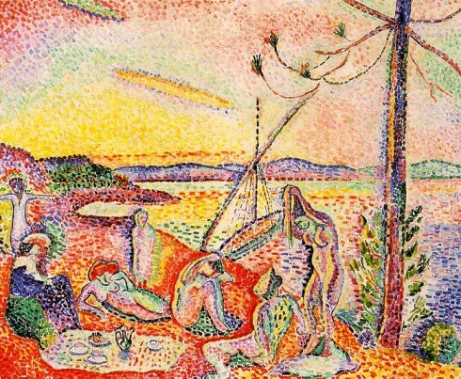

Henri Matisse, *Luxe, calme et volupté*, 1904, oil on canvas, 37 x 46 inches (Museé d'Orsay, Paris)

In *Luxe, calm et volupté* (1904), for example, Matisse employed a pointillist style by applying paint in small dabs and dashes. Instead of the subtle blending of complimentary colors typical of Neo-Impressionism Seurat, for example), the combination of firey oranges, yellows, greens and purple is almost overpowering in its vibrant impact.

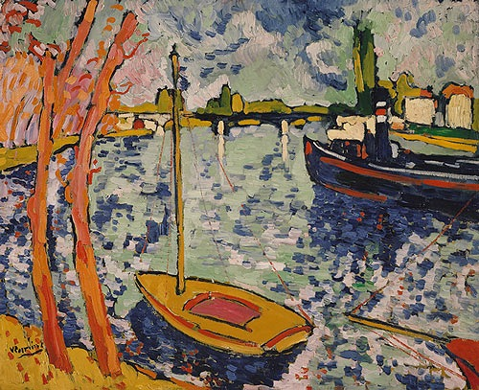Similarly, while paintings such as Vlaminck’s *The River Seine at Chatou* (1906) appear to mimic the spontaneous, active brushwork of Impressionism, the Fauves adopted a painterly approach to enhance their work’s emotional power, not to capture fleeting effects of color, light or atmosphere on their subjects. Their preference for landscapes, carefree figures and lighthearted subject matter reflects their desire to create an art that would appeal primarily to the viewers’ senses.

Maurice de Vlaminck, *The River Seine at Chatou*, 1906, Oil on canvas, 32 1/2 x 40 1/8 in./ 82.6 x 101.9 cm (The Metropolitan Museum of Art)

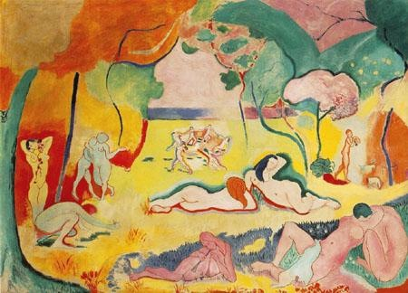Paintings such as Matisse’s *Bonheur de Vivre* (1905-06) epitomize this goal. Bright colors and undulating lines pull our eye gently through the idyllic scene, encouraging us to imagine feeling the warmth of the sun, the cool of the grass, the soft touch of a caress, and the passion of a kiss.

Like many modern artists, the Fauves also found inspiration in objects from Africa and other non-western cultures. Seen through a Colonialist lens, the formal distinctions of African art reflected current notions of Primitivism–the belief that, lacking the corrupting influence of European civilization, non-western peoples were more in tune with the primal elements of nature.

Henri Matisse, *Bonheur de Vivre (Joy of Life)*, oil on canvas, 1905-06 (Barnes Foundation)

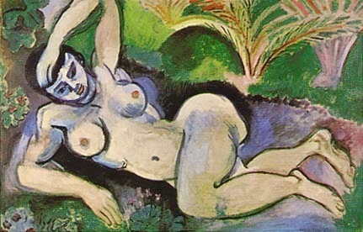

*Blue Nude (Souvenir of Biskra)* of 1907 shows how Matisse combined his traditional subject of the female nude with the influence of primitive sources. The woman’s face appears mask-like in the use of strong outlines and harsh contrasts of light and dark, and the hard lines of her body recall the angled planar surfaces common to African sculpture. This distorted effect, further heightened by her contorted pose, clearly distinguishes the figure from the idealized odalisques of Ingres and painters of the past.

Henri Matisse, *The Blue Nude (Souvenir de Biskra)*, oil on canvas, 1907 (Baltimore Museum of Art)

The Fauves interest in Primitivism reinforced their reputation as “wild beasts” who sought new possibilities for art through their exploration of direct expression, impactful visual forms and instinctual appeal.

Text by Dr. Virginia B. Spivey