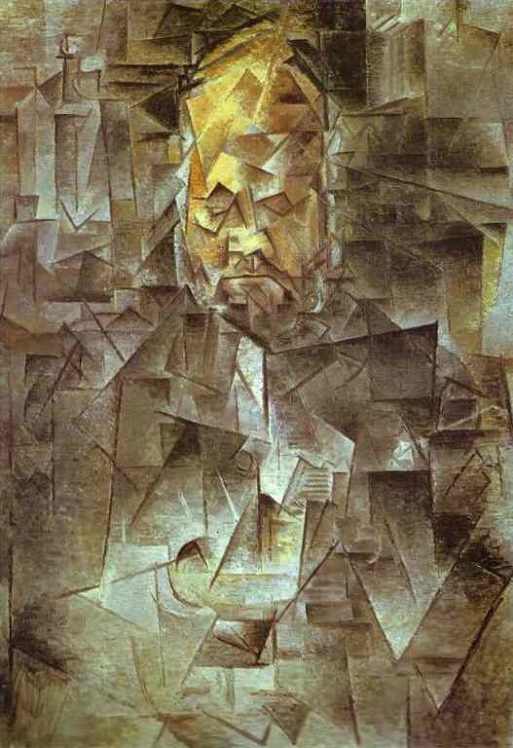**Analytical Cubism: Pablo Picasso (1881-1973)**

**Portrait of Ambroise Vollard, 1910**

Knowledge

Picasso’s completion of a series of dealer portraits at this time underlines the importance of the new art markets away from the traditional Salons. Vollard was one of the most important ‘avant-garde’ dealers in Paris at the time, and had worked with most of the key post impressionist artists as well as the Fauves. He worked with Picasso from his arrival in Paris in 1901 until 1906 when Picasso began an exclusive arrangement with Daniel Kahnweiler.

Understanding

During these years, Picasso and Braque worked closely, “roped together like mountaineers”, trying to find a way out of the deceptions of traditional art. With photography now so far advanced, mere verisimilitude was no longer a viable aim for painting. Picasso pushes his faceting much further here than in the Early Cubist years (eg Reservoir at Horta, 1909), the colour is also more monochromatic, making the subject less easy to read. In fact comparison with photographs of Vollard show that Picasso’s capturing of the prominent, balding forehead does give an accurate idea of his likeness.

However, we are challenged to rethink our perceptions of looking at paintings as a ‘window on the world’, particularly the assumption of a single point perspective. Vollard’s nose is shown both in profile and from above, giving a fragmented, but multiple view. The individual facets are mainly triangular in shape, and use both chiaroscuro and stippling to create surface interest. The light and tone used does not emanate from a single light source but does give an idea of tangibility to the canvas, where the background and foreground exist on the same plane. Picasso achieves a unity in his composition by making these facets incomplete, so that they almost appear to leak into one another. The corners of the rectangular portrait however are less completely worked as this surface system is challenged by the actual edges of the canvas.

Synopticity

Braque’s work and experiments are of key importance here, together with the primitive work of ancient Iberian sculpture (that Picasso had seen again on his recent travels to Horta) and African tribal masks. Both these sources suggested that primitive art offered an honesty not through realism and academic detail but through simplification and a piercing directness. Cezanne’s 1907 Retrospective underpins much of the shift into Cubism and Cezanne had also completed a portrait of Vollard.

This work also refers to the ‘duration’ ideas of the prominent and very popular French philosopher, Henri Bergson and to his argument that reality was in constant flux and change, as memories and experiences of the past affect our ways of looking at the future (Bergson ‘The Creative Evolution’, 1907). Technical advances in both cinematography and photography at the time also made an impact as the Pathe newsreel condensed physical distances and a day’s events into just a few minutes. Real life experiences like speed of travel had also encouraged Picasso and Braque to rethink the role and requirements for modern painting in the first decade of the 20th century.

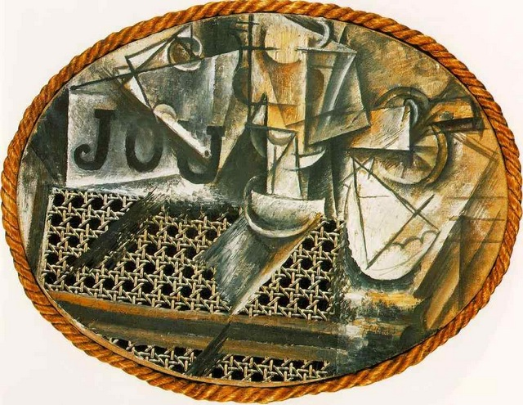**Synthetic Cubism: Pablo Picasso (1881-1973)**

**Still Life with Chair Caning, 1912**

Knowledge

Synthetic Cubism followed Analytical Cubism in 1912, as Picasso and Braque sought to move away from the almost abstracted effect of their Analytical work and re-collect the elements of the image into a single, flat surface. Braque’s experimentation with papier collee (stuck papers) and Picasso’s inclusion of a piece of pre-printed cloth (with a caning design) in this work were hugely important shifts that finally destroyed the almost sacred nature of the painter’s canvas itself. Picasso’s use of a coiled rope here to ‘frame’ this painting is again revolutionary and can be seen as a humorous dig at the grandeur of traditional heavily worked gilt frames.

Understanding

With the inclusion of other materials, Picasso and Braque could continue their experiments in a different way. Textures and associations were brought in by the materials themselves: here the caning evokes both the table cloth in the cafe – a horizontal surface – and the chair back– a vertical surface. Picasso continues this play with ideas in the use of lettering. First introduced in Braque’s work ‘Le Portugais’, 1911, Picasso here plays on the different ways in which we can complete the word ‘JOU’ (newspaper, game, to play, sex) as well as on the ways the inclusion of letters from the newspaper further disrupts our understanding of the space he describes on the canvas. The facets are much more varied here than in Picasso’s Analytical work (Portrait of Ambroise Vollard, 1910), but again the shapes are incomplete and modulated by light and shaded areas. The sandy areas to the right, echoed by the colour of the rope frame hint at the introduction of the greater colour with which Synthetic Cubism is associated. The subject is still hard to read, but there are suggestions of a bottle and/or glass in the centre and perhaps a spade symbol from a pack of cards to the right, so that overall the work suggests the experience of cafe life – playing, drinking, relaxing rather than a single image of a cafe, which again explores Bergson’s ideas of duration and experience.

Synopticity

Again, in the close working relationship with Braque at this time, there are many of his ideas which are explored by Picasso (like the lettering). The oval form also has its precedent in Braque’s painting ‘Man with a Violin’, Spring 1912.

Saussure’s work on Signs and Signifiers is important here, as Picasso plays on the viewer’s assumptions and thus explores the idea that signs do not have the same meaning to all.

The inclusion of ‘real’ (or found) elements in this work is hugely influential in subsequent modern art, but has its precedents both in Spanish 17th sculpture which typically used bone, rope, cloth and hair in its lifelike wooden carvings and in tribal masks which again used elements to symbolise the human form.