

NAME:

**Ancient History**

**Period Study: The Julio-Claudian Emperors, 31 BC – AD 68**

**TOPIC 5: Nero, AD 54-68**

***This booklet covers the following topics:***

* The presentation of Nero by the ancient sources
* The importance of Agrippina and Nero’s wives
* Piso’s conspiracy in AD 65
* The Great Fire of Rome in Ad 64
* Nero’s attitude towards the imperial cult and religion
* Administrative changes in Rome
* Relations the Plebs, Equestrians and Senate
* The Revolt of Vindex
* The death of Nero and accession of Galba

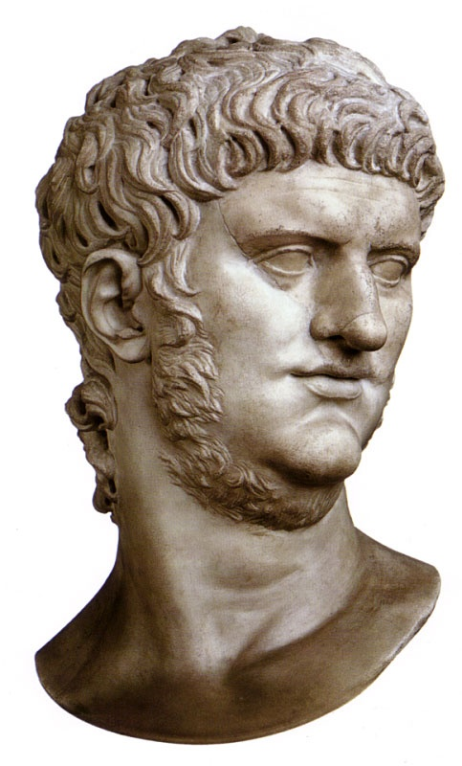

**Suggested Reading**

**History Today Articles (go to** [www.historytoday.com](http://www.historytoday.com) **username= Godalming; password= history)**

# The Praetorian Guard

By [Geoffrey Powell](http://www.historytoday.com/author/geoffrey-powell)

Published in [History Today](http://www.historytoday.com/archive/history-today/latest) [Volume 18 Issue 12 December 1968](http://www.historytoday.com/archive/history-today/volume-18-issue-12-december-1968)

# Women in Imperial Rome

By [J.P.V.D. Balsdon](http://www.historytoday.com/author/jpvd-balsdon)

Published in [History Today](http://www.historytoday.com/archive/history-today/latest) [Volume 9 Issue 8 August 1959](http://www.historytoday.com/archive/history-today/volume-9-issue-8-august-1959)

# Agrippina, the Woman Who Would Rule Rome

# [**James Romm**](https://www.historytoday.com/author/james-romm)

# Published in [History Today](https://www.historytoday.com/archive/history-today/latest) [Volume 64 Issue 4 April 2014](https://www.historytoday.com/archive/history-today/volume-64-issue-4-april-2014)

# Death of the Emperor Claudius

[**Richard Cavendish**](https://www.historytoday.com/author/richard-cavendish)

Published in [History Today](https://www.historytoday.com/archive/history-today/latest) [Volume 54 Issue 10 October 2004](https://www.historytoday.com/archive/history-today/volume-54-issue-10-october-2004)

# Historians Reconsidered: Tacitus

[**Harold Mattingly**](https://www.historytoday.com/author/harold-mattingly)

Published in [History Today](https://www.historytoday.com/archive/history-today/latest) [Volume 2 Issue 9 September 1952](https://www.historytoday.com/archive/history-today/volume-2-issue-9-september-1952)

# The Great Fire of Rome

[**Richard Cavendish**](https://www.historytoday.com/author/richard-cavendish)

Published in [History Today](https://www.historytoday.com/archive/history-today/latest) [Volume 64 Issue 7 July 2014](https://www.historytoday.com/archive/history-today/volume-64-issue-7-july-2014)

# The British Under Roman Rule: A Study in Colonialism

[**Graham Webster**](https://www.historytoday.com/author/graham-webster)

Published in [History Today](https://www.historytoday.com/archive/history-today/latest)

**Textbooks**

* R. Cromarty, J. Harrison & S. Matthews, *OCR Ancient History, Component 2: Rome*, Bloomsbury, 2018 (Due to be published February 2018)

**Books in the ILC**

* R. L. Fox, The Classical World: an Epic History of Greece and Rome, Penguin, 2006
* M. Beard, *S.P.Q.R.: A History of Rome*, Profile Books, 2015
* T. Holland, *Dynasty,* Abacus, 2016
* P. Mantin & R. Pulley, *The Roman World, From Republic to Empire,* Cambridge, 1993
* T. Martin, *Ancient Rome: From Romulus to Justinian,* Yale, 2013

**Useful Websites**

* <https://www.bloomsbury.com/cw/ocr-as-and-a-level-ancient-history/?pid=330294> (A companion website for the OCR Ancient History textbook – good selection of wider reading and revision quizzes)
* <http://www.ancient.eu/>
* <http://www.livius.org/>
* [www.ocr.org.uk](http://www.ocr.org.uk)

**Podcasts**

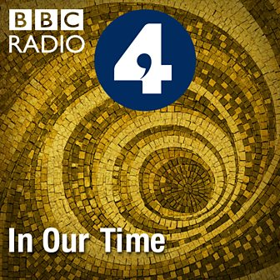Julius Caesar - [www.bbc.co.uk/programmes/b04jlygw](http://www.bbc.co.uk/programmes/b04jlygw)

The Augustan Age - <http://www.bbc.co.uk/programmes/b00ktfmw>

Rome and European Civilization **-** [www.bbc.co.uk/programmes/p00547ms](http://www.bbc.co.uk/programmes/p00547ms)

Tacitus and the Decadence of Rome - <http://www.bbc.co.uk/programmes/b00cdtxp>

Agrippina The Younger - <https://www.bbc.co.uk/programmes/b074yzwk>

*For help in accessing the ebook catalogue on dawsonera, go to the ILC’s page on Godalming Online and read their guide to accessing ebooks.*

*Ebooks can be read using your college log on details whilst in college or at home.*

**ANCIENT HISTORY LUNCHTIME SUPPORT**

**If you need any help in Ancient History going over content, completing homework, attempting assessed questions or preparing for exams, there will be a lunchtime support session each Wednesday between 1 and 2 pm in room 211.**

**How is Nero presented in the ancient sources?**

[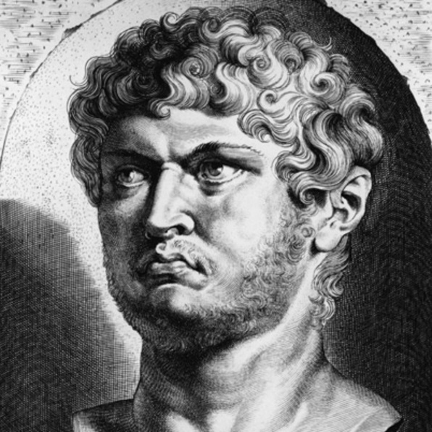](https://www.google.co.uk/url?sa=i&rct=j&q=&esrc=s&source=imgres&cd=&cad=rja&uact=8&ved=2ahUKEwjZ-eit2t3aAhUJXBQKHc78BVAQjRx6BAgBEAU&url=https://www.biography.com/people/nero-9421713&psig=AOvVaw1kEFqBPQSoCJGGtaObruVd&ust=1525030203102040)As we have seen, many of our sources are hostile to the Julio-Claudians and their absolute power. In the cases of Tiberius and particularly Gaius, they portrayed the emperors as power-hungry rulers often obsessed by their own personal excess.

Much the same is seen with Nero as the sources are rarely positive about him. They do however credit Nero **‘A Golden Five Years’**, known as a ***quinquennium aureum****.*

**Prescribed Source – Suetonius, *Nero*, 10-11**

10. As a further guarantee of his virtuous intentions, he promised to model his rule on the principles laid down by Augustus, and never missed an opportunity of being generous or merciful or of showing what a good companion he was. He lowered, if he could not abolish, some of the heavier taxes, and reduced by three-quarters the fee for denouncing evasions of the Papian Law. Moreover, he presented the people with 400 sesterces each, settled annual salaries on distinguished but impoverished senators – to the amount of 500,000 sesterces in some cases – and granted the praetorian cohorts a free monthly issue of grain. If asked to sign the usual execution order for a felon, he would sigh, 'Ah, how I wish that I had never learned to write!' He seldom forgot a face, and would greet men of whatever rank by name without a moment's hesitation. Once, when the Senate passed a vote of thanks to him, he answered, 'Wait until I deserve them!' He allowed even the common people to watch him taking exercise on the Campus Martius, and often gave public declamations. Also, he recited his own poems, both at home and in the theatre – a performance which so delighted everyone that a special thanksgiving was voted him, as though he had won a great victory, and the passages he had chosen were printed in letters of gold on plaques dedicated to Jupiter Capitolinus.

11. He gave an immense variety of entertainments - youth games, chariot races in the Circus, stage plays, a gladiatorial show – persuading even old men of consular rank, and old ladies too, to attend the youth games. He reserved seats for the *equites* at the Circus, and actually raced four-camel chariots! At the Great Games, as he called the series of plays devoted to the hope of his reigning for ever, parts were taken by men and women of both orders, and one well-known *eques* rode an elephant down a sloping tightrope. When he staged *The Fire*, a Roman play by Afranius, the actors were allowed to keep the valuable furnishings they rescued from the burning house. Throughout the games all kinds of gifts were scattered to the people – 1,000 assorted birds daily, and quantities of food parcels, besides vouchers for grain, clothes, gold, silver, precious stones, pearls, paintings, slaves, transport animals, and even trained wild beasts – and finally for ships, blocks of tenements, and farms.

1. **From the source above, select an example of a positive action from Nero for each of the following groups:**

***Plebs***

***Equestrians***

***Soldiers***

***Senators***

**Tacitus** also refers to Nero’s positive start by explaining the enthusiasm with which he was greeted by the Praetorian Guard and his deification of his father Claudius, something he recorded in coinage:

**Prescribed Source – Aureus showing Claudius’ deification, AD 54**

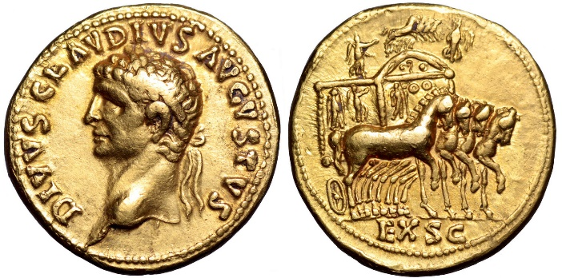

**Obv.:** Head of Claudius, ‘Divine Claudius Augustus’

**Rev.:** Ornamental four-horse chariot surmounted with a miniature set of four horses flanked by victories; ‘By decree of the Senate’

The act of turning Claudius into a god demonstrated Nero’s **filial piety** (respect for his father). This was expected of a good emperor when they took power but was a particularly important thing for Nero to do as he was Claudius’ adopted son and needed to stress his link to Claudius to gain his ***auctoritas***. Nero was also aware that many would see **Britannicus** as the more natural successor to Claudius.

However, the portrayal of Nero in the ancient sources is generally **negative**. One particular element of Nero’s reign which was attacked by the sources was his love of Greek culture and theatre. The term to describe this love of Greek culture was **philhellenism** and the sources suggest that it ‘corrupted’ true Roman values.

**Prescribed Source - Suetonius, *Nero* 20-23**

20. Music formed part of his childhood curriculum, and he early developed a taste for it. Soon after his accession, he summoned Terpnus, the greatest lyre player of the day, to sing to him when dinner had ended, for several nights in succession, until very late. Then, little by little, he began to study and practise himself, and conscientiously undertook all the usual exercises for strengthening and developing the voice. He would also lie on his back with a slab of lead on his chest, use enemas and emetics to keep down his weight, and refrain from eating apples and every other food considered deleterious to the vocal cords. Ultimately, though he voice was still feeble and husky, he was pleased enough with his progress to nurse theatrical ambitions, and would quote to his friends the Greek proverb 'Unheard melodies are never sweet.' His first stage appearance was at Neapolis, where, disregarding an earthquake which shook the theatre, he sang his piece through to the end. He often performed at Neapolis, for several consecutive days too, and even while giving his voice a brief rest he could not stay away from the theatre, nut went to dine in the orchestra, where he promised the crowd in Greek that, when he had downed a drink or two, he would give them something to make their ears ring. So captivated was he by the rhythmic applause of some Alexandrian soldiers from a fleet which had just put in that he sent to Egypt for more. He also chose a few young *equites* and more than 5,000 ordinary youths, whom he divided into claques to learn the various Alexandrian methods of applause, - they were known respectively as 'Bees', 'Roof tiles' and 'Brick-bats' - and to provide it liberally whenever he sang. It was easy to recognize them by their pomaded hair, splendid dress and absence of rings on their left hands. The *equites* who led them earned 400,000 sesterces a performance.

21. Appearances at Rome meant so much to Nero that he held the Neronia again before the scheduled date. When the crowd clamoured to hear his heavenly voice, he answered that he would perform in the gardens later if anyone really wanted to hear him; but when the guards on duty seconded the appeal, he delightedly agreed to oblige them. He wasted no time in getting his name entered on the list of competing lyre players, and dropped his ticket into the urn with the others. Praetorian prefects carried his lyre as he went up to play, anda group of military tribunes and close friends accompanied him. After taking his place and briefly begging the audience's kind attention, he announced through Cluvius Rufus, a man of consular rank, that he was going to sing Niobe, which he did, until almost the tenth hour. He then put off the rest of the competition and the award of the prize to the following year, which would give him another opportunity to sing. But, since a year was a long time to wait, he continued to make frequent appearances. He toyed with the idea of playing opposite professional actors in private shows, because a praetor had offered him 1 million sesterces if he would consent. And he did actually appear in tragedies, taking the parts of heroes and gods, sometimes even of heroines and goddesses, wearing masks modelled on his own face or that of whatever woman happened to be his current mistress. Among his performances were Canace in childbirth, Orestes the matricide, Oeddipus blinded and Hercules raving. There is a story that a young recruit on guard in the wings recognized him in the rags and fetters demanded by the part of Hercules and dashed boldly to his assistance.

22. Horses had been Nero's main interest since childhood; whatever his tutors might do, they could never stop his chatter about the chariot races at the Circus. When scolded by one of them for telling his fellow pupils about a Green charioteer who had the misfortune to get dragged by his team, Nero untruthfully explained that he had been discussing Hector. At the beginning of his reign he used every day to play with model ivory chariots on a board, and came up from the country to attend all the races, even minor ones, at first in secret and then without the least embarrassment, so that there was never any doubt at Rome when he would be in residence. He frankly admitted that he wished the number of prizes increased; as a result, the races were multiplied so that the contests now lasted until a late hour and the faction managers no longer thought it worthwhile to bring out their teams except for a full day's racing. Very soon Nero set his heart on driving a chariot himself in a regular race, and after a preliminary trial in the palace gardens before an audience of slaves and *hoi polloi* he made a public appearance at the Circus Maximus; on this occasion one of his freedmen replaced the magistrate who dropped the napkin as the starting signal.

However, these amateur incursions into the arts at Rome did not satisfy him, and he headed for Achaia, as I mentioned above. His main reason was that the cities which regularly sponsored musical contents had adopted the practice of sending him every available prize for lyre playing; he always accepted these with great pleasure, giving the delegates the earliest audience of the day and invitations to private dinners. They would beg Nero to sing when the meal was over, and applaud his performance to the echo, which made him announce, 'The Greeks alone are worthy of my genius, they really listen to music.' So he sailed off hastily, and as soon as he arrived at Cassiope he gave his first song recital before the altar of Jupiter Cassius, after which he went the round of all the contests.

23. He ordered those contests which normally took place only at long intervals to be held during his visit, even if it meant repeating them, and broke tradition at Olympia by introducing a musical competition into the athletic games. When his freedman Helius advised him that he was urgently needed in Rome at Rome, he would not be distracted by official business, but wrote back, 'Yes, you have made yourself quite plain. I am aware that you want me to go home; you will do far better, however, if you encourage me to stay until I have proved myself worthy of my reputation.' No one was allowed to leave the theatre during his recitals, however pressing the reason, and the gates were kept barred. We hear of women in the audience giving birth and of men so bored with the music and the applause that they furtively dropped down from the wall at the rear or shammed dead and were carried away for burial. Nero's stage fright and general nervousness, his jealously of rivals, and his awe of the judges were more easily seen than believed. He treated his fellow competitors as though they were his equals, and would fuss over them, pay court to them, abuse them behind their backs, and sometimes insult them to their faces; if any were particularly good singers, he would bribe them not to do themselves justice. Before every performance he would address the judges with the utmost deference: he had done what he could, he said, and the issue was now in Fortune's hands; but since they were men of judgement and experience, they would know how to eliminate the factor of chance. When they told him not to worry he felt a little better, but still anxious, and mistook the silence of some for severity and the embarrassment of others for disfavour, admitting that he suspected every one of them.

1. **What interests, other than playing the lyre, does Suetonius say Nero had?**
2. **What is the tone of this source? Explain your answer with at least one supporting quotation**

**Tacitus** was also offended by Nero’s love of Greek culture and his enjoyment of chariot-races. (Tacitus gives us the most detailed account of Nero’s reign, but it stops in AD 66). For Tacitus, coming from the Roman elite, these types of behaviour were below the **dignity** of an emperor and what made it worse was that he tried to engage the rest of Rome in them as well, corrupting its traditional, conservative values. Tacitus is therefore extremely snobbish when he criticises Nero’s interest in music and chariot races, and these are characteristics that would have certainly made him popular with plebs.

**Prescribed Source – Tacitus, *Annals*, 14.15**

14.15. However, Nero was not yet ready to disgrace himself on a public stage. Instead he instituted ‘Youth Games’. There were many volunteers, Birth, age official career did not prevent people from acting – in Greek or Latin style – or from accompanying their performances with effeminate gestures and songs. Eminent women, too, rehearsed indecent parts. In the wood which Augustus had planted round his Naval Lake, places of assignation and taverns were built, and every stimulus to vice was displayed for sale. Moreover, there were distributions of money. Respectable people were compelled to spend it; disreputable people did so gladly. Promiscuity and degradation throve. Roman morals had long become impure, but never was there so favourable an environment for debauchery as among this filthy crowd. Even in good surroundings people find it hard to behave well. Here every form of immorality competed for attention, and no chastity, modesty, or vestige of decency could survive.

The climax was the emperor’s stage debut. Meticulously tuning his lyre, he struck practice notes to the trainers beside him. A battalion attended with its officers. So did Burrus, grieving – but applauding. Now, too, was formed a corps of Roman knights known as the Augustiani. These powerful young men, impudent by nature or ambition, maintained a din of applause day and night, showering divine epithets on Nero’s beauty and voice. They were grand and respected as if they had done great things.

1. **What does Tacitus seem most concerned about under Nero?**
2. **From this source how would you describe Tacitus’ views or character? (as few words as possible)**

In addition to these past-times, the sources also criticise Nero for his **excessive behaviour:**

**Prescribed Source – Suetonius, *Nero* 26-27**

26. His insolence, lust, extravagance, greed and cruelty he at first revealed only gradually and secretly, to be sure, as though merely youthful mistakes; but even then there could be no doubt that these were the faults of his character, not of his age. As soon as night fell he would snatch a hat or cap and make a round of the taverns or prowl the streets in search of mischief – and not always innocent mischief either, because one of his games was to attack men on their way home from dinner, stab them if they offered resistance, and then drop their bodies down the sewers. He would also break into shops, afterwards opening a miniature market in his home with the stolen goods, dividing them up into lots, auctioning them himself, and squandering the proceeds. During these escapades he often risked being blinded or killed – once he was beaten almost to death by a senator whose wife he had molested, which taught him never to go out after dark unless an escort of military tribunes was following him at a discrete distance. He would also secretly visit the theatre by day, in a sedan chair, and watch quarrels among the pantomime actors, cheering them on from the top of the proscenium; then, when they came to blows and fought it out with stones and broken benches, he joined in the fun by throwing things on the heads of the crowd. On one occasion he fractured a praetor's skull.

27. Gradually Nero's vices gained the upper hand: he no longer tried to laugh them off or hide or deny them, but turned quite brazen. His feasts now lasted from noon till midnight, with an occasional break for diving into a warm bath or, if it were summer, into snow-cooled water. Sometimes he would drain the artificial lake in the Campus Martius or the other in the Circus, and hold public dinner parties there, with prostitutes and dancing girls from all over the city serving as waitresses. Whenever he floated down the Tiber to Ostia or cruised past Baiae, he had a row of temporary brothels erected along the shore, where a number of noblewomen, pretending to be madams, stood waiting to solicit his business. He also forced his friends to provide him with dinners; one of them spent 4 million sesterces on a turban party, and another even more on a rose banquet.

[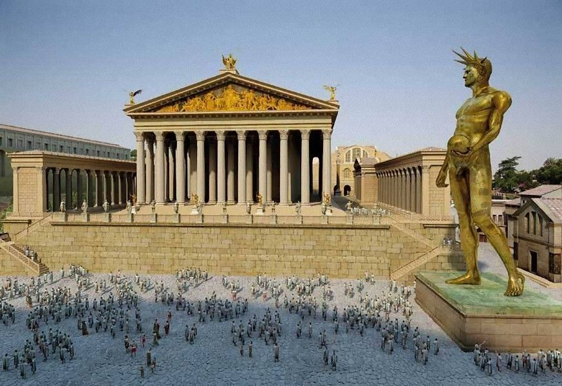](https://www.google.co.uk/url?sa=i&rct=j&q=&esrc=s&source=images&cd=&cad=rja&uact=8&ved=2ahUKEwjwmIb85t3aAhXGthQKHWbZC5sQjRx6BAgBEAU&url=https://www.pinterest.com/pin/804666658393362333/&psig=AOvVaw1tU3YJETg3I6PhsysQX0a5&ust=1525033546223976)**Suetonius** gives us further evidence of Nero’s excessive character by describing his **Colossus**. This was 30-metre high bronze statue of Nero that sat on the Palatine Hill that became a symbol of Nero’s self-indulgence:

**Prescribed Source – Suetonius, *Nero*, 31-32**

31. His wastefulness showed most of all in the architectural projects. He built a house stretching from the Palatine to the Esquiline which he called the 'The Passageway', and when it burned down soon afterwards he rebuilt it under the new name of 'The Golden House'. The following details will give some notion of its size and magnificence. A huge statue of himself, 120 feet high, stood in the entrance hall and a threefold portico ran for a whole mile. An enormous pool, more like a sea than a pool, was surrounded by buildings made to resemble cities, and by a landscape garden consisting of ploughed fields, vineyards, pastures and woodlands – where every variety of domestic and wild animal roamed about. Parts of the house were overlaid with gold and studded with precious stones and mother-of-pearl. All the dining rooms had ceilings of fretted ivory, the panels of which could slide back and let a rain of flowers, or perfume from hidden sprinklers, shower upon the guests. The main dining room was circular, and its roof revolved slowly, day and night, just like the sky. Sea water or sulphur water was always on tap in the baths. When the palace had been decorated throughout in this lavish style, Nero dedicated it, and condescended to remark, 'Good, not I can at least begin to live like a human being!"

**Prescribed Source - Pliny, *Natural History* 34.45–46**

But for sheer size, all statues of this sort have been surpassed in our lifetime by Zenodorus' *Mercury.* He produced this over ten years in the settlement of Averni in Gaul and was paid 40 million sesterces. Once he had given proof of his skill there, he was summoned to Rome by Nero where he made the colossus, over 100 feet tall, intended as a statue of the emperor, but now dedicated to the Sun, after condemnation of that *princeps'* crimes. In his studio we used to look with wonder not only not only at the remarkable clay model, but also at the frame of withes which formed the first stage of the work. That statue shows that the art of casting bronze has now died out, since Nero would have been prepared to meet the expense of silver or gold, though Zenodorus was second to none of the old masters in casting and engraving bronze.

1. **What extra detail about the Colossus do you learn from Pliny that makes it even more excessive?**

For his part, it is likely that Nero felt that his enjoyment of music, Greek culture and public entertainments such as chariot racing, was a sign of him being cultured and sophisticated. Nero was certainly not ashamed of his enjoyment and wanted to publicise his playing of the lyre, in particular, to ordinary Romans:

**Prescribed Source – *As* of Nero as a lyre-player, AD 62**

**Obv.:** Head of Nero, ‘Nero Claudius Caesar, Augustus Germanicus’

**Rev.:** Nero, as Apollo Citharodeus, playing lyre; ‘Pontifex maximus, with tribunician power, victorious commander, father of the fatherland’

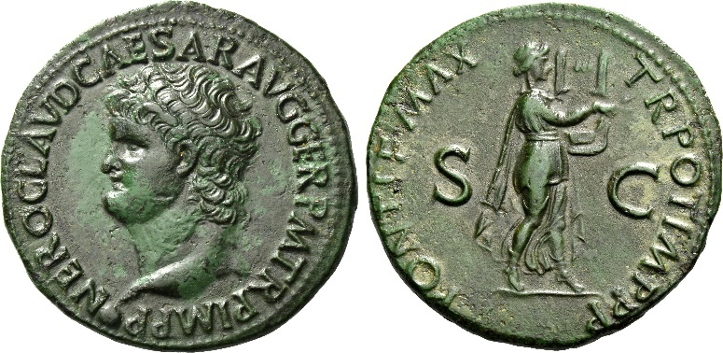

Nero’s pride in his lyre-playing would have only outraged our ancient authors (Tacitus, Suetonius and Dio in particular) who viewed this as unfit behaviour for an emperor and as evidence of Rome’s declining moral standards.

However, all of the sources are hostile to Nero and represent a narrow, elite view. Nero was certainly unpopular by the end of his reign but was not universally hated. For example, 10 years after his death in AD 68, an opponent to the then emperor Titus called Terentius Maximus, gathered supporters by claiming to be Nero showing that his name was powerful enough to attract followers even after his death.

**How is Nero presented in the ancient sources?**

[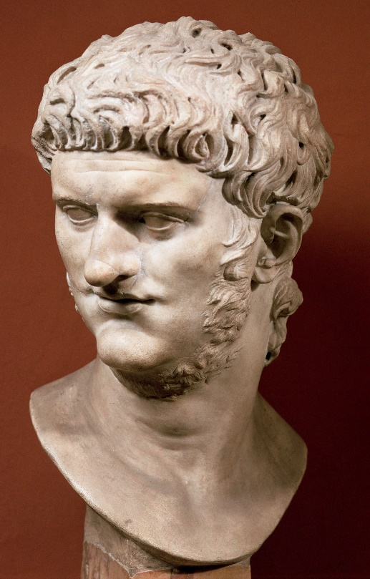](https://www.google.co.uk/url?sa=i&rct=j&q=&esrc=s&source=images&cd=&ved=2ahUKEwi27dj6693aAhVGbRQKHQdMDSgQjRx6BAgBEAU&url=http://www.history.com/topics/ancient-history/ancient-rome/pictures/roman-leaders-and-emperors/bust-of&psig=AOvVaw21X4cTMQIjvnvU9kIsTBzl&ust=1525034907078720)**Task:** using the notes and sources on the previous pages, summarise what you have learnt about Nero’s character and how he is viewed by our ancient authors.

**From what you have gained so far, what similarities can you see between Nero and the other emperors you have studied?**

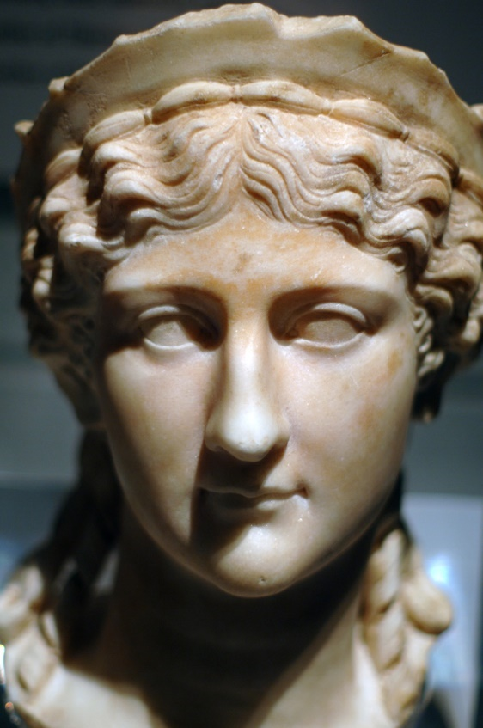**Nero’s early years as emperor – Agrippina**

**RECAP:**

1. What was Agrippina’s family background?
2. In What year did she marry Claudius?
3. How did she advance her son Lucius Domitius during Claudius’ reign?
4. Who has the stronger claim to the throne, Nero or Britannicus?

When Nero took power in AD 54 he was **sixteen** years old. It is clear from the sources that his accession was carefully controlled to prevent rivals putting forward Britannicus as emperor. Tacitus in particular wants to create a picture of Nero **usurping** the throne which is not entirely accurate. The following source describes the steps taken immediately after Claudius’ death.

**Prescribed Source – Tacitus, *Annals* 12.68-12.69**

12.68. The Senate was summoned. Consuls and priests offered prayers for the emperor’s safety. But meanwhile his already lifeless body was being wrapped in blankets and poultices. Moreover, the appropriate steps were being taken to secure Nero’s accession. First Agrippina, with heart-broken demeanour, held Britannicus to her as though to draw comfort from him. He was the very image of his father, she declared. By various devices she prevented him from leaving his room and likewise detained his sisters, Claudia Antonia and Octavia. Blocking every approach with troops, Agrippina issued frequent encouraging announcements about the emperor’s health, to maintain the Guard’s morale and await the propitious moment forecast by the astrologers.

12.69. At last, at midday on October the thirteenth, the palace gates were suddenly thrown open. Attended by Sextus Afranius Burrus, commander of the Guard, out came Nero to the battalion which, in accordance with regulations, was on duty. At a word from its commander, he was cheered and put into a litter. Some of the men are said to have looked round hesitantly and asked where Britannicus was. However, as no counter-suggestion was made, they accepted the choice offered them. Nero was then conducted into the Guard’s camp. There, after saying a few words appropriate to the occasion – and promising gifts on the generous standard set by his father – he was hailed as emperor. The army’s decision was followed by senatorial decrees. The provinces, too, showed no hesitation.

Claudius was voted divine honour, and his funeral was modelled on that of the divine Augustus – Agrippina imitating the grandeur of her great-grandmother Livia, the first Augusta. But Claudius’ will was not read, in case his preference of stepson to son should create a public impression of unfairness and injustice.

1. **What was Britannicus prevented from doing and why?**
2. **What role did Burrus play and why was this so significant?**

Nero’s take-over of power in AD 54 was carefully **stage-managed** and the three controlling figures were:

* **Agrippina the Younger**
* **Burrus (commander of the Praetorian Guard)**
* **Seneca (Nero’s tutor)**

***‘Agrippina’s sole purpose in marrying Claudius was to make her son emperor.’ To what extent do the events surrounding Nero’s accession support this view?***

Whether or not Agrippina had engineered and arranged Nero’s rise to power, she was undoubtedly a powerful influence in the early years of his reign. The ***quinquennium aureum*** is dated to from the start of Nero’s reign in AD 54 to the death of his mother in 59, after which time Nero would play much less attention to the advice of those around him.

**Prescribed Source – Aureus of Nero, AD 54**

**Obv.:** Heads of Nero and Agrippina, ‘Agrippina Augusta, wife of the divine Claudius, mother of Nero Caesar’

**Rev.:** ‘By decree of the senate to Nero Caesar Augustus Germanicus, son of the divine Claudius hailed victorious commander, with tribunician power’

1. 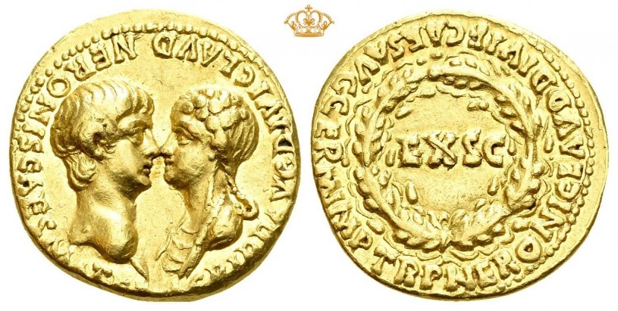**How would you describe the way in which Nero and Agrippina are shown on this coin?**

Agrippina was not, however, unchallenged in her influence over Nero. **Seneca** and **Burrus** opposed her influence and looked to undermine it, whilst Nero himself, as he grew older, wanted increasingly to assert his independence. He also developed a ruthless streak that was incompatible with the control of his mother. A good example of this was when Agrippina threatened to support Britannicus’s claim to the throne, as he approached the age of 14 when he could be considered a man. Nero responded by allegedly having Britannicus poisoned in AD 55 (the day before his 14th birthday).

**Tacitus** suggests that Agrippina used even more extreme methods to control her son:

**Prescribed Source – Tacitus, *Annals,* 14.2**

14.2. According to another author, Cluvius Rufus, Agrippina’s passion to retain power carried her so far that at midday, the time when food and drink were beginning to raise Nero’s temperature, she several times appeared before her inebriated son all decked out and ready for incest. Their companions observed sensual kisses and evilly suggestive caresses. Seneca, supposing that the answer to woman’s enticements was a woman, called in the ex-slave Acte. She feared for Nero’s reputation – and for her own safety. Now she was instructed to warn Nero that Agrippina was boasting of her intimacy with her son, that her boasts had received wide publicity, and that the army would never tolerate a sacrilegious emperor.

If Agrippina did use sex to control her son (and even Tacitus says this is a rumour he has heard from another author) it demonstrates the lengths she was going to keep her influence over an increasingly independent son.

However in AD 59 Agrippina, on the orders of her son Nero was murdered. This came after a series of failed earlier attempts on her life described by **Tacitus** and Nero was also advised heavily by **Seneaca** when considering how best to deal with his ‘overly-powerful mother’.

**Prescribed Source - Suetonius, *Nero* 34**

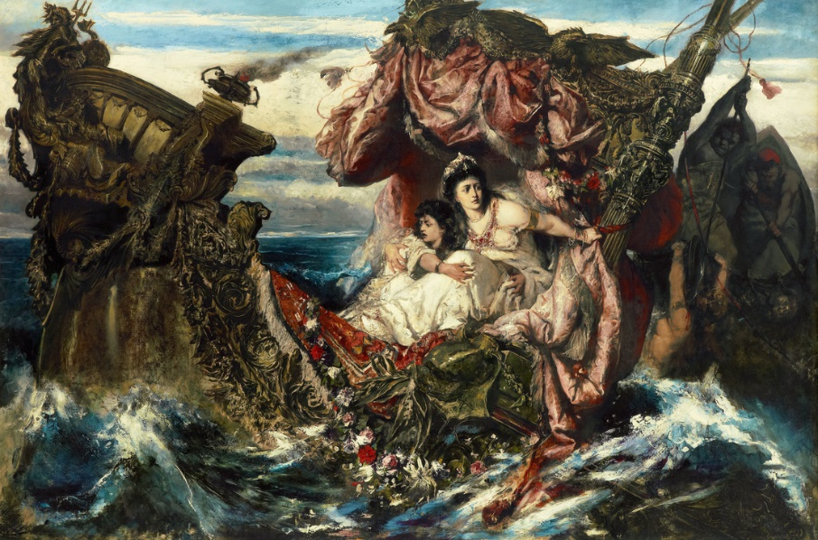34. The over-watchful, over-critical eye that Agrippina kept on whatever Nero said or did proved more than he could stand. He first tried to embarrass her by frequent threats to abdicate and go into retirement in Rhodes. Then, having deprived her of all honour and power, and even of her Roman and German bodyguard, he expelled her from the Palatine, after which he did everything possible to annoy her, sending people to pester her with lawsuits while she stayed in Rome, and when she took refuge on her country estates making them constantly drive or snail past the windows, disturbing her with jeers and catcalls. In the end threats and violent behaviour terrified him into deciding that she must die. He tried to poison her three times, but she had always taken the antidote in advance; so he rigged up a machine in the ceiling of her bedroom which would dislodge the panels and drop them on her while she slept. However, someone gave the secret away. Then he had a collapsible cabin boat designed which would either sink or fall in on top of her. Under pretence of a reconciliation, he sent the most friendly note inviting her to celebrate the Quinquatrus with him at Baiae, and on her arrival he made one of his captains stage as accidental collision with the galley in which she had sailed. Then he protracted the feast until a late hour, and when at last she said, 'I really must get back to Bauli' he offered her his collapsible boat instead of the damaged galley. Nero was in a very happy mood as he led Agrippina down to the quay, and even kissed her breasts before she stepped aboard. He sat up all night, on tenterhooks of anxiety, waiting for news of her death. At dawn Lucius Agermus, her freedman, entered joyfully to report that, although the ship had foundered, his mother had swum to safety, and that he need have no fears on her account. For want of a better plan, Nero ordered one of his men to drop a dagger surreptitiously beside Agermus, whom he arrested at once on a charge of attempted murder. After this he arranged for Agrippina to be killed, and made it seem as if she had sent Agermus to assassinate him but committed suicide on hearing that the plot had miscarried. Other more gruesome details are supplied by reliable authorities: it appears that Nero rushed off to examine Agrippina's corpse, handling her legs and arms critically and, between drinks, discussing their good and bad points. Though encouraged by the congratulations which poured in from the army and the Senate and the People, he was never thereafter able to free his conscience from the guilt of this crime. He often admitted that the Furies were pursuing him with whips and burning torches, and he set Persian mages at work to conjure up his mother's ghost and make her stop haunting him. During his tour of Greece he dared not participate in the Eleusinian Mysteries when a herald ordered all criminals present to withdraw before the ceremonies began.

**Failed attempt 1:**

**Failed attempt 2:**

**Failed attempt 3**

**Successful attempt 4:**

Having disposed of his mother, Nero proceeded to murder his aunt Domitia. He found her confined to bed with severe constipation. The old lady stroked his downy beard affectionately – he was already full grown – murmuring, 'Whenever you celebrate your coming of age and present me with this, I shall die happy.' Nero turned to his courtiers and said laughingly, 'In that case I must shave at once' - which he did. Then he ordered the doctors to give her a laxative pf fatal strength, seized her property before she was quite dead, and avoided all legal complications by tearing up the will.

**Nero’s wives**

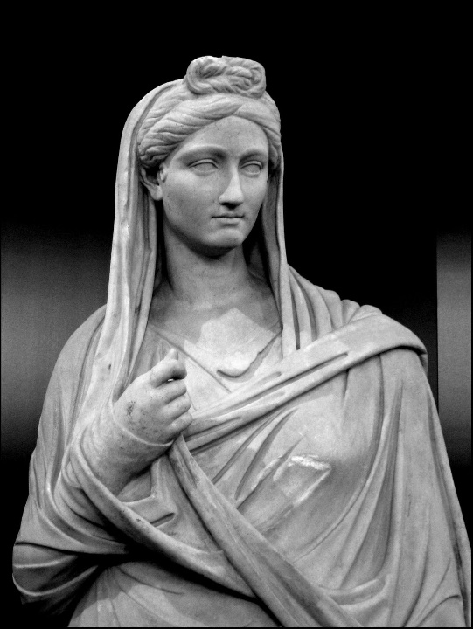**TASK:** from the whole of the course you have studied so far, give any examples of wives the sources present as ‘good’ and those they present as ‘bad’. For each record the characteristics that they are praised or criticised for.

***‘Bad’ Wives?***

***‘Good’ Wives?***

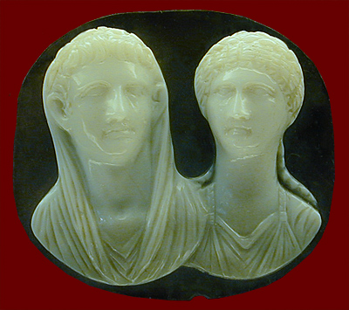Nero’s wives do not receive that much attention from the ancient writers. They tend to be portrayed to match the traditional stereotypes as either symbols of virtue or overly-ambitious and depraved.

Nero’s first wife **Octavia** (see the image showing Nero and Octavia) was the daughter of Claudius and married Nero in AD 53. The marriage was by all accounts loveless and for Nero, Octavia’s value was in her direct link to Claudius, which in turn strengthened his legitimacy. Nero began to have an affair with a freedwomen – **Acte** – and would go on to have Octavia exiled on charges of sexual misconduct (note how the accusation of being sexually perverse or promiscuous is often used to attack a wife or woman in power). 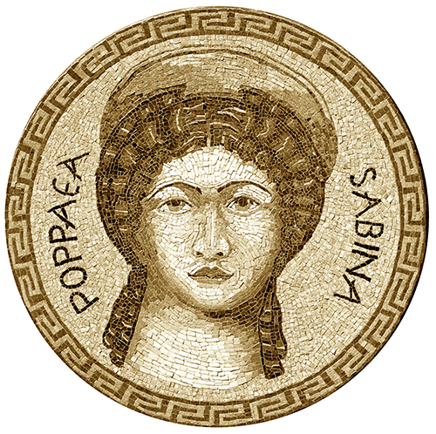Octavia was murdered in AD 62.

After his affair with Acte, Nero moved on to **Poppaea Sabina**. Nero’s mother opposed the marriage to Poppaea and it is suggested by **Tacitus** that this was one of Nero’s motives for murdering both Octavia and Agrippina:

**Prescribed Source – Tacitus, *Annals* 14.1**

When the new year came, and Gaius Vipstanus Apronianus and Gaius Fonteius Capito became consuls, Nero ceased delaying his long-mediated crime. The longer his reign lasted, the bolder he became. Besides, he loved Poppaea more every day. While Agrippina lived, Poppaea saw no hope of his divorcing Octavia and marrying her. So she nagged and mocked him incessantly. He was under his guardian’s thumb, she said – master neither of the empire nor of himself. ‘Otherwise’, she said, ‘why these postponements of our marriage? I suppose my looks and victorious ancestors are not good enough. Or do you distrust my ability to bear children? Or the sincerity of my love?

‘No! I think that you are afraid that, if we married, I might tell you frankly how the senate is downtrodden and the public enraged by your mother’s arrogance and greed. If Agrippina can only tolerate daughters-in-law who hate her son, let me be Otho’s wife again! I will go anywhere in the world where I only need to hear of the emperor’s humiliations rather than see them – and see you in danger, like myself!’ This appeal was reinforced by tears and all a lover’s tricks. Nero was won. Nor was their any opposition, Everyone longed for the mother’s domination to end. But no one believed that her son’s hatred would go as far as murder.

1. **How does Tacitus portray both Agrippina and Poppaea in this extract?**

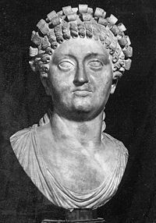

**Tacitus’** portrayal of Poppaea reveals his own prejudice towards a woman holding political influence or power in Rome (this is shared by another elite, conservative writer Dio). Josephus on the other hand describes Poppaea as a much more positive figure and as an intelligent politician. Nero also clearly valued Poppaea’s influence and role and commemorated this in coinage. Poppaea, however died in AD 65, she had given birth to Nero’s daughter Claudia but she too died at only four months. Nero would deify both of them. This can be taken as evidence of his genuine affection towards Pompaea but **Tacitus** suggest that Nero may have attacked Poppaea whilst she was pregnant meaning that his praise for her after her death may have also been motivated by guilt.

Nero’s third wife was **Statilia Messalina**. She was the great-great-granddaughter of Augustus’ general Statilius Taurus. This choice was designed to be ‘sensible’ and demonstrate Nero’s respectability (although Suetonius claims that Nero killed Statilia’s husband to marry her). The marriage to Nero would be Statilia’s fifth and she would outlive Nero to marry two more times.

1. **What does the information about Nero’s wives reveal or suggest about:**

|  |  |
| --- | --- |
| **Nero** | **The Ancient Authors** |
|  |  |

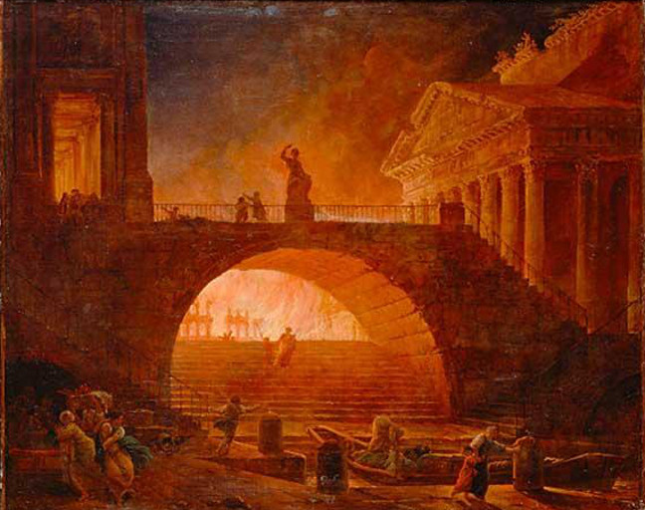**The Great Fire of Rome, July AD 64**

**RECAP**: what can you remember about the fire of Rome from the work you complete at ‘Go to Godalming Day’?

The fire that broke out in AD 64 would burn for six days and destroy three of Rome’s 14 districts leaving only four untouched by the fire.

It would also became one of the more infamous and controversial events of Nero’s reign. Some sources, in particular **Suetonius,** claim that Nero deliberately started the fire to clear areas of the city to create, among other things, his new palace the ***Domus Aurea***‘Golden House’. Another famous rumour was that Nero sang whilst watching the city burn.

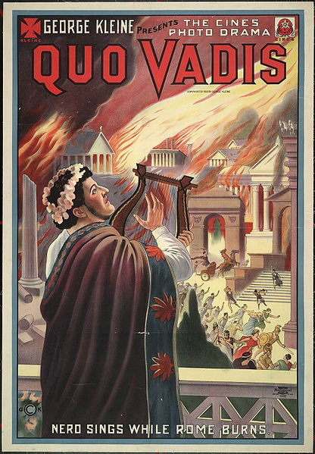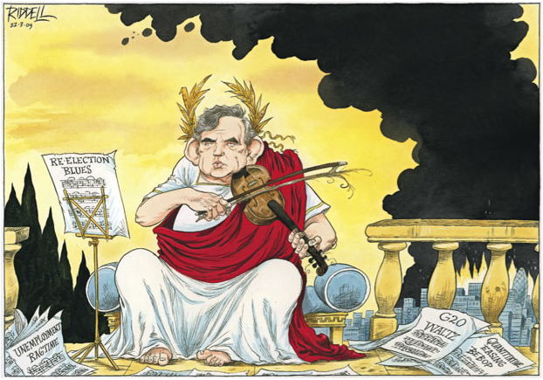

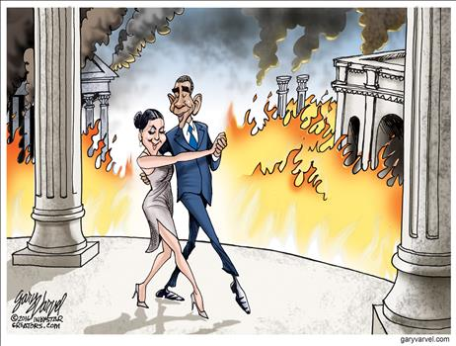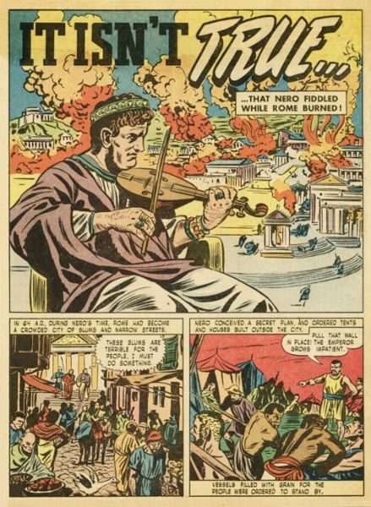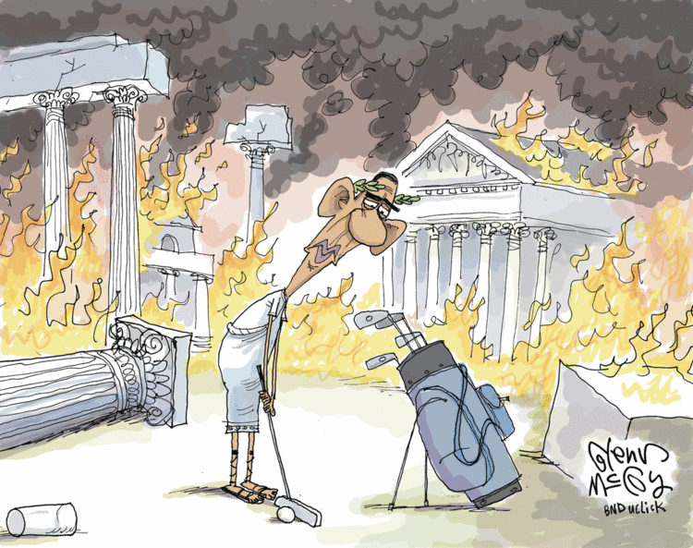

***“Nero fiddled while Rome burned…”***

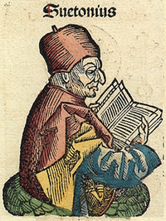**The accounts of the Fire of Rome**

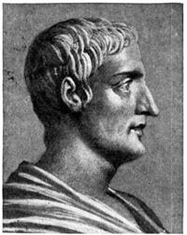

***Tacitus***

***Suetonius***

**Prescribed Source – Suetonius, *Nero* 38**

38. Nero showed no greater mercy to the common folk, or to the very walls of Rome. Once in the course of general conversation, someone quoted the line 'When I am dead, may fire consume the earth,' but Nero said that the first part of the line should read 'While I yet live', and soon converted this fancy into fact. Pretending to be disgusted by the drab old buildings and narrow, winding streets of Rome, he brazenly set fire to the city, and though a number of former consuls caught his attendants trespassing on their property with to and blazing torches, they dared not interfere. He also coveted the sites of several granaries, solidly built in stone, near the Golden House; having knocked down their walls with siege engines, he set the interiors ablaze. This terror lasted for six days and seven nights, causing many people to take shelter in the tombs. Not only did a vast number of tenements burn down, but houses which had belonged to famous generals and were still decorated with their trophies; temples too, dating back to the time of the kingship, and others dedicated during the Punic and Gallic wars – in fact every ancient monument of historical interest that had hitherto survived. Nero watched the conflagration from the tower in the Gardens of Maecenas, enraptured by what he called 'the beauty of the flames', then put on his tragedian's costume and sang *The Fall of Troy* from beginning to end. He offered to remove corpses and rubble free of charge, but allowed nobody to search among ruins even of his own home; he wanted to collect as much loot as possible himself. Then he opened a fire-relief fund and insisted on contributions, which bled the provincials white and practically beggared all private citizens.

**Prescribed Source – Tacitus, *Annals* 15.38-44**

15.38. Disaster followed. Whether it was accidental or caused by criminal act on the part of the emperor is uncertain – both versions have supporters. Now started the most terrible and destructive fire which Rome had ever experiences. It began in the Circus, where it adjoins the Palatine and Caelian hills. Breaking out in shops selling inflammable goods, and fanned by the wind, the conflagration instantly grew and swept the whole length of the Circus. There were no walled mansions or temples, or any other obstructions, which could arrest it. First, the fire swept over the level spaces. Then it climbed the hills - but returned to ravage the lower ground again. It out-stripped every counter-measure. The ancient city’s narrow winding streets and irregular blocks encouraged its progress.

Terrified shrieking women, helpless old and young, people intent on their own safety, people unselfishly supporting invalids or waiting for them, fugitives and lingerers alike – all heightened the confusion. When people looked back, menacing flame sprang up before them or outflanked them. When they escaped to a neighbouring quarter, the fire followed – even districts believed remote proved to be involved. Finally, with no idea where or what to flee, they crowded on to the country roads, or lay in the fields. Some who had lost everything – even their food for the day – could have escaped, but preferred to die. So did others, who had failed to rescue their loved ones. Nobody dared fight the flames. Attempts to do so were prevented by menacing gangs. Torches, too, were openly thrown in, by men crying that they acted under orders. Perhaps they had received orders. Or they may just have wanted to plunder unhampered.

15.39. Nero was at Antium. He only returned to the city when the fire was approaching the mansion he had built to link the Gardens of Maecenas to the Palatine. The flames could not be prevented from overwhelming the whole of the Palatine, including his palace. Nevertheless, for the relief of the homeless, fugitive masses he threw open the Field of Mars, including Agrippa’s public buildings, and even his own Gardens. Nero also constructed emergency accommodation for the destitute multitude. Food was brought from Ostia and neighbouring towns, and the price of corn was cut to less than ¼ sesterces a pound. Yet these measures, for all their popular character, earned no gratitude. For a rumour had spread that, while the city was burning, Nero had gone on his private stage and, comparing modern calamities with ancient, had sung of the destruction of Troy.

15.40. By the sixth day enormous demolitions had confronted the raging flames with bare ground and open sky, and the fire was finally stamped out at the foot of the Esquiline Hill. But before panic had subsided, or hope revived, flames broke out again in the more open regions of the city. Here there were fewer casualties; but the destruction of temples and pleasure arcades was even worse. This new conflagration caused additional ill-feeling because it started on Tigellinus’ estate in the Aemilian district. For people believed that Nero was ambitious to found a new city to be called after himself.

Of Rome’s fourteen districts only four remained intact. Three were levelled to the ground. The other seven were reduced to a few scorched and mangled ruins. 14.41. To count the mansions, blocks, and temples destroyed would be difficult. They included shrines of remote antiquity, such as Servius Tullius’ temple of the Moon, the Great Altar and holy place dedicated by Evander to Hercules, the temple vowed by Romulus to Jupiter the Stayer, Numa’s sacred residence, and Vesta’s shrine containing Rome’s household gods. Among the losses, too, were the precious spoils of countless victories. Greek artistic masterpieces, and authentic records of old Roman genius. All the splendour of the rebuilt city did not prevent the older generations from remembering these irreplaceable objects. It was noted that the fire had started on July 19th, the day on which the Senonian Gauls had captured and burnt the city. Others elaborately calculated that the two fires were separated by the same number of years, months, and days.

14.42. But Nero profited by his country’s ruin to build a new palace. Its wonders were not so much customary and commonplace luxuries like gold and jewels, but lawns and lakes and faked rusticity – woods here, open spaces and views there. With their cunning, impudent artificialities, Nero’s architects and engineers, Severus and Celer, did not balk at effects which nature herself had ruled out as impossible.

They also fooled away an emperor’s riches. For they promised to dig a navigable canal from Lake Avernus to the Tiber estuary, over the stony shore and mountain barriers. The only water to feed the canal was in the Pontine marshes. Elsewhere, all was precipitous or waterless. Moreover, even if a passage could have been forced, the labour would have been unendurable and unjustified. But Nero was eager to perform the incredible; so he attempted to excavate the hills adjoining Lake Avernus. Traces of his frustrated hopes are visible today.

15.43. In parts of Rome unfilled by Nero’s palace, construction was no – as after the burning by the Gauls – without plan or demarcation. Street-fronts were of regulated alignment, streets were broad, and houses built round courtyards. Their height was restricted, and their frontages protected by colonnades. Nero undertook to erect these at his own expense, and also to clear debris from building-sites before transferring them to their owners. He announced bonuses, in proportion to rank and resources, for the completion of houses and blocks before a given date. Rubbish was to be dumped in the Ostian marshes by corn ships returning down the Tiber.

A fixed proportion of every building had to be massive, untimbered stone from Gabii or Alba (these stones being fireproof). Furthermore, guards were to ensure a more abundant and extensive public water-supply, hitherto diminished by irregular private enterprise. House-holders were obliged to keep fire-fighting apparatus in an accessible place; and semi-detached houses were forbidden – they must have their own walls. These measures were welcomed for their practicality, and they beautified the new city. Some, however, believed that the old town’s conflagration had been healthier, since its narrow streets and high houses had provided protection against burning sun, whereas now the shadowless open spaces radiated a fiercer heat.

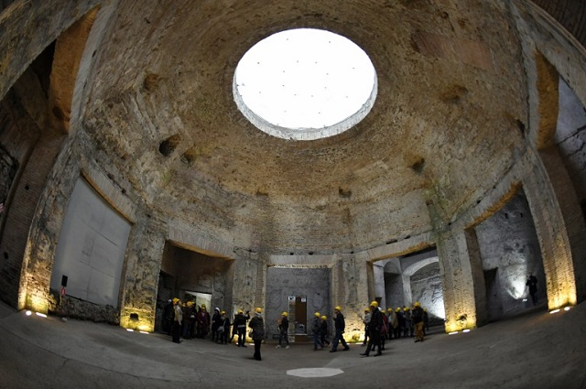Whether it was his motive or not, Nero did take advantage of the fire to rebuild parts of Rome. This centred-around the *Domus Aurea* or ‘Golden House’ which would be Nero’s new, vast palace complex and included a revolving dining room:

**Prescribed Source - Pliny, *Natural History* 36.111**

But two houses have dwarfed all of these. We have twice seen the whole city encircled by the palaces of the *princeps* Gaius and Nero, the latter's being nothing less than a house of gold.

**Prescribed Source – Suetonius, *Nero* 31-32**

31. His wastefulness showed most of all in the architectural projects. He built a house stretching from the Palatine to the Esquiline which he called the 'The Passageway', and when it burned down soon afterwards he rebuilt it under the new name of 'The Golden House'. The following details will give some notion of its size and magnificence. A huge statue of himself, 120 feet high, stood in the entrance hall and a threefold portico ran for a whole mile. An enormous pool, more like a sea than a pool, was surrounded by buildings made to resemble cities, and by a landscape garden consisting of ploughed fields, vineyards, pastures and woodlands – where every variety of domestic and wild animal roamed about. Parts of the house were overlaid with gold and studded with precious stones and mother-of-pearl. All the dining rooms had ceilings of fretted ivory, the panels of which could slide back and let a rain of flowers, or perfume from hidden sprinklers, shower upon the guests. The main dining room was circular, and its roof revolved slowly, day and night, just like the sky. Sea water or sulphur water was always on tap in the baths. When the palace had been decorated throughout in this lavish style, Nero dedicated it, and condescended to remark, 'Good, not I can at least begin to live like a human being!"

The fire of Rome in AD 64 and Nero’s response to it did have some positive outcomes. In the long-term, it allowed future emperors to launch ambitious rebuilding programmes that would improve the city. In the shorter-term, new building regulations were brought in under Nero that would strengthen Rome from future fires. Nero’s building work could also be said to have increased the magnificence and glory or Rome – its ***lustre.*** An example of this was his construction of a Triumphal Arch sometime between AD 58 and 62, which Nero commemorated on the following coin:

[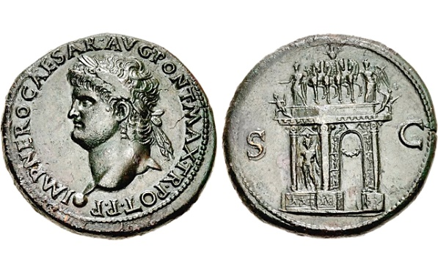](https://www.google.co.uk/url?sa=i&rct=j&q=&esrc=s&source=images&cd=&cad=rja&uact=8&ved=2ahUKEwjuydWa4uLaAhXCvhQKHXDbDqEQjRx6BAgBEAU&url=https://www.coinworld.com/news/world-coins/2015/05/evidence-of-ancient-triumphal-arch-found-on-coin-of-nero.all.html&psig=AOvVaw17o0ovpZiMiv2StQ_I1a1R&ust=1525204090783638)**Prescribed Source – Sesterces showing Arch of Nero, AD 64**

**Obv.:** Heads of Nero; ‘Nero Claudius Caesar Augustus Germanicus, Pontifex maximus, with tribunician power, victorious commander father of the fatherland’

**Rev.:** Triumphal arch. Nero in four horse chariot on top, accompanied by Victory and Peace. Figure of Mars on side of arch; ‘By decree of the Senate’

However, this is also revealing about Nero as the Triumph was originally intended for the general Corbulo only for Nero to take it as his own and celebrate it publicly. **Gnaeus Domitius Corbulo** was the leading general of Claudius’ and Nero’s reigns who between AD 54 and 63 campaigned in Armenia and Syria to put down rebellions and mange local politics. He was ordered to commit suicide by Nero in 67 who was becoming concerned about his growing popularity.

Overall the sources want to add the fire of Rome to the outrages committed by Nero. **Suetonius** in particular builds a picture of Nero disgracing his family, the Senate and then finally, with the fire, the people and the city of Rome.



**Extension Task**

For a very good summary of the Great Fire of Rome and the historical accounts of it, read Richard Cavendish’ article **“The Great Fire of Rome”** available at [www.historytoday.com](http://www.historytoday.com) (Username: godalming; Password: history)

**Nero’s attitude towards religion and imperial cult**

The sources give very little detail on Nero’s attitude towards the imperial cult and most-likely he was uninterested in it (think about how much of a contrast this is with Gaius). Contemporary poets do praise Nero as a god but this doesn’t suggest a deliberate attempt of the emperor to emphasise himself as living god. Instead the poets were copying the style of Augustan poets (e.g. Virgil) who spoke of the emperor as a god.

[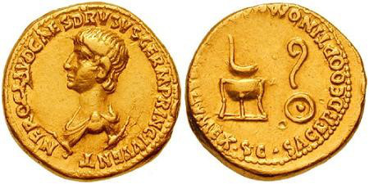](https://www.google.co.uk/url?sa=i&rct=j&q=&esrc=s&source=images&cd=&cad=rja&uact=8&ved=2ahUKEwjPhIHg6eLaAhVGRhQKHbi7C5IQjRx6BAgBEAU&url=https://ancientglass.wordpress.com/2016/11/11/roman-glass-simpulum-continued-from-another-page/&psig=AOvVaw1Skwwxj5TOIdE3C6SwrTV9&ust=1525206124629634)Nero does appear, however, determined to defend traditional Roman religion from non-traditional religions. Nero was again trying to emulate (copy) Augustus for whom restoring traditional Roman values was a key goal. An example of this was Nero’s induction into the priestly college during the reign of Claudius, which was commemorated in the following coin:

**Obv.:** Draped head of Nero; ‘Nero Claudius Caesar Drusus Germanicus, leader of the younger generation’

**Rev.:** Ladle above tripod to left; augur’s wand above dishes (used in sacrifices) to right, ‘Co-opted as an additional member of every college of priests, by decree of the senate’

Nero was clearly trying to show Rome how seriously he took his religious role by taking part in this traditional Roman cult.

The commitment to traditional Roman religion can also be seen in Nero’s treatment of Christians following the fire in AD 64. According to **Tacitus:**

**Prescribed Source – Tacitus, Annals 15.44**

15.44. So much for human precautions. Next came attempts to appease heaven. After consultation of the Sibylline books, prayers were addressed to Vulcan, Ceres, and Proserpina. Juno, too, was propitiated. Women who had been married were responsible for the rites – first on the Capitol, then at the nearest sea-board, where water was taken to sprinkle her temple and statue. Women with husbands living also celebrated ritual banquets and vigils.

But neither human resources, nor imperial munificence, nor appeasement of the gods, eliminated sinister suspicions that the fire had been instigated. To suppress this rumour, Nero fabricated scapegoats – and punished with every refinements the notoriously depraved Christians (as they were popularly called). Their originator, Christ, had been executed in Tiberius’ reign by the governor of Judaea, Pontius Pilatus. But in spite of this temporary setback the deadly superstition had broken out afresh, not only in Judaea (where the mischief had started) but even in Rome. All degraded and shameful practices collect and flourish in the capital.

First, Nero had self-acknowledged Christians arrested. Then, on their information, large numbers of others were condemned – not so much for incendiarism as for their anti-social tendencies. Their deaths were made farcical. Dressed in wild animals’ skins, they were torn to pieces by dogs, or crucified, or made into torches to be ignited after dark as substitutes for daylight. Nero provided his Gardens for the spectacle, and exhibited displays in the Circus, at which he mingled with the crowd – or stood in a chariot, dressed as a charioteer. Despite their guilt as Christians, and the ruthless punishment it deserved, the victims were pitied. For it was felt that they were being sacrificed to one man’s brutality rather than to the national interest.

1. **Why according to Tacitus did Nero execute Christians?**
2. **Why despite their ‘guilt’ did people pity the Christians?**

**Relations with the senate, equestrians and plebs**

**Senate**

Most of our sources look at Nero’s reign from a senatorial perspective and are extremely critical of his ‘humiliation of the senate’. Nero’s reign began relatively well with the senate but soon worsened as he focused on indulging his own passions.

**Prescribed Source – Tacitus, *Annals,* 14.13-14**

14.13. Nero lingered in the cities of Campania. His return to Rome was a worrying problem. Would the senate be obedient? Would the people cheer him? Every bad character (and no court had ever had so many) reassured him that Agrippina was detested, and that her death had increased his popularity. They urged him to enter boldly and see for himself how he was revered. Preceding him – as they had asked to – they found even greater enthusiasm than they had promised. The people marshalled in their tribes were out to meet him., the senators were in their gala clothes, wives and children drawn up in lines by sex and age. Along his route there were tiers of seats as though for a triumph. Proud conqueror of a servile nation, Nero proceeded to the Capitol and paid his vows.

Then he plunged into the wildest improprieties, which vestiges of respect for his mother had hitherto not indeed, but at least impeded.

[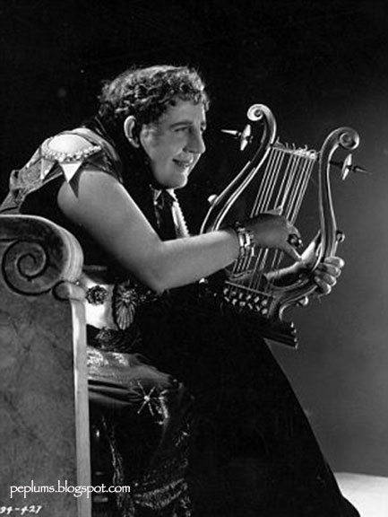](https://www.google.co.uk/url?sa=i&rct=j&q=&esrc=s&source=images&cd=&cad=rja&uact=8&ved=2ahUKEwjskdrp-OLaAhWBtBQKHSNLB1gQjRx6BAgBEAU&url=http://www.peplumtv.com/2012/09/nero-and-his-lyre-while-rome-burns.html&psig=AOvVaw1rNtt6asfoVSbhMBcUJWTF&ust=1525210167972388)14.14. Nero had long desired to drive in four-horse chariot races. Another equally deplorable ambition was to sing to the lyre, like a professional. ‘Chariot-racing’, he said, ‘was an accomplishment of ancient kings and leaders - honoured by poets, associated with divine worship. Singing, too, is sacred to Apollo: the glorious and provident god is represented in a musician’s dress in Greek cities, and also in Roman temples.’

There was no stopping him. But Seneca and Burrus tried to prevent him from gaining both his wishes by conceding one of them. In the Vatican alley, therefore, an enclosure was constructed, where he could drive his horses, remote from public eye. But soon the public were admitted – and even invited; and they approved vociferously. For such is a crowd: avid for entertainment, and delighted if the emperor shares their tastes. However, this scandalous publicity did not satiate Nero, as his advisers had expected. Indeed, it led him on. But if he shared his degradation, he thought it would be less; so he brought on to the stage members of the ancient nobility whose poverty made them corruptible. They are dead, and I feel I owe it to their ancestors not to name them. For though they behaved dishonourably, so did the man who paid them to offend (instead of not to do so). Well-known knights, too, he induced by huge presents to offer their services in the arena. But gifts from the man who can command carry with them an obligation.

1. **From this source, why might there be considerable opposition to Nero from the Senate?**
2. **From the source, how did the Senate react to Nero?**

One exception in the Senate, mentioned in Tacitus was **Thrasea Paetus** who he used as a voice of opposition to Nero and as an exaggerated symbol of senatorial virtue (remember that Tacitus himself was a senator). For example, Tacitus tells us that when the Senate was competing to give Nero and his family the most extravagant gift, Paetus **“walked out of the senate – thereby endangering himself without bringing general freedom any nearer” (Tacitus , 14.12).** Under future emperors this would become known as **stoic** opposition but although Tacitus presents it as noble, even he admits that it was the exception under Nero and that it achieved little. As with most if not all of the emperors we have studied, the Senate were generally sycophantic and compliant.

**Equestrians**

Whilst Nero was humiliating the senate he made more use of the equestrians. **Gaius Ofonius Tigellinus** was an equestrian who was made Praetorian Prefect in AD 62 despite his relatively low birth. Tacitus is again very critical of this and accuses Tigellinus of corrupting Nero, encouraging him to take part in immoral behaviour only to desert him upon his downfall. For example:

**Prescribed Source – Tacitus, *Annals*, 15.37**

15.37. Nero himself now tried to make it appear that Rome was his favourite abode. He gave feasts in public places as if the whole city were his own home. But the most prodigal and notorious banquet was given by Tigellinus. To avoid repetitious accounts of extravagance, I shall describe it, as a model of its kind. The entertainment took place on a raft constructed on Marcus Agrippa's lake. It was towered by other vessels, with gold an ivory fittings. Their rowers were degenerates, assorted according to age and vice. Tigellinus had also collected birds and animals from remote countries, and even the products of the ocean. On the quays were brothels stocked with high-ranking ladies. Opposite them could be seen naked prostitutes, indecently posturing and gesturing.

At nightfall the woods and houses nearby echoed with singing and blazed with lights. Nero was already corrupted by every lust, natural and unnatural. But he now refuted any surmises that no further degradation was possible for him. For a few days later he went through a formal wedding ceremony with one of the perverted gang called Pythagoras. The emperor, in the presence of witnesses, put on the bridal veil. Dowry, marriage bed, wedding torches, all were there. Indeed everything was public which even in a natural union is veiled by night.

In addition to this, equestrians were also an important part of Nero’s ‘fan club’ which attended his performances and were payed to applaud the emperor:

**Prescribed Source – Suetonius, *Nero*, 20**

He also chose a few young *equites* and more than 5,000 ordinary youths, whom he divided into claques to learn the various Alexandrian methods of applause, - they were known respectively as 'Bees', 'Roof tiles' and 'Brick-bats' - and to provide it liberally whenever he sang. It was easy to recognize them by their pomaded hair, splendid dress and absence of rings on their left hands. The *equites* who led them earned 400,000 sesterces a performance.

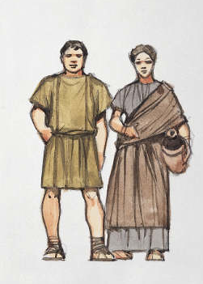**Plebs**

**Recap:** From what you have gained so far about Nero’s character and behaviour how popular would you expect him to be with the Plebs?

Of all the groups in Rome, Nero craved popularity from the plebs. **Tacitus** is unsurprisingly **snobbish** about this need for their support as can be seen from the source on the page before –

**“But soon the public were admitted – and even invited; and they approved vociferously. For such is a crowd: avid for entertainment, and delighted if the emperor shares their tastes”**

Nero clearly, however, understood the importance of the **‘bread and circuses’** policy and carried this out well. Like previous emperors (Augustus and Claudius in particular) he combine public generosity – ***largesse*** *–* with free hand-outs of corn to maintain the support of ordinary Romans.

**Prescribed Source – Suetonius*, Nero*, 11**

11. He gave an immense variety of entertainments - youth games, chariot races in the Circus, stage plays, a gladiatorial show – persuading even old men of consular rank, and old ladies too, to attend the youth games. He reserved seats for the *equites* at the Circus, and actually raced four-camel chariots! At the Great Games, as he called the series of plays devoted to the hope of his reigning for ever, parts were taken by men and women of both orders, and one well-known *eques* rode an elephant down a sloping tightrope. When he staged *The Fire*, a Roman play by Afranius, the actors were allowed to keep the valuable furnishings they rescued from the burning house. Throughout the games all kinds of gifts were scattered to the people – 1,000 assorted birds daily, and quantities of food parcels, besides vouchers for grain, clothes, gold, silver, precious stones, pearls, paintings, slaves, transport animals, and even trained wild beasts – and finally for ships, blocks of tenements, and farms.

**Suetonius** shows us the range of entertainments Nero provided for the people and also gives a hint in this source of Nero’s distribution of food/grain which he also wanted to be publicly celebrated:

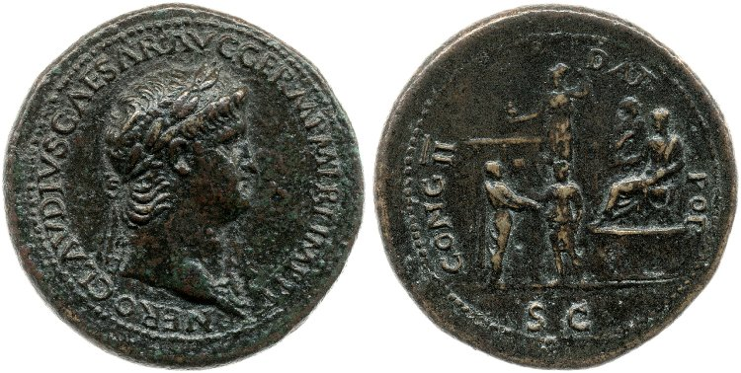**Prescribed Source – Sestertius of Nero, AD 64**

**Obv.:** Head of Nero; Nero Claudius Caesar Augustus Germanicus, pontifex maximus, with tribunician power, victorious commander, father of the fatherland’

**Rev.:** Nero in a toga on a platform with the prefect of the corn dole behind him. An attendant in the centre hands a token to a standing citizen in a toga. Minerva stands behind with owl and spear in hand, beside the flat roof of a building, ‘He gives a second handout to the people’

Nero did not, however, remain universally popular with the plebs throughout his reign (AD 54-68) and the sources suggest that towards the end he was losing their support too:

**Prescribed Source – Suetonius*, Nero*, 45**

45. He aggravated popular resentment by profiteering in grain, which was already priced far too high. And, unluckily for him, word went around during the general shortage of food that a ship from Alexandria had just unloaded a cargo of sand for the imperial wrestlers.

Nero was now so universally loathed that no abuse could be found bad enough for him. Someone tied a tress of hair to the head of one of his statues with a note attached in Greek: 'This is a real contest for once, and you are going to lose!' A leather bag was draped around the neck of another statue, with a similar note reading, 'I have done what I could, but you deserve the sack.' Insults were scrawled on columns about his crowing having aroused even the cocks, and many people played the trick of pretending to have trouble with their slaves at night and shouting out, 'Vengeance is coming!'

1. **Why according to Suetonius did resentment towards Nero from the plebs begin to increase? (put this in your own words)**
2. **From the source above, how serious was the opposition of the plebs during Nero’s rule?**

As Nero’s reign became increasingly excessive, and in particular following the Great Fire in AD 64, the emperor undoubtedly did lose popularity with the plebs. However, it would be wrong to say that there was mass opposition to Nero and he clearly remained popular with some after his death – remember that several people would claim to be Nero after AD 68 to gain public support showing that the emperor’s name cannot have been that despised.

**Summary Questions**

1. **Would you have rather been a Senator, Equestrian or Pleb during the reign of Nero? Explain your answer fully.**
2. **How useful are the sources in helping us to understand Nero’s relationship with the Senate, equestrians and plebs?**

1. **“Ultimately, Nero was a populist emperor, and as much as he victimised the upper classes, the urban plebs and the majority of the provincials continued to revel in the benefits provided by their pleasure-driven princeps.” (R. Cromarty & J. Harrison, *Rome)***

**How convincing do you find this assessment of Nero’s relationship with the Senate, equestrians and plebs?**

**The Revolt of Vindex; The death of Nero**

After the *quinquennium aureum* The Roman Empire begin to show signs of opposition to Nero and to Roman Rule.

Three rebellions occurred that would shake Nero’s power:

1. Areas of **Britain** rebelled in in 61 under the leadership of **Boudica**
2. **Judaea** rebelled in 66

**Prescribed Source – Dio, *History or Rome* 63:22.1**

Such was the nature of Nero’s life and reign. I shall now recount how he was overthrown and fell from power.

While Nero was still in Greece, the Jews embarked on a rebellion which had been clearly coming. He sent Vespasian to deal with them. The inhabitants of Britain and Gaul, burdened by taxation, were also becoming more restive and inflamed.

1. **Gaul** rebelled under **Gaius Julius Vindex**

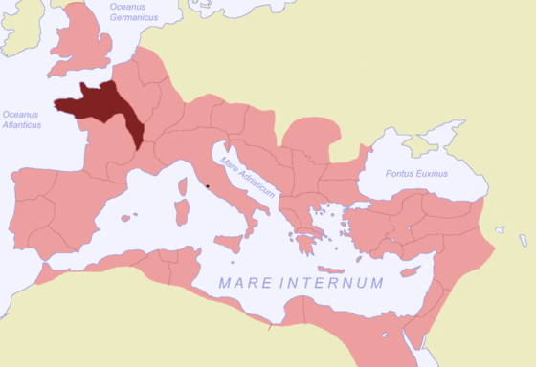Of these, the revolt of Vindex was the most serious and would lead eventually to Nero’s downfall and death. Videx was a ‘Romanised’ Gaul (i.e. one that had adopted Roman culture and ‘civilisation’). He was also a senator and the provincial governor of ***Gallia Lugdunensis*** making his revolt in AD 68 particularly threatening to Nero.

**The Sources and the revolt of Vindex**

Before looking at the events and consequences of Vindex’s revolt it is important to understand how the sources want to portray these events. Firstly, the most detailed account of Nero’s reign – Tacitus – ends in AD 66 meaning that the most important author in helping us to understand the revolt is **Dio**. Dio presents Vindex as the natural punishment for the excesses of Nero’s reign and also as the opposite of Nero himself. Whereas Nero had betrayed Roman culture in favour of Greek, Vindex, a Gaul, had embraced Roman values and culture. **Dio**, therefore, clearly wants us to view Vindex as a heroic figure, claiming that:

There was a man from Gaul called Gaius Julius Vindex, an Aquitanian of royal descent, and, by virtue of his father’s rank, a Roman senator. He was a man strong in physique and shrewd intelligence, skilled in warfare and not lacking in courage to meet any big challenge. He also had a passionate love of freedom and boundless ambition.

In addition to this image, Dio also wants to make Vindex a champion of freedom against the tyranny of Nero. Ina speech **Dio** records him as saying:

“Now, therefore, is the time to rise up against him. Rescue yourselves and rescue the Romans as well! Liberate the entire world!”

Overall we cannot take Dio’s account of the Vindex rebellion at face value as he portrays Vindex in the most favourable light possible to make Nero’s downfall look like the natural outcome of his tyrannical rule.

However, there is also evidence from Vindex himself that supports the idea that he claimed to be rebelling to protect Rome and its people from Nero and that he was also acting on behalf of the Senate and the people:

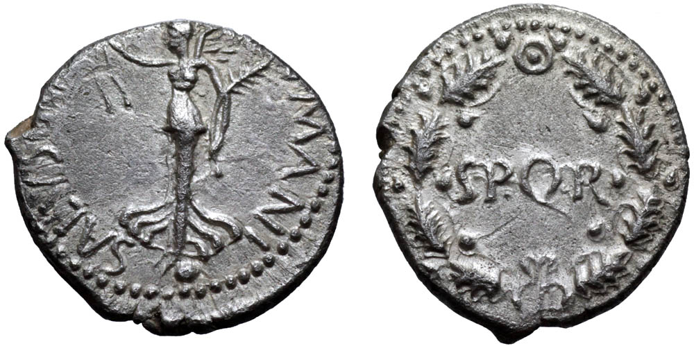**Prescribed Source – Denarius of Vindex, AD 68**

**Obv.:** Victory standing on a globe, with a wreath in her right hand and a palm in her left; ‘Salvation of the human race’

**Rev.:** Oak wreath; Senate and the people of Rome

**Prescribed Source – Suetonius, *Nero*, 40**

40. At last, after nearly fourteen years of Nero's misrule, the earth rid herself of him. The first move was made by the Gauls under Julius Vindex, the praetorian governor of the province.

1. **How does Suetonius present the revolt of Vindex and how similar is this to Dio?**

**The events of the Revolt**

[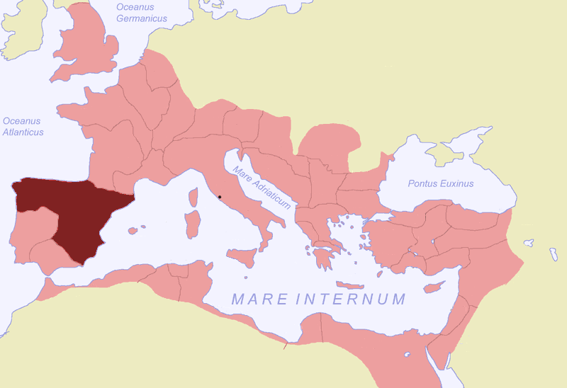](https://upload.wikimedia.org/wikipedia/commons/c/cd/Tarraconensis_SPQR.png)When the rebellion started Nero was away from Rome in Neapolis and we are told that he did nothing in response for eight days. Suetonius even claims that Nero welcomed the rebellion as it would give him an excuse to fight a campaign in Gaul and strip the Gaul’s of their wealth. Nero underestimated the threat posed by Vindex but may have also been aware that he had no direct access to any legions whilst the emperor should be able to rely on legions in Upper Germany, under the control of **Lucius Verginius Rufus**, to put down the rebellion.

Nero began to take the revolt more seriously when **Servius Sulpicius Galba**, governor of a province in northern Spain, was declared emperor by his soldiers in AD 68. This came after Vindex had appealed for help and meant that revolt appeared to be spreading across the empire. The sources are again very critical of Nero’s response. Suetonius claims that the only action Nero took was to pack up his stage equipment and choose which concubines to take with him.

Meanwhile the commander of the legions in Upper Germany, Rufus, marched into Gaul and slaughtered Vindex’s army. 20,000 were killed and Vindex committed suicide.

Rufus’ soldiers went on to try to declare their general emperor. When Rufus refused this saying that only the Senate and People of Rome could decide the issue, the Senate officially endorsed **Galba** as emperor and declared Nero a public enemy. Galba himself began to issue coins presenting himself as the ‘liberator’ 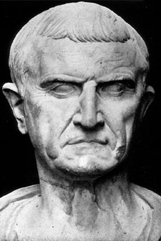of Rome, justifying his rebellion and depicting Nero as a tyrant:

[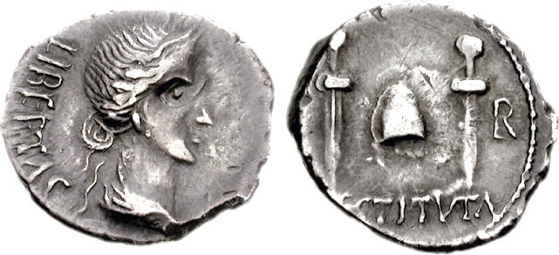](https://www.cngcoins.com/Coin.aspx?CoinID=85173)**Prescribed Source – Denarius of Galba, AD 68**

Obv.: Female with hair in a small knot above neck; ‘Liberty to the people’

Rev.: Pileus between two daggers; ‘Restored’

Galba

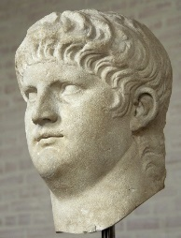By this point Nero had returned to Rome but waking in his palace he found that his guard and servants and deserted him. Nero, realising that he had lost control, fled the city taking only three freemen with him. When Nero knew that he had been discovered by the forces sent to find him he attempted to commit suicide but losing his nerve got one of his freedmen to do this for him. His death appeared to be as dramatic as his performances in life; Nero’s final words were meant to be:

***“Jupiter, what an artist perishes in me!”***

**Nero died 9th June AD 68 and with him the Julio-Claudian dynasty ended.**

Galba would follow Nero as emperor but Rome would descend into civil war and ‘The Year of the Four Emperors’. Out of this **Vespasian** would emerge as the new ruler and founder of the **Flavian dynasty**.

**The Revolt of Vindex; The death of Nero – The Sources**

**Suetonius**

**Prescribed Source – Suetonius *Nero* 40-49**

40. At last, after nearly fourteen years of Nero's misrule, the earth rid herself of him. The first move was made by the Gauls under Julius Vindex, the praetorian governor of the province.

Nero's astrologers had told him that he would one day be removed from public office, and were given the famous reply 'A simple craft will keep a man from want.' This referred doubtless to his lyre playing, which, although it might be only a pastime for a *princeps,* would have to support him if he were reduced to earning a livelihood. Some astrologers forecast that, if forced to leave Rome, he would find another throne in the east; one or two even particularized that of Jerusalem. Other assured him that he would recoup all his losses, a predicted on which he based high hopes, for when he seemed to have lost the provinces of Britain and Armenia, but managed to regain them both, he assumed that the disasters foretold had already taken place. Then the oracle of Apollo at Delphi warned him to beware the seventy-third year, and assuming that this referred to his own seventy-third year, not Galba's he looked forward cheerfully to a ripe old age and an unbroken run of good luck – so much so that when he lost some very valuable objects in a shipwreck, he hastened to tell his friends that the fish would fetch them back to him.

Nero heard of the Gallic revolt on the anniversary of his mother's murder. He was in Neapolis at the time, and took the news so phlegmatically that everyone diagnosed satisfaction at finding a good excuse to declare war on such rich provinces and strip them clean. Going straight to the gymnasium, he was soon engrossed in watching athletic contest, and when a far more serious dispatch reached him at dinner time he still showed no sign if disturbance beyond a threat to punish the rebels. In fact for eight days he wrote no orders and issued no special announcements, apparently trying to ignore the whole affair.

41. At last a series of insulting edicts signed by Vindex must have made some impression on him: in a letter to the Senate he urged them to avenge himself and the commonwealth, but pleaded an infected throat as an excuse for not appearing in person. Two taunts really went home: an insulting claim that he was a bad lyre player and a reference to him as 'Ahenobarbus' rather than 'Nero'. Yet he told the Senate that he had already intended to renounce his adoptive name and resume that of his family; as for his lyre playing, he replied that he could hardly deserve Vindex's taunt (which proved the other accusations just as false) after his long and painstaking cultivation of the art and asked several senators whether they knew of any better performer than himself. When further urgent dispatches arrived in quick succession he hurried back to Rome in a state of terror. On the way, however, he happened to notice a group of monumental sculpture which represented a beaten Gaul being dragged along, head first, by a mounted Roman; this lucky sign sent him into a transport of joy, and he lifted his hands in gratitude to heaven. When, therefore, he arrived in the city, he neglected to address either the Senate or the people; instead he summoned the leading citizens to his home, where, after a brief discussion of the Gallic situation, he devoted the remainder of the session to demonstrating a completely new type of water organ and explaining the mechanical complexities of several different models. He even remarked that he would have them installed in the theatre, 'if Vindex has no objection'.

42. But when news arrived of the revolt of Galba and the Spanish provinces, he fainted dead away and remained mute and insensible for a long while. Coming to himself, he tore his clothes and beat his forehead, crying that all was now over. His old nurse tried to console him by pointing out that many rulers in the past had experienced similar setbacks, but Nero insisted that to lose the supreme power while still alive was something that had never happened to anyone else before. Yet he made not the slightest attempt to alter his lazy and extravagant life. On the contrary, he celebrated whatever good news came in and composed comic songs about the leaders of the revolt, which he set to bawdy tunes and sang with appropriate gestures; these have since become popular favourites. Then he stole into the theatre and sent a message to an actor who was being loudly applauded that he was taking advantage of his leader's absence from the stage on business of state by pushing himself forward.

43. At the first news of revolt Nero is said to have formed several appalling, though characteristic, schemes for dealing with the situation. Thus he intended to recall all army commanders and provincial governors and execute them on a charge of conspiracy, and to slaughter all exiles everywhere, for fear that they might join the rebels, and all Gallic residents at Rome, because they might be implicated in the rising. He further considered giving the army free permission to pillage the Gallic provinces; poisoning the entire Senate at a banquet; and setting fire to the city again, but first letting wild beasts loose in the streets to hinder the citizens from coping with the blaze. However, he had to abandon these schemes, not because he scrupled to carry them out, but because he realized their impracticability in view of the military campaign soon to be forced on him. So he dismissed the consuls from office before their term ended and took over both consulships himself, declaring, 'It stands to reason: only a consul can subdue Gaul.' But one day, soon after assuming the consular insignia, he left the dining room with his arms around two friends' shoulders, and remarked that when he reached Gaul he would at once step unarmed in front of the embattled enemy and weep, and weep. This would soften their hearts and win them back to loyalty, and on the next day he would stroll among his joyful troops singing paeans of victory, which he really ought to be composing now.

44. In his military preparations he was mainly concerned with finding enough wagons to carry his stage equipment and arranging for the concubines who would accompany him to have male haircuts and be issued with Amazonian shields and axes. When this was settled, Nero called the Roman people to arms; but since not an single eligible recruit came forward, he forcibly enlisted a number of slaves, choosing the best from each household and refusing exemption even to stewards or secretaries. All classes had to pay income tax, and every tenant of a private house or flat was told that he owed a year's rent to the imperial exchequer. Nero insisted in being paid in none but newly minted coins, or in silver and gold of high standard; hence many people would not contribute anything, protesting that he would do much better if he reclaimed the fees from his informers.

45. He aggravated popular resentment by profiteering in grain, which was already priced far too high. And, unluckily for him, word went around during the general shortage of food that a ship from Alexandria had just unloaded a cargo of sand for the imperial wrestlers.

Nero was now so universally loathed that no abuse could be found bad enough for him. Someone tied a tress of hair to the head of one of his statues with a note attached in Greek: 'This is a real contest for once, and you are going to lose!' A leather bag was draped around the neck of another statue, with a similar note reading, 'I have done what I could, but you deserve the sack.' Insults were scrawled on columns about his crowing having aroused even the cocks, and many people played the trick of pretending to have trouble with their slaves at night and shouting out, 'Vengeance is coming!'

46. The implications of auspices, of omens old and new, and of his own dreams began to terrify Nero. In the past he had never known what it was to dream, but after killing his mother he dreamed that he was steering a ship and that someone tore the tiller from his hands. Next, his wife Octavia pulled him down into thick darkness, where hordes of winged ants swarmed over him. Then the statues of the nations, which had been dedicated in the Theatre of Pompey, began to hem him in and prevent him from getting away, while his favourite Asturian horse turned into an ape, or all except the head, which whinnied a tune. Finally, the doors of the Mausoleum opened by themselves and a voice from inside called, 'Enter, Nero!'

On the Kalends of January the household gods, which had just ben decorated tumbled to the ground during preparations for the sacrifice, and as Nero was taking the auspices Sporus gave him a ring engraved with Proserpine's descent to the underworld. Then a great crowd gathered to pay their annual vows to Nero, but the keys of the Capitol were mislaid. Again, while his speech against Vindex was being read in the Senate, a passage running 'the criminals will soon incur the punishment and die the death which they so thoroughly deserve' was hailed on all sides with cries 'Augustus, you will do so!' People also noticed that Nero, at his latest public appearance, sang the part of Oedipus in exile and ended with the line 'Wife, mother, father, do my death compel!'

47. When a dispatch bringing the news that the other armies had also revolted was brought him at lunch, he tore it up, pushed over the table, and sent smashing to the ground two of his 'Homeric' drinking cups – so called because they were engraved with scenes from Homer. He made Lucusta give him some poison, which he put in a golden box, and then crossed to the Servilian gardens, where he tried to persuade the tribunes and centurions of the praetorians to flee with him – because his most faithful freedmen had gone ahead to equip a fleet at Ostia. Some answered evasively, others flatly refused; one even shouted out the line 'Is it so terrible a thing to die?'

Nero had no idea what to do. A number of alternatives offered – for example, throwing himself on the mercy of Parthians or of Galba, or appearing pathetically on the Rostra to beg the people's pardon for his sins – thy might at least make him prefect of Egypt, he thought, if they could not find it in their hearts to forgive him altogether. A speech to this effect was later found among the papers in his writing case, and the usual view is that only fear of being torn to pieces before he reached the Forum prevented him from delivering it.

Nero suspended his deliberations until the following day, but woke at midnight to find that his bodyguard had deserted him. He leaped out of bed and summoned his friends. When they did not appear, he went with a few members of his staff to knock at their doors. But nobody either opened or answered. He returned to his room. By now even the servants had absconded with the bed linen and the box of poison. He shouted for Spiculus the gladiator or any other trained executioner to end his misery at one blow. NO one came. 'What? Have I then neither friends nor enemies left?' He cried, and dashed out, apparently intending to hurl himself into the Tiber.

48. Changing his mind once more, however, he said that all he wanted was some secluded spot where he could collect his thought at leisure. Phaon an imperial freedman, suggested his own suburban villa, four miles away, between the Via Salaria and the Via Nomentana. Nero jumped at the offer. He was barefoot and wearing only a tunic, but he simply pulled on a faded cloak and hat, took horse, and trotted off, holding a handkerchief over his face. Only four companions went with him, including Sporus. Suddenly a slight earth tremor was felt and lightning flashed in their eyes, which terrified Nero. Then from the nearby camp he heard soldiers shouting about the defeat which Galba would inflict on him. He heard one man exclaim as they passed, 'Those fellows are in pursuit of Nero,' and another, 'What's the latest news of him in the city?' Then Nero's horse took fright at the smell of a dead body lying by the roadside, which made him expose his face. He was immediately recognized and saluted by the praetorian veteran. They reached a lane leading to Phaon's villa and, abandoning their horses, followed a path which ran through a briar patch and a plantation of reeds to the rear wall of the house. Because the going was difficult Nero made them spread a cloak for him to walk on When begged by Phaon to lie low for a while in a gravel pit, he answered, 'No, I refuse to go underground before I die.' While the servants tunnelled through the wall, he scooped up some water in his hands from a neighbouring pool and drank it, saying, 'This is Nero's own special brew.' Then he pulled out all the thorns from his ragged cloak and crawled into the villa by way of the tunnel. Finding himself in a slave's bedroom, beside a couch with a poor mattress over which an old cape had been thrown, he sank down on it and, although hungry, refused some coarse bread; but he confessed himself still thirsty, and sipped a little warm water.

49. Finally, when his companions unanimously insisted on his trying to escape from the miserable fate threatening him, he ordered them to dig a grave at once, of the right size for his body, and then collect any pieces of marble that they could find and fetch wood and water for the disposal of the corpse. As they bustled about obediently, he muttered through his tears 'Dead! And so great an artist!'

A runner brought a letter to Phaon. Nero tore it from the man's hands and read that, having been declared a public enemy by the Senate, he would be punished in ancient style when arrested. He asked what 'ancient style' meant, and learned that the executioners stripped their victim naked, thrust his head into a wooded fork, and then flogged him to death with sticks. In terror, he snatched up the two daggers which he had brought along and tried their points, but threw them down again, protesting that the fatal hour had not yet come. Then he begged Sporus to weep and mourn for him, and also begged one of them to set him an example by committing suicide first. He kept moaning about his cowardice and muttering, 'How ugly and vulgar my life has become!'; 'This is certainly not fitting for Nero, not fitting at all'; 'I have to keep a stiff upper lip in all this'; 'Come, pull yourself together!' By this time the troop of cavalry who had orders to take him alive were coming up the road. Nero gasped, 'Hark to the sound I hear! It is hooves of galloping horses.' Then, with the help of his secretary Epaphroditus, he stabbed himself in the throat and was already half-dead when a cavalry officer entered, pretending to have rushed to his rescue, and staunched the wound with his cloak. Nero muttered, 'Too late! But, ah, what fidelity!' So speaking, he died, with eyes glazed and bulging from their sockets, a sight which horrified everybody present. He had made his companions promise, whatever happened, not to let his head be cut off, but to have him buried all in one piece. Galba's freedman Icelus, who had been imprisoned when first news came of the revolt and was now at liberty again, granted this indulgence.

**Dio**

**Prescribed Source – Dio, *History of* Rome, 63:22.1–26.1**

Such was the nature of Nero’s life and reign. I shall now recount how he was overthrown and fell from power.

While Nero was still in Greece, the Jews embarked on a rebellion which had been clearly coming. He sent Vespasian to deal with them. The inhabitants of Britain and Gaul, burdened by taxation, were also becoming more restive and inflamed.

There was a man from Gaul called Gaius Julius Vindex, an Aquitanian of royal descent, and, by virtue of his father’s rank, a Roman senator. He was a man strong in physique and shrewd intelligence, skilled in warfare and not lacking in courage to meet any big challenge. He also had a passionate love of freedom and boundless ambition. This was the man who was the leader of the Gauls. This Vindex summoned the people of Gaul to a meeting. They had suffered a great deal, and were still suffering, from the numerous capital levies imposed upon them by Nero. Vindex mounted a platform and delivered a long attack on Nero, urging them to rebel against him and join his revolt. “Because”, he said, “he has plundered the whole Roman world, because he has destroyed the full flower of the senate, and because he has committed incest with, and killed, his own mother, and does not even maintain a semblance of being in charge. Numerous killings, lootings and other outrages have been committed by a variety of people on a number of occasions. But as for those crimes committed by Nero himself, how could anyone do justice to them in words? I have seen him, my friends and allies, believe me, I have seen that man (if you can call him a man when he has Sporus as a wife and Pythagoras as a husband), in the very heart of the theatre, that is, in the *orchestra*, sometimes holding a lyre and wearing a loose-fitting tunic and buskins, sometimes wearing high-heeled shoes and mask. I have often heard him singing, I have heard him declaiming, I have heard him acting. I have seen him bound in chains, I have seen him dragged along by force, pregnant and, would you believe, even giving birth. In short, by the lines he speaks and listens to, by the acts that he allows to be done to him and that he does to others, he is experiencing everything in mythology. Is there anyone, then, who will call such a man ‘Caesar’ and ‘Imperator’ and ‘Augustus’? Never! No one must ever abuse these sacred titles. These were titles held by Augustus and Claudius; this man deserves to be called Thyestes, Oedipus, Alcmaeon or Orestes. For these are the roles he acts on stage, and these are the names that he has chosen to take the place of his others. Now, therefore, is the time to rise up against him. Rescue yourselves and rescue the Romans as well! Liberate the entire world!”

These words of Vindex struck a chord in his entire audience. It was not that he was seeking supreme power for himself, but he preferred to support Servius Sulpicius Galba for the leadership, Galba was a man renowned for his fairness and military experience; he was governor of Spain and had a sizeable military force at his command. And he was the man who was proclaimed emperor by his soldiers.

Rufus, the governor of Germany, launched an expedition to attack Vindex. When he reached Vesontio, he started to besiege the city on the pretext that it had not opened its gates to let him in. Vindex came to the aid of the city in opposition to Rufus and encamped a short distance away. Messages passed between the two leaders until finally they held a private conference with no one else present, at which, it was assumed, they came to a mutual agreement to oppose Nero. After this, Vindex set out with his army as though to take control of the town. Rufus’ troops saw them approaching and thought that they were advancing directly against them; so on their own initiative they marched out to attack them. They fell upon them when they were least expecting it and were not in any sort of order. As a result they slaughtered them wholesale. When he saw this, Vindex was greatly distressed and committed suicide. This is what actually happened. Many, however, later inflicted wounds on the body and so gave the false impression to some that they had actually killed him.

Rufus was greatly distressed at Vindex’s death, but refused to accept the position as emperor, even though his troops kept urging him to do so, and indeed he might easily have obtained it. For he was an energetic man with a large and enthusiastic force. His soldiers cast down and shattered the images of Nero, and hailed their general ‘Caesar’ and ‘Augustus’. When he remained unconvinced by this, one of his soldiers quickly inscribed the words on one of his standards. Rufus, however, erased the words and, after managing with some difficulty to restore order, persuaded them to refer the matter to the senate and people. This he did either because he did not think it right for the army to bestow supreme power on anybody (indeed he kept making the point that this was the prerogative of the senate and people), or because he was utterly high-minded and had no personal desire to obtain the position of emperor, for which other were prepared to stop at nothing.

Nero heard about Vindex’s revolt just after lunch as he was watching a gymnastic contest in Neapolis. Far from being disturbed, he leaped down from his seat and eagerly contested a bout with one of the athletes. Nor did he hasten to return to Rome, but simply sent a letter to the senate in which he excused himself for not having come, pleading a sore throat and implying by this that he would have liked – even at such a juncture – to sing to them.

**Prescribed Source – Dio, *History of* Rome 26.3–27.1**

In most respects Nero behaved very much as usual and rejoiced in the news, since he was expecting to defeat Vindex and it now seemed that he had a good excuse for levying some fines and ordering some executions and he continued to live a life of luxury. After the shrine of Sabina had been completed and decorated, he dedicated it in a lavish ceremony, setting up an inscription on the building to the effect that the women had built it in honour of Sabina, the goddess Venus. And in this he was telling the truth; for it had been completely built out of the numerous funds that he had confiscated from women.

He also continued to have his little jokes. I shall pass over most of them, but let me recount one. One night all of a sudden he hurriedly summoned the leading senators and equestrians, as if to consult them about the current political problems. But he announced to them (and I am quoting his actual words), “I have discovered how to make the water-organ make both a louder and a more musical sound.” Such were the jokes that he made even at this critical moment in his reign. It did not concern him that the doors both of the Mausoleum of Augustus and of his own bedroom has opened automatically on that very night, nor that on the Alban Mount it had rained such a quantity of blood that it flowed like a river, nor that the sea had retreated a long distance from the coast of Egypt and submerged a large part of Lycia.

But when he heard the news that Galba had been proclaimed emperor by his soldiers and that Rufus had deserted Galba, he became very much afraid, and not only made preparations himself in Rome, but also sent Rubrius Gallus and certain others to confront the rebels.

But when Nero learned that Petronius, whom he had sent on in advance against the rebels with the larger part of the army, had joined Galba’s side, he no longer placed any hope in putting down the revolt by force of arms.

**Prescribed Source – Dio, *History of* Rome 27.2–29.3**

Now that he had been deserted by all without exception, he made plans to kill the senators, burn the city to the ground and sail for Alexandria, giving this clue as to the future: “Even if we fall from power, this little talent will support us.” For he had reached such a point of madness that he actually believed that he would be able to live as a private citizen and, what is more, as a lyre-player.

Nero was just about to do this, when the senate removed his bodyguard, and then, entering the camp, declared him a public enemy and appointed Galba emperor in his place.

When he realized that he had been deserted by his bodyguard as well (he happened to be spending the night in some gardens), he began to plan his escape. He put on some shabby clothing and mounted a horse of no better quality. He covered his head and rode to an estate of Phaon, an imperial freedman, together with the said Phaon, Epaphroditus and Sporus under cover of night. While he was doing this, a terrible earthquake occurred, which gave the impression that the whole ground was being split apart and the souls of all those who had been put to death on his orders were rising up together against him. Even though he was in disguise, he was recognized by one of the people whom he met on the road, so they say, and addressed as ‘emperor’. So he turned off the road and his in a place that was covered with reeds.

And he waited there until daybreak, lying flat on the ground, doing his best to avoid being seen. Every person who walked past he suspected of having come for him. Every voice he trembled at, as though it was seeking him out. And if any little dog barked or any little bird chirped or if any bush or branch shook in the breeze, it startled him terribly. And neither was he able to get any rest as a result of these disturbances nor did he dare to chat to any of his companions, in case someone else should hear. But he kept lamenting and bemoaning his fate to himself. For he kept considering among other things how he had once taken great delight in the enormous size of his retinue of attendants, but was now hiding in the dark with just three freedmen. For such was the drama that the divine power had prepared for him. He could no longer play the part of other matricides and outcasts; he was now playing himself. Now he was sorry for all the outrages he had committed, as though he were able to undo all the trouble he had caused. Such was the tragic role that Nero was now playing, and this line kept going through his mind:

“it is to a cruel death that I am being summoned by my wife and father.”

Then later, when no one was apparently searching for him, he crossed over into a cave, and there in his hunger he ate the sort of bread he had never before tasted and in his thirst he drank the sort of water that he had never before drunk. Hardly able to stomach it, he remarked, “So this is my famous boiled drink!”

Such was the emperor’s plight. Meanwhile, the Roman people were offering sacrifices and going mad with delight, some even wearing felt caps as though they had just been freed from slavery. And they voted Galba the prerogatives of imperial power. As for Nero, they organized a thorough search for him. For a while they could not puzzle out where he had taken refuge; but then they discovered his whereabouts and despatched some men on horseback against him. He, realizing that they were approaching, ordered his companions to kill him. When they refused, he groaned and said, “I really am alone; I have neither a friend nor a foe.” Meanwhile, the men on horseback arrived and so he committed suicide, uttering that famous remark, “Jupiter, what an artist perishes with me!” And as he lingered in the throes of death, Epaphroditus dealt the decisive blow.

He had lived thirty years and nine months, of which he had been emperor for thirteen years and eight months. He was the last of the descendants of Aeneas and of Augustus, as was clearly signalled when the laurels planted by Livia and her breed of white chickens perished shortly before he died.

**The Revolt of Vindex and the Downfall of Nero – Five Steps**

How reliable are the accounts of Nero’s downfall from Suetonius and Dio?

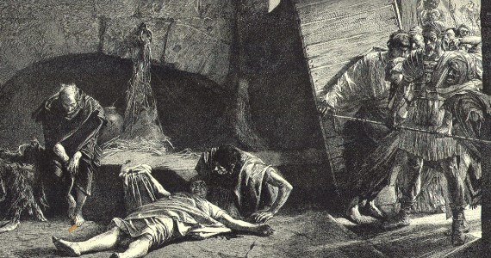

**The downfall and death of Nero in five steps**

**KEY TERMS**

|  |  |
| --- | --- |
| **Term** | **Description** |
| **quinquennium aureum** |  |
| ***Domus Aurea*** |  |
| ***Gallia Lugdunensis*** |  |
|  |  |
|  |  |
|  |  |
|  |  |

**KEY FIGURES**

|  |  |
| --- | --- |
| **nAME** | **Description** |
| **Britannicus** |  |
| **Claudia Octavia** |  |
| **Acte** |  |
| **Poppaea Sabina** |  |
| **Burrus** |  |
| **Seneca** |  |
| **Statilia Messalina** |  |
| **Gnaeus Domitius Corbulo** |  |
| **Gaius Julius Vindex** |  |
| **Lucius Verginius Rufus** |  |
| **Servius Sulpicius Galba** |  |
|  |  |

**The Roman Empire**

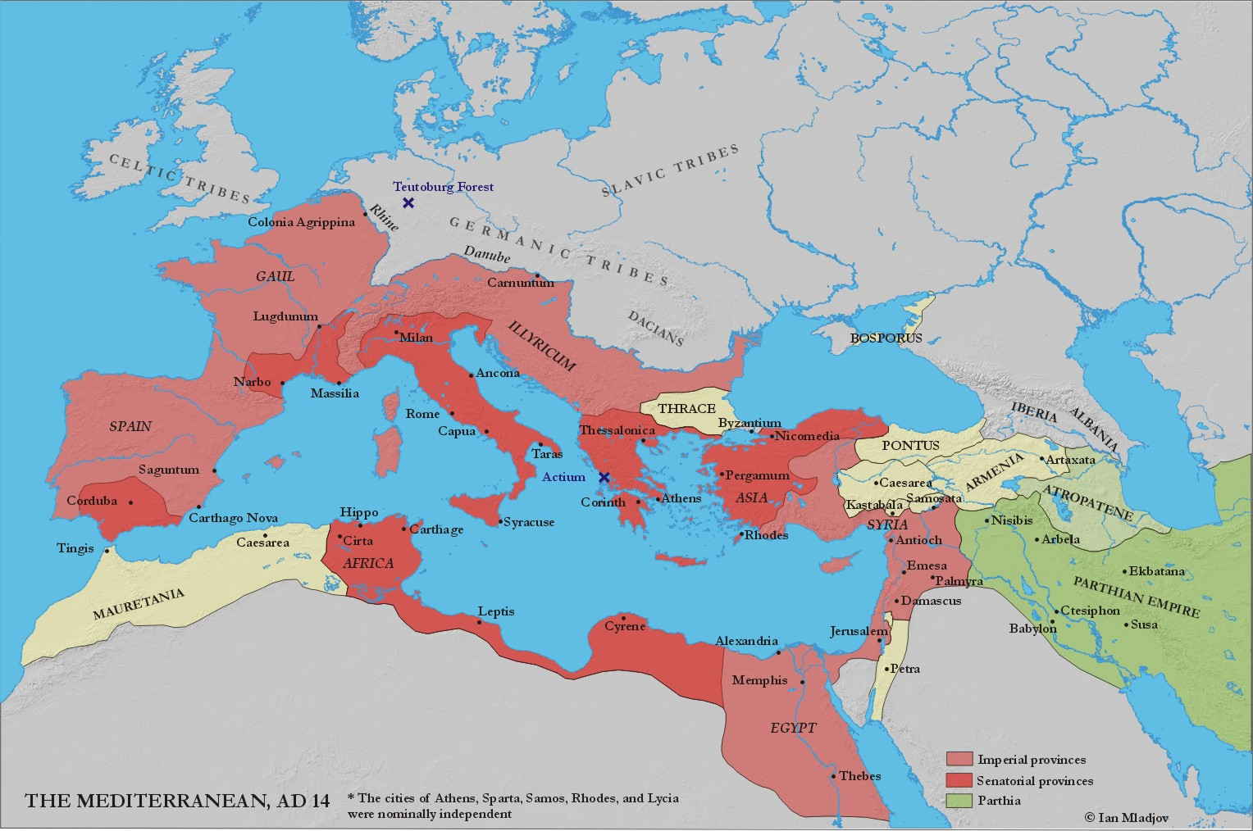



HOMEWORK RECORD

|  |  |  |  |
| --- | --- | --- | --- |
| ***Date set*** | ***Details*** | ***Date Due*** | ***Done?*** |
|  |  |  |  |
|  |  |  |  |
|  |  |  |  |
|  |  |  |  |
|  |  |  |  |
|  |  |  |  |
|  |  |  |  |
|  |  |  |  |
|  |  |  |  |
|  |  |  |  |