**The Death of Claudius, AD 54**

***Was Claudius Poisoned?***

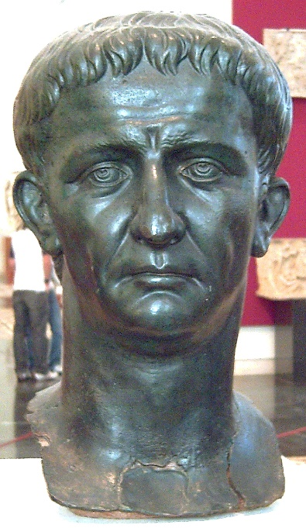

**Prescribed Source – Suetonius *Claudius* 44–45**

44. Soon afterwards he composed his will and made all the magistrates put their seals to it as witnesses; but Agrippina, now being accused of many crimes by informers as well as her own conscience, prevented him from doing anything further.

Most people think that Claudius was poisoned, but when and by whom is disputed. Some say that the eunuch Halotus, his official taster, administered the drug while he was dining with the priests on the Capitoline Hill; others, that Agrippina did so herself at a family banquet, poisoning a dish of mushrooms, his favourite food. An equal discrepancy exists between the accounts of what happened next. Many authorities assert that he immediately lost his power of speech, suffered frightful pain all night long, and died shortly before dawn. A variant version is that he fell into a coma but vomited up the entire contents of his stomach and was then poisoned a second time, either by gruel, the excuse being that he needed food to revive him, or by means of an enema, the excuse being that his bowels must be emptied too.

45. Claudius’ death was not revealed until all the arrangements had been completed for his successor. As a result, people made vows for his safety as though he still lived, and a troop of comic actors were summoned, under the pretence that he had asked to be diverted by their antics. He died on 13 October during the consulship of Asinius Marcellus and Acilius Aviola, in the sixty-fourth year of his life and the fourteenth year of his reign. He was given a princely funeral and officially deified, an honour which Nero later neglected and then cancelled but which Vespasian restored.

**Prescribed Source – Tacitus, *Annals*, 12.65-12.69**

12.65. However, the charge against Leida was attempting the life of the empress by magic, and disturbing the peace of Italy by failing to keep her Calabrian slave-gangs in order. On these charges she was sentenced to death – in spite of vigorous opposition from Narcissus. His suspicions of Agrippina continually grew deeper. ‘Whether Britannicus or Nero comes to the throne’, he was said to have told his friends, ‘my destruction is inevitable. But Claudius has been so good to me that I would give my life to help him. The criminal intentions for which Messalina was condemned with Gaius Silius have re-emerged in Agrippina. With Britannicus as his successor the emperor has nothing to fear. But the intrigues of his stepmother in Nero’s interests are fatal to the imperial house – more ruinous than if I had said nothing about her predecessor’s unfaithfulness. And once more there is unfaithfulness. Agrippina’s lover is Pallas. *That* is the final proof that there is nothing she will not sacrifice to imperial ambition – neither decency, nor honour, nor chastity.’

Talking like this, Narcissus would embrace Britannicus and pray he would soon be a man. With hands outstretched – now to the boy, now to heaven – he besought that Britannicus might grow up and cast out his father’s enemies, and even avenge his mother’s murderers. 12.66. Then Narcissus’ anxieties caused his health to fail. He retired to Sinuessa, to recover his strength in its mild climate and health-giving waters.

Agrippina had long decided on murder. Now she saw her opportunity. Her agents were ready. But she needed advice about poisons. A sudden, drastic effect would give her away. A gradual, wasting recipe might make Claudius, confronted with death, love his son again. What was needed was something subtle that would upset the emperor’s faculties but produce a deferred fatal effect. An expert in such matters was selected - a woman called Locusta, recently sentenced for poisoning but with a long career of imperial service ahead of her. By her talents, a preparation was supplied. It was administered by the eunuch Halotus who habitually served the emperor and tasted his food.

12.67. Later, the whole story became known. Contemporary writers stated that the poison was sprinkled on a particularly succulent mushroom. But because Claudius was torpid – a drunk – its effect was not at first apparent; and an evacuation of his bowels seemed to have saved him. Agrippina was horrified. But when the ultimate stakes are so alarmingly large, immediate disrepute is brushed aside. She had already secured the complicity of the emperor’s doctor Xenophon; and now she called him in. The story is that, while pretending to help Claudius to vomit, he put a feather dipped in a quick poison down his throat. Xenophon knew that major crimes, though hazardous to undertake, are profitable to achieve.

12.68. The Senate was summoned. Consuls and priests offered prayers for the emperor’s safety. But meanwhile his already lifeless body was being wrapped in blankets and poultices. Moreover, the appropriate steps were being taken to secure Nero’s accession. First Agrippina, with heart-broken demeanour, held Britannicus to her as though to draw comfort from him. He was the very image of his father, she declared. By various devices she prevented him from leaving his room and likewise detained his sisters, Claudia Antonia and Octavia. Blocking every approach with troops, Agrippina issued frequent encouraging announcements about the emperor’s health, to maintain the Guard’s morale and await the propitious moment forecast by the astrologers.

**Summary Questions**

1. **Which of the two authors above appears more certain that Agrippina did poison Claudius?**
2. **What steps did Agrippina take immediately after Claudius’ death to ensure Nero’s accession?**
3. **Why, regardless of whether she was responsible, was Claudius’ death in AD 54 perfectly timed for Agrippina?**