Scope of work: Painting of Working Life (French)

Gustave Courbet’s *The Stonebreakers* (1849, oil on canvas), illustrates the plight of men, forced through poverty or debt, to labour under physically exhausting conditions. Men engaged in breaking stones was a common scene in daily life at the time and this subject would also be depicted by the British painters Henry Wallis and John Brett.

Courbet’s stone breakers are a young boy and an older man breaking up stones on a road which is under construction. The setting suggests the countryside and this road will eventually lead to a town or city. The costume of the figures suggests they are peasants and the scene may be Courbet’s birthplace of Ornans in rural France. Such roles as stone breaking were occupied by the lowest paid in society and Courbet has deliberately highlighted their ordeal by having the figures fill the composition and placing the focus on them. Behind these figures, a hill rises to the top of the canvas, this hill might be a metaphor for the insurmountable task facing these two individuals. A glimpse of bright blue sky suggests these figures still have a day’s work ahead of them.

Courbet was a Realist who painted individuals and events in a non-idealised, direct way. He did not sentimentalise his subjects but showed them in as accurate a manner as possible so that when we look at the painting we experience what these individuals endure. This view is supported by the Socialist writer and friend of Courbet, Pierre Proudhon, who wrote of the painting; “This modern servitude devours the generations in their youth”. The tattered clot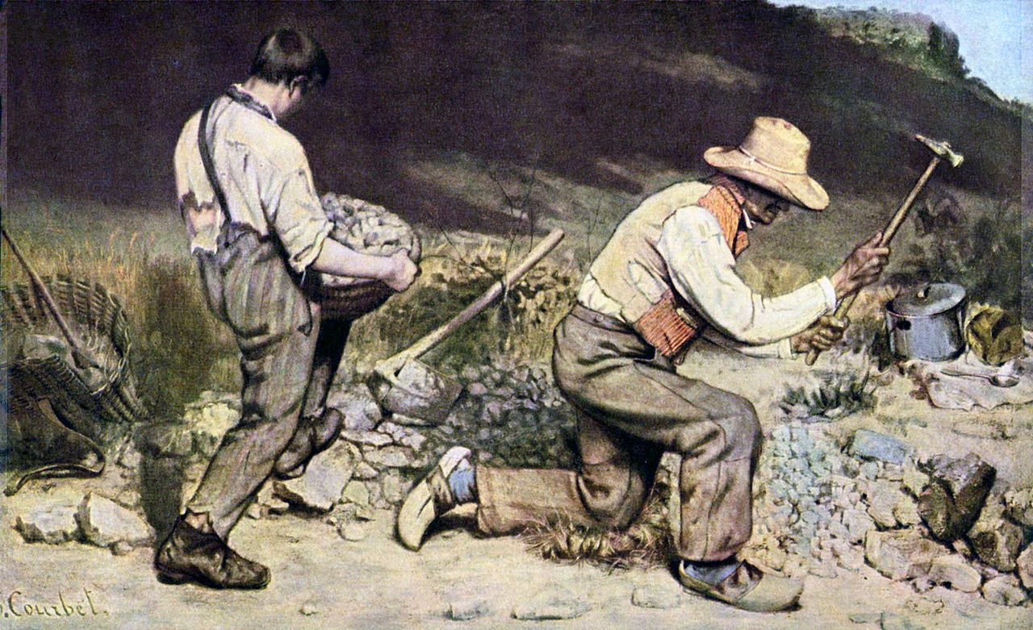hing worn by the figures mirrors in colour the rough ground beneath them, further linking them to the task they are undertaking.

The young boy struggles to lift a basket filled with stones, his youth and slight physique indicating this is an occupation for a stronger adult male. His older companion has broken these stones from the road. A pile of stones slowly rises behind them, neither figure engages with the viewer, they are absorbed in the completion of their task. Tools such as a pickaxe reinforce the struggle these characters endure. This might be a painting of unknown individuals, however Courbet does not celebrate their struggle, instead he encourages us to sympathise with them. He described this work as a ‘*portrayal of injustice’*.

The large scale of the painting was typical of Courbet’s depictions of peasants and workers. It gives a sense of importance to subjects often overlooked or ignored by the Salons at this time. Courbet treated these individuals, their lives and struggles with the same gravitas traditionally reserved for history paintings.

**Courbet described his inspiration for Stone Breakers in a November 1849 letter to Francis and Marie Wey:**

“I had taken our carriage to go to the Château of Saint-Denis to paint a landscape. Near Maisières I stopped to consider two men breaking stones on the road. One rarely encounters the most complete expression of poverty, so right there on the spot I got an idea for a painting. I made a date to meet them in my studio the following morning, and since then I have painted my picture.

…On one side is an old man of seventy, bent over his work, his sledgehammer raised, his skin parched by the sun, his head shaded by a straw hat; his trousers, of coarse material, are completely patched; and in his cracked sabots you can see his bare heels sticking out of socks that were once blue. On the other side is a young man with swarthy skin, his head covered with dusk; his disgusting shirt all in tatters reveals his arms and parts of his back; a leather suspender holds up what is left of his trousers, and his mud-caked leather boots show gaping holes on every side. The old man is kneeling, the young man standing behind him energetically carrying a basket of broken rocks. Alas! In this class, this is how one begins, and that is how one ends.”[1]

**Contemporary critic A.J. Dupays offered his opinion of Courbet’s Stone Breakers in his review of the 1852 Salon:**

“Two stonebreakers of the department of Doubs. That’s it! It is a subject with very little appeal. To render it even more unpleasant the artist has suppressed the two heads of the poor laborers, that is to say, the only things capable of preserving the interest of such an empty subject. The standing worker turns his back to us and we see only his nape; the other who kneels has his head hidden under his straw hat. What happens to the principal objects of a painting if they are not treated with the importance that is evidently accorded them, positioned with their relative legitimate value, expressive of a certain truth, and rendered with a vivacity suitable to display the artist’s talent for material execution? Instead of that wan and ambiguous glimmer of light spread throughout the scene, shouldn’t we feel the full effect of sunlight that the painter meant to put there, indicated by the cast shadows that, however, do not sufficiently achieve the aim of making it shine?”

A.J. Dupays, “Salon de 1850,” L’Illustration (31 January - 7 February 1851):72; cited in Albert Boime, Art in an Age of Civil Struggle 1848-1871 (Chicago, IL and London: The University of Chicago Press, 2007), p. 162.

**For contemporary art critic and social activist Pierre-Joseph Prudhon Courbet’s Stone Breakers stimulated thoughts about the current social and political conditions:**

“The Stone Breakers is an irony addressed to our industrial civilization, which daily invents fantastic machines for plowing, sowing, mowing, harvesting, threshing, grinding, kneading, spinning, weaving, cutting, printing, and manufacturing nails, paper, pins, and cards; executing all kinds of work, often very complicated and delicate, and that is incapable of freeing man from the work that is the most rough, difficult, the most repugnant, eternal cause of misery….

Close your eyes now. The people included in Courbet’s painting are two: a young man eighteen years old and an old man of sixty. Before examining the painting, tell me which of these two men seem to you to express the greatest oppression and misery. – The old one, naturally; age adds misfortune to poverty, whereas youth does not surrender to these afflictions. OK, you are deceived; look.

The kneeling old man, bent over his rude task, who breaks stones on the side of the road with a long-handled hammer, certainly deserves your sympathy. His immobile body conveys a melancholy that goes straight to the heart. His stiff arms rise and fall with the regularity of a lever. Here indeed is the mechanical or mechanized man in the desolation caused by our splendid civilization and incomparable industry. Nevertheless, this man has seen his best days, since he is true to life; if the present is for him without illusions, without hope, he  owed less to hold together his memories, his regrets, and it is not a small matter to have to remember something; while the unfortunate boy who carries the stones will never know the joys of life; chained to a life of drudgery from an early age, he has already torn himself up; his shoulder bent, his gait heavy, his pants baggy; uncaring misery has made him lose interest in himself and the quickness of his eighteen years. Crushed in puberty, he does not live. Thus modern servitude devours generations in their formative years: voila, the proletariat. And we speak of freedom, of human dignity! We cry out against the slavery of blacks, whose treatment as beasts of burden at least guarantees protection against this excess of poverty. Pray to God that our proletariat be granted a material existence as good as blacks. Without a doubt, it would not be completely fair to judge this great nation of ten million sovereign voters by this sad example; but does that make it any less true that this is one of the shameful aspects of our society, and that there is not one of us, city dweller or peasant, worker or proprietor, who may not one day, by an accident of fortune, see himself reduced to this? The condition of  stone breakers is the same for more than six million souls in France; boast of your industry, your philanthropy, and your politics!”  
         
Pierre-Joseph Prudhon, Du Principe de l’art et de sa destination sociale (Paris : Garnier Frères, 1865), pp. 236-41

Weblinks:

<https://smarthistory.org/courbet-the-stonebreakers/>

<https://www.gustave-courbet.com/the-stonebreakers.jsp>

<http://www.19thcenturyart-facos.com/artwork/stone-breakers>

1. How is this work typical of Realism?

2. How is this work typical of Courbet?

3. What do the quotes from Courbet and Proudhon mean in terms of the theme of this painting?

4. How does this work differ to the examples by Henry Wallis and John Brett (see PowerPoint)?

5. How does Courbet’s painting technique complement the theme/subject matter of the painting?

6. How does Courbet’s background/biography link to this painting?

7. Analyse the formal features in detail. How do they help with the narrative and message of the work.

**Potential exam questions which this work can be used to answer.**

Part A) Explain how one painting is Realist in style.

Part B) Analyse one painting which depicts a scene of working life.

Part B) Explain how one painting of this period has been shaped by its **social, historical and/or cultural** context.

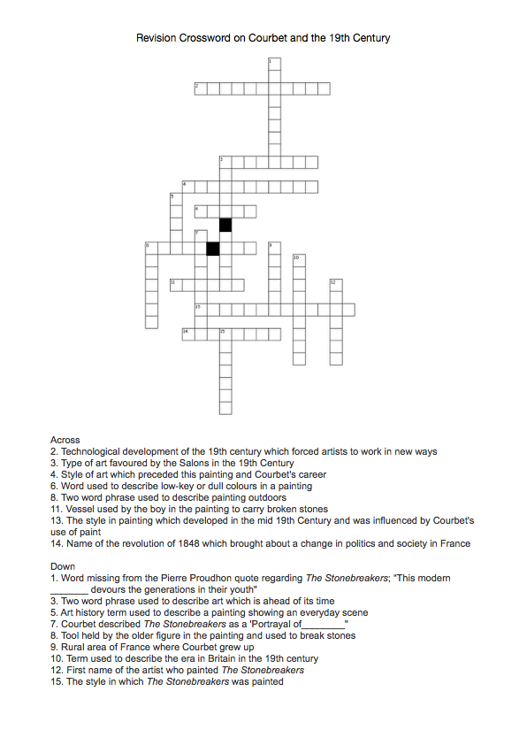

1. Cited in Albert Boime, Art in an Age of Civil Struggle 1848-1871 (Chicago, IL and London: The University of Chicago Press, 2007), pp. 158-9. 