**Chirality and Carbonyl Compounds**

**Unit 4 - Jan 2010**

**Q1.**\*(a)  Ethanol can be oxidized successively to ethanal and to ethanoic acid.

The boiling temperatures of these substances are: ethanol 78 °C, ethanal 21°C, ethanoic acid 118 °C.

Explain in terms of the intermolecular forces in the liquids why the order of the boiling temperature is



**(3)**

.............................................................................................................................................

.............................................................................................................................................

.............................................................................................................................................

.............................................................................................................................................

(b)  State what tests you would perform in each case, and the result you would expect, to show that

(i)  ethanal contains a carbonyl group.

**(2)**

.............................................................................................................................................

.............................................................................................................................................

(ii)  ethanal is an aldehyde.

**(2)**

.............................................................................................................................................

.............................................................................................................................................

(c)  Ethanal reacts with HCN, in the presence of a catalyst of cyanide ions from KCN, to give a cyanohydrin, CH3CH(OH)CN.

(i)  Give the mechanism for this reaction.

**(3)**

(ii)  Explain why it is necessary to use HCN and KCN in this reaction, rather than HCN on its own.

**(1)**

.............................................................................................................................................

*(iii)  Explain why the product mixture from this reaction is **not** optically active.

**(2)**

.............................................................................................................................................

.............................................................................................................................................

**(Total for question = 13 marks)**

**Q2.** The repeat unit of the polyester formed from ethane-1,2-diol, HOCH2CH2OH, and

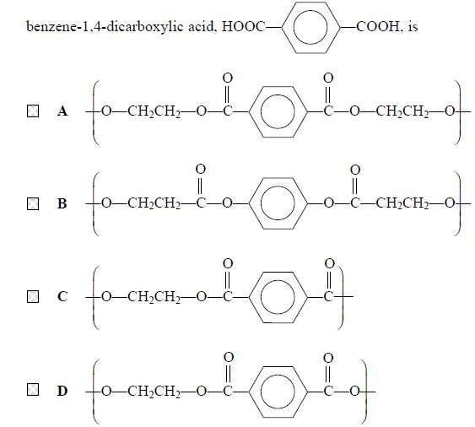

**(Total for question = 1 mark)**

**Unit 4 - Jun 2010**

**Q3.**Which of the following compounds has both optical and *E*-*Z* isomers?

   **A**     CH3CHCHCH2CH3

   **B**     CH3CHClCHC(CH3)2

   **C**     CH3CClCClCH3

   **D**     CH3CHBrCHCHCl

**(Total for question = 1 mark)**

**Q4.**When propanone reacts with iodine in the presence of sodium hydroxide, the crystalline solid product has the formula

   **A**     CH3I

   **B**     CHI3

   **C**     CH3COCH2I

   **D**     CH3COCI3

**(Total for question = 1 mark)**

**Q5.**Which of the following reacts with hydrogen cyanide, HCN, to make a racemic mixture?

   **A**     Methanal, HCHO

   **B**     Ethanal, CH3CHO

   **C**     Propanone, CH3COCH3

   **D**     Pentan-3-one, C2H5COC2H5

**(Total for question = 1 mark)**

**Q6.**Which of the following is a redox reaction?

   **A**     Ethanal reacting with Tollens' reagent.

   **B**     Ethanoyl chloride reacting with ammonia.

   **C**     Ethanoic acid reacting with ethanol.

   **D**     Ethanoic acid reacting with sodium hydroxide.

**(Total for question = 1 mark)**

**Q7.**The following methods can be used to distinguish between pairs of organic compounds without further tests.

**A**     Warm each compound with Fehling's or Benedict's solution.

**B**     Add solid sodium carbonate to each compound.

**C**     Add 2,4-dinitrophenylhydrazine (Brady's reagent) to each compound.

**D**     Add water, drop by drop, to each compound.

(a)  Which test would distinguish propanone from propan-1-ol?

**(1)**

   **A**

   **B**

   **C**

   **D**

(b)  Which test would distinguish between aqueous solutions of ethanoic acid and ethanol?

**(1)**

   **A**

   **B**

   **C**

   **D**

(c)  Which test would distinguish ethanoyl chloride from ethanol?

**(1)**

   **A**

   **B**

   **C**

   **D**

**(Total for question = 3 marks)**

**Unit 4 - Jan 2011**

**Q8.**Which of the following has both optical and E-Z isomers?

   **A**     ClCH2CHClCH==CH2

   **B**     CH2==CClCH2CH2Cl

   **C**     ClCH2CH==CHCH2Cl

   **D**     CHCl==CHCHClCH3

**(Total for question = 1 mark)**

**Q9.**One optically active isomer of 2−chlorobutane reacts with hydroxide ions to form butan−2−ol.

C2H5CHClCH3 + OH− → C2H5CH(OH)CH3 + Cl−

The organic product is a **mixture** of enantiomers because

   **A**    butan−2−ol contains a chiral carbon atom.

   **B**    the reaction is a nucleophilic substitution.

   **C**    2−chlorobutane forms a carbocation intermediate.

   **D**    2−chlorobutane forms a five-bonded transition state.

**(Total for question = 1 mark)**

**Q10.**Which of the following does not have hydrogen bonding in a pure sample, but forms hydrogen bonds with water when it dissolves?

   **A**    Propane

   **B**    Propanal

   **C**    Propanol

   **D**    Propanoic acid

**(Total for question = 1 mark)**

**Q11.**The equation below shows the type of reaction which can be used in the production of biodiesel from vegetable oils.

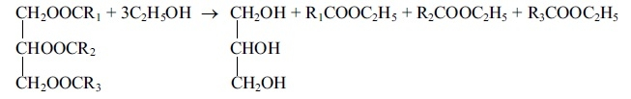

(a) (i)  Name this type of reaction.

**(1)**

.............................................................................................................................................

     (ii)  Suggest why water must not be present when this reaction with ethanol is carried out.

**(1)**

.............................................................................................................................................

(b)  Give **one** reason why biodiesel is considered a "greener" fuel than diesel produced from crude oil.

**(1)**

.............................................................................................................................................

*(c)  The products of the type of reaction shown with ethanol can be separated and identified using gas chromatography (GC).

     In chromatography, compounds are separated because of the difference in distribution between a mobile phase and a stationary phase.  
  
     Explain why this difference in distribution occurs, and contrast the phases used in gas chromatography (GC) and high performance liquid chromatography (HPLC).

**(5)**

.............................................................................................................................................

.............................................................................................................................................

.............................................................................................................................................

.............................................................................................................................................

.............................................................................................................................................

**(Total for question = 8 marks)**

**Q12.**  A student investigated the reaction between iodine and propanone in acidic conditions.

                                    CH3COCH3(aq) + I2(aq) → CH3COCH2I(aq) + HI(aq)

  •   50 cm3 of 0.020 mol dm−3 iodine solution was measured into a flask. •   25 cm3 of propanone and 25 cm3 of 1.0 mol dm−3 sulfuric acid were measured into a second flask.  
         •   Several 10 cm3 samples of 0.5 mol dm−3sodium hydrogencarbonate solution were placed in separate conical flasks.  
         •   The mixture of propanone and sulfuric acid was added to the iodine, and a clock started.  
         •   At two minute intervals, 10 cm3 of the reaction mixture was removed and added to one of the flasks containing sodium hydrogencarbonate solution.  
         •   The contents of this flask were then titrated with 0.01 mol dm−3 sodium thiosulfate.

(a)  Explain the purpose of adding the reaction mixture to the sodium hydrogencarbonate.

**(2)**

.............................................................................................................................................

.............................................................................................................................................

(b)  What indicator should be used in the titration?

**(1)**

.............................................................................................................................................

*(c)  In this experiment the concentration of the iodine was 0.020 mol dm−3 and the concentrations of propanone and sulfuric acid were both 1.00 mol dm−3. Why was the iodine solution used much less concentrated than the propanone and sulfuric acid?

**(2)**

.............................................................................................................................................

.............................................................................................................................................

(d)  The shape of the graph obtained from the results of the experiment is shown below.

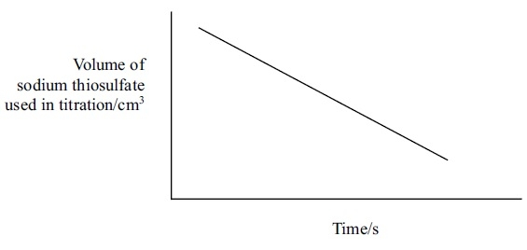

   Use the graph to deduce the order of reaction with respect to iodine, explaining your reasoning.

**(2)**

.............................................................................................................................................

.............................................................................................................................................

(e)  The solutions used in this experiment could be measured using either measuring cylinders or pipettes.

      Give **one** advantage of using a measuring cylinder and one advantage of using a pipette.

**(2)**

.............................................................................................................................................

.............................................................................................................................................

.............................................................................................................................................

(f)  In a further investigation, different volumes of sulfuric acid, propanone, iodine and water were mixed. The time taken for the mixture to go colourless was measured.

    &nbspThe experiments were repeated and the results below show average values for the rate of the reaction.

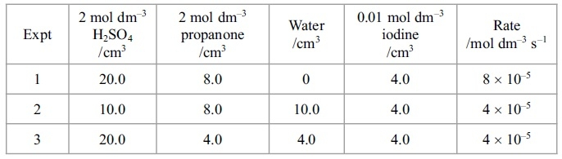

   (i)   Explain why water is added in experiments 2 and 3.

**(1)**

.............................................................................................................................................

   (ii)   Show how you would use the data in the table to deduce the order of reaction with respect to propanone and hydrogen ions. Write the rate equation for the reaction.

**(3)**

.............................................................................................................................................

.............................................................................................................................................

.............................................................................................................................................

.............................................................................................................................................

**(Total for question = 13 marks)**

**Q13.**Hydrogen cyanide, HCN, reacts with propanal, CH3CH2CHO, in the presence of potassium cyanide, KCN.

(a) The mechanism for this reaction is

**(1)**

   **A**    nucleophilic addition.

   **B**    nucleophilic substitution.

   **C**    electrophilic addition.

   **D**    electrophilic substitution.

(b) The first stage of the mechanism of this reaction is

**(1)**

   **A**    the lone pair of electrons on carbon in CN¯ attacking Cδ+ of propanal.

   **B**    the lone pair of electrons on nitrogen in CN¯ attacking Cδ+ of propanal.

   **C**    the lone pair of electrons on oxygen in propanal attacking Cδ+ of HCN.

   **D**    the lone pair of electrons on oxygen in propanal attacking Hδ+ in HCN.

(c) The product of the reaction is

**(1)**

   **A**    1−hydroxypropanenitrile.

   **B**    2−hydroxypropanenitrile.

   **C**    1−hydroxybutanenitrile.

   **D**    2−hydroxybutanenitrile.

**(Total for question = 3 marks)**

**Unit 4 - Jun 2011**

**Q14.**This question is about four compounds with molecular formula C4H8O.

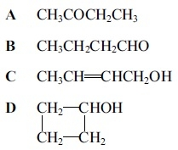

(a) The compounds which react when heated with a mixture of potassium dichromate(VI) and sulfuric acid are

**(1)**

   **A**

   **B**

   **C**

   **D**

(b) The compound which produces a yellow precipitate when heated with a mixture of iodine and sodium hydroxide is

**(1)**

   **A**

   **B**

   **C**

   **D**

(c) There would **not** be a significant peak at mass/charge ratio of 15 in the mass spectrum of

**(1)**

   **A**     Titrations **A** and **B** only.

   **B**     Titrations **A**, **B** and **D** only.

   **C**     Titration **C** only.

   **D**     Titrations **A**, **B**, **C** and **D**.

**(Total for question = 3 marks)**

**Q15.**Ethanoic acid is **not** a product in the reaction of

   **A**     ethanal with lithium tetrahydridoaluminate.

   **B**     ethanoyl chloride with water.

   **C**     ethyl ethanoate with dilute sulfuric acid.

   **D**     ethanol refluxed with potassium dichromate(VI) and sulfuric acid.

**(Total for question = 1 marks)**

**Q16.**The following tests can be carried out on organic compounds.

**A**     Warm with 2,4-dinitrophenylhydrazine.

**B**     Warm with Fehling's or Benedict's solution.

**C**     Add solid sodium carbonate.

**D**     Add phosphorus(V) chloride, PCl5.

(a) Which test would give a positive result with propanoic acid but not with propan-1-ol?

**(1)**

   **A**

   **B**

   **C**

   **D**

(b) Which test would give a positive result with propanoic acid **and** with propan-1-ol?

**(1)**

   **A**

   **B**

   **C**

   **D**

(c) Which test would give a positive result with propanal but not with propanone?

**(1)**

   **A**

   **B**

   **C**

   **D**

**(Total for question = 3 marks)**

**Q17.**A sequence of reactions for the production of lactic acid is shown below.

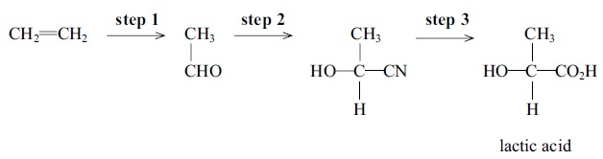

(a) (i) Name the type and mechanism of the reaction in step **2**.

**(2)**

      ..............................................................................................................................................

(ii) Which **two** substances need to be added to ethanal to carry out the reaction in **step 2**?

**(2)**

      ..............................................................................................................................................

      ..............................................................................................................................................

(iii) Give the mechanism for the reaction in **step 2**, using curly arrows to show movements of electron pairs.

**(3)**

*(iv) The product of **step 2** is not optically active even though it has a chiral carbon atom in its formula. Explain, by reference to the mechanism, the reason for the lack of optical activity.

**(2)**

      .............................................................................................................................................

      ..............................................................................................................................................

(b) What reactant, or combination of reactants, is needed to carry out **step 3?**

**(1)**

      ..............................................................................................................................................

(c) (i) What is the systematic name of lactic acid?

**(1)**

      ..............................................................................................................................................

(ii) Lactic acid molecules can combine to form a biodegradable polymer, poly(lactic acid) or PLA.      Draw a section of the polymer with **two** units of the polymer chain and showing all bonds.

**(1)**

(iii) Suggest why PLA is biodegradable.

**(1)**

     ..............................................................................................................................................

      ..............................................................................................................................................

(iv) Lactic acid can be prepared from ethene as shown in the scheme. Lactic acid also forms when milk turns sour.

Suggest **one** reason why it would be advantageous to make lactic acid from milk rather than from ethene.

**(1)**

      ..............................................................................................................................................

      .............................................................................................................................................

**(Total for question = 14 marks)**

**Q18.**Which of the following compounds is a *Z* isomer **and** contains a chiral carbon atom?

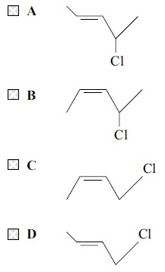

**(Total for question = 1 marks)**