**Unit 2 - Jun 2014**

**Q26.**Hydrogen, H2, is not a completely 'carbon neutral' fuel. Which of the following is an **incorrect** reason for this?

   **A**    Some CO2 is released in the transportation of H2 fuel.

   **B**    CO2 is made when the electricity is generated for the manufacture of H2.

   **C**    A small amount of CO2 is produced on the combustion of H2 fuel.

   **D**    CO2 is released during the construction of the H2 manufacturing plant.

**(Total for question = 1 mark)**

**Q27.** Which of the following isomeric alcohols, with molecular formula C5H12O, can be oxidized to a carboxylic acid with five carbon atoms?

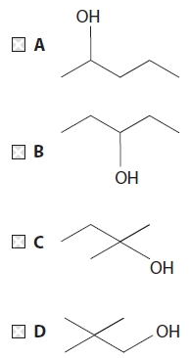

**(Total for question = 1 mark)**

**Q28.**Insect-borne diseases, such as malaria, affect the lives of millions of people. Chemists are constantly finding new compounds to combat the transmission of these diseases. One such compound is the insect repellent commonly called *p*-menthane-3,8-diol (this is not its systematic name). It is used to protect both humans and animals.

The structure of *p*-menthane-3,8-diol is shown below.

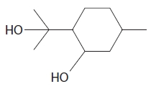

*p*-menthane-3,8-diol is found naturally in the leaves of *Eucalyptus citriodora*, which is native to Australia and is commonly known as 'Lemon Bush'. It can be extracted from these leaves but is currently commercially prepared by chemical synthetic pathways. However, the commercially-made chemical has been found by some scientists to be less effective than the natural leaf extract.

It is possible that *p*-menthane-3,8-diol can kill microorganisms and it is this additional potential use and others which are being investigated by the chemical industry.

*p*-menthane-3,8-diol should not be confused with either methane or methanol.

(a)  *p*-menthane-3,8-diol has two alcohol functional groups. Classify the type of alcohol group on the far left of the structure drawn above and explain the meaning of the term 'functional group'.

**(2)**

.............................................................................................................................................

.............................................................................................................................................

.............................................................................................................................................

(b)  Give the molecular formula of *p*-menthane-3,8-diol.

**(1)**

.............................................................................................................................................

(c)  *p*-menthane-3,8-diol is found in the oily extract from the leaves of the 'Lemon Bush'.

One method used to extract the oil is described below.

Initially, the leaves are ground up using a pestle and mortar with some sand and an organic solvent, such as cyclohexane.

(i)  Suggest why sand is used.

**(1)**

.............................................................................................................................................

.............................................................................................................................................

*(ii)  The solvent cyclohexane forms intermolecular forces with other organic molecules when they dissolve.

Identify these intermolecular forces and explain how they arise.

**(3)**

Type of intermolecular force

.............................................................................................................................................

How they arise

.............................................................................................................................................

.............................................................................................................................................

(iii)  How could the sand and other solid residue be removed from the mixture?

**(1)**

.............................................................................................................................................

(iv)  At this stage, either anhydrous magnesium sulfate or calcium chloride is added. Suggest the reason for this.

**(1)**

.............................................................................................................................................

*(v)  A student suggested using the following apparatus to remove the cyclohexane from the mixture.

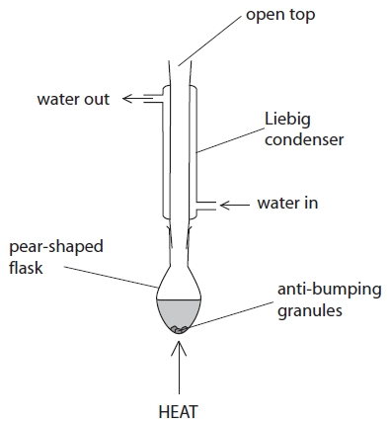

Explain, in terms of the processes that occur in the above apparatus, why this method is unsuitable to remove the cyclohexane.

Suggest how this apparatus could be adjusted for a successful separation.

DATA• Boiling temperatures: *p*-menthane-3,8-diol 266 °C; cyclohexane 81 °C**(4)**

.............................................................................................................................................

.............................................................................................................................................

.............................................................................................................................................

.............................................................................................................................................

.............................................................................................................................................

(d)  Spectroscopic techniques can be used to confirm the presence and identity of organic molecules such as *p*-menthane-3,8-diol.

(i)  Suggest how infrared spectroscopy could be used to confirm the presence of the functional group in a molecule such as *p*-menthane-3,8-diol.

**(1)**

.............................................................................................................................................

.............................................................................................................................................

(ii)  Suggest the identity of two fragment ions, with a *m*/*e* value of more than 13 but less than 20, that could be observed in a mass spectrum of *p*-menthane-3,8-diol.

**(2)**

First fragment ion

.............................................................................................................................................

Second fragment ion

.............................................................................................................................................

(e)  One reason why the synthetic *p*-menthane-3,8-diol may be less effective than the natural extract is because there are many isomers of this molecule.

Complete the structures below to show two structural isomers of *p*-menthane-3,8-diol which have the same number of alcohol functional groups and the same carbon skeleton.

**(2)**

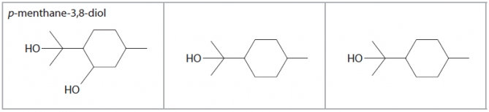

*(f)  State two key principles of sustainability, and how the chemical industry might achieve these, when mass-producing a molecule such as *p*-menthane-3,8-diol.

**(4)**

Principle 1

.............................................................................................................................................

.............................................................................................................................................

.............................................................................................................................................

Principle 2

.............................................................................................................................................

.............................................................................................................................................

.............................................................................................................................................

.............................................................................................................................................

.............................................................................................................................................

**(Total for question = 22 marks)**

**Q29.**Which of the following reagents gives a **positive** result with a tertiary alcohol?

   **A**    Acidified potassium dichromate(VI) solution

   **B**    Phosphorus(V) chloride

   **C**    Dilute sulfuric acid

   **D**    Bromine water

**(Total for question = 1 mark)**

**Q30.** This is a question about halogenoalkanes.

(a)  Halogenoalkanes can react with hydroxide ions in different ways depending on the conditions used. Using 1-chloro-1-fluoroethane, CH3CHClF, as an example of a halogenoalkane, the following reaction could occur in aqueous solution.

CH3CHClF + OH− → CH3CHOHF + Cl−

(i)  Suggest why it is unlikely that the fluorine atom in CH3CHClF would be substituted by the hydroxide ion.

**(1)**

.............................................................................................................................................

.............................................................................................................................................

*(ii)  A student attempted to draw the reaction mechanism for the reaction in (a)(i), but made a total of three errors.

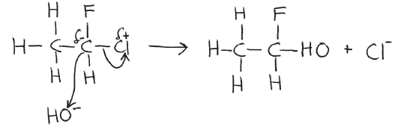

Identify these errors and state how they should be corrected.

**(3)**

First error

.............................................................................................................................................

.............................................................................................................................................

.............................................................................................................................................

Second error

.............................................................................................................................................

.............................................................................................................................................

Third error

.............................................................................................................................................

.............................................................................................................................................

.............................................................................................................................................

(iii)  In hot alcoholic solution, a different reaction may occur between halogenoalkanes and hydroxide ions.

Write the equation for the reaction between 1-chloro-1-fluoroethane, CH3CHClF, and hydroxide ions in alcoholic solution.

**(2)**

(b)  Chloroethane can be produced in various ways as shown below. Identify, by name or formula, the reagent needed for each of these reactions.

**(3)**

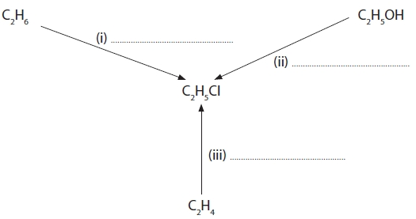

(c)  (i)  Chloroethane will react with alcoholic ammonia **initially** to produce ethylamine. Complete the equation for this reaction.

**(1)**

.............................. + NH3 → .............................. + ..............................

(ii)  Name the type and mechanism of the reaction occurring in (c)(i).

**(2)**

(iii)  What feature of the ammonia molecule enables the reaction in (c)(i) to take place?

**(1)**

.............................................................................................................................................

(iv)  If aqueous ammonia was used in (c)(i), instead of alcoholic ammonia, suggest the identity of the organic product that would be formed.

**(1)**

.............................................................................................................................................

(d)  Dichlorodifluoromethane, CCl2F2, is also known as Freon 12 and its manufacture was banned in 1994 under the terms of the Montreal Protocol.

(i)  Complete the equation for the initiation stage and suggest equations for two of the propagation stages and a termination stage for the mechanism of the reaction that this molecule might undergo with ozone.

**(4)**

Initiation           CCl2F2 →

Propagation 1

Propagation 2

Termination

*(ii)  Explain why the effect of Freon 12 molecules on the ozone layer was such a serious issue that scientists recommended its use to be discontinued.

**(2)**

.............................................................................................................................................

.............................................................................................................................................

(iii)  Freon 12, CCl2F2, could also be described as a "greenhouse gas". Explain what the term 'greenhouse gas' means.

**(2)**

.............................................................................................................................................

.............................................................................................................................................

(iv)  Freon 12, and other similar molecules, are not normally viewed as contributors to the greenhouse effect. Suggest why this is so.

**(1)**

.............................................................................................................................................

.............................................................................................................................................

**(Total for question = 23 marks)**