**Q1.**          The diagram shows a short section of a DNA molecule.

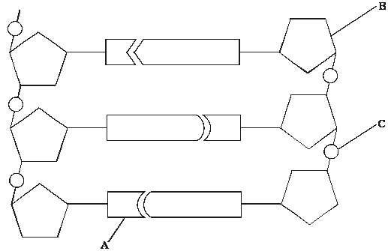

(a)     On the diagram draw a box round **one** nucleotide.

**(1)**

(b)     Use the letters in the diagram to indicate a part of the molecule which

(i)      is **not** a base and is different in an RNA molecule;

.............................................................................................................

(ii)     contains nitrogen.

.............................................................................................................

**(2)**

(c)     (i)      The sequence of bases on one strand of DNA is important for protein synthesis. What is its role?

.............................................................................................................

.............................................................................................................

**(1)**

(ii)     How are the two strands of the DNA molecule held together?

.............................................................................................................

**(1)**

(iii)     Give **one** advantage of DNA molecules having two strands.

.............................................................................................................

.............................................................................................................

**(1)**

**(Total 6 marks)**

**Q2.**          (a)     Complete the table to show **two** differences between the structure of DNA and RNA.

|  |  |
| --- | --- |
| **DNA** | **RNA** |
|  |  |
|  |  |

(b)     Explain how a gene codes for a protein.

......................................................................................................................

......................................................................................................................

......................................................................................................................

......................................................................................................................

**(2)**

(c)     What are homologous chromosomes?

......................................................................................................................

......................................................................................................................

......................................................................................................................

......................................................................................................................

**(2)**

**(Total 6 marks)**

**Q3.**          (a)     Complete the table to show the differences between DNA, mRNA and tRNA.

|  |  |  |
| --- | --- | --- |
| **Type of nucleic acid** | **Hydrogen bonds present () or not present ()** | **Number of polynucleotide strands in molecule** |
| DNA |  |  |
| mRNA |  |  |
| tRNA |  |  |

**(2)**

(b)     The diagram shows the bases on one strand of a piece of DNA.

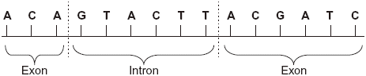

(i)      In the space below, give the sequence of bases on the pre-mRNA transcribed from this strand.

**(2)**

(ii)     In the space below, give the sequence of bases on the mRNA produced by splicing this piece of pre-mRNA.

**(1)**

**(Total 5 marks)**

**Q4.**          (a)     The diagram shows one pair of nucleotides of a DNA molecule.

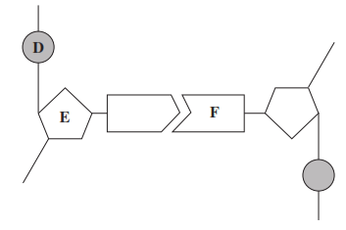

Name

**D**.............................................................

**E** .............................................................

**F** .............................................................

**(3)**

(b)     Complete the table to give **two** differences between the structure of DNA and the structure of RNA.

|  |  |  |
| --- | --- | --- |
|  | **DNA** | **RNA** |
| **1** |  |  |
| **2** |  |  |

**(2)**

**(Total 5 marks)**

**Q5.**          The bases in DNA nucleotides contain nitrogen.

Researchers grew bacteria on a medium containing 15N (‘heavy’ nitrogen) for several generations. They then transferred the bacteria to a medium containing 14N (‘ordinary’ nitrogen). They analysed DNA from the bacteria at three stages:

1. whilst the bacteria were growing on the 15N medium

2. after one division of the bacteria on the 14N medium

3. after two divisions of the bacteria on the 14N medium

The diagram shows their results.

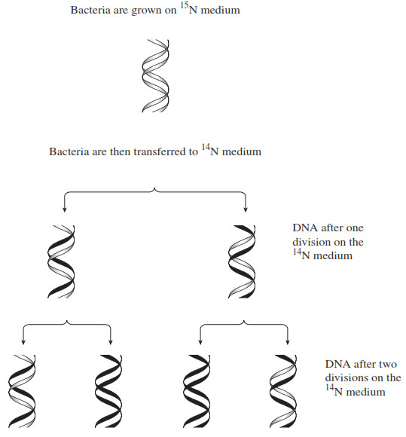

(a)     Describe how the proportion of DNA that contained 15N changed at each division when bacteria were grown on the 14N medium.

.......................................................................................................................

.......................................................................................................................

.......................................................................................................................

.......................................................................................................................

**(2)**

(b)     The change in the proportion of DNA containing 15N is due to the way in which DNA replicates. Explain how.

.......................................................................................................................

.......................................................................................................................

.......................................................................................................................

.......................................................................................................................

**(2)**

**(Total 4 marks)**

**Q6.**          The diagram shows a molecule of DNA.  It is replicating.

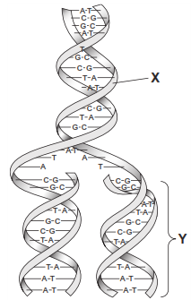

(a)     Name **two** substances in the region labelled **X**.

1  ........................................................................

2  ........................................................................

**(1)**

(b)     Describe how, after the parent DNA strands separated, the second strand of DNA in region **Y** was formed.

......................................................................................................................

......................................................................................................................

......................................................................................................................

......................................................................................................................

......................................................................................................................

......................................................................................................................

(*Extra space*)................................................................................................

......................................................................................................................

......................................................................................................................

**(3)**

**(Total 4 marks)**

**Q7.**          A student carried out an investigation into the mass of product formed in an enzyme-controlled reaction at three different temperatures. Only the temperature was different for each experiment. The results are shown in the graph.

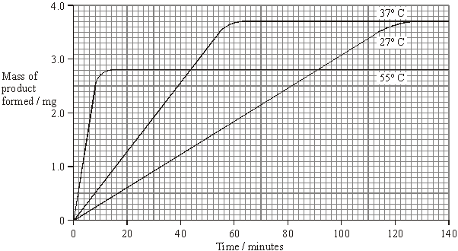

(a)     Use your knowledge of enzymes to explain

(i)      why the initial rate of reaction was highest at 55 °C;

.............................................................................................................

.............................................................................................................

.............................................................................................................

.............................................................................................................

**(2)**

(ii)     the shape of the curve for 55 °C after 20 minutes.

.............................................................................................................

.............................................................................................................

.............................................................................................................

.............................................................................................................

.............................................................................................................

.............................................................................................................

**(3)**

(b)     Explain why the curves for 27 °C and 37 °C level out at the same value.

......................................................................................................................

......................................................................................................................

......................................................................................................................

......................................................................................................................

**(2)**

**(Total 7 marks)**

**Q8.**          The diagram shows one nucleotide pair of a DNA molecule.

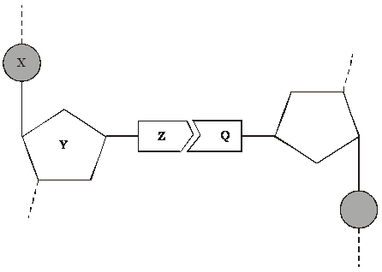

(a)     Name the parts of the nucleotide labelled **X**, **Y** and **Z**.

**X** .....................................................

**Y** .....................................................

**Z** .....................................................

**(3)**

(b)     What type of bond holds **Z** and **Q** together?

......................................................................................................................

**(1)**

(c)     A sample of DNA was analysed. 28% of the nucleotides contained thymine. Calculate the percentage of nucleotides which contained cytosine. Show your working.

Answer ....................................... %

**(2)**

**(Total 6 marks)**

**Q9.**          (a)     Complete the table to give **two** differences between DNA and RNA.

|  |  |  |
| --- | --- | --- |
| **Difference** | **DNA** | **RNA** |
| 1 |  |  |
| 2 |  |  |

**(2)**

(b)     Describe the part played by RNA in protein synthesis.

......................................................................................................................

......................................................................................................................

......................................................................................................................

......................................................................................................................

......................................................................................................................

......................................................................................................................

*(Extra space)  ..............................................................................................*

......................................................................................................................

......................................................................................................................

**(3)**

**(Total 5 marks)**

**Q10.** The diagram shows the process of DNA replication. The horizontal lines represent the positions of bases.

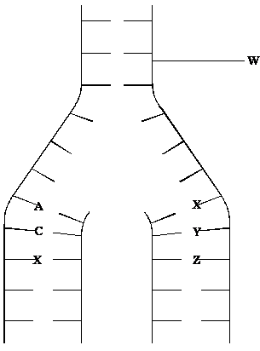

(i)      What is represented by the part of the DNA molecule labelled **W**?

......................................................................................................................

**(1)**

(ii)      In the diagram, **A** represents adenine and **C** represents cytosine.

Name the base found at

position **X**; .....................................................................................................

position **Y**; .....................................................................................................

position **Z**. .....................................................................................................

**(3)**

**(Total 4 marks)**

**Q11.**          New alleles arise as a result of mutations in existing genes. These mutations may occur during DNA replication.

(a)     Explain what is meant by an allele.

......................................................................................................................

......................................................................................................................

**(1)**

(b)     Explain how DNA replicates.

......................................................................................................................

......................................................................................................................

......................................................................................................................

......................................................................................................................

......................................................................................................................

......................................................................................................................

......................................................................................................................

......................................................................................................................

**(4)**

(c)     Explain why a mutation involving the deletion of a base may have a greater effect than one involving substitution of one base for another.

......................................................................................................................

......................................................................................................................

......................................................................................................................

......................................................................................................................

......................................................................................................................

......................................................................................................................

**(3)**

**(Total 8 marks)**

**Q12.**          (a)     Describe and explain how the structure of DNA results in accurate replication.

......................................................................................................................

......................................................................................................................

......................................................................................................................

......................................................................................................................

......................................................................................................................

......................................................................................................................

......................................................................................................................

......................................................................................................................

**(4)**

(b)     Describe the behaviour of chromosomes during mitosis and explain how this results in the production of two genetically identical cells.

......................................................................................................................

......................................................................................................................

......................................................................................................................

......................................................................................................................

......................................................................................................................

......................................................................................................................

......................................................................................................................

......................................................................................................................

......................................................................................................................

......................................................................................................................

......................................................................................................................

......................................................................................................................

......................................................................................................................

......................................................................................................................

......................................................................................................................

**(7)**

(c)     A cancerous tumour is formed by uncontrolled mitotic division. This results in a mass of cells with an inadequate blood supply. Drugs are being developed which only kill cells in a low oxygen environment. Suggest how these drugs could be useful in the treatment of cancer.

......................................................................................................................

......................................................................................................................

......................................................................................................................

......................................................................................................................

**(2)**

**(Total 13 marks)**

**Q13.**          (a)     The mRNA codon for the amino acid tyrosine is UAU.

(i)      Give the DNA triplet for tyrosine.

.............................................................................................................

**(1)**

(ii)     Give the tRNA anticodon for tyrosine.

.............................................................................................................

**(1)**

(b)     Give **two** ways in which the structure of a molecule of tRNA differs from the structure of a molecule of mRNA.

1 ...................................................................................................................

......................................................................................................................

2 ...................................................................................................................

......................................................................................................................

**(2)**

**(Total 4 marks)**

**Q14.**          (a)     Explain why the replication of DNA is described as semi-conservative.

......................................................................................................................

......................................................................................................................

......................................................................................................................

......................................................................................................................

**(2)**

(b)     Bacteria require a source of nitrogen to make the bases needed for DNA replication. In an investigation of DNA replication some bacteria were grown for many cell divisions in a medium containing 14N, a light form of nitrogen. Others were grown in a medium containing 15N, a heavy form of nitrogen. Some of the bacteria grown in a 15N medium were then transferred to a 14N medium and left to divide once.

DNA was isolated from the bacteria and centrifuged.

The DNA samples formed bands at different levels, as shown in the diagram.

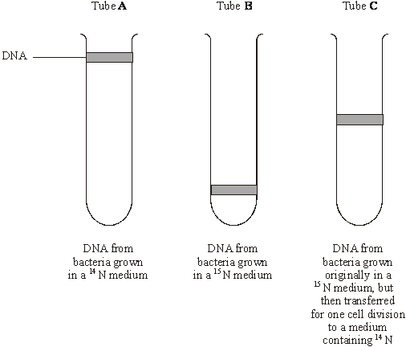

(i)      What do tubes **A** and **B** show about the density of the DNA formed using the two different forms of nitrogen?

.............................................................................................................

.............................................................................................................

**(1)**

(ii)     Explain the position of the band in tube **C**.

.............................................................................................................

.............................................................................................................

.............................................................................................................

.............................................................................................................

**(2)**

(c)     In a further investigation, the DNA of the bacterium was isolated and separated into single strands. The percentage of each nitrogenous base in each strand was found. The table shows some of the results.

|  |  |  |  |  |
| --- | --- | --- | --- | --- |
|  | **Percentage of base present** | | | |
| **DNA sample** | Adenine | Cytosine | Guanine | Thymine |
| Strand 1 | 26 |  | 28 | 14 |
| Strand 2 | 14 |  |  |  |

Use your knowledge of base pairing to complete the table.

**(2)**

**(Total 7 marks)**

**Q15.** Read the following passage.

Malaria is a disease so deadly that it has devastated armies and destroyed great civilisations.  
It has been estimated that in the course of history malaria has been responsible for the death of one out of every two people who have ever lived. Even today, with all the advantages of modern technology, it is still responsible for some three million deaths a year.

5     The first half of the twentieth century was a time of hope for malarial control. The drugs

chloroquine and proguanil had just been discovered and there seemed a real possibility of a malaria-free world. Unfortunately, this honeymoon ended almost as soon as it had started, with the emergence of drug-resistant parasite populations. Scientists now accept that whatever new drug they come up with, it is likely to have a very limited effective life. As a result, they are increasingly looking at combinations of drugs.

The approach to malaria control which holds the best hope is the production of a vaccine. One of these is being developed by a researcher in South America. His vaccine is based on a small synthetic polypeptide called SPf66 which is dissolved in a saline solution and given as an injection. A series of early trials on human volunteers produced confusing results.

In one trial the effectiveness of the vaccine was claimed to be 80% while, in others, the results were statistically insignificant. Not only were the results inconclusive but the methods used were challenged by other scientists. In particular, the controls were considered inappropriate.

Another, possibly more promising, approach has been the development of a DNA-based  
vaccine. In theory, all that is required is to identify the DNA from the parasite which encodes key antigens. Unfortunately, scientists have hit snags. Although they have succeeded in sequencing the human genome, the genome of the malarial parasite has created major difficulties. This is partly because of the very high proportion of the bases adenine and thymine. In some places these two bases average 80%, and on chromosomes 2 and 3 nearly 100% of the bases present are adenine and thymine. Because of this, it has proved impossible to cut the relevant DNA with the commonly available restriction enzymes into pieces of a suitable size for analysis.

          Use information from the passage and your own knowledge to answer the following questions.

(a)     Explain how a resistant parasite population is likely to arise and limit the life of any new anti-malarial drug (lines 8 - 9).

......................................................................................................................

......................................................................................................................

......................................................................................................................

......................................................................................................................

......................................................................................................................

......................................................................................................................

**(3)**

(b)     A person has a 1 in 500 probability of being infected by a chloroquine-resistant strain of malarial parasite and a 1 in 500 probability of being infected by a proguanil-resistant strain. Use a calculation from these figures to explain why scientists are “increasingly looking at combinations of drugs” (lines 9 - 10).

......................................................................................................................

......................................................................................................................

......................................................................................................................

......................................................................................................................

**(2)**

(c)     (i)      Explain why trials of the SPf66 vaccine needed a control.

.............................................................................................................

.............................................................................................................

**(1)**

(ii)     The controls for the SPf66 vaccine trials were considered inappropriate (line 17).

Suggest how the control groups in these trials should have been treated.

.............................................................................................................

.............................................................................................................

.............................................................................................................

.............................................................................................................

**(2)**

(d)     In some of the DNA of a malarial parasite, the proportion of adenine and thymine bases averages 80% (lines 22 - 23). In this DNA what percentage of the nucleotides would you expect to contain

(i)      phosphate; ..........................................................................................

(ii)     guanine? .............................................................................................

**(2)**

(e)     (i)      Use your knowledge of enzymes to explain why restriction enzymes only cut DNA at specific restriction sites.

.............................................................................................................

.............................................................................................................

.............................................................................................................

.............................................................................................................

.............................................................................................................

.............................................................................................................

**(3)**

(ii)     Restriction enzymes that can cut the DNA of chromosomes 2 and 3 produce pieces that are too small for analysis. Explain why these restriction enzymes produce small DNA fragments.

.............................................................................................................

.............................................................................................................

.............................................................................................................

.............................................................................................................

**(2)**

**(Total 15 marks)**

**Q16.**          (a)     There are two forms of nitrogen. These different forms are called isotopes. 15N is a heavier isotope than the normal isotope 14N.

In an investigation, a culture of bacteria was obtained in which all the nitrogen in the DNA was of the 15N form. The bacteria (generation 0) were transferred to a medium containing only the normal isotope, 14N, and allowed to divide once. A sample of these bacteria (generation 1) was then removed. The DNA in the bacteria of generation 1 was extracted and spun in a high-speed centrifuge.

The bacteria in the 14N medium were allowed to divide one more time. The DNA was also extracted from these bacteria (generation 2) and spun in a high speed centrifuge.

The diagram shows the results of this investigation.

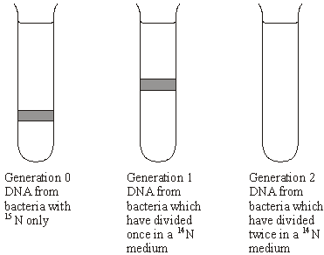

(i)      Which part of the DNA molecule contains nitrogen?

.............................................................................................................

**(1)**

(ii)     Explain why the DNA from generation 1 is found in the position shown.

.............................................................................................................

.............................................................................................................

.............................................................................................................

.............................................................................................................

**(2)**

(iii)     Complete the diagram to show the results for generation 2.

**(2)**

(b)     The table shows the percentage of different bases in the DNA of different organisms.

|  |  |  |  |  |
| --- | --- | --- | --- | --- |
| Organism | Adenine% | Guanine% | Thymine% | Cytosine% |
| Human |  | 19 |  |  |
| Bacterium | 24 | 26 | 24 | 26 |
| Virus | 25 | 24 | 33 | 18 |

(i)      Complete the table to show the percentages of different bases in human DNA.

**(2)**

(ii)     The structure of virus DNA is different from the DNA of the other two organisms. Giving evidence from the table, suggest what this difference might be.

.............................................................................................................

.............................................................................................................

.............................................................................................................

.............................................................................................................

**(2)**

**(Total 9 marks)**

**Q17.**          (a)     Nucleic acids, such as DNA, are polymers, made up of many repeating monomer units. Name the monomer from which nucleic acids are made.

......................................................................................................................

**(1)**

(b)     The table shows the percentage of different bases in the DNA of some organisms.

|  |  |  |  |  |  |
| --- | --- | --- | --- | --- | --- |
|  | **Organism** | **Percentage of each base** | | | |
|  | **Adenine** | **Guanine** | **Cytosine** | **Thymine** |
|  | Human | 31.2 | 18.8 | 18.8 | 31.2 |
|  | Cow | 27.9 | 22.1 | 22.1 | 27.9 |
|  | Salmon | 29.4 | 20.6 | 20.6 | 29.4 |
|  | Rat | 28.6 |  |  |  |
|  | Virus | 24.7 | 24.1 | 18.5 | 32.7 |

(i)      Calculate the missing figures for rat DNA and write them into the table.

**(2)**

(ii)     The virus has single-stranded DNA as its genetic material. Explain the evidence from the table which suggests that the DNA is single-stranded.

.............................................................................................................

.............................................................................................................

.............................................................................................................

.............................................................................................................

**(2)**

**(Total 5 marks)**

**Q18.**          (a)     Starch and protein are biologically important polymers.

(i)      Explain what is meant by a polymer.

.............................................................................................................

.............................................................................................................

**(1)**

(ii)     Give **one** example of a biologically important polymer other than starch or protein.

.............................................................................................................

**(1)**

(b)     In an investigation, the enzyme amylase was mixed in a test tube with a buffer solution and a suspension of starch. The amylase broke down the starch to maltose. When all the starch had been broken down, a sample was removed from the test tube and tested with biuret reagent.

(i)      Explain why a buffer solution was added to the amylase-starch mixture.

.............................................................................................................

.............................................................................................................

.............................................................................................................

**(2)**

(ii)     What colour would you expect the sample to go when tested with biuret reagent?

.............................................................................................................

**(1)**

(iii)     Give an explanation for your answer to part (ii)

.............................................................................................................

.............................................................................................................

.............................................................................................................

**(2)**

**(Total 7 marks)**

**Q19.**          **Figure 1** shows a short section of a DNA molecule.

**Figure 1**

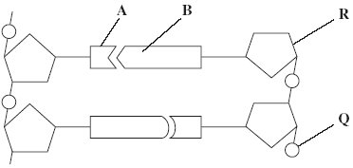

(a)     Name parts **R** and **Q**.

(i)      **R** ....................................................

(ii)     **Q** ....................................................

**(2)**

(b)     Name the bonds that join **A** and **B**.

......................................................................................................................

**(1)**

(c)     Ribonuclease is an enzyme. It is 127 amino acids long.

          What is the minimum number of DNA bases needed to code for ribonuclease?



**(1)**

(d)     **Figure 2** shows the sequence of DNA bases coding for seven amino acids in the enzyme ribonuclease.

**Figure 2**

**G  T  T  T  A  C  T  A  C  T  C  T  T  C  T  T  C  T  T  T  A**

The number of each type of amino acid coded for by this sequence of DNA bases is shown in the table.

|  |  |
| --- | --- |
| **Amino acid** | **Number present** |
| Arg | 3 |
| Met | 2 |
| Gln | 1 |
| Asn | 1 |

Use the table and **Figure 2** to work out the sequence of amino acids in this part of the enzyme. Write your answer in the boxes below.

|  |  |  |  |  |  |  |
| --- | --- | --- | --- | --- | --- | --- |
| Gln |  |  |  |  |  |  |

**(1)**

(e)     Explain how a change in a sequence of DNA bases could result in a non-functional enzyme.

......................................................................................................................

......................................................................................................................

......................................................................................................................

......................................................................................................................

......................................................................................................................

......................................................................................................................

**(3)**

**Total 8 marks)**

**Q20.**(a)     The table shows some substances found in cells. Complete the table to show the properties of these substances. Put a tick in the box if the statement is correct.

|  |  |  |  |  |  |
| --- | --- | --- | --- | --- | --- |
|  |  | **Substance** | | | |
|  | **Statement** | Starch | Glycogen | Deoxyribose | DNA helicase |
|  | Substance contains only the elements carbon, hydrogen and oxygen |  |  |  |  |
|  | Substance is made from amino acid monomers |  |  |  |  |
|  | Substance is found in both animal cells and plant cells |  |  |  |  |

**(4)**

(b)     The diagram shows two molecules of β-glucose.

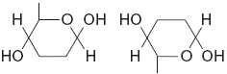

On the diagram, draw a box around the atoms that are removed when the two β-glucose molecules are joined by condensation.

**(2)**

(c)     (i)      Hydrogen bonds are important in cellulose molecules. Explain why.

.............................................................................................................

.............................................................................................................

.............................................................................................................

.............................................................................................................

**(2)**

(ii)     A starch molecule has a spiral shape. Explain why this shape is important to its function in cells.

.............................................................................................................

.............................................................................................................

.............................................................................................................

**(1)**

**(Total 9 marks)**

**Q21.**(a)     (i)      Describe the role of DNA polymerase in DNA replication.

...................................................................................................................

...................................................................................................................

**(1)**

(ii)     Other than being smaller, give **two** ways in which prokaryotic DNA is different from eukaryotic DNA.

1 ................................................................................................................

2 ................................................................................................................

**(2)**

(b)     The table shows the percentage of each base in the DNA from three different organisms.

|  |  |  |  |  |  |
| --- | --- | --- | --- | --- | --- |
|  | **Organism** | **Percentage of each base in DNA** | | | |
|  | Adenine | Guanine | Thymine | Cytosine |
|  | Human | 30.9 | 19.9 | 29.4 | 19.8 |
|  | Grasshopper | 29.4 | 20.5 | 29.4 | 20.7 |
|  | Virus | 24.0 | 23.3 | 21.5 | 31.2 |

(i)      Humans and grasshoppers have very similar percentages of each base in their DNA but they are very different organisms.

Use your knowledge of DNA structure and function to explain how this is possible.

...................................................................................................................

...................................................................................................................

...................................................................................................................

...................................................................................................................

...................................................................................................................

**(2)**

(ii)     The DNA of the virus is different from that of other organisms. Use the table above and your knowledge of DNA to suggest what this difference is. Explain your answer.

...................................................................................................................

...................................................................................................................

...................................................................................................................

...................................................................................................................

...................................................................................................................

**[Extra space]** ...........................................................................................

...................................................................................................................

**(2)**

**(Total 7 marks)**

**Q22.**          The diagram shows a cell cycle.

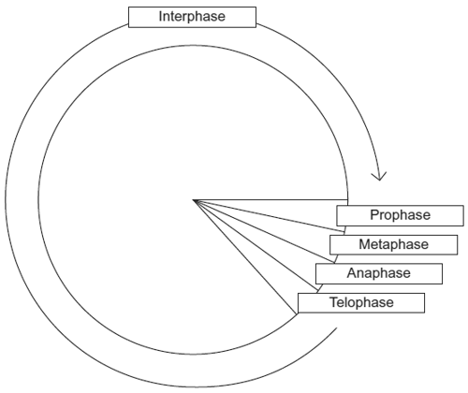

(a)     In prophase of mitosis, the chromosomes become visible. Describe what happens in

(i)metaphase

.............................................................................................................

.............................................................................................................

.............................................................................................................

.............................................................................................................

.............................................................................................................

**(2)**

(ii)anaphase.

.............................................................................................................

.............................................................................................................

.............................................................................................................

.............................................................................................................

.............................................................................................................

**(2)**

(b)     (i)      Cells lining the human intestine complete the cell cycle in a short time. Explain the advantage of these cells completing the cell cycle in a short time.

.............................................................................................................

.............................................................................................................

.............................................................................................................

**(1)**

(ii)     The time required for a cell to complete the cell cycle was 4 hours 18 minutes.

Calculate the time required in minutes for this cell to multiply to produce eight cells.  
Show your working.

Answer .....................................................

**(2)**

(c)Mikanolide is a drug that inhibits the enzyme DNA polymerase. Explain why this drug may be effective against some types of cancer.

......................................................................................................................

......................................................................................................................

......................................................................................................................

......................................................................................................................

......................................................................................................................

**(2)**

**(Total 9 marks)**

**Q23.**(a)     The diagram shows a stage of mitosis in an animal cell.

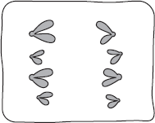

(i)      Name this stage.

...............................................................................................................

**(1)**

(ii)     Describe what happens during this stage that results in the production of two genetically identical cells.

...............................................................................................................

...............................................................................................................

...............................................................................................................

...............................................................................................................

...............................................................................................................

**(2)**

(b)     A sample of epithelial tissue from the small intestine of an animal was analysed.  
Some of the cells had 8.4 units of DNA, others had only 4.2 units.

(i)      Use your knowledge of the cell cycle to explain why some cells had 8.4 units of DNA and others had only 4.2 units.

...............................................................................................................

...............................................................................................................

...............................................................................................................

...............................................................................................................

...............................................................................................................

**(2)**

(ii)     How many units of DNA would you expect to be present in a gamete formed in this animal as a result of meiosis?



**(1)**

**(Total 6 marks)**

**Q25.**The diagram shows part of a DNA molecule.

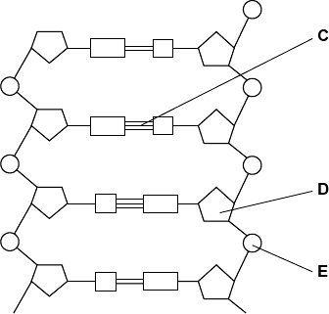

(a)     (i)      DNA is a polymer. What is the evidence from the diagram that DNA is a polymer?

...............................................................................................................

...............................................................................................................

...............................................................................................................

**(1)**

(ii)     Name the parts of the diagram labelled **C**, **D** and **E**.

|  |  |  |
| --- | --- | --- |
|  | Part **C** | ....................................................................... |
|  | Part **D** | ....................................................................... |
|  | Part **E** | ....................................................................... |

**(3)**

(iii)    In a piece of DNA, 34% of the bases were thymine.

Complete the table to show the names and percentages of the other bases.

|  |  |  |
| --- | --- | --- |
|  | **Name of base** | **Percentage** |
|  | Thymine | 34 |
|  |  |  |
|  |  | 34 |
|  |  |  |

**(2)**

(b)     A polypeptide has 51 amino acids in its primary structure.

(i)      What is the minimum number of DNA bases required to code for the amino acids in this polypeptide?

|  |  |
| --- | --- |
|  |  |

**(1)**

(ii)     The gene for this polypeptide contains more than this number of bases.

Explain why

...............................................................................................................

...............................................................................................................

...............................................................................................................

**(1)**

**(Total 8 marks)**

**Q26.**(a)    Describe how DNA is replicated.

**(6)**

(b)     The graph shows information about the movement of chromatids in a cell that has just started metaphase of mitosis.

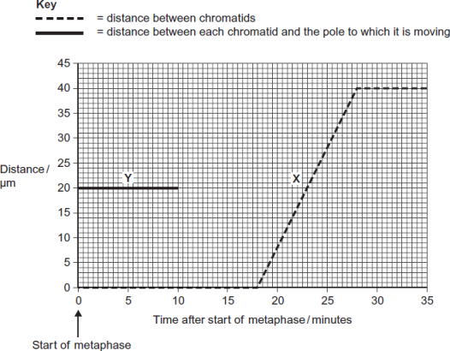

(i)      What was the duration of metaphase in this cell?

  minutes

**(1)**

(ii)     Use line **X** to calculate the duration of anaphase in this cell.

  minutes

**(1)**

(iii)    Complete line **Y** on the graph.

**(2)**

(c)     A doctor investigated the number of cells in different stages of the cell cycle in two tissue samples, **C** and **D.** One tissue sample was taken from a cancerous tumour. The other was taken from non-cancerous tissue. The table shows his results.

|  |  |  |  |
| --- | --- | --- | --- |
|  |  | **Percentage of cells in each stage of the cell cycle** | |
|  | **Stage of the cell cycle** | Tissue sample **C** | Tissue sample **D** |
|  | Interphase | 82 | 45 |
|  | Prophase | 4 | 16 |
|  | Metaphase | 5 | 18 |
|  | Anaphase | 5 | 12 |
|  | Telophase | 4 | 9 |

(i)      In tissue sample **C**, one cell cycle took 24 hours. Use the data in the table to calculate the time in which these cells were in interphase during one cell cycle. Show your working.

Time cells in interphase ...................................... hours

**(2)**

(ii)     Explain how the doctor could have recognised which cells were in interphase when looking at the tissue samples.

...............................................................................................................

...............................................................................................................

...............................................................................................................

**(1)**

(iii)    Which tissue sample, **C** or **D**, was taken from a cancerous tumour?   
Use information in the table to explain your answer.

...............................................................................................................

...............................................................................................................

...............................................................................................................

...............................................................................................................

...............................................................................................................

**(2)**

**(Total 15 marks)**

**Q27.**(a)     The events that take place during interphase and mitosis lead to the production of two genetically identical cells. Explain how.

........................................................................................................................

........................................................................................................................

........................................................................................................................

........................................................................................................................

........................................................................................................................

........................................................................................................................

........................................................................................................................

........................................................................................................................

........................................................................................................................

**[Extra space]** ................................................................................................

........................................................................................................................

........................................................................................................................

........................................................................................................................

**(4)**

(b)     A student cut thin sections of tissue at different distances from the tip of a root. She stained the sections and viewed them with an optical microscope.

For each section, the student counted the number of cells in mitosis and the total number of cells in each field of view. She then calculated a **mitotic index** for each section using the equation:

mitotic index = 

The student’s results are shown in the graph.

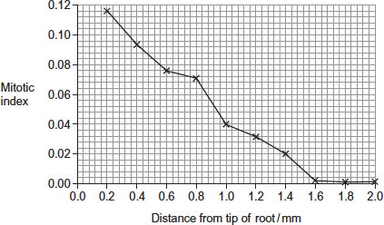

(i)      The student cut thin sections of tissue to view with an optical microscope.   
Explain why it was important that the sections were thin.

...............................................................................................................

...............................................................................................................

...............................................................................................................

...............................................................................................................

...............................................................................................................

**(2)**

(ii)     What does the graph show about the growth of roots?  
Use the data to explain your answer.

...............................................................................................................

...............................................................................................................

...............................................................................................................

...............................................................................................................

...............................................................................................................

**(2)**

**(Total 8 marks)**

**Q28.**(a)     DNA helicase is important in DNA replication. Explain why.

........................................................................................................................

........................................................................................................................

........................................................................................................................

........................................................................................................................

........................................................................................................................

**(2)**

Scientists investigating DNA replication grew bacteria for several generations in a nutrient solution containing a heavy form of nitrogen (15N). They obtained DNA from a sample of these bacteria.

The scientists then transferred the bacteria to a nutrient solution containing a light form of nitrogen (14N). The bacteria were allowed to grow and divide twice. After each division, DNA was obtained from a sample of bacteria.

The DNA from each sample of bacteria was suspended in a solution in separate tubes. These were spun in a centrifuge at the same speed and for the same time. The diagram shows the scientists’ results.

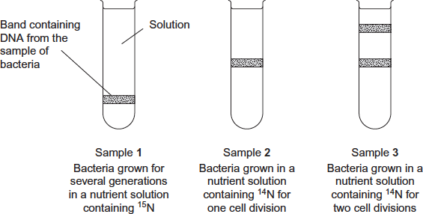

(b)     The table shows the types of DNA molecule that could be present in samples **1** to **3**.  
Use your knowledge of semi-conservative replication to complete the table with a tick if the DNA molecule is present in the sample.

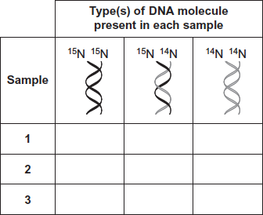

**(3)**

(c)     Cytarabine is a drug used to treat certain cancers. It prevents DNA replication. The diagram shows the structures of cytarabine and the DNA base cytosine.

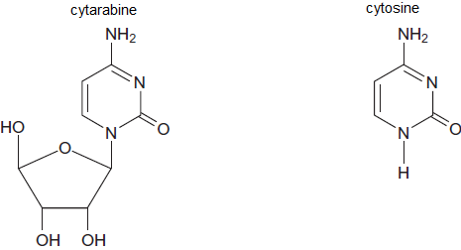

(i)      Use information in the diagram to suggest how cytarabine prevents DNA replication.

...............................................................................................................

...............................................................................................................

...............................................................................................................

...............................................................................................................

...............................................................................................................

**(2)**

(ii)     Cytarabine has a greater effect on cancer cells than on healthy cells. Explain why.

...............................................................................................................

...............................................................................................................

...............................................................................................................

**(1)**

**(Total 8 marks)**

**Q29.Figure 1** shows one base pair of a DNA molecule.

**Figure 1**

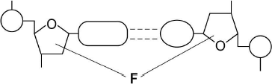

(a)     Name part **F** of each nucleotide.

........................................................................................................................

**(1)**

(b)     Scientists determined that a sample of DNA contained 18% adenine.

What were the percentages of thymine and guanine in this sample of DNA?

|  |  |  |
| --- | --- | --- |
|  | Percentage of thymine |  |
|  | Percentage of guanine |  |

**(2)**

During replication, the two strands of a DNA molecule separate and each acts as a template for the production of a new strand.

**Figure 2** represents DNA replication.

**Figure 2**

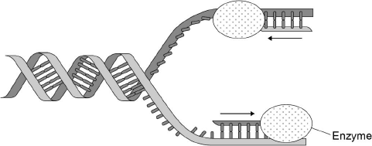

(c)     Name the enzyme shown in **Figure 2**.

........................................................................................................................

**(1)**

The arrows in **Figure 2** show the directions in which each new DNA strand is being produced.

(d)     Use **Figure 1, Figure 2** and your knowledge of enzyme action to explain why the arrows point in opposite directions.

........................................................................................................................

........................................................................................................................

........................................................................................................................

........................................................................................................................

........................................................................................................................

........................................................................................................................

........................................................................................................................

........................................................................................................................

**(4)**

**(Total 8 marks)**

**Q30.**(a)     Explain how the structure of DNA is related to its functions.

........................................................................................................................

........................................................................................................................

........................................................................................................................

........................................................................................................................

........................................................................................................................

........................................................................................................................

........................................................................................................................

........................................................................................................................

........................................................................................................................

........................................................................................................................

........................................................................................................................

........................................................................................................................

*(Extra space)* ..................................................................................................

........................................................................................................................

........................................................................................................................

........................................................................................................................

........................................................................................................................

........................................................................................................................

........................................................................................................................

........................................................................................................................

........................................................................................................................

........................................................................................................................

........................................................................................................................

**(6)**

Scientists investigated three genes, **C**, **D** and **E**, involved in controlling cell division.  
They studied the effect of mutations in these genes on the risk of developing lung cancer.

The scientists analysed genes **C**, **D** and **E** from healthy people and people with lung cancer.

•        If a person had a normal allele for a gene, they used the symbol N.

•        If a person had two mutant alleles for a gene, they used the symbol M.

They used their data to calculate the risk of developing lung cancer for people with different combinations of N and M alleles of the genes. A risk value of 1.00 indicates no increased risk. The following table shows the scientists’ results.

|  |  |  |  |  |
| --- | --- | --- | --- | --- |
|  | **Gene C** | **Gene D** | **Gene E** | **Risk of developing lung cancer** |
|  | N | N | N | 1.00 |
|  | M | N | N | 1.30 |
|  | N | N | M | 1.78 |
|  | N | M | N | 1.45 |
|  | N = at least one copy of the normal allele is present M = two copies of the mutant allele are present | | | |

(b)     What do these data suggest about the relative importance of the mutant alleles of genes **C**, **D** and **E** on **increasing** the risk of developing lung cancer? Explain your answer.

........................................................................................................................

........................................................................................................................

........................................................................................................................

........................................................................................................................

........................................................................................................................

........................................................................................................................

........................................................................................................................

**(3)**

Chemotherapy is the use of a drug to treat cancer. The drug kills dividing cells.  
The figure below shows the number of healthy cells and cancer cells in the blood of a patient receiving chemotherapy. The arrows labelled **F** to **I** show when the drug was given to the patient.

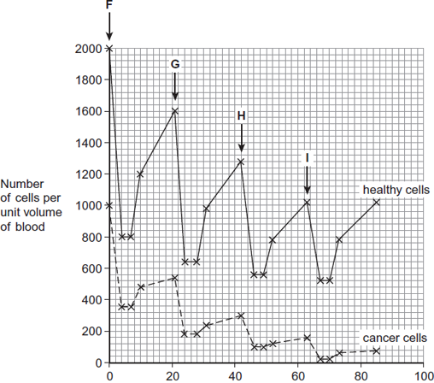  
                                    Time / days

(c)     Calculate the rate at which healthy cells were killed between days 42 and 46.

.............. cells killed per unit volume of blood per day

**(1)**

(d)     Describe similarities and differences in the response of healthy cells and cancer cells to the drug between times **F** and **G**.

........................................................................................................................

........................................................................................................................

........................................................................................................................

........................................................................................................................

........................................................................................................................

........................................................................................................................

*(Extra space)* .................................................................................................

........................................................................................................................

........................................................................................................................

**(3)**

(e)     More cancer cells could be destroyed if the drug was given more frequently.

Suggest why the drug was **not** given more frequently.

........................................................................................................................

........................................................................................................................

........................................................................................................................

........................................................................................................................

**(2)**

**(Total 15 marks)**

**Q31.**The following figure represents part of a DNA molecule.

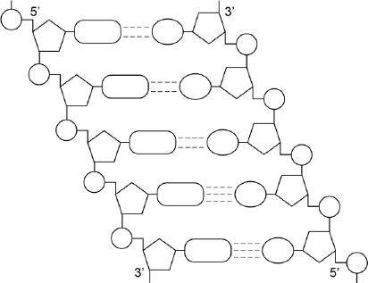

(a)     Draw a box around a single nucleotide.

**(1)**

The table below shows the percentage of bases in each of the strands of a DNA molecule.

|  |  |  |  |  |  |
| --- | --- | --- | --- | --- | --- |
|  | **DNA strand** | **Percentage of each base** | | | |
|  | **A** | **C** | **G** | **T** |
|  | Strand **1** | 16 |  |  |  |
|  | Strand **2** |  | 21 | 34 |  |

(b)     Complete the table by adding the missing values.

**(2)**

(c)     During replication, the two DNA strands separate and each acts as a template for the production of a new strand. As new DNA strands are produced, nucleotides can only be added in the 5’ to 3’ direction.

Use the figure in part **(a)** and your knowledge of enzyme action and DNA replication to explain why new nucleotides can only be added in a 5’ to 3’ direction.

........................................................................................................................

........................................................................................................................

........................................................................................................................

........................................................................................................................

........................................................................................................................

........................................................................................................................

........................................................................................................................

........................................................................................................................

**(Extra space)** ................................................................................................

........................................................................................................................

........................................................................................................................

**(4)**

**(Total 7 marks)**

**Q32.**Read the following passage.

|  |  |  |
| --- | --- | --- |
|  | Herpes simplex virus (HSV) infects nerve cells in the face, including some near the lips. Like many other viruses, HSV can remain inactive inside the body for years. When HSV becomes active, it causes cold sores around the mouth. |  |
|  | Human cells infected with a virus may undergo programmed cell death. While HSV is inactive inside the body, only one of its genes is transcribed. This gene is the latency-associated transcript (*LAT*) gene that prevents programmed cell death of an infected nerve cell. | 5 |
|  | Scientists have found that transcription of the *LAT* gene produces a microRNA. This microRNA binds to some of the nerve cell’s own mRNA molecules. These mRNA molecules are involved in programmed cell death of nerve cells. The scientists concluded that production of this microRNA allows HSV to remain in the body for years. | 10 |

Use information from the passage and your own knowledge to answer the following questions.

(a)     HSV infects nerve cells in the face (line 1). Explain why it infects **only** nerve cells.

........................................................................................................................

........................................................................................................................

........................................................................................................................

........................................................................................................................

........................................................................................................................

........................................................................................................................

**(Extra space)** .................................................................................................

........................................................................................................................

........................................................................................................................

**(3)**

(b)     HSV can remain inactive inside the body for years (lines 2–3). Explain why this virus can be described as **inactive**.

........................................................................................................................

........................................................................................................................

........................................................................................................................

........................................................................................................................

**(2)**

(c)     Suggest **one** advantage of programmed cell death (line 4).

........................................................................................................................

........................................................................................................................

**(1)**

(d)     The scientists concluded that production of this microRNA allows HSV to remain in the body for years (lines 10–12).

Explain how this microRNA allows HSV to remain in the body for years.

........................................................................................................................

........................................................................................................................

........................................................................................................................

........................................................................................................................

........................................................................................................................

........................................................................................................................

........................................................................................................................

........................................................................................................................

**(Extra space)** .................................................................................................

........................................................................................................................

........................................................................................................................

........................................................................................................................

**(4)**

**(Total 10 marks)**

**M1.**          (a)     appropriately placed box;

**1**

(b)     (i)      B;

(ii)     A;

**2**

(c)     (i)      determines (sequence of) amino acids / specific protein  
produced / mRNA formation;

**1**

(ii)     hydrogen bonds;

**1**

(iii)     stability / protects bases / replication;

**1**

**[6]**

**M2.**          (a)     Any two of:

|  |  |
| --- | --- |
| DNA | RNA |
| Large molecule | Smaller |
| Double stranded | Single stranded |
| Contains Thymine (T) | Contains Uracil (U) |
| Contains deoxyribose | Contains ribose |

**2 max**

(b)     Base sequence (on DNA/in gene);Determines sequence of amino acids;By determining base sequence on (messenger) RNA;Code is a triplet code/three base code for an amino acid;

**2 max**

(c)     Pairs of chromosomes/two chromosomes;With genes for same features / with same genes;At same loci / in same sequence;

*Accept same alleles*

**2 max**

**[6]**

**M3.**          (a)

|  |  |  |
| --- | --- | --- |
| DNA |  | 2 |
| mRNA |  | 1 |
| tRNA |  | 1 |

*One mark for each correct column  
Regard blank as incorrect in the context of this question  
Accept numbers written out: two, one, one*

**2**

(b)     (i)      Marking principles  
1 mark for complete piece transcribed;

*Correct answer  
UGU CAU GAA UGC UAG*

1 mark for complementary bases from sequence transcribed;

*but allow 1 mark for complementary bases from section transcribed, providing all four bases are involved*

**2**

(ii)     Marking principle  
1 mark for bases corresponding to exons taken from (b)(i)

*Correct answer  
UGU UGC UAG  
If sequence is incorrect in (b)(i), award mark if section is from exons. Ignore gaps.*

**1**

**[5]**

**M4.**          (a)     **D** phosphate;**E** pentose sugar/deoxyribose;**F** (nitrogenous) base/ organic base/ thymine/adenine/ cytosine/guanine;

*In* ***D*** *reject phosphorous*

*In* ***E***

*Accept 5-carbon sugar*

*Reject sugar alone*

**3**

(b)

|  |  |  |
| --- | --- | --- |
|  | **DNA** | **RNA** |
|  | double-stranded | single-stranded |
|  | deoxyribose | ribose |
|  | Thymine/T | Uracil/U |
|  | very large/long | very small/short |

*Accept double helix for DNA*

*Accept longer and shorter*

*Need comparison but could be in one box*

*List rule applies.*

**2 max**

**[5]**

**M5.**          (a)     Decreases by 50%;

Per generation / per division;

*Only accessible if linked to first marking point*

***OR***

15N makes up ½ after 1 division;

Makes up ¼ after 2nd division;

**2**

(b)     In DNA replication strands separate;  
Each acts as template (for formation of new strand);  
One strand in each new molecule / semi-conservative replication;  
New strands made using 14N.

**2 max**

**[4]**

**M6.**          (a)     (Pentose) sugar/deoxyribose and phosphate;

*Reject ribose and phosphorus*

**1**

(b)     Semi-conservative replication;Complementary pairing;Hydrogen bonding (of bases/nucleotides);Condensation/described of nucleotides;DNA polymerase involved;

*Accept example (A, T and C, G)*

**3 max**

**[4]**

**M7.**          (a)     (i)      substances / molecules have more (kinetic) energy / moving faster;

*(reject vibrate)*

increased collisions / enzyme substrate complexes formed;

**2**

(ii)     causes denaturation / tertiary structure / shape change / H+ / ionic bonds break;  
(shape) of active site changed;  
substrate no longer binds / not complementary to (active site);

**3**

(b)     all substrate changed into product / reaction is complete;  
same amount of product formed as same initial substrate concentration;

**2**

**[7]**

**M8.**          (a)**X**, phosphate;  
**Y**, deoxyribose / pentose / 5-carbon sugar;  
**Z**, (nitrogenous) base;

*(accept named base)*

**3**

(b)     (specific) hydrogen (bonds);

**1**

(c)     thymine 28% so adenine 28%  
therefore 44% cytosine and guanine;  
therefore 22% cytosine;

*(idea of equal amounts T and A, C and G – 1 mark, correct answer 2 marks)*

**2**

**[6]**

**M9.**          (a)     Two suitable differences between DNA and RNA;

*1 mark per correct row to 2 max*

e.g.

DNA is double stranded, RNA is single stranded;DNA has thymine present, RNA has Uracil present;

*Accept T and U*

DNA is larger/heavier/longer, RNA is smaller/lighter/shorter;DNA has a deoxyribose sugar, RNA has a ribose sugar;DNA stays in the nucleus, RNA leaves the nucleus;

**2 max**

(b)     Three suitable examples;

e.g.

Carries coded information about the sequence of amino acids;Copied from DNA/gene;Code is in sequence of bases / triplet / three bases / a codon codes  
for one amino acid;Moves out of nucleus/goes into cytoplasm;To ribosomes;

*Accept codons allow anticodons / tRNA to bind*

*Accept carries ‘start’ and ‘stop’ codes*

*Accept moves through ribosomes*

**3 max**

**[5]**

**M10.**          (i)      sugar or phosphate / S-P / nucleotide chain / backbone /   
original / parent DNA;

**1**

(ii)      X thymine; Y guanine; Z adenine;

*(Allow T, G and A) Reject: thiamine*

**3**

**[4]**

**M11.**          (a)     different form of a gene;

**1**

(b)     hydrogen bonds broken;  
semi-conservative replication / both strands used (as templates);  
nucleotides line up complementary / specific base pairing / A and T / C and G;  
DNA polymerase;

**4**

(c)     deletion causes frame shift / alters base sequence (from point of mutation);  
changes many amino acids / sequence of amino acids (from this point);  
substitution alters one codon / triplet / one amino acid altered / code  
degenerate / same amino acid coded for;

**3**

**[8]**

**M12.**          (a)     1       two strands therefore semi-conservative replication (possible);

2       base pairing / hydrogen bonds holds strands together

3       hydrogen bonds weak / easily broken, allow strands to separate;

4       bases (sequence) (exposed so) act as template / can be copied;

5       A with T, C with G / complementary copy;

6       DNA one parent and one new strand;

**4 max**

(b)     1       chromosomes shorten / thicken / supercoiling;

2       chromosomes (each) two identical chromatids / strands / copies   
(due to replication);

3       chromosomes / chromatids move to equator / middle of the spindle / cell;

4       attach to individual spindle fibres;

5       spindle fibres contract / centromeres divide / repel;

6       (sister) chromatids / chromosomes (separate)   
move to opposite poles / ends of the spindle;

7       each pole / end receives all genetic information /   
identical copies of each chromosome;

8       nuclear envelope forms around each group of chromosomes /   
chromatids / at each pole;

**7 max**

(c)     cancer cells killed, normal body cells survive;

cancer cells low oxygen (as blood supply cannot satisfy demand);

**2**

**[13]**

**M13.**          (a)     (i)      ATA;

**1**

(ii)     AUA;

**1**

(b)     tRNA ‘clover leaf’ shape; (allow reference to loop / folded structure)  
tRNA standard length;  
tRNA has an amino acid binding site;  
tRNA has anticodon available / three exposed bases;  
tRNA has hydrogen bonds (between base pairs);

**2 max**

**[4]**

**M14.**          (a)     each strand copied / acts as a template;  
(daughter) DNA one new strand and one original / parent strand;

**2**

(b)     (i)      15N / tube **B** (DNA), more / greater density;

*(reject heavier)*

**1**

(ii)     DNA with one heavy and one light strand;  
new / synthesised strand, made with 14N / light strand;

**2**

(c)     32;  
28 32 26;

**2**

**[7]**

**M15.**          (a)     Presence of resistant and non-resistant varieties / mutation produces resistant variety;  
Resistant ones survive / non-resistant ones killed by treatment;  
These will reproduce and produce more resistant parasites / pass on resistance allele;

**3**

(b)     Likelihood of being infected (by strain resistant to both drugs) is less;  
1/500 × 1/500/1/250 000;  
Drug has longer effective life;

**max 2**

(c)     (i)      As comparison / to show that nothing else in the treatment was responsible;

**1**

(ii)     Given injections of saline / injection without SPf66;  
(otherwise) treated the same as experimental group;

**2**

(d)     (i)      100%;

**1**

(ii)     10%;

**1**

(e)     (i)      Different lengths of DNA have different base sequences / cut at specific sequence;  
Results in different shape / different shape of active site;  
Therefore (specific sequence) will only fit active site of enzyme;

**3**

(ii)     Recognition sites contain only AT pairs;  
Which would occur very frequently;

**2**

**[15]**

**M16.**          (a)     (i)      base / named bases;

*reject nucleotide or uracil*

**1**

(ii)     it has been produced by semi-conservative  
replication / one old strand and one new;   
One strand has 15N bases and the other 14N;

*Accept light / heavy N (therefore) it is less dense / lighter;*

**2**

(iii)     one band is in same position as generation 1;  
one band higher;  
*accept a line. N.B. need a visible gap*

**2**

(b)     (i)      A = 31 and JT = 31;  
C = 19;

**2**

(ii)     viral DNA single-stranded / not double-stranded;  
evidence from table e.g. not equal amount of A and T  
/ C and G / all different;

**2**

*ignore no base-pairing In this* ***Question*** *assume It’ means viral DNA*

**[9]**

**M17.**          (a)     nucleotide;

**1**

(b)     (i)      21.4, 21.4; 28.6;

**2**

(ii)     amounts of A and T / C and G / complementary bases different;  
therefore no base-pairing;

**2 max**

**[5]**

**M18.**          (a)     (i)      (Molecule) made up of many identical / similar molecules / monomers / subunits;

*Not necessary to refer to similarity with monomers.*

**1**

(ii)     Cellulose / glycogen / nucleic acid / DNA / RNA;

**1**

(b)     (i)      To keep pH constant;  
A change in pH will slow the rate of the reaction / denature  
the amylase / optimum for reaction;

**2**

(ii)     Purple / lilac / mauve / violet;  
*Do not allow blue or pink.*

**1**

(iii)     Protein present / the enzyme / amylase is a protein;  
Not used up in the reaction / still present at the end of  
the reaction;

**2**

**[7]**

**M19.**          (a)     (i)      Deoxyribose;

*pentose / 5C sugar = neutral*

**1**

(ii)     Phosphate / Phosphoric acid;

*phosphorus / P = neutral*

**1**

(b)     Hydrogen (bonds);

**1**

(c)     381 / 384 / 387;

**1**

(d)     (Gln) Met Met Arg Arg Arg Asn;

**1**

(e)     Change in (sequence of) amino acids / primary structure;

Change in hydrogen / ionic / disulfide bonds leads to change in tertiary structure / active site (of enzyme);

Substrate cannot bind / no enzyme-substrate complexes form;

***Q*** *Reject = different amino acids are formed*

**3**

**[8]**

**M20.**(a)

|  |  |  |  |  |
| --- | --- | --- | --- | --- |
|  |  |  |  |  |
|  |  |  |  |  |
|  |  |  |  |  |

*One mark for each correct column*

*Mark ticks only and ignore crosses*

**4**

(b)     1.      Two marks for box round two hydrogens and one of the oxygens from OH groups on carbons 1 and 4;;

2.      One mark from incorrect answer involving any two hydrogens and an oxygen from carbons 1 and 4;

*Do not award marks if all atoms concerned are on same carbon atom or are on carbon atoms other than 1 and 4 or where the answer does not have two hydrogen and one oxygen*

**2**

(c)     (i)      1.      Holds chains / cellulose molecules together / forms cross links between chains / cellulose molecules / forms microfibrils, providing strength / rigidity (to cellulose / cell wall);

2.      Hydrogen bonds strong in large numbers;x

*Principles here are first mark for where hydrogen bonds are formed and second for a consequence of this.*

*Accept microfibres*

**2**

(ii)     Compact / occupies small space / tightly packed;

*Answer indicates depth required. Answers such as “good for storage”, “easily stored” or “small” are insufficient.*

**1**

**[9]**

**M21.**(a)     (i)      Joins nucleotides (to form new strand).

*Accept: joins sugar and phosphate / forms sugar-phosphate backbone*

*Reject: (DNA polymerase) forms base pairs / hydrogen bonds*

**1**

(ii)     (Prokaryotic DNA)

1.      Circular / non-linear (DNA);

*Accept converse for eukaryotic DNA*

*Ignore: references to nucleus, binary fission, strands and plasmids*

2.      Not (associated) with proteins / histones;

*Accept does not form chromosomes / chromatin*

3.      No introns / no non-coding DNA.

*Accept only exons*

***Q*** *Neutral: no ‘junk’ DNA*

**2 max**

(b)     (i)      1.      Have different genes;

*Reject: different alleles*

2.      (Sobases / triplets) are in a different sequence / order;

*Accept: base sequence that matters, not percentage*

3.      (So) different amino acid (sequence / coded for) / different protein / different polypeptide / different enzyme.

*Unqualified ‘different amino acids’ does not gain a mark*

*Reject: references to different amino acids formed*

*Ignore: references to mutations / exons / non-coding / introns*

**2 max**

(ii)     (Virus DNA)

1.      A does not equal T / G does not equal C;

*Accept: similar for equal*

*Accept: virus has more C than G / has more A than T*

2.      (So) no base pairing;

3.      (So) DNA is not double stranded / is single stranded.

**2 max**

**[7]**

**M22.**          (a)     (i)      Spindle formed / chromosome / centromere / chromatids  
attaches to spindle;

Chromosomes / chromatids line up / move to middle / equator  
(of cell);

*Do not award second mark for answers referring to chromosomes ‘pairing up’.*

*Ignore reference to homologous chromosomes unless context suggests pairing which negates second mark.*

*Neutral: Details on nuclear membrane.*

*Accept: Diagram for second marking point.*

**2**

(ii)     Chromosome / centromere splits / chromatids / ‘chromosomes’ separate / pulled apart;

To (opposite) sides / poles / centrioles (of cell);

*Reject: Homologous chromosomes separate for first marking point.*

*Accept: Diagram for second marking point.*

*Chromatids / ‘chromosomes’ move to poles / sides / centrioles = 2 marks.*

**2**

(b)     (i)      Form / replace cells quickly / rapidly / divide / multiply / replicate rapidly;

*Neutral: Repair cells.*

*Answers must convey idea of ‘speed’.*

**1**

(Ii)     Correct answer = 774 minutes / 12 hours 54mins = 2 marks;;

Incorrect answer but indicates 3 cell cycles involved = one mark;

**2**

(c)     Prevents / slows DNA replication / doubling / prevents / slows mitosis;

New strand not formed / nucleotides (of new strand) not joined  
together / sugar-phosphate bonds not formed;

*First marking point must be in context of DNA replication not cell replication.*

*Do not negate first marking point if role of DNA polymerase is described incorrectly e.g. Reject: ‘joins bases / strands together’.*

*Role of DNA polymerase must be correct for last marking point.*

**2**

**[9]**

**M23.**(a)     (i)      Anaphase

**1**

(ii)     1.      Sister / identical chromatids / identical chromosomes;

*Reject: Homologous chromosomes separate.*

*Allow any reference to chromatids / chromosomes being identical e.g. same DNA*

2.      To (opposite) poles / ends / sides;

**2**

(b)     (i)      1.      8.4 / cells with twice DNA content = replicated DNA / late interphase / prophase / metaphase / anaphase;

*Any reference to interphase must suggest towards end of interphase.*

*'Chromosomes replicate' is not enough for DNA replicates.*

2.      4.2 = DNA not replicated / (early) interphase / telophase / cell just divided / finished mitosis;

**2**

(ii)     2.1;

**1**

**[6]**

**M24.**          **Essay Using DNA in science and technology**

**DNA and classification**

2.2 Structure of DNA

2.3 Differences in DNA lead to genetic diversity

2.9 Comparison of DNA base sequences

**Genetic engineering and making useful substances**

2.5 Plasmids

5.8 The use of recombinant DNA to produce transformed organisms that benefit humans

**Other uses of DNA**

2.5 Cell cycle and treatment of cancer

5.8 Gene therapy;

      Medical diagnosis and the treatment of human disease;

      The use of DNA probes to screen patients for clinically important genes.

**M25.**(a)     (i)     Repeating units / nucleotides / monomer / molecules;

*Allow more than one, but reject two*

**1**

(ii)     1.      C = hydrogen bonds;

2.      D = deoxyribose;

*Ignore sugar*

3.      E = phosphate;

*Ignore phosphorus, Ignore molecule*

**3**

(iii)

|  |  |  |
| --- | --- | --- |
|  | **Name of base** | **Percentage** |
|  | Thymine | 34 |
|  | Cytosine / Guanine | 16 |
|  | Adenine | 34 |
|  | Cytosine / Guanine | 16 |

*Spelling must be correct to gain MP1*

*First mark = names correct*

*Second mark = % correct, with adenine as 34%*

**2**

(b)     (i)     153;

**1**

(ii)     Some regions of the gene are non-coding / introns / start / stop code / triplet / there are two DNA strands;

*Allow addition mutation*

*Ignore unqualified reference to mutation*

*Accept reference to introns and exons if given together*

*Ignore ‘junk’ DNA / multiple repeats*

**1**

**[8]**

**M26.**(a)     1.      Strands separate / H-bonds break;

*1.* ***Q*** *Neutral: strands split*

*1. Accept: strands unzip*

2.      DNA helicase (involved);

3.      Both strands / each strand act(s) as (a) template(s);

4.      (Free) nucleotides attach;

*4. Neutral: bases attach*

*4. Accept: nucleotides attracted*

5.      Complementary / specific base pairing / AT and GC;

6.      DNA polymerase joins nucleotides (on new strand);

*6. Reject: if wrong function of DNA polymerase*

7.      H-bonds reform;

8.      Semi-conservative replication / new DNA molecules contain one old strand and one new strand;

*8. Reject: if wrong context e.g. new DNA molecules contain half of each original strand*

**6 max**

(b)     (i)      18;

*Do not accept 17.5*

**1**

(ii)     10;

**1**

(iii)    1.      Horizontal until 18 minutes;

*Allow + / - one small box*

2.      (Then) decreases as straight line to 0 μm at 28 minutes;

*2. Allow lines that start from the wrong place, ending at 0 at 28 minutes*

**2**

(c)     (i)      Two marks for correct answer of 19.68 or 19.7;;

*Accept 19hrs 41mins*

One mark for incorrect answers in which candidate clearly multiplies by 0.82;

*Allow one mark for incorrect answers that clearly show 82% of 24 (hours)*

**2**

(ii)     1.      No visible chromosomes / chromatids / visible nucleus;

**1**

(iii)    **D** (no mark)

1.      Lower % (of cells) in interphase / higher % (of cells) in mitosis / named stage of mitosis;

*1. Accept: ‘less’ or ‘more’ instead of ‘%’*

*1. Do not accept: higher % (of cells) in each / all stage(s)*

2.      (So) more cells dividing / cells are dividing quicker;

*2. Accept: uncontrolled cell division*

*2. Do not award if Tissue* ***C*** *is chosen*

**2**

**[15]**

**M27.**(a)     1.      DNA replicated;

*Reject: DNA replication in the wrong stage*

2.      (Involving) specific / accurate / complementary base-pairing;

*Accept: semi conservative replication*

3.      (Ref to) two identical / sister chromatids;

4.      Each chromatid / moves / is separated to (opposite) poles / ends of cell.

*Reject: meiosis / homologous chromosomes / crossing over*

*Note: sister chromatids move to opposite poles / ends = 2 marks for mp 3 and mp 4*

*Reject: events in wrong phase / stage*

**4**

(b)     (i)      1.      To allow (more) light through;

*Accept: transparent*

2.      A single / few layer(s) of cells to be viewed.

*Accept: (thin) for better / easier stain penetration*

**2**

(ii)     1.      More / faster mitosis / division near tip / at 0.2 mm;

*Neutral: references to largest mitotic index*

2.      (Almost) no mitosis / division at / after 1.6 mm from tip;

*Accept: cell division for mitosis*

*Penalise once for references to meiosis*

3.      (So) roots grow by mitosis / adding new cells to the tip.

*Accept: growth occurs at / near / just behind the tip (of the root)*

*Accept: converse arguments*

**2 max**

**[8]**

**M28.**(a)     1.      Separates / unwinds / unzips strands / helix / breaks H-bonds;

*1.* ***Q*** *Neutral: strands / helix split*

*1. Accept: unzips bases*

2.      (So) nucleotides can attach / are attracted / strands can act as templates;

*2.* ***Q*** *Neutral: bases can attach*

*2. Neutral: helix can act as a template*

**2**

(b)   
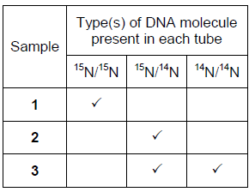

*One mark for each correct row*

**3**

(c)     (i)      1.      Similar shape / structure (to cytosine) / added instead of cytosine / binds to guanine;

*1. Accept: idea that only one group is different*

*1. Reject: same shape*

2.      Prevents (complementary) base pairing / prevents H-bonds forming / prevents formation of new strand / prevents strand elongation / inhibits / binds to (DNA) polymerase;

*2. Accept: prevents cytosine binding*

*Neutral: ’prevents DNA replicationߢ as given in the question stem*

*Neutral: ’competitive inhibitorߢ unqualified*

*Neutral: inhibits DNA helicase*

**2**

(ii)     (Cancer cells / DNA) divide / replicate fast(er) / uncontrollably;

*Accept: converse argument for healthy cells*

**1**

**[8]**

**M29.**(a)     Deoxyribose.

**1**

(b)     1.      Thymine 18 (%);

2.      Guanine 32 (%).

**2**

(c)     DNA polymerase.

**1**

(d)     1.      (**Figure 1** shows) DNA has antiparallel strands / described;

2.      (**Figure 1** shows) shape of the nucleotides is different / nucleotides aligned  differently;

3.      Enzymes have active sites with specific shape;

4.      Only substrates with complementary shape / only the 3’ end can bind with active site of enzyme / active site of DNA polymerase.

**4**

**[8]**

**M30.**(a)     1.      Sugar-phosphate (backbone) / double stranded / helix **so** provides strength / stability / protects bases / protects hydrogen bonds;

*Must be a direct link / obvious to get the mark*

*Neutral: reference to histones*

2.      Long / large molecule **so** can store lots of information;

3.      Helix / coiled **so** compact;

*Accept: can store in a small amount of space for ‘compact’*

4.      Base sequence allows information to be stored / base sequence codes for amino acids / protein;

*Accept: base sequence allows transcription*

5.      Double stranded **so** replication can occur semi-conservatively / strands can act as templates / complementary base pairing / A-T and G-C so accurate replication / identical copies can be made;

6.      (Weak) hydrogen bonds **for** replication / unzipping / strand separation / many hydrogen bonds **so** stable / strong;

*Accept: 'H-bonds' for ‘hydrogen bonds’*

**6**

(b)     1.      (Mutation) in **E** produces highest risk / 1.78;

2.      (Mutation) in **D** produces next highest risk / 1.45;

3.      (Mutation) in **C** produces least risk / 1.30;

*Must be stated directly and not implied*

***E*** *>* ***D*** *>* ***C*** *= 3 marks*

*Accept: values of 0.78, 0.45 and 0.30 for MP1, MP2 and MP3 respectively*

*If no mark is awarded, a principle mark can be given for the idea that all mutant alleles increase the risk*

**3**

(c)     **180**;

**1**

(d)     **(Similarities):**

1.      Same / similar pattern / both decrease, stay the same then increase;

2.      Number of cells stays the same for same length of time;

*Ignore: wrong days stated*

**(Differences):**

(Per unit volume of blood)

3.      Greater / faster decrease in number of healthy cells / more healthy cells killed / healthy cells killed faster;

*Accept: converse for cancer cells*

*Accept: greater percentage decrease in number of cancer cells / greater proportion of cancer cells killed*

4.      Greater / faster increase in number of healthy cells / more healthy cells replaced / divide / healthy cells replaced / divide faster;

*Accept: converse for cancer cells*

*For* ***differences****, statements made must be comparative*

**3 max**

(e)     1.      More / too many healthy cells killed;

2.      (So) will take time to replace / increase in number;

*Neutral: will take time to ‘repair’*

3.      Person may die / have side effects;

**2 max**

**[15]**

**M31.**(a)      Box around single nucleotide.

**1**

(b)

|  |  |  |  |  |  |
| --- | --- | --- | --- | --- | --- |
|  | **DNA strand** | **Percentage of each base** | | | |
|  | **A** | **C** | **G** | **T** |
|  | Strand **1** | (16) | **34** | **21** | **29** |
|  | Strand **2** | **29** | (21) | (34) | **16** |

2 rows correct = 2 marks;

1 row correct = 1 mark.

**2**

(c)     1.      Reference to DNA polymerase;

2.      (Which is) specific;

3.      Only complementary with / binds to 5’ end (of strand);

*Reject hydrogen bonds / base pairing*

4.      Shapes of 5’ end and 3’ end are different / description of how different.

**4**

**[7]**

**M32.**(a)     1.      Outside of virus has antigens / proteins;

2.      With complementary shape to receptor / protein in membrane of cells;

3.      (Receptor / protein) found only on membrane of nerve cells.

*Accept converse argument*

**3**

(b)     1.      No more (nerve) cells infected / no more cold sores form;

2.      (Because) virus is not replicating.

**2**

(c)     Prevents replication of virus.

**1**

(d)     MicroRNA binds to cell’s mRNA (no mark)

1.      (Binds) by specific base pairing;

2.      (So) prevents mRNA being read by ribosomes;

3.      (So) prevents translation / production of proteins;

4.      (Proteins) that cause cell death.

**4**

**[10]**

**E1.**          This question was very well answered and the majority of candidates gained at least half the marks available. A significant number of candidates gained maximum marks.

(a)     Very few candidates failed to draw correctly a box round one nucleotide on the diagram.

(b)     In part (i), most candidates gained the mark for indicating that **B** (deoxyribose), is different in a RNA molecule. Slightly fewer candidates obtained the mark for part (ii) by indicating that molecule **A** (an organic base) contains nitrogen.

(c)     In part (i), many candidates correctly described the role of the sequence of bases on DNA in protein synthesis. However, a number of candidates referred to tRNA formation rather than to mRNA. Almost every candidate gained the mark for hydrogen bonds in part (ii). Although many candidates gained a mark in part (iii), vague statements simply referring to ‘protection’ were not credited.

**E2.**          In (a), nearly all candidates were able to describe two differences between the structure of DNA and RNA. The answers to (b) and (c) were polarised; either candidates knew the relevant material and scored well, or they produced very weak answers. In (b), weaker candidates used amino acids and nitrogenous bases, and gene and triplet completely interchangeably. Very few mentioned the base sequence on DNA being copied to (messenger) RNA. In (c), many candidates did not specify that homologous chromosomes form a pair and, of those who did, too many just wrote ‘they are identical’ with no mention of genes and positioning (loci).

**E3.**          (a)     This part of the question was often poorly answered. While errors in the first column were perhaps predictable, those not infrequently given in the second column suggested confusion between polynucleotide strands and bases or even chromosomes.

(b)     This question was marked in such a way that a candidate who made a single error was still able to gain some credit. The answers to both parts were generally sound although there were occasional errors involving giving the base sequence on the complementary DNA strand, or resulting from uncertainty over splicing.

**E4.**          This question was intended to be a highly accessible start to the paper and almost all candidates scored highly.

**E5.**          In part (a), disappointingly few candidates described the halving of the proportion of DNA that contained 15N at each generation. In part (b), more candidates were able to relate semi- conservative replication to the reduction in the proportion of DNA containing 15N.

**E6.**          Both parts of the question were generally well answered and a good number of candidates scored full marks. However, in (a), a minority of candidates either suggested bases, such as Adenine and Thymine, or were not precise enough when suggesting ‘sugar’ as a component. The majority knew that **X** was the sugar-phosphate backbone and suggested phosphate and pentose (5-carbon) sugar. Some suggested ribose as the pentose sugar, which could not be credited.

Part (b) proved to be a good discriminator. Most candidates stated that the process was known as semi-conservative replication and correctly described complementary base pairing. However, although many mentioned the breaking of hydrogen bonds in the initial separation of the two strands (which was not required), they failed to mention that they were formed as the newly synthesised strand binds to the template strand. Also, the role of DNA polymerase was not well understood by a good number.

**E7.**          (a)     Many candidates gained full marks, although some referred to breaking of disulphide bridges. A common error, caused by misinterpretation of the graph axes, was to attribute the levelling off to a maximum rate of reaction, with all the active sites being used.

(b)     Many candidates appreciated that all the substrate had been used up but most were reluctant to relate this to the same amount of product or that the initial substrate was the same.

**E8.**          (a)     Many candidates had learnt the material needed to answer this question and many obtained full marks. When marks were not gained it was usually because of references to phosphoric acid for **X**, sugar or ribose for **Y** or amino acid for **Z**.

(b)     It was pleasing to find that almost all candidates correctly identified these as hydrogen bonds.

(c)     There were many correct answers, demonstrating that most candidates understood that A binds to T in equal amounts, as does C to G. Some candidates obtained one mark for stating these relationships, even though they went on to make some error in their calculation of the percentage of cytosine.

**E9.**          In (a), over 80% of candidates correctly stated two differences between DNA and RNA, all alternatives in the mark scheme being seen frequently. A few candidates failed to score because they mismatched features across the two columns, e.g., giving a base for DNA opposite a sugar for RNA.

Part (b) discriminated well between candidates, with a fairly even spread of marks from three down to zero. Many candidates knew that RNA is copied from DNA, or that it moves from the nucleus to the ribosomes, but relatively few were able to give a clear or correct account of coding.

**E10.**          **BYA2**

Some candidates found it difficult to see what was required here but any appropriate answer was accepted. The second part was generally well answered although some failed to gain marks as a result of poor spelling.

**BYA3**

In part (i) there were some vague answers which did not gain credit. Although examiners allowed a variety of correct responses, some candidates simply offered nucleotide. This was not specific enough. A small number referred to the phosphate chain or deoxyribose backbone, showing a lack of understanding of the structure of DNA. In part (ii), X and Y were usually correct, but Z was sometimes named as uracil. Examiners were amazed at the number of spelling variants offered for thymine.

**E11.**          There were some excellent answers to this question with the most able candidates gaining maximum marks. Weaker candidates were often able to obtain some marks in parts (b) and part (c).

Surprisingly, explaining what is meant by an allele proved to be quite difficult for many candidates. There were many vague references to an allele ‘being part of a gene’ or ‘being a gene for eye colour’. The context provided by candidates often suggested that alleles were different genes.

As in previous years a significant number of candidates confused DNA replication with transcription. It was often difficult to give credit in these answers, except for the first mark point referring to hydrogen bonds being broken. As in previous years, there was considerable confusion concerning the role of DNA polymerase. However, naming the enzyme itself was credited in this answer to avoid a double penalty for incorrectly describing its role in question 6(b). There was also some confusion between bases and nucleotides. Nevertheless, better candidates had little difficulty obtaining maximum marks, some answers displaying knowledge well beyond the requirements of this specification. Weaker candidates often gained marks for referring to semi-conservative replication and complementary base pairing.

In part (c) the effects of a mutation involving a deletion or a substitution were generally well known. Most candidates referred to ‘frame shifts’ and appreciated the degenerate nature of the genetic code. However, some weaker candidates referred to ‘amino acids in the DNA’ being deleted or substituted. Better candidates had little difficulty gaining maximum marks.

**E12.**          This question gave candidates the opportunity to display their knowledge of factual material from the specification. Answers were often marred by inaccurate recall and poor expression. Once again, weaker candidates failed to select the appropriate information to answer the question set.

(a)     Generally this section was poorly done with little reference to the question. Most candidates attempted to describe DNA replication without explanation as to how the structure of the molecule allows this to happen. Base pairing, often quoted, was well understood.

(b)     There were some good answers but very few examples of full marks. Most candidates described chromosomes shortening, referred to movement to the equator and had some knowledge of the cause of chromatid separation. Beyond this there was confusion over the involvement of homologous pairs and many candidates failed to mention the identical nature of chromatids. Only the very able candidates alluded to the significance of the movement to opposite poles. Weaker candidates could not put the events of the process into order. It was disappointingly rare to read a logically presented, coherent full answer. The majority of the candidates could use the information in the stem of the question and gained both marks.

(c)     Targeting of the cells as a concept was only implied, but not referred to, so restricting some candidates to one mark.

**E13.**          Although only a few candidates obtained maximum marks on this question, most candidates were able to gain between two and four marks.

Better candidates had little difficulty in providing the correct responses for parts (i) and (ii). Weaker candidates often correctly identified the DNA triplet for tyrosine but gave an incorrect tRNA anticodon for the same amino acid.

The most frequent correct responses referred to the 'clover leaf' or folded structure of tRNA, the presence of an amino acid binding site or the anticodon. Incorrect responses included references to tRNA consisting of two strands, possessing three anticodons or possessing thymine rather than uracil.

**E14.**          This question produced a large spread of marks. Inaccurate use of terminology compromised the marks gained by many candidates in parts (a) and (b).

(a)     Generally this part was poorly done. Most candidates seemed unaware that both strands were replicated.  Answers lacked clarity because candidates used the word ‘strand’ loosely when trying to explain DNA replication. They seemed aware that DNA is a double helix but not that this is a double polynucleotide or that the polynucleotides are the strands and the double helix a molecule.

(b)     Again, the imprecise use of the word ‘strand’ revealed a lack of understanding of DNA replication. The most common error described half the new DNA strand as 14N and half 15N.

(c)     The vast majority of candidates could apply their knowledge of base pairing to complete the table correctly.

**E15.**          (a)     Many candidates understood the basic principles of natural selection underlying this part of the question and better answers related these to the development of resistance in malarial parasites. Responses, however, were frequently marred by imprecise use of terms. Thus malarial parasites were variously described as developing resistance, immunity or, in some cases, allergies to the drugs concerned, while resistance was described as taking place in bacteria, the disease or even in the human population.

(b)     Evidence from BYA5 suggests that many candidates understand that probabilities are combined by multiplication. However, they were unable to apply this principle to the example in this part of the question. The most frequent response was to add the two figures. The resulting value of 1/250 then proved difficult to explain, and the simple idea that the probability of being infected by a strain of malarial parasite resistant to both drugs was much lower eluded most.

(c)     The concept of a control proved surprisingly unfamiliar to most candidates and even the best seldom progressed beyond explaining that a control offered a standard against which to compare the effectiveness of the vaccine. This idea should have given rise, in part (ii), to injection with saline only in an otherwise identically treated control group. Answers ranged from those who clearly failed to appreciate the nature of a control and discussed issues which were largely ethical in nature, to responses which were in varying degrees incomplete. Such responses included making sure that both groups “lived in the same place” or “were the same age”, ignoring the fact that these were only part of a whole range of factors which should have been kept constant. Evidence from this question and from the coursework suggests that the issue of controls is one that needs to be addressed by centres.

(d)     Better candidates experienced little apparent difficulty in identifying the correct percentages here. Incorrect answers fell into no set pattern and most responses which could conceivably be given arose at least once.

(e)     Many candidates were obviously of the opinion that restriction enzymes function in a way that is totally different from other enzymes, and attempted to explain their specificity in part (i) in terms of base pairing. Others clearly understood the principles involved but neglected to relate their understanding of enzyme action to this particular question. A lack of precision characterised many of the answers to part (ii). Thus there were frequent references to adenine and thymine but not to these bases forming the restriction sites. However, most candidates were able to equate the frequency of cutting to the small size of the resulting fragments.

**E16.**          **Unit 2**

          (a)     In (i), this was known by most, though a few failed to gain marks by suggesting ‘nucleotide’ ‘amino group’ or even ‘phosphate’.

Part (ii) was often poorly answered by repeating the given part, that 14N is lighter than 15N. Better answers recognised that semi-conservative replication would mean that one of the strands would contain the heavier isotope, and one the lighter isotope. A few candidates thought that the bands were bacteria or nitrogen.

Candidates often scored one mark for (iii), usually for the higher band, but it was rare for candidates to score both marks.

(b)     In (i), most candidates scored both marks.

Many scored full marks for (ii). However, the weakest candidates thought that viral DNA had different base-pairing rules.

**Unit 3**

(a)     Specifically, nitrogen is part of the organic base. The chemical understanding of some was shown to be poor with suggestions of phosphates or amino acids. From the responses provided, it would seem that few candidates were familiar with semi-conservative replication. Few were able to express this concept and explanations were not convincing.

(b)     Candidates were familiar with base pairing and most calculated the appropriate percentages. Fewer recognized, from the evidence provided from the different percentages of all the bases, that viral DNA is single stranded.

**E17.**          **Unit 2**

          (a)     Surprisingly few gave the correct response of nucleotides. Many gave one or all of the parts of a nucleotide, or amino acids.

(b)     (i)      Virtually all candidates gained two marks for calculating the missing figures.

(ii)     Though most candidates had the right idea, many found it difficult to explain that the bases did not show a 1:1 ratio and were therefore not paired. The concept of base pairing was often omitted.

**Unit 3**

(a)     A wide variety of answers was seen here ranging from no response to amino acids, assorted sugars, a list of the components of DNA and, in a disappointingly small number of scripts, nucleotides.

(b)     A pleasing number of candidates scored two marks here but several went astray as a result of poor maths or weak biology. Part (ii) proved a test of expression and many spent time explaining that the virus DNA was double-stranded or used much of the margin to fit in all their ideas.

**E18.**          (a)     Imprecise expression frequently limited the marks awarded for part (i). Care clearly needed to be taken to avoid suggesting too few components, with answers such as that a polymer consisted of ‘two or more’ monomers. Those who did not make use of the term ‘monomer’ needed to indicate, in some way, the similarity of the constituents. They did not always do this. The most frequent reason for failing to gain credit for part (ii) was where candidates gave substances, such as haemoglobin and amylopectin, which were excluded by the wording of the question. Nevertheless, many candidates gave correct answers.

(b)     In part (i), most candidates recognised the importance of buffers in maintaining pH, although some associated them with temperature. Better candidates could generally develop the idea and usually gained a second mark through reference to denaturation. Unfortunately, some saw parts (ii) and (iii) as a trick and pointed out that since starch was not a protein, it would give a negative result. Others made the same error by simply failing to focus on the right component of the mixture. Perhaps more disturbing is the continued failure of so many candidates at this level to learn the relevant information relating to basic biochemical tests. There was again much confusion over test and result, apparent both here and in the answers to Question **4** (b).

**E19.**          (a)     (i)      Most candidates correctly named part **R** as deoxyribose. Answers identifying part **R** as pentose or as a five carbon sugar were considered too imprecise due to the question clearly identifying the molecule as being DNA.

(ii)     Most candidates correctly named part **Q** as a phosphate group or as phosphoric acid. Unfortunately, some candidates incorrectly named parts **R** and **Q** the wrong way round.

(b)     Almost every candidate correctly stated ‘hydrogen bonds’.

(c)     Approximately fifty percent of candidates obtained this mark. Although there was a wide range of incorrect answers, the most common error was to divide, rather than multiply the number of amino acids by three.

(d)     Over 90 % of candidates were able to correctly work out the sequence of amino acids.

(e)     This question proved to be an effective discriminator. Most candidates gained at least one mark, often by mentioning a change in the sequence in amino acids. However, a significant number of candidates incorrectly referred to ‘different amino acids being formed’. Many of these candidates gained a second mark for describing that the active site or tertiary structure would be altered. Better candidates gained maximum marks either by linking this to enzyme-substrate complexes not being formed or to changes in hydrogen/disulfide bonds.

**E20.**(a)     Although this question produced an even spread of marks across the entire ability range, the overall marks were disappointing for a question largely targeted at Grade E candidates. Many appeared uncertain as to the distribution of starch and glycogen, the identity of deoxyribose as a carbohydrate or of DNA helicase as an enzyme.

(b)     Most candidates were able to gain some credit for recognising that condensation involved the elimination of a molecule of water, although there were some who apparently failed to appreciate that water molecules contained two hydrogen atoms and an oxygen atom, or that condensation involved linking the molecules shown. The better candidates selected the appropriate atoms and gained both of the available marks.

(c)     In part (i), candidates were usually able to make an appropriate reference to the role of hydrogen bonds in strengthening either cellulose or the cell wall. Many, however, were uncertain as to the location of these bonds and produced answers referring to linking the β-glucose residues. Part (ii) was usually well answered and most candidates were able to discuss the compact shape of starch molecules. There were, however, some answers incorrectly based on the idea of a large surface area to volume ratio.

**E21.**(a)     (i)      Only a quarter of students obtained the mark. DNA polymerase catalyses the reactions that make the polymer, DNA. It does this by catalysing the formation of bonds between nucleotides that have already undergone complementary base-pairing to an exposed template strand. Many students described DNA polymerase as making nucleotides base-pair and this was not given credit.

(ii)     Many students appeared to ignore ‘DNA’ in the question and included various differences between prokaryotic and eukaryotic cells, including differences in how they divide. As a result, only a quarter obtained 2 marks.

(b)     (i)      About 40% of students obtained 2 marks in this part. This was usually for references to different sequences of bases resulting in different proteins being made. Some failed to obtain one of these marks because they referred to different sequences on DNA making or producing different amino acids. Few students noted that different species have different genes, reflected in different base sequences.

(ii)     About half of students failed to score in this part. The question did discriminate, in that students who did well on the whole paper tended to do well on this question. Most commonly, correct responses referred to the differences in percentages of C and G and A and T and then went on to suggest there was no base-pairing. A few students correctly suggested the DNA was single-stranded. Weaker responses simply restated the numbers from the table.

**E22.**          (a)     (i)      It was clearly evident that the vast majority of candidates had a good understanding of what happens in metaphase with two thirds of candidates gaining both marks and only ten percent scoring zero. Most candidates gained credit for mentioning chromosomes moving to the equator of the cell. A number of candidates, however, referred to homologous chromosomes aligning in pairs and described metaphase I of meiosis.

(ii)     Almost seventy five percent of candidates gained two marks often by stating that ‘chromatids move to opposite poles’. Again, approximately ten percent of candidates scored zero.

(b)     (i)      Although most candidates appreciated that the cells lining the human intestine needed to be replaced only half of the candidates conveyed the idea that this occurs quickly. A significant number of candidates simply stated that the cells needed to be repaired.

(ii)     Almost half the candidates gained both marks for 774 minutes or 12 hours 54 minutes. A small number of candidates provided an incorrect answer but correctly indicated three cell cycles for one mark. Many of the remaining candidates used four cell cycles to obtain an incorrect answer of 1032 minutes.

(c)     There were some excellent detailed answers to this question which gained both marks. These were, however, in the minority. Most candidates gained at least one mark usually for stating that DNA replication would be inhibited. Generally, there was considerable confusion over the role of DNA polymerase, with many candidates believing it to be involved in breaking hydrogen bonds or in complementary base pairing.

**E23.**(a)     (i)      Over 80% of students correctly named this stage of mitosis as anaphase. A common incorrect response was telophase.

(ii)      Most students gained one mark for describing the separation of the chromatids to opposite sides of the cell. However, less than 30% of students explained that the chromatids would be identical in terms of their genetic content. Most students simply stated that the cells being produced would be identical. This was in the stem of the question and, therefore, did not gain credit.

(b)     (i)       This proved to be a very effective discriminator. The most common mark was for linking cells containing 8.4 units with DNA replication. It was only better students who correctly explained how cells with 4.2 units were produced. A third of students gained no credit, often referring to meiosis, gametes and haploid cells in their explanations.

(ii)     Two thirds of students correctly showed that a gamete formed in this animal would contain 2.1 units of DNA.

**E24.**          **Using DNA in science and technology**

The very best essays from candidates who selected this option were outstanding. They reviewed, often in great detail, the relevant aspects of the specification although not always incorporating the role of DNA in the classification of organisms. Considering that much of the content of this essay could be drawn from this unit, it was surprising how poor many answers were. Understanding of techniques was often extremely limited, particularly *in vivo* gene cloning and the use of markers. Many essays presented no more than a broad overview either emphasising ethical issues at the expense of biological detail or failing to distinguish established practice from wishful thinking.

**E25.**(a)      (i)       Students were aware that polymers were made of many monomers, but in many cases went on to include descriptions in their answers that implied they did not understand what the monomers in this case were. A number of answers suggested that each strand was a monomer or that the monomers were amino acids.

(ii)      Most students knew the names of the parts of the diagram; the most common mistake was giving ‘sugar’ or ‘ribose’ instead of deoxyribose.

(iii)     In order to gain both marks, students had to show that they knew the names of the bases. This proved very revealing in that almost all knew the initial letters of the four bases but only a minority could write down the names correctly. About half were able to complete the simple calculation to give the percentage of the other three bases.

(b)     (i)       Those who failed to gain credit often did so because they were, apparently, of the opinion that one base coded for three amino acids.

(ii)      Introns, non-coding DNA, start and stop codes were all known to be non-coding DNA and, thus, adding to the length of the gene without contributing to the polypeptide. Some students also mentioned addition mutations or the fact that there are two strands. A minority of students incorrectly linked the degeneracy of the genetic code to the difference in number of bases.

**E26.**(a)     This proved to be an excellent discriminator. Just over 70% of students scored at least half marks. Many were aware of the breaking of hydrogen bonds, the role of DNA helicase and complementary base pairing. However, it was only better responses that referred to the attachment of free nucleotides (as opposed to free bases) and both strands acting as templates. DNA polymerase was frequently mentioned but its role was often confused in weaker responses. This enzyme joins nucleotides on the newly formed strand, it does not cause complementary base pairing. Some students negated the mark for semi-conservative replication through poor expression. The most common examples of this included ‘each new DNA molecule contains half of the original strand’ and ‘new strands contain half of the original strand’. Very few students wrote about hydrogen bonds reforming.

(b)     (i)      Two-thirds of students correctly gave the duration of metaphase as **18** minutes.

(ii)     80% of students correctly calculated the duration of anaphase as **10** minutes.

(iii)    This proved to be a good discriminator. Most students gained one mark for extending the horizontal line to 18 minutes, or decreasing this line to 0 μm at 28 minutes. Weaker responses often showed the horizontal line increasing.

(c)     (i)      70% of students correctly calculated the time the cells were in interphase as **19.7** hours. Very few students gained the principle mark for multiplying by 0.82.

(ii)     Just under half of students were aware that cells in interphase could be detected by a visible nucleus or the inability to see chromosomes. Weaker responses typically referred to the inability to see *DNA* or that the cells in interphase would contain twice the amount of chromosomes.

(iii)    This proved to be a good discriminator. Most students were aware that cancer cells divide more rapidly than healthy cells. However, it was only better responses that referred to data in the table and correctly linked this to tissue **D**. Some students wrongly thought that more cells in interphase meant more rapid cell division due to increased DNA replication.

**E27.**(a)     The examiners noted that many students approached this part as ‘describe mitosis’ and proceeded to do so in various degrees of correct detail. The question asked for an explanation of how events in mitosis lead to the production of genetically identical cells. Some students focused on DNA replication but ignored chromatid movements and others only discussed chromatids. Many obtained 1 or 2 marks for references to DNA replication and / or chromatids moving to the poles (of the spindle).

Some students clearly got confused between sister chromatids and homologous pairs of chromosomes.

The examiners were looking for replication of DNA, involving complementary base-pairing, in order to produce exact copies of genetic information. Then, how this is linked to sister chromatids and how their separation during mitosis leads to genetically identical cells.

(b)     (i)      About 60% of students correctly suggested that the sections had to be thin to allow light to pass through but few went beyond that. The examiners were looking for the idea that thin sections would allow individual cells, or layers of cells, to be seen (and the chromosomes within them, if present). Only about 20% obtained a second mark.

(ii)     Many students wrote about the size of the mitotic index in this part, simply describing the graph and not explaining growth. The examiners were looking for answers relating the rate of mitosis at the tip of the root to growth. A third of students did this and obtained both marks.

**E28.**(a)     This proved to be a good discriminator. Most students were aware that DNA helicase separates strands or breaks hydrogen bonds. However, only better responses went on to state that this allows nucleotides to attach or the strands to act as templates. Unfortunately, poor expression or a lack of precision let down some students. This was usually for DNA ‘splitting’, or ‘bases’, rather than nucleotides, attaching.

(b)     Just under half of students gained full credit.

(c)     (i)      This proved to be a good discriminator. A quarter of students scored full marks. Most were aware that cytarabine has a similar structure to cytosine. However, weaker responses were often vague regarding the subsequent effect of this, eg ‘prevents DNA replication’ or ‘inhibits helicase’. Similarly, there were many unqualified references to cytarabine acting as a competitive inhibitor. It was only the best responses that suggested cytarabine may prevent base pairing, prevent the formation of a new strand or act as an inhibitor of DNA polymerase.

(ii)     Just over seventy percent of students were aware that cancer cells divide faster than healthy cells.

**E30.**Parts (a), (b) and (d) proved to be good discriminators.

(a)     It was disappointing that only just below 40% of students scored at least half marks. This was mainly due to simply describing the structure of DNA, without explaining how these features relate to its functions. Some students wrote about DNA structure and function in different paragraphs. This made it unclear which feature went with which function, as no direct links had been made. In contrast, there were some truly excellent responses, which had clearly been well planned before putting pen to paper. The most common mark points awarded were for the sugar-phosphate backbone providing strength or protecting bases, the helix allowing the molecule to be compact, weak hydrogen bonds allowing strand separation or replication and the two strands acting as templates or allowing semi-conservative replication. Relatively few students linked complementary base pairing with accurate replication or the production of identical copies of DNA. Similarly, few students referred to DNA as a large molecule that can store lots of information, or the base sequence coding for amino acids. Weaker responses often mentioned this in the context of the genetic code being degenerate. Indeed, some students thought that the base sequence causes amino acids to be *produced*. The ability to convey that *many* hydrogen bonds provide stability was rarely seen. It was also unfortunate that a number of students wasted their time by writing about irrelevant topics such as the differences between prokaryotic and eukaryotic DNA and the role of histones. There were also some lengthy accounts of DNA replication, enzyme structure and the different levels of protein structure.

(b)     Many students scored at least two marks for stating that a mutation in gene **E** produces the highest risk and a mutation in gene **C** produces the lowest risk. However, only the best responses also referred to gene **D**. Students who did not mention any of the genes usually picked up one mark for noting that all of the mutant alleles increase the risk of lung cancer. Surprisingly, some thought that a mutation in gene **D** produces the highest risk.

(c)     Just fewer than 40% of students gave the correct answer of **180**.

(d)     Two-thirds of students scored at least two marks. Many were able to identify the decrease, plateau and increase for healthy cells and cancer cells. However, relatively few made reference to the plateau occurring for the same length of time. Students who failed to gain a mark for a similarity usually ignored the plateau. Most students spotted that a greater number of healthy cells were killed or that they experienced a faster decrease in number. Similarly, it was impressive to see that some used data from the graph to calculate that a greater *proportion* of cancer cells were killed. Many students also noted the faster increase in the number of healthy cells.

(e)     Half of students scored full marks. This was usually for mentioning that too many healthy cells would be killed, which could kill the patient or cause side effects. However, relatively few appreciated that it would take time to replace the healthy cells that had been killed.