**Q1.**The diagram represents part of the human digestive system. The organs are labelled **A−F**.

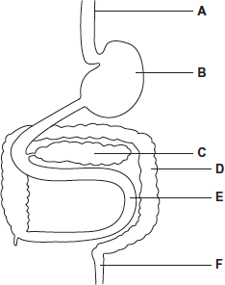

(a)     Give the letter of the organ that produces amylase.



**(1)**

(b)     Give the letter of the organ that produces maltase.



**(1)**

(c)     Maltose is hydrolysed by the enzyme maltase.

Explain why maltase catalyses only this reaction.

........................................................................................................................

........................................................................................................................

........................................................................................................................

........................................................................................................................

........................................................................................................................

........................................................................................................................

........................................................................................................................

**[Extra space]** ................................................................................................

........................................................................................................................

........................................................................................................................

**(3)**

**(Total 5 marks)**

**Q2.**Bromelain is a protein-digesting enzyme found in pineapples. Some people claim that bromelain tablets have benefitial effect on health. These effects include reducing swelling and pain after surgery and reducing growth of cancers.

Bromelain is absorbed from the gut into the blood. Scientists gave a group of volunteers 3 g of bromelain in tablets each day for three days. They then measured the maximum mass of bromelain in the blood of each volunteer. The mean value for the maximum mass of bromelain in the blood of the volunteers was 0.025 mg.

(a)     There is a difference between the mass of bromelain that the volunteers were given and the maximum mass of bromelain in their blood. Suggest **one** explanation for this difference.

........................................................................................................................

........................................................................................................................

**(1)**

(b)     The scientists measured the concentration of bromelain in the blood. What else did they need to measure to calculate the total mass of the bromelain in the blood of a volunteer?

........................................................................................................................

........................................................................................................................

**(1)**

**(Total 2 marks)**

**Q3.**          Lactose is a disaccharide found in milk. In the small intestine, it is digested into glucose and galactose by the enzyme lactase. Molecules of lactase are located in the plasma membranes of cells lining the small intestine.

(a)     What evidence in the paragraph suggests that galactose is a monosaccharide?

......................................................................................................................

......................................................................................................................

**(1)**

(b)     (i)      Name **one** other digestive enzyme that is located in the plasma membranes of cells lining the small intestine.

.............................................................................................................

**(1)**

(ii)     Give an advantage of lactase and other digestive enzymes being located in the plasma membranes of cells lining the small intestine, rather than being secreted into the lumen of the small intestine.

.............................................................................................................

.............................................................................................................

**(1)**

(c)     The absorption of galactose from the small intestine is reduced if the absorbing cells are treated with a respiratory inhibitor, such as cyanide. Suggest an explanation for this.

......................................................................................................................

......................................................................................................................

......................................................................................................................

......................................................................................................................

**(2)**

**(Total 5 marks)**

**Q4.          S**       The figure belowshows the processes involved in absorbing amino acids into a capillary from the small intestine.

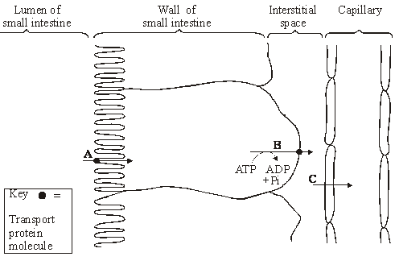

(i)      Name processes **A**, **B** and **C**. In each case, give the evidence for your answer.

**A**       Process ...............................................................................................

Evidence .............................................................................................

............................................................................................................

**B**       Process ..............................................................................................

Evidence .............................................................................................

............................................................................................................

**C**       Process ..............................................................................................

Evidence .............................................................................................

.............................................................................................................

**(3)**

(ii)      Explain how process **B** creates the conditions for process **A** to occur.

......................................................................................................................

......................................................................................................................

......................................................................................................................

......................................................................................................................

**(2)**

**(Total 5 marks)**

**Q5.**          The diagram shows one method by which amino acids are absorbed from the small intestine into the blood. They are co-transported into the epithelial cell with sodium ions (Na+) at point **X** on the diagram. Normally, the concentration of sodium ions inside the epithelial cell is low.

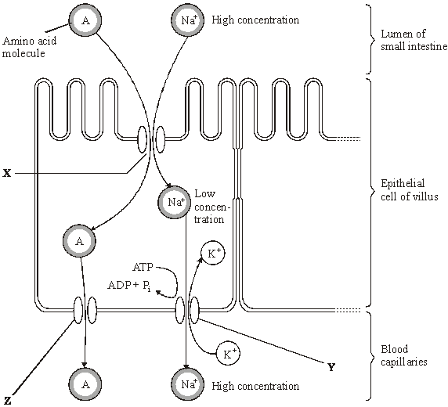

*Source*: adapted from M. ROWLAND,  
*Biology (University of Bath Science 16-19)* (Nelson Thornes) 1992.

Dinitrophenol (DNP) prevents oxidative phosphorylation. When treated with DNP, the sodium-potassium pump at **Y** no longer works. As a result, the concentration of sodium ions in the cell rises and amino acid absorption stops.

(i)      Explain why pump **Y** will **not** work in the presence of DNP.

......................................................................................................................

......................................................................................................................

......................................................................................................................

......................................................................................................................

**(2)**

(ii)      Explain why sodium ions and amino acids are **not** absorbed from the lumen of the small intestine in the presence of DNP.

......................................................................................................................

......................................................................................................................

......................................................................................................................

......................................................................................................................

**(2)**

(iii)     By what mechanism would amino acids leave the epithelial cell at point **Z**?

......................................................................................................................

**(1)**

**(Total 5 marks)**

**Q6.**(a)     Describe the role of the enzymes of the digestive system in the complete breakdown of starch.

......................................................................................................................

......................................................................................................................

......................................................................................................................

......................................................................................................................

......................................................................................................................

......................................................................................................................

......................................................................................................................

......................................................................................................................

......................................................................................................................

......................................................................................................................

**(5)**

(b)     Describe the processes involved in the absorption of the products of starch digestion.

......................................................................................................................

......................................................................................................................

......................................................................................................................

......................................................................................................................

......................................................................................................................

......................................................................................................................

......................................................................................................................

......................................................................................................................

......................................................................................................................

......................................................................................................................

**(5)**

**(Total 10 marks)**

**Q7.**          (a)     Dietary recommendations are that lipid intake should make up 30% of energy intake. The recommended energy intake for most women aged 19-49 is 8100 kJ day–1.The energy content of lipid is 37.8 kJ g–1. Calculate the recommended lipid intake per day for these women. Show your working.

Answer ................................................... g

**(2)**

In humans, triglycerides are the main form of dietary lipids. They are digested in the gut and the products of digestion are absorbed by the small intestine.

**S**       (b)     Describe a biochemical test that could be performed on a sample of food to determine whether it contained triglycerides.

......................................................................................................................

......................................................................................................................

......................................................................................................................

......................................................................................................................

**(2)**

(c)     The diagram shows the events that occur in the absorption of monoglycerides and fatty acids. These molecules enter the epithelial cells of the small intestine by diffusion. Once inside they are reassembled into triglycerides in organelle **Q**. The triglyceride molecules are formed into chylomicrons in organelle **T**. Chylomicrons are made from many triglyceride molecules surrounded with protein molecules. The chylomicrons leave the cell and enter vessel **S**.

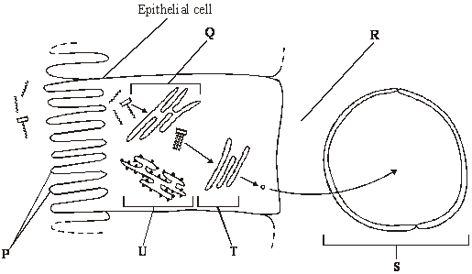

**S**       (i)      Explain the importance of the structures labelled **P**.

.............................................................................................................

.............................................................................................................

**(1)**

(ii)     Name

**R**; .......................................................................................................

**S**. ........................................................................................................

**(2)**

**S**       (iii)     Describe the role played by organelle **U** in the formation of chylomicrons.

.............................................................................................................

.............................................................................................................

.............................................................................................................

.............................................................................................................

**(2)**

**S**       (iv)    Suggest how the chylomicrons leave the epithelial cell. Give a reason for your answer.

.............................................................................................................

.............................................................................................................

.............................................................................................................

.............................................................................................................

**(2)**

**(Total 11 marks)**

**Q8.**          The diagram shows an epithelial cell from the small intestine.

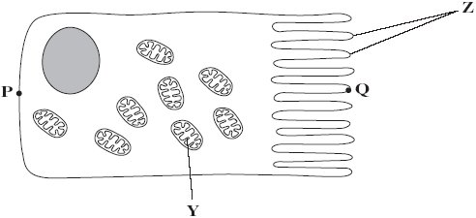

(a)     (i)      Name organelle **Y**.

.............................................................................................................

**(1)**

(ii)     There are large numbers of organelle **Y** in this cell. Explain how these organelles help the cell to absorb the products of digestion.

.............................................................................................................

.............................................................................................................

.............................................................................................................

.............................................................................................................

.............................................................................................................

**(2)**

(b)     This diagram shows the cell magnified 1000 times. Calculate the actual length of the cell between points **P** and **Q**. Give your answer in µm. Show your working.

Answer ...................................... µm

**(2)**

(c)     Coeliac disease is a disease of the human digestive system. In coeliac disease, the structures labelled **Z** are damaged.

Although people with coeliac disease can digest proteins they have low concentrations of amino acids in their blood.

Explain why they have low concentrations of amino acids in their blood.

......................................................................................................................

......................................................................................................................

......................................................................................................................

......................................................................................................................

......................................................................................................................

**(2)**

**(Total 7 marks)**

**Q9.**Scientists investigated the effect of lipase and a 3% bile salts solution on the digestion of triglycerides. The graph below shows their results.

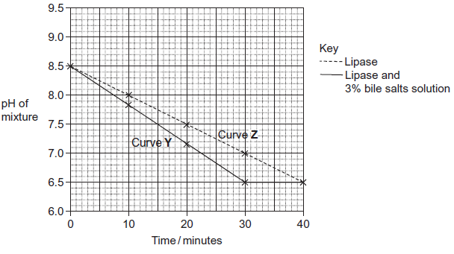

The scientists also incubated triglycerides with different concentrations of bile salts. After 30 minutes they measured the diameter of the triglyceride droplets. They used the results to calculate the mean radius of the droplets at each concentration. The table below shows their results.

|  |  |  |  |  |  |  |  |
| --- | --- | --- | --- | --- | --- | --- | --- |
|  | Concentration of bile salts /% | 0 | 1 | 2 | 3 | 4 | 5 |
|  | Mean radius of triglyceride droplet / μm | 6 | 5 | 4 | 3 | 2 | 1 |

(a)     Describe how you would use a microscope to find the mean diameter of triglyceride droplets on a slide.

.........................................................................................................................

.........................................................................................................................

.........................................................................................................................

.........................................................................................................................

.........................................................................................................................

.........................................................................................................................

*(Extra space)* ..................................................................................................

.........................................................................................................................

.........................................................................................................................

**(3)**

(b)     (i)      The ratio of mean radius of triglyceride droplets in bile salts at a concentration of 0% to the mean radius in bile salts at a concentration of 3% is 2 : 1.

What is the ratio of their surface areas? Show your working.

You can calculate the surface area of a droplet from the formula

A = 4*π*r2

Where  A = surface area  
    r = radius  
   *π* = 3.14

**(2)**

(ii)     Use the data in the table to explain the difference between curves **Y** and **Z** in the graph.

...............................................................................................................

...............................................................................................................

...............................................................................................................

...............................................................................................................

...............................................................................................................

...............................................................................................................

*(Extra space)* ........................................................................................

...............................................................................................................

...............................................................................................................

**(3)**

**(Total 8 marks)**

**Q11.**Scientists investigated the effect of lipase and a 3% bile salts solution on the digestion of triglycerides. The graph below shows their results.



(a)     Describe what curve **Y** shows about the effect of lipase and bile salts on the pH of the mixture.

.........................................................................................................................

.........................................................................................................................

.........................................................................................................................

.........................................................................................................................

.........................................................................................................................

**(2)**

(b)     The concentration of lipase did not change during the course of the investigation.  
Explain why.

.........................................................................................................................

.........................................................................................................................

.........................................................................................................................

**(1)**

(c)     One of the scientists decided to repeat the investigation at a temperature 10°C below the original temperature.  
Describe how you would expect his plotted curve to be different from curve **Z**.

.........................................................................................................................

.........................................................................................................................

**(1)**

**(Total 4 marks)**

**Q12.**Biologists divided new-born rats randomly into four groups.

They fed the rats in each group on a standard diet which only differed in the carbohydrate content. When these rats were adult, the biologists measured the activity of lactase in the digestive system of the rats. The following table shows the mean results for each group.

|  |  |  |
| --- | --- | --- |
|  | **Diet** | **Mean lactase activity / µ mol of lactose digested per  hour (± standard deviation)** |
|  | Low sucrose | 57.9 (± 14.5) |
|  | High sucrose | 184.2 (± 30.8) |
|  | Low starch | 86.9 (± 13.3) |
|  | High starch | 221.4 (± 25.4) |

(a)     Give **one** piece of evidence from the table that indicates lactase activity is affected by diet.

........................................................................................................................

........................................................................................................................

**(1)**

(b)     Some students suggested from these data that increasing starch in the diet was the most effective way to increase lactase activity in lactase deficient people. Is this conclusion valid? Explain your answer.

........................................................................................................................

........................................................................................................................

........................................................................................................................

........................................................................................................................

........................................................................................................................

**(2)**

**(Total 3 marks)**

**Q13.**(a)     Messenger RNA (mRNA) is used during translation to form polypeptides.  
Describe how mRNA is produced in the nucleus of a cell.

........................................................................................................................

........................................................................................................................

........................................................................................................................

........................................................................................................................

........................................................................................................................

........................................................................................................................

........................................................................................................................

........................................................................................................................

........................................................................................................................

........................................................................................................................

........................................................................................................................

........................................................................................................................

**(6)**

(b)     Describe the structure of proteins.

........................................................................................................................

........................................................................................................................

........................................................................................................................

........................................................................................................................

........................................................................................................................

........................................................................................................................

........................................................................................................................

........................................................................................................................

........................................................................................................................

........................................................................................................................

........................................................................................................................

........................................................................................................................

**(5)**

(c)     Describe how proteins are digested in the human gut.

........................................................................................................................

........................................................................................................................

........................................................................................................................

........................................................................................................................

........................................................................................................................

........................................................................................................................

........................................................................................................................

........................................................................................................................

........................................................................................................................

........................................................................................................................

........................................................................................................................

........................................................................................................................

**(4)**

**(Total 15 marks)**

**Q14.**Doctors compared two tests for lactase deficiency.

Doctors investigated three groups of people. The people in all three groups were not allowed to eat or drink for 8 hours before the test. They each then drank a solution containing 50 g of lactose made with a radioactive form of carbon called 14C.

•        Group **A** were the control group

•        Group **B** were lactase deficient

•        Group **C** had irritable bowel syndrome (IBS)

Both lactase deficieny and irritable bowel syndrome have similar symptoms.

**The lactose tolerance test**

The doctors measured the concentration of radioactive glucose in the blood of each person. The figure below shows the results. Each point shows the result for one person 3 hours after drinking the lactose solution.

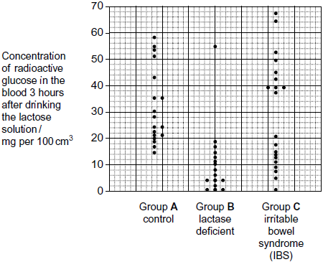

(a)     (i)      Give the range of results for the control group (group **A**)

...............................................................................................................

**(1)**

(ii)     Each person in the control group was given 50 g of lactose containing the same amount of radioactive carbon. All the products of lactose digestion were absorbed into their blood. The concentration of glucose was measured in mg per 100 cm3 of blood.

Explain why the variation in the results may be due to differences in body mass.

...............................................................................................................

...............................................................................................................

...............................................................................................................

...............................................................................................................

**(2)**

(b)     In the test the doctors obtained different results for the three groups.

Would this test be useful to identify people who were lactase deficient? Use the data from all three groups to explain your answer.

........................................................................................................................

........................................................................................................................

........................................................................................................................

........................................................................................................................

........................................................................................................................

........................................................................................................................

(Extra space) .................................................................................................

........................................................................................................................

........................................................................................................................

**(3)**

**(Total 6 marks)**

**Q15.**Some people are lactose intolerant. The lactose in milk and milk products, such as cheese, causes digestive discomfort in these people.

Scientists gave 159 adult volunteers, who had dia gnosed themselves as lactose intolerant, a questionnaire to complete. The volunteers were asked,

•        do you eat the food?

•        if you eat the food, do you feel discomfor t after eating it?

The results are shown in the table.

|  |  |  |  |  |  |  |
| --- | --- | --- | --- | --- | --- | --- |
|  | **Food** | **Typical lactose content / g per serving** | **Percentage of people who** | | | |
|  | **A** do not eat the food | **B** feel discomfort after eating the food | **C (= A + B)** do not eat the food or feel discomfort after eating the food | **D** feel no discomfort after eating the food |
|  | Hard cheese | 1.2 | 11.1 | 39.9 | 51.0 | 49.0 |
|  | Pizza | 3.0 | 10.4 | 57.8 | 68.2 | 31.8 |
|  | Soft cheese | 3.6 | 25.1 | 53.0 | 78.1 | 21.9 |
|  | Ice cream | 6.0 | 14.6 | 68.2 | 82.8 | 17.2 |
|  | Milk | 9.9 | 27.0 | 67.1 | 94.1 | 5.9 |

(a)     The scientists investigated the relationship between the lactose content of the food and the amount of digestive discomfort.

(i)      The figures in columns **A** and **B** were used to produce those in column **C**.  
The scientists used column **C** rather than column **B** in their analysis. Suggest why.

...............................................................................................................

...............................................................................................................

**(1)**

(ii)     Describe the relationship between the lactose content of the food and the data in column **C**.

...............................................................................................................

...............................................................................................................

**(1)**

(iii)    The scientists could **not** conclude that the discomfort was caused by the increase in lactose content of the food. Explain why.

...............................................................................................................

...............................................................................................................

...............................................................................................................

...............................................................................................................

...............................................................................................................

**(2)**

(b)     Suggest **two** reasons why the data in this table may be unreliable.

1 .....................................................................................................................

........................................................................................................................

2 .....................................................................................................................

........................................................................................................................

**(2)**

**(Total 6 marks)**

**Q16.**          Different cells in the body have different functions.

(a)     Some white blood cells are phagocytic. Describe how these phagocytic white blood cells destroy bacteria.

......................................................................................................................

......................................................................................................................

......................................................................................................................

......................................................................................................................

......................................................................................................................

......................................................................................................................

......................................................................................................................

......................................................................................................................

*(Extra space)* ...............................................................................................

.....................................................................................................................

.....................................................................................................................

.....................................................................................................................

.....................................................................................................................

**(4)**

(b)The epithelial cells that line the small intestine are adapted for the absorption of glucose. Explain how.

.....................................................................................................................

.....................................................................................................................

.....................................................................................................................

.....................................................................................................................

.....................................................................................................................

.....................................................................................................................

.....................................................................................................................

.....................................................................................................................

.....................................................................................................................

.....................................................................................................................

.....................................................................................................................

.....................................................................................................................

*(Extra space)* ...............................................................................................

.....................................................................................................................

.....................................................................................................................

.....................................................................................................................

.....................................................................................................................

**(6)**

**(Total 10 marks)**

**17.**Biological washing powders contain enzymes which hydrolyse substances that cause stains on clothes.

A manufacturer tested the ability of two types of the same brand of washing powder to remove different food substances that stain clothes.

•        Type **A** contained an enzyme.

•        Type **B** was identical to **A** except it did **not** contain the enzyme.

**Figure 1** shows the results.

**Figure 1**

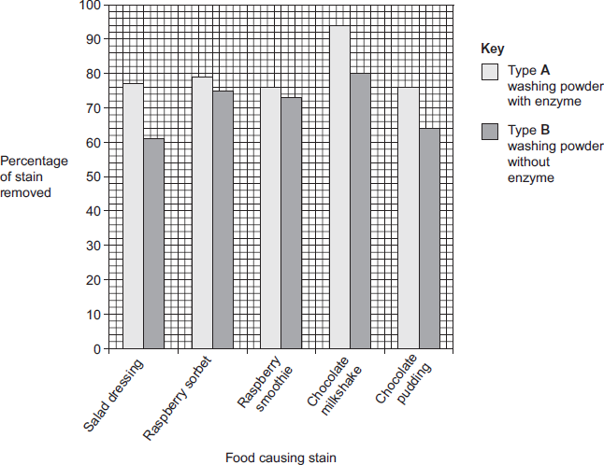

A scientist worked for a company that wanted to develop a biological washing powder that was effective over a range of temperatures. He investigated the effect of temperature on the rates of the reaction catalysed by two enzymes, **P** and **S** used in biological washing powders.

**Figure 2** shows his results.

**Figure 2**

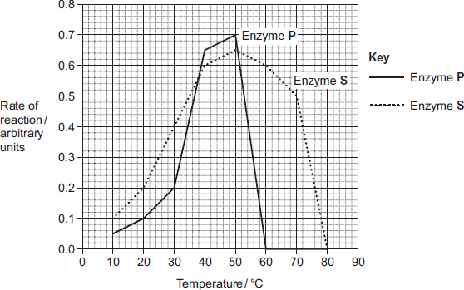

(a)     Many of the substances causing the food stains are large, insoluble proteins.  
Suggest how a biological washing powder removes this type of stain.

........................................................................................................................

........................................................................................................................

........................................................................................................................

........................................................................................................................

........................................................................................................................

**(2)**

(b)     The manufacturer of type **A** and type **B** washing powder claimed that these results showed that biological washing powders are better at removing stains from clothes.

Use the information in **Figure 1** to evaluate this claim.

........................................................................................................................

........................................................................................................................

........................................................................................................................

........................................................................................................................

........................................................................................................................

........................................................................................................................

........................................................................................................................

........................................................................................................................

(Extra space) .................................................................................................

........................................................................................................................

........................................................................................................................

........................................................................................................................

**(4)**

(c)     Most customers want a washing powder which removes stains from clothes over a range of temperatures. After obtaining the results shown in **Figure 2**, which enzyme should the scientist recommend for use in a biological powder?

Give reasons for your answer.

........................................................................................................................

........................................................................................................................

........................................................................................................................

........................................................................................................................

........................................................................................................................

........................................................................................................................

(Extra space) .................................................................................................

........................................................................................................................

........................................................................................................................

**(3)**

(d)     Biological washing powders often contain a number of different enzymes. This enables them to remove a wider range of stains from clothes.  
Explain why a number of enzymes are required to remove a wider range of stains.

........................................................................................................................

........................................................................................................................

........................................................................................................................

........................................................................................................................

........................................................................................................................

........................................................................................................................

(Extra space) .................................................................................................

........................................................................................................................

........................................................................................................................

**(3)**

**(Total 12 marks)**

**Q18.**          Scientists investigated the relationship between the percentage of fat in the diet and the death rate from breast cancer in 24 different countries. They plotted the data from each country on the graph below.

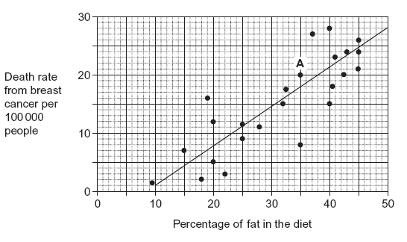

(a)     Describe the information given by point **A** on the graph.

......................................................................................................................

......................................................................................................................

......................................................................................................................

**(1)**

(b)Describe how the scientists calculated the death rate from breast cancer for each country.

......................................................................................................................

......................................................................................................................

......................................................................................................................

**(1)**

(c)Some people have used the graph to conclude that a high percentage of fat in the diet causes breast cancer. Evaluate this conclusion.

......................................................................................................................

......................................................................................................................

......................................................................................................................

......................................................................................................................

......................................................................................................................

......................................................................................................................

*(Extra space)* ...............................................................................................

......................................................................................................................

......................................................................................................................

**(3)**

**(Total 5 marks)**

**Q19.**A student investigated the effect of chewing on the digestion of starch in cooked wheat.

He devised a laboratory model of starch digestion in the human gut. This is the method he used.

1.      Volunteers chewed cooked wheat for a set time. The wheat had been cooked in boiling water.

2.      This chewed wheat was mixed with water, hydrochloric acid and a protein-digesting enzyme and left at 37 °C for 30 minutes.

3.      A buffer was then added to bring the pH to 6.0 and pancreatic amylase was added. This mixture was then left at 37 °C for 120 minutes.

4.      Samples of the mixture were removed at 0, 10, 20, 40, 60 and 120 minutes, and the concentration of reducing sugar in each sample was measured.

5.      Control experiments were carried out using cooked wheat that had been chopped up in a blender, not chewed.

(a)     What reducing sugar, or sugars, would you expect to be produced during chewing?  
Give a reason for your answer.

........................................................................................................................

........................................................................................................................

........................................................................................................................

........................................................................................................................

**(2)**

(b)     In this model of digestion in the human gut, what other enzyme is required for the complete digestion of starch?

........................................................................................................................

**(1)**

(c)     What was the purpose of step 2, in which samples were mixed with water, hydrochloric acid and pepsin?

........................................................................................................................

........................................................................................................................

**(1)**

(d)     In the control experiments, cooked wheat was chopped up to copy the effect of chewing.

Suggest a more appropriate control experiment. Explain your suggestion.

........................................................................................................................

........................................................................................................................

........................................................................................................................

........................................................................................................................

**(2)**

(e)     The figure below shows the student’s results.

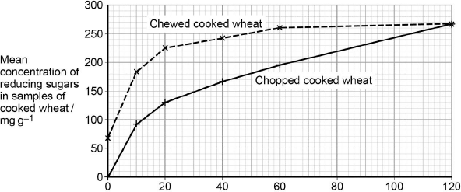  
                               Incubation time / minutes

Explain what these results suggest about the effect of chewing on the digestion of starch in wheat.

........................................................................................................................

........................................................................................................................

........................................................................................................................

........................................................................................................................

........................................................................................................................

........................................................................................................................

**(3)**

**(Total 9 marks)**

**Q20.**Some people have a medical condition called pancreatitis. This can lead to their pancreatic duct becoming blocked. As a result, a high concentration of amylase is found in their blood.

At 12-hour intervals, a doctor measured the concentration of amylase in the blood of a person suffering from a blocked pancreatic duct. He also measured the concentration of amylase in the blood of a healthy person.

The figure below shows his results.

|  |  |  |  |
| --- | --- | --- | --- |
|  |  | **Concentration of amylase in the blood / arbitrary units** | |
|  | **Time / hours** | **Person with blocked pancreatic duct** | **Healthy person** |
|  | 0 | 1800 | 800 |
|  | 12 | 2200 | 750 |
|  | 24 | 2500 | 700 |
|  | 36 | 2000 | 750 |
|  | 48 | 1400 | 800 |

(a)     (i)      The changes in concentration of amylase in the blood of a person with a blocked pancreatic duct are different from those of a healthy person during the period shown in the figure above.

Describe **two** of these differences.

1 ............................................................................................................

...............................................................................................................

...............................................................................................................

2 ............................................................................................................

...............................................................................................................

...............................................................................................................

**(2)**

(ii)     In a person with a blocked pancreatic duct, starch digestion is affected.  
Explain how.

...............................................................................................................

...............................................................................................................

...............................................................................................................

...............................................................................................................

...............................................................................................................

**(2)**

(b)     Healthy people have amylase in their blood. This does not cause any harmful effects in the body.  
Explain why.

........................................................................................................................

........................................................................................................................

........................................................................................................................

........................................................................................................................

........................................................................................................................

**(2)**

(c)     Pancreatitis can lead to the release of protein-digesting enzymes into the blood. This is harmful to the body.  
Suggest **one** reason why.

........................................................................................................................

........................................................................................................................

........................................................................................................................

........................................................................................................................

........................................................................................................................

**(2)**

**(Total 8 marks)**

**Q21.**(a)    Describe how you would test a sample of food for the presence of starch.

........................................................................................................................

........................................................................................................................

........................................................................................................................

........................................................................................................................

........................................................................................................................

**(2)**

(b)     The concentration of glucose in the blood rises after eating a meal containing carbohydrates.

The rise is slower if the carbohydrate is starch rather than sucrose. Explain why.

........................................................................................................................

........................................................................................................................

........................................................................................................................

........................................................................................................................

........................................................................................................................

(Extra space)..................................................................................................

........................................................................................................................

........................................................................................................................

**(3)**

The glycaemic load (GL) of a diet is a measure of how much digestible carbohydrate it contains. The higher the GL of a diet the more quickly it raises the blood glucose concentration after a meal. A diet with a high GL also increases the concentration of harmful lipids in the blood.

Scientists investigated the relationship between diets with different glycaemic loads and the risk of developing coronary heart disease (CHD) in women.

The scientists determined the glycaemic loads of the diets of a large number of women. They then divided the women into 5 groups. Group 1 had diets with the lowest glycaemic load and group 5 had diets with the highest glycaemic load. The scientists determined the risk of developing CHD in each group.

The graph shows their results.

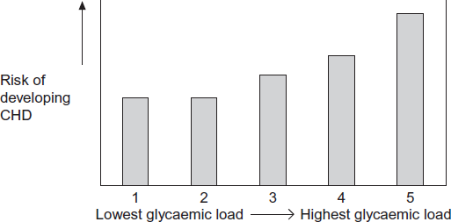

Diet group

(c)     The scientists excluded women who smoked from the study. Explain why.

........................................................................................................................

........................................................................................................................

........................................................................................................................

**(1)**

(d)     (i)      What do these data show about the effect that glycaemic load of the diet has on the risk of developing CHD?

...............................................................................................................

...............................................................................................................

...............................................................................................................

**(1)**

(ii)     Use the information provided to explain the effect that glycaemic load of the diet has on the risk of developing CHD.

...............................................................................................................

...............................................................................................................

...............................................................................................................

...............................................................................................................

**(2)**

**(Total 9 marks)**

**M1.**(a)     C.

*Ignore name of organ*

**1**

(b)     E.

*Ignore name of organ*

**1**

(c)     1.       Active site (of enzyme) has (specific) shape / tertiary structure / active site complementary to substrate / maltose;

*Reject active site on substrate.  
Must have idea of shape*

*Assume “it” = maltase*

*Accept (specific) 3D active site*

*Reject has same shape*

2.       (Only) maltose can bind / fit;

*Accept “substrate” for “maltose”*

3.       To form enzyme substrate complex.

*Accept E−S complex*

**3**

**[5]**

**M2.**(a)     (Most of) bromelain is digested / not absorbed / broken down in blood;

**1**

(b)     Total volume of blood;

**1**

**[2]**

**M3.**          (a)     Digestion / hydrolysis / breakdown of a disaccharide into monosaccharides;  
OR  
(glucose and galactose form lactose) glucose is a monosaccharide;

**max 1**

(b)     (i)      Dipeptidase / disaccharidase / named disaccharidase;

**1**

(ii)     Enzymes not lost (with gut contents) / more effective absorption  
of products formed by these enzymes;

**1**

(c)     No ATP formed / no energy released by respiration;

*[reject “making” energy]*

Link ATP to active transport (of galactose) into cells;

**2**

**[5]**

**M4.**          (i)      In all cases reject ‘energy’ unless qualified

A –  facilitated diffusion as transport protein needed but ATP not needed;

B –  active transport ‘energy’ unless as (transport protein and) ATP needed; qualified

C –  (simple) diffusion as neither ATP nor transport protein needed;

*(Ignore all references to concentration gradients)*

**3**

(ii)      creates low concentration of amino acids / Na+ in cell concentration gradient established between lumen and cell (of amino acids or Na+)

**2**

**[5]**

**M5.**          (i)      Lack of ATP;  
Pump = active transport / requires energy / ATP provides energy /   
transport is up  
concentration gradient;

**2**

(ii)      Concentration of Na+ inside cell no longer less than concentration in  
gut lumen / no longer a concentration gradient;  
No (facilitated) diffusion of NA+ ions possible / amino acid absorption  
requires diffusion of Na+ ions into cell;

**2**

(iii)     Diffusion / facilitated diffusion;

**1**

**[5]**

**M6.**(a)     Amylase;

(Starch) to maltose:

Maltase;

Maltose to glucose;

Hydrolysis;

(Of) glycosidic bond;

***Q*** *Do not penalise incorrect site for digestion or incorrect site of enzyme production.*

**5 max**

(b)     Glucose moves in with sodium (into epithelial cell);

Via (carrier / channel) protein / symport;

Sodium removed (from epithelial cell) by active transport / sodium- potassium pump;

Into blood;

Maintaining low concentration of sodium (in epithelial cell) / maintaining sodium concentration gradient (between lumen and epithelial cell);

Glucose moves into blood;

By (facilitated) diffusion;

***Q*** *Only allow diffusion mark in context of movement of glucose into the blood.*

**5 max**

**[10]**

**M7.**          (a)     Two marks for correct answer of 64.285 / 64.3 / 64;

*(allow 1 mark for (8100 / 100 × 30) / 37.8)*

**2**

(b)     dissolve in / add ethanol then mix with water;  
emulsion / white colour indicates triglycerides present;

**2**

(c)     (i)      increase the surface area for absorption;

*(ignore wrong ref. to name)*

**1**

(ii)     **R** = tissue fluid / interstitial fluid / extracellular fluid / intercellular space;  
**S** = lymph(atic) vessel / lymph capillary / lacteal;

**2**

(iii)     proteins are synthesised by **U**;  
involvement of ribosomes;  
protein isolation / transport (inside RER);  
vesicle formation;

**2 max**

(iv)    exocytosis / description of;  
because of size / too large to leave by other methods;

**2**

**[11]**

**M8.**          (a)     (i)      Mitochondrion;

*Neutral: cristae*

**1**

(ii)     (Site of aerobic) respiration / ATP production / energy release;

***Q*** *Reject: anaerobic respiration*

***Q*** *Reject: energy produced*

         Active transport / transport against the concentration gradient;

*Accept: energy produced in the form of ATP*

**2**

(b)     89 – 91 gains 2 marks;

*Correct answer gains 2 marks outright*

Principle of:

 gains 1 mark;

*89-91 (mm) / 1000 or 8.9-9.1 (cm) / 1000 gains 1 mark*

**2**

(c)     Suitable explanation given e.g.

*Accept: converse arguments*

          Reduced surface area; (So) less absorption;

*Neutral: structure* ***Z*** *incorrectly named*

(Membrane-bound) enzymes less effective;  
(So) proteins / polypeptides not digested;

*Reduced surface area for absorption gains 2 marks*

Cell membranes damaged;  
(So) Fewer / less effective carrier / channel proteins;

*Accept: references to diffusion and active transport for ‘absorption’*

Carrier / channel proteins damaged;  
(So) less absorption;

*Reject: active transport if linked to channel proteins*

**2**

**[7]**

**M9.**(a)     Measure with eyepiece graticule / scale;  
Calibrate with stage micrometer / scale on slide / object of known size;   
Repeats and calculate the mean;  
***OR***Use a ruler to estimate the field diameter under microscope;  
How many droplets go across the field;  
Repeats and calculate mean;

*Accept references to radius*

**3**

(b)     (i)      Two mark for correct answer of 4 : 1;;  
One mark for incorrect answer but working shows that candidate has clearly attempted to compare values of r2 / 62 and 32 / 36 and 9;

*Idea of comparing ratios  
A ratio of 1 : 4 should gain 1 mark*

**2**

(ii)     Small droplets have a larger surface area to volume ratio;

More surface for lipase (to act), leading to faster digestion of triglycerides;

Fatty acids are produced more quickly so pH will drop more quickly in curve Y / with bile salts / less fatty acids in curve Z / without bile salts so pH drop more slowly;

**3**

**[8]**

**M10.**(a)     Diet including saturated fats leads to higher plasma cholesterol concentrations;  
Higher in all age groups;  
But sample size is very small;  
Standard deviations overlap / suggest wide variation;

**3 max**

(b)     The sex of individual is a risk factor for high cholesterol;  
To remove a / one variable / to establish a fair test;

**2**

(c)     Monkeys and humans closely related therefore similar conclusions might be drawn;  
High concentrations of plasma cholesterol lead to an increased risk of cardiovascular disease in humans;  
Don’t know if diet has the same effect in monkeys (as in humans) / could have different effects because not the same species;

**3**

**[8]**

**M11.**(a)     pH goes down and levels out;  
after 30 min / pH 6.5;

**2**

(b)     Enzyme not used up in reaction;

**1**

(c)     Curve will be less steep:

*Only accept answers relating to curve* ***not*** *rate of reaction*

**1**

**[4]**

**M12.**(a)     High sucrose / starch diet leads to increase in lactase activity;

**1**

(b)     Not valid / cannot be certain because overlap in SD between high sucrose and high starch;

Study based on rats (not human) so may not apply to human;

**2**

**[3]**

**M13.**(a)      1.      Helicase;

2.      Breaks hydrogen bonds;

3.      Only one DNA strand acts as template;

4.      RNA nucleotides attracted to exposed bases;

5.      (Attraction) according to base pairing rule;

6.      RNA polymerase joins (RNA) nucleotides together;

7.      Pre-mRNA spliced to remove introns.

**6 max**

(b)     1.      Polymer of amino acids;

2.      Joined by peptide bonds;

3.      Formed by condensation;

4.      Primary structure is order of amino acids;

5.      Secondary structure is folding of polypeptide chain due to hydrogen bonding;

*Accept alpha helix / pleated sheet*

6.      Tertiary structure is 3-D folding due to hydrogen bonding and ionic / disulfide bonds;

7.      Quaternary structure is two or more polypeptide chains.

**5 max**

(c)     1.      Hydrolysis of peptide bonds;

2.      Endopeptidases break polypeptides into smaller peptide chains;

3.      Exopeptidases remove terminal amino acids;

4.      Dipeptidases hydrolyse / break down dipeptides into amino acids.

**4**

**[15]**

**M14.**(a)     (i)      14 / 15 – 58 / 59 or 43 – 45 (mg per 100cm3);

*Wrong calculation does not disqualify*

**1**

(ii)     The larger the person the more blood they would have so have a lower concentration of blood glucose;

as same amount of glucose absorbed / all / 50g absorbed;

**2**

(b)     1.      Any reference to overlap between all 3 groups;

2.      One lactase deficient subject had high blood glucose / similar to control;

3.      Some control / Group A subjects had the similar blood glucose to LD / Group B subjects / some IBS subjects had similar results to lactase deficient subjects;

**3**

**[6]**

**M15.**(a)     (i)      Assumed that did not eat due to discomfort in the past;

**1**

(ii)     Positive correlation / as lactose concentration increases the data in column C increases / percentage who do not eat the food or feel discomfort after eating the food increases;

**1**

(iii)    Correlation does not mean that there is a causal relationship;

May be due to some other factor / example of factor;

*Do not accept casual*

**2**

(b)     1.      People self-diagnosed lactose intolerant condition;

2.      Discomfort may be due to other factor / infection / other component of diet / is subjective;

3.      Large variation in lactose content of specific food items / e.g. variation in lactose content of different soft cheeses;

4.      Amount in a serving may vary;

5.      Untruthful responses / demand characteristics;

*Sample size = neutral.*

**2 max**

**[6]**

**M16.**          (a)     1.      Phagocyte attracted to bacteria by chemicals / recognise antigens on bacteria as foreign;

2.      Engulf / ingest bacteria;

3.      Bacteria in vacuole / vesicle;

4.      Lysosome fuses with / empties enzymes into vacuole;

5.      Bacteria digested / hydrolysed;

*1. Accept names chemical e.g. toxin*

*2. Allow description of engulfing*

*3. Accept: bacteria in phagosome*

*5. Neutral: Break down*

*5. Accept digestive enzymes destroy bacteria*

*5. Do not accept “destroy bacteria” as it is in question stem*

**4 max**

(b)     1.      Microvilli provide a large / increased surface area;

2.      Many mitochondria produce ATP / release or provide energy (for active transport);

3.      Carrier proteins for active transport;

4.      Channel / carrier proteins for facilitated diffusion;

5.      Co-transport of sodium (ions) and glucose or symport / carrier protein for sodium (ions) and glucose;

6.      Membrane-bound enzymes digest disaccharides / produce glucose;

*1. Reject villi on epithelial cells*

*1. Accept brush border*

*2. Accept large SA:vol ratio*

*3. Need idea of “lots”*

*4. Reject: energy produced*

*5. Accept Na+K+ pump*

*6. Neutral: Channel proteins*

*7. Accept named example*

**6**

**[10]**

**M17.**(a)     1.      Enzyme hydrolyses / breaks down protein to amino acids;

2.      Products are soluble / can be washed away;

**2**

(b)     **Arguments for biological washing powder:**

*3 max if only arguments against biological washing powder are referred to*

1.      More effective with all stains;

*Accept different ways of expressing ‘effective’ e.g. higher % of stain removed*

2.      Greater improvement with salad dressing / chocolate milkshake / chocolate pudding;

**Arguments against biological washing powder:**

3.      Little / less improvement with raspberry sorbet / raspberry smoothie;

4.      Only tested 5 / a small number of stains;

5.      Only chose stains that would work / didn’t select stains that wouldn’t work;

6.      Only included results that did work / didn’t show results that didn’t work;

7.      Only one set of results / not repeated;

8.      Only compared against one washing powder / may not be true for other washing powders;

*Ignore references to unknown masses of powder, temperature of washes or other aspects of technique or different fabrics*

**4 max**

(c)     1.      Enzyme **S** effective across a wider range of temperatures;

2.      Enzyme **S** *more* active above 50 °C / active up to 80 °C / active above 60 °C;

3.      Enzyme **S** more active below (about) 37 °C temperature;

4.      (Although) Enzyme **P** has higher rate of reaction at optimum / 40 – 50 °C;

5.      Enzyme **P** denatured above 50 °C;

*Answers should be in the context of choosing enzyme* ***S*** *but, if* ***P*** *is chosen, points 4 and 5 may still be awarded, if described*

*In points 2 and 3, a temperature must be stated. Allow ± 5 degrees of values shown*

**3 max**

(d)     1.      Stains caused by different substances;

2.      Enzymes are specific;

3.      Active site specific to substrate / other substrates cannot fit active site;

*This could be expressed in other ways e.g. ‘other substrates are not complementary to the active site’*

**3**

**[12]**

**M18.**          (a)     In one country where the percentage of fat (in the diet) is 35%, the death rate (from breast cancer) is 20 per 100 000;

*Must have reference to country*

*Accept … 1 per 5 000 / 0.02%*

**1**

(b)     1.      No. of deaths from breast cancer divided by total population × 100 000;

2.      No. of deaths from breast cancer divided by all deaths × 100 000;

3.      Sample and count deaths from breast cancer in 100 000 people;

*If sample not 100 000 then must scale appropriately*

**1 max**

(c)     1.      Positive correlation;

2.      But correlation does not show causation / some other (named) factor may be involved;

3.      Evidence against positive correlation e.g. different death rates at same % fat / similar death rates at different % fat / some countries with higher death rate have lower fat intake;

*1. Accept description of positive correlation / directly proportional.*

*Accept positive relationship.*

*2. Do not accept casual in place of causal.*

*3. Answer must be consistent with data.*

**3**

**[5]**

**M19.**(a)     1.      Maltose;

2.      Salivary amylase breaks down starch.

**2**

(b)     Maltase.

**1**

(c)     (Mimics / reproduces) effect of stomach.

**1**

(d)     1.      Add boiled saliva;

2.      Everything same as experiment but salivary amylase denatured.

**2**

(e)     1.      Some starch already digested when chewing / in mouth;

2.      Faster digestion of chewed starch;

3.      Same amount of digestion without chewing at end.

*Accept use of values from graph*

**3**

**[9]**

**M20.**(a)     (i)      For person with pancreatitis / blocked pancreatic duct:

1.      At 0 h / start higher than healthy person / higher than healthy person throughout;

2.      Rises then falls whereas healthy person falls then rises;

3.      At 48 h / end, below the starting value whereas healthy person is the same (as at start);

*Differences required for all points*

**2 max**

(ii)     1.      Little / less / no amylase can enter small intestine;

*Accept gut or intestine but reject wrong locations e.g. stomach*

2.      Little / less / no starch digested (in intestine);

**2**

(b)     1.      Amylase is specific (to starch);

2.      No starch in human blood / cells / tissues / starch only in plants;

**2**

(c)     1.      Could digest own body / own proteins;

*e.g. ‘could digest carrier proteins in body cells’ would score 2 marks*

*e.g. ‘could digest antibodies in blood’ would also score 2 marks*

2.      Example of protein digested e.g. membrane protein, antibody, named protein in blood;

*Do not credit unsuitable example such as muscle proteins*

**2**

**[8]**

**M21.**(a)     1.      Add iodine / potassium iodide solution to the food sample;

*1. Allow ‘iodine’*

*2. Must be in the context of the correct reagent*

2.      Blue / black / purple indicates starch is present;

**2**

(b)     1.      Starch digested to maltose / by amylase;

*Ignore ‘hard to digest / easily digested’*

2.      Maltose digested to glucose / by maltase;

3.      Digestion of sucrose is a single step / only one enzyme / sucrase;

*3. Accept converse for starch*

*3. Do not accept digestion of sucrose is faster*

**3**

(c)     1.      Smoking increases risk of CHD / introduces another variable;

**1**

(d)     (i)      1.      No effect on risk with diet group 1 and 2 / lowest glycaemic load;

*Simple statement of correlation is not enough for this mark*

2.      Above diet group 2 / in higher groups, risk increases as glycaemic load increases;

**1 max**

(ii)     1.      (Higher GL diets lead to) more (harmful) lipids (in blood), so greater risk of atheroma;

*Ignore reference to lipids in diet*

2.      Atheroma leads to blockage of coronary artery / increased risk of blood clot in coronary artery;

*Ignore references to myocardial infarction / heart attack*

**2**

**[9]**

**E1.**(a)     More than 80% of students correctly named organ C.

(b)     More than 62% of students correctly named organ E.

(c)     There was considerable evidence of a good understanding of the importance of the (specific) active site of the enzyme. This was expressed in a variety of ways. Students discussed the importance of the tertiary structure determining the active site. Many indicated that the active site of maltase was complementary to either the substrate or maltose. Unfortunately some students incorrectly stated that maltose possessed the specific active site. Nearly all students had a clear understanding of the resultant enzyme-substrate complex.

80% of students scored two marks, often because they failed to indicate that maltose would bind / join / fit or attach to the maltase and so form the enzyme-substrate complex. The poor expression of some students resulted in them suggesting that the complementary shapes were matching. Unfortunately this conveyed the idea of the shapes being the same.

**E3.**          (a)     It was common to see answers that referred to galactose as the single breakdown product of ll lactose and answers of this nature did not gain credit.

(b)     Part (i) tended to be well answered by candidates though part (ii) did not elicit the desired response in many instances. Many candidates answered in terms of surface area. Some candidates realised the enzymes would pass out of the body but identified this as an example of excretion. Unfortunately these candidates often made the same error in 2 (a) (i).

(c)     The assertion that mitochondria *made* energy prevented a significant number of candidates scoring one of the marks available. Many candidates scored both the marks available.

**E4.**          In (i), candidates needed to be aware of the distinction between kinetic energy and energy stored in a molecule of ATP. It is incorrect to say that diffusion and facilitated diffusion require no energy. They require no ATP but the molecules must have kinetic energy or they will not move. In part (ii), some candidates explained why amino acids are continually absorbed into the capillary, but most, correctly, explained how removing amino acids by active transport maintains a low concentration in the epithelial cell and, therefore, a concentration gradient between the lumen and the cell.

**E5.**          Some candidates clearly did not know the meaning of the term oxidative phosphorylation, in part (i), and thought that the poison DNP was a direct inhibitor of pump **Y** in the plasma membrane of the intestinal epithelial cell shown in the diagram, due to its direct attachment to the membrane protein. Others thought the DNP prevented the breakdown of ATP rather than its synthesis, although a fair proportion were on the right track and many realised that there could be no active transport in the presence of DNP (for whatever reason) and hence scored at least one mark. Some candidates left this section blank, presumably preferring not to wrestle with the complexities of what may have been to them an unfamiliar diagram.  
In (ii), many candidates were unsure about the nature of the concentration gradient in the presence of DNP and implied there would now be a ‘greater’ concentration of sodium ions inside the cell than in the lumen of the small intestine – although by what mechanism was not at all clear. Many were content to state that no more entry of sodium ions and amino acids would be possible rather than giving the extra detail that diffusion would no longer be able to occur.  
Opinions were divided in part (iii), although most realised that diffusion or facilitated diffusion of amino acids out of the epithelial cell would occur at point **Z** on the diagram. ‘Active transport’ was a common wrong answer, despite the lack of use of ATP at **Z** compared with its breakdown illustrated elsewhere – at point **Y**.

**E6.**(a)     This question proved to be an effective discriminator. Most candidates gained at least one mark by mentioning the enzyme amylase. Many of these candidates gained a second mark for naming maltose as the product of the action of amylase on starch.  
However, it was not uncommon to see starch being broken down directly into glucose by amylase. There were also a significant number of answers which included irrelevant references to bile, lipase and a range of proteases. A few candidates confused maltose and maltase but others had little difficulty in quickly accumulating maximum marks by describing the hydrolytic action of maltase in breaking maltose down into glucose.  
Fortunately, the mark scheme did not penalise candidates for incorrect sites of enzyme production or incorrect sites of digestion. The action of enzymes on glycosidic bonds was infrequently mentioned by candidates. Almost twenty percent of candidates obtained maximum marks often displaying impressive use of terminology and understanding of this topic.

(b)     This proved to be much more demanding that part (a) with a much lower mean mark being obtained. A number of candidates simply repeated their answer to part (a) or provided details on the digestion of other carbohydrates such as lactose and sucrose.  
There were also a number of blank or very brief answers. The most accessible marking points related to the movement of glucose from the epithelial cells into the blood by (facilitated) diffusion. The process by which glucose entered the epithelial cells was less well understood. Many candidates had some idea that sodium ions are involved but it was not always clear where they were moving to or from. The role of active transport caused similar confusion for a number of candidates and there were also some references to osmosis. However, despite this there were some outstanding responses demonstrating a thorough understanding of co-transport.

**E7.**          **Unit 6**

(a)     Although the correct answer was given by many candidates, a significant minority made arithmetical errors or rounded their answers incorrectly.

(b)     The emulsion test was most frequently cited but the method was often not described correctly.

Many of these responses used water or ethanol as the sole reagent or cited an incorrect test. A small minority of candidates gave details of incubating with lipase and testing for pH change, these answers received the appropriate credit.

(c)     Microvilli were correctly identified and their function described by most candidates in part (i).

Part (ii) caused problems to the weaker candidates and the vast range of alternative answers generated by these candidates indicated that they had not understood the diagram. Part (iii) produced good responses from the candidates who correctly identified the rough endoplasmic reticulum, although a small proportion thought the structure was the Golgi body. Part (iv) was generally poorly answered. The most common incorrect response was facilitated diffusion.

Often these responses were given in answers which clearly indicated the size of the chylomicrons and it was interesting to observe the lack of coherent thinking displayed by many candidates.

**Unit 7**

(a)     Calculations of the recommended daily lipid intake were often incorrect, a common error being to disregard the given energy content of one gram of lipid. Some spoiled their answers by inappropriate rounding or by compounding rounding approximations in a two-stage calculation.

(b)     Many candidates did not know the details of the emulsion test for lipids. Benedict.s, the biuret test and the iodine test were all suggested.

(c)     In (i), most knew that the microvilli shown in the diagram would increase the surface area for absorption of the products of digestion. However, in (ii), the identification of **R** and **S** was rarely correct. **R**, the tissue fluid, was sometimes thought to be ‘cytoplasm’, a ‘blood vessel’, or merely a ‘space’. **S**, the lymph vessel or lacteal, was thought to be a ‘blood vessel’, a ‘lysosome’, even the ‘small intestine’. In part (iii), many recognised organelle **U** as the rough endoplasmic reticulum and knew that the protein part of the chylomicron would be made here, better candidates emphasising the part played by its ribosomes. Some correctly suggested a role in transport, perhaps mentioning vesicle formation. Others incorrectly thought triglycerides were synthesised here, despite the indication in the diagram that this was fulfilled by the smooth ER. It was evident in (iv) that many candidates had no appreciation of the size of the chylomicrons – despite having been given the information in the stem to section (d) that they were composed of many triglyceride molecules and were surrounded by proteins. Hence, ‘diffusion’, ‘facilitated diffusion’ and ‘active transport’ were not sensible answers. Better candidates knew that such large structures could only leave the cell by exocytosis.

**E8.**          (a)     (i)      Over 90% of candidates correctly identified organelle **Y** as a mitochondrion.

(ii)     This question proved to be a good discriminator. Most candidates gained at least one mark for the function of mitochondria in terms of respiration, energy release or ATP production. Better candidates usually went on to link this to active transport. Unfortunately, some candidates disqualified the first mark through poor expression e.g. ‘energy produced’ and ‘produces ATP for respiration’. Similarly, some answers referred to facilitated diffusion and linked this to a requirement for ATP. A minority of candidates incorrectly referred to structure **Y** as either ‘microvilli’ or ‘ribosome’. This resulted in incorrect answers relating to surface area and protein synthesis respectively.

(b)     Most candidates gained one mark for the principle of dividing the measured length by the magnification. However, only the best candidates were able to convert the measured length to micrometres. Candidates who failed to score often divided the magnification by the measured length.

(c)     Most candidates scored one mark for mentioning a reduced surface area. The more able usually went on to link this to reduced absorption for full marks. However, some candidates disqualified this mark by referring to less protein being absorbed. Relatively few candidates referred to the cell membrane or membrane proteins.

**E12.**(a)     This question was well answered with most candidates making the required connection.

(b)     This question was not well answered. The commonest response was that it is not possible to generalise from rats to humans. Only the very best candidates grasped the concept of overlapping standard deviation. Although the concept of standard deviation was understood, only the best candidates were clear about an overlap in the standard deviation suggesting an uncertain conclusion.

**E14.**(a)     (i)      Most candidates scored this mark. Those who did not had usually misread the graph.

(ii)     Many candidates made the link that a larger person would have more blood but the second marking point, that therefore there would be a lower concentration of glucose, was less frequently seen. Candidates frequently described the glucose as being more spread out. This was not given credit. A common misconception was that diffusion distances in larger people were greater. As in question 10, candidates who referred simply to different masses, rather than to masses being high or low, did not gain credit.

(b)     Better candidates realised that there was considerable overlap between the groups and scored at least two marks. Less able candidates decided that in many cases the test was fine and ignored the overlap.

**E15.**(a)     (i)      Only better candidates clearly understood the idea that some individuals did not eat the food due to discomfort from eating it in the past.

(ii)     Most candidates clearly described a positive correlation in one form or another. Candidates failing to gain this mark often provided only part of the information in the column heading C.

(iii)    Better candidates had little difficulty explaining that correlation does not mean that there is a causal relationship and that some other factor may be involved. However, many candidates only provided part of this explanation for one mark or provided answers that bore little relevance to the wording of the question.

(b)     Many candidates gained both marks in this question, often for understanding that self-diagnosis and subjectivity of ‘discomfort’ could make the data unreliable. The idea of untruthful responses was also often credited.

**E16.**          (a)     Phagocytosis was well understood by candidates and many gained full marks. Many, however, wasted time by describing antigen presentation which was not required. Almost all candidates knew that the bacteria would be engulfed and many referred to their inclusion in a phagosome or vacuole. Weaker candidates failed to gain marks through imprecision, e.g., not realising that the lysosomes fuse with the phagocytic vesicle and just writing about them releasing enzymes or not specifying what sort of enzymes and then repeating the stem by saying the bacteria were destroyed without any mention of digestion or hydrolysis.

(b)     Many candidates failed to realise that this question was about cell adaptation. There was a lot of confusion between adaptations of the cell and of the intestine wall generally, with many answers focusing on factors such as a good blood supply and maintaining a steep concentration gradient. Such responses were not relevant to this question. Many candidates had a good understanding of glucose co-transport and described this in detail, usually gaining two or three marks, even though their answers were not focused on cell adaptation. Most scored one mark for understanding a large surface area was involved but many attributed this to villi rather than to microvilli. Better candidates gained a further two marks for explaining the cells would have a large number of mitochondria that provide the ATP for active uptake.

**E17.**(a)     There was some weakness with both the answers to this question and the assessment of what was written. As mentioned before, marking points show the minimum required answer and marking point 1 clearly identified that amino acids would be formed. It was disappointing that quite a few assessors felt that “smaller proteins are formed” or simply that “proteins are digested” was sufficient to award this marking point.

(b)     In the main, students used the information provided well to answer this question. The majority referred to trusted ideas such as the limited number of stains used or that there was only a single set of results. Higher scoring students used the more sophisticated arguments, such as not including results where there was no change, and made specific reference to the actual stains.

(c)     It was also the case that many students answered this question well, particularly where appropriate temperatures were identified to support the use of enzyme **S** or to explain why enzyme **P** was inappropriate for use. However, the general idea, that enzyme **S** was effective across a wider range of temperatures, was often not recognised.

(d)     Many students finished with full credit in this question. In weaker answers, as was often the case with many questions, students failed to translate the idea in the question first. Thus, ‘a wider range of stains’ was not explained as caused by different substances being present but this did not prevent most being able to identify that the specific nature of enzymes was due to their active site.

**E18.**          (a)     Candidates often failed to appreciate that point A referred to just one of the 24 countries represented on the graph. The graph showed two points with 35% fat that had different death rates. A number thought that 20 in 100 000 was the same as 200 000.

(b)     This question proved to be challenging for many with only the more able gaining the mark. Some suggested a suitable method but then failed to multiply their answer by 100 000. There were many vague answers such as use hospital records, or reading the answer from the graph.

(c)     The majority gained two marks for evaluating the data on the graph, although many simply repeated a stock answer along the lines of there being „a positive correlation but correlation does not mean causation‟. Unfortunately, some candidates failed to gain the first mark by failing to state that the correlation was positive. The better candidates actually looked at the data and gave examples which did not fit in with the pattern – for example, the widely differing death rate with 35% fat in the diet.

**E20.**(a)     (i)      The first part of this question required the description of differences. Many students were able to identify two appropriate differences but it was also the case that the Marking Guidelines were not always applied as given, in particular, where only one statement was made and no difference shown.

(ii)     A common weakness with answers to this question was a failure to identify the location of where little or no amylase would reach and less starch digestion would occur as a result of a blocked pancreatic duct. Only a few students considered that salivary amylase would not be affected.

(b)     Many students identified the specific nature of amylase but did not always explain that there would be no harmful effects because the substrate for amylase (starch) was not found in blood.

(c)     In this part, students were frequently able to suggest that body proteins would be digested but were less able to offer a suitable example of a protein. It was common to see a hopeful reference to “blood cells” without a specific identification of (cell) membrane proteins or other blood proteins, such as antibodies, that would have gained credit. Occasionally, assessors allowed protein examples that would not be part of the blood and therefore not answering the question asked.

**E21.**(a)     A surprising number of students did not do well on this question. Some muddled the names of the reactant with the name of the test, such as the biuret test for starch. Others gave an incorrect procedure, such as boiling with hydrochloric acid. Some gave the wrong colour change, such as turning brown.

(b)     This question discriminated clearly between students who had a good understanding of the biochemical nature of starch and students who had only a shaky memory of digestion from GCSE. The slower, two-step process by which starch is hydrolysed, firstly into maltose and then from maltose into glucose, was described well in better answers. Weaker answers referred to starch being insoluble, or a polysaccharide as the explanation for slower absorption.

(c)     Almost all students gained this mark.

(d)     (i)       Almost all students gave a simple description of correlation, which was not true for groups 1 and 2, so did not gain the mark. This was another instance where students did not look closely enough at the data before starting to formulate their answer.

(ii)     Although most students seemed to understand the idea behind this, a significant number did not write precisely enough. For example, they may have stated that risk of CHD increases as GL increases but did not specify that this was true for diet group 2 and above. Omitting to name the coronary artery as the site of atheroma development also meant that some students did not obtain mark point 3. The stem of the question stated that a diet with high GL increases the concentration of harmful lipids in the blood. Students should have realised that re-stating this would not obtain a mark and that they needed to make the link with atheroma.