**Q1.** Lung cancer, chronic bronchitis and coronary heart disease (CHD) are associated with smoking. **Tables 1** and **2** give the total numbers of deaths from these diseases in the UK in 1974.

**Table 1 Men**

|  |  |  |  |
| --- | --- | --- | --- |
| **Age/years** | **Number of deaths (in thousands)** | | |
|  | lung cancer | chronic bronchitis | coronary heart disease |
| 35 - 64 | 11.5 | 4.2 | 31.7 |
| 65 - 74 | 12.6 | 8.5 | 33.3 |
| 75+ | 5.8 | 8.1 | 29.1 |
| Total (35 - 75+) | 29.9 | 20.8 | 94.1 |

**Table 2 Women**

|  |  |  |  |
| --- | --- | --- | --- |
| **Age/years** | **Number of deaths (in thousands)** | | |
|  | lung cancer | chronic bronchitis | coronary heart disease |
| 35 – 64 | 3.2 | 1.3 | 8.4 |
| 65 – 74 | 2.6 | 1.9 | 18.2 |
| 75+ | 1.8 | 3.5 | 42.3 |
| Total (35 – 75+) | 7.6 | 6.7 | 68.9 |

(i)      Using an example from the tables, explain why it is useful to give data for men and women separately.

......................................................................................................................

......................................................................................................................

......................................................................................................................

**(2)**

(ii)     Data like these are often given as percentages of people dying from each cause.

Explain the advantage of giving these data as percentages.

......................................................................................................................

......................................................................................................................

......................................................................................................................

......................................................................................................................

**(2)**

**(Total 4 marks)**

**Q2.**          (a)     When first hatched, the young of some species of fish are less than 2 mm long.  
Explain how these young fish get enough oxygen to their cells without having gills.

......................................................................................................................

......................................................................................................................

......................................................................................................................

......................................................................................................................

**(2)**

(b)     Mackerel are fast swimming fish whereas toadfish only swim slowly. The table shows some features of the gills of these fish.

|  |  |  |
| --- | --- | --- |
|  | **Thickness of lamellae / µm** | **Number of lamellae per mm of gill length** |
| Mackerel | 5 | 32 |
| Toadfish | 35 | 8 |

Use evidence from the table to explain how mackerel are able to swim faster than toadfish.

......................................................................................................................

......................................................................................................................

......................................................................................................................

......................................................................................................................

......................................................................................................................

**(3)**

**(Total 5 marks)**

**Q3.**          (a)     Describe **two** differences between active transport and facilitated diffusion.

1 ...................................................................................................................

......................................................................................................................

2 ...................................................................................................................

......................................................................................................................

**(2)**

(b)     Explain why molecules of oxygen and carbon dioxide are able to diffuse across membranes.

......................................................................................................................

......................................................................................................................

......................................................................................................................

......................................................................................................................

......................................................................................................................

**(2)**

(c)     Explain why ventilation of the lungs increases the efficiency of gas exchange.

......................................................................................................................

......................................................................................................................

......................................................................................................................

......................................................................................................................

......................................................................................................................

**(2)**

**(Total 6 marks)**

**Q4.**          Alpha-1-antitrypsin is a protein that reduces the activity of enzymes that can damage lung tissue.  
Cigarette smoke contains hydrogen peroxide. Hydrogen peroxide reduces the activity of alpha-1-antitrypsin. Scientists investigated the effect of different concentrations of hydrogen peroxide on the activity of alpha-1-antitrypsin. The graph shows their results.

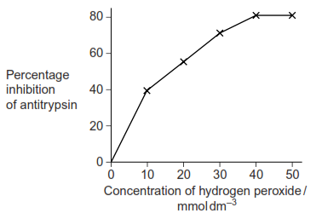

(a)     (i)      Hydrogen peroxide reacts with two amino acids in alpha-1-antitrypsin.  Explain how this reduces activity of the protein.

.............................................................................................................

.............................................................................................................

.............................................................................................................

.............................................................................................................

**(2)**

(ii)     Explain the results shown in the graph.

.............................................................................................................

.............................................................................................................

.............................................................................................................

.............................................................................................................

**(2)**

(b)     Long-term smokers are often short of breath. Use this information to explain why.

......................................................................................................................

......................................................................................................................

......................................................................................................................

......................................................................................................................

**(2)**

**(Total 6 marks)**

**Q5.**          This question should be written in continuous prose, where appropriate.  
Quality of Written Communication will be assessed in the answer.

(a)     Explain how the ventilation mechanism of a fish and the structure of its gills result in the efficient uptake of oxygen from water.

......................................................................................................................

......................................................................................................................

......................................................................................................................

......................................................................................................................

......................................................................................................................

......................................................................................................................

......................................................................................................................

......................................................................................................................

......................................................................................................................

......................................................................................................................

......................................................................................................................

......................................................................................................................

......................................................................................................................

......................................................................................................................

......................................................................................................................

**(6)**

**Table 1** compares some features of water and air.

|  |  |  |
| --- | --- | --- |
| **Feature** | **Water** | **Air** |
| Relative density | 1000 | 1 |
| Maximum concentration of oxygen / cm3 dm–3 | 9 | 130 |

**Table 1**

**Table 2** shows some features of gas exchange in a fish and in a mammal.

|  |  |  |
| --- | --- | --- |
| **Feature** | **Fish** | **Mammal** |
| Percentage of oxygen extracted from water or air | 80 | 25 |
| Oxygen consumption at rest / cm3 kg–1 hour–1 | 100 | 200 |

**Table 2**

(b)     (i)      The fish has a body mass of 0.2 kg. Calculate the volume of water it will need to pass over its gills each hour to supply the oxygen required when resting. Show your working.

Answer ............................................ dm3 / hour–1

**(2)**

(ii)     Ventilation in mammals involves movement of air to and from the gas exchange surface in a tidal pattern. Using information in the tables, explain why it is easier to move water over the gas exchange surface of a fish in one direction rather than in a tidal pattern.

.............................................................................................................

.............................................................................................................

.............................................................................................................

.............................................................................................................

**(2)**

(c)     A rise in the temperature of water decreases the amount of oxygen dissolved in the water. As the water temperature rises, the rate of ventilation in a fish also rises. Explain the advantage of this.

......................................................................................................................

......................................................................................................................

......................................................................................................................

......................................................................................................................

**(2)**

**(Total 12 marks)**

**Q6.**          (a)     The photograph shows part of the gill of a fish as seen through a light microscope. It is magnified × 400.

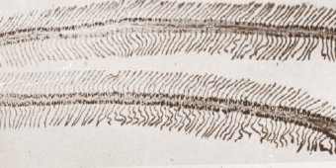

(i)      Explain how the structure of the gill makes oxygen uptake efficient.

.............................................................................................................

.............................................................................................................

.............................................................................................................

.............................................................................................................

**(2)**

(ii)     Water containing dissolved oxygen flows over the gill in the opposite direction to the blood flow inside. Explain why this arrangement is important for efficient oxygen uptake.

.............................................................................................................

.............................................................................................................

.............................................................................................................

.............................................................................................................

**(2)**

(b)     There is a one-way flow of water over the gills of a fish whereas there is a two-way flow of air in the lungs of a mammal. Suggest **one** advantage to a fish of this one-way flow of water over its gills.

......................................................................................................................

......................................................................................................................

**(1)**

**(Total 5 marks)**

**Q7.**          (a)     Describe and explain how fish maintain a flow of water over their gills.

......................................................................................................................

......................................................................................................................

......................................................................................................................

......................................................................................................................

......................................................................................................................

......................................................................................................................

......................................................................................................................

......................................................................................................................

......................................................................................................................

......................................................................................................................

**(4)**

(b)     Describe and explain how the structure of the mammalian breathing system enables efficient uptake of oxygen into the blood.

......................................................................................................................

......................................................................................................................

......................................................................................................................

......................................................................................................................

......................................................................................................................

......................................................................................................................

......................................................................................................................

......................................................................................................................

......................................................................................................................

......................................................................................................................

......................................................................................................................

......................................................................................................................

**(6)**

**(Total 10 marks)**

**Q8.**          (a)     Describe how air is taken into the lungs.

......................................................................................................................

......................................................................................................................

......................................................................................................................

......................................................................................................................

......................................................................................................................

......................................................................................................................

**(3)**

The volume of air breathed in and out of the lungs during each breath is called the tidal volume. The breathing rate and tidal volume were measured for a cyclist pedalling at different speeds. The graph shows the results.

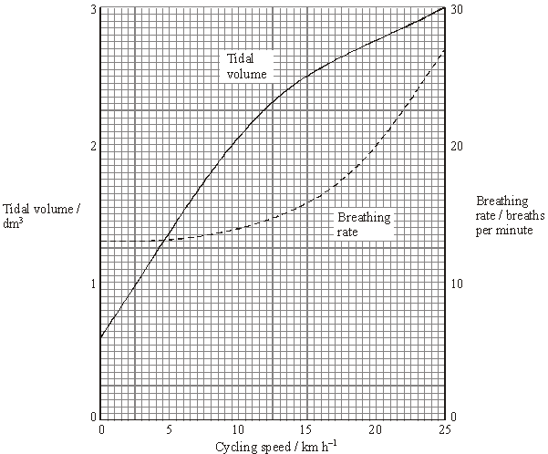

(b)     Describe the **two** curves.

(i)      Tidal volume

.............................................................................................................

.............................................................................................................

.............................................................................................................

(ii)     Breathing rate

.............................................................................................................

.............................................................................................................

.............................................................................................................

**(2)**

(c)     Calculate the total volume of air breathed in and out per minute when the cyclist is cycling at 20 km h–1. Show your working.

........................................ dm3

**(2)**

**(Total 7 marks)**

**Q9.**          (a)     The diagram represents the flow of water and blood through the gills of a fish. The figures give relative oxygen concentrations.

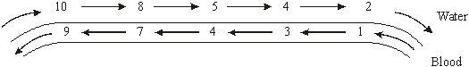

Use the information in diagram to explain the advantage of the countercurrent flow.

......................................................................................................................

......................................................................................................................

......................................................................................................................

......................................................................................................................

......................................................................................................................

**(2)**

(b)     In the ventilation cycle of a fish, water enters the mouth cavity and then passes through the gills into the opercular cavity. The graph shows the difference in pressure between the mouth cavity and the opercular cavity.

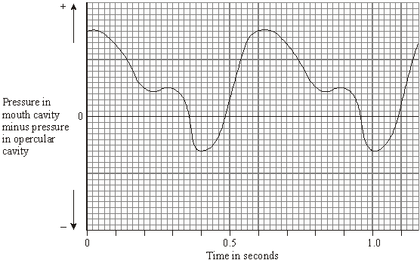

Calculate the number of ventilation cycles per minute of the fish. Show your working.

Answer ......................................

**(2)**

**(Total 4 marks)**

**Q10.**          **Figure 2** shows a single stoma and surrounding cells from the leaf of a xerophytic plant.

**Figure 2**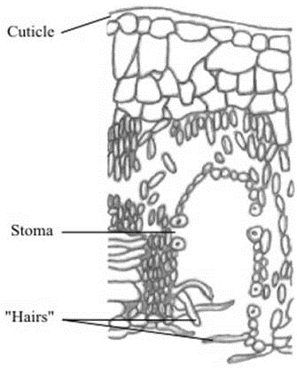

(i)      Explain how the cuticle reduces water loss.

......................................................................................................................

......................................................................................................................

**(1)**

(ii)     Explain how **one** of the other labelled parts reduces water loss.

......................................................................................................................

......................................................................................................................

......................................................................................................................

......................................................................................................................

**(2)**

**(Total 3 marks)**

**Q11.**          (a)     Describe the features of fish gills that give them a large surface area.

......................................................................................................................

......................................................................................................................

......................................................................................................................

......................................................................................................................

**(2)**

The graph shows the relationship between gill surface area and body mass for three species of fish.

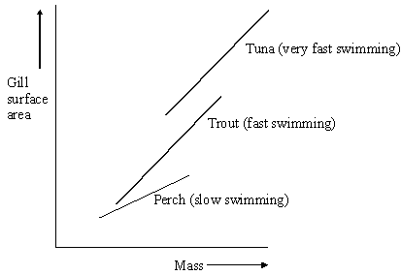

(b)     (i)      Describe the relationships between gill surface area, mass and swimming speed shown in the diagram.

.............................................................................................................

.............................................................................................................

**(1)**

(ii)     Explain the relationship between gill surface area and swimming speed.

.............................................................................................................

.............................................................................................................

.............................................................................................................

.............................................................................................................

**(2)**

**(Total 5 marks)**

**Q12.**Scientists studied three species of plant.

They selected fully grown leaves from five different plants of each species.

For each leaf they measured:

•        leaf surface area

•        leaf thickness

•        the number of stomata per mm2.

The scientists’ results are shown in the table below.

|  |  |  |  |  |
| --- | --- | --- | --- | --- |
|  | **Plant species** | **Mean leaf surface area / mm2** | **Mean leaf thickness / µm** | **Mean number of stomata per mm2** |
|  | **A** | 218.0 | 191.5 | 380.0 |
|  | **B** | 17.0 | 296.3 | 136.0 |
|  | **C** | 2.2 | 354.8 | 419.0 |

(a)     How did the scientists ensure they could make a valid comparison between leaves from different species?

........................................................................................................................

........................................................................................................................

**(1)**

(b)     Describe a method you could use to find the surface area of a leaf.

........................................................................................................................

........................................................................................................................

........................................................................................................................

........................................................................................................................

........................................................................................................................

........................................................................................................................

**[Extra space]** ................................................................................................

........................................................................................................................

........................................................................................................................

**(3)**

(c)     (i)      Which species, **A** or **B**, would you predict grew in a drier environment?

Explain **one** feature that caused you to choose this species.

Species ................................................................................................

Explanation ...........................................................................................

...............................................................................................................

...............................................................................................................

**(1)**

(ii)     Other than the features of leaves in the table above, give **two** features of leaves of xerophytes.

For each feature explain how it reduces water loss.

Feature 1 ..............................................................................................

Explanation ...........................................................................................

...............................................................................................................

Feature 2 ..............................................................................................

Explanation ...........................................................................................

...............................................................................................................

**(2)**

(d)     Species **C** has a high number of stomata per mm2. Despite this it loses a small amount of water.

Use the data to explain why.

........................................................................................................................

........................................................................................................................

........................................................................................................................

**(1)**

**(Total 8 marks)**

**Q13.** The graph shows how pulmonary ventilation changes during a period of exercise.

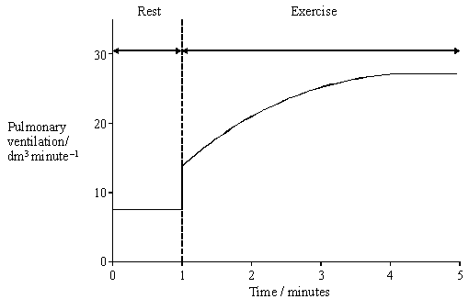

(a)     Describe how pulmonary ventilation changed during the period of exercise.

......................................................................................................................

......................................................................................................................

......................................................................................................................

**(1)**

(b)     After 4 minutes of exercise, the breathing rate was 20 breaths per minute. Explain how you could use this information and the graph to calculate tidal volume.

......................................................................................................................

......................................................................................................................

......................................................................................................................

......................................................................................................................

**(2)**

(c)     When a person starts to breathe out, the percentage of oxygen in the air first exhaled is the same as the percentage of oxygen in the atmospheric air. Explain why.

......................................................................................................................

......................................................................................................................

......................................................................................................................

**(2)**

**(Total 5 marks)**

**Q14.** The drawing shows an electron micrograph of a section through part of an alveolus from a lung.

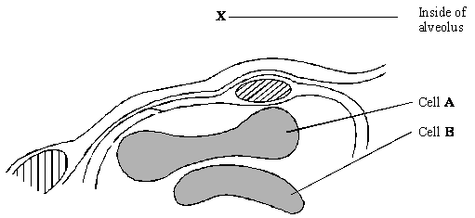

(a)     Describe the path of a molecule of oxygen from the air in the alveolus at **X** to the plasma membrane of cell **A**.

......................................................................................................................

......................................................................................................................

**(1)**

(b)     Cell **A** is a eukaryotic cell. Give **two** features that may be found in a prokaryotic cell which are not found in cell **A**.

1 ...................................................................................................................

......................................................................................................................

2 ...................................................................................................................

......................................................................................................................

**(2)**

(c)     Cells **A** and **B** are biconcave discs. Explain **one** advantage of a biconcave disc over a spherical cell of the same volume in transporting oxygen.

......................................................................................................................

......................................................................................................................

......................................................................................................................

......................................................................................................................

**(2)**

(d)     The diameter of a human red blood cell is 7 µm.

(i)      Calculate the magnification of the drawing. Show your working.

Magnification = ...............................

**(2)**

(ii)     In calculating the magnification, what assumption did you have to make about how the section was cut?

.............................................................................................................

.............................................................................................................

**(1)**

**(Total 8 marks)**

**Q15.**          (a)     Describe the part played by the diaphragm in causing air to enter the lungs during breathing.

......................................................................................................................

......................................................................................................................

......................................................................................................................

......................................................................................................................

......................................................................................................................

......................................................................................................................

**(3)**

Seals are mammals. They have lungs and must breathe air. They can dive and remain under water for a long time. The table shows the flow of blood to the lungs and to the diaphragm in a seal when it is on land and when it is under water.

|  |  |  |  |
| --- | --- | --- | --- |
|  | **Organ** | **Blood flow / cm3 min–1 g–1** | |
|  | **On land** | **Under water** |
|  | Lungs | 0.88 | 0.52 |
|  | Diaphragm | 0.21 | 0.02 |

(b)     Explain why the figures in the table are given per gram of tissue.

......................................................................................................................

......................................................................................................................

......................................................................................................................

......................................................................................................................

**(2)**

(c)     Calculate the percentage by which blood flow to the lungs is reduced when a seal is swimming under water. Show your working.

Answer ............................................

**(2)**

(d)     There is a greater percentage reduction in blood flow to the diaphragm than to the lungs during a dive. Explain the advantage to a diving seal of

(i)      blood continuing to flow to the lungs;

.............................................................................................................

.............................................................................................................

**(1)**

(ii)     a large reduction in blood flow to the diaphragm.

.............................................................................................................

.............................................................................................................

.............................................................................................................

.............................................................................................................

**(2)**

**(Total 10 marks)**

**Q16.**          The electron micrograph shows a section through a fish gill. The directions of flow of water and of blood are indicated by arrows.

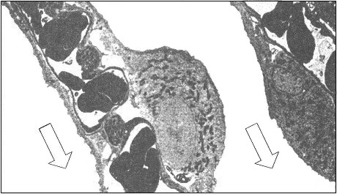

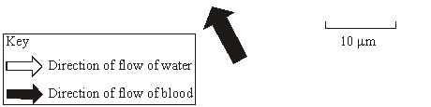

(a)     Calculate the minimum distance that a molecule of oxygen would have to travel from the water to a red blood cell. Give your answer in micrometres and show your working.

Answer .......................................... µm.

**(2)**

(b)     Explain how the relationship between the direction of flow of water and of blood shown in the micrograph is useful to a fish.

......................................................................................................................

......................................................................................................................

......................................................................................................................

......................................................................................................................

......................................................................................................................

......................................................................................................................

**(3)**

**(Total 5 marks)**

**Q17.**A scientist used grasshoppers to investigate the effect of composition of air on breathing rate in insects. He changed the composition of air they breathed in by varying the concentrations of oxygen and carbon dioxide.

The scientist collected 20 mature grasshoppers from a meadow. He placed the grasshoppers in a small chamber where he could adjust and control the composition of air surrounding them. The small chamber restricted the movement of the grasshoppers.

His results for three of the grasshoppers are shown in the table below in the form in which he presented them.

|  |  |  |  |  |  |  |
| --- | --- | --- | --- | --- | --- | --- |
|  |  |  | **Percentage of oxygen and carbon dioxide in  different types of air breathed in by grasshoppers** | | | |
|  |  |  | **A Air from atmosphere** | **B Pure oxygen** | **C Gas mixture 1** | **D Gas mixture 2** |
|  | **Gas** | **Oxygen** | 20.9 | 100.0 | 91.0 | 84.0 |
|  | **Carbon dioxide** | 0.1 | 0.0 | 9.0 | 16.0 |
|  |  | | | | | |
|  | **Breathing rate of grasshopper in different types of air / breaths per  minute** | **Grasshopper 1** | 53 | 11 | 99 | 107 |
|  | **Grasshopper 2** | 48 | 25 | 88 | 99 |
|  | **Grasshopper 3** | 61 | 13 | 96 | 93 |

(a)     The percentages of oxygen and carbon dioxide in Column **A** do **not** add up to 100% but in columns **C** and **D** they do.

Suggest **two** reasons for this difference.

1 .....................................................................................................................

........................................................................................................................

2 .....................................................................................................................

........................................................................................................................

**(2)**

(b)     Use all the data to describe the effect of concentration of carbon dioxide on the breathing rate of grasshoppers.

........................................................................................................................

........................................................................................................................

........................................................................................................................

........................................................................................................................

........................................................................................................................

........................................................................................................................

**[Extra space]** ................................................................................................

........................................................................................................................

........................................................................................................................

**(3)**

(c)     One of the different types of air was similar to the air in the meadow where the grasshoppers were collected. It provides data that might be used to calculate a mean breathing rate for grasshoppers in the meadow.

(i)      Use the data to estimate the mean breathing rate of the three grasshoppers in the meadow. Show your working.

Mean breathing rate = ............................................. breaths per minute

**(2)**

(ii)     The estimate does not provide a reliable value for the mean breathing rate of all insect species in the meadow.

Other than being an estimate, suggest and explain **three** reasons why this value would **not** be reliable.

1 ............................................................................................................

...............................................................................................................

...............................................................................................................

2 ............................................................................................................

...............................................................................................................

...............................................................................................................

3 ............................................................................................................

...............................................................................................................

...............................................................................................................

**(3)**

**(Total 10 marks)**

**Q18.**          Many insects release carbon dioxide in short bursts even though they produce it at a constant rate. The diagram shows how this is achieved in one particular insect.

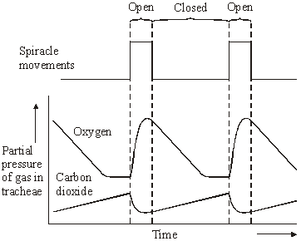

(a)     Using information from the diagram, suggest what stimulates the spiracles to open.

......................................................................................................................

......................................................................................................................

**(1)**

(b)     Explain what causes the oxygen concentration in the tracheae to fall when the spiracles are closed.

......................................................................................................................

......................................................................................................................

......................................................................................................................

......................................................................................................................

**(2)**

(c)     The insect lives in dry conditions. Suggest an advantage of the pattern of spiracle movements shown in the diagram.

......................................................................................................................

......................................................................................................................

......................................................................................................................

......................................................................................................................

**(2)**

**(Total 5 marks)**

**Q19.**          A person was sitting at rest and breathing normally. A recording was made of the changes in the volume of air in his lungs over a ten-second period. The diagram shows this recording.

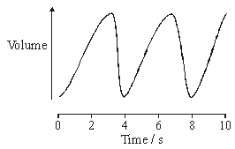

(a)     Describe the part played by muscles in bringing about the change between 3 and 4 seconds.

......................................................................................................................

......................................................................................................................

**(1)**

(b)     Describe how an increase in lung volume leads to air entering the lungs.

......................................................................................................................

......................................................................................................................

**(1)**

**(Total 2 marks)**

**Q20.**          In the lungs, the alveoli are the site of gas exchange.

(a)     A large number of small alveoli is more efficient in gas exchange than a smaller number of larger alveoli. Explain why.

......................................................................................................................

......................................................................................................................

......................................................................................................................

......................................................................................................................

**(2)**

(b)     The diagram shows part of an alveolus and a capillary.

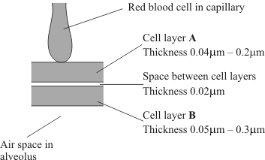

(i)      Name the type of cells in layer **B**.

.............................................................................................................

**(1)**

(ii)     What is the minimum distance a molecule of carbon dioxide diffuses from the blood plasma to the air space in the alveolus?

.............................................................................................................

**(1)**

(c)     Just before a person starts to exhale, the composition of the air in an alveolus differs from the composition of the air in the trachea.

(i)      Give **two** ways in which the composition would differ.

1 ..........................................................................................................

2 ..........................................................................................................

**(1)**

(ii)     Explain what causes this difference in composition between the air in the alveolus and the air in the trachea.

.............................................................................................................

.............................................................................................................

**(1)**

(d)     The partial pressure of a gas is a measure of the amount of gas that is present.   
The partial pressure of carbon dioxide in blood going to the lungs is 6.3 kPa.   
The partial pressure of carbon dioxide in an alveolus is 5.3 kPa.

(i)      Through which vessel does blood leave the heart to go to the lungs?

.............................................................................................................

**(1)**

(ii)     Suggest why blood returning to the heart from the lungs contains some carbon dioxide.

.............................................................................................................

.............................................................................................................

.............................................................................................................

.............................................................................................................

**(2)**

**(Total 9 marks)**

**Q21.**          The graph shows airflow into and out of the lungs during a normal breath.

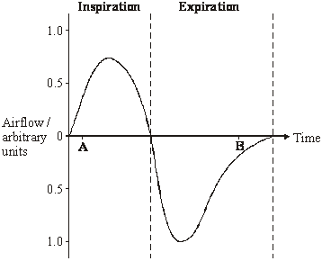

(a)     (i)      How will the concentration of carbon dioxide in the airflow differ at times **A** and **B**?

.............................................................................................................

.............................................................................................................

**(1)**

(ii)     Describe the role of diffusion in producing this difference.

.............................................................................................................

.............................................................................................................

.............................................................................................................

.............................................................................................................

**(2)**

(b)     Use information from the graph to sketch a curve on the axes below to show how the volume of air in the lungs changes during inspiration.

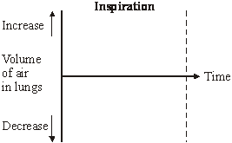

**(2)**

(c)     The intercostal muscles are between the ribs. In normal breathing, describe the part played by the intercostal muscles

(i)      during inspiration;

.............................................................................................................

.............................................................................................................

.............................................................................................................

.............................................................................................................

.............................................................................................................

.............................................................................................................

**(3)**

(ii)     during expiration.

.............................................................................................................

.............................................................................................................

**(1)**

**(Total 9 marks)**

**Q22.**          In an investigation, a locust was given alternating supplies of atmospheric air and pure  
carbon dioxide. The rate of pumping movements of the insect’s abdomen was measured.

The graph shows the results.

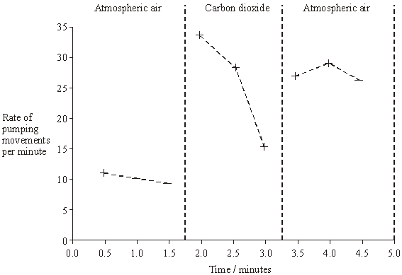

(a)     Explain what caused

(i)      the rise in the rate of abdominal pumping movements between 1.5 and 2.0 minutes,

.............................................................................................................

.............................................................................................................

**(1)**

(ii)     the fall in the rate of abdominal pumping movements between 2.0 and 3.0 minutes.

.............................................................................................................

.............................................................................................................

.............................................................................................................

.............................................................................................................

**(2)**

(b)     The rate of abdominal pumping movements increases between 3.0 and 3.5 minutes. Suggest the advantage of this change to the locust.

......................................................................................................................

......................................................................................................................

**(1)**

**(Total 4 marks)**

**Q23.**          Read the following passage.

|  |  |  |
| --- | --- | --- |
|  | 5        10 | *Campylobacter jejuni* is a bacterium. It is one of the commonest causes of diarrhoea in humans. The illness that it causes does not usually last very long and many sufferers do not even go to the doctor. The only treatment required is the use of oral rehydration solutions to replace the water lost by diarrhoea. In 1998, laboratory tests confirmed 60 000 cases of diarrhoea caused by this bacterium in the UK. The bacterium was more frequently found in males than in females with a ratio of 1.5 : 1.  In rare cases, the nervous system may be affected. Scientists are now beginning to understand the cause of this. Sugars in the antigens on the surface of the bacteria are identical to some of the sugars on the surface of nerve cells. Antibodies produced against the bacteria may therefore attack the body’s nerve cells. There can be serious problems if this leads to paralysis of the diaphragm. Breathing difficulties result and the patient may die. |

Use information in the passage and your own knowledge to answer the following questions.

(a)     (i)      The number of cases of diarrhoea confirmed as being caused by *Campylobacter jejuni* in the UK in 1998 was 60 000 (lines 4–5). Explain why the true number of cases is thought to be more than this.

.............................................................................................................

.............................................................................................................

.............................................................................................................

**(1)**

(ii)     Calculate the number of cases of diarrhoea confirmed as being caused by *Campylobacter jejuni* in men in 1998.

Answer ..........................................

**(1)**

(b)     Explain why antibodies produced against *Campylobacter jejuni* also attack nerve cells (lines 9 –10).

......................................................................................................................

......................................................................................................................

......................................................................................................................

......................................................................................................................

......................................................................................................................

......................................................................................................................

**(3)**

(c)     Explain how paralysis of the diaphragm leads to breathing difficulties (line 11).

......................................................................................................................

......................................................................................................................

......................................................................................................................

......................................................................................................................

......................................................................................................................

**(2)**

**(Total 7 marks)**

**Q24.**          The drawing shows part of the lower leaf epidermis of sorghum.

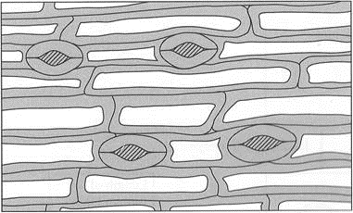



(a)     Calculate the number of stomata per mm2 of the leaf surface. Show your working.

Answer ....................................... stomata per mm2

**(2)**

(b)     Sorghum has few stomata per mm2 of leaf surface area. Explain how this is an adaptation to the conditions in which sorghum grows.

......................................................................................................................

......................................................................................................................

......................................................................................................................

......................................................................................................................

......................................................................................................................

......................................................................................................................

**(3)**

**(Total 5 marks)**

**Q25.**          Read the following passage.

When a person breathes in, the diaphragm muscle contracts and the diaphragm flattens.  
This, together with movement of the ribs, leads to air being drawn into the lungs.  
Breathing out is generally passive and results from the relaxation of the diaphragm  
muscle and the elastic recoil of the lung tissue.

5     Two sets of intercostal muscles also play an important part in breathing in humans.  
Contraction of the external intercostal muscles is associated with breathing in. During  
strenuous exercise, contraction of the internal intercostal muscles helps force air out of  
the lungs. In this case, breathing out is active.

Crocodiles also have lungs and breathe air. They have well developed intercostal

10   muscles but do not appear to use these during breathing. They also lack a diaphragm.  
Breathing in, in crocodiles, is brought about by contraction of muscles attaching the  
liver to the hip bones (see diagram). This pulls the liver back and causes air to enter  
the lungs. Breathing out results from the contraction of abdominal muscles which  
move the liver forwards.

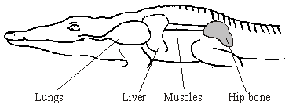

Use information in the passage and your own knowledge to answer the questions.

(a)     Describe the movement of the ribs when a person breathes in (line 2).

......................................................................................................................

......................................................................................................................

**(1)**

(b)     (i)      Explain what is meant by passive (line 3).

.............................................................................................................

.............................................................................................................

**(1)**

(ii)     Is breathing out in crocodiles active or passive? Explain your answer.

.............................................................................................................

.............................................................................................................

**(1)**

(c)     Explain how movement of the liver causes air to enter a crocodile’s lungs.

......................................................................................................................

......................................................................................................................

......................................................................................................................

......................................................................................................................

......................................................................................................................

......................................................................................................................

**(3)**

(d)     Describe the difference in the composition of gases in inhaled and exhaled air. Explain how these differences are caused.

......................................................................................................................

......................................................................................................................

......................................................................................................................

......................................................................................................................

......................................................................................................................

......................................................................................................................

......................................................................................................................

......................................................................................................................

......................................................................................................................

......................................................................................................................

......................................................................................................................

......................................................................................................................

......................................................................................................................

......................................................................................................................

......................................................................................................................

**(6)**

**(Total 12 marks)**

**Q26.**          The diagram shows the position of the diaphragm at times **P** and **Q**.

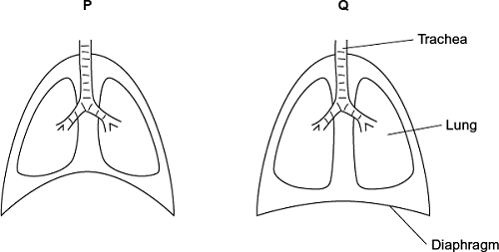

(a)     Describe what happens to the diaphragm between times **P** and **Q** to bring about the change in its shape.

........................................................................................................................

........................................................................................................................

........................................................................................................................

........................................................................................................................

........................................................................................................................

**(2)**

(b)     Air moves into the lungs between times **P** and **Q**. Explain how the diaphragm causes this.

........................................................................................................................

........................................................................................................................

........................................................................................................................

........................................................................................................................

........................................................................................................................

*(Extra space)* .................................................................................................

........................................................................................................................

........................................................................................................................

........................................................................................................................

**(3)**

(c)     Describe how oxygen in air in the alveoli enters the blood in capillaries.

**(2)**

**(Total 7 marks)**

**Q27.**          Read the following passage.

Several diseases are caused by inhaling asbestos fibres. Most of these  
diseases result from the build up of these tiny asbestos fibres in the lungs.

One of these diseases is asbestosis. The asbestos fibres are very small and  
enter the bronchioles and alveoli. They cause the destruction of phagocytes

5       and the surrounding lung tissue becomes scarred and fibrous. The fibrous  
tissue reduces the elasticity of the lungs and causes the alveolar walls  
to thicken. One of the main symptoms of asbestosis is shortness of breath  
caused by reduced gas exchange.

People with asbestosis are at a greater risk of developing lung cancer. The time

10      between exposure to asbestos and the occurrence of lung cancer is 20–30 years.

Use information in the passage and your own knowledge to answer the following questions.

(a)     Destruction of phagocytes (lines 4–5) causes the lungs to be more susceptible to infections. Explain why.

......................................................................................................................

......................................................................................................................

......................................................................................................................

......................................................................................................................

**(2)**

(b)     (i)      The reduced elasticity of the lungs (lines 6–7) causes breathing difficulty. Explain how.

.............................................................................................................

.............................................................................................................

.............................................................................................................

.............................................................................................................

**(2)**

(ii)     Apart from reduced elasticity, explain how changes to the lung tissue reduce the efficiency of gas exchange.

.............................................................................................................

.............................................................................................................

.............................................................................................................

.............................................................................................................

.............................................................................................................

.............................................................................................................

.............................................................................................................

.............................................................................................................

**(4)**

(c)     (i)      Doctors did not make the link between exposure to asbestos and an increased risk of developing lung cancer for many years. Use information in the passage to explain why.

.............................................................................................................

.............................................................................................................

**(1)**

(ii)     Give **one** factor, other than asbestos, which increases the risk of developing lung cancer.

.............................................................................................................

**(1)**

**(Total 10 marks)**

**Q28.**          (a)     A fish uses its gills to absorb oxygen from water. Explain how the gills of a fish are adapted for efficient gas exchange.

......................................................................................................................

......................................................................................................................

......................................................................................................................

......................................................................................................................

......................................................................................................................

......................................................................................................................

......................................................................................................................

......................................................................................................................

......................................................................................................................

......................................................................................................................

......................................................................................................................

......................................................................................................................

**(6)**

Mackerel live in the surface waters of the sea. Toadfish live on the seabed in deep water.

(b)     The concentration of oxygen is higher in the surface waters than it is in water close to the seabed. Suggest why.

......................................................................................................................

......................................................................................................................

......................................................................................................................

......................................................................................................................

**(2)**

(c)     The graph shows oxygen dissociation curves for toadfish haemoglobin and for mackerel haemoglobin.

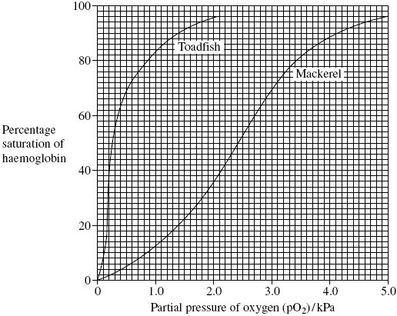

Explain how the shape of the curve for toadfish haemoglobin is related to where the toadfish is normally found.

......................................................................................................................

......................................................................................................................

......................................................................................................................

......................................................................................................................

**(2)**

(d)     Scientists analysed the sequence of amino acids in one polypeptide chain in the haemoglobin of four different species of ape. The only difference they found affected the amino acids at three positions in the polypeptide chain. Their results are shown in the table. The letters are abbreviations for particular amino acids.

|  |  |  |  |  |
| --- | --- | --- | --- | --- |
|  | **Species** | **Position 87** | **Position 104** | **Position 125** |
|  | Chimpanzee | T | R | P |
|  | Bonobo | T | R | P |
|  | Gorilla | T | K | P |
|  | Orang utan | K | R | Q |

What information do the data in the table suggest about the relationships between the chimpanzee, the bonobo and the gorilla? Explain your answer.

......................................................................................................................

......................................................................................................................

......................................................................................................................

......................................................................................................................

**(2)**

**(Total 12 marks)**

**Q29.**          (a)     Gas exchange in fish takes place in gills. Explain how **two** features of gills allow efficient gas exchange.

1 ...................................................................................................................

......................................................................................................................

2 ...................................................................................................................

......................................................................................................................

**(2)**

(b)     A zoologist investigated the relationship between body mass and rate of oxygen uptake in four species of mammal. The results are shown in the graph.

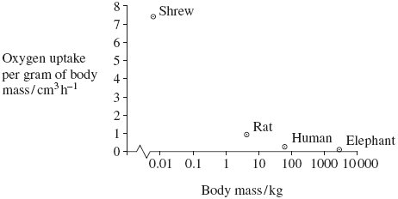

(i)      The scale for plotting body mass is a logarithmic scale. Explain why a logarithmic scale was used to plot body mass.

.............................................................................................................

.............................................................................................................

**(1)**

(ii)     Describe the relationship between body mass and oxygen uptake.

.............................................................................................................

.............................................................................................................

**(1)**

(iii)     The zoologist measured oxygen uptake per gram of body mass. Explain why he measured oxygen uptake per gram of body mass.

.............................................................................................................

.............................................................................................................

.............................................................................................................

.............................................................................................................

**(2)**

**(Total 6 marks)**

**Q30.**          (a)     Many different substances enter and leave a cell by crossing its cell surface membrane. Describe how substances can cross a cell surface membrane.

......................................................................................................................

......................................................................................................................

......................................................................................................................

......................................................................................................................

......................................................................................................................

......................................................................................................................

......................................................................................................................

......................................................................................................................

......................................................................................................................

......................................................................................................................

**(5)**

(b)     Describe and explain how the lungs are adapted to allow rapid exchange of oxygen between air in the alveoli and blood in the capillaries around them.

......................................................................................................................

......................................................................................................................

......................................................................................................................

......................................................................................................................

......................................................................................................................

......................................................................................................................

......................................................................................................................

......................................................................................................................

......................................................................................................................

......................................................................................................................

**(5)**

**(Total 10 marks)**

**Q31.**          Miner’s lung is a disease caused by breathing in dust in coal mines. The dust causes the alveolar epithelium to become thicker. People with miner’s lung have a lower concentration of oxygen in their blood than healthy people.

(a)     (i)      Describe the path by which oxygen goes from an alveolus to the blood.

.............................................................................................................

.............................................................................................................

.............................................................................................................

.............................................................................................................

.............................................................................................................

**(2)**

(ii)     Explain why people with miner’s lung have a lower concentration of oxygen in their blood.

.............................................................................................................

.............................................................................................................

**(1)**

(b)     In healthy lungs, a gradient is maintained between the concentration of oxygen in the alveoli and the concentration of oxygen in the lung capillaries.

(i)      Describe how ventilation helps to maintain this difference in oxygen concentration.

.............................................................................................................

.............................................................................................................

.............................................................................................................

.............................................................................................................

.............................................................................................................

**(2)**

(ii)     Give **one** other way that helps to maintain the difference in oxygen concentration.

.............................................................................................................

**(1)**

(c)     Scientists investigated the number of cases of miner’s lung reported in Britain between 1992 and 2006.

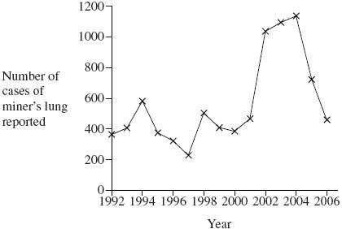

Coal mining in Britain had been dramatically reduced by 1990.

Some scientists concluded that the rise in reported cases of miner’s lung after 1992 shows that the disease takes a long time to develop.

Evaluate this conclusion.

......................................................................................................................

......................................................................................................................

......................................................................................................................

......................................................................................................................

......................................................................................................................

**(2)**

**(Total 8 marks)**

**Q32.**          The graph shows changes in the volume of air in a person’s lungs during breathing.

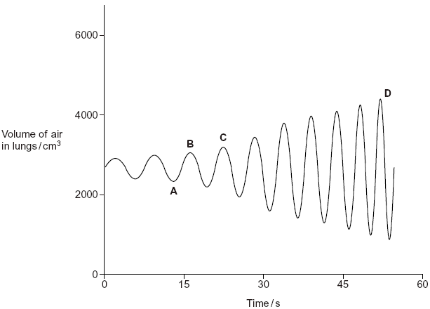

The person was breathing in between times **A** and **B** on the graph.

(i)      Explain how the graph shows that the person was breathing in between times **A**and **B**.

......................................................................................................................

......................................................................................................................

**(1)**

(ii)     Describe and explain what happens to the shape of the diaphragm between times **A**and **B**.

......................................................................................................................

......................................................................................................................

......................................................................................................................

......................................................................................................................

**(2)**

**(Total 3 marks)**

**Q33.**(a)     Explain how oxygen is loaded, transported and unloaded in the blood.

........................................................................................................................

........................................................................................................................

........................................................................................................................

........................................................................................................................

........................................................................................................................

........................................................................................................................

........................................................................................................................

........................................................................................................................

........................................................................................................................

........................................................................................................................

........................................................................................................................

........................................................................................................................

*(Extra space)* .................................................................................................

........................................................................................................................

........................................................................................................................

........................................................................................................................

........................................................................................................................

........................................................................................................................

**(6)**

Midges are very small insects. The early stages of the life cycle of midges are called larvae. Midge larvae live in water. A biologist investigated the uptake of oxygen by the larvae of two species of midge. He measured the rate of uptake of oxygen by the larvae in water containing different concentrations of oxygen. The table shows his results.

|  |  |  |  |
| --- | --- | --- | --- |
|  | **Concentration of oxygen in water / cm3dm-3** | **Mean rate of oxygen uptake / cm3g-1h-1** | |
|  | *Chironomus longistylus* | *Tanytarsus brunnipes* |
|  | 1 | 220 | 141 |
|  | 2 | 285 | 246 |
|  | 3 | 304 | 342 |
|  | 4 | 313 | 362 |
|  | 5 | 320 | 367 |
|  | 6 | 318 | 430 |
|  | 7 | 320 | 469 |

(b)     The larvae in this investigation were kept at a temperature of 17 °C. Why was it important that the larvae of both species were kept at the same temperature?

........................................................................................................................

........................................................................................................................

........................................................................................................................

........................................................................................................................

........................................................................................................................

**(2)**

(c)     Describe the effect of an increase in oxygen concentration on the mean rate of oxygen uptake in *Chironomus longistylus*.

........................................................................................................................

........................................................................................................................

........................................................................................................................

........................................................................................................................

........................................................................................................................

**(2)**

(d)     *Chironomus longistylus* lives in still water whereas *Tanytarsus brunnipes* lives in fast running streams. The water in fast running streams has a higher concentration of oxygen than in still water. Use the table in part (a) to suggest how *Chironomus longistylus* is better adapted than *Tanytarsus brunnipes* to living in still water.

........................................................................................................................

........................................................................................................................

........................................................................................................................

........................................................................................................................

........................................................................................................................

**(2)**

(e)     Lungfish are freshwater fish which have gills and lungs. Scientists investigated how Australian and African lungfish use their lungs and gills for gas exchange. The graphs show the results of this investigation.

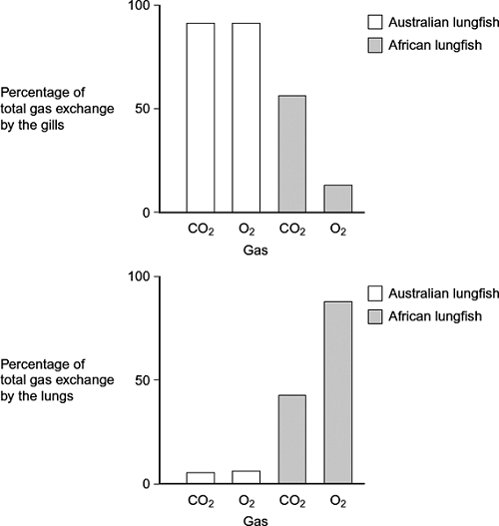

(i)      Describe the difference in the way carbon dioxide is lost from the body of an Australian lungfish and an African lungfish.

...............................................................................................................

...............................................................................................................

...............................................................................................................

**(1)**

(ii)     African lungfish are likely to survive for longer than Australian lungfish when living in pools that dry up. Explain why.

...............................................................................................................

...............................................................................................................

...............................................................................................................

...............................................................................................................

...............................................................................................................

**(2)**

**(Total 15 marks)**

**Q34.**(a)     Scientists who investigate disease may look at risk factors. What is a risk factor?

........................................................................................................................

........................................................................................................................

........................................................................................................................

**(1)**

Scientists investigated the link between pollution from vehicle exhausts and the number of cases of asthma. Between 1976 and 1996, the scientists recorded changes in the following

•        the concentration in the air of substances from vehicle exhausts

•        the number of cases of asthma.

The graph shows their results

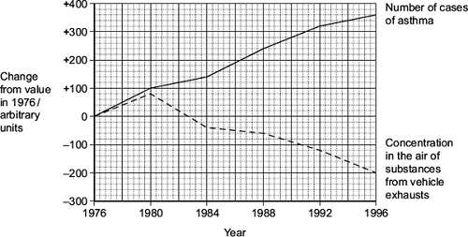

(b)     Between which years on the graph was there

(i)      a positive correlation between the number of cases of asthma and the concentration in the air of substances from vehicle exhausts

...............................................................................................................

**(1)**

(ii)     a negative correlation between the number of cases of asthma and the concentration in the air of substances from vehicle exhausts?

...............................................................................................................

**(1)**

(c)     The scientists concluded that substances in the air from vehicle exhausts did not cause the increase in asthma between 1976 and 1980. Explain why.

........................................................................................................................

........................................................................................................................

........................................................................................................................

........................................................................................................................

........................................................................................................................

........................................................................................................................

(*Extra space*) .................................................................................................

........................................................................................................................

........................................................................................................................

**(3)**

**(Total 6 marks)**

**Q35.**A person with asthma breathed out as hard as he could. The graph shows the volume of air he breathed out in the first 6 seconds of a breath. Curve **A** shows the volume before he used an inhaler. Curve **B** shows the volume after he used an inhaler.

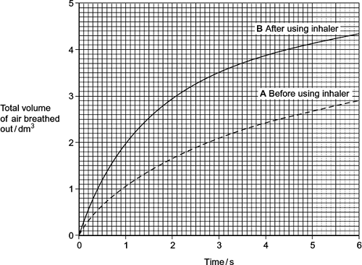

(a)     The diaphragm helps to bring about the changes shown by the curve **A**.  
Explain how.

........................................................................................................................

........................................................................................................................

........................................................................................................................

........................................................................................................................

........................................................................................................................

(*Extra space*)..................................................................................................

........................................................................................................................

........................................................................................................................

........................................................................................................................

**(3)**

(b)     You could use curve **A** to find the total volume of air that this person could breathe out in one complete breath. Describe how.

........................................................................................................................

........................................................................................................................

........................................................................................................................

........................................................................................................................

........................................................................................................................

**(2)**

(c)     The inhaler which the person used contained a substance that dilates bronchioles.  
Use this information to explain why curve **A** is different from curve **B**.

........................................................................................................................

........................................................................................................................

........................................................................................................................

........................................................................................................................

........................................................................................................................

**(2)**

**Q36.**Scientists used fossil leaves from one species of pine tree to investigate whether changes in the concentration of carbon dioxide in the air over long periods of time had led to changes in the number of stomata in the leaves.

Their method is outlined below.

•        They selected sites of different ages.

•        They collected between 11 and 24 fossil leaves from each site.

•        They found the mean number of stomata per mm2 on the leaves from each site.

•        They estimated the age of each sample by dating organic remains around the leaves at each site.

They compared results from the fossil leaves with leaves from the same species of pine tree growing today.

They knew the concentration of carbon dioxide in the air at different times in the past.

Their results are shown in the table.

|  |  |  |  |
| --- | --- | --- | --- |
|  | **Age of sample  / years** | **Concentration of  carbon dioxide in the  air / %** | **Mean number of stomata  per mm2  (± standard deviation)** |
|  | present day | 0.0350 | 92 (±2) |
|  | 5000 | 0.0270 | 87 (±4) |
|  | 10 000 | 0.0250 | 95 (±2) |
|  | 15 000 | 0.0205 | 108 (±6) |
|  | 20 000 | 0.0195 | 115 (±4) |
|  | 25 000 | 0.0188 | 118 (±6) |
|  | 30 000 | 0.0190 | 130 (±6) |

(a)     The concentration of carbon dioxide in the air has changed with time. Use the data to describe how.

........................................................................................................................

........................................................................................................................

........................................................................................................................

........................................................................................................................

........................................................................................................................

**(2)**

(b)     The scientists calculated the mean number of stomata per mm2 and the standard deviation.

What does the standard deviation show?

........................................................................................................................

........................................................................................................................

........................................................................................................................

........................................................................................................................

........................................................................................................................

**(2)**

(c)     The scientists found the age of the fossil leaves by dating the organic remains around them.  
Would this have affected the accuracy of their data? Explain your answer.

........................................................................................................................

........................................................................................................................

........................................................................................................................

**(1)**

(d)     30 000 years ago the mean number of stomata per mm2 on the lower epidermis of pine tree leaves was much higher than it is today. This would have enabled the plant to grow faster when the carbon dioxide concentration of the air was low.

Explain why.

........................................................................................................................

........................................................................................................................

........................................................................................................................

**(1)**

(e)     A student who saw these results concluded that as the carbon dioxide concentration of the air had increased the number of stomata per mm2 in leaves had decreased.  
Do the results support this conclusion?

........................................................................................................................

........................................................................................................................

........................................................................................................................

........................................................................................................................

........................................................................................................................

........................................................................................................................

(Extra space) .................................................................................................

........................................................................................................................

........................................................................................................................

**(3)**

(f)      The leaves of plants that grow in dry areas usually have a low number of stomata per mm2. Use your knowledge of leaf structure to suggest **three** other adaptations that the leaves might have that enable the plants to grow well in dry conditions.

1 .....................................................................................................................

2 .....................................................................................................................

3 .....................................................................................................................

**(3)**

**(Total 12 marks)**

**Q37.**          (a)     Flatworms are small animals that live in water. They have no specialised gas exchange or circulatory systems.  
The drawing shows one type of flatworm.

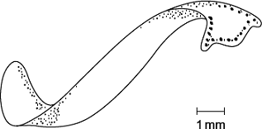

(i)      Name the process by which oxygen reaches the cells inside the body of this flatworm.

...............................................................................................................

**(1)**

(ii)     The body of a flatworm is adapted for efficient gas exchange between the water and the cells inside the body.  
Using the diagram, explain how **two** features of the flatworm’s body allow efficient gas exchange.

1 ............................................................................................................

...............................................................................................................

2 ............................................................................................................

...............................................................................................................

**(2)**

(b)     (i)      A leaf is an organ. What is an organ?

...............................................................................................................

...............................................................................................................

...............................................................................................................

**(1)**

(ii)     Describe how carbon dioxide in the air outside a leaf reaches mesophyll cells inside the leaf.

...............................................................................................................

...............................................................................................................

...............................................................................................................

...............................................................................................................

...............................................................................................................

...............................................................................................................

*(Extra space)* ........................................................................................

...............................................................................................................

...............................................................................................................

**(3)**

**(Total 7 marks)**

**Q38.**The ‘placebo effect’ describes the improvement in patients’ symptoms due to psychological effects. Scientists investigated the placebo effect in patients with asthma. They divided a large number of asthma patients into three groups, **1**, **2** and **3**.

•        Group 1 inhaled a spray containing albuterol every day. Albuterol is a drug used to treat asthma.

•        Group 2 inhaled a placebo spray every day. This was identical to the spray given to  
group 1 but it did not contain albuterol.

•        Group 3 did not receive any spray treatment.

(a)     Describe one way the scientists could have allocated the patients to each group.

........................................................................................................................

........................................................................................................................

........................................................................................................................

........................................................................................................................

**(2)**

The scientists measured the forced expiratory volume (FEV1 ) of each patient at regular intervals. The forced expiratory volume (FEV1 ) is the volume of air forced out of the lungs in the first second when breathing out. The scientists recorded each patient’s FEV1  before treatment started and after 60 days of treatment. They then calculated the mean increase in FEV1  for each group. Their results are shown in the graph. The bars show the standard deviation.

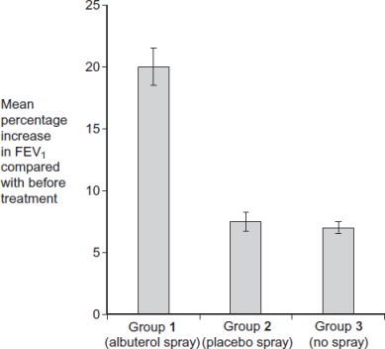

Patient group

(b)     What do the standard deviation bars suggest about the difference in the mean increase in FEV1  between Group **1** and the other groups? Explain your answer.

........................................................................................................................

........................................................................................................................

........................................................................................................................

........................................................................................................................

........................................................................................................................

**(2)**

(c)     What do the data suggest about the ‘placebo effect’ in this investigation? Explain your answer.

........................................................................................................................

........................................................................................................................

........................................................................................................................

........................................................................................................................

........................................................................................................................

**(2)**

(d)     On each occasion that a patient’s FEV1  was measured, a doctor repeated the measurement several times. Explain why.

........................................................................................................................

........................................................................................................................

........................................................................................................................

........................................................................................................................

........................................................................................................................

**(2)**

(e)     All the patients continued with their normal treatment for asthma. The normal treatment was the same for all patients and its effects were short-lived. The patients were told to stop this treatment 24 hours before FEV1  measurements were taken.

(i)      Suggest why all the patients were allowed to continue with their normal asthma treatment in this investigation.

...............................................................................................................

...............................................................................................................

...............................................................................................................

**(1)**

(ii)     Suggest why the patients were told to stop their normal asthma treatment 24 hours before their FEV1  measurements were taken.

...............................................................................................................

...............................................................................................................

...............................................................................................................

...............................................................................................................

...............................................................................................................

...............................................................................................................

**(2)**

(f)     After 60 days, the patients in each group were asked to give themselves an *Improvement* Score from 0-10 to show how much they felt their symptoms had improved. This was done before their FEV1  was measured. The scientists calculated the mean *Improvement* Score for each group.

(i)      The scientists concluded that the data obtained for the Improvement Scores were less reliable than the data obtained measuring FEV1 . Suggest why they concluded this.

...............................................................................................................

...............................................................................................................

...............................................................................................................

...............................................................................................................

...............................................................................................................

...............................................................................................................

**(2)**

(ii)     Group 3 reported the lowest mean *Improvement* Score. Suggest **one** explanation for this.

...............................................................................................................

...............................................................................................................

...............................................................................................................

...............................................................................................................

...............................................................................................................

...............................................................................................................

**(2)**

**(Total 15 marks)**

**Q39.**(a)    The diagram shows the structure of the human gas exchange system.

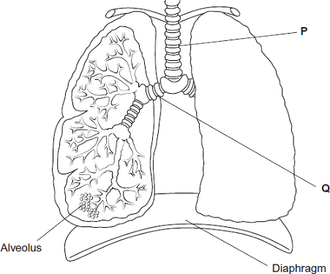

Name organs

**P** ...................................................

**Q** ...................................................

**(1)**

(b)     Explain how downward movement of the diaphragm leads to air entering the lungs.

........................................................................................................................

........................................................................................................................

........................................................................................................................

........................................................................................................................

**(2)**

**(Total 3 marks)**

**Q40.**(a)     (i)      Name the process by which oxygen passes from an alveolus in the lungs into the blood.

....................................................

**(1)**

(ii)     Describe **two** adaptations of the structure of alveoli for efficient gas exchange.

1.............................................................................................................

...............................................................................................................

2.............................................................................................................

...............................................................................................................

**(2)**

(b)

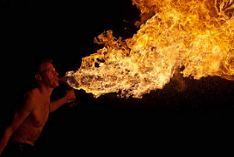  
                                                                 © iStock/Thinkstock

The photograph shows a fire-breather creating a ball of fire. Fire-breathers do this by blowing a fine mist of paraffin oil onto a flame. Some of this mist can be inhaled and may eventually lead to fibrosis.

People who have been fire-breathers for many years often find they cannot breathe out properly. Explain why.

...............................................................................................................

...............................................................................................................

...............................................................................................................

...............................................................................................................

...............................................................................................................

**(2)**

**(Total 5 marks)**

**Q41.**Doctors investigated the effect of the smoking habits of men on their non-smoking wives.

The doctors recruited 540 non-smoking women aged 40 or older. They divided these women into groups according to the smoking habits of their husbands.  
After 14 years, the doctors recorded how many of the wives had died and their cause of death.

They used these data to determine the relative risk of a wife dying from a particular disease according to her husband’s smoking habit.

In this comparison, they gave the relative risk to the wife of a non-smoker as 1.00. A value greater than 1.00 shows an increased risk compared to the wife of a non-smoker.

The results are shown in the table below.

|  |  |  |  |  |
| --- | --- | --- | --- | --- |
|  | **Cause of death** | **Relative risk of wife dying** | | |
|  | **Husband non-smoker** | **Husband smokes 1 to 19 cigarettes /day** | **Husband smokes more than 19 cigarettes / day** |
|  | Lung cancer | 1.00 | 1.61 | 2.08 |
|  | Emphysema | 1.00 | 1.29 | 1.49 |
|  | Cervical cancer | 1.00 | 1.15 | 1.14 |
|  | Stomach cancer | 1.00 | 1.02 | 0.99 |
|  | Heart disease | 1.00 | 0.97 | 1.03 |

A journalist concluded from these data that if a husband smoked, it greatly increased the risk of his wife dying of certain diseases. Evaluate this statement.

..................................................................................................................................

..................................................................................................................................

..................................................................................................................................

..................................................................................................................................

..................................................................................................................................

..................................................................................................................................

..................................................................................................................................

..................................................................................................................................

*(Extra space)* ...........................................................................................................

..................................................................................................................................

..................................................................................................................................

..................................................................................................................................

**(Total 4 marks)**

**Q42.**Large insects contract muscles associated with the abdomen to force air in and out of the spiracles. This is known as ‘abdominal pumping’. The table shows the mean rate of abdominal pumping of an insect before and during flight.

|  |  |  |
| --- | --- | --- |
|  | **Stage of flight** | **Mean rate of abdominal pumping / dm 3 of air kg −1 hour −1** |
|  | Before | 42 |
|  | During | 186 |

(a)     Calculate the percentage increase in the rate of abdominal pumping before and during flight. Show your working.

Answer ..................................... %

**(2)**

(b)     Abdominal pumping increases the efficiency of gas exchange between the tracheoles and muscle tissue of the insect. Explain why.

........................................................................................................................

........................................................................................................................

........................................................................................................................

........................................................................................................................

........................................................................................................................

**(2)**

(c)     Abdominal pumping is an adaptation not found in many small insects. These small insects obtain sufficient oxygen by diffusion.

Explain how their small size enables gas exchange to be efficient without the need for abdominal pumping.

........................................................................................................................

........................................................................................................................

........................................................................................................................

**(1)**

The graph shows the concentration of oxygen inside the tracheoles of an insect when at rest. It also shows when the spiracles are fully open.

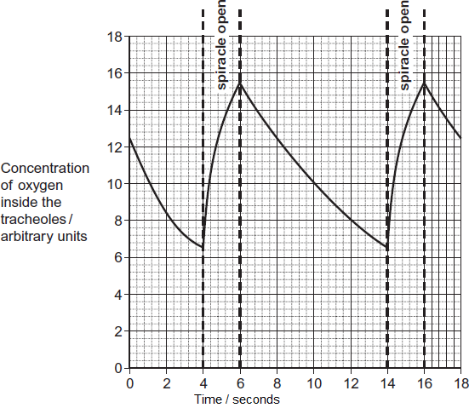

(d)     Use the graph to calculate the frequency of spiracle opening. Show your working.

Frequency ..................................... times per minute

**(2)**

(e)     The insect opens its spiracles at a lower frequency in very dry conditions. Suggest **one** advantage of this.

........................................................................................................................

........................................................................................................................

........................................................................................................................

**(1)**

(f)     The ends of tracheoles connect directly with the insect’s muscle tissue and are filled with water. When flying, water is absorbed into the muscle tissue. Removal of water from the tracheoles increases the rate of diffusion of oxygen between the tracheoles and muscle tissue. Suggest **one** reason why.

........................................................................................................................

........................................................................................................................

........................................................................................................................

**(1)**

**(Total 9 marks)**

**Q43.**Scientists studied the rate of carbon dioxide uptake by grape plant leaves. Grape leaves have stomata on the lower surface but no stomata on the upper surface.

The scientists recorded the carbon dioxide uptake by grape leaves with three different treatments:

**Treatment 1** − No air-sealing grease was applied to either surface of the leaf.

**Treatment 2** − The lower surface of the leaf was covered in air-sealing grease that prevents gas exchange.

**Treatment 3** − Both the lower surface and the upper surface of the leaf were covered in air–sealing grease that prevents gas exchange.

The scientists measured the rate of carbon dioxide uptake by each leaf for 60 minutes in light and then for 20 minutes in the dark.

The scientists’ results are shown in the diagram below.

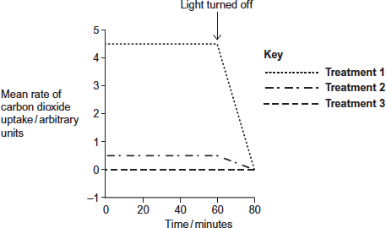

(a)     Suggest the purpose of each of the three leaf treatments.

**Treatment 1** ..................................................................................................

........................................................................................................................

........................................................................................................................

**Treatment 2** ..................................................................................................

........................................................................................................................

........................................................................................................................

**Treatment 3** ..................................................................................................

........................................................................................................................

........................................................................................................................

**(3)**

(b)     (i)      Describe the results shown for **Treatment 1**.

...............................................................................................................

...............................................................................................................

...............................................................................................................

...............................................................................................................

...............................................................................................................

**(2)**

(ii)     The stomata close when the light is turned off.

Explain the advantage of this to the plant.

...............................................................................................................

...............................................................................................................

...............................................................................................................

...............................................................................................................

...............................................................................................................

**(2)**

(c)     (i)      **Treatment 2** shows that even when the lower surface of the leaf is sealed there is still some uptake of carbon dioxide.

Suggest how this uptake of carbon dioxide continues.

...............................................................................................................

...............................................................................................................

...............................................................................................................

**(1)**

(ii)     In both **Treatment 1** and **Treatment 2**, the uptake of carbon dioxide falls to zero when the light is turned off.

Explain why.

...............................................................................................................

...............................................................................................................

...............................................................................................................

...............................................................................................................

...............................................................................................................

**(2)**

**(Total 10 marks)**

**Q44.**(a)     Describe and explain how the countercurrent system leads to efficient gas exchange across the gills of a fish.

........................................................................................................................

........................................................................................................................

........................................................................................................................

........................................................................................................................

........................................................................................................................

........................................................................................................................

*(Extra space)* .................................................................................................

........................................................................................................................

........................................................................................................................

**(3)**

(b)     Amoebic gill disease (AGD) is caused by a parasite that lives on the gills of some species of fish. The disease causes the lamellae to become thicker and to fuse together.

AGD reduces the efficiency of gas exchange in fish. Give **two** reasons why.

1 .....................................................................................................................

........................................................................................................................

2 .....................................................................................................................

........................................................................................................................

**(2)**

(c)     The table below shows some features of gas exchange of a fish at rest.

|  |  |  |
| --- | --- | --- |
|  | Volume of oxygen absorbed by the gills from each dm3 of water / cm3 | 7 |
|  | Mass of fish / kg | 0.4 |
|  | Oxygen required by fish / cm3 kg–1 hour–1 | 90 |

(i)      Calculate the volume of water that would have to pass over the gills each hour to supply the oxygen required by the fish. Show your working.

.......................................................... dm3

**(2)**

(ii)     The volume of water passing over the gills increases if the temperature of the water increases. Suggest why.

...............................................................................................................

...............................................................................................................

...............................................................................................................

**(1)**

**(Total 8 marks)**

**Q45.**Scientists investigated the effect of the water potential of soil water on plant growth. They investigated the effect of this water potential on several plant processes.

The figure below shows their results in the form they were presented. The bars show whether or not each process was occurring.

The plants stopped growing when the water potential of the soil water was below –0.7 mPa. All of the changes in the plants were related to the ability of the roots to take up water from the soil.

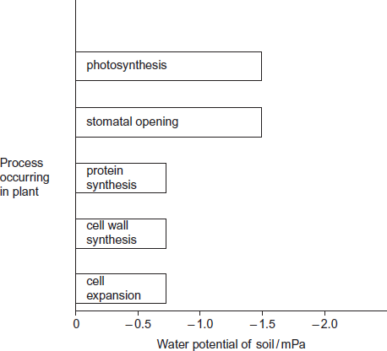

(a)     Describe the results in the figure.

........................................................................................................................

........................................................................................................................

........................................................................................................................

........................................................................................................................

........................................................................................................................

**(2)**

(b)     Explain the relationship between stomatal opening and photosynthesis.

........................................................................................................................

........................................................................................................................

........................................................................................................................

........................................................................................................................

........................................................................................................................

**(2)**

(c)     Although photosynthesis is still occurring, plants stop growing when the soil water potential falls below –0.7 mPa.

Use information from the figure above to suggest two reasons why.

........................................................................................................................

........................................................................................................................

........................................................................................................................

........................................................................................................................

........................................................................................................................

........................................................................................................................

**(3)**

**(Total 7 marks)**

**Q46.**(a)     Describe how oxygen in the air reaches capillaries surrounding alveoli in the lungs. Details of breathing are **not** required.

........................................................................................................................

........................................................................................................................

........................................................................................................................

........................................................................................................................

........................................................................................................................

........................................................................................................................

........................................................................................................................

........................................................................................................................

**(Extra space)** ................................................................................................

........................................................................................................................

**(4)**

Forced expiratory volume (FEV) is the greatest volume of air a person can breathe out in 1 second.

Forced vital capacity (FVC) is the greatest volume of air a person can breathe out in a single breath.

The figure below shows results for the volume of air breathed out by three groups of people, **A**, **B** and **C**. Group **A** had healthy lungs. Groups **B** and **C** had different lung conditions that affect breathing.

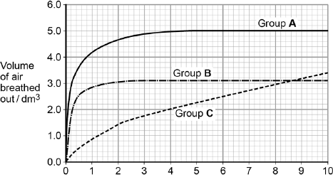  
                          Time breathing out / s

(b)     Calculate the percentage drop in FEV for group **C** compared with the healthy people.

Answer = ...................................

**(1)**

(c)     Asthma affects bronchioles and reduces flow of air in and out of the lungs.  
Fibrosis does not affect bronchioles; it reduces the volume of the lungs.

Which group, **B** or **C**, was the one containing people with fibrosis of their lungs? Use the information provided and evidence from the figure above to explain your answer.

........................................................................................................................

........................................................................................................................

........................................................................................................................

........................................................................................................................

........................................................................................................................

........................................................................................................................

**(Extra space)** ................................................................................................

........................................................................................................................

........................................................................................................................

**(3)**

**(Total 8 marks)**

**Q47.**Breathing out as hard as you can is called forced expiration.

(a)     Describe and explain the mechanism that causes forced expiration.

........................................................................................................................

........................................................................................................................

........................................................................................................................

........................................................................................................................

........................................................................................................................

........................................................................................................................

........................................................................................................................

........................................................................................................................

**(4)**

Two groups of people volunteered to take part in an experiment.

•        People in group **A** were healthy.

•        People in group **B** were recovering from an asthma attack.

Each person breathed in as deeply as they could. They then breathed out by forced expiration.

A scientist measured the volume of air breathed out during forced expiration by each person.

The graph below shows the results.

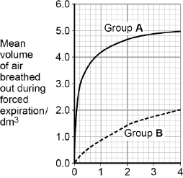                          
Time breathing out / s

(b)     Forced expiration volume (FEV) is the volume of air a person can breathe out in1 second.

Using data from the first second of forced expiration, calculate the percentage decrease in the FEV for group **B** compared with group **A**.

Answer = ................................... %

**(1)**

(c)     The people in group **B** were recovering from an asthma attack.  
Explain how an asthma attack caused the drop in the mean FEV shown in the figure below.

........................................................................................................................

........................................................................................................................

........................................................................................................................

........................................................................................................................

........................................................................................................................

........................................................................................................................

........................................................................................................................

........................................................................................................................

**(Extra space)** ................................................................................................

........................................................................................................................

........................................................................................................................

........................................................................................................................

**(4)**

**(Total 9 marks)**

**Q48.**A biologist investigated the effect of water temperature on the rate of ventilation of gills in a species of fish. She kept four fish in a thermostatically controlled aquarium and measured the mean ventilation rate by counting movements of their gill covers.

Her results are shown in **Figure 1**.

**Figure 1**

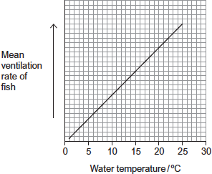

In this investigation, the biologist also monitored the concentration of oxygen in the water in the aquarium. The concentration of oxygen in water changes with temperature of the water. **Figure 2** shows how it changes.

**Figure 2**

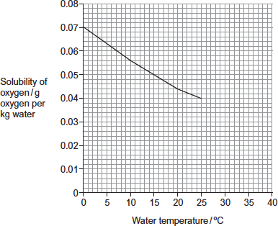

(a)     Suggest a difficulty of counting movements of gill covers as a method of measuring rate of ventilation in fish.

........................................................................................................................

........................................................................................................................

**(1)**

(b)     The biologist concluded that there was a correlation between rate of ventilation of the gills and temperature of the water. A scatter diagram can be used to look for a correlation but, in this investigation, it was **not** the appropriate graph for her data.  
Explain why.

........................................................................................................................

........................................................................................................................

........................................................................................................................

**(1)**

(c)     (i)      Describe the relationship between temperature of water, oxygen in water and rate of ventilation.

...............................................................................................................

...............................................................................................................

...............................................................................................................

**(1)**

(ii)     Use **Figure 1** and **Figure 2** to explain the advantage to the fish of the change in its rate of ventilation.

...............................................................................................................

...............................................................................................................

...............................................................................................................

...............................................................................................................

...............................................................................................................

...............................................................................................................

**[Extra space]** .......................................................................................

...............................................................................................................

...............................................................................................................

**(3)**

**(Total 6 marks)**

**M1.**          (i)     Because there are big differences;  
any correct named example e.g. lung cancer / bronchitis much lower  
in women than in men;

**2**

(ii)     easier to compare if sample size effectively the same;  
different numbers of people in each group;

**2**

**[4]**

**M2.**          (a)     exchange / diffusion across body surface / skin;  
short diffusion pathway / distance / large SA:V ratio;

**2**

(b)     large numbers of lamellae so large SA;  
lamellae thin so short (diffusion) pathway to blood / capillaries;  
high rate of oxygen uptake for respiration / energy release;

*(accept more oxygen)*

**3**

**[5]**

**M3.**          (a)     Active transport against / facilitated down with concentration gradient;

*Accept answers in terms of water potentials*

Active transport uses ATP/energy, /facilitated doesn’t;

*Reject along/across gradient*

Active uses carrier (proteins), / facilitated (often) uses channel (proteins);

**2 max**

(b)     Lipid/fatty acid part of membrane is non-polar/hydrophobic;

*Accept lipid/fatty acid bilayer*

Oxygen and carbon dioxide small/ non-polar (molecules);

Oxygen/carbon dioxide can diffuse through/dissolve in/  
get between molecules in this layer;

Down a concentration gradient;

**2 max**

(c)     Brings more oxygen/removes carbon dioxide;

Maintains diffusion/concentration gradients;

Between alveoli and blood/capillaries;

*Reject references to surface area*

**2 max**

**[6]**

**M4.**          (a)     (i)      Changes shape of antitrypsin;  
Reference to hydrogen/ionic/disulfide bonds;  
No longer attaches to/interacts/ reacts with trypsin;

*Accept protease*

**2**

(ii)     Higher the concentration of hydrogen peroxide, more amino acids/  
proteins affected;  
More antitrypsin molecules change shape;

**2**

(b)     (Longterm smokers) inhale a lot of hydrogen peroxide;  
Smokers have more active enzyme that damages lung tissue;  
Reducing gas exchange surface;

**2 max**

**[6]**

**M5.**          (a)     *(explanation must be linked to structures to gain second mark for each linked pair)*

|  |  |
| --- | --- |
| filaments / lamellae ; | large SA; |
| gill plates or secondary lamellae; |  |
| large number of capillaries; | to remove oxygen / to maintain a gradient; |
| thin epithelium; | short diffusion pathway; |
| pressure changes; | to bring in more water / to maintain gradient; |
| countercurrent flow (or description); | exchange / diffusion along whole length / concentration gradient maintained / equilibrium not achieved / blood always meets water with higher oxygen concentration; |

**6**

(b)     (i)      requires 20 cm3 of oxygen / extracts 7.2 cm3 of oxygen /

*reject if referring to volume of water*

**;

2.7 / 2.8 (dm3h–1);

*(correct answer award 2 marks)*

**2**

(ii)     high (relative) density / heavy;  
requires large input of energy as difficult to push back out;

**2**

(c)     (*for each pair second point must be linked to first*)  
to provide same amount of oxygen;   
need to have more water flowing over gills;  
OR  
metabolic rate / respiration increases (with increase in temperature);  
so more oxygen required;

**2 max**

**[12]**

**QWC 1**

**M6.**          (a)     (i)      one feature;

then linked Explanation;

(many) filaments / lamellae / secondary lamellae;

so large surface area;

large number of capillaries; (NOT “good blood supply”)

maintains a diffusion gradient / removes oxygen;

thin epithelium / lamellae wall;

short diffusion pathway;

**2**

(ii)     maintains diffusion / concentration gradient / equilibrium  
not reached;

diffusion occurs across whole length (of lamellae / gill);

**2**

(b)     less energy needed / continuous flow of water or O2;

**1**

**[5]**

**M7.**          (a)     1. mouth opens, operculum / opercular valve shuts;  
2. floor of mouth lowered;  
3. water enters due to decreased pressure / increased volume;  
4. mouth closes, operculum / opercular valve opens;  
5. floor raised results in increased pressure / decreased volume;  
6. high / increased pressure forces / pushes water over gills;

**4 max**

(b)     1. alveoli provide a large surface area;  
2. walls of alveoli thin to provide a short diffusion pathway;  
3. walls of capillary thin / close to alveoli provides  
    a short diffusion pathway;  
4. walls (of capillaries / alveoli) have flattened cells;  
5. cell membrane permeable to gases;  
6. many blood capillaries provide a large surface area;  
7. intercostal / chest muscles / diaphragm muscles / to ventilate lungs /   
    maintain a diffusion / concentration gradient;  
8. wide trachea / branching of bronchi / bronchioles for efficient  
    flow of air;  
9. cartilage rings keep airways open;  
    (*reject moist and thin membranes*)

**6 max**

**[10]**

**M8.**          (a)     contraction of (diaphragm) muscles flattens diaphragm;  
contraction of intercostal muscles raises ribcage;  
increase in volume decreases pressure;

**3**

(b)     (i)      tidal volume increases steeply, then increase slows down after 10 to 15 km h-1;

**1**

(ii)     breathing rate increases slowly then steeply after 10 to 15 km h-1;

*(max 1 if no reference to speed where change occurs in either (i) or (ii))*

**1**

(c)     20 × 2.75 = 55 dm2;

*(award 1 mark for correct method i.e. tidal volume × rate);*

**2**

**[7]**

**M9.**          (a)     (diffusion) gradient will be maintained all the way along the gill / the amount of oxygen in the water is always higher than in the blood / the numbers in the water are always higher than in the blood;  
more oxygen will diffuse into the blood;

**2**

(b)     100 cycles per minute;

*(principle of 60 / x or 0.6 seen gains one mark)*

**2**

**[4]**

**M10.**          (i)      (waxy so) impermeable to water / waterproof / stops water  
passing through;

**1**

(ii)     reference to hairs / position of stomata (sunken stomata /   
stomata in pits )  
LINKED to reduced air movement / trap layer of air /   
trap water vapour (*reject water) /* maintains humidity;

reduces diffusion gradient / concentration gradient of water /   
water potential gradient;

*OR*

stoma can close;  
reduces area for evaporation or transpiration;

**2**

**[3]**

**M11.**          (a)     (gills have) lamellae on filaments;  
lots of both;

**2**

(b)     (i)      all 3 go up;

*Accept converse*

**1**

(ii)     more oxygen can be supplied;  
for more respiration;

*Accept answer relating to CO2*

**2**

**[5]**

**M12.**(a)      (Scientists) used fully grown leaves / used five plants of each (species).

*Ignore other references to methodology. Reward only information provided in the Resource.*

*Do not accept reference to number of leaves − different plants were used.*

**1**

(b)     Either

1.      Draw around leaf on graph paper;

*Mark as a trio − MP1, MP2 and MP3 OR MP4, MP5 and MP6. Do not mix and match.*

*Both aspects needed for mark − drawing and type of paper.*

2.      Count squares (however described);

*There is no reward for additional detail e.g. dealing with part squares.*

3.      Multiply by 2 (for upper and lower leaf surface);

OR

4.      Draw around a leaf on paper of known mass (per unit area);

*Both aspects needed for mark − drawing and mass of paper.*

5.      Cut out *and* weigh;

6.      Multiply by 2 (for upper and lower leaf surface).

**3**

(c)     (i)      Species **B** (no mark)

1.      Smaller surface area

*so*

         less evaporation / less heat absorbed;

*Correctly selected feature and the explanation required for 1 mark.*

*In all marking points − ‘less water loss’ is insufficient as an explanation but accept transpiration for evaporation or diffusion.*

2.      Thicker leaves

*so*

         greater diffusion distance (for water);

*Accept ‘thicker leaves so more water storage’.*

3.      Fewer stomata / lower stomatal density

*so*

         less diffusion / evaporation (of water);

4.      Smaller surface area to volume ratio

*so*

         less evaporation.

**1 max**

(ii)     1.      Thick(er) cuticle

*so*

          increase in diffusion

          distance / slower (rate of) diffusion;

*Feature and explanation needed for each mark.*

*Reject other features not related to leaves.*

*Reject features related to water storage.*

*‘Cuticle’ alone is insufficient (all leaves have a cuticle). Reject suggestion of ‘less’ diffusion, for idea of ‘slower diffusion’, an idea of rate is required.*

2.      Hairs on leaves

*so*

         reduction in air movements / increase in humidity / decrease in water potential gradient;

3.      Curled leaves

*so*

         reduction in air movements / increase in humidity / decrease in water potential gradient;

4.      Sunken stomata

*so*

         reduction in air movements / increase in humidity / decrease in water potential gradient.

**2 max**

(d)     Small leaves / surface area *so* (total) number of stomata is low.

*Both aspects needed for mark.*

**1**

**[8]**

**M13.**          (a)     Immediate / rapid increase, steady rise and plateau clearly identified;

*Ignore references to rest period if clearly identified as such*

**1**

(b)     Find value of pulmonary ventilation from graph / 26-28;  
Divide by breathing rate / 20;

**2**

(c)     Air is from nose / trachea / bronchi / not been in alveoli / dead space;  
Gas exchange / diffusion only in alveoli / not in these structures;

**2**

**[5]**

**M14.**          (a)     Epithelium of alveolus, capillary wall / epithelium / endothelium, plasma;

**1**

(b)     Cell wall;  
Capsule;  
Flagellum;  
Mesosomes;  
Plasmid;  
Genetic material / DNA / nucleoid;  
Ribosomes;

*Accept references to size only if some idea of range is given*

**max 2**

(c)     Large (surface) area;  
For diffusion;  
     or  
Short distance to centre of cell / to all haemoglobin;  
For diffusion;

**2**

(d)     (i)      Correct answer of approximately 7800 / 8000 = 2 marks  
Incorrect answer but clearly derived by  
dividing diameter of cell A by 7                        = 1 mark

**2**

(ii)     Idea of cut through maximum diameter / middle;

**1**

**[8]**

**M15.**          (a)     Diaphragm (muscle) contracts;  
Flattens / Increases volume of chest;  
Reduced pressure allows air to enter;

**3**

(b)     Allows comparison;  
As organs differ in size / as larger organs will need more blood;

**2**

(c)     2 marks for 40.91 / 40.9 / 41  
1 mark for 59.09 / 59.1 / 59

**2**

(d)     (i)      Some oxygen still in lungs (which will enter the blood) /   
removal of carbon dioxide (from blood);

**1**

(ii)     More blood available for other organs;  
Supplying oxygen / glucose / removing carbon dioxide;  
OR  
Diaphragm muscles not contracting (as not breathing);  
Will not require (as much) oxygen / glucose;

**2**

**[10]**

**M16.**          (a)     ;

= 1.25 to 1.5;

*allow 1 mark if correct working shown*

**max 2**

(b)     Maintains concentration gradient (over whole length of gill) / diffusion  
can occur over whole gill;  
More oxygen enters blood ( / more CO2 leaves);  
More (aerobic) respiration / more energy release in muscle / for  
swimming; *‘more’ needed ONCE only*

**3**

**[5]**

**M17.**(a)     1.      Other gases / nitrogen / water vapour in atmosphere / **A**;

2.      Only oxygen and carbon dioxide in gas mixtures / **C** and **D**;

3.      Composition of / gases in **A** not controlled / composition of gas mixtures / **C** and **D** controlled.

**2 max**

(b)     1.      Breathing rate *lowest* when no carbon dioxide / in (pure) oxygen /  
         B;

*Idea of ‘lowest’ must be stated.*

2.      (Generally) presence of carbon dioxide increases breathing rate / as concentration of carbon dioxide increases breathing rate increases / there is a positive correlation;

*A general point incorporating all concentrations.*

3.      Breathing rate increases when (carbon dioxide) higher than 0.1% / concentration in atmosphere / A;

*This MP requires a specific comparison to 0.1% or the atmospheric concentration.*

*Accept ‘gas mixtures 1 and 2 / C and D’ for ‘higher carbon dioxide’.*

4.      Breathing rate of **grasshopper 3** falls in D / 16% / gas mixture 2 (whereas others increase).

*Restating data alone is insufficient for any mark point.*

**3 max**

(c)     (i)      54;

***OR***

1.      Correct data / column **A** chosen;

*A correct answer of 54 gets 2 marks.*

*MP1 and MP2 allow a possible mark for an incorrect calculation or choice of wrong data.*

2.      Correct calculation of mean from data chosen;

*Check − the three values must be from same column.*

**2 max**

(ii)     1.      Small sample / only 3 (grasshoppers)

*so* may not be representative (of all grasshoppers / insects);

2.      Grasshoppers are not the only insects / species;

*so* genetic / behavioural / metabolic differences;

3.      (Insects) not all mature / are at different stages of development / different sizes;

*so* different metabolic rates;

4.      Movement not restricted / not at rest in meadow;

*so* (rate of) respiration higher;

5.      (Naturally-occurring) carbon dioxide concentration lower in meadow;

*so* breathing rate lower;

*Explanations required, therefore both parts of answer required for credit in each marking point.*

*Accept appropriate converse answers.*

*Accept ‘respiration’ for ‘metabolism’ and vice versa.*

**3 max**

**[10]**

**M18.**          (a)     increasing carbon dioxide concentration / partial pressure;  
*(decrease in oxygen negates)*

**1**

(b)     (oxygen is used in) respiration therefore diffuses (from tracheae) to tissues;  
oxygen unable to enter organism;

**2**

(c)     spiracles not open all the time;  
therefore there is less water loss  
(by diffusion through spiracles);

**2**

**[5]**

**M19.**         (a)     Muscles (associated with breathing) relax;

**1**

(b)     Produces lower pressure (and air moves in down pressure gradient);

**1**

**[2]**

**M20.**          (a)     (Small alveoli with) large surface area;  
For diffusion;

**2**

(b)     (i)      Epithelium / epithelial / squamous / pavement cells;  
*Reject endothelium.*

**1**

(ii)     0.11 μm;

**1**

(c)     (i)      Less oxygen / more carbon dioxide / more water vapour;  
*Two differences required, but only one mark for this part  
of the question.*

**1**

(ii)     Gas exchange takes place in alveoli / does not take place  
in trachea;

**1**

(d)     (i)      Pulmonary artery;

**1**

(ii)     Concentrations reach equilibrium / become equal;  
Diffusion occurs when there is a concentration gradient  
(so some will remain in blood);  
OR  
Lung cells / vessel cells respire;  
Add / produce carbon dioxide;

**2**

**[9]**

**M21.**          (a)     (i)      less at **A** / more at **B**;

*(accept inspiration and expiration as equivalent to A and B)*

**1**

(ii)     carbon dioxide diffuses / passes / into alveoli / from blood;  
as higher concentration in blood / low concentration in alveolus;

*(first mark for site and direction, second for cause)*

**2**

(b)     curve increases;  
*(reject if decreases)*then levels out;

**2**

(c)     (i)      contract;  
ribs move upwards / out;  
increasing volume / decreasing pressure in chest / thorax / lungs;

**3**

(ii)     intercostal muscles relax;

*(if you can ignore ref to internal contracting, do so)*

**1**

**[9]**

**M22.**          (a)     (i)      high / higher CO2 concentration / lack of oxygen;

**1**

(ii)     CO2 asphyxiates / is toxic;  
lack of oxygen for (aerobic) respiration;  
OR  
lack of energy / ATP (for pumping movements);  
reduced muscle function / muscle fatigue

**2 max**

(b)     removal of (excess) CO2 / oxygen to break down lactate / to  
repay oxygen debt / to enable aerobic respiration;

**1**

**[4]**

**M23.**          (a)     (i)      Many people do not go to the doctor;

**1**

(ii)     36000;

*No marks awarded for working here as calculation is very straightforward*

**1**

(b)     Same sugars / antigens on bacteria / nerve cells;

*Do not accept references to same shape as equivalent to complementary.*

Bind with antibody / form antigen-antibody complex;

*Reject react*

Have complementary shape / fit binding site;

*Reject active site*

**3**

(c)     Diaphragm will not move down / flatten / contract;

*Ignore references to breathing out*

Thoracic cavity / lung volume not increased so cannot breathe in;

**2**

**[7]**

**M24.**          (a)     235–240;;  
*(one mark for an answer between 200-300  
based on 2 - 3 stomata in 0.01mm2Alternatively, one mark for calculating the area of the  
rectangle correctly as 0.016 – 0.017mm2)*

**2**

(b)     grows in arid / dry conditions;  
less surface area;  
(rate of) transpiration / water loss would be reduced;

**3**

**[5]**

**M25.**          (a)     up and out;

**1**

(b)     (i)      does not require work / effort / involve muscle contraction / energy   
expenditure;

**1**

(ii)     active as it involves contraction of muscles;

**1**

(c)     liver moves back;  
increases volume of lungs;   
pressure lower (in lungs than outside);

**3 max**

(d)     *maximum of three marks for description, points 1 to 4*

1       inhaled air contains more oxygen than exhaled air;

2       inhaled air contains less carbon dioxide than exhaled air;

3       inhaled air contains less water (vapour);

4       relative amount / percentage of nitrogen also changes;

5       respiration results in lower blood oxygen / higher blood carbon dioxide;

6       oxygen enters blood / carbon dioxide leaves blood in alveoli;

7       by diffusion;

8       water vapour diffuses from moist surface;

**6 max**

**[12]**

**M26.**          (a)     1.      Flatten / moves down;

*1. Ignore: additional information about rib movements*

2.      (Diaphragm muscle) contracts;

**2**

(b)     1.      Diaphragm contracts / moves down / flattens;

*Ignore refs to rib movement*

2.      Increases volume (of thorax) and decrease in pressure;

*2. Accept pressure lower than atmospheric pressure*

3.      Air moves from high to lower pressure / down pressure gradient;

*3. Reject: by diffusion*

**3**

(c)     1.      Diffusion;

*Accept down diffusion gradient*

2.      Across (alveoli) epithelium / (capillary) endothelium;

*2. Accept: capillary epithelium / squamous cell*

**2 max**

**[7]**

**M27.**          (a)     Phagocytes engulf / ingest pathogens / microorganisms / bacteria / viruses;

Phagocytes destroy pathogens / microorganisms / bacteria / viruses;

Lung diseases are caused by pathogens / microorganisms / bacteria / viruses;

***Q*** *Allow description of process of engulfing*

**2 max**

(b)     (i)      Alveoli / lungs will not inflate / deflate fully / reduced lung capacity;

Breathing out particularly affected / no longer passive;

**2**

(ii)     Alveolar walls thicken;

Longer diffusion pathway;

Scarred / fibrous tissue;

Reduces surface area (for gaseous exchange);

***Q*** *Diffusion is essential for 2nd point and surface area for 4th point.*

**4**

(c)     (i)      Cancer develops 20 – 30 years after exposure (to asbestos);

**1**

(ii)     Smoking / air pollution / specified industrial source;

**1**

**[10]**

**M28.**          (a)     1.      Large surface area provided by lamellae / filaments increases diffusion / makes diffusion efficient;;

***Q*** *Candidates are required to refer to lamellae or filaments. Do not penalise for confusion between two*

2.      Thin epithelium / distance between water and blood;

3.      Water and blood flow in opposite directions / countercurrent;

4.      (Point 4) maintains concentration gradient (along gill) / equilibrium not reached / as water always next to blood with lower concentration of oxygen;

5.      Circulation replaces blood saturated with oxygen;

6.      Ventilation replaces water (as oxygen removed);

**6**

(b)     Mixing of air and water (at surface);

Air has higher concentration of oxygen than water;

Diffusion into water;

Plants / seaweeds near surface / in light;

Produce oxygen by photosynthesis;

**2 max**

(c)     Not much oxygen near sea bed;

Toadfish haemoglobin (nearly) saturated / loads readily at / has higher affinity for oxygen at low partial pressure (of oxygen);

**2**

(d)     The chimpanzee and the bonobo are more closely related (than to the gorilla);

They have identical amino acids / one of the amino acids is different in the gorilla;

**2**

**[12]**

**M29.**          (a)     Filaments / lamellae provide large surface area;

Thin / flattened epithelium / one / two cell layers so short diffusion pathway (between water and blood);

Countercurrent / blood flow maintains concentration / diffusion gradient;

***Q*** *Do not credit thin cell walls / membranes*

**2 max**

(b)     (i)      Large / wide range of values (so can fit on graph);

**1**

(ii)     Decrease in uptake with increase in mass / negative correlation;

**1**

(iii)    Enables comparison;

As animals differ in size / mass;

**2**

**[6]**

**M30.**          (a)     1.      (Simple / facilitated) diffusion from high to low concentration / down concentration gradient;

***Q*** *Do not allow across / along / with concentration gradient*

2.      Small / non-polar / lipid-soluble molecules pass via phospholipids / bilayer;

*Reject: named molecule passing through membrane by an incorrect route*

*Accept: diagrams if annotated*

***OR***

Large / polar / water-soluble molecules go through proteins;

3.      Water moves by osmosis / from high water potential to low water potential / from less to more negative water potential;

4.      Active transport is movement from low to high concentration / against concentration gradient;

*Only penalise once if active transport is not named  
e.g. ‘movement against the concentration gradient involves proteins and requires ATP’ = 2 marks*

5.      Active transport / facilitated diffusion involves proteins / carriers;

*Accept: facilitated diffusion involves channels*

*Reject: active transport involves channels*

6.      Active transport requires energy / ATP;

7.      Ref. to Na+ / glucose co-transport;

*Credit ref. to endo / exocytosis as an alternative*

**5 max**

(b)     1.      Many alveoli / alveoli walls folded provide a large surface area;

*Neutral: alveoli provide a large surface area*

2.      Many capillaries provide a large surface area;

3.      (So) fast diffusion;

*Neutral: greater / better diffusion  
Neutral: fast gas exchange  
Allow ‘fast diffusion’ only once*

4.      Alveoli or capillary walls / epithelium / lining are thin / short distance between alveoli and blood;

*Reject: thin membranes / cell walls  
Accept: one cell thick for ‘thin’*

5.      Flattened / squamous epithelium;

*Accept: endothelial*

6.      (So) short diffusion distance / pathway;

7.      (So) fast diffusion;

8.      Ventilation / circulation;

*Accept: descriptions for ventilation / circulation*

9.      Maintains a diffusion / concentration gradient;

10.    (So) fast diffusion;

*Do not double penalise if description lacks detail  
e.g. thin membranes so a short diffusion distance = 1 mark*

**5 max**

**[10]**

**M31.**          (a)     (i)      Through alveolar epithelium;

         Through capillary epithelium / endothelium;

*Accept: Through lining / wall of alveolus and capillary for 1 mark*

*Accept: squamous epithelial cells for ‘epithelium’  
Neutral: alveolar endothelium  
Neutral: references to diffusion*

***Q*** *Correct use of terminology;*

**2**

(ii)     (Thicker alveolar wall) – no mark

*Neutral: less diffusion*

         (So) Longer diffusion pathway / slower diffusion;

*Neutral: references to surface area*

**1**

(b)     (i)      (In alveolus)

*Need the idea of air moving and oxygen concentration*

Brings in air containing a high(er) oxygen concentration;

*Neutral: reference to carbon dioxide concentration*

Removes air with a low(er) oxygen concentration;

**2**

(ii)     Circulation of blood / moving blood;

*Neutral: blood Neutral: short diffusion pathway*

**1**

(c)     Long time between decrease in mining and increase in cases;

Graph shows fluctuations;

Correlation does not prove causation / there may be other causes of miner’s lung;

Improved diagnosis methods;

Do not know number of cases / baseline before 1990;

Not all cases reported / not all individuals with miner’s lung visit a doctor;

*Accept: correct use of figures from graph for the first marking point: e.g. cases do not increase until after 2000 / 2001-2004 / 10 years later.*

**2 max**

**[8]**

**M32.**          (i)      (Lung volume) increases / reaches a maximum (at **B**);

*Do not negate mark for ‘breathing out’ if qualified e.g. when (lung volume) decreases*

**1**

(ii)     Flattens / lowers / moves down;

         (Diaphragm / muscle) contracts;

*Reject: second mark only if intercostal muscles cause the diaphragm to flatten*

**2**

**[3]**

**M33.**(a)     1.      Haemoglobin carries oxygen / has a high affinity for oxygen / oxyhaemoglobin;

2.      Loading / uptake / association in lungs;

3.      at high p.O2;

4.      Unloads / dissociates / releases to respiring cells / tissues;

5.      at low p.O2;

6.      Unloading linked to higher carbon dioxide (concentration);

*6. Ignore reference to incorrect pH in relation to effect of higher carbon dioxide concentrations for marking point*

**6**

(b)     1.      Allows comparison;

*Do not credit 'temperature affects results' on its own;*

2.      (Different temperature) affects enzymes;

*2. Allow reference to denaturation of enzymes.*

3.      (Different temperature) affects respiration / metabolism;

4.      (Different temperature) affects amount of dissolved oxygen;

**2 max**

(c)     1.      Increases then levels out / stops increasing / fluctuates slightly;

2.      At 5 (cm3 dm-3) / 320 (cm3 g-1h-1);

*Allow description of 'fluctuates slightly' in terms of candidate quoting figures after 320.*

**2**

(d)     1.      *Chronimus longistylus* has higher uptake at low (oxygen) concentrations;

*Chronimus longistylus has higher uptake to (oxygen concentration of) 2 / lower uptake after 2; (= 2 marks)*

2.      (Higher uptake) up to 2 cm3 dm-3;

*2. Award mark if candidate uses figures from table e.g. higher at concentration 1 (220) or concentration 2 (285).*

*Higher uptake at concentration 1 or 2 = 2 marks.*

**2**

(e)     (i)      More (than in African) lost via gills in Australian lungfish / less (than African) lost via lungs in Australian lungfish;

**1**

(ii)     1.      More / most exchange is via lungs (in African lungfish);

*1. Allow converse for first point.*

2.      Gills will not function / function less efficiently (in air);

*2. Allow water is required for gills to function.*

**2**

**[15]**

**M34.**(a)     Something that increases chance / increases probability / makes it more likely;

**1**

(b)     (i)      1976 - / to / and 1980;

**1**

(ii)     1980 - / to / and 1996;

**1**

(c)     1.      Correlation does not mean that there is a causal relationship;

*1. Do not accept casual*

2.      May be some other factor / named factor associated with vehicles and asthma / producing rise in both;

3.      (After 1980) asthma continues to rise but exhaust concentration falls / negative correlation (after 1980);

**3**

**[6]**

**M35.**(a)     1.      (Diaphragm / diaphragm muscle) relaxes / relaxed;

*Ignore references to inhalation, intercostal muscles or ribs if given as additional information.*

2.      Domed shape / (diaphragm) moves up;

3.      Increases pressure and decreases volume;

**3**

(b)     1.      Extend / extrapolate curve / graph;

2.      (Read off where) it flattens / reaches maximum / peaks;

**2**

(c)     1.      (Without inhaler) narrower bronchioles / bronchioles not dilated as muscle (surrounding bronchioles) contracted;

*Assume answer relates to Curve* ***A****, unless otherwise stated.*

2.      Less air able to pass through / more difficult for air to pass through;

**2**

**[7]**

**M36.**(a)     1.      The more recent the sample the greater the concentration;

*Accept converse*

*This could be expressed by reference to time e.g. ‘concentration has increased since 25 000 years ago*

2.      Increases most in last 5000 years / more or less constant / slight increase between 30 000 and 15 000 years ago;

**2**

(b)     1.      Variation in data / spread of data;

*Reject references to range e.g. ‘range of data’*

2.      Around the mean;

*Both marks are possible in the context of using the data*

**2**

(c)     1.      Yes as pine leaves not in organic matter of the same age;

2.      No as organic matter would be the same age as the pine leaves;

*Accept either approach*

**1 max**

(d)     Can get more CO2 for photosynthesis;

*More CO2 enters leaf is insufficient.   
Accept light-independent (reaction) as equivalent*

**1**

(e)     Any **three** from:

1.      (Overall data show) negative correlation;

*Do not allow description of correlation because in question stem*

2.      Little change in number of stomata in last 10 000 years;

3.      Small sample size;

4.      Only one species studied;

5.      Other factors / named factor may have affected number of stomata;

6.      Evidence does not support the conclusion between 30 000 and 25 000 years ago / between 5000 years ago and present day;

*Accept reference to either one of these age ranges*

7.      Appropriate reference to standard deviations (in comparing means);

*E.g. no overlap between 15 000 and 10 000 years ago*

**3 max**

(f)     Any **three** from :

1.      Thick cuticle;

2.      Small leaves / low surface area;

*Accept other ways of describing ‘small’, e.g. ‘needle-like’*

3.      Hairy leaves;

4.      Sunken stomata;

5.      Rolled leaves;

**3 max**

**[12]**

**M37.**         (a)     (i)     Diffusion;

*Ignore references to structures, membrane components etc*

*Allow simple diffusion*

*Reject facilitated diffusion*

**1**

(ii)     1.      (Thin / flat body) so short distance for diffusion / short diffusion pathway;

*Ignore references to membrane, wall, body surface*

2.      (Thin / flat body so) large surface area to volume ratio;

*‘It’ refers to flatworm’s body*

**2**

(b)     (i)     A group of tissues;

*Ignore references to function Group = more than one*

**1**

(ii)     1.      (Carbon dioxide enters) via stomata;

*Reject stroma*

2.      (Stomata opened by) guard cells;

3.      Diffuses through air spaces;

*Allow concentration gradient. Reject along gradient unless direction made clear*

4.      Down diffusion gradient;

**3 max**

**[7]**

**M38.**(a)     1.      Random;

*Random number generator = 2 marks*

2.      Method e.g. number generator / number out of a hat;

*Same age = 2 marks*

***OR***

3.      Matched / all the same;

4.      For e.g. age / sex;

**2 max**

(b)     1.      (Differences) are real / significant / not due to chance;

*It = the difference*

2.      (As) bars / SDs do not overlap;

*2. Accept: ‘standard errors do not overlap’ as told ‘standard deviation’ in the question stem*

**2**

(c)     1.      No / slight (placebo) effect;

2.      Group **2** and **3** results are similar / the same / SDs / bars overlap;

*2. Accept: other descriptions of Groups* ***2*** *and* ***3***

*2. Accept: that Groups* ***2*** *and* ***3*** *are not significantly different*

**2**

(d)     1.      (Allows) anomalies to be identified / ignored / effect of anomalies to be reduced / effect of variation in data to be minimised / concordant results;

*Accept: ‘outliers’ instead of anomalies*

*1. Reject: idea of not recording anomalies / preventing anomalies from occurring*

*1. Accept: ‘cancels out anomalies’ as bottom line response*

2.      (Makes) average / mean (more) reliable;

*2.* ***Q*** *Neutral: makes the average / mean more accurate*

*2. Ignore: ‘more reliable’ alone*

**2**

(e)     (i)      1.      Unethical / unfair not to treat patients;

2.      Dangerous / could cause an asthma attack;

**1 max**

(ii)     1.      Ensures normal treatment does not affect results / improvements are only due to the spray;

2.      (As) normal treatment is short-lived / effective for less than 24 hours / (24h) is long enough for normal treatment to wear off;

**2**

(f)     (i)      1.      (Improvement scores) are qualitative / subjective / rely on own judgement / different patients may assess symptoms differently;

*Accept: converse arguments for measuring FEV1 e.g. quantitative / objective patients cannot lie*

2.      Some patients may lie / exaggerate / want to please doctors;

*1. Neutral: empirical evidence*

**2**

(ii)     1.      Not blind / patients knew they were not receiving treatment / patients did not receive treatment;

2.      (So) more likely to underestimate / give lower scores / did not expect to improve / less improvement;

**2**

**[15]**

**M39.**(a)     (**P**) Trachea / windpipe and (**Q**) bronchus;

*For* ***P*** *or* ***Q****, accept (ring of) cartilage (i.e. not for both)*

*Accept bronchi*

*Reject bronchioles*

*Ignore reference to left or right lung*

**1**

(b)     1.      Increases volume (in lungs / thorax);

*Context must be lungs / thorax*

*Ignore space increases*

2.      Lowers pressure (in lungs / thorax);

*Accept lungs / chest expand*

*Ignore reference to ‘change in pressure’*

3.      Air (pushed) in by higher outside pressure / down pressure gradient;

*Ignore reference to ‘sucked in’*

**2 max**

**[3]**

**M40.**(a)     (i)      (Simple) diffusion;

*Reject facilitated diffusion*

*Accept lipid diffusion*

**1**

(ii)     1.      Thin walls / cells;

*1. ‘Short diffusion pathway’ alone is an explanation not a description*

*1. Accept squamous epithelia / one cell thick*

2.      (Total) surface area is large;

*2. Ignore references to ‘volume ratio’*

**2**

(b)     1.      Loss of elasticity / elastic tissue / increase in scar tissue;

*1. Accept elastin*

2.      Less recoil;

**2**

**[5]**

**M41.**FOR

1.      (If the husband smokes) there’s a greater risk of dying from lung cancer / emphysema / cervical cancer;

2.      The more the husband smokes, the greater the risk of dying from lung cancer / emphysema;

3.      Suitable use of figures from the table to illustrate answer;

AGAINST

4.      Little difference in risk of dying of stomach / heart disease;

5.      Other factor (than husband smoking) / named factor might cause death;

6.      Only one sample / further studies needed;

**4 max**

**[4]**

**M42.**(a)     Correct answer of 342.8 − 343 = 2 marks;;

Credit incorrect answers that show the numerator as 144 (or 186-42) or denominator as 42 for 1 mark;

**2**

(b)     1.      More air / oxygen enters / air / oxygen enters quickly / quicker;

*1. Accept: converse for carbon dioxide*

*1. Can be in any correct context eg insect, tracheoles, muscle*

*1. Neutral: air / oxygen enters*

(So) maintains / greater diffusion or concentration gradient;

**2**

(c)     Large(r) SA:VOL / short(er) diffusion distance (to tissues);

*Accept: thin diffusion pathway*

**1**

(d)     6 / 6.6 / 6.7 / 7 / 7.5 / 8 = 2 marks;;

*Different answers given for different interpretations of the graph*

Award 1 mark for incorrect answers that have divided 60 by any number;

**2**

(e)     Less / no water lost / (more) water retained;

*Accept: less dehydration / less evaporation*

***Q*** *Reject: less ‘transpiration’*

***Q*** *Reject: less water lost by osmosis*

**1**

(f)     1.      Greater surface area exposed to air;

*Neutral: shorter diffusion distance*

2.      Gases move / diffuse faster in air than through water;

*2.* ***Q*** *Neutral: ‘harder to diffuse’*

*2. Accept gases diffuse directly, rather than through water*

3.      Increases volume / amount of air;

**1 max**

**[9]**

**M43.**(a)     1.      (No grease)

            means stomata are open

            OR

            allows normal CO2 uptake;

*Allow ‘gas exchange’ for CO2 uptake.*

*‘As a control’ is insufficient on its own.*

2.      (Grease on lower surface)

seals stomata

OR

stops CO2 uptake through

stomata

OR

to find CO2 uptake through

stomata

OR

shows CO2 uptake through cuticle / upper surface;

3.      (Grease on both surfaces) shows sealing is effective

OR

stops all CO2 uptake.

**3**

(b)     (i)      1.      (Mean rate of) carbon dioxide uptake was constant *and* fell after the light turned off;

*Ignore absence of arbitrary units in both marking points.*

*Both ideas needed for mark.*

*Accept ‘stayed at 4.5’ as equivalent to ‘was constant’.*

2.      Uptake fell from 4.5 to 0 / uptake started to fall at 60 minutes and reached lowest at 80 minutes / uptake fell over period of 20 minutes;

*One correct use of figures required.*

*Accept fell to nothing / no uptake for 0.*

**2**

(ii)     1.      (Because) water is lost through stomata;

2.      (Closure) prevents / reduces water loss;

3.      Maintain water content of cells.

*This marking point rewards an understanding of reducing water loss e.g. reduce wilting, maintain turgor, and is not related to photosynthesis.*

**2 max**

(c)     (i)      (Carbon dioxide uptake) through the upper surface of the leaf / through cuticle.

**1**

(ii)     1.      No use of carbon dioxide in photosynthesis (in the dark);

2.      No diffusion gradient (maintained) for carbon dioxide into leaf / there is now a diffusion gradient for carbon dioxide out of leaf (due to respiration).

**2**

**[10]**

**M44.**(a)     1.      Water and blood flow in opposite directions;

*Accept: diagram if clearly annotated*

2.      Maintains concentration / diffusion gradient / equilibrium not reached / water always next to blood with a lower concentration of oxygen;

*Must have the idea of ‘maintaining’ or ‘always’ in reference to concentration / diffusion gradient*

*Accept: constant concentration / diffusion gradient*

3.      Along whole / length of gill / lamellae;

*Accept: gill plate / gill filament*

**3**

(b)     1.      (Thicker lamellae so) greater / longer diffusion distance / pathway;

***Q*** *Neutral: ‘thicker’ diffusion pathway*

2.      (Lamellae fuse so) reduced surface area;

*Accept: reduced SA:VOL*

**2**

(c)     (i)      Correct answer of **5.1** or **5.14(2857)** (dm3) = 2 marks;;

*Allow 1 mark max for an answer of* ***5*** *if the correct answer of* ***5.1*** *or* ***5.14(2857)*** *is* ***not*** *shown*

One mark for incorrect answers that show **36** or **0.4 × 90** or **90 ÷ 7;**

**2**

(ii)     1.      Increased metabolism / respiration / enzyme activity;

*Accept: enzymes work more efficiently*

2.      Less oxygen (dissolved in water);

*Neutral: references to increased kinetic energy (of water molecules)*

**1 max**

**[8]**

**M45.**(a)     1.      Protein synthesis **and** cell wall synthesis **and** cell expansion   
         stop at −0.7 / at a *higher* water potential than other two;

*If all 3 are correctly identified in marking point 1, accept ‘the others / the other two’ in marking point 2, and vice versa*

2.      Photosynthesis **and** stomatal opening stop at -1.5 / at a *lower* water potential than other three;

*Correct processes must be named in at least one of marking point 1 or marking point 2*

*Where reference to water potential differences are made, they must be comparative, eg ‘higher’*

**2**

(b)     1.      Stomata allow uptake of carbon dioxide;

2.      Carbon dioxide used in / required for photosynthesis;

**2**

(c)     1.      Growth involves cell division / cell expansion / increase in mass;

*Marking point 1 is for the principle*

2.      Protein synthesis stops **so** no enzymes / no membrane proteins / no named protein (for growth / division);

*Marking points 2, 3 and 4 require appreciation of ‘why’ before credit can be awarded*

*‘named’ protein must relate to proteins involved in growth or cell division*

3.      Cell wall synthesis stops **so** no new cells can be made;

*Full credit is possible without a statement of the principle   
(marking point 1)*

4.      No cell expansion / increase in mass **because** (cells) stop taking up water;

**3 max**

**[7]**

**M46.**(a)      1.     Trachea and bronchi and bronchioles;

2.      Down pressure gradient;

3.      Down diffusion gradient;

4.      Across alveolar epithelium.

*Capillary wall neutral*

5.      Across capillary endothelium / epithelium.

**4 max**

(b)     (About) 80.0%.

**1**

(c)     1.      (Group **B** because) breathe out as quickly as healthy / have similar FEV to group **A**;

2.      So bronchioles not affected;

3.      FVC reduced / total volume breathed out reduced.

*Allow this marking point for group* ***C***

**3**

**[8]**

**M47.**(a)     1.      Contraction of internal intercostal muscles;

2.      Relaxation of diaphragm muscles / of external intercostal muscles;

3.      Causes decrease in volume of chest / thoracic cavity;

4.      Air pushed down pressure gradient.

**4**

(b)     19(%);

**1**

(c)     1.      Muscle walls of bronchi / bronchioles contract;

2.      Walls of bronchi / bronchioles secrete more mucus;

3.      Diameter of airways reduced;

4.      (Therefore) flow of air reduced.

**4**

**[9]**

**M48.**(a)     Fish keep moving / swimming / movement of gill covers too fast to count (at higher temperatures).

*Accept converse.*

*Reject personal errors e.g. with counting.*

*Neutral − ‘water not clear’ or ‘difficult to see movement of gill covers’.*

**1**

(b)     1.      There is only one dependent variable / there are not two dependent variables / water temperature is the independent variable / breathing rate is dependent on water temperature;

*Accept either approach for 1 mark.*

*For ‘independent’ accept ‘manipulated’.*

*Reject −‘need two continuous variables’.*

2.      Water temperature *plus* breathing rate are not both properties of  
         fish

or

water temperature *plus* breathing rate are not both properties of water.

*Accept reference to the ‘two variables’ (instead of water temperature plus breathing rate)*

**1 max**

(c)     (i)      As (water) temperature increases, oxygen (concentration / solubility) falls and ventilation rate increases.

*MP requires all 3 aspects before credit is possible. The correct context is required for each aspect so*

*e.g. do not reward*

*‘as oxygen concentration falls, water temperature increases’*

*or*

*‘as temperature increases, ventilation rate increases and oxygen concentration falls’.*

**1**

(ii)     1.      As concentration / solubility of oxygen falls

         less oxygen flows over gills / less oxygen enters gills / less oxygen enters fish;

*For MP1 and MP2 accept converse.*

*Both aspects needed for mark.*

2.      (As a result) blood oxygen (concentration) falls / is lower;

3.      An increase in ventilation rate increases / maintains the flow of oxygen / carbon dioxide across gills / into (or out of) fish;

*Accept idea in relation to either gas or ‘gas exchange’.*

4.      Maintains diffusion / concentration gradient(s) (in gills);

*Gradient(s) relates to either / both gas(es).*

5.      To maintain oxygen supply to cells / tissues / organs / to maintain respiration.

*Accept a named example of ‘tissues’ e.g. muscle.*

**3 max**

**[6]**

**E1.**          In part (i) most candidates were aware that there are differences in the figures for men and women. However, despite being asked to use an example from the tables, many failed to do so. In part (ii) many candidates were aware that percentages lead to ease of comparison, but few referred to differing sample sizes.

**E2.**          (a)     Many candidates scored one mark most commonly for recognition of the short diffusion pathway, which was often related to the SA:V ratio. Surprisingly few answers then went on to relate this to exchange occurring across the body surface.

(b)     Again, only the very weakest candidates failed to gain the surface area mark, usually omitting to link the increased surface area to number of lamellae present. Only the better candidates explained fully the short diffusion pathway in relation to the blood capillaries. Poor expression with reference to respiration and ‘synthesising energy’ appeared in a number of weaker answers.

**E3.**          There were many good answers to (a), with about half of candidates obtaining both marks. However, a fifth obtained no marks, often because they got active and facilitated transport the wrong way round.

In (b), marks were most commonly awarded for references to the small size of the molecules and a diffusion gradient. Some candidates were aware that these are non-polar molecules and can dissolve, or diffuse through, the lipid bilayer.

Nearly half of candidates obtained no marks in (c). It was disappointing to see how few had any real idea about the importance of ventilation of the lungs in maintaining a concentration gradient. Most answers were in terms of what happens in the alveolus, between the air space there and the blood.

**E4.**          This question was poorly answered by many candidates, often because they did not understand the need to ‘explain’.

(a)     Answers to (i) were frequently a simple description of the graph. Others attempted to explain, but only stated that hydrogen peroxide decreased protein activity without referring to denaturation or changes in shape, and how this would render alpha-I- antitrypsin unable to bind to trypsin. The same description was often offered in (ii), where most candidates failed to score any marks. Some candidates understood that the more hydrogen peroxide there was, the more alpha-I-antitrypsin would be inhibited, but there was no reference to amino acids being affected or antitrypsin molecules changing shape.

(b)     Here, many candidates failed to use the information they were given, and simply wrote about the damage caused by smoking in general. Only the best candidates could explain that long-term smokers inhale more hydrogen peroxide, so they would have more active enzyme, resulting in a reduced gas exchange surface.

**E5.**          (a)     There were some excellent answers to this question with many candidates gaining full marks. Examiners were looking for each feature being linked to how it fulfils its function. Marks were therefore lost by candidates who failed to specify the functional advantage of a described feature. Imprecise descriptions including ‘thin gills’ and ‘good blood supply’ also failed to gain credit. The countercurrent principle was well understood and most candidates were aware of filaments and lamellae, but very few included details of secondary lamellae or gill filaments.

(b)     The calculation was beyond most candidates, with very few even attempting it. Some did calculate 20 cm³ but then gave it as the actual answer. A majority of candidates realised water is denser than air, but only the better candidates linked this to energy input. Very few referred to difficulty in pushing the water back out. Some candidates associated tidal movement with decreased efficiency of the countercurrent mechanism.

(c)     This question was not well answered, most candidates giving vague descriptions of ‘more oxygen being absorbed’. Only the very best candidates appreciated the increased amount of water flowing resulted in the same amount of oxygen being extracted.

**E6.**          The quality of the answers here were very centre-specific.

(a)     Candidates frequently scored high marks in part (i), but some candidates failed to mention a specific feature. The most common answer was that filaments or lamellae increased the surface area. In part (ii), the idea of maintaining the gradient was often recognised, but not over the whole length of the gill.

(b)     There was only an occasional reference to energy or that there would be a continuous flow. There were many vague answers to ‘it being less efficient’.

**E7.**          (a)     There was a large range of answers to this question., including some excellent, detailed descriptions, which achieved full marks. A frequent mistake was to misinterpret the question and give a detailed but irrelevant explanation of the counterflow mechanism. Some candidates were unclear about the structure of the gills and produced confused accounts of the roles and functions of the buccal cavity and operculum. Some clearly did not understand the principle of ventilation at all.

(b)     Answers to this question proved disappointing. Many candidates understood the basic structure and function of the lungs but did not produce detailed accounts, using appropriate AS terminology. Answers tended to concentrate on surface area of alveoli and short diffusion pathways, or to give detailed descriptions of lung structure and the mechanism of breathing, without linking this to the uptake of oxygen.

**E8.**          (a)     This was surprisingly poorly answered with many candidates providing descriptions of a standard lower than that expected for GCSE. There was generally a lack of a clear sequence in the descriptions with links not being made between an action and its effect, such as contraction of intercostal muscles and raising of the ribcage. The link between an increase in volume and a decrease in pressure was often omitted, as was the required reference to diaphragm muscle. Some candidates concentrated on a description of the nervous control of breathing which was not part of this module.

(b)     This was considered a more straightforward question and was usually well-answered. Marks were lost by poor terminology, candidates sometimes describing a decrease in tidal volume rather than a slowing down in the rate of increase. A minority attempted to explain the curves without offering a description.

(c)     The majority of candidates gained the principle mark but only the better candidates gave the correct answer. A significant number was unable to read the data correctly. The most common mistake was to read off both the tidal volume and breathing rate from where one of the lines crossed the *x* axis at 20 km h-1, producing answers of 40 (2 × 20) or 77.5 - 77.6 (2.75 × 27.5). Some candidates having correctly obtained the data then carried out the wrong calculation.

**E9.**          There were mixed responses to this question on ventilation in fish.

(a)     Few candidates gained full marks. Many of them simply stated that the diffusion gradient was maintained, or failed to appreciate that the fish obtain more oxygen.

(b)     Many candidates gained two marks for the number of ventilation cycles in a minute. The most common mistake was 2 cycles per minute.

**E10.**          The role of the cuticle was well known. Some candidates failed to gain marks through incomplete answers such as ‘the cuticle reduces transpiration’ rather than relating water loss to the impermeable nature of the cuticle. In part (ii), most candidates were able to describe a feature that reduces water loss, but only the more able candidates explained how the feature reduces transpiration by affecting the water diffusion gradient.

**E11.**          (a)     Despite the straightforward nature of this question very few candidates scored both of the marks available. Clearly candidates had limited knowledge of the basic structure of fish gills. Over 50% of the responses referred to lamellae and gill plates as the two principal structures rather than describing the presence of lamellae on filaments.

(b)     This part was well answered and better candidates often implied causation in their responses, with statements such as “as gill surface area increases, so do mass and swimming speed”.

Most of the better candidates scored both marks here. Less able candidates often failed to give an explanation of what the increased oxygen uptake was for.

**E12.**(a)     It was vital in this question that students used the information provided in Resource A. Other answers relating to general methodology were not creditworthy.

(b)     Most students gained mark point 1 and 2 but many did not multiply by two for the upper and lower surface of the leaf in order to achieve mark point 3.

(c)     Both parts to this question required a feature and an explanation for each mark point and AS level answers were expected before credit was given; the marking guidelines give the minimum acceptable answer. So, for example, answers relating to water concentration in place of water potential are at a lower level and were, therefore, not creditworthy.

(d)     Very few students could combine the two pieces of information from the table to appreciate that the very small leaf surface area meant that the total number of stomata was very low.

**E13.**          (a)     The pattern of change consisted of three phases, an immediate increase followed by a slower rise to a plateau. The performance descriptors for AS biology recently released by QCA indicate that the ability to describe trends and patterns in data is held to be indicative of a grade E candidate. Despite this, large numbers of candidates show little competence with this skill, either in theory papers or in their coursework. The main problems encountered in this particular question were a failure to distinguish between rest and activity, and the frequency of responses based on such simplistic ideas as that “during exercise the rate of pulmonary ventilation goes up”.

(b)     The relationship between pulmonary ventilation, breathing rate and tidal volume created something of a challenge. Although better candidates could generally re-arrange the equation, they still experienced difficulty in explaining how the value for the pulmonary ventilation could be obtained from the graph. Less able candidates frequently incorporated stroke volume or time into the account and multiplied or divided by these quantities.

(c)     Many candidates were able to offer lucid explanations of the information provided and showed familiarity with the concept of dead space. Others, not always the weaker candidates, confused this concept with residual volume. Otherwise sound answers were sometimes marred by imprecise expression. The term “throat” was often used, for example, to refer to the airways.

**E14.**          (a)     Only the best candidates interpreted the diagram correctly and, having done this, were able to describe the pathway in appropriate biological language. There were rather too many references to walls and membranes to be sure of understanding. In addition, there was some interpretation of the question as requiring a reference to the mechanism involved. This resulted in some lengthy explanations of the process of diffusion.

(b)     Common correct answers were the possession of a capsule and a cell wall, but there was a disappointing number of incorrect responses. These tended to arise either because the candidate sought to compare a prokaryotic cell with an unspecified eukaryotic cell, or because references were made to features such as nuclei and mitochondria which were absent from prokaryotic cells. Many of the responses made in this question clearly highlighted the perils of failing to read the question carefully.

(c)     Candidates who explained the advantage of a disc shape in terms of increased surface area encountered few problems in equating this property to diffusion. Others were less successful, either because they were unable to explain the flattened shape of the cell in terms of a short diffusion pathway, or because they constructed inappropriate arguments based on the amount of haemoglobin present or the flexibility of the cells.

(d)     Despite the frequency of such calculations in Unit tests, candidates met with only limited success in part (i). This part of the question gave rise to two problems which created particular difficulties. Candidates had to select the right measurement to represent the diameter and they had to convert this measurement to micrometres. Both tasks presented major hurdles to those of more limited ability. Further difficulties arose from a failure to calculate magnification from the data provided. Part (ii), however, was generally answered well, although there were those who sought to offer explanations based on resolution or the orientation of the specimen, perhaps relying on uncertain memories of previous mark schemes.

**E15.**          (a)     Answers were either of an excellent standard, describing succinctly how the action of the diaphragm led to an increase in thoracic volume and a decrease in pressure, or they demonstrated a limited and confused understanding of the principles involved. Many less able candidates wrote about both inhalation and exhalation. The examiners ignored irrelevant material where possible but could not do so where information concerning exhalation contradicted that given for inhalation. Considerable uncertainty was demonstrated over the precise change in shape of the diaphragm during inhalation. It was often described as moving upwards or outwards, answers which suggested confusion with movement of the ribs.

(b)     Incorrect responses to this question could be divided into two categories. Many candidates obviously failed to interpret the data correctly, not noticing that they concerned a single animal. Answers referring to allowing a comparison between the organs of different sized animals were thus, clearly, incorrect. Others failed to identify the intended emphasis in the question and explained such points as why grams rather than kilograms were selected; why units were in grams rather than in cubic centimetres, or why they related to tissue. Good candidates went beyond the idea of a”fair test” and referred to differences in size of the organs concerned.

(c)     It is of concern that so many A level biologists fail to attempt any question which involves numbers, particularly when it involves the straightforward calculation of a percentage. There were many correct responses but others showed working which revealed a lack of understanding of what was involved, seemingly selecting figures at random and carrying out mathematical manipulations which proved impossible to follow or to comprehend. The large number of candidates who subtracted the data for the seal under water from that for the animal on land made the first step towards an answer and gained some credit.

(d)     Candidates who appreciated that an air-breathing seal would be unable to continue breathing while under water were usually able to make some progress with this question. Such candidates generally noted in part (i) that continued blood flow to the lungs would result in removal of residual oxygen. Surprisingly many candidates encountered difficulties here because they based their answers on the transfer of oxygen to the lungs in order to allow breathing to continue. Where common sense prevailed, answers to part (ii) usually involved some reference to the diaphragm not contracting, allowing blood to be diverted elsewhere. It was not uncommon to find answers where cause and effect were confused, and there were a number of accounts in which candidates clearly saw a reduction in blood flow as the key feature in preventing diaphragm contraction under water.

**E16.**          (a)     Most candidates were unable to choose the minimum distance to measure on the photograph between the water and a red blood cell in the fish gill. Calculations based on an incorrect initial measurement still gained some credit.

(b)     While most were able to write at length about how counterflow maintained the oxygen concentration gradient, only some went on to point out that the benefit to the fish was that it would obtain more oxygen from the water and hardly any explained that the extra oxygen would be useful to a fish since it would result in a higher rate of respiration.

**E17.**(a)     Most were able to suggest two correct reasons for the difference. A minority misunderstood the question and attempted to suggest biological factors which may have brought about a change in the composition of the gas mixtures.

(b)     Many students made full use of all the data and were able to clearly describe the key effects shown. Only the best answers made a specific comparison to the breathing rate at the 0.1% carbon dioxide concentration. A number repeated all the data without describing the effect of a change in carbon dioxide concentration. A minority seemed unable to make any valid analysis of the data and made only simplistic statements about the general trend.

(c)     The majority of students produced an accurate calculation of breaths per minute. Incorrect answers included working out the mean for all grasshoppers or selecting data from the wrong column.

In part (b) most students were able suggest reasons why the mean may not be reliable but failed to go on and give a suitable biological explanation for the reason given. Many answers included references to possible anomalies and lack of reliability despite this being given in the question. Very few suggested that the carbon dioxide level may be lower in the meadow

**E18.**          (a)     Most candidates correctly spotted the rise in the partial pressure of carbon dioxide.

(b)     Most candidates produced a good logical account and achieved both marks.

(c)     Again most candidates clearly knew what was expected and produced clear logical answers.

Many candidates who produced answers that did not actually relate water loss to spiracles movements failed to gain the second mark. Some candidates confused spiracles with stomata.

**E19.**          (a)     The quality of the answers to part (a) were very much centre-based and often reflected completion of the relevant subject matter from the specification rather than an inherent lack of understanding. Better candidates had clearly encountered muscles and could give some account of their role in breathing. Even among these candidates, however, errors and lack of precision were apparent. There were still far too many references to ‘messages’ or to nerves ‘telling’ various organs what to do.

(b)     Most candidates were correctly able to link an increase in lung volume with a reduction in pressure, although there were many who were of the opinion that air is drawn into the lungs against a pressure gradient.

**E20.**          (a)     It was disappointing to observe that few candidates appeared to take note of the mark allocation for this part of the question. Two marks should have suggested that rather more was required than ‘large surface area’. To gain full credit it was necessary to link this aspect of the exchange surface with diffusion.

(b)     AQA apologises for the error in the diagram accompanying this question. Clearly, the diameter of the red blood cell should have been given as 7.5 mm, not 0.75 mm. This information was not required for the calculation so it was felt safer to remove it completely, hence the erratum notice. In part (i), most candidates recognised cell layer **B** as epithelium although there were occasional incorrect references to endothelium or epidermis. Part (ii), however, created problems for many in that they either chose to calculate the maximum thickness or encountered difficulties with the decimal point.

(c)     In part (i), those candidates who understood the meaning of the word ‘composition’ were generally able to refer correctly to the concentrations of oxygen and carbon dioxide, although occasional poor expression left the examiners uncertain as to whether the concentrations quoted referred to the alveoli or to the trachea. However, there were many who clearly did not understand what was meant by composition and referred to such features as ‘the percentage of the air’ or pressure differences. There were many comprehensive answers to part (c)(ii) although some candidates again experienced difficulties in expressing their ideas.

(d)     Although most answers were correct, there were occasional references to the pulmonary vein and to various chambers of the heart in part (i). In part (ii), the best candidates clearly appreciated that the lung cells would be respiring and would produce carbon dioxide, or that the concentration of carbon dioxide in the blood would reach equilibrium with that in the alveoli. Others produced responses that, even if not gaining credit, were at least biologically sound. What was disturbing, however, were the many answers along such lines as ‘the heart needs oxygen to continue beating so it changes some into carbon dioxide’ or ‘there is not enough oxygen in the lungs to replace all the carbon dioxide’.

**E21.**          (a)     (i)      Although the graph in this question was probably unfamiliar, it was pleasing to note from the answers that many could interpret it and clearly understood what was represented.

(ii)     Answers here were seldom so convincing. There was much irrelevant discussion of oxygen uptake and transport. Where carbon dioxide was mentioned, many candidates failed to link diffusion to events in the lungs. Perhaps more disturbing was the widespread misconception that diffusion of carbon dioxide is directly affected by the oxygen concentration gradient. Answers such as “Because oxygen has been taken in, there will be a high concentration so carbon dioxide can no longer diffuse out” were not infrequent.

(b)     The answers which gained credit showed the volume of air increasing during inspiration but seldom drew on the information in the graph to indicate that a maximum value would be reached.

The simple strategy of checking on their own inspiration might have helped candidates here.

(c)     Produced many excellent answers and it was encouraging to note so many using such terms as contract and relax, volume and pressure to explain the role of the intercostal muscles. It should be noted however that the specification does not require a knowledge of the roles of the internal and external intercostal muscles and, for some, this extra detail proved their downfall.

**E22.**          (a)     The question asked candidates to explain what caused the given changes in pumping movements of the locust’s abdomen in the different gases. Many candidates interpreted this as the purpose the locust had in mind and scored no marks. In part (i), since the only parameter changed was to replace normal atmospheric air with pure carbon dioxide, then the increase in carbon dioxide concentration (or possibly the reduction in oxygen concentration) should have been the obvious cause of the changed abdominal pumping frequency. In (ii), some very strange hypotheses were proposed about the locust becoming ‘adapted’ to breathing pure carbon dioxide or that the level of this pure carbon dioxide was somehow declining with time.   Some realised there would be a lack of oxygen for respiration and, hence, less energy available to power the muscles involved in driving the pumping movements.

(b)     Since a possible advantage to the locust was asked for here then ideas relating to outcome were appropriate in this case. Sensible suggestions included expulsion of the excess carbon dioxide or the provision of more oxygen enabling aerobic respiration or the breakdown of lactate.

**E23.**          (a)     Most candidates were able to extract the relevant information from the passage and explain that many of those with the illness failed to see a doctor. The concept of a ratio in part (ii) proved difficult for some to understand. Although there were many correct answers there were many that should have been considered, at best, to have been improbable.

(b)     Many candidates were able to comment on the identical nature of the sugars in the bacterial antigens and on the surface of nerve cells. For some, this led to a comprehensive account of antibody binding and the formation of an antibody-antigen complex. Others rather lost their way at this stage and did no more than suggest that this led to antibodies ‘attacking’ the nerve cells.

(c)     There were many lengthy accounts presented in answer to this part of the question.  
Able candidates frequently described the entire process of ventilation and extended their answers onto additional sheets before eventually arriving at a point where they describe the effects of paralysis. It was clear, however, that many candidates had little idea of the precise role of the diaphragm. It was not infrequently described, for example, as ‘pushing the ribs up and out’. Such statements as ‘breathing in causes the diaphragm to flatten’ were common and revealed confusion between cause and effect.

**E24.**          (a)     Very few candidates correctly worked out the area as 0.0167mm2 and many seemed to have a basic problem with calculating areas. It was common to see 0.1 x 0.1 = 0. l mm2. Many candidates failed to gain credit by carrying out calculations that were not clearly identified. A common approach was to estimate the number of stomata in an area 0. 1mm x 0. 1mm, which gained credit if done correctly. Many gave answers that were clearly incorrect, such as 20-25 or even 0.25!

(b)     Most candidates picked up the 2 marking points but some failed to gain the second point by incorrectly stating that ‘fewer stomata prevent water loss’. Few answers referred to the idea of there being a reduced surface area.

**E25.**          (a)     Most candidates gained the mark available here although there were some who reversed the direction of movement and occasional inappropriate references to ribs “expanding”.

(b)     Those candidates who, in part (i), attempted to define “passive” as being the opposite of “active” and therefore not involving muscle contraction usually gained credit. Others, however, appeared to consider autonomic events as occurring without the use of energy and many referred to “unconscious” or not having to “think about it”. Part (ii), however, was well answered and most candidates were able to extract the relevant information from the passage and explain why breathing out in crocodiles could be considered to be active.

(c)     Where the quality of written communication was acceptable and candidates expressed their answers in terms of volume and pressure, responses to this question were generally sound. It was encouraging to see so many candidates displaying a clear understanding of the unfamiliar biology on which this question was based.

(d)     Many of the weakest candidates failed to gain any credit for this part of the question. The reasons were varied. They attempted to offer explanations based on inaccurate versions of the carbon cycle; they assumed that inspired air only contained oxygen and expired air contained nothing but carbon dioxide, or they failed to make clear the differences that they were required to describe. Candidates of more modest ability tended to identify the differences in the relative amounts of oxygen and carbon dioxide but failed, despite in some cases writing at great length, to offer cogent explanation. Better again were candidates who described these differences and offered explanations in terms of diffusion across the alveolar epithelium. The very best candidates commented additionally on water vapour and the change in the relative amount of nitrogen.

**E26.**          (a)     Many students complicated what should have been a straightforward question by adding a lot of unnecessary information. Many failed to recognise that the question was asking for what happened between times P and Q and described what was happening at P and at Q. Others did not distinguish between the instructions ‘describe’ and ‘explain’ and went on to give an unnecessary explanation. There was also some confusion as to whether the diaphragm moved up or down when the muscle contracted.

(b)     Over half the students answered well and gained all three marks. However, as in part (a) there were many who included a lot of unnecessary information, usually about the intercostal muscles. While this did not necessarily result in the student failing to gain credit, it did waste time. Students should be encouraged to use the correct terminology; it was common to see references to space and size rather than volume, and concentration rather than pressure. There was some confusion between cause and effect with students stating that it was the intake of air that caused the movement of the diaphragm and the increase in volume. Students who stated that the air entered by diffusion could not gain the final marking point.

(c)     Most students gained one mark for stating that the oxygen moved by diffusion but only the more able students referred to the epithelial or endothelial cells that made up the walls of the alveoli and capillary.

**E27.**          (a)     Although it was evident that most candidates had a good idea of the role of phagocytes, poor use of terminology often resulted in marks not being awarded. It was common to see responses such as phagocytes ‘fighting disease’ or destroying ‘foreign bodies’ or ‘infections’. Nevertheless, approximately a third of candidates obtained both marking points.

(b)     (i)      Most candidates obtained one mark for stating that the lungs would not fully inflate or deflate. However, very few candidates obtained a second mark for suggesting that breathing out would particularly be affected or that the rate of diffusion would be reduced. There was some confusion over the meaning of the term *elasticity* with many references to ‘lungs contracting and relaxing’.

(ii)     This proved to be an effective discriminator. The vast majority of candidates obtained at least one mark often by referring to the presence of scarred or fibrous tissue in the lungs. Most candidates then gained a second mark by linking this to a reduction in the surface area for effective gaseous exchange. Fewer candidates specifically referred to the thickening of the alveolar walls but instead mentioned thickening of lung tissue. However, a significant number of candidates were able to link this thickening to a longer diffusion pathway.

(c)     (i)      Most candidates obtained this mark using the information in the passage to explain that lung cancer develops 20 – 30 years after exposure to asbestosis.  
Candidates failing to gain this mark often provided incomplete responses such ae ‘it takes a long time for cancer to develop’.

(ii)     The vast majority of candidates obtained this mark by referring to smoking.

**E28.**          (a)     Candidates showed a good understanding of the adaptations of gills for efficient gas exchange. Although there were some who wrote in very general terms about ‘gills’, most candidates linked surface area to the possession of gill filaments or lamellae and to diffusion. The principle of counter-current flow was frequently mentioned and it was clear that most candidates had an excellent understanding of this concept. Some illustrated their answers with diagrams and these were occasionally very helpful.  
Candidates should be aware, however, that marks can only be awarded for diagrams that are properly labelled. There were numerous sketches on which were written figures that might have represented anything. Some points were made less frequently or less convincingly. There was relatively little mention of the roles of ventilation and circulation in maintaining the concentration gradient and many struggled to describe the short diffusion path in sufficient detail to gain credit. There were also a number of frequent misconceptions. These included references to air passing over the gills; to diffusion only being able to take place in water, and to the presence of carbon dioxide being essential for the diffusion of oxygen.

(b)     Successful responses to this part of the question usually referred to photosynthesis or to the diffusion of oxygen from the higher concentration in the air. There were many answers, however, that involved fanciful ideas about generation of oxygen at depth and this bubbling to the surface, or incorporated the concept of need, such as that there was less oxygen at depth because the toadfish did not need it.

(c)     This answer illustrated a common failing among less able candidates in answering questions that involve application of knowledge. They were often inclined to rely on recall and, while most were able to indicate that the toadfish environment was low in oxygen, they not infrequently related this to high altitude. There was also a tendency to give answers that were too brief, omitting reference to the context of low partial pressure when describing the high affinity of toadfish haemoglobin for oxygen.

(d)     Answers to this question tended to fall into two categories. Either candidates gave very good answers that made the points in the mark scheme succinctly, or they wrote at length about the three organisms without ever quite answering the question. However, it was encouraging to see many excellent answers to a question set in a context which is new to the specification.

**E29.**          (a)     Most candidates gained at least one mark often by explaining that filaments and/or lamellae in the gills provide a large surface area allowing efficient gas exchange. The failure of many candidates to gain both marks was often due to poor use of terminology particularly in relation to the short diffusion pathway between the blood and water and the countercurrent flow mechanism.

(b)     (i)      Approximately half the candidates obtained this mark appreciating that a logarithmic scale enabled the plotting of a large range of values.

(ii)     The vast majority of candidates correctly described the relationship between body mass and oxygen uptake.

(iii)     It was surprising that only one in every five candidates obtained both marks for this question. Many candidates obtained a mark for indicating that measuring oxygen uptake per gram of body mass would enable a comparison to be made. However, only better candidates linked this to the difference in body mass or size of the animals.

**E30.**          This question discriminated well across the ability range and there were many excellent answers to parts (a) and (b). Weaker candidates were often let down by poor expression and this was particularly notable for part (b).

(a)     Approximately half of the candidates gained at least three marks. Most correctly described movement down a concentration gradient by diffusion and against a concentration gradient by active transport. The requirement for energy or ATP in active transport was frequently noted. Similarly, many candidates were aware that membrane proteins are involved in active transport or facilitated diffusion. However, some disqualified this mark for stating that active transport involves channel proteins. Better candidates also referred to the movement of water by osmosis and related the property of a molecule to its route through the plasma membrane. Weaker candidates sometimes confused active transport and facilitated diffusion. Similarly, a minority described the structure of the membrane, without any reference to transport across it.

(b)     Just over half of candidates gained at least four marks. It was pleasing to see better candidates often scoring full marks. References to a flattened epithelium or many capillaries providing a large surface area were rare. However, all other marking points were frequently seen. Many candidates appreciated the role of ventilation or circulation in maintaining a concentration gradient. Unfortunately, weaker candidates often gave answers that lacked detail or were out of context e.g. ‘thin membranes’, ‘better diffusion’ and ‘faster gas exchange’. Similarly, they did not usually relate ‘large surface area’ to the many alveoli present. A minority of candidates started their answer with Fick’s equation but did not relate this to the question in sufficient detail.

**E31.**          (a)     (i)      Very few candidates gained two marks for this question. Only the most able used the correct scientific terminology to name the layers of the alveolus and capillary through which oxygen passes. A mark was often awarded for ‘alveolar epithelium’ or referring to the wall of both alveolus and capillary. However, a number of candidates who referred to the capillary simply stated that oxygen entered, without any reference to a layer. A number of weaker candidates referred to ‘one cell thick membranes’ or gave answers that focused solely on diffusion. Similarly, a minority of candidates referred to the passage of air through the ‘bronchial tree’, from trachea to alveoli.

(ii)     This proved to be a good discriminator. Nearly 60% of candidates gained this mark for explaining that a thicker alveolar epithelium would increase the diffusion pathway or reduce the rate of diffusion. Candidates who failed to score usually referred to ‘less diffusion’, ‘less surface area’ or ‘a longer pathway for gas exchange’.

(b)     (i)      Approximately one third of candidates gained one mark for the idea that ventilation brings in air with a high concentration of oxygen. However very few then went on to mention the removal of air with a low concentration of oxygen. References to the removal of air almost always referred to carbon dioxide concentration. This was not credited. Similarly, many candidates did not read the stem of the question carefully and described the need for a concentration gradient between the alveolus and blood. This was usually expressed in terms of where the concentration of oxygen would be high and low. A minority of candidates described the roles of the ribcage, intercostals muscles and diaphragm in ventilation.

(ii)     Many candidates gained the mark for the idea that the circulation of blood also helps to maintain the concentration gradient between the alveolus and capillary. However, some candidates did not attempt this question or gave answers that related to the properties of a gas exchange surface.

(c)     This was well answered and most candidates scored at least one mark. This was usually for the idea that miner’s lung may be caused by other factors. Better candidates noticed fluctuations on the graph and made reference to a suitable year when the number of cases had dramatically increased. Weaker candidates often gave vague answers such as ‘the number of cases gradually increased’ without qualification or they suggested how coal dust may have affected the lungs over time.

**E32.**          (i)      90% of candidates gained this mark for noting that the volume of air in the lungs increased. Candidates who failed to score usually referred to ‘fluctuations’ in the graph.

(ii)     Just over 40% of candidates scored full marks. However, most candidates gained one mark for stating that the diaphragm contracts or flattens. Some answers went into unnecessary detail about the role of the intercostal muscles and ribcage in inhalation. This was not asked for. Additionally, a minority of weaker candidates thought that the intercostal muscles move the diaphragm.

**E33.**(a)     This question produced a good spread of marks. Most students referred to haemoglobin combining with oxygen in red blood cells and appreciated that loading took place in the lungs. Some students then described the unloading of oxygen at respiring tissues and these students often linked this to the increase in carbon dioxide. Generally, only better students referred to high and low partial pressures of oxygen and gained maximum marks. A significant minority of responses ignored loading and unloading of oxygen and described the passage of oxygenated blood through the circulatory system.

(b)     Almost half the students failed to gain a mark as they often simply referred to it being a 'fair test' without an explanation. Most answers gaining credit mentioned enzymes and better students linked this to respiration to gain two marks. Answers relating to the temperature affecting the amount of dissolved oxygen were fairly infrequent as were references to enabling 'comparisons' between the larvae of both species.

(c)     Most students appreciated that the mean rate of oxygen uptake increased and then levelled out with an increase in oxygen concentration in the water. However, only better students specifically referred to where oxygen uptake levelled out. Students gaining zero marks often stated that there was a positive correlation between the variables.

(d)     Many students noted, for one mark, that Chironomus longistylus has a higher oxygen uptake at lower concentrations of oxygen. However, less than 25% of students used the data to support their observation and gain a second mark.

(e)     (i)       Almost 80% of students gained this mark, often by stating that more oxygen is lost via the gills in Australian lungfish than in African lungfish.

(ii)     Most students were aware that more exchange is via the lungs in African lungfish. However, far fewer students gained a second mark by mentioning that gills would not function in air.

**E34.**(a)     An encouraging number of students correctly suggested that a risk factor would increase the likelihood or chance of an event occurring. Where errors occurred, they usually involved incorrectly referring to risk factors causing, or being a side effect of, specific diseases. Defining a risk factor as a factor which affects risk was considered to be insufficient to gain credit.

(b)     Most students correctly distinguished between positive and negative correlation although there were those who explained either in their answers to part (b) (ii) or part (c) that negative correlation meant no correlation.

(c)     The better students had clearly examined the data presented in the question and referred to correlation not necessarily meaning causation and to the negative correlation from 1980 onwards. These students sometimes suggested that other factors such as population increase could explain the rise in both the number of cases of asthma and of the concentration of substances from vehicle exhausts. It was clear that many students took refuge in set responses that might have been relevant to previous questions but did not apply to the data here. Such responses included poor diagnosis and factors that might have explained the increase in asthma cases but had little bearing on the increase in the concentration of substances from vehicle exhausts. There were also a number of answers along the "we do not know" theme. Answers to questions of this nature should be based on the material that has been provided. "We do not know" is generally an inappropriate response.

**E35.**(a)     All that was required in answer to this part of the question was a description of the role of the diaphragm in exhalation. Consequently, those who read and understood the question usually gained maximum credit. There were many, however, who failed to notice that the question related to a person breathing out and wrote either about inhalation or about both inhalation and exhalation. Among these students, frequent crossing out and replacement of terms suggested much uncertainty over the detail of the mechanism involved. This was occasionally compounded by a failure to separate the roles of diaphragm and ribs with references to the diaphragm moving up and out. Other students misunderstood the question completely and wrote about the effect of the inhaler.

(b)     Many students again ignored the instruction given in the question and made no attempt to use the graph. These students often inappropriately applied the formula linking pulmonary ventilation to tidal volume and breathing rate. Others assumed that the breath had been completed in 6 seconds and simply read off the corresponding value from the y-axis. It was only the very best students who appreciated that the curve required extrapolation to the point where it levelled.

(c)     Although this part of the question was frequently well answered, there was a widespread failure to refer specifically either to curve **A** or **B**. Failure to clarify this meant that, on occasion, it was not possible to award credit. Weaker students were clearly uncertain of the roles of bronchioles and wrote of increased surface area and oxygen diffusing through the bronchiole walls. There were also comments that suggested confusion between asthma, emphysema and even tuberculosis.

**E36.**(a)     In general, students made good use of the data, as required, answering this question. Weaker answers only identified the overall trend.

(b)     There was some misinterpretation of this question by students. All that was required was a description of what standard deviation shows, namely, the variation in, or spread of data about, the mean value. Some attempted to discuss standard deviation values related to the data obtained but there was no specific direction to do so in this case.

(c)     Given that two possible approaches to this question were possible, the majority of students were able to make one acceptable line of reasoning.

(d)     The link between carbon dioxide and photosynthesis was not apparent to a large number of students. Thus, they failed to gain the mark for this question.

(e)     Although all responses were seen within the work that was moderated, most students could not make three relevant points – the mark allocation was the key for this – to justify whether the results supported the conclusion. It was rare to see recognition of a negative correlation, although some described such but were only repeating the question stem and, for doing so, there is no credit. This type of question reflects a weakness with the assimilation of resource material. The likelihood of another factor being responsible was the most common point made, but this supports the idea that many students produce rehearsed answers without showing a comprehension of what is in the resources.

(f)     Many students finished strongly with a question relying on recall. The Marking Guidelines specifically referred to “thick” cuticle but some assessors credited reference to ‘waxy’ as an alternative.

**E37.**         (a)      (i)      The term diffusion was known well, with the majority of students answering correctly.

(ii)     This question was successfully answered by the vast majority of students. Where students failed to gain a mark it was because they referred to the flatworm having a large surface area rather than a large surface area to volume ratio.

(b)     (i)      Many students could recall that an organ is a group of tissues.

(ii)     Few students gained all three marks for this question but most achieved one or two marks in clearly appreciating that carbon dioxide enters a leaf through the stomata. Students clearly understood the process of diffusion but failed to gain credit where they stated that diffusion occurs across or along, rather than down, the gradient.

**E38.**(a)     60% of students scored full marks and the first route on the mark scheme was the most popular. Students scoring one mark typically mentioned ‘random’. However, some responses conveyed a failure to read the question stem carefully enough. Consequently, they answered a different question from the one asked and produced answers such as ‘reduces bias’, ‘use a double blind trial’, ‘ensure there is the same number of patients in each group’ and ‘do not tell patients which treatment they are receiving’.

(b)     It was disappointing that 60% of students were unfamiliar with the use of standard deviation and scored zero. Only a quarter of students stated that the bars did not overlap and related this to the difference in results between Group **1** and the other groups as being significant, or not due to chance. Weaker responses that did make reference to the standard deviation bars usually went no further than to state that the bar for Group **1** was larger than that of the other groups.

(c)     Three-quarters of students were aware that there was no evidence of a placebo effect, or that this effect was slight. However, the ability to link this to data shown in the graph proved to be a good discriminator.

(d)     Two-thirds of students gained one mark for the idea that anomalies could be identified. However, some thought that repeats prevented anomalies from occurring or being recorded. It was only the best responses that referred to allowing a more reliable mean to be calculated. Taking additional readings does not necessarily allow results to be closer to the true value. Hence, references to ‘a more accurate mean’ were not credited. Weaker responses often referred to ‘the results’ being more reliable or more accurate, without further qualification.

(e)     (i)      Just over half of students gained this mark. Students who failed to score typically repeated information given in the question stem. The most typical response seen was ‘so that the normal treatment was the same for all patients’.

(ii)     Almost all students scored at least one mark. This was usually for appreciating that the normal treatment would not affect the results. Weaker responses usually relied on vague, stock *How Science Works* phrases, e.g. ‘so a comparison can be made’, ‘it would give less reliable results’ and ‘to make it a fair test’. There was also evidence that a minority of students failed to read the question carefully enough. Their responses referred to albuterol as, the normal treatment or FEV as the experimental drug.

(f)     (i)      80% of students scored at least one mark. This was usually for stating that improvement scores are subjective or qualitative. Only 10% of students went further and suggested that some patients might lie, exaggerate or want to please doctors. Again, weaker responses typically repeated information given in the question stem, e.g. ‘the improvement score is how much the patients felt their symptoms had improved so it less reliable’.

(ii)     Almost all students scored at least one mark. This was usually for the idea that patients knew they were not receiving any treatment. However, two-thirds of students were able to complete the story by linking this to patients being more likely to give lower improvement scores.

**E39.**This question was intended to be a highly accessible start to the paper but produced a lot of discrimination.

(a)     A third of students could not name both structures.

(b)     Answers to this question were better and a majority scored two marks. It was pleasing to see many references to pressure gradients and relatively few references to ‘sucking’ air into the lungs.

**E40.**(a)     (i)      The majority of students knew this term. Some failed to obtain the mark by referring to facilitated diffusion.

(ii)     The features of alveoli were well known. When students failed to score, it was often because they failed to answer the question but instead described general properties of all gas exchange surfaces. Common stand-alone answers that did not gain marks were: thin cell walls, one-cell thick membranes, thin membranes, thin lining, and folded lining. No mark was awarded for references to individual alveoli having a large surface area.

(b)     This question was usually answered well. Students who did not gain marks often gave a general description of the causes and symptoms of fibrosis, rather than explaining why these prevented air being breathed out of the lungs.

**E41.**Students did not score highly on this question. They often failed to interpret the question and use the data appropriately. Few students quoted correct figures and many failed to realise that the figures for stomach cancer and heart disease showed little difference. Many wrote in terms of contracting the disease rather than dying from it, as referred to in the resource. Others vaguely referred to ‘certain diseases’ and therefore failed to gain credit. In many cases, students simply repeated answers they had learned from past papers. These answers often gained one mark for referring to the idea that other factors are involved.

**E42.**(a)     This proved to be a good discriminator. One-third of students used the correct formula and generally had little difficulty in gaining both marks. Of the remaining two-thirds, most obtained one mark for using the correct numerator or denominator.

(b)     Most students gained at least one mark. This was usually for the idea of maintaining a concentration or diffusion gradient. Surprisingly, relatively few students appreciated that abdominal pumping would result in more air entering, or that air would enter quicker. Many simply stated that air was 'forced in'.

(c)     Most students gained this mark by referring to a large surface area to volume ratio. Relatively few mentioned a short diffusion distance. Unfortunately, a minority of students suggested that a small size provides a *small* surface area to volume ratio.

(d)     Different interpretations of the graph resulted in most students obtaining a correct answer. A common incorrect response was '5'. This was due to students incorrectly measuring the time between the spiracles opening as 12 seconds.

(e)      Most students appreciated that an insect opens its spiracles at a lower frequency in dry conditions and that this reduces water loss.

(f)      It was disappointing that only one-fifth of students obtained this mark. Correct responses usually always mentioned that gases move faster in air than in water. Relatively few mentioned an increase in the volume of air but instead mentioned an increase in the concentration of oxygen. Similarly, references to surface area were often in the wrong context. They suggested that the surface area of the tracheoles increased, rather than the surface area of the tracheoles *exposed to air.*

**E43.**(a)     Most students gave reasonable suggestions for the purpose of treatments 1 and 2 but found the purpose of treatment 3 more difficult to explain. In this question and in question (c)(i), it was important that students had read the information in Resource B stating that these leaves have stomata only on their lower surface.

(b)     (i)      Students still find it difficult to describe a trend on a graph such as this accurately. Many students failed to state clearly that the rate stayed constant for the first 60 minutes and then fell (as required for mark point 1).

(ii)     Some students were not explicit enough in their answer that the water is lost through the stomata in order to achieve mark point 1.

(c)     (i)      Students who stated that there were stomata on the upper surface of the leaf could not be awarded this mark, as Resource B stated that these leaves have stomata only on their lower surface.

(ii)     Most students achieved mark point 1 but only better answers went on to explain why this meant there was no uptake of carbon dioxide.

**E44.**Parts (a), (b) and (c)(i) proved to be good discriminators.

(a)     60% of students scored at least two marks. This was usually for appreciating that water and blood flow in opposite directions to maintain a concentration or diffusion gradient. However, relatively few students mentioned that this occurs along the whole length of the gill. Those who scored zero often gave an account of how the gills are adapted for efficient gas exchange, or did not convey the importance of *maintaining* a concentration or diffusion gradient. There were also some lengthy descriptions of ventilation in fish. It should be noted that this topic is not included in the specification content for BIOL2.

(b)     70% of students scored full marks for linking thicker lamellae to a greater diffusion distance and the fusion of lamellae to a reduced surface area. However, some failed to pick up a second mark due to a lack of precision; for example, ‘less diffusion occurs’ and ‘the diffusion pathway is thicker’.

(c)    (i)      A third of students obtained the correct answer of **5.14** and scored both marks outright. However, many students obtained the principle mark for showing 90 × 0.4 or 90 ÷ 7 in their method.

(ii)     Very few students obtained the marks by suggesting that an increase in the temperature of the water would increase the fish’s metabolism, or rate of respiration, or cause less oxygen to dissolve in the water. The majority of students referred to an increase in kinetic energy, or that water molecules would be moving faster.

**E45.**(a)     Some of the lower-scoring students failed to access this question. Credit was available for stating that the relative processes stopped at particular values. Reference to processes happening at those values was insufficient, unless qualified by giving the range of values over which the processes happened. Some assessors incorrectly gave credit where positive, rather than negative, values were shown.

(b)     This question proved accessible to most but some explanations were unnecessarily complicated by reference to transpiration.

(c)     Many students found this question challenging. They were expected to suggest how growth was prevented when the processes stopped. Merely stating that they stopped was unworthy of a mark. Credit was inappropriately given by some assessors when the potential role of proteins as enzymes or membrane proteins, or the *naming* of a specific protein, had not been given. Some students failed to explain that a lack of cell wall synthesis would affect new cell production and consequently prevent growth. Higher-scoring students frequently achieved full credit.

**E48.**(a)     Only about half of students achieved this mark. Many answers suggested counting errors as the main difficulty or the problem encountered in counting more than one fish at a time. A number of students suggested that different degrees of movement of the gill covers would lead to inaccurate determination of ventilation rates rather than the simple issue that fish are continually on the move.

(b)     Only a minority of students knew that data from two dependent variables are needed to draw a scatter diagram. Many suggested the lack of enough data or the continuous nature of the data was the reason.

(c)     This question tested the ability to use data from two different graphs. Successful students described the relationship in one clear statement. Unsuccessful students usually gave two conflicting statements or suggested that the increase in ventilation rate was the cause of the reduction in oxygen levels.

Most understood the link between the ventilation rate and oxygen uptake and its subsequent use in respiration or by cells. Only a few appreciated the need to maintain a diffusion gradient and the effect on blood oxygen levels. A surprising number suggested that fish are "warm-blooded" and attempted to link the change in ventilation rate in warmer water to the need for a homeostatic response. Some linked the increased water temperature to increased enzyme activity and thus a demand for more oxygen.