**Q1.**Some people have a form of *heart failure* where their heart is not pumping blood as well as it used to. Some people with heart failure are given an artificial heart to improve circulation of blood from the left ventricle.  
**Figure 1** shows where this type of artificial heart is connected.

**Figure 1**

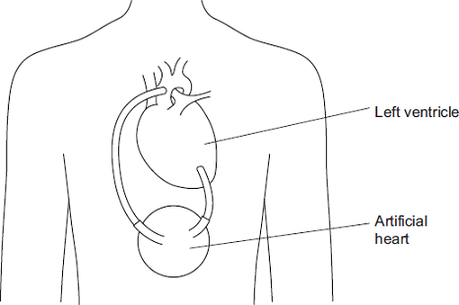

(a)     Name the blood vessel to which the artificial heart is connected.

..................................................................

**(1)**

(b)     In these patients, the right ventricle still produces sufficient blood flow to keep the patient alive.

Suggest why the left ventricle requires the help of the artificial heart but the right ventricle does not.

........................................................................................................................

........................................................................................................................

........................................................................................................................

........................................................................................................................

........................................................................................................................

**(2)**

(c)     **Figure 2** shows the internal structure of this type of artificial heart.

**Figure 2**

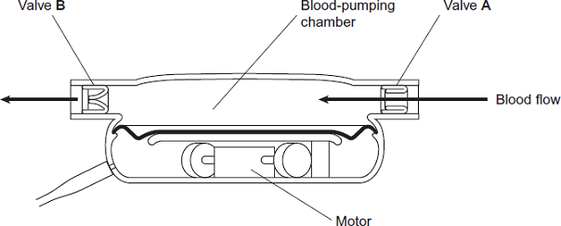

Valves **A** and **B** have the same functions as heart valves involved in the cardiac cycle. Name the heart valve that has the same function as:

valve **A**............................................................................................................

valve **B**............................................................................................................

**(2)**

(d)     There are different designs of artificial heart. Doctors compared results for patients who received two different types of artificial heart, **X**  and **Y.**

They recorded information 2 years after the artificial hearts were implanted. Their results are **shown in Figure 3**.

**Figure 3**

|  |  |  |  |  |
| --- | --- | --- | --- | --- |
|  |  | **Information recorded 2 years after artificial heart implanted** | | |
|  | **Type of artificial heart** | **Number of patients surviving without replacement of artificial heart** | **Number of patients surviving but who required repair or replacement of artificial heart** | **Number of patients who died** |
|  | **X** (119 patients) | 62 | 13 | 44 |
|  | **Y** (58 patients) | 7 | 24 | 27 |

Which type of artificial heart was the more successful? Use calculations to support your answer.

........................................................................................................................

........................................................................................................................

........................................................................................................................

........................................................................................................................

........................................................................................................................

........................................................................................................................

........................................................................................................................

*(Extra space)*..................................................................................................

........................................................................................................................

........................................................................................................................

**(3)**

**(Total 8 marks)**

**Q2.**          (a)     A fish uses its gills to absorb oxygen from water. Explain how the gills of a fish are adapted for efficient gas exchange.

......................................................................................................................

......................................................................................................................

......................................................................................................................

......................................................................................................................

......................................................................................................................

......................................................................................................................

......................................................................................................................

......................................................................................................................

......................................................................................................................

......................................................................................................................

......................................................................................................................

......................................................................................................................

**(6)**

Mackerel live in the surface waters of the sea. Toadfish live on the seabed in deep water.

(b)     The concentration of oxygen is higher in the surface waters than it is in water close to the seabed. Suggest why.

......................................................................................................................

......................................................................................................................

......................................................................................................................

......................................................................................................................

**(2)**

(c)     The graph shows oxygen dissociation curves for toadfish haemoglobin and for mackerel haemoglobin.

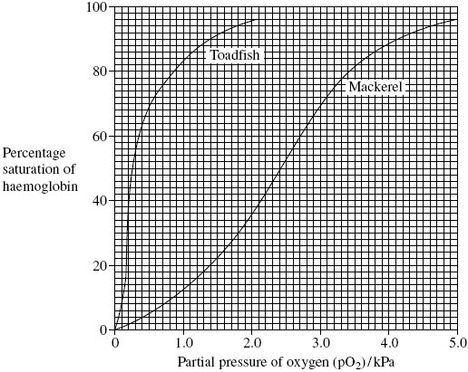

Explain how the shape of the curve for toadfish haemoglobin is related to where the toadfish is normally found.

......................................................................................................................

......................................................................................................................

......................................................................................................................

......................................................................................................................

**(2)**

(d)     Scientists analysed the sequence of amino acids in one polypeptide chain in the haemoglobin of four different species of ape. The only difference they found affected the amino acids at three positions in the polypeptide chain. Their results are shown in the table. The letters are abbreviations for particular amino acids.

|  |  |  |  |  |
| --- | --- | --- | --- | --- |
|  | **Species** | **Position 87** | **Position 104** | **Position 125** |
|  | Chimpanzee | T | R | P |
|  | Bonobo | T | R | P |
|  | Gorilla | T | K | P |
|  | Orang utan | K | R | Q |

What information do the data in the table suggest about the relationships between the chimpanzee, the bonobo and the gorilla? Explain your answer.

......................................................................................................................

......................................................................................................................

......................................................................................................................

......................................................................................................................

**(2)**

**(Total 12 marks)**

**Q3.**          When a stethoscope is placed on the chest wall, sounds are heard as the heart beats. These heart sounds are caused by valves shutting. The diagram shows the heart sounds from a resting person.

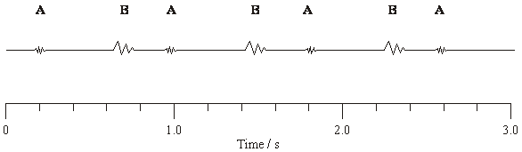

(a)     (i)      The sounds labelled **A** on the diagram are made by the closing of the valves at the entrance to the arteries. What makes the sounds labelled **B**?

.............................................................................................................

.............................................................................................................

**(1)**

(ii)     Explain what causes the valve to shut when sound **A** is heard.

.............................................................................................................

.............................................................................................................

**(1)**

(b)     In this person, the stroke volume is 70 cm3. Calculate the cardiac output. Show your working.

Cardiac output ............................... cm3 per minute

**(3)**

**(Total 5 marks)**

**Q4.**          The diagram shows part of a capillary and some of the cells surrounding it.

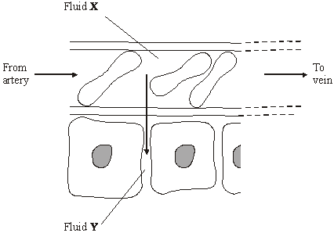

(a)     Name

(i)      fluid **X**,

.............................................................................................................

**(1)**

(ii)     fluid **Y**

.............................................................................................................

**(1)**

(b)     Describe and explain **one** way in which the composition of fluid **Y** differs from that of   
fluid **X**.

......................................................................................................................

......................................................................................................................

......................................................................................................................

......................................................................................................................

**(2)**

(c)     Explain how fluid leaves the capillary at the arterial end.

......................................................................................................................

......................................................................................................................

......................................................................................................................

......................................................................................................................

**(2)**

**(Total 6 marks)**

**Q5.**(a)     **Figure 1** shows the oxygen dissociation curve for human haemoglobin.

**Figure 1**

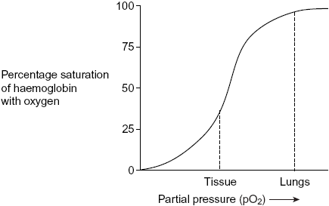

Use **Figure 1** to describe how haemoglobin loads and unloads oxygen in the body.

......................................................................................................................

......................................................................................................................

......................................................................................................................

......................................................................................................................

......................................................................................................................

**(3)**

(b)     **Figure 2** shows oxygen dissociation curves from mammals of different size.

**Figure 2**

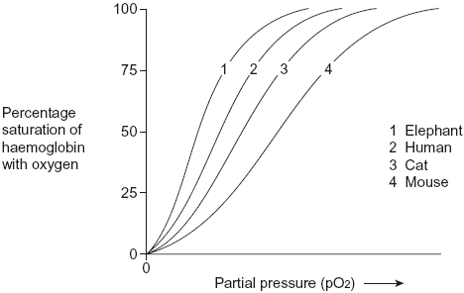

(i)      Describe the relationship between the size of mammals and the oxygen dissociation curves of their haemoglobins.

.............................................................................................................

.............................................................................................................

**(1)**

(ii)     Heat from respiration helps mammals to maintain a constant body temperature.

Use this information to explain the relationship between the surface area to volume ratio of mammals and the oxygen dissociation curves of their haemoglobins.

.............................................................................................................

.............................................................................................................

.............................................................................................................

.............................................................................................................

.............................................................................................................

.............................................................................................................

.............................................................................................................

**(4)**

**(Total 8 marks)**

**Q6.**         The cardiac cycle is controlled by the sinoatrial node (SAN) and the atrioventricular node (AVN).

Describe how.

...............................................................................................................................

...............................................................................................................................

...............................................................................................................................

...............................................................................................................................

...............................................................................................................................

...............................................................................................................................

...............................................................................................................................

...............................................................................................................................

**(Total 5 marks)**

**Q7.**          The diagram shows some of the large blood vessels in a mammal.

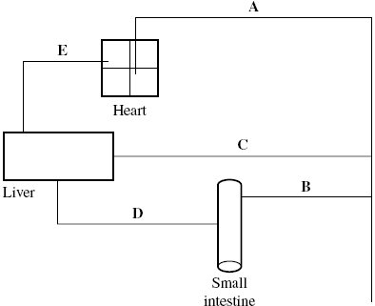

(a)     Add arrows to the diagram to show the direction of blood flow in each of the blood vessels **A** to **E**.

**(1)**

(b)     Which of blood vessels **A** to **E** contains blood at the lowest pressure?



**(1)**

(c)     Complete the table to show **two** differences between the structure of vessel **C** and the structure of vessel **E**.

|  |  |  |
| --- | --- | --- |
| **Structural feature** | **Vessel C** | **Vessel E** |
|  |  |  |
|  |  |  |

**(2)**

(d)     Blood vessel **B** contains smooth muscle in its walls. Explain how this muscle may reduce the blood flow to the small intestine.

......................................................................................................................

......................................................................................................................

......................................................................................................................

......................................................................................................................

**(2)**

(e)     Elastic tissue in the walls of blood vessel **A** helps to even out the pressure of blood through this vessel. Explain how.

......................................................................................................................

......................................................................................................................

......................................................................................................................

......................................................................................................................

**(2)**

**(Total 8 marks)**

**Q8.**          (a)     An increase in respiration in the tissues of a mammal affects the oxygen dissociation curve of haemoglobin. Describe and explain how.

......................................................................................................................

......................................................................................................................

......................................................................................................................

......................................................................................................................

**(2)**

(b)     There is less oxygen at high altitudes than at sea level.

(i)      People living at high altitudes have more red blood cells than people living at sea level. Explain the advantage of this to people living at high altitude.

.............................................................................................................

.............................................................................................................

.............................................................................................................

.............................................................................................................

**(2)**

(ii)     The graph shows oxygen dissociation curves for people living at high altitude and for people living at sea level.

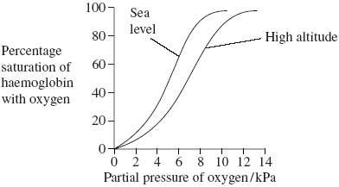

Explain the advantage to people living at high altitude of having the oxygen dissociation curve shown in the graph.

.............................................................................................................

.............................................................................................................

.............................................................................................................

.............................................................................................................

**(2)**

**(Total 6 marks)**

**Q9.**          The diagram shows tissue fluid and cells surrounding a capillary.

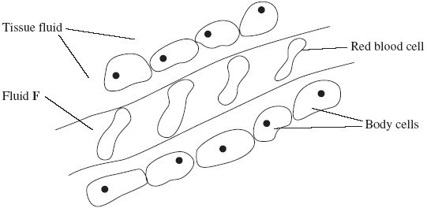

(a)     Name fluid **F**.

......................................................................................................................

**(1)**

(b)     Give **one** way in which fluid **F** is different from tissue fluid.

......................................................................................................................

**(1)**

(c)     (i)      The blood pressure is high at the start of the capillary. Explain how the left ventricle causes the blood to be at high pressure.

.............................................................................................................

.............................................................................................................

**(1)**

(ii)     The blood pressure decreases along the length of the capillary. What causes this decrease in pressure?

.............................................................................................................

.............................................................................................................

**(1)**

(d)     In children, some diets may result in a low concentration of protein in fluid **F**. This can cause the accumulation of tissue fluid. Explain the link between a low concentration of protein in fluid **F** and the accumulation of tissue fluid.

......................................................................................................................

......................................................................................................................

......................................................................................................................

......................................................................................................................

......................................................................................................................

......................................................................................................................

**(3)**

**(Total 7 marks)**

**Q11.**          (a)     Haemoglobin contains iron. One type of anaemia is caused by a lack of iron. This type of anaemia can be treated by taking tablets containing iron. A number of patients were given a daily dose of 120 mg of iron. **Figure 1** shows the effect of this treatment on the increase in the concentration of haemoglobin in their red blood cells.

**Figure 1**

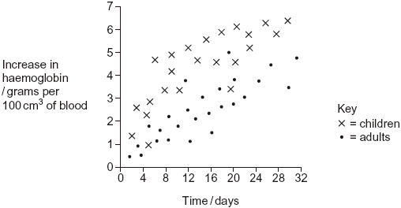

(i)      Give **one** difference in the response of adults and children to this treatment.

.............................................................................................................

.............................................................................................................

**(1)**

(ii)     You could use the graph to predict the effect of this treatment on the increase in haemoglobin content of an adult after 40 days. Explain how.

.............................................................................................................

.............................................................................................................

.............................................................................................................

.............................................................................................................

**(2)**

(iii)     Haemoglobin has a quaternary structure. Explain what is meant by a quaternary structure.

.............................................................................................................

.............................................................................................................

**(1)**

(b)     (i)      Pernicious anaemia is another type of anaemia. One method of identifying pernicious anaemia is to measure the diameter of the red blood cells in a sample of blood that has been diluted with an isotonic salt solution. Explain why an isotonic salt solution is used to dilute the blood sample.

.............................................................................................................

.............................................................................................................

.............................................................................................................

.............................................................................................................

.............................................................................................................

.............................................................................................................

**(3)**

(ii)     A technician compared the red blood cells in two blood samples of equal volume. One sample was from a patient with pernicious anaemia, the other was from a patient who did not have pernicious anaemia. **Figure 2** shows some of the results she obtained.

**Figure 2**

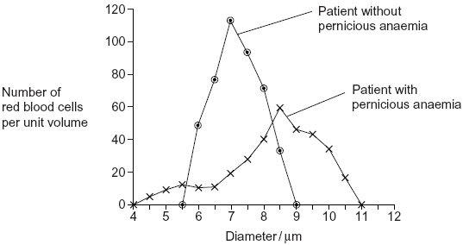

Describe **two** differences between the blood samples.

1 ..........................................................................................................

.............................................................................................................

2 ..........................................................................................................

.............................................................................................................

**(2)**

**(Total 9 marks)**

**Q12.**(a)     (i)      The human heart has four chambers.  
In which **one** of the four chambers of the human heart does pressure reach the highest value?

...............................................................................................................

**(1)**

(ii)     Explain how the structure of this chamber causes this high pressure.

...............................................................................................................

...............................................................................................................

...............................................................................................................

**(1)**

The table shows the volume of blood in a man's right ventricle at different times during one cardiac cycle.

|  |  |  |
| --- | --- | --- |
|  | **Time / s** | **Volume of blood / cm3** |
|  | 0.0 | 125 |
|  | 0.1 | 148 |
|  | 0.2 | 103 |
|  | 0.3 | 70 |
|  | 0.4 | 56 |
|  | 0.5 | 55 |
|  | 0.6 | 98 |
|  | 0.7 | 125 |

(b)     (i)      Use the data in the table to calculate the man’s heart rate.

                 Heart rate = ............................................. beats per minute

(ii)     Use the data in the table and your answer to part (b) (i) to calculate the man’s cardiac output. Show your working.

                 Cardiac output = ........................................ cm3 per minute

**(3)**

(c)     Use information from the table to complete the table below to show whether the valves are **open** or **closed** at each of the times shown. Write open or closed in the appropriate boxes.

|  |  |  |  |
| --- | --- | --- | --- |
|  | **Time / s** | **Valve between right atrium and right ventricle** | **Valve between right ventricle and pulmonary artery** |
|  | 0.2 |  |  |
|  | 0.6 |  |  |

**(2)**

**Q13.**          Read the following passage.

Some foods contain substances called flavenoids. Flavenoids lower blood  
cholesterol concentration and reduce the risk of developing coronary  
heart disease.

Some types of dark chocolate have a high concentration of flavenoids. One

5        group of scientists investigated the effect of eating dark chocolate on the risk

of developing coronary heart disease.

The scientists randomly divided healthy volunteers into two groups. Every day  
one group was given dark chocolate containing flavenoids to eat. The other  
group acted as a control.

10      The scientists measured the diameter of the lumen of the main artery in the

arms of the volunteers every week. At the end of a month, the diameter of  
the lumen of the main artery in the arm of the volunteers who had eaten  
dark chocolate containing flavenoids had increased.

Use information from the passage and your own knowledge to answer the questions.

(a)     (i)      The scientists used healthy volunteers in this investigation (line 7). Why was it important that the volunteers were healthy?

.............................................................................................................

.............................................................................................................

.................................................................................................

**(1)**

(ii)     The scientists randomly divided the volunteers into two groups (line 7). Explain why they divided them randomly.

.............................................................................................................

.............................................................................................................

**(1)**

(b)     (i)      Describe how the control group should have been treated.

.............................................................................................................

.............................................................................................................

.............................................................................................................

.............................................................................................................

**(2)**

(ii)     Why was it important to have a control group in this investigation?

.............................................................................................................

.............................................................................................................

**(1)**

**(Total 5 marks)**

**Q14.**          The diagram shows a cross-section of a blood vessel.

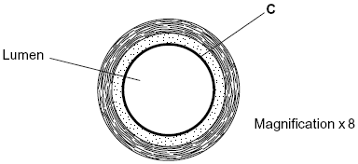

(a)     Name layer **C**.

......................................................................................................................

**(1)**

(b)     Calculate the actual diameter of the lumen of this blood vessel in millimetres. Show your working.

Answer ............................................. mm

**(2)**

(c)     The aorta has many elastic fibres in its wall. An arteriole has many muscle fibres in its wall.

(i)      Explain the importance of elastic fibres in the wall of the aorta.

.............................................................................................................

.............................................................................................................

.............................................................................................................

.............................................................................................................

**(2)**

(ii)     Explain the importance of muscle fibres in the wall of an arteriole.

.............................................................................................................

.............................................................................................................

.............................................................................................................

.............................................................................................................

**(2)**

(d)     The graph shows the rate of blood flow in different blood vessels. It also shows the total cross-sectional area of these blood vessels.

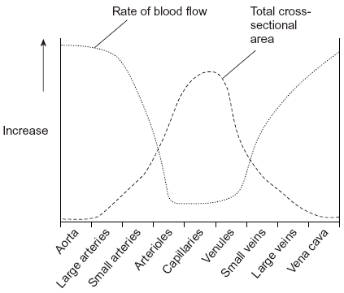

(i)      The rate of blood flow decreases from the aorta to the capillaries. Use information from the graph to explain why.

.............................................................................................................

.............................................................................................................

.............................................................................................................

**(1)**

(ii)     Efficient exchange of substances in the capillaries is linked to the rate of blood flow. Explain how.

.............................................................................................................

.............................................................................................................

.............................................................................................................

**(1)**

**(Total 9 marks)**

**Q15.**          (a)     Students measured the rate of transpiration of a plant growing in a pot under different environmental conditions. Their results are shown in the table.

|  |  |  |
| --- | --- | --- |
|  | **Conditions** | **Transpiration rate / g h–1** |
|  | **A**    Still air 15° | 1.2 |
|  | **B**    Moving air 15° | 1.7 |
|  | **C**    Still air 25° | 2.3 |

During transpiration, water diffuses from cells to the air surrounding a leaf.

(i)      Suggest an explanation for the difference in transpiration rate between conditions **A** and **B**.

.............................................................................................................

.............................................................................................................

.............................................................................................................

.............................................................................................................

.............................................................................................................

**(2)**

(ii)     Suggest an explanation for the difference in transpiration rate between conditions **A** and **C**.

.............................................................................................................

.............................................................................................................

.............................................................................................................

.............................................................................................................

.............................................................................................................

**(2)**

(b)     Scientists investigated the rate of water movement through the xylem of a twig from a tree over 24 hours. The graph shows their results. It also shows the light intensity for the same period of time.

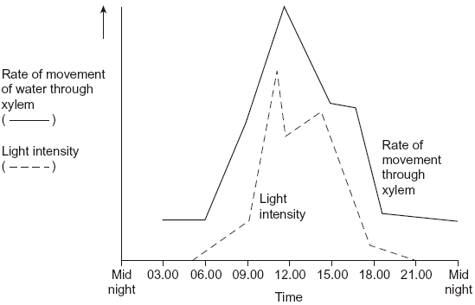

(i)      Describe the relationship between the rate of water movement through the xylem and the light intensity.

.............................................................................................................

.............................................................................................................

.............................................................................................................

**(1)**

(ii)     Explain the change in the rate of water movement through the xylem between 06.00 and 12.00 hours.

.............................................................................................................

.............................................................................................................

.............................................................................................................

.............................................................................................................

.............................................................................................................

**(2)**

(iii)     The scientists also measured the diameter of the trunk of the tree on which the twig had been growing. The diameter was less at 12.00 than it was at 03.00 hours.

Explain why the diameter was less at 12.00 hours.

.............................................................................................................

.............................................................................................................

.............................................................................................................

.............................................................................................................

.............................................................................................................

**(2)**

(c)     Arteries and arterioles take blood away from the heart.

Explain how the structures of the walls of arteries and arterioles are related to their functions.

......................................................................................................................

......................................................................................................................

......................................................................................................................

......................................................................................................................

......................................................................................................................

......................................................................................................................

......................................................................................................................

......................................................................................................................

......................................................................................................................

......................................................................................................................

......................................................................................................................

......................................................................................................................

**(6)**

**(Total 15 marks)**

**Q16.**          The diagram shows a human heart as seen from the front. The main blood vessels are labelled **D** to **G**. The arrows show the pathways taken by the electrical activity involved in coordinating the heartbeat in the cardiac cycle.

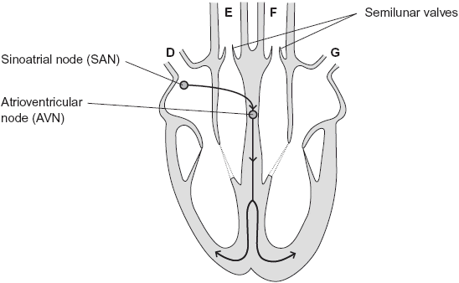

(a)     Which of the blood vessels, **D** to **G**

(i)      carries oxygenated blood to the heart



**(1)**

(ii)     carries deoxygenated blood to the lungs?



**(1)**

(b)     Explain, in terms of pressure, why the semilunar valves open.

......................................................................................................................

......................................................................................................................

......................................................................................................................

**(1)**

(c)     When a wave of electrical activity reaches the AVN, there is a short delay before a new wave leaves the AVN. Explain the importance of this short delay.

......................................................................................................................

......................................................................................................................

......................................................................................................................

......................................................................................................................

......................................................................................................................

**(2)**

(d)     The table shows the cardiac output and resting heart rate of an athlete before and after completing a training programme.

|  |  |  |  |
| --- | --- | --- | --- |
|  |  | **Before training** | **After training** |
|  | Cardiac out/cm3 | 5000 | 5000 |
|  | Resisting heart rate/beats per minute | 70 | 55 |

(i)      Calculate the athlete’s stroke volume after training. Show your working.

.............................. cm3

**(2)**

(ii)     Use information from the table to explain how training has caused the resting heart rate of this athlete to be lower.

.............................................................................................................

.............................................................................................................

.............................................................................................................

.............................................................................................................

.............................................................................................................

**(2)**

**(Total 9 marks)**

**Q17.**          The diagram shows a molecule of haemoglobin.

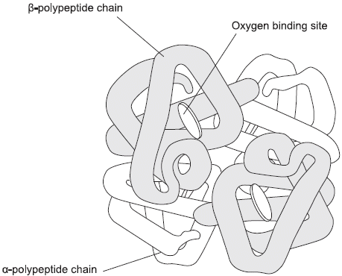

(a)     What is the evidence from the diagram that haemoglobin has a quaternary structure?

......................................................................................................................

......................................................................................................................

**(1)**

(b)     (i)      A gene codes for the α-polypeptide chain. There are 423 bases in this gene that code for amino acids. How many amino acids are there in the α-polypeptide chain?



**(1)**

(ii)     The total number of bases in the DNA of the α-polypeptide gene is more than 423.

Give **two** reasons why there are more than 423 bases.

1 ..........................................................................................................

.............................................................................................................

2 ..........................................................................................................

.............................................................................................................

**(2)**

(c)     The haemoglobin in one organism may have a different chemical structure from the haemoglobin in another organism. Describe how.

......................................................................................................................

......................................................................................................................

**(1)**

(d)     The graph shows oxygen dissociation curves for horse haemoglobin and for llama haemoglobin. Horses are adapted to live at sea level and llamas are adapted to live in high mountains.

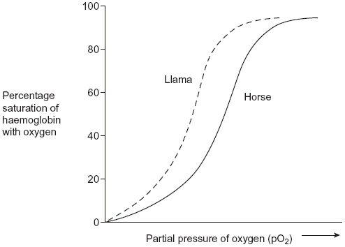

Use the graph to explain why llamas are better adapted to live in high mountains than horses.

......................................................................................................................

......................................................................................................................

......................................................................................................................

......................................................................................................................

......................................................................................................................

......................................................................................................................

**(3)**

**(Total 8 marks)**

**Q18.**          Erythropoietin (EPO) is a substance produced in the body. It increases the production of red blood cells. Synthetic EPO is made artificially. It is used to treat patients who have a form of anaemia in which there is a reduced number of red blood cells. Scientists investigated the effect of synthetic EPO on volunteers with this form of anaemia.

•        The scientists injected synthetic EPO in a salt solution into patients in the experimental groups. They also set up control groups.

•        They gave the different experimental groups different doses of synthetic EPO and different lengths of treatment.

•        At the beginning and end of the treatment, the scientists measured each patient’s haemoglobin concentration. From these measurements, they calculated the mean increase in haemoglobin concentration.

Some of the results are shown in the table.

|  |  |  |  |  |
| --- | --- | --- | --- | --- |
|  | **Number of volunteers** | **Length of treatment / weeks** | **Dose of synthetic EPO / units per kilogram per week** | **Mean increase in haemoglobin concentration / arbitrary units** |
|  | 58 | 8 | 85 | 19.0 |
|  | 18 | 8 | 170 | 26.0 |
|  | 40 | 12 | 150 | 12.5 |
|  | 82 | 12 | 450 | 34.2 |
|  | 46 | 24 | 120 | 23.0 |
|  | 53 | 24 | 240 | 31.0 |

(a)     Explain why treatment with synthetic EPO affects the haemoglobin concentration in these volunteers.

......................................................................................................................

......................................................................................................................

......................................................................................................................

......................................................................................................................

......................................................................................................................

**(2)**

(b)Suggest how the control groups should have been treated in this investigation.

......................................................................................................................

......................................................................................................................

......................................................................................................................

......................................................................................................................

......................................................................................................................

**(2)**

(c)The scientists measured the dose of synthetic EPO per kilogram per week.

Explain why they measured the dose per unit mass and per unit time.

......................................................................................................................

......................................................................................................................

......................................................................................................................

......................................................................................................................

......................................................................................................................

**(2)**

(d)Explain how the information that the scientists collected might be useful in treating patients with anaemia.

......................................................................................................................

......................................................................................................................

......................................................................................................................

......................................................................................................................

......................................................................................................................

**(2)**

(e)Some athletes have used synthetic EPO as a performance enhancer. Explain how synthetic EPO may improve performance in long-distance events.

......................................................................................................................

......................................................................................................................

......................................................................................................................

......................................................................................................................

......................................................................................................................

......................................................................................................................

......................................................................................................................

......................................................................................................................

*(Extra space) ……..*.......................................................................................

......................................................................................................................

......................................................................................................................

......................................................................................................................

**(4)**

(f)      Athletes may be tested to see if the concentration of EPO in their blood is above normal. Suggest how scientists determine the normal concentration of EPO in blood.

......................................................................................................................

......................................................................................................................

......................................................................................................................

......................................................................................................................

......................................................................................................................

**(2)**

(g)     Synthetic EPO can increase blood pressure. Suggest why.

......................................................................................................................

......................................................................................................................

......................................................................................................................

**(1)**

**(Total 15 marks)**

**Q19.**          Lugworms live in mud where the partial pressure of oxygen is low. The graph shows oxygen dissociation curves for a lugworm and for a human.

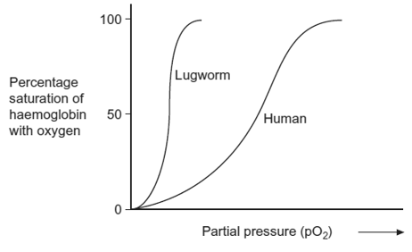

(a)Explain the advantage to the lugworm of having haemoglobin with a dissociation curve in the position shown.

......................................................................................................................

......................................................................................................................

......................................................................................................................

......................................................................................................................

**(2)**

(b)In humans, substances move out of the capillaries to form tissue fluid. Describe how this tissue fluid is returned to the circulatory system.

......................................................................................................................

......................................................................................................................

......................................................................................................................

......................................................................................................................

......................................................................................................................

......................................................................................................................

*(Extra space)* ...............................................................................................

......................................................................................................................

......................................................................................................................

**(3)**

**(Total 5 marks)**

**Q20.**          Read the following passage.

Chlamydia is a bacterium. Scientists have shown that infection with chlamydia can cause heart disease in humans. Infection with the bacterium can stimulate the formation of atheroma. This can lead to a heart attack.

Other scientists have been working with mice. These scientists have suggested that chlamydia may cause heart disease in a different way. They have found a protein on the surface of chlamydia cells which is similar to a protein in the heart muscle of mice. After an infection with chlamydia, cells of the immune system of the mice may attack their heart muscle cells and cause heart disease.

Use the information in the passage and your own knowledge to answer the following questions.

(a)(i)      Using information from the passage, explain what is meant by an antigen.

.............................................................................................................

.............................................................................................................

.............................................................................................................

.............................................................................................................

**(2)**

(ii)     After an infection with chlamydia, cells of the immune system of the mice may attack the heart muscle cells (lines 7-8). Explain why.

.............................................................................................................

.............................................................................................................

.............................................................................................................

.............................................................................................................

.............................................................................................................

**(2)**

(b)Some scientists have suggested that people should be vaccinated to prevent infection by chlamydia. Evaluate this suggestion.

......................................................................................................................

......................................................................................................................

......................................................................................................................

......................................................................................................................

......................................................................................................................

......................................................................................................................

*(Extra space)* ................................................................................................

......................................................................................................................

......................................................................................................................

**(3)**

**(Total 7 marks)**

**Q21.**          The table shows pressure changes in the left side of the heart during one cardiac cycle.

|  |  |  |  |
| --- | --- | --- | --- |
|  |  | **Blood pressure / k Pa** | |
|  | **Time / s** | **Left atrium** | **Left ventricle** |
|  | 0.0 | 0.7 | 0.3 |
|  | 0.1 | 1.0 | 2.0 |
|  | 0.2 | 0.2 | 12.5 |
|  | 0.3 | 0.2 | 15.3 |
|  | 0.4 | 1.0 | 4.5 |
|  | 0.5 | 0.5 | 1.0 |
|  | 0.6 | 0.6 | 0.3 |
|  | 0.7 | 0.7 | 0.3 |

(a)     Between which times is the valve between the atrium and the ventricle closed?

Explain your answer.

Times ............................. s and ............................. s

Explanation ..................................................................................................

......................................................................................................................

......................................................................................................................

......................................................................................................................

**(2)**

(b)The maximum pressure in the ventricle is much higher than that in the atrium.

Explain what causes this.

......................................................................................................................

......................................................................................................................

......................................................................................................................

......................................................................................................................

**(2)**

(c)Use the information in the table to calculate the heart rate in beats per minute.

Answer .............................. beats per minute

**(1)**

**(Total 5 marks)**

**Q22.**(a)     Explain how oxygen is loaded, transported and unloaded in the blood.

........................................................................................................................

........................................................................................................................

........................................................................................................................

........................................................................................................................

........................................................................................................................

........................................................................................................................

........................................................................................................................

........................................................................................................................

........................................................................................................................

........................................................................................................................

........................................................................................................................

........................................................................................................................

*(Extra space)* .................................................................................................

........................................................................................................................

........................................................................................................................

........................................................................................................................

........................................................................................................................

........................................................................................................................

**(6)**

Midges are very small insects. The early stages of the life cycle of midges are called larvae. Midge larvae live in water. A biologist investigated the uptake of oxygen by the larvae of two species of midge. He measured the rate of uptake of oxygen by the larvae in water containing different concentrations of oxygen. The table shows his results.

|  |  |  |  |
| --- | --- | --- | --- |
|  | **Concentration of oxygen in water / cm3dm-3** | **Mean rate of oxygen uptake / cm3g-1h-1** | |
|  | *Chironomus longistylus* | *Tanytarsus brunnipes* |
|  | 1 | 220 | 141 |
|  | 2 | 285 | 246 |
|  | 3 | 304 | 342 |
|  | 4 | 313 | 362 |
|  | 5 | 320 | 367 |
|  | 6 | 318 | 430 |
|  | 7 | 320 | 469 |

(b)     The larvae in this investigation were kept at a temperature of 17 °C. Why was it important that the larvae of both species were kept at the same temperature?

........................................................................................................................

........................................................................................................................

........................................................................................................................

........................................................................................................................

........................................................................................................................

**(2)**

(c)     Describe the effect of an increase in oxygen concentration on the mean rate of oxygen uptake in *Chironomus longistylus*.

........................................................................................................................

........................................................................................................................

........................................................................................................................

........................................................................................................................

........................................................................................................................

**(2)**

(d)     *Chironomus longistylus* lives in still water whereas *Tanytarsus brunnipes* lives in fast running streams. The water in fast running streams has a higher concentration of oxygen than in still water. Use the table in part (a) to suggest how *Chironomus longistylus* is better adapted than *Tanytarsus brunnipes* to living in still water.

........................................................................................................................

........................................................................................................................

........................................................................................................................

........................................................................................................................

........................................................................................................................

**(2)**

(e)     Lungfish are freshwater fish which have gills and lungs. Scientists investigated how Australian and African lungfish use their lungs and gills for gas exchange. The graphs show the results of this investigation.

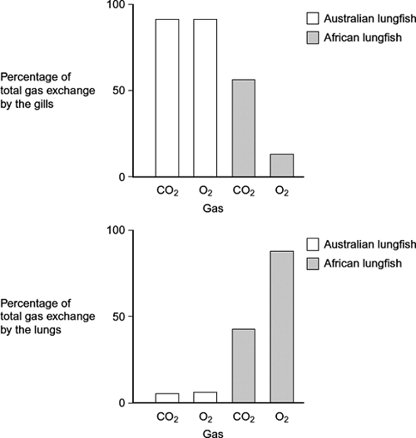

(i)      Describe the difference in the way carbon dioxide is lost from the body of an Australian lungfish and an African lungfish.

...............................................................................................................

...............................................................................................................

...............................................................................................................

**(1)**

(ii)     African lungfish are likely to survive for longer than Australian lungfish when living in pools that dry up. Explain why.

...............................................................................................................

...............................................................................................................

...............................................................................................................

...............................................................................................................

...............................................................................................................

**(2)**

**(Total 15 marks)**

**Q23.**Read the following passage.

|  |  |  |
| --- | --- | --- |
|  | Aspirin is a very useful drug. One of its uses is to reduce fever and inflammation. Aspirin does this by preventing cells from producing substances called prostaglandins. Prostaglandins are produced by an enzyme-controlled pathway. Aspirin works by inhibiting one of the enzymes in this pathway. Aspirin attaches permanently to a chemical group on one of the monomers that make up the active site of this enzyme. | 5 |
|  | The enzyme that is involved in the pathway leading to the production of prostaglandins is also involved in the pathway leading to the production of thromboxane. This is a substance that promotes blood clotting. A small daily dose of aspirin may reduce the risk of myocardial infarction (heart attack). | 10 |

Use information from the passage and your own knowledge to answer the following questions.

(a)     Name the monomers that make up the active site of the enzyme (lines 6 – 7).

........................................................................................................................

**(1)**

(b)     The diagram shows the pathways by which prostaglandins and thromboxane are formed.

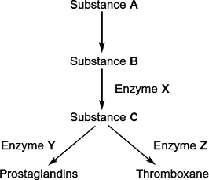

(i)      Aspirin only affects one of the enzymes in this pathway. Use information in lines 5 - 7 to explain why aspirin does **not** affect the other enzymes.

...............................................................................................................

...............................................................................................................

...............................................................................................................

...............................................................................................................

...............................................................................................................

**(2)**

(ii)     Which enzyme, **X**, **Y** or **Z**, is inhibited by aspirin? Explain the evidence from the passage that supports your answer.

Enzyme ................................................................................................

Explanation ...........................................................................................

...............................................................................................................

...............................................................................................................

**(2)**

(c)     Aspirin is an enzyme inhibitor. Explain how aspirin prevents substrate molecules being converted to product molecules.

........................................................................................................................

........................................................................................................................

........................................................................................................................

........................................................................................................................

........................................................................................................................

**(2)**

**(Total 7 marks)**

**Q24.**Ivabradine is a drug that slows heart rate. It is taken as a pill. Doctors investigated its value in reducing the resting heart rate of patients with coronary heart disease.

•        They described their investigation as a large-scale, controlled trial. It was also carried out on people living in different areas.

•        The results of the trial showed that ivabradine slowed heart rate.

•        Angina is a pain in the chest. It results when insufficient oxygen is brought to the heart muscle during exercise. The doctors found that ivabradine reduced angina.

(a)     The results of the ivabradine trial were reliable.

(i)      Explain the importance of the ivabradine investigation being a large-scale trial.

...............................................................................................................

...............................................................................................................

...............................................................................................................

**(1)**

(ii)     Explain the importance of the ivabradine investigation being carried out on people living in different areas.

...............................................................................................................

...............................................................................................................

...............................................................................................................

**(1)**

(b)     The ivabradine investigation was a controlled trial. Suggest how the control group would have been treated.

........................................................................................................................

........................................................................................................................

........................................................................................................................

........................................................................................................................

........................................................................................................................

**(2)**

(c)     An electrocardiogram is made by attaching recording electrodes to a person’s chest. It shows the electrical changes that take place in a person’s heart each time it beats. A sports physiologist produced electrocardiograms for a fit adult male.

Chart **X** shows an electrocardiogram from this man after 10 minutes of complete rest.

A cardiac cycle consists of the filling time and the contraction time. The filling time and the contraction time for one cardiac cycle are shown on this chart.

Chart **X**

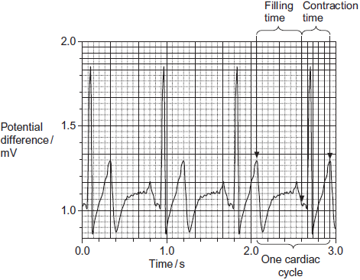

Chart **Y** shows an electrocardiogram from the same man immediately after a period of exercise.

Chart **Y**

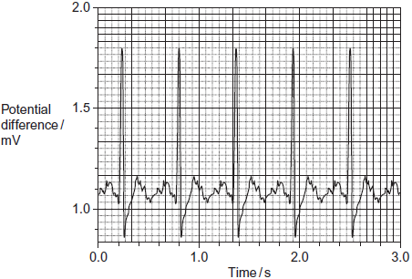

Ivabradine slows heart rate.

(i)      Use information from the charts above to explain why ivabradine increases the volume of blood entering the heart during a cardiac cycle.

...............................................................................................................

...............................................................................................................

**(1)**

(ii)     Ivabradine reduces angina. Suggest how an increase in the volume of blood entering the heart reduces angina.

...............................................................................................................

...............................................................................................................

...............................................................................................................

...............................................................................................................

...............................................................................................................

...............................................................................................................

(Extra space) ........................................................................................

...............................................................................................................

...............................................................................................................

**(3)**

**(Total 8 marks)**

**Q25.**An electrocardiogram is made by attaching recording electrodes to a person’s chest. It shows the electrical changes that take place in a person’s heart each time it beats. A sports physiologist produced electrocardiograms for a fit adult male.

Chart **X** shows an electrocardiogram from this man after 10 minutes of complete rest.

A cardiac cycle consists of the filling time and the contraction time. The filling time and the contraction time for one cardiac cycle are shown on this chart.

Chart **X**

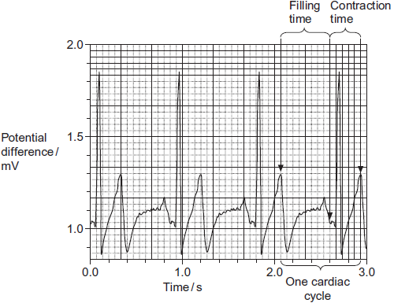

Chart **Y** shows an electrocardiogram from the same man immediately after a period of exercise.

Chart **Y**

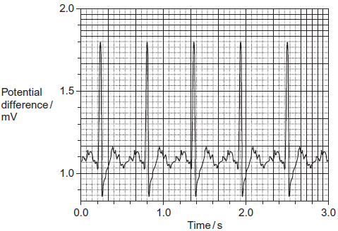

(a)     Give **one** way in which an electrocardiogram could have produced more reliable results than counting the pulse.

........................................................................................................................

........................................................................................................................

........................................................................................................................

**(1)**

(b)     (i)      Chart **X** shows that the man’s resting heart rate was 67 beats per minute. What was his pulse rate? Explain your answer.

...............................................................................................................

...............................................................................................................

...............................................................................................................

**(2)**

(ii)     Use chart **Y** to calculate the man’s heart rate after the period of exercise.  
Show your working.

Answer .................................................... beats per minute

**(2)**

(c)     Use charts **X** and **Y** to describe how exercise affected filling time.

........................................................................................................................

........................................................................................................................

........................................................................................................................

........................................................................................................................

........................................................................................................................

**(2)**

(d)     The physiologist used electrocardiograms to investigate the effect of increasing heart rate on filling time.  
Describe how she could have modified the method of exercising you used to produce a range of increases in heart rate.

........................................................................................................................

........................................................................................................................

........................................................................................................................

........................................................................................................................

........................................................................................................................

**(2)**

**(Total 9 marks)**

**Q26.**Some people have a condition called *white-coat hypertension*. People with this condition develop a higher than normal heart rate and blood pressure when they are in a doctor’s surgery. High heart rate is correlated with high blood pressure.

Doctors investigated differences in heart rate between men *with white-coat hypertension* and those without the condition. They measured the men’s mean heart rates:

•        in the doctor’s surgery, by recording the pulse in the wrist for 1 minute, when the men were lying down

•        at home, using a portable heart rate monitor when the men were walking around

•        at home, using a portable heart rate monitor when the men were sleeping.

(a)     The groups of men selected for this investigation were matched.

Other than being men, suggest **one** factor for which they should have been matched.

........................................................................................................................

**(1)**

(b)     Explain why the pulse recordings in the doctor’s surgery were taken when the men were lying down.

........................................................................................................................

........................................................................................................................

........................................................................................................................

**(1)**

(c)     The pulse felt in the artery in the wrist can be recorded and used to measure heart rate.

Suggest why the pulse felt can be used to measure heart rate.

........................................................................................................................

........................................................................................................................

........................................................................................................................

........................................................................................................................

........................................................................................................................

**(2)**

(d)     The portable heart rate monitor recorded the men’s heart rates continuously. This gave more reliable mean heart rates than those obtained by recording the pulse in the wrist for 1 minute.

Suggest why it is more reliable.

........................................................................................................................

........................................................................................................................

........................................................................................................................

........................................................................................................................

........................................................................................................................

**(2)**

(e)     The table shows the doctors’ results.

|  |  |  |  |
| --- | --- | --- | --- |
|  | **Where and how heart rate was measured** | **Mean heart rate / beats per minute** | |
|  | **Men with white-coat hypertension** | **Men without white-coat hypertension** |
|  | Doctor’s surgery, recording pulse when lying down | 67 | 63 |
|  | At home, walking around, using heart monitor | 76 | 73 |
|  | At home, sleeping, using heart monitor | 63 | 60 |

A journalist, who saw these results, stated that they showed there is no such thing as *white-coat hypertension*.

Do these data support this statement? Give reasons for your answer.

........................................................................................................................

........................................................................................................................

........................................................................................................................

........................................................................................................................

........................................................................................................................

**(2)**

**(Total 8 marks)**

**Q27.**          Scientists compared the results of three investigations, **A**, **B** and **C**. These investigations were into the effect of drinking different amounts of alcohol on the risk of developing heart disease.

The graph shows the results of these investigations.

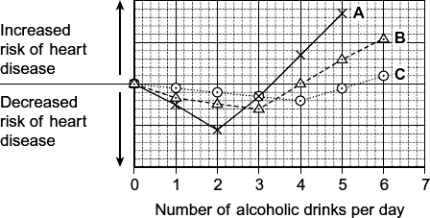

(a)     Describe the relationship between increasing the number of alcoholic drinks per day and the risk of heart disease in investigation **A**.

........................................................................................................................

........................................................................................................................

........................................................................................................................

........................................................................................................................

........................................................................................................................

**(2)**

(b)     All the volunteers who took part in investigation **C** were aged between 40 and 50 years old. Explain how choosing volunteers of a similar age improved this investigation.

........................................................................................................................

........................................................................................................................

........................................................................................................................

**(1)**

(c)     A newspaper headline used the information in the graph to claim ‘Alcohol is good for you.’ Evaluate this claim.

........................................................................................................................

........................................................................................................................

........................................................................................................................

........................................................................................................................

........................................................................................................................

........................................................................................................................

*(Extra space)* .................................................................................................

........................................................................................................................

........................................................................................................................

**(3)**

**(Total 6 marks)**

**Q28.**          (a)     Scientists measured the rate of water flow and the pressure in the xylem in a small branch. Their results are shown in the graph.

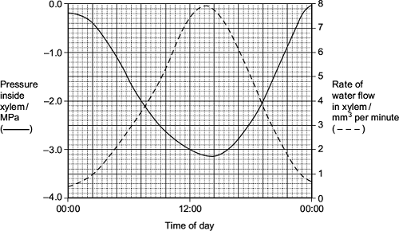

(i)      Use your knowledge of transpiration to explain the changes in the rate of flow in the xylem shown in the graph.

...............................................................................................................

...............................................................................................................

...............................................................................................................

...............................................................................................................

...............................................................................................................

...............................................................................................................

*(Extra space)* ........................................................................................

...............................................................................................................

...............................................................................................................

**(3)**

(ii)     Explain why the values for the pressure in the xylem are negative.

...............................................................................................................

...............................................................................................................

...............................................................................................................

**(1)**

(b)     Doctors measured the thickness of the walls of three blood vessels in a large group of people. Their results are given in the table.

|  |  |  |
| --- | --- | --- |
|  | **Name of vessel** | **Mean wall thickness /mm (± standard deviation)** |
|  | Aorta | 5.7 ± 1.2 |
|  | Pulmonary artery | 1.0 ± 0.2 |
|  | Pulmonary vein | 0.5 ± 0.2 |

(i)      Explain the difference in thickness between the pulmonary artery and the pulmonary vein.

...............................................................................................................

...............................................................................................................

...............................................................................................................

**(1)**

(ii)     The thickness of the aorta wall changes all the time during each cardiac cycle.  
Explain why

...............................................................................................................

...............................................................................................................

...............................................................................................................

...............................................................................................................

...............................................................................................................

...............................................................................................................

*(Extra space)* ........................................................................................

...............................................................................................................

...............................................................................................................

**(3)**

(iii)    Which of the three blood vessels shows the greatest variation in wall thickness?  
Explain your answer.

...............................................................................................................

...............................................................................................................

...............................................................................................................

**(1)**

(c)     Describe how tissue fluid is formed **and** how it is returned to the circulatory system.

........................................................................................................................

........................................................................................................................

........................................................................................................................

........................................................................................................................

........................................................................................................................

........................................................................................................................

........................................................................................................................

........................................................................................................................

........................................................................................................................

........................................................................................................................

........................................................................................................................

........................................................................................................................

*(Extra space)* .................................................................................................

........................................................................................................................

........................................................................................................................

........................................................................................................................

........................................................................................................................

........................................................................................................................

........................................................................................................................

........................................................................................................................

........................................................................................................................

........................................................................................................................

........................................................................................................................

**(6)**

**(Total 15 marks)**

**Q29.**(a)     (i)      An arteriole is described as an organ. Explain why.

...............................................................................................................

...............................................................................................................

...............................................................................................................

**(1)**

(ii)     An arteriole contains muscle fibres. Explain how these muscle fibres reduce blood flow to capillaries.

...............................................................................................................

...............................................................................................................

...............................................................................................................

...............................................................................................................

...............................................................................................................

**(2)**

(b)     (i)      A capillary has a thin wall. This leads to rapid exchange of substances between the blood and tissue fluid. Explain why.

...............................................................................................................

...............................................................................................................

...............................................................................................................

**(1)**

(ii)     Blood flow in capillaries is slow. Give the advantage of this.

...............................................................................................................

...............................................................................................................

...............................................................................................................

**(1)**

(c)     Kwashiorkor is a disease caused by a lack of protein in the blood. This leads to a swollen abdomen due to a build up of tissue fluid.

Explain why a lack of protein in the blood causes a build up of tissue fluid.

........................................................................................................................

........................................................................................................................

........................................................................................................................

........................................................................................................................

........................................................................................................................

........................................................................................................................

*(Extra space)*..................................................................................................

........................................................................................................................

........................................................................................................................

**(3)**

**(Total 8 marks)**

**Q30.**Some substances can cross the cell-surface membrane of a cell by simple diffusion through the phospholipid bilayer. Describe other ways by which substances cross this membrane.

**(Total 5 marks)**

**Q31.**If red blood cells are placed in pure water, water enters the cells by osmosis and they burst. This is called haemolysis. As red blood cells burst they release pigment.

Scientists placed samples of red blood cells in different concentrations of sodium chloride solution for the same period of time. They used red blood cells from four different mammals: dog, guinea pig, rabbit and sheep.

If haemolysis had taken place, the solution turned red. The scientists measured the intensity of the red colour using a colorimeter. The more intense the red colour, the greater the amount of haemolysis.

The scientists calculated the percentage of red blood cells that were haemolysed in each sodium chloride solution.

The following figure shows the scientists’ results.

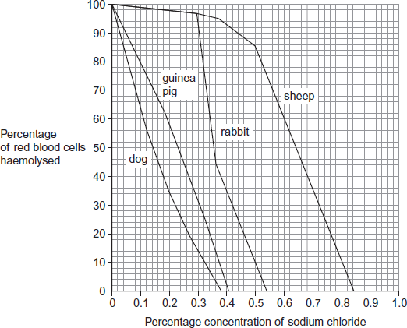

(a)     Use the figure to give **two** differences between the results for dog and sheep.

Difference 1 ...................................................................................................

........................................................................................................................

Difference 2 ...................................................................................................

........................................................................................................................

**(2)**

(b)     Calculate the difference in the percentage of haemolysed cells between sheep and rabbit at a sodium chloride concentration of 0.5%.

..................................................

**(1)**

(c)     Explain the relationship between the depth of the red colour of the solution and how much haemolysis has taken place.

........................................................................................................................

........................................................................................................................

........................................................................................................................

........................................................................................................................

........................................................................................................................

**(2)**

(d)     During treatment in a veterinary surgery, any of the mammals in the figure above may be given an infusion of sodium chloride solution directly into a vein. The concentration of sodium chloride solution used is 0.9%, rather than 0.5%, regardless of the species of mammal.

Explain the advantage to the vet of using this concentration.

........................................................................................................................

........................................................................................................................

........................................................................................................................

........................................................................................................................

(Extra space) .................................................................................................

........................................................................................................................

........................................................................................................................

**(2)**

**(Total 7 marks)**

**Q32.**(a)     The oxygen dissociation curve for haemoglobin shifts to the right during vigorous exercise. Explain the advantage of this shift.

........................................................................................................................

........................................................................................................................

........................................................................................................................

........................................................................................................................

........................................................................................................................

........................................................................................................................

**(3)**

(b)     Weddell seals are diving mammals that live in cold environments. A Weddell seal is shown in **Figure 1**.

**Figure 1**

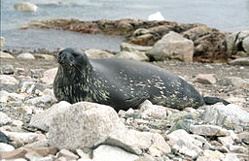

By Jerzystrzelecki (own work) [CC BY 3.0] via Wikimedia Commons

(i)      Explain how the body shape of a Weddell seal is an adaptation to living in a cold environment.

...............................................................................................................

...............................................................................................................

...............................................................................................................

...............................................................................................................

**(2)**

(ii)     Weddell seals can remain underwater for long periods of time. **Figure 2** shows the rate of blood flow to different organs of a Weddell seal before a dive and during a long dive.

**Figure 2**

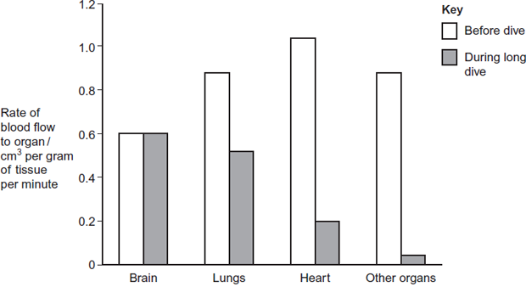  
        Organ

Describe and explain the changes in the rate of blood flow to the different organs during a long dive.

...............................................................................................................

...............................................................................................................

...............................................................................................................

...............................................................................................................

...............................................................................................................

...............................................................................................................

*(Extra space)* ........................................................................................

...............................................................................................................

...............................................................................................................

**(3)**

**(Total 8 marks)**

**Q33.**(a)    The table shows three statements about some biological molecules. Complete the table with a tick in each box if the statement is true for haemoglobin, cellulose or starch.

|  |  |  |  |  |
| --- | --- | --- | --- | --- |
|  | **Statement** | **Haemoglobin** | **Cellulose** | **Starch** |
|  | Has a quaternary structure |  |  |  |
|  | Formed by condensation reactions |  |  |  |
|  | Contains nitrogen |  |  |  |

**(3)**

The graph shows oxygen dissociation curves for the haemoglobin of a mother and her fetus.

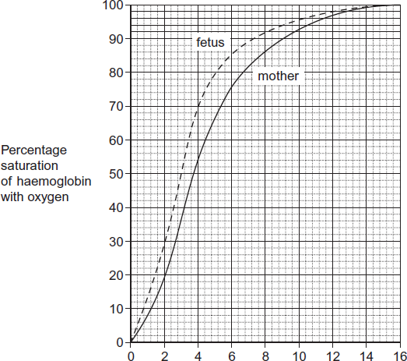

Partial pressure of oxygen (pO2) / kPa

(b)     What is the difference in percentage saturation between the haemoglobin of the mother and her fetus at a partial pressure of oxygen (pO2) of 4 kPa?



**(1)**

(c)     The oxygen dissociation curve of the fetus is to the left of that for its mother. Explain the advantage of this for the fetus.

........................................................................................................................

........................................................................................................................

........................................................................................................................

........................................................................................................................

........................................................................................................................

**(2)**

(d)     After birth, fetal haemoglobin is replaced with adult haemoglobin. Use the graph to suggest the advantage of this to the baby.

........................................................................................................................

........................................................................................................................

........................................................................................................................

........................................................................................................................

........................................................................................................................

........................................................................................................................

**(2)**

(e)     Hereditary persistence of fetal haemoglobin (HPFH) is a condition in which production of fetal haemoglobin continues into adulthood. Adult haemoglobin is also produced.

People with HPFH do not usually show symptoms. Suggest why.

........................................................................................................................

........................................................................................................................

........................................................................................................................

**(1)**

**(Total 9 marks)**

**Q34.**(a)    Describe how a heartbeat is initiated and coordinated.

**(5)**

(b)     Explain how the heart muscle and the heart valves maintain a one-way flow of blood from the left atrium to the aorta.

**(5)**

**(Total 10 marks)**

**Q35.**Scientists investigated the effect of a 6-week exercise programme on the resting heart rate of males and females.

The scientists recruited a large group of male volunteers and a large group of female volunteers. They measured the resting heart rate of each volunteer before the exercise programme. Both groups took part in the same exercise programme. The scientists measured the resting heart rate of each volunteer after the exercise programme.

The scientists determined the mean resting heart rate and the range of resting heart rates for each group before and after the exercise programme. The graph shows their results.

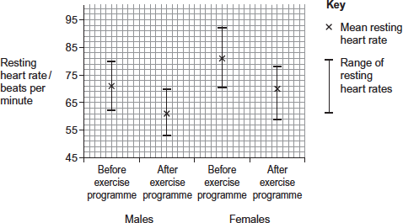

(a)     What was the range of the resting heart rates in males after the exercise programme?

........................................................................................................................

**(1)**

(b)     Calculate the percentage decrease in the mean resting heart rate of females after the exercise programme. Show your working.

Answer = ............................ %

**(2)**

(c)     The scientists used the percentage change in the mean resting heart rate after the exercise programme to compare the results for males and females.

Explain why they used percentage change in the resting heart rate.

........................................................................................................................

........................................................................................................................

........................................................................................................................

........................................................................................................................

........................................................................................................................

**(2)**

(d)     The scientists calculated the cardiac output of the volunteers before and after the exercise programme. In some volunteers, their cardiac output stayed the same, even though their resting heart rate decreased.

Explain how their cardiac output could stay the same even when their resting heart rate had decreased.

........................................................................................................................

........................................................................................................................

........................................................................................................................

........................................................................................................................

........................................................................................................................

**(2)**

**(Total 7 marks)**

**Q36.**The figure below shows recordings made from the heart of a dog.

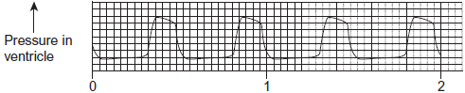  
                        Time / seconds

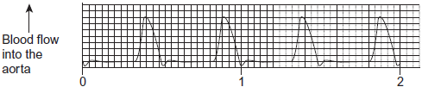  
                        Time / seconds

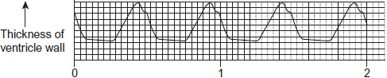  
                        Time / seconds

(a)     Use information from the figure to explain how the pressure in the dog’s ventricle is related to blood flow into the aorta.

........................................................................................................................

........................................................................................................................

........................................................................................................................

........................................................................................................................

*(Extra space)* .................................................................................................

........................................................................................................................

**(2)**

(b)     Use information from the figure to explain how the pressure in the dog’s ventricle is related to the thickness of the ventricle wall.

........................................................................................................................

........................................................................................................................

........................................................................................................................

........................................................................................................................

*(Extra space)* .................................................................................................

........................................................................................................................

**(2)**

(c)     Use the figure to calculate the heart rate of the dog in beats per minute.  
Show your working.

Heart rate ........................................... beats per minute

**(2)**

**(Total 6 marks)**

**Q37.** The pressure of the blood in an artery was measured during a cardiac cycle. The minimum pressure was 9.6 kPa and the maximum pressure was 13.4 kPa.

(a)     Describe how the increase in pressure of the blood in the artery results from the events in the cardiac cycle.

......................................................................................................................

......................................................................................................................

......................................................................................................................

......................................................................................................................

**(2)**

(b)     The elastin fibres in the wall of the artery help to smooth out the flow of blood. What happens to these fibres as the pressure of the blood in the artery changes?

......................................................................................................................

......................................................................................................................

......................................................................................................................

......................................................................................................................

**(2)**

(c)     Give **one** way in which the structure of the wall of an artery is similar to the structure of the wall of a capillary.

......................................................................................................................

......................................................................................................................

**(1)**

**(Total 5 marks)**

**Q38.**          The chart shows the change in the speed of flow and pressure of blood from the start of the aorta into the capillaries.

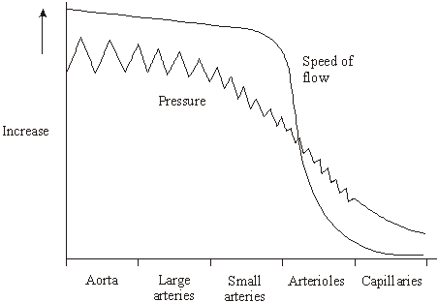

(a)     Describe and explain the changes in the speed of flow of the blood shown in the chart.

......................................................................................................................

......................................................................................................................

......................................................................................................................

......................................................................................................................

**(2)**

(b)     Explain how the structure of the arteries reduces fluctuations in pressure.

......................................................................................................................

......................................................................................................................

......................................................................................................................

......................................................................................................................

**(2)**

(c)     Explain how the structure of capillaries is related to their function.

......................................................................................................................

......................................................................................................................

......................................................................................................................

......................................................................................................................

**(2)**

(d)     In one cardiac cycle, the volume of blood flowing out of the heart along the pulmonary artery is the same as the volume of blood returning along the pulmonary vein. Explain why the volumes are the same although the speed of flow in the artery is greater than in the vein.

......................................................................................................................

......................................................................................................................

**(1)**

**(Total 7 marks)**

**Q39.**          The graph shows changes in pressure in different parts of the heart during a period of one second.

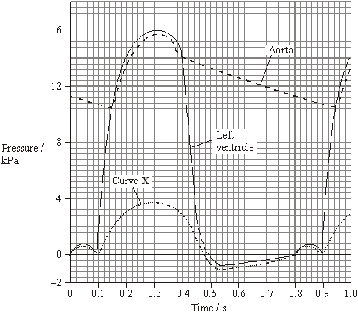

(a)     (i)      At what time do the semilunar valves close?

.............................................................................................................

**(1)**

(ii)     Use the graph to calculate the heart rate in beats per minute.

Show your working.

Answer ............................. beats per minute

**(1)**

(iii)     Use the graph to calculate the total time that blood flows out of the left side of the heart during one minute when beating at this rate. Show your working.

Answer ........................... seconds

**(1)**

(b)     What does curve **X** represent? Explain your answer.

**X** = ...............................................................................................................

Explanation ..................................................................................................

......................................................................................................................

**(2)**

(c)     The volume of blood pumped out of the left ventricle during one cardiac cycle is called the stroke volume.

The volume of blood pumped out of the left ventricle in one minute is called the cardiac output. It is calculated using the equation

Cardiac output = stroke volume × heart rate

After several months of training, an athlete had the same cardiac output but a lower resting heart rate than before. Explain this change.

......................................................................................................................

......................................................................................................................

......................................................................................................................

......................................................................................................................

**(2)**

**(Total 7 marks)**

**Q40.** The graph shows dissociation curves for human oxyhaemoglobin at rest and during exercise.

**Table 1** gives information about conditions in the body at rest and during exercise.

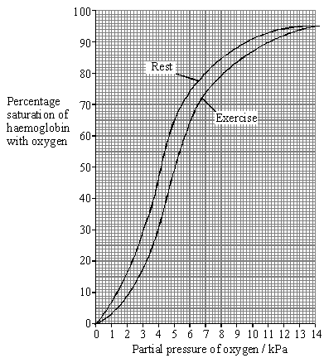

|  |  |  |
| --- | --- | --- |
|  | **Rest** | **Exercise** |
| **Plasma pH** | 7.4 | 7.2 |
| **Blood temperature / °C** | 37.0 | 39.0 |
| **Alveolar partial pressure of oxygen / kPa** | 13.3 | 13.3 |
| **Tissue partial pressure of oxygen / kPa** | 5.0 | 4.0 |

**Table 1**

(a)     What is meant by the term *partial pressure*?

......................................................................................................................

......................................................................................................................

**(1)**

(b)     Use **Table 1** and the graph to calculate the difference in the percentage saturation of haemoglobin in the tissues between rest and exercise.

Answer ............................ %

**(1)**

(c)     Explain the differences between the figures shown in **Table 1** for rest and exercise.

......................................................................................................................

......................................................................................................................

......................................................................................................................

......................................................................................................................

......................................................................................................................

......................................................................................................................

......................................................................................................................

......................................................................................................................

**(4)**

(d)     Explain the advantage of the difference in position of the dissociation curve during exercise.

......................................................................................................................

......................................................................................................................

......................................................................................................................

......................................................................................................................

**(2)**

**Table 2** shows how the oxygen concentration in the blood going to and from a muscle changes from rest to heavy exercise.

|  |  |  |  |
| --- | --- | --- | --- |
|  | | **Oxygen concentration / cm3 per 100 cm3 blood** | |
|  | | **Blood in arteries** | **Blood in veins** |
| **At rest** | **In solution** | 0.3 | 0.2 |
| **As oxyhaemoglobin** | 19.5 | 15.0 |
| **Total oxygen** | 19.8 | 15.2 |
| **During heavy exercise** | **In solution** | 0.3 | 0.1 |
| **As oxyhaemoglobin** | 20.9 | 5.3 |
| **Total oxygen** | 21.2 | 5.4 |

**Table 2**

(e)     By how many times is the volume of oxygen removed from the blood by the muscle in **Table 2** during heavy exercise greater than the volume removed at rest?

Show your working.

Answer ..................................... times

**(2)**

(f)      Does enriching inspired air with oxygen have any effect on the amount of oxygen reaching the tissues? Support your answer with evidence from the graph and **Table 2**.

......................................................................................................................

......................................................................................................................

......................................................................................................................

......................................................................................................................

......................................................................................................................

......................................................................................................................

**(3)**

**S** (g)     The change to the dissociation curve is one of a number of ways in which the total oxygen supplied to muscles is increased during exercise. Give **two** other ways in which the total oxygen supplied to muscles during exercise is increased.

1 ...................................................................................................................

......................................................................................................................

2 ...................................................................................................................

......................................................................................................................

**(2)**

**(Total 15 marks)**

**Q41.**          (a)     Explain why both the heart and arteries are described as organs.

......................................................................................................................

......................................................................................................................

**(1)**

The table shows changes in the volume of blood in the left ventricle over a period of one second.

|  |  |
| --- | --- |
| **Time / s** | **Volume of blood as percentage of maximum** |
| 0 | 70 |
| 0.1 | 100 |
| 0.2 | 70 |
| 0.3 | 30 |
| 0.4 | 0 |
| 0.5 | 35 |
| 0.6 | 60 |
| 0.7 | 70 |
| 0.8 | 70 |
| 0.9 | 100 |
| 1.0 | 70 |

Use information in the table to answer the following questions.

(b)     What is the approximate length of one cardiac cycle?

......................................................................................................................

**(1)**

(c)     At what time is there least blood in the *right* ventricle? Explain your answer.

......................................................................................................................

......................................................................................................................

**(1)**

(d)     (i)      Between which times are the muscles in the wall of the left atrium contracting?

Give the reason for your answer.

Times ..................................................................................................

Reason ................................................................................................

.............................................................................................................

**(1)**

(ii)     Between which times are the semilunar valves in the arteries open? Give the reason for your answer.

Times ..................................................................................................

Reason ................................................................................................

.............................................................................................................

**(1)**

(e)     The maximum volume of blood in the left ventricle is 45 cm3. Calculate the volume of blood in the left ventricle at 0.5 s. Show your working.

Volume of blood = ................................................. cm3

**(2)**

**(Total 7 marks)**

**Q42.** Lung cancer, chronic bronchitis and coronary heart disease (CHD) are associated with smoking. **Tables 1** and **2** give the total numbers of deaths from these diseases in the UK in 1974.

**Table 1 Men**

|  |  |  |  |
| --- | --- | --- | --- |
| **Age/years** | **Number of deaths (in thousands)** | | |
|  | lung cancer | chronic bronchitis | coronary heart disease |
| 35 - 64 | 11.5 | 4.2 | 31.7 |
| 65 - 74 | 12.6 | 8.5 | 33.3 |
| 75+ | 5.8 | 8.1 | 29.1 |
| Total (35 - 75+) | 29.9 | 20.8 | 94.1 |

**Table 2 Women**

|  |  |  |  |
| --- | --- | --- | --- |
| **Age/years** | **Number of deaths (in thousands)** | | |
|  | lung cancer | chronic bronchitis | coronary heart disease |
| 35 – 64 | 3.2 | 1.3 | 8.4 |
| 65 – 74 | 2.6 | 1.9 | 18.2 |
| 75+ | 1.8 | 3.5 | 42.3 |
| Total (35 – 75+) | 7.6 | 6.7 | 68.9 |

(i)      Using an example from the tables, explain why it is useful to give data for men and women separately.

......................................................................................................................

......................................................................................................................

......................................................................................................................

**(2)**

(ii)     Data like these are often given as percentages of people dying from each cause.

Explain the advantage of giving these data as percentages.

......................................................................................................................

......................................................................................................................

......................................................................................................................

......................................................................................................................

**(2)**

**(Total 4 marks)**

**Q43.**(a)     What is the function of the coronary arteries?

........................................................................................................................

........................................................................................................................

........................................................................................................................

........................................................................................................................

........................................................................................................................

**(2)**

(b)     **Figure 1** shows some of the large blood vessels in a mammal.

**Figure 1**

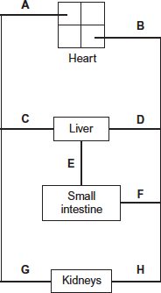

(i)      Which of the blood vessels **A** to **H** is the vena cava?



**(1)**

(ii)     Which of the blood vessels **A** to **H** is the renal artery?



**(1)**

(c)     **Figure 2** shows how the blood pressure changes as blood travels from the aorta to the capillaries.

**Figure 2**

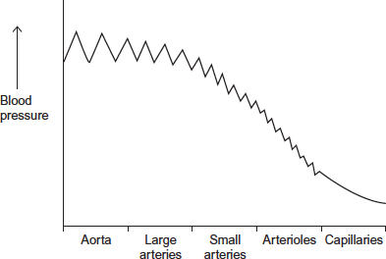

The rise and fall in blood pressure in the aorta is greater than in the small arteries.Suggest why.

........................................................................................................................

........................................................................................................................

........................................................................................................................

........................................................................................................................

........................................................................................................................

........................................................................................................................

**[Extra space]** ................................................................................................

........................................................................................................................

........................................................................................................................

**(3)**

**(Total 7 marks)**

**Q44.**          (a)     Tissue fluid is formed from blood plasma. Complete the table to show substances present in tissue fluid and blood plasma. Use a tick if the substance is present and a cross if it is absent.

|  |  |  |  |  |
| --- | --- | --- | --- | --- |
|  | **Substance** | | | |
|  | **Glucose** | **Sodium ions** | | **Haemoglobin** |
| Tissue fluid |  | |  |  |
| Blood plasma |  | |  |  |
|  |  |  |  |  |

**(2)**

(b)     The hydrostatic pressure of the blood at the arteriole end of the capillary helps to form tissue fluid. Explain how.

......................................................................................................................

......................................................................................................................

......................................................................................................................

......................................................................................................................

**(2)**

**(Total 4 marks)**

**Q45.**          (a)     Haemoglobin is a protein with a quaternary structure. What is meant by a *quaternary* structure?

......................................................................................................................

......................................................................................................................

**(1)**

(b)     Explain how oxygen in a red blood cell is made available for respiration in active tissues.

......................................................................................................................

......................................................................................................................

......................................................................................................................

......................................................................................................................

......................................................................................................................

......................................................................................................................

**(3)**

(c)     Haemoglobin is broken down in the liver. One product of this breakdown is amino acids. Give **one** use in the body of these amino acids.

......................................................................................................................

......................................................................................................................

**(1)**

**(Total 5 marks)**

**Q46.**          (a)     The graph shows hourly blood pressure recordings from a group of 65 people.

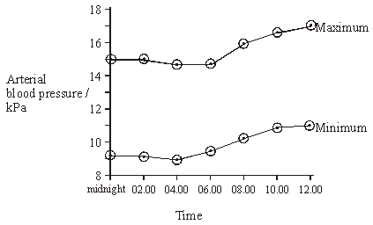

(i)      Describe how the mean maximum arterial blood pressure changes over the period shown in the graph.

.............................................................................................................

.............................................................................................................

**(1)**

(ii)     In each cardiac cycle, the arterial pressure has a maximum value. Explain the link between this maximum value and the events of the cardiac cycle.

.............................................................................................................

.............................................................................................................

**(1)**

(iii)     The recordings shown in this graph were taken from an artery. Describe **two** ways in which you would expect blood pressure in a vein to differ from that in an artery.

1 ....................................................................…..................................

............................................................................................................

2 ....................................................................…..................................

.............................................................................................................

**(2)**

(b)     Molecules of different substances differ in size. The relative molecular mass of a substance gives an indication of the size of its molecules. The table shows the relative permeability of the wall of a capillary to different molecules.

|  |  |  |  |
| --- | --- | --- | --- |
|  | **Substance** | **Relative molecular mass** | **Relative permeability of capillary wall** |
|  | Water  Urea  Glucose  Haemoglobin  Albumin (plasma protein)  Globulin (plasma protein) | 18  60  180  68 000  69 000  140 000 | 1.00  0.96  0.60  0.01  0  0 |

(i)      Describe the relationship between molecule size and the permeability of the capillary wall.

.............................................................................................................

.............................................................................................................

.............................................................................................................

.............................................................................................................

**(2)**

(ii)     The water potential of the plasma at the venule end of the capillary is more negative than the water potential at the arteriole end. Use the table to explain why.

.............................................................................................................

.............................................................................................................

.............................................................................................................

.............................................................................................................

**(2)**

(iii)     Although the capillary walls are slightly permeable to haemoglobin molecules, there is no haemoglobin in the tissue fluid. Explain what causes the absence of haemoglobin in tissue fluid.

.............................................................................................................

.............................................................................................................

**(1)**

**(Total 9 marks)**

**Q47.**          (a)     Explain how the shape of a red blood cell allows it to take up a large amount of oxygen in a short time.

......................................................................................................................

......................................................................................................................

......................................................................................................................

......................................................................................................................

**(2)**

Samples of blood were mixed with equal volumes of different liquids. A drop of each mixture was put on a slide and examined with an optical microscope. The table shows the appearance of each slide.

|  |  |  |  |
| --- | --- | --- | --- |
|  | **Slide** | **Liquid added** | **Appearance of slide** |
|  | **A** | Distilled water | No cells seen. Slide appears a uniform pale red colour |
|  | **B** | Sucrose solution | Cells are smaller in diameter than in an untreated sample of blood |
|  | **C** | Detergent (dissolves lipids) | No cells seen. Slide appears a uniform pale red colour |

(b)     (i)      What does the appearance of slide **B** tell you about the plasma membrane surrounding a red blood cell?

.............................................................................................................

.............................................................................................................

**(1)**

(ii)     Explain the appearance of slide **C**.

.............................................................................................................

.............................................................................................................

.............................................................................................................

.............................................................................................................

**(2)**

**(Total 5 marks)**

**Q48.**          A frog’s heart was attached to an instrument which measured the force produced as the heart contracted. **Graph 1** shows the changes in force when the heart was bathed in a solution of salts at 20 °C. **Graph 2** shows the results when the heart was bathed in the same solution at the same temperature, but including acetylcholine.

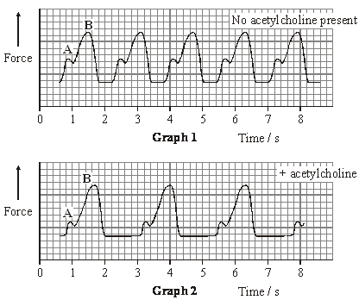

(a)     Points **A** and **B** show when the atria and ventricle were contracting. Which point, **A** or **B**, shows contraction of the ventricle? Give **two** reasons for your answer.

Point .....................................

Reason 1 ......................................................................................................

......................................................................................................................

Reason 2 ......................................................................................................

......................................................................................................................

**(2)**

(b)     Calculate the frog’s heart rate when acetylcholine was **not** present. Show your working.

Heart rate = .................................... beats per minute.

**(2)**

(c)     (i)      From the graphs, what can you conclude about the effect of acetylcholine on

heart rate;

.............................................................................................................

stroke volume?

.............................................................................................................

**(2)**

(ii)     Use your answer to part (i) to explain the effect of acetylcholine on cardiac output.

.............................................................................................................

.............................................................................................................

**(1)**

(iii)     Addition of acetylcholine in the experiment mimics the effect of one branch of the autonomic nervous system. Which branch is this?

.............................................................................................................

**(1)**

(d)     (i)      Explain how nervous control in a human can cause increased cardiac output during exercise.

.............................................................................................................

.............................................................................................................

.............................................................................................................

.............................................................................................................

.............................................................................................................

.............................................................................................................

.............................................................................................................

.............................................................................................................

**(4)**

(ii)     Explain why increased cardiac output is an advantage during exercise.

.............................................................................................................

.............................................................................................................

.............................................................................................................

.............................................................................................................

.............................................................................................................

.............................................................................................................

**(3)**

**(Total 15 marks)**

**Q49.**          (a)     The table shows some data for a shrew and an elephant.

|  |  |  |  |
| --- | --- | --- | --- |
|  |  | **Shrew** | **Elephant** |
|  | **Body mass** | 10 g | 5000 kg |
|  | **Volume of oxygen taken up per hour** | 20 cm3 | 52.5 dm3 |

The rate of oxygen uptake for the shrew is 2 cm3g–1h–1. Calculate the volume of oxygen taken up per gram of body tissue per hour in the elephant.  
Show your working.

Answer ................................... cm3g–1h–1

**(2)**

(b)     The graph shows the oxyhaemoglobin dissociation curves for these mammals.

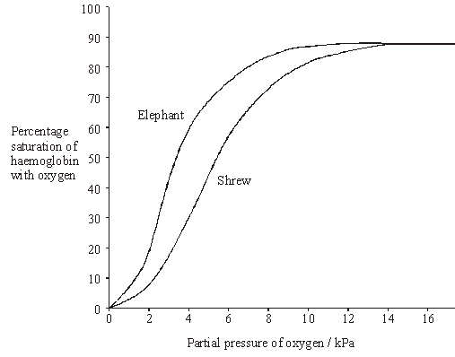

The tissues of the shrew have a higher rate of oxygen consumption per gram of body tissue than the elephant. There is an advantage to the shrew in having haemoglobin with a dissociation curve in the position shown. Explain this advantage.

......................................................................................................................

......................................................................................................................

......................................................................................................................

......................................................................................................................

......................................................................................................................

......................................................................................................................

**(3)**

**(Total 5 marks)**

**Q50.**          The graph shows changes in the volume of blood in the left ventricle.

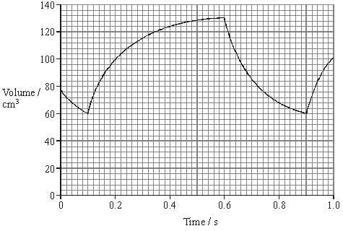

(a)     Between which times is the left *atrium* contracting? Give the evidence from the graph that supports your answer.

Times ...........................................................................................................

Evidence ......................................................................................................

......................................................................................................................

**(2)**

(b)     Use the graph to calculate.

(i)      the heart rate;

Answer ............................................

**(2)**

(ii)     stroke volume.

Answer ............................................

**(1)**

(c)     Describe how you would calculate cardiac output from heart rate and stroke volume.

......................................................................................................................

......................................................................................................................

**(1)**

The table shows the rate of blood flow to some organs when a person is at rest and during a period of vigorous exercise.

|  |  |  |
| --- | --- | --- |
| **Organ** | **Rate of blood flow / cm3 minute–1** | |
| **at rest** | **during exercise** |
| Skeletal muscles | 1 000 | 16 000 |
| Kidney | 1 200 | 1 200 |
| Brain | 750 |  |
| Heart muscle | 300 | 1 200 |

(d)     Suggest a value for the rate of blood flow to the brain during exercise.

......................................................................................................................

**(1)**

(e)     (i)      The coronary arteries take blood to the muscles in the wall of the heart. Calculate the ratio of the rate of blood flow into the coronary arteries during exercise to the rate flowing into these arteries at rest.

Answer.............................................

**(1)**

(ii)     At rest the rate of flow of blood to the heart muscle is 0.9 cm3 g–1 per minute. Calculate the volume of blood 1g of heart muscle would receive in 5 minutes of vigorous exercise.

Answer.............................................

**(1)**

**(Total 9 marks)**

**Q51.**          The table shows the relative thickness of layers in the walls of an artery and a vein.

|  |  |  |  |
| --- | --- | --- | --- |
|  | **Layer in wall** | **Thickness / µm** | |
|  |  | **Artery** | **Vein** |
|  | Endothelium | 20 | 20 |
|  | Smooth muscle | 490 | 240 |
|  | Elastic tissue | 370 | 240 |
|  | Connective tissue | 120 | 120 |

(a)     Explain why a vein may be described as an organ.

......................................................................................................................

......................................................................................................................

**(1)**

(b)     (i)      Use information from the table to suggest the thickness of a capillary wall.   
Give the reason for your answer.

.............................................................................................................

.............................................................................................................

**(1)**

(ii)     The diameter of the artery was 4 mm. Calculate the diameter of the lumen of this artery. Show your working.

Answer .................................

**(2)**

(c)     Explain how the elastic tissue in the wall helps to even out the pressure of blood flowing through the artery.

......................................................................................................................

......................................................................................................................

......................................................................................................................

......................................................................................................................

**(2)**

**(Total 6 marks)**

﻿

**Q52.**The mean internal diameter and the mean speed of blood flow for different human blood vessels are shown below in the table.

|  |  |  |  |
| --- | --- | --- | --- |
|  | **Blood vessel** | **Mean internal diameter / mm** | **Mean speed of blood flow / mm s−1** |
|  | Aorta | 35 | 470 |
|  | Coronary artery | 4 | 380 |
|  | Arteriole | 0.03 | 110 |
|  | Capillary | 0.001 | 15 |
|  | Vena cava | 20 | 270 |

(a)     Although the speed of blood flow in an arteriole is greater than speed of blood flow in a capillary, blood does **not** accumulate in the arterioles.

Explain why.

........................................................................................................................

........................................................................................................................

........................................................................................................................

**(1)**

(b)     Other than causing slow blood flow, explain **one** advantage of capillaries being narrow.

........................................................................................................................

........................................................................................................................

........................................................................................................................

........................................................................................................................

**(2)**

(c)     What factor limits the minimum internal diameter of the lumen of a capillary?

........................................................................................................................

........................................................................................................................

........................................................................................................................

**(1)**

(d)     The volume of blood leaving the capillary network into the veins is less than the volume of blood entering from the arteries.

Explain why.

........................................................................................................................

........................................................................................................................

........................................................................................................................

**(1)**

**(Total 5 marks)**

**Q53.**          This diagram shows a human heart seen from the front.

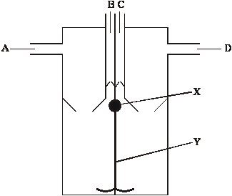

(a)     (i)      Which **one or more** of vessels **A** to **D** contains oxygenated blood?

.............................................................................................................

**(1)**

(ii)     During a cardiac cycle, the pressure of the blood in vessel **C** is higher than the pressure of the blood in vessel **B**. Explain what causes this difference in pressure.

.............................................................................................................

.............................................................................................................

**(1)**

(b)     What does the diagram suggest about the pressure in the atria compared to the pressure in the ventricles at the stage in the cardiac cycle represented in the diagram? Explain your answer.

......................................................................................................................

......................................................................................................................

......................................................................................................................

......................................................................................................................

**(2)**

(c)     The wave of electrical activity which coordinates the heart beat is delayed slightly at part **X**. It then passes along part **Y** to the base of the ventricles.

Explain the importance of

(i)      the slight delay at part **X**;

.............................................................................................................

.............................................................................................................

.............................................................................................................

.............................................................................................................

**(2)**

(ii)     the electrical activity being passed to the base of the ventricles.

.............................................................................................................

.............................................................................................................

.............................................................................................................

.............................................................................................................

**(2)**

**(Total 8 marks)**

﻿

**Q54.**          (a)     The graph shows the heart rates of two men with hypertension. They were watching television. One of the men had taken a beta blocker and the other had taken a placebo (dummy pill).

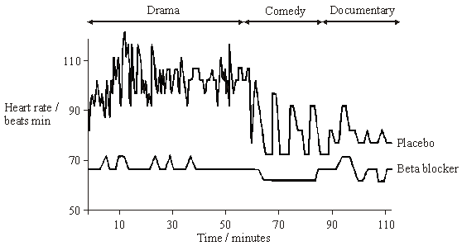

(i)      Use the graph to describe the effects of the beta blocker on heart rate.

................................................................................................................

.............................................................................................................

.............................................................................................................

.............................................................................................................

**(2)**

(ii)     In this investigation, it was important that neither man knew which type of pill he had taken. Suggest why.

.............................................................................................................

.............................................................................................................

**(1)**

(b)     The table shows the results of an investigation into the effects of prescribing beta blockers to patients who had suffered a myocardial infarction.

|  |  |  |
| --- | --- | --- |
| Patient age at time of myocardial infarction / years | Under 60 | 60 – 69 |
| Percentage reduction in mortality within the next 2 years compared with groups who had taken a placebo | 19 | 33 |

(i)      Give **one** conclusion which may be drawn from these data.

.............................................................................................................

.............................................................................................................

**(1)**

(ii)     Explain how the percentage reduction in mortality would have been calculated.

.............................................................................................................

.............................................................................................................

.............................................................................................................

.............................................................................................................

**(2)**

**(Total 6 marks)**

**Q55.**          Seals are mammals. They spend much of the time in water but have lungs and breathe air. When a seal is resting at the surface of the water, the blood flow to each gram of swimming muscles is 0.21 cm3 per minute. When it is swimming under water, the blood flow to different organs changes. The flow to the swimming muscles is then 0.05 cm3 per gram per minute.

(a)     Describe the part played by arterioles in redistributing blood to different organs.

......................................................................................................................

......................................................................................................................

......................................................................................................................

......................................................................................................................

**(2)**

(b)     (i)      Describe how the change in blood flow to the muscles of a seal differs from the change in blood flow to human muscles as activity increases.

.............................................................................................................

.............................................................................................................

**(1)**

(ii)     Suggest the advantage to the seal of the change in blood flow to the muscles.

.............................................................................................................

.............................................................................................................

.............................................................................................................

.............................................................................................................

**(2)**

**(Total 5 marks)**

**Q56.**          Relaxation of heart muscle is called diastole. Contraction is called systole. The diagram shows the periods of diastole and systole when the heart is beating.

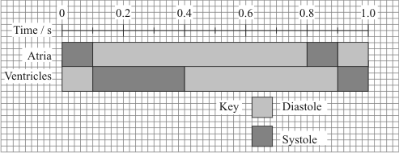

(a)     At what time is the volume of blood in the ventricle at a maximum?

......................................................................................................................

**(1)**

(b)     Calculate the heart rate in beats per minute. Show your working.

Heart rate = ................................... beats per minute

**(2)**

(c)     The valves between the atria and the ventricles are closed between 0.1 s and 0.4 s.

(i)      Explain how pressure causes these valves to be shut.

.............................................................................................................

.............................................................................................................

**(1)**

(ii)     Explain how closure of these valves is essential to the functioning of the heart.

.............................................................................................................

.............................................................................................................

**(1)**

The graph shows the effect of the pressure of blood in the veins on the stroke volume of the heart.

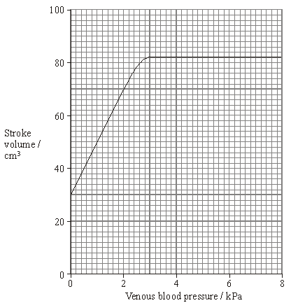

(d)     Describe how venous blood pressure affects stroke volume.

......................................................................................................................

......................................................................................................................

......................................................................................................................

......................................................................................................................

**(2)**

(e)     At a venous pressure of 2 kPa, the cardiac output is 5600 cm3 per minute. Calculate the number of times the ventricle contracts in one minute. Show your working.

Answer ......................................

**(2)**

(f)      Explain how blood in a vein in the leg is returned to the heart.

......................................................................................................................

......................................................................................................................

......................................................................................................................

......................................................................................................................

......................................................................................................................

......................................................................................................................

......................................................................................................................

......................................................................................................................

......................................................................................................................

......................................................................................................................

......................................................................................................................

......................................................................................................................

......................................................................................................................

......................................................................................................................

......................................................................................................................

**(6)**

**(Total 15 marks)**

**Q57.**          Ions of metals such as zinc often pollute rivers. The effect of zinc ions on gas exchange and respiration in fish was investigated. Fish were kept in tanks of water in a laboratory.

The fish in one group (**X**) had a solution of a zinc compound injected directly into their blood and were then put in a tank of zinc-free water. A second group (**Y**) was not injected but had the solution of the zinc compound added to the water in the tank.

The partial pressure of oxygen in the blood of both groups of fish was then monitored. The results are shown in the graph.

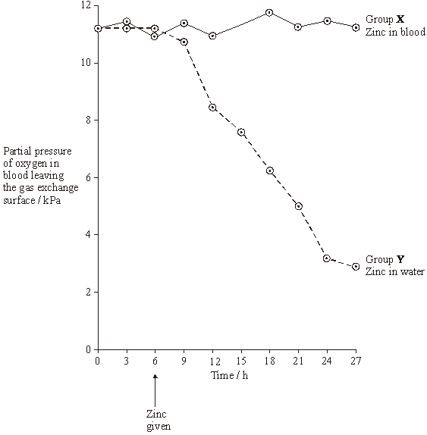

(a)     During this investigation, the water temperature in the tanks was kept constant. Explain why changes in the water temperature might lead to the results of the investigation being unreliable.

......................................................................................................................

......................................................................................................................

**(1)**

(b)     The results from the two groups were compared using a statistical test.

(i)      Suggest a null hypothesis that could be tested.

.............................................................................................................

**(1)**

(ii)     Explain why it is important to use a statistical test in analysing the results of this investigation.

.............................................................................................................

.............................................................................................................

.............................................................................................................

.............................................................................................................

**(2)**

(c)     Two suggestions were made to explain the results shown in the graph.

**A**       Zinc ions reduce the rate at which oxygen is taken up from the water and passes into the blood.

**B**       Zinc ions reduce the ability of haemoglobin to transport oxygen.

Which of these suggestions is the more likely? Explain the evidence from the graph that supports your answer.

......................................................................................................................

......................................................................................................................

......................................................................................................................

......................................................................................................................

**(2)**

(d)     During the investigation, the pH of the blood was also monitored. It decreased in group **Y**. Suggest an explanation for this decrease in pH.

......................................................................................................................

......................................................................................................................

......................................................................................................................

......................................................................................................................

......................................................................................................................

......................................................................................................................

**(3)**

(e)     Leaves were collected from sycamore trees growing in a polluted wood and the concentration of some metal ions in samples of these leaves was measured. Woodlice were then fed with the leaves. After 20 weeks, the concentration of the ions in the bodies of the woodlice was measured. Some of the results are shown in the table.

|  |  |  |  |  |
| --- | --- | --- | --- | --- |
|  | **Concentration of ions / µg g–1** | | | |
|  | Copper | Cadmium | Zinc | Lead |
| Leaves | 52 | 26 | 1430 | 908 |
| Woodlice | 1130 | 525 | 1370 | 132 |

(i)      Which of the elements shown in the table is concentrated most by the woodlice? Use suitable calculations to support your answer.

**(2)**

(ii)     Suggest what happens to most of the lead ions in the leaves eaten by the woodlice.

.............................................................................................................

.............................................................................................................

**(1)**

(iii)     Explain the difference in the copper ion concentration between the leaves and the woodlice.

.............................................................................................................

.............................................................................................................

.............................................................................................................

.............................................................................................................

**(2)**

(f)      Yorkshire fog is a species of grass. Two varieties of Yorkshire fog were studied. One variety was tolerant to arsenic, while the other variety was not. In a series of investigations, it was found that

•        Arsenic-tolerant plants grow in soil which contains a high concentration of arsenic.

•        Arsenic-tolerant plants growing in soil containing high concentrations of arsenic and phosphorus-containing compounds have very low concentrations of arsenic in their cells. They also have low concentrations of phosphates in their cells. Arsenic and phosphorus are chemically similar.

•        Plants that are not tolerant to arsenic grow poorly on soil which has a high concentration of both arsenic and phosphorus-containing compounds.

•        Tolerance to arsenic in Yorkshire fog is caused by a single gene with the allele, **a**, for tolerance recessive to the allele, **A**, for non-tolerance.

(i)      What caused the allele for tolerance to first arise?

.............................................................................................................

.............................................................................................................

**(1)**

(ii)     Give **two** functions of phosphates in plant cells.

1 ..........................................................................................................

.............................................................................................................

2 ..........................................................................................................

.............................................................................................................

**(2)**

(iii)     Arsenic-tolerant Yorkshire fog plants are very rare in areas with low concentrations of arsenic in the soil, even where the soil has a high concentration of phosphate. Explain why they are unable to compete in these conditions with plants that are not tolerant to arsenic.

.............................................................................................................

.............................................................................................................

.............................................................................................................

.............................................................................................................

.............................................................................................................

.............................................................................................................

**(3)**

**(Total 20 marks)**

**Q58.**          The graph shows the oxyhaemoglobin dissociation curve at two different partial pressures of carbon dioxide (pCO2).

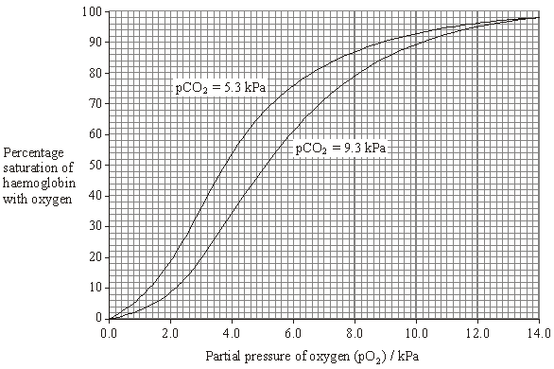

(a)     During vigorous exercise, the blood entering a leg muscle had a pO2 of 4 kPa and a pCO2 of 5.3 kPa. The blood leaving the muscle had a pO2 of 2.8 kPa and a pCO2 of 9.3 kPa. Each dm3 of blood leaving the lungs contained 200 cm3 oxygen and was 98% saturated with oxygen.

Use this information and information from the graph to calculate the volume of oxygen released to the muscle from 1 dm3 of blood. Show your working.

Answer ...................................... cm3 oxygen

**(2)**

**S**       (b)     The blood leaving a muscle has a lower pH than the blood entering it. During vigorous exercise, the fall in pH is even greater. Explain what causes this greater fall in pH.

......................................................................................................................

......................................................................................................................

......................................................................................................................

......................................................................................................................

......................................................................................................................

......................................................................................................................

**(3)**

**(Total 5 marks)**

**Q59.**The figure below represents a capillary surrounded by tissue fluid.  
The values of the hydrostatic pressure are shown.

|  |  |  |  |
| --- | --- | --- | --- |
|  | **Arteriole end** | *direction of blood flow* | **Venule end** |
|  | Hydrostatic pressure = 4.3 kPa                                Hydrostatic pressure = 1.6 kPa | | |
|  | **Tissue fluid** Hydrostatic pressure = 1.1 kPa | | |

(a)     Use the information in the figure above to explain how tissue fluid is formed.

........................................................................................................................

........................................................................................................................

........................................................................................................................

........................................................................................................................

**(2)**

(b)     The hydrostatic pressure falls from the arteriole end of the capillary to the venule end of the capillary. Explain why.

........................................................................................................................

........................................................................................................................

**(1)**

(c)     High blood pressure leads to an accumulation of tissue fluid. Explain how.

........................................................................................................................

........................................................................................................................

........................................................................................................................

........................................................................................................................

........................................................................................................................

........................................................................................................................

**(Extra space)** .................................................................................................

........................................................................................................................

........................................................................................................................

**(3)**

(d)     The water potential of the blood plasma is more negative at the venule end of the capillary than at the arteriole end of the capillary. Explain why.

........................................................................................................................

........................................................................................................................

........................................................................................................................

........................................................................................................................

........................................................................................................................

........................................................................................................................

**(Extra space)** .................................................................................................

........................................................................................................................

........................................................................................................................

**(3)**

**(Total 9 marks)**

**Q60.**A principle of homeostasis is the maintenance of a constant internal environment. An increase in the concentration of carbon dioxide would change the internal environment and blood pH.

Explain the importance of maintaining a constant blood pH.

.................................................................................................................................

.................................................................................................................................

.................................................................................................................................

.................................................................................................................................

.................................................................................................................................

.................................................................................................................................

**[Extra space]** .........................................................................................................

.................................................................................................................................

.................................................................................................................................

.................................................................................................................................

**(Total 3 marks)**

**M1.**(a)     Aorta;

**1**

(b)     1.      Left ventricle pumps to whole body (except lungs) / pumps blood further;

*Accept converse for right ventricle*

*Reject ‘push’*

2.      Left ventricle does most work / produces a greater pressure / produces a greater force;

**2**

(c)     1.      (Valve **A**) atrioventricular valve;

*Accept bicuspid / mitral*

2.      Semi-lunar valve;

*Accept aortic valve*

*Ignore references to left and right*

**2**

(d)     **X** because (no mark)

*Accept other valid calculations - probabilities*

1.      52.1% survived without replacement compared to 12.1% / difference of 40%;

*If correct figures written in table, award marks*

2.      10.9% required repair or replacement of artificial heart compared to 41.4% / difference of 30.5%;

*Max 2 if incorrect rounding of values*

3.      37% died compared to 46.6% / difference of 9.6%;

***OR***

(X / Y = 119 divided by 58 = 2.05)

14.4; 49.2; 55.4;

*Note that this ratio could be reversed i.e. 58 divided by 119 multiplied by numbers in top row*

*Accept rounded to 14; 49; and 55;*

**3**

**[8]**

**M2.**          (a)     1.      Large surface area provided by lamellae / filaments increases diffusion / makes diffusion efficient;;

***Q*** *Candidates are required to refer to lamellae or filaments. Do not penalise for confusion between two*

2.      Thin epithelium / distance between water and blood;

3.      Water and blood flow in opposite directions / countercurrent;

4.      (Point 4) maintains concentration gradient (along gill) / equilibrium not reached / as water always next to blood with lower concentration of oxygen;

5.      Circulation replaces blood saturated with oxygen;

6.      Ventilation replaces water (as oxygen removed);

**6**

(b)     Mixing of air and water (at surface);

Air has higher concentration of oxygen than water;

Diffusion into water;

Plants / seaweeds near surface / in light;

Produce oxygen by photosynthesis;

**2 max**

(c)     Not much oxygen near sea bed;

Toadfish haemoglobin (nearly) saturated / loads readily at / has higher affinity for oxygen at low partial pressure (of oxygen);

**2**

(d)     The chimpanzee and the bonobo are more closely related (than to the gorilla);

They have identical amino acids / one of the amino acids is different in the gorilla;

**2**

**[12]**

**M3.**          (a)     (i)      the atrioventricular / mitral / bicuspid / tricuspid valves (closing);

**1**

(ii)     pressure in artery greater than pressure in ventricle;

**1**

(b)     correct answer 5250 = 3 marks;  
*where answer incorrect:*one heart beat identified as taking 0.8 s;  
heart rate calculated as 75 (beats per minute);  
cardiac output = heart rate x stroke volume;  
*marking points to be awarded independently but onus on  
candidate to show clearly what has been done*

**3**

**[5]**

**M4.**          (a)     (i)      plasma;

**1**

(ii)     tissue fluid;

**1**

(b)     fluid **Y** contains little / no protein; *reject blood cells*molecules too large (to pass through capillary wall);

**OR**

fluid **Y** contains less glucose;  
some will have entered tissue cells;  
accept any other biologically correct difference marked in a  
similar way.

**2 max**

(c)     hydrostatic pressure / blood pressure / arterial pressure;  
greater than osmotic effect which forces molecules / fluid out;  
*ignore references here to diffusion or osmosis.*

**2**

**[6]**

**M5.**(a)     Loading / uptake / association of oxygen at high p.O2;

In lungs (haemoglobin) is (almost) fully saturated / in lungs haemoglobin has a high affinity for oxygen;

Unloads / releases / dissociates oxygen at low p.O2;

Unloading linked to higher carbon dioxide concentration;

*Allow converse for second marking point in tissues i.e. haemoglobin has low affinity / releases most of its oxygen.*

*Mark for haemoglobin having high affinity for oxygen must be ‘in lungs’.*

**3 max**

(b)     (i)      Larger the mammal the more to the left / steeper / ‘higher’ is the  
curve / the higher the affinity for oxygen;

*Allow converse.*

*Ignore references to Bohr shift*

**1**

(ii)     Smaller mammal has greater surface area to volume ratio;

Smaller mammal / larger SA:Vol ratio more heat lost (per unit body mass);

*Allow converse explanation for larger mammals or lower surface area to volume ratio.*

Smaller mammal / larger SA:Vol ratio has greater rate of respiration / metabolism;

*Allow suitable named mammal as alternative to smaller or larger mammal.*

Oxygen required for respiration so (haemoglobin) releases more oxygen / oxygen released more readily / haemoglobin has lower affinity;

**4**

**[8]**

**M6.**         1.      SAN initiates heartbeat / acts as a pacemaker / myogenic;

***Q*** *Must be in context*

2.      (SAN) sends wave of electrical activity / impulses (across atria) causing atrial contraction;

*Reject: signals / electronic / messages / nerve impulses once only*

3.      AVN delays (electrical activity / impulses);

*Neutral: reference to non-conducting tissue delaying impulses instead of the AVN*

4.      (Allowing) atria to empty before ventricles contract / ventricles to fill before they contract;

5.      (AVN) sends wave of electrical activity / impulses down Bundle of His / Purkyne fibres;

6.      (Causing) ventricles to contract (from base up) / ventricular systole;

**5 max**

**[5]**

**M7.**          (a)     Arrows on all five vessels in correct direction;

**1**

(b)     E;

**1**

(c)

|  |  |  |
| --- | --- | --- |
| **Feature** | **Vessel C** | **Vessel E** |
| Valves | Absent | Present |
| (Relative) thickness of walls | Thicker | Thinner |
| Elastin / elastic tissue / fibres | More | Less |
| Muscle | More | Less |
| Lumen | Narrow | Wide |

*Two marks for two correct rows*

*Accept any pair of contrasting terms with same meaning as those used.*

**2 max**

(d)     Contracts;

(Causing) vasoconstriction / narrows lumen;

**2**

(e)     (Elastic tissue) stretches when pressure is high;

Springs back / recoils / returns to normal;

***Q*** *Do not credit references to contracting, relaxing or expanding*

**2 max**

**[8]**

**M8.**          (a)     Increase in / more carbon dioxide;

          Curve moves to the right / depressed;

***Q*** *Any reference to haemoglobin increasing affinity for oxygen disqualifies second mark point.*

**2**

(b)     (i)      More haemoglobin;

         So can load / pick up more oxygen (in the lungs);

***Q*** *Second mark point must relate to idea of loading oxygen. Answers referring only to transport of oxygen should not be credited this mark.*

**2**

(ii)     (Haemoglobin) has lower affinity for oxygen / more oxygen released;

         In / to the cells / tissues;

**2**

**[6]**

**M9.**          (a)     (Blood) plasma;

**1**

(b)     More / larger proteins / less urea / carbon dioxide / more glucose / amino acids / fatty acids / oxygen / high(hydrostatic) pressure;

***Q*** *Reference to blood cells / water potential = neutral****Q*** *No Protein should not be credited*

**1**

(c)     (i)      Contracts;

***Q*** *Do not accept pumping of heart / heart beating*

**1**

(ii)     Loss of fluid / volume;

         Friction / resistance (of capillary wall);

***Q*** *Reference to a narrow lumen is not sufficient to gain a mark unless friction or resistance is mentioned.*

**1 max**

(d)     Water potential (in capillary) not as low / is higher / less negative / water potential gradient is reduced;

More tissue fluid formed (at arteriole end);

Less / no water absorbed (into blood capillary) by osmosis; (into blood capillary);

***Q*** *The last two marking points must be in context of movement into the blood capillary*

**3**

**[7]**

**M10.**(a)     Diet including saturated fats leads to higher plasma cholesterol concentrations;  
Higher in all age groups;  
But sample size is very small;  
Standard deviations overlap / suggest wide variation;

**3 max**

(b)     The sex of individual is a risk factor for high cholesterol;  
To remove a / one variable / to establish a fair test;

**2**

(c)     Monkeys and humans closely related therefore similar conclusions might be drawn;  
High concentrations of plasma cholesterol lead to an increased risk of cardiovascular disease in humans;  
Don’t know if diet has the same effect in monkeys (as in humans) / could have different effects because not the same species;

**3**

**[8]**

**M11.**          (a)     (i)      Faster / greater / more effective response in children;

*Do not accept children have more haemoglobin*

**1**

(ii)     Use line of best fit;

**1**

Extrapolate / extend line (and read from graph);

*Allow calculation using rate of increase per day = one mark.  
However for both marks this must be linked to line of best fit.*

**1**

(iii)    More than one polypeptide chain;

*Allow many polypeptide chains.*

*‘Haemoglobin has four polypeptide chains’ must be in correct context to gain mark.*

**1**

(b)     (i)      Has same water potential;

*Allow converse for effect of using distilled water or a concentrated solution.*

**1**

No (net) water movement / osmosis;

**1**

Cells will not swell / burst / change size;

*No osmotic lysis = two marks*

**1**

(ii)     Pernicious anaemia (cells) greater range / spread / variation of diameters / widths;

Some pernicious anaemia (cells) wider than 9 (µm) / some  
less than 5.5 (µm) / without pernicious anaemia none more than 9 (µm) / none less than 5.5 (µm);

Pernicious anaemia (cells) peak / most frequent at 8.5 (µm) / peak / most frequent at higher diameter / / without pernicious anaemia peak / most frequent at 7 (µm) / peaks at lower diameter;

*There are several alternatives for marking points 2 and 3*

**2 max**

**[9]**

**M12.**(a)     (i)      Left ventricle;

**1**

(ii)     Thick muscle / thick walls;

*Accept more muscle / more muscular.*

*Ignore stronger muscle.*

**1**

(b)     (i)      85.7 / 86;

*Accept 85*

*Ignore additional decimal places.*

**1**

(ii)     Two marks for correct answer of 7905 - 7998;

*Accept either formula or illustration with figures from table.*

One mark for incorrect answer in which candidate provides evidence of multiplying heart rate by stroke volume;

**2**

(c)     1.      Closed open;

2.      Open closed;

**2**

**[7]**

**M13.**          (a)     (i)      Healthy volunteers have ‘normally’ functioning vessels;

***OR***

Blood vessel / lumen / diameter not affected by other factors / is of normal size;

*Accept: a valid ethical argument  
e.g. treatment does not harm healthy volunteers*

*Reject: ref. to change in artery thickness*

*Accept: converse arguments for unhealthy volunteers*

*Must be related to this investigation*

*Neutral: to ensure that that the results are due to the independent variable*

**1**

(ii)     Avoids bias / selection (by scientists);

*Neutral: ref. to having the same number / gender / age of people in each group;*

**1**

(b)     (i)      Same as experimental group;

Chocolate with no flavenoids;

*Neutral: no dark chocolate*

*Neutral: placebo*

*Reject: milk chocolate*

*Neutral: ref. to fair testing*

**2**

(ii)     (To ensure that results are) not due to some other substance in the chocolate / due to flavenoids (only);

*Must be related to this investigation*

*Neutral: to ensure that the results are due to the independent variable*

*Neutral: to show results are not due to other factors*

*Neutral: to show results are only due to the chocolate*

*Neutral: to compare results for people who did and did not have flavenoids*

**1**

**[5]**

**M14.**          (a)     Endothelium / epithelium;

*Allow endothelial / epithelial*

*Reject: epidermis / endodermis*

**1**

(b)     Measurement divided by 8;

**1**

Allow answer in range of 3-3.3 for two marks;

*Correct answer gains 2 marks.*

**1**

(c)     (i)      Stretches / ’expands’ under high pressure / when ventricle  
contracts / systole and recoils / ’springs back’ under low pressure / when ventricle relaxes / diastole;

***Q*** *References to aorta contracting or relaxing negates marks for stretch and recoil.*

Smooths blood flow / maintains blood pressure / reduces pressure surges;

*Stretch and recoil without reference to blood pressure etc. = one mark.*

*Stretch and recoil to smooth blood flow etc. = two marks*

*Ignore references to aorta withstanding blood pressure or not being damaged.*

**2**

(ii)     (Muscle) contracts;

*‘It’ in answer = muscle*

**1**

(Arteriole) constricts / narrows / alters size  
of lumen / reduces / regulates blood flow (to capillaries);

*Allow converse (muscle) relaxes and (arteriole) dilates etc / increase blood flow etc.*

*Ignore references to pressure*

**1**

(d)     (i)      Large / increase in (total) cross sectional area / friction / resistance;

**1**

(ii)     (More) time for exchange of substances;

**1**

**[9]**

**M15.**         (a)     (i)      1.      Removes water vapour / moisture / saturated air;

2.      Increases water potential gradient / more diffusion / more evaporation;

**2**

(ii)     1.      Increases kinetic energy so water molecules move faster;

2.      Increases diffusion / evaporation;

**2**

(b)     (i)      Positive correlation / as light intensity increases so does rate of water movement / follows same pattern / directly proportional;

**1**

(ii)     1.      Stomata open and photosynthesis increases / transpiration increases;

2.      More water pulled up due to cohesion between water molecules / by cohesion tension;

**2**

(iii)    1.      Water pulled up trunk / moves up at fast rate under tension;

2.      Sticking / adhesion (between water and) cells / walls / pulls xylem in;

*Adhesion is not a specification requirement.*

*Accept cohesion in this context*

**2**

(c)     **Elastic tissue**

1.      Elastic tissue stretches under pressure / when heart beats then recoils / springs back;

2.      Evens out pressure / flow;

*Do not allow credit for expands / contracts / relaxes in this context.*

*From a marking viewpoint ignore all specific references to arteries and arterioles. Consider all points as applying to both.*

*2   Do accept controls*

**Muscle**

3.      Muscle contracts to reduce diameter of lumen / vasoconstriction / constricts vessel;

4.      Changes flow / pressure;

**Epithelium**

5.      Epithelium smooth;

6.      Reduces friction / blood clots / less resistance;

**6**

**[15]**

**M16.**          (a)     (i)      **G**;

*Neutral: name of blood vessel*

**1**

(ii)     **E**;

*Neutral: name of blood vessel*

**1**

(b)     Pressure is greater below valve / in ventricle than (artery);

*Must be comparative*

*Reject: pressure is greater in ventricle than atrium*

*Neutral: pressure in ventricle increases*

*Accept:* ***E*** */* ***F*** */ named artery*

*Accept: converse argument*

**1**

(c)     Allow atria to empty / contract / ventricles to fill;

Before ventricles contract;

***OR***

Delays contraction of ventricles;

Until after atria have contracted / ventricles have filled;

*Neutral: ‘to pump blood’*

**2**

(d)     (i)      Two marks for correct answer of 91 / 90.9;;

One mark for incorrect answers which clearly show understanding of the relationship between SV = CO / HR;

*Correct answer = 2 marks outright*

*5000 divided by 70, 55 or 15 = 1 mark for principle*

**2**

(ii)     Increase in size or volume of heart / ventricles / increased heart muscle / increased strength of contraction / hypertrophy;

Cardiac output is the same (before and after training) so must be increase in stroke volume / more blood leaves heart in each beat;

*Accept: increased strength of heart muscle*

*Neutral: heart muscle contracts more*

***Q*** *Do not allow ‘heart is stronger’*

*Neutral: more blood leaves the heart*

*If the term ‘stroke volume’ is not used, it must be defined*

**2**

**[9]**

**M17.**          (a)     More that one polypeptide / chain;

*Ignore references to haem / other groups*

**1**

(b)     (i)      141;

**1**

(ii)     1.      Stop / start sequences;

2.      Non coding DNA (in the gene) / introns / multiple repeats / junk DNA;

*Do not credit “some bases repeated”*

3      Two chains / a non-coding strand / complementary base pairs;

4.      Addition of base by mutation;

**2 max**

(c)     Different primary structure / amino acids / different number of polypeptide chains;

*Question is about haemoglobin so do not credit differences in DNA*

**1**

(d)     1.      Low partial pressure of oxygen in lungs;

2.      (Llama) haemoglobin able to load more oxygen / (llama)  
haemoglobin saturated (at low / particular partial pressure of oxygen);

3.      Higher affinity for oxygen;

*The terms used in the graph (or near approximations) should be used in this answer.*

*Ignore references to unloading*

*The answer must relate to llamas*

**3**

**[8]**

**M18.**          (a)     More red blood cells;

More haemoglobin;

**2**

(b)     Given (only) salt solution;

(Otherwise) treated the same way;

*Accept: ‘Placebo’ in salt solution.*

*Reference to salt solution is essential for first marking point.*

**2**

(c)     Allows comparison to be made;

Different masses / weights (of volunteers) / different weeks / lengths of treatment;

*Accept: ‘Both were different’ for one mark.*

*Neutral: Size for second marking point.*

**2**

(d)     To determine (most effective) dose / length of treatment / to find the most cost effective treatment;  
Investigate long term effect / toxicity / side effects;

*Do not credit marks for descriptions of the information in the table in terms of dose and length of treatment.*

**2**

(e)     More haemoglobin / more red blood cells;

(More) oxygen can be absorbed / transported (for) respiration / to respiring tissues / cells;

(More) energy released / more ATP for muscle contraction;

Delays anaerobic respiration / delays build up of  
lactate / lactic acid;

*Reject: ‘Energy produced or made’ but allow ‘energy made in form of ATP’.*

**4**

(f)      Large sample / wide range (of individuals tested);  
Random (sampling);

Tested at different times / more than once;

Mean / average value determined;

Idea of establishing a range for the normal concentration / reference  
to use of standard deviation;

**2 max**

(g)     Blood thicker / denser / more viscous / more ‘concentrated’ / heart  
contraction greater / increases volume of blood;

*Accept: More blood cells in same volume / ’space’.*

*Neutral: ‘more red blood cells’ / ‘more blood’ on its own.*

*Neutral: ‘Heart pumps / beats more / harder’.*

**1**

**[15]**

**M19.**          (a)     High(er) affinity for oxygen / absorbs / loads more oxygen;

At lower partial pressure (of oxygen) / lower pO2;

*Accept: Loads oxygen ‘quicker’, ‘more readily’, ‘higher saturation’, use of figures from graph for first point.*

*Neutral: References to unloading.*

**2**

(b)     1.      (Hydrostatic) pressure lower in capillary / blood / higher in tissues / tissue fluid;

2.      Water (returns);

3.      By osmosis;

4.      Water potential lower / more negative in blood / capillary / higher / less negative water potential in tissues / via water potential gradient;

5.      Due to protein (in blood);

6.      (Returns) via lymph (system / vessels);

*First marking point must be in context of between blood and tissue fluid.*

*Neutral: References to hydrostatic pressure and water potential at arteriole end of capillary.*

**3 max**

**[5]**

**M20.**          (a)     (i)      Protein on (surface of) chlamydia;

That initiates an immune response (in mice) / causes antibody production;

*Neutral “foreign protein”*

*Do not accept glycoprotein.*

*2. Accept description of initiating immune response.*

**2**

(ii)     1.      Antibodies / memory cells against chlamydia (protein / antigen) are present;

2.      Protein on heart (muscle) similar to chlamydia protein / antigen so T cells / antibodies (attack heart muscle cells);

*2. Look for idea that both proteins are similar*

*2. Detail of what is attacking the heart muscle cells*

**2**

(b)     **FOR**

1.      Prevents / reduces heart disease / attacks;

2.      Cheaper to vaccinate than treat heart disease;

**AGAINST**

3.      Vaccination costly;

4.      Don’t know frequency of chlamydia infection;

5.      Research in mice might not be replicated in humans / humans might have a different protein;

6.      Vaccine could cause heart disease or immune response against heart (muscle);

*2 max for arguments against*

*Accept other valid answers*

**3 max**

**[7]**

**M21.**          (a)     0.1 and 0.5;

Pressure in ventricle greater (than pressure in atrium);

*Both figures must be correct.*

*Comparison needed.*

**2**

(b)     1.      (Ventricle has) thick wall / more muscle;

2.      So contractions are stronger / harder;

*Neutral: Contracts to produce more pressure.*

*Neutral: Pump harder.*

*Neutral: Reference to a need to pump blood further / round the body.*

**2**

(c)     85 / 86 / 85.7;

*Ignore additional decimal places*

**1**

**[5]**

**M22.**(a)     1.      Haemoglobin carries oxygen / has a high affinity for oxygen / oxyhaemoglobin;

2.      Loading / uptake / association in lungs;

3.      at high p.O2;

4.      Unloads / dissociates / releases to respiring cells / tissues;

5.      at low p.O2;

6.      Unloading linked to higher carbon dioxide (concentration);

*6. Ignore reference to incorrect pH in relation to effect of higher carbon dioxide concentrations for marking point*

**6**

(b)     1.      Allows comparison;

*Do not credit 'temperature affects results' on its own;*

2.      (Different temperature) affects enzymes;

*2. Allow reference to denaturation of enzymes.*

3.      (Different temperature) affects respiration / metabolism;

4.      (Different temperature) affects amount of dissolved oxygen;

**2 max**

(c)     1.      Increases then levels out / stops increasing / fluctuates slightly;

2.      At 5 (cm3 dm-3) / 320 (cm3 g-1h-1);

*Allow description of 'fluctuates slightly' in terms of candidate quoting figures after 320.*

**2**

(d)     1.      *Chronimus longistylus* has higher uptake at low (oxygen) concentrations;

*Chronimus longistylus has higher uptake to (oxygen concentration of) 2 / lower uptake after 2; (= 2 marks)*

2.      (Higher uptake) up to 2 cm3 dm-3;

*2. Award mark if candidate uses figures from table e.g. higher at concentration 1 (220) or concentration 2 (285).*

*Higher uptake at concentration 1 or 2 = 2 marks.*

**2**

(e)     (i)      More (than in African) lost via gills in Australian lungfish / less (than African) lost via lungs in Australian lungfish;

**1**

(ii)     1.      More / most exchange is via lungs (in African lungfish);

*1. Allow converse for first point.*

2.      Gills will not function / function less efficiently (in air);

*2. Allow water is required for gills to function.*

**2**

**[15]**

**M23.**(a)     Amino acid / amino acids ;

*If anything else is given as well do not award mark.*

**1**

(b)     (i)      1.      Affects one monomer / amino acid;

*i.e. What is affected*

2.      Not found in all active sites;

*i.e. Where it is found.*

*2. Must relate to active site. Enzyme is insufficient.*

**2**

(ii)     1.      **X**;

2.      Enzyme in both pathways;

*2. Award independently*

**2**

(c)     1.      Occupies / blocks / binds to active site;

*i.e. What it does in terms of the active site.*

2.      Substrate will not fit / does not bind / no longer complementary to / enzyme-substrate complex not formed;

*1. Ignore references to change in shape and shape of aspirin molecule.*

*Ignore reference to competitive inhibitor i.e. Consequence required*

**2**

**[7]**

**M24.**(a)     (i)      Identifies anomalies / minimises effect of anomalies / unusual results / results more likely to be representative / more reliable mean;

*Accept likely to see side effects*

**1**

(ii)     Minimises / avoids regional bias / effects;

*This is the basic principle. Accept examples that make this basic point, e.g.*

*There may be factors that affect people living in different areas*

**1**

(b)     1.      Treated the same as those on ivabradine / experimental group;

2.      Given dummy pill / placebo;

*Do not accept: given no pill*

**2**

(c)     (i)      Increases filling time;

**1**

(ii)     1.      Maximum / large amount of blood leaves heart / ventricles / increases stroke volume / cardiac output;

*Must be in context of blood leaving the heart*

2.      More blood / more oxygen to heart muscle / heart tissue;

*Accept wall of heart*

3.      Via coronary arteries;

**3 max**

**[8]**

**M25.**(a)     Records every heart beat / does not miss heart beats / gives more precise / accurate measurements;

*Qualified reference to human error e.g. in counting*

**1**

(b)     (i)      1.      67 / 69.2 / the same;

*All that is required here is a connection to be established between heart rate and pulse rate*

2.      There is one surge in pressure / pulse each time the heart contracts / beats;

**2**

(ii)     Two marks for correct answer in range 90.0 – 113.0;;

One mark for incorrect answer in which duration of one heart beat is clearly identified as between 0.53 and 0.66 seconds;

**2**

(c)     Allow two marks for quantitative statement: e.g. filling time decreases from 0.55 ± 0.1 to 0.30 ± 0.1 s;;

Allow one mark for qualitative statement: e.g. Filling time decreases;

*Accept other quantitative statements such as those based on proportion of cardiac cycle*

**2**

(d)     One mark for more general answer, e.g. increase exercise;

*This is the general principle. Detail may vary if centre uses different exercise*

Two marks for detailed answer, e.g. increase frequency / duration of exercise;;

*Reject comments not related to method used*

**2**

**[9]**

**M26.**(a)     One suitable factor;

*Not health or lifestyle*

E.g. Age / no heart condition / not on medication;

*Accept BMI / smokers / diet / fitness / race etc. – has to affect heart rate or blood pressure*

**1 max**

(b)     Patients were at rest / not moving / not using muscles / in standardised position / controlled conditions;

*Accept same position as sleeping*

*Ignore relaxed*

**1**

(c)     1.      Caused by pressure / surge of blood;

*Ignore pulse rate equals heart rate*

2.      From (one) contraction / beat of (left) ventricle / heart;

*Reject right ventricle*

*Ignore pumps / pumping*

**2**

(d)     1.      Monitor records heart rate over long period of time / all the time / more data collected;

*Ignore reference to continuously as in stem*

*Ignore anomalies can be discarded*

2.      Anomalies in recording have less effect;

*Ignore more accurate / reliable mean*

3.      Recording pulse rate for one minute only may give an anomalous / atypical result;

4.      Errors when trying to count pulse for one minute / human error;

5.      Monitor records HR over a range of activities during the day / pulse rate only records for a single set of conditions;

**2 max**

(e)     1.      Men with condition always have higher heart rates;

*Accept blood pressure references for heart rate*

2.      But no direct measurements of blood pressure;

*Accept – no stats analysis to show significance*

3.      Only one investigation / test / need more studies;

*Ignore references to ‘yes’ and ‘no’ throughout*

4.      Using different recording methods / conditions (in each case so cannot compare results);

5.      Men without condition also have increased / higher heart rate in doctor’s surgery;

**2 max**

**[8]**

**M27.**          (a)     1.      (Risk) decreases, then increases;

2.      (Risk) increases from 2 (drinks per day);

*Accept increases risk above 3*

**2**

(b)     Age affects heart disease / age affects how alcohol affects the body;

*Accept age affects results*

*Accept ‘removes confounding variable’*

*Accept ’controlling a variable’*

**1**

(c)                        *To gain 3 marks candidates must have mp1 and 2 from mps 2-5*

1.      (True because) studies show decreased risk up to 3 drinks per day;

*Accept any evidence from graph*

**1**

2.      (False because) eg all show an increased risk above 5 drinks / day, eg **A** and **B**, show increased risk (of heart disease) above 4 per day;

*Accept any evidence from graph*

3.      Data only about heart disease / alcohol causes other diseases / social problems;

4.      Amount of alcohol per drink may vary;

5.      May be due to other factor

**2 max**

**[6]**

**M28.**         (a)     (i)      1.      Stomata open;

*Allow converse*

2.      Transpiration highest around mid-day as middle of day warmer / lighter;

*2. Allow ‘Sun is at its hottest’*

3.      (Increased) tension / water potential gradient;

*Ignore ‘pull, suck’*

**3**

(ii)     (Inside xylem) lower than atmospheric pressure / (water is under) tension;

*Accept cohesion tension. Ignore vacuum*

**1**

(b)     (i)     High pressure / smoothes out blood flow / artery wall contains more collagen / muscle / elastic (fibres) / connective tissue;

*Accept converse for pulmonary vein*

*Incorrect function of artery disqualifies mark*

**1**

(ii)     1.      (Aorta wall) stretches because ventricle / heart contracts / systole / pressure increases;

*1. Allow expand*

2.      (Aorta wall) recoils because ventricle relaxes / heart relaxes / diastole / pressure falls;

*2. Allow spring back*

*Reject any reference to contract / relax in MP1 and 2*

3.      Maintain smooth flow / pressure;

**3**

(iii)    Aorta 1.2 / largest SD;

*Allow pulmonary vein provided candidate relates standard deviation to mean*

**1**

(c)     Formation

1.      High blood / hydrostatic pressure / pressure filtration;

2.      Forces water / fluid out;

*2. Reject plasma, ignore tissue*

3.      Large proteins remain in capillary;

Return

4.      Low water potential in capillary / blood;

5.      Due to (plasma) proteins;

6.      Water enters capillary / blood;

7.      (By) osmosis;

*7. Osmosis must be in correct context*

8.      Correct reference to lymph;

**6 max**

**[15]**

**M29.**(a)     (i)      Made of (different) tissues / more than one tissue;

**1**

(ii)     1.      (Muscle) contracts;

*Assume that ‘they’ or ‘it’ = muscle*

2.      (Arteriole) narrows / constricts / reduces size of lumen / vessel / vasoconstriction;

*Ignore: references to pressure*

***Q*** *Correct context for muscle contracts, vessel constricts*

**2**

(b)     (i)      Short diffusion distance / pathway;

*Accept: thin diffusion pathway*

**1**

(ii)     (More) time for exchange / diffusion (of substances);

*Accept: example of more time for specific substance to be exchanged*

**1**

(c)     1.      Water potential (in capillary) not as low / is higher / less negative / water potential gradient is reduced;

*Accept: ‘blood or plasma’ instead of ‘capillary’*

2.      Less / no water removed (into capillary);

*Accept converse: water remains in the tissue*

3.      By osmosis (into capillary);

***Q*** *Marking points 2. and 3. must be in the context of movement into the capillary*

*Neutral: reference to more tissue fluid being formed as in the question stem*

*Neutral: reference to lymphatic drainage*

**3**

**[8]**

**M30.**By osmosis (no mark)

*No mark awarded for naming terms e.g. osmosis, facilitated diffusion, active transport, co-transport etc.*

1.      From a high water potential to a low water potential / down a water potential gradient;

2.      Through aquaporins / water channels;

*QWC ignore large / small WP*

By facilitated diffusion (no mark)

*QWC ignore reference to high / low concentrations of water or high / low concentration of solution*

3.      Channel / carrier protein;

4.      Down concentration gradient;

By active transport (no mark)

*QWC ignore ‘ along’ concentration gradients*

5.      Carrier protein / protein pumps;

6.      Against concentration gradient;

7.     Using ATP / energy (from respiration);

*Co-transport subsumed into mark scheme for active transport and facilitated diffusion*

By phagocytosis / endocytosis (no mark)

*Can award MP2, 3, 5 for 3 marks with no context given*

8.     Engulfing by cell surface membrane to form vesicle / vacuole;

*Ignore lipid diffusion as in stem of question*

By exocytosis / role of Golgi vesicles (no mark)

9.     Fusion of vesicle with cell surface membrane;

**5 max**

**[5]**

**M31.**(a)     1.      (Curve for) dog falls rapidly at the start but (curve for) sheep falls  
         slowly at first;

*Do* ***not*** *allow curve for dog falls more steeply (since from 0.5% NaCl fall in sheep is just as steep as fall in dog)*

2.      Sheep doesn’t fall rapidly until 0.5 (but dog falls rapidly from 0);

3.      (Trend shows that) for any concentration of sodium chloride haemolysis is lower     in the dog;

*The idea of a trend is required. Statement of individual values alone is insufficient, eg ‘at 0.2, 34% in dog and 98% in sheep’ is insufficient*

*Accept dog reaches 0 at lower concentration of sodium chloride than for sheep / dog reaches 0 at 0.38% compared to 0.84 % in sheep;*

**2 max**

(b)     74 to 76;

*Accept a value within this range*

**1**

(c)     1.      (Red) colour is due to haemoglobin;

*Note: a correct response to marking point 2 also scores marking point 1*

2.      The more haemoglobin released the more red the solution;

*Need idea of haemoglobin release before giving credit*

**2**

(d)     1.      (Use of 0.9%) will not cause haemolysis in any (of the mammals);

*Full credit requires statement of marking point 1 and any approach from marking point 2*

2.      (So) will not kill any of the animals;

or

Only need to use / store / buy one concentration of sodium chloride solution / cheaper to have one concentration of sodium chloride solution / can buy in bulk;

or

Anyone can give it / no need to find out what concentration any animal requires;

*Different approaches available for this marking point*

**2 max**

**[7]**

**M32.**(a)     1.      Lower affinity for oxygen / releases more oxygen / oxygen is released quicker / oxygen dissociates / unloads more readily;

***Q*** *Neutral: the organism / body has a lower affinity for oxygen / releases more oxygen*

2.      (To) muscles / tissues / cells

3.      (For) high / rapid respiration;

***Q*** *Reject: ‘****produces*** *more energy’ on its own*

*Neutral: reference to partial pressure*

*Accept: (for) respiration to produce more energy in the form of ATP / release more energy*

**3**

(b)     (i)      1.      Small SA:VOL;

*Neutral: small limbs / small ears / extremities*

*Neutral: small SA*

*Accept: large VOL:SA*

*Neutral: reference to fat / blubber / insulation*

2.      (So) reduces heat loss / (more) heat retained;

*Note: MP2 is independent of MP1*

**2**

(ii)     1.      Brain is the same, others fall;

*Note: 1. might not be given in the same sentence*

*Assume that ‘other organs fall’ = all three organ categories fall*

*Accept: ‘blood flow is reduced to all organs except for the brain’*

2.      Brain controls other organs / remains active / needs constant supply of oxygen;

*Accept: ‘seal would die’ = brain remains active*

3.      Lungs not used / are used less / seal is not breathing / heart rate decreases / heart pumps less / blood diverted to muscles;

*Reject: seal is not respiring*

**3**

**[8]**

**M33.  
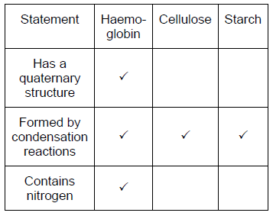**

*One mark for each correct row*

**3**

(b)     16;

**1**

(c)     1.      Higher affinity / loads more oxygen at low / same / high partial pressure / pO2;

2.      (Therefore) oxygen moves from mother / to fetus;

**2**

(d)     1.      Low affinity / oxygen dissociates;

*Assume ‘it’ is adult haemoglobin*

*1. Accept: converse if ‘fetal haemoglobin’ is clearly stated*

2.      (Oxygen) to respiring tissues / muscles / cells;

*2.* ***Q****: Neutral ‘respirate’*

**2**

(e)     Enough adult Hb produced / enough oxygen released / idea that curves / affinities / Hb are similar / more red blood cells produced;

*Neutral: ‘adult Hb is also produced’ as in the question stem*

*Reject: curves / affinities / Hb are the same*

**1**

**[9]**

**M34.**(a)     1.      SAN sends wave of electrical activity / impulses (across atria) causing atrial contraction;

*Accept excitation*

2.      Non-conducting tissue prevents immediate contraction of ventricles / prevents impulses reaching the ventricles;

3.      AVN delays (impulse) whilst blood leaves atria / ventricles fill;

4.      (AVN) sends wave of electrical activity / impulses down Bundle of His;

*4. Allow Purkyne fibres / tissue*

5.      Causing ventricles to contract from base up;

**5**

(b)     1.      Atrium has higher pressure than ventricle (due to filling / contraction) causing atrioventricular valves to open;

*Start anywhere in sequence, but events must be in the correct order.*

*1. Accept bicuspid, reject tricuspid*

*1. Allow: blood passes through the valve = valve open / blood stopped from passing through the valve = valve closed*

2.      Ventricle has higher pressure than atrium (due to filling / contraction) causing atrioventricular valves to close;

3.      Ventricle has higher pressure than aorta causing semilunar valve to open;

*Points 1, 2 and 3 must be comparative: eg higher 3. Allow aortic valve*

4.      Higher pressure in aorta than ventricle (as heart relaxes) causing semilunar valve to close;

*4. Allow aortic valve*

5.      (Muscle / atrial / ventricular) contraction causes increase in pressure;

**5**

**[10]**

**M35.**(a)     53−70 / 70-53 / 17 (beats per minute).

**1**

(b)     13.6 / 13.58 / 14;

*If answer is incorrect, 1 mark for the principle of difference (11) divided by initial heart rate (81).*

* or      for 1 mark*

*Ignore + or - signs*

**2**

(c)     1.      Allows comparison;

2.      (Initial / resting) heart rates different (between males and females).

**2**

(d)     1.      Cardiac output = stroke volume × heart rate

*1. Accept CO = SV × HR*

2.      (So) stroke volume increases / increased size or volume of ventricles.

*2. Neutral: more blood leaves heart*

*2. If the term stroke volume is not used, it must be defined*

**2 max**

**[7]**

**M36.**(a)     1.      Ventricle pressure rises **then** blood starts to flow into aorta because pressure causes (aortic / semilunar) valve to open;

*Accept times, eg ventricle pressure rises at 0.3 (25) seconds,followed by blood flow into aorta at 0.35 / 0.4 seconds*

***Idea of sequence is essential***

*Accept times*

2.      Ventricle pressure starts to fall **so** blood flow falls;

***Idea of sequence is essential***

**2**

(b)     1.      Thickness of wall increases **because** ventricle (wall) contracts;

*Must be idea that increase in thickness is linked to contraction*

*Accept muscle for ventricle and systole for muscle contraction*

2.      Contraction **causes** the increase in pressure;

*Accept thickening of wall*

**2**

(c)                        *2 marks for correct answer*

1.      Between 120 ± 5;;

*Length of cycles varies slightly*

2.      Length of cardiac cycle correct but final answer wrong;

*Length of cardiac cycle = 0.45 - 0.52*

**2**

**[6]**

**M37.**          (a)     Caused by blood leaving the heart / entering artery;  
As a result of ventricles contracting / systole;

**2**

(b)     Stretch as pressure increases;  
Recoil / spring back as pressure drops;

*Do not accept contract and relax in this context.*

*Allow 1 mark for ‘stretch and recoil’ without reference to pressure.*

**2**

(c)     Both have an endothelium / epithelium / squamous cells;

**1**

**[5]**

**M38.**          (a)     slow decrease in speed until reaches arterioles then rapid decrease;  
increase in total cross-sectional area of blood vessels / more friction;

**2**

(b)     elastic tissue / fibres / wall;  
expands / recoils / springs back (to smooth the pressure surges);  
*(recoil linked to elastic tissues)*

**2**

(c)     walls / endothelium one cell thick / made of flattened cells;  
short diffusion pathway

*OR*

narrow lumen;  
reduces rate of flow / more time for diffusion;

*OR*

gaps / pores between cells (*accept fenestrations between cells);*increased rate of diffusion / fluid movement out of vessel;

**2**

(d)     larger / wider lumen so greater volume carried;

**1**

**[7]**

**M39.**          (a)     (i)      0.4(s);

**1**

(ii)     

**1**

(iii)     0.26 (between 0.4 – 0.14) × 75 (or from (a)(ii)) = 19.5(s)  
*OR*0.25 (between 0.4 – 0.15) × 75 (or from (a)(ii)) = 18.75(s)

*(no double penalty)(allow rounding only if working shown)*

**1**

(b)     (ii)     right ventricle;  
same pattern / description (as left ventricle) but lower (pressure);

**2**

(c)     increase in volume / size of ventricles (*accept heart) /* hypertrophy of  
heart / increased strength of heart muscle / increased strength of  
contraction; more blood leaves heart in each contraction / increase  
in stroke volume;

**2**

**[7]**

**M40.**          (a)     It is a measure of the concentration of a gas  
(in a mixture of gases or a liquid);

**1**

(b)     37-38%

*Accept 36 – 39*

(c)     muscle contraction causes increased respiration;  
increased CO2 production lowering blood pH / lactate released  
lowering blood pH;  
increased heat released therefore increased temperature;  
increased O2 consumption lowering tissue *P*O2;

**4**

(d)     haemoglobin has a lower affinity for oxygen;  
more O2 for respiration;

**2**

(e)     **3.4 times = 2 marks**(incorrect answer in which candidate shows amount of oxygen removed at rest is 4.6 and amount removed during exercise is 15.8 = 1 mark)

**2**

(f)      Nearly all O2 is transported by haemoglobin / v. little transported in plasma;  
**EITHER**Haemoglobin is (nearly) fully saturated with O2 at the alveoli both at  
rest and when exercising;  
Therefore no (very little) further increase is possible;  
**OR**Haemoglobin is only 95% saturated with oxygen at the alveoli;  
Therefore enriching inspired / air with oxygen will raise this to 100%;

**3**

(g)     increased depth / rate / pulmonary ventilation;  
increase stroke volume / heart rate / Q increases blood flow rate;  
arterioles [*Accept* artery] supplying the muscles  
dilate / vasodilation / greater proportion of blood flow to the muscles;

**max 3**

**[15]**

**M41.**          (a)     Contain different / more than one tissue / type of cell;

**1**

(b)     0.8 (s)

**1**

(c)     0.4 (s) as events in right ventricle same as in left;

**1**

(d)     (i)      0 - 0.1 / 0.4 - 0.9 because the volume increasing / ventricle   
filling / blood entering;

**1**

(ii)     from 0.9 / 0.1 – 0.4 because volume decreasing / ventricle   
emptying / blood leaving;

**1**

*Accept any two figures from within the range.*

(e)     Correct answer of 15.75 / 15.8 / 16 = 2 marks  
Incorrect answer but clear understanding that 45cm3 is 100% = 1 mark

**2**

**[7]**

**M42.**          (i)     Because there are big differences;  
any correct named example e.g. lung cancer / bronchitis much lower  
in women than in men;

**2**

(ii)     easier to compare if sample size effectively the same;  
different numbers of people in each group;

**2**

**[4]**

**M43.**(a)     1.      (Carry) oxygen / glucose;

*Accept: oxygenated blood*

*Ignore references to removing waste products*

*Ignore references to arteries ‘pumping’ blood*

2.      (To) heart muscle / tissue / cells / myocytes.

*Must be supply to heart or cardiac*

**2**

(b)     (i)      **A**;

*Accept: A on its own even if outside box*

*Reject if two (or more) letters given*

**1**

(ii)     **H**;

*Accept: H on its own even if outside box*

*Reject if two (or more) letters given*

**1**

(c)     (Aorta)

1.      (is) close / directly linked to the heart / ventricle / pressure is higher / is very high;

2.      (Aorta has) elastic tissue;

*Accept elasticity*

*Ignore reference to muscle*

3.      (Aorta has) stretch / recoil.

***Q*** *Reject: contracts / relaxes / pumps*

*Accept: for mp 2 and mp 3, converse for small arteries if qualified by little / less*

**3**

**[7]**

**M44.**          (a)

|  |  |  |  |
| --- | --- | --- | --- |
|  | glucose | sodium ions | haemoglobin |
| Tissue fluid |  |  | ; |
| Blood plasma |  |  | ; |

*Mark for each correct row*

**2**

(b)     Hydrostatic pressure higher than osmotic “effect”;  
Forces / squeezes / pushes out / water / small molecules / ions / examples;

**2**

**[4]**

**M45.**          (a)     Structure resulting from aggregation of several polypeptide chanins / tertiary structures / eq:

**1**

(b)     Low pH / (more)H+ ; due to (increased) CO2 (increased) respiration;  
(ignore refs to buffering action of haemoglobin)  
(increased) dissociation of haemoglobin;  
Oxygen diffuses from r.b.c. to tissues;

**3**

(c)     Deaminated for use in respiration / used in protein synthesis / suitable e.g.;

**1**

**[5]**

**M46.**          (a)     (i)      Pattern described as constant / decrease to 04.00 / 06.00  
then rising;

**1**

(ii)     Corresponds to ventricles contracting / systole;

**1**

(iii)     Less / little difference between maximum and  
minimum / less variation / constant / not pulsed / smoother;  
pressure in vein lower

**2**

(b)     (i)      The larger the molecule, the less permeable;  
Over 68 000 walls not permeable;

**2**

(ii)     Plasma proteins / albumin and globulin too large to leave capillary;  
Water lost / Increase in concentration of proteins in blood / plasma;

**2**

(iii)     Haemoglobin in red blood cells /   
Haemoglobin too large to pass through membrane of RBC /   
Red blood cells (containing haemoglobin) too large to pass  
through wall;

**1**

**[9]**

**M47.**          (a)     Large surface area to volume ratio;  
For diffusion;  
OR  
Flat / thin;   
So oxygen can reach all haemoglobin / centre rapidly / short pathway;

**max 2**

(b)     (i)      Partially permeable / allows water through but not sucrose;

*Accept semi-permeable / selectively permeable.*

**1**

(ii)     Phospholipid (in membrane) / bilayer dissolved / broken down;  
Allows haemoglobin / contents to leak out;

**2**

**[5]**

**M48.**          (a)     B – It is the 2nd contraction / occurs (immediately) after A / occurs after atrium;  
Larger / more force / more pressure;

**2**

(b)     

= 37 to 38

*allow 1 mark if correct working shown*

**max 2**

(c)     (i)      (Heart rate)               reduced;  
(Stroke volume)        no effect;

**2**

(ii)     Reduced because C.O. = H.R. x S.V. / connection argument based on reduced H.R;

**1**

(iii)     Parasympathetic;

**1**

(d)     (i)      1.      Coordination via medulla (of brain) / cardiac centre;

2.      (Increased) impulses along sympathetic ( / cardiac accelerator) nerve

3.      To S.A. node / pacemaker;

4.      More impulses sent from / increased rate of discharge of S.A. node / pacemaker;

*Not “beats”; not “speeds up”*

**4**

(ii)     In exercise – More energy release / more respiration / actively respiring muscles / for aerobic respiration;  
Higher cardiac output – Increases O2 supply (to muscles);  
                                    Increases glucose supply (to muscles);  
                                    Increases CO2 removal (from muscles) /   
                                    lactate removal;  
                                    Increases heat removal (from muscles) /   
                                    for cooling;

*If no “increase” – max 2 marks*

**3**

**[15]**

**M49.**          (a)     0.01 / 0.0105;

*(allow 1 mark for 52 500 / 5 000 000)*

**2**

(b)     (at the tissues at low pp oxygen) the shrew’s haemoglobin is less  
saturated with oxygen / has reduced affinity;  
oxyhaemoglobin dissociates more readily / haemoglobin releases  
oxygen more readily / more oxygen released;  
allowing greater demand / respiration rate;

**3**

**[5]**

**M50.**          (a)     0.1 – 0.6 seconds;  
Volume (in left ventricle) increasing / ventricle filling;

**2**

(b)     (i)      2 marks for correct answer of 75 (beats) per minute;  
1 mark if heart beat correctly identified as lasting 0.8 seconds;

**2**

(ii)     70 cm3;

**1**

(c)     Multiply them;

**1**

(d)     750;

*Accept a small increase – up to 800 cm3*

**1**

(e)     (i)      4 : 1 / 4;  
*Ratio must be expressed in simplest terms*

**1**

(ii)     18 cm3;

**1**

**[9]**

**M51.**          (a)     made of (different) tissues / specified tissues;

**1**

(b)     (i)      20 µm as it consists of endothelium only / does not contain muscle,  
connective tissues and elastic tissue;

*(consider other answers and credit understanding.)*

**1**

(ii)     1 mark        calculation derived from diameter - (2 × wall thickness) /   
                   answer of 3mm;  
2 marks      2mm / 2000µm;

**2**

(c)     stretches as a result of high pressure / surge of blood;  
then recoils;

**2**

**[6]**

﻿

**M52.**(a)     1.      Many / more capillaries (than arterioles);

2.      (Cross-sectional) area of capillaries (much) greater (than of arterioles).

*Note: maximum of* ***1*** *mark for this question*

**1 max**

(b)     1.      Short pathway / short distance between blood and outside of capillary;

*Reference to blood and cells required*

2.      Large surface area (of blood) in contact with walls of capillaries;

*Idea is per unit volume of blood but candidates need not say this*

3.      Fast exchange / fast diffusion / fast osmosis.

*Must relate to increased speed*

**2 max**

(c)     Width / size / diameter of blood cell.

*Accept named blood cell*

*Reject platelet*

*Accept idea that below a certain diameter friction becomes too great for blood to flow*

**1**

(d)     (Fluid) in tissue fluid / (fluid) in lymph.

**1**

**[5]**

**M53.**          (a)     (i)      **C** and **D**;

**1**

(ii)     left ventricle with thicker wall / more muscle / (muscle in)  
left ventricle contracts more forcefully / beats more strongly;

**1**

(b)     higher in atria / lower in ventricles;  
atrioventricular valves / valves between atria and ventricles open;

*(position of valves must be identified.*

*Do not accept an unqualified reference to valves.*

*Assume pronouns refer to atria.)*

**2**

(c)     (i)      allows blood to pass into ventricles / from atria / so that atria  
can empty; before ventricles contract;

**2**

(ii)     ventricle contracts from base / upwards;  
blood pushed through **B** and **C** / arteries / all blood ejected;

**2**

**[8]**

**M54.**          (a)     (i)     1        Reduces heart rate;

2        Keeps heart rate stable / reduces variation in heart rate;

3        Nullifies external stimulus;

*Individual points must be supported with information from the graph  
If no information quoted max 1 mark*

**2**

(ii)     To ensure change in heart rate due to beta blocker and not person’s behaviour / knowing may affect heart rate;

**1**

(b)     (i)      Beta blockers reduce mortality (following myocardial infarction) /   
Greater reduction in the older group;

**1**

(ii)

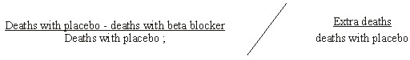

x100;

**2**

**[6]**

**M55.**         (a)     The muscle in the wall / sphincter contracts;

*Accept converse*

Reducing blood flow / narrowing / closing arteriole;

*The muscle to which the candidate is referring must be clearly in the wall of the arteriole.*

**2**

(b)     (i)      Blood flow increased in humans / reduced in seals;

**1**

(ii)     Less oxygen / blood taken to muscles;

*None is incorrect*

(More) oxygen available for organs / brain;  
Can stay under water longer (without breathing);

**max 2**

**[5]**

**M56.**          (a)     0.1 / 0.9 (s);

**1**

(b)     Two marks for correct answer of 75 (beats per minute);

One mark for incorrect answer based on cardiac cycle taking 0.8 seconds;

**2**

(c)     (i)      Pressure in ventricle higher than pressure in atria;

**1**

(ii)     Prevents backflow of blood / prevents flow from ventricles to atria;

**1**

(d)     Increase (in stroke volume) as blood pressure increases, remains constant / plateaus; after 3 kPa / when stroke volume = 82cm3

**2**

(e)     Two marks for correct answer of 80;  
One mark for incorrect answer recognising that ventricle contracts once every cardiac cycle / stroke volume = 70 cm3

**2**

(f)      1       Muscles (surrounding veins) contract and press on (walls of) vein and squeezes blood along veins;

2       Valves prevent backflow / ensure flow in one direction;

3       Systole / contraction of heart pumps blood (through arteries) into veins / residual arterial pressure / negative pressure in chest due to inspiration;

4       Recoil of heart muscle during diastole / after contraction;

5       Draws blood from veins into atria;

*Accept sucks*

6       Wide lumen little resistance / friction

**6**

**[15]**

**M57.**          (a)     (variation in) temperature will affect the solubility of oxygen / rate of respiration / use of oxygen by cells / diffusion / gas exchange;  
*to gain credit point made must concern oxygen*

**1**

(b)     (i)      there is no difference between the partial pressure of oxygen in the two groups / the partial pressure of oxygen is the same in each group;

**1**

(ii)     results may have been due to chance and statistical test allows us to determine the probability of this / of the difference between results   
being significant;  
enables acceptance or rejection of null hypothesis;  
*The key points here are chance and probability used in the correct context.*

**2**

(c)     **A**;  
because partial pressure of oxygen only reduced when zinc in water / in **Y** / because when injected zinc / in **X** has no effect on partial pressure of oxygen in blood;

**2**

(d)     less oxygen transport to cells / in fish / in blood;   
anaerobic respiration;  
lactic acid produced / less carbon dioxide removed (from gills);  
more H+;

**3 max**

(e)     (i)      copper;  
calculation based on comparing concentration in woodlice with that in leaves;  
*accept any suitable method here, giving marks for the method and explanation. For example, calculating ratio of concentration in woodlice to concentration in leaves.*

**2**

(ii)     not absorbed from gut / passes out in faeces / egested / urine / excreted;

**1**

(iii)     woodlice eat large amount of leaves;  
copper stored / accumulates in body;

**2**

(f)      (i)      mutation;

**1**

(ii)     (as a component of) nucleic acids / DNA / RNA / nucleotides;  
phospholipids;   
ATP / ADP;

**2 max**

(iii)     arsenic-tolerant plants would not be able to take up phosphates / take up a little phosphate;  
since likely to involve same mechanism / same carrier / protein;   
(process of ) growth would be poorer than non-tolerant plants;

**3**

**[20]**

**M58.**          (a)     correct answer: 77 - 78 ;;   *allow 75 - 80* = 2 marks  
OR  Use of 55 AND 17 saturation / fall = 38;     = 1 mark  
OR  (Fall = y % +) use of ;                       = 1 mark

**2**

(b)     (in exercise) - faster respiration rate meaning more CO2 production;  
CO2 is acidic / forms carbonic acid / lactic acid production;  
release of H+ ions;

**3**

**[5]**

**M59.**(a)      1.      (Overall) outward pressure of 3.2 kPa;

2.      Forces small molecules out of capillary.

**2**

(b)     Loss of water / loss of fluid / friction (against capillary lining).

**1**

(c)     1.      High blood pressure = high hydrostatic pressure;

2.      Increases outward pressure from (arterial) end of capillary / reduces inward pressure at (venule) end of capillary;

3.      (So) more tissue fluid formed / less tissue fluid is reabsorbed.

*Allow lymph system not able to drain tissues fast enough*

**3**

(d)     1.      Water has left the capillary;

2.      Proteins (in blood) too large to leave capillary;

3.      Increasing / giving higher concentration of blood proteins (and thus wp).

**3**

**[9]**

**M60.**(Maintaining constant pH to avoid)

1.      Named protein / enzyme (in blood) sensitive to / affected by change in  
          pH;

*Accept converse for MP2 and MP3.*

*Named example should be a protein that might be affected (by change in pH) eg haemoglobin, carrier protein in plasma membrane.*

*Accept ‘change in H+ concentration’ for ‘change in pH’.*

2.      (Resultant) change of charge / shape / tertiary structure;

*The change in charge idea relates to the enzyme / protein and not the blood (plasma) or red blood cells.*

*‘Denaturation’ alone is insufficient.*

3.      Described effect on named protein or enzyme.

e.g. less oxygen binds with haemoglobin / less transport across membranes / fewer substrates can fit active site / fewer enzyme-substrate complexes.

*Idea of ‘less’ or ‘fewer’ required. Ignore suggestion of ‘no’ or ‘none’.*

**[3]**

**E1.**(a)     Two-thirds of students were able to identify the aorta.

(b)     Students had difficulty expressing their ideas. However, nearly fifty percent obtained both marks. Some students failed to score one of the marks because they made vague references to ‘pushing’ by the left ventricle, rather than pressure.

(c)     The majority of students correctly identified the valves with the same function. The commonest error was to put semi-lunar for both; perhaps students focused more on the appearance of the valves, rather than their function.

(d)     This produced a full range of marks. Some students ignored the instruction to use calculations and just described the results. Others made vague references to percentages but without calculating any. Another approach seen was to approximate on the basis that there were about twice as many patients given X than Y. These approaches were not given credit. There were many good answers where students calculated percentages based on the columns of data in the table. Some students failed to gain one mark through incorrect rounding of percentages. There was a minority of students who calculated both percentage survival and percentage mortality, without appreciating that they are converse expressions of the same point. A third of students obtained all three marks and twenty-five percent scored zero.

**E2.**          (a)     Candidates showed a good understanding of the adaptations of gills for efficient gas exchange. Although there were some who wrote in very general terms about ‘gills’, most candidates linked surface area to the possession of gill filaments or lamellae and to diffusion. The principle of counter-current flow was frequently mentioned and it was clear that most candidates had an excellent understanding of this concept. Some illustrated their answers with diagrams and these were occasionally very helpful.  
Candidates should be aware, however, that marks can only be awarded for diagrams that are properly labelled. There were numerous sketches on which were written figures that might have represented anything. Some points were made less frequently or less convincingly. There was relatively little mention of the roles of ventilation and circulation in maintaining the concentration gradient and many struggled to describe the short diffusion path in sufficient detail to gain credit. There were also a number of frequent misconceptions. These included references to air passing over the gills; to diffusion only being able to take place in water, and to the presence of carbon dioxide being essential for the diffusion of oxygen.

(b)     Successful responses to this part of the question usually referred to photosynthesis or to the diffusion of oxygen from the higher concentration in the air. There were many answers, however, that involved fanciful ideas about generation of oxygen at depth and this bubbling to the surface, or incorporated the concept of need, such as that there was less oxygen at depth because the toadfish did not need it.

(c)     This answer illustrated a common failing among less able candidates in answering questions that involve application of knowledge. They were often inclined to rely on recall and, while most were able to indicate that the toadfish environment was low in oxygen, they not infrequently related this to high altitude. There was also a tendency to give answers that were too brief, omitting reference to the context of low partial pressure when describing the high affinity of toadfish haemoglobin for oxygen.

(d)     Answers to this question tended to fall into two categories. Either candidates gave very good answers that made the points in the mark scheme succinctly, or they wrote at length about the three organisms without ever quite answering the question. However, it was encouraging to see many excellent answers to a question set in a context which is new to the specification.

**E3.**          (a)     Although there were many correct answers to part (i), incorrect responses were frequent. These generally stemmed from failing to note the information provided in the question. Thus “opening of the atrioventricular valves” was not infrequently given. Part (ii) was deliberately worded to encourage candidates to respond in terms of cause rather than effect. In spite of this, many explained that the valves shut to prevent backflow. Others again failed to note the requirements of the question and described the relative pressures in the atria and the ventricles, rather in arteries and ventricles as was required.

(b)     Questions requiring the calculation of rates from information similar to that provided in part (b) are not uncommon. In spite of this, candidates experience considerable difficulties in identifying recurring patterns. Such was the case here, and relatively few were able to determine 0.8 seconds as the starting point for the calculation. Converting this to a rate provided an additional set of problems with many electing to multiply by 60. Having determined the heart rate, most were then able to calculate cardiac output by multiplying heart rate by stroke volume. Candidate’s working frequently failed to show sufficient annotation to indicate to what the various figures referred. It proved difficult to award credit in such cases.

**E4.**          (a)     Although the responses given by some candidates suggested very limited knowledge of the role of capillaries in the formation of tissue fluid, answers were generally correct. The only incorrect response that occurred with any frequency was confusion between the terms plasma and blood.

(b)     Some candidates clearly experienced difficulties over the meaning of the term “composition” and wrote about plasma being “stickier” or “thicker”. For others, poor quality of written communication was reflected in their responses with it proving difficult to determine whether specific references were to fluid X or to fluid Y. Those candidates who targeted lower concentrations of proteins were usually able to link the difference correctly to molecule size although some answers that followed this approach were over-general and simply discussed “nutrients”. On the other hand, those who discussed smaller molecules frequently encountered difficulties in maintaining the converse argument, that there would be a lower concentration of substances with small molecules in the tissue fluid.

(c)     Although there was scope here for most candidates to gain some credit, the examiners were not always convinced that the conflict between hydrostatic pressure and osmosis had been understood. Answers frequently described a water potential gradient that would supplement hydrostatic pressure. Others equated the idea of fluid being forced through the capillary wall with diffusion and osmosis. A significant minority of candidates totally failed to interpret the question and attempted to explain how fluid passed along the length of the capillary.

**E5.**(a)     Almost a third of candidates obtained maximum marks by clearly describing how haemoglobin loads and unloads oxygen in different parts of the body. Other candidates often lost marks by failing to refer to partial pressure of oxygen or to the percentage saturation of haemoglobin in the lungs and tissues. Weaker candidates tended not to use the graph and often demonstrated a lack of understanding of the terms dissociation and affinity.

(b)     (i)      Most candidates gained this mark for correctly describing the relationship between the size of mammals and the oxygen dissociation curves of their haemoglobins.

(ii)     Most candidates correctly related the size of mammal to a large or small surface area to volume ratio and appreciated that oxygen was required for respiration. However, weaker candidates had difficulty explaining the relationship between the surface area to volume ratio of mammals and the position of the oxygen dissociation curves of their haemoglobins. There was also some confusion between the size of a mammal and the amount of heat lost from its surface area.

**E6.**          There were many excellent answers to this question, with many candidates scoring at least three marks. Both questions proved to be good discriminators.

Most candidates understood the role of the SAN in initiating the heartbeat and generating electrical impulses, which cause contraction of the atria. Similarly, there were numerous references to the passage of impulses along the Bundle of His or Purkyne fibres and the subsequent contraction of the ventricles. However, there were some inventive spellings of ‘Purkyne’. It was encouraging to see only a small number of candidates referring to electrical impulses as ‘signals’, ‘messages’ or ‘electronic pulses’. It was usually only the most able candidates, who correctly referred to the delay at the AVN and described its significance. A number of candidates described the delay in the wrong context. This was usually in terms of a delay in impulses reaching the AVN or the non-conducting tissue of the heart causing the delay. Weaker candidates often gave a muddled sequence of events or gave a description of the cardiac cycle in terms of blood flow, valves and pressure changes.

**E7.**          (a)     Most candidates revealed a sound understanding of the direction of blood flow through the vessels shown in the diagram. Such errors that arose usually concerned the hepatic circulation.

(b)     As was expected of a question targeted at grade E candidates, there were many correct answers to this part. There was, however, a failure to appreciate that blood always flows from a higher to a lower pressure and this led to a number of incorrect responses.

(c)     In the many cases where vessels **C** and **E** were correctly identified as an artery and a vein, candidates were usually able to complete the table with two appropriate differences. There were, however, references to the vein having no muscular or elastic layer. Examiners expressed concern over the inability of some to complete the table unambiguously.

(d)     Many candidates failed to address the question. Instead of explaining how the muscle in the wall of the blood vessel reduced blood flow, they offered general answers covering both vasoconstriction and vasodilation. The term ‘smooth muscle’ also appeared unfamiliar and there were numerous attempts to describe its function in terms of providing a friction-free surface or as being devoid of ribosomes.

(e)     Although knowledge of the role of muscle contraction and the resulting vasoconstriction was sound, the same could not be said of the function of elastic tissue. Many of the problems that candidates experienced with this question came from poor use of terminology. The concepts of stretch and recoil were frequently confused with contraction and relaxation.

**E8.**          (a)     Most candidates had little difficulty obtaining at least one mark by referring to an increase in the production of carbon dioxide. However, candidates were far less successful in describing the effect of an increase in respiration on the oxygen dissociation curve of haemoglobin. There were almost as many responses indicating that the curve would move to the left as there were correct answers indicating a shift to the right. Unfortunately, many candidates disqualified a correct description by suggesting that this would increase the affinity of haemoglobin for oxygen.

(b)     (i)      Most candidates did gain a mark for referring to an increase in the haemoglobin content of the blood. However, most candidates then linked this to an increase in the oxygen carrying capacity of the blood rather than to an increase in the oxygen uptake in the lungs. The latter being the main advantage to people living at high altitudes where there is less oxygen in the air.

(ii)     As expected this question proved more demanding with approximately one in four candidates obtaining both marks. These candidates used the information provided on the graph to explain that haemoglobin would release more oxygen to the tissues as its affinity for oxygen decreases.

**E9.**          (a)     Most candidates correctly named fluid **F** as plasma or blood plasma. A common response not credited was blood.

(b)     Very few candidates obtained this mark despite the large number of alternative answers available on the mark scheme. A very common error was to state that tissue fluid has no protein rather than less or smaller proteins. References to blood cells were not credited as fluid **F** is plasma rather than blood, the latter consisting of plasma and blood cells.

(c)     (i)      Many candidates did not obtain this mark as most referred to ‘pumping’ or ‘beating’ of the ventricle rather than using the precise term contraction.

(ii)     Unfortunately many candidates simply stated that the pressure decreases as distance from the heart increases. Better candidates explained the reason for this decrease in pressure in terms of friction or loss of fluid from capillaries.

(d)     Answers to this question were very disappointing with very few candidates obtaining all three marks and many candidates scoring zero. Candidates gaining credit often appreciated that a decrease in the concentration of protein in the blood would increase the water potential in the capillary. However, candidates often failed to use the term osmosis in the correct context, describing the movement of a wide range of substances by osmosis. Even better candidates often failed to gain credit by referring to fluid rather than water moving by osmosis. Additionally, there was considerable confusion in the direction of movement of water between the tissue fluid and plasma.

**E11.**          (a)     (i)      Most candidates gained this mark by indicating that the response was more effective in children. However, a significant minority of candidates interpreted the graph as showing that adults had a more effective response to the treatment.

(ii)     Considering a similar question was asked on the January 2010 paper it was disappointing to note that less than half the candidates gained both marks. Most candidates did refer to a line of best fit but many then failed to explain that the line should be extended to predict the haemoglobin content after 40 days. Credit was also given for detailed answers using the rate of increase per day to predict haemoglobin content.

(iii)     Only a third of candidates clearly explained what is meant by a quaternary structure. Most candidates suggested that it meant four polypeptide chains or many proteins were present.

(b)     (i)      Almost a third of candidates obtained zero on this question, suggesting these candidates had not revised relevant principles from unit 1. A significant number of candidates interpreted isotonic as meaning a constant pH. Candidates who did know what isotonic meant were often able to provide a suitable explanation to gain at least two out of the three marks. However, there was still some confusion over the term osmosis with weaker candidates referring to salt moving by this process.

(ii)     Most candidates were able to describe one difference between the two blood samples, often in relation to the variation in diameters. Many incorrectly referred to a difference in number of red blood cells, or their descriptions were too vague to gain a second mark point.

**E12.**(a)     Most students correctly identified the left ventricle in their answers to part (i) and many progressed to describe the importance of the thick muscular wall of this chamber in producing high pressure. There were many, however, who confused cause and effect and attempted to explain why high pressure was necessary.

(b)     Most students were aware that cardiac output could be calculated by multiplying heart rate by stroke volume, although there was occasional use of terms more appropriate to calculating pulmonary ventilation. Heart rate was frequently calculated correctly but the figures were sometimes transposed in transfer to the answer space. More difficulties were experienced, however, with determining stroke volume as 148 - 55 or 93. Errors here fell into a number of categories but it was particularly disturbing to see so many responses in which the correct figures were selected but subtraction errors resulted in credit being withheld.

(c)     There were many correct answers to this question but some students failed to heed the instructions and attempted to answer with ticks and crosses. Credit could not be awarded in these cases.

**E13.**          (a)     (i)      Only the most able candidates gained this mark for suggesting that the blood vessels of healthy volunteers would not be affected by other factors or would be of normal size. Very few candidates noted that the blood vessels of healthy volunteers would function normally. Credit was given for valid ethical arguments, providing that they were qualified. However, a number of candidates failed to score through not relating their answers to the investigation. Weaker candidates tended to echo the need for ‘reliable results’ or ‘a fair test’.

(ii)     Nearly 65% of candidates were aware of the need to avoid bias or selection. However, some candidates thought the volunteers were divided randomly to ensure that both groups contained the same number of people, or the same number of males and females. As in part (a)(i), weaker candidates tended to confine their answers to 'reliable results' or 'a fair test'.

(b)     (i)      Most candidates noted that the control group should have been treated in the same way as the experimental group. However, it was only better candidates who stated that the control group should have been given chocolate with no flavenoids. The most common incorrect response was ‘do not give any dark chocolate’. Weaker candidates sometimes made vague references to using a placebo but this was not usually taken any further.

(ii)     Candidates were asked why it was important to have a control group in this investigation. Hence, this question tested the ability of candidates to apply their knowledge to an unfamiliar context. They were required to do more than define the term ‘control group’. For this reason, general answers such as that ‘results are not due to other factors’ and ‘results are due to the independent variable’ were not credited. Better candidates related their answers to this investigation. They were aware that a control group was used to ensure that the results obtained were due to the flavenoids or that they did not result from other substances in the chocolate. Many candidates were aware of the need to compare both groups. However, relatively few explained why this was necessary.

**E14.**          (a)     Just over half the candidates correctly identified layer C as the endothelium or epithelium. Common incorrect responses included elastic layer, endodermis and epidermis.

(b)     Most candidates scored the principle mark by dividing a measured diameter by eight (the magnification). Over half the candidates gained both marks. A significant minority of candidates measured the diameter of the blood vessel across the outer walls rather than the diameter of the lumen. These candidates usually gained the principle mark.

(c)     (i)      Compared with responses to a similar question on the June 2009 paper, it was pleasing to note that fewer candidates mentioned elastic fibres contracting or relaxing. There were more correct references to ‘stretch and recoil’ and to the role of elastic fibres in smoothing blood flow. However, some weaker candidates did refer to elastic fibres contracting and suggested that the aorta pumps blood around the body.

(ii)     Surprisingly, a significant percentage of candidates did not obtain a mark in this question. Candidates often referred to muscle fibres constricting and dilating and to arterioles contracting and relaxing. The importance of muscle fibres in arterioles was often related to the prevention of arterioles bursting. Nevertheless, over half the candidates were able to obtain at least one mark. Only a relatively small percentage, however, was able to describe precisely how muscle fibres regulate blood flow.

(d)     (i)      Most candidates gained this mark by referring to the increase in the total cross- sectional area from the aorta to the capillaries.

(ii)     Only a third of candidates gained this mark. Candidates often referred to the decrease in the rate of blood flow in the capillaries but did not link this with more time for efficient exchange of substances.

**E15.**          (a)     Many candidates appeared to understand the principles that were being tested in the two parts of this question but explanations often fell short of the required standard. In part (i) a reference was required to the dispersal of water vapour and the consequences of this on the diffusion or water potential gradient. Many less able candidates offered explanations in terms of moving air forcing water out of the leaf or involving water moving out of the leaf by osmosis. Those who appreciated, in part (ii), that an increase in temperature increased kinetic energy usually progressed to refer to an increase in the rate of movement of water molecules. Others, perhaps inevitably, attempted to link temperature with enzyme activity

(b)     Most candidates followed the instruction in part (i) and described the relationship with sufficient precision to gain the mark. They were also able to link movement through the xylem to increased light intensity and stomatal opening with some success. However, by far the most popular response to part (ii) was to suggest that there would be an increase in the rate of photosynthesis and therefore more water would be needed by the plant. The terms cohesion and tension were frequently used in such a way as to suggest little real understanding. It was not uncommon to read about water molecules being pulled through the xylem because “they stick to each other by cohesion-tension”. The idea conveyed in part (iii) appeared to be unfamiliar to all but the best candidates. The structure of the question should have lead candidates to realise that it was testing the same basic principle. The question was worded in such a way as to encourage candidates to explain the lower diameter at 12.00. Many opted however to explain the converse of this and based their answers on suggestions involving storage of water in the xylem.

(c)     Responses to this question were very disappointing as evidenced by the large number of candidates who were unable to gain credit. Many answers were very general and did little more than suggest, often at great length, that “strong” walls meant that blood vessels did not burst under pressure. Such answers often established this point for arteries, then repeated it for arterioles. Only the very best candidates appeared aware of the presence of muscle and elastic tissue within the walls and could describe the roles of these particular tissues. There was also much emphasis on valves. They were correctly described as not being present in arteries and arterioles but then discussed in terms of what they would have done if they had been present. Those candidates who referred to the endothelium were generally able to point out its functions in reducing friction. There were others, however, who considered the lumen to be a fundamental component of the wall.

**E16.**          (a)     (i)      71% of candidates gave the correct response G.

(ii)     70% of candidates gave the correct response E.

(b)     Many candidates gave a comparative response that clearly showed that the pressure was higher below the valve. However, weaker candidates often failed to make a comparison and often simply stated that ‘the pressure in the ventricles increases’. Where a comparison was made, this was often between the ventricles and the atria.

(c)     Many candidates gained one mark for stating that the delay allows the atria to empty or the ventricles to fill. However, it was usually only better candidates who were able to take this further and explain that it delayed contraction of the ventricles. Weaker candidates often thought that the delay allows valves to close or gave unnecessary detail involving the Bundle of His and Purkyne fibres.

(d)     (i)      75% of candidates gained full credit on this question. However, most candidates were aware how to calculate stroke volume and gained one mark. The minority of candidates who failed to score typically multiplied cardiac output and heart rate. This gave a stroke volume of 275,000 cm3. Candidates should be encouraged to check that their final answer does not seem unreasonable.

(ii)     Many candidates scored at least one mark. Better candidates had no trouble in relating training to an increase in heart muscle or size. They usually then went on to explain the consequence of this in terms of an increase in the stroke volume. Weaker candidates were often let down by poor expression. Vague statements such as ‘the heart is stronger’ and ‘the heart pumps more blood’ were common. Some of these candidates related a lower heart rate to less oxygen being needed after exercise. It was clear that a minority of candidates thought that the term ‘after exercise’ referred to a single training session, rather than a prolonged training programme, as stated in the stem of the question. A minority of candidates related a lower heart rate to ventilation.

**E17.**          (a)     Although there were various interpretations of the diagram, most candidates correctly indicated the presence of more than one polypeptide chain.

(b)     In part (i), many candidates correctly identified the number of amino acids coded by this piece of DNA as 141. Incorrect responses were usually centred on multiplying the number of bases either by two or by three. In part (ii), the single mark that was most frequently awarded was for a reference to introns. Many candidates, however, interpreted the question as asking about the nature of the genetic code. There were many responses centred on there being “more than one code for an amino acid”.

(c)     Despite the mark allocation shown for this question, there were some very extensive answers involving the DNA base sequence and protein structure. Many of these accounts also reflected much confusion between the terms base and amino acid. There were occasional unfortunate references to the environment causing the difference in haemoglobin structure.

(d)     Better candidates were able to identify the principle involved here and suggested an explanation based on the ability of haemoglobin to load more oxygen at lower partial pressures. Where these candidates used the information from the graph and wrote of the partial pressure of oxygen and the percentage saturation of haemoglobin, they were usually able to gain full credit. There was, however, much imprecise wording and accounts were often marred by such phrases as there was “less air in mountains” and “the llama carries more oxygen”. Less able candidates frequently twist the wording of questions round. This question, for example, was occasionally answered as requiring an explanation of the adaptations of horses to living at low altitudes. Such an interpretation failed to gain credit.

**E18.**          (a)     This was well answered with almost eighty percent of candidates obtaining both marks for explaining that EPO would increase the number of red blood cells and consequently the concentration of haemoglobin. Less than five percent of candidates scored zero.

(b)     Most candidates gained at least one mark by stating that the control group would be treated in exactly the same way as the experimental group apart from being given EPO. Approximately a third of candidates gained the second mark by indicating that the control group would be injected only with salt solution. Many candidates simply referred to a placebo without mentioning the salt solution.

(c)     This proved quite challenging with over forty percent of candidates scoring zero. Many of these candidates limited their response to the idea that the investigators would be able to see if EPO was effective. The idea of allowing a ‘comparison’ was the most common marking point awarded. Relatively few candidates considered the different masses of the volunteers or the different weeks of treatment.

(d)     Over half the candidates failed to gain any marks on this question because they limited their answers to descriptions of the data in the table. Better candidates realised that the information provided would enable the investigators to determine the most effective dose and length of treatment.

(e)     This question was well answered with over seventy five percent of candidates gaining three or more of the four marks available. Candidates realised that EPO would increase the amount of oxygen being transported to the respiring tissues because of an increase in the number of red blood cells. This was often linked to an increase in the energy released. Better candidates had often gained maximum marks before mentioning that this energy would be available for muscle contraction or that anaerobic respiration could be delayed.

(f)      This question proved more demanding than expected. Most candidates did gain at least one of the two marks available but a significant number of responses lacked detail. These answers often suggested testing one or two athletes or one athlete and a non-athlete. The most common scoring marking points related to random sampling, determining a mean value and testing a large sample of individuals. It was pleasing to see some high quality answers which included the use of standard deviation when establishing the normal concentration of EPO.

(g)     Most candidates failed to gain this mark as they simply referred to ‘more blood’ being present. Better candidates often suggested that an increase in blood pressure would be due to an increase in the volume of the blood or ‘thicker’ or ’denser’ blood.

**E19.**          (a)     Most candidates obtained at least one mark for stating that the haemoglobin of a lugworm has a higher affinity for oxygen than has human haemoglobin. It was pleasing to note that compared with previous years many candidates referred to low partial pressure of oxygen rather than low oxygen concentration. This enabled them to access the second mark.

(b)     There were some very impressive responses to this part of the question with almost a third of candidates obtaining maximum marks. Candidates obtaining a single mark often did so by referring to the role of the lymphatic system in returning tissue fluid to the circulatory system. A significant number of candidates wasted time by explaining the formation of tissue fluid at the arteriole end of the capillary. There was some confusion by weaker candidates about the effect of protein on the water potential inside blood capillaries. Many candidates did refer to osmosis but not always in the correct context.

**E20.**          (a)     (i)      Many candidates gave a generic answer, failing to refer to the passage as instructed. These candidates often scored only one mark for explaining that an antigen causes an immune response. Candidates who scored both marks used the information given to explain that, in this example, the antigen was a protein on Chlamydia.

(ii)     In this question, candidates were more confident in using the information from the passage and most gained at least a mark for explaining that the proteins on the Chlamydia cell and the heart were similar. There were candidates who confused antigens with antibodies and even enzymes but many candidates gained a second mark, usually by explaining that antibodies would attack the heart muscle cells. There were a number of excellent answers that showed a clear understanding of the immune response.

(b)     A number of candidates did not go further than the information given in the question, simply stating that the vaccination would prevent Chlamydia infection. This was not credited. Candidates who considered the information in the passage wrote about the possibility of preventing atheroma or, if the human proteins were similar to those in the mouse, the risk of causing heart disease. There were also creditworthy references to the cost of a vaccination campaign being higher than alternative methods of reducing the incidence of Chlamydia. Unfortunately, many limited their answer to just one factor rather than evaluating the suggestion as instructed.

**E21.**          (a)     Candidates did not answer this question well. Only the most able understood that the valve would be closed when the ventricular pressure exceeds that in the atrium. Many simply stated that the pressure in the ventricles was high or increasing, making no comparison with atrial pressure. Consequently few gained the first marking point for giving the times the valve would be closed.

(b)     Many candidates did not explain what causes the higher pressure in the ventricle with many trying to relate the answer to the distance the blood ‘has to travel’. More able candidates were able to relate the higher pressure to the increased thickness of the wall of the ventricle which would be able to contract more strongly. As in previous unit tests, credit was only given to answers referring to muscle contraction and not to “pumping”.

(c)     A large number of candidates answered correctly, although many did not seem to know how to use the data in the table to calculate the rate and left this question blank.

**E22.**(a)     This question produced a good spread of marks. Most students referred to haemoglobin combining with oxygen in red blood cells and appreciated that loading took place in the lungs. Some students then described the unloading of oxygen at respiring tissues and these students often linked this to the increase in carbon dioxide. Generally, only better students referred to high and low partial pressures of oxygen and gained maximum marks. A significant minority of responses ignored loading and unloading of oxygen and described the passage of oxygenated blood through the circulatory system.

(b)     Almost half the students failed to gain a mark as they often simply referred to it being a 'fair test' without an explanation. Most answers gaining credit mentioned enzymes and better students linked this to respiration to gain two marks. Answers relating to the temperature affecting the amount of dissolved oxygen were fairly infrequent as were references to enabling 'comparisons' between the larvae of both species.

(c)     Most students appreciated that the mean rate of oxygen uptake increased and then levelled out with an increase in oxygen concentration in the water. However, only better students specifically referred to where oxygen uptake levelled out. Students gaining zero marks often stated that there was a positive correlation between the variables.

(d)     Many students noted, for one mark, that Chironomus longistylus has a higher oxygen uptake at lower concentrations of oxygen. However, less than 25% of students used the data to support their observation and gain a second mark.

(e)     (i)       Almost 80% of students gained this mark, often by stating that more oxygen is lost via the gills in Australian lungfish than in African lungfish.

(ii)     Most students were aware that more exchange is via the lungs in African lungfish. However, far fewer students gained a second mark by mentioning that gills would not function in air.

**E23.**There was much evidence from the answers to different parts of this question of the difficulties that many students experience with comprehension questions. It appeared that many of those of more limited ability took very little note of the information in the passage or of instructions embedded within the questions. They identified this question as relating to enzyme inhibition and sought refuge in set responses, many of which were largely irrelevant. Further evidence of the difficulties that the question presented was provided by the number of answers that were crossed through and rewritten on extra sheets.

(a)     Most students correctly identified the monomers concerned as amino acids.

(b)     Students, who read the question carefully and noted the information to which the lines referred, should have been able to point out in their answers to part (i) that aspirin would bind to one of the amino acids making up the active site and that different enzymes would have different amino acid sequences. Responses along these lines were made by disappointingly few students. Better students produced economical answers to part (ii) in which they correctly identified enzyme **X** and explained that it was involved in the production of both prostaglandins and thromboxane. Others wrote at great length with tortuous logic and often included detailed quotes from the passage of marginal relevance.

(c)     Many students appeared to be of the opinion that aspirin was a non-competitive inhibitor and described it binding at some site on the enzyme other than the active site. Most of these students, however, were able to gain some credit for correctly pointing out that the substrate itself could not bind and produce an enzyme-substrate complex.

**E24.**(a)     (i)      Many students scored here. Some responses simply referred to ‘results’ rather than the ‘mean’ being reliable and others had the erroneous idea that anomalies should be simply discarded.

(ii)     Most students understood the principle here and had pollution, diet and lifestyle as the most common factors that could affect people living in different areas. The term ‘regional bias’ tended not to be used but students could correctly use examples to illustrate the point.

(b)     Very few students failed to score full marks here. The only problem arose when students did not fully understand the term placebo. Weaker responses simply referred to the control group being given no pill.

(c)     (i)      Most students gave a correct response here, though some simply repeated the idea that more blood enters as heart rate slows rather than explained why.

(ii)     This question provided a range of responses. Very few students achieved 3 marks. Good students referred to more blood or oxygen reaching the heart muscle, although weaker responses failed to mention heart muscle and simply referred to the heart in general. Only better students could link this to more blood leaving the heart or used terms such as stroke volume or cardiac output. It was disappointing to note how few students referred to the blood reaching the heart muscle via the coronary arteries, generally a standard marking point in questions related to angina.

**E25.**(a)     Most students could gain credit here for the idea that the ECG does not miss beats or gives more accurate (nearer the true value) or precise (low variation between repeats) measurements. Again, there was some confusion over the terms accurate and reliable.

(b)     (i)      It was surprising how many students failed to gain the first marking point. Having been given the value of 69.2, some students gave an incorrect figure due to the fact that it was not possible to have 0.2 of a beat. Some carried out calculations. Only better students could score the second marking point by relating the pulse to the contraction of the heart.

(ii)     Most students scored highly on this question.

(c)     Most students score one mark for the idea that filling time decreases and better students provide a correct quantitative statement for 2 marks. Some provided a reason for the decrease and failed to score the second mark.

(d)     The part of the question that stated ‘the method you used’ was ignored by many and they tended to describe use of treadmills or walking, jogging and running instead of remaining with ‘squats’. Other answers discriminated well, with lower level responses referring to a general idea of increasing the exercise and better ones adding references to duration or frequency of the squats.

**E26.**This proved to be the most challenging question on the paper, probably because of its high How *Science Works* content.

(a)     This question was answered correctly by almost all students.

(b)     On the other hand, only sixty percent of students obtained a mark in this question, usually for some reference to the men being ‘at rest’. Many students thought it was to negate the effect of gravity, or because surgery is always carried out with people lying down.

(c)      About half of students obtained one mark, usually for linking pulse rate to beats of the heart. Few got a second mark for the idea that each beat produces a pressure surge in arteries.

(d)     This question produced quite a large number of answers where the stem of the question was repeated, in that the monitor was more reliable because it recorded continuously. A significant number of students also thought, wrongly, that it would allow one to discard anomalous results. Marks were most commonly awarded for ideas of obtaining more data, or avoiding human error in recording the pulse. The other mark points were seen. About a quarter of students obtained both marks and sixty percent obtained one mark.

(e)     This question was most notable for the use of apparently rote answers; “there’s no control”, “there’s no placebo”, “there are other factors, .....”. Relatively few students appeared to make efforts to use the information and consider the study in the question. About half of students obtained one mark. The commonest observations were that the men with the condition always had higher heart rates, or that this involved only one study and more investigations were needed. Very few noted that blood pressure itself was not measured in the study.

**E27.**          (a)     Students had been well prepared for this type of question and many gained both marks for identifying the trends and referring correctly to figures from the graph. Students should be encouraged to limit their answer to the question asked – a significant number attempted to explain the data or to comment on the data from the other investigations.

(b)     Most students correctly stated that age was a risk factor for heart disease. There were, however, many who gave vague generic answers rather than relating what they wrote to the actual question, with answers such as ‘making it a fair test’, without explaining why it would be fair

(c)     The better students had clearly examined the data presented in the graph and provided evidence from specific investigations both in support of, and against, this claim. Weaker answers referred vaguely to few or many drinks and therefore failed to score. Some students correctly suggested that the data were only about heart disease and that other effects of alcohol were not considered. Students should be encouraged to quote data from the graph when asked to use this information.

**E28.**         (a)      (i)       There were many approaches used in trying to explain this. Better students were precise in answering, relating data given to stomatal action and transpiration. Some did not read the stem carefully and wrote about changes in pressure. Many others failed to make the link between flow in the xylem and transpiration. The idea of increased tension occured only rarely but most students showed an understanding of cohesion.

(ii)     Most students made an attempt at this question but often made incorrect reference to root pressure and osmosis. There were some imprecise general discussions of water flow and transpiration, but there were also good answers showing clear understanding of principles. Again the best answers addressed the context of the question rather than producing generalisations. Many incorrect answers linked the negative values of water potential to negative pressure in the xylem.

(b)     (i)       Generally answered well, but answers often only described rather than explained the difference in wall thickness. A significant number of students wrongly referred to the artery wall as ‘needing thick layer of muscle to pump the blood’.

(ii)     There were frequent incorrect references to the aorta wall contracting or relaxing and to thickness increasing due to contraction. There were also many very general references to vasodilation or constriction. A frequently expressed incorrect idea was that the wall would become thicker with increasing pressure.

(iii)    This question was answered well by the majority of students. Frequent inappropriate responses involved relating the function of the vessel to wall thickness rather than to the variations in wall thickness.

(c)     The majority of students were able to score high marks on this question. Many gave well reasoned answers, although some failed to include precise detail. There were often good discussions relating to hydrostatic, water and osmotic pressures. Many students made good references to the role of the lymphatic system, although a common error was to state that the lymph nodes returned the surplus fluid to the circulatory system.

**E29.**(a)     (i)      Most students were aware that an organ consists of more than one tissue. Students who failed to score, usually described a tissue rather than an organ.

(ii)     This proved to be a good discriminator. Just over half the students gained full marks for being aware that muscles contract, causing vasoconstriction of an arteriole. Weaker responses often used scientific terms in the wrong context. It was not uncommon in such responses to read that muscles ‘constrict’ or that arterioles ‘contract’, ‘stretch’ or ‘recoil’. Similarly, some students did not seem to remember which way around these events occur in the context of *reducing* blood flow. Consequently, some students stated that muscles contract *and* relax, and arterioles constrict and dilate but did not make clear which of these *reduced* blood pressure.

(b)     (i)       Most students were aware that a thin wall provides a short diffusion pathway. Weaker responses often referred to a diffusion gradient being maintained or faster diffusion occurring.

(ii)      Most students correctly linked slow blood flow in capillaries to more time for exchange. Again, weaker responses usually referred to faster diffusion occurring.

(c)     It was disappointing that just over 40% of students scored zero. Many were aware that the water potential in the capillary would increase. However, the ability to tell the rest of the story proved to be an excellent discriminator. Weaker responses usually lacked precision or were out of context. They often referred to the movement of tissue fluid, rather than water. Similarly, some students described the movement of water out of the capillary, rather than less water moving into the capillary. It was clear that some students had difficulty in applying their knowledge of tissue fluid to an unfamiliar context and simply wrote all they knew about how tissue fluid is formed and reabsorbed.

**E30.**In this question there was some confusion between channel and carrier proteins and their roles in facilitated diffusion and active transport. Quite a large number attempted to write about co-transport and obtained credit via the mark points for facilitated diffusion and active transport. Some who took this approach got themselves rather confused about what moved where, and how. About a third of students scored five marks.

**E31.**(a)     Students do need to refer to the Resource(s) when answering questions in this section. This question referred to differences between the curves for dog and sheep. This meant describing patterns within the curves and the overall trends. Some assessors incorrectly gave credit for statements suggesting that a higher percentage of dog cells haemolysed at lower concentrations of sodium chloride.

(b)     Few had difficulty with the calculation in this question.

(c)     It is generally the rule that repeating information given in a question stem, or in this case, the Resource material, attracts little or no credit. It was not enough to say that the red colour was due to a red pigment; identifying haemoglobin was vital. Furthermore, an expression of the relationship between depth of colour and the release of haemoglobin from ruptured cells was essential if full credit was to be achieved.

(d)     Many students scored the first marking point, appreciating that the 0.9% sodium chloride solution does not cause haemolysis in any of the mammals. Not all assessors took into account all of the various approaches that were possible for achieving the second marking point.

**E32.**Parts (a) and (b)(i) proved to be good discriminators.

(a)     70% of students related the shift to the right of the curve for haemoglobin with a lower affinity, enabling oxygen to be released to tissues. However, some thought that this shift gave haemoglobin a higher affinity, so that more oxygen could be carried to muscles. A minority of students ‘hedged their bets’ and mentioned both. Many students were aware that oxygen is released to respiring tissues. However, the ability to relate vigorous exercise with a high rate of respiration was only seen in the best responses.

(b)    (i)      70% of students scored full marks. Those who did not typically referred to surface area only, a *larger* SA:VOL, a *smaller* VOL:SA, fat or small extremities.

(ii)     Half of students scored at least two marks. This was usually for describing how the rate of blood flow to the different organs changed during the dive and appreciating that the brain needs to remain active. The weakest responses usually did no more than state the values shown in the graph for each organ. However, better responses did appreciate that these changes in blood flow were to enable oxygen to be conserved. Similarly, they also explained the reduced blood flow to the lungs in terms of the seal not breathing when underwater. Surprisingly, a minority of students thought that seals use gills when diving and therefore less blood needs to flow to the lungs. Many students noted the reduced blood flow to the heart. However, relatively few linked this to a reduced heart rate. The suggestion that blood flow is diverted to muscles was rarely seen.

**E33.**(a)     This proved to be a good discriminator. Half of students gained at least two marks and a wide range of incorrect answers were seen. However, it was evident that many students did not know that proteins contain nitrogen or that polymers are formed by condensation reactions.

(b)     Most students gave the correct answer of **16**.

(c)     Many students were aware that fetal haemoglobin has a higher affinity for oxygen than adult haemoglobin. However, the ability to link this to partial pressure of oxygen discriminated well. Very few students directly stated that oxygen moves from mother to foetus.

(d)     Many students were aware that adult haemoglobin has a lower affinity for oxygen. However, the ability to link this to respiring cells, tissues or muscles proved to be a good discriminator.

(e)     It was disappointing that only a quarter of students gained this mark. Many simply repeated the question stem and stated that ‘adult haemoglobin is also produced’. Only the best responses conveyed the idea of ‘enough’, or that the curves are similar.

**E34.**(a)     Well-prepared students were able to gain very good marks on this question, giving detailed and logically-written responses. The most commonly missed mark was mark point 2, concerning the band of non-conducting tissue between atria and ventricles that prevents the spread of impulses immediately down to the ventricles. Weaker answers contained fundamental errors, including muddling aorta with atria and the SAN and AVN opening valves to allow blood to pass through.

(b)     Again, well-prepared students often gained full marks for this question, giving clear, sequential descriptions of the one-way flow of blood through the left side of the heart. A very small number of responses clearly described movement of blood through the right side of the heart and, having specified right atrium, tricuspid valve and right ventricle, did not gain any marks. Weaker students knew the sequence of events but were not able to explain the movement of blood in terms of changes in the pressure gradients caused by cardiac muscle contraction. Others assumed that since the stem of the question asked for movement of blood from left atrium to aorta that the two structures were directly connected.

**E35.**(a)     82% of students gave the correct range of resting heart rates. Those who failed to score usually either misread the scale on the graph or gave the range for females rather than males.

(b)     More than half the students carried out the calculation correctly, although some worked out the percentage in comparison with the heart rate after the exercise programme rather than before. Some students did several different calculations, got several different answers, and then left it to the examiner to choose which one was the right one. Obviously this did not score any marks, even if one of the calculations was correct. A minority of students failed to gain one of the marks through incorrect rounding of the answer.

(c)     The majority of students recognised that using percentage change would allow comparison but a significant number wrote generic answers rather than relating their answer to this question. It was not uncommon for students to write about different sample sizes or that they all had different heart rates with only about half the students correctly stating that the mean initial resting heart rates of the two groups was different.

(d)     This question discriminated well with most students recognising that the stroke volume would have increased. There was some confusion over terminology- some students did not know what cardiac output was and confused it with stroke volume, so were trying to explain the wrong thing. Weaker students wrote about ventilation rates and tidal volume rather than heart rate and stroke volume.

**E36.**(a)    The most noticeable features of answers to (a) and (b) were the failure to use the information in the figure and attempts to use rote answers based on, often flawed, factual recall. A few very good answers to (a) were seen where students noted the delay between increase in pressure in the ventricle and flow into the aorta. These went on to link this to the pressure gradient required to open the (semilunar) valve. Most students wrote simple and incorrect descriptive statements along the lines of, ‘pressure and flow go up together’.

(b)     More correct responses were seen than in (a). About 20% of answers correctly related the increase in thickness to contraction of the wall of the ventricle and this contraction to increase in pressure. Many students wrote that thickness of the ventricle wall increases to cope with pressure, or drifted into accounts of the relative thicknesses of the walls of the left and right ventricle.

**E37.**          (a)     Candidates who were aware of the basic structure of the heart and the events of the cardiac cycle had little difficulty in equating the increase in arterial blood pressure with ventricular contraction. Incorrect responses usually centred round atrial contraction.

(b)     There were inevitably many references to the contraction and relaxation of elastic fibres and this was sometimes associated with pumping blood through the arteries. Relatively few expressed their answers in terms of stretching and recoiling. The relationship between the structure of blood vessels and their function remains an area of the specification where there is much uncertainty.

(c)     Perhaps half of the candidates who entered for this Unit test included an appropriate reference to endothelia (or epithelia). Others identified the lumen as part of the wall structure and there were occasional references to the presence of muscle in both artery and capillary walls.

**E38.**          (a)     Many candidates were unable to provide an accurate description of the changes in speed of blood flow. Many answers incorrectly referred to the speed of flow decreasing in capillaries rather than arterioles as shown in the graph. More able candidates provided a clear description in terms of a slow decrease in speed and then a rapid decrease as blood reaches the arterioles. Very few candidates went on to explain how increased friction or an increase in cross sectional area affects the speed of flow.

(b)     Many candidates were able to explain how fluctuations in pressure are reduced by the stretch and recoil of the elastic tissue in artery walls.

(c)     This was well answered by most candidates. However, candidates frequently failed to gain marks by a lack of accuracy such as referring to ‘thin capillaries’ or ‘capillaries are one cell thick’ with no mention of the capillary wall. Some candidates even referred to ‘thin cell walls’. Better candidates linked the one cell thick endothelium to a short diffusion pathway.

(d)Many candidates were confused by this question. Only the most able candidates linked the larger lumen of the pulmonary vein to an increase in blood volume.

**E39.**          (a)     Most candidates were able to use the graph to determine the time when the semilunar valves close and to calculate heart rate. The most common error was inaccurate reading of the graph when calculating heart rate. Only the more able candidates were able to calculate the total time that blood flows out of the left side of the heart in part (iii).

(b)     Many candidates incorrectly identified curve **X** as being the left atrium. Better candidates were able to identify curve **X** as the right ventricle and explain this in terms of the curve having the same pattern as the left ventricle but with a lower pressure.

(c)     The majority of candidates were able to attain the two marks by explaining how training leads to an increase in stroke volume because of an increased strength or size of heart muscle. However, weaker candidates made vague references to the heart getting stronger with no mention of heart muscle or strength of contraction.

**E40.**          (a)     A wide range of descriptions was accepted, though some candidates failed to be precise enough to be awarded a mark.

(b)     Few candidates answered this question correctly and, from the working given and marks made on the graphs, there was clear evidence that many were not comfortable with analysing information presented graphically.

(c)     The question clearly required consideration of the differences shown in the table. This caused problems for the candidates because only three values in the table showed differences, therefore responses should have been restricted to explaining these three differences. Very few candidates scored four marks for this question because they simply gave an explanation for the four factors in the table and did not provide the additional depth required on any of the three differences.

(d)     The principle of the Bohr shift was well explained and two marks were commonly awarded. Some candidates made an attempt to relate affinity to curve position but failed to show real understanding of the processes involved.

(e)     It was good to see many candidates recording their working clearly. They were able to score a mark for working despite in some cases producing incorrect answers. The most common error was only to take into account oxygen transported as oxyhaemoglobin.

(f)      There were few answers worthy of credit given in response to this question. In general candidates failed to appreciate that haemoglobin is saturated with oxygen in the lungs whilst exercising and breathing normal atmospheric air. Failure to start from this point meant few scored marks here.

(g)     A well answered question. References to veins redistributing blood flow were common, particularly from weaker candidates.

**E41.**          (a)     Problems only arose where candidates attempted to define organs in terms of function. Such definitions were either too general in that they could apply to any level of organisation from molecule upwards, or they were only related to the circulatory system. Organs are better defined in terms of tissues. Better candidates almost invariably adopted this approach.

(b)     Many candidates clearly approached this question by simply identifying times when the volume of blood in the left ventricle was the same. Applying this principle without appreciating the overall pattern of change led to a range of incorrect answers including 0.2, 0.7 and 1.0 seconds. Others attempted to convert the cycle length to a rate.

(c)     Although many candidates were aware of the synchronous beating of both sides of the heart, a considerable number gave an answer of 0.9 seconds. They reasoned that the time when there was least blood in one side of the heart would correspond to the period of maximum volume in the other.

(d)     There were two major sources of error in this part of the question. Many of the less able candidates were unable to find an appropriate way of expressing the required range of times and produced a string of figures which were open to various interpretations. Others failed to link their answers to the information provided. They offered explanations which either were not associated with a change in volume or were expressed in terms of consequence, using such phrases as that the valves were open “to prevent backflow”.

(e)     Many candidates were able to arrive at the correct answer to this question, albeit by circuitous means on some occasions. A sizeable minority gave the answer as 22.2% as they had subtracted 35 from 45 and calculated this difference as a percentage of 45.

**E42.**          In part (i) most candidates were aware that there are differences in the figures for men and women. However, despite being asked to use an example from the tables, many failed to do so. In part (ii) many candidates were aware that percentages lead to ease of comparison, but few referred to differing sample sizes.

**E43.**(a)     and (b) These questions involved factual recall in a frequently tested topic area. Despite this, part (a) discriminated quite highly, with students who scored highly on the paper as a whole tending to get the highest marks. About half obtained both marks but 20% failed to score. Most students obtained one mark for noting that the blood in the coronary arteries is oxygenated, or supplies oxygen. They were much less secure about where the blood was going, with many thinking these arteries supplied the rest of the body. Part (b) was better answered by most students.

(c)     For this part, many obtained 1 mark for noting that the aorta is the nearest artery to the heart. Relatively few noted that the aorta has a lot of elastic tissue that stretches and recoils, allowing large changes in pressure. Some incorrectly wrote about elastic tissue contracting.

**E44.**          (a)     Candidates experienced difficulties here and few were able to obtain full credit. Even the best candidates occasionally failed to appreciate that plasma did not contain haemoglobin. It was surprising, however, how many other incorrect responses were also given.

(b)     A pleasing number of candidates recognised the relationship between hydrostatic pressure and the effect of osmosis, and many appreciated that the result of this was to force something from the blood. Understanding of the composition of tissue fluid, however, left much to be desired and few could describe precisely what was forced from the blood.

**E45.**          (a)     A good number of candidates knew that the quaternary structure of a haemoglobin molecule involved the association of four polypeptide chains. Some failed to gain the mark by stating that four *proteins* were associated and some just wrote four ‘units’, which was clearly insufficient. A few candidates suggested that the quaternary structure is the fourth dimension of protein structure.

(b)     There were some very good accounts of how hydrogen ions (produced as a result of the increased carbon dioxide concentration in active tissues) lead to the increased dissociation of oxyhaemoglobin; the oxygen so released diffuses down a concentration gradient from the cell, through the plasma and into the respiring cells.

(c)     Most candidates knew that the amino acids formed as a result of the breakdown of haemoglobin are used to synthesise new proteins. Some gave examples and some also knew that these amino acids may be deaminated and the keto acid formed used as a respiratory substrate. Some displayed a basic lack of understanding by suggesting that the amino acids could be used to from urea.

**E46.**          (a)     Although many candidates gained the mark in part (i), others failed either to identify the trend or offered interpretations not in keeping with the data provided. Thus there were numerous answers which were based on highly regimented views of sleeping and waking hours, but made no reference to specific times. The answer to part (ii) should have been straightforward, but many clearly interpreted the term cardiac cycle as referring to long-term events associated with the heart. Others clearly understood the underlying concept but confused atria and ventricles, or systole and diastole. Part (iii) produced some sound answers, although a number of candidates simply produced the converse statement for the second point. There were, for example, numerous references to a lower pressure in the vein for the first point and a higher pressure in the artery for the second. A popular misconception was that the pressure in the vein varied more as a result of valve action.

(b)     QCA’s performance descriptors for candidates expected to gain a grade E indicate that they should be able to describe trends and patterns shown in data presented as tables and graphs. The answers to part (i) indicated that candidates across the entire ability range have difficulties with this skill. Most noted a decrease in permeability with increasing relative molecular mass, but many either described this in terms of cell walls or failed to note that the capillary wall was completely impermeable to molecules of the size of albumin and above. The concept of tissue fluid formation is still poorly understood by many and in the case of part (ii) this was compounded by a failure to take sufficient note of the requirements of the question. Many candidates clearly sought to repeat earlier mark schemes and often described at considerable length the formation and reabsorption of tissue fluid. There was also much confusion over which end of the capillary was under consideration and a widespread failure to use any of the information provided. In part (iii), those candidates who were aware that red blood cells contain haemoglobin could generally offer a sensible explanation for its absence from tissue fluid. Others attempted a functional approach and displayed an alarming lack of understanding.

**E47.**          (a)     A number of candidates either failed to read the question with sufficient care, or chose to ignore the instruction about shape, and produced inappropriate answers relating to the absence of a nucleus or the possession of haemoglobin. Those who confined their answers to relevant points usually referred to the surface area of the cell, unfortunately frequently stopping short of a reference to the all-important principle of the surface-area to volume ratio. The role of diffusion in the uptake of oxygen was seldom mentioned.

(b)     Although it was clear from the answers to part (i) that most candidates recognised that osmosis accounted for the shrinkage of the cells in the sample, few were able to draw the conclusion that the plasma membrane was partially permeable. Candidates seldom went further than to explain that the observation resulted from water loss, or reflected a thin membrane. Less able candidates also attempted to explain the role of detergent in terms of osmosis. Of those who recognised that a lipid solvent would dissolve the phospholipids present in the plasma membrane, few provided a satisfactory explanation of the result. There were a number of incorrect references to the leakage of organelles from the cell accounting for the red coloration.

**E48.**          **Unit 6**

(a)     While the vast majority recognised that peak **B** on the graph represented contraction of the ventricle, their stated reasons often lacked clarity. Most did observe correctly that it contracted with more force than that shown in peak **A** and that it occurred immediately after peak **A** (i.e. the atrium).

(b)     Here, most candidates were unable to measure accurately from the graph the time taken for a single cardiac cycle. Since individual cycles varied slightly in length, the wisest move would have been to measure the time taken for all 5 cycles printed on the graph in order to determine a mean value which could then have been used to find the heart rate per minute. Additionally, some made basic arithmetic errors.

(c)     In (i), most deduced correctly that heart rate was slowed down by acetylcholine, but many thought that the stroke volume was also reduced (or, occasionally, even increased) rather than remaining unchanged. In (ii), many referred correctly to the simple formula, cardiac output = heart rate x stroke volume and, provided their answer was consistent with that from part (i), credit was given. In (iii), most knew that acetylcholine was the neurotransmitter for the parasympathetic branch of the autonomic nervous system.

(d)     Although most had the right idea in section (i), many gave a very incomplete account and filled the given space with irrelevancies. Many also gave greater prominence to the hypothalamus than to the medulla oblongata as the coordinating centre in the brain. Many insisted that ‘an impulse’ (rather than many) was sent along the sympathetic nerve (which was confused with the ‘vagus’ and even the ‘phrenic’ nerve). Most knew the SAN was involved, a few that noradrenaline was released from the nerve endings (although some confused this with ‘adrenaline’ from the blood). Very few mentioned that the SAN would increase its rate of discharge, but most knew that the heart rate and, for some, the stroke volume would be increased.  
In (ii), most concentrated, as ever, on the need for increased oxygen supply during exercise. A fair proportion did remember to include also the removal of carbon dioxide, lactate, or heat. Often, as in question 2 (b), the purpose of extra energy release from an increased rate of respiration, was overlooked.

**Unit 7**

(a)     The correct identification of B as the ventricles was necessary to obtain either of the two marks available for this section. Some candidates stated that the higher peak of B showed the greater pressure developed in the ventricles displaying that they had not read the axis labels on the graph with sufficient care.

(b)     This calculation was attempted by more candidates than the first and more correct answers were observed. Although the question clearly required data to be extracted from the first graph some candidates based their calculations on data they had obtained from the second graph.

(c)     In part (i), heart rate was usually identified as decreasing but stroke volume was often incorrectly referred to as increasing. It appeared that candidates were looking at the relative differences in the peaks of A and B instead of judging the position of peak B against the y axis. As part (ii) relied on answers given in part (i), correct explanations of incorrect initial responses were able to obtain the mark and often did. Several candidates did not offer any more detail than the statement ‘it went down’ and were not able to obtain the mark as they had clearly been asked to use their answers from (i) to produce an explanation. Part (iii) was answered correctly by many candidates.

(d)     Some candidates lost credit through wrongly associating the responses with the hypothalamus. Many good answers were seen to this question though the context of the release of noradrenaline was not always clear. Part (ii) produced many three-mark responses and weaker candidates were usually able to obtain marks here. Some obtained two of the marks but failed to obtain the third because removal of carbon dioxide or an equivalent waste material was not considered.

**E49.**          (a)     Many candidates obtained the correct answer and were awarded both marking points. The problems encountered by the others usually involved converting the units. Most had the right numbers but the decimal point was in the wrong place in nearly half of them. A small proportion of candidates reversed numerator and denominator.

(b)     Most candidates were on the right lines here but few expressed themselves well enough to get all three marks. There were many poorly expressed answers which often failed to make the necessary comparative statement. Shrews living at high altitudes and flying shrews featured in a number of scripts as did the Bohr shift, despite the information given. Generally candidates understood the principle but experienced difficulties expressing it.

          It is worth noting that the better candidates usually produced succinct answers which gained all three marks.

**E50.**          (a)     Most candidates recognised that contraction of the atrium would be accompanied by an increase in the volume of the ventricle and identified this as happening between 0.2 and 0.6 seconds.

(b)     What should have been two straightforward calculations proved too demanding for many. In part (i), there appeared to have been a variety of reasons for this. Some candidates clearly did not understand what was meant by heart rate or stroke volume and were also seemingly unaware that the required figures could be obtained from the graph. Others experienced difficulty in recognising that a repeated pattern of volume changes represented a single heart beat. Even where this was determined as 0.8 seconds, they were at some loss as to know how to convert this figure to heart rate and, more often than not, multiplied by 60. Part (ii) was a simple matter of reading the difference between 60cm3 and 130 cm3. There were very few correct answers, many of the incorrect responses falling into one of two categories, either misreading the maximum volume as 125 cm3 or neglecting to subtract the volume of blood remaining in the ventricle.

(c)     Most gave the correct answer here, usually phrased in terms of ‘timesing’ one by the other.

(d)     Most candidates realised that the blood flow to the brain remains fairly constant and suggested a rate of flow of 750 cm3 minute-1. However, there were those who were of the opinion that it was substantially increased or decreased.

(e)     Most candidates simplified the figures in calculating the ratio but then reversed them. This particular question clearly stated that the ratio required was that of blood flow during   exercise to blood flow at rest. As such, the correct answer was 4 : 1 not 1 : 4. It should have been possible to have used this figure in part (ii) to calculate the flow to the heart muscle during vigorous exercise. Although there were many correct answers, many failed to take note of the condition of exercise and produced an answer of 4.5 cm3.

**E51.**          (a)     Answers emphasised that the term “organ” is better defined in terms of structure than function.

Answers such as that an organ has a “specific function” are true of all levels of organisation from molecule to system.

(b)     (i)      Required candidates to draw on the information in the table and their understanding of the structure of capillary walls to suggest the required figure. Better candidates had no difficulty in arriving at an answer of 20 µm. Those candidates who appreciated that this was considerably larger than the value they might have expected were also given credit, as long as their responses were suitably explained.

(ii)     Incorrect answers were frequent, commonly resulting from either the inability to convert micrometres to millimetres, or to a failure to appreciate that the wall completely surrounds the lumen.

(c)     Produced numerous answers which were based on the use of inappropriate terminology.

Candidates should be advised to refer to elastic tissue stretching and recoiling, reserving the terms contracting and relaxing for muscle.

**E52.**(a)     Many students could answer this successfully and both mark point 1 and 2 were seen.

(b)     This question required students to explain one advantage. Many answers stated an advantage (e.g. ‘so there is a shorter diffusion pathway’) without giving a full description and accompanying explanation linked to the function of the capillary. Some answers relating to the short diffusion pathway did not demonstrate AS level understanding of the importance of this being between the blood inside the capillary and the surrounding tissues with which exchange is occurring. Without this further description, mark point 1 could not be awarded.

(c)     Most students achieved this mark.

(d)     Most students successfully answered this question either suggesting fluid remains in the tissue fluid or returns in the lymph. Some suggested blood was left in the tissue fluid which is the incorrect context and so negates the mark point. Better answers gave a full explanation of fluid remaining in the tissue fluid and then draining into the lymph.

**E53.**          The examiners were pleased to note some evidence of an improved understanding of those aspects of physiology tested in this question. With the notable exception of part (a)(ii), there were many excellent answers.

(a)     (i)      Most candidates were able to select the relevant blood vessels although, occasionally, the only reference was to vessel **C**.

(ii)     It was hoped that the wording would have steered candidates towards identifying the difference in the musculature of the ventricle walls as the cause of the pressure difference. A significant number of responses, however, were based on the importance of the difference.

(b)     Candidates clearly need more guidance from centres in approaching questions which require an explanation of cause. There were also errors associated with a poor grasp of the underlying physiology with references either to the contraction or pumping of blood vessels, or to differences in oxygen concentration as the significant factor. The majority of candidates correctly identified the atrial pressure as being higher than that in the ventricles and could usually refer to the open atrioventricular valves as providing the necessary evidence.

(c)     It was encouraging to note the many excellent answers which conveyed a sound understanding of the mechanism of coordination and control of the heart beat. There were occasional references to blood flowing from the ventricles to the atria but credit was generally only withheld from those candidates who were able to provide part of the answer.

(i)      References to allowing time for the ventricles to fill were not always followed by a comment on their subsequent contraction.

(ii)     The less convincing answers tended to rephrase the question instead of referring to the significance of the ventricles contracting from the base.

**E54.**          (a)     Although candidates clearly understood what the graph showed, only the minority actually used it to quantify their answers in part (i). There were many very vague responses to part (ii). Few candidates correctly linked the effect of the men’s knowledge of which pill they had taken on their subsequent heart rate. Many vague answers simply stated it would affect results.

(b)     Part (i) produced many correct responses. One common error involved statements linking reduction in mortality and age that went well beyond the table provided. Examiners were looking for a statement that related to the age groups shown in the table. Part (ii) proved a bridge too far for most candidates and they could not explain the calculation that should be performed.

**E55.**          (a)     The better candidates described the role of arterioles in terms of vasoconstriction and the contraction of muscle in the walls. Many answers however, lacked appropriate detail, often offering little more than the fact that arterioles transported blood to capillaries.

(b)     Part (i) was usually well answered with most candidates able to describe the difference in blood flow in the organisms concerned. Those marks that were withheld usually resulted from uncertainty over which animal was being considered. In part (ii), better candidates built on their previous answer and were able to suggest that this led to seals being able to stay under water for longer even though the physiological explanation did not always impress. The main reasons for failing to gain credit here were either through contradiction of the point that had clearly been made in the answer to part (i), or in failing to add significantly to information already provided in the question. Thus there were many references to a reduction in blood flow to the swimming muscles but few to oxygen supply.

**E56.**          (a)     Those candidates who understood the diagram correctly selected times of 0.1 or 0.9 s. Others demonstrated their lack of understanding by producing a variety of single values and ranges.

(b)     This question was not well answered. Those who correctly identified the length of a single cardiac cycle as 0.8 s frequently encountered difficulty in converting this figure into a rate, often arriving at the value of 48 by multiplying the length of the cycle by 60. Candidates would be well advised to test their answers against their everyday experience. It is possible that by doing this some might recognise an unlikely figure as resulting from an error in calculation.

(c)     Those who offered a comparative statement in part (i) generally produced correct answers. Part (ii) was also answered well.

(d)     Although some, often more able, candidates offered an explanation rather than a description, it was encouraging to note the considerable number who gave a clear description of the relationship between stroke volume and venous blood pressure, and were able to relate the change in gradient of the curve to precisely quoted values from the axes. However, there were also many candidates who either failed to understand the data provided, equating, for example, stroke volume with the likelihood of suffering from a stroke. Others simply misread the graph.

(e)     Given the reassurance of a formula, many candidates answered this question correctly. There were, however, a number of bizarre answers which defied explanation other than mathematical ineptitude. There were also some candidates who clearly did not appreciate the relationship between the cardiac cycle and ventricular contraction and divided an otherwise correct answer by two.

(f)      There were two main approaches adopted to this question. A considerable number of candidates took the question as an opportunity to display their knowledge of the pathways by which the blood circulates in the body. Such answers were often very poor, and the paths described involved the return of the blood through sundry named veins, organs and arteries. Others attempted a more sensible approach. These candidates were generally aware of the action of muscle pumps and the role of valves in preventing backflow. The best answers incorporated considerable extra detail about, for example, the role of residual arterial pressure and of negative pressure in the chest resulting from inspiration.

**E57.**          **Unit 8**

(a)     Most candidates were able to explain that an increase in water temperature would influence a relevant feature such as oxygen solubility or respiration. Answers based on the effect of temperature on the rate of enzyme activity or on metabolism were, however, a little too general, failing to relate to the specific investigation described in the question. There were a few references to ensuring “a fair test”, an entirely inappropriate response at this level.

(b)     The responses to this section formed a sharp contrast to the high marks frequently awarded for statistical analysis in coursework. Answers to part (i) were often centre-dependent, some candidates being able to produce a sound null hypothesis; others clearly had little idea. These candidates frequently lacked understanding of the purpose of the investigation or of the concept of a null hypothesis. The weakest responses usually involved equating the expression with an inappropriate statistical formula. In part (ii), many candidates were aware that statistical tests are related to chance, but fewer were able to explain that such tests give a measure of the probability that chance might account for the results obtained.

(c)     Most candidates correctly identified A as the more likely explanation and were able to justify their choice.

(d)     Better candidates were able to produce in a logical account in which they successfully linked a lower oxygen concentration to anaerobic respiration and the production of lactic acid. Others revealed a disturbing lack of understanding of respiratory biochemistry, suggesting that the evolution of carbon dioxide was entirely independent of the consumption of oxygen. They inevitably based their answers on an argument that, despite reduced oxygen, fish must continue to respire aerobically, so there would be an increase in carbon dioxide. There were occasional references to supposed chemical effects of zinc.

(e)     The best candidates used common sense in part (i) and, realising that the only elements that were concentrated were copper and cadmium, calculated appropriate ratios for these ions. Credit was also given to those who supported their conclusions by calculating the inverse. A significant number, however, merely subtracted the relevant values from each other, an approach which inevitably led to an incorrect answer. The examiners were instructed to be generous in marking the calculations and undertook much work in interpreting confusing presentation. Centres would do well to advise candidates that it is their responsibility to present material sufficiently clearly that the logic of the response can be followed. In part (ii), most recognised that lead ions would be egested or excreted, although there was some incorrect usage of these terms. Most candidates were aware, in part (iii), that woodlice would concentrate copper. The principle of bioaccumulation was often correctly described but not always related to eating a large number of leaves. Weaker candidates frequently referred to additional sources of copper ions or to the intriguing possibility of copper ions multiplying within the body of the woodlouse.

(f)      Mutation figured widely in the responses to part (i), although there were occasional incorrect references to natural selection or to the presence of arsenic causing the allele to first arise. Although there were a number of rather vague references to growth and formation of new cells, the majority of candidates were able to identify two specific effects of phosphates in part (ii). Answers to part (iii) were frequently marred by a failure to answer the question and explain why arsenic-tolerant plants were unable to compete in the conditions described. Candidates referred to both arsenic-tolerant and non-tolerant plants as “they” and it was often far from clear as to which they were referring. However, it was encouraging to note that, although this question was targeted specifically at Grade A candidates, many others were able to suggest that arsenic-tolerant plants would not grow as well because they were unable to take up sufficient phosphates.

**Unit 9**

(a)     Candidates offered a range of explanations, suggesting that the air mixed the water, that it affected the zinc, and that it was needed to make the test fair. Few candidates earned a mark; those that did suggested that oxygen would no longer be a limiting factor. Links were rarely made with the effect it would have on the saturation of the haemoglobin.

(b)     (i)      A large number of individuals know from their coursework that the term ‘null hypothesis’ implies ‘no difference’, but they did not always recognise where this lack of difference might lie. Weaker candidates made comments about chance. The commonest error was to devise a hypothesis relating to gas exchange and respiration.

(ii)     Many commented on the need to look for effects that are due to chance. Some quoted significance levels, but failed to mention probability. Many referred to establishing levels of accuracy, and a few made statements about the null hypothesis. It was disappointing to note that large numbers of candidates are able to suggest null hypotheses in their coursework but are unable to apply these statistical skills to material presented in an unfamiliar context.

(c)     Most candidates recognised the answer as A, and were able to use the graph to explain their choice. Those that could not were vague in their answers.

(d)     Unless candidates recognised that there was less oxygen available to the cells they were inclined to answer irrelevantly. The best recognised the anaerobic respiration that would ensue, and therefore lactic acid would be produced. Some wrote of haemoglobin as a buffer, but failed to recognise that it would be the extra hydrogen ions which affected the pH not those absorbed through the buffer. Weaker candidates were confused over the numbering of the pH scale. They thought that zinc affected the pH of the water, or that zinc caused haemoglobin to pick up fewer hydrogen ions from the water.

(e)     (i)      The calculations were absent in some cases, and very varied where present. Simple ratios were the best idea, but some even calculated standard deviations. Subtractions were also fine. Many candidates had no idea what to calculate. The commonest response was to find the mean concentration of cadmium and copper in shrews, without any reference to the levels in the source of food. Many gave calculations without saying what they were, leaving the examiner to guess. The weakest candidates mis-read the data as numbers of shrews or numbers of ions. Despite poor performances on the supporting mathematics, many candidates could comment on the relative concentrations.

(ii)     The fate of the ions was mixed. There appears to be widespread confusion over egestion and excretion and the fact that ions have to be absorbed before they can be used appears to have escaped some. Weaker candidates were of the opinion that the copper ions could be broken down.

(iii)     Candidates had little understanding of the ways in which ions accumulate through diet.

(f)      (i)      Most candidates correctly identified mutations as the cause of the allele arising, but some offered a choice to the examiner regarding natural selection.

(ii)     Likewise, most candidates were able to name two functions of phosphates. A few were confused with protein synthesis. Some answered too vaguely with ‘membranes’, iii). This part of the question presented difficulties to many and only the better candidates directed their responses appropriately. There were many vague references to “fogs” and inappropriate set-piece answers on inheritance.

**E58.**          (a)     It was evident that some of the better candidates were well prepared for dealing with data from oxyhaemoglobin dissociation curves. Errors included misreading the figures from the graph and not knowing how to deal with the 98% saturation figure. Many weak candidates did not even attempt the calculation.

(b)     This was very well answered, with full marks being quite common. Since the question referred to a greater fall in pH of the blood during vigorous exercise, a comparative answer was required: thus more carbon dioxide would have been produced due to a faster respiration rate. Most knew that carbon dioxide formed an acid in water and chemical equations showing the formation of carbonic acid and ET ions were quite common. Those for whom vigorous exercise was the immediate clue for the involvement of anaerobic respiration had lactic acid production as a mark-worthy point. However, such candidates often forgot that glucose catabolism in such circumstances would usually be via a mixture of aerobic and anaerobic processes and so they failed to mention carbon dioxide production and tended to score less well. Some referred to the interaction of ET ions and haemoglobin. Unfortunately, this was irrelevant here as the EE ions would actually be combining with oxyhaemoglobin in the muscle, helping to displace oxygen and hence this would hardly contribute to an increase in ET ion concentration.

**E60.**Although this question tested familiar ground, many students could not gain more than two marks, as answers were either not of an A2 standard or appreciative that discussing digestive enzymes was not appropriate in the context of the blood. Besides ‘enzymes’, haemoglobin was the most commonly named protein. Students generally lost marks for weak descriptions of the effect of a change of pH on the (named) protein or the belief that a change in pH would mean that enzyme− substrate complexes would no longer be formed or that haemoglobin could no longer carry oxygen. In this context, some felt that death would be the result, a rather drastic outcome for a fluctuation of blood pH.