**Q1.**The diagram represents part of the human digestive system. The organs are labelled **A−F**.

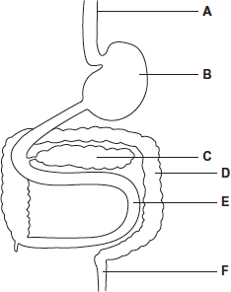

(a)     Give the letter of the organ that produces amylase.



**(1)**

(b)     Give the letter of the organ that produces maltase.



**(1)**

(c)     Maltose is hydrolysed by the enzyme maltase.

Explain why maltase catalyses only this reaction.

........................................................................................................................

........................................................................................................................

........................................................................................................................

........................................................................................................................

........................................................................................................................

........................................................................................................................

........................................................................................................................

**[Extra space]** ................................................................................................

........................................................................................................................

........................................................................................................................

**(3)**

**(Total 5 marks)**

**Q2.**(a)     Describe the role of the enzymes of the digestive system in the complete breakdown of starch.

......................................................................................................................

......................................................................................................................

......................................................................................................................

......................................................................................................................

......................................................................................................................

......................................................................................................................

......................................................................................................................

......................................................................................................................

......................................................................................................................

......................................................................................................................

**(5)**

(b)     Describe the processes involved in the absorption of the products of starch digestion.

......................................................................................................................

......................................................................................................................

......................................................................................................................

......................................................................................................................

......................................................................................................................

......................................................................................................................

......................................................................................................................

......................................................................................................................

......................................................................................................................

......................................................................................................................

**(5)**

**(Total 10 marks)**

**Q3.**          Catalase is an enzyme. It catalyses the breakdown of hydrogen peroxide in the reaction:

2H2O2    →    2H2O    +    O2

hydrogen         water      oxygen

peroxide

In an investigation, samples of different substances were added to hydrogen peroxide in a series of test tubes. The rate of reaction was measured by recording the rate at which bubbles of oxygen were produced. A scale going from 0 for no bubbles to 5 for the maximum rate of bubbling was used to measure this. The results are shown in the table.

|  |  |  |
| --- | --- | --- |
| **Tube** | **Substance added** | **Rate at which bubbles of oxygen were produced** |
| **A** | Piece of liver | 4 |
| **B** | Ground liver and sand | 5 |
| **C** | Sand | 0 |
| **D** | Piece of cooled, boiled liver | 0 |

(a)     Explain the difference between the rate at which bubbles were produced in.

(i)      tubes **A** and **B**;

..............................................................................................................

.............................................................................................................

.............................................................................................................

.............................................................................................................

**(2)**

(ii)     tubes **A** and **D**.

.............................................................................................................

.............................................................................................................

.............................................................................................................

.............................................................................................................

.............................................................................................................

.............................................................................................................

**(3)**

(b)     Explain the purpose of tube **C**.

......................................................................................................................

......................................................................................................................

**(1)**

(c)     The graph shows the energy changes which take place during the reaction in which hydrogen peroxide is converted to water and oxygen.

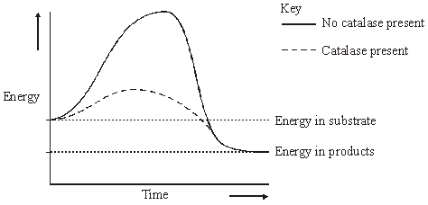

Use the graph to explain why

(i)      hydrogen peroxide breaks down at a lower temperature when catalase is present than when it is not present;

.............................................................................................................

.............................................................................................................

**(1)**

(ii)     test tubes **A** and **B** became warmer when the reaction was taking place.

.............................................................................................................

.............................................................................................................

.............................................................................................................

.............................................................................................................

**(2)**

**(Total 9 marks)**

**Q4.**          (a)     The diagrams represent an enzyme, its substrate and two other molecules, **A** and **B**.

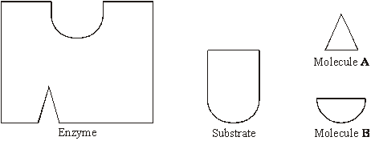

The addition of a non-competitive inhibitor will prevent the formation of an enzyme-substrate complex. Draw a labelled diagram based on relevant molecules selected from the diagram above to explain how this occurs.

**(2)**

(b)     A decrease in temperature decreases the kinetic energy of molecules in a solution. Explain how a decrease in temperature decreases the rate of an enzyme-controlled reaction.

......................................................................................................................

......................................................................................................................

......................................................................................................................

......................................................................................................................

**(2)**

(c)     Urea breaks hydrogen bonds. Explain how the addition of urea would affect the rate of an enzyme-controlled reaction.

......................................................................................................................

......................................................................................................................

......................................................................................................................

......................................................................................................................

......................................................................................................................

......................................................................................................................

**(3)**

**(Total 7 marks)**

**Q5.**          A test has been developed to determine if a person is infected with variant CJD (vCJD), the human form of BSE (mad cow disease). The test detects the protein which causes vCJD in a urine sample.

The test kit contains the following components.

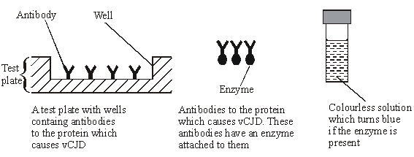

(a)     Complete the flow chart to describe how this test would be used.

|  |  |
| --- | --- |
|  | Urine sample is added to well in test plate |

**↓**

|  |  |
| --- | --- |
|  | Plate is washed to remove unbound vCJD protein |

**↓**

|  |  |
| --- | --- |
|  |  |

**↓**

|  |  |
| --- | --- |
|  |  |

**↓**

|  |  |
| --- | --- |
|  |  |

**(3)**

(b)     Explain why this test would detect vCJD, but not other antigens in the urine.

......................................................................................................................

......................................................................................................................

......................................................................................................................

......................................................................................................................

**(2)**

**(Total 5 marks)**

**Q6.**          The box jellyfish produces a poison (venom) which enters the blood when a person is stung. A person who has been stung can be treated with an injection of antivenom. This antivenom is produced by injecting small amounts of venom from box jellyfish into sheep, then extracting antibodies from the sheeps’ blood. These antibodies are then injected into the person who has been stung.

(a)     If a sheep is injected with the box jellyfish venom on more than one occasion a higher yield of antivenom is obtained. Explain why.

......................................................................................................................

......................................................................................................................

......................................................................................................................

......................................................................................................................

**(2)**

(b)     Injecting antivenom does not give a person lasting protection against the venom of box jellyfish. Explain why.

......................................................................................................................

......................................................................................................................

......................................................................................................................

......................................................................................................................

**(2)**

(c)     Suggest **one** possible problem in injecting people with antivenom made in this way.

......................................................................................................................

......................................................................................................................

**(1)**

**(Total 5 marks)**

**Q7.**          Read the following passage.

During the course of a day, we come into contact with many poisonous substances. These include industrial and household chemicals. The skin acts as a barrier and prevents many of these substances entering and harming the body.

The skin is one of the largest organs in the body. It is composed of several layers of

5        tissue. The outer layer consists of dead cells packed with keratins. Keratins are a group of proteins that differ from each other in their primary structure. Each keratin molecule consists of several polypeptide chains, each individual chain wound into a spiral or helix. The polypeptide chains include many sulphur-containing amino acids and these help to give the keratin molecules their characteristic strength.

Use information from the passage and your own knowledge to answer the questions.

(a)     What is the evidence from the passage that keratin molecules have a quaternary structure?

......................................................................................................................

......................................................................................................................

**(1)**

(b)     Explain how sulphur-containing amino acids help to give keratin molecules their characteristic strength (lines 8–9).

......................................................................................................................

......................................................................................................................

......................................................................................................................

......................................................................................................................

**(2)**

(c)     Explain why differences in primary structure result in keratins with different properties   
(line 6).

......................................................................................................................

......................................................................................................................

......................................................................................................................

......................................................................................................................

**(2)**

(d)     The skin prevents poisonous substances entering and harming the body (line 3). Explain why these substances are unable to pass through the outer layer of skin cells by active transport.

......................................................................................................................

......................................................................................................................

......................................................................................................................

......................................................................................................................

......................................................................................................................

......................................................................................................................

**(3)**

(e)     Skin cells may be studied with a transmission electron microscope or an optical microscope. Explain the advantages and limitations of using a transmission electron microscope to study cells.

......................................................................................................................

......................................................................................................................

......................................................................................................................

......................................................................................................................

......................................................................................................................

......................................................................................................................

......................................................................................................................

......................................................................................................................

......................................................................................................................

......................................................................................................................

......................................................................................................................

......................................................................................................................

......................................................................................................................

......................................................................................................................

**(6)**

**(Total 14 marks)**

**Q8.**          Uric acid is produced in the body. One of the reactions involved in the production of uric acid is catalysed by xanthine oxidase.

xanthine

 oxidase

xanthine          uric acid

(a)     A sample of xanthine oxidase was tested by mixing with biuret reagent. Describe and explain the result of this test.

......................................................................................................................

......................................................................................................................

......................................................................................................................

......................................................................................................................

**(2)**

(b)     Explain why xanthine oxidase is able to catalyse this reaction but it is not able to catalyse other reactions.

......................................................................................................................

......................................................................................................................

......................................................................................................................

......................................................................................................................

**(2)**

(c)     Gout is a painful condition caused by uric acid crystals in the joints. It is often treated with a drug that inhibits xanthine oxidase. The diagram shows a molecule of xanthine and a molecule of this drug.

Xanthine                                  Drug used  
to treat gout

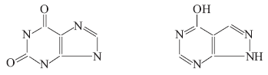

Use the diagram to explain why this drug is effective in the treatment of gout.

......................................................................................................................

......................................................................................................................

......................................................................................................................

......................................................................................................................

......................................................................................................................

..........................................................................................**(3) (Total 7 marks)**

**Q9.**Lactose is a disaccharide found in milk. In the human small intestine, the enzyme lactase catalyses the hydrolysis of lactose to the monosaccharides, galactose and glucose. These monosaccharides are then absorbed into the blood.

**S**Complete the diagram to show the hydrolysis of lactose to galactose and glucose.

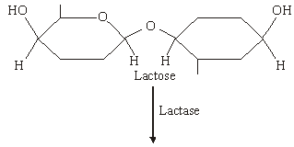

**(Total 2 marks)**

**Q10.**          Some enymes digest protein. They hydrolyse the peptide bonds between amino acids. The extent to which a protein is digested is called the degree of hydrolysis (DH). The DH value may be calculated from the equation:



(a)     (i)      A protein molecule contains 151 amino acids. What is the total number of peptide bonds in this molecule?

.............................................................................................................

**(1)**

(ii)     A molecule of this protein is digested. The DH value of the digested protein is 18. Calculate the number of peptide bonds that have been hydrolysed.

Answer ......................................

**(1)**

(b)     What would be the DH value of a protein if it were completely hydrolysed to amino acids? Explain how you arrived at your answer.

DH value ......................................................................................................

Explanation ..................................................................................................

......................................................................................................................

......................................................................................................................

**(2)**

Enzymes **A** and **B** digest protein. The graph shows the effect of pH on the rates of reaction of these enzymes.

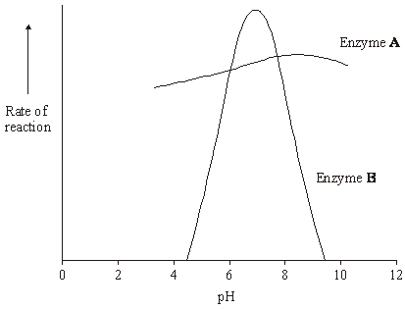

(c)     Pepsin is a protein-digesting enzyme found in the stomach. It has an optimum pH of 2 and is fully denatured at pH 6. Sketch a curve on the graph to show the effect of pH on the rate of reaction of pepsin.

**(1)**

(d)     Explain why the rate of reaction of enzyme **B** is low at pH 5.

......................................................................................................................

......................................................................................................................

......................................................................................................................

......................................................................................................................

......................................................................................................................

......................................................................................................................

**(3)**

(e)     Enzyme **A** is present in some washing powders used for cleaning clothes. Use the graph to suggest why enzyme **A** would be of more use in washing clothes than enzyme **B**.

......................................................................................................................

......................................................................................................................

......................................................................................................................

**(1)**

(f)      Use your knowledge of protein structure to explain why enzymes are specific and may be affected by non-competitive inhibitors.

......................................................................................................................

......................................................................................................................

......................................................................................................................

......................................................................................................................

......................................................................................................................

......................................................................................................................

......................................................................................................................

......................................................................................................................

......................................................................................................................

......................................................................................................................

......................................................................................................................

......................................................................................................................

......................................................................................................................

......................................................................................................................

**(6)**

**(Total 15 marks)**

**Q11.**          (a)     Sucrose, maltose and lactose are disaccharides.

(i)      Sucrase is an enzyme. It hydrolyses sucrose during digestion. Name the products of this reaction.

................................................... and ..................................................

**(2)**

(ii)     Sucrase does **not** hydrolyse lactose. Use your knowledge of the way in which enzymes work to explain why.

.............................................................................................................

.............................................................................................................

.............................................................................................................

.............................................................................................................

**(2)**

(b)     A woman was given a solution of sucrose to drink. Her blood glucose concentration was measured over the next 90 minutes. The results are shown on the graph.

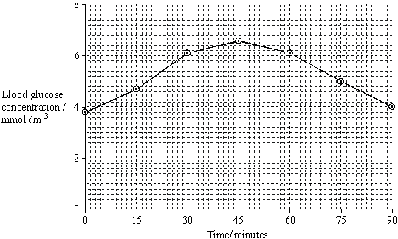

(i)      Describe how the woman’s blood glucose concentration changed in the period shown in the graph.

.............................................................................................................

.............................................................................................................

.............................................................................................................

.............................................................................................................

**(2)**

(ii)     Explain the results shown on the graph.

.............................................................................................................

.............................................................................................................

.............................................................................................................

.............................................................................................................

**(2)**

**(Total 8 marks)**

**Q12.**Bromelain is a protein-digesting enzyme found in pineapples. Some people claim that bromelain tablets have benefitial effect on health. These effects include reducing swelling and pain after surgery and reducing growth of cancers.

Bromelain is absorbed from the gut into the blood. Scientists gave a group of volunteers 3 g of bromelain in tablets each day for three days. They then measured the maximum mass of bromelain in the blood of each volunteer. The mean value for the maximum mass of bromelain in the blood of the volunteers was 0.025 mg.

(a)     There is a difference between the mass of bromelain that the volunteers were given and the maximum mass of bromelain in their blood. Suggest **one** explanation for this difference.

........................................................................................................................

........................................................................................................................

**(1)**

(b)     The scientists measured the concentration of bromelain in the blood. What else did they need to measure to calculate the total mass of the bromelain in the blood of a volunteer?

........................................................................................................................

........................................................................................................................

**(1)**

**(Total 2 marks)**

**Q13.**(a)     The table shows some substances found in cells. Complete the table to show the properties of these substances. Put a tick in the box if the statement is correct.

|  |  |  |  |  |  |
| --- | --- | --- | --- | --- | --- |
|  |  | **Substance** | | | |
|  | **Statement** | Starch | Glycogen | Deoxyribose | DNA helicase |
|  | Substance contains only the elements carbon, hydrogen and oxygen |  |  |  |  |
|  | Substance is made from amino acid monomers |  |  |  |  |
|  | Substance is found in both animal cells and plant cells |  |  |  |  |

**(4)**

(b)     The diagram shows two molecules of β-glucose.

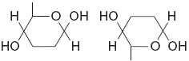

On the diagram, draw a box around the atoms that are removed when the two β-glucose molecules are joined by condensation.

**(2)**

(c)     (i)      Hydrogen bonds are important in cellulose molecules. Explain why.

.............................................................................................................

.............................................................................................................

.............................................................................................................

.............................................................................................................

**(2)**

(ii)     A starch molecule has a spiral shape. Explain why this shape is important to its function in cells.

.............................................................................................................

.............................................................................................................

.............................................................................................................

**(1)**

**(Total 9 marks)**

**Q14.**Doctors compared two tests for lactase deficiency.

Doctors investigated three groups of people. The people in all three groups were not allowed to eat or drink for 8 hours before the test. They each then drank a solution containing 50 g of lactose made with a radioactive form of carbon called 14C.

•        Group **A** were the control group

•        Group **B** were lactase deficient

•        Group **C** had irritable bowel syndrome (IBS)

Both lactase deficieny and irritable bowel syndrome have similar symptoms.

**The carbon dioxide breath test**

In this test the doctors measured the amount of 14C in the carbon dioxide breathed out. The doctors took measurements at intervals for 8 hours after each volunteer had drunk the lactose solution. The following figure shows the mean results for each group.

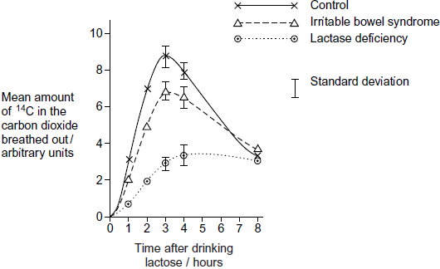

(a)     Describe the common trend shown by **all** the curves in the figure.

........................................................................................................................

........................................................................................................................

........................................................................................................................

**(1)**

(b)     Explain why the doctors stopped measuring the amounts of 14C in the carbon dioxide breathed out after 8 hours.

........................................................................................................................

........................................................................................................................

........................................................................................................................

........................................................................................................................

**(2)**

(c)     Carbon dioxide in the breath contained the radioactive form of carbon, 14C. Explain how 14C in carbon dioxide came from 14C in glucose in the blood.

........................................................................................................................

........................................................................................................................

........................................................................................................................

........................................................................................................................

**(2)**

(d)     The doctors concluded that measuring the amount of 14C in the carbon dioxide in the breath after 3 hours was a better way of diagnosing lactase deficiency than the lactose tolerance test. Do you agree with the doctors’ conclusion? Give the reasons for your answer.

........................................................................................................................

........................................................................................................................

........................................................................................................................

........................................................................................................................

........................................................................................................................

**(2)**

**(Total 7 marks)**

**Q15.**          A glucose biosensor is an instrument used to measure glucose concentration. It contains an enzyme called glucose oxidase.

(a)     A glucose biosensor detects only glucose. Use your knowledge of the way in which enzymes work to explain why.

......................................................................................................................

......................................................................................................................

......................................................................................................................

......................................................................................................................

......................................................................................................................

......................................................................................................................

**(3)**

(b)     It is better to use a biosensor than the Benedict’s test to measure the concentration of glucose in a sample of blood. Suggest **two** reasons why.

1 ...................................................................................................................

......................................................................................................................

2 ...................................................................................................................

......................................................................................................................

**(2)**

(c)     (i)      Diabetes mellitus is a disease that can lead to an increase in blood glucose concentration. Some diabetics need insulin injections. Insulin is a protein so it cannot be taken orally. Suggest why insulin cannot be taken orally.

.............................................................................................................

.............................................................................................................

.............................................................................................................

**(1)**

(ii)     A drug company produced a new type of insulin. Scientists from the company carried out a trial in which they gave this new type of insulin to rats. They reported that the results of this trial on rats were positive. A newspaper stated that diabetics would benefit from this new drug. Suggest **two** reasons why this statement should be viewed with caution.

1 ..........................................................................................................

.............................................................................................................

2 ..........................................................................................................

.............................................................................................................

**(2)**

**(Total 8 marks)**

**Q16.**          **Figure 1** shows a short section of a DNA molecule.

**Figure 1**

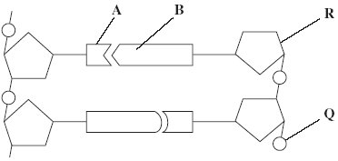

(a)     Name parts **R** and **Q**.

(i)      **R** ....................................................

(ii)     **Q** ....................................................

**(2)**

(b)     Name the bonds that join **A** and **B**.

......................................................................................................................

**(1)**

(c)     Ribonuclease is an enzyme. It is 127 amino acids long.

          What is the minimum number of DNA bases needed to code for ribonuclease?



**(1)**

(d)     **Figure 2** shows the sequence of DNA bases coding for seven amino acids in the enzyme ribonuclease.

**Figure 2**

**G  T  T  T  A  C  T  A  C  T  C  T  T  C  T  T  C  T  T  T  A**

The number of each type of amino acid coded for by this sequence of DNA bases is shown in the table.

|  |  |
| --- | --- |
| **Amino acid** | **Number present** |
| Arg | 3 |
| Met | 2 |
| Gln | 1 |
| Asn | 1 |

Use the table and **Figure 2** to work out the sequence of amino acids in this part of the enzyme. Write your answer in the boxes below.

|  |  |  |  |  |  |  |
| --- | --- | --- | --- | --- | --- | --- |
| Gln |  |  |  |  |  |  |

**(1)**

(e)     Explain how a change in a sequence of DNA bases could result in a non-functional enzyme.

......................................................................................................................

......................................................................................................................

......................................................................................................................

......................................................................................................................

......................................................................................................................

......................................................................................................................

**(3)**

**(Total 8 marks)**

**Q17.**Scientists investigated the effect of lipase and a 3% bile salts solution on the digestion of triglycerides. The graph below shows their results.

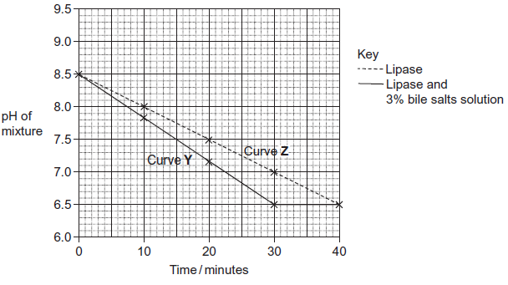

The scientists also incubated triglycerides with different concentrations of bile salts. After 30 minutes they measured the diameter of the triglyceride droplets. They used the results to calculate the mean radius of the droplets at each concentration. The table below shows their results.

|  |  |  |  |  |  |  |  |
| --- | --- | --- | --- | --- | --- | --- | --- |
|  | Concentration of bile salts /% | 0 | 1 | 2 | 3 | 4 | 5 |
|  | Mean radius of triglyceride droplet / μm | 6 | 5 | 4 | 3 | 2 | 1 |

(a)     Describe how you would use a microscope to find the mean diameter of triglyceride droplets on a slide.

.........................................................................................................................

.........................................................................................................................

.........................................................................................................................

.........................................................................................................................

.........................................................................................................................

.........................................................................................................................

*(Extra space)* ..................................................................................................

.........................................................................................................................

.........................................................................................................................

**(3)**

(b)     (i)      The ratio of mean radius of triglyceride droplets in bile salts at a concentration of 0% to the mean radius in bile salts at a concentration of 3% is 2 : 1.

What is the ratio of their surface areas? Show your working.

You can calculate the surface area of a droplet from the formula

A = 4*π*r2

Where  A = surface area  
    r = radius  
   *π* = 3.14

**(2)**

(ii)     Use the data in the table to explain the difference between curves **Y** and **Z** in the graph.

...............................................................................................................

...............................................................................................................

...............................................................................................................

...............................................................................................................

...............................................................................................................

...............................................................................................................

*(Extra space)* ........................................................................................

...............................................................................................................

...............................................................................................................

**(3)**

**(Total 8 marks)**

**Q18.**          The graph shows the effect of substrate concentration on the rate of an enzyme-controlled reaction.

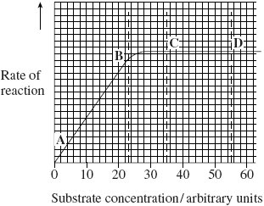

(a)     (i)      Describe what the graph shows about the effect of substrate concentration on the rate of this enzyme-controlled reaction.

.............................................................................................................

.............................................................................................................

.............................................................................................................

.............................................................................................................

**(2)**

(ii)     What limits the rate of this reaction between points **A** and **B**? Give the evidence from the graph for this.

.............................................................................................................

.............................................................................................................

.............................................................................................................

.............................................................................................................

**(2)**

(iii)     Suggest a reason for the shape of the curve between points **C** and **D**.

.............................................................................................................

.............................................................................................................

**(1)**

(b)     Sketch a curve on the graph to show the rate of this reaction in the presence of a competitive inhibitor.

**(1)**

(c)     Methotrexate is a drug used in the treatment of cancer. It is a competitive inhibitor and affects the enzyme folate reductase.

(i)      Explain how the drug lowers the rate of reaction controlled by folate reductase.

.............................................................................................................

.............................................................................................................

.............................................................................................................

.............................................................................................................

.............................................................................................................

**(2)**

(ii)     Methotrexate only affects the rate of the reaction controlled by folate reductase.

Explain why this drug does not affect other enzymes.

.............................................................................................................

.............................................................................................................

**(1)**

**(Total 9 marks)**

**Q19.**(a)     (i)      The equation shows the reaction catalysed by the enzyme lactase. Complete this equation.

Lactose + ...............................  Glucose + ...............................

**(2)**

(ii)     Name the type of chemical reaction shown in this equation.

.............................................................................................................

**(1)**

(b)     Lactase is an enzyme. Lactose is a reducing sugar.

(i)      Describe how you could use the biuret test to distinguish a solution of the enzyme, lactase from a solution of lactose.

.............................................................................................................

.............................................................................................................

**(1)**

(ii)     Explain the result you would expect with the enzyme.

.............................................................................................................

.............................................................................................................

**(1)**

**(Total 5 marks)**

**Q20.**Biologists divided new-born rats randomly into four groups.

They fed the rats in each group on a standard diet which only differed in the carbohydrate content. When these rats were adult, the biologists measured the activity of lactase in the digestive system of the rats. The following table shows the mean results for each group.

|  |  |  |
| --- | --- | --- |
|  | **Diet** | **Mean lactase activity / µ mol of lactose digested per  hour (± standard deviation)** |
|  | Low sucrose | 57.9 (± 14.5) |
|  | High sucrose | 184.2 (± 30.8) |
|  | Low starch | 86.9 (± 13.3) |
|  | High starch | 221.4 (± 25.4) |

(a)     Give **one** piece of evidence from the table that indicates lactase activity is affected by diet.

........................................................................................................................

........................................................................................................................

**(1)**

(b)     Some students suggested from these data that increasing starch in the diet was the most effective way to increase lactase activity in lactase deficient people. Is this conclusion valid? Explain your answer.

........................................................................................................................

........................................................................................................................

........................................................................................................................

........................................................................................................................

........................................................................................................................

**(2)**

**(Total 3 marks)**

**Q21.**          A protease is an enzyme that digests protein. The graph shows how the activity of a protease varies with temperature.

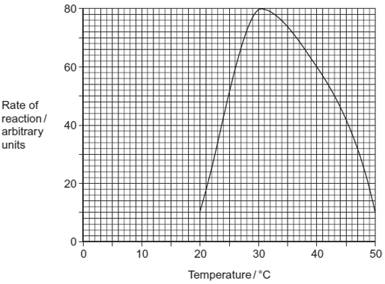

(a)     (i)      Describe what the graph shows about the effect of temperature on the rate of reaction.

.............................................................................................................

.............................................................................................................

.............................................................................................................

**(1)**

(ii)     Explain the shape of the curve between 30 °C and 50 °C.

.............................................................................................................

.............................................................................................................

.............................................................................................................

.............................................................................................................

.............................................................................................................

.............................................................................................................

*(Extra space)* ......................................................................................

.............................................................................................................

**(3)**

(b)Students investigated the effect of pH on the activity of the protease.

•        The students used agar plates containing protein. The protein made the agar cloudy.

•They made four wells of equal size in the agar of each plate.

•They added a drop of protease solution to each of the wells. The protease solution in each well was at a different pH.

•The students incubated the agar plates for 4 hours at a constant temperature.

The diagram shows the agar plates after they were incubated and the pH of the protease solution in each well.

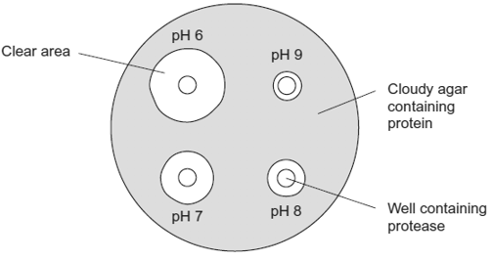

(i)      How should the students make sure that the pH of the protease solution did **not** change?

.............................................................................................................

**(1)**

(ii)     Use the graph to suggest a suitable temperature for incubating the agar plates.

Explain your answer.

.............................................................................................................

.............................................................................................................

.............................................................................................................

**(1)**

(iii)     Use the diagram to describe the effect of pH on the activity of this protease.

.............................................................................................................

.............................................................................................................

.............................................................................................................

**(1)**

**(Total 7 marks)**

**Q22.**Lettuce growers investigated the best conditions for germinating lettuce seeds. They soaked lettuce seeds for 8 hours in distilled water at different temperatures. They then germinated some of the seeds at 20°C and some at 35°C. The table shows their results.

|  |  |  |  |
| --- | --- | --- | --- |
|  | **Temperature at which seeds were soaked / ºC** | **Percentage of seeds which germinated** | |
|  | **at 20°C** | **at 35°C** |
|  | 20 | 100 | 89 |
|  | 25 | 100 | 43 |
|  | 30 | 41 | 1 |
|  | 35 | 21 | 0 |

(a)     Use the information above to describe and explain the effect of temperature on lettuce seed germination.

.........................................................................................................................

.........................................................................................................................

.........................................................................................................................

.........................................................................................................................

.........................................................................................................................

.........................................................................................................................

*(Extra space)* ....................................................................................................

.........................................................................................................................

.........................................................................................................................

**(3)**

(b)     Explain why the lettuce growers measured germination as a percentage.

.........................................................................................................................

.........................................................................................................................

**(1)**

**(Total 4 marks)**

**Q23.**Doctors compared two tests for lactase deficiency.

Doctors investigated three groups of people. The people in all three groups were not allowed to eat or drink for 8 hours before the test. They each then drank a solution containing 50 g of lactose made with a radioactive form of carbon called 14C.

•        Group **A** were the control group

•        Group **B** were lactase deficient

•        Group **C** had irritable bowel syndrome (IBS)

Both lactase deficieny and irritable bowel syndrome have similar symptoms.

**The lactose tolerance test**

The doctors measured the concentration of radioactive glucose in the blood of each person. The figure below shows the results. Each point shows the result for one person 3 hours after drinking the lactose solution.

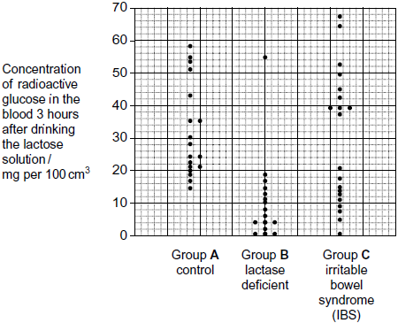

(a)     (i)      Give the range of results for the control group (group **A**)

...............................................................................................................

**(1)**

(ii)     Each person in the control group was given 50 g of lactose containing the same amount of radioactive carbon. All the products of lactose digestion were absorbed into their blood. The concentration of glucose was measured in mg per 100 cm3 of blood.

Explain why the variation in the results may be due to differences in body mass.

...............................................................................................................

...............................................................................................................

...............................................................................................................

...............................................................................................................

**(2)**

(b)     In the test the doctors obtained different results for the three groups.

Would this test be useful to identify people who were lactase deficient? Use the data from all three groups to explain your answer.

........................................................................................................................

........................................................................................................................

........................................................................................................................

........................................................................................................................

........................................................................................................................

........................................................................................................................

(Extra space) .................................................................................................

........................................................................................................................

........................................................................................................................

**(3)**

**(Total 6 marks)**

**Q24.**          Nitrogenase catalyses the reduction of nitrogen during nitrogen fixation. The reaction requires 16 molecules of ATP for each molecule of nitrogen that is reduced.

(a)     Nitrogen gas is the usual substrate for this enzyme. Name the product.

......................................................................................................................

**(1)**

(b)     Nitrogenase also catalyses reactions involving other substances. Explain what this suggests about the shapes of the molecules of these other substances.

......................................................................................................................

......................................................................................................................

......................................................................................................................

......................................................................................................................

......................................................................................................................

**(2)**

(c)     (i)      *Azotobacter* is a nitrogen-fixing bacterium. It produces the enzyme nitrogenase. The enzyme only works in the absence of oxygen.

*Azotobacter* has a very high rate of aerobic respiration compared with bacteria that do not fix nitrogen. Suggest **two** advantages of the very high rate of aerobic respiration.

.............................................................................................................

.............................................................................................................

.............................................................................................................

.............................................................................................................

.............................................................................................................

**(2)**

(ii)     If scientists could transfer the gene that codes for nitrogenase to cereal plants, these cereal plants would be able to fix nitrogen. However, the scientists would expect these genetically engineered cereal plants to grow more slowly than cereal plants that get their nitrogen from fertiliser. Explain why they would grow more slowly.

.............................................................................................................

.............................................................................................................

.............................................................................................................

.............................................................................................................

.............................................................................................................

**(2)**

**(Total 7 marks)**

**Q25.**          (a)     Haemoglobin contains iron. One type of anaemia is caused by a lack of iron. This type of anaemia can be treated by taking tablets containing iron. A number of patients were given a daily dose of 120 mg of iron. **Figure 1** shows the effect of this treatment on the increase in the concentration of haemoglobin in their red blood cells.

**Figure 1**

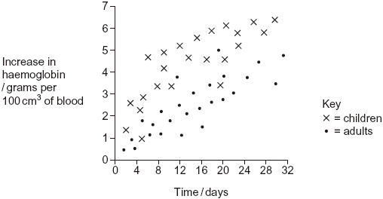

(i)      Give **one** difference in the response of adults and children to this treatment.

.............................................................................................................

.............................................................................................................

**(1)**

(ii)     You could use the graph to predict the effect of this treatment on the increase in haemoglobin content of an adult after 40 days. Explain how.

.............................................................................................................

.............................................................................................................

.............................................................................................................

.............................................................................................................

**(2)**

(iii)     Haemoglobin has a quaternary structure. Explain what is meant by a quaternary structure.

.............................................................................................................

.............................................................................................................

**(1)**

(b)     (i)      Pernicious anaemia is another type of anaemia. One method of identifying pernicious anaemia is to measure the diameter of the red blood cells in a sample of blood that has been diluted with an isotonic salt solution. Explain why an isotonic salt solution is used to dilute the blood sample.

.............................................................................................................

.............................................................................................................

.............................................................................................................

.............................................................................................................

.............................................................................................................

.............................................................................................................

**(3)**

(ii)     A technician compared the red blood cells in two blood samples of equal volume. One sample was from a patient with pernicious anaemia, the other was from a patient who did not have pernicious anaemia. **Figure 2** shows some of the results she obtained.

**Figure 2**

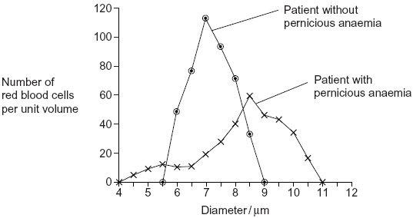

Describe **two** differences between the blood samples.

1 ..........................................................................................................

.............................................................................................................

2 ..........................................................................................................

.............................................................................................................

**(2)**

**(Total 9 marks)**

**Q26.**          Folic acid is a substance required by bacteria for cell growth. Bacteria produce folic acid by the following reaction.



The diagram shows the structure of a molecule of PABA. It also shows the structure of a molecule of a drug called sulfanilamide, which can be used to treat bacterial infections. Sulfanilamide prevents bacteria producing folic acid.

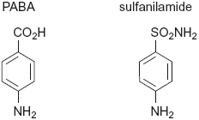

Use the diagram and your knowledge of enzymes to explain how sulphanilamide prevents bacteria producing folic acid.

...............................................................................................................................

...............................................................................................................................

...............................................................................................................................

...............................................................................................................................

...............................................................................................................................

...............................................................................................................................

**(Total 3 marks)**

**Q27.**          Gangliosides are lipids found in the cell surface membranes of nerve cells. Hexosaminidase is an enzyme present in blood that breaks down gangliosides. If gangliosides are not broken down, they damage nerve cells.

(a)     Hexosaminidase only breaks down gangliosides. It does not break down other lipids.

Explain why this enzyme only breaks down gangliosides.

......................................................................................................................

......................................................................................................................

......................................................................................................................

......................................................................................................................

......................................................................................................................

......................................................................................................................

**(3)**

(b)     Hexosaminidase is found in the blood of healthy people. People with Tay Sachs disease do not have this enzyme in their blood.

Doctors confirm Tay Sachs disease by using a blood test. The technician carrying out the test adds a solution containing a high concentration of gangliosides to a sample of blood from the person being tested. The technician then measures the concentration of gangliosides in the person’s blood at regular intervals.

(i)      Complete the graph below by sketching a curve to show the results you would expect for a person with Tay Sachs disease. Label this curve **T**.

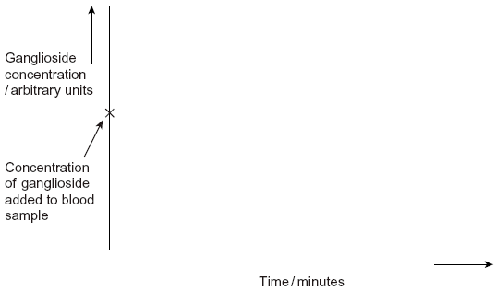

**(1)**

(ii)     Sketch a curve on the same graph to show the results you would expect for a healthy person who does **not** have Tay Sachs disease. Label this curve **H**.

**(1)**

(c)     Scientists are trying to find a way to give the missing enzyme to people with Tay Sachs disease. Suggest why they cannot give the enzyme as a tablet that is swallowed.

......................................................................................................................

......................................................................................................................

......................................................................................................................

......................................................................................................................

**(2)**

**(Total 7 marks)**

**Q28.**In the early 1980s, before DNA analysis had been developed, scientists investigated the genetic variation of cheetahs living in captivity. They used skin grafts to do this. They carried out skin grafts on anaesthetised animals by

•        removing a small piece of skin from one animal. This animal was the recipient.

•        replacing the removed skin by a piece of skin taken from another animal. This animal was the donor.

•        attaching the new piece of skin with stitches.

A graft may be accepted by the recipient. It will be rejected if the recipient’s immune system recognises the antigens on the skin as foreign.

Scientists carried out skin grafts between cheetahs living in captivity and domestic cats.  
The table shows the data that they obtained.

|  |  |  |  |  |
| --- | --- | --- | --- | --- |
|  | **Recipient of skin graft** | **Donor of skin graft** | **Relationship** | **Time taken for the graft to be rejected / days** |
|  | Domestic cat 1 | Domestic cat 2 | Unrelated | 13 |
|  | Cheetah 1 | Domestic cat 3 | Unrelated | 12 |
|  | Cheetah 1 | Cheetah 2 | Sisters | No rejection after 52 days |
|  | Cheetah 3 | Cheetah 4 | Unrelated | 49 |
|  | Cheetah 5 | Cheetah 6 | Unrelated | No rejection after 78 days |
|  | Cheetah 7 | Cheetah 8 | Unrelated | No rejection after 41 days |
|  | Cheetah 9 | Cheetah 10 | Unrelated | No rejection after 24 days |
|  | Cheetah 11 | Cheetah 12 | Unrelated | No rejection after 14 days |
|  | Cheetah 13 | Cheetah 14 | Unrelated | No rejection after 44 days |

The scientists also grafted skin from one area to another on the same animal. These grafts were not rejected.

(a)     (i)      The scientists grafted skin from a domestic cat to a cheetah. Suggest why.

...............................................................................................................

...............................................................................................................

**(1)**

(ii)     They also grafted skin from one area to another on the same animal. Explain why.

...............................................................................................................

...............................................................................................................

**(1)**

(b)     (i)      Give **three** conclusions that you can make from the data in the table above about the time taken for rejection.

1. ...........................................................................................................

...............................................................................................................

2. ...........................................................................................................

...............................................................................................................

3. ...........................................................................................................

...............................................................................................................

**(3)**

(ii)     Give **one** reason why these conclusions may **not** be reliable.

...............................................................................................................

...............................................................................................................

**(1)**

(iii)    There are proteins on the skin of cheetahs that act as antigens. What do the data in the table suggest about these cheetah antigens?

...............................................................................................................

...............................................................................................................

**(1)**

(iv)    Antigens are proteins. Explain why a knowledge of antigens can show that animals are genetically similar.

...............................................................................................................

...............................................................................................................

...............................................................................................................

...............................................................................................................

**(2)**

**(Total 9 marks)**

**Q29.**Wheat is an important cereal crop. Ryegrass is a weed in wheat fields. Wheat and ryegrass belong to the grass family.

Scientists investigated competition between wheat and ryegrass seedlings. They set up three experiments **W, X**, and **Y** as shown in the diagram.

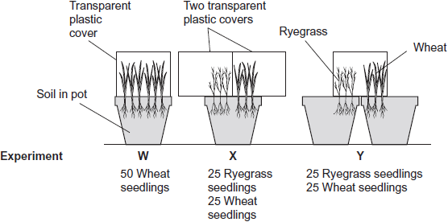

The table shows the mean dry mass of the wheat seedlings as a percentage of their dry mass when grown alone.

|  |  |  |  |  |
| --- | --- | --- | --- | --- |
|  |  | **Experiment** | | |
|  |  | **W** | **X** | **Y** |
|  | Mean dry mass of wheat seedlings as  a percentage of their dry mass when  grown alone | 100 | 76 | 46 |

(a)     Experiment **W** was a control experiment. Explain the purpose of the control experiment in this investigation.

........................................................................................................................

........................................................................................................................

........................................................................................................................

........................................................................................................................

........................................................................................................................

**(2)**

(b)     What can you conclude from this investigation about competition between wheat and ryegrass? Use the data in the table to support your answer.

........................................................................................................................

........................................................................................................................

........................................................................................................................

........................................................................................................................

........................................................................................................................

........................................................................................................................

........................................................................................................................

........................................................................................................................

(Extra space) ..................................................................................................

........................................................................................................................

........................................................................................................................

........................................................................................................................

**(4)**

(c)     Explain how a decrease in temperature could affect the outcome of this investigation.

........................................................................................................................

........................................................................................................................

........................................................................................................................

........................................................................................................................

........................................................................................................................

**(2)**

**(Total 8 marks)**

**Q30.**          The diagram shows the life cycle of a fly.

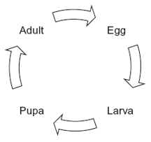

When the larva is fully grown, it changes into a pupa. The pupa does not feed. In the pupa, the tissues that made up the body of the larva are broken down. New adult tissues are formed from substances obtained from these broken-down tissues and from substances that were stored in the body of the larva.

(a)     Hydrolysis and condensation are important in the formation of new adult proteins.  
Explain how.

......................................................................................................................

......................................................................................................................

......................................................................................................................

......................................................................................................................

**(2)**

(b)     Most of the protein stored in the body of a fly larva is a protein called calliphorin.  
Explain why different adult proteins can be made using calliphorin.

......................................................................................................................

......................................................................................................................

**(1)**

The table shows the mean concentration of RNA in fly pupae at different ages.

|  |  |  |
| --- | --- | --- |
|  | **Age of pupa as percentage of total time spent as a pupa** | **Mean concentration of RNA / μg per pupa** |
|  | 0 | 20 |
|  | 20 | 15 |
|  | 40 | 12 |
|  | 60 | 17 |
|  | 80 | 33 |
|  | 100 | 20 |

(c)     Describe how the concentration of RNA changes during the time spent as a pupa.

......................................................................................................................

......................................................................................................................

......................................................................................................................

......................................................................................................................

**(2)**

(d)     (i)      Describe how you would expect the number of lysosomes in a pupa to change with the age of the pupa. Give a reason for your answer.

.............................................................................................................

.............................................................................................................

.............................................................................................................

.............................................................................................................

**(2)**

(ii)     Suggest an explanation for the change in RNA concentration in the first 40% of the time spent as a pupa.

.............................................................................................................

.............................................................................................................

.............................................................................................................

.............................................................................................................

.............................................................................................................

**(2)**

(e)     Suggest an explanation for the change in RNA concentration between 60 and 80% of the time spent as a pupa.

......................................................................................................................

......................................................................................................................

......................................................................................................................

......................................................................................................................

......................................................................................................................

**(2)**

(f)      The graph shows changes in the activity of two respiratory enzymes in a fly pupa.

•        Enzyme **A** catalyses a reaction in the Krebs cycle

•        Enzyme **B** catalyses the formation of lactate from pyruvate

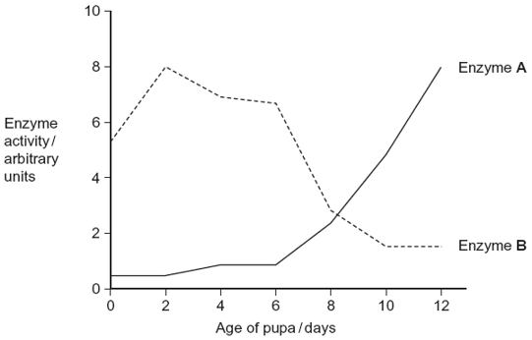

During the first 6 days as a pupa, the tracheae break down. New tracheae are formed after 6 days. Use this information to explain the change in activity of the two enzymes.

......................................................................................................................

......................................................................................................................

......................................................................................................................

......................................................................................................................

......................................................................................................................

......................................................................................................................

*(Extra space)* ................................................................................................

......................................................................................................................

......................................................................................................................

......................................................................................................................

**(4)**

**(Total 15 marks)**

**Q31.**Different extracts may be added to milk to make cheese. All of these extracts contain chymosin.

•        Animal rennet comes from calves and lambs. Rennet from these young animals contains between 80 and 95% chymosin. It also contains between 5 and 20% of another protein-digesting enzyme called pepsin.

•        Vegetarian rennet comes from fungi. It contains 100% chymosin.

•        Recombinant chymosin comes from bacteria which have had an animal gene for chymosin inserted in them. It contains 100% chymosin.

Scientists investigated the effect of temperature on the time these different extracts took to coagulate milk. Their results are shown below.

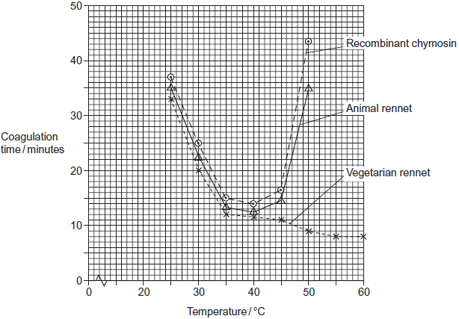

(a)     Suggest **two** disadvantages of using animal rennet rather than recombinant chymosin as a source of chymosin for making cheese.

1 .....................................................................................................................

........................................................................................................................

2 .....................................................................................................................

........................................................................................................................

**(2)**

(b)     The shape of the curve for recombinant chymosin is similar to the shape of the curve for animal rennet. Suggest why.

........................................................................................................................

........................................................................................................................

........................................................................................................................

**(1)**

(c)     (i)      Describe how the coagulation time for vegetarian rennet is different from that for animal rennet.

...............................................................................................................

...............................................................................................................

...............................................................................................................

**(1)**

(ii)     Calculate the percentage reduction in coagulation time between 45 °C and 60 °C for vegetarian rennet. Show your working.

Answer ....................................................%

**(2)**

(d)     Explain the shape of the curve for animal rennet above 45 °C.

........................................................................................................................

........................................................................................................................

........................................................................................................................

........................................................................................................................

........................................................................................................................

........................................................................................................................

(Extra space) .................................................................................................

........................................................................................................................

........................................................................................................................

**(3)**

**(Total 9 marks)**

**Q32.**The figure below summarises the way in which cheese is made.

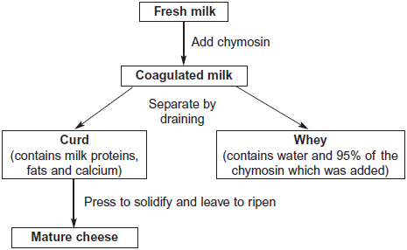

(a)     A student carried out a biuret test on a sample of whey. The sample turned purple.  
Use the flowchart to explain why.

........................................................................................................................

........................................................................................................................

........................................................................................................................

........................................................................................................................

........................................................................................................................

**(2)**

(b)     The percentage of protein in mature cheese is greater than the percentage of protein in coagulated milk. Use the flow chart to explain why.

........................................................................................................................

........................................................................................................................

........................................................................................................................

**(1)**

**(Total 3 marks)**

**Q33.**          (a)     *Clostridium difficile* is a bacterium that is present in the gut of up to 3% of healthy adults and 66% of healthy infants.

(i)*C. difficile* rarely causes problems, either in healthy adults or in infants. This is because its numbers are kept low by competition with harmless bacteria that normally live in the intestine.

Use this information to explain why some patients treated with antibiotics can be affected by *C. difficile*.

.............................................................................................................

.............................................................................................................

.............................................................................................................

.............................................................................................................

.............................................................................................................

**(2)**

(ii)     Suggest why older people are more likely to be affected by *C. difficile*.

.............................................................................................................

.............................................................................................................

.............................................................................................................

**(1)**

(b)The antibiotic methicillin inhibits the enzyme transpeptidase. This enzyme is used by some bacteria to join monomers together during cell wall formation. Methicillin has a similar structure to these monomers. Use this information to explain how methicillin inhibits the enzyme transpeptidase.

......................................................................................................................

......................................................................................................................

......................................................................................................................

......................................................................................................................

......................................................................................................................

**(2)**

(c)     MRSA is a variety of *Staphylococcus aureus*. It is difficult to treat infections caused by this bacterium because it is resistant to methicillin and to some other antibiotics. As a result, some patients who are already very ill may die if they become infected with MRSA. The graph shows the number of deaths in England and Wales between 1994 and 2008 caused by MRSA.

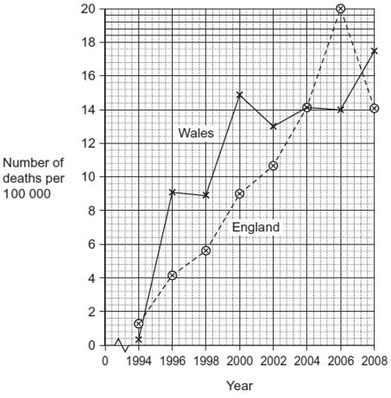

(i)It may be difficult to identify MRSA as the actual cause of death. Explain why.

.............................................................................................................

.............................................................................................................

.............................................................................................................

**(1)**

(ii)     Describe the change in the number of deaths caused by MRSA in England in the period shown in the graph.

.............................................................................................................

.............................................................................................................

.............................................................................................................

**(1)**

(iii)Calculate the percentage increase in the number of deaths caused by MRSA in Wales from 1996 to 2006. Show your working.

Answer ......................................

**(2)**

**(Total 9 marks)**

**Q34.**(a)     In humans, the enzyme maltase breaks down maltose to glucose.  
This takes place at normal body temperature.

Explain why maltase:

•        only breaks down maltose

•        allows this reaction to take place at normal body temperature.

........................................................................................................................

........................................................................................................................

........................................................................................................................

........................................................................................................................

........................................................................................................................

........................................................................................................................

........................................................................................................................

........................................................................................................................

........................................................................................................................

........................................................................................................................

*(Extra space)* .................................................................................................

........................................................................................................................

........................................................................................................................

........................................................................................................................

........................................................................................................................

........................................................................................................................

........................................................................................................................

........................................................................................................................

........................................................................................................................

........................................................................................................................

........................................................................................................................

**(5)**

(b)     Scientists have investigated the effects of competitive and non-competitive inhibitors of the enzyme maltase.

Describe competitive and non-competitive inhibition of an enzyme.

........................................................................................................................

........................................................................................................................

........................................................................................................................

........................................................................................................................

........................................................................................................................

........................................................................................................................

........................................................................................................................

........................................................................................................................

........................................................................................................................

........................................................................................................................

*(Extra space)* .................................................................................................

........................................................................................................................

........................................................................................................................

........................................................................................................................

........................................................................................................................

........................................................................................................................

........................................................................................................................

........................................................................................................................

........................................................................................................................

........................................................................................................................

........................................................................................................................

**(5)**

**(Total 10 marks)**

**Q35.**Some of the catalase produced by *Aspergillus niger* is intracellular and some is extracellular.

Intracellular enzymes stay inside the cells that produce them. Extracellular enzymes are secreted from the cells that produce them.

Another group of scientists grew a different strain of *A. niger*.

•        *A. niger* grows from tiny structures called spores. The scientists kept the spores in an isotonic medium at a low temperature until they needed them.

•        They put spores of *A. niger* into a 500 cm3 flask containing a sterile medium. The medium contained starch.

•        They measured the total amount of catalase and the amount of extracellular catalase produced by the fungus over a period of 100 hours.

The graph shows their results.

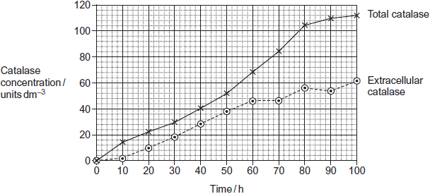

(a)     (i)      The scientists kept the spores in an isotonic medium until they were needed.  
Suggest why it was important that the medium was isotonic.

...............................................................................................................

...............................................................................................................

...............................................................................................................

...............................................................................................................

...............................................................................................................

**(2)**

(ii)     The scientists kept the spores at a low temperature until they were needed.  
Suggest why.

...............................................................................................................

...............................................................................................................

...............................................................................................................

**(1)**

(b)     Starch is a source of carbon, hydrogen and oxygen for the fungus. Name one other chemical element that must be in the culture medium before *A. niger* can synthesise catalase. Give the reason for your answer.

Chemical element ...........................................................................................

Reason ...........................................................................................................

........................................................................................................................

........................................................................................................................

........................................................................................................................

**(2)**

(c)     To get reliable results in this investigation, the medium must be sterile.  
Explain why.

........................................................................................................................

........................................................................................................................

........................................................................................................................

........................................................................................................................

........................................................................................................................

**(2)**

(d)     (i)      At what time was the concentration of intracellular catalase highest?

...............................................................................................................

**(1)**

(ii)     Between what times was the rate of total catalase production highest?

...............................................................................................................

**(1)**

(e)     Technologists prefer to manufacture extracellular enzymes rather than intracellular enzymes. This is because intracellular enzymes are more expensive to purify than extracellular enzymes. Suggest why intracellular enzymes are more expensive to purify.

........................................................................................................................

........................................................................................................................

........................................................................................................................

........................................................................................................................

........................................................................................................................

**(2)**

**(Total 11 marks)**

**Q36.**The diagram shows the structure of a bacterium and the sites of action of two antibiotics.

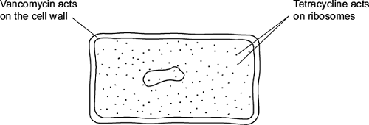

(a)     (i)      Use information in the diagram to explain why vancomycin does **not** affect human cells.

...............................................................................................................

...............................................................................................................

**(1)**

(ii)     Use information in the diagram to explain how tetracycline prevents bacterial growth.

...............................................................................................................

...............................................................................................................

**(1)**

(b)     Frequent treatment with vancomycin can result in resistant strains of bacteria. Explain how.

........................................................................................................................

........................................................................................................................

........................................................................................................................

........................................................................................................................

........................................................................................................................

........................................................................................................................

*(Extra space)* .................................................................................................

........................................................................................................................

........................................................................................................................

**(2)**

**(Total 4 marks)**

**Q37.**         The equation shows the breakdown of lactose by the enzyme lactase.

Lactose + water   galactose + monosaccharide **X**

(a)     (i)      Name the type of reaction catalysed by the enzyme lactase.

.............................................................................................................

**(1)**

(ii)     Name monosaccharide **X**.

.............................................................................................................

**(1)**

(b)     (i)      Describe how you would use a biochemical test to show that a reducing sugar is present.

.............................................................................................................

.............................................................................................................

.............................................................................................................

.............................................................................................................

.............................................................................................................

**(2)**

(ii)     Lactose, galactose and monosaccharide **X** are all reducing sugars.  
After the lactose has been broken down there is a higher concentration of reducing sugar. Explain why.

.............................................................................................................

**(1)**

(c)A high concentration of galactose slows down the breakdown of lactose by lactase.  
Use your knowledge of competitive inhibition to suggest why.

......................................................................................................................

......................................................................................................................

......................................................................................................................

......................................................................................................................

......................................................................................................................

**(2)**

**(Total 7 marks)**

**Q38.**Read the following passage.

|  |  |  |
| --- | --- | --- |
|  | Aspirin is a very useful drug. One of its uses is to reduce fever and inflammation. Aspirin does this by preventing cells from producing substances called prostaglandins. Prostaglandins are produced by an enzyme-controlled pathway. Aspirin works by inhibiting one of the enzymes in this pathway. Aspirin attaches permanently to a chemical group on one of the monomers that make up the active site of this enzyme. | 5 |
|  | The enzyme that is involved in the pathway leading to the production of prostaglandins is also involved in the pathway leading to the production of thromboxane. This is a substance that promotes blood clotting. A small daily dose of aspirin may reduce the risk of myocardial infarction (heart attack). | 10 |

Use information from the passage and your own knowledge to answer the following questions.

(a)     Name the monomers that make up the active site of the enzyme (lines 6 – 7).

........................................................................................................................

**(1)**

(b)     The diagram shows the pathways by which prostaglandins and thromboxane are formed.

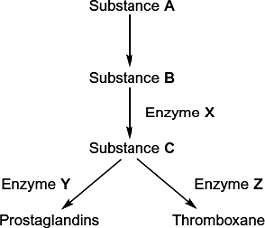

(i)      Aspirin only affects one of the enzymes in this pathway. Use information in lines 5 - 7 to explain why aspirin does **not** affect the other enzymes.

...............................................................................................................

...............................................................................................................

...............................................................................................................

...............................................................................................................

...............................................................................................................

**(2)**

(ii)     Which enzyme, **X**, **Y** or **Z**, is inhibited by aspirin? Explain the evidence from the passage that supports your answer.

Enzyme ................................................................................................

Explanation ...........................................................................................

...............................................................................................................

...............................................................................................................

**(2)**

(c)     Aspirin is an enzyme inhibitor. Explain how aspirin prevents substrate molecules being converted to product molecules.

........................................................................................................................

........................................................................................................................

........................................................................................................................

........................................................................................................................

........................................................................................................................

**(2)**

**(Total 7 marks)**

**Q39.**Catalase is used in a number of industrial processes. It is normally obtained from a fungus called *Aspergillus niger*. Scientists produced a mutant strain of *A*. *niger* called K30. They wanted to know if this mutant strain produced more catalase than the normal strain of *A*. *niger*.

•        The scientists grew samples of the normal strain of the fungus and of the K30 strain on jelly in separate Petri dishes. The jelly contained a blue substance which is turned colourless by catalase.

•        They incubated the dishes for 3 days then measured the diameter of the colourless zone around the fungus.

•        They calculated the ratio of the diameter of the colourless zone to the diameter of the fungus.

The diagram shows the dishes after incubation.

**Normal  
strain**

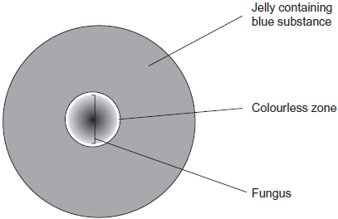

**K30 strain**



(a)     The scientists grew both strains of fungi on dishes kept at 30 °C. Keeping the dishes at a temperature of 15 °C would affect the results. Use your knowledge of kinetic energy to explain why.

........................................................................................................................

........................................................................................................................

........................................................................................................................

........................................................................................................................

........................................................................................................................

**(2)**

(b)     (i)      The scientists gave their results as ratios. Explain the advantage of giving the results of this investigation as a ratio.

...............................................................................................................

...............................................................................................................

...............................................................................................................

...............................................................................................................

...............................................................................................................

**(2)**

(ii)      For the normal strain the ratio of the diameter of the colourless zone to the diameter of the fungus was 1.1 : 1.

Calculate the ratio of the diameter of the colourless zone to the diameter of the fungus for the K30 strain. Show your working.

Ratio = ...................................................

**(2)**

(c)     The catalase produced by the K30 strain of the fungus is mainly an extracellular enzyme. This means that the fungus secretes catalase from its cells into the jelly in the Petri dish.

Describe and explain the evidence from the investigation which shows that the catalase is an extracellular enzyme.

........................................................................................................................

........................................................................................................................

........................................................................................................................

........................................................................................................................

........................................................................................................................

**(2)**

**(Total 8 marks)**

**Q40.**          Read the following passage.

Gluten is a protein found in wheat. When gluten is digested in the small intestine,  
the products include peptides. Peptides are short chains of amino acids. These  
peptides cannot be absorbed by facilitated diffusion and leave the gut in faeces

Some people have coeliac disease. The epithelial cells of people with coeliac disease  
do not absorb the products of digestion very well. In these people, some of the                 5   
peptides from gluten can pass between the epithelial cells lining the small intestine  
and enter the intestine wall. Here, the peptides cause an immune response that leads  
to the destruction of microvilli on the epithelial cells.

Scientists have identified a drug which might help people with coeliac disease.  
It reduces the movement of peptides between epithelial cells. They have                        10  
carried out trials of the drug with patients with coeliac disease.

Use the information in the passage and your own knowledge to answer the following questions.

(a)     Name the type of chemical reaction which produces amino acids from proteins.

........................................................................................................................

**(1)**

(b)     The peptides released when gluten is digested cannot be absorbed by facilitated diffusion (lines 2 – 3). Suggest why.

........................................................................................................................

........................................................................................................................

........................................................................................................................

........................................................................................................................

........................................................................................................................

........................................................................................................................

*(Extra space)* .................................................................................................

........................................................................................................................

........................................................................................................................

**(3)**

*(Extra space)* .................................................................................................

........................................................................................................................

........................................................................................................................

**(3)**

(c)     Explain why the peptides cause an immune response (lines 7 – 8).

........................................................................................................................

........................................................................................................................

........................................................................................................................

**(1)**

(d)     Scientists have carried out trials of a drug to treat coeliac disease (lines 10 – 11).  
Suggest **two** factors that should be considered before the drug can be used on patients with the disease.

1 .....................................................................................................................

........................................................................................................................

2 .....................................................................................................................

........................................................................................................................

**(2)**

**(Total 7 marks)**

**Q41.**(a)    Name the monosaccharides of which the following disaccharides are composed.

(i)      Sucrose

monosaccharides.....................................and.......................................

**(1)**

(ii)     Lactose

monosaccharides.....................................and.......................................

**(1)**

(b)     Amylase and maltase are involved in the digestion of starch in the small intestine.

Complete the table by identifying where these enzymes are produced and the product of the reaction they catalyse.

|  |  |  |  |
| --- | --- | --- | --- |
|  | **Name of enzyme** | **Where the enzyme is produced** | **Product of the reaction catalysed by the enzyme** |
|  | Amylase |  |  |
|  | Maltase |  |  |

**(2)**

**(Total 4 marks)**

**Q42.**          (a)     A student investigated the effect of pH on the activity of the enzyme amylase.  
She set up the apparatus shown in the diagram.

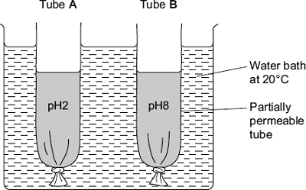

The tubes were made from Visking tubing. Visking tubing is partially permeable.  
She added an equal volume of amylase solution and starch to each tube.

•        She added a buffer solution at pH2 to tube **A**.

•        She added an equal volume of buffer solution at pH8 to tube **B**.

After 30 minutes, she measured the height of the solutions in both tubes.  
She then tested the solutions in tubes **A** and **B** for the presence of reducing sugars.

Describe how the student would show that reducing sugars were present in a solution.

........................................................................................................................

........................................................................................................................

........................................................................................................................

........................................................................................................................

........................................................................................................................

........................................................................................................................

*(Extra space)* .................................................................................................

........................................................................................................................

........................................................................................................................

**(3)**

(b)     After 30 minutes, the solution in tube **B** was higher than the solution in tube **A**.

(i)      Explain why the solution in tube **B** was higher.

...............................................................................................................

...............................................................................................................

...............................................................................................................

...............................................................................................................

...............................................................................................................

...............................................................................................................

*(Extra space)* ........................................................................................

...............................................................................................................

...............................................................................................................

**(3)**

(ii)     The student concluded from her investigation that the optimum pH of amylase was pH8. Is this conclusion valid? Explain your answer

...............................................................................................................

...............................................................................................................

...............................................................................................................

**(1)**

**(Total 7 marks)**

**Q43.**Mycolic acids are substances that form part of the cell wall of the bacterium that causes tuberculosis. Mycolic acids are made from fatty acids. Isoniazid is an antibioticthat is used to treat tuberculosis. The diagram shows how this antibiotic inhibits the production of mycolic acids in this bacterium.

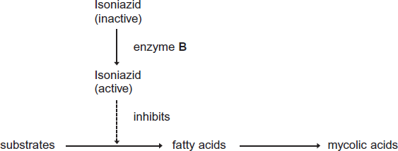

(a)     Treatment with isoniazid leads to the osmotic lysis of this bacterium. Use information in the diagram to suggest how.

........................................................................................................................

........................................................................................................................

........................................................................................................................

........................................................................................................................

........................................................................................................................

**(2)**

(b)     Human cells also produce fatty acids. Isoniazid does not affect the production of these fatty acids.

Use information in the diagram to suggest **one** reason why isoniazid does **not** affect the production of fatty acids in human cells.

........................................................................................................................

........................................................................................................................

........................................................................................................................

**(1)**

(c)     A mutation in the gene coding for enzyme **B** could lead to the production of a non-functional enzyme. Explain how.

........................................................................................................................

........................................................................................................................

........................................................................................................................

........................................................................................................................

........................................................................................................................

........................................................................................................................

*(Extra space)*..................................................................................................

........................................................................................................................

........................................................................................................................

**(3)**

**(Total 6 marks)**

**Q44.**The enzyme tyrosine kinase (TK) is found in human cells. TK can exist in a non-functional and a functional form. The functional form of TK is only produced when a phosphate group is added to TK.

This is shown in **Figure 1.**

**Figure 1**

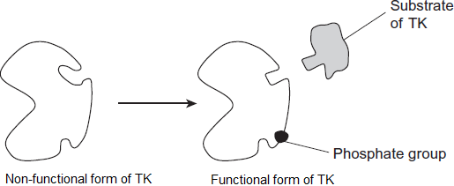

(a)     Addition of a phosphate group to the non-functional form of TK leads to production of the functional form of TK.

Explain how.

........................................................................................................................

........................................................................................................................

........................................................................................................................

........................................................................................................................

........................................................................................................................

**(2)**

(b)     The binding of the functional form of TK to its substrate leads to cell division. Chronic myeloid leukaemia is a cancer caused by a faulty form of TK. Cancer involves uncontrolled cell division.

**Figure 2** shows the faulty form of TK.

**Figure 2**

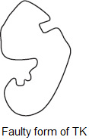

Suggest how faulty TK leads to chronic myeloid leukaemia.

........................................................................................................................

........................................................................................................................

........................................................................................................................

........................................................................................................................

........................................................................................................................

**(2)**

(c)     Imatinib is a drug used to treat chronic myeloid leukaemia. **Figure 3** shows how imatinib inhibits faulty TK.

**Figure 3**

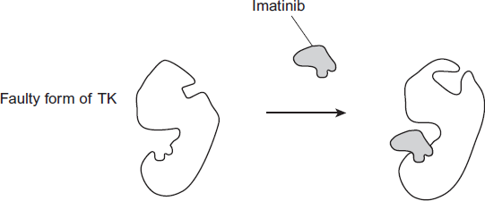

Using all of the information, describe how imatinib stops the development of chronic myeloid leukaemia.

........................................................................................................................

........................................................................................................................

........................................................................................................................

........................................................................................................................

........................................................................................................................

**(2)**

**(Total 6 marks)**

**Q45.**Biological washing powders contain enzymes which hydrolyse substances that cause stains on clothes.

A manufacturer tested the ability of two types of the same brand of washing powder to remove different food substances that stain clothes.

•        Type **A** contained an enzyme.

•        Type **B** was identical to **A** except it did **not** contain the enzyme.

**Figure 1** shows the results.

**Figure 1**

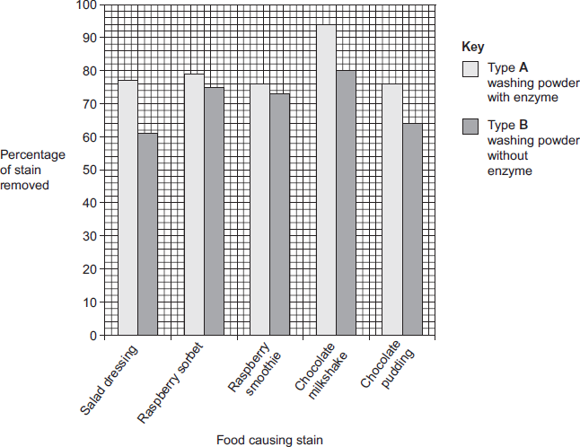

A scientist worked for a company that wanted to develop a biological washing powder that was effective over a range of temperatures. He investigated the effect of temperature on the rates of the reaction catalysed by two enzymes, **P** and **S** used in biological washing powders.

**Figure 2** shows his results.

**Figure 2**

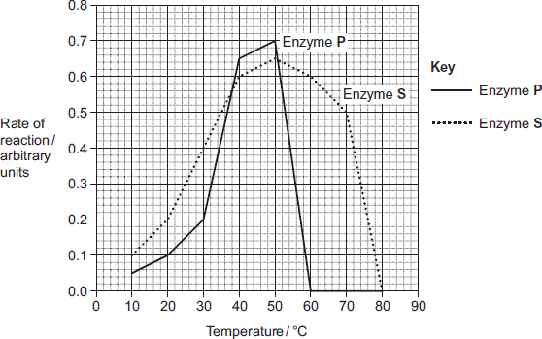

(a)     Many of the substances causing the food stains are large, insoluble proteins.  
Suggest how a biological washing powder removes this type of stain.

........................................................................................................................

........................................................................................................................

........................................................................................................................

........................................................................................................................

........................................................................................................................

**(2)**

(b)     The manufacturer of type **A** and type **B** washing powder claimed that these results showed that biological washing powders are better at removing stains from clothes.

Use the information in **Figure 1** to evaluate this claim.

........................................................................................................................

........................................................................................................................

........................................................................................................................

........................................................................................................................

........................................................................................................................

........................................................................................................................

........................................................................................................................

........................................................................................................................

(Extra space) .................................................................................................

........................................................................................................................

........................................................................................................................

........................................................................................................................

**(4)**

(c)     Most customers want a washing powder which removes stains from clothes over a range of temperatures. After obtaining the results shown in **Figure 2**, which enzyme should the scientist recommend for use in a biological powder?

Give reasons for your answer.

........................................................................................................................

........................................................................................................................

........................................................................................................................

........................................................................................................................

........................................................................................................................

........................................................................................................................

(Extra space) .................................................................................................

........................................................................................................................

........................................................................................................................

**(3)**

(d)     Biological washing powders often contain a number of different enzymes. This enables them to remove a wider range of stains from clothes.  
Explain why a number of enzymes are required to remove a wider range of stains.

........................................................................................................................

........................................................................................................................

........................................................................................................................

........................................................................................................................

........................................................................................................................

........................................................................................................................

(Extra space) .................................................................................................

........................................................................................................................

........................................................................................................................

**(3)**

**(Total 12 marks)**

**Q46.**A student investigated the effect of chewing on the digestion of starch in cooked wheat.

He devised a laboratory model of starch digestion in the human gut. This is the method he used.

1.      Volunteers chewed cooked wheat for a set time. The wheat had been cooked in boiling water.

2.      This chewed wheat was mixed with water, hydrochloric acid and a protein-digesting enzyme and left at 37 °C for 30 minutes.

3.      A buffer was then added to bring the pH to 6.0 and pancreatic amylase was added. This mixture was then left at 37 °C for 120 minutes.

4.      Samples of the mixture were removed at 0, 10, 20, 40, 60 and 120 minutes, and the concentration of reducing sugar in each sample was measured.

5.      Control experiments were carried out using cooked wheat that had been chopped up in a blender, not chewed.

(a)     What reducing sugar, or sugars, would you expect to be produced during chewing?  
Give a reason for your answer.

........................................................................................................................

........................................................................................................................

........................................................................................................................

........................................................................................................................

**(2)**

(b)     In this model of digestion in the human gut, what other enzyme is required for the complete digestion of starch?

........................................................................................................................

**(1)**

(c)     What was the purpose of step 2, in which samples were mixed with water, hydrochloric acid and pepsin?

........................................................................................................................

........................................................................................................................

**(1)**

(d)     In the control experiments, cooked wheat was chopped up to copy the effect of chewing.

Suggest a more appropriate control experiment. Explain your suggestion.

........................................................................................................................

........................................................................................................................

........................................................................................................................

........................................................................................................................

**(2)**

(e)     The figure below shows the student’s results.

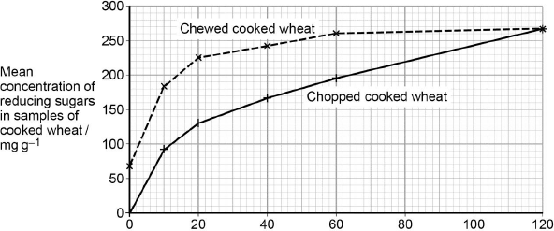  
                               Incubation time / minutes

Explain what these results suggest about the effect of chewing on the digestion of starch in wheat.

........................................................................................................................

........................................................................................................................

........................................................................................................................

........................................................................................................................

........................................................................................................................

........................................................................................................................

**(3)**

**(Total 9 marks)**

**Q47.**Some species of crop plant produce a substance called glycinebetaine (GB).

Scientists transferred the gene for GB into a species of crop plant that does not normally produce GB. These genetically modified plants then produced GB.

The scientists grew large numbers of the same crop plant with and without the gene at different temperatures. After 3 days, they found the increase in dry mass of the plants.

**Figure 1** shows their results.

**Figure 1**

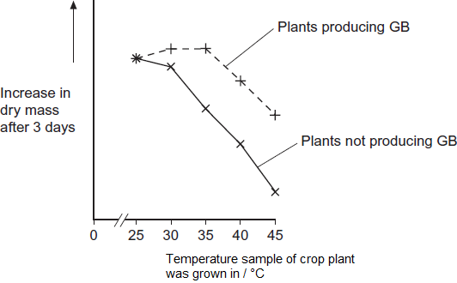

(a)     Describe the effect on growth of transferring the gene for GB into this plant.

........................................................................................................................

........................................................................................................................

........................................................................................................................

........................................................................................................................

........................................................................................................................

**(2)**

(b)     The scientists measured the rate of photosynthesis in plants that produce GB and plants that do not produce GB at 25°C, 35°C and 45°C.

**Figure 2** shows their results.

**Figure 2**

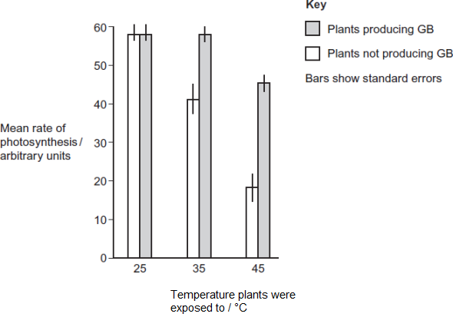

(i)      The scientists concluded that the production of GB protects photosynthesis from damage by high temperatures.

Use these data to support this conclusion.

...............................................................................................................

...............................................................................................................

...............................................................................................................

**(1)**

(ii)     Use the data from **Figure 2**  for plants that do not produce GB to explain the effect of temperature on changes in dry mass of the plants shown in **Figure 1.**

...............................................................................................................

...............................................................................................................

...............................................................................................................

...............................................................................................................

...............................................................................................................

...............................................................................................................

...............................................................................................................

...............................................................................................................

*(Extra space)*........................................................................................

...............................................................................................................

...............................................................................................................

...............................................................................................................

**(4)**

Rubisco activase is an enzyme found in chloroplasts. It activates the light-independent reaction of photosynthesis.

The scientists discovered that, as temperature increased from 25°C to 45°C, rubisco activase began attaching to thylakoid membranes in chloroplasts and this stopped it working.

(c)     Rubisco activase stops working when it attaches to a thylakoid.

Use your knowledge of protein structure to explain why.

........................................................................................................................

........................................................................................................................

........................................................................................................................

........................................................................................................................

........................................................................................................................

**(2)**

(d)     The scientists investigated the effect of GB on attachment of rubisco activase to thylakoid membranes at different temperatures.

**Figure 3** shows their results.

**Figure 3**

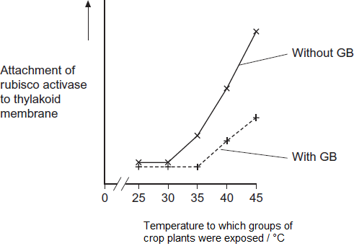

Use information from **Figure 2** and **Figure 3** to suggest how GB protects the crop plant from high temperatures.

........................................................................................................................

........................................................................................................................

........................................................................................................................

........................................................................................................................

........................................................................................................................

........................................................................................................................

........................................................................................................................

........................................................................................................................

*(Extra space)*..................................................................................................

........................................................................................................................

........................................................................................................................

........................................................................................................................

**(4)**

(e)     The scientists’ hypothesis at the start of the investigation was that crop plants genetically engineered to produce GB would become more resistant to high environmental temperatures.  
The scientists developed this hypothesis on the basis of previous research on crops that are grown in hot climates.

Suggest how the scientists arrived at their hypothesis.

........................................................................................................................

........................................................................................................................

........................................................................................................................

........................................................................................................................

........................................................................................................................

**(2)**

**(Total 15 marks)**

**Q48.**(a)    The table contains statements about three stages of respiration.

Complete the table with a tick if the statement in the first column is true for each stage of respiration in an animal.

|  |  |  |  |  |
| --- | --- | --- | --- | --- |
|  |  | **Glycolysis** | **Link reaction** | **Krebs cycle** |
|  | Occurs in mitochondria |  |  |  |
|  | Carbon dioxide produced |  |  |  |
|  | NAD is reduced |  |  |  |

**(3)**

(b)     The following reaction occurs in the Krebs cycle.



A scientist investigated the effect of the enzyme inhibitor malonate on this reaction. The structure of malonate is very similar to the structure of succinate. The scientist added malonate and the respiratory substrate, pyruvate, to a suspension of isolated mitochondria. She also bubbled oxygen through the suspension.

(i)      Explain why the scientist did not use glucose as the respiratory substrate for these isolated mitochondria.

...............................................................................................................

...............................................................................................................

...............................................................................................................

...............................................................................................................

...............................................................................................................

**(2)**

(ii)     Explain how malonate inhibits the formation of fumarate from succinate.

...............................................................................................................

...............................................................................................................

...............................................................................................................

...............................................................................................................

...............................................................................................................

**(2)**

(iii)    The scientist measured the uptake of oxygen by the mitochondria during the investigation. The uptake of oxygen decreased when malonate was added. Explain why.

...............................................................................................................

...............................................................................................................

...............................................................................................................

...............................................................................................................

...............................................................................................................

**(2)**

**(Total 9 marks)**

**Q49.**(a)    An enzyme catalyses only one reaction. Explain why.

........................................................................................................................

........................................................................................................................

........................................................................................................................

........................................................................................................................

........................................................................................................................

**(2)**

(b)     Gout is a disease caused by the build-up of uric acid crystals in joints. Uric acid is produced from xanthine in a reaction catalysed by the enzyme xanthine oxidase.



Allopurinol is a drug used to treat gout. The diagram shows the structures of xanthine and allopurinol.

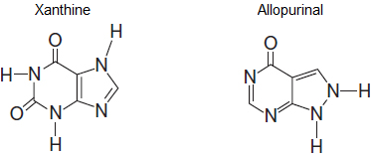

Use this information to suggest how allopurinol can be used to treat gout.

........................................................................................................................

........................................................................................................................

........................................................................................................................

........................................................................................................................

........................................................................................................................

........................................................................................................................

(Extra space)..................................................................................................

........................................................................................................................

........................................................................................................................

**(3)**

**(Total 5 marks)**

**Q50.**Cow’s milk contains the sugar lactose. Many cats are unable to digest cow’s milk because they are lactose intolerant.

Cow’s milk can be made suitable for these cats by treating it with the enzyme lactase to hydrolyse lactose. This makes the cow’s milk lactose-free. Beads are coated with lactase and placed in a tube, as shown in the diagram below. Cow’s milk flows over the beads and the lactose is hydrolysed.

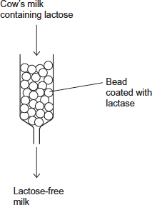

(a)     Attaching lactase to the beads is a more efficient use of lactase than adding the lactase directly to cow’s milk.

Suggest **three** reasons why it is more efficient to attach lactase to the beads.

1 .....................................................................................................................

........................................................................................................................

2 .....................................................................................................................

........................................................................................................................

3 .....................................................................................................................

........................................................................................................................

**(3)**

(b)     Monosaccharides and disaccharides taste sweet.  
The lactose-free milk made after hydrolysis with lactase tastes sweeter than the cow’s milk containing lactose.  
Suggest why.

........................................................................................................................

........................................................................................................................

........................................................................................................................

........................................................................................................................

........................................................................................................................

**(2)**

**(Total 5 marks)**

**Q51.**The diagram below represents one process that occurs during protein synthesis.

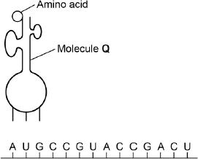

(a)     Name the process shown.

........................................................................................................................

**(1)**

(b)     Identify the molecule labelled **Q**.

........................................................................................................................

**(1)**

(c)     In the diagram above, the first codon is AUG. Give the base sequence of:

the complementary DNA base sequence .....................................................

the missing anticodon ...................................................................................

**(2)**

The table below shows the base triplets that code for two amino acids.

|  |  |  |
| --- | --- | --- |
|  | **Amino acid** | **Encoding base triplet** |
|  | Aspartic acid | GAC, GAU |
|  | Proline | CCA, CCG, CCC, CCU |

(d)     Aspartic acid and proline are both amino acids. Describe how two amino acids differ from one another. You may use a diagram to help your description.

........................................................................................................................

........................................................................................................................

........................................................................................................................

**(1)**

(e)     Deletion of the sixth base (G) in the sequence shown in the diagram above would change the nature of the protein produced but substitution of the same base would not. Use the information in the table and your own knowledge to explain why.

........................................................................................................................

........................................................................................................................

........................................................................................................................

........................................................................................................................

........................................................................................................................

........................................................................................................................

**(Extra space)** ................................................................................................

........................................................................................................................

........................................................................................................................

**(3)**

**(Total 8 marks)**

**Q52.**(a)     Messenger RNA (mRNA) is used during translation to form polypeptides.  
Describe how mRNA is produced in the nucleus of a cell.

........................................................................................................................

........................................................................................................................

........................................................................................................................

........................................................................................................................

........................................................................................................................

........................................................................................................................

........................................................................................................................

........................................................................................................................

........................................................................................................................

........................................................................................................................

........................................................................................................................

........................................................................................................................

**(6)**

(b)     Describe the structure of proteins.

........................................................................................................................

........................................................................................................................

........................................................................................................................

........................................................................................................................

........................................................................................................................

........................................................................................................................

........................................................................................................................

........................................................................................................................

........................................................................................................................

........................................................................................................................

........................................................................................................................

........................................................................................................................

**(5)**

(c)     Describe how proteins are digested in the human gut.

........................................................................................................................

........................................................................................................................

........................................................................................................................

........................................................................................................................

........................................................................................................................

........................................................................................................................

........................................................................................................................

........................................................................................................................

........................................................................................................................

........................................................................................................................

........................................................................................................................

........................................................................................................................

**(4)**

**(Total 15 marks)**

**Q53.**The following figure represents part of a DNA molecule.

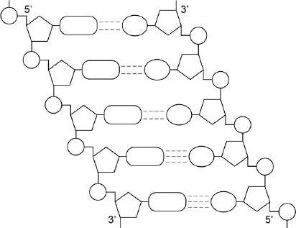

(a)     Draw a box around a single nucleotide.

**(1)**

The table below shows the percentage of bases in each of the strands of a DNA molecule.

|  |  |  |  |  |  |
| --- | --- | --- | --- | --- | --- |
|  | **DNA strand** | **Percentage of each base** | | | |
|  | **A** | **C** | **G** | **T** |
|  | Strand **1** | 16 |  |  |  |
|  | Strand **2** |  | 21 | 34 |  |

(b)     Complete the table by adding the missing values.

**(2)**

(c)     During replication, the two DNA strands separate and each acts as a template for the production of a new strand. As new DNA strands are produced, nucleotides can only be added in the 5’ to 3’ direction.

Use the figure in part **(a)** and your knowledge of enzyme action and DNA replication to explain why new nucleotides can only be added in a 5’ to 3’ direction.

........................................................................................................................

........................................................................................................................

........................................................................................................................

........................................................................................................................

........................................................................................................................

........................................................................................................................

........................................................................................................................

........................................................................................................................

**(Extra space)** ................................................................................................

........................................................................................................................

........................................................................................................................

**(4)**

**(Total 7 marks)**

**Q54.**Newborn babies can be fed with breast milk or with formula milk. Both types of milk contain carbohydrates, lipids and proteins.

•        Human breast milk also contains a bile-activated lipase. This enzyme is thought to be inactive in milk but activated by bile in the small intestine of the newborn baby.

•        Formula milk does not contain a bile-activated lipase.

Scientists investigated the benefits of breast milk compared with formula milk.

(a)     The scientists used kittens (newborn cats) as model organisms in their laboratory investigation.

Other than ethical reasons, suggest **two** reasons why they chose to use cats as model organisms.

1 .....................................................................................................................

........................................................................................................................

2 .....................................................................................................................

........................................................................................................................

**(2)**

(b)     Before starting their experiments, the scientists confirmed that, like human breast milk, cat’s milk also contained bile-activated lipase.

To do this, they added bile to cat’s milk and monitored the pH of the mixture.

Explain why monitoring the pH of the mixture could show whether the cat’s milk contained lipase.

........................................................................................................................

........................................................................................................................

........................................................................................................................

........................................................................................................................

**(2)**

The scientists then took 18 kittens. Each kitten had been breastfed by its mother for the previous 48 hours.

The scientists divided the kittens randomly into three groups of six.

•        The kittens in group **1** were fed formula milk.

•        The kittens in group **2** were fed formula milk plus a supplement containing bile-activated lipase.

•        The kittens in group **3** were fed breast milk taken from their mothers.

Each kitten was fed 2 cm3 of milk each hour for 5 days.

The scientists weighed the kittens at the start of the investigation and on each day for 5 days.

The figure below shows the scientists’ results.

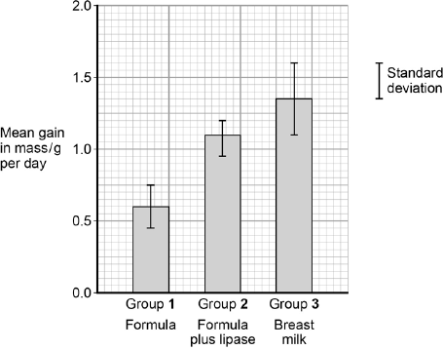  
Type of milk given to kittens

(c)     What can you conclude from the figure about the importance of bile-activated lipase in breast milk?

........................................................................................................................

........................................................................................................................

........................................................................................................................

........................................................................................................................

........................................................................................................................

........................................................................................................................

**(Extra space)** ................................................................................................

........................................................................................................................

........................................................................................................................

**(3)**

**(Total 7 marks)**

**Q55.**A technician investigated the effect of temperature on the rate of an enzyme-controlled reaction. At each temperature, he started the reaction using the same concentration of substrate.

The following graph shows his results.

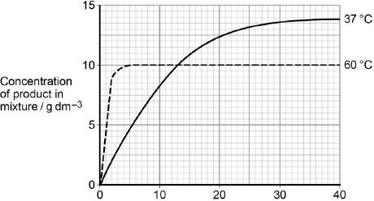  
                     Time after start of reaction / minutes

(a)     Give **two** other factors the technician would have controlled.

1 ............................................................................................................

2 ............................................................................................................

**(1)**

(b)     Draw a tangent on each curve to find the initial rates of reaction.  
Use these values to calculate the ratio of the initial rates of reaction at 60 °C : 37 °C.  
Show your working.

Ratio = ................................... :1

**(2)**

(c)     Explain the difference in the initial rate of reaction at 60 °C and 37 °C.

........................................................................................................................

........................................................................................................................

........................................................................................................................

........................................................................................................................

**(2)**

(d)     Explain the difference in the rates of reaction at 60 °C and 37 °C between 20 and 40 minutes.

........................................................................................................................

........................................................................................................................

........................................................................................................................

........................................................................................................................

........................................................................................................................

........................................................................................................................

........................................................................................................................

........................................................................................................................

**(Extra space)** ................................................................................................

........................................................................................................................

........................................................................................................................

........................................................................................................................

**(4)**

**(Total 9 marks)**

**Q56.Figure 1** shows one base pair of a DNA molecule.

**Figure 1**

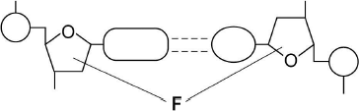

(a)     Name part **F** of each nucleotide.

........................................................................................................................

**(1)**

(b)     Scientists determined that a sample of DNA contained 18% adenine.

What were the percentages of thymine and guanine in this sample of DNA?

|  |  |  |
| --- | --- | --- |
|  | Percentage of thymine |  |
|  | Percentage of guanine |  |

**(2)**

During replication, the two strands of a DNA molecule separate and each acts as a template for the production of a new strand.

**Figure 2** represents DNA replication.

**Figure 2**

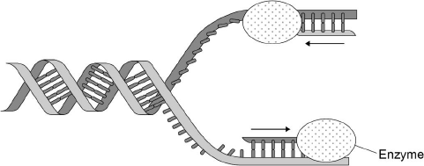

(c)     Name the enzyme shown in **Figure 2**.

........................................................................................................................

**(1)**

The arrows in **Figure 2** show the directions in which each new DNA strand is being produced.

(d)     Use **Figure 1, Figure 2** and your knowledge of enzyme action to explain why the arrows point in opposite directions.

........................................................................................................................

........................................................................................................................

........................................................................................................................

........................................................................................................................

........................................................................................................................

........................................................................................................................

........................................................................................................................

........................................................................................................................

**(4)**

**(Total 8 marks)**

**Q57.**A principle of homeostasis is the maintenance of a constant internal environment. An increase in the concentration of carbon dioxide would change the internal environment and blood pH.

Explain the importance of maintaining a constant blood pH.

.................................................................................................................................

.................................................................................................................................

.................................................................................................................................

.................................................................................................................................

.................................................................................................................................

.................................................................................................................................

**[Extra space]** .........................................................................................................

.................................................................................................................................

.................................................................................................................................

.................................................................................................................................

**(Total 3 marks)**

**Q58.**A technician investigated the effect of temperature on the rate of an enzyme-controlled reaction. At each temperature, he started the reaction using the same volume of substrate solution and the same volume of enzyme solution.

The figure below shows his results.

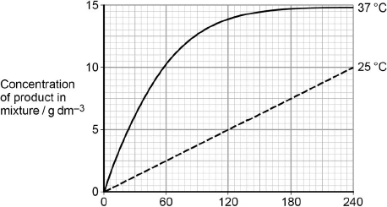  
                Time after start of reaction / s

(a)     Give **one** other factor the technician would have controlled.

........................................................................................................................

........................................................................................................................

**(1)**

(b)     Calculate the rate of reaction at 25 °C.

Answer ................................................

**(2)**

(c)     Describe and explain the differences between the two curves.

........................................................................................................................

........................................................................................................................

........................................................................................................................

........................................................................................................................

........................................................................................................................

........................................................................................................................

........................................................................................................................

........................................................................................................................

........................................................................................................................

........................................................................................................................

**(Extra space)** ................................................................................................

........................................................................................................................

........................................................................................................................

........................................................................................................................

........................................................................................................................

**(5)**

**(Total 8 marks)**

**Q59.**Cyanide is poisonous. Cyanide binds to cytochrome oxidase, which is an enzyme in the electron transport chain in mitochondria. This stops the movement of electrons to oxygen. As a result, ATP cannot be made via aerobic respiration. If a person or animal is exposed to cyanide, a substance that acts as an antidote can reduce or prevent poisoning. This substance binds to cyanide.

Scientists investigated the effect of cyanide on the rate of respiration of cells in different animal organs and in organs from different animals. They extracted organs from animals that had just been killed. For each animal organ they set up 3 dishes. Each dish contained:

•        phosphate solution

•        saline (sodium chloride) solution

•        cyanide solution of known concentration.

They measured the mean amount of oxygen used by the slices of organs in one hour. Their results are shown in **Table 1**.

**Table 1**

|  |  |  |  |  |  |
| --- | --- | --- | --- | --- | --- |
|  | **Trial** | **Animal organ** | **Mean amount of oxygen used, in the absence or presence of cyanide, per hour / arbitrary units** | | |
|  | **No cyanide** | **10−4 mol dm−3 cyanide** | **10−2 mol dm−3 cyanide** |
|  | **A** | Sheep liver | 2.7 | 2.5 | 0.7 |
|  | **B** | Sheep kidney | 14.1 | 9.9 | 1.9 |
|  | **C** | Ox liver | 1.9 | 1.5 | 0.8 |
|  | **D** | Rat kidney | 20.7 | 18.8 | 2.3 |
|  | **E** | Rat liver | 10.5 | 10.0 | 1.9 |
|  | **F** | Guinea pig kidney | 16.8 | 14.4 | 1.9 |

(a)     Suggest how binding of cyanide to cytochrome oxidase affects the enzyme.

........................................................................................................................

........................................................................................................................

........................................................................................................................

........................................................................................................................

........................................................................................................................

........................................................................................................................

**[Extra space]** .................................................................................................

........................................................................................................................

........................................................................................................................

**(3)**

(b)     Suggest how the antidote can reduce poisoning by cyanide.

........................................................................................................................

........................................................................................................................

........................................................................................................................

**(1)**

(c)     **Table 1** shows the scientists’ results for different trials. The trials could be put into groups to allow comparisons to be made within each group.

(i)      As an example of how trials could be grouped, **Group 1** has been completed in **Table 2** below. Complete **Table 2** to show **three** other possible ways that the scientists’ trials could be grouped.

**Table 2**

|  |  |  |
| --- | --- | --- |
|  | **Group** | **Trials allowing comparisons to be made** |
|  | **1** | **A** with **B** |
|  | **2** |  |
|  | **3** |  |
|  | **4** |  |

**(2)**

(ii)     What is the effect of cyanide on **Group 1** trials in **Table 2**? Use evidence from **Table 1** to support your answer.

...............................................................................................................

...............................................................................................................

...............................................................................................................

...............................................................................................................

...............................................................................................................

...............................................................................................................

**(3)**

(iii)    Calculate the percentage difference in oxygen use for ‘rat liver’ (**Trial E**) between a cyanide concentration of 10−4 and 10−2 mol dm−3.

Percentage difference = ................................................................

**(2)**

**(Total 11 marks)**

**Q60.**A stomach ulcer is caused by damage to the cells of the stomach lining. People with stomach ulcers often have the bacterium *Helicobacter pylori* in their stomachs.

A group of scientists was interested in trying to determine how infection by *H. pylori* results in the formation of stomach ulcers.

The scientists grew different strains of *H. pylori* in liquid culture.

The table below shows the substances released by each of these strains.

|  |  |  |  |
| --- | --- | --- | --- |
|  | ***H. pylori* strain** | **Substances released by the *H. pylori* cells** | |
|  | **Toxin** | **Enzyme that neutralises acid** |
|  | **A** |  |  |
|  | **B** |  |  |
|  | **C** |  |  |

The scientists centrifuged the cultures of each strain to obtain cell-free liquids. They added each liquid to a culture of human cells. They then recorded the amount of damage to the human cells.

Their results are shown below. The error bars show ± 1 standard deviation.

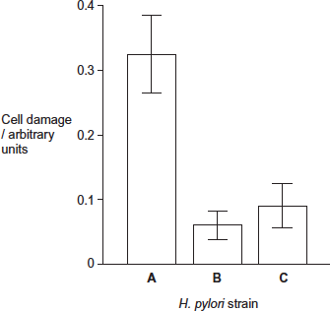

(a)     Describe and explain how centrifuging the culture allowed the scientists to obtain a cell-free liquid.

........................................................................................................................

........................................................................................................................

........................................................................................................................

........................................................................................................................

........................................................................................................................

........................................................................................................................

**[Extra space]** ................................................................................................

........................................................................................................................

........................................................................................................................

**(3)**

(b)     The scientists measured cell damage by measuring the activity of lysosomes.  
Give **one** function of lysosomes.

........................................................................................................................

........................................................................................................................

........................................................................................................................

**(1)**

(c)     *H. pylori* cells produce an enzyme that neutralises acid.  
Suggest **one** advantage to the *H. pylori* of producing this enzyme.

........................................................................................................................

........................................................................................................................

........................................................................................................................

........................................................................................................................

........................................................................................................................

**(2)**

(d)     What do these data suggest about the damage caused to human cells by the toxin and by the enzyme that neutralises acid?  
Explain your answer.

........................................................................................................................

........................................................................................................................

........................................................................................................................

........................................................................................................................

........................................................................................................................

........................................................................................................................

**[Extra space]** ................................................................................................

........................................................................................................................

........................................................................................................................

**(3)**

(e)     The scientists carried out a further investigation. They treated the liquid from **strain A** with a protein-digesting enzyme before adding it to a culture of human cells. No cell damage was recorded.  
Suggest why there was no damage to the cells.

........................................................................................................................

........................................................................................................................

........................................................................................................................

........................................................................................................................

........................................................................................................................

........................................................................................................................

**[Extra space]** ................................................................................................

........................................................................................................................

........................................................................................................................

**(3)**

**(Total 12 marks)**

**M1.**(a)     C.

*Ignore name of organ*

**1**

(b)     E.

*Ignore name of organ*

**1**

(c)     1.       Active site (of enzyme) has (specific) shape / tertiary structure / active site complementary to substrate / maltose;

*Reject active site on substrate.  
Must have idea of shape*

*Assume “it” = maltase*

*Accept (specific) 3D active site*

*Reject has same shape*

2.       (Only) maltose can bind / fit;

*Accept “substrate” for “maltose”*

3.       To form enzyme substrate complex.

*Accept E−S complex*

**3**

**[5]**

**M2.**(a)     Amylase;

(Starch) to maltose:

Maltase;

Maltose to glucose;

Hydrolysis;

(Of) glycosidic bond;

***Q*** *Do not penalise incorrect site for digestion or incorrect site of enzyme production.*

**5 max**

(b)     Glucose moves in with sodium (into epithelial cell);

Via (carrier / channel) protein / symport;

Sodium removed (from epithelial cell) by active transport / sodium- potassium pump;

Into blood;

Maintaining low concentration of sodium (in epithelial cell) / maintaining sodium concentration gradient (between lumen and epithelial cell);

Glucose moves into blood;

By (facilitated) diffusion;

***Q*** *Only allow diffusion mark in context of movement of glucose into the blood.*

**5 max**

**[10]**

**M3.**          (a)     (i)      (Grinding) breaks open cells / increases surface area (of liver);  
Releases catalase / enzyme / more catalase / allows more hydrogen peroxide into liver;

**2**

(ii)     Heating causes bonds (maintaining tertiary structure) to break;  
Denatures / changes tertiary structure so active site changed;  
Substrate no longer fits / ES complex not formed;

**3**

(b)     (Control) to show that sand did not affect reaction (with ground liver);

**1**

(c)     (i)      Lower activation energy / less energy required to bring about reaction;

**1**

(ii)     Energy in products / water and oxygen less than energy in substrate / reactants / hydrogen peroxide;  
(Difference) given out as heat / exothermic;

**2**

**[9]**

**M4.**          (a)     diagram showing molecule **A** fitting in inhibition site; distortion  
of active site;

**2**

(b)     molecules moving less / slower; reduces chance of collision  
(between enzyme and substrate) / of enzyme-substrate  
complexes being formed; *(reject converse)*

**2**

(c)     these bonds hold / maintain tertiary / globular structure (of enzyme);  
enzyme denatured / tertiary structures destroyed; (shape of) active site  
distorted / changes;  
substrate no longer fits / enzyme-substrate complex not formed;

**3 max**

**[7]**

**M5.**          (a)     add antibodies / enzyme;  
wash to remove unbound antibodies;  
add (colourless) solution;

*(mark correct responses sequentially)*

**3**

(b)     antibodies specific / shape only fits one antigen;  
other antigens different shape and would not bind to antibodies;

**2**

**[5]**

**M6.**          (a)     Stimulates memory cells;

Secondary response, so antivenom / antibodies produced quicker;

**2**

(b)     Passive immunity; so no memory cells produced;

Antivenom breaks down / destroyed;

**2**

(c)     Could transfer disease / Allergy / Immune response to antibodies  
from animal;

**1**

**[5]**

**M7.**          (a)     Several / more than one polypeptide chain in molecule;

*Evidence must only relate to 4ºstructure*

**1**

(b)     Chemical bonds formed between sulphur-containing groups /   
R-groups / form stronger disulphide bonds;  
Bind chain(s) to each other;

**2**

(c)     Different number / sequences of amino acids;  
Bonds in different places which gives different shape;

**2**

(d)     Outer layer of skin cells are dead / do not respire  
Do not contain mitochondria / do not produce ATP / release energy;  
Cells do not have required proteins / carriers;

**3**

(e)     Advantages:

1       Small objects can be seen;

2       TEM has high resolution as wavelength of electrons shorter;

*Accept better*

Limitations:

3       Cannot look at living cells as cells must be in a vacuum;

4       must cut section / thin specimen;

5       Preparation may create artefact

6       Does not produce colour image;

**6**

**[14]**

**M8.**          (a)     Lilac / purple / mauve / violet;

Xanthine oxidase is a protein;

*Reject pink or blue as the resulting colour with biuret.*

**2**

(b)     Substrate has specific shape;

Allows binding / fitting / forms ES complex with active site;

Or

Active site has specific shape;

Allows binding / fitting / forms ES complex with substrate;

*Accept structure ≡ shape*

**2**

(c)     Xanthine similar shape to drug;

Drug fits active site / competes for active site / is a competitive inhibitor;

Less / no uric acid formed;

**3**

**[7]**

**M9.**          use of water;

*must be above arrowhead  
OH drawn correctly in place of glycosidic bond on  
each monosaccharide;*

**[2]**

**M10.**          (a)     (i)      150;

**1**

(ii)      27;

**1**

(b)     100;  
number of peptide bond hydrolysed = total number present / all peptide bonds have been hydrolysed;

*accept calculation showing same number top and bottom.*

**2**

(c)     curve rising to peak at pH 2 and falling to zero by pH 6;

**1**

(d)     (change in pH) leads to breaking of bonds holding tertiary structure / changes charge on amino acids;  
enzyme / protein / active site loses shape / denatured; substrate will not bind with / fit active site / fewer / no ES complexes formed;

**3**

(e)     more resistant to changes in pH and washing conditions variable / works in alkaline pH and washing powders alkaline;

*mark awarded for indicating aspect of effect of pH and advantage of this in terms of washing powder and conditions in wash.*

**1**

(f)      maximum of three marks for specificity, points 1 - 3. Can only be given credit in context of specificity

1       each enzyme / protein has specific primary structure / amino acid sequence;

2       folds in a particular way / has particular tertiary structure giving an active site with a unique structure;

3       shape of active site complementary to / will only fit that of substrate;   
maximum of three marks for inhibition, points 5 – 8

4       inhibitor fits at site on the enzyme other than active site;

5       distorts active site;

6       so substrate will no longer fit / form enzyme-substrate complex

**6**

**[15]**

**M11.**          (a)     (i)      Glucose;

Fructose;

*Any order.*

**2**

(ii)     Lactose has a different shape / structure;

Does not fit / bind to active site of enzyme / sucrase;

*Only allow a second mark if reference is made to the active site.  
Max 1 mark if active site is described as being on the substrate.*

**OR**

Active site of enzyme / sucrase has a specific shape / structure; Does not fit / bind to lactose;

*Do not accept same shape.*

**2**

(b)     (i)      Rose and fell;

Peak at 45 (minutes) / concentration of 6.6 (mmol dm–3);

**2**

(ii)     Glucose (produced by digestion) is absorbed / enters blood;

Decrease as used up / stored;

**2**

**[8]**

**M12.**(a)     (Most of) bromelain is digested / not absorbed / broken down in blood;

**1**

(b)     Total volume of blood;

**1**

**[2]**

**M13.**(a)

|  |  |  |  |  |
| --- | --- | --- | --- | --- |
|  |  |  |  |  |
|  |  |  |  |  |
|  |  |  |  |  |

*One mark for each correct column*

*Mark ticks only and ignore crosses*

**4**

(b)     1.      Two marks for box round two hydrogens and one of the oxygens from OH groups on carbons 1 and 4;;

2.      One mark from incorrect answer involving any two hydrogens and an oxygen from carbons 1 and 4;

*Do not award marks if all atoms concerned are on same carbon atom or are on carbon atoms other than 1 and 4 or where the answer does not have two hydrogen and one oxygen*

**2**

(c)     (i)      1.      Holds chains / cellulose molecules together / forms cross links between chains / cellulose molecules / forms microfibrils, providing strength / rigidity (to cellulose / cell wall);

2.      Hydrogen bonds strong in large numbers;x

*Principles here are first mark for where hydrogen bonds are formed and second for a consequence of this.*

*Accept microfibres*

**2**

(ii)     Compact / occupies small space / tightly packed;

*Answer indicates depth required. Answers such as “good for storage”, “easily stored” or “small” are insufficient.*

**1**

**[9]**

**M14.**(a)     Increase in the first 3 – 4 hours and then decrease;

**1**

(b)     Little / no difference (at 8 hours);

Between all groups;

**2**

(c)     Respiration ( produce CO2);

By cells / tissues;

**2**

(d)     Clear differences between the lactose deficient and IBS / control group;

No overlap in SD;

*Accept between all groups*

**2**

**[7]**

**M15.**          (a)     Enzyme / active site has a (specific) tertiary structure;

Only glucose has correct shape / is complementary / will bind / fit to active site;

(Forming) enzyme-substrate complex;

***Q*** *Allow second mark if candidate refers to correct shape or complementary in terms of the enzyme. Do not allow ‘same’ shape*

***Q*** *Do not allow third mark if active site is described as being on substrate.*

**3**

(b)     (Only detects glucose whereas) Benedict’s detects (all) reducing sugars / named examples;

Provides a reading / is quantitative / Benedict’s only provides a colour / doesn’t measure concentration / is qualitative / semiquantitative;

Is more sensitive / detects low concentration;

Red colour / colour of blood masks result;

Can monitor blood glucose concentration continuously;

***Q*** *Do not credit quicker / more accurate unless qualified.*

***Q*** *Allow Benedict’s detects monosaccharides for first mark point.*

**2 max**

(c)     (i)      Broken down by enzymes / digested / denatured (by pH) too large to be absorbed;

**1**

(ii)     Study not carried out on humans / only carried out on rats;  
Long-term / side effects not known;  
Scientists have vested interest;  
Study should be repeated / further studies / sample size not known;

**2 max**

**[8]**

**M16.**          (a)     (i)      Deoxyribose;

*pentose / 5C sugar = neutral*

**1**

(ii)     Phosphate / Phosphoric acid;

*phosphorus / P = neutral*

**1**

(b)     Hydrogen (bonds);

**1**

(c)     381 / 384 / 387;

**1**

(d)     (Gln) Met Met Arg Arg Arg Asn;

**1**

(e)     Change in (sequence of) amino acids / primary structure;

Change in hydrogen / ionic / disulfide bonds leads to change in tertiary structure / active site (of enzyme);

Substrate cannot bind / no enzyme-substrate complexes form;

***Q*** *Reject = different amino acids are formed*

**3**

**[8]**

**M17.**(a)     Measure with eyepiece graticule / scale;  
Calibrate with stage micrometer / scale on slide / object of known size;   
Repeats and calculate the mean;  
***OR***Use a ruler to estimate the field diameter under microscope;  
How many droplets go across the field;  
Repeats and calculate mean;

*Accept references to radius*

**3**

(b)     (i)      Two mark for correct answer of 4 : 1;;  
One mark for incorrect answer but working shows that candidate has clearly attempted to compare values of r2 / 62 and 32 / 36 and 9;

*Idea of comparing ratios  
A ratio of 1 : 4 should gain 1 mark*

**2**

(ii)     Small droplets have a larger surface area to volume ratio;

More surface for lipase (to act), leading to faster digestion of triglycerides;

Fatty acids are produced more quickly so pH will drop more quickly in curve Y / with bile salts / less fatty acids in curve Z / without bile salts so pH drop more slowly;

**3**

**[8]**

**M18.**          (a)     (i)      Increases then plateaus / constant / steady / rate does not change;

*Neutral: ‘peaks’ / ‘reaches a maximum’ / ‘stops increasing’ / ‘no effect’ instead of ‘plateaus’  
Reject: rate decreases / reaction stops*

Correct reference. to 27 / 28 units;  
e.g. increases up to / plateaus at 27 / 28

**2**

(ii)     Substrate concentration / amount of substrate;

As substrate concentration increases, rate increases / positive correlation (between rate and substrate concentration);

**2**

(iii)    All active sites occupied / saturated / enzyme limiting (rate of reaction) / maximum number of E-S complexes;

*Reject: enzymes used up  
Reject: substrate limits rate of reaction  
Neutral: substrate no longer limits the reaction  
Neutral: reference to temperature*

**1**

(b)     Curve is lower and plateaus at a higher substrate concentration  
(it must also start at zero);

*Accept: curve lower and joins existing curve at final point (with no plateau)  
Reject: if curve plateaus before original  
Reject: if curve plateaus lower than original*

**1**

(c)     (i)      Methotrexate / drug is a similar shape / structure to substrate so binds to / fits / is complementary to active site;

***Q*** *Reject: same structure / shape*

***Q*** *Reject: reacts with active site*

         Less substrate binds / less enzyme-substrate complexes formed;

*Accept: substrate cannot bind / enzyme-substrate complex not formed*

**2**

(ii)     Methotrexate / drug is only similar shape to specific substrate / only fits this active site;

*Assume that ‘it’ refers to the drug*

***OR***

Methotrexate / drug is a different shape to other substrates / will not fit other active sites;

**1**

**[9]**

**M19.**(a)     (i)      (Lactose +) Water; → (Glucose +) Galactose;

*Accept: H2O for water*

**2**

(ii)     Hydrolysis;

*Accept: if phonetically correct*

**1**

(b)     (i)      (Add Biuret reagent to both solutions) – no mark;

*Neutral: positive / negative result*

         Lactase / enzyme will give purple / lilac / mauve;

*Neutral: incorrect reference to the method*

**OR**

Lactose / reducing sugar will not give purple / lilac / mauve / will remain blue;

**1**

(ii)     Lactase / enzyme is a protein;

*Accept: lactase / enzyme contains peptide bonds*

**1**

**[5]**

**M20.**(a)     High sucrose / starch diet leads to increase in lactase activity;

**1**

(b)     Not valid / cannot be certain because overlap in SD between high sucrose and high starch;

Study based on rats (not human) so may not apply to human;

**2**

**[3]**

**M21.**          (a)     (i)      Increase to 30 °C / 31 °C and then decreases / optimum or max rate at 30 °C / 31 °C;

*Accept: peak at 30 °C / 31 °C*

**1**

(ii)     1.      Enzyme denatured / hydrogen bonds / bonds holding tertiary structure broken / tertiary structure changed;

2.      Change in shape of active site (of enzymes);

3.      Substrate / protein no longer fits / binds (into active site) / few or no ES complexes;

*1. Reject: Peptide bonds broken*

*Denatures active site = 2 marks for mp 1 and 2*

*2. Q Only allow second point if active site is used correctly*

*Accept: active site no longer complementary*

*3. Accept: Substrate cannot bind to enzyme*

**3**

(b)     (i)      Use buffer / test pH (at end / at intervals);

*Accept a method of measuring pH.*

*Reject litmus.*

**1**

(ii)     (30 °C / 31 °C) Maximum rate / optimum temperature;

*Accept other valid answers e.g. temp below  
30 °C as enzyme not denatured.*

**1**

(iii)     Works best at pH 6 / at higher pH activity decreases;

*Accept converse*

*Insufficient: pH 6 had largest clear area*

**1**

**[7]**

**M22.**(a)     Increased soaking temperature decreases germination in seeds (germinated) at 35°C / soaking and germinating at 35°C results in failure (to germinate);

Soaking at 20°C and 25°C has no effect on seeds germinated at 20°C;

(Soaking above 30°C) may denature enzymes / proteins;

*In 3rd marking point:  
Accept description of denaturation  
Reject breakage of peptide bonds*

**3 max**

(b)     So that they could compare different numbers of seedlings;

**1**

**[4]**

**M23.**(a)     (i)      14 / 15 – 58 / 59 or 43 – 45 (mg per 100cm3);

*Wrong calculation does not disqualify*

**1**

(ii)     The larger the person the more blood they would have so have a lower concentration of blood glucose;

as same amount of glucose absorbed / all / 50g absorbed;

**2**

(b)     1.      Any reference to overlap between all 3 groups;

2.      One lactase deficient subject had high blood glucose / similar to control;

3.      Some control / Group A subjects had the similar blood glucose to LD / Group B subjects / some IBS subjects had similar results to lactase deficient subjects;

**3**

**[6]**

**M24.**          (a)     Ammonia / ammonium / NH3 / NH4+;

**1**

(b)     Will have similar shape / tertiary structure (as substrate) / complementary shape (to active site);

*Neutral: same shape as substrate*

Fit / bind with active site / forms enzyme-substrate complex;

*Reject: same shape as active site*

**2**

(c)     (i)      Provides ATP for the reaction / nitrogen fixation / reduction of nitrogen / formation of ammonia;

*Accept: ATP or energy*

Enzyme / nitrogenase produced quicker / more enzyme produced;

*Ignore references to temperature*

Uses / removes oxygen (so nitrogenase works);

*Use of oxygen must be in the correct context*

**2 max**

(ii)     ATP used for / needed for nitrogen fixation / reduction of nitrogen / formation of ammonia / production of enzyme / nitrogenase;

*Accept: ATP or energy*

(So less ATP) available for growth / protein synthesis / production of new cells / production of biomass;

*Accept: converse for those without fertiliser*

**2**

**[7]**

**M25.**          (a)     (i)      Faster / greater / more effective response in children;

*Do not accept children have more haemoglobin*

**1**

(ii)     Use line of best fit;

**1**

Extrapolate / extend line (and read from graph);

*Allow calculation using rate of increase per day = one mark.  
However for both marks this must be linked to line of best fit.*

**1**

(iii)    More than one polypeptide chain;

*Allow many polypeptide chains.*

*‘Haemoglobin has four polypeptide chains’ must be in correct context to gain mark.*

**1**

(b)     (i)      Has same water potential;

*Allow converse for effect of using distilled water or a concentrated solution.*

**1**

No (net) water movement / osmosis;

**1**

Cells will not swell / burst / change size;

*No osmotic lysis = two marks*

**1**

(ii)     Pernicious anaemia (cells) greater range / spread / variation of diameters / widths;

Some pernicious anaemia (cells) wider than 9 (µm) / some  
less than 5.5 (µm) / without pernicious anaemia none more than 9 (µm) / none less than 5.5 (µm);

Pernicious anaemia (cells) peak / most frequent at 8.5 (µm) / peak / most frequent at higher diameter / / without pernicious anaemia peak / most frequent at 7 (µm) / peaks at lower diameter;

*There are several alternatives for marking points 2 and 3*

**2 max**

**[9]**

**M26.**          Similar structure / shape (to PABA) / both complementary;

Competes for / binds to active site / competitive inhibitor;

Less PABA binds / less E-S complexes;

***OR***

Specific reference to different structure / shape (to PABA) using the diagram;

Binds to position other than active site / binds to allosteric site / binds to inhibitor site / non-competitive inhibitor;

Changes the active site so substrate cannot bind / less PABA binds / less E-S complexes;

***Q*** *Reject: same structure / shape*

*Note: competitive inhibitor binds to active site = 1 mark (same mark point)*

*Assume that ‘it’ refers to sulfanilamide*

*Accept: PABA / substrate cannot bind*

*Neutral: less product produced as in question stem*

*Neutral: different structure / shape to PABA*

*Reject: active site on substrate for second marking point only*

**[3]**

**M27.**          (a)     Active site (complementary / specific) structure / shape;  
(Only) fits / binds to gangliosides;  
Forms enzyme-substrate complexes;

***OR***

Active site (complementary / specific) structure / shape;  
(Does not) fit / bind with other lipids;  
Does not form enzyme-substrate complexes;

*Note: ‘active site has a specific shape’ = 2 marks;  
Reject: same shape*

*Second mark for either route can refer to the enzyme or the substrate*

*Accept: converse of second mark point and (different) structure / shape if referring to other lipids*

**3 max**

(b)     (i)      No change / substrate remains high / horizontal line;

*Curve should be labelled  
If curve* ***H*** *correctly labelled then assume other is curve* ***T***

*Reject: obvious rise or fall / rise then plateau*

**1**

(ii)     Curve decreases rapidly at first then more slowly;

*Curve should be labelled*

*If curve* ***T*** *correctly labelled then assume other is curve* ***H***

*Reject: falling at a slower rate initially*

**1**

(c)     (Enzymes are) proteins;  
Digested / broken down / destroyed (by enzymes / acid);

**OR**

(Enzymes are) too large;  
To cross cell membranes / be absorbed / enter the bloodstream;

*Accept: denatured (by acid)*

*Neutral: digested by saliva*

*Reject: digested by amylase*

*Neutral: will not reach the bloodstream*

**2**

**[7]**

**M28.**(a)     (i)      To show whether immune response occured / because cats are (genetically) related to cheetahs;

*Ignore reference to control.*

**1**

(ii)     To show that rejection did not normally occur / skin could (successfully) be grafted;

**1**

(b)     (i)      Rapid rejection between unrelated (domestic) cats / cats are **not** genetically similar;  
Rapid rejection between (domestic) cat and cheetah / cats and cheetahs are not genetically similar;  
Slow / no rejection in cheetahs / cheetahs are genetically similar;

**3**

(ii)     Sample size small;  
Time observed was short;

**1 max**

(iii)    Similar (antigens on all cheetahs);

*Accept same / not very different*

**1**

(iv)    Protein / antigen production determined by alleles / genes / base sequence on DNA;  
The more similar the proteins the more similar their alleles / genes / base sequence on DNA / the more they are genetically similar;

**2**

**[9]**

**M29.**(a)     Shows mass of wheat seedlings when grown on their own;

Allows percentage to be calculated / allows comparison / allows effect of competition to be seen;

**2**

(b)     1.      Interspecific competition / ryegrass reduces growth of wheat;

2.      Justification by using values;

*100% with wheat but less when grown with ryegrass*

3.      Competition between shoots had a greater effect than competition between roots;

4.      Justification by use of values;

*46% when shoots complete / in* ***Y*** */ 76% when roots compete /* ***X***

*When marking please number marking points   
E.g.  means a mark awarded for point 4.*

**4**

(c)     Growth involves enzymes / enzyme-controlled reactions;

Lower temperature means less kinetic energy / fewer collisions / fewer E–S complexes formed;

Wheat and ryegrass affected to a different extent;

*Accept other valid physiological processes such as growth involves diffusion / lower temperature means less kinetic energy / molecules move slower.*

**2 max**

**[8]**

**M30.**          (a)     1.      Hydrolysis breaks proteins / hydrolyses proteins / produces amino acids (from proteins);

2.      Protein synthesis involves condensation;

**2**

(b)     Amino acids (from calliphorin) can be joined in different sequences /   
rearranged;

**1**

(c)     1.      Fall, rise and fall;

2.      Rise after 40 and fall after 80;

*Ignore concentration values.*

**2**

(d)     (i)      Fall / increase then fall;

Lysosomes associated with tissue breakdown;

**2**

(ii)     1.      Tissues / cells are being broken down;

2.      RNA is digested / hydrolysed / broken down;

3.      By enzymes from lysosomes;

4.      New proteins not made / no new RNA made;

**2 max**

(e)     1.      (RNA) associated with making protein;

2.      New / adult tissues are forming;

**2**

(f)      1.      In the first 6 days no / little oxygen supplied / with breakdown of tracheae, no / little oxygen supplied;

2.      (Without tracheae) respire anaerobically;

3.      Anaerobic respiration involves reactions catalysed by enzyme **B**  / conversion of pyruvate to lactate / involves lactate production;

4.      Enzyme **A** / Krebs cycle is part of aerobic respiration;

*Or, with emphasis on aerobic respiration:*

*1. Tracheae supply oxygen / after 6 days oxygen supplied;*

*2. (With tracheae) tissues can respire aerobically.*

**4**

**[15]**

**M31.**(a)     (Rennet) has less / variable amount of chymosin;

Limited supply (of rennet) available;

Pepsin may digest curd / protein / has another

protein- digesting enzyme;

(Animal) rennet unacceptable by vegetarians / vegans / against religious beliefs / harms animals;

*Accept use of figures e.g. 80-90% for first mark point.*

**2 max**

(b)     Both contain chymosin / both derived from animal gene;

**1**

(c)     (i)      (Coagulation time) is reduced / is more active;

**1**

(ii)     2 marks for correct answer of 27% / 27.3%;;

1 mark for incorrect answer in which candidate has shown fall in coagulation time as 3 (minutes) or 11 -8;

**2 max**

(d)     1.      (Enzyme) denatured / loss of tertiary structure / hydrogen bonds broken;

2.      Shape of active site changes / no longer complementary;

3.      Less / no substrate binds / fewer / no enzyme-substrate complexes formed;

**3**

**[9]**

**M32.**(a)     2 marks for Chymosin / enzyme is a protein; ;

Protein / peptide bonds present;

**2 max**

(b)     Water removed;

**1**

**[3]**

**M33.**          (a)     (i)      Antibiotics kill other bacteria / *Clostridium* is resistant;

Less / no competition so (*Clostridium*)  
reproduces / replicates / multiplies / increases in number;

*Reference to bacteria being ‘immune’ negates first marking point.*

*Reference to mitosis negates second marking point.*

**2**

(ii)     Immune system less effective / more likely to have other  
infections / been in hospital;

*Accept: ‘Weak / lower’ immune system’.*

**1**

(b)     Attaches to active site (of enzyme);  
(Methicillin) is a competitive inhibitor / prevents monomers / substrate  
attaching (to enzyme);

*‘Competes for active site’ = 2 marks.*

*Neutral: ‘Prevents monomers joining / attaching to each other’.*

*Allow one mark max for answers relating to non-competitive inhibitor changing active site / preventing substrate attaching.*

*Do not penalise Methicillin forms an enzyme / substrate complex.*

**2**

(c)     (i)      Have other illness / medical condition / ’weak’ immune system / disease / infection;

*Reject: Due to ‘other factors’, ‘are smokers’, ‘are obese’ unless related to disease or illness.*

**1**

(ii)     Increase up to 2006 / 20 (per 100 000) then decreases;

**1**

(iii)     Correct answer in range of 52 – 59.1% = two marks;

Incorrect answer but shows change as between 4.8 – 5.2 / shows  
correct subtraction giving this change e.g. 14 – 9 = one mark.

**2**

**[9]**

**M34.**(a)     1.      Tertiary structure / 3D shape of enzyme (means);

*Accept references to active site*

2.      Active site complementary to maltose / substrate / maltose fits into active site / active site and substrate fit like a lock and key;

*Idea of shapes fitting together*

3.      Description of induced fit;

4.      Enzyme is a catalyst / lowers activation energy / energy required for reaction;

*Accept “provides alternative pathway for the reaction at a lower energy level”*

5.      By forming enzyme-substrate complex;

*Accept idea that binding stresses the bonds so more easily broken*

***Do not award point 5 simply for any reference to E-S complex***

**5**

(b)     1.      Inhibitors reduce binding of enzyme to substrate / prevent formation of ES complex;

*Max 3 if only one type of inhibition dealt with. Accept maltase and maltose as examples of enzyme and substrate (and others)*

*Only once, for either inhibitor*

**(Competitive inhibition),**

2.      Inhibitor similar shape (idea) to substrate;

3.      (Binds) in to active site (of enzyme);

*Accept allows max rate of reaction to be reached / max product will eventually be formed*

*Accept complementary to active site*

4.      (Inhibition) can be overcome by more substrate;

**(Non-competitive inhibition),**

5.      Inhibitor binds to site on enzyme other than active site;

6.      Prevents formation of active site / changes (shape of) active site;

*Accept does not allow max rate of reaction to be reached / max product will not be formed*

7.      Cannot be overcome by adding more substrate;

**5 max**

**[10]**

**M35.**(a)     (i)      1.      Water potential same (inside and outside) / no  
         water potential gradient;

*Accept symbol Ψ or abbreviation WP as alternatives to water potential.*

2.      Water does not enter / leave spores;

3.      By osmosis / prevents osmotic damage;

*Answer must refer to osmosis.*

**2 max**

(ii)     Prevents growth (before ready) / stops growth of (other) microorganisms / slows enzyme action / prevents enzymes being denatured;

**1**

(b)     1.      Nitrogen / N / sulfur / S;

2.      Catalase is a protein / catalase is made up of amino acids / enzymes are proteins / enzymes are made up of amino acids;

*Specific reference needed to proteins or amino acids.*

**2**

(c)     1.      Prevents contamination by (other) microorganisms;

*Accept alternatives such as microbes, bacteria, other fungi.*

2.      Which also produce the enzyme / catalase / which would produce substances that affect catalase;

**2**

(d)     (i)      90 hours;

*Hours must be specified in answer to (c)*

**1**

(ii)     70 – 80 (hours);

*Allow with no reference to units.*

*Incorrect units negates answer.*

**1**

(e)     1.      Extra steps (with intracellular enzymes);

2.      Cells have to be broken open;

3.      Cell walls / bits of cells have to be removed / separated from enzyme;

4.      Needs to be separated from all the other enzymes in the cell;

**2 max**

**[11]**

**M36.**(a)     (i)      (Human cells) don't have a cell wall;

*Accept "they" refers to human cells.*

**1**

(ii)     (Affects) protein synthesis;

*Allow description e.g. 'amino acids not joined together / translation.*

*Reject: affects transcription.*

**1**

(b)     1.      Mutation present / occurs;

*Ignore antibiotic causes mutation.*

2.      Resistance gene / allele;

*1. or 2.*

*Reference to immunity disqualifies first credited marking point.*

3.      Resistant bacteria (survive and) reproduce;

*Reference to mitosis negates marking point 3.*

**2**

**[4]**

**M37.**          (a)     (i)      Hydrolysis;

*Accept phonetic spelling.*

*Ignore reaction.*

**1**

(ii)     (Alpha) glucose;

*Accept α glucose.*

*Reject β glucose / beta glucose*

**1**

(b)     (i)      Add Benedict’s (reagent) and heat / warm;

Red / orange / yellow / green (colour);

*Reject Add HCl*

*Accept brown, reject other colours*

**2**

(ii)     2 products / 2 sugars produced;

*Look for idea of* ***two***

*Accept named monosaccharides produced.*

*“More” insufficient for mark*

*Neutral if incorrect products named*

*Neutral “lactose is a polysaccharide”*

*Neutral “lactose is not a reducing sugar”*

*Neutral: Reference to surface area.*

**1**

(c)     1.      Galactose is a similar shape / structure to lactose / both complementary;

*Q Reject: Same shape / structure*

2.      (Inhibitor / Galactose) fits into / enters / binds with active site (of enzyme);

*Accept blocks active site*

3.      Prevents / less substrate fitting into / binding with (active site) / fewer or no E-S complexes;

*Look for principles:*

*1. Shape*

*2. Binding to active site*

*3. Consequence*

**2 max**

**[7]**

**M38.**(a)     Amino acid / amino acids ;

*If anything else is given as well do not award mark.*

**1**

(b)     (i)      1.      Affects one monomer / amino acid;

*i.e. What is affected*

2.      Not found in all active sites;

*i.e. Where it is found.*

*2. Must relate to active site. Enzyme is insufficient.*

**2**

(ii)     1.      **X**;

2.      Enzyme in both pathways;

*2. Award independently*

**2**

(c)     1.      Occupies / blocks / binds to active site;

*i.e. What it does in terms of the active site.*

2.      Substrate will not fit / does not bind / no longer complementary to / enzyme-substrate complex not formed;

*1. Ignore references to change in shape and shape of aspirin molecule.*

*Ignore reference to competitive inhibitor i.e. Consequence required*

**2**

**[7]**

**M39.**(a)     ***EITHER***

*Answer either based on*

1.      Molecules move at slower speeds;

*2 diffusion or*

2.      Decreases rate of diffusion;

*4 enzymes.*

***OR***

3.      Molecules move at slower speed;

4.      Fewer collisions between enzymes and substrates / fewer enzyme-substrate complexes formed;

*Accept converse answers if clearly in context of “If it stayed at 30 C”.*

**2 max**

(b)     (i)      1.      Allows comparison;  
2. Different amounts of fungus added / fungus is different size at start;

**2**

(ii)     Two marks for correct answer in range 1.7 : 1 to 1.3 : 1;;

*Answer must be expressed this way round and must give the diameter of the fungus as 1.*

One mark for unsimplified answer in range 29 : 19 to 27 : 21;

*Calculations are based on tolerance limits for measurements of ± 1 mm. If the actual measurements are other than 28 and 20, marking guidelines should be adjusted accordingly.*

**2**

(c)     1.      Colourless zone around fungus / colourless zone outside fungus;

2.      No fungus growing here / must be enzyme here;

*Accept any alternative wording clearly relating to colourless zone.*

**2**

**[8]**

**M40.**          (a)     Hydrolysis (reaction);

*Accept phonetic spelling*

**1**

(b)     1.      Too big / wrong shape;

*Wrong charge - neutral*

*Accept insoluble*

2.      To fit / bind / pass through (membrane / into cell / through carrier / channel protein);

3.      Carrier / channel protein;

*Accept carrier / channel protein not present*

**3**

(c)     Foreign / (act as) antigen / non-self;

*Reject foreign cells*

**1**

(d)     1.      Dose to be given;

*Accept: interaction with other drugs*

2.      No (serious) side effects;

3.      How effective;

4.      Cost of drug;

**2 max**

**[7]**

**M41.**(a)     (i)      Glucose and fructose;

*Ignore reference to alpha and beta*

*Either way around*

**1**

(ii)     Glucose and galactose;

*Ignore reference to alpha and beta*

*Either way around*

**1**

(b)     1.      (Amylase) pancreas, produces maltose;

*Place and product = 1 mark*

*(mark horizontally)*

2.      (Maltase) in / on epithelium (of small intestine), produces glucose;

*Ignore references to salivary glands or saliva*

*Accept wall / lining of small intestine*

*Ignore reference to cells alone*

*Ignore reference to ribosomes / rER*

**2**

**[4]**

**M42.**          (a)     1.      Add Benedict’s;

*Hydrolyse with acid negates mp1*

2.      Heat;

*Accept warm, but not an unqualified reference to water bath*

3.      Red / orange / yellow / green (shows reducing sugar present);

*Accept brown*

**3**

(b)     (i)      1.      Starch hydrolysed / broken down / glucose / maltose produced;

*Neutral: Sugar produced*

2.      Lower water potential;

3.      Water enters by osmosis;

**3**

(ii)     Only 2 pHs studied / more pHs need to be tested;

*Accept: different amylase may have a different optimum pH*

**1**

**[7]**

**M43.**(a)     1.      Cell wall not formed / production inhibited;

*1.* ***Q*** *Accept: weakened cell wall, but do not accept ‘cell wall is broken down’*

2.      Lower water potential in bacterium;

*2. Accept: converse*

*2. Must be clear that the lower water potential is in the bacterium*

3.      Water enters and causes lysis / expansion / pressure;

**2 max**

(b)     Human cells lack enzyme (**B**) / have a different enzyme / produce different fatty acids / use different substrates;

*Neutral: ‘human cells do not have cell walls’ as out of context*

**1**

(c)     1.      Change in base sequence (of DNA / gene) leading to change in amino acid sequence / primary structure (of enzyme);

*1. Accept: different amino acids coded for*

*1. Reject: different amino acids produced*

2.      Change in hydrogen / ionic / disulphide bonds leading to change in the tertiary structure / active site (of enzyme);

*2. Neutral: alters 3D structure / 3D shape*

3.      Substrate not complementary / cannot bind (to enzyme / active site) / no enzyme-substrate complexes form;

**3**

**[6]**

**M44.**(a)     1.      (Phosphate) changes shape of TK / changes shape of enzyme /   
changes the active site;

*It = phosphate*

*Accept ‘alters’ for changes*

*Reject that phosphate is an inhibitor*

*Accept adding energy / affecting charged / affects polar groups (on amino acids)*

2.      Active site forms / becomes the right shape / can bind to substrate / complementary to substrate / E-S complex can form;

*Reject similar / same shape as substrate*

**2**

(b)     1.      Faulty TK has functional active site without phosphate;

*Accept ‘works without phosphate’*

2.      (So, faulty) TK functional all the time / TK not controlled (by phosphate);

**2**

(c)     1.      Non-competitive inhibitor / binds to site other than active site;

*Accept allosteric site*

*Do not accept ‘changes shape’ unqualified*

2.      Causes TK to be in non-functional form / active site not formed / wrong shape / E-S complex not formed;

3.      So, (uncontrolled) cell division stopped / slowed / controlled;

**2 max**

**[6]**

**M45.**(a)     1.      Enzyme hydrolyses / breaks down protein to amino acids;

2.      Products are soluble / can be washed away;

**2**

(b)     **Arguments for biological washing powder:**

*3 max if only arguments against biological washing powder are referred to*

1.      More effective with all stains;

*Accept different ways of expressing ‘effective’ e.g. higher % of stain removed*

2.      Greater improvement with salad dressing / chocolate milkshake / chocolate pudding;

**Arguments against biological washing powder:**

3.      Little / less improvement with raspberry sorbet / raspberry smoothie;

4.      Only tested 5 / a small number of stains;

5.      Only chose stains that would work / didn’t select stains that wouldn’t work;

6.      Only included results that did work / didn’t show results that didn’t work;

7.      Only one set of results / not repeated;

8.      Only compared against one washing powder / may not be true for other washing powders;

*Ignore references to unknown masses of powder, temperature of washes or other aspects of technique or different fabrics*

**4 max**

(c)     1.      Enzyme **S** effective across a wider range of temperatures;

2.      Enzyme **S** *more* active above 50 °C / active up to 80 °C / active above 60 °C;

3.      Enzyme **S** more active below (about) 37 °C temperature;

4.      (Although) Enzyme **P** has higher rate of reaction at optimum / 40 – 50 °C;

5.      Enzyme **P** denatured above 50 °C;

*Answers should be in the context of choosing enzyme* ***S*** *but, if* ***P*** *is chosen, points 4 and 5 may still be awarded, if described*

*In points 2 and 3, a temperature must be stated. Allow ± 5 degrees of values shown*

**3 max**

(d)     1.      Stains caused by different substances;

2.      Enzymes are specific;

3.      Active site specific to substrate / other substrates cannot fit active site;

*This could be expressed in other ways e.g. ‘other substrates are not complementary to the active site’*

**3**

**[12]**

**M46.**(a)     1.      Maltose;

2.      Salivary amylase breaks down starch.

**2**

(b)     Maltase.

**1**

(c)     (Mimics / reproduces) effect of stomach.

**1**

(d)     1.      Add boiled saliva;

2.      Everything same as experiment but salivary amylase denatured.

**2**

(e)     1.      Some starch already digested when chewing / in mouth;

2.      Faster digestion of chewed starch;

3.      Same amount of digestion without chewing at end.

*Accept use of values from graph*

**3**

**[9]**

**M47.**(a)     1.      No effect at 25°C

*The question only refers to plants with GB*

*1. Reject same mass*

2.      Keeps growing at 30°C and 35°C / up to 35°C (more than without GB);

3.      Above 35°C, falls but grows more than plant without GB;

*3. Accept at all temperatures above 25°C more growth than without GB*

**2 max**

(b)     (i)      Significantly different / SEs do not overlap ;

*Accept converse without GB*

**1**

(ii)     (As temperature increases,)

1.      Enzyme activity reduced / (some) enzymes denatured;

2.      Less photosynthesis, so fewer sugars formed;

3.      Less respiration / less energy / ATP for growth;

4.      Less energy for named function associated with growth

*4. Eg mitosis, uptake of mineral ions*

**4**

(c)     1.      (Rubisco activase attaches to thylakoid and) this changes shape / tertiary structure (of enzyme) / blocks active site / changes active site;

*Note - question states enzyme stops working when it attaches to thylakoid, not before*

*1. Accept rubisco in this context*

2.      (This) prevents substrate / RuBP entering active site / binding;

*2. Accept prevents ES complex forming*

*2. Accept no longer complementary to substrate / RuBP*

**2**

(d)     1.      GB prevents / reduces binding of rubiscoactivase to (thylakoid membrane);

*1. Accept enzyme instead of rubiscoactivase. Accept rubisco*

2.      (Prevents it) up to 35°C;

3.      (So) rubiscoactivase / enzyme remains active;

4.      (So) photosynthesis / light-independent stage still happens;

*4. Accept descriptions of light-independent stage*

5.      Above 35°C, some binding still occurs but less than without GB, so less reduction in growth;

**4 max**

(e)     1.      Looked for information / journals, on crop plants that grow at high temperatures;

*1. “other research” is minimum accepted*

*1. Accept previous experiments research with temperature resistant crops*

*Ignore simple references to looking at previous studies / other plants - need to relate to this context*

2.      (Crop plants cited in this research) contain / make GB;

3.      So assumed making plants produce GB makes them resistant to high temperatures;

**2 max**

**[15]**

**M48.**(a)

|  |  |  |  |  |
| --- | --- | --- | --- | --- |
|  |  | **Glycolysis** | **Link reaction** | **Krebs cycle** |
|  | Occurs in mitochondria |  | √ | √ |
|  | Carbon dioxide produced |  | √ | √ |
|  | NAD is reduced | √ | √ | √ |

Mark horizontally

**3**

(b)     (i)      1.      Glucose is used / broken down during glycolysis / in cytoplasm;

*1. Accept: glucose to pyruvate or glucose not converted to pyruvate for one mark*

2.      Glucose cannot cross mitochondrial membrane(s) / pyruvate can cross mitochondrial membrane(s);

**2**

(ii)     1.      Is a competitive inhibitor / attaches to active site;

*1 Accept: inhibitor / malonate attaches to active site to form an enzyme-substrate complex*

2.      Reduces / prevents enzyme-substrate / E-S complex forming;

*2 Accept: substrate / succinate cannot bind to enzyme*

*2 Accept mark point 2, but not mp1 in context of non-competitive inhibition*

**2**

(iii)    1.      Krebs cycle inhibited as NAD / Coenzyme / FAD not / less reduced;

2.      Hydrogens not passed to ETC therefore oxygen not used as (much as a) final / terminal (electron) acceptor;

**2**

**[9]**

**M49.**(a)     1.      (Enzyme has) active site;

*1. Reject active site is same shape as substrate*

*1. Reject active site is on the substrate*

*1. Accept active site forms during induced fit*

2.      Only substrate fits (the active site);

*2. Accept converse statement*

**2**

(b)     Assume "it" = allopurinol

1.      (Allopurinol) is a similar shape to xanthine;

*1. Reject same shape. Accept similar structure*

2.      (Allopurinol) enters active site / is a competitive inhibitor;

*2. Ignore e-s complexes in relation to inhibitor*

*2. Reject non-competitive inhibitor in the context of binding to the active site*

*2. Ignore complementary / fits*

3.      Less xanthine binds / fewer e-s complexes / fewer uric acid crystals formed / less uric acid formed;

*3. Reject no e-s complexes / xanthine cannot enter active site, no uric acid*

*3. Can award in context of non-competitive inhibition*

**3**

**[5]**

**M50.**(a)     Accept **three** suitable suggestions:

1.      (Lactase / beads) can be reused / not washed away;

*1. Accept lactase / beads not wasted*

*1. Less lactase used is insufficient*

2.      No need to remove from milk;

*2. Accept lactase not present in milk.*

3.      Allows continuous process;

4.      The enzyme is more stable;

5.      Avoid end-product inhibition.

*Ignore ref to SA*

**3 max**

(b)     1.      (Lactose hydrolysed to) galactose and glucose;

2.      (So) more sugar molecules;

*2. Idea of* ***more*** *sugars essential*

3.      (So) more / different receptors stimulated / sugars produced are sweeter (than lactose).

**2 max**

**[5]**

**M51.**(a)     Translation.

**1**

(b)     Transfer RNA / tRNA.

**1**

(c)     TAC;

UAC.

**2**

(d)     Have different R group.

*Accept in diagram*

**1**

(e)     1.      Substitution would result in CCA / CCC / CCU;

2.      (All) code for same amino acid / proline;

3.      Deletion would cause frame shift / change in all following codons / change next codon from UAC to ACC.

**3**

**[8]**

**M52.**(a)      1.      Helicase;

2.      Breaks hydrogen bonds;

3.      Only one DNA strand acts as template;

4.      RNA nucleotides attracted to exposed bases;

5.      (Attraction) according to base pairing rule;

6.      RNA polymerase joins (RNA) nucleotides together;

7.      Pre-mRNA spliced to remove introns.

**6 max**

(b)     1.      Polymer of amino acids;

2.      Joined by peptide bonds;

3.      Formed by condensation;

4.      Primary structure is order of amino acids;

5.      Secondary structure is folding of polypeptide chain due to hydrogen bonding;

*Accept alpha helix / pleated sheet*

6.      Tertiary structure is 3-D folding due to hydrogen bonding and ionic / disulfide bonds;

7.      Quaternary structure is two or more polypeptide chains.

**5 max**

(c)     1.      Hydrolysis of peptide bonds;

2.      Endopeptidases break polypeptides into smaller peptide chains;

3.      Exopeptidases remove terminal amino acids;

4.      Dipeptidases hydrolyse / break down dipeptides into amino acids.

**4**

**[15]**

**M53.**(a)      Box around single nucleotide.

**1**

(b)

|  |  |  |  |  |  |
| --- | --- | --- | --- | --- | --- |
|  | **DNA strand** | **Percentage of each base** | | | |
|  | **A** | **C** | **G** | **T** |
|  | Strand **1** | (16) | **34** | **21** | **29** |
|  | Strand **2** | **29** | (21) | (34) | **16** |

2 rows correct = 2 marks;

1 row correct = 1 mark.

**2**

(c)     1.      Reference to DNA polymerase;

2.      (Which is) specific;

3.      Only complementary with / binds to 5’ end (of strand);

*Reject hydrogen bonds / base pairing*

4.      Shapes of 5’ end and 3’ end are different / description of how different.

**4**

**[7]**

**M54.**(a)     **Two** suitable suggestions;

E.g.

1.      (Are mammals so) likely to have same physiology / reactions as humans;

2.      Small enough to keep in laboratory / produce enough milk to extract;

3.      (Can use a) large number.

*Ignore references to ethical issues*

**2 max**

(b)     1.      Hydrolysis of lipids produces fatty acids;

2.      Which lower pH of mixture.

**2**

(c)     1.      (Bile-activated lipase / it) increases growth rate (of kittens);

2.      Results for formula with lipase not (significantly) different from breast milk / are (significantly) different from formula milk alone;

3.      Showing addition of (bile-activated) lipase is the likely cause (of increased growth);

4.      Lipase increases rate of digestion of lipids / absorption of fatty acids.

**3 max**

**[7]**

**M55.**(a)     Any **two** of the following:

Concentration of enzyme

Volume of substrate solution

pH.

*Allow same concentration of substrate*

**1**

(b)     Ratio between 5.18:1 and 5.2:1

Initial rates incorrect but correctly used = 1 mark.

*Allow 1 mark if rate at:*

*60°C = 0.83g dm–3 s–1 /49.8g dm–3 minute–1*

***OR***

*37°C = 0.16g dm–3 s–1 /9.6g dm–3 minute–1*

**2**

(c)     At 60 °C:

1.      More kinetic energy;

2.      More E–S complexes formed.

*Allow converse for 37 °C*

**2**

(d)     Different times:

1.      Higher temperature / 60 °C causes denaturation of all of enzyme;

*Accept converse for 37 °C*

2.      Reaction stops (sooner) because shape of active site changed;

*Reject if active site on substrate*

Different concentrations of product (at 60 °C)

3.      Substrate still available (when enzyme denatured);

4.      But not converted to product.

**4**

**[9]**

**M56.**(a)     Deoxyribose.

**1**

(b)     1.      Thymine 18 (%);

2.      Guanine 32 (%).

**2**

(c)     DNA polymerase.

**1**

(d)     1.      (**Figure 1** shows) DNA has antiparallel strands / described;

2.      (**Figure 1** shows) shape of the nucleotides is different / nucleotides aligned  differently;

3.      Enzymes have active sites with specific shape;

4.      Only substrates with complementary shape / only the 3’ end can bind with active site of enzyme / active site of DNA polymerase.

**4**

**[8]**

**M57.**(Maintaining constant pH to avoid)

1.      Named protein / enzyme (in blood) sensitive to / affected by change in  
          pH;

*Accept converse for MP2 and MP3.*

*Named example should be a protein that might be affected (by change in pH) eg haemoglobin, carrier protein in plasma membrane.*

*Accept ‘change in H+ concentration’ for ‘change in pH’.*

2.      (Resultant) change of charge / shape / tertiary structure;

*The change in charge idea relates to the enzyme / protein and not the blood (plasma) or red blood cells.*

*‘Denaturation’ alone is insufficient.*

3.      Described effect on named protein or enzyme.

e.g. less oxygen binds with haemoglobin / less transport across membranes / fewer substrates can fit active site / fewer enzyme-substrate complexes.

*Idea of ‘less’ or ‘fewer’ required. Ignore suggestion of ‘no’ or ‘none’.*

**[3]**

**M58.**(a)     Concentration of substrate solution / of enzyme solution / pH.

**1**

(b)     1.      2.5 / 0.04;

*1 mark for correct value*

2.      g dm–3 minute–1 / g dm–3 s–1;

*1 mark for related unit*

**2**

(c)     1.      Initial rate of reaction faster at 37 °C;

2.      Because more kinetic energy;

3.      So more E–S collisions / more E–S complexes formed;

4.      Graph reaches plateau at 37 °C;

5.      Because all substrate used up.

*Allow converse for correct descriptions and explanations for curve at 25 °C*

**5**

**[8]**

**M59.**(a)     1.      Inhibition;

*Accept either competitive or non-competitive inhibition or a description of either.*

2.      Changes tertiary structure (of enzyme);

3.      Changes shape of / blocks active site (of enzyme);

*The active site must be in the context of the enzyme / cytochrome oxidase.*

4.      Enzyme cannot bind to its substrate / no enzyme-substrate  
         complex formed.

*Accept ‘ES’. Accept ‘substrate cannot attach to enzyme’.*

**3 max**

(b)     (Antidote reacts with / binds to cyanide) *so* cyanide cannot bind to enzyme / cytochrome oxidase

OR

(Antidote reacts with / binds to cyanide) *so* causing cyanide to be released from the enzyme / cytochrome oxidase.

*Key idea is how the antidote affects the cyanide.*

**1**

(c)     (i)      1.      **A** + **C** + **E** / all liver (trials)

2.      **B** + **D** + **F** / all kidney (trials)

3.      **D** + **E** / all rat (trials);;

*Accept a description of any trial letter.*

*All 3 groups correct = 2 marks.*

*Any 2 groups correct = 1 mark.*

*1 group / no groups correct = 0 mark.*

**2 max**

(ii)     1.      Cyanide reduces oxygen use / rate of respiration in **A** and **B**         / in both

         OR

         as concentration of cyanide increases, the use of oxygen decreases in both;

*Accept use of letters or description of the animal* ***and*** *organ*

*Reference to ‘both’, in some way, is required.*

2.      Greater effect of cyanide (on oxygen use) on sheep kidney / **B** than on sheep liver / **A**;

*Comparison required in the statement. The statement should not be inferred from MP3.*

3.      Appropriate calculations of mean oxygen use from the data  
E.g. 1 liver falls by 74% whereas kidney falls by 87%

         OR

         liver falls to 0.26 / to 26% whereas kidney falls to 0.13 / to 13%

         E.g. 2 liver falls by 2.0(au) whereas kidney falls by 12.2(au);

*Check correct calculations using the data but a comparison must be shown. Accept other calculations using the data.*

**3**

(iii)    81(%);

*Correct answer = 2 marks.*

*Allow 1 mark for either:*

*Showing 8.1 divided by 10 or answer of 19(%).*

*Ignore ‘+’ or ‘−’ in showing the difference.*

**2**

**[11]**

**M60.**(a)     1.      Large / dense / heavy cells;

2.      Form pellet / move to bottom of tube (when centrifuged);

3.      Liquid / supernatant can be removed.

*Must refer to whole cells.*

**3**

(b)     Break down cells / cell parts / toxins.

*Idea of ‘break down / digestion’ needed, not just damage*

**1**

(c)     1.      To stop / reduce them being damaged / destroyed / killed;

*Reject (to stop) bacteria being denatured.*

2.      By stomach acid.

*Must be in context of stomach.*

**2**

(d)     1.      More cell damage when both present / A;

2.      Some cell damage when either there on their own / some cell damage in B and C;

*MP1 and MP2 − figures given from the graph are insufficient.*

3.      Standard deviation does not overlap for A with B and C so  
         difference is real;

*MP3 and MP4* ***both*** *aspects needed to gain mark.*

4.     Standard deviations do overlap between B and C so no real  
        difference.

*MP3 and MP4 accept reference to significance / chance for ‘real difference’*

**3 max**

(e)     1.      Enzyme (a protein) is broken down (so no enzyme activity);

*Accept hydrolyse / digested for ‘broken down’.*

2.      No toxin (as a result of protein-digesting enzyme activity);

*Must be in the correct context.*

3.      (So) toxin is protein.

*This must be stated, not inferred from use of ‘protein−digesting enzyme’.*

**3**

**[12]**

**E1.**(a)     More than 80% of students correctly named organ C.

(b)     More than 62% of students correctly named organ E.

(c)     There was considerable evidence of a good understanding of the importance of the (specific) active site of the enzyme. This was expressed in a variety of ways. Students discussed the importance of the tertiary structure determining the active site. Many indicated that the active site of maltase was complementary to either the substrate or maltose. Unfortunately some students incorrectly stated that maltose possessed the specific active site. Nearly all students had a clear understanding of the resultant enzyme-substrate complex.

80% of students scored two marks, often because they failed to indicate that maltose would bind / join / fit or attach to the maltase and so form the enzyme-substrate complex. The poor expression of some students resulted in them suggesting that the complementary shapes were matching. Unfortunately this conveyed the idea of the shapes being the same.

**E2.**(a)     This question proved to be an effective discriminator. Most candidates gained at least one mark by mentioning the enzyme amylase. Many of these candidates gained a second mark for naming maltose as the product of the action of amylase on starch.  
However, it was not uncommon to see starch being broken down directly into glucose by amylase. There were also a significant number of answers which included irrelevant references to bile, lipase and a range of proteases. A few candidates confused maltose and maltase but others had little difficulty in quickly accumulating maximum marks by describing the hydrolytic action of maltase in breaking maltose down into glucose.  
Fortunately, the mark scheme did not penalise candidates for incorrect sites of enzyme production or incorrect sites of digestion. The action of enzymes on glycosidic bonds was infrequently mentioned by candidates. Almost twenty percent of candidates obtained maximum marks often displaying impressive use of terminology and understanding of this topic.

(b)     This proved to be much more demanding that part (a) with a much lower mean mark being obtained. A number of candidates simply repeated their answer to part (a) or provided details on the digestion of other carbohydrates such as lactose and sucrose.  
There were also a number of blank or very brief answers. The most accessible marking points related to the movement of glucose from the epithelial cells into the blood by (facilitated) diffusion. The process by which glucose entered the epithelial cells was less well understood. Many candidates had some idea that sodium ions are involved but it was not always clear where they were moving to or from. The role of active transport caused similar confusion for a number of candidates and there were also some references to osmosis. However, despite this there were some outstanding responses demonstrating a thorough understanding of co-transport.

**E3.**          (a)     Weak candidates revealed themselves immediately by confining their answers to descriptions of the data provided, and there were numerous references to producing four or five bubbles. In part (i), better candidates clearly appreciated that the sand would increase the surface area but were not always certain of what. Consequently there were frequent links with the enzyme, or with hydrogen peroxide. Relatively few candidates amplified the initial idea and indicated the consequences of an increased surface area. The allocation of three marks to part (ii) should have indicated that rather more was required than ‘denaturing’. Better candidates clearly appreciated this, and were able to offer appropriate detail. Less able candidates not infrequently ignored the fact that the liver had been boiled and concerned themselves solely with cooling.

(b)     The words ‘control’ and ‘fair test’ turned up frequently in the answers to this part of the question and all but the weakest candidates attempted to relate the term to the investigation concerned. It was apparent, however, that a substantial number of candidates appeared to lack any real idea of the purpose of this particular control. Such statements as ‘to show that the sand didn’t contain an enzyme’ or even to show that ‘there was no hydrogen peroxide contained in the sand’ were not infrequent.

(c)     Although there was wide use of the term activation energy, it was not always supported by the necessary understanding. However, most responses to part (i) contained sufficient correct biology to gain the mark. Failure to gain credit in part (ii) was usually attributable to one of two reasons. Many candidates did not follow the instruction and draw on information from the graph. Others were confused as to the source of the energy transferred as heat, with many being of the opinion that it resulted from friction between colliding molecules.

**E4.**          (a)     Revealed an excellent understanding of non-competitive inhibition and there were many correct answers. Occasionally candidates involved both molecules **A** and **B** or attempted to make up an entirely different molecule which they attached to the side of the enzyme.

(b)     Most answers indicated that fewer collisions resulted in fewer enzyme-substrate complexes being formed, even if this was explained simply in terms of lower kinetic energy, information provided in the question. It should be noted that answers based on an increase in temperature were unacceptable as were those responses based on denaturation.

(c)     Although there were many excellent answers, less able candidates were often unable to apply their knowledge to this unfamiliar example. The most common incorrect responses were based on urea increasing the rate of reaction, either by somehow assisting enzymes in breaking hydrogen bonds in the substrate or in breaking the bonds binding substrates to active sites.

**E5.**          (a)     This proved an excellent discriminator. Some achieved three marks but there was a tendency to include interpretation rather than method or to suggest impractical steps such as adding the test plate to the solution. Flow charts seem to be unfamiliar to many candidates.

(b)     Whilst a few scored two here, many failed to gain marks by discussing enzymes and active sites, failing to realise that antigens with a specific shape were involved.

**E6.**          (a)     Generally answered quite well, though, because the stem clearly indicated the yield of antibodies was higher with the secondary response, answers that simply stated ”more antibodies produced’ were not credited. Examiners were looking for the faster rate of production as this was not given in the stem.

(b)     Although this question was attempted by most candidates it showed that some thought antibodies can die.

(c)     The better candidates tended to respond in terms of eliciting an immune response to the antivenom and gained the mark. Some candidates responded in terms of ethical issues and vegetarianism. Examiners found many of these responses were too vague or below the level needed to gain credit.

**E7.**          (a)     Difficulties were experienced with this question where answers were frequently unselective, relating not only to quaternary structure but to aspects of secondary and tertiary structure as well. To gain credit here, candidates needed to confine their answers to the fact that keratin molecules consisted of several polypeptide chains.

(b)     Most candidates clearly appreciated that the bonds formed between sulphur- containing amino acids were strong and helped to bind the individual polypeptide chains. Less able candidates often confused these bonds with peptide bonds or did little more than paraphrase the wording of the question.

(c)     As was not infrequently the case with the answers to many of the questions in this paper, less able candidates gave the impression of relying on the recall of mark schemes from broadly similar past questions. In this case they either simply described the primary structure of a protein, which gained little credit, or described how the primary structure of a protein affected its tertiary structure which was potentially, at least, a better option. Those who read the question carefully were usually able to comment on differences in the amino acid sequence leading to differences in bonding and in molecular shape. There was some confusion, presumably among candidates who had also completed Module 2 or 3, between amino acids, proteins and bases.

(d)     As in part (c), the principal requirement here was to answer the question as written. Unfortunately, the response offered by many was no more than a description of active transport. In this question candidates were expected to use this knowledge along with information available in the passage to explain why substances were unable to pass through the outer layer of skin cells. Those who approached the question in the right way generally pointed out that the cells were dead and progressed to make an appropriate comment about respiration and the release of energy or generation of ATP. A not infrequent misconception was that since movement against a concentration gradient involves active transport, active transport cannot be involved in movement down a gradient.

(e)     The many good answers to this part of the question suggested that most candidates had a clear understanding of the principles of electron microscopy and were able to offer a lucid account of its advantages and limitations. Less able candidates were usually able to explain the advantages associated with high resolution but the limitations they suggested concerning expense, size, the production of black and white images and the need for technical support were of a more anecdotal nature and seldom gained significant credit.

**E8.**          (a)     Although there was some confusion with Benedict’s test and the use of iodine, the majority of candidates clearly associated the biuret test with proteins, and were able to explain that the resulting lilac colour was due to the xanthine oxidase being an enzyme and therefore a protein. A disappointing number, however, failed to commit themselves, describing both positive and negative results or suggesting that a lilac colour would be produced “if a protein was present“.

(b)     Better candidates gave clear and succinct answers explaining specificity in terms of the concepts of molecular shape and binding to the active site. Others failed to gain credit for the imprecise use of language.

(c)     In many accounts, it was unclear as to whether the answer was referring to xanthine or to xanthine oxidase, or to the precise location of the active site with many candidates clearly of the opinion that it formed part of the substrate. Candidates must appreciate that they will be tested on their ability to apply their knowledge to material presented in an unfamiliar context. This is a specification requirement. Those who recognised that there was a basic similarity in the shape of the two molecules shown, were usually able to describe the role of the drug as a competitive inhibitor which would prevent the synthesis of uric acid. Others concentrated on differences between the molecules and attempted to draw on a knowledge of chemistry, much of it fanciful and all of it outside the realms of the specification, in attempting to explain how the drug either bound to xanthine or dissolved uric acid crystals.

**E9.**Many candidates copied the orientation of the two hexoses and gained one mark for the correct monosaccharides. However, several candidates inverted the second hexose and then failed to copy it correctly. It was more common to see water as a product rather than a reactant, although few candidates included this at all. A small but significant number of responses showed water being removed with the direct linking of carbons one and four.

**E10.**          (a)     It was encouraging to note the many candidates who clearly understood the unfamiliar biology presented in parts (a) and (b) and were able to gain maximum credit. In part (a), the difficulty for many was determining the number of hydrogen bonds present. It was evident from some answers that there was much confusion with DNA, particularly with those responses that involved multiplying by two or dividing by three.

(b)     Most candidates explained, often with considerable clarity, that all bonds would be broken with complete hydrolysis. Many were also able to derive the correct answer.

(c)     Most candidates sketched an appropriate curve on the graph.

(d)     Answers to part (d) gave cause for some concern. Many candidates offered a bullet-pointed list often involving an increase in kinetic energy, faster movement and more frequent collisions between enzyme and substrate. This suggested that they had done little more than set out a standard response to a temperature-related problem. Answers to this question reinforced the view expressed by many examiners, that many candidates see learning of past mark schemes as an effective substitute for understanding the relevant biological principles. Where attempts were made to explain how a low pH would affect the rate of the enzyme concerned, answers were often disappointingly superficial with answers such as that “the enzyme works more efficiently at a greater pH and so at pH 5 it is not working at its fastest” being typical.

(e)     While most candidates successfully linked this part of the question to enzyme activity over a greater pH range, few took their answers to the required level and related this to washing conditions.

(f)      The main difficulty experienced by candidates in attempting this part of the question was in tailoring responses to fit the theme of specificity. Thus, there were many descriptions of protein molecules and enzyme action which failed to comment on the uniqueness of either primary or tertiary structure. Non-competitive inhibition was described much better, although examiners were of the opinion that the facts cited by candidates were not always supported by genuine understanding. Encouragingly, there were few candidates who confused competitive and non-competitive inhibition although rather more were uncertain as to the location of the active site and frequently assigned this to the substrate.

**E11.**          (a)     Most candidates were able to identify glucose as one of the monomers from which a molecule of sucrose was formed, but there was less certainty about the other. Part (ii) was designed to be accessible to grade E candidates and, in view of this, it was disappointing to see so few gaining full credit. There were a number of predictable errors such as in describing the active site as being on the substrate, and in maintaining that active site and substrate were the same shape. Credit was generally lost however because of a lack of precision in the answers. There were many general references to specificity that were simply worded in terms of sucrose and lactose not being ‘specific to each other’ or enzymes being specific to a particular substrate. Good answers amplified the concepts of shape and fit with appropriate reference to complementarity and the active site of the enzyme.

(b)     It is encouraging to note that most candidates were able to describe the data in the graph with appropriate precision and gained full credit for their answers to part (i). There were, however, candidates who failed to distinguish between the terms ‘describe’ and ‘explain’ and offered inappropriate responses both here and in part (ii). In part (ii), better candidates generally identified the role of absorption in raising the glucose concentration and respiration or storage resulting in the fall after 45 minutes. Difficulties arose where candidates referred imprecisely to sugar, and there were many answers where the examiners were left unclear as to whether glucose or sucrose was being discussed. It was also apparent that many candidates considered the graph to be showing some aspect of enzyme activity and responded in terms of the effect of a particular parameter on substrate or product concentration.

**E13.**(a)     Although this question produced an even spread of marks across the entire ability range, the overall marks were disappointing for a question largely targeted at Grade E candidates. Many appeared uncertain as to the distribution of starch and glycogen, the identity of deoxyribose as a carbohydrate or of DNA helicase as an enzyme.

(b)     Most candidates were able to gain some credit for recognising that condensation involved the elimination of a molecule of water, although there were some who apparently failed to appreciate that water molecules contained two hydrogen atoms and an oxygen atom, or that condensation involved linking the molecules shown. The better candidates selected the appropriate atoms and gained both of the available marks.

(c)     In part (i), candidates were usually able to make an appropriate reference to the role of hydrogen bonds in strengthening either cellulose or the cell wall. Many, however, were uncertain as to the location of these bonds and produced answers referring to linking the β-glucose residues. Part (ii) was usually well answered and most candidates were able to discuss the compact shape of starch molecules. There were, however, some answers incorrectly based on the idea of a large surface area to volume ratio.

**E14.**(a)     This was answered well with most candidates scoring the mark. Those who did not offered vague descriptions of trend, referring only to the shape of the curve. This should have been supported with data from the axes.

(b)     This was a very straightforward question and candidates scored well. The commonest error was to refer to curves levelling off without any reference to this happening at the *same* value.

(c)     There were some really good answers here with many candidates scoring the mark for respiration. Better candidates linked this idea to cells but others often confused ventilation and respiration. Statements such as glucose goes to the lungs and gets breathed out were not uncommon.

(d)     Many candidates score the first mark stating there was a clear difference between the lactose deficient group and the IBS or control group. Good candidates achieved the second marking point of there being no overlap between the standard deviations. Candidates appeared to understand that a small standard deviation indicated reliable data. However, they were often uncertain of the implications of overlapping values.

**E15.**          (a)     This question proved to be an effective discriminator with only a third of candidates obtaining maximum marks. Most candidates gained at least one mark often for stating that glucose has a complementary shape to the enzyme in the biosensor. Although many candidates did gain a second mark for referring to the active site a significant number did not and often suggested that an active site is present on the substrate.  
There were, however, some excellent explanations of the way in which enzymes work including references to their tertiary structure and the formation of enzyme substrate complexes.

(b)     The majority of candidates gained at least one mark often by stating that the Benedict’s test only provides a colour or does not measure the concentration of blood glucose. Another common correct response was that the Benedict’s test detects not only glucose but all reducing sugars. However, a number of candidates incorrectly stated that the Benedict’s test detects all sugars. A few candidates indicated that the red colour produced during a positive Benedict’s test would be masked by the colour of the blood. Responses which simply referred to the biosensor being more accurate or quicker without any further details were not credited.

(c)     (i)      Most candidates obtained this mark by suggesting that insulin would be digested or broken down by enzymes. A few candidates did suggest that it may be too large to be absorbed or that it could be denatured by acid in the stomach.  
Candidates who failed to gain the mark often suggested that it would be broken down by amylase.

(ii)     This was very well answered. Almost every candidate obtained at least one mark often by indicating that the study had not been carried out on humans.  
Many candidates then linked this to unknown long term or side effects to gain a second marking point. It was also pleasing to note the number of responses which displayed an understanding of ‘How Science works’ including references to the vested interests of scientists, unknown sample size and the need for further or repeat studies.

**E16.**          (a)     (i)      Most candidates correctly named part **R** as deoxyribose. Answers identifying part **R** as pentose or as a five carbon sugar were considered too imprecise due to the question clearly identifying the molecule as being DNA.

(ii)     Most candidates correctly named part **Q** as a phosphate group or as phosphoric acid. Unfortunately, some candidates incorrectly named parts **R** and **Q** the wrong way round.

(b)     Almost every candidate correctly stated ‘hydrogen bonds’.

(c)     Approximately fifty percent of candidates obtained this mark. Although there was a wide range of incorrect answers, the most common error was to divide, rather than multiply the number of amino acids by three.

(d)     Over 90 % of candidates were able to correctly work out the sequence of amino acids.

(e)     This question proved to be an effective discriminator. Most candidates gained at least one mark, often by mentioning a change in the sequence in amino acids. However, a significant number of candidates incorrectly referred to ‘different amino acids being formed’. Many of these candidates gained a second mark for describing that the active site or tertiary structure would be altered. Better candidates gained maximum marks either by linking this to enzyme-substrate complexes not being formed or to changes in hydrogen/disulfide bonds.

**E18.**          (a)     (i)      Most candidates gained one mark for describing that the rate of reaction increased and then remained constant. Unfortunately, a minority of candidates disqualified this mark by stating that the plateau was where the reaction had stopped or the rate had decreased. Surprisingly, very few candidates correctly identified the substrate concentration at which the rate of reaction started to level off. Many simply referred to point **B** on the graph, or typically gave a value from 20-25. A minority of candidates gave an explanation for the shape of the curve.

(ii)     Most candidates were aware that substrate concentration was limiting the rate of reaction. Many then went on to explain correctly how this could be determined from the graph. A minority of candidates did not read the question stem carefully and referred to the curve **after** point **B**. References to temperature as the limiting factor were not credited as this could not be determined from the graph.

(iii)     This proved to be a good discriminator. Just less than half of candidates gained this mark for explaining that all active sites were occupied or that enzyme concentration was a limiting factor. Weaker candidates were often let down by poor expression or a lack of detail e.g. ‘enzymes working flat out’, ‘all enzymes are active’, ‘enzymes are at saturation point’ and ‘maximum number of collisions’. As was the case for (a)(i), a minority of candidates thought that the reaction had stopped between points **C** and **D**. Other incorrect explanations seen included reference to enzyme denaturation and the presence of an inhibitor.

(b)     Almost half of candidates scored one mark. Many candidates who failed to score were aware that the initial rate of reaction would be lower. However, they usually confused the two types of enzyme inhibitor and drew the plateau below that of the original curve.

(c)     (i)      Most candidates gained at least one mark for stating that the drug would bind to the active site. Weaker candidates sometimes missed out on this mark through a lack of detail e.g. ‘the drug binds to the enzyme’. Better candidates usually went on to score full marks for the idea that less enzyme-substrate complexes would form. References to the drug having a similar shape to the substrate were less frequent. However, some candidates disqualified this for stating that the drug was the same shape as the substrate or active site.

(ii)     Just less than half of candidates gained the mark for explaining that the drug could only fit the active site of folate reductase. This was expressed in a variety of ways but typically in terms of the complementary shapes of drug and active site. Very few candidates gained the mark for explaining that the drug was a similar shape to only one substrate. Weaker candidates often wrote in general terms about enzyme specificity, without reference to the drug. Similarly, as in (c)(i), poor expression prevented some candidates from scoring. This was usually for referring to the enzyme rather than active site or for stating that the drug was the same shape as the active site.

**E19.**(a)     (i)      It was disappointing that only one third of candidates scored full marks on this question, given that it was targeted at grade E and involved straightforward recall. However, most candidates gained at least one mark for correctly naming water as the reactant or galactose as the product. A common incorrect response for the missing reactant was ‘lactase’, despite this being given in the stem of the question. There was a wide variety of suggestions for the missing product. These included water, fructose, maltose and sucrose.

(ii)     Over 70% of candidates correctly named the reaction as hydrolysis. The most common incorrect responses seen were ‘digestion’ and ‘condensation’.

(b)     There was widespread failure to read the stem of each question part, which resulted in only a minority of candidates gaining full credit. It was also clear that many candidates had failed to distinguish between the terms ‘describe’ and ‘explain’ for part (i) and (ii) respectively.

(i)      There were numerous references to the Benedict’s test for reducing sugars and, to a lesser extent, iodine solution and universal indicator. It was also clear from the colour changes given that many candidates were not familiar with basic food tests. Candidates who did refer to the biuret test often limited their answer to describing the method and naming the reagents involved. For those who did mention a purple colour, it was not often clear if they were referring to lactose or lactase.

(ii)     Many candidates gave the answer to (b)(i) here but failed to explain why this result would be achieved.

**E20.**(a)     This question was well answered with most candidates making the required connection.

(b)     This question was not well answered. The commonest response was that it is not possible to generalise from rats to humans. Only the very best candidates grasped the concept of overlapping standard deviation. Although the concept of standard deviation was understood, only the best candidates were clear about an overlap in the standard deviation suggesting an uncertain conclusion.

**E21.**          (a)     (i)      Candidates answered this question well, often referring to the optimum temperature of 30/31 °C. Weaker candidates did not use the graph and those who did not do so failed to score. Some candidates explained the effect of temperature on the rate of reaction rather than describing it.

(ii)     This part of the specification is well understood by candidates and many gained all three marks. A large number failed to answer the question asked and explained the shape of the curve between 20 and 30 °C. Although many of these candidates went on to score full marks, they wasted valuable time. It was pleasing to see that many candidates had understood the more difficult concept of more enzyme molecules being denatured as the temperature increased.

(b)     (i)      Most candidates correctly suggested using a buffer solution to maintain pH, but some answered in a different way by suggesting checking the pH at the end of the investigation using a pH meter or universal indicator. This also gained credit. Other indicators such as litmus would not give a precise enough measure of pH and so were not accepted. Surprisingly, common errors were to suggest keeping the temperature constant or sealing the plates.

(ii)     Most students suggested a temperature near the optimum to give a fast rate of reaction or a temperature lower than 30 °C to avoid denaturation. Both of these answers gained credit. A small number of candidates suggested a temperature but failed to give a reason.

(iii)     Most candidates gained credit here, but a minority were uncertain as to whether high or low pH was acidic. Weaker candidates did not make the link between the size of the cleared area and the activity of the enzyme.

**E22.**(a)     Students had to relate the high percentage of red light to the rate of photosynthesis. Credit was not given if this was only related to the rate of bubble production. Some seemed confused by the data for white light and described how this lamp had the most even distribution of colours and was, therefore, ‘most similar’ to white light. This did not gain credit.

(b)     Most students gained this mark.

**E23.**(a)     (i)      Most candidates scored this mark. Those who did not had usually misread the graph.

(ii)     Many candidates made the link that a larger person would have more blood but the second marking point, that therefore there would be a lower concentration of glucose, was less frequently seen. Candidates frequently described the glucose as being more spread out. This was not given credit. A common misconception was that diffusion distances in larger people were greater. As in question 10, candidates who referred simply to different masses, rather than to masses being high or low, did not gain credit.

(b)     Better candidates realised that there was considerable overlap between the groups and scored at least two marks. Less able candidates decided that in many cases the test was fine and ignored the overlap.

**E24.**          (a)     Most candidates correctly identified ammonia as the product of nitrogen fixation.

(b)     Candidates appreciated the idea of substances with a similar shape fitting the active site of an enzyme. Some, however, incorrectly identified the active site as part of a substrate structure.

(c)     (i)      Better candidates identified ATP as the product of aerobic respiration and went on to suggest, appropriately, that as Azotobacter removes oxygen during aerobic respiration, nitrogenase would have the required anaerobic conditions and catalyse the fixation of nitrogen. Less able candidates did not make full use of information provided in the question introduction and had limited success.

(ii)     Processes involved in growth, such as protein synthesis or the production of new cells, require energy. If this energy is used in nitrogen fixation, less will be available for growth. Consequently, growth will be slower. Better candidates expressed this idea clearly.

**E25.**          (a)     (i)      Most candidates gained this mark by indicating that the response was more effective in children. However, a significant minority of candidates interpreted the graph as showing that adults had a more effective response to the treatment.

(ii)     Considering a similar question was asked on the January 2010 paper it was disappointing to note that less than half the candidates gained both marks. Most candidates did refer to a line of best fit but many then failed to explain that the line should be extended to predict the haemoglobin content after 40 days. Credit was also given for detailed answers using the rate of increase per day to predict haemoglobin content.

(iii)     Only a third of candidates clearly explained what is meant by a quaternary structure. Most candidates suggested that it meant four polypeptide chains or many proteins were present.

(b)     (i)      Almost a third of candidates obtained zero on this question, suggesting these candidates had not revised relevant principles from unit 1. A significant number of candidates interpreted isotonic as meaning a constant pH. Candidates who did know what isotonic meant were often able to provide a suitable explanation to gain at least two out of the three marks. However, there was still some confusion over the term osmosis with weaker candidates referring to salt moving by this process.

(ii)     Most candidates were able to describe one difference between the two blood samples, often in relation to the variation in diameters. Many incorrectly referred to a difference in number of red blood cells, or their descriptions were too vague to gain a second mark point.

**E26.**          Over half of the candidates gained at least two marks for noting that sulfanilamide acts as a competitive inhibitor, which prevents PABA from binding. Many candidates were also aware of the importance of shape. However, this mark was sometimes disqualified for stating that sulfanilamide and PABA are the same shape. Weaker candidates were let down by poor expression. They referred to ‘inhibiting bacteria’ or placed the active site on PABA or sulfanilamide. A minority of candidates focused on folic acid and went on to describe enzyme denaturation by the acid. Few candidates took the non-competitive inhibitor route of the mark scheme. However, those who did often scored two marks.

**E27.**          (a)     Just over 60% of candidates scored full marks for this question. Many candidates understood that the active site has a specific or complementary shape, which ensures that only gangliosides can bind. Candidates who did not gain full credit usually referred to the enzyme rather than the active site. A minority of weaker candidates placed the active site on the substrate.

(b)     Some candidates failed to score on parts (i) or (ii) through not reading the question stem carefully. Consequently, curves were drawn without labels or that did not start at the point required. A wide variety of curve shapes was seen for both question parts.

(c)     Approximately one fifth of candidates scored full marks for this question. This was usually for taking the second route in the mark scheme and stating that enzymes are too large to be absorbed. Most candidates who took the first route were aware that enzymes could be digested if taken orally. However, relatively few recalled that enzymes are proteins.

**E28.**(a)     Candidates’ knowledge of classification allowed many to make valid statements in their answers to part (a) about cats and cheetahs being from the same family or both being feline. Occasional candidates incorrectly referred to cats and cheetahs belonging to the same species. In part (b), some candidates were able to interpret the grafting of skin from one part of an animal to another as a test to see whether rejection would occur in these circumstances. The word ‘reaction’ was not considered to be synonymous with the specific biological meaning of rejection.

(b)     Candidates could have taken one of two approaches in answering part (a). They could either have concentrated on the speed of rejection or on the closeness of the genetic relationship between relevant animals. Despite this, this part of the question was not answered well and responses tended to lack the necessary precision to gain credit. Most candidates responded to the word reliable in part (b) with a suitable comment about the size of sample, but there were a few responses that were correctly worded in terms of the duration of the observation. Although many of the answers to part (c) were correctly based on the inference that cheetahs must share similar antigens as skin grafts were tolerated between animals, responses to part (d) were often poor. There were many confused accounts that failed to reflect the fundamental idea that proteins such as antigens are coded for by DNA and so any variation in the amino acid sequence of the protein implied a variation in the DNA coding. Candidates rarely answered in these simple terms.

**E29.**(a)     The general purpose of a control experiment was understood well and many expressed the idea that a control would allow comparison with wheat plants grown on their own.  
Candidates were less inclined however to point out that a control was necessary in order to determine the dry mass as the relevant percentage.

(b)     Most candidates were able to suggest that interspecific competition occurred and extract the relevant data to support this. They experienced considerably more difficulty, however, in explaining the effects of the plastic covers in terms of competition between the roots or the shoots.

(c)     The marking guidelines allowed for full credit for less than comprehensive answers to this question. This was perhaps fortunate because few suggested that temperature might have affected wheat and ryegrass seedlings differently.

**E30.**          This question was intended to be synoptic and as such required a basic understanding of principles established in other units. There were some outstanding answers but it was also disappointing to note that there were many candidates who clearly had little idea of the functions of cell organelles or of the role of ribosomes and RNA in protein synthesis.

(a)     There were, perhaps inevitably, candidates who confused condensation and hydrolysis but most were able used the terms appropriately in the context of protein digestion and synthesis.

(b)     Those who understood protein structure usually gained credit, but almost two-thirds of all candidates made no progress here. While the most frequent problems stemmed from confusing amino acids with bases, others appeared uncertain that proteins could be digested.

(c)     Most, but by no means all, candidates identified the overall trend of decrease, increase, decrease but rather fewer supported this with data from the table relating to the age of the pupa. Where the age was quoted, it was not uncommon to see it given in days or years. A little common sense might have excluded the latter.

(d)     Answers to part (i) might have been better had more candidates distinguished between the roles of lysosomes and ribosomes. There were many responses associating an increase in lysosomes with increased protein synthesis towards the end of the time spent as a pupa.

Others linked lysosomes with disease and answered in terms of increased exposure to bacterial infection. A major misconception in the answers to part (ii) was that protein synthesis would decrease RNA concentration as it was “used up” in the process.

(e)     Although some of the candidates answering this part of the question were unable to identify the trend in the table, most recognised that tissue formation involved protein synthesis and hence the increase in RNA.

(f)      This question discriminated very effectively over the range of available marks but, at all levels of ability, candidates appeared to find difficulty with spelling the words aerobic and anaerobic. Examiners try to avoid being unnecessarily pedantic over the spelling of technical terms but the onus is on candidates to make their intentions clear, particularly when the words concerned are closely similar. A considerable number of candidates failed to equate tracheae with insect gas exchange and wrote of breathing and the lungs.

**E31.**(a)     Most candidates gained a mark for realising that rennet has less chymosin. Many of these candidates gained the second mark by mentioning the presence of another protein-digesting enzyme in the rennet. There were a few correct references to vegetarians but answers relating to ethical considerations often lacked focus and were too generalised.

(b)     Many candidates failed to gain this mark as their answers suggested that the animal gene was present in chymosin.

(c)     (i)      Candidates had little difficulty gaining this mark, clearly recognising that vegetarian rennet reduces the coagulation time or has greater activity.

(ii)     Approximately 60% of candidates obtained both marks for this calculation. Between 5 to 10% gained one mark for an incorrect answer which indicated that the fall in coagulation time was 3 minutes.

(d)     Although a significant number of candidates gained three marks, this question still provided some discrimination. A large percentage of candidates did not specify which type of bond breaks during denaturation or incorrectly referred to peptide bonds being broken. Similarly, the idea of the shape of the active site being altered was not always evident. Nevertheless, the overall high quality of the answers demonstrated that enzyme activity is generally well understood by most candidates.

**E32.**(a)     Many candidates gained both marks by stating that ‘Chymosin is a protein’. However, a significant number of candidates stated that a purple colour in the biuret test indicated that no protein was present.

(b)     Most candidates realised that removing water would increase the percentage of protein in mature cheese.

**E33.**          (a)     (i)      This caused little difficulty for most candidates with the vast majority gaining at least one mark for suggesting that *C. difficile* is resistant to antibiotics. Although many candidates realised that the other bacterial species would be killed, they failed to gain a second mark by not stating that there would be an increase in the number of *C. difficile*.

(ii)     Most candidates gained this mark by suggesting that the immune system would be less effective. There were several answers linked to older people taking lots of antibiotics. These responses were not credited.

(b)     Although the majority of candidates obtained at least one of the two marks available, there was still some confusion, particularly with weaker candidates, about the precise role of methicillin. Most candidates realised it was a competitive inhibitor but a significant number referred to it possessing an active site. Approximately forty percent of candidates provided a clear accurate explanation of competitive inhibition by methicillin.

(c)     (i)      The majority of candidates had little difficulty explaining that some of these patients were already ill and this illness could be the cause of death.

(ii)     The vast majority of candidates gained this mark by describing the increase in the number of deaths up to 2006 followed by a decrease.

(iii)     Less than a third of candidates could correctly calculate the percentage increase in the number of deaths caused by MRSA in Wales from 1996 to 2006. A small percentage of candidates obtained a single mark for reading figures from the graph but almost sixty percent scored zero.

**E34.**Both parts of this question discriminated well but for different reasons. Part (a) tested understanding of how enzymes work and (b) tested recall of how inhibitors of enzymes work.

(a)     Many students obtained one or two marks by referring to the tertiary structure of the enzyme and/or the complementary fit; demonstrating understanding of why maltase only catalyses the reaction involving maltose. Only students with an understanding of how enzymes act as catalysts that lower activation energy obtained further marks. These students wrote about how the formation of the enzyme-substrate complex involved an induced fit. They went on to write about how this stressed bonds in the substrate molecule, making it more reactive and thus lowering the activation energy for the reaction. They also noted that the enzyme, as a catalyst, remains unchanged after the reaction. Many students appeared to be triggered by the word ‘temperature’ and wrote about why the enzyme would not work if the temperature was above or below normal body temperature; denaturing being frequently mentioned. These responses were not answering the question and did not receive any credit.

(b)     About half of students obtained all five marks in this part, displaying good recall of how competitive and non-competitive inhibitors work. It was encouraging to see that quite a few wrote about the relative effects of increasing substrate concentration on the two types of inhibition. Some students got the two types of inhibitor mixed up and failed to score one or two of the marks. Poor expression also hindered quite a few, with statements such as, “The competitive inhibitor has the *same* shape as the substrate.”, or “The non-competitive inhibitor binds to the other active site of the enzyme”.

**E35.**(a)     (i)      The many students who understood the concept of water potential were able to gain maximum credit here.

(ii)     Many students appeared of the opinion that this was another question centred on water potential. Others sought, more appropriately, to link this to enzyme action and growth. Not all of these students, however, appeared to understand that cooling an enzyme does not lead to its denaturation.

(b)     Those students who could identify a chemical element as such and understood the protein nature of enzymes generally answered this question well. Some, who clearly appreciated the underlying principle, were handicapped by poor expression. Thus, it was not unusual to read such statements as “enzymes contain protein” or “proteins are turned into enzymes”.

(c)     Most answers centred round the idea of contamination but relatively few students amplified this basic statement with a reference to other microorganisms.

(d)     Most students gave appropriate values from the graph although there were occasional errors involving units. It was not unusual to find the time given in seconds rather than hours.

(e)     One of the key ideas in answering questions in examinations is that of adding value. Students were provided with the information that “intracellular enzymes stay inside the cells that produce them” and “intracellular enzymes are more expensive to produce”. The many students who took four or more lines to write that because intracellular enzymes stay inside the cells that produce them they are more expensive to purify therefore gained no credit.

**E36.**(a)     (i)      Over 90% of students correctly explained that vancomycin does not affect human cells as these cells do not contain a cell wall.

(ii)     Approximately two thirds of students gained this mark by outlining the role of ribosomes in protein synthesis.

(b)     This proved to be an effective discriminator. Most students obtained at least one mark often by referring to vertical gene transmission. Many students then referred to the reproduction of resistant bacteria to gain a second mark. Over a third of students gained maximum marks by explaining that a mutation leads to resistant strains or by stating that a resistant gene or allele is produced. Unfortunately, some weaker students incorrectly referred to bacteria becoming 'immune' or to bacteria reproduction by 'mitosis'.

**E37.**          (a)     (i)      Most candidates correctly named the type of reaction as hydrolysis.

(ii)     Most candidates correctly named glucose.

(b)     (i)      Most candidates gained full marks for describing the test for reducing sugars accurately. Some did not mention the need for heat, and a few could not recall the correct test – the biuret test being the most common error. A few candidates lost credit because they described the non-reducing sugar test and hydrolysed with hydrochloric acid first.

(ii)     The majority of the candidates could explain the idea that one molecule of lactose was being hydrolysed to give two molecules of product, both of which were reducing sugars. The commonest reason for missing the mark was when students paraphrased the stem of the question, stating that the reason there was a higher concentration of reducing sugar was because there was more reducing sugar present. A surprising number of candidates gave answers relating to an increase in surface area.

(c)     Although many candidates gained full marks on this question there was a significant number who were confused about the position of the active site, placing it on the sugar rather than the enzyme. A number of candidates thought that galactose would bind to lactose rather than lactase.

**E38.**There was much evidence from the answers to different parts of this question of the difficulties that many students experience with comprehension questions. It appeared that many of those of more limited ability took very little note of the information in the passage or of instructions embedded within the questions. They identified this question as relating to enzyme inhibition and sought refuge in set responses, many of which were largely irrelevant. Further evidence of the difficulties that the question presented was provided by the number of answers that were crossed through and rewritten on extra sheets.

(a)     Most students correctly identified the monomers concerned as amino acids.

(b)     Students, who read the question carefully and noted the information to which the lines referred, should have been able to point out in their answers to part (i) that aspirin would bind to one of the amino acids making up the active site and that different enzymes would have different amino acid sequences. Responses along these lines were made by disappointingly few students. Better students produced economical answers to part (ii) in which they correctly identified enzyme **X** and explained that it was involved in the production of both prostaglandins and thromboxane. Others wrote at great length with tortuous logic and often included detailed quotes from the passage of marginal relevance.

(c)     Many students appeared to be of the opinion that aspirin was a non-competitive inhibitor and described it binding at some site on the enzyme other than the active site. Most of these students, however, were able to gain some credit for correctly pointing out that the substrate itself could not bind and produce an enzyme-substrate complex.

**E39.**(a)     Students were provided with “kinetic energy” as a starting point for their answers to this question and therefore should not have expected credit merely for stating that it decreased. They were expected to go beyond this and link the decrease in kinetic energy to the slower speed of molecular movement and, if they approached the question from an enzyme standpoint, fewer collisions between enzymes and substrates. In general, there was a clear understanding of principles but responses often lacked the necessary detail to secure full credit.

(b)     (i)      While it was widely appreciated that the use of ratios allowed comparisons to be made, fewer students could explain why their use was important in the context of this investigation. The key feature was that it took into account differences in the initial amount of fungus, not just the amount of fungus.

(ii)     The majority of students used the model provided and expressed the results of their calculations appropriately.

(c)     It was again clear from the responses to this question that many of the less able students experienced difficulties with a question that required explanation. It was apparent to the moderating team that while most understood the relatively simple idea underpinning the question only the better students were able to explain this logically and unambiguously.

**E40.**          (a)     Many students gave the correct answer, hydrolysis. Those who failed to score usually confused hydrolysis with condensation.

(b)     Many students correctly identified that the peptide was too large or insoluble and therefore gained one mark. Only the more able students went on to explain that peptides would therefore not be able to pass through the carrier or channel protein. There was a significant number of students who wrote about active transport despite facilitated diffusion being referred to in the question.

(c)     This question was generally answered well with most students recognising that the peptide would be considered “foreign” or “non-self”. Those students who failed to score often referred to the peptides as cells.

(d)     Some students failed to use the information in the passage, which stated that the drug had already been tested on patients with coeliac disease, and produced answers referring to trialling on animals or people without the disease. The majority correctly wrote about side effects, though some gave this answer twice with slightly different wording. Large numbers of answers gave generic responses here such as age or gender, without giving any thought to the context of the question.

**E41.**(a)     It was pleasing to find that the vast majority of students are familiar with the monosaccharides in sucrose and lactose.

(b)     This proved to be one of the most challenging questions on the paper. Only about ten percent of students got both marks and sixty-five percent scored zero. The question clearly asks about digestion of starch in the small intestine. Despite this, many had the salivary glands as the site of production of the amylase active in the intestine (which was ignored by the examiners). Very few had any idea where maltase is produced and answers ranged from the thyroid gland to the pancreas.

**E42.**          (a)     The Benedict’s test for reducing sugars was well known with most students gaining all three marks. The main problem here was that many students failed to heat the solution, either by not mentioning heating at all or simply saying ‘put it in a water bath’ without specifying a temperature - water baths can be at any set temperature. There was a significant number who confused the tests for reducing and non-reducing sugars and a small number who described other biochemical tests.

(b)     (i)       It was encouraging to see that the best students were able to apply their knowledge of several different parts of the unit and explain their answers well. These answers were often concise, explaining that more maltose would be produced, lowering the water potential so that water entered by osmosis.

There were many confused answers, however, and it was evident that some students were unsure as to whether pH 2 was acidic or alkaline. Most understood that amylase would hydrolyse the starch into maltose but then went on to write at length about the effect of pH on the rate of enzyme action.

(ii)     Most students gained this mark, realising that you need to look at a range of pH values to be able to conclude what the optimum pH is, but some obviously thought that optimum simply meant the best of those considered. There was a surprising number of students who inexplicably referred to the optimum temperature.

**E43.**(a)     This proved to be an excellent discriminator. Nearly half of students scored full marks. This was usually for stating that the cell wall does not form, leading to cell lysis due to entry of water. It was usually only the best responses that referred to a lower water potential in the bacterium. Weaker responses revealed a number of misconceptions. These often referred to the cell wall being broken down or that isoniazid *caused* the cell wall to become permeable to water.

(b)     Half of students were aware that human cells may lack enzyme **B**, use different substrates, or produce different fatty acids. Weaker responses usually fell into one of two types. The first suggested the idea that isoniazid is an enzyme. This led to widespread references to enzyme inhibition and active sites on a variety of molecules. The second used the fact that human cells do not have cell walls. The question asked why isoniazid does not affect the production of *fatty acids* in human cells. Hence, reference to cell walls was out of context and was not credited.

(c)     Two-thirds of students scored full marks and all marking points were regularly seen. Weaker responses were marked by the use of scientific terms in the wrong context, e.g. ‘different amino acids produced’, ‘base sequence of the enzyme’, ‘amino acid base sequence’, ‘amino acids coding for’ and ‘different hydrogen bonds form between bases’.

**E44.**This was a question where many students failed to use the information given, or were let down by poor expression of ideas.

(a)     Sixty percent of students obtained both marks and thirty percent obtained one mark. Those who obtained one mark frequently stated that phosphate was a non-competitive inhibitor and then went on to say that it made the enzyme active. Some students made more considered observations along the lines of, ‘Like a non-competitive inhibitor, phosphate binds to a site other than the active site, changes the shape of the enzyme and causes the active site to form’. These answers were given full credit.

(b)     This proved very difficult for the majority of students. Many failed to make any use of the information or diagrams in the question and resorted to vague statements about cancer and uncontrolled division. Some wrote about TK as though it was a cancerous cell, rather than an enzyme. Many got confused between faulty and non-functional forms of TK.

(c)     This proved to be accessible, with marks awarded being very similar to those for (a). The context was obviously more familiar to students. Weaker answers often involved references to there being two active sites on the faulty TK. It has been noted in many papers that some students think any binding site, on any protein, is an active site.

**E45.**(a)     There was some weakness with both the answers to this question and the assessment of what was written. As mentioned before, marking points show the minimum required answer and marking point 1 clearly identified that amino acids would be formed. It was disappointing that quite a few assessors felt that “smaller proteins are formed” or simply that “proteins are digested” was sufficient to award this marking point.

(b)     In the main, students used the information provided well to answer this question. The majority referred to trusted ideas such as the limited number of stains used or that there was only a single set of results. Higher scoring students used the more sophisticated arguments, such as not including results where there was no change, and made specific reference to the actual stains.

(c)     It was also the case that many students answered this question well, particularly where appropriate temperatures were identified to support the use of enzyme **S** or to explain why enzyme **P** was inappropriate for use. However, the general idea, that enzyme **S** was effective across a wider range of temperatures, was often not recognised.

(d)     Many students finished with full credit in this question. In weaker answers, as was often the case with many questions, students failed to translate the idea in the question first. Thus, ‘a wider range of stains’ was not explained as caused by different substances being present but this did not prevent most being able to identify that the specific nature of enzymes was due to their active site.

**E47.**As a whole, this question tested students’ understanding of the relationship between photosynthesis and the growth of plants. The questions were marked on outcome; this is to say that the examiners expected answers of A-level standard.

(a)     Many students failed to read the y axis carefully enough. All of the samples of plants increased in dry mass after 3 days, they all grew but some less than others. GB had no effect at 25°C, compared with plants without GB. Few students noted this and quite a number stated that GB produced more growth at all temperatures. Relatively few students made reference to the protection given to growth by GB up to 35°C. However, quite a few noted that growth was reduced less above 35°C with GB.

(b)     (i)      There was only one mark available for this question and, with this in mind, students were required to refer to the standard error bars not overlapping, or to state that there was a significant difference between plants producing GB and those that weren’t.

(ii)     Over a third of students obtained one mark, usually for linking a reduction in photosynthesis to a reduction in glucose (simple sugar) production. Some were also given credit for suggesting that the reduction could be linked to reduced enzyme activity. This was as far as most students went. Indeed, quite a large number wrote about reduced photosynthesis producing ‘less food for the plant’. This was disappointing at A-level. For most students, their statement about reduced glucose production was simply followed by ‘therefore growth falls’. There were very good answers that linked reduced glucose production to less respiratory substrate and thus less ATP / energy for growth. Others displayed understanding that sugars from photosynthesis form the basis for production of other organic substances and that these add to dry mass.

(c)     This was another question where some students failed to read the question carefully. A large majority correctly suggested that *when* the enzyme attaches to the thylakoid, this changes the shape of the enzyme, and / or its active site. They then went on to link this to a failure to bind to its substrate. Those who did not read carefully suggested that the enzyme was changed *before* binding to the thylakoid. This did not preclude them from scoring marks but made it less likely.

(d)     It was pleasing to see that the chain of evidence and logic was seen by most students. The number of marks they obtained tended to be a question of how much of the story they gave.

(e)     Many students ignored the statement in the stem that the hypothesis was developed on the basis of previous research. Instead, they reiterated the evidence from the study in the question. Good answers included the idea that research might have shown that crops in hot climates naturally produce GB.

**E48.**(a)     Over ninety percent of students obtained at least one mark, usually by identifying which reactions occur in mitochondria. The majority also knew the stages of respiration during which NAD is reduced. However, the stages of respiration during which carbon dioxide is produced were less well known.

(b)     (i)       Most students obtained a mark for stating that glucose is used in glycolysis or that it is broken down in the cytoplasm. Very few students gained the second mark, as they failed to explain that glucose could not pass through mitochondrial membranes.

(ii)     The vast majority of students obtained a mark for suggesting that malonate attaches to the active site of an enzyme, or that it is a competitive inhibitor. Most of these students then gained credit for explaining that this would reduce the formation of enzyme-substrate complexes. However, weaker responses were very confused, with malonate, fumarate or succinate having an active site. Some students referred to non-competitive inhibition.

(iii)     Almost forty percent of students gained both marks in this question, which produced some excellent answers. These students referred to the inhibition of the Krebs cycle, reduced production of reduced co-enzymes and the role of oxygen as the terminal electron acceptor. Students obtaining a single mark often referred to the Krebs cycle being inhibited. A common misconception in weaker responses was that oxygen is used directly in the Krebs cycle.

**E49.**(a)     Most students were able to tackle this successfully, showing a good understanding of enzyme specificity. Where a mark was not awarded, it was usually because the active site had not been specifically identified as the part of the enzyme where the substrate binds. Some incorrect responses referred to the active site of the substrate.

(b)     The effect of a competitive inhibitor on the rate of a reaction was generally well known. Some students did not obtain mark point 3 because they stated that no uric acid crystals would be formed, rather than fewer crystals would be formed. A number of poor responses suggested a reaction between xanthine and allopurinol which would form a compound that could not enter the active site, or referred to the tertiary structure of allopurinol.

**E50.**(a)     The question required students to apply their knowledge to an unfamiliar context and so learned responses about enzymes did not score well. Many students incorrectly suggested that the beads increased the surface area of the lactase - they did not think of the comparison in terms of adding a solution of the enzyme directly to the milk. However many students gained two marks, usually for stating that the enzyme remained on the beads and could be re-used and also that the enzyme did not have to be removed from the milk.

(b)     This question discriminated well and over half the students scored both marks. Many students could name the two monosaccharides produced when lactose is hydrolysed but it was surprising how many thought that lactose was a polysaccharide. Some students failed to gain the second marking point as they went no further than repeating the question stem in their answer.

**E57.**Although this question tested familiar ground, many students could not gain more than two marks, as answers were either not of an A2 standard or appreciative that discussing digestive enzymes was not appropriate in the context of the blood. Besides ‘enzymes’, haemoglobin was the most commonly named protein. Students generally lost marks for weak descriptions of the effect of a change of pH on the (named) protein or the belief that a change in pH would mean that enzyme− substrate complexes would no longer be formed or that haemoglobin could no longer carry oxygen. In this context, some felt that death would be the result, a rather drastic outcome for a fluctuation of blood pH.

**E59.**(a)     Nearly all students scored 2 marks here with most achieving 3. Good answers incorporated all the mark points.

(b)     Some students only repeated the information in the resource that ‘antidote reacts with / binds to cyanide’, some had the antidote destroying the cyanide and some referred to the cyanide as if it were an enzyme.

(c)     (i)      Many students only gave two trials in each group, rather than including all those that could be compared in each category as was required. The order in which the groups were given was not important.

(ii)     This question required students to identify overall trends / patterns in the data rather than just restating the figures for mark point 1 and 2. Similarly some form of calculation was required for mark point 3; calculations equivalent to those shown (for example relating different concentrations of cyanide to those given in the examples) were acceptable.

(iii)     Many students successfully calculated this percentage but a proportion of students made little or no attempt at this calculation.

**E60.**(a)     Most students tried to answer this question by writing all they knew about the use of the centrifuge in cell fractionation, rather than applying their knowledge of the use of the centrifuge to this example of obtaining a cell free liquid. Mark points 2 and 3 were still available if the cells were homogenised first. Mark point 3 was rarely awarded, as many students simply referred to removing the pellet (rather than the supernatant), or they suggested filtering which would break up the pellet and mix the contents once again.

(b)     The vast majority of students could recall the function of lysosomes. Some only stated that lysosomes stored enzymes rather than identifying their active role.

(c)     This question was generally well answered, with just a few students showing confusion by suggesting that ‘bacteria would be denatured’ or that ‘neutralising acid would lower the pH’.

(d)     Mark points 1 and 2 were commonly awarded but few students could correctly describe the relevance of the standard deviation and the overlap with other strains. Some students tried to explain why the damage was caused to human cells, rather than explain how the data support the conclusion drawn.

(e)     Students who fully understood Resource B and the principle of the cell-free liquid answered this question very well. Many students gave answers suggesting the *H. pylori* cells were still present. They were often unable to score mark point 2, as they were suggesting there was no toxin as a result of the cells being unable to produce it; the incorrect context for awarding this mark.