**Q1.**          The graph shows the variation in length of 86 Atlantic salmon.

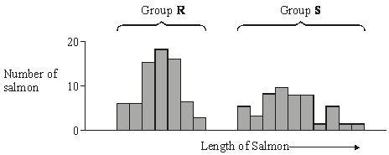

(a)     Give **two** possible causes of this variation that result from meiosis during gamete formation.

1 ...................................................................................................................

......................................................................................................................

2 ...................................................................................................................

......................................................................................................................

**(2)**

(b)     When comparing variation in size between two groups of organisms, it is often considered more useful to compare standard deviations rather than ranges. Explain why.

......................................................................................................................

......................................................................................................................

......................................................................................................................

......................................................................................................................

**(2)**

**(Total 4 marks)**

**Q2.**          Zooplankton are very small animals which feed on algae (green protoctists) found in lakes. The chart shows the mean depth of zooplankton populations in four lakes, **P** to **S**, during the day and the night. It also shows the standard deviations of the means. The depth at which the light intensity is 1% of the surface light intensity is also shown.

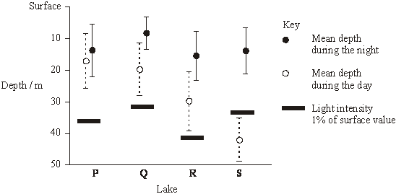

      (a)     Explain the evidence that the zooplankton feed at night.

......................................................................................................................

......................................................................................................................

......................................................................................................................

......................................................................................................................

**(3)**

(b)     Predatory fish, which hunt by sight, are present in some of the lakes. These fish have been present in the lakes for different lengths of time.

|  |  |
| --- | --- |
| **Lake** | **Estimated length of time predatory fish have been present / years** |
| **P** | 0 |
| **Q** | 5 |
| **R** | 25 |
| **S** | Over 1000 |

(i)      Describe the relationship between the depth of the zooplankton during the day and the length of time predators have been present in the lake.

.............................................................................................................

.............................................................................................................

**(1)**

       (ii)     Suggest how the differences in behaviour of the zooplankton populations in the four lakes might have evolved.

.............................................................................................................

.............................................................................................................

.............................................................................................................

.............................................................................................................

.............................................................................................................

.............................................................................................................

**(3)**

**(Total 7 marks)**

**Q3.**          The drawings show two dogwhelks taken from two different populations. Dogwhelk **A** came from a sheltered shore and dogwhelk **B** from a shore exposed to heavy wave action. The dogwhelks attach themselves to rocks with a muscular foot which comes out through the aperture. The shell length : aperture length ratios (L/A) were calculated. The mean and standard deviation for each population are shown under the drawings.

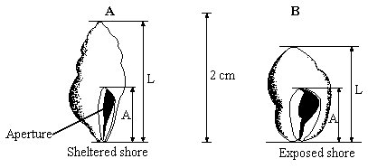

         mean L/A ratio          = 1.91                       mean L/A ratio          = 1.78  
standard deviation    = 0.19                       standard deviation    = 0.10

(a)     Describe how you would collect a random sample of each population.

......................................................................................................................

......................................................................................................................

......................................................................................................................

......................................................................................................................

......................................................................................................................

......................................................................................................................

**(3)**

(b)     What do the standard deviations tell you about the two populations of dogwhelks?

......................................................................................................................

......................................................................................................................

......................................................................................................................

......................................................................................................................

**(2)**

(c)     Suggest how the effect of wave action on the two populations of dogwhelks could result in differences between

(i)      the mean L/A ratios;

......................................................................................................................

......................................................................................................................

......................................................................................................................

......................................................................................................................

(ii)     the standard deviations.

......................................................................................................................

......................................................................................................................

......................................................................................................................

......................................................................................................................

**(4)**

**(Total 9 marks)**

**Q4.**          Antimicrobial proteins (AMPs), found in the skin of the African clawed frog, can kill bacteria. When AMPs are injected into humans, they are broken down by protease enzymes. Scientists have produced a number of AMPs that are not broken down by proteases. They did this by making these AMPs from man-made amino acids containing fluorine. The AMPs containing fluorine were found to be more effective in killing bacteria than AMPs without fluorine.

(a)     Name the type of reaction involved when a protease enzyme breaks down an AMP.

.......................................................................................................................

**(1)**

(b)     Suggest why protease enzymes cannot break down AMPs made from amino acids containing fluorine.

.......................................................................................................................

.......................................................................................................................

.......................................................................................................................

.......................................................................................................................

**(2)**

(c)     Scientists carried out an investigation to compare the effectiveness of AMPs containing fluorine and a frog AMP. They inoculated an agar plate with a culture of one species of bacterium. They cut four wells in the agar. They placed a frog AMP in one well. They put three different man-made AMPs containing fluorine in the other three wells. They incubated the plate for 48 hours. After incubation, there were clear areas around each well where the bacteria had not grown.

The appearance of the plate after incubation is shown below.

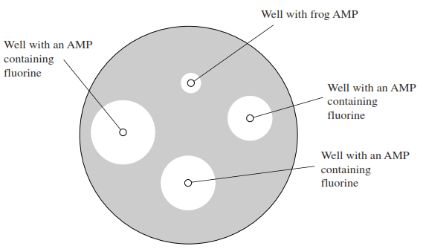

(i)      Give **one** example of aseptic technique that the scientists would have used during this investigation.

.............................................................................................................

.............................................................................................................

**(1)**

(ii)     What conclusions could the scientists draw from these results?

.............................................................................................................

.............................................................................................................

.............................................................................................................

.............................................................................................................

.............................................................................................................

.............................................................................................................

*(Extra space)*  .....................................................................................

.............................................................................................................

.............................................................................................................

**(3)**

**(Total 7 marks)**

**Q5.**          A student was provided with two agar plates. She transferred a culture of bacterium **A** onto one plate and a culture of bacterium **B** to the second plate. She placed paper discs containing antibiotics on the surface of the agar. She then incubated the plates for 24 hours.  
The diagram shows the agar plates before and after incubation.

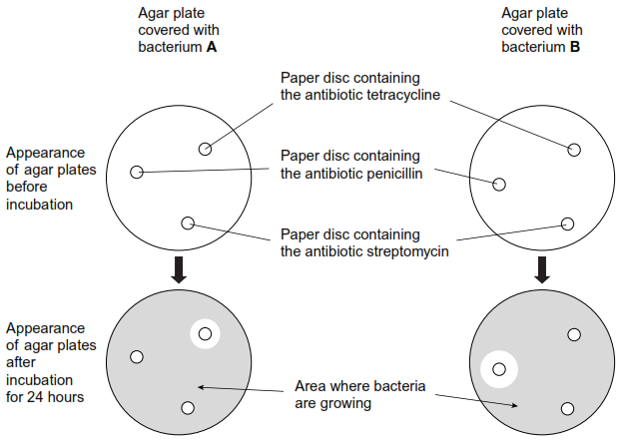

(a)     The student used a pair of forceps to place the paper discs onto the surface of the agar.  
Explain why she passed the forceps through a Bunsen flame before and after each time she used them.

......................................................................................................................

......................................................................................................................

......................................................................................................................

......................................................................................................................

**(2)**

(b)     Explain the appearance of the agar plates after incubation.

......................................................................................................................

......................................................................................................................

......................................................................................................................

......................................................................................................................

......................................................................................................................

......................................................................................................................

......................................................................................................................

......................................................................................................................

(*Extra space*)  ...............................................................................................

......................................................................................................................

......................................................................................................................

......................................................................................................................

**(4)**

**(Total 6 marks)**

**Q6.**          Some birds feed on animals found in mud in estuaries. The drawing shows the heads of three species of these birds and their prey.

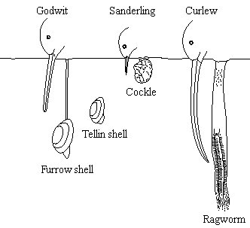

(a)     Use the information in the drawing to explain how interspecific competition between the birds is reduced.

......................................................................................................................

......................................................................................................................

......................................................................................................................

......................................................................................................................

......................................................................................................................

**(2)**

(b)     Explain how competition might have played a part in the evolution of the long curved beak of the curlew.

......................................................................................................................

......................................................................................................................

......................................................................................................................

......................................................................................................................

......................................................................................................................

......................................................................................................................

......................................................................................................................

......................................................................................................................

**(4)**

(c)     Mud higher up the shore receives fresh water draining from the land. Ragworms are able to survive in this mud because they can tolerate the absorption of water into their tissues. Explain what causes a ragworm to absorb water when higher up the shore.

......................................................................................................................

......................................................................................................................

......................................................................................................................

......................................................................................................................

**(2)**

**(Total 8 marks)**

**Q7.**          (a)     Explain how crossing over can contribute to genetic variation.

......................................................................................................................

......................................................................................................................

......................................................................................................................

......................................................................................................................

......................................................................................................................

......................................................................................................................

**(3)**

(b)     Maize seeds were an important food crop for the people who lived in Peru. The seeds could be kept for long periods. Each year, some were sown to grow the next crop. Archaeologists have found well-preserved stores. The graph shows the lengths of seeds collected from three stores of different ages.

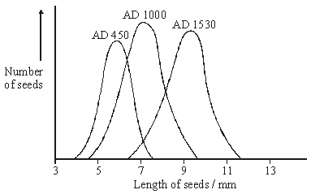

(i)      Within each store the maize seeds showed a range of different lengths.  
Explain **one** cause of this variation.

.............................................................................................................

.............................................................................................................

.............................................................................................................

.............................................................................................................

**(2)**

(ii)     Use your knowledge of genetics and selection to explain the changes in the mean length of the seeds between AD 450 and AD 1530.

.............................................................................................................

.............................................................................................................

.............................................................................................................

.............................................................................................................

.............................................................................................................

.............................................................................................................

.............................................................................................................

**(4)**

**(Total 9 marks)**

**Q8.** When coal is mined by open-cast mining, the top layer of soil is first scraped off and stored in a large heap. Once mining has finished, the area can be reclaimed. Soil from this store is then spread back over the surface.

Some of the bacteria living in the soil store respire aerobically and some respire anaerobically. **Table 1** shows the numbers of aerobic and anaerobic bacteria found at different depths in a soil store.

|  |  |  |  |  |
| --- | --- | --- | --- | --- |
| **Depth / cm** | **Mean number of bacteria per gram of soil (× 107)** | | | |
| Aerobic bacteria | | Anaerobic bacteria | |
| after 1 month | after 6 months | after 1 month | after 6 months |
| 0 | 12.0 | 12.1 | 0.6 | 0.8 |
| 50 | 10.4 | 8.6 | 0.8 | 1.3 |
| 100 | 10.1 | 6.1 | 0.7 | 4.1 |
| 150 | 10.0 | 3.2 | 0.7 | 7.9 |
| 200 | 11.6 | 0.8 | 0.7 | 8.4 |
| 250 | 11.9 | 0.7 | 0.8 | 8.8 |
| 300 | 11.0 | 0.8 | 0.6 | 9.1 |

**Table 1**

(a)     Some of the soil used to determine bacterial numbers was collected from the surface of the soil store. Describe how you would ensure that this soil was collected at random.

......................................................................................................................

......................................................................................................................

......................................................................................................................

......................................................................................................................

**(2)**

(b)     (i)      Describe how the numbers of aerobic bacteria after 6 months change with depth.

.............................................................................................................

.............................................................................................................

.............................................................................................................

.............................................................................................................

**(2)**

(ii)     Explain the difference in the numbers of aerobic bacteria at a depth of 300 cm between 1 and 6 months.

.............................................................................................................

.............................................................................................................

.............................................................................................................

.............................................................................................................

**(2)**

(c)     Explain how the changes in bacterial numbers which take place at 150 cm illustrate the process of succession.

......................................................................................................................

......................................................................................................................

......................................................................................................................

......................................................................................................................

......................................................................................................................

......................................................................................................................

**(3)**

Dehydrogenase is an enzyme involved in aerobic respiration. Dehydrogenase activity in a soil sample can be used as a measure of the activity of aerobic bacteria. The graph shows the mean dehydrogenase activity of soil samples taken from the same depth in a soil store at different times. The bars on the graph represent two standard errors above and below the mean.

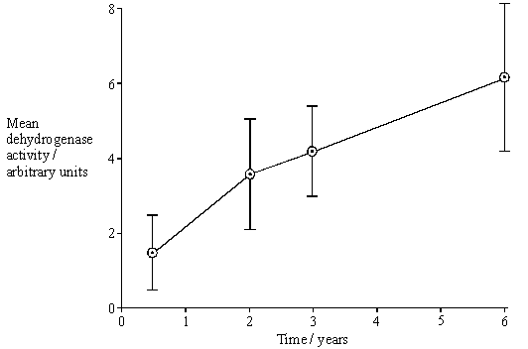

(d)     (i)      From what depth in the soil store would you expect these soil samples to have been taken? Use information from **Table 1** to explain your answer.

.............................................................................................................

.............................................................................................................

.............................................................................................................

.............................................................................................................

**(2)**

(ii)     How would you expect dehydrogenase activity to vary with depth after 6 months?

Use information from **Table 1** to explain your answer.

.............................................................................................................

.............................................................................................................

.............................................................................................................

.............................................................................................................

.............................................................................................................

.............................................................................................................

**(3)**

(e)     What do the error bars tell you about the difference between the mean dehydrogenase activity at 6 months and 3 years? Explain your answer in terms of probability and chance.

......................................................................................................................

......................................................................................................................

......................................................................................................................

......................................................................................................................

......................................................................................................................

......................................................................................................................

**(3)**

(f)      **Table 2** shows the dehydrogenase activity and the number of aerobic bacteria present in some soil samples.

|  |  |
| --- | --- |
| **Dehydrogenase activity / arbitrary units** | **Number of aerobic bacteria per gram of soil (× 107)** |
| 13.1 | 12.0 |
| 9.2 | 8.7 |
| 5.5 | 6.5 |
| 3.0 | 4.6 |
| 2.2 | 2.7 |
| 0.4 | 0.6 |

**Table 2**

A sample of soil was found to have dehydrogenase activity of 8.7 arbitrary units. Explain how you would use the data in **Table 2** to predict the likely number of aerobic bacteria in 1 g of this soil sample.

......................................................................................................................

......................................................................................................................

......................................................................................................................

......................................................................................................................

......................................................................................................................

......................................................................................................................

**(3)**

**(Total 20 marks)**

**Q9.**          Yarrow is a herbaceous plant which grows in California at altitudes from 1500 m to 3000 m. The mean height of the stems of plants growing at 3000 m is smaller than that of plants growing at 1500 m.

**S**       (a)     The higher the altitude, the lower the mean temperature. Explain how the lower temperature at high altitude reduces the growth of plants.

......................................................................................................................

......................................................................................................................

......................................................................................................................

......................................................................................................................

......................................................................................................................

**(4)**

**S**       (b)     The relative contribution of environmental and genetic factors on the growth of the plants was investigated. Samples of young plants were taken and grown outdoors in prepared plots at altitudes of 1500 m and 3000 m.

|  |  |  |
| --- | --- | --- |
| **Altitude at which young** | **Mean maximum height of stems of plants / cm** | |
| **plants were collected / m** | **Grown at 1500 m** | **Grown at 3000 m** |
| 1500 | 80.4 | 35.3 |
| 3000 | 31.5 | 24.7 |

Describe the evidence from the table that the variation in height is

(i)      partly genetically determined;

.............................................................................................................

.............................................................................................................

**(1)**

(ii)     partly environmentally determined.

.............................................................................................................

.............................................................................................................

**(1)**

**(Total 6 marks)**

**Q10.**          Lake Malawi in East Africa contains around 400 different species of cichlids which are small, brightly coloured fish. All these species have evolved from a common ancestor.

(a)     Describe **one** way in which scientists could find out whether cichlids from two different populations belong to the same species.

......................................................................................................................

......................................................................................................................

......................................................................................................................

......................................................................................................................

**(2)**

(b)     During the last 700 000 years there have been long periods when the water level was much lower and Lake Malawi split up into many smaller lakes. Explain how speciation of the cichlids may have occurred following the formation of separate, smaller lakes.

......................................................................................................................

......................................................................................................................

......................................................................................................................

......................................................................................................................

......................................................................................................................

......................................................................................................................

......................................................................................................................

......................................................................................................................

**(4)**

(c)     Many species of cichlids are similar in size and, apart from their colour, in appearance. Suggest how the variety of colour patterns displayed by these cichlids may help to maintain the fish as separate species.

......................................................................................................................

......................................................................................................................

......................................................................................................................

......................................................................................................................

**(2)**

**(Total 8 marks)**

**Q11.**          IQ test scores have been used as a measure of intelligence. Genetic and environmental factors may both be involved in determining intelligence. In an investigation of families with adopted children, the mean IQ scores of the adopted children was closer to the mean IQ scores of their adoptive parents than to that of their biological parents.

(a)     Explain what the results of this investigation suggest about the importance of genetic and environmental factors in determining intelligence.

......................................................................................................................

......................................................................................................................

**(1)**

(b)     Explain how data from studies of identical twins and non-identical twins could provide further evidence about the genetic control of intelligence.

......................................................................................................................

......................................................................................................................

......................................................................................................................

......................................................................................................................

......................................................................................................................

......................................................................................................................

......................................................................................................................

......................................................................................................................

**(4)**

**otal 5 marks)**

**Q12.** Parts of the sea shore form a very hostile environment for living organisms. Twice each day the incoming and outgoing tides alternately cover the organisms on the sea shore with water and then leave them exposed. The force of the waves could also dislodge any organisms that were not firmly attached.

The diagram shows a section through a rocky shore. Two sites were studied: site **A** was on the upper shore and site **B** on the lower shore.

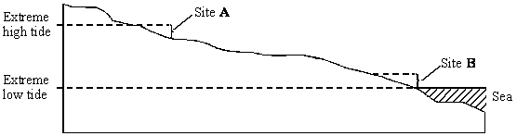

The table shows the seaweeds that were found growing at sites **A** and **B**.

|  |  |  |  |
| --- | --- | --- | --- |
| **Site A: upper shore** | **Mean number per m2** | **Site B: lower shore** | **Mean number per m2** |
| *Ascophyllum nodosum Fucus spiralis Fucus vesiculosus Pelvetia canaliculata* | 2 10 4 6 | *Corallina officinalis Fucus serratus Laminaria digitata Laminaria hyperborea Laminaria saccharina Laurencia pinnatifida Palmaria palmata* | 31 8 15 3 6 18 6 |
| Index of diversity |  | Index of diversity | 4.77 |

(a)     (i)      Use the formula 

where       **d** = index of diversity  
**N** = total number of organisms of all species  
**n** = total number of organisms of a particular species

to calculate the index of diversity for the seaweeds growing at site **A**.  
Show your working.

Index of diversity at site **A** = ......................................

**(2)**

(ii)     Give **one** advantage of calculating the index of diversity rather than just recording the number of species present.

.............................................................................................................

.............................................................................................................

**(1)**

(b)     Availability of water is one abiotic factor which determines the distribution of seaweeds. The graph shows loss in mass due to water evaporation for two of the seaweed species. The two seaweeds belong to the same genus but one was found only on the upper shore and the other only on the lower shore.

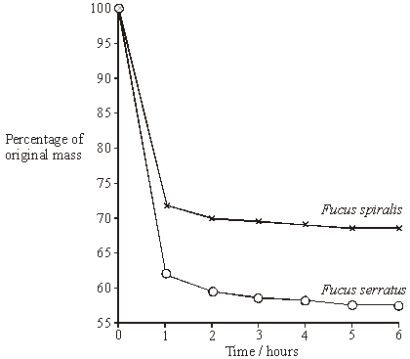

Explain how the results shown in the graph relate to the distribution of these two seaweeds on the sea shore.

......................................................................................................................

......................................................................................................................

......................................................................................................................

......................................................................................................................

......................................................................................................................

**(3)**

**(Total 6 marks)**

**Q13.**          It is difficult to get rid of dandelions from a garden because small pieces of the root are able to grow into new plants if left behind in the soil. This is shown in the drawing.

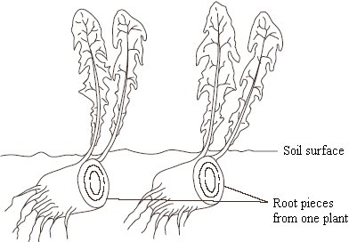

(a)     Explain why the plants produced form a clone.

......................................................................................................................

......................................................................................................................

......................................................................................................................

......................................................................................................................

**(2)**

(b)     Suggest **one** reason why the plants in a clone may not be identical in appearance.

......................................................................................................................

......................................................................................................................

**(1)**

(c)     Most plants produce seeds after fertilisation in sexual reproduction. However, dandelions produce small, windblown seeds without fertilisation taking place. Suggest **two** advantages to the dandelion of being able to reproduce from these seeds, as well as from pieces of root.

Advantage 1 .................................................................................................

......................................................................................................................

Advantage 2 …..............................................................................................

......................................................................................................................

**(2)**

**(Total 5 marks)**

**Q14.**          (a)     In an investigation, two sterile agar plates were inoculated with bacteria from the same culture. Then, using a syringe, 2 cm3 of an antibiotic solution were added to plate **1** and 2 cm3 of sterile water were added to plate **2**. The diagram shows the plates after 24 hours.

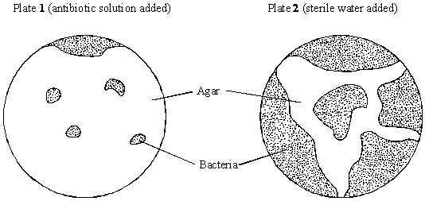

(i)      At the start of the investigation, the agar was sterilised. Explain why.

.............................................................................................................

.............................................................................................................

**(1)**

(ii)     The water was added to plate **2** as a control. Explain why this control was necessary.

.............................................................................................................

.............................................................................................................

**(1)**

(b)     Explain why some bacteria were able to grow on plate **1**.

......................................................................................................................

......................................................................................................................

**(1)**

**(Total 3 marks)**

**Q15.**          (a)     Explain what is meant by stabilising selection and describe the circumstances under which it takes place.

......................................................................................................................

......................................................................................................................

......................................................................................................................

......................................................................................................................

......................................................................................................................

......................................................................................................................

......................................................................................................................

......................................................................................................................

......................................................................................................................

**(5)**

(b)     Some European clover plants can produce cyanide. Those plants that can produce cyanide are called cyanogenic; those that cannot produce cyanide are called acyanogenic. Cyanide is toxic to the cells of animals and plants.

When the leaves of cyanogenic plants are damaged by slugs, or exposed to low temperatures, membranes within the cells are broken. This causes the release of the enzymes that control the reactions which produce cyanide.

The proportions of cyanogenic and acyanogenic plants in clover populations were determined in different parts of Europe. These are shown in the diagram below, together with the mean minimum winter temperatures. Slugs are not usually active at temperatures below 0 °C.

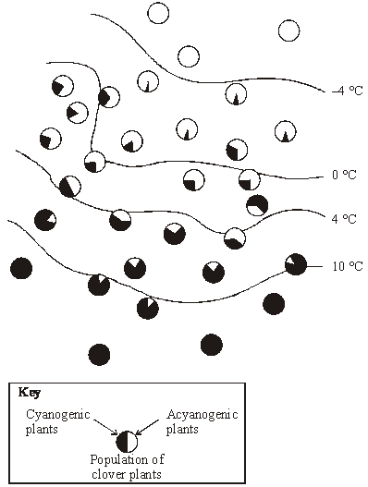

Explain the proportions of cyanogenic and acyanogenic plants in clover populations growing in the area where the mean minimum winter temperature is below –4°C and in the area where it is above 10 °C.

......................................................................................................................

......................................................................................................................

......................................................................................................................

......................................................................................................................

......................................................................................................................

......................................................................................................................

......................................................................................................................

......................................................................................................................

......................................................................................................................

**(5)**

**(Total 10 marks)**

**Q16.**(a)     A mutation can lead to the production of a non-functional enzyme. Explain how.

**(6)**

Scientists investigated the effect of a specific antibiotic on two strains of the same species of bacterium.

•        One strain, SR, shows a **stringent response** in the presence of this antibiotic. Part of this response involves stopping cell division. This gives this strain a greater resistance to the effects of this antibiotic.

•        The other strain, non-SR, cannot carry out a stringent response.

The scientists grew cultures of the SR strain and the non-SR strain containing the same number of bacterial cells. They then stopped each strain from dividing and exposed them to different concentrations of the antibiotic. After a fixed time, the scientists estimated the number of living bacteria remaining in the cultures.

**Figure 1** shows their results.

**Figure 1**

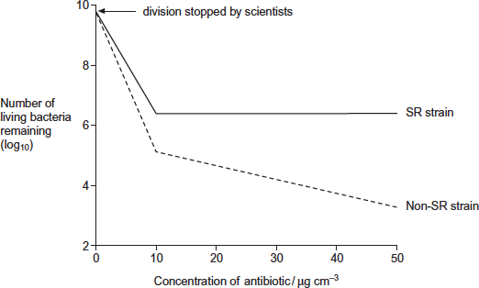

(b)     Describe differences in the effect of increasing the concentration of antibiotic on the SR strain and the non-SR strain.

........................................................................................................................

........................................................................................................................

........................................................................................................................

........................................................................................................................

........................................................................................................................

**[Extra space]** ................................................................................................

........................................................................................................................

**(2)**

(c)     One way in which the stringent response gives resistance to this antibiotic is by stopping cell division.

The scientists concluded that stopping cell division is not the **only** way in which the stringent response gives resistance to this antibiotic.

Explain how **Figure 1** supports this conclusion.

........................................................................................................................

........................................................................................................................

........................................................................................................................

........................................................................................................................

........................................................................................................................

**[Extra space]** ................................................................................................

........................................................................................................................

**(2)**

(d)     The stringent response involves a number of enzyme-catalysed reactions.

Explain how scientists could use this knowledge to design drugs that make the treatment of infections caused by the SR strain more successful.

........................................................................................................................

........................................................................................................................

........................................................................................................................

........................................................................................................................

........................................................................................................................

**(2)**

The antibiotic damages the bacterium by causing the production of substances called free radicals.

The scientists exposed the SR strain and the non-SR strain to the antibiotic. They then measured the amounts of free radicals and an enzyme called catalase in both strains.

**Figure 2** shows their results.

**Figure 2**

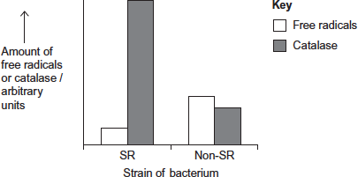

(e)     Use the information provided and **Figure 2** to suggest an explanation for the greater resistance of the SR strain to this antibiotic.

........................................................................................................................

........................................................................................................................

........................................................................................................................

........................................................................................................................

........................................................................................................................

........................................................................................................................

........................................................................................................................

**[Extra space]** ................................................................................................

........................................................................................................................

........................................................................................................................

**(3)**

**(Total 15 marks)**

**Q17.**          (a)     Some antibiotics bind with specific receptors in the plasma membranes of bacteria. The structure of these receptors is determined genetically. Bacteria can become resistant to an antibiotic because a gene mutation results in an altered receptor.

Explain how resistance to an antibiotic could become widespread in a bacterial population following a gene mutation conferring resistance in just one bacterium.

......................................................................................................................

......................................................................................................................

......................................................................................................................

......................................................................................................................

......................................................................................................................

......................................................................................................................

......................................................................................................................

......................................................................................................................

......................................................................................................................

......................................................................................................................

**(5)**

(b)     Some humans have a genetic resistance to infection. A recessive allele gives increased resistance to infection by the malarial parasite. In a population, the proportion of babies born who are homozygous for this allele is 0.01. Use the Hardy-Weinberg equation to calculate the expected proportion of heterozygotes in this population. Show your working.

Answer ............................................

**(4)**

**(Total 9 marks)**

**Q18.**During the last 50 years, there have been changes in the climate of the UK. One of the main changes is temperature. The data in the following resources all relate to southern England.

**Figure 1** shows the mean temperatures for January and February combined.

**Figure 1**

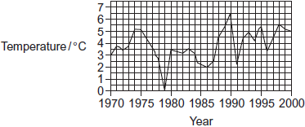

**Figure 2** shows the mean temperatures for March.

**Figure 2**



Birds, such as chaffinches, have been recorded as breeding earlier. Chaffinches build nests. When the nest is complete, the female lays eggs until she has produced a full clutch of 4 to 6 eggs. After the eggs hatch, the parent birds feed the young on insects.

**Figure 3** shows the mean date on which chaffinches laid their first egg.

**Figure 3**

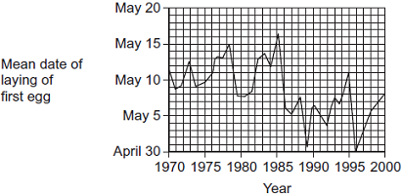

The data from which this graph was drawn were collected by volunteers. They used standard record cards. The volunteers used one record card for each nest they found. Each card was used to record

•        the geographical location

•        the habitat in which the nest site was situated

•        the date of each visit to the nest by the volunteer

•        the number of eggs present in the nest at each visit.

Visits were made to the nests at least once every 5 days.

(a)     Do the data in **Figure 1** and **Figure 2** support the idea that there has been a rise in the mean temperatures in southern England between 1970 and 2000? Explain your answer.

........................................................................................................................

........................................................................................................................

........................................................................................................................

........................................................................................................................

........................................................................................................................

**(2)**

(b)     Describe briefly how you would use a statistical test to find whether there is a significant correlation between mean March temperature and the date when chaffinches laid their first egg.

........................................................................................................................

........................................................................................................................

........................................................................................................................

........................................................................................................................

........................................................................................................................

........................................................................................................................

(Extra space) .................................................................................................

........................................................................................................................

........................................................................................................................

**(3)**

(c)     In chaffinches, the date of laying the first egg is determined by a number of factors. These include day length and temperature. What is the advantage to the bird of egglaying being determined by

(i)      daylength

...............................................................................................................

...............................................................................................................

...............................................................................................................

...............................................................................................................

...............................................................................................................

**(2)**

(ii)     temperature?

...............................................................................................................

...............................................................................................................

...............................................................................................................

...............................................................................................................

...............................................................................................................

**(2)**

(d)     Scientists found that there was a correlation between mean annual temperature and the date when chaffinches laid the first egg. Can you conclude that higher temperatures cause earlier laying of the first egg?  
Explain your answer.

........................................................................................................................

........................................................................................................................

........................................................................................................................

........................................................................................................................

........................................................................................................................

**(2)**

(e)     How does the way in which the data were collected affect the conclusions which can be drawn from **Figure 3**?

........................................................................................................................

........................................................................................................................

........................................................................................................................

........................................................................................................................

........................................................................................................................

**(2)**

**(Total 13 marks)**

**Q19.**          There is evidence that the first photosynthetic organisms were primitive water-dwelling bacteria. The very first of these lived near the surface of the water in lakes and contained a purple pigment that absorbed light most strongly in the green region of the spectrum. Later, other bacteria evolved that lived on the top of sediment at the bottom of the lakes (**Figure 1**). Gene mutations had enabled these bacteria to synthesise chlorophyll instead of the purple pigment present in the bacteria living near to the surface. Chlorophyll absorbs light most strongly in the blue and red regions of the spectrum (**Figure 2**).

**Figure 1**

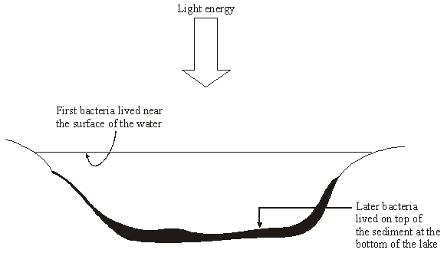

**Figure 2**

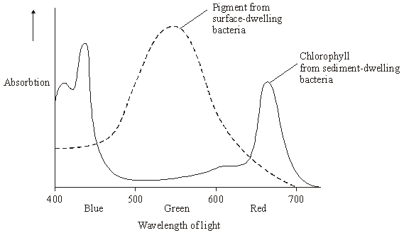

(a)     Describe how light energy absorbed by chlorophyll molecules is used to synthesise ATP.

......................................................................................................................

......................................................................................................................

......................................................................................................................

......................................................................................................................

......................................................................................................................

......................................................................................................................

......................................................................................................................

......................................................................................................................

......................................................................................................................

......................................................................................................................

**(5)**

(b)     Use **Figure 2** to explain how natural selection would favour the evolution of sediment-dwelling bacteria containing a different photosynthetic pigment from those living near the surface of the water.

......................................................................................................................

......................................................................................................................

......................................................................................................................

......................................................................................................................

......................................................................................................................

......................................................................................................................

......................................................................................................................

......................................................................................................................

......................................................................................................................

......................................................................................................................

......................................................................................................................

**(6)**

**(Total 11 marks)**

**Q20.**          The diagram shows a seahorse. A seahorse is a fish. Mating in seahorses begins with courtship behaviour. After this, the female transfers her unfertilised eggs to the male’s pouch. Most male fish fertilise eggs that have been released into the sea. However, a male seahorse fertilises the eggs while they are inside his pouch. The fertilised eggs stay in the pouch where they develop into young seahorses.

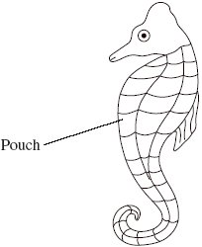

(a)     Give **two** ways in which courtship behaviour increases the probability of successful mating.

1 ...................................................................................................................

......................................................................................................................

2 ...................................................................................................................

......................................................................................................................

**(2)**

(b)     Give **one** way in which reproduction in seahorses increases the probability of

(i)      fertilisation

.............................................................................................................

.............................................................................................................

**(1)**

(ii)     survival of young seahorses.

.............................................................................................................

.............................................................................................................

**(1)**

          Scientists investigated the effect of total body length on the selection of a mate in one Australian species of seahorse. The scientists used head length as a measure of total body length.

(c)     (i)      Use the diagram to suggest why the scientists measured head length rather than total body length.

.............................................................................................................

.............................................................................................................

**(1)**

(ii)     Suggest why the scientists were able to use head length as a measure of total body length.

.............................................................................................................

.............................................................................................................

**(1)**

The scientists measured the head lengths of the female and male of a number of pairs.  
The results are shown in the graph.

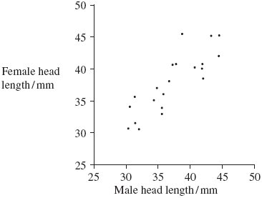

(d)     The scientists concluded that total body length affects the selection of a mate.  
Explain how the results support this conclusion.

......................................................................................................................

......................................................................................................................

**(1)**

(e)     A female with a head length of 50 mm selected a mate. Explain how you could use the graph to predict the total head length of the mate selected.

......................................................................................................................

......................................................................................................................

......................................................................................................................

......................................................................................................................

**(2)**

(f)      Scientists studied two species of North American seahorse. They thought that these two species are closely related. Describe how comparisons of biological molecules in these two species could be used to find out if they are closely related.

......................................................................................................................

......................................................................................................................

......................................................................................................................

......................................................................................................................

......................................................................................................................

......................................................................................................................

......................................................................................................................

......................................................................................................................

......................................................................................................................

......................................................................................................................

......................................................................................................................

......................................................................................................................

**(6)**

**(Total 15 marks)**

**Q21.**          Finches are small birds. Fourteen species of finch are found on the Galapagos Islands.

(a)     What is a species?

......................................................................................................................

......................................................................................................................

......................................................................................................................

......................................................................................................................

**(2)**

(b)     Measurements were made of the beak depth of two species of finch (species **A** and species **B**) on different islands. Species **A** is found on island 1, species **B** is found on island 2. Both species are found on island 3. They are thought to have colonised island 3 from islands 1 and 2 respectively. The graphs show the ranges of beak depths of the two species on the different islands.

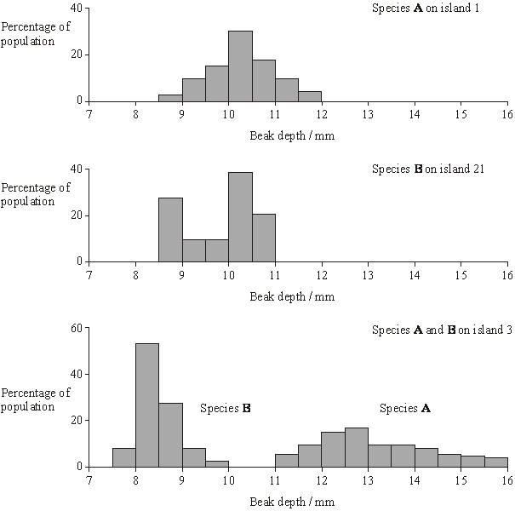

What type of natural selection took place in the populations of both species after they had colonised island 3? Explain your answer.

......................................................................................................................

......................................................................................................................

......................................................................................................................

......................................................................................................................

......................................................................................................................

**(3)**

**(Total 5 marks)**

**Q22.**The table shows the taxons and the names of the taxons used to classify one species of otter. They are **not** in the correct order.

|  |  |  |  |
| --- | --- | --- | --- |
|  |  | **Taxon** | **Name of taxon** |
|  | **J** | Family | Mustelidae |
|  | **K** | Kingdom | Animalia |
|  | **L** | Genus | Lutra |
|  | **M** | Class | Mammalia |
|  | **N** | Order | Carnivora |
|  | **O** | Phylum | Chordata |
|  | **P** | Domain | Eukarya |
|  | **Q** | Species | lutra |

(a)     Put letters from the table above into the boxes in the correct order. Some boxes have been completed for you.

|  |  |  |  |  |  |  |  |  |  |  |  |  |  |  |  |
| --- | --- | --- | --- | --- | --- | --- | --- | --- | --- | --- | --- | --- | --- | --- | --- |
|  |  |  |  |  | **O** |  | **M** |  |  |  |  |  | **L** |  | **Q** |

**(1)**

(b)     Give the scientific name of this otter.

........................................................................................................................

**(1)**

Scientists investigated the effect of hunting on the genetic diversity of otters. Otters are animals that were killed in very large numbers for their fur in the past.

The scientists obtained DNA from otters alive today and otters that were alive before hunting started.

For each sample of DNA, they recorded the number of base pairs in alleles of the same gene. Mutations change the numbers of base pairs over time.

The figure below shows the scientists’ results.

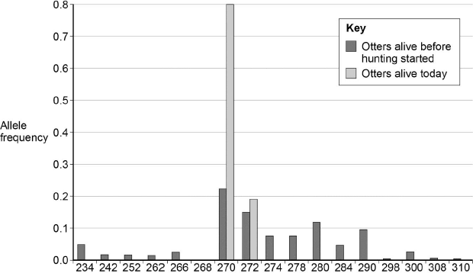  
                        Allele size / number of base pairs

(c)     The scientists obtained DNA from otters that were alive before hunting started.

Suggest **one** source of this DNA.

........................................................................................................................

........................................................................................................................

**(1)**

(d)     What can you conclude about the effect of hunting on genetic diversity in otters? Use data from the figure above to support your answer.

........................................................................................................................

........................................................................................................................

........................................................................................................................

........................................................................................................................

**(2)**

(e)     Some populations of animals that have never been hunted show very low levels of genetic diversity.

Other than hunting, suggest **two** reasons why populations might show very low levels of genetic diversity.

1 .....................................................................................................................

........................................................................................................................

2 .....................................................................................................................

........................................................................................................................

**(2)**

**(Total 7 marks)**

**Q23.**          (a)     Haemoglobin contains iron. One type of anaemia is caused by a lack of iron. This type of anaemia can be treated by taking tablets containing iron. A number of patients were given a daily dose of 120 mg of iron. **Figure 1** shows the effect of this treatment on the increase in the concentration of haemoglobin in their red blood cells.

**Figure 1**

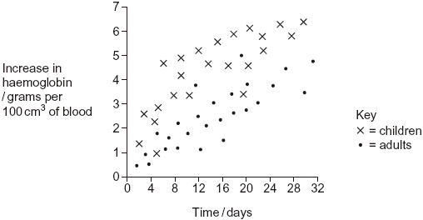

(i)      Give **one** difference in the response of adults and children to this treatment.

.............................................................................................................

.............................................................................................................

**(1)**

(ii)     You could use the graph to predict the effect of this treatment on the increase in haemoglobin content of an adult after 40 days. Explain how.

.............................................................................................................

.............................................................................................................

.............................................................................................................

.............................................................................................................

**(2)**

(iii)     Haemoglobin has a quaternary structure. Explain what is meant by a quaternary structure.

.............................................................................................................

.............................................................................................................

**(1)**

(b)     (i)      Pernicious anaemia is another type of anaemia. One method of identifying pernicious anaemia is to measure the diameter of the red blood cells in a sample of blood that has been diluted with an isotonic salt solution. Explain why an isotonic salt solution is used to dilute the blood sample.

.............................................................................................................

.............................................................................................................

.............................................................................................................

.............................................................................................................

.............................................................................................................

.............................................................................................................

**(3)**

(ii)     A technician compared the red blood cells in two blood samples of equal volume. One sample was from a patient with pernicious anaemia, the other was from a patient who did not have pernicious anaemia. **Figure 2** shows some of the results she obtained.

**Figure 2**

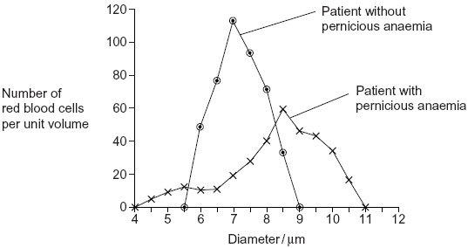

Describe **two** differences between the blood samples.

1 ..........................................................................................................

.............................................................................................................

2 ..........................................................................................................

.............................................................................................................

**(2)**

**(Total 9 marks)**

**Q24.**          (a)     The number of patients infected with the bacterium MRSA has increased in some hospitals. Scientists have suggested ways to reduce the transmission of MRSA in hospitals. Suggest **two** ways to reduce the transmission of MRSA in hospitals.

1 ...................................................................................................................

......................................................................................................................

2 ...................................................................................................................

......................................................................................................................

**(2)**

(b)     The minimum inhibitory concentration (MIC) is the lowest concentration of a substance that prevents the growth of a microorganism.

When antibiotics are prescribed for treating patients, higher doses than the MIC are recommended. Suggest **two** reasons why.

1 ...................................................................................................................

......................................................................................................................

2 ...................................................................................................................

......................................................................................................................

**(2)**

Scientists tested a new group of drugs for their effectiveness against four species of bacteria. The scientists used MICs to compare the effectiveness of four drugs. The results are shown in the table.

|  |  |  |  |  |  |
| --- | --- | --- | --- | --- | --- |
|  |  | **Minimum inhibitory concentration / μg cm–3** | | | |
|  | **Drug** | *Escherichia coli* | *Staphylococcus aureus* | *Enterococcus faecalis* | *Pseudomonas aeruginosa* |
|  | **P** | 0.39 | 0.049 | 0.049 | 3.13 |
|  | **Q** | 1.54 | 0.049 | 0.195 | 3.13 |
|  | **R** | 0.39 | 0.049 | 0.195 | 1.56 |
|  | **S** | 1.56 | 0.098 | 0.390 | 12.50 |

(c)     Which of the four drugs is

(i)      most effective against *Enterococcus faecalis*?



**(1)**

(ii)     least effective against all the species of bacteria used?



**(1)**

(d)     The effectiveness of these drugs was tested in double-blind trials using human volunteers. In a double-blind trial neither the volunteers nor the scientists know which treatment a particular volunteer is receiving.

(i)      Suggest **two** ways in which a double-blind trial improves reliability.

1 ..........................................................................................................

.............................................................................................................

2 ..........................................................................................................

.............................................................................................................

**(2)**

(ii)     Suggest **two** factors the scientists should have considered when selecting adult volunteers for this trial.

1 ..........................................................................................................

2 ..........................................................................................................

**(2)**

(e)     Scientists investigated resistance of the bacterium, *S. aureus* to the antibiotic Norfloxacin. They grew the bacteria in a medium containing a low concentration of Norfloxacin. The concentration of Norfloxacin that they added killed some of the bacteria. It did not kill all of them. Every 24 hours, they removed a sample of the bacteria from the culture. They tested the sample to find the concentration of Norfloxacin that prevented the growth of 50 % of the bacteria in the sample.  
The scientists then used the same method to investigate the resistance of *S. aureus* to a new drug, drug **X**. The results of both investigations are shown in the graph.

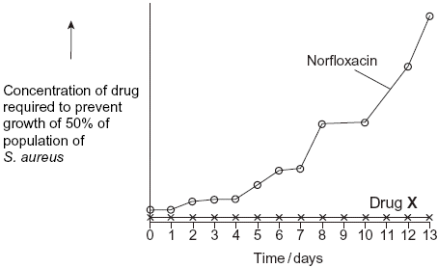

Describe the results obtained with Norfloxacin.

......................................................................................................................

......................................................................................................................

**(1)**

**(Total 11 marks)**

**Q25.**          Penicillins are antibiotics. Some bacteria produce an enzyme that breaks down one sort of penicillin.

(a)     There are different sorts of penicillin. All of these have the same basic chemical structure shown in the diagram but group **X** is different.

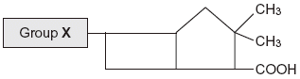

A bacterial infection that cannot be treated with one sort of penicillin can be treated with a different sort. Use your knowledge of enzyme action to explain why the different sort of penicillin is effective in treating the infection.

......................................................................................................................

......................................................................................................................

......................................................................................................................

......................................................................................................................

......................................................................................................................

......................................................................................................................

**(3)**

(b)     Farmers often keep large numbers of cattle together. Farmers used to give cattle food which had antibiotics added to it.

(i)      Suggest how adding antibiotics to the food of the cattle increased profit for the farmers.

.............................................................................................................

.............................................................................................................

.............................................................................................................

.............................................................................................................

**(2)**

(ii)     Adding antibiotics to the food of cattle is now banned in many countries. Use your knowledge of selection to explain why adding antibiotics was banned.

.............................................................................................................

.............................................................................................................

.............................................................................................................

.............................................................................................................

**(2)**

**(Total 7 marks)**

**Q26.**          **Figure 1** shows a fresh-water shrimp.

**Figure 1**

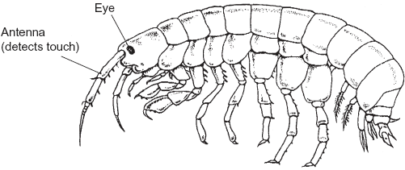

Biologists collected shrimps from a stream inside a cave and from the same stream when it was in the open.

They measured the maximum diameter of each shrimp’s eye. They also measured the length of its antenna. From these measurements they calculated the mean values for each site. **Figure 2** shows their results.

**Figure 2**

|  |  |  |  |
| --- | --- | --- | --- |
|  |  | Shrimps from the stream | |
|  |  | Inside the cave | In the open |
|  | Mean diameter of eye /mm | 0.09 | 0.24 |
|  | Mean length of antenna /mm | 8.46 | 5.81 |

(a)     The biologists measured the maximum diameter of each shrimp’s eye.

Explain why they measured the **maximum** diameter.

......................................................................................................................

......................................................................................................................

......................................................................................................................

**(1)**

(b)     A scientist working many years earlier suggested that animals which live in caves had similar adaptations. These adaptations included

•        smaller eyes

•        greater use of sense organs such as those involved in detecting touch.

(i)      Do the data in **Figure 2** support this scientist’s suggestion? Explain your answer.

.............................................................................................................

.............................................................................................................

.............................................................................................................

.............................................................................................................

.............................................................................................................

**(2)**

(ii)     The data in **Figure 2** are mean values. Explain how standard deviations of these cmean values would help you to interpret the data in **Figure 2**.

.............................................................................................................

.............................................................................................................

.............................................................................................................

.............................................................................................................

.............................................................................................................

**(2)**

(c)     The biologists investigated shrimps living in other streams. They measured the length of the antennae of these shrimps. They also measured their body length. **Figure 3** shows the mean antenna length plotted against mean body length for each site.

**Figure 3**

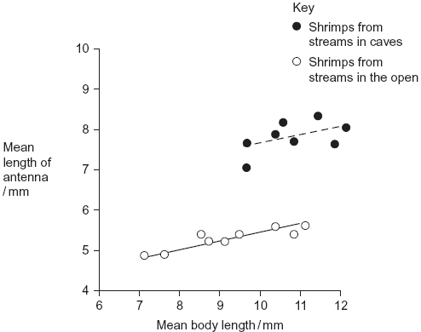

(i)      What does the information in the graph suggest about the body lengths of shrimps living in caves and living in the open?

.............................................................................................................

.............................................................................................................

.............................................................................................................

.............................................................................................................

.............................................................................................................

**(2)**

(ii)     Do the data in the graph support the conclusion that shrimps with longer bodies have longer antennae? Give the reason for your answer.

.............................................................................................................

.............................................................................................................

.............................................................................................................

**(1)**

Other biologists investigated the genetic diversity of these shrimps. **Figure 4** shows some of the data they collected.

**Figure 4**

|  |  |  |  |  |
| --- | --- | --- | --- | --- |
|  | **Gene** | **Allele** | **Percentage of shrimps with this allele in steam** | |
|  | **Inside a cave** | **In the open** |
|  | PGI | **A** | 0.9 | 2.5 |
|  | **B** | 0.0 | 3.3 |
|  | **C** | 98.2 | 66.4 |
|  | **D** | 0.9 | 6.6 |
|  | **E** | 0.0 | 21.3 |
|  |  | | | |
|  | ACO2 | **J** | 0.0 | 5.6 |
|  | **K** | 0.0 | 76.7 |
|  | **L** | 100.0 | 17.8 |

(d)     The biologists concluded that the shrimps in the open had a higher genetic diversity than those in the cave. Explain how the data in **Figure 4** support this conclusion.

......................................................................................................................

......................................................................................................................

......................................................................................................................

**(1)**

(e)     The percentage of shrimps with allele **L** in the cave is different from the percentage of shrimps with allele **L** in the open. Use your knowledge of the founder effect to suggest a reason for this difference.

......................................................................................................................

......................................................................................................................

......................................................................................................................

......................................................................................................................

......................................................................................................................

......................................................................................................................

**(3)**

(f)      The biologists who studied these shrimps wanted to know if the shrimps living in the cave were the same species as those living in the open. They used breeding experiments to investigate this.

(i)      Describe how the biologists should carry out these breeding experiments.

.............................................................................................................

.............................................................................................................

.............................................................................................................

.............................................................................................................

(ii)     The results of breeding experiments would help the biologists to decide whether the shrimps were the same species. Explain how.

.............................................................................................................

.............................................................................................................

**(3)**

**(Total 15 marks)**

**Q27.**          (a)     *Clostridium difficile* is a bacterium that is present in the gut of up to 3% of healthy adults and 66% of healthy infants.

(i)*C. difficile* rarely causes problems, either in healthy adults or in infants. This is because its numbers are kept low by competition with harmless bacteria that normally live in the intestine.

Use this information to explain why some patients treated with antibiotics can be affected by *C. difficile*.

.............................................................................................................

.............................................................................................................

.............................................................................................................

.............................................................................................................

.............................................................................................................

**(2)**

(ii)     Suggest why older people are more likely to be affected by *C. difficile*.

.............................................................................................................

.............................................................................................................

.............................................................................................................

**(1)**

(b)The antibiotic methicillin inhibits the enzyme transpeptidase. This enzyme is used by some bacteria to join monomers together during cell wall formation. Methicillin has a similar structure to these monomers. Use this information to explain how methicillin inhibits the enzyme transpeptidase.

......................................................................................................................

......................................................................................................................

......................................................................................................................

......................................................................................................................

......................................................................................................................

**(2)**

(c)     MRSA is a variety of *Staphylococcus aureus*. It is difficult to treat infections caused by this bacterium because it is resistant to methicillin and to some other antibiotics. As a result, some patients who are already very ill may die if they become infected with MRSA. The graph shows the number of deaths in England and Wales between 1994 and 2008 caused by MRSA.

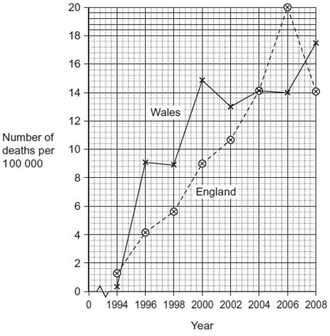

(i)It may be difficult to identify MRSA as the actual cause of death. Explain why.

.............................................................................................................

.............................................................................................................

.............................................................................................................

**(1)**

(ii)     Describe the change in the number of deaths caused by MRSA in England in the period shown in the graph.

.............................................................................................................

.............................................................................................................

.............................................................................................................

**(1)**

(iii)Calculate the percentage increase in the number of deaths caused by MRSA in Wales from 1996 to 2006. Show your working.

Answer ......................................

**(2)**

**(Total 9 marks)**

**Q28.**          The table shows some differences between three varieties of banana plant.

|  |  |  |  |  |
| --- | --- | --- | --- | --- |
|  |  | Variety **A** | Variety **B** | Variety **C** |
|  | Number of chromosomes in a leaf cell | 22 | 33 | 44 |
|  | Growth rate of fruit / cm3 week–1 | 2.9 | 6.9 | 7.2 |
|  | Breaking strength of leaf / arbitrary units | 10.8 | 9.4 | 7.8 |

(a)     (i)      How many chromosomes are there in a male gamete from variety **C**?



**(1)**

(ii)     Variety **B** cannot produce fertile gametes. Use information in the table to explain why.

.............................................................................................................

.............................................................................................................

.............................................................................................................

.............................................................................................................

.............................................................................................................

**(2)**

          In some countries very strong winds may occur. Banana growers in these countries choose to grow variety **B**.

(b)     (i)      Use the data in the table to explain why banana growers in these countries choose to grow variety **B** rather than variety **A**.

.............................................................................................................

.............................................................................................................

.............................................................................................................

**(1)**

(ii)     Use the data in the table to explain why banana growers in these countries choose to grow variety **B** rather than variety **C**.

.............................................................................................................

.............................................................................................................

.............................................................................................................

**(1)**

(c)     Banana growers can only grow new variety **B** plants from suckers. Suckers grow from cells at the base of the stem of the parent plant.

Use your knowledge of cell division to explain how growing variety **B** on a large scale will affect the genetic diversity of bananas.

......................................................................................................................

......................................................................................................................

......................................................................................................................

......................................................................................................................

......................................................................................................................

**(2)**

**(Total 7 marks)**

**Q29.**Australian scientists investigated one aspect of competition between wheat and ryegrass.

•        They crushed up some wheat plants and mixed the crushed plants with distilled water.

•        Water-soluble substances in the crushed plants dissolved in the distilled water. The scientists called this solution the *full-strength* extract.

•        The scientists then made a series of dilutions of the full-strength extract.

•        They put ryegrass seeds into each dilution and recorded how many seeds germinated (started to grow). If the seeds germinated, they measured the lengths of the roots of the seedlings.

•        They presented their results as percentages of a control experiment.

The graph shows the effects of different concentrations of the extract on the germination of ryegrass and on the length of the roots of the seedlings that grew from them.

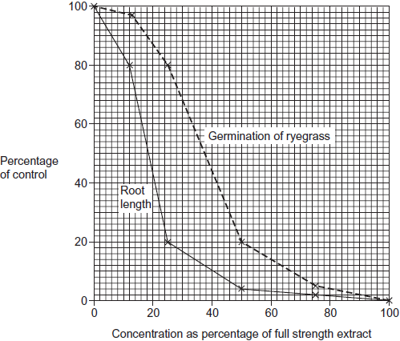

(a)     Describe the control that the scientists set up in this investigation.

........................................................................................................................

........................................................................................................................

**(1)**

(b)     The scientists found a positive correlation between the inhibition of germination and the concentration of the extract.

(i)      Describe how they could find out whether this correlation was significant.

...............................................................................................................

...............................................................................................................

...............................................................................................................

...............................................................................................................

...............................................................................................................

**(2)**

(ii)      Explain why a correlation does **not** mean that the extract caused inhibition of germination.

...............................................................................................................

...............................................................................................................

...............................................................................................................

**(1)**

(c)     The scientists concluded that wheat plants produce substances that help them to compete with ryegrass.

(i)      Give evidence from the investigation to support this conclusion.

...............................................................................................................

...............................................................................................................

...............................................................................................................

...............................................................................................................

...............................................................................................................

**(2)**

(ii)     Why might their conclusion **not** be valid?

...............................................................................................................

...............................................................................................................

...............................................................................................................

...............................................................................................................

...............................................................................................................

...............................................................................................................

(Extra space) ........................................................................................

...............................................................................................................

...............................................................................................................

**(3)**

**(Total 9 marks)**

**Q30.**The body markings of cheetahs vary, in particular the pattern of bands on their tails. Cheetahs are solitary animals but the young stay with their mother until they are between 14 and 18 months old.

Scientists investigated the banding pattern on the tails of cheetahs living in the wild.

•        They drove a car alongside a walking cheetah and used binoculars to study the tail pattern.

•        They gave each cheetah a banding pattern score based on the width of the dark and light bands on the end of the tail.

•        They scored the width of the bands on the right and left side of the tail using a 5 point scale of width.

A typical pattern on the right side of one cheetah’s tail is shown in **Figure 1**.

**Figure 1**

|  |  |  |  |  |  |  |  |
| --- | --- | --- | --- | --- | --- | --- | --- |
|  | Band number | 1 | 2  3 | 4 | 5 | 6 | 7 |



|  |  |  |  |  |  |  |  |
| --- | --- | --- | --- | --- | --- | --- | --- |
|  | Band width score | 3 | 1  1 | 4 | 3 | 3 | 3 |

The scientists collected data from each cheetah on four separate occasions. **Figure 2** shows the data for one of the cheetahs.

**Figure 2**

|  |  |  |  |  |  |  |  |  |
| --- | --- | --- | --- | --- | --- | --- | --- | --- |
|  | **Side of tail** | **Mean band width score (± standard deviation)** | | | | | | |
|  | **Band 1** | **Band 2** | **Band 3** | **Band 4** | **Band 5** | **Band 6** | **Band 7** |
|  | Right | 3.00  (± 0.82) | 1.00  (± 0.00) | 1.00  (± 0.00) | 3.75  (± 0.50) | 2.75  (± 0.50) | 3.00  (± 0.00) | 3.00  (± 0.00) |
|  | Left | 3.75  (± 0.50) | 3.25  (± 0.50) | 2.00  (± 0.50) | 3.00  (± 0.00) | 2.00  (± 0.00) | 2.50  (± 0.50) | 3.00  (± 0.50) |

(a)     The scientists only used data from cheetahs which were fully grown. Suggest why.

........................................................................................................................

........................................................................................................................

**(1)**

(b)     The scientists estimated the width of the bands on the same cheetah on four separate occasions. They did not always get the same score.

(i)      Give **two** pieces of evidence from **Figure 2** which show that the scientists sometimes obtained different scores for the same band.

1 ............................................................................................................

...............................................................................................................

2 ............................................................................................................

...............................................................................................................

**(2)**

(ii)     The method the scientists used resulted in them getting different scores for the same band. Suggest why.

...............................................................................................................

...............................................................................................................

**(1)**

(c)     What is the evidence from **Figure 2** that the dark and light bands do **not** form rings of equal width around the tail?

........................................................................................................................

........................................................................................................................

**(1)**

(d)     The scientists found the difference in banding pattern between

•        offspring in the same family

•        cheetahs chosen randomly.

Explain how scientists could use this information to show that some variation in tail banding was genetic.

........................................................................................................................

........................................................................................................................

........................................................................................................................

........................................................................................................................

........................................................................................................................

........................................................................................................................

(Extra space) .................................................................................................

........................................................................................................................

........................................................................................................................

**(3)**

**(Total 8 marks)**

**Q31.**          (a)     Explain what is meant by genetic diversity.

......................................................................................................................

......................................................................................................................

**(1)**

(b)Apart from genetic factors what other type of factor causes variation within a species?

......................................................................................................................

**(1)**

(c)The spotted owl is a bird. Numbers of spotted owls have decreased over the past 50 years. Explain how this decrease may affect genetic diversity.

......................................................................................................................

......................................................................................................................

......................................................................................................................

......................................................................................................................

......................................................................................................................

**(2)**

**(Total 4 marks)**

**Q32.**(a)    There are ethical and economic arguments for maintaining biodiversity.

(i)      Suggest **one** ethical argument for maintaining biodiversity.

...............................................................................................................

...............................................................................................................

...............................................................................................................

**(1)**

(ii)     Suggest **one** economic argument for maintaining biodiversity.

...............................................................................................................

...............................................................................................................

...............................................................................................................

**(1)**

Ecologists calculated the percentage of bird species that have become extinct on six islands in the last one hundred years. They also calculated the percentage of original forest area remaining on each island after the same time period. The graph shows their results.

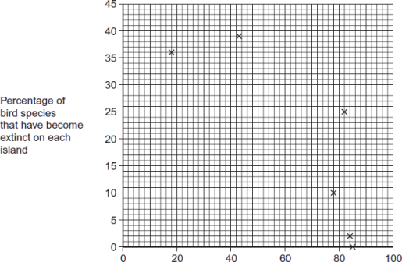

Percentage of original forest area   
remaining on each island

(b)     Explain the relationship between the percentage of original forest area remaining and the percentage of bird species that have become extinct.

...............................................................................................................

...............................................................................................................

...............................................................................................................

...............................................................................................................

...............................................................................................................

**(2)**

(c)     What **two** measurements would the ecologists have needed to obtain to calculate the index of diversity of birds on each island?

1......................................................................................................................

2......................................................................................................................

**(2)**

(d)     The ecologists noted that the species of birds surviving on the coldest islands had a larger body size than those surviving on warmer islands.

Explain how a larger body size is an adaptation to a colder climate

........................................................................................................................

........................................................................................................................

........................................................................................................................

........................................................................................................................

........................................................................................................................

**(2)**

**(Total 8 marks)**

**Q33.**The diagram shows the structure of a bacterium and the sites of action of two antibiotics.

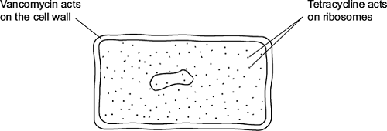

(a)     (i)      Use information in the diagram to explain why vancomycin does **not** affect human cells.

...............................................................................................................

...............................................................................................................

**(1)**

(ii)     Use information in the diagram to explain how tetracycline prevents bacterial growth.

...............................................................................................................

...............................................................................................................

**(1)**

(b)     Frequent treatment with vancomycin can result in resistant strains of bacteria. Explain how.

........................................................................................................................

........................................................................................................................

........................................................................................................................

........................................................................................................................

........................................................................................................................

........................................................................................................................

*(Extra space)* .................................................................................................

........................................................................................................................

........................................................................................................................

**(2)**

**(Total 4 marks)**

**Q34.**Phenylketonuria is a disease caused by mutations of the gene coding for the enzyme PAH. The table shows part of the DNA base sequence coding for PAH. It also shows a mutation of this sequence which leads to the production of non-functioning PAH.

|  |  |  |  |  |  |  |  |  |  |  |  |  |  |
| --- | --- | --- | --- | --- | --- | --- | --- | --- | --- | --- | --- | --- | --- |
|  | DNA base sequence coding for PAH | C | A | G | T | T | C | G | C | T | A | C | G |
|  | DNA base sequence coding for non-functioning PAH | C | A | G | T | T | C | C | C | T | A | C | G |

(a)     (i)      What is the maximum number of amino acids for which this base sequence could code?



**(1)**

(ii)     Explain how this mutation leads to the formation of non-functioning PAH.

...............................................................................................................

...............................................................................................................

...............................................................................................................

...............................................................................................................

...............................................................................................................

...............................................................................................................

(*Extra space*) ........................................................................................

...............................................................................................................

...............................................................................................................

**(3)**

PAH catalyses a reaction at the start of two enzyme-controlled pathways.  
The diagram shows these pathways.

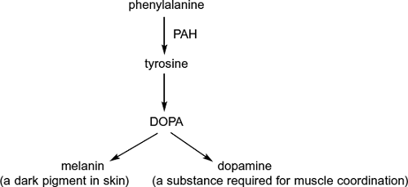

(b)     Use the information in the diagram to give **two** symptoms you might expect to be visible in a person who produces non-functioning PAH.

1 .....................................................................................................................

2 .....................................................................................................................

**(2)**

(c)     One mutation causing phenylketonuria was originally only found in one population in central Asia. It is now found in many different populations across Asia. Suggest how the spread of this mutation may have occurred.

........................................................................................................................

........................................................................................................................

........................................................................................................................

**(1)**

**Q35.**          Sugar beet is a crop grown for the sugar stored in its root. The sugar is produced by photosynthesis in the leaves of the plant. Plant breeders selected high-yielding wild beet plants. They used these plants to produce a strain of sugar beet to grow as a crop.

The drawings show a wild beet plant and a sugar beet plant. The drawings are to the same scale.

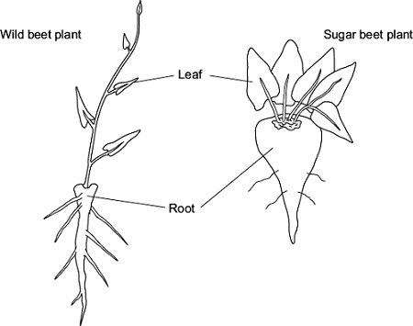

(a)     Use the drawings to describe **two** ways in which a sugar beet plant is different from a wild beet plant.

Explain how each of these differences would give an increased yield of sugar.

Difference 1 ...................................................................................................

........................................................................................................................

Explanation ....................................................................................................

........................................................................................................................

Difference 2 ...................................................................................................

........................................................................................................................

Explanation ....................................................................................................

........................................................................................................................

**(4)**

(b)     Sugar beet plants have been selected for a faster rate of growth.

Suggest how the faster rate of growth may increase profit for a farmer.

........................................................................................................................

........................................................................................................................

........................................................................................................................

**(1)**

(c)     Describe and explain how selection will have affected the genetic diversity of sugar beet.

........................................................................................................................

........................................................................................................................

........................................................................................................................

........................................................................................................................

........................................................................................................................

**(2)**

**(Total 7 marks)**

**Q36.**The Amazonian forest today contains a very high diversity of bird species.

•        Over the last 2 000 000 years, long periods of dry climate caused this forest to separate into a number of smaller forests.

•        Different plant communities developed in each of these smaller forests.

•        Each time the climate became wetter again, the smaller forests grew in size and merged to reform the Amazonian forest.

(a)     Use the information provided to explain how a very high diversity of bird species has developed in the Amazonian forest.

........................................................................................................................

........................................................................................................................

........................................................................................................................

........................................................................................................................

........................................................................................................................

........................................................................................................................

........................................................................................................................

........................................................................................................................

........................................................................................................................

........................................................................................................................

*(Extra space)*..................................................................................................

........................................................................................................................

........................................................................................................................

........................................................................................................................

........................................................................................................................

**(5)**

(b)     Speciation is far less frequent in the reformed Amazonian forest. Suggest one reason for this.

........................................................................................................................

........................................................................................................................

........................................................................................................................

**(1)**

**(Total 6 marks)**

**Q37.**To reduce the damage caused by insect pests, some farmers spray their fields of crop plants with pesticide. Many of these pesticides have been shown to cause environmental damage.

Bt plants have been genetically modified to produce a toxin that kills insect pests. The use of Bt crop plants has led to a reduction in the use of pesticides.

Scientists have found that some species of insect pest have become resistant to the toxin produced by the Bt crop plants.

The figure below shows information about the use of Bt crops and the number of species of insect pest resistant to the Bt toxin in one country.

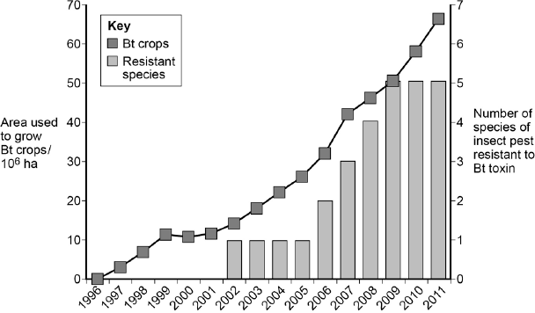  
      Year

(a)     Can you conclude that the insect pest resistant to Bt toxin found in the years 2002 to 2005 was the same insect species? Explain your answer.

........................................................................................................................

........................................................................................................................

**(1)**

(b)     One farmer stated that the increase in the use of Bt crop plants had caused a mutation in one of the insect species and that this mutation had spread to other species of insect. Was he correct? Explain your answer.

........................................................................................................................

........................................................................................................................

........................................................................................................................

........................................................................................................................

........................................................................................................................

........................................................................................................................

........................................................................................................................

........................................................................................................................

**(Extra space)** ................................................................................................

........................................................................................................................

........................................................................................................................

........................................................................................................................

**(4)**

(c)     There was a time lag between the introduction of Bt crops and the appearance of the first insect species that was resistant to the Bt toxin.  
Explain why there was a time lag.

........................................................................................................................

........................................................................................................................

........................................................................................................................

........................................................................................................................

........................................................................................................................

........................................................................................................................

**(3)**

**(Total 8 marks)**

**Q38.**The Amish are a group of people who live in America. This group was founded by 30 Swiss people, who moved to America many years ago. The Amish do not usually marry people from outside their own group.

One of the 30 Swiss founders had a genetic disorder called Ellis-van Creveld syndrome. People with this disorder have heart defects, are short and have extra fingers and toes. Ellis-van Creveld syndrome is caused by a faulty allele.

In America today, about 1 in 200 Amish people are born with Ellis-van Creveld syndrome. This disorder is very rare in people in America who are not Amish.

(a)     In America today, there are approximately 1250 Amish people who have Ellis-van Creveld syndrome. Use the information provided to calculate the current Amish population of America.

Amish population .....................................

**(1)**

(b)     The faulty allele that causes Ellis-van Creveld syndrome is the result of a mutation of a gene called *EVC.* This mutation leads to the production of a protein that has one amino acid missing.

(i)      Suggest how a mutation can lead to the production of a protein that has one amino acid missing.

...............................................................................................................

...............................................................................................................

...............................................................................................................

...............................................................................................................

...............................................................................................................

**(2)**

(ii)     Suggest how the production of a protein with one amino acid missing may lead to a genetic disorder such as Ellis-van Creveld syndrome.

...............................................................................................................

...............................................................................................................

...............................................................................................................

...............................................................................................................

...............................................................................................................

**(2)**

**(Total 5 marks)**

**Q39.**(a)     Explain how the structure of DNA is related to its functions.

........................................................................................................................

........................................................................................................................

........................................................................................................................

........................................................................................................................

........................................................................................................................

........................................................................................................................

........................................................................................................................

........................................................................................................................

........................................................................................................................

........................................................................................................................

........................................................................................................................

........................................................................................................................

*(Extra space)* ..................................................................................................

........................................................................................................................

........................................................................................................................

........................................................................................................................

........................................................................................................................

........................................................................................................................

........................................................................................................................

........................................................................................................................

........................................................................................................................

........................................................................................................................

........................................................................................................................

**(6)**

Scientists investigated three genes, **C**, **D** and **E**, involved in controlling cell division.  
They studied the effect of mutations in these genes on the risk of developing lung cancer.

The scientists analysed genes **C**, **D** and **E** from healthy people and people with lung cancer.

•        If a person had a normal allele for a gene, they used the symbol N.

•        If a person had two mutant alleles for a gene, they used the symbol M.

They used their data to calculate the risk of developing lung cancer for people with different combinations of N and M alleles of the genes. A risk value of 1.00 indicates no increased risk. The following table shows the scientists’ results.

|  |  |  |  |  |
| --- | --- | --- | --- | --- |
|  | **Gene C** | **Gene D** | **Gene E** | **Risk of developing lung cancer** |
|  | N | N | N | 1.00 |
|  | M | N | N | 1.30 |
|  | N | N | M | 1.78 |
|  | N | M | N | 1.45 |
|  | N = at least one copy of the normal allele is present M = two copies of the mutant allele are present | | | |

(b)     What do these data suggest about the relative importance of the mutant alleles of genes **C**, **D** and **E** on **increasing** the risk of developing lung cancer? Explain your answer.

........................................................................................................................

........................................................................................................................

........................................................................................................................

........................................................................................................................

........................................................................................................................

........................................................................................................................

........................................................................................................................

**(3)**

Chemotherapy is the use of a drug to treat cancer. The drug kills dividing cells.  
The figure below shows the number of healthy cells and cancer cells in the blood of a patient receiving chemotherapy. The arrows labelled **F** to **I** show when the drug was given to the patient.

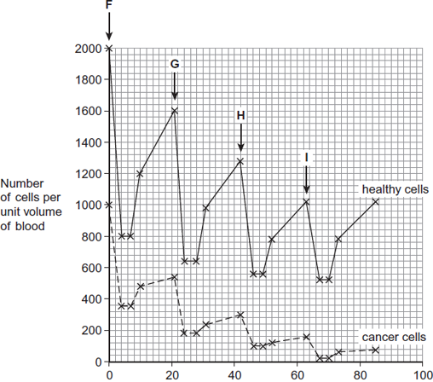  
                                    Time / days

(c)     Calculate the rate at which healthy cells were killed between days 42 and 46.

.............. cells killed per unit volume of blood per day

**(1)**

(d)     Describe similarities and differences in the response of healthy cells and cancer cells to the drug between times **F** and **G**.

........................................................................................................................

........................................................................................................................

........................................................................................................................

........................................................................................................................

........................................................................................................................

........................................................................................................................

*(Extra space)* .................................................................................................

........................................................................................................................

........................................................................................................................

**(3)**

(e)     More cancer cells could be destroyed if the drug was given more frequently.

Suggest why the drug was **not** given more frequently.

........................................................................................................................

........................................................................................................................

........................................................................................................................

........................................................................................................................

**(2)**

**(Total 15 marks)**

**Q40.**Malaria is a disease that is spread by insects called mosquitoes. In Africa, DDT is a pesticide used to kill mosquitoes, to try to control the spread of malaria.

Mosquitoes have a gene called *KDR*. Today, some mosquitoes have an allele of this gene, *KDR minus*, that gives them resistance to DDT. The other allele, *KDR plus*, does not give resistance.

Scientists investigated the frequency of the *KDR minus* allele in a population of mosquitoes in an African country over a period of 10 years.

The figure below shows the scientists’ results.

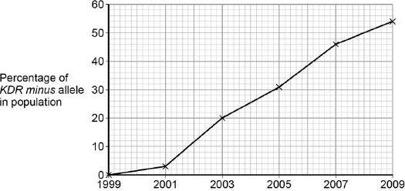

          Year

(a)     Use the Hardy–Weinberg equation to calculate the frequency of mosquitoes heterozygous for the *KDR* gene in this population in 2003.

Show your working.

Frequency of heterozygotes in population in 2003 ...................................

**(2)**

(b)     Suggest an explanation for the results in the figure above.

........................................................................................................................

........................................................................................................................

........................................................................................................................

........................................................................................................................

........................................................................................................................

........................................................................................................................

........................................................................................................................

........................................................................................................................

**(Extra space)** ................................................................................................

........................................................................................................................

........................................................................................................................

........................................................................................................................

........................................................................................................................

**(4)**

The *KDR plus* allele codes for the sodium ion channels found in neurones.

(c)     When DDT binds to a sodium ion channel, the channel remains open all the time.  
Use this information to suggest how DDT kills insects.

........................................................................................................................

........................................................................................................................

........................................................................................................................

........................................................................................................................

**(2)**

(d)     Suggest how the *KDR minus* allele gives resistance to DDT.

........................................................................................................................

........................................................................................................................

........................................................................................................................

........................................................................................................................

**(2)**

**(Total 10 marks)**

**Q41.Table 1** shows how a bird called the bluethroat (*Luscinia svecica*) is classified by biologists.

**Table 1**

|  |  |  |
| --- | --- | --- |
|  | **Taxon** | **Name of taxon** |
|  | Domain | Eukaryota |
|  |  | Animalia |
|  |  | Chordata |
|  |  | Aves |
|  |  | Passeriformes |
|  |  | Muscicapidae |
|  | Genus |  |
|  | Species |  |

(a)     Complete **Table 1** by filling the seven blank spaces with the correct terms.

**(2)**

A group of scientists investigated genetic diversity in different species of bird. For each species, the scientists:

•        collected feathers from a large number of birds

•        extracted DNA from cells attached to each feather

•        analysed the samples of DNA to find genetic diversity.

**Table 2** summarises their results.

**Table 2**

|  |  |  |  |
| --- | --- | --- | --- |
|  | **Species of bird** | **Number of genes  examined** | **Number of genes  examined that showed genetic diversity** |
|  | Willow flycatcher | 708 | 197 |
|  | House finch | 269 | 80 |
|  | Bluethroat | 232 | 81 |

(b)     In this investigation, what is meant by **genetic diversity?**

........................................................................................................................

........................................................................................................................

**(1)**

(c)     The scientists concluded that the bluethroat showed greater genetic diversity than the willow flycatcher. Explain why they reached this conclusion. Use calculations to support your answer.

........................................................................................................................

........................................................................................................................

........................................................................................................................

........................................................................................................................

**(2)**

**(Total 5 marks)**

**M1.**          (a)     (i)     Continuous variation – range of values / not discrete categories / many  
categories / no gaps;

**1**

(ii)     Crossing over / chiasmata;  
Random segregation / independent assortment;  
In meiosis I and meiosis II;

**max 2**

(b)     Range influenced by single ‘outlier’ (*accept anomaly*) /   
converse for S.D.;  
S.D. shows dispersion / spread about mean / range only shows highest  
and lowest values / extremes;  
Or  
S.D. allows statistical use;  
Tests whether or not differences are significant;

**max 2**

**[4]**

**M2.**          (a)     zooplankton nearer surface at night;

algae only found at surface;

photosynthetic;

no / little light below 30 / 40m;

**3**

(b)     (i)      with increasing time predators have been present in the lake, the

greater the depth at which the zooplankton occur during the day;

**1**

(ii)     variation in migration behaviour;

vertical migration reduces chance of predation / prey can’t be seen in

low light intensity;

those that migrated more likely to reproduce;

genes / alleles (for behaviour) passed to next generation;

increase in frequency of gene / allele in population;

**3 max**

**[7]**

**M3.**          (a)     generation of random co-ordinates;  
use of 10 or more quadrats;  
collection of all dog whelks in quadrat;

**3**

(b)     greater variation for sheltered population / population A;  
range / spread around the mean;

*(or converse)*

**2**

(c)     (i)      smaller ratio means relatively larger foot / population B has  
relatively large foot;  
better able to grip;  
larger / longer shells have greater area exposed / are subject  
to greater force;

(ii)     wave action limits the max. L / A ratio / extremes;  
valid point about age, e.g. greater age range on sheltered  
shore / live longer on sheltered shore;

*(allow shell size marking point in either (c)(i)  
or (c)(ii) but only credit once)*

**4 max**

**[9]**

**M4.**          (a)     Hydrolysis;

*Accept breaking of peptide bonds*

**1**

(b)     Adding fluorine changes shape/different shape from other proteins;Do not fit active site (of protease);Induced fit not produced;

**2 max**

(c)     (i)      Suitable example;e.g. Flaming spreader/ use lid of Petri dish as umbrella/ clean  
bench with disinfectant/ sterilise agar in autoclave;

*Ignore references to wearing gloves, unless suitably qualified and unqualified references to ‘clean‘*

**1**

(ii)     All the AMPs killed/inhibited the bacteria/AMPs with fluorine more  
effective than frog AMP;Not All fluorine AMPs are equally effective;Diameter/area of clear zone indicates effectiveness;Only used one kind of bacterium/need to repeat using other bacteria;Need to repeat the investigation/only one plate used;Credit suitable measurements or calculations;

**3 max**

**[7]**

**M5.**          (a)     To sterilise/kill bacteria;  
So that only one kind of bacteria present on agar plate/to prevent contamination  
(by bacteria);

**2**

(b)     Clear zone / inhibition zone is where bacteria have not grown/been inhibited/killed;Antibiotic diffuses out of paper disc/into agar;Bacterium **A** inhibited/killed by tetracycline/tetracycline has little effect on  
bacterium **B**;Bacterium **B** inhibited/killed by penicillin/bacterium **A** resistant to penicillin;Both kinds of bacteria resistant to streptomycin;

***Q*** *Ignore references to ‘immune’*

**4 max**

**[6]**

**M6.**          (a)     description of interspecific competition / competition between species / birds with beaks of different lengths;  
link length of beaks to different positions of prey / reference to named bird with particular prey e.g. curlews with longer beaks able to feed on ragworms;

**2**

(b)     variation in beak length in curlews / one species;  
longer / more curved beaked curlews outcompete / at advantage /   
suggested advantage e.g. larger / curled beaks access more food;  
reproduction;  
genes passed on (to offspring);

**4**

(c)     body has lower water potential;  
water diffuses along a water potential gradient / by osmosis;

**2**

**[8]**

**M7.**          (a)     sections of chromatids exchanged;  
sections have different alleles;  
new combinations of (linked) alleles;

*(allow 1 mark for idea that ‘genes’ are exchanged,  
if no other marks gained)*

**3**

(b)     (i)      length controlled by many genes / polygenes;  
each gene may have different alleles / idea of additive effects;  
OR  
environmental factors / or named factor;  
how named factor may affect growth of seeds;

**2 max**

(ii)     1.      selection of large seeds for sowing;

2.      higher proportion of alleles for long length / loss of alleles for short seeds from population;

3.      (possible appearance of) new alleles through mutation;

4.      process repeated over many generations;

*(G - allow 1 mark idea for that ‘largeness’ selected, survives and inherited)*

**4**

**[9]**

**QWC 1**

**M8.**          (a)     Tapes / string / axes laid out at right angles / grid area;  
Method of obtaining random co-ordinates;  
*Do not allow “Use random number generator”*

**2**

(b)     (i)      Decrease then remain constant;  
From 200 cm / over 150 cm;

**2**

(ii)     Oxygen decreasing because soil becomes more compacted / not  
replaced;  
Decrease in oxygen leads to fewer aerobes surviving;

**2**

(c)     Anaerobic bacteria replace aerobic as oxygen decreased by aerobic bacteria;  
Remove competition;  
Aerobic bacteria no longer able to survive in these conditions;

**3**

(d)     (i)      Near the surface / in top 50 cm;  
Table shows decrease with time at greater depths;

**2**

(ii)     Decrease;  
Fewer aerobic bacteria with depth;  
Oxygen concentration decreases / less oxygen at depth;

**3**

(e)     Probability greater than 95% / 0.95;  
Results are not due to chance / results are significant;  
Because bars do not overlap;

**3**

(f)      Plot as graph;  
Draw line of best fit;  
Read off appropriate value;

**3**

**[20]**

**M9.**          (a)     lower enzyme activity;

decrease in rate of photosynthesis so less carbohydrate formed / named carbohydrate / lower translocation of sucrose / to growing point;  
lower respiration;  
lower rate of nutrient uptake / protein synthesis / cell division;

**4**

(b)     (i)      differ in height when plants from different altitudes grown   
in same environment;

**1**

(ii)     plants from 1500 / 3000m differ in height when grown at different

altitudes;

**1**

**[6]**

**M10.**          (a)     breed together;

if fertile offspring, then same species;

**2**

(b)     isolation of two populations;

variation already present due to mutations;

different environmental conditions / selection pressures leading to  
selection of different features and hence different alleles;

different frequency of alleles;

separate gene pools / no interbreeding;

**4**

(c)     selection of mate dependent on colour pattern;

prevents interbreeding / keeps gene pools separate;

**2**

**[8]**

**M11.**          (a)     greater environmental influence than genetic;

**1**

(b)     identical twins have same genotype / converse for non-identical;  
compare identical and non-identical twins / identical twins who  
have been separated / non-identical twins in same environment;  
if genetic - similarity between identical twins / converse;  
large sample required / use a statistical test;

**4**

**[5]**

**M12.**          (a)     (i)      EITHER:     Correct answer: 3.45 / 3.44 / 3.4            = 2 marks  
OR:            Understanding of ∑n(n-1) / use of  
                   134 / (2 + 90 + 12 + 30)  
                   + wrong answer                                      = 1 mark

**max 2**

(ii)     Takes account of number of individuals / abundance /   
population size (as well as number of species);

**1**

(b)     The species at A /  *F.spiralis* loses less water /   
loses water less rapidly / loses less mass;

The species at A / *F.spiralis* better adapted to / can survive where   
exposed for longer / to drier conditions;

The species at A / *F.spiralis* avoids competition For named aspect  
– e.g. light / substratum / space / CO2;

*ACCEPT converse argument re. F. serratus*

**3**

**[6]**

**M13.**          (a)     mitosis;

genetically / genes / genotype identical;

*(reject same genes)*

*(ignore references to asexual reproduction)*

**2**

(b)     (different)  
environmental conditions / named environmental factor / mutation;

**1**

(c)     dispersal / prevent overcrowding / competition / colonise ;

increased number of (proven) offspring; *(not quicker)*

**2**

**[5]**

**M14.**          (a)     (i)      to ensure that no unwanted bacteria will be present;

**1**

(ii)     to check that bacteria cells do not die anyway / to show  
water / solvent has no effect on growth;

**1**

(b)     some bacteria are resistant / some areas of dish have no antibiotic /   
antibiotic not spread evenly;

**1**

**[3]**

**M15.**         (a)     1.      Occurs in an unchanging environment;

**1**

+

2.      Selection against extremes / selection for the mean / mean / median / mode unaltered

3.      Range / S.D is reduced

4.      Increasing proportion of populations becomes well adapted to environment;

**4**

(b)     1.      All plants are acyanogenic below –4 °C and (most) cyanogenic above +10 °C;

2.      Cyanogenic plants’ cells freeze below –4°;

3.      Releasing cyanide (into their own tissues) / damaging / killing plants / disrupting metabolism;

4.      Selective advantage not to produce cyanide at –4 °C;

5.      Slugs present at higher temperatures / not usually present / inactive at lower temperatures and cyanide production kills / deters slugs;

**5**

**[10]**

**M16.**(a)      1.      Change / mutation in base / nucleotide sequence (of DNA / gene);

*Q.*

*Ignore: references to changing base-pairing*

*Accept: affect for change, if in correct context*

*Accept: changes triplets / codons*

2.      Change in amino acid sequence / primary structure (of enzyme);

*Accept: different amino acid(s) coded for*

***Q*** *Reject: different amino acids produced / formed / made*

3.      Change in hydrogen / ionic / disulfide bonds;

*Accept: references to sulfur bonds*

4.      Change in the tertiary structure / shape;

*Neutral: alters 3D structure / 3D shape*

5.      Change in active site;

6.      Substrate not complementary / cannot bind (to enzyme / active site) / no enzyme-substrate complexes form.

*Accept: no E S complexes form*

**6**

(b)     1.      Non-SR strain falls more / SR strain falls less / up to 10(μg / cm−3);

*Must include 10 but only required once in either MP1 or MP2*

*Ignore: units or absence of*

*This must be a comparative statement*

2.      Above 10(μg / cm−3), SR strain levels out / off and non-SR strain continues to decrease;

3.      Greater difference between strains with increasing concentration of antibiotic.

*This must be a comparative statement*

**2 max**

(c)     1.      Division stopped (of both strains by scientist);

*Reject: references to mitosis stopping*

2.      SR strain still more resistant / fewer die / none die (at higher concentrations of antibiotic).

*Accept: SR strain and non-SR strain would be similar if resistance is due to only stopping division*

*Need some comparison with non-SR*

**2**

(d)     1.      Make a competitive / non-competitive inhibitor;

*Mark in pairs*

*either MP1 and MP2 OR MP3 and MP4*

2.      Competitive competes with / blocks active site / non-competitive inhibitor affects / changes active site;

*Do not mix and match*

OR

3.      (Make a drug) that inhibits / denatures / destroys enzyme / stringent response;

*Accept: drug that ‘knocks out’ / destroys enzyme*

4.      Give at the same time as / before an antibiotic.

**2 max**

(e)     (SR strain)

1.      Fewer free radicals (than non-SR);

*Note: has to be comparative statement*

2.      Produces more catalase (than non-SR);

*Accept converse statements for non-SR.*

3.      Catalase (might be) linked to production of fewer free radicals / breaking down / removing free radicals.

*Accept: hydrolysis of radicals by catalase.*

**3**

**[15]**

**M17.**          (a)     1. frequent use of antibiotic creates selection pressure / antibiotic kills bacteria;  
2. bacteria with mutation / resistance have (selective) advantage over others / described;  
3. (survive to) reproduce more than other types pass on advantageous allele / mutated allele in greater numbers;  
4. frequency of (advantageous) allele increases in subsequent generations;

*(penalise use of “gene” instead of allele once only)*

5. frequency of resistant types increases in subsequent generations;

**5**

(b)     correct answer = 0.18;  
And three marks for three of:  
p + q = 1 and p2 + 2pq + q2 = 1;  
0.01 = q2 ;  
q = 0.1;  
p = 0.9  
frequency of heterozygotes = 2pq = 2 × 0.1 × 0.9 / 2 × candidates  
p × candidates q;

**4 max**

**[9]**

**M18.**(a)     Shows trend of mean temperature rise;  
Higher temperatures more frequent since 1984 (in January and February);  
Considerable variation in temperature from year to year;  
Which may be due to chance;

*No mark for yes or no Do not penalise candidates who state there is no trend*

**2 max**

(b)     Construct null nypothesis;  
Use Spearman rank (and calculate test statistic);  
Look up in table (to find critical value of P = 0.05 / 5 %);  
Use figure (in table) to accept or reject null hypothesis;

**3 max**

(c)     (i)      (Particular daylength) always occurs at same time of year / valid example;  
Birds do not start laying eggs when period of warm weather occurs early in year;  
Synchronises breeding behaviour;  
Sufficient foraging time for food collection for young;

**2 max**

(ii)     Birds able to respond to changing climate;  
Food availability (mainly) determined by temperature;  
As insect / invertebrate development temperature-dependent;

**2 max**

(d)     A correlation does not indicate a causal relationship;  
As may be due to another factor / named factor;

**2**

(e)     Visits could be up to 5 days apart;  
Date of egg-laying may be inaccurate by 5+ days;

**2**

**[13]**

**M19.**          (a)     Excitation of chlorophyll molecule / electrons / energy of (pairs of)  
electrons raised to higher energy level;

Electron(s) emitted from chlorophyll molecule;

Electron(s) to electron transport chain;

Loss of energy by electron(s) along electron transport chain;

Energy lost by electron(s) is used to synthesise ATP;

From ADP + Pi;

*“By electrons” need not be stated in each marking point if it can be reasonably inferred that the candidate is referring to electrons*

**max 5**

(b)     Little green light reaches bottom as absorbed by surface dwellers / water;  
Red and blue not absorbed and so penetrate;  
Variation in pigments of sediment dwellers;  
Bacteria with chlorophyll at an advantage as chlorophyll absorbs red and blue;  
(Survive to) reproduce in greater numbers and pass on advantageous   
alleles / genes in greater numbers / increase in frequency of advantageous  
alleles in subsequent generations;  
Increase in frequency / numbers of bacteria with chlorophyll;

**6**

**[11]**

**M20.**          (a)     Recognition of same species;

Stimulates release of gametes;

Recognition of mate / opposite gender;

Indication of sexual maturity / fertility;

**2 max**

(b)     (i)      Internal fertilisation / fertilisation occurs in pouch / limited area;

***Q*** *The term fertilisation is not required in the answer but must be implied.*

**1**

(ii)     Protection from predators (developing in pouch);

**1**

(c)     (i)      Less stress caused to seahorse / quicker / more accurate method / body is curved / head is linear;

***Q*** *Do not accept “easier” unless qualified.*

**1**

(ii)     Head length proportional to body length / or described;

**1**

(d)     Positive correlation between head / body lengths of male and female / female and male with similar head / body lengths pair together;

**1**

(e)     Use line of best fit;

And extrapolate / extend line as required;

**2**

(f)      (Compare) DNA;

Sequence of bases / nucleotides;

Compare same / named protein;

Sequence of amino acids / primary structure;

Immunological evidence – not a mark

Inject (seahorse) protein / serum into animal;

(Obtain) antibodies / serum;

Add protein / serum / plasma from other (seahorse) species;

Amount of precipitate indicates relationship;

***Q*** *The marks awarded for reference to DNA and sequence of bases / nucleotides must be in a different context to DNA hybridisation.*

**6 max**

**[15]**

**M21.**          (a)     group of organisms with similar features;  
can (interbreed to) produce fertile offspring;

**2**

(b)     directional selection;   
*any TWO from*selection against one extreme / for one extreme;  
against broadest beaks in B and narrowest beaks  
in **A** / for narrowest in **B** and broadest in **A**;  
whole distribution / range / mean / mode / median is  
shifted towards favoured extreme;

**3 max**

**[5]**

**M22.**(a)      PKNJ.

**1**

(b)     *Lutra lutra.*

**1**

(c)     Bone / skin / preserved remains / museums.

**1**

(d)     1.      (Hunting) reduced population size(s), so (much) only few alleles left;

*Accept bottleneck*

2.      Otters today from one / few surviving population(s);

*Accept founder effect*

3.      Inbreeding.

*Allow any* ***two***

**2 max**

(e)     1.      Population might have been very small / genetic bottleneck;

2.      Population might have started with small number of individuals / by one pregnant female / founder effect;

3.      Inbreeding.

*Allow any* ***two***

**2 max**

**[7]**

**M23.**          (a)     (i)      Faster / greater / more effective response in children;

*Do not accept children have more haemoglobin*

**1**

(ii)     Use line of best fit;

**1**

Extrapolate / extend line (and read from graph);

*Allow calculation using rate of increase per day = one mark.  
However for both marks this must be linked to line of best fit.*

**1**

(iii)    More than one polypeptide chain;

*Allow many polypeptide chains.*

*‘Haemoglobin has four polypeptide chains’ must be in correct context to gain mark.*

**1**

(b)     (i)      Has same water potential;

*Allow converse for effect of using distilled water or a concentrated solution.*

**1**

No (net) water movement / osmosis;

**1**

Cells will not swell / burst / change size;

*No osmotic lysis = two marks*

**1**

(ii)     Pernicious anaemia (cells) greater range / spread / variation of diameters / widths;

Some pernicious anaemia (cells) wider than 9 (µm) / some  
less than 5.5 (µm) / without pernicious anaemia none more than 9 (µm) / none less than 5.5 (µm);

Pernicious anaemia (cells) peak / most frequent at 8.5 (µm) / peak / most frequent at higher diameter / / without pernicious anaemia peak / most frequent at 7 (µm) / peaks at lower diameter;

*There are several alternatives for marking points 2 and 3*

**2 max**

**[9]**

**M24.**          (a)     Isolation / quarantine / ‘kept separate’;

Screening / testing (of patients / doctors etc);

Sterilisation of wards / equipment / method to improve hygiene;

*Do not allow improve ‘hygiene’ or ‘cleanliness’ without named example such as ‘washing hands’ use of gloves etc.*

**2 max**

(b)     May not all be absorbed;

May be broken down / metabolised / excreted quickly;

To kill the microorganisms / bacteria;

Reference to antibiotic resistance;

*Reference to becoming ‘immune’ negates last marking point.*

**2 max**

(c)     (i)      P;

**1**

(ii)     S;

**1**

(d)     (i)      Prevents bias;

Vested interest (of scientists);

Prevents ‘placebo’ / positive / negative / psychological effects / ‘demand characteristics’ (in volunteers);

**2 max**

(ii)     Age;

Ethnicity;

Lifestyle;

Body mass;

Health;

Sex of person;

*Ignore references to same or different*

**2 max**

(e)     Gradual / slight increase followed by rapid / greater increase;

*Allow more detailed descriptions which describe similar trend of gradual increase followed by rapid increase.*

**1**

**[11]**

**M25.**          (a)     **Shape**

1.      Different penicillin has different shape / structure / enzyme / active site has specific shape / structure;

*Not different*

**Binding**

2.      No longer fits / binds to active site / not complementary to active site / does not form E-S complex;

**Consequence**

3.      (Different) penicillin not broken down;

**3**

(b)     (i)      1.      Kills pathogenic / harmful bacteria / pathogens;

2.      Disease less likely / improves health / animals healthier / reduces spread of infection;

3.      Faster growth / more productive animals / more food converted to meat / greater survival / lower vet’s bills / increased yield / less energy (for “fighting infection”);

*Principles:*

*Action of antibiotic. Do not accept stops all disease*

*Action on health*

*Effect on production*

**2 max**

(ii)     1.      (Adding antibiotics) selects in favour of antibiotic resistance / resistant bacteria more likely to survive;

2.      Increase in numbers / higher proportion of resistant bacteria;

*Penalise immune only on the first occasion it occurs in this part of the question.*

**2**

**[7]**

**M26.**          (a)     (So results) can be compared / so measurement is the same each time / because eye is not perfectly round / uniform;

*Accept eye opens to different amounts*

**1**

(b)     (i)      1.      Eye (diameter) is smaller and antennae longer;

2.      Antennae detecting touch;

3.      Data only refers to shrimps / data may not apply to all animals / only in one area;

*The principle here is that candidate has recognised that both features confirm suggestion. Exact wording does not matter.*

**2 max**

(ii)     1.      Standard deviation gives a measure of spread / variation;

2.      More standard deviations overlap, the less likely it is that differences are real / significant / the more likely they are caused by chance;

*Do not accept range*

*Accept converse.*

*Although we are looking for the idea of significance, we cannot require this term.*

**2**

(c)     (i)      Qualitative statement about

          difference in size /

          difference in variation /

          overlap in size;

Quantitative statement about

          difference in size /

          difference in variation /

          overlap in size;

Supported by relevant two sets of figures from graph;;

*Note simplistic answer involving a quantitative statement gains 1 mark.*

*More specific answer involving quantitative information gains 2 marks.*

**2**

(ii)     (No) for same body length, antenna are longer / antenna are shorter / some with longer body have short antennae / some with shorter body length have longer antennae;

***OR***

(Yes) positive correlation in open / in cave;

*Habitat not critical as a term.*

*Must refer to idea of same habitat*

*Accept description*

**1**

(d)     More alleles of each gene / shrimps in open have all the alleles;

*Candidates are required to use the information from the table. Must therefore refer to alleles.*

**1**

(e)     1.      A small number of shrimps were / went into the cave;

2.      All / high proportion of shrimps had allele L;

3.      Cave population descended from these / these reproduce;

**3**

(f)      (i)      1.      Cross shrimps from two sites / watch courtship;

2.      Breed young together / observe mating;

3.      Allow 1 mark for any method of improving quality of results e.g. carry out reciprocal crosses / large number of crosses / isolate beforehand;

*Other valid equivalent suggestions should be accepted.*

(ii)     If same species the shrimps would breed, producing fertile young / courtship species specific;

*Accept any form of evidence – mating / laying eggs / giving birth to young.*

**3**

**[15]**

**M27.**          (a)     (i)      Antibiotics kill other bacteria / *Clostridium* is resistant;

Less / no competition so (*Clostridium*)  
reproduces / replicates / multiplies / increases in number;

*Reference to bacteria being ‘immune’ negates first marking point.*

*Reference to mitosis negates second marking point.*

**2**

(ii)     Immune system less effective / more likely to have other  
infections / been in hospital;

*Accept: ‘Weak / lower’ immune system’.*

**1**

(b)     Attaches to active site (of enzyme);  
(Methicillin) is a competitive inhibitor / prevents monomers / substrate  
attaching (to enzyme);

*‘Competes for active site’ = 2 marks.*

*Neutral: ‘Prevents monomers joining / attaching to each other’.*

*Allow one mark max for answers relating to non-competitive inhibitor changing active site / preventing substrate attaching.*

*Do not penalise Methicillin forms an enzyme / substrate complex.*

**2**

(c)     (i)      Have other illness / medical condition / ’weak’ immune system / disease / infection;

*Reject: Due to ‘other factors’, ‘are smokers’, ‘are obese’ unless related to disease or illness.*

**1**

(ii)     Increase up to 2006 / 20 (per 100 000) then decreases;

**1**

(iii)     Correct answer in range of 52 – 59.1% = two marks;

Incorrect answer but shows change as between 4.8 – 5.2 / shows  
correct subtraction giving this change e.g. 14 – 9 = one mark.

**2**

**[9]**

**M28.**          (a)     (i)      22;

**1**

(ii)     1.      Odd number of chromosomes / 33 chromosomes (in leaf cell);

2.      Chromosomes cannot pair / cannot undergo meiosis / would result in half chromosomes / cannot form haploid cells;

**2**

(b)     (i)      Fast growth / produces crop fast / produces large crop;

*Do not insist on relative statement.*

*Accept similar terms for fast. E.g. “better” growth*

*Do not accept unqualified references to profit.*

**1**

(ii)     Leaves less likely to break / higher breaking strength;

**1**

(c)     Low genetic diversity because they are produced by mitosis;

Will all have the same DNA / genes / alleles / will be genetically identical / will be clones;

***OR***

Low genetic diversity because they are not produced by meiosis;

No crossing over / independent segregation / will not be genetically different;

*Independent segregation is the specification term. Accept other such as random assortment.*

**2**

**[7]**

**M29.**(a)     Same number of ryegrass seedlings in distilled water;

**1**

(b)     (i)      Produce null hypothesis;

Carry out Spearman Rank correlation test / find correlation coefficient;

Use values to show P < critical value / find probability of results being due to chance;

*Accept valid example*

*E.g. There is no correlation between inhibition of germination and the concentration of the extract.*

**2 max**

(ii)     May be another factor / named factor (that also inhibits germination);

*e.g. amount of water in extract*

**1**

(c)     (i)      Extract inhibits ryegrass germination / extract stops ryegrass starting to grow;

Inhibition of root length / causes ryegrass to have shorter roots;

**2**

(ii)     Scientists crushed plants to get extract;

Plants might not secrete substances in the extract into the soil;

These substances might get broken down in the soil;

Wheat and ryegrass might not grow at the same time / wheat plants might not produce substance when ryegrass is growing;

Concentration of extract in the soil might be different from that in solution;

**3 max**

**[9]**

**M30.**(a)     Banding pattern changes as cheetah gets older / difficult to judge as tail is short / fluffy;

**1**

(b)     (i)      Mean not (always) a whole number;  
Standard deviation not (always) zero;

**2**

(ii)     Movement of tail / angle of sight / confused it with another band / subjective estimation;

*Accept reference to* ***Figure 1***

*E.g. Bands 2 and 3 have same thickness but look different*

**1**

(c)     Band width not the same on both sides of tail;

**1**

(d)     Offspring of the same family will be more similar genetically;  
As have same mother (and father) / parent;  
Expect to see more differences in randomly chosen cheetahs;

**3**

**[8]**

**M31.**          (a)     Difference in DNA / base sequence / difference in alleles / genes / gene pool;

*Neutral: ‘fewer alleles’ unless qualified e.g. fewer different alleles.*

**1**

(b)     Environmental;

*Accept: Environment*

**1**

(c)     Reduced (genetic diversity);

As fewer different / varied alleles / genes / reduced gene pool;

**2**

**[4]**

**M32.**(a)     (i)      (We should maintain biodiversity to)

*Prevent extinction / loss of populations / reduction in populations / loss of habitats / save organisms for future generations (idea of);*

*Neutral: references to ‘playing God’ / animal rights*

**1**

(ii)     A suitable example of how some species may be important financially e.g.

1.      medical / pharmaceutical uses;

2.      commercial products / example given;

3.      tourism;

4.      agriculture;

5.      saving local forest communities;

**1 max**

(b)     1.      Fewer plant species / decrease in plant diversity;

*Accept: converse arguments for islands with a high percentage of forest remaining*

*1. Neutral: fewer plants*

2.      Fewer habitats nesting sites / niches / food sources / varieties / less protection from predators / hunters / environment;

*2. Neutral: fewer homes*

*2. Neutral: less food*

**2**

(c)     1.      Number of (individuals / birds of) each species;

*1. Neutral: number of species*

2.      Total number of individuals / birds of all species;

*2. Accept: ‘total number of birds’ as given context for ‘all species’ in the investigation*

**2**

(d)     1.      (Larger birds have) a low(er) SA:VOL;

*Neutral: reference to fat / feathers*

2.      (So) less heat loss / more heat retained;

*MP2 is independent of MP1*

**2**

**[8]**

**M33.**(a)     (i)      (Human cells) don't have a cell wall;

*Accept "they" refers to human cells.*

**1**

(ii)     (Affects) protein synthesis;

*Allow description e.g. 'amino acids not joined together / translation.*

*Reject: affects transcription.*

**1**

(b)     1.      Mutation present / occurs;

*Ignore antibiotic causes mutation.*

2.      Resistance gene / allele;

*1. or 2.*

*Reference to immunity disqualifies first credited marking point.*

3.      Resistant bacteria (survive and) reproduce;

*Reference to mitosis negates marking point 3.*

**2**

**[4]**

**M34.**(a)     (i)      4;

**1**

(ii)     1.      Change in amino acid / (sequence of) amino acids / primary structure;

*1. Reject = different amino acids are 'formed'*

2.      Change in hydrogen / ionic / disulphide bonds alters tertiary structure / active site (of enzyme);

*2. Alters 3D structure on its own is not enough for this marking point.*

3.      Substrate not complementary / cannot bind (to enzyme / active site) / no enzyme- substrate complexes form;

**3**

(b)     1.      Lack of skin pigment / pale / light skin / albino;

2.      Lack of coordination / muscles action affected;

**2 max**

(c)     Founder effect / colonies split off / migration / interbreeding;

*Allow description of interbreeding e.g. reproduction between individuals from different populations*

**1**

**[7]**

**M35.**          (a)     2 of the following pairs:

*Mark for explanation must be paired with correct change in structure*

1.      Larger leaves;

2.      Photosynthesis;

***OR***

*Accept converse descriptions of leaves, root and stem: longer root, taller stem, smaller leaves*

3.      Larger / bigger / thicker root;

4.      Storage;

***OR***

5.      Stem shorter / absent;

*Accept converse correct explanation*

6.      Less energy used in stem growth / more energy for producing sugar;

**4 max**

(b)     Beet ready quicker / less time required / allows land to be used again / harvested earlier;

*Allow more crops / many harvests. Ignore references to yield / profit*

**1**

(c)     1.      (Diversity) reduced / fewer different alleles / less variation / smaller gene pool;

2.      As alleles have been chosen / rejected;

**2**

**[7]**

**M36.**(a)     1.      No interbreeding / gene pools are separate / geographic(al) isolation;

*Accept: all marks if answer written in context of producing increased diversity of plants*

*1 Do not award this mark in context of new species being formed and then not interbreeding*

*1 Accept reproductive isolation as an alternative to no interbreeding*

2.      Mutation;

*2 Accept: genetic variation*

3.      Different selection pressures / different foods / niches / habitats;

*3 Accept: different environment / biotic / abiotic conditions or named condition*

*3 Neutral: different climates*

4.      Adapted organisms survive and breed / differential reproductive success;

5.      Change / increase in allele frequency / frequencies;

**5**

(b)     Similar / same environmental / abiotic / biotic factors / similar / same selection pressures / no isolation / gene flow can occur (within a species);

*Accept: same environment*

**1**

**[6]**

**M37.**(a)     (No – no mark)

Graph / bar chart only shows number of species, not the name of the species.

**1**

(b)     (No – no mark)

1.      Mutations are spontaneous / random;

2.      Only the rate of mutation is affected by environment;

3.      Different species do not interbreed / do not produce fertile offspring;

4.      So mutation / gene / allele cannot be passed from one species to another.

*Ignore references to correlation does not prove causation*

**4**

(c)     1.      Initially one / few insects with favourable mutation / allele;

2.      Individuals with (favourable) mutation / allele will have more offspring;

3.      Takes many generations for (favourable) mutation / allele to become the most common allele (of this gene).

**3**

**[8]**

**M38.**(a)     250 000;

**1**

(b)     (i)      Loss of 3 bases / triplet = 2 marks;;

*‘Stop codon / code formed’ = 1 mark max unless related to the last amino acid*

Loss of base(s) = 1 mark;

*eg triplet for last amino acid is changed to a stop codon / code = 2 marks*

*3 bases / triplet forms an intron = 2 marks*

*Accept: descriptions for ‘intron’ eg non-coding DNA*

*‘Loss of codon’ = 2 marks*

**2**

(ii)     1.      Change in tertiary structure / active site;

*Neutral: change in 3D shape / structure*

2.      (So) faulty / non-functional protein / enzyme;

*Accept: reference to examples of loss of function eg fewer E-S complexes formed*

**2**

**[5]**

**M39.**(a)     1.      Sugar-phosphate (backbone) / double stranded / helix **so** provides strength / stability / protects bases / protects hydrogen bonds;

*Must be a direct link / obvious to get the mark*

*Neutral: reference to histones*

2.      Long / large molecule **so** can store lots of information;

3.      Helix / coiled **so** compact;

*Accept: can store in a small amount of space for ‘compact’*

4.      Base sequence allows information to be stored / base sequence codes for amino acids / protein;

*Accept: base sequence allows transcription*

5.      Double stranded **so** replication can occur semi-conservatively / strands can act as templates / complementary base pairing / A-T and G-C so accurate replication / identical copies can be made;

6.      (Weak) hydrogen bonds **for** replication / unzipping / strand separation / many hydrogen bonds **so** stable / strong;

*Accept: 'H-bonds' for ‘hydrogen bonds’*

**6**

(b)     1.      (Mutation) in **E** produces highest risk / 1.78;

2.      (Mutation) in **D** produces next highest risk / 1.45;

3.      (Mutation) in **C** produces least risk / 1.30;

*Must be stated directly and not implied*

***E*** *>* ***D*** *>* ***C*** *= 3 marks*

*Accept: values of 0.78, 0.45 and 0.30 for MP1, MP2 and MP3 respectively*

*If no mark is awarded, a principle mark can be given for the idea that all mutant alleles increase the risk*

**3**

(c)     **180**;

**1**

(d)     **(Similarities):**

1.      Same / similar pattern / both decrease, stay the same then increase;

2.      Number of cells stays the same for same length of time;

*Ignore: wrong days stated*

**(Differences):**

(Per unit volume of blood)

3.      Greater / faster decrease in number of healthy cells / more healthy cells killed / healthy cells killed faster;

*Accept: converse for cancer cells*

*Accept: greater percentage decrease in number of cancer cells / greater proportion of cancer cells killed*

4.      Greater / faster increase in number of healthy cells / more healthy cells replaced / divide / healthy cells replaced / divide faster;

*Accept: converse for cancer cells*

*For* ***differences****, statements made must be comparative*

**3 max**

(e)     1.      More / too many healthy cells killed;

2.      (So) will take time to replace / increase in number;

*Neutral: will take time to ‘repair’*

3.      Person may die / have side effects;

**2 max**

**[15]**

**M40.**(a)      0.32.

*Correct answer = 2 marks*

*Accept 32% for 1 mark max*

*Incorrect answer but identifying 2pq as heterozygous = 1 mark*

**2**

(b)     1.      Mutation produced *KDR minus* / resistance allele;

2.      DDT use provides selection pressure;

3.      Mosquitoes with *KDR minus* allele more likely (to survive) to reproduce;

4.      Leading to increase in *KDR minus* allele in population.

**4**

(c)     1.      Neurones remain depolarised;

2.      So no action potentials / no impulse transmission.

**2**

(d)     1.      (Mutation) changes shape of sodium ion channel (protein) / of receptor (protein);

2.      DDT no longer complementary / no longer able to bind.

**2**

**[10]**

**M41.**(a)      1.      Kingdom, Phylum, Class, Order, Family;

2.      *Luscinia svecica.*

*1 mark for each correct column*

*Allow Genus and Species if both placed in box for species but not if both placed in genus box*

**2**

(b)     Number of different alleles of each gene.

*Accept number of different base sequences (found) in each gene*

**1**

(c)     1.      Has greater proportion of genes / percentage of genes showing diversity;

2.      Percentage is 35% compared with 28% / proportion is 0.35 compared with 0.28.

*Allow correct figures that are not rounded up, i.e., 34.9% / 0.349 and 27.8% / 0.278*

**2**

**[5]**

**E1.**          (a)     Most candidates suggested crossing over in prophase I and independent assortment of chromosomes in anaphase I of meiosis. Some correctly suggested independent assortment of chromatids in anaphase II of meiosis.

(b)     Explanations of standard deviation and range sometimes suffered as a result of vague and imprecise language. It is not helpful to use the term ‘range’ when trying to explain what range means. It is incorrect to say that standard deviation relates *each value* to the mean, as a good number of candidates suggested, and it is not enough to say that standard deviation describes the spread of data; it describes the dispersion or spread *about the mean*. Candidates need to be more precise in their answers.

**E2.**          (a)     The majority of candidates scored at least two marks. Some confused algae with      zooplankton or had problems expressing themselves when describing the different depths by using terms such as .higher depth.

(b)     Part (i) was answered correctly by most candidates but some misread the data and referred to number of fish rather than time present. Many candidates tried to answer part (ii) in terms of geographical isolation, so there were many references to zooplankton living in deep water, rather than selection acting on the variation in depth of migration during the day. Candidates that linked parts (i) and (ii) together generally scored well, although a significant number of candidates stated that zooplankton had the capacity to learn.

**E3.**          (a)     This question proved a good discriminator with a surprising range of answers being produced. Candidates appeared not fully to appreciate the question, with many having difficulty applying a standard technique to an unfamiliar situation. A number of candidates described setting up transects without reference to the random nature of the sample to be obtained, references to counting were common and many failed to suggest a sufficient number of quadrats. A few resorted to throwing the quadrats over their shoulder, some doing so even after describing how to produce random co-ordinates.

(b)     This question was generally well answered with most candidates gaining two marks. Weaker answers confused the data with probability values.

(c)     (i)      This was generally poorly answered. Most gained a mark for linking the foot or aperture size with grip but few answers were clearly expressed, with only the best candidates discussing both aperture and shell size. There were confused ideas attributing smaller shell size to erosion by waves.

(ii)     Answers to this question were disappointing with few candidates being able to amplify their understanding of standard deviation. Only the better candidates recognised the point of the question and were able to appreciate the effect of wave action on limiting the range of sizes. The idea of size being age-related and linked to situation was rarely given.

**E4.**          (a)     Many candidates correctly identified this as a hydrolysis reaction, although a minority confused this with condensation.

(b)     Many candidates did not appreciate that the amino acids contained fluorine, and thought that the question referred to fluorine instead. Although many candidates scored both marks here, weaker candidates thought that the amino acids with fluorine did not have the correct active site to fit with the protease enzymes, showing poor understanding of the location of the active site.

(c)     In (i), there were many vague answers such as ‘check everything is clean’ ‘wear gloves’ or ‘heat all equipment in a Bunsen flame’. Some candidates did not understand the term ‘aseptic technique’ and suggested that the plates should be put into an incubator. However, good candidates were able to score well on this question. In (ii), most candidates scored at least one mark. Weaker candidates thought that the AMPs were growing on the plate, so answered that frog AMP does not grow as well as the others. Although many candidates did understand that the fluorine AMPs were more effective than the frog AMP and related this to the size of the inhibition zone, it was rare to see a comment about the different fluorine AMPs varying in effectiveness, or the fact that only one plate had been produced.

**E5.**          (a)     Most candidates understood that the forceps were passed through a Bunsen flame to sterilise them or to kill bacteria on them. However, some thought that flaming ‘cleaned’ the forceps. A few thought that flaming would denature the antibiotics or even antigens or antibodies on the forceps. Few candidates explained that flaming would ensure that other bacteria were not introduced, or that only one kind of bacterium was present on the plate.

(b)     Many candidates scored three or four marks and wrote clear answers here. However, a significant minority misinterpreted the diagram and thought that the clear regions round some of the discs were areas where bacteria had grown, showing they were resistant to the antibiotics. Quite a number of candidates confused antibiotics and antibodies, so described the clear zones as areas where antibodies had bound to antigens. Others thought that the antibiotics were growing, and thought that some of the antibiotics were resistant to the bacteria.

**E6.**          (a)     Although most candidates clearly understood the question, many failed to gain marks by poorly explaining interspecific competition or failing to refer adequately to the diagram, giving vague references to different birds feeding on different prey. A few suggested that interspecific competition referred to the different species of prey, with a small minority discussing intraspecific competition.

(b)     This question produced a range of answers from clearly linked explanations of natural selection to poorly expressed ideas which paid more credence to Lamarckism than Darwinism, suggesting that the long beak was produced in response to a need to develop one. Marks were frequently lost by referring to competition between species or discussing godwits rather than restricting their descriptions to the curlew. Variation within the curlew species was rarely given and this aspect of evolution seems poorly understood with a number of candidates suggesting that a single mutation had produced a bird with a longer beak. The weakest answers discussed the evolution of godwits into curlews or of interbreeding between species.

(c)     This question was usually well answered with many candidates gaining full marks. Only a few candidates failed to refer to water potential or incorrectly described the movement of water in terms of water potential. Most clearly understand the concept but some discussed differences in water potentials on the seashore, which was beyond the scope of the question.

**E7.**          (a)     This question revealed an unexpected lack of understanding of how crossing over actually results in variation, despite the fact that is regularly cited as a cause. Very few referred to the exchange of parts of chromatids, and even fewer pointed out that variation resulted when sections with different alleles were recombined. Crude diagrams often indicated that it was thought that alleles of the same gene were at different loci. The only mark obtained by the majority was for the general principle that ‘genes’ are exchanged, which was credited despite the lack of precision. Many candidates revealed major misconceptions, such as that genes are exchanged at the point where ‘chromosomes’ cross over, and that as a result of crossing over cells ‘contain genes from different gametes’.

(b)     (i)      Most candidates did not appreciate that the question was asking about variation within each store, rather than the change over time. Many, therefore, gave mutation as an answer. Those who did try to explain continuous variation within a store of seeds explained it more often in terms of an environmental factor, which was credited, than there being several genes controlling length. Those who mentioned an environmental factor rarely went on to explain how it would result in variation.

(ii)     Because only a few candidates understood that the variation involved many genes, each possibly with two or more alleles, there were few explanations which referred to the longer seeds having a higher proportion of alleles favouring length, with this proportion increasing as a result of regular selection. Most gave a vague general account of selection, often couched in terms which indicated scant regard for the role of seeds in the life of plants. It was frequently suggested that the seeds adapted to conditions, reproduced and then passed on their genes. A significant number of candidates misinterpreted the graph, and thought that the mean length of the seeds increased up to AD 1000 and then decreased again.

**E8.**          (a)     Most candidates clearly appreciated that the samples would best be obtained by using random numbers to determine co-ordinates, although they were not always specific as to how these numbers would be generated. There were, however, frequent references to “throwing” a quadrat, a technique which does not give rise to a genuinely random distribution.

(b)     In part (i), candidates revealed considerable difficulty in recognising the trend of a decrease followed by stabilisation from a depth of around 200 cm. The most frequent response was to ignore the change in gradient and refer simply to the population falling. Where a genuine attempt was made to offer an explanation for the difference in numbers in part (ii), answers were usually correctly related to the decreasing concentration of oxygen available for respiration.

(c)     There was obvious confusion in the minds of some between the concepts of ecological succession and natural selection. While some of those who made this distinction produced excellent answers, others lost their way in rambling anthropomorphic accounts of bacteria “not finding conditions to their liking” or being “happier” with conditions at other depths. There were also many general references to “bacteria”. These lacked the necessary precision to gain significant credit.

(d)     Part (i) was generally well answered and there were many accounts based on correct references to the surface layers being the only ones where numbers of aerobic bacteria increased. Part (ii) also produced some sound responses although candidates were inclined to embellish their answers with irrelevant detail relating to the anticipated change with time. Once again, a failure to gain marks most commonly stemmed from imprecise use of the word “bacteria”. In both parts (c) and (d) there was a need to refer them as being either aerobic or anaerobic.

(e)     There was encouraging evidence of a good understanding of standard error and many candidates were able to show some appreciation of this demanding concept. However, answers were seldom targeted at explaining what the error bars revealed about the difference in activity at the times given. In spite of the wording of the last sentence of the question, the terms probability and chance were seldom incorporated into the explanation.

(f)      The most frequent approach to this part of the question was to produce a mass of figures supporting a complex but inappropriate calculation. With these data the best approach was to construct a graph and draw a line of best fit. The likely number of bacteria could then have been established by reading off the appropriate value from the curve.

**E9.**          (a)     Most candidates correctly described the effect of reduced temperature on enzyme activity.    Many of these failed to develop their answer further to explain the effect on physiological      processes and growth. Those that did often limited their answer to photosynthesis, and so were not able to score full marks. Some failed to read the question carefully and described the effect of factors other than temperature.

(b)     Poor expression and incomplete answers were both a major feature, with many candidates having the right idea, but not expressing their answer with sufficient clarity to score the marks.

**E10.**          Most candidates had little difficulty obtaining at least half the available marks for this question.

(a)     The vast majority of candidates gained both marks, almost invariably for indicating that organisms of the same species would breed together to produce fertile offspring. A few weaker candidates referred to DNA but these answers were only credited when a specific method of comparing the DNA, e.g. DNA sequencing, was mentioned.

(b)     Most candidates were able to gain at least one or two marks, often for referring to variation being present in each population and the different selection pressures in the different environments. Better candidates had little difficulty obtaining maximum marks by explaining that organisms with favourable alleles would survive and pass these alleles on to future generations, resulting in a change in the frequency of alleles. However, some weaker candidates provided descriptions akin to Lamarckism, although these were not as prevalent as in previous years.

(c)     Unfortunately, a significant number of candidates considered colour and camouflage rather than colour and mate selection. However, candidates making the correct link usually obtained both marking points.

**E11.**          This question was generally well answered by the majority of candidates although few candidates gained maximum marks.

(a)     Almost invariably correct. Candidates who did not gain this mark often failed to compare the importance of both factors in determining intelligence.

(b)     The vast majority of candidates gained two marks often for comparing data from identical and non-identical twins and providing a valid conclusion. A common error was to suggest that non-identical twins have ‘different genes’ or ‘share 50% of their genes’. Few candidates suggested a large sample size would be needed or that a statistical test could be used.

**E12.**          (a)     Most candidates were able to substitute the data in the formula and calculate the index of diversity correctly. There were occasional arithmetical errors. Many appreciated that the numbers of individuals had been used in the calculation of the index of diversity, or pointed out that the influence of rare species would be minimised. Weaker candidates frequently thought the index of diversity was good for comparing two areas (although why this should be an advance on just comparing the numbers of species present was not made apparent).

(b)     Some candidates were confused and seemed to regard the results as having been derived *in situ* on the shore rather than being produced using a balance in a laboratory. Many confused cause and effect and ignored information provided earlier in the question, insisting that *Fucus spiralis* must have been located on the lower shore as it lost less water due to having been exposed for a shorter time. Those who did realise that *Fucus spiralis* in fact lost less water because it was better adapted to life on the upper shore, very rarely went on to suggest that living in this location (seemingly rather hostile) would result in reduced competition between it and the other species.

**E13.**          Most candidates were able to apply their knowledge and gained credit but some failed to gain marks through failure to answer the question as set in part (c).

(a)     There were many well rehearsed descriptions; some weaker candidates failed to gain marks through poor use of terminology.

(b)     This question was very well answered, most candidates naming a specific environmental factor. Very few answers referred to mutation.

(c)     Many candidates failed to use the information in the stem of the question and answered in terms of one or the other method rather than the advantage in having two methods. Some candidates were over elaborate, not recognising the seeds are produced asexually and therefore gave ‘variation’ as one advantage.

**E14.**          (a)     In part (i) there were many imprecise answers referring to the prevention of contamination without explaining that there might be bacteria present in the agar. A few candidates thought that sterilisation would get rid of unwanted substances rather than microorganisms. Part (ii) also produced many vague answers. It was common to read “so that you can compare them” and the inevitable references to “fair tests”. However, the better candidates were well aware of the need to show that the bacteria grew well without the antibiotic present.

(b)     There were many references to the bacteria becoming immune, rather than resistant. Some thought that the bacteria had grown before the antibiotic was applied, or that the antibiotic was “not strong enough”.

**E15.**          Much of the material in this question was unfamiliar and required careful analysis to score highly. Even so, candidates across the ability range scored highly on the question, although it was mainly able candidates who did so.

(a)     Many answers to this question, which demanded only straight recall, were disappointing. Most candidates did not get beyond saying that stabilising selection acts against the extremes and results in a smaller range or standard deviation. They often cited the example of human birth mass. Better candidates were able to explain that this occurred because those individuals showing the mean value were best adapted to the environment and that, as a consequence, the mean would not change as the process repeated itself generation after generation. However, only a few of those took notice of the question and explained that stabilising selection occurs in an unchanging or stable environment.

(b)     Candidates who made the link between temperature, the activity of slugs and the proportions of cyanogenic and acyanogenic clover plants usually went on to score well by explaining the selective advantage of producing cyanide when slugs are active and not producing cyanide when temperatures are so low that the cyanide would be released into the plant’s own tissues.  
Those who did not make this link often pursued an inappropriate line of reasoning concerning the effect of temperature on enzyme kinetics and developed highly teleological answers.

**E16.**(a)     There were many good answers to this part, with 25% of students obtaining all 6 marks. For the rest, it was a matter of how much of the story they gave. Some students failed to gain one of the marks because the examiners rejected references to changes in base sequences leading to different amino acids being produced or made. The most commonly missed point related to changes in bonding within the structure, due to a different primary structure. The examiners were also looking for changes in tertiary structure of the protein, rather than just changes in shape.

(b)     In this part, many obtained one mark for noting the difference in response of SR and non-SR above 10 μg cm-3. Fewer, about a third, noted the greater effect on the non-SR up to 10 μg cm-3 and obtained a second mark.

(c)     The logic in this part defeated many students and nearly half failed to score. In the main stem, it says that the scientists stopped cell division before exposing the bacteria to the antibiotic. Despite stopping cell division in both SR and non-SR, the SR bacteria remained more resistant. This suggests something other than stopping cell division is involved. There were some very good answers (13%) that did follow the logic and obtained 2 marks. Some obtained 1 mark, usually for noting that cell division had been stopped.

(d)     Many students obtained 1 mark for suggesting the development / use of either a competitive or non-competitive inhibitor of an enzyme involved in the stringent response. Surprisingly few were able to explain successfully how either of these would stop an enzyme working and thus obtain a second mark. A minority of students obtained a mark for just suggesting the use of an inhibitor (type unspecified) to block the enzyme pathway.

In this part, students illustrated something that is frequently seen in answers to exam questions. Information is provided in the question, students are instructed to use this information, but then go off on a different tangent. Students who did use the information often produced very good and very clear answers along the following lines. The SR bacteria contain fewer harmful free radicals. They also contain more of the enzyme catalase. (Perhaps) the catalase breaks down the free radicals (before they cause harm). Other students did not make comparisons between SR and non-SR but often tried explanations based around comparisons between free radicals and catalase within strains but with no sensible explanation of how this would help the bacteria. Some invented hypothetical effects of free radicals, or catalase, or both on antibiotics, or on bacterial cells.

**E17.**          (a)     Although most candidates recognised this as a question about natural selection, many did not gain marks by failing to identify the nature of the selection pressure (use of the antibiotic) or to explain how resistance would become widespread. Some candidates answered in a completely different way and, effectively, answered part (ii) by describing the nature of mutations and how they could affect the ability of an antibiotic to bind with receptors in the bacterial membrane. This said, however, there were quite a number of very good responses scoring full marks or nearly full marks.

(b)     Many candidates, of all abilities, were familiar with the Hardy-Weinberg equations and were able to apply them to the data given to calculate the frequency of the heterozygotes (0.18/18%). The most common error was to assume that the frequency of those homozygous recessive (0.01) in the population is represented by q, rather than by q2. Some then used this wrong value to find p and, from that, 2pq and so were able to gain some credit for showing elements of a correct method, even though they arrived at an incorrect answer.

**E18.**(a)     Candidates recognised that temperatures were generally higher and also suggested that the temperature fluctuated. This question was usually marked at the correct level. It was less common for candidates to identify that the trend in the data may have been due to chance.

(b)     This was well understood with the vast majority scoring two or more marks. It was marked at the correct level by most centres. Most commonly the null hypothesis was absent in responses. Many accounts provided extensive unnecessary detail about calculating the test statistic. This was often incorrectly given credit.

(c)     (i)      Only a very small number of candidates established valid links between egg-laying and daylength. Very few candidates realised that daylength was related to a particular time of year. Too many answers which did not correspond to points on the marking guidelines were credited by centres. Credit was also often incorrectly given for synchronising egg-laying rather than breeding behaviour.

(ii)     Candidates had more success with the relationship of egg-laying and temperature. They established links with availability of food and an increase in insect numbers. Many candidates, however, discussed body temperature and survival of young and this was incorrectly credited by some centres. Others answered in terms of temperature affecting egg hatching.

(d)     This was well answered by the vast majority and marked at the correct level.

(e)     Many candidates were able to use the data supplied to suggest that the date of egg-laying would be imprecise. Many answers were linked to the collection of data by volunteers, candidates considering that as a consequence the data were unreliable and the conclusions that could be drawn were debatable. Again answers not meeting the requirements of those in the marking guidelines, such as ‘don’t know when the eggs were laid’, were credited.

**E19.**          (a)     Nearly all candidates were able to described photophosphorylation accurately and many scored full marks.

(b)     A good number of candidates recognised the benefit of sediment-dwelling bacteria being able to absorb wavelengths of light that were not absorbed by the surface-dwelling bacteria. However they often then went on to suggest that the bacteria with this ability would out-compete the surface dwellers, rather than sediment dwellers without the ability to synthesise chlorophyll. As a result, some of the points they made about the process of natural selection were in the wrong context.

**E20.**          (a)     Most candidates had little difficulty obtaining at least one mark often for stating that courtship behavior enables recognition of the same species. Over a third of candidates gained a second mark. These candidates often linked courtship behaviour to sexual maturity or to the release of gametes. Most candidates failing to gain two marks often provided only one suggestion or there was a lack of clarity in their answers.

(b)     (i)      Almost two thirds of candidates gained this mark. Most candidates used the information in the stem of the question to explain that fusion between gametes would be more likely within a limited area.

(ii)     Less than half the candidates obtained this mark by indicating that developing within the pouch protected young seahorses from predators.

(c)     (i)      Most candidates gained this mark often by stating that the curved tail made it difficult to obtain an accurate measurement of body length.

(ii)     This proved slightly more difficult with a number of candidates providing the same answer as in (c)(i). Nevertheless, over 60% of candidates did obtain the mark by suggesting that body length is proportional to head length.

(d)     The vast majority of candidates obtained this mark by describing the trend of seahorses with similar head/body lengths pairing together.

(e)     This was generally well answered with most candidates obtaining the first marking point by referring to drawing a line of best fit. Over 50% of candidates gained the second mark by explaining how extrapolation of the graph could be used to predict the total head length of selected mate.

(f)      This question proved an excellent discriminator. The vast majority of candidates described how DNA hybridisation could be used to find out if the two species of seahorses are closely related. Not surprisingly, the quality of the descriptions of DNA hybridisation varied considerably and a variety of alternative methods were credited. Most candidates gained a couple of marks for naming the technique and for the principle of mixing the DNA strands of the two species. Many candidates also appreciated that a higher temperature would be required to separate hybrid strands from closely related species. A maximum of four marks was available for a full description of DNA hybridisation.

Other methods described included; comparing DNA base sequences, comparing amino acid sequences and immunological studies. There was considerable confusion between the first two methods with many candidates referring to ‘amino acid sequences of DNA’. Few candidates appreciated that the same or a named protein should be studied when comparing amino acid sequences. Descriptions of immunological investigations were relatively infrequent and apart from some notable exceptions, were generally of poor quality displaying little understanding of even the basic principles. Nevertheless, over a third of candidates obtained four or more marks for this question with many providing outstanding detailed descriptions of the various methods involved.

**E21.**          (a)     Nearly all candidates knew that members of the same species can reproduce to produce fertile offspring. Fewer, made the additional point that they shared similar features.

(b)     Responses to this question were disappointing and were most likely due to candidates not really looking carefully at the evidence and realising that the means and ranges of beak depth of the two species on island 3 had shifted in opposite directions. A majority of candidates thought that the changes in distribution of beak depths of the two species on island 3 were an example of disruptive selection. It is likely that these candidates focused on the third graph, saw two distributions and assumed that there had been selection in favour of the two extremes of one distribution. Some even went as far as to say that sympatric speciation had occurred.

**E23.**          (a)     (i)      Most candidates gained this mark by indicating that the response was more effective in children. However, a significant minority of candidates interpreted the graph as showing that adults had a more effective response to the treatment.

(ii)     Considering a similar question was asked on the January 2010 paper it was disappointing to note that less than half the candidates gained both marks. Most candidates did refer to a line of best fit but many then failed to explain that the line should be extended to predict the haemoglobin content after 40 days. Credit was also given for detailed answers using the rate of increase per day to predict haemoglobin content.

(iii)     Only a third of candidates clearly explained what is meant by a quaternary structure. Most candidates suggested that it meant four polypeptide chains or many proteins were present.

(b)     (i)      Almost a third of candidates obtained zero on this question, suggesting these candidates had not revised relevant principles from unit 1. A significant number of candidates interpreted isotonic as meaning a constant pH. Candidates who did know what isotonic meant were often able to provide a suitable explanation to gain at least two out of the three marks. However, there was still some confusion over the term osmosis with weaker candidates referring to salt moving by this process.

(ii)     Most candidates were able to describe one difference between the two blood samples, often in relation to the variation in diameters. Many incorrectly referred to a difference in number of red blood cells, or their descriptions were too vague to gain a second mark point.

**E24.**          (a)     The vast majority of candidates gained at least one mark often by describing a method to improve hygiene. The failure of many candidates to gain both marks was often due to providing two methods of improving hygiene rather than two distinct ways of reducing transmission of MRSA. Approximately a third of candidates did obtain a second mark, usually by referring to isolation of infected patients.

(b)     Approximately two thirds of candidates obtained at least one mark by suggesting that higher doses than the minimum inhibitory concentration of antibiotic would kill microorganisms. Better candidates referred to the need to prevent antibiotic resistant bacteria surviving. Weaker candidates often incorrectly referred to bacteria ‘becoming immune’. There were few correct answers relating to some of the antibiotic not being absorbed or being broken down in the body.

(c)     (i)      The vast majority of candidates, almost 90 %, correctly named drug P as being most effective against Enteroccus faecalis.

(ii)     A similar percentage of candidates correctly named drug S as being most effective against all the species of bacteria used.

(d)     (i)      The vast majority of candidates obtained at least one mark often by referring to the prevention of bias. Over a third of candidates gained a second mark usually by commenting on the ‘placebo effect’.

(ii)     This was well answered with almost 95 % of candidates gaining at least one mark and two thirds of candidates gaining both points. Age, sex and health were the most common responses. Failure to obtain both marks was often due to two health-related factors being provided.

(e)     Conversely, this was not well answered with almost nine out of ten candidates failing to describe the results shown on the graph. Most candidates simply stated that there was an increase without referring to a gradual, followed by a rapid, increase.

**E25.**          (a)     Better candidates accessed the full mark range and there were some excellent logical accounts based on the information provided. Less able candidates were generally able to recognise that they were expected to draw on their knowledge of enzymes. They experienced considerable difficulties, however, in identifying the enzyme and its substrate in the context of this question. Thus the enzyme was often incorrectly given as the penicillin molecule or equated with the gene encoding it. The substrate on the other hand was identified as either an antigen or an antibody or, more commonly, as a bacterium. Elsewhere, there were a number of answers which offered convincing detail of enzyme action but were totally unrelated to the situation presented in the question.

(b)     Although part (i) revealed a general understanding that the addition of antibiotics would result in fewer cows becoming ill, candidates did not always link this to bacterial infection or could indicate with sufficient clarity how famers would benefit financially. In part (ii), the concept of selection proved to be very poorly understood by all but the best candidates. Where the concept was invoked, there was a widespread failure to appreciate that, in the context of this question, selection referred to antibiotic resistance in bacteria, not in cattle. Other candidates resorted to ethical considerations, many of which implied a total lack of consideration of animal welfare by farmers.

**E26.**          (a)     Although a considerable number of candidates gained credit for their answers to this part of the question, others offered inappropriate suggestions. Many of these were yet again centred on the converse and attempted to explain why they did not measure the minimum diameter.

(b)     There was evidence from the answers to part (i) that many candidates still fail to absorb material presented in the stem of a question or look critically at data in tables and graphs. Thus, although most appreciated that shrimps that lived in caves had smaller eyes and longer antennae than those that lived in the open, they were unable to point out either that the antennae were responsible for detecting touch or that these data only referred to shrimps. More limited candidates often suggested that shrimps either had eyes or sense organs. Those candidates who avoided explaining standard deviation in terms of range, generally gained at least one mark for part (ii). Better candidates were also aware that overlap in the values of standard deviation was important in indicating whether differences were attributable to chance or were significant.

(c)     In part (i), most candidates made an appropriate qualitative statement about the body lengths of the shrimps concerned but few supported this with data from the graph. Some appeared distracted by antennal length and failed to identify the thrust of the question. Part (ii) was generally well answered.

(d)     Most candidates appeared to have understood the information in the graph but could not always explain this with sufficient clarity to gain credit. Thus, although an answer relating to cave shrimps and ocean shrimps (interpreted as shrimps living in open streams) could be awarded credit, one that merely referred to shrimps in streams could not. There were also many sweeping statements such as that “the percentage of shrimps was higher in the open for all alleles”. This was clearly not correct. More credit might have been awarded had candidates based their wording more carefully on that supplied in the column headings in the table.

(e)     One of the key phrases in this question was “Use your knowledge of the founder effect”. This should have indicated that candidates were required to apply this concept to the example provided in the question. A significant number failed to do this and opted instead to discuss the difference in percentages in terms of either natural selection or genetic bottlenecks. Such approaches rarely gained credit. Others offered extremely general explanations that made no reference either to shrimps or to allele L. These accounts often incorporated volcanic eruptions and hunting to extinction. Answers were further marred by imprecise language with the term “species” used in a variety of ways that had an adverse effect on the sense of the argument presented. Some candidates again turned the question round and attempted unsuccessfully to use their knowledge of the founder effect to explain the percentage of shrimps with the allele L in the open.

(f)      Candidates who answered this question successfully either suggested breeding cave shrimps with those living in the open to see if fertile offspring were produced, or looking at whether courtship behaviour led to successful mating. Although both of these approaches were acceptable, those based on DNA hybridisation and protein analysis were not. Those candidates who chose to discuss crossing shrimps often suggested procedures that would not have guaranteed the relevant parentage. Attempts were made to add detail and there were some valid comments about repeats and carrying out reciprocal crosses. However, there was much discussion about the ethics of experimental work and the perceived cruelty of such experiments that could not be given credit.

**E27.**          (a)     (i)      This caused little difficulty for most candidates with the vast majority gaining at least one mark for suggesting that *C. difficile* is resistant to antibiotics. Although many candidates realised that the other bacterial species would be killed, they failed to gain a second mark by not stating that there would be an increase in the number of *C. difficile*.

(ii)     Most candidates gained this mark by suggesting that the immune system would be less effective. There were several answers linked to older people taking lots of antibiotics. These responses were not credited.

(b)     Although the majority of candidates obtained at least one of the two marks available, there was still some confusion, particularly with weaker candidates, about the precise role of methicillin. Most candidates realised it was a competitive inhibitor but a significant number referred to it possessing an active site. Approximately forty percent of candidates provided a clear accurate explanation of competitive inhibition by methicillin.

(c)     (i)      The majority of candidates had little difficulty explaining that some of these patients were already ill and this illness could be the cause of death.

(ii)     The vast majority of candidates gained this mark by describing the increase in the number of deaths up to 2006 followed by a decrease.

(iii)     Less than a third of candidates could correctly calculate the percentage increase in the number of deaths caused by MRSA in Wales from 1996 to 2006. A small percentage of candidates obtained a single mark for reading figures from the graph but almost sixty percent scored zero.

**E28.**          (a)     Most candidates correctly identified the number of chromosomes in a male gamete in part (i) and appreciated in part (ii) that a chromosome number of 33 could not lead to viable gametes. Not all were certain as to the reason for this, however. One frequent misconception was that it is not possible to have a gamete with an odd number of chromosomes. Weaker candidates often attempted to explain why the gametes that would be produced were unable to form a zygote. Their answers were often further marred by poor use of technical language. There was much confusion between the terms chromosome, gamete and zygote.

(b)     There were some excellent answers to both parts of this question. Both parts again required candidates to use the data in the table and it was clear that some failed to take sufficient care with this. The breaking strength of the leaf, for example, was not uncommonly expressed as the strength of the plant or even the breaking strength of the banana fruit. Candidates should be advised to use the wording provided in table headings and graph labels wherever possible.

(c)     It was clear that some candidate’s knowledge of cell division failed to extend to the use of such terms as mitosis and meiosis. The quality of many answers was also influenced by poor understanding of technical terms. Thus different varieties of bananas were not infrequently referred to as species and genetic diversity was equated with species diversity. Consequently what should have been a simple answer linking mitosis to genetically identical offspring not often involved irrelevant accounts of competition and speciation.

**E29.**(a)     Almost all candidates referred to carrying out the procedure using distilled water but very few indicated that the same number of ryegrass seedlings would be required.

(b)     Maximum credit was usually scored in part (a) with candidates correctly choosing the Spearman rank correlation test and indicating either that they would use this to test a null hypothesis or determine the probability of obtaining results by chance. Part (b) was, almost without exception, answered correctly.

(c)     Most candidates scored at least one of the two available marks for part (a) by identifying either the reduced germination of ryegrass or the reduced root growth. There were few convincing answers to part (b), however, and most candidates approached this question by unjustified criticism of the experimental approach.

**E30.**(a)     There was widespread recognition that tail band width would be likely to change with age.

(b)     In part (a), many candidates lacked the mathematical understanding to appreciate that a mean which had a value with decimal places suggested that measurements of the same band must differ. Likewise, they did not appreciate that a standard deviation with a value other than zero indicated variation in the measurements of the same band. However in part (b), having read the description of the procedure, most recognised that viewing an animal's tail through binoculars from a moving vehicle was likely to give rise to inconsistent data.

(c)     Most candidates correctly used the data about the width of bands from the left and right sides of the tail as evidence that rings of equal width were not found.

(d)     The most frequently awarded mark was for showing an understanding that unrelated animals would be expected to show more variation than animals from the same family. It was less usual to find a link to the idea that members of one family are genetically closely related, or a reference to the animals’ parentage.

**E31.**          (a)     Over seventy percent of candidates were able to explain what is meant by genetic diversity. Weaker candidates confused genetic diversity with species diversity. A significant number referred to fewer alleles rather than fewer different alleles.

(b)     Very few candidates did not refer to the environment as the other type of factor causing variation in a species.

(c)     Very few candidates scored zero and fifty percent gained both marks in this question. Most candidates realised that genetic diversity would be reduced and many could explain this in terms of a genetic bottleneck or reduction in the variety of alleles in the population.

**E32.**(a)     (i)      40% of students gave one ethical argument for maintaining biodiversity that was of A-level standard. This was the idea of preventing extinction or loss of habitats. References to animal rights, or ‘playing God’ were classed as neutral.

(ii)     Just under half of students gave one economic argument for maintaining biodiversity. The most common responses that gained credit referred to medicine, tourism or agriculture.

(b)     This proved to be a good discriminator. Nearly two-thirds of students gained at least one mark usually for the answer ‘fewer habitats’. Very few students mentioned that a lower percentage of the original forest meant that fewer plant species would be present. The ability to express the idea of ‘fewer food sources’ discriminated well. This was often conveyed in weaker responses as ‘less food’, which was not credited.

(c)     85% of students scored at least one mark. This was usually for ‘number of each species’. It should be noted that the specification requires students to be able to calculate one specific index of diversity. The ‘number of species’ is not required to calculate this index of diversity. Consequently, this response was classed as neutral

(d)     70% of students scored full marks. Students who did not typically referred to surface area only, a *larger* SA:VOL, a *smaller* VOL:SA, fat or feathers.

**E33.**(a)     (i)      Over 90% of students correctly explained that vancomycin does not affect human cells as these cells do not contain a cell wall.

(ii)     Approximately two thirds of students gained this mark by outlining the role of ribosomes in protein synthesis.

(b)     This proved to be an effective discriminator. Most students obtained at least one mark often by referring to vertical gene transmission. Many students then referred to the reproduction of resistant bacteria to gain a second mark. Over a third of students gained maximum marks by explaining that a mutation leads to resistant strains or by stating that a resistant gene or allele is produced. Unfortunately, some weaker students incorrectly referred to bacteria becoming 'immune' or to bacteria reproduction by 'mitosis'.

**E34.**(a)     (i)      Over 90% of students correctly determined that base sequence could code for a maximum number of four amino acids.

(ii)     The vast majority of students gained at least one mark, often by mentioning a change in the sequence in amino acids. However, a significant number of students incorrectly referred to 'different amino acids being formed'. Most students gained a second mark for explaining that the active site/ tertiary structure would be altered. Over 50% of students gained maximum marks either by linking this to enzyme-substrate complexes not being formed or to changes in hydrogen bonds.

(b)     Most students had little difficulty in using the information to give two symptoms of phenylketonuria and gained both marks.

(c)     The majority of students obtained this mark, often by referring to migration or by describing interbreeding. However, over a third of students failed to gain credit and often accounted for the spread of phenylketonuria by horizontal or vertical gene transfer.

**E35.**          (a)     This question was generally answered well, although some students had not appreciated the significance of the statement that the drawings were to the same scale. The lateral roots on the sugar beet were incorrectly referred to as root hairs and led students to structure answers around the uptake of water and minerals. The weakest answers came from students who had ignored the information in the stem of the question about the role of the root in the storage of the sugar.

(b)     Only a minority of students answered this question well. The commonest mistake was to write about profit in terms of more plants rather than the faster rate of growth. Others failed to gain marks by, apparently, intending to write about the ‘sugar beet plant’ but shortening this to ‘sugar’ and thereby making their answer nonsensical.

(c)     Most students understood that selective breeding would reduce genetic diversity but fewer were able to explain that this was because of the deliberate selection of a few alleles during the selective breeding process.

**E36.**(a)     This question was the most effective discriminator on the entire paper. The best answers used all the information provided to describe how geographic isolation could cause a very high diversity of bird species. At the other extreme, speciation was ignored and a description of succession was given. Most answers did attempt to explain speciation but often did not make sufficient use of the information provided to gain high marks. Usually these accounts only gained the marks for geographic isolation and for describing differential reproductive success. Poor use of terminology was also clearly evident in these weaker responses. References to different selection pressures and changes in allele frequency were often only mentioned in better responses.

(b)     Surprisingly, almost fifty percent of students failed to gain this mark. Common incorrect response referred to a climax community being formed, or mutations not occurring. Students gaining this mark often mentioned no ‘isolationߣ or ‘a similar environmentߣ.

**E38.**(a)     Nearly all students gave the correct answer of **250,000**.

(b)     (i)      One-third of students gained at least one mark. This question required students to apply the principle that three bases code for one amino acid to an unfamiliar context. However, other creditworthy approaches were used to explain why the faulty protein has one amino acid missing. This said, many students simply defined the term ‘mutation’ or repeated information given in the question stem. Consequently, there were many references to a *change* in the base sequence or amino acid sequence. Only the best responses mentioned a loss of bases. Students who took a different approach fell into one of two camps. Some suggested that a stop codon had formed for one mark. However, it was rare to see this related to the final amino acid of the protein. Similarly,others were clearly aware of introns but rarely mentioned that three bases may form an intron. Unfortunately, a minority of students provided a good response to (c) (ii) for this question part.

(ii)     One-third of students gained full marks. Many were aware that the protein produced could be faulty or non-functional. However, the ability to explain this in terms of a change in tertiary structure or active site discriminated well. Unfortunately, some students went no further than to state that the protein would have a different primary structure. This was given in the question stem and therefore not credited.

**E39.**Parts (a), (b) and (d) proved to be good discriminators.

(a)     It was disappointing that only just below 40% of students scored at least half marks. This was mainly due to simply describing the structure of DNA, without explaining how these features relate to its functions. Some students wrote about DNA structure and function in different paragraphs. This made it unclear which feature went with which function, as no direct links had been made. In contrast, there were some truly excellent responses, which had clearly been well planned before putting pen to paper. The most common mark points awarded were for the sugar-phosphate backbone providing strength or protecting bases, the helix allowing the molecule to be compact, weak hydrogen bonds allowing strand separation or replication and the two strands acting as templates or allowing semi-conservative replication. Relatively few students linked complementary base pairing with accurate replication or the production of identical copies of DNA. Similarly, few students referred to DNA as a large molecule that can store lots of information, or the base sequence coding for amino acids. Weaker responses often mentioned this in the context of the genetic code being degenerate. Indeed, some students thought that the base sequence causes amino acids to be *produced*. The ability to convey that *many* hydrogen bonds provide stability was rarely seen. It was also unfortunate that a number of students wasted their time by writing about irrelevant topics such as the differences between prokaryotic and eukaryotic DNA and the role of histones. There were also some lengthy accounts of DNA replication, enzyme structure and the different levels of protein structure.

(b)     Many students scored at least two marks for stating that a mutation in gene **E** produces the highest risk and a mutation in gene **C** produces the lowest risk. However, only the best responses also referred to gene **D**. Students who did not mention any of the genes usually picked up one mark for noting that all of the mutant alleles increase the risk of lung cancer. Surprisingly, some thought that a mutation in gene **D** produces the highest risk.

(c)     Just fewer than 40% of students gave the correct answer of **180**.

(d)     Two-thirds of students scored at least two marks. Many were able to identify the decrease, plateau and increase for healthy cells and cancer cells. However, relatively few made reference to the plateau occurring for the same length of time. Students who failed to gain a mark for a similarity usually ignored the plateau. Most students spotted that a greater number of healthy cells were killed or that they experienced a faster decrease in number. Similarly, it was impressive to see that some used data from the graph to calculate that a greater *proportion* of cancer cells were killed. Many students also noted the faster increase in the number of healthy cells.

(e)     Half of students scored full marks. This was usually for mentioning that too many healthy cells would be killed, which could kill the patient or cause side effects. However, relatively few appreciated that it would take time to replace the healthy cells that had been killed.