**Q1.**(a)     Give **three** ways in which courtship behaviour increases the probability of successful mating.

1 .....................................................................................................................

2 .....................................................................................................................

3 .....................................................................................................................

**(3)**

Male field crickets produce a courtship song by vibrating their wings. The natural song contains seven low-pitched ‘chirps’ followed by two high-pitched ‘ticks’.

Scientists recorded this song and used a computer program to change the number of chirps and ticks. Different versions of the song were then played back continuously to females in the presence of a male. This male had previously had one wing removed so he could not produce a courtship song. The scientists determined the percentage of females that showed courtship behaviour within 5 minutes of hearing each recorded song.

The results of the scientists’ playback experiments are shown in the table below.

|  |  |  |  |  |
| --- | --- | --- | --- | --- |
|  | **Version of recorded song played** | **Number of chirps** | **Number of ticks** | **Percentage of females that showed courtship behaviour within 5 minutes** |
|  | **K** | No song played | | 30 |
|  | **L (natural)** | 7 | 2 | 83 |
|  | **M** | 7 | 0 | 70 |
|  | **N** | 0 | 2 | 65 |
|  | **O** | 7 | 1 | 83 |
|  | **P** | 7 | 4 | 82 |

(b)     The scientists wanted to know if the recorded natural song was less effective than the natural song in stimulating courtship behaviour.

Suggest how the scientists could determine if the recorded natural song (**L**) was less effective than the natural song.

........................................................................................................................

........................................................................................................................

........................................................................................................................

........................................................................................................................

........................................................................................................................

**(2)**

(c)     A student concluded from the data in the table above that the number of chirps and ticks is essential for successfully stimulating courtship behaviour.

Do these data support this conclusion? Explain your answer.

........................................................................................................................

........................................................................................................................

........................................................................................................................

........................................................................................................................

........................................................................................................................

........................................................................................................................

........................................................................................................................

........................................................................................................................

........................................................................................................................

**[Extra space]** ................................................................................................

........................................................................................................................

........................................................................................................................

........................................................................................................................

**(4)**

**(Total 9 marks)**

**Q2.**The following figure shows how some animals with hooves are classified.

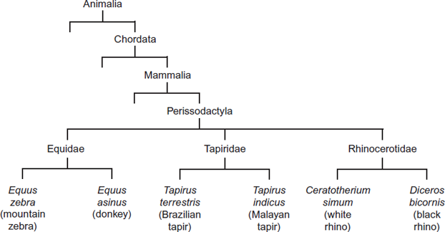

(a)     This type of classification can be described as a phylogenetic hierarchy.

(i)      What is meant by a **hierarchy**?

...............................................................................................................

...............................................................................................................

...............................................................................................................

...............................................................................................................

*(Extra space)* ........................................................................................

...............................................................................................................

**(2)**

(ii)     How many different families are shown in the figure?



**(1)**

(iii)    To which phylum does the white rhino belong?

...............................................................................................................

**(1)**

(b)     (i)      Explain the role of independent segregation in meiosis.

...............................................................................................................

...............................................................................................................

...............................................................................................................

...............................................................................................................

**(2)**

(ii)     A zedonk is the offspring produced from breeding a mountain zebra with a donkey.

•        The body cells of a mountain zebra contain 32 chromosomes.

•        The body cells of a donkey contain 62 chromosomes.

Use this information to suggest why zedonks are usually infertile.

...............................................................................................................

...............................................................................................................

...............................................................................................................

...............................................................................................................

**(2)**

**(Total 8 marks)**

**Q3.**          (a)     The mammals form a class called the Mammalia within the animal kingdom. The grey wolf is a species of mammal. **Figure 1** shows the groups within the Mammalia to which the wolf (labelled **W**) belongs.

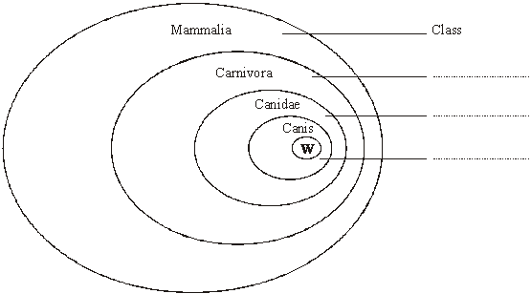

**Figure 1**

(i)      Label **Figure 1** to show the names of the groups.

**(2)**

(ii)     The lion, *Panthera leo*, belongs to another group in the Carnivora, called the Felidae. Add this information to **Figure 1**, using the letter L to represent the lion species.

**(1)**

(b)     The diagrams show two systems of classification of mammals. **Figure 2** shows a simple hierarchy. **Figure 3** shows a phylogenetic system.

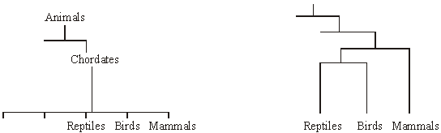

**Figure 2**                                                                    **Figure 3**

(i)      What is meant by a hierarchy?

.............................................................................................................

.............................................................................................................

**(1)**

(ii)     By reference to **Figures 2** and **3**, explain how a phylogenetic system differs from a simple hierarchy.

.............................................................................................................

.............................................................................................................

.............................................................................................................

.............................................................................................................

.............................................................................................................

.............................................................................................................

**(3)**

**(Total 7 marks)**

**Q4.**          This question should be written in continuous prose, where appropriate.

Quality of Written Communication will be assessed in these answers.

(a)     Use your knowledge of classification to arrange *class*, *phylum*, *genus* and *family* in order of decreasing number of species.

          largest number of                                                               smallest number of  
species                                                                                                 species

......................             ......................           ......................           ......................

**(1)**

(b)     Cytochrome c is a protein involved in one of the reactions of aerobic respiration in a mitochondrion. The molecular structure of cytochrome c from different species has been analysed. More similarities are present in the structure of cytochrome c in closely related species than in distantly related species.

(i)      Explain what is meant when two species are described as being *closely related*.

............................................................................................................

............................................................................................................

**(1)**

(ii)     A difference in the molecular structure of cytochrome c may arise in a small population that becomes geographically isolated. Explain how the difference may arise and how it may spread in the population.

............................................................................................................

............................................................................................................

............................................................................................................

............................................................................................................

............................................................................................................

............................................................................................................

............................................................................................................

............................................................................................................

**(4)**

**(Total 6 marks)**

**Q5.**          Armadillos are mammals. The map shows the ranges of three species of armadillo in South America.

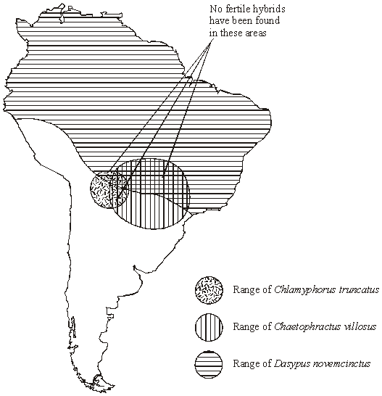

(a)     (i)      What evidence in their ranges suggests that the three armadillos belong to different species?

.............................................................................................................

.............................................................................................................

**(1)**

(ii)     What further evidence would confirm that the three armadillos belong to different species?

.............................................................................................................

.............................................................................................................

**(1)**

(b)     (i)      Complete the table to show the classification of *Dasypus novemcinctus*.

|  |  |  |
| --- | --- | --- |
|  | Kingdom |  |
|  | Phylum | Chordata |
|  |  | Mammalia |
|  |  | Xenarthra |
|  |  | Dasypodidae |
|  | Genus |  |
|  | Species |  |

**(2)**

(ii)     What is the lowest taxonomic grouping that the three species of armadillos can share? Explain your answer.

.............................................................................................................

.............................................................................................................

.............................................................................................................

.............................................................................................................

**(1)**

**(Total 5 marks)**

**Q6.**          Courtship and mating in fruitflies can occur equally well in the light or dark.

The diagrams show the courtship sequence of males from two closely related species of fruitfly (species **A** and species **B**). The numbers show the probability of one courtship element following from another.

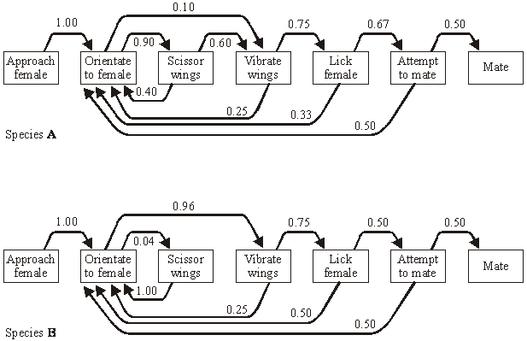

(a)     Once a male of species **A** has orientated to the female, what is the probability that he will perform each courtship element once only and then attempt to mate?   
Show your working.

Probability ........................................

**(2)**

(b)     Suggest how the courtship sequences provide evidence to support the claim that the two species are

(i)      closely related;

.............................................................................................................

.............................................................................................................

**(1)**

(ii)     separate species.

.............................................................................................................

.............................................................................................................

**(1)**

(c)     During courtship, vibration of the wings creates a sound. The sound is different in the two species of fruitfly. Explain how this prevents mating between members of different species.

......................................................................................................................

......................................................................................................................

......................................................................................................................

......................................................................................................................

**(2)**

**(Total 6 marks)**

**Q7.**          (a)     Explain the principles which biologists use to classify organisms into groups.

......................................................................................................................

......................................................................................................................

......................................................................................................................

......................................................................................................................

......................................................................................................................

......................................................................................................................

**(3)**

Cytochrome c is a protein with about 100 amino acids and is present in all eukaryotic organisms. It has the same three-dimensional shape in all species, but only 30 of the amino acids are the same in all species. The amino acid sequence of cytochrome c has been used to construct the phylogenetic tree shown below.

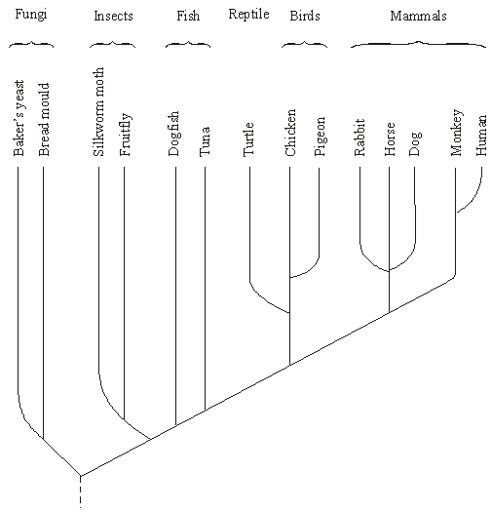

(b)     Name the kingdoms represented in this phylogenetic tree.

......................................................................................................................

**(1)**

(c)     What does the phylogenetic tree show about the evolutionary relationship between fungi and insects?

......................................................................................................................

......................................................................................................................

......................................................................................................................

......................................................................................................................

**(2)**

(d)     Suggest how information on amino acid sequences is used to construct a phylogenetic tree.

......................................................................................................................

......................................................................................................................

......................................................................................................................

......................................................................................................................

**(2)**

(e)     Suggest **one** advantage and **one** disadvantage of using cytochrome c to construct a phylogenetic tree.

Advantage

......................................................................................................................

......................................................................................................................

Disadvantage

......................................................................................................................

......................................................................................................................

**(2)**

**(Total 10 marks)**

**Q8.**          (a)     The cheetah, *Acinonyx jubatus*, and other cat species belong to the family Felidae. Complete the table to show the classification of the cheetah.

|  |  |
| --- | --- |
| Kingdom | Animalia |
|  | Chordata |
|  | Mammalia |
|  | Carnivora |
| Family | Felidae |
| Genus |  |
|  |  |

**(2)**

(b)     This system of classification is described as hierarchical. Explain what is meant by a hierarchical classification.

......................................................................................................................

......................................................................................................................

**(1)**

(c)     Despite differences in form, leopards, tigers and lions are classified as different species of the same genus. Cheetahs, although similar in form to leopards, are classified in a different genus.

(i)      Describe **one** way by which different species may be distinguished.

.............................................................................................................

.............................................................................................................

**(1)**

(ii)     Suggest **two** other sources of evidence which scientists may have used to classify cheetahs and leopards in different genera.

1 ..........................................................................................................

.............................................................................................................

2 ..........................................................................................................

.............................................................................................................

**(2)**

**(Total 6 marks)**

**Q9.**          Lake Malawi in East Africa contains around 400 different species of cichlids which are small, brightly coloured fish. All these species have evolved from a common ancestor.

(a)     Describe **one** way in which scientists could find out whether cichlids from two different populations belong to the same species.

......................................................................................................................

......................................................................................................................

......................................................................................................................

......................................................................................................................

**(2)**

(b)     During the last 700 000 years there have been long periods when the water level was much lower and Lake Malawi split up into many smaller lakes. Explain how speciation of the cichlids may have occurred following the formation of separate, smaller lakes.

......................................................................................................................

......................................................................................................................

......................................................................................................................

......................................................................................................................

......................................................................................................................

......................................................................................................................

......................................................................................................................

......................................................................................................................

**(4)**

(c)     Many species of cichlids are similar in size and, apart from their colour, in appearance. Suggest how the variety of colour patterns displayed by these cichlids may help to maintain the fish as separate species.

......................................................................................................................

......................................................................................................................

......................................................................................................................

......................................................................................................................

**(2)**

**(Total 8 marks)**

**Q10.**          **S**       Clover plants have leaves all through the year. Some clover plants have leaves that produce poisonous hydrogen cyanide gas when damaged. These cyanogenic plants are less likely to be eaten by snails. However, the leaves of these plants can be damaged by frost, resulting in the production of enough hydrogen cyanide to kill the plants. Acyanogenic plants do not produce hydrogen cyanide. This characteristic is genetically controlled.

The map shows the proportions of the two types of plant in populations of clover from different areas in Europe. It also shows isotherms, lines joining places with the same mean January temperature.

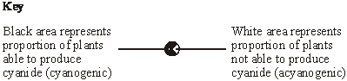

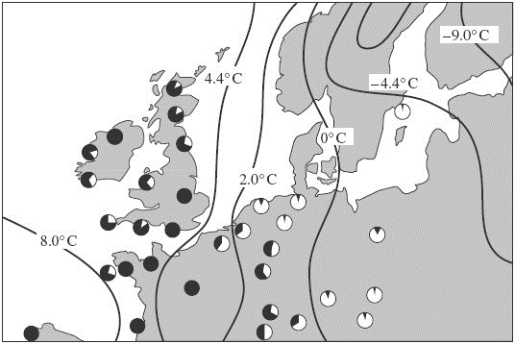

(a)     Explain how different proportions of cyanogenic plants may have evolved in populations in different parts of Europe.

......................................................................................................................

......................................................................................................................

......................................................................................................................

......................................................................................................................

......................................................................................................................

......................................................................................................................

......................................................................................................................

......................................................................................................................

**(4)**

(b)     Differences in cyanide production may affect the total number of clover plants growing in different areas. Describe how you would use quadrats in an investigation to determine whether or not there is a difference in the number of clover plants in two large areas of equal size.

......................................................................................................................

......................................................................................................................

......................................................................................................................

......................................................................................................................

......................................................................................................................

......................................................................................................................

......................................................................................................................

......................................................................................................................

**(4)**

**(Total 8 marks)**

**Q11.**          In taxonomy, each of the levels of classification (class, family, genus, kingdom, order, phylum and species) is called a taxon. The diagram represents just three of these levels of classification.

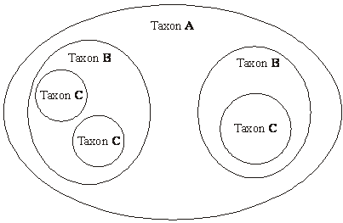

Explain which of these levels of classification could **not** be

(i)      a genus;........................................................................................................

......................................................................................................................

(ii)      a phylum.......................................................................................................

......................................................................................................................

**(Total 2 marks)**

**Q12.**(a)     The guinea pig, *Cavia porcellus*, is a small mammal. Complete the table to show the classification of the guinea pig.

|  |  |  |
| --- | --- | --- |
|  | Kingdom |  |
|  |  | Chordata |
|  |  | Mammalia |
|  |  | Rodentia |
|  | Family | Caviidae |
|  | Genus |  |
|  | Species |  |

**(2)**

(b)     In South America, there are several species of guinea pig. They are thought to have arisen by sympatric speciation.  
Explain how sympatric speciation may have occurred.

........................................................................................................................

........................................................................................................................

........................................................................................................................

........................................................................................................................

........................................................................................................................

........................................................................................................................

**(3)**

(c)     In guinea pigs, hair length and hair colour are controlled by two genes on different chromosomes. The hair may be either long or short and its colour either black or brown.

A male guinea pig and a female guinea pig both had short, black hair. The male was homozygous for hair length, and the female was homozygous for hair colour. Repeated crossings of these two guinea pigs resulted in offspring of four different genotypes, all of which had short, black hair.

Complete the genetic diagram to explain these results. Write in the box the symbols you will use to represent the alleles.

|  |  |  |
| --- | --- | --- |
|  | Allele for short hair = .................  Allele for black hair = ................. | Allele for long hair = ..................  Allele for brown hair = ............... |

|  |  |  |  |
| --- | --- | --- | --- |
|  | Parental phenotypes | Male Short, black hair | Female Short, black hair |
|  | Parental genotypes | .......................... | .......................... |
|  | Gamete genotypes | .......................... | .......................... |
|  |  |  |  |
|  |  |  |  |
|  |  |  |  |
|  | Offspring genotypes | .......................................................... | |
|  | Offspring phenotypes | Short, black hair | |

**(4)**

(d)     In another investigation, the same female guinea pig was twice mated with another male which had long, brown hair. Of the 14 offspring, 10 had short, black hair and 4 had long, black hair. The investigators expected equal numbers of offspring with these two phenotypes. They used a χ2 test to determine whether the observed results fitted the expected 1:1 ratio.

Give a suitable null hypothesis for the investigation.

........................................................................................................................

........................................................................................................................

**(1)**

**(Total 10 marks)**

**Q13.**          Finches are small birds. Fourteen species of finch are found on the Galapagos Islands.

(a)     What is a species?

......................................................................................................................

......................................................................................................................

......................................................................................................................

......................................................................................................................

**(2)**

(b)     Measurements were made of the beak depth of two species of finch (species **A** and species **B**) on different islands. Species **A** is found on island 1, species **B** is found on island 2. Both species are found on island 3. They are thought to have colonised island 3 from islands 1 and 2 respectively. The graphs show the ranges of beak depths of the two species on the different islands.

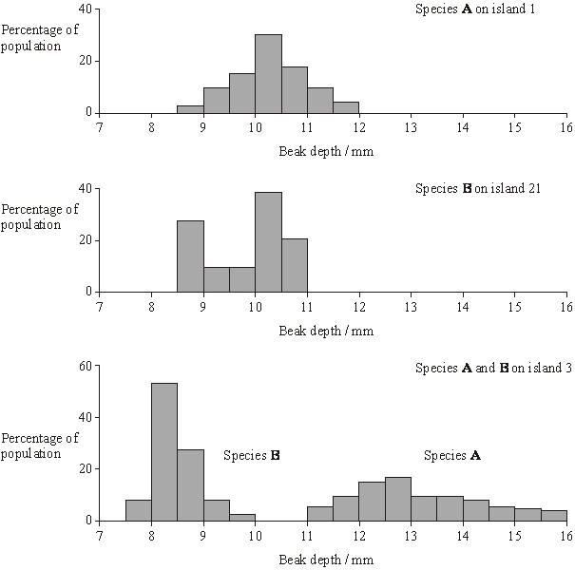

What type of natural selection took place in the populations of both species after they had colonised island 3? Explain your answer.

......................................................................................................................

......................................................................................................................

......................................................................................................................

......................................................................................................................

......................................................................................................................

**(3)**

**(Total 5 marks)**

**Q14.**          (a)     An order is a taxonomic group. All seals belong to the same order. Name **one** other taxonomic group to which all seals belong.

......................................................................................................................

**(1)**

(b)     The diagram shows how some species of seal are classified.

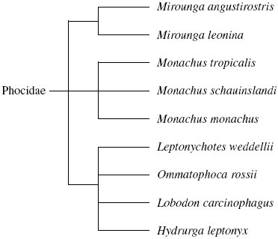

(i)      How many different genera are shown in this diagram?



**(1)**

(ii)     All the seals shown in the diagram are members of the Phocidae. Phocidae is an example of a taxonomic group. Of which taxonomic group is it an example?

.............................................................................................................

**(1)**

(iii)     The diagram is based on the evolutionary history of the seals. What does the information in the diagram suggest about the common ancestors of *Mirounga angustirostris*, *Mirounga leonina* and *Monachus tropicalis*?

.............................................................................................................

.............................................................................................................

.............................................................................................................

**(1)**

(c)     A species of seal shows genetic diversity. Explain what is meant by genetic diversity.

......................................................................................................................

......................................................................................................................

**(1)**

**(Total 5 marks)**

**Q15.**          In 2002, biologists identified a new group of insects. They called these insects gladiators.

(a)     (i)      *Mantophasma zephyra* is one species of gladiator. Complete the table to show how this species is classified.

|  |  |
| --- | --- |
| Kingdom | Animalia |
|  | Arthropoda |
|  | Insecta |
|  | Notoptera |
| Family | Mantophasmatodae |
|  |  |
| Species |  |

**(2)**

(ii)     This system of classification consists of a hierarchy. Explain what is meant by a hierarchy.

.............................................................................................................

.............................................................................................................

.............................................................................................................

.............................................................................................................

**(2)**

(b)     In 2002, very few gladiators were available for identification. Scientists around the world used photographs to establish the relationship of gladiators to other insects.

Explain how.

......................................................................................................................

......................................................................................................................

**(1)**

**(Total 5 marks)**

**Q16.**The body markings of cheetahs vary, in particular the pattern of bands on their tails. Cheetahs are solitary animals but the young stay with their mother until they are between 14 and 18 months old.

Scientists investigated the banding pattern on the tails of cheetahs living in the wild.

•        They drove a car alongside a walking cheetah and used binoculars to study the tail pattern.

•        They gave each cheetah a banding pattern score based on the width of the dark and light bands on the end of the tail.

•        They scored the width of the bands on the right and left side of the tail using a 5 point scale of width.

A typical pattern on the right side of one cheetah’s tail is shown in **Figure 1**.

**Figure 1**

|  |  |  |  |  |  |  |  |
| --- | --- | --- | --- | --- | --- | --- | --- |
|  | Band number | 1 | 2  3 | 4 | 5 | 6 | 7 |



|  |  |  |  |  |  |  |  |
| --- | --- | --- | --- | --- | --- | --- | --- |
|  | Band width score | 3 | 1  1 | 4 | 3 | 3 | 3 |

The scientists collected data from each cheetah on four separate occasions. **Figure 2** shows the data for one of the cheetahs.

**Figure 2**

|  |  |  |  |  |  |  |  |  |
| --- | --- | --- | --- | --- | --- | --- | --- | --- |
|  | **Side of tail** | **Mean band width score (± standard deviation)** | | | | | | |
|  | **Band 1** | **Band 2** | **Band 3** | **Band 4** | **Band 5** | **Band 6** | **Band 7** |
|  | Right | 3.00  (± 0.82) | 1.00  (± 0.00) | 1.00  (± 0.00) | 3.75  (± 0.50) | 2.75  (± 0.50) | 3.00  (± 0.00) | 3.00  (± 0.00) |
|  | Left | 3.75  (± 0.50) | 3.25  (± 0.50) | 2.00  (± 0.50) | 3.00  (± 0.00) | 2.00  (± 0.00) | 2.50  (± 0.50) | 3.00  (± 0.50) |

(a)     The scientists only used data from cheetahs which were fully grown. Suggest why.

........................................................................................................................

........................................................................................................................

**(1)**

(b)     The scientists estimated the width of the bands on the same cheetah on four separate occasions. They did not always get the same score.

(i)      Give **two** pieces of evidence from **Figure 2** which show that the scientists sometimes obtained different scores for the same band.

1 ............................................................................................................

...............................................................................................................

2 ............................................................................................................

...............................................................................................................

**(2)**

(ii)     The method the scientists used resulted in them getting different scores for the same band. Suggest why.

...............................................................................................................

...............................................................................................................

**(1)**

(c)     What is the evidence from **Figure 2** that the dark and light bands do **not** form rings of equal width around the tail?

........................................................................................................................

........................................................................................................................

**(1)**

(d)     The scientists found the difference in banding pattern between

•        offspring in the same family

•        cheetahs chosen randomly.

Explain how scientists could use this information to show that some variation in tail banding was genetic.

........................................................................................................................

........................................................................................................................

........................................................................................................................

........................................................................................................................

........................................................................................................................

........................................................................................................................

(Extra space) .................................................................................................

........................................................................................................................

........................................................................................................................

**(3)**

**(Total 8 marks)**

**Q17.**There are over 200 species of catfish. All catfish evolved from a common ancestor.  
The diagram shows how some species of catfish are classified. This diagram is based on the evolutionary links between these species.

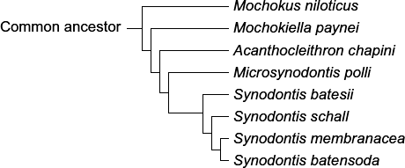

(a)     (i)      Which species of catfish is most closely related to *Synodontis membranacea*?

...............................................................................................................

**(1)**

(ii)     Which species of catfish is most distantly related to *Synodontis membranacea*?

...............................................................................................................

**(1)**

(b)     How many different genera are shown in this diagram?



**(1)**

(c)     (i)      A scientist carried out breeding experiments with catfish from different populations.  
Describe how the results could show that the catfish belong to the same species.

...............................................................................................................

...............................................................................................................

...............................................................................................................

**(1)**

(ii)     The variety of colours displayed by catfish is important in courtship. Give **two** ways in which courtship increases the probability of successful mating.

1 ............................................................................................................

...............................................................................................................

2 ............................................................................................................

...............................................................................................................

**(2)**

**(Total 6 marks)**

**Q18.**          Hummingbirds belong to the order Apodiformes. One genus in this order is *Topaza*.

(a)     (i)      Name **one** other taxonomic group to which all members of the Apodiformes belong.

...............................................................................................................

**(1)**

(ii)     Name the taxonomic group between order and genus.

...............................................................................................................

**(1)**

The crimson topaz and the fiery topaz are hummingbirds.

Biologists investigated whether the crimson topaz and the fiery topaz are different species of hummingbird, or different forms of the same species.

They caught large numbers of each type of hummingbird. For each bird they

•        recorded its sex

•        recorded its mass

•        recorded the colour of its throat feathers

•        took a sample of a blood protein.

The table shows some of their results.

|  |  |  |  |  |  |
| --- | --- | --- | --- | --- | --- |
|  |  | **Crimson topaz** | | **Fiery topaz** | |
|  |  | **Male** | **Female** | **Male** | **Female** |
|  | Mean mass / g (± standard deviation) | 13.6 (±1.9) | 10.8 (±1.3) | 14.2 (±1.6) | 11.6 (±0.63) |
|  | Colour of throat feathers | Green | Grey edges | Yellowish green | No grey edges |

(b)     Explain how the standard deviation helps in the interpretation of these data.

........................................................................................................................

........................................................................................................................

........................................................................................................................

........................................................................................................................

........................................................................................................................

**(2)**

(c)     The biologists analysed the amino acid sequences of the blood protein samples from these hummingbirds.

Explain how these sequences could provide evidence as to whether the crimson topaz and the fiery topaz are different species.

........................................................................................................................

........................................................................................................................

........................................................................................................................

........................................................................................................................

........................................................................................................................

**(2)**

**(Total 6 marks)**

**Q19.**The Amazonian forest today contains a very high diversity of bird species.

•        Over the last 2 000 000 years, long periods of dry climate caused this forest to separate into a number of smaller forests.

•        Different plant communities developed in each of these smaller forests.

•        Each time the climate became wetter again, the smaller forests grew in size and merged to reform the Amazonian forest.

(a)     Use the information provided to explain how a very high diversity of bird species has developed in the Amazonian forest.

........................................................................................................................

........................................................................................................................

........................................................................................................................

........................................................................................................................

........................................................................................................................

........................................................................................................................

........................................................................................................................

........................................................................................................................

........................................................................................................................

........................................................................................................................

*(Extra space)*..................................................................................................

........................................................................................................................

........................................................................................................................

........................................................................................................................

........................................................................................................................

**(5)**

(b)     Speciation is far less frequent in the reformed Amazonian forest. Suggest one reason for this.

........................................................................................................................

........................................................................................................................

........................................................................................................................

**(1)**

**(Total 6 marks)**

**Q20.**Organisms can be classified using a hierarchy of phylogenetic groups.

(a)     Explain what is meant by:

(i)      a hierarchy

...............................................................................................................

...............................................................................................................

...............................................................................................................

...............................................................................................................

...............................................................................................................

**(2)**

(ii)     a phylogenetic group.

...............................................................................................................

...............................................................................................................

...............................................................................................................

**(1)**

(b)     Cytochrome c is a protein involved in respiration. Scientists determined the amino acid sequence of human cytochrome c. They then:

•        determined the amino acid sequences in cytochrome c from five other animals

•        compared these amino acid sequences with that of human cytochrome c

•        recorded the number of differences in the amino acid sequence compared with human cytochrome c.

The table shows their results.

|  |  |  |
| --- | --- | --- |
|  | **Animal** | **Number of differences in the amino acid sequence compared with human cytochrome c** |
|  | **A** | 1 |
|  | **B** | 12 |
|  | **C** | 12 |
|  | **D** | 15 |
|  | **E** | 21 |

(i)      Explain how these results suggest that animal **A** is the most closely related to humans.

...............................................................................................................

...............................................................................................................

...............................................................................................................

...............................................................................................................

...............................................................................................................

**(2)**

(ii)     A student who looked at these results concluded that animals **B** and **C** are more closely related to each other than to any of the other animals.

Suggest **one** reason why this might **not** be a valid conclusion.

...............................................................................................................

...............................................................................................................

...............................................................................................................

**(1)**

(iii)    Cytochrome c is more useful than haemoglobin for studying how closely related different organisms are. Suggest **one** reason why.

...............................................................................................................

...............................................................................................................

...............................................................................................................

**(1)**

**(Total 7 marks)**

**Q21.**(a)     What is a *species?*

........................................................................................................................

........................................................................................................................

........................................................................................................................

**(2)**

(b)     Scientists investigated the diversity of plants in a small area within a forest. The table shows their results.

|  |  |  |
| --- | --- | --- |
|  | **Plant species** | **Number of individuals** |
|  | Himalayan raspberry | 20 |
|  | Heartwing sorrel | 15 |
|  | Shala tree | 9 |
|  | Tussock grass | 10 |
|  | Red cedar | 4 |
|  | Asan tree | 6 |
|  | Spanish needle | 8 |
|  | Feverfew | 8 |

The index of diversity can be calculated by the formula



where

*d* = index of diversity  
*N* = total number of organisms of all species  
*n* = total number of organisms of each species

(i)      Use the formula to calculate the index of diversity of plants in the forest. Show your working.

Answer .....................................

**(2)**

(ii)     The forest was cleared to make more land available for agriculture.

After the forest was cleared the species diversity of insects in the area decreased. Explain why.

...............................................................................................................

...............................................................................................................

...............................................................................................................

...............................................................................................................

...............................................................................................................

...............................................................................................................

(Extra space).........................................................................................

...............................................................................................................

...............................................................................................................

**(3)**

**(Total 7 marks)**

**Q22.**Micronesia is a group of islands in the Pacific Ocean. The white-fronted ground dove is a bird found on these islands.

The diagram below shows how the white-fronted ground dove is classified.

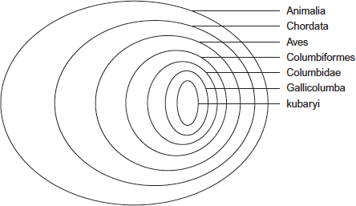

(a)      To which class does the white-fronted ground dove belong?

...................................................................................................................

**(1)**

(b)     Give the scientific name for the white-fronted ground dove.

...................................................................................................................

**(1)**

(c)    This classification system consists of a hierarchy as there are small groups within larger groups.

Give **one** other feature of a hierarchy that is shown in the diagram.

...................................................................................................................

...................................................................................................................

**(1)**

**(Total 3 marks)**

**Q23.Table 1** shows how a bird called the bluethroat (*Luscinia svecica*) is classified by biologists.

**Table 1**

|  |  |  |
| --- | --- | --- |
|  | **Taxon** | **Name of taxon** |
|  | Domain | Eukaryota |
|  |  | Animalia |
|  |  | Chordata |
|  |  | Aves |
|  |  | Passeriformes |
|  |  | Muscicapidae |
|  | Genus |  |
|  | Species |  |

(a)     Complete **Table 1** by filling the seven blank spaces with the correct terms.

**(2)**

A group of scientists investigated genetic diversity in different species of bird. For each species, the scientists:

•        collected feathers from a large number of birds

•        extracted DNA from cells attached to each feather

•        analysed the samples of DNA to find genetic diversity.

**Table 2** summarises their results.

**Table 2**

|  |  |  |  |
| --- | --- | --- | --- |
|  | **Species of bird** | **Number of genes  examined** | **Number of genes  examined that showed genetic diversity** |
|  | Willow flycatcher | 708 | 197 |
|  | House finch | 269 | 80 |
|  | Bluethroat | 232 | 81 |

(b)     In this investigation, what is meant by **genetic diversity?**

........................................................................................................................

........................................................................................................................

**(1)**

(c)     The scientists concluded that the bluethroat showed greater genetic diversity than the willow flycatcher. Explain why they reached this conclusion. Use calculations to support your answer.

........................................................................................................................

........................................................................................................................

........................................................................................................................

........................................................................................................................

**(2)**

**(Total 5 marks)**

**Q24.**The table shows the taxons and the names of the taxons used to classify one species of otter. They are **not** in the correct order.

|  |  |  |  |
| --- | --- | --- | --- |
|  |  | **Taxon** | **Name of taxon** |
|  | **J** | Family | Mustelidae |
|  | **K** | Kingdom | Animalia |
|  | **L** | Genus | Lutra |
|  | **M** | Class | Mammalia |
|  | **N** | Order | Carnivora |
|  | **O** | Phylum | Chordata |
|  | **P** | Domain | Eukarya |
|  | **Q** | Species | lutra |

(a)     Put letters from the table above into the boxes in the correct order. Some boxes have been completed for you.

|  |  |  |  |  |  |  |  |  |  |  |  |  |  |  |  |
| --- | --- | --- | --- | --- | --- | --- | --- | --- | --- | --- | --- | --- | --- | --- | --- |
|  |  |  |  |  | **O** |  | **M** |  |  |  |  |  | **L** |  | **Q** |

**(1)**

(b)     Give the scientific name of this otter.

........................................................................................................................

**(1)**

Scientists investigated the effect of hunting on the genetic diversity of otters. Otters are animals that were killed in very large numbers for their fur in the past.

The scientists obtained DNA from otters alive today and otters that were alive before hunting started.

For each sample of DNA, they recorded the number of base pairs in alleles of the same gene. Mutations change the numbers of base pairs over time.

The figure below shows the scientists’ results.

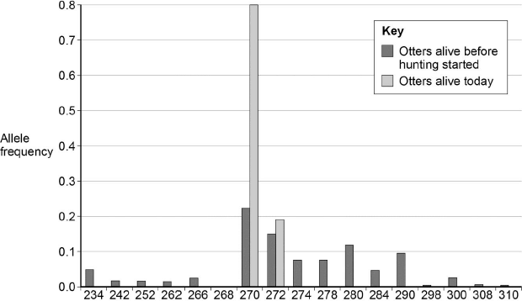  
                        Allele size / number of base pairs

(c)     The scientists obtained DNA from otters that were alive before hunting started.

Suggest **one** source of this DNA.

........................................................................................................................

........................................................................................................................

**(1)**

(d)     What can you conclude about the effect of hunting on genetic diversity in otters? Use data from the figure above to support your answer.

........................................................................................................................

........................................................................................................................

........................................................................................................................

........................................................................................................................

**(2)**

(e)     Some populations of animals that have never been hunted show very low levels of genetic diversity.

Other than hunting, suggest **two** reasons why populations might show very low levels of genetic diversity.

1 .....................................................................................................................

........................................................................................................................

2 .....................................................................................................................

........................................................................................................................

**(2)**

**(Total 7 marks)**

**M1.**(a)     1.      Recognise / identify / attract same species;

*Ignore: references to letting them produce fertile offspring*

2.      Stimulates / synchronises mating / production / release of gametes;

3.      Recognition / attraction of mate / opposite sex;

*Accept finding a mate*

*Accept: gender*

4.      Indication of (sexual) maturity / fertility / receptivity / readiness to mate;

5.      Formation of a pair bond / bond between two organisms (to have / raise young).

**3 max**

(b)     1.      Use a (real) male (with intact wings / no wing removed);

*Mark ignoring reference to birds / or other types of animals*

*Accept: use a real cricket, since only males sing*

2.      Determine (percentage) response (of females compared with **L**).

*Accept: compare results with* ***L***

**2**

(c)     1.      Lowest / only 30% courtship with no song / K / (or) courtship still occurred when no song played / **K**;

*Note: throughout, for courtship accept response / stimulation / reaction*

*Neutral: references to methodology*

*Answer must make clear there is no song / version K*

2.      Reduced courtship when no ticks / M / there is some courtship when no ticks / M;

3.      Reduced courtship when no chirps / N / there is some courtship when no chirps / N;

*Accept: use of figures from the table in an explanation*

4.      (So) courtship must involve a visual stimulus / other factor involved;

5.      Chirps more important as lowest courtship when none / N / ticks less important as similar courtship when changed / M;

*Must make comparison to gain mark*

6.      Data only show presence and absence of chirps / 0 and 7 chirps.

*Note: ‘courtship still occurred when no sound played so a visual stimulus / other factor / something else (e.g. pheromone?) must be involved’*

*= 2 marks*

**4 max**

**[9]**

**M2.**(a)     (i)      1.      Groups within groups;

*Accept: idea of larger groups at the top* ***or*** *smaller groups at the bottom*

2.      No overlap (between groups);

**2**

(ii)     **3**;

**1**

(iii)    Chordata;

*Accept: if phonetically correct eg ‘Cordata’*

**1**

(b)     (i)      1.      (To provide) genetic variation;

*Genetic variation must be directly stated and not implied*

2.      (Allows) different combinations of maternal and paternal chromosomes / alleles;

*Accept: any allele of one gene can combine with any allele of another gene*

**2**

(ii)     1.      (Zedonk has) 47 / odd / uneven number of chromosomes;

*Accept: diploid number would be odd*

*Reject: if wrong number of chromosomes is given*

2.      Chromosomes cannot pair / are not homologous / chromosome number cannot be halved / meiosis cannot occur / sex cells / haploid cells are not produced;

*Accept: cannot have half a chromosome*

***Q*** *Reject: meiosis cannot occur* ***in*** *sex cells*

**2**

**[8]**

**M3.**          (a)     (i)      Order, Family, Genus.

*(all correct = 2 marks; 2 correct = 1 mark)*

**2**

(ii)     3 concentric circles in Carnivora, labelled Felidae, Panthera and L;

**1**

(b)     (i)      large groups split into smaller groups (which do not overlap);

**1**

(ii)     (phylogenetic) based on evolutionary history;  
shows ancestry of groups / points of divergence / example,   
e.g. reptiles and birds separated after mammals / reptiles  
and birds more closely related than mammals;  
(hierarchical) based on shared characteristics (seen today);

**3**

**[7]**

**M4.**          (a)     phylum, class, family, genus;

**1**

(b)     (i)      more recent common ancestor / DNA in common;

**1**

(ii)     mutation causes variation;  
genes (coding) for protein / cytochrome c with different structures;  
EITHER  
individuals with a modified cytochrome c have a selective   
advantage / are selected for / these individuals are more likely to survive   
to have offspring / have more offspring;

*(must link a comparison of survival to reproduction)*

gene / allele frequency changes over generations / time;  
OR  
changed structure does not affect protein function;  
these structural differences accumulate over time;

**4**

**[6]**

**M5.**          (a)     (i)      there are no fertile hybrids found in the overlapping regions;

**1**

(ii)     even if mating took place, there would be no fertile hybrids /   
different chromosome number / gene pool / evolutionary history / many morphological / biochemical / serological differences;

**1**

(b)     (i)

|  |  |
| --- | --- |
| Kingdom | **Animalia / Animals** |
| Phylum | Chordata |
| **Class** | Mammalia |
| **Order** | Xenarthra |
| **Family** | Dasypodidae |
| Genus | ***Dasypus*** |
| Species | ***(D.) novemcinctus*** |
| 1 mark per correct column | |

**2**

(ii)     Family, as all three belong to different genera;

**1**

**[5]**

**M6.**          (a)     principle of sequential multiplication (0.9×0.6×0.75×0.67);  
0.27;

*(correct answer 2 marks)*

**2**

(b)     (i)      similar sequence / actions / sign stimuli;

**1**

(ii)     additional action in sequence(species A) / scissor wings blocks  
sequence in B;

**1**

(c)     (acts as) sign stimulus;  
responds only to species-specific sound;

**2**

**[6]**

**M7.**          (a)     large groups are divided into smaller groups;  
(*not just ‘hierarchical’*)  
members of a group have features in common based on anatomy  
/ fossils / embryology / DNA / specific aspect of cell biology  
/ homologous structures;

reflects evolutionary history;

**3**

(b)     fungi and animals;

**1**

(c)     (insects and fungi) have common ancestor;  
they diverged a long time ago / before others referred to in phylogenetic tree;

**2**

(d)     those with similar sequences put in same groups / are more closely related;  
the greater difference in amino acid sequence the longer ago the groups  
diverged;

**2**

(e)     A - present in all (eukaryotic) species or organisms / quantifiable;  
D - extinct species not considered / no timing of events available / only limited number of amino acid sequences / can’t include prokaryotic species

**2**

**[10]**

**M8.**          (a)     phylum, class, order;  
species, *Acinonyx jubatus;*

**2**

(b)     larger groups containing smaller groups;

**1**

(c)     (i)      do not interbreed to produce fertile offspring / different DNA /   
different niches;

**1**

(ii)     fossil record;  
evolutionary history / phylogeny;  
biochemical differences e.g. DNA / proteins / cytochromes;  
homologous features / named feature;  
karyotype / number and form of chromosomes;  
*(discount any example credited in (i))*

**2**

**[6]**

**M9.**          (a)     breed together;

if fertile offspring, then same species;

**2**

(b)     isolation of two populations;

variation already present due to mutations;

different environmental conditions / selection pressures leading to  
selection of different features and hence different alleles;

different frequency of alleles;

separate gene pools / no interbreeding;

**4**

(c)     selection of mate dependent on colour pattern;

prevents interbreeding / keeps gene pools separate;

**2**

**[8]**

**M10.**          (a)     colder / below 0°C (January) areas, cyanogenic plants die in this cold / acyanogenic survive;  
non-cyanogenic allele / gene passed on more often / its frequency increases;  
warmer (January) areas cyanogenic plants at advantage,  
because of less herbivore selection pressure / feeding;  
so cyanogenic survive more often to pass on cyanogenic allele / gene.

**4 max**

(b)     large (and equal) number of quadrats in each area;  
*(reject several)*random sampling method, described;  
*(accept described ‘systematic’ method)*percentage cover / point hits per quadrat / count plants;  
mean / average value for each area;  
statistics test to see if differences significant.

**4 max**

**[8]**

**M11.**          (i)      Taxon **A** - there is more than one level / taxon below it / genus only has species / only has one level / taxon above it;

(ii)      Taxon **C** - there is more than one level / taxon above it / phylum only has kingdom / only has one level taxon above it;

**[2]**

**M12.**(a)     Table completed as below:

|  |  |  |  |
| --- | --- | --- | --- |
|  | Kingdom | Animalia / Animals |  |
|  | Phylum | Chordata | |
|  | Class | Mammalia | |
|  | Order | Rodentia | |
|  | Family | Caviidae | |
|  | Genus | *Cavia* | Column 1 correct; |
|  | Species | *porcellus* | Column 2 correct; |

**2**

(b)     Mutation occurs;

Correct e.g. of isolating mechanism

e.g.  
temporal − different breeding seasons / feeding times /   
ecological / behavioural − different courtship displays / different niches / habitats / feeding areas /

mechanical − mismatch of reproductive parts /

gamete incompatibility − sperm killed in female’s reproductive tract /   
hybrid inviability / hybrid infertility;

*Ignore references to “genetic isolation” or “reproductive isolation”*

Different selection pressures operate / changes in allele frequency / divergence of gene pools;

**3**

(c)     Using candidate’s symbols for alleles −

e.g. B = black, b = brown, S = short, s = long:

Parental genotypes correct:        Male **A**          Female **B**

                                           SSBb            SsBB;

Gametes correctly derived from

candidate’s parental genotypes: SB     Sb     SB     sB;

offspring genotypes correctly

derived from candidate’s

suggested gametes         − accept Punnett square or line diagram;

offspring genotypes correct:       SSBB     SsBB     SSBb     SsBb;

*If monohybrid:cross  0 marks*

**4**

(d)     There is no (significant) difference between observed and expected results / any difference is due to chance;

**1**

**[10]**

**M13.**          (a)     group of organisms with similar features;  
can (interbreed to) produce fertile offspring;

**2**

(b)     directional selection;   
*any TWO from*selection against one extreme / for one extreme;  
against broadest beaks in B and narrowest beaks  
in **A** / for narrowest in **B** and broadest in **A**;  
whole distribution / range / mean / mode / median is  
shifted towards favoured extreme;

**3 max**

**[5]**

**M14.**          (a)     Kingdom / phylum / class;

**1**

(b)     (i)      6;

**1**

(ii)     Family;

**1**

(iii)    The two species of *Mirounga* shared a common ancestor  
more recently than they did with *Monarchus tropicalis*;

**1**

(c)     Difference in DNA / base sequence / alleles / genes;

**1**

**[5]**

**M15.**          (a)     (i)      Phylum, Class, Order, Genus;

         Mantophasma (M) / (Mantophasma) zephyra;

**2**

(ii)     Groups within (larger) groups;

         No overlap;

**2**

(b)     Comparison of / look for similar features / structures / appearance;

**1**

**[5]**

**M16.**(a)     Banding pattern changes as cheetah gets older / difficult to judge as tail is short / fluffy;

**1**

(b)     (i)      Mean not (always) a whole number;  
Standard deviation not (always) zero;

**2**

(ii)     Movement of tail / angle of sight / confused it with another band / subjective estimation;

*Accept reference to* ***Figure 1***

*E.g. Bands 2 and 3 have same thickness but look different*

**1**

(c)     Band width not the same on both sides of tail;

**1**

(d)     Offspring of the same family will be more similar genetically;  
As have same mother (and father) / parent;  
Expect to see more differences in randomly chosen cheetahs;

**3**

**[8]**

**M17.**(a)     (i)      *Synodontis batensoda / S. batensoda;*

*Ignore spellings*

**1**

(ii)     *Mochokus niloticus;*

*Ignore spellings*

**1**

(b)     5;

**1**

(c)     (i)      Fertile offspring produced;

*Allow suitable description of offspring being fertile.*

**1**

(ii)     1.      Attracts / recognises same species;

*Attracts mate of the same species = two marks.*

2.      Attracts / recognises mate / opposite sex;

3.      Indication of sexual maturity / fertility / synchronises mating;

*Allow 'ready to mate'.*

4.      Stimulates release of gametes;

5.      Form pair bond;

**2 max**

**[6]**

**M18.**         (a)     (i)     Kingdom / phylum / class;

*Accept Animalia / animal kingdom / Chordata / Chordates / Aves*

*Allow phonetic spelling*

**1**

(ii)     Family;

**1**

(b)     1.      Shows the spread of the data / how data varies;

*1. Reject range.*

*Accept varies from the mean*

2.      Overlap = no difference / due to chance / not significant;

*2. Allow converse*

**2**

(c)     1.      Different species would have different amino acid sequences;

*Accept more closely related = more similar sequence*

2.      Amino acid sequence is the result of DNA / alleles / base sequence;

*References to incorrect statements about coding negates second mark*

**2**

**[6]**

**M19.**(a)     1.      No interbreeding / gene pools are separate / geographic(al) isolation;

*Accept: all marks if answer written in context of producing increased diversity of plants*

*1 Do not award this mark in context of new species being formed and then not interbreeding*

*1 Accept reproductive isolation as an alternative to no interbreeding*

2.      Mutation;

*2 Accept: genetic variation*

3.      Different selection pressures / different foods / niches / habitats;

*3 Accept: different environment / biotic / abiotic conditions or named condition*

*3 Neutral: different climates*

4.      Adapted organisms survive and breed / differential reproductive success;

5.      Change / increase in allele frequency / frequencies;

**5**

(b)     Similar / same environmental / abiotic / biotic factors / similar / same selection pressures / no isolation / gene flow can occur (within a species);

*Accept: same environment*

**1**

**[6]**

**M20.**(a)     (i)      1.      Groups within groups;

*1. accept idea of larger groups at the top / smaller groups at the bottom*

2.      No overlap (between groups);

**2**

(ii)     (Grouped according to) evolutionary links / history / relationships / common ancestry;

*Neutral: closely related*

*Neutral: genetically similar*

**1**

(b)     (i)      1.      (Only) one amino acid different / least differences / similar amino acid sequence / similar primary structure;

2.      (So) similar DNA sequence / base sequence;

**2**

(ii)     1.      Compared with humans / not compared with each other;

*Accept: degenerate code / more than one triplet (codes) for an amino acid*

2.      Differences may be at different positions / different amino acids affected / does not show where the differences are (in the sequence);

**1 max**

(iii)    1.      All organisms respire / have cytochrome c;

*Accept: converse arguments for haemoglobin*

*1. Accept ‘more’ instead of ‘all’*

*1. Accept ‘animals’ instead of organismsߢ*

2.      (Cytochrome c structure) is more conserved / less varied (between organisms);

*2. Neutral: cytochrome c is conserved*

**1 max**

**[7]**

**M21.**(a)     1.      Group of similar organisms / organisms with similar features / organisms with same genes / chromosomes;

*1. Accept: same number of chromosomes*

*1. Accept: smallest taxonomic group*

*1. Reject: genetically identical. Only allow 1 max if mentioned*

*1.* ***Q*** *Neutral: similar genes / chromosomes*

2.      Reproduce / produce offspring;

*2. Accept: breed / mate*

3.      That are fertile;

*3. Neutral: that are ‘viable’*

*‘Produce fertile offspring’ = 2 marks*

**2 max**

(b)     (i)      Correct answer of 6.97 to 7 = 2 marks;

One mark for 6320 as numerator or 906 as denominator;

**2**

(ii)     1.      Decrease in variety of plants / fewer plant species;

*1. Accept: reference to monoculture or description*

*1. Neutral: fewer plants*

2.      Fewer habitats / niches;

*2. Neutral: fewer homes / less shelter*

3.      Decrease in variety of food / fewer food sources;

*3. Neutral: less food*

*3. Accept: less variety of prey*

**3**

**[7]**

**M22.**(a)    Aves;

**1**

(b)     Gallicolumba kubaryi;

*Must have both words and in this order*

*Must be capital G*

*If starts with k, award mark as impossible to recognise difference*

*Ignore: underlining*

*Accept: phonetic spelling*

*Accept: G kubaryi (must be a capital / upper case G)*

**1**

(c)    No overlap.

**1**

**[3]**

**M23.**(a)      1.      Kingdom, Phylum, Class, Order, Family;

2.      *Luscinia svecica.*

*1 mark for each correct column*

*Allow Genus and Species if both placed in box for species but not if both placed in genus box*

**2**

(b)     Number of different alleles of each gene.

*Accept number of different base sequences (found) in each gene*

**1**

(c)     1.      Has greater proportion of genes / percentage of genes showing diversity;

2.      Percentage is 35% compared with 28% / proportion is 0.35 compared with 0.28.

*Allow correct figures that are not rounded up, i.e., 34.9% / 0.349 and 27.8% / 0.278*

**2**

**[5]**

**M24.**(a)      PKNJ.

**1**

(b)     *Lutra lutra.*

**1**

(c)     Bone / skin / preserved remains / museums.

**1**

(d)     1.      (Hunting) reduced population size(s), so (much) only few alleles left;

*Accept bottleneck*

2.      Otters today from one / few surviving population(s);

*Accept founder effect*

3.      Inbreeding.

*Allow any* ***two***

**2 max**

(e)     1.      Population might have been very small / genetic bottleneck;

2.      Population might have started with small number of individuals / by one pregnant female / founder effect;

3.      Inbreeding.

*Allow any* ***two***

**2 max**

**[7]**

**E1.**(a)     There were many good answers to this part and nearly half of students obtained all 3 marks.

(b)     This part also produced many correct responses, with most referring in some way to using a real or intact male in an experiment and recording female responses. Those who failed to score often tried to find alternative ways to use the recorded songs described in the question but without success.

(c)     Very few students obtained all 4 marks in this part. This was rarely due to errors but rather to writing at length about only one or two points on the mark scheme. Many noted that courtship occurred when no song was played, or there were no chirps, or no ticks. Others went into a lot of detail about why ticks seemed to be less important than chirps. Many obtained one mark for one or more of these ideas being evidence for some other factor being involved.

**E2.**Given that this question was targeted at grade E, it was surprising that parts (a)(i), (b)(i) and (b)(ii) proved to be good discriminators.

(a)    (i)      Half of students were aware that a hierarchy contains groups within groups, with no overlap. However, the ‘no overlap’ concept was often missed. Similarly, it was disappointing that nearly 30% of students failed to score, considering that a simple definition from the specification was required. Weaker responses often referred to the idea of ranking, dominance or importance.

(ii)     Most students gave the correct answer of **3**.

(iii)    Most students gave the correct answer of **Chordata**.

(b)    (i)      Just over half of students scored at least one mark. This was usually for relating independent segregation to genetic variation. Better responses showed an appreciation of how this is achieved. Typically, these referred to different combinations of maternal and paternal chromosomes, or the random arrangement of homologous chromosomes. Commonly seen responses that lacked the required precision included ‘provides variation’ and ‘allows different combinations of chromosomes’. A minority of students failed to score due to writing about crossing over. The role of independent segregation in producing haploid cells was rarely seen.

(ii)     One-third of students scored full marks. However, a number lost marks through a lack of precision; for example, ‘there would be the wrong number of chromosomes’ or ‘they are different species so the offspring would be infertile’. The most common misconceptions seen were that ‘the offspring would have 94 chromosomes’ and ‘meiosis would not be able to occur *in* the sex cells’.

**E3.**          Classification continues to be a problem area for many, and candidates from many centres appeared to have little knowledge or understanding of the principles.

(a)     (i)      Often the only marks obtained in the question were for naming the groups. Despite the fact that similar questions have been asked before, a considerable number of candidates could not remember the names, and quite often resorted to giving only the first letter from the mnemonic, or offering an alternative such as ‘field’ for family or ‘group’ for genus.

(ii)     Only the better candidates completed this successfully, suggesting that even those who knew the names of the groups did not understand the principles. It was, for example, quite common to spread the names ‘Felidae’, ‘Panthera’ and ‘leo’ into three separate circles, instead of forming a new set of circles within the Carnivora.

(b)     Candidates from some centres gave good answers based on the section in the specification. Many, however, simply based their answers on what they could glean from the diagrams. A common answer to part (i) was that in a hierarchy organisms are placed in groups, but without reference to the idea of sub-division into smaller groups. In part (ii), many simply described the different appearance of the diagrams; comments about the phylogenetic system ‘having more layers’ or being ‘more complex’ or ‘like a staircase’ were common. It was often suggested that the phylogenetic system is ‘based on genetics’ without further qualification, presumably using the name as a guide. A surprising number of weak candidates thought that the diagrams represented food webs.

**E4.**          (a)     The vast majority of candidates answered this question correctly.

(b)     (i)      Many candidates answered this question correctly by stating similarities between genes or DNA. Few considered recent ancestry. A significant number referred only to phenotypic similarities or they used a definition of species to suggest that the organisms would fail to produce fertile offspring.

(ii)     Most candidates picked up marks for referring to mutations and for an understanding of variation, although a significant proportion stated that the mutation occurred in the structure of the protein, or implied that cytochrome was an organism. Unfortunately, most candidates failed to link their answer to cytochrome c and relied on generalisations about ‘natural selection’ and ‘survival’ without focusing on why differences in the protein would be the basis of evolutionary change. Also, very few candidates either considered time or multiple generations in their explanation about a change in allele frequency; in many answers, evolution occurred in a single step.

**E5.**          (a)     (i)      A good number of candidates spotted that where the ranges of the three armadillos overlapped, no fertile hybrids had been found and recognised that this suggests that they are, in fact, different species. Others just suggested that because their ranges overlap, they must be different species.

This is clearly insufficient evidence to make this deduction.

(ii)     Those who realised in (i) that the absence of fertile hybrids was evidence of the armadillos being different species, sometimes went on to suggest that their absence from controlled breeding would be more conclusive proof of this. Others correctly suggested that difference in chromosome number or significant morphological or serological differences could provide further evidence. Some of those who suggested in (i) that overlapping ranges was evidence in itself of the armadillos being different species went on to suggest that the absence of fertile hybrids in those overlapping areas was further evidence, and this was given credit, although it had been the intended response for (a) (i).

(b)     (i)      Many candidates completed the first column of the table correctly, but fewer completed the second column correctly. The commonest error was to reverse the generic and specific levels of the binomial Dasypus novemcinctus.

(ii)     Generally, only better candidates realised (from their binomials) that the three armadillos belong to different genera and that, therefore, the lowest taxonomic grouping that the three could share is that of family.

**E6.**          (a)     Candidates gave variable answers. Only the better candidates were able to apply their knowledge and score high marks. Candidates failed to gain credit for vague answers lacking scientific rigour with poor use of terminology.

(b)     (i)      A pleasing number of candidates understood how to work out probability. Common mistakes included incorporating 0.5 into the calculation and adding up the figures.

(ii)     Most candidates gained the first mark. Only the better candidates referred to the absence of scissor wings for the second mark, most candidates simply quoting the difference in probabilities.

(c)     Reticence to use the term ‘sign stimulus’ prevented many candidates from gaining both marks.

**E7.**          (a)     Often not well done and answers were generally poorly expressed. Many candidates did not answer the question set and just described the classification system involving Kingdom, Phylum, etc. or gave the definition of a species. Often there was no mention of putting organisms into groups with similar characteristics. Those who did mention characteristics often did not mention the standard methods and chose any characteristic which could be different such as method of feeding. References to cell or anatomical differences were often vague.

(b)     About half the candidates gave the correct two answers. Many candidates just listed the groups at the top of the tree and many included Protoctists in their answer.

(c)     Most candidates stated that fungi and insects had a common ancestor, but only a few were able to give a full answer. Many stated that insects had evolved from fungi, or were closely related.

(d)     There were many unclear answers which used poor language. Although many put organisms with similar sequences in the same branch, they did not develop their answer any further. There were many references to protein or DNA structure instead of amino acid sequences.

(e)     This was often poorly answered, although many scored the marks relating to eukaryotes/prokaryotes.

**E8.**          Although only a few candidates obtained maximum marks on this question, most candidates were able to gain between two and four marks.

(a)     Most candidates correctly filled in phylum, class and order, however, weaker candidates often put common names such as cat or cheetah in the species box.

(b)     Approximately half the candidates gained this mark. Most candidates who did not, either provided definitions which were too vague or referred to ‘different sizes’ of organisms.

(c)     (i)      Most candidates obtained this mark by referring to the breeding of organisms to produce fertile offspring.

(ii)     Very few candidates gained two marks with the majority simply referring to different diets, colours or behaviour. Correct answers usually referred to fossils, evolutionary history or biochemical differences.

**E9.**          Most candidates had little difficulty obtaining at least half the available marks for this question.

(a)     The vast majority of candidates gained both marks, almost invariably for indicating that organisms of the same species would breed together to produce fertile offspring. A few weaker candidates referred to DNA but these answers were only credited when a specific method of comparing the DNA, e.g. DNA sequencing, was mentioned.

(b)     Most candidates were able to gain at least one or two marks, often for referring to variation being present in each population and the different selection pressures in the different environments. Better candidates had little difficulty obtaining maximum marks by explaining that organisms with favourable alleles would survive and pass these alleles on to future generations, resulting in a change in the frequency of alleles. However, some weaker candidates provided descriptions akin to Lamarckism, although these were not as prevalent as in previous years.

(c)     Unfortunately, a significant number of candidates considered colour and camouflage rather than colour and mate selection. However, candidates making the correct link usually obtained both marking points.

**E10.**          Many good answers were seen to both parts of this question. The topics covered were obviously familiar to many candidates. Where marks were not gained, it was usually because of omissions rather than errors. The full range of marks was seen and the question discriminated well.

(a)     Almost all of the candidates obtained a mark for noting that cyanogenic plants might die in areas with very low mean January temperatures. Many went on to obtain a second mark for identifying the positive advantage that cyanogenic plants have in warmer areas, because they deter herbivores. Only the better candidates wrote about the impact of these different selection pressures on allele frequencies in different clover populations. It was encouraging to note that ‘rote answers’, unrelated to this example were absent. Some weaker candidates did fail to score marks because they wrote in general terms about factors affecting natural selection and evolution but with no reference to the specific factors given in this example.

(b)     The vast majority of candidates were familiar with the use of quadrats. Many were also able to describe a suitable method for placing these at random locations in the study areas. Some candidates suggested the use of transects and this suggestion was rejected; unless they suggested the use of very large numbers of transects along randomly chosen lines. Many candidates scored one mark for suggesting the use of large numbers of quadrats. A surprising number failed to get this mark, either because they made no reference to sample size, or because they wrote vaguely about ‘several’ quadrats being used. The majority of candidates obtained a mark for what a quadrat might be used to measure. A large number of candidates made reference to the use of statistics but often that was all they said. The examiners were looking for the use of a statistical test to determine whether or not there was a significant difference in the number of clover plants in the two areas.

**E11.**          This representation of the relationship between taxa was clearly new to most, but a good number were able to apply their understanding of taxonomy to deduce that A could not be a genus and that C could not be a phylum. Some found it difficult to explain their reasons, but most made it clear that this was because a genus can only contain one lower taxonomic level, whilst a phylum has only one higher taxonomic level.

**E12.**(a)     The majority of candidates were able to complete the table correctly to show the missing levels of classification of the guinea pig.

(b)     In explaining sympatric speciation, many candidates demonstrated that they were well versed in the various forms of isolating mechanism, although some confused sympatric and allopatric speciation, and suggested various inappropriate geographical forms of isolation. Many also appreciated that changes in allele frequency or divergence of gene pools might occur between separate populations. Many forgot to mention *mutation* as the cause of changes in alleles.

(c)     Careless handwriting by many candidates made it difficult for examiners to distinguish between letters used as symbols for the alleles. Although a fair proportion got this section completely correct, errors included monohybrid crosses and sex-linkage.

(d)     The vast majority understood the meaning of the term *null hypothesis* and were able to state a suitable one.

**E13.**          (a)     Nearly all candidates knew that members of the same species can reproduce to produce fertile offspring. Fewer, made the additional point that they shared similar features.

(b)     Responses to this question were disappointing and were most likely due to candidates not really looking carefully at the evidence and realising that the means and ranges of beak depth of the two species on island 3 had shifted in opposite directions. A majority of candidates thought that the changes in distribution of beak depths of the two species on island 3 were an example of disruptive selection. It is likely that these candidates focused on the third graph, saw two distributions and assumed that there had been selection in favour of the two extremes of one distribution. Some even went as far as to say that sympatric speciation had occurred.

**E14.**          (a)     Most candidates correctly identified a taxonomic group to which all seals belonged, although some failed to understand the meaning of the phrase ‘taxonomic group’ and suggested mammals or animals.

(b)     In spite of the many correct answers to part (i), there was much less certainty over the identity of a genus. The correct answer of six was seen relatively rarely and, while there was a certain logic to some of the alternatives suggested, it was difficult to understand the reasoning underlying many of the others. Although part (ii) was answered rather better, some of the responses to part (iii) suggested a lack of understanding of the diagram. The references to grandparents and to brothers and sisters suggested confusion of the taxonomic representation here with a family tree. Some candidates also experienced difficulty with the idea of a common ancestor, and clearly interpreted common as meaning found in large numbers. Of those who did appreciate what was required, only the better candidates answered appropriately.

(c)     The concept of genetic diversity is new to this specification and it was encouraging to note that many candidates clearly understood the meaning of the term.

**E15.**          (a)     (i)      The vast majority of candidates gained at least one mark for completing the column relating to taxonomic group. Completing the genus and species rows proved more troublesome with a significant number of candidates including ‘gladiator’ in their answer.

(ii)     It was clearly evident that many candidates had no idea of what *hierarchy* means in terms of classification and attempted to give a non scientific definition. However, almost a third of candidates gained one mark for various descriptions of ‘groups within groups’. Very few candidates referred to no overlap between the groups resulting in less than 10% of candidates gaining both marks.

(b)     Most candidates gained this mark often by explaining that similar features could be compared.

**E16.**(a)     There was widespread recognition that tail band width would be likely to change with age.

(b)     In part (a), many candidates lacked the mathematical understanding to appreciate that a mean which had a value with decimal places suggested that measurements of the same band must differ. Likewise, they did not appreciate that a standard deviation with a value other than zero indicated variation in the measurements of the same band. However in part (b), having read the description of the procedure, most recognised that viewing an animal's tail through binoculars from a moving vehicle was likely to give rise to inconsistent data.

(c)     Most candidates correctly used the data about the width of bands from the left and right sides of the tail as evidence that rings of equal width were not found.

(d)     The most frequently awarded mark was for showing an understanding that unrelated animals would be expected to show more variation than animals from the same family. It was less usual to find a link to the idea that members of one family are genetically closely related, or a reference to the animals’ parentage.

**E17.**(a)     (i)      Very few students failed to identify *Synodontis batensoda* as the species of catfish most closely related to *Synodontis membranacea*.

(ii)     Similarly, less than 4% of students failed to identify Mochokus niloticus as the species of catfish most distantly related to *Synodontis membranacea*.

(b)     This proved to be more demanding with over a third of students failing to determine that the number of different genera shown in the diagram was five.

(c)     (i)       The vast majority of students obtained this mark. Students who failed to gain credit often stated that 'viable offspring' would be produced without indicating that the offspring would be fertile.

(ii)     This question was very well answered with the majority of students gaining both marks. The importance of courtship in attracting the opposite sex, allowing species recognition and as an indicator of sexual maturity were common scoring points.

**E18.**         (a)      (i)      Almost all students gained this mark.

(ii)      Again, almost all gained this mark, with many writing a mnemonic of one form or another in the margin.

(b)     Most students gained the first mark for a simple definition of standard deviation in terms of the spread of the data. A few failed to gain the mark by using the word ‘range ’ as an alternative to ‘spread’. The interpretation of standard deviation in terms of overlap was less well understood, and very few students suggested that a low standard deviation was related to closely grouped and therefore reliable data.

(c)     The majority of low marks gained in this question resulted from students failing to respond to the question ‘ …these sequences (i.e. the amino acid sequences) could provide evidence … ’and going on to describe how different DNA base sequences would give different proteins. Although students seemed to appreciate that different species have different amino acid sequences in the same protein, few could link this to differences in the DNA base sequence. Students seemed unclear about the relationships between the DNA base sequences and the amino acid sequence, and the use of incorrect terminology made their answers even more opaque.

**E19.**(a)     This question was the most effective discriminator on the entire paper. The best answers used all the information provided to describe how geographic isolation could cause a very high diversity of bird species. At the other extreme, speciation was ignored and a description of succession was given. Most answers did attempt to explain speciation but often did not make sufficient use of the information provided to gain high marks. Usually these accounts only gained the marks for geographic isolation and for describing differential reproductive success. Poor use of terminology was also clearly evident in these weaker responses. References to different selection pressures and changes in allele frequency were often only mentioned in better responses.

(b)     Surprisingly, almost fifty percent of students failed to gain this mark. Common incorrect response referred to a climax community being formed, or mutations not occurring. Students gaining this mark often mentioned no ‘isolationߣ or ‘a similar environmentߣ.

**E20.**Parts (a)(i), (a)(ii) and (b)(i) proved to be good discriminators.

(a)     (i)      One-third of students were aware that a hierarchy contains groups within groups, with no overlap. However, the ‘no overlap’ concept was often missed. Similarly, it was disappointing that nearly forty percent of students failed to score, considering that a simple definition from the specification was required. Weaker responses often referred to the idea of ranking, dominance or importance. There were also some very confused responses, which focused on predators and prey in the context of a pyramid of numbers.

(ii)     Half of students were aware that a phylogenetic group is based on evolutionary links or history. Students who failed to score often focused on one syllable of the word ‘phylogenetic’. Consequently, the responses ‘a group within a hierarchy’ and ‘has similar genes’ were often seen.

(b)     (i)      Almost all students scored at least one mark for recognising that animal **A** has the least number of differences in the amino acid sequence. However, the ability to go back one step and relate this to a similar DNA sequence discriminated well. Weaker responses often lacked detail, eg ‘similar DNA’ and ‘similar genes’. Similarly, a minority referred to the ‘amino acid base sequence’ or thought that DNA is made of amino acids.

(ii)     Most students gained the mark for recognising that the amino acid sequences were compared with humans or not with each other. Fewer mentioned that different amino acids may be affected in each sequence. Similarly, responses that referred to the degeneracy of the genetic code were rare. Weaker responses usually relied on vague, stock *How Science Works* phrases in relation to possible flaws in the methodology. They usually referred to a lack of repeats, the inability to control certain variables or the absence of a control group. Again, a minority of students confused DNA and protein structures.

(iii)    One-third of students were aware that all organisms respire, or that fewer organisms have haemoglobin. Some were given benefit of the doubt in terms of haemoglobin structure varying more due to the environment. This was accepted in terms of evolutionary change, rather than the effects of pH or *p*CO2. Students who made a direct reference to these factors causing the structure of haemoglobin to vary more did not gain credit. Weaker responses often stated that haemoglobin would vary less than cytochrome c, or that cytochrome c was the same in all organisms.

**E21.**This question was targeted at grade E. It is again surprising that all parts proved to be good discriminators.

(a)     Two-thirds of students gained full marks. This was usually for mentioning that organisms of the same species can produce fertile offspring. However, some students failed to gain the mark for replacing the word ‘fertile’ with ‘viable’.

(b)     (i)      Seventy percent of students correctly calculated the index of diversity within the range of 6.97 to 7. Of the other thirty percent, most gained one mark for calculating a correct numerator or denominator.

(ii)     Nearly all students gained at least one mark, typically for ‘fewer habitats’. Similarly, reference to pesticides or machinery decreasing species diversity was common. Compared with the previous series, it was pleasing to see a greater percentage of students refer to ‘less food sources’ or ‘less variety of food’, rather than simply ‘less food’. Relatively few students linked clearing the forest to a reduction in the number of plant species.

**E22.**It was pleasing to see that most students obtained the marks in this part.