**Providers of Sports Development**

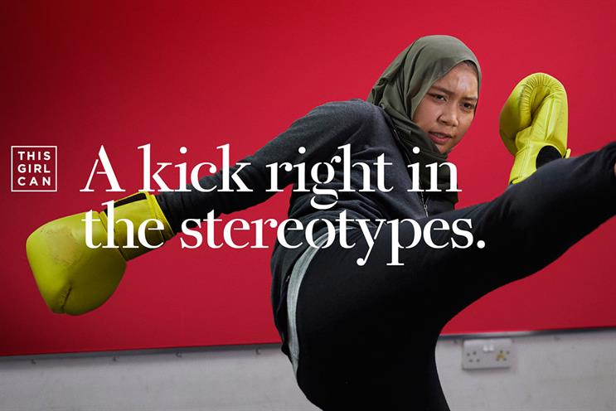

1. For your first task, using the following website, research Sport England and write about what they do and who they work with. <https://www.sportengland.org/>

Who are they/what do they do:

1. For your second task, using the ‘campaigns and our work’ tab – locate ‘This Girl Can’ and answer the following questions:

|  |  |
| --- | --- |
| When was the campaign established? |  |
| What is the purpose of the campaign? |  |
| Is this girl can based in counties, regions or nationwide? |  |
| What does the campaign celebrate? |  |

1. For your final task – using the ‘how we can help’ tab, explain how Sport England train PE Teachers in secondary schools.

**Bibliography**

<https://www.englandathletics.org/clubs-and-facilities/news/sport-england-announces-195m-fund-for-sport-and-physical-activity/>

<https://www.sportengland.org/campaigns-and-our-work/this-girl-can>

<https://www.campaignlive.co.uk/article/this-girl-can-moves-advertising-activism/1424851>